Name of journal: World Journal of Gastroenterology
ESPS Manuscript NO: 11553
Columns: Research Report

Experimental infection of Z:ZCLA mongolian gerbils with human hepatitis E virus

Hong Y et al. Mongolian Gerbils infected with human HEV

Yan Hong, Zhuo-Jing He, Wei Tao, Ting Fu, Yan-Kun Wang, Yong Chen

Yan Hong, Zhuo-Jing He, Wei Tao, Ting Fu, Yan-Kun Wang, Yong Chen, Institute of Bioengineering, Zhejiang Academy of Medical Science, Hangzhou 310013, Zhejiang Province, China

Author contributions: Hong Y, He ZJ, Tao W, Fu T and Chen Y designed the study; Hong Y, He ZJ, Tao W, Fu T and Wang YK performed the experiments; Tao W, Fu T and Wang YK analyzed data; and Hong Y, He ZJ and Chen Y wrote the paper.

supported by Science Technology Department of Zhejiang Province, grant No. 2011F20015; and Health And Family Planning Commission of Zhejiang Province, grant No. XKQ-010001

Correspondence to: Yan Hong, Professor, Institute of Bioengineering, Zhejiang Academy of Medical Science, 182 Tianmushan Road, Xihu District, Hangzhou 310013, Zhejiang Province, China. hongy1008@163.com

Telephone: +86-571-88215588 Fax: +86-571-88215588
Received: May 27, 2014 Revised: July 22, 2014
Accepted: September 5, 2014

Published online:

Abstract
AIM: To investigate whether Z:ZCLA Mongolian gerbils are readily susceptible to infection by human hepatitis E virus (HEV).

METHODS: Z:ZCLA Mongolian gerbils were infected with a clinical HEV strain from an acute hepatitis E patient, and virus pathogenesis was assessed in this host. Feces samples from gerbils were collected weekly for reverse transcription nested polymerase chain reaction. Serumanti-HEV IgG and alanine aminotransferase (ALT) were detected by enzyme linked immunosorbent assay. At sacrifice, animal liver, spleen, and kidney were collected for histopathologic examination.

RESULTS: HEV infected gerbils showed fatigue，with histopathological changes observed in the liver, spleen and kidney. HEV RNA was detected in fecal samples 7 d after inoculation, and lasted for 42 d. Interestingly, ALT levels were moderately increased in infected animals compared with the control group.

CONCLUSION These findings indicated that Z:ZCLA Mongolian gerbils are susceptible to human HEV.

© 2014 Baishideng Publishing Group Inc. All rights reserved.

Key words: Hepatitis E virus; Mongolian gerbils; Infection; Interspecies transmission; Zoonosis

Core tip: Z:ZCLA Mongolian gerbils were infected with human hepatitis E virus (HEV). Feces samples from gerbils were collected weekly for reverse transcription nested polymerase chain reaction. Serum anti-HEV IgG and alanine aminotransferase (ALT) detection was carried out by enzyme linked immunosorbent assay. At sacrifice, animal liver, spleen, and kidney were collected for histopathologic examination. HEV RNA was detected in fecal samples 7 d after inoculation, and lasted for 42 d. Interestingly, ALT levels were moderately increased in infected animals compared with the control group. These findings indicated that Z:ZCLA Mongolian gerbils are susceptible to human HEV.

Hong Y, He ZJ, Tao W, Fu T, Wang YK, Chen Y. Experimental infection of Z:ZCLA mongolian gerbils with human hepatitis E virus. World J Gastroenterol 2014; In press

Introduction
Hepatitis E virus (HEV) infection is a significant public health problem in many developing countries, causing large outbreaks of acute hepatitis. It is admitted that HEV transmission occurs primarily by the fecal-oral route through contaminated drinking water in areas with poor sanitation. However, hepatitis E has recently been diagnosed with increasing frequency in industrialized countries^{[1]}, and seroreactivity is observed in 5%-21% of asymptomatic individuals^{[2]}.
Interestingly, antibodies to HEV have been detected in a wide range of domestic and feral mammals, and HEV RNA has been isolated from pig^{[3-5]}, deer^{[6]}, wild boar^{[7]}, rodents^{[8-10]}, and chickens^{[11]}. The prevalence of HEV-specific antibodies in wild rodents is well documented^{[12-15]}, and HEV was recently isolated from rats trapped in several cities of industrialized countries^{[8]}. Thus, it is important to assess whether rodents constitute a potential source of human HEV infection. Wild gerbils, called midday jird [Meriones meridianus (M. meridianus)] have been experimentally infected with human HEV, and lesions similar to those found in human hepatitis E patients were observed^{[16]}. However, M. meridianus is not a breeding species and the animal biological characteristics are unknown. Other studies have reported the transmission of HEV from swine feces in southern China to Mongolian gerbil (Merionesunguiculatus), which serves as an animal model for a wide range of diseases^{[17]}.
Z:ZCLA Mongolian gerbil (Merionesunguiculatus) is a relatively new laboratory stock, domesticated by Zhejiang Experimental Animal Center, a branch of our institution. The animals originated from Inner Mongolia of China, and have been artificially propagated for more than 30 years. So far the gerbils have been bred for 46 generations and systematically characterized for basic biological attributes. The aim of the present study was to assess whether Z:ZCLA Mongolian gerbils are readily susceptible to infection by human HEV.

Materials and Methods
Virus
A clinical strain of HEV was isolated from a fecal sample of an acute hepatitis E patient (Hangzhou, China). A 221-nt product was amplified from the fecal sample by reverse transcription nested polymerase chain reaction (RT-nPCR) and directly sequenced to yield the consensus sequence. The virus sequence showed 99% homology with the Xinjiang strain D11092 (genotype 1). For virus preparation, 5 g of patient’s feces were resuspended in phosphate-buffered saline (PBS, pH 7.4) containing 0.01% diethyl pyrocarbonate (DEPC), at a proportion of 10% (w/v). After centrifugation of the suspension at 12000 × g for 20 min, the resulting supernatant was filtered sequentially through 0.45 and 0.22 μm filters before inoculation. The viruses were inoculated into each gerbil at a minimum viral count of 5.5 × 10²/ml of feces supernatant, as calculated by viral genomic titer determined by Real-Time reverse quantitative PCR.

Animals and infection
Twenty-one specific pathogen-free male Z:ZCLA Mongolian gerbils with bodymass of 40 ± 5 g (approximately 5 wk of age) were provided by Experimental Animal Center, Zhejiang Academy of Medical Sciences (China) and maintained in a pathogen-free animal facility. Adequate measures were taken to minimize animal discomfort. Procedures involving animals in this study were approved by the local committee of Animal Use and Protection.
Gerbils were divided into two groups, with 14 in the virus infection group, and seven controls. The day before infection, each gerbil was injected 6 × 10⁴-8 × 10⁴ units of Penicillin intraperitoneally. The infection group was inoculated intraperitoneally with a 100 μL virus suspension described above. Gerbils in the control group were inoculated with 100 μL PBS. All animals were provided with food and water ad libitum during 7 wk. Fecal samples were collected each week post-inoculation and stored at -20 ℃ until use. Two gerbils of the infection group and 1 control animal were humanely euthanized weekly post-inoculation. Serum was obtained from blood samples collected weekly and stored at -20 ℃. Liver, spleen, and kidney were fixed in 10% neutral buffered formalin for histopathologic examination immediately upon sampling.

Serologic tests
Serum specimens were assessed for IgG antibodies to HEV by using a commercial enzyme-linked immunosorbent assay [enzyme linked immunosorbent assay (ELISA); Wantai Biological Pharmacy Co., Beijing, China] kit, according to the manufacturer’s instructions. The absorbance was determined at 450 nm (Multiscan Titertek MCC).
ALT levels were detected in serum samples with an automated biochemistry analyzer (Olympus 2700, Japan).

Histopathological studies
For histological studies, fixed tissues (liver, spleen, and kidney) were dehydrated with increasing concentrations of ethanol and embedded in paraffin according to standard laboratory procedures. Tissues were cut in 7 μm sections and stained with hematoxylin and eosin for histological evaluation. Observation was carried out on an Olympus CX41 microscope (Olympus, Beijing, China).

RNA extraction and nested reverse transcription PCR
Total RNA was extracted from 10% fecal supernatants. After centrifugationof the suspension at 12000 × g for 15 min, the resulting supernatant was mixed with 10% PEG 6000 (w/v) and 2.3% NaCl (w/v), and stored at 4 ℃ overnight. The solution was centrifuged at 12000 × g for 20 min the following day. Total RNA was extracted from the sediment by the TRIZOL reagent (®Invitrogen, Carlsbad, CA, United States), according to the manufacturer’s instructions, and was dissolved in 20 μl ribonuclease (RNase)-free water. Reverse transcription was performed using a commercially available Primescript first strand cDNA synthesis kit (®TakaRa, Dalian, China) following the manufacturer’s instructions. The resulting cDNA was amplified by nested PCR using primers based on sequences of the open reading frame 2 (5123-7105 nt) of the Chinese HEV isolate (the sites based on L08816.1)^{[18]}. The external forward primer (6272-6294 nt, PCR1) was 5’-CCGACAGAATTGATTTCGTCGGC-3’ and the reverse primer (6579-6557 nt, PCR4) was 5’-CCGTAAGTGGACTGGTCATACTC-3’; the internal forward primer (6323-6345 nt, PCR2) was 5’-GTCGTCTCAGCCAATGGCGAGCC-3’, and the reverse primer (6521-6543 nt, PCR3) was 5’-GAAAGCCAAAGCACATCATTAGC-3’. The RT-nPCR product was expected to be 221 base pairs. The first roundPCR was set up at 94 ℃ for 5 min, followed by 94 ℃ for 30 s, 55 ℃ for 30 s and 72 ℃ for 10min, repeated for 33 cycles. The second round PCR protocol was the same as the first one except that melting temperature of 57 ℃ was used. The PCR products were assessed by electrophoresis on 1% agarose gel. Negative (water) was included and the PCR products were identified by sequencing to exclude the possibility of contamination and failure of amplification.

Results
Clinical evaluation
The HEV infected gerbils showed fatigue and loose hair. As expected, no evidence of clinical disease was observed in control gerbils.

Serological analysis
Serum specimens were examined using an automatic biochemical analyzer to determine serum ALT levels. As shown in Figure 1, ALT levels were moderately increased in gerbils infected with HEV, compared with control animals, at days 14 and 21 post-inoculation. Assays were performed in triplicate and data expressed as mean ± SD. In addition, serum anti-HEV antibodies were assessed in HEV inoculated and non-inoculated groups by ELISA, and no anti-HEV IgG was detected in either group.

Detection of HEV RNA by RT-nPCR
Viral shedding in feces was detected intermittently by RT-nPCR, beginning at 7 d after inoculation in all infected gerbils. Indeed, right size PCR products were detected by electrophoresis on 1% agarose gel, which showed a 221 bp DNA fragment (Figure 2). The fecal excretion of HEV lasted for 42 d. All data obtained for the seven weeks experimental period are summarized in Table 1.

Histopathologic examination
To determine whether gerbils responded to the HEV-containing inoculum with histopathologic signs of injury, tissues (liver, spleen, and kidney) from inoculated and control gerbils were sectioned, stained, and examined by light microscopy. We observed changes attributable to inoculation in the liver, spleen, and kidney. Hepatic inflammation and focal hepatocellular necrosis were observed in inoculated gerbils. In addition, mixed infiltration of lymphocytes and eosinophils in the portal tracts was observed (Figure 3A). Furthermore, enlarged splenocytes and multiple vacuolar degeneration were observed in the spleens of inoculated gerbils (Figure 3B). Moreover, increased lymphocyte and macrophage infiltration was observed in renal tissuesafter HEV infection (Figure 3C). Of note, no damage was observed in any tissue from control animals（Figure 3D-F）.

Discussion
Hepatitis E genotype 1 is an infectious agent, which causes a disease considered to be endemic in developing countries, due to poor sanitary conditions. However, recent reports drew attention to Hepatitis E appearance in developed countries; the most recent survey showed that 21% of US residents are seropositive for anti-HEV IgG^{[19]}. Although some research assays could yield "false-positive" results, with controversy surrounding current enzyme immunoassays used for HEV detection^{[2]}, more thorough HEV studiesare urgently needed.
HEV infection is described as a disease transmitted primarily via the fecal-oral route through contaminated drinking water^{[20]}. In addition, wild or domestic swine consumption probably plays an important role in the occurrence of hepatitis E genotype 3 or 4^{[21,22]}. However, as evidences began to accumulate, recent investigations suggested the possibility of other modes of transmission. It was reported that HEV can be transmitted from person to person^{[23]}, despite the fact HEV presence in stool is acknowledged as a major source of transmission by contact exposure to other animals^{[24]}. Because rodents and humans often share the environment, especially in inner cities, there is a possibility for rodents to get in touch with human feces. Therefore, rodents are particularly interesting as a potential source of human HEV infections.
To date, the Mongolian gerbil is used widely as a model animal in scientific studies. However, the Z:ZCLA Mongolian gerbil is a relatively new closed colony, of which ancestors were obtained in Inner Mongolia of China by Zhejiang Experimental Animal Center in 1978. This population has stable biological characteristics, and lives longer than other Mongolian gerbil populations in China. Moreover, these animals have been used in multiple investigation fields: parasites, cerebral hemorrhage, viruses, bacteria, lipometabolism, and carbohydrate metabolism. The results presented here suggested that Z:ZCLA Mongolian gerbils are susceptible to human HEV, as evidenced by clinical signs of HEV infection, changes in serum ALT levels, fecal viral shedding, and lesions of organs, including liver, spleen, and kidney. As shown above, fecal virus shedding was detected at 7 d post-infection and lasted for 5 wk. Similar findings were previously described by Lin et al^{[25]}, who found HEV RNA in fecal excretion obtained from gerbils inoculated with swine HEV, 3-4 wk. With the large number of rodents in large cities, HEV can be spread easily and for a long time by rat feces; therefore, the effects of HEV via the fecal-oral route are difficult to predict.
During the experimental infection, no anti-HEV antibodies were detected in the inoculated gerbils. Similar to a previous study, in which Wistar rats were infected with human HEV, sero-conversion could not be detected, when the experiment stopped at day 35 post-inoculation^{[26]}. In another study, gerbils infected with swine HEV produced anti-HEV antibodies at 49 days post-inoculation, with noticeably lower optical density values than the positive control^{[25]}. Therefore, the magnitude of rat viremia might be reduced in comparison with that of other inoculated mammalians.
The results presented here indicate that Z:ZCLA Mongolian gerbils could be experimentally infected by human HEV; therefore this rodent should be considered a helpful animal model for HEV studies. Specifically, it can be used to further describe the mechanism of HEV interspecies transmission. In addition, rodent control in inner cities may help prevent HEV transmission.

comments
Background
Hepatitis E virus (HEV) infection is a significant public health problem in many developing countries, causing large outbreaks of acute hepatitis. However, in industrialized countries, hepatitis E has recently been diagnosed with increasing frequency as a cause of sporadic hepatitis, and frequent seroreactivity in 5%-21% of asymptomatic persons has been recorded. Because antibodies to HEV have been detected in a wide range of domestic and feral mammals, and HEV RNA recently isolated from rats trapped in several cities in industrialized countries, it is important to understand whether rodents are a potential source of human HEV infection.

Research frontiers
HEV infection is known as a disease transmitted primarily via the fecal-oral route through contaminated drinking water. However, recent investigations have suggested the possibility of other modes of transmission. It was reported that HEV can be transmitted from person to person despite the fact that HEV presence in stool is acknowledged as a major source of transmission by contact exposure to other animals. Because rodents and humans often share the environment, especially in inner cities, rodents could get in touch with human feces easily. Therefore, rodents are particularly interesting as a potential source of human HEV infections.

Innovations and breakthroughs
It has been shown that wild gerbils, called midday jird [Meriones meridianus (M. meridianus)] could be experimentally infected by human HEV and lesions similar to those found in human hepatitis E patients were observed. However, M. meridianus is not a breeding species and their biological characteristics are unknown. Other studies have reported the transmission of HEV from swine feces to Mongolian gerbil (Meriones unguiculatus)，which serves as an animal model for a wide range of diseases. Z:ZCLA Mongolian gerbil (Meriones unguiculatus) is arelatively new laboratory stock, domesticated by Zhejiang Experimental Animal Center, a branch of our institution. The animals originated from Inner Mongolia of China, and were artificially propagated for more than 30 years. So far the gerbils have been bred for 46 generations, and their basic biological characteristics have been systematically described. The aim of the present study was to investigate whether Z:ZCLA Mongolian gerbils are readily susceptible to infection with human HEV.

Applications
The study results suggest that Z:ZCLA Mongolian gerbils could be experimentally infected by human HEV; therefore, Meriones unguiculatus should be considered a helpful animal model for HEV studies. Specifically, it can be used to further describe the mechanism of HEV interspecies transmission.

Terminology
Hepatitis E virus (HEV) is an emerging pathogen and the most common cause of acute viral hepatitis worldwide.

Peer review
This manuscript comprises the experimental infection of a novel laboratory stock of Mongolian Gerbils with a clinical strain of human hepatitis E virus. Apart from the introduction of an animal model for HEV (interspecies) infection, the authors raise the question about the influence of rodents on HEV transmission to humans.

References
1 Purcell RH, Emerson SU. Hepatitis E virus. In: Knipe, DM, Howley PM, eds. Fields virology. 4th ed.Philadelphia: Lippincott Williams & Wilkins, 2001: 3051–3061
2 Teshale EH, Hu DJ, Holmberg SD. The two faces of hepatitis E virus. Clin Infect Dis 2010; 51: 328-334 [PMID: 20572761 DOI: 10.1086/653943]
3 van der Poel WH, Verschoor F, van der Heide R, Herrera MI, Vivo A, Kooreman M, de Roda Husman AM. Hepatitis E virus sequences in swine related to sequences in humans, The Netherlands. Emerg Infect Dis 2001; 7: 970-976 [PMID: 11747723 DOI: 10.3201/eid0706.010608]
4 Huang FF, Haqshenas G, Guenette DK, Halbur PG, Schommer SK, Pierson FW, Toth TE, Meng XJ. Detection by reverse transcription-PCR and genetic characterization of field isolates of swine hepatitis E virus from pigs in different geographic regions of the United States. J Clin Microbiol 2002; 40: 1326-1332 [PMID: 11923352 DOI: 10.1128/JCM.40.4.1326-1332.2002]
5 Pei Y, Yoo D. Genetic characterization and sequence heterogeneity of a canadian isolate of Swine hepatitis E virus. J Clin Microbiol 2002; 40: 4021-4029 [PMID: 12409369 DOI: 10.1128/JCM.40.11.4021-4029.2002]
6 Tei S, Kitajima N, Takahashi K, Mishiro S. Zoonotic transmission of hepatitis E virus from deer to human beings. Lancet 2003; 362: 371-373 [PMID: 12907011 DOI: 10.1016/S0140-6736(03)14025-1]
7 Takahashi K, Kitajima N, Abe N, Mishiro S. Complete or near-complete nucleotide sequences of hepatitis E virus genome recovered from a wild boar, a deer, and four patients who ate the deer. Virology 2004; 330: 501-505 [PMID: 15567444 DOI: 10.1016/j.virol.2004.10.006]
8 Purcell RH, Engle RE, Rood MP, Kabrane-Lazizi Y, Nguyen HT, Govindarajan S, St Claire M, Emerson SU. Hepatitis E virus in rats, Los Angeles, California, USA. Emerg Infect Dis 2011; 17: 2216-2222 [PMID: 22172320 DOI: 10.3201/eid1712.110482]
9 Johne R, Plenge-Bönig A, Hess M, Ulrich RG, Reetz J, Schielke A. Detection of a novel hepatitis E-like virus in faeces of wild rats using a nested broad-spectrum RT-PCR. J Gen Virol 2010; 91: 750-758 [PMID: 19889929 DOI: 10.1099/vir.0.016584-0]
10 Kanai Y, Miyasaka S, Uyama S, Kawami S, Kato-Mori Y, Tsujikawa M, Yunoki M, Nishiyama S, Ikuta K, Hagiwara K. Hepatitis E virus in Norway rats (Rattus norvegicus) captured around a pig farm. BMC Res Notes 2012; 5: 4 [PMID: 22217009 DOI: 10.1186/1756-0500-5-4]
11 Huang FF, Sun ZF, Emerson SU, Purcell RH, Shivaprasad HL, Pierson FW, Toth TE, Meng XJ. Determination and analysis of the complete genomic sequence of avian hepatitis E virus (avian HEV) and attempts to infect rhesus monkeys with avian HEV. J Gen Virol 2004; 85: 1609-1618 [PMID: 15166445 DOI: 10.1099/vir.0.79841-0]
12 Arankalle VA, Joshi MV, Kulkarni AM, Gandhe SS, Chobe LP, Rautmare SS, Mishra AC, Padbidri VS. Prevalence of anti-hepatitis E virus antibodies in different Indian animal species. J Viral Hepat 2001; 8: 223-227 [PMID: 11380801 DOI: 10.1046/j.1365-2893.2001.00290.x]
13 Hirano M, Ding X, Li TC, Takeda N, Kawabata H, Koizumi N, Kadosaka T, Goto I, Masuzawa T, Nakamura M, Taira K, Kuroki T, Tanikawa T, Watanabe H, Abe K. Evidence for widespread infection of hepatitis E virus among wild rats in Japan. Hepatol Res 2003; 27: 1-5 [PMID: 12957199 DOI: 10.1016/S1386-6346(03)00192-X]
14 Favorov MO, Kosoy MY, Tsarev SA, Childs JE, Margolis HS. Prevalence of antibody to hepatitis E virus among rodents in the United States. J Infect Dis 2000; 181: 449-455 [PMID: 10669325 DOI: 10.1086/315273]
15 Vitral CL, Pinto MA, Lewis-Ximenez LL, Khudyakov YE, dos Santos DR, Gaspar AM. Serological evidence of hepatitis E virus infection in different animal species from the Southeast of Brazil. Mem Inst Oswaldo Cruz 2005; 100: 117-122 [PMID: 16021297 DOI: 10.1590/S0074-02762005000200003]
16 Zhao SY, Liao LF, Zou LY, Yu ZY. Study of experiment on HEV infection in Gerbil (Merionesmeridianus) from generation to generation. Zhongguo Meijie Shengwuxue and Kongzhi Zazhi 2001; 12: 215–218
17 Gaucher D, Chadee K. Molecular cloning and expression of gerbil granulocyte/macrophage colony-stimulating factor. Gene 2002; 294: 233-238 [PMID: 12234685 DOI: 10.1016/S0378-1119(02)00795-3]
18 Bi SL, Purdy MA, McCaustland KA, Margolis HS, Bradley DW. The sequence of hepatitis E virus isolated directly from a single source during an outbreak in China. Virus Res 1993; 28: 233-247 [PMID: 8346669 DOI: 10.1016/0168-1702(93)90024-H]
19 Kuniholm MH, Purcell RH, McQuillan GM, Engle RE, Wasley A, Nelson KE. Epidemiology of hepatitis E virus in the United States: results from the Third National Health and Nutrition Examination Survey, 1988-1994. J Infect Dis 2009; 200: 48-56 [PMID: 19473098 DOI: 10.1086/599319]
20 Balayan MS, Andjaparidze AG, Savinskaya SS, Ketiladze ES, Braginsky DM, Savinov AP, Poleschuk VF. Evidence for a virus in non-A, non-B hepatitis transmitted via the fecal-oral route. Intervirology 1983; 20: 23-31 [PMID: 6409836 DOI: 10.1159/000149370]
21 Li TC, Chijiwa K, Sera N, Ishibashi T, Etoh Y, Shinohara Y, Kurata Y, Ishida M, Sakamoto S, Takeda N, Miyamura T. Hepatitis E virus transmission from wild boar meat. Emerg Infect Dis 2005; 11: 1958-1960 [PMID: 16485490 DOI: 10.3201/eid1112.051041]
22 Mizuo H, Yazaki Y, Sugawara K, Tsuda F, Takahashi M, Nishizawa T, Okamoto H. Possible risk factors for the transmission of hepatitis E virus and for the severe form of hepatitis E acquired locally in Hokkaido, Japan. J Med Virol 2005; 76: 341-349 [PMID: 15902701 DOI: 10.1002/jmv.20364]
23 Teshale EH, Grytdal SP, Howard C, Barry V, Kamili S, Drobeniuc J, Hill VR, Okware S, Hu DJ, Holmberg SD. Evidence of person-to-person transmission of hepatitis E virus during a large outbreak in Northern Uganda. Clin Infect Dis 2010; 50: 1006-1010 [PMID: 20178415 DOI: 10.1086/651077]
24 Huang F, Zhang W, Gong G, Yuan C, Yan Y, Yang S, Cui L, Zhu J, Yang Z, Hua X. Experimental infection of Balb/c nude mice with Hepatitis E virus. BMC Infect Dis 2009; 9: 93 [PMID: 19523236 DOI: 10.1186/1471-2334-9-93]
25 Li W, Sun Q, She R, Wang D, Duan X, Yin J, Ding Y. Experimental infection of Mongolian gerbils by a genotype 4 strain of swine hepatitis E virus. J Med Virol 2009; 81: 1591-1596 [PMID: 19623666 DOI: 10.1002/jmv.21573]
26 Maneerat Y, Clayson ET, Myint KS, Young GD, Innis BL. Experimental infection of the laboratory rat with the hepatitis E virus. J Med Virol 1996; 48: 121-128 [PMID: 8835343 DOI: 10.1002/(SICI)1096-9071(199602)48:2<121::AID-JMV1>3.0.CO;2-B]

P-Reviewer: Kim sr S-Editor: Ma YJ L-Editor: E-Editor:

Figureure 1 alanine aminotransferase level changes after hepatitis E virus infection. Z:ZCLA Mongolian gerbils showed ALT (ALT) level changes upon hepatitis E virus (HEV) infection. The ALT levels were moderately increased in the inoculated group compared with controls at days 14 and 21 post-inoculation. No changes were observed in the control group.

Figureure2 reverse transcription nested polymerase chain reaction detection of viral shedding in feces. hepatitis E virus (HEV) RNA was detected by reverse transcription nested polymerase chain reaction (RT-nPCR) in feces from all inoculated gerbils. M: DNA Marker; 1-6 represent experimental time points (weeks): the second round PCR products of gerbil feces samples on intermittent days; 7: a negative control containing water.

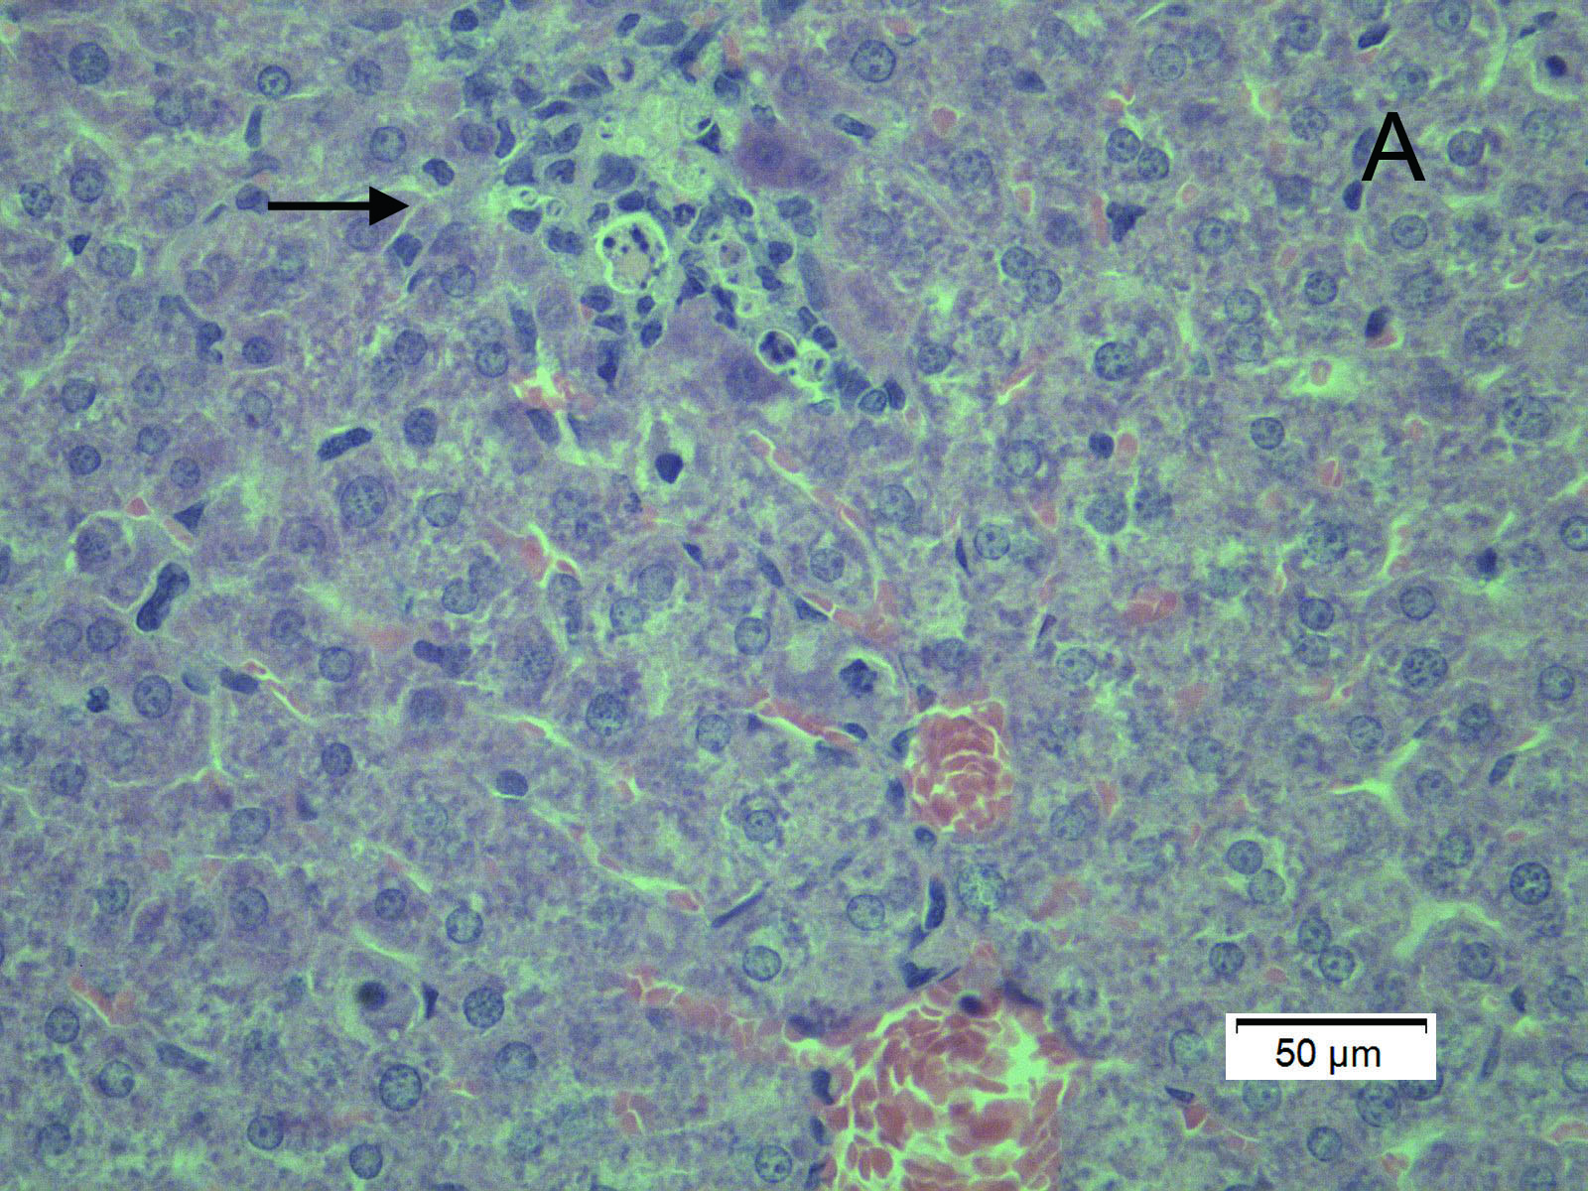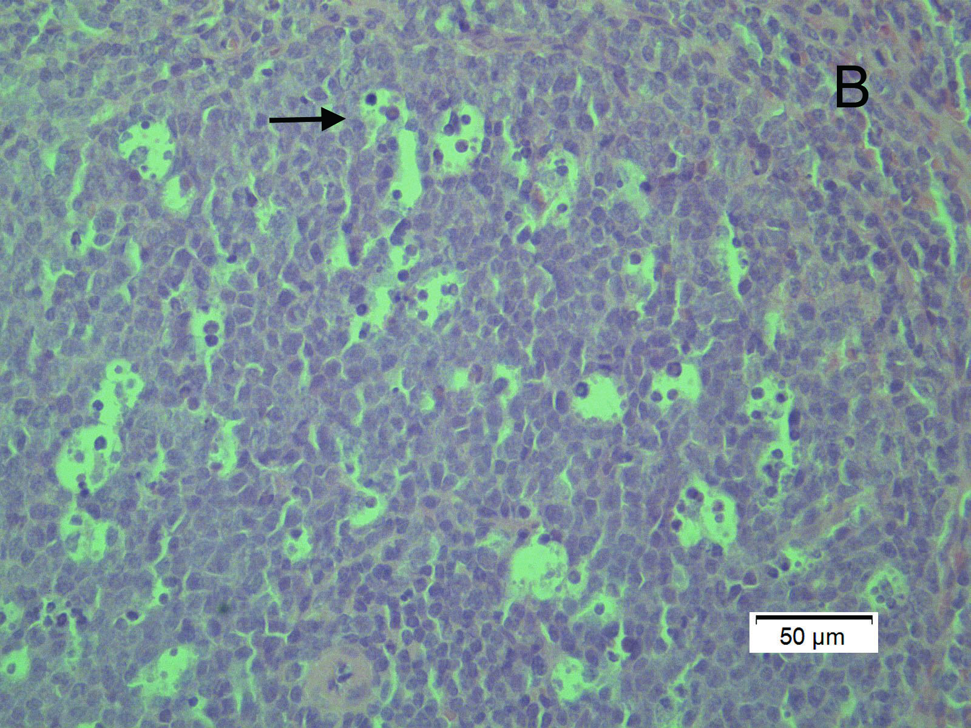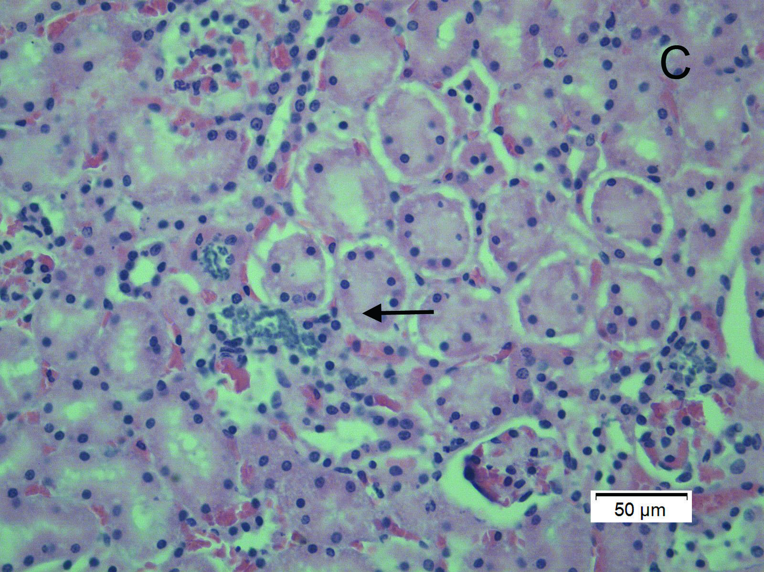
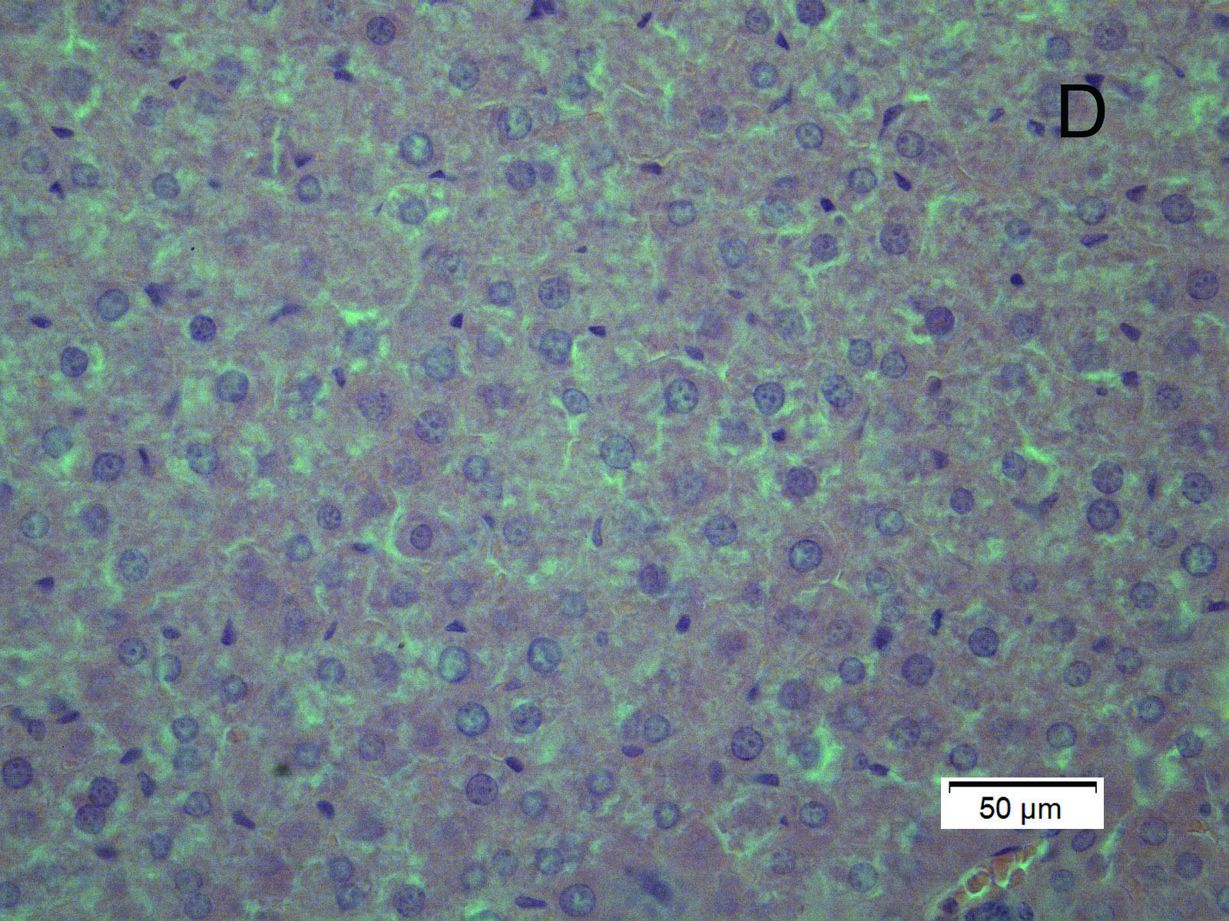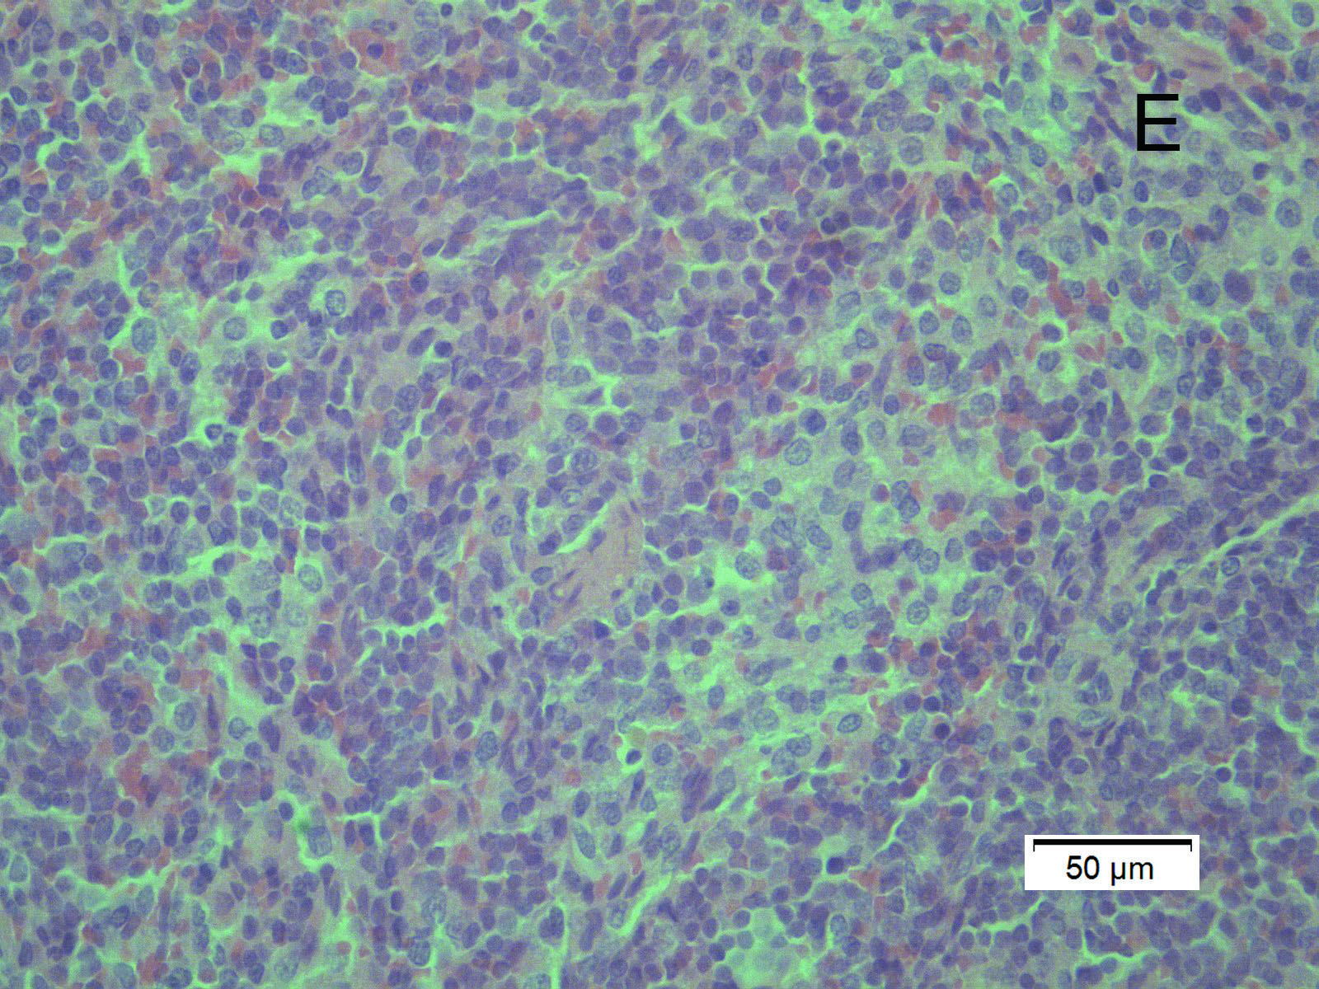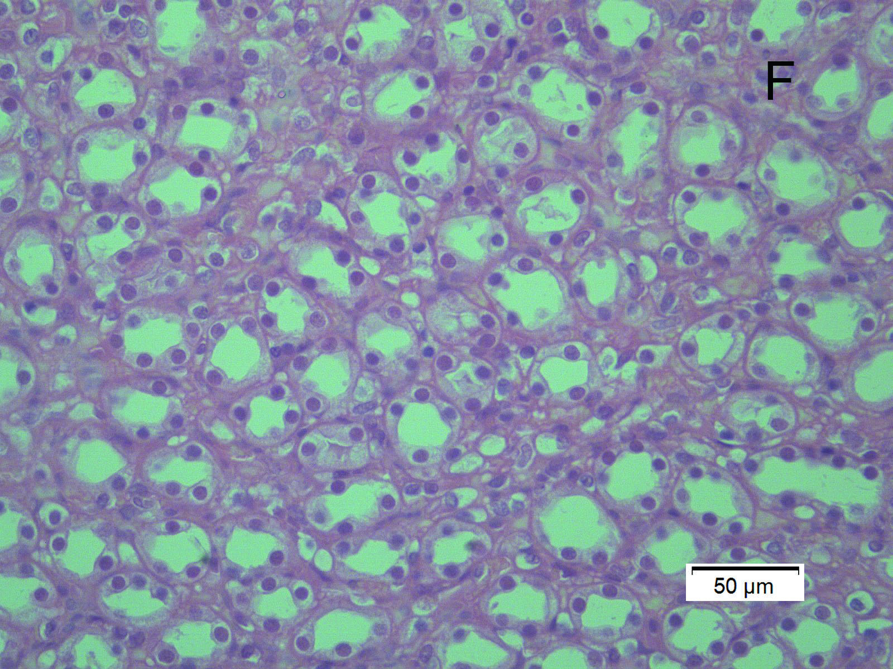
Figureure 3 Histopathologic changes in the inoculated group. Histopathologic changes in the inoculated group. A: Liver, slight histiocytic hepatitis, and focal accumulation of inflammatory cells surrounding hepatocytes (21 DPI); B: Spleen, ruptured and enlarged splenocytes showing multiple vacuolar degeneration (21 DPI); C: Kidney, disarranged kidney cells with increased infiltrating lymphocytes and macrophages (35 DPI); D: Negative control liver; E: Negative control spleen; F: negative control kidney. Tissues were stained with hematoxylin and eosin. Original magnifications × 400.

Table 1 Detection of hepatitis E virus RNA in gerbils inoculated with hepatitis E virus
 | Hepatitis E virus RNA positive rate on weeks post-inoculation
group | 0 | 7 | 14 | 21 | 28 | 35 | 42 | 49
inoculated group | 0/14 | 5/14 | 10/12 | 10/10 | 8/8 | 6/6 | 1/4 | 0/2
control group | 0/7 | 0/7 | 0/6 | 0/5 | 0/4 | 0/3 | 0/2 | 0/1
Viral shedding in feces was detected by reverse transcription nested polymerase chain reaction.

