November 02, 2012 Jian-Xia Cheng, Editorial Office,
Director

Dear Editor
NORTHGATE MEDICAL PC

Please find enclosed the edited manuscript in Word format (File name: 497-review.doc)

Title: Efficacy and safety of Chlorella supplementation in adults with chronic HCV infection Author: Jose Azocar and Arley Diaz
Name of Journal: World Journal of Gastroenterology

ESPS Manuscript NO: 497

The manuscript has been improved according to the suggestions of reviewers

- Format has been updated

- Revision has been made according to the suggestion of the reviewer

  - The introduction section was reviewed and reduced (2)The definition of the AIM of the study was improved
- Discussion section was expanded
- The potential mechanisms for the Chlorella induced benefits were incorporated. (S)Comments on the limitations of the present study, mainly the number of participants and limited duration (12 weeks), were incorporated in the discussion.
- Comments on the value of the ASTIALT ratio were incorporated and the ASTIALT ratios of
all the participants were added to Table 1.
- The main conclusions are stated in the Abstract, and the format was updated
- The references were reduced from 40 to 30

- References and typesetting were corrected

Thank you for publishing our manuscript in the World Journal of Gastroenterology.

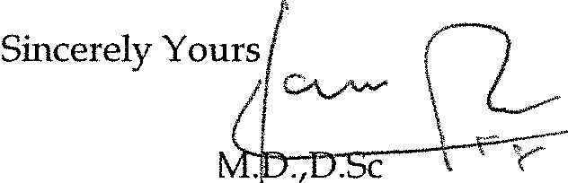I hope the readers of WJG will find our contribution informative and useful. Please do not hesitate to let me know if any other adjustments are needed for the publication of our article.

Jose Azocar,
Nortgate Mediqal PC 1985 Main StreA
Springfield, MA 0'1103, USA
E-mail jazocar@rcn.com

1985 Main Street, Springfield, MA 01103 T (413) 364 8586 Fax (413) 788 9840

