Name of Journal: World Journal of Gastrointestinal Surgery
Manuscript NO: 80887
Manuscript Type: ORIGINAL ARTICLE

Clinical Trials Study
Endoscopic ultrasound-guided intraportal injection of autologous bone marrow in patients with decompensated liver cirrhosis: A case series

Zheng SP et al. EUS-guided intervention with bone marrow

Shao-Peng Zheng, Ao-Jian Deng, Jing-Jing Zhou, Ling-Zhi Yuan, Xiao Shi, Fen Wang

Shao-Peng Zheng, Ao-Jian Deng, Jing-Jing Zhou, Ling-Zhi Yuan, Xiao Shi, Fen Wang, Department of Gastroenterology, Third Xiangya Hospital of Central South University, Changsha 410013, Hunan Province, China

Shao-Peng Zheng, Ao-Jian Deng, Ling-Zhi Yuan, Fen Wang, Hunan Key Laboratory of Non-resolving Inflammation and Cancer, Central South University, Changsha 410000, Hunan Province, China

Author contributions: Wan F designed the research; Zheng SP, Zhou JJ, Yuan LZ, Shi X, and Wan F performed the research; Zheng SP analyzed the data; Zheng SP and Deng AJ wrote the paper.

Supported by the National Natural Science Foundation of China, No. 82270594; National Natural Science Foundation for Youths of China, No. 882002614 and No. 82103151; Hunan Provincial Natural Science Foundation of China, No. 2020JJ4853; Scientific Research Project of Hunan Provincial Health Commission, No. 202103032097; Outstanding Youth Foundation of Hunan Province, No. 2022JJ20092; Hunan Provincial Natural Science Foundation of China for Youths, No. 2021JJ40935 and No. 2020JJ5609; and Wisdom Accumulation and Talent Cultivation Project of Third Xiangya Hospital of Central South University, No. YX202103.

Corresponding author: Fen Wang, MD, PhD, Doctor, Professor, Department of Gastroenterology, Third Xiangya Hospital of Central South University, No. 138 Tongzi Road, Changsha 410013, Hunan Province, China. wfen-judy@csu.edu.cn

Received: October 17, 2022
Revised: January 31, 2023
Accepted: March 21, 2023
Published online:

Abstract
BACKGROUND
Recently, stem cell therapy has been extensively studied as a promising treatment for decompensated liver cirrhosis (DLC). Technological advances in endoscopic ultrasonography (EUS) have facilitated EUS-guided portal vein (PV) access, through which stem cells can be precisely infused.

AIM
To investigate the feasibility and safety of fresh autologous bone marrow injection into the PV under EUS guidance in patients with DLC.

METHODS
Five patients with DLC were enrolled in this study after they provided written informed consent. EUS-guided intraportal bone marrow injection with a 22G FNA needle was performed using a transgastric, transhepatic approach. Several parameters were assessed before and after the procedure for a follow-up period of 12 mo.

RESULTS
Four males and one female with a mean age of 51 years old participated in this study. All patients had hepatitis B virus-related DLC. EUS-guided intraportal bone marrow injection was performed in all patients successfully without any complications such as hemorrhage. The clinical outcomes of the patients revealed improvements in clinical symptoms, serum albumin, ascites, and Child-Pugh scores throughout the 12-mo follow-up.

CONCLUSION
The use of EUS-guided fine needle injection for intraportal delivery of bone marrow was feasible and safe and appeared effective in patients with DLC. This treatment may thus be a safe, effective, non-radioactive, and minimally invasive treatment for DLC.

Key Words: Endoscopic ultrasonography; Fine needle injection; Portal vein; Decompensated liver cirrhosis; Bone marrow

Zheng SP, Deng AJ, Zhou JJ, Yuan LZ, Shi X, Wang F. Endoscopic ultrasound-guided intraportal injection of autologous bone marrow in patients with decompensated liver cirrhosis: A case series. World J Gastrointest Surg 2023; In press

Core Tip: In this study, we showed that the use of endoscopic ultrasonography (EUS)-guided fine needle injection for intraportal delivery of stem cells was feasible and safe and appeared effective in patients with decompensated liver cirrhosis (DLC). And it is the first attempt to investigate the feasibility and safety of fresh autologous bone marrow injection into the portal vein under EUS guidance in patients with DLC.

INTRODUCTION
Cirrhosis refers to a late stage of liver fibrosis caused by chronic liver damage due to various etiologies such as alcohol and viral hepatitis. Liver cirrhosis (LC) is the 11th most common cause of death worldwide^{[1]}. The most frequent clinical manifestations of hepatic decompensation include ascites, variceal bleeding, hepatic encephalopathy, and jaundice. The prognosis of these patients is worse and significantly shorter than that of patients with compensated cirrhosis^{[2]}. Despite various medical therapies, the morbidities and mortality associated with decompensated LC (DLC) is high. To date, liver transplantation is the only curative treatment for DLC. However, the shortage of donor livers, immunological rejection, surgical complications, and high cost greatly limit the clinical application of liver transplantation.
In recent years, stem cell therapy has been extensively studied as a promising treatment for DLC. Stem cells can not only differentiate into hepatocytes, but also play an important role in anti-fibrosis, anti-inflammation, and the immune regulation of liver diseases^{[3-7]}. Thus, stem cell therapy has the potential to restore normal liver function by increasing the number of normal hepatocytes and improving the pathological structure of liver tissue. However, the application of this therapy has been hindered due to the genomic instability and the tumorigenicity of stem cells^{[8,9]}.
Strategies such as liver-targeted stem cell therapy can not only increase the number of therapeutic stem cells in the liver but also reduce the distribution of stem cells in non-targeted organs and the total amount of infused stem cells, and therefore reduce the risk of malignant transformation of stem cells. With the recent technological advancements in endoscopic ultrasonography (EUS) and its instrumentation, EUS offers a potential access to the portal vein^{[10-12]}, through which the stem cells can be precisely delivered to the liver. Due to the proximity of the portal vein to the gastrointestinal tract, EUS-guided access to the portal venous system has been studied as an alternate approach to standard routes for portal vein angiography and portal pressure gradient measurement. To date, data on EUS-guided intraportal fine needle injection (FNI) of stem cells or bone marrow in patients with DLC remain scarce. In this prospective study, we performed fresh autologous bone marrow injection into the portal venous system of patients with DLC under the guidance of EUS and evaluated its safety and efficacy during a 12-mo period of follow-up.

MATERIALS AND METHODS
In this study, patients with DLC were enrolled for EUS-guided intraportal autologous bone marrow infusion between January 2020 and February 2020. This study was reviewed and approved by the institutional ethics committee of the local hospital (No: 2018-S403; date: December 26, 2018). Registration number of this study was ChiCTR2000035269 in Chinese Clinical Trial Registry. Written informed consent was obtained from all enrolled patients. All methods related to this study were carried out in accordance with the ethical standards of the declaration of Helsinki concerning research involving human subjects. Patients satisfying the following criteria were enrolled in this study.

Inclusion criteria
The inclusion criteria were: (1) Age > 18 years; (2) DLC with ascites; (3) alcoholic or posthepatitic cirrhosis; and (4) endoscopy was tolerable after anesthesia evaluation.

Exclusion criteria
The exclusion criteria were: (1) Pregnant or lactating women; (2) patients with severe anemia and coagulation dysfunction (international normalized ratio > 1.5); (3) failure of hemostasis treatment for gastrointestinal bleeding in the past month; (4) presence of spontaneous peritonitis, hepatic encephalopathy, hepatorenal syndrome, and acute infection; (5) presence of coexisting severe heart, lung, kidney, blood system, or other diseases, or history of mental illness; and (6) malignant tumor of the liver or other organs.

Therapeutic methods
Bone marrow sampling: All patients were given the standard medical treatment for LC and under antiviral therapy against hepatitis B after hospitalization. After preoperative evaluation and enrollment in this study, autologous bone marrow sampling was performed. The aspiration of bone marrow were performed in the sterile operating room. The right posterior superior iliac spine was selected as the puncture site, and the skin was cleaned with 70% alcohol. The skin, subcutaneous tissues, and periosteum overlying the selected site for puncture were infiltrated with local anesthesia, and serial punctures from multiple sites were performed. With needles passing perpendicularly into the cavity of the ileum at a point just near the right posterior superior iliac spine, about 30 mL of the patients’ bone marrow was collected in a syringe containing 10 mL of heparin saline (62.5 U/mL). And the bone marrow samples were subjected to transplantation immediately after aspiration in the same sterile operating room. In addition, 1 mL of bone marrow was collected for flow cytometry to count the total number of nucleated cells and the proportion of CD34⁺ cells, which have the character of plasticity and can change into hepatocytes.

Endoscopic procedure: The EUS-guided portal vein puncture was performed by experienced endosonographers using an endoscopic ultrasound system (EU-ME2, Olympus, Tokyo, Japan), a linear echoendoscope (UCT-260, Olympus, Tokyo, Japan), and a 22G FNA needle (Cook Medical, Winston-Salem, NC, United States). First, under intravenous anesthesia with propofol, the echoendoscope was introduced into the stomach transorally. Then, after identification of the portal vein (PV), the endoscopic FNA needle was advanced through the liver parenchyma into the lumen of the PV under Doppler imaging. After puncturing the intrahepatic PV, the stylet was withdrawn from the needle and blood was aspirated before injection to confirm the position of the needle. Then, through the FNA needle, a total of 40 mL of fresh autologous bone marrow fluid (30 mL of fresh autologous bone marrow and 10 mL of heparin saline) was injected into the PV at an approximate rate of 1 mL/min under continuous ultrasonic monitoring. Needle placement was meticulously monitored during injection to ensure consistency. It usually takes about 30-40 min for the whole injection, and the injection is administered under the guidance of endoscopic ultrasound, which helps us to maintain the infusion rate and needle stability. Following completion of the infusion, the FNA needle was gradually removed. Upon withdrawal of the needle, just prior to leaving the liver capsule, color Doppler imaging was used to ensure that there was no flow in the needle track. Finally, the needle was removed, followed by compression at the puncture site for about 5 min using the ultrasonic stylet. Before withdrawing the echoendoscope, intrahepatic or perihepatic hemorrhage or hematoma was ruled out by color Doppler. Subsequently, the patient was placed under close observation and the ongoing medical treatment was continued.

Follow-up
The endpoint of the follow-up period was 12 mo after the procedure. During the follow-up visits, clinical history was collected and a physical examination, laboratory tests, and abdominal ultrasonography were performed. The main clinical symptoms noted were the presence/absence of ascites, variceal bleeding, hepatic encephalopathy, and jaundice. Laboratory tests included a complete hemogram, liver function tests, coagulation profile, serum hyaluronic acid, serum laminin, serum collagen IV, and serum procollagen III. Abdominal ultrasound emphasized the grade of ascites, the PV diameter, portal vein thrombosis, and neoplastic lesions in the liver. At the same time, elastography was performed by ultrasound to estimate the liver stiffness (LS) and the fat attenuation parameters.

Statistical analysis
The quantitative variables are described as the mean ± SD. The changes in the parameters relative to baseline at 1 mo, 3 mo, 6 mo, and 12 mo after treatment were determined using analysis of variance (ANOVA) with Fisher’s protected least-significant difference test. The IBM® SPSS® for Windows version 25.0 software was used for statistical data analyses.

RESULTS
Baseline characteristics
In this study, five patients (4 males and 1 female) were included. The etiology of cirrhosis in all patients was hepatitis B virus infection. The mean age of the patients was 51 (range 30-71) years. The main clinical symptoms were abdominal distention (3/5), gastrointestinal bleeding (1/5), edema (1/5), and abdominal pain (1/5). The total number of nucleated cells in 30 mL bone marrow was 300-500 × 10⁶ and the percentage of CD34⁺ cells was 0.52%-1.73%. Detailed characteristics are shown in Table 1. The follow-up period was 12 mo.

Feasibility
The intrahepatic part of the PV could be clearly demonstrated by EUS in all patients. Access to the targeted vessel was accomplished without any failures. All patients successfully underwent EUS-guided FNI into the PV with a 22G FNA needle. The precise delivery of a total of 40 mL of bone marrow fluid to the liver was achieved in all patients. The procedure was performed only one time in all patients (Figure 1).

Complications
No complications such as hemorrhage, hematoma, perforation, fever, pain, infection, acute liver failure, or hepatic encephalopathy were observed during or after the procedure. Neither PV thrombosis nor liver neoplastic lesions was detected by abdominal ultrasonography in any patient during the 12-mo follow-up period. No patient died during the follow-up period.

Clinical outcomes
All patients survived during the 12-mo follow-up and exhibited an improvement in their clinical symptoms. Moreover, no patient experienced gastrointestinal bleeding during the follow-up period.
The serum albumin (ALB) level increased in the early postoperative period compared with that before the procedure, and reached the maximum at 6 mo (Figure 2A). In the 12th mo, the serum ALB level decreased slightly but was still within the normal range. The serum ALB levels in the first month and third month after the procedure were higher than the baseline level (35.76 g/L ± 5.87 g/L vs 27.58 g/L ± 4.91 g/L, P < 0.01; 34.64 g/L ± 4.10 g/L vs 27.58 g/L ± 4.91 g/L, P < 0.05).
Generally, the grade of ascites detected by abdominal ultrasonography was reduced in the early postoperative period and continued to decrease during the first 6 mo after the procedure. However, there was a slight increase in size in the 12th mo, but it was still smaller than that at baseline (Figure 2B). However, the changes were not statistically significant at each follow-up time point compared with that before treatment.
The trend of Child-Pugh scores was similar to that of ascites (Figure 3A). Specifically, there were four patients with Child-Pugh class A and one patient with class B, and no patient had class C at the sixth month after treatment; however, there were one, three, and one patient with classes A, B, and C at baseline, respectively (Figure 3B).

DISCUSSION
The technology of EUS-FNI uncovers a novel pathway for stem cell infusion for the treatment of DLC. This study demonstrated that the use of EUS-FNI for intraportal delivery of stem cells was feasible and safe and could alleviate severity in patients with DLC.
In this study, we used EUS-FNI to directly transfuse the autologous bone marrow into the PV. Traditionally, stem cell therapy is administered through the peripheral vein^{[13]}, the hepatic artery under fluoroscopic guidance^{[14]}, and the PV under the guidance of abdominal ultrasound^{[15]}. These approaches are effective, but not without limitations. The peripheral vein method has the limitations of poor targetability as well as high risk of side effects, including the tumorigenesis of normal organs. Compared to the hepatic artery, blood flow through the PV has a larger volume and slower velocity, which is more conducive for the implantation of stem cells. In addition, EUS prevents radiation exposure associated with fluoroscopy. Compared with abdominal ultrasound, EUS has the advantage of improved visualization of blood vessels within and around the liver with less interference by ascites, bowel gas, or abdominal wall fat. Other potential benefits include increased efficiency and convenience to patients who require concurrent esophagogastroduodenoscopy and EUS.
Although injury to adjacent vascular structures can be avoided using real-time Doppler, the risk of bleeding during EUS-FNI significantly determines the safety of operation, especially when performing FNI within the PV. The use of an optimally sized puncture needle in FNI can significantly reduce tissue injury and bleeding. Magno et al^{[16]} investigated the differences in 19G, 22G, and 25G FNA needles for EUS-guided angiography in a live porcine model. The results revealed that the 25G FNA needle did not bring about any visible vascular injury or bleeding. The 22G needle left a visible puncture mark on the vessels without any active bleeding, while the 19G needle caused a localized vascular hematoma around the large-caliber vessels. However, smaller-caliber needles generated higher resistance to injection of the iodinated contrast. For this reason, the 22G FNA needle was selected to puncture the portal vein under the guidance of EUS. Moreover, a larger gauge needle size allows adequate flow of fresh bone marrow to minimize the time within the needle, and appears to reduce clotting of bone marrow compared with smaller gauge needles^{[17]}. In our study, all patients were successfully treated with fresh autologous bone marrow injected into the PV with a 22G FNA needle under the guidance of EUS. No bleeding-related complications, such as hemorrhage or hematoma, were detected by Doppler. Moreover, no patient developed portal vein thrombosis during the 12-mo follow-up period. These results indicated that EUS-guided intraportal FNI using a 22G FNA needle can be a safe approach for bone marrow infusion.
In addition, the transgastric and transhepatic approach was chosen for the advancement of the needle as it was assumed to be safer than the transduodenal approach. This approach provided a natural tamponade of the needle track by the surrounding liver parenchyma during withdrawal, thereby preventing post-procedural bleeding^{[18]}. Accordingly, color Doppler detected no bleeding within the needle track after the removal of needle in the current study. Furthermore, no complications such as perforation, infection, impaired liver function, or PV thrombosis were detected during the follow-up, suggesting that this operation was safe.
Drug delivery by EUS-guided intraportal FNI offers an accurate targetability. The concentration of drug within the liver is augmented while drug concentration in the peripheral circulation is reduced, which can increase the efficacy and reduce the side effects of stem cell therapy. Faigel et al^{[19]} performed EUS-guided portal injection chemotherapy (EPIC) for treatment of hepatic metastases in a porcine model. In their study, pigs were treated with irinotecan, doxorubicin, or ALB-bound paclitaxel nanoparticles by either EPIC or systemic injection, and drug delivery by EPIC showed a higher hepatic concentration and a reduction in both systemic and cardiac levels compared to that by injection in systemic circulation. Owing to superior targetability, the volume of bone marrow used in our study was less and the clinical outcomes, especially serum ALB, ascites, and Child-Pugh score, were almost equally beneficial compared to systemic injection in a prior study^{[13]}.
There are several limitations of this study. This study was a single center, single arm clinical study. The sample size was small and there was no control group. Moreover, the follow-up period was short. Future multicenter and larger controlled studies with longer follow-up periods are required to determine the real potential of our novel technique for the treatment of DLC. Besides, we did not obtain the evidence of homing of the transplanted bone marrow in the liver, and we will design animal experiments to further prove this hypothesis.
Despite these limitations, the application of EUS-FNI for intraportal stem cell therapy can be combined with the EUS-guided intervention with coils and cyanoacrylate glue in the treatment of both DLC and gastric varices, which is one of its most common complications^{[20]}. Most of all, a comprehensive endoscopic evaluation and therapy of patients with DLC by a gastroenterologist will be practical. In these cases, variceal screening, EUS elastography, EUS-guided portal pressure gradient measurement^{[21]}, EUS-guided liver biopsy^{[22]}, and EUS-FNI for treatment of varices and DLC may all be conducted in the same endoscopic session.

CONCLUSION
In conclusion, this study demonstrated that the use of EUS-guided FNI for intraportal delivery of bone marrow was feasible and safe and appeared effective in patients with DLC. This treatment may be a safe, effective, non-radioactive, and minimally invasive treatment for DLC.

ARTICLE HIGHLIGHTS
Research background
Bone marrow injection by endoscopic ultrasound (EUS)-guided intraportal fine needle injection (FNI) offers an accurate targetability, and this study proved that the use of EUS-guided FNI for intraportal delivery of bone marrow stem cells was feasible and safe and appeared effective in patients with decompensated liver cirrhosis (DLC).

Research motivation
We conducted this study to investigate the feasibility and safety of fresh autologous bone marrow injection into the portal vein under EUS guidance in patients with DLC.

Research objectives
To investigate the feasibility and safety of fresh autologous bone marrow injection into the portal vein under EUS guidance in patients with DLC.

Research methods
Five patients with DLC were enrolled in this study after they provided written informed consent. EUS-guided intraportal bone marrow injection with a 22G FNA needle was performed using a transgastric, transhepatic approach. Several parameters were assessed before and after the procedure for a follow-up period of 12 mo.

Research results
Four males and one female with a mean age of 51 years old participated in this study. All patients had hepatitis B virus-related DLC. EUS-guided intraportal bone marrow injection was performed in all patients successfully without any complications such as hemorrhage. The clinical outcomes of the patients revealed improvements in clinical symptoms, serum albumin, ascites, and Child-Pugh scores throughout the 12-mo follow-up.

Research conclusions
The use of EUS-guided FNI for intraportal delivery of bone marrow was feasible and safe and appeared effective in patients with DLC. This treatment may thus be a safe, effective, non-radioactive, and minimally invasive treatment for DLC.

Research perspectives
Future multicenter and larger controlled studies with longer follow-up periods are required to determine the real potential of our novel technique for the treatment of DLC.

REFERENCES
1 Asrani SK, Devarbhavi H, Eaton J, Kamath PS. Burden of liver diseases in the world. J Hepatol 2019; 70: 151-171 [PMID: 30266282 DOI: 10.1016/j.jhep.2018.09.014]
2 D'Amico G, Pasta L, Morabito A, D'Amico M, Caltagirone M, Malizia G, Tinè F, Giannuoli G, Traina M, Vizzini G, Politi F, Luca A, Virdone R, Licata A, Pagliaro L. Competing risks and prognostic stages of cirrhosis: a 25-year inception cohort study of 494 patients. Aliment Pharmacol Ther 2014; 39: 1180-1193 [PMID: 24654740 DOI: 10.1111/apt.12721]
3 Schwartz RE, Reyes M, Koodie L, Jiang Y, Blackstad M, Lund T, Lenvik T, Johnson S, Hu WS, Verfaillie CM. Multipotent adult progenitor cells from bone marrow differentiate into functional hepatocyte-like cells. J Clin Invest 2002; 109: 1291-1302 [PMID: 12021244 DOI: 10.1172/JCI15182]
4 Parekkadan B, van Poll D, Megeed Z, Kobayashi N, Tilles AW, Berthiaume F, Yarmush ML. Immunomodulation of activated hepatic stellate cells by mesenchymal stem cells. Biochem Biophys Res Commun 2007; 363: 247-252 [PMID: 17869217 DOI: 10.1016/j.bbrc.2007.05.150]
5 Roderfeld M, Rath T, Pasupuleti S, Zimmermann M, Neumann C, Churin Y, Dierkes C, Voswinckel R, Barth PJ, Zahner D, Graf J, Roeb E. Bone marrow transplantation improves hepatic fibrosis in Abcb4-/- mice via Th1 response and matrix metalloproteinase activity. Gut 2012; 61: 907-916 [PMID: 21868490 DOI: 10.1136/gutjnl-2011-300608]
6 Ye Z, Lu W, Liang L, Tang M, Wang Y, Li Z, Zeng H, Wang A, Lin M, Huang L, Wang H, Hu H. Mesenchymal stem cells overexpressing hepatocyte nuclear factor-4 alpha alleviate liver injury by modulating anti-inflammatory functions in mice. Stem Cell Res Ther 2019; 10: 149 [PMID: 31133062 DOI: 10.1186/s13287-019-1260-7]
7 Lee CW, Chen YF, Wu HH, Lee OK. Historical Perspectives and Advances in Mesenchymal Stem Cell Research for the Treatment of Liver Diseases. Gastroenterology 2018; 154: 46-56 [PMID: 29107021 DOI: 10.1053/j.gastro.2017.09.049]
8 Miura M, Miura Y, Padilla-Nash HM, Molinolo AA, Fu B, Patel V, Seo BM, Sonoyama W, Zheng JJ, Baker CC, Chen W, Ried T, Shi S. Accumulated chromosomal instability in murine bone marrow mesenchymal stem cells leads to malignant transformation. Stem Cells 2006; 24: 1095-1103 [PMID: 16282438 DOI: 10.1634/stemcells.2005-0403]
9 Ben-David U, Mayshar Y, Benvenisty N. Large-scale analysis reveals acquisition of lineage-specific chromosomal aberrations in human adult stem cells. Cell Stem Cell 2011; 9: 97-102 [PMID: 21816361 DOI: 10.1016/j.stem.2011.06.013]
10 Binmoeller KF, Sendino O, Kane SD. Endoscopic ultrasound-guided intravascular therapy. J Hepatobiliary Pancreat Sci 2015; 22: 44-50 [PMID: 25366271 DOI: 10.1002/jhbp.183]
11 ASGE Technology Committee, Trikudanathan G, Pannala R, Bhutani MS, Melson J, Navaneethan U, Parsi MA, Thosani N, Trindade AJ, Watson RR, Maple JT. EUS-guided portal vein interventions. Gastrointest Endosc 2017; 85: 883-888 [PMID: 28320514 DOI: 10.1016/j.gie.2017.02.019]
12 Braden B, Gupta V, Dietrich CF. Therapeutic EUS: New tools, new devices, new applications. Endosc Ultrasound 2019; 8: 370-381 [PMID: 31417067 DOI: 10.4103/eus.eus_39_19]
13 Kim JK, Kim SJ, Kim Y, Chung YE, Park YN, Kim HO, Kim JS, Park MS, Sakaida I, Kim DY, Lee JI, Ahn SH, Lee KS, Han KH. Long-Term Follow-Up of Patients After Autologous Bone Marrow Cell Infusion for Decompensated Liver Cirrhosis. Cell Transplant 2017; 26: 1059-1066 [PMID: 28120743 DOI: 10.3727/096368917X694778]
14 Guo C, Guo G, Zhou X, Chen Y, Han Z, Yang C, Zhao S, Su H, Lian Z, Leung PSC, Gershwin ME, Zhou X, Han Y. Long-term Outcomes of Autologous Peripheral Blood Stem Cell Transplantation in Patients With Cirrhosis. Clin Gastroenterol Hepatol 2019; 17: 1175-1182.e2 [PMID: 30613001 DOI: 10.1016/j.cgh.2018.10.034]
15 Salama H, Zekri AR, Bahnassy AA, Medhat E, Halim HA, Ahmed OS, Mohamed G, Al Alim SA, Sherif GM. Autologous CD34+ and CD133+ stem cells transplantation in patients with end stage liver disease. World J Gastroenterol 2010; 16: 5297-5305 [PMID: 21072892 DOI: 10.3748/wjg.v16.i42.5297]
16 Magno P, Ko CW, Buscaglia JM, Giday SA, Jagannath SB, Clarke JO, Shin EJ, Kantsevoy SV. EUS-guided angiography: a novel approach to diagnostic and therapeutic interventions in the vascular system. Gastrointest Endosc 2007; 66: 587-591 [PMID: 17725951 DOI: 10.1016/j.gie.2007.01.011]
17 Chapman CG, Waxman I. EUS-Guided Portal Venous Sampling of Circulating Tumor Cells. Curr Gastroenterol Rep 2019; 21: 68 [PMID: 31813055 DOI: 10.1007/s11894-019-0733-2]
18 Zhang W, Peng C, Zhang S, Huang S, Shen S, Xu G, Zhang F, Xiao J, Zhang M, Zhuge Y, Wang L, Zou X, Lv Y. EUS-guided portal pressure gradient measurement in patients with acute or subacute portal hypertension. Gastrointest Endosc 2021; 93: 565-572 [PMID: 32615178 DOI: 10.1016/j.gie.2020.06.065]
19 Faigel DO, Lake DF, Landreth TL, Kelman CC, Marler RJ. EUS-guided portal injection chemotherapy for treatment of hepatic metastases: feasibility in the acute porcine model. Gastrointest Endosc 2016; 83: 444-446 [PMID: 26358330 DOI: 10.1016/j.gie.2015.08.064]
20 Kozieł S, Pawlak K, Błaszczyk Ł, Jagielski M, Wiechowska-Kozłowska A. Endoscopic Ultrasound-Guided Treatment of Gastric Varices Using Coils and Cyanoacrylate Glue Injections: Results after 1 Year of Experience. J Clin Med 2019; 8 [PMID: 31731504 DOI: 10.3390/jcm8111786]
21 Huang JY, Samarasena JB, Tsujino T, Lee J, Hu KQ, McLaren CE, Chen WP, Chang KJ. EUS-guided portal pressure gradient measurement with a simple novel device: a human pilot study. Gastrointest Endosc 2017; 85: 996-1001 [PMID: 27693644 DOI: 10.1016/j.gie.2016.09.026]
22 Baran B, Kale S, Patil P, Kannadath B, Ramireddy S, Badillo R, DaVee RT, Thosani N. Endoscopic ultrasound-guided parenchymal liver biopsy: a systematic review and meta-analysis. Surg Endosc 2021; 35: 5546-5557 [PMID: 33052529 DOI: 10.1007/s00464-020-08053-x]

Footnotes
Institutional review board statement: This study was reviewed and approved by the institutional ethics committee of the local hospital (Approval No. 2018-S403).

Clinical trial registration statement: This study is registered at Chinese Clinical Trial Registry https://www.chictr.org.cn. The registration identification number is ChiCTR2000035269.

Informed consent statement: All study participants, or their legal guardian, provided informed written consent prior to study enrollment.

Conflict-of-interest statement: There are no conflicts of interest to report.

Data sharing statement: The data presented in this study are available on request from the corresponding author.

CONSORT 2010 statement: The authors have read the CONSORT 2010 statement, and the manuscript was prepared and revised according to the CONSORT 2010 statement.

Open-Access: This article is an open-access article that was selected by an in-house editor and fully peer-reviewed by external reviewers. It is distributed in accordance with the Creative Commons Attribution NonCommercial (CC BY-NC 4.0) license, which permits others to distribute, remix, adapt, build upon this work non-commercially, and license their derivative works on different terms, provided the original work is properly cited and the use is non-commercial. See: https://creativecommons.org/Licenses/by-nc/4.0/

Provenance and peer review: Unsolicited article; Externally peer reviewed.
Peer-review model: Single blind

Peer-review started: October 17, 2022
First decision: January 3, 2023
Article in press:

Specialty type: Gastroenterology and hepatology
Country/Territory of origin: China
Peer-review report’s scientific quality classification
Grade A (Excellent): 0
Grade B (Very good): 0
Grade C (Good): C
Grade D (Fair): D
Grade E (Poor): 0

P-Reviewer: Fusaroli P, Italy; Tomizawa M, Japan S-Editor: Chen YL L-Editor: Wang TQ P-Editor: Chen YL

Figure Legends
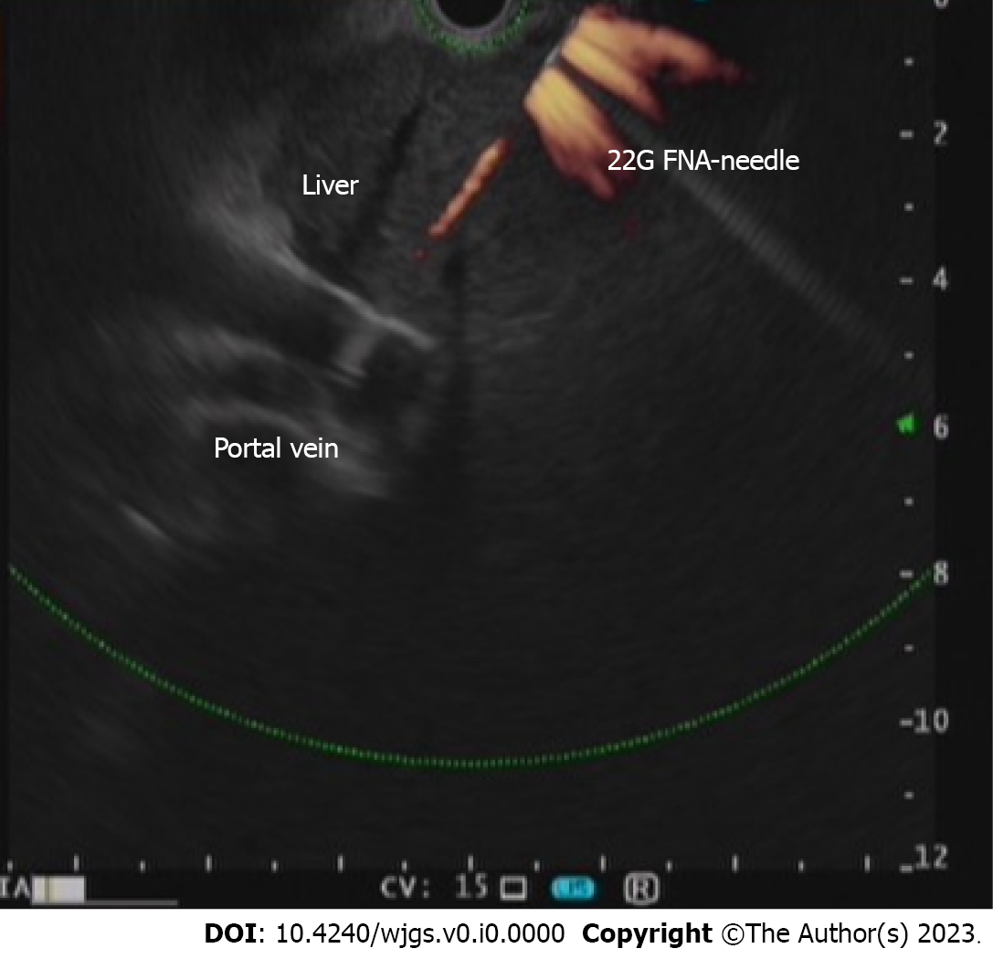
Figure 1 Endoscopic ultrasonography-guided intraportal fine needle injection of autologous bone marrow.

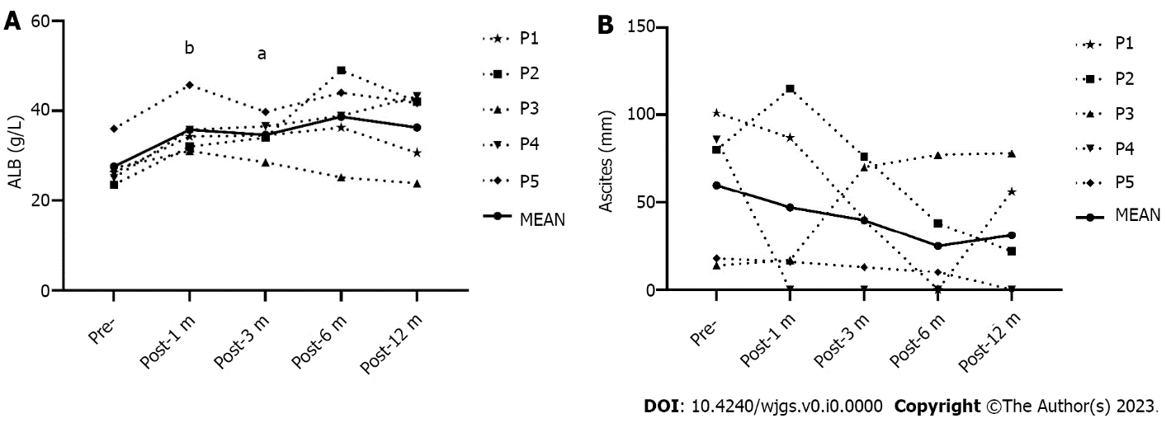
Figure 2 Changes in serum albumin and ascites in patients who underwent endoscopic ultrasonography-guided autologous bone marrow infusion. A: Serum albumin; B: Depth of ascites evaluated by abdominal ultrasound. ALB: Albumin. ªP < 0.05, ^{b}P < 0.01.

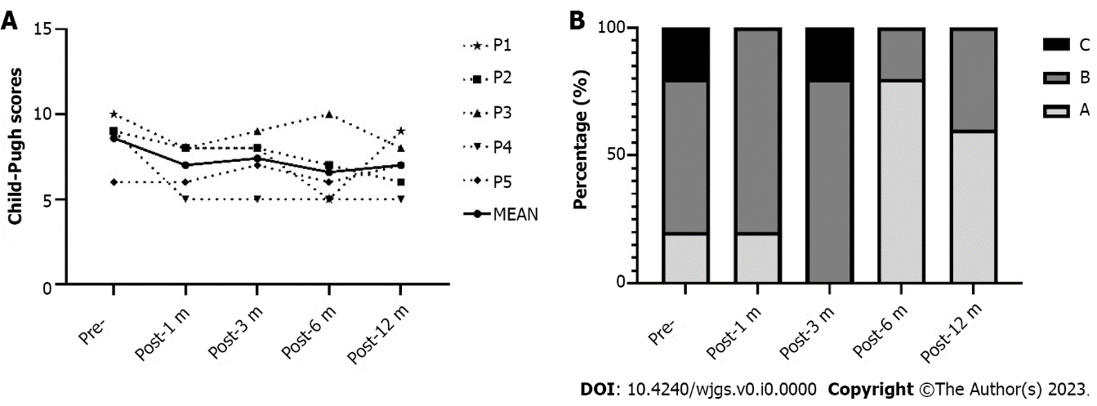
Figure 3 Changes in Child-Pugh score and class in patients who underwent endoscopic ultrasonography-guided autologous bone marrow infusion. A: Child-Pugh scores; B: Classes.

Table 1 Baseline characteristics of patients
Item | P1 | P2 | P3 | P4 | P5
Age (yr) | 30 | 71 | 136 | 57 | 54
HGB (g/L) | 63.00 | 107.00 | 3.91 | 81.00 | 115.00
RBC (× 10¹²/L) | 2.15 | 3.05 | 28.00 | 2.74 | 4.22
PLT (× 10⁹/L) | 61 | 92 | 2.18 | 78 | 115
WBC (× 10⁹/L) | 2.80 | 3.34 | 41.00 | 2.81 | 2.07
ALT (U/L) | 26 | 46 | 52 | 29 | 27
AST (U/L) | 43 | 82 | 38 | 52 | 36
TBIL (µmol/L) | 28.3 | 18.3 | 27.2 | 10.9 | 14.9
ALB (g/L) | 26.2 | 23.5 | 16.0 | 25.0 | 36.0
PT (s) | 18.0 | 13.3 | 40.3 | 16.0 | 16.8
APTT (s) | 48.6 | 37.7 | 23.4 | 40.5 | 31.7
TT (s) | 20.00 | 19.50 | 0.99 | 20.60 | 17.90
FIB (g/L) | 1.48 | 1.60 | 405.76 | 1.64 | 1.95
HA (ng/mL) | 124.35 | 674.70 | 204.40 | 297.91 | 123.04
LN (ng/mL) | 41.15 | 33.83 | 67.56 | 73.10 | 25.86
IV-C (ng/mL) | 77.16 | 122.50 | 81.95 | 57.27 | 25.47
PCIII (ng/mL) | 74.20 | 125.50 | 14.00 | 58.48 | 28.56
Ascites (mm) | 101 | 80 | 11 | 86 | 18
PV (mm) | 11.0 | 10.0 | 24.8 | 10.0 | 16.0
LS (KPA) | 37.9 | 29.8 | 283.0 | 18.0 | 20.2
FAP (db/m) | 235 | 220 | None | 246 | 243
PVT | None | None | None | None | None
Neoplastic lesions | None | None | 9 | None | None
Child-Pugh score | 10 | 9 | 136 | 9 | 6
IV-C: Collagen IV; ALB: Albumin; ALT: Alanine aminotransferase; APTT: Activated partial thromboplastin time; AST: Aspartate aminotransferase; FAP: Fat attenuation parameters; FIB: Fibrinogen; HA: Hyaluronic acid; HGB: Hemoglobin; LN: Laminin; LS: Liver stiffness; PC III: Procollagen III; PLT: Platelets; PT: Prothrombin time; PV: Portal vein; PVT: Portal vein thrombosis; RBC: Red blood cells; TBIL: Total bilirubin; TT: Thrombin time; WBC: White blood cells.

