Name of Journal: World Journal of Clinical Cases
Manuscript NO: 88389
Manuscript Type: META-ANALYSIS

Systematic review and network meta-analysis of different non-steroidal anti-inflammatory drugs for juvenile idiopathic arthritis

Zeng T et al. Different NSAIDs for JIA

Tao Zeng, Jian-Zhong Ye, Hui Qin, Qian-Qian Xu

Tao Zeng, Jian-Zhong Ye, Hui Qin, Qian-Qian Xu, College of Medicine, Jingchu University of Technology Jingmen, Jingmen 448000, Hubei Province, China

Author contributions: Zeng T and Ye JZ conceived and designed the study; Qin H searched and selected relevant studies; Xu QQ and Zeng T extracted and interpreted data; and all authors critically reviewed and approved the final manuscript.

Supported by the Science and Technology Plan Project of Jingmen Science and Technology Bureau, No. 2018YFZD025.

Corresponding author: Qian-Qian Xu, MD, Senior Statistician, College of Medicine, Jingchu University of Technology Jingmen, No. 33 Xiangshan Road, Jingmen 448000, Hubei Province, China. yanfenjiu19940211@163.com

Received: September 22, 2023
Revised: January 23, 2024
Accepted: March 1, 2024
Published online:

Abstract
BACKGROUND
Various non-steroidal anti-inflammatory drugs (NSAIDs) have been used for juvenile idiopathic arthritis (JIA). However, the optimal method for JIA has not yet been developed.

AIM
To perform a systematic review and network meta-analysis to determine the optimal instructions.

METHODS
We searched for randomized controlled trials (RCTs) from PubMed, Embase, Google Scholar, CNKI, and Wanfang without restriction for publication date or language at August, 2023. Any RCTs that comparing the effectiveness of NSAIDs with each other or placebo for JIA were included in this network meta-analysis. The surface under the cumulative ranking curve (SUCRA) analysis was used to rank the treatments. P value less than 0.05 was identified as statistically significant.

RESULTS
We included 8 RCTs (1127 patients) comparing 8 different instructions including meloxicam (0.125 qd and 0.250 qd), Celecoxib (3 mg/kg bid and 6 mg/kg bid), piroxicam, Naproxen (5.0 mg/kg/d, 7.5 mg/kg/d and 12.5 mg/kg/d), inuprofen (30-40 mg/kg/d), Aspirin (60-80 mg/kg/d, 75 mg/kg/d, and 55 mg/kg/d), Tolmetin (15 mg/kg/d), Rofecoxib, and placebo. There were no significant differences between any two NSAIDs regarding ACR Pedi 30 response. The SUCRA shows that celecoxib (6 mg/kg bid) ranked first (SUCRA, 88.9%), rofecoxib ranked second (SUCRA, 68.1%), Celecoxib (3 mg/kg bid) ranked third (SUCRA, 51.0%). There were no significant differences between any two NSAIDs regarding adverse events. The SUCRA shows that placebo ranked first (SUCRA, 88.2%), piroxicam ranked second (SUCRA, 60.5%), rofecoxib (0.6 mg/kg qd) ranked third (SUCRA, 56.1%), meloxicam (0.125 mg/kg qd) ranked fourth (SUCRA, 56.1%), and rofecoxib (0.3 mg/kg qd) ranked fifth (SUCRA, 56.1%).

CONCLUSION
In summary, celecoxib (6 mg/kg bid) was found to be the most effective NSAID for treating JIA. Rofecoxib, piroxicam, and meloxicam may be safer options, but further research is needed to confirm these findings in larger trials with higher quality studies.

Key Words: Non-steroidal anti-inflammatory drugs; Juvenile idiopathic arthritis; Network meta-analysis; Systematic review

Zeng T, Ye JZ, Qin H, Xu QQ. Systematic review and network meta-analysis of different non-steroidal anti-inflammatory drugs for juvenile idiopathic arthritis. World J Clin Cases 2024; In press

Core Tip: In summary, celecoxib (6 mg/kg bid) was found to be the most effective non-steroidal anti-inflammatory drug for treating juvenile idiopathic arthritis. Rofecoxib, piroxicam, and meloxicam may be safer options, but further research is needed to confirm these findings in larger trials with higher quality studies.

INTRODUCTION
Juvenile idiopathic arthritis (JIA) refers to several types of chronic arthritis that appear before the age of 16^{[1-3]}. JIA affects 294000 children in the United States, which characterized by chronic arthritis^{[4,5]}. The pathogenesis of JIA was unknown. Clinical manifestations of JIA is joint pain, swelling, and morning stiffness^{[6,7]}. Symptoms of JIA often persist into adulthood and are one of the leading causes of joint dysfunction in children^{[8]}. At present, JIA is difficult to cure in the short term. The goal of treatment for JIA is to achieve sustained remission or low disease activity^{[9]}.
There are two forms of COX in the human body currently: COX-1 and COX-2^{[10,11]}. Normally, COX-2 expression is low, but in inflammatory conditions, it is dramatically increased and thus causing a high level of inflammation^{[12]}. Non-steroidal anti-inflammatory drugs (NSAIDs) work by blocking COX enzyme synthesis, which in turn inhibits prostaglandin synthesis^{[13,14]}. Thus, NSAIDs have definite pain-relieving and anti-inflammatory properties. Moreover, NSAIDs is well tolerated by children and has fewer side effects. Therefore, NSAIDs are recommended drugs for symptom relief in JIA.
NSAIDs, which include traditional non-selective NSAIDS and selective NSAIDs. There are no direct comparisons of NSAIDs in current research, so it’s important to evaluate their effectiveness and safety from the perspectives of healthcare providers and payers. Currently, there is a lack of systematic review and meta-analysis that comparing different NSAIDs for JIA. Network meta-analysis enables comparisons between drugs that have not been directly compared in head-to-head trials, using a common comparator like placebo^{[15,16]}. We will use network meta-analysis to determine the best treatment for JIA and guide clinical decision-making. Our goal is to compare NSAIDs for JIA treatment through network meta-analysis.

MATERIALS AND METHODS
Search strategy
Two authors independently searched the electronic literature database of PubMed, Embase, Google Scholar, CNKI and Wanfang without restriction for publication date or language at August, 2023. The key words for searching can be seen in Supplement material. Articles and references were searched to prevent overlooking important sources. Previous systematic reviews, meta-analyses, and randomized controlled trials were also reviewed. Any disagreements between authors were resolved with a third independent author. Only studies involving humans were included in the search. As this study is a network meta-analysis, ethical approval was not necessary.

Inclusion criteria
The inclusion criteria were as follows: (1) Patients were diagnosed with JIA; (2) studies comparing NSAIDs therapies [meloxicam (0.125 qd and 0.250 qd), Celecoxib (3 mg/kg bid and 6 mg/kg bid)], piroxicam, Naproxen (5.0 mg/kg/d, 7.5 mg/kg/d, and 12.5 mg/kg/d), Inuprofen (30-40 mg/kg/d), Aspirin (60-80 mg/kg/d, 75 mg/kg/d, and 55 mg/kg/d), Tolmetin (15 mg/kg/d), Rofecoxib (0.3 mg/kg qd, 0.6 mg/kg), or with placebo; (3) randomized controlled trials (RCTs); and (4) studies reporting ACR Pedi 30 response and adverse events in patients.
The following studies were excluded: (1) Abstract only (insufficient data); (2) repeatedly published studies; (3) repeated studies; (4) not RCT; and (5) secondary research papers (e.g., reviews, meta-analyses).

Data extraction
Two investigators independently extracted data from included trials using a standardized form, including author, publication year, country, participant characteristics, sample size, follow-up duration, and drugs. Clinical outcomes containing ACR Pedi 30 response and adverse events. In case of inconsistencies, extensive discussions were used for resolution.

Quality assessment and publication bias assessment
Two assessors evaluated the quality of individual trials based on the Cochrane Handbook, looking at factors like randomization, blinding, and reporting bias. Trials were categorized as “low risk”, “high risk”, or “unclear”.

Statistical analysis
A network meta-analysis was performed to compare various treatments utilizing a random-effect model within a Bayesian framework. The analysis was carried out using the “gemtc” and “rjags” packages in R software version 3.5.1. Convergence was ensured through the implementation of a Markov chain Monte Carlo Bayesian approach with four chains, each consisting of 20000 iterations. Each chain generated 150000 sample iterations, with 10 thinning intervals and 100000 burn-ins. Estimates were based on median values from posterior distributions, with statistically significant differences indicated by 95% confidence intervals excluding 1 for odds ratios and 0 for mean differences. A significance level of P < 0.05 was used. Surface under the cumulative ranking curve (SUCRA) values were used in the network meta-analysis to rank interventions, with higher values indicating greater efficacy. A cluster-ranking plot was used to find the best outcome indicator. Heterogeneity was assessed with the I² test, while inconsistency within models was measured with the deviance information criterion. Node-splitting analysis and funnel plots were used to check for local inconsistencies and publication bias respectively.

RESULTS
Included studies and risks of bias assessment
The search retrieved a total of 755 articles which were identified from PubMed (322), Embase (189), Google Scholar (215), CNKI (20), and Wanfang (9). Of these, 123 were removed as duplicates. Based on our review of the title and abstract, 632 full-text papers were reviewed and 618 were excluded. Then, full-text articles were assessed for eligibility and 6 studies were excluded for reasons. Finally, a total of 8 studies^{[17-24]} met the inclusion criteria and included for analysis (Figure 1).
Table 1 displayed the basic characteristics of the included studies. The total sample included 467 patients whose mean or median baseline age of participants ranged from 7.7 to 11.4 years and all of them were published after 1977. Subtype of JIA including polyarticular JIA, oligoarticular JIA and systemic JIA. NSAIDs including meloxicam (0.125 qd and 0.250 qd), Celecoxib (3 mg/kg bid and 6 mg/kg bid), piroxicam, Naproxen (5.0 mg/kg/d, 7.5 mg/kg/d, and 12.5 mg/kg/d), Inuprofen (30-40 mg/kg/d), Aspirin (60-80 mg/kg/d, 75 mg/kg/d, and 55 mg/kg/d), Tolmetin (15 mg/kg/d), Rofecoxib (0.3 mg/kg qd, 0.6 mg/kg), and placebo. Most trials included in the meta-analysis had unclear risk of bias, with 3 studies having adequate random sequence generation and 5 studies reporting adequate allocation concealment. Blinding of participants and personnel was adequate in all included studies, with details shown in Figure 2.

ACR Pedi 30 response
Three studies, involving a total of 770 patients, evaluated the clinical efficacy of four treatments (meloxicam, celecoxib, naproxen, and rofecoxib) in relation to the ACR Pedi 30 response. The network structure diagrams in Figure 3A illustrate the direct comparisons between these drugs in terms of their impact on the ACR Pedi 30 response. There were no notable differences in ACR Pedi 30 response between NSAIDs (Figure 3B). Celecoxib (6 mg/kg bid) had the highest ranking in SUCRA at 88.9%, followed by rofecoxib at 68.1% and Celecoxib (3 mg/kg bid) at 51.0% (Figure 3C).

Adverse events
Eight studies with ten treatments (meloxicam, naproxen, piroxicam, placebo, rofecoxib, tolmetin, aspirin, celecoxib, and diclofenac) were analyzed for adverse events (Figure 4A). The network structure diagrams showed direct comparisons between the drugs, revealing no significant differences in adverse events among any two NSAIDs (Figure 4B). The results of the SUCRA indicate that the placebo intervention achieved the highest ranking with a SUCRA value of 88.2%, followed by piroxicam with a SUCRA of 60.5%. Rofecoxib at a dosage of 0.600 mg/kg per day ranked third with a SUCRA of 56.1%, while meloxicam at a dosage of 0.125 mg/kg per day and rofecoxib at a dosage of 0.3 mg/kg per day both achieved a SUCRA of 56.1%, placing them in fourth and fifth positions respectively (Figure 4C).

DISCUSSION
Main findings
The systematic review found no significant differences in efficacy or safety among NSAIDs. Celecoxib and rofecoxib were ranked highest in terms of efficacy, while piroxicam and rofecoxib were deemed safer compared to other NSAIDs.

Compared with other meta-analysis
Two relevant pair-wise meta-analyses on the topic have been published^{[25,26]}. Our meta-analysis aligns with previous studies, but offers unique contributions. It is the first network meta-analysis comparing NSAIDs for JIA and includes a protocol for optimal treatment. Thus, our results from this network meta-analysis could help health-care professionals make clinical decisions. NSAIDs remain essential for relieving joint symptoms in JIA patients, despite the shift towards biologics-targeted therapy.

Study strengths and limitations
This review is the first to systematically analyze and compare NSAIDs in JIA patients, providing a more comprehensive assessment than direct comparisons. At the same time, SUCRA value from network meta-analysis realize the efficacy and safety of each drug global sorting. The study did not find a statistically significant difference in lowering ACR Pedi 30 response between the two drugs. Based on the SUCRA values derived from trials included in our network meta-analysis, celecoxib (6 mg/kg bid) seem to be the most efficacious drug in lowering ACR Pedi 30 response. This was similar to the finding of the previous study, where a no significant difference between NSAIDs for osteoarthritis^{[27]}.
Furthermore, NSAIDs are well tolerated and has a good safety record. The most common adverse reactions are gastrointestinal adverse effects, headache, fever rash and impairment of liver function. The main side effects of NSAIDs were gastrointestinal issues, with no serious adverse events reported. The study found no significant difference in side effects between the drugs. Placebo had the highest ranking in terms of safety, followed by piroxicam and rofecoxib. The rate of adverse event after administration NSAIDs varied from 0.7% to 70.5%^{[28-30]}. Currently, there are fewer reports of changes in kidney function among children using NSAIDs, with the most common being reversible acute renal insufficiency. In the early stages of NSAID usage, other potential renal damages, such as nephrotic syndrome and interstitial nephritis, may also manifest.
Our meta-analysis has limitations, including the lack of randomized controlled trials and a small number of participants, necessitating larger clinical trials. Finally, we were unable to report other outcomes like blood loss, hospital stay relevant to this meta-analysis. The diversity in the study results may be due to differences in study quality, design, and patient characteristics. Incomplete data recording was also noted, which could introduce bias when combining the data. However, our study still offers some valuable insights for clinical use.

CONCLUSION
In summary, celecoxib (6 mg/kg bid) was found to be the most effective NSAID for treating JIA. Rofecoxib, piroxicam, and meloxicam may be safer options, but further research is needed to confirm these findings in larger trials with higher quality studies.

ARTICLE HIGHLIGHTS
Research background
Different non-steroidal anti-inflammatory drugs (NSAIDs) have been used for juvenile idiopathic arthritis (JIA), but the best method has not been determined.

Research motivation
To perform a systematic review and network meta-analysis to identify the most effective NSAID for JIA patients.

Research objectives
To perform a systematic review and network meta-analysis to determine the optimal instructions.

Research methods
We searched for randomized controlled trials (RCTs) from PubMed, Embase, Google Scholar, CNKI, and Wanfang without restriction for publication date or language at August, 2022. Any RCTs that comparing the effectiveness of NSAIDs with each other or placebo for JIA were included in this network meta-analysis. The surface under the cumulative ranking curve (SUCRA) analysis was used to rank the treatments. P value less than 0.05 was identified as statistically significant.

Research results
Eight RCTs (1127 patients) compared different instructions for NSAIDs, including meloxicam, Celecoxib, piroxicam, Naproxen, inuprofen, Aspirin, Tolmetin, Rofecoxib, and placebo. No significant differences were found in ACR Pedi 30 response between any two NSAIDs. Celecoxib (6 mg/kg bid) had the highest SUCRA ranking at 88.9%, followed by rofecoxib at 68.1% and Celecoxib (3 mg/kg bid) at 51.0%. There were no notable differences in adverse events between NSAIDs. Placebo had the highest ranking, followed by piroxicam, rofecoxib (0.600 mg/kg qd), meloxicam (0.125 mg/kg qd), and rofecoxib (0.300 mg/kg qd).

Research conclusions
In summary, celecoxib (6 mg/kg bid) was found to be the most effective NSAID for treating JIA.

Research perspectives
Rofecoxib, piroxicam, and meloxicam may be safer options, but further research is needed to confirm these findings in larger trials with higher quality studies.

REFERENCES
1 Zaripova LN, Midgley A, Christmas SE, Beresford MW, Baildam EM, Oldershaw RA. Juvenile idiopathic arthritis: from aetiopathogenesis to therapeutic approaches. Pediatr Rheumatol Online J 2021; 19: 135 [PMID: 34425842 DOI: 10.1186/s12969-021-00629-8]
2 Prakken B, Albani S, Martini A. Juvenile idiopathic arthritis. Lancet 2011; 377: 2138-2149 [PMID: 21684384 DOI: 10.1016/S0140-6736(11)60244-4]
3 Ravelli A, Martini A. Juvenile idiopathic arthritis. Lancet 2007; 369: 767-778 [PMID: 17336654 DOI: 10.1016/S0140-6736(07)60363-8]
4 Okamoto N, Yokota S, Takei S, Okura Y, Kubota T, Shimizu M, Nozawa T, Iwata N, Umebayashi H, Kinjo N, Kunishima T, Yasumura J, Mori M. Clinical practice guidance for juvenile idiopathic arthritis (JIA) 2018. Mod Rheumatol 2019; 29: 41-59 [PMID: 30126298 DOI: 10.1080/14397595.2018.1514724]
5 Gowdie PJ, Tse SM. Juvenile idiopathic arthritis. Pediatr Clin North Am 2012; 59: 301-327 [PMID: 22560572 DOI: 10.1016/j.pcl.2012.03.014]
6 Boros C, Whitehead B. Juvenile idiopathic arthritis. Aust Fam Physician 2010; 39: 630-636 [PMID: 20877765]
7 Bovid KM, Moore MD. Juvenile Idiopathic Arthritis for the Pediatric Orthopedic Surgeon. Orthop Clin North Am 2019; 50: 471-488 [PMID: 31466663 DOI: 10.1016/j.ocl.2019.06.003]
8 Akioka S. Interleukin-6 in juvenile idiopathic arthritis. Mod Rheumatol 2019; 29: 275-286 [PMID: 30686091 DOI: 10.1080/14397595.2019.1574697]
9 Jacobson JL, Pham JT. Juvenile Idiopathic Arthritis: A Focus on Pharmacologic Management. J Pediatr Health Care 2018; 32: 515-528 [PMID: 30177013 DOI: 10.1016/j.pedhc.2018.02.005]
10 Bindu S, Mazumder S, Bandyopadhyay U. Non-steroidal anti-inflammatory drugs (NSAIDs) and organ damage: A current perspective. Biochem Pharmacol 2020; 180: 114147 [PMID: 32653589 DOI: 10.1016/j.bcp.2020.114147]
11 Rigas B, Huang W, Honkanen R. NSAID-induced corneal melt: Clinical importance, pathogenesis, and risk mitigation. Surv Ophthalmol 2020; 65: 1-11 [PMID: 31306671 DOI: 10.1016/j.survophthal.2019.07.001]
12 Schjerning AM, McGettigan P, Gislason G. Cardiovascular effects and safety of (non-aspirin) NSAIDs. Nat Rev Cardiol 2020; 17: 574-584 [PMID: 32322101 DOI: 10.1038/s41569-020-0366-z]
13 Dodwell ER, Latorre JG, Parisini E, Zwettler E, Chandra D, Mulpuri K, Snyder B. NSAID exposure and risk of nonunion: a meta-analysis of case-control and cohort studies. Calcif Tissue Int 2010; 87: 193-202 [PMID: 20552333 DOI: 10.1007/s00223-010-9379-7]
14 Miller LG, Prichard JG. Current issues in NSAID therapy. Prim Care 1990; 17: 589-601 [PMID: 2236338 DOI: 10.1016/S0095-4543(21)00885-X]
15 Zhao Z, Ma JX, Ma XL. Different Intra-articular Injections as Therapy for Hip Osteoarthritis: A Systematic Review and Network Meta-analysis. Arthroscopy 2020; 36: 1452-1464.e2 [PMID: 31919027 DOI: 10.1016/j.arthro.2019.09.043]
16 Zhao Z, Ma J, Ma X. Comparative efficacy and safety of different hemostatic methods in total hip arthroplasty: a network meta-analysis. J Orthop Surg Res 2019; 14: 3 [PMID: 30609925 DOI: 10.1186/s13018-018-1028-2]
17 Ruperto N, Nikishina I, Pachanov ED, Shachbazian Y, Prieur AM, Mouy R, Joos R, Zulian F, Schwarz R, Artamonova V, Emminger W, Bandeira M, Buoncompagni A, Foeldvari I, Falcini F, Baildam E, Kone-Paut I, Alessio M, Gerloni V, Lenhardt A, Martini A, Hanft G, Sigmund R, Simianer S; Pediatric Rheumatology International Trials Organization. A randomized, double-blind clinical trial of two doses of meloxicam compared with naproxen in children with juvenile idiopathic arthritis: short- and long-term efficacy and safety results. Arthritis Rheum 2005; 52: 563-572 [PMID: 15692986 DOI: 10.1002/art.20860]
18 Foeldvari I, Szer IS, Zemel LS, Lovell DJ, Giannini EH, Robbins JL, West CR, Steidle G, Krishnaswami S, Bloom BJ. A prospective study comparing celecoxib with naproxen in children with juvenile rheumatoid arthritis. J Rheumatol 2009; 36: 174-182 [PMID: 19012356 DOI: 10.3899/jrheum.080073]
19 García-Morteo O, Maldonado-Cocco JA, Cuttica R, Garay SM. Piroxicam in juvenile rheumatoid arthritis. Eur J Rheumatol Inflamm 1987; 8: 49-53 [PMID: 2957205]
20 Giannini EH, Brewer EJ, Miller ML, Gibbas D, Passo MH, Hoyeraal HM, Bernstein B, Person DA, Fink CW, Sawyer LA. Ibuprofen suspension in the treatment of juvenile rheumatoid arthritis. Pediatric Rheumatology Collaborative Study Group. J Pediatr 1990; 117: 645-652 [PMID: 2213396 DOI: 10.1016/s0022-3476(05)80708-5]
21 Haapasaari J, Wuolijoki E, Ylijoki H. Treatment of juvenile rheumatoid arthritis with diclofenac sodium. Scand J Rheumatol 1983; 12: 325-330 [PMID: 6361986 DOI: 10.3109/03009748309099735]
22 Kvien TK, Høyeraal HM, Sandstad B. Naproxen and acetylsalicylic acid in the treatment of pauciarticular and polyarticular juvenile rheumatoid arthritis. Assessment of tolerance and efficacy in a single-centre 24-week double-blind parallel study. Scand J Rheumatol 1984; 13: 342-350 [PMID: 6395321 DOI: 10.3109/03009748409111307]
23 Levinson JE, Baum J, Brewer E Jr, Fink C, Hanson V, Schaller J. Comparison of tolmetin sodium and aspirin in the treatment of juvenile rheumatoid arthritis. J Pediatr 1977; 91: 799-804 [PMID: 333079 DOI: 10.1016/s0022-3476(77)81045-7]
24 Reiff A, Lovell DJ, Adelsberg JV, Kiss MH, Goodman S, Zavaler MF, Chen PY, Bolognese JA, Cavanaugh P Jr, Reicin AS, Giannini EH. Evaluation of the comparative efficacy and tolerability of rofecoxib and naproxen in children and adolescents with juvenile rheumatoid arthritis: a 12-week randomized controlled clinical trial with a 52-week open-label extension. J Rheumatol 2006; 33: 985-995 [PMID: 16583464]
25 Castellsague J, Riera-Guardia N, Calingaert B, Varas-Lorenzo C, Fourrier-Reglat A, Nicotra F, Sturkenboom M, Perez-Gutthann S; Safety of Non-Steroidal Anti-Inflammatory Drugs (SOS) Project. Individual NSAIDs and upper gastrointestinal complications: a systematic review and meta-analysis of observational studies (the SOS project). Drug Saf 2012; 35: 1127-1146 [PMID: 23137151 DOI: 10.2165/11633470-000000000-00000]
26 DeWitt EM, Sherry DD, Cron RQ. Pediatric rheumatology for the adult rheumatologist I: therapy and dosing for pediatric rheumatic disorders. J Clin Rheumatol 2005; 11: 21-33 [PMID: 16357693 DOI: 10.1097/01.rhu.0000152151.12999.76]
27 Song GG, Seo YH, Kim JH, Choi SJ, Ji JD, Lee YH. Relative efficacy and tolerability of etoricoxib, celecoxib, and naproxen in the treatment of osteoarthritis : A Bayesian network meta-analysis of randomized controlled trials based on patient withdrawal. Z Rheumatol 2016; 75: 508-516 [PMID: 26768273 DOI: 10.1007/s00393-015-0023-9]
28 Grosser T, Ricciotti E, FitzGerald GA. The Cardiovascular Pharmacology of Nonsteroidal Anti-Inflammatory Drugs. Trends Pharmacol Sci 2017; 38: 733-748 [PMID: 28651847 DOI: 10.1016/j.tips.2017.05.008]
29 Tielemans MM, Eikendal T, Jansen JB, van Oijen MG. Identification of NSAID users at risk for gastrointestinal complications: a systematic review of current guidelines and consensus agreements. Drug Saf 2010; 33: 443-453 [PMID: 20486727 DOI: 10.2165/11534590-000000000-00000]
30 Harirforoosh S, Asghar W, Jamali F. Adverse effects of nonsteroidal antiinflammatory drugs: an update of gastrointestinal, cardiovascular and renal complications. J Pharm Pharm Sci 2013; 16: 821-847 [PMID: 24393558 DOI: 10.18433/j3vw2f]

Footnotes
Conflict-of-interest statement: The authors declare that they have no conflict of interest to disclose.

PRISMA 2009 Checklist statement: The authors have read the PRISMA 2009 Checklist, and the manuscript was prepared and revised according to the PRISMA 2009 Checklist.

Open-Access: This article is an open-access article that was selected by an in-house editor and fully peer-reviewed by external reviewers. It is distributed in accordance with the Creative Commons Attribution NonCommercial (CC BY-NC 4.0) license, which permits others to distribute, remix, adapt, build upon this work non-commercially, and license their derivative works on different terms, provided the original work is properly cited and the use is non-commercial. See: https://creativecommons.org/Licenses/by-nc/4.0/

Provenance and peer review: Unsolicited article; Externally peer reviewed.
Peer-review model: Single blind

Peer-review started: September 22, 2023
First decision: December 15, 2023
Article in press:

Specialty type: Orthopedics
Country/Territory of origin: China
Peer-review report’s scientific quality classification
Grade A (Excellent): A
Grade B (Very good): 0
Grade C (Good): 0
Grade D (Fair): 0
Grade E (Poor): 0

P-Reviewer: Glumac S, Croatia S-Editor: Chen YL L-Editor: A P-Editor:

Figure Legends
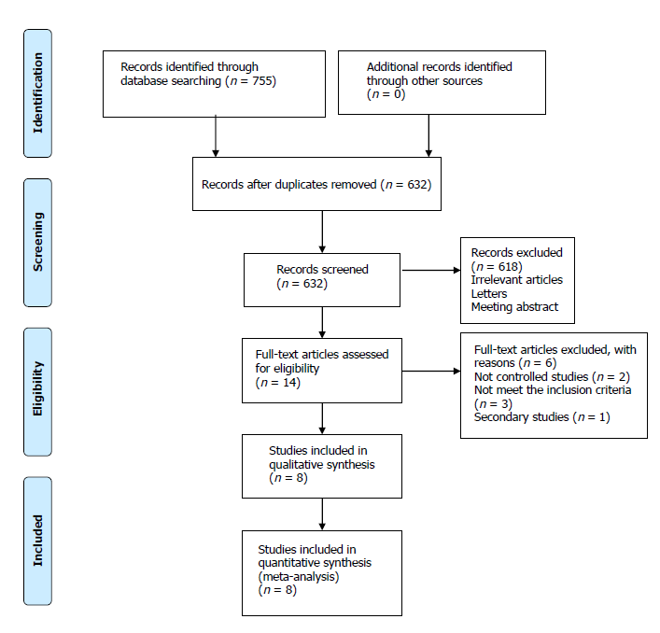
Figure 1 Literature review flow-chart.
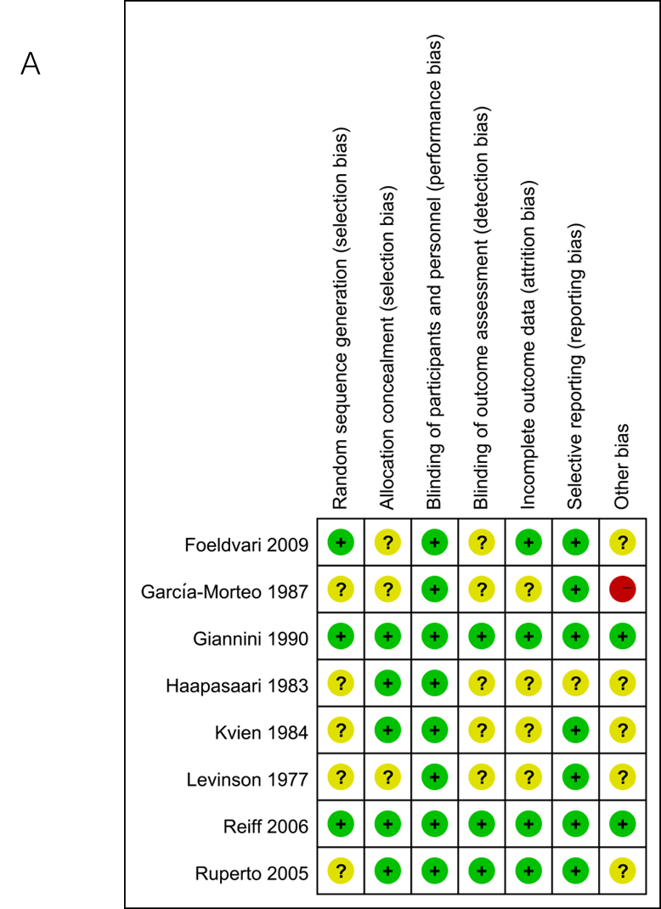
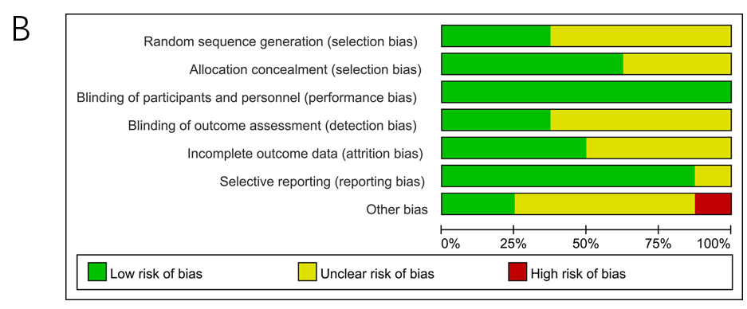
Figure 2 Risk of bias summary and bias graph. A: Risk of bias summary; B: Risk of bias graph.

Figure 3 ACR Pedi 30 response. A: The network of evidence of all the trials for ACR Pedi 30 response; B: Forest plot comparing different treatment with naproxen for need for ACR Pedi 30 response; C: Surface under the cumulative ranking curve values of different treatment for need for ACR Pedi 30 response.

Figure 4 Adverse events. A: The network of evidence of all the trials for adverse events; B: Forest plot comparing different treatment with placebo for need for adverse events; C: Surface under the cumulative ranking curve values of different treatment for need for adverse events.

Table 1 General characteristic of the included studies
Ref. | Sample size |  |  | Mean age |  |  | Subtype | t1 | t2 | t3 | DMARDs (%) | Biologic agents (%) | CS (%) | Treatment duration (wk)
 | t1 | t2 | t3 | t1 | t2 | t3
Ruperto et al^{[17]}, 2005 | 73 | 74 | 78 | 8.9 | 9.0 | 7.5 | pJIA, oJIA | Meloxicam (0.125 qd) | Meloxicam (0.250 qd) | Naproxen (5.000 mg/kg) | 24.7/28.4/37.2 | NS | 19.3/22.0/14.9 | 12
Foeldvari et al^{[18]}, 2009 | 77 | 82 | 83 | 10.4 | 10.2 | 10.4 | pJIA, oJIA | Celecoxib (3.0 mg/kg bid) | Celecoxib (6.0 mg/kg bid) | Naproxen (7.5 mg/kg) | 50.6/47.6/51.8 | 0/3.7/3.6 | NS | 12
García-Morteo et al^{[19]}, 1987 | 12 | 14 |  | 8.5 | 8.5 |  | pJIA, oJIA | Piroxicam | Naproxen (12.5 mg/kg/d) |  | NS | NS | 11.5 | 12
Giannini et al^{[20]}, 1990 | 45 | 47 |  | 7.7 | 7.7 |  | pJIA, oJIA, sJIA | Inuprofen (30-40 mg/kg/d) | Aspirin (60-80 mg/kg/d) |  | 0 | 0 | NS | 12
Haapasaari et al^{[21]}, 1983 | 15 | 15 | 15 | NS | NS | NS | pJIA, oJIA, sJIA | Diclofenac (2-3 mg/kg/d) | Aspirin (50-100 mg/kg/d) | Placebo | NS | NS | NS | 2
Kvien et al^{[22]}, 1984 | 40 | 40 |  | 11.4 | 9.0 |  | pJIA, oJIA | Naproxen (10 mg/kg/d) | Aspirin (75 mg/kg/d) |  | 0 | 0 | 0 | 24
Levinson et al^{[23]}, 1977 | 53 | 54 |  | 9.4 | 9.0 |  | pJIA, oJIA, sJIA | Tolmetin (15 mg/kg/d) | Aspirin (55 mg/kg/d) |  | NS | 0 | 0 | 12
Reiff et al^{[24]}, 2006 | 109 | 100 | 101 | 9.7 | 9.4 | 10.7 | pJIA, oJIA | Rofecoxib (0.3 mg/kg qd) | Rofecoxib (0.6 mg/kg) | Naproxen (7.5 mg/kg/d) | 53.2/51.0/45.5 | NS | 19.3/22.0/14.9 | 12
CS: Corticosteroid; pJIA: Polyarticular juvenile idiopathic arthritis; oJIA: Oligoarticular juvenile idiopathic arthritis; sJIA: Systemic juvenile idiopathic arthritis; DMARDs: Disease-modifying anti-rheumatic drugs.

