Name of Journal: World Journal of Clinical Cases
Manuscript NO: 81204
Manuscript Type: CASE REPORT

Gemcitabine-induced peripheral vascular disease and prolonged response in a patient with metastatic pancreatic adenocarcinoma: A case report

Fabien MB et al.Vascular acrosyndrome with Gemcitabine

Moinard-Butot Fabien, Poprawa Elodie, Schohn Anna, Pietro Addeo, Benabdelghani Meher

Moinard-Butot Fabien, Poprawa Elodie, Benabdelghani Meher, Department of Medical Oncology, Institut de Cancérologie Strasbourg Europe, Strasbourg 67200, France

Schohn Anna, Department of Supportive Care, Institut de cancérologie Strasbourg Europe, Strasbourg 67200, France

Pietro Addeo, Hepato-Pancreato-Biliary Surgery and Liver Transplantation, Hôpitaux Universitaires de Strasbourg, Strasbourg 67200, France

Author contributions: Moinard-Butot F and Benabdelghani M Writing original draft preparation; Moinard-Butot F, Poprawa E and Schohn A performed visualization; Moinard-Butot F, Poprawa E, Schohn A, Addeo P and Benabdelghani M writing review and editing; all authors have read and agreed to the published version of the manuscript.

Corresponding author: Moinard-Butot Fabien, MD, Doctor, Department of Medical Oncology, Institut de Cancérologie Strasbourg Europe, 17 Rue Albert Calmette, Strasbourg 67200, France. f.moinard-butot@icans.eu

Received: October 29, 2022
Revised: January 17, 2023
Accepted: February 2, 2023
Published online:

Abstract
BACKGROUND
Gemcitabine is an antimetabolite used in the treatment of pancreatic cancer. One of the side effects of gemcitabine is vascular toxicity. Here, we report the case of a patient treated with gemcitabine who had peripheral vascular disease concomitant with a prolonged antitumor response.

CASE SUMMARY
A 75-year-old man was diagnosed with locally recurrent pancreatic cancer. Partial response was achieved after 9 mo of gemcitabine. At the same time, the patient reported peripheral vascular disease without necrosis. Chemotherapy was suspended, and after one month the Positron Emission Tomography (PET) scan showed locoregional tumor recurrence. Gemcitabine was resumed and partial response was obtained, but peripheral vascular disease occurred.

CONCLUSION
Our results suggest that the appearance of peripheral vascular disease may be related to a prolonged response to gemcitabine.

Key Words: Gemcitabine; Pancreatic cancer; Peripheral vascular disease; Prolonged tumor response; Case report

Fabien MB, Elodie P, Anna S, Addeo P, Meher B. Gemcitabine-induced peripheral vascular disease and prolonged response in a patient with metastatic pancreatic adenocarcinoma: A case report. World J Clin Cases 2023; In press

Core Tip: Gemcitabine is known for vascular side effect. In this case, we report a vascular acrosyndrome that occurred during first-line with Gemcitabine for pancreatic adenocarcinoma. In this case, the patient experienced prolonged tumor response. Immunological phenomena could be responsible for this double effect.

INTRODUCTION
Gemcitabine is a nucleoside metabolic inhibitor. This antimetabolite drug has displayed significant antitumor activity in pancreatic adenocarcinoma^{[1]}. Gemcitabine causes often myelosuppression, influenza-like syndrome and vascular toxicity^{[2]}. Among toxic vascular effects of gemcitabine, we find venous and arterial events, digital ischemia and necrosis, vascular inflammation, and thrombotic microangiopathy. We report a case of locoregional recurrent pancreatic adenocarcinoma in a patient treated with gemcitabine who experienced severe peripheral vascular disease and prolonged antitumor response.

CASE PRESENTATION
Chief complaints
A 75-year-old man presented with a diagnosis of borderline adenocarcinoma of the pancreatic body in April 2019.

History of present illness
In July 2021, during Gemcitabine, the patient reported the appearance of Raynaud’s phenomenon-like symptoms.

History of past illness
For borderline adenocarcinoma of the pancreatic body, he underwent neoadjuvant chemotherapy by FOLFIRINOX (12 cycles) with stable disease. He underwent pancreaticoduodenectomy in January 2020 (ypT2N2R1). A PET scan showed locoregional recurrence during a follow-up in August 2020 (Figure 1). In accordance with ESMO guidelines, chemotherapy with gemcitabine was initiated. Partial objective response was observed after 9 mo and gemcitabine was continued as maintenance therapy (Figure 1).

Personal and family history
A 75-year-old man had a history of smoking (15 pack-year), and stopped in 1976. He was treated with verapamil for hypertension and with tinzaparine for a deep vein thrombosis of the lower left extremity since 2019.

Physical examination
The symptoms consisting of loss of sensitivity and cold-induced cyanosis of the left middle finger matching with a typical syncopal phase of the Raynaud’s phenomenon. Other arguments in favor of this phenomenon were sparing of the thumb and absence of digital pulp ulceration. Allen's test showed pathological results at the radial and ulnar levels. There were no megacapillaries or flame hemorrhage, cupuliform ulceration, or rectangular telangiectasia. There was no toe involvement.

Laboratory examinations
Laboratory analyses showed normal hemogram, electrolytes, creatinine, liver function, and hemostasis. C3- and C4-complement, cryoglobulin, ANCA and CPK did not show any abnormality. Anti-extractable nuclear antigen antibodies and antinuclear antibody (ANA) were negative. The specific absence of anti-Scl70 or anti-centromere antibodies was noted. Other antiphospholipid antibodies were not detected either.

Imaging examinations
An arterial and venous Doppler ultrasound found no abnormality.

FINAL DIAGNOSIS
At the patient’s request, chemotherapy was suspended for 4 wk after the onset of symptoms. Paraneoplastic syndrome was initially suspected. PET scan in August 2021 showed locoregional tumor recurrence coincident with an elevation of CA 19-9 blood level at 893 ng/mL. Weekly gemcitabine chemotherapy was consequently resumed, and partial response was obtained after 3 mo of chemotherapy. CA 19-9 blood levels gradually decreased to 380 ng/mL. Gemcitabine was eventually interrupted in December 2021 after 13 cycles because of resurgence of the vascular acrosyndrome (permanent cyanosis and pain) then affecting the distal phalanx of both left and right 2nd and 3rd fingers (Figure 2) and causing great repercussions on daily activities. Symptoms showed little to no improvement after 2 mo with the appearance of ulceration of the 3rd digits (Figure 3). A Doppler echocardiography showed no macrovascular abnormalities but capillary microscopy revealed impaired microcirculation.

TREATMENT
The patient was then referred to the cardiovascular department where a treatment with iloprost (prostacyclin analog) was introduced for a duration of 28 days.

OUTCOME AND FOLLOW-UP
We noticed clinical improvement after 1 mo of treatment, and the disappearance of the ulceration (Figure 3). Gemcitabine was not resumed and disease progression was observed on the March 2022 CT scan. The patient died in June 2022.

DISCUSSION
In the present study, we report a case of metastatic pancreatic adenocarcinoma in a patient presenting with peripheral vascular disease that occurred during first-line chemotherapy. The vascular symptoms improved after discontinuation of gemcitabine. In this case, the patient experienced prolonged tumor response. The median survival time was 5.6 mo in historical studies using gemcitabine. Here, the patient showed no sign of progressive disease 17 mo after treatment initiation. Cases of Raynaud’s phenomenon and digital necrosis after receiving gemcitabine for bladder cancer and lung cancer have been reported^{[3–6]}. Three cases of Raynaud’s phenomenon and/or digital ischemia have also been described in patients with pancreatic cancer^{[6–8]}. Peripheral vascular disease is a rare and painful condition that impairs the patient quality of life. The most frequent etiologies are connective diseases, vasculopathies, hematological diseases, paraneoplastic syndromes, drugs, infectious diseases, and embolic diseases. They can all be complicated by secondary vasospasm^{[9]}. In this case, we discuss the multifactorial mechanisms underlying peripheral vascular disease, aggravated by the administration of antimetabolites, and the relationship to the associated better outcomes.
Antimetabolites can have cumulative toxicity leading to endothelial dysfunction and hypercoagulability. Several chemotherapies can induce endothelial lesions or cause thromboembolic events^{[10–15]}.
Many vascular side effects have been reported in the literature as related to gemcitabine treatment. We note venous and arterial events, vasculitis with necrosis, thrombotic microangiopathy, severe capillary leak syndrome, and digital necrosis^{[5,6,16,17]}. Here, chemotherapy was stopped, resulting in the improvement of symptoms despite cancer progression. The occurrence of peripheral vascular disease in patients with cancer can also be considered a paraneoplastic disorder, natably in the case of adenocarcinoma, squamous cell carcinoma or hematological diseases^{[18]}. Several mechanisms have been proposed to explain peripheral vascular disease associated with cancer. It is suggested hypothesis a peripheral vasospasm or larger production of vasoconstrictor substances by tumor cells following neoplastic involvement of the cervical sympathetic trunk^{[19]}. A thromboembolic mechanism with either migration of tumor fragments or hyperviscosity, hypercoagulability and spontaneous platelet aggregation has also been suggested^{[20]}. In many case-report of patients with paraneoplastic peripheral vascular disease, vasospastic complications improve after initiation of suitable anticancer treatment^{[21]}. For our patient, this etiology was unlikely to be the cause of the patient's digital manifestations, as he had an radiologic response at the time of symptoms worsening.
The hypothesis immunological’s mechanism has also been suggested. In fact, cancer diseases can promote autoimmunity by generating autoantibodies against different autoantigens, leading to the activation of the complement upon contact with the arterial wall^{[22]}.
The association between toxicity and treatment efficacy has long been a concern in cancer patients. Better outcomes associated with immune-related adverse events is well described in cancer patients treated with immunotherapy. For example, vitiligo is significantly correlated with a better outcome to ICI in melanoma^{[23]}.
The restoration of antitumor immunity during treatment with immunotherapy leads to multiples manifestations, including vasculitis of the medium and large vessels but rarely of the small vessels^{[24]}. Several recent studies have described the development of acral vascular necrosis with immunotherapy, without history of autoimmune disease^{[25,26]}. The mechanism of action of immunotherapy could lead to a disturbance of immune tolerance with stimulation of T population of lymphocytes or to the formation of autoantibodies against many antigens such as endothelial cells and be at the origin of the disorder’s vascularization. Additionally, an autoimmune etiology of digital ischemic symptoms during treatment of immunotherapy is supported, as a steroids treatment might improve acral necrosis^{[27,28]}.
One study postulated that antimetabolites induced both vascular and immunological adverse effects and prolonged response as shown with ICI^{[29]}. Gemcitabine has the capacity to activate the immune system and create an inflammatory tumor microenvironment^{[30,31]}. In particular, it depletes regulatory T lymphocytes and selectively kills immunosuppresive cells, thereby alleviating immunosuppression and enhancing cytotoxic T-cell-dependent anti-cancer immune responses^{[32]}.

CONCLUSION
Peripheral vascular disease is a rare complication of antimetabolite chemotherapeutic drugs. This is the second study to report the case of peripheral vascular disease and prolonged response with gemcitabine. Immunological phenomena could be responsible for this double effect.

ACKNOWLEDGEMENTS
The authors gratefully thank Lisa Schohn for her contribution to the proofreading of the English version.
REFERENCES
1 Burris HA 3rd, Moore MJ, Andersen J, Green MR, Rothenberg ML, Modiano MR, Cripps MC, Portenoy RK, Storniolo AM, Tarassoff P, Nelson R, Dorr FA, Stephens CD, Von Hoff DD. Improvements in survival and clinical benefit with gemcitabine as first-line therapy for patients with advanced pancreas cancer: a randomized trial. J Clin Oncol 1997; 15: 2403-2413 [PMID: 9196156 DOI: 10.1200/JCO.1997.15.6.2403]
2 Aapro MS, Martin C, Hatty S. Gemcitabine--a safety review. Anticancer Drugs 1998; 9: 191-201 [PMID: 9625429 DOI: 10.1097/00001813-199803000-00001]
3 D'Alessandro V, Errico M, Varriale A, Greco A, De Cata A, Carnevale V, Grilli M, De Luca P, Brucoli I, Susi M, Camagna A. [Case report: Acro-necrosis of the upper limbs caused by gemcitabine therapy]. Clin Ter 2003; 154: 207-210 [PMID: 12910811]
4 Yamada Y, Suzuki K, Nobata H, Kawai H, Wakamatsu R, Miura N, Banno S, Imai H. Gemcitabine-induced hemolytic uremic syndrome mimicking scleroderma renal crisis presenting with Raynaud's phenomenon, positive antinuclear antibodies and hypertensive emergency. Intern Med 2014; 53: 445-448 [PMID: 24583433 DOI: 10.2169/internalmedicine.53.1160]
5 Blaise S, Appeltants H, Carpentier PH, Debru JL. [Digital ischaemia and gemcitabine. Two new cases]. J Mal Vasc 2005; 30: 53-57 [PMID: 15924070 DOI: 10.1016/s0398-0499(05)83795-3]
6 Kuhar CG, Mesti T, Zakotnik B. Digital ischemic events related to gemcitabine: Report of two cases and a systematic review. Radiol Oncol 2010; 44: 257-261 [PMID: 22933925 DOI: 10.2478/v10019-010-0020-1]
7 Zaima C, Kanai M, Ishikawa S, Kawaguchi Y, Masui T, Mori Y, Nishimura T, Matsumoto S, Yanagihara K, Chiba T, Mimori T. A case of progressive digital ischemia after early withdrawal of gemcitabine and S-1 in a patient with systemic sclerosis. Jpn J Clin Oncol 2011; 41: 803-806 [PMID: 21478179 DOI: 10.1093/jjco/hyr045]
8 Vénat-Bouvet L, Ly K, Szelag JC, Martin J, Labourey JL, Genet D, Tubiana-Mathieu N. Thrombotic microangiopathy and digital necrosis: two unrecognized toxicities of gemcitabine. Anticancer Drugs 2003; 14: 829-832 [PMID: 14597878 DOI: 10.1097/00001813-200311000-00009]
9 McMahan ZH, Wigley FM. Raynaud's phenomenon and digital ischemia: a practical approach to risk stratification, diagnosis and management. Int J Clin Rheumtol 2010; 5: 355-370 [PMID: 26523153 DOI: 10.2217/ijr.10.17]
10 Doll DC, List AF, Greco FA, Hainsworth JD, Hande KR, Johnson DH. Acute vascular ischemic events after cisplatin-based combination chemotherapy for germ-cell tumors of the testis. Ann Intern Med 1986; 105: 48-51 [PMID: 2424354 DOI: 10.7326/0003-4819-105-1-48]
11 Robben NC, Pippas AW, Moore JO. The syndrome of 5-fluorouracil cardiotoxicity. An elusive cardiopathy. Cancer 1993; 71: 493-509 [PMID: 8422644 DOI: 10.1002/1097-0142(19930115)71:2<493::aid-cncr2820710235>3.0.co;2-c]
12 Mosseri M, Fingert HJ, Varticovski L, Chokshi S, Isner JM. In vitro evidence that myocardial ischemia resulting from 5-fluorouracil chemotherapy is due to protein kinase C-mediated vasoconstriction of vascular smooth muscle. Cancer Res 1993; 53: 3028-3033 [PMID: 8391384]
13 Tonato M, Mosconi AM, Martin C. Safety profile of gemcitabine. Anticancer Drugs 1995; 6 Suppl 6: 27-32 [PMID: 8718422 DOI: 10.1097/00001813-199512006-00005]
14 Tempero MA, Brand R. Fatal pulmonary toxicity resulting from treatment with gemcitabine. Cancer 1998; 82: 1800-1801 [PMID: 9576306 DOI: 10.1002/(sici)1097-0142(19980501)82:9<1802::aid-cncr33>3.0.co;2-6]
15 Dobbie M, Hofer S, Oberholzer M, Herrmann R. Veno-occlusive disease of the liver induced by gemcitabine. Ann Oncol 1998; 9: 681 [PMID: 9681086 DOI: 10.1023/a:1008225930573]
16 Viguier JB, Solanilla A, Boulon C, Constans J, Conri C. [Digital ischemia in two patients treated with gemcitabine]. J Mal Vasc 2010; 35: 185-188 [PMID: 20116189 DOI: 10.1016/j.jmv.2009.12.032]
17 Holstein A, Bätge R, Egberts EH. Gemcitabine induced digital ischaemia and necrosis. Eur J Cancer Care (Engl) 2010; 19: 408-409 [PMID: 19490003 DOI: 10.1111/j.1365-2354.2008.01057.x]
18 Racanelli V, Prete M, Minoia C, Favoino E, Perosa F. Rheumatic disorders as paraneoplastic syndromes. Autoimmun Rev 2008; 7: 352-358 [PMID: 18486921 DOI: 10.1016/j.autrev.2008.02.001]
19 Poszepczynska-Guigné E, Viguier M, Chosidow O, Orcel B, Emmerich J, Dubertret L. Paraneoplastic acral vascular syndrome: epidemiologic features, clinical manifestations, and disease sequelae. J Am Acad Dermatol 2002; 47: 47-52 [PMID: 12077580 DOI: 10.1067/mjd.2002.120474]
20 Le Besnerais M, Miranda S, Cailleux N, Girszyn N, Marie I, Lévesque H, Benhamou Y. Digital ischemia associated with cancer: results from a cohort study. Medicine (Baltimore) 2014; 93: e47 [PMID: 25170929 DOI: 10.1097/MD.0000000000000047]
21 Naschitz JE, Rosner I, Rozenbaum M, Zuckerman E, Yeshurun D. Rheumatic syndromes: clues to occult neoplasia. Semin Arthritis Rheum 1999; 29: 43-55 [PMID: 10468414 DOI: 10.1016/s0049-0172(99)80037-7]
22 Abu-Shakra M, Buskila D, Ehrenfeld M, Conrad K, Shoenfeld Y. Cancer and autoimmunity: autoimmune and rheumatic features in patients with malignancies. Ann Rheum Dis 2001; 60: 433-441 [PMID: 11302861 DOI: 10.1136/ard.60.5.433]
23 Ouwerkerk W, van den Berg M, van der Niet S, Limpens J, Luiten RM. Biomarkers, measured during therapy, for response of melanoma patients to immune checkpoint inhibitors: a systematic review. Melanoma Res 2019; 29: 453-464 [PMID: 30855527 DOI: 10.1097/CMR.0000000000000589]
24 Martins F, Sofiya L, Sykiotis GP, Lamine F, Maillard M, Fraga M, Shabafrouz K, Ribi C, Cairoli A, Guex-Crosier Y, Kuntzer T, Michielin O, Peters S, Coukos G, Spertini F, Thompson JA, Obeid M. Adverse effects of immune-checkpoint inhibitors: epidemiology, management and surveillance. Nat Rev Clin Oncol 2019; 16: 563-580 [PMID: 31092901 DOI: 10.1038/s41571-019-0218-0]
25 Gambichler T, Strutzmann S, Tannapfel A, Susok L. Paraneoplastic acral vascular syndrome in a patient with metastatic melanoma under immune checkpoint blockade. BMC Cancer 2017; 17: 327 [PMID: 28499411 DOI: 10.1186/s12885-017-3313-6]
26 Khaddour K, Singh V, Shayuk M. Acral vascular necrosis associated with immune-check point inhibitors: case report with literature review. BMC Cancer 2019; 19: 449 [PMID: 31088420 DOI: 10.1186/s12885-019-5661-x]
27 Le Burel S, Champiat S, Routier E, Aspeslagh S, Albiges L, Szwebel TA, Michot JM, Chretien P, Mariette X, Voisin AL, Lambotte O. Onset of connective tissue disease following anti-PD1/PD-L1 cancer immunotherapy. Ann Rheum Dis 2018; 77: 468-470 [PMID: 28242618 DOI: 10.1136/annrheumdis-2016-210820]
28 Comont T, Sibaud V, Mourey L, Cougoul P, Beyne-Rauzy O. Immune checkpoint inhibitor-related acral vasculitis. J Immunother Cancer 2018; 6: 120 [PMID: 30446009 DOI: 10.1186/s40425-018-0443-6]
29 Geier M, Babey H, Monceau-Baroux L, Quéré G, Descourt R, Cornec D, Robinet G. Vascular Acrosyndromes Associated With Prolonged Tumor Response in Advanced Lung Cancer Patients During Treatment With Antimetabolites: A Report of Two Cases. Front Oncol 2021; 11: 644282 [PMID: 33869037 DOI: 10.3389/fonc.2021.644282]
30 Sen T, Della Corte CM, Milutinovic S, Cardnell RJ, Diao L, Ramkumar K, Gay CM, Stewart CA, Fan Y, Shen L, Hansen RJ, Strouse B, Hedrick MP, Hassig CA, Heymach JV, Wang J, Byers LA. Combination Treatment of the Oral CHK1 Inhibitor, SRA737, and Low-Dose Gemcitabine Enhances the Effect of Programmed Death Ligand 1 Blockade by Modulating the Immune Microenvironment in SCLC. J Thorac Oncol 2019; 14: 2152-2163 [PMID: 31470128 DOI: 10.1016/j.jtho.2019.08.009]
31 Parente P, Parcesepe P, Covelli C, Olivieri N, Remo A, Pancione M, Latiano TP, Graziano P, Maiello E, Giordano G. Crosstalk between the Tumor Microenvironment and Immune System in Pancreatic Ductal Adenocarcinoma: Potential Targets for New Therapeutic Approaches. Gastroenterol Res Pract 2018; 2018: 7530619 [PMID: 30662458 DOI: 10.1155/2018/7530619]
32 Zheng H, Zeltsman M, Zauderer MG, Eguchi T, Vaghjiani RG, Adusumilli PS. Chemotherapy-induced immunomodulation in non-small-cell lung cancer: a rationale for combination chemoimmunotherapy. Immunotherapy 2017; 9: 913-927 [PMID: 29338609 DOI: 10.2217/imt-2017-0052]

Footnotes
Informed consent statement: All study participants provided informed written consent prior to study enrollment.

Conflict-of-interest statement: The authors declare no conflict of interest.

CARE Checklist (2016) statement: The authors have read the CARE Checklist (2016), and the manuscript was prepared and revised according to the CARE Checklist (2016).

Open-Access: This article is an open-access article that was selected by an in-house editor and fully peer-reviewed by external reviewers. It is distributed in accordance with the Creative Commons Attribution NonCommercial (CC BY-NC 4.0) license, which permits others to distribute, remix, adapt, build upon this work non-commercially, and license their derivative works on different terms, provided the original work is properly cited and the use is non-commercial. See: https://creativecommons.org/Licenses/by-nc/4.0/

Provenance and peer review: Unsolicited article; Externally peer reviewed.
Peer-review model: Single blind

Peer-review started: October 29, 2022
First decision: January 12, 2023
Article in press:

Specialty type: Oncology
Country/Territory of origin: France
Peer-review report’s scientific quality classification
Grade A (Excellent): 0
Grade B (Very good): B
Grade C (Good): C
Grade D (Fair): 0
Grade E (Poor): 0

P-Reviewer: Ghazanfar A, United Kingdom; Ungureanu BS S-Editor: Ma YJ L-Editor: A P-Editor: Ma YJ
Figure Legends
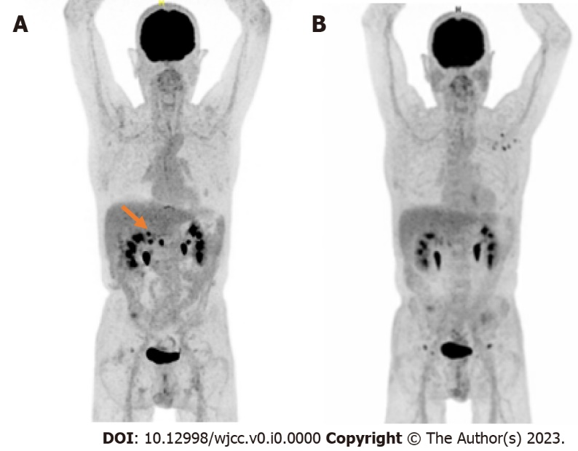
Figure 1 A positron emission tomography scan with fluorodeoxyglucose F 18. A: Locoregional recurrence in August 2020; B: Partial response in May 2021.

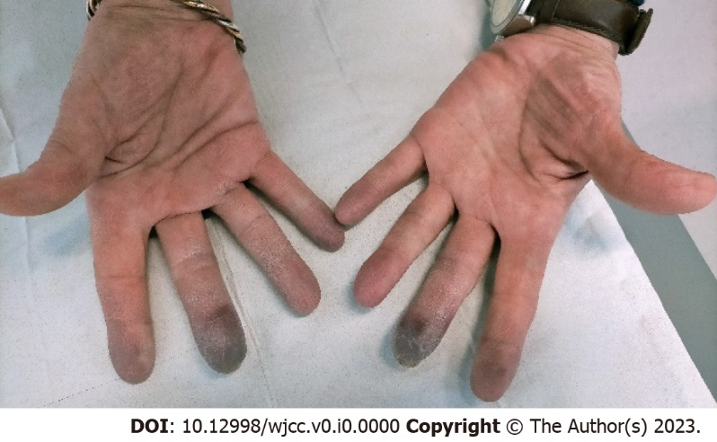
Figure 2 Peripheral vascular disease affecting distal phalanx of both left and right, second and third fingers.

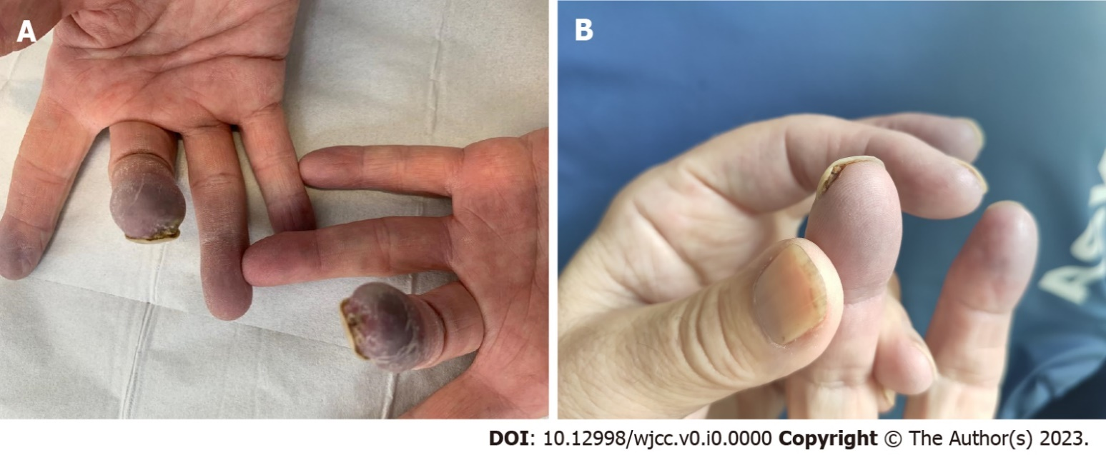
Figure 3 Evolution of ulcerations with treatment. A: Ulceration of the third digits on both hands; B: Clinical improvement after treatment with iloprost.

