Name of Journal: World Journal of Gastrointestinal Oncology
Manuscript NO: 79440
Manuscript Type: ORIGINAL ARTICLE

Basic Study
E3 ubiquitin ligase TRIM55 promotes metastasis of gastric cancer cells by mediating epithelial-mesenchymal transition

Li WW et al. TRIM55 and gastric cancer

Wei-Wei Li, Hao Yuan, Shuai Kong, Shu-Bo Tian

Wei-Wei Li, Department of Pulmonary and Critical Care Medicine, Shandong Provincial Hospital, Cheeloo College of Medicine, Shandong University, Jinan 250021, Shandong Province, China

Wei-Wei Li, Department of Critical Care Medicine, The 960th Hospital of the People's Liberation Army Joint Logistics Support Force, Jinan 250031, Shandong Province, China

Hao Yuan, Shuai Kong, Shu-Bo Tian, Department of Gastrointestinal Surgery, Shandong Provincial Hospital Affiliated to Shandong First Medical University, Jinan 250021, Shandong Province, China

Shuai Kong, Shu-Bo Tian, Department of Gastrointestinal Surgery, Shandong Provincial Hospital, Cheeloo College of Medicine, Shandong University, Jinan 250021, Shandong Province, China

Author contributions: Li WW and Yuan H contributed equally to this work; Tian SB and Li WW designed the study; Li WW and Yuan H performed all experiments; Kong S and Tian SB analyzed the data and drafted the article; All authors read and approved the final manuscript.

Supported by Shandong Province Medicine and Health Science and Technology Development Plan Project, No. 2019WS477.

Corresponding author: Shu-Bo Tian, PhD, Chief Doctor, Surgeon, Department of Gastrointestinal Surgery, Shandong Provincial Hospital Affiliated to Shandong First Medical University, No. 324 Jingwuweiqi Road, Jinan 250021, Shandong Province, China. ttkl_bo@126.com

Received: August 21, 2022
Revised: September 28, 2022
Accepted: October 27, 2022
Published online: November 15, 2022

Abstract
BACKGROUND
Gastric cancer (GC) is considered a major global health problem. The role of TRIM55, a member of the three-domain protein family, in GC is unknown.

AIM
To determine the expression of TRIM55 in GC tissues and its relationship with clinicopathological characteristics, and to investigate the effects of TRIM55 on the malignant biological behavior of GC cells.

METHODS
Differential expression of TRIM55 in GC and para-cancer tissues was detected by immunohistochemistry, and the relationship between TRIM55 level and clinicopathological characteristics and prognosis was analyzed. Gain-of-function, loss-of-function, cell counting kit-8 assay, colony formation, transwell assay, wound healing assay, and western blot analysis were used to assess the potential role of TRIM55 in the development of GC.

RESULTS
TRIM55 expression was significantly increased in GC tissues compared with adjacent normal tissues. High expression of TRIM55 was associated with advanced pathological stage and poor prognosis. Overexpression of TRIM55 promoted invasion and metastasis of GC cells in vitro by regulating epithelial-mesenchymal transition (EMT), whereas knockdown of TRIM55 had the opposite effect. Our data showed that TRIM55 is highly expressed in GC tissues, and is associated with poor prognosis. TRIM55 plays the role of an oncogene in GC, and it promotes metastasis of GC through the regulation of EMT.

CONCLUSION
TRIM55 may be a possible target for the diagnosis and prognosis of GC patients.

Key Words: TRIM55; Gastric cancer; Prognosis; Epithelial-mesenchymal transition

©The Author(s) 2022. Published by Baishideng Publishing Group Inc. All rights reserved.

Citation: Li WW, Yuan H, Kong S, Tian SB. E3 ubiquitin ligase TRIM55 promotes metastasis of gastric cancer cells by mediating epithelial-mesenchymal transition. World J Gastrointest Oncol 2022; 14(11): 2183-2194
URL: https://www.wjgnet.com/1948-5204/full/v14/i11/2183.htm
DOI: https://dx.doi.org/10.4251/wjgo.v14.i11. 2183

Core Tip: TRIM55 expression was elevated in gastric cancer (GC) cancer tissues. Depletion of TRIM55 in GC cells suppressed proliferation, migration and invasion of cells. Knockdown of TRIM55 affected the expression of cell epithelial-mesenchymal transition-related proteins. TRIM55 may serve as an oncogene in GC.

INTRODUCTION
Gastric cancer (GC) is one of the most common tumors and seriously affects patients’ health^{[1]}. Comprehensive treatment based on surgery is the preferred strategy for GC^{[2]}. Postoperative metastasis is the leading cause of death from GC; however, the mechanisms underlying the occurrence and the development of GC have not been fully elucidated, and there is a lack of effective markers for early diagnosis^{[3]}. Therefore, identifying molecular markers of GC is important for the early diagnosis, treatment, and prognostic evaluation of GC. The three-domain protein (TRIM) family is composed of many members, including the tripartite motif, which consists of a RING domain, 1 or 2 Box motifs, and a coiled-coil region^{[4]}. Some TRIM proteins are involved in the regulation of cellular transcription, cell proliferation, and tumor development; thus, they play a role in either promoting or inhibiting cancer^{[5]}. The structural diversity of TRIM family proteins underpins their functional diversity. TRIM55, also known as muscle-specific RING zinc finger protein 2, maintains muscle development and cardiac function. TRIM55 plays an important role in early skeletal muscle differentiation and the generation of muscle fibers^{[6]}. Studies have shown that mir-30-5p can inhibit muscle cell differentiation and regulate the alternative splicing of TRIM55 by targeting Muscleblind-like Protein^{[7]}. TRIM55 can regulate the TNF-α-CCL2 pathway and promote an inflammatory response in the development of mesangial proliferative glomerulonephritis^{[8]}; however, the role of TRIM55 in GC has not been fully elucidated.
In this study, we determined the differential expression of TRIM55 in GC patients and investigated the relationship between TRIM55 and clinicopathological characteristics. We found that TRIM55 induced proliferation, migration, and invasion of GC cells. We also investigated the mechanism underlying these effects.

MATERIALS AND METHODS
Tissue samples
Tissues were obtained from 91 GC patients admitted to the Department of Gastrointestinal Surgery of Shandong Provincial Hospital Affiliated to Shandong First Medical University between July 2014 and December 2015. The tumor tissue samples and adjacent normal gastric mucosal tissue samples were validated by pathologists. Of the 91 patients, 61 were male and 30 were female, with an average age of 63.6 years. Data such as gender and age of the patient, tumor location, tumor pathological stage, and lymph node metastasis, were also collected. In addition, five fresh GC tissue samples and matched adjacent normal gastric tissues were obtained from our hospital. The research protocols were approved by the Ethics Committee of the Provincial Hospital Affiliated to Shandong First Medical University, and all the patients signed an informed consent form before surgery.

Cell culture and transfection
Human GC cell lines (AGS, MKN28, MGC803, SGC7901, HGC27, and MKN45) and the immortalized gastric mucosa cell line (GES-1) were provided by the Cell Center of the Chinese Academy of Medical Sciences. All the cell lines were cultured in RPMI-1640 medium containing 10% fetal bovine serum (FBS, Gibco, United States). Cells were cultured in an incubator at 37 °C and 5% CO₂. According to the CDS coding sequence of TRIM55, small interfering RNAs (siRNA) to knock down TRIM55 were designed and synthesized by RiboBio (Guangzhou, China), and the scramble nonsense sequence was used as the negative control (si-control). The targeting TRIM55 siRNA sequence was as follows: TRIM55 siRNA, 5’-AUCAAACUUCUCACAAAGCUC-3’. The control siRNA was not homologous to any human genome sequence. For the overexpression assay, the coding sequence of TRIM55 was amplified and cloned into a pcDNA3.1-HA vector to construct the TRIM55 overexpression system (TRIM55 plasmid). The pcDNA3.1-HA empty vector was used as the negative control in HGC27 cells.

Immunohistochemical staining
The GC tissue and adjacent tissue were embedded in paraffin and sliced into 4-μm-thick sections. Xylene was used for dewaxing and citrate buffer was used for antigen repair. After washing with PBS 4 times, the samples were sealed with BSA blocking solution at 37 °C. TRIM55 primary antibody (Novus, United States) was added and incubated overnight at 4 °C. According to the instructions of the immunohistochemical test kit, the secondary antibody was added and incubated for 20 min at room temperature. Then, streptavidin-peroxidase conjugate was added and the samples were incubated for 20 min. DAB was used for staining and hematoxylin was used for redyeing and dehydration. The sections were observed and photographed under a microscope and analyzed with Image analysis software. According to the staining intensity, no staining was scored as 0, light yellow was scored as 1, brownish yellow was scored as 2, and brown was scored as 3. According to the percentage of positive cells, the score for no positive cells was 0, 1%–10% was 1, 11%–50% was 2, 51–75% was 3, and 76%–100% was 4. The expression of TRIM55 was considered to be high if the multiple of the two scores was ≥ 5.

Quantitative real-time polymerase chain reaction
Total RNA was extracted using TRIzol reagent (Invitrogen) and reverse transcribed to cDNA using a reverse transcription kit (Takara, Dalian, China) following the manufacturer’s instructions. The quantitative real-time polymerase chain reaction three-step method was used, and the 2^{-ΔΔCt} method was used to calculate the relative expression levels of TRIM55. GAPDH was used as the endogenous control. The upstream primer sequence of TRIM55 was 5 '-GGTTTTGGATAGACATGGGGT-3', and the downstream primer sequence was 5 '-TTCTCCTCTTGGGTTCGGGT-3'.

Cell counting kit-8 assay
Cells were seeded in 96-well plates (2000 cells/well) and placed into an incubator for further culture. Ten microliters of cell counting kit-8 (CCK-8) reagent (Dojindo, Mashikimachi, Japan) was added to each well on days 1, 2, 3, and 4. After 4 h incubation, the absorbance value at 450 nm (OD450) was measured with a microplate reader. The growth curve of cells was drawn according to the OD value. Three independent assays were performed for each time point.

Colony formation assay
Two thousand cells/well were plated in a six-well plate and allowed to grow in complete growth medium for 14 d. The colonies were then fixed with 4% paraformaldehyde for 15 min, followed by staining with 0.1% crystal violet solution for 10 min. The number of colonies was counted, and the average value was calculated from three independent experiments.

Transwell migration and invasion assay
GC cells at the logarithmic growth stage were trypsinized and suspended in serum-free media at a concentration of 1 × 10⁶ cells/mL. Two hundred microliters of the cell suspension was added to the upper transwell chamber. Culture medium containing 10% FBS was added to the lower chamber. For the invasion assay, the transwell membrane was coated with Matrigel. After 48 h incubation, the cells that did not pass through the membrane in the upper chamber were removed with cotton swabs. The migrated/invaded cells were fixed with paraformaldehyde for 30 min and stained with 0.1% crystal violet solution. The cells were observed under a microscope and five random fields were selected to count the number of migrated or invaded cells.

Wound healing assay
GC cells were inoculated into a six-well plate at a density of 5 × 10⁵ cells/well until 90% confluence was reached. Then, a sterile 100-μL pipette tip was used to scrape the bottom surface of the plate to form a wound vertically. The cells were washed with 1× PBS, and complete growth medium was added. The wound margins were observed at 0 and 24 h in 5 randomly selected microscopic regions, and the mean cell spacing was calculated.

Western blot assays
GC cells were collected and lysed in immunoprecipitation lysis buffer. After protein quantification by the BCA method, 30 μg of protein sample was used for electrophoresis. After transfer and blocking, the membrane was incubated overnight at 4 °C with the primary antibody. Horseradish peroxidase-labeled secondary antibody was added and incubated for 1 h. The bands were visualized using chemiluminescence reagent.

Statistical analysis
Statistical analyses were performed using GraphPad Prism software version 7.0 (CA, United States). All the data are represented as mean ± SD from three independent experiments. Differences among groups were compared using student’s t-test and one-way analysis of variance. The prognostic factors were analyzed by univariate and multivariate Cox regression models. The Kaplan-Meier method was used to calculate the survival rate, and the log-rank test was used to compare different survival curves. A value of P < 0.05 was considered to indicate a statistically significant difference.

RESULTS
TRIM55 is highly expressed in GC samples
Immunohistochemical results showed that TRIM55 was mainly expressed in the nucleus. Figure 1A-D shows the representative immunohistochemical staining images of TRIM55 in normal gastric mucosa tissue and cancer tissue. The expression of TRIM55 was significantly high in 91 GC tissues and low in para-cancer tissues (Table 1, P < 0.001). There was no significant correlation between TRIM55 expression and age at diagnosis, gender, tumor location, or Lauren type (P > 0.05, Table 2). However, a significant relationship was found between TRIM55 expression and tumor stage, lymph node metastasis, and T stage (P < 0.05, Table 2).
To further confirm the results, we performed western blotting using five GC specimens and matched normal tissues. The results showed that protein levels of TRIM55 in GC tissues were up-regulated compared to non-tumor tissues (Figure 1E).

Relationship between TRIM55 expression and prognosis of GC
The 5-year survival rate of patients with high TRIM55 expression was lower than that of those with low expression (P = 0.026, Figure 1F). The median overall survival of patients with high and low expression of TRIM55 was 34 mo [95% confidence interval (CI): 13.3–62.8] and 57 mo (95%CI: 25.5–84.5), respectively. Similarly, patients with high TRIM55 gene expression had a poor prognosis in the TCGA database (Figure 1G). Univariate Cox regression analysis showed that T stage, lymph node metastasis, TNM stage, and TRIM55 expression level were the influencing factors for the prognosis of GC patients (Table 3). Further multivariate Cox regression analysis showed that lymph node metastasis, TNM stage, and TRIM55 expression level were independent factors affecting the prognosis of GC (Table 3).

TRIM55 protein is upregulated in GC cell lines
The protein level of TRIM55 was analyzed in the immortalized gastric mucosal epithelial cell line GES-1 and six GC cell lines (AGS, MKN28, MGC803, SGC7901, HGC27, and MKN45). The results showed that the expression level of TRIM55 in GC cell lines was significantly higher than that in GES-1 cells (Figure 2A). Among them, the expression level of TRIM55 was highest in SGC7901 and lowest in the HGC27 cell line.

Transfection efficiency of TRIM55 siRNA and TRIM55 overexpressed plasmid
To analyze the effects of TRIM55 knockdown, SGC7901 (cells with high TRIM55 expression) GC cells were transfected with TRIM55 siRNA. The results showed that both mRNA and protein expressions of TRIM55 were significantly lower in cells transfected with TRIM55 siRNA compared to those in the control group (Figure 2B and C). HGC27 cells with low endogenous TRIM55 expression were transfected with TRIM55 overexpressed plasmid to determine the effects. We found that cells transfected with the overexpressed plasmid had higher mRNA and protein levels of TRIM55 compared to those transfected with the empty vector (Figure 2D and E).

TRIM55 promotes proliferation of GC cells
The CCK-8 assay was used to determine the proliferation of GC cells. The results showed that SGC7901 cell proliferation was significantly inhibited on days 2, 3, and 4 after TRIM55 knockdown (P < 0.001, Figure 3A). However, the proliferation of HGC27 cells was significantly increased on days 2, 3, and 4 (P < 0.001, Figure 3B) when TRIM55 was overexpressed in these cells. These results suggest that TRIM55 can promote the proliferation of GC cells.
The colony formation assay showed that the colony number was significantly reduced after siRNA transfection in SGC7901 cells (Figure 3C). Similarly, overexpression of TRIM55 in HGC27 cells enhanced the ability of cells to form colonies (Figure 3D).

TRIM55 promotes invasion and migration of GC cells
The transwell migration and invasion assay results showed that TRIM55 knockdown significantly reduced the migration and invasion of SGC7901 cells (Figure 4A). Furthermore, the number of migrated and invaded HGC27 cells was significantly increased after TRIM55 overexpression (Figure 4B). The wound-healing assay revealed that knockdown of TRIM55 significantly impaired the migration ability of SGC7901 cells (Figure 5A), while HGC27 migration ability was enhanced after overexpression of TRIM55 (Figure 5B). These results suggest that TRIM55 could promote the invasion and migration of GC cells.

TRIM55 promotes the migration and invasive growth of GC cells by inducing epithelial-mesenchymal transition
To further explore the potential mechanism of how TRIM55 promotes the progression of GC, we analyzed the expression of epithelial-mesenchymal transition (EMT)-related proteins by western blot analysis (Figure 6). The results showed that in the SGC7901 cell line, E-cadherin expression was significantly up-regulated after TRIM55 knockdown, while N-cadherin, Vimentin, ZEB1, and Snail expression were significantly down-regulated compared with the control group (Figure 6A). Furthermore, the opposite results were observed when TRIM55 was overexpressed in the HGC27 cell line (Figure 6B). These results confirmed that TRIM55 promotes the invasion and metastasis of GC cells by inducing EMT.

DISCUSSION
TRIM55 belongs to the TRIM protein family, which plays an important role in the development and progression of tumors. TRIM proteins have three characteristic domains and function as an E3 ligase; they also mediate ubiquitination and regulate intracellular pathophysiological and tumor-related processes by degrading target molecules. TRIM family members exhibit oncogenic and tumor-suppressive capacities in different human cancer types by regulating signal transduction pathways^{[9,10]}. EMT is a transitional process in which epithelial cells lose intercellular adhesion and polarity, and they acquire mesenchymal cell characteristics, enhanced cell motility, and migration ability^{[11,12]}.
The progression of EMT is regulated by translational factors and epigenetic modification^{[13]}. Also, microRNAs and long non-coding RNAs are also involved in EMT regulation as post-translational regulators^{[14]}. The tumor cells or other stromal cells can secret exosomes. Exosomes are extracellular vesicles with a lipid bilayer containing proteins, lipids and functional RNAs, which can transfer information between tumor cells or between tumor cells and the tumor microenvironment, thereby regulating the EMT process^{[15,16]}. As EMT plays essential physiological roles, EMT-targeted therapy combined with conventional chemotherapy can improve the sensitivity of tumor cells to drugs.
TRIM proteins were found to be associated with EMT in various types of cancer. TRIM11 protein was upregulated in GC tissue and cell lines, and it could promote cell proliferation, migration, invasion, and EMT of GC by activating β-catenin signaling^{[17]}. TRIM47 mainly influenced the EMT signaling pathway, was highly expressed in GC, and was associated with poor prognosis of patients^{[18]}. In GC, TRIM44 expression was also increased in GC tissues and cell lines, and it regulated GC cell metastasis by altering the expression of EMT-associated factors^{[19]}.
Previous studies have demonstrated that the role of TRIM55 in tumors is tissue specific. For example, a study revealed that TRIM55 expression was significantly suppressed in lung adenocarcinoma tissues and tumor cells. TRIM55 exerted its tumor-suppressive effect by increasing the degradation of Snail protein via ubiquitination^{[20]}. TRIM55 was downregulated in hepatocellular carcinoma (HCC) tissue and associated with tumor stage and poor prognosis. Overexpression of TRIM55 can suppress the migration and invasion of HCC cells through EMT and the MMP2 pathways^{[21]}.
To the best of our knowledge, our study is the first to determine the expression levels and biological functions of TRIM55 in GC. We demonstrated that TRIM55 could be a potential new biomarker for diagnosing and evaluating GC patients. First, we performed immunohistochemical staining, and the results showed that TRIM55 was highly expressed in GC tissues and that TRIM55 expression was related to the T stage, lymph node metastasis, and TNM stage of GC. Survival analysis showed that the 5-year survival rate of GC patients with high expression of TRIM55 was significantly reduced. Cox regression analysis also confirmed that TRIM55 expression was an independent prognostic factor in GC. These results suggest that TRIM55 may be involved in the occurrence and development of GC. Furthermore, to confirm the biological functions of TRIM55 in GC, we performed a gain and loss of function experiment in vitro. Results from the CCK-8 assay, colony formation assay, transwell, and wound healing assays indicated that inhibition of TRIM55 decreases the proliferation and invasion of GC cells, whereas the overexpression of TRIM55 promotes these processes in GC cells. Finally, we used western blot analysis to confirm that knockdown or overexpression of TRIM55 could alter the EMT-related protein, suggesting that TRIM55 could regulate the EMT process. TRIM proteins could serve the ubiquitination function to stabilize or dislocate target proteins in various cellular compartments^{[4]}. Ubiquitination is a post-transcriptional modification that labels the target proteins to be degraded at the proteasome level. Thus, TRIM family members determine both tumor suppressor and oncogenic roles by affecting the signal pathways in cancer development and progression. For example, TRIM29 and TRIM8 exhibited contextual function in different cancers^{[22-24]}. They negatively or positively regulate tumorigenesis and tumor progression by affecting pathways. In our study, we showed that TRIM55 is highly expressed in gastric tumors and cultured tumor cells. TRIM55 has E3 ubiquitin ligase activity and whether it can regulate the EMT-related proteins through ubiquitination requires further investigation.
However, some limitations exist in our study. First, the detection of TRIM55 was based on a single-center clinical cohort, and the functional experiments were only performed in vitro. Future studies should enroll more patients and utilize animal models to confirm our conclusions. Second, TRIM55 has E3 ubiquitin ligase activity and whether it can regulate the EMT-related proteins through ubiquitination requires further study.

CONCLUSION
In summary, our study analyzed the expression of TRIM55 in GC and demonstrated that TRIM55 could promote GC cell proliferation, migration, and invasion via the EMT process. Overexpression of TRIM55 could be an independent factor predicting poor survival, and TRIM55 may serve as a potential therapeutic target for GC. In addition, whether TRIM55 can affect EMT through other molecular mechanisms remains to be examined in future studies.

ARTICLE HIGHLIGHTS
Research background
TRIM55 plays important role in hepatocellular carcinoma and lung adenocarcinoma. However, little is known about the role of TRIM55 in gastric cancer (GC).

Research motivation
To discover the targets for the diagnosis, treatment and prognosis prediction of GC.

Research objectives
To explore the biological function of TRIM55 and its underlying molecular mechanism in GC.

Research methods
The expression of TRIM55 was determined by quantitative real-time polymerase chain reaction and Western blot. Cell counting kit-8 assay, colony formation, wound healing assay and transwell assay were used to investigate the TRIM55 function.

Research results
TRIM55 expression levels were significantly increased in GC cell lines and tissues. High expression of TRIM55 was correlated with poor prognosis of GC patients. Knockdown of TRIM55 in GC cell lines inhibited proliferation, colony formation, migration and invasion in vitro. TRIM55 can regulate the expression of epithelial-mesenchymal transition-related proteins in GC cells.

Research conclusions
TRIM55 functions as an oncogene through promoting cell proliferation, migration and invasion in GC.

Research perspectives
TRIM55 may be a new potential target in GC treatment.

REFERENCES
1 Rahman R, Asombang AW, Ibdah JA. Characteristics of gastric cancer in Asia. World J Gastroenterol 2014; 20: 4483-4490 [PMID: 24782601 DOI: 10.3748/wjg.v20.i16.4483]
2 Tung I, Sahu A. The treatment of resectable gastric cancer: a literature review of an evolving landscape. J Gastrointest Oncol 2022; 13: 871-884 [PMID: 35557598 DOI: 10.21037/jgo-21-721]
3 Xia JY, Aadam AA. Advances in screening and detection of gastric cancer. J Surg Oncol 2022; 125: 1104-1109 [PMID: 35481909 DOI: 10.1002/jso.26844]
4 Mohammadi A, Pour Abbasi MS, Khorrami S, Khodamoradi S, Mohammadi Goldar Z, Ebrahimzadeh F. The TRIM proteins in cancer: from expression to emerging regulatory mechanisms. Clin Transl Oncol 2022; 24: 460-470 [PMID: 34643877 DOI: 10.1007/s12094-021-02715-5]
5 Hatakeyama S. TRIM proteins and cancer. Nat Rev Cancer 2011; 11: 792-804 [PMID: 21979307 DOI: 10.1038/nrc3139]
6 Perera S, Holt MR, Mankoo BS, Gautel M. Developmental regulation of MURF ubiquitin ligases and autophagy proteins nbr1, p62/SQSTM1 and LC3 during cardiac myofibril assembly and turnover. Dev Biol 2011; 351: 46-61 [PMID: 21185285 DOI: 10.1016/j.ydbio.2010.12.024]
7 Zhang BW, Cai HF, Wei XF, Sun JJ, Lan XY, Lei CZ, Lin FP, Qi XL, Plath M, Chen H. miR-30-5p Regulates Muscle Differentiation and Alternative Splicing of Muscle-Related Genes by Targeting MBNL. Int J Mol Sci 2016; 17 [PMID: 26840300 DOI: 10.3390/ijms17020182]
8 Lu Y, Mei Y, Chen L, Wu L, Wang X, Zhang Y, Fu B, Chen X, Xie Y, Cai G, Bai X, Li Q, Chen X. The role of transcriptional factor D-site-binding protein in circadian CCL2 gene expression in anti-Thy1 nephritis. Cell Mol Immunol 2019; 16: 735-745 [PMID: 29568121 DOI: 10.1038/s41423-018-0020-4]
9 Cambiaghi V, Giuliani V, Lombardi S, Marinelli C, Toffalorio F, Pelicci PG. TRIM proteins in cancer. Adv Exp Med Biol 2012; 770: 77-91 [PMID: 23631001 DOI: 10.1007/978-1-4614-5398-7_6]
10 Mantovani F, Walerych D, Sal GD. Targeting mutant p53 in cancer: a long road to precision therapy. FEBS J 2017; 284: 837-850 [PMID: 27808469 DOI: 10.1111/febs.13948]
11 Xu R, Won JY, Kim CH, Kim DE, Yim H. Roles of the Phosphorylation of Transcriptional Factors in Epithelial-Mesenchymal Transition. J Oncol 2019; 2019: 5810465 [PMID: 31275381 DOI: 10.1155/2019/5810465]
12 Yeung KT, Yang J. Epithelial-mesenchymal transition in tumor metastasis. Mol Oncol 2017; 11: 28-39 [PMID: 28085222 DOI: 10.1002/1878-0261.12017]
13 Lu W, Kang Y. Epithelial-Mesenchymal Plasticity in Cancer Progression and Metastasis. Dev Cell 2019; 49: 361-374 [PMID: 31063755 DOI: 10.1016/j.devcel.2019.04.010]
14 Huang Y, Hong W, Wei X. The molecular mechanisms and therapeutic strategies of EMT in tumor progression and metastasis. J Hematol Oncol 2022; 15: 129 [PMID: 36076302 DOI: 10.1186/s13045-022-01347-8]
15 Jiang J, Li J, Zhou X, Zhao X, Huang B, Qin Y. Exosomes Regulate the Epithelial-Mesenchymal Transition in Cancer. Front Oncol 2022; 12: 864980 [PMID: 35359397 DOI: 10.3389/fonc.2022.864980]
16 Kim H, Lee S, Shin E, Seong KM, Jin YW, Youn H, Youn B. The Emerging Roles of Exosomes as EMT Regulators in Cancer. Cells 2020; 9 [PMID: 32252322 DOI: 10.3390/cells9040861]
17 Lan Q, Tan X, He P, Li W, Tian S, Dong W. TRIM11 Promotes Proliferation, Migration, Invasion and EMT of Gastric Cancer by Activating β-Catenin Signaling. Onco Targets Ther 2021; 14: 1429-1440 [PMID: 33658804 DOI: 10.2147/OTT.S289922]
18 Xia Y, Wei Z, Huang W, Wei X, He Y. Trim47 overexpression correlates with poor prognosis in gastric cancer. Neoplasma 2021; 68: 307-316 [PMID: 33350849 DOI: 10.4149/neo_2020_200708N706]
19 Wang F, Ruan L, Yang J, Zhao Q, Wei W. TRIM14 promotes the migration and invasion of gastric cancer by regulating epithelial-to-mesenchymal transition via activation of AKT signaling regulated by miR-195-5p. Oncol Rep 2018; 40: 3273-3284 [PMID: 30272351 DOI: 10.3892/or.2018.6750]
20 Guo T, Zhang Z, Zhu L, Chen W, Ding Y, Li W, Huang Y, Huang J, Pan X. TRIM55 suppresses malignant biological behavior of lung adenocarcinoma cells by increasing protein degradation of Snail1. Cancer Biol Ther 2022; 23: 17-26 [PMID: 34974792 DOI: 10.1080/15384047.2021.2004835]
21 Li X, Huang L, Gao W. Overexpression of Tripartite Motif Conaining 55 (TRIM55) Inhibits Migration and Invasion of Hepatocellular Carcinoma (HCC) Cells via Epithelial-Mesenchymal Transition and Matrix Metalloproteinase-2 (MMP2). Med Sci Monit 2019; 25: 771-777 [PMID: 30685767 DOI: 10.12659/MSM.910984]
22 Esposito JE, De Iuliis V, Avolio F, Liberatoscioli E, Pulcini R, Di Francesco S, Pennelli A, Martinotti S, Toniato E. Dissecting the Functional Role of the TRIM8 Protein on Cancer Pathogenesis. Cancers (Basel) 2022; 14 [PMID: 35565438 DOI: 10.3390/cancers14092309]
23 Deng X, Fu X, Teng H, Fang L, Liang B, Zeng R, Chen L, Zou Y. E3 ubiquitin ligase TRIM29 promotes pancreatic cancer growth and progression via stabilizing Yes-associated protein 1. J Transl Med 2021; 19: 332 [PMID: 34353343 DOI: 10.1186/s12967-021-03007-w]
24 Xu M, Hu J, Zhou B, Zhong Y, Lin N, Xu R. TRIM29 prevents hepatocellular carcinoma progression by inhibiting Wnt/β-catenin signaling pathway. Acta Biochim Biophys Sin (Shanghai) 2019; 51: 68-77 [PMID: 30566565 DOI: 10.1093/abbs/gmy151]

Footnotes
Institutional review board statement: The study was reviewed and approved by the Shandong Provincial Hospital Affiliated to Shandong First Medical University Institutional Review Board.

Institutional animal care and use committee statement: No animal subjects were involved in our experiments.

Informed consent statement: All study participants or their legal guardian provided informed written consent about personal and medical data collection prior to study enrolment.

Data sharing statement: Technical appendix, statistical code, and dataset available from the corresponding author at ttkl_bo@126com.

Open-Access: This article is an open-access article that was selected by an in-house editor and fully peer-reviewed by external reviewers. It is distributed in accordance with the Creative Commons Attribution NonCommercial (CC BY-NC 4.0) license, which permits others to distribute, remix, adapt, build upon this work non-commercially, and license their derivative works on different terms, provided the original work is properly cited and the use is non-commercial. See: https://creativecommons.org/Licenses/by-nc/4.0/

Provenance and peer review: Unsolicited article; Externally peer reviewed.

Peer-review model: Single blind

Peer-review started: August 21, 2022
First decision: September 13, 2022
Article in press: October 27, 2022

Specialty type: Oncology
Country/Territory of origin: China
Peer-review report’s scientific quality classification
Grade A (Excellent): 0
Grade B (Very good): 0
Grade C (Good): C, C, C
Grade D (Fair): 0
Grade E (Poor): 0

P-Reviewer: Liu YQ, United States; Qin Y, China S-Editor: Fan JR L-Editor: A P-Editor: Yuan YY
Figure Legends
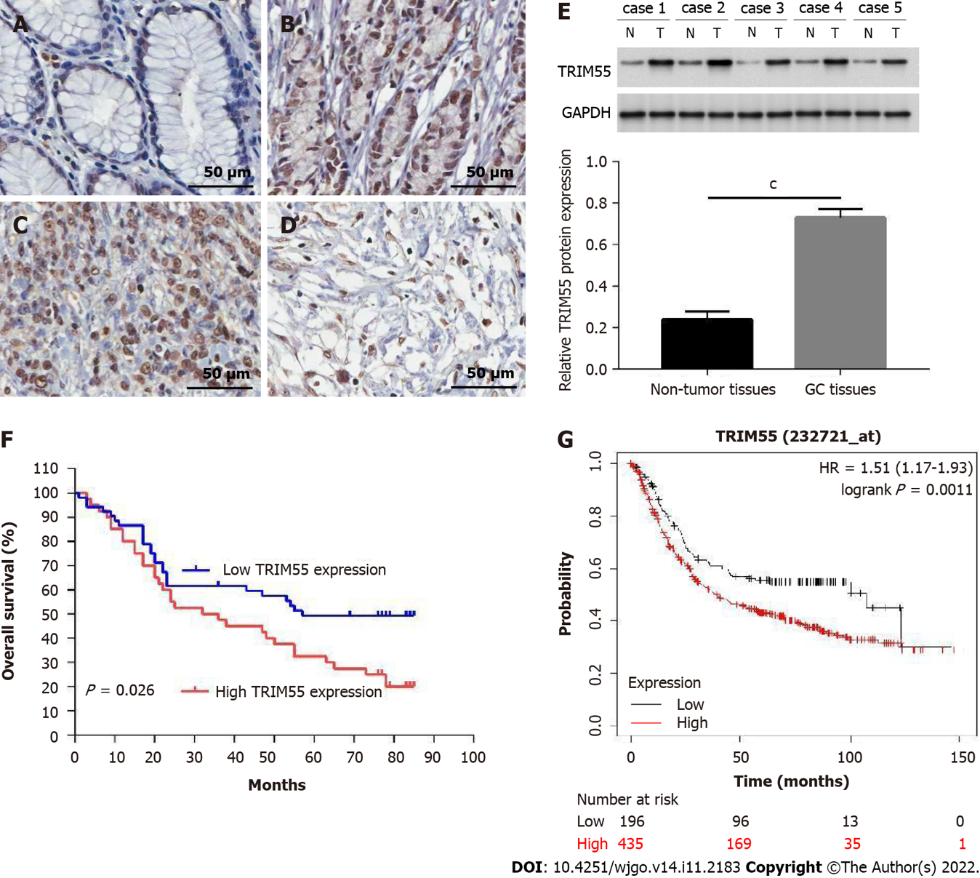
Figure 1 Representative images of immunohistochemical staining for TRIM55 in human gastric cancer tissue and its prognostic significance. A: Low expression of TRIM55 in gastric normal mucosa tissue; B: TRIM55 expression in well-differentiated adenocarcinoma; C: TRIM55 expression in poorly differentiated adenocarcinoma; D: Overexpression of TRIM55 in signet-ring cell carcinoma. Original magnification, 400 ×; E: TRIM55 protein levels in five tumor samples and their matched normal tissues; F: Overall survival curves for 91 gastric cancer (GC) patients according to TRIM55 protein expression (P = 0.026); G: Overall survival curves of TCGA GC patients with different TRIM55 expression. ^{c}P < 0.001. HR: Hazard ratio; GC: Gastric cancer.
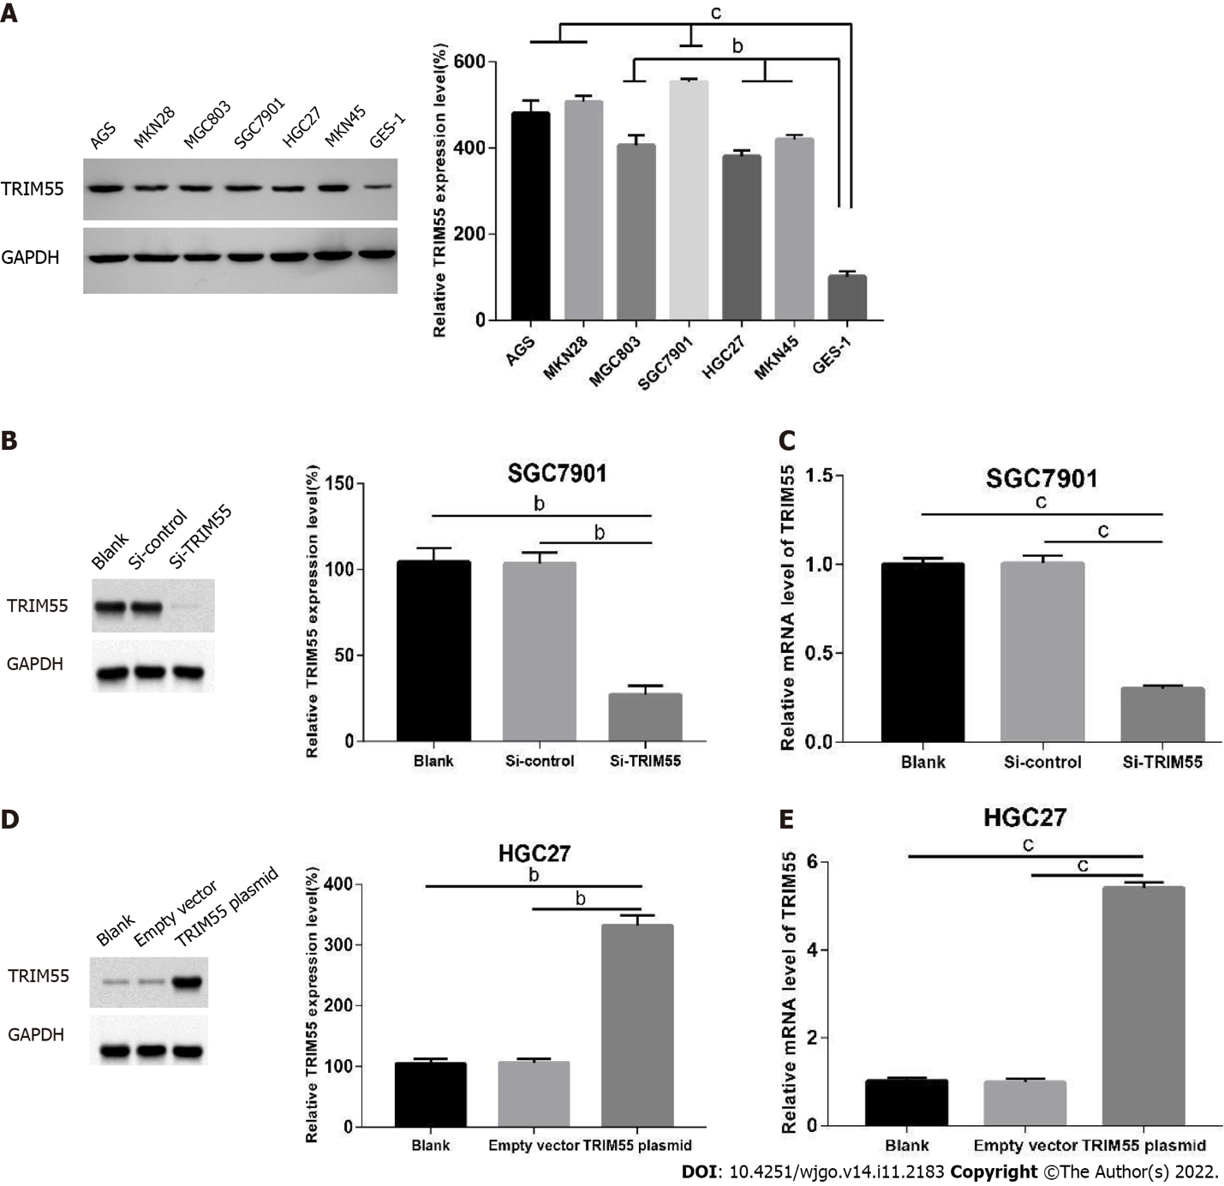
Figure 2 TRIM55 expression in gastric cancer cells. A: The expression of TRIM protein was detected in gastric cancer (GC) cells by western blot. The histogram shows the expression of TRIM55 in GC cells was stronger than that in gastric mucosa cell line; B: The interference efficiency of TRIM55 small interfering RNA (siRNA) in SGC7901 cells was detected by Western blot; C: Quantitative real-time-polymerase chain reaction assay was performed to determine TRIM55 expression after transfection with siRNA; D: The up-regulation of TRIM55 expression in HGC27 cells was detected by Western blot; E: TRIM55 mRNA expression level in HGC27 after transfection with the TRIM55 plasmid. ^{b}P < 0.01; ^{c}P < 0.001.
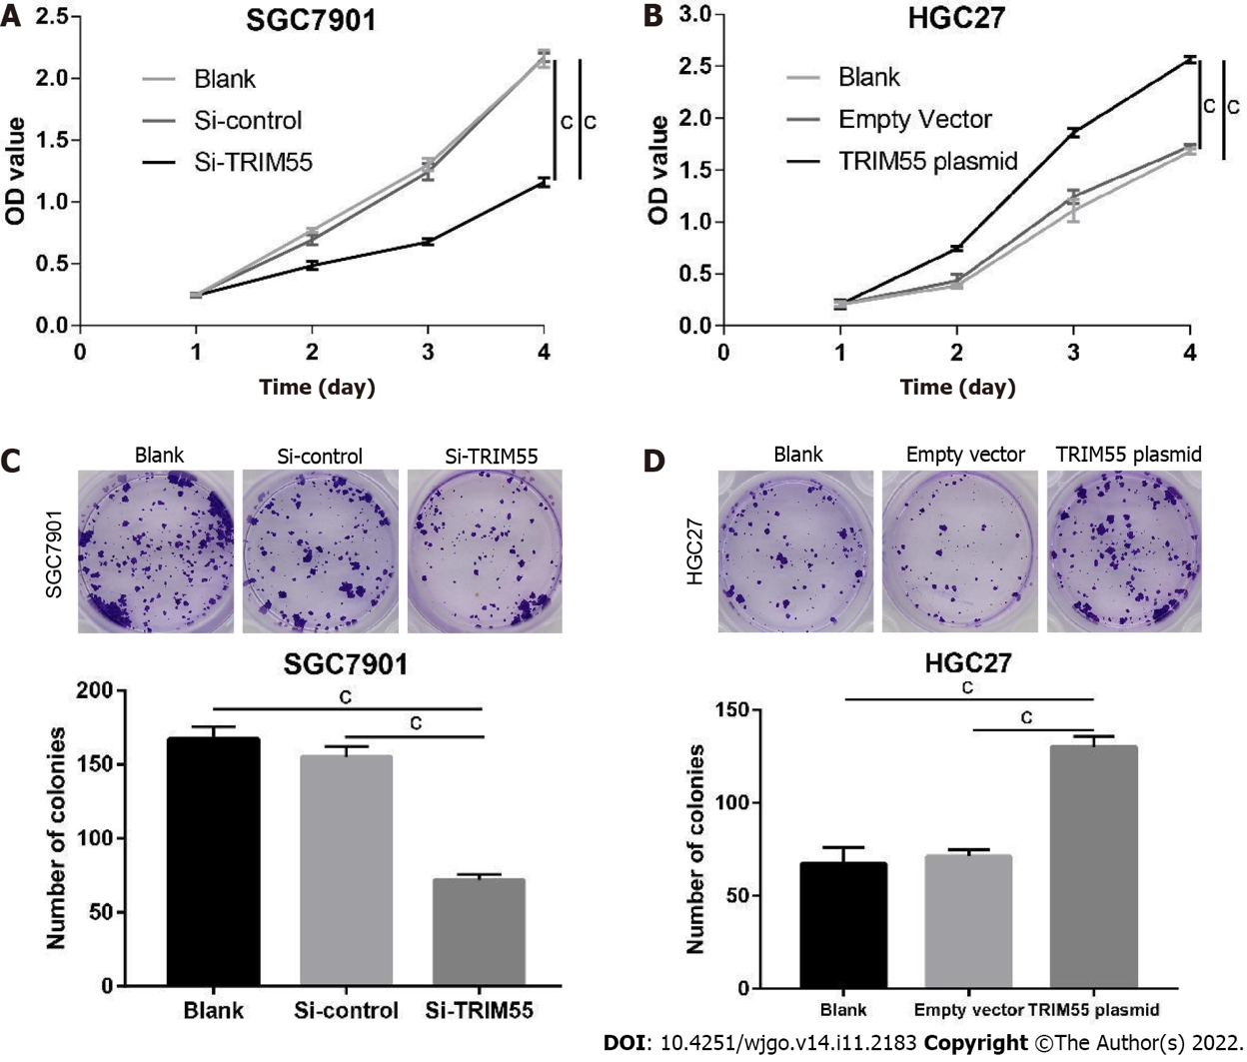
Figure 3 TRIM55 regulates gastric cancer cell proliferation. A and B: Cell viability detected by cell counting kit-8 assay in SGC7901 cells after knockdown of TRIM55 and in HGC27 cells after overexpression of TRIM55; C and D: Colony formation analysis of TRIM55 knockdown-treated SGC7901 cells and TRIM55 overexpression-treated HGC27 cells. ^{c}P < 0.001.
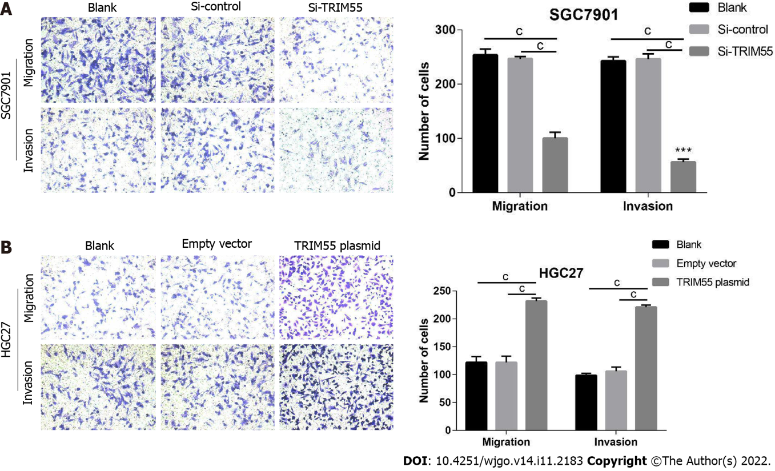
Figure 4 TRIM55 promotes metastasis of gastric cancer cells. A: Migration and invasion analysis of TRIM55 knockdown-treated SGC7901 cells; B: Migration and invasion analysis of TRIM55 overexpression treated-HGC27 cells. ^{c}P < 0.001.
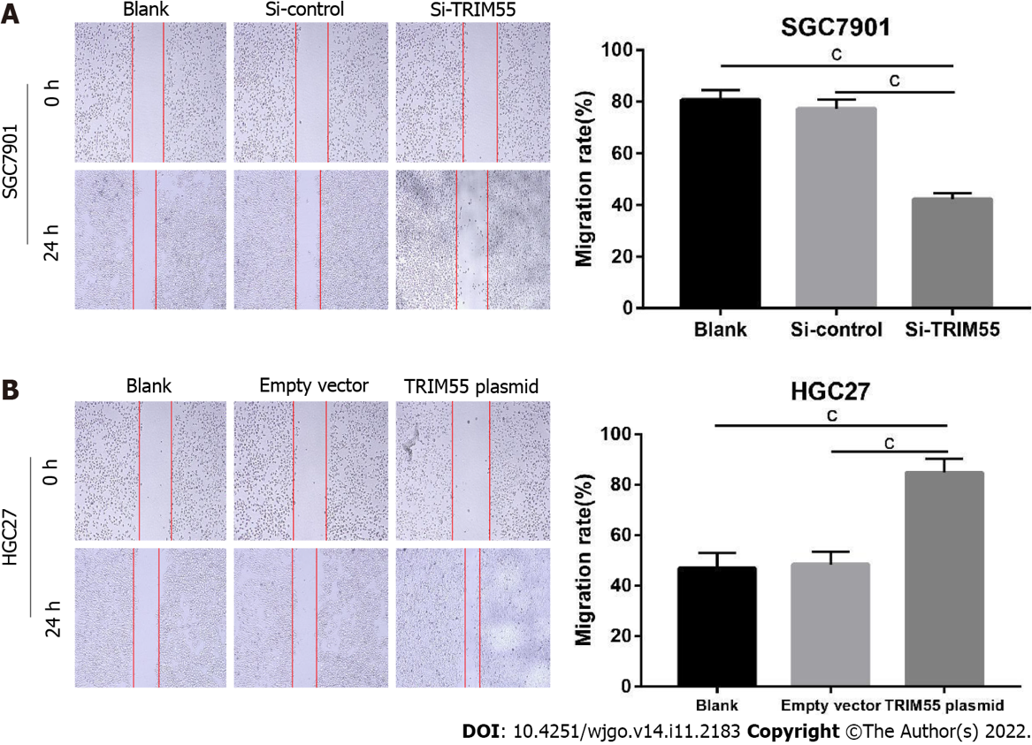
Figure 5 Wound healing assays were performed in gastric cancer cells. A: Migration rates of SGC7901 cells at 24 h were lower than that in control groups after knockdown of TRIM55; B: Migration rates of HGC27 cells at 24 h were higher than that in control groups after overexpression of TRIM55. ^{c}P < 0.001.
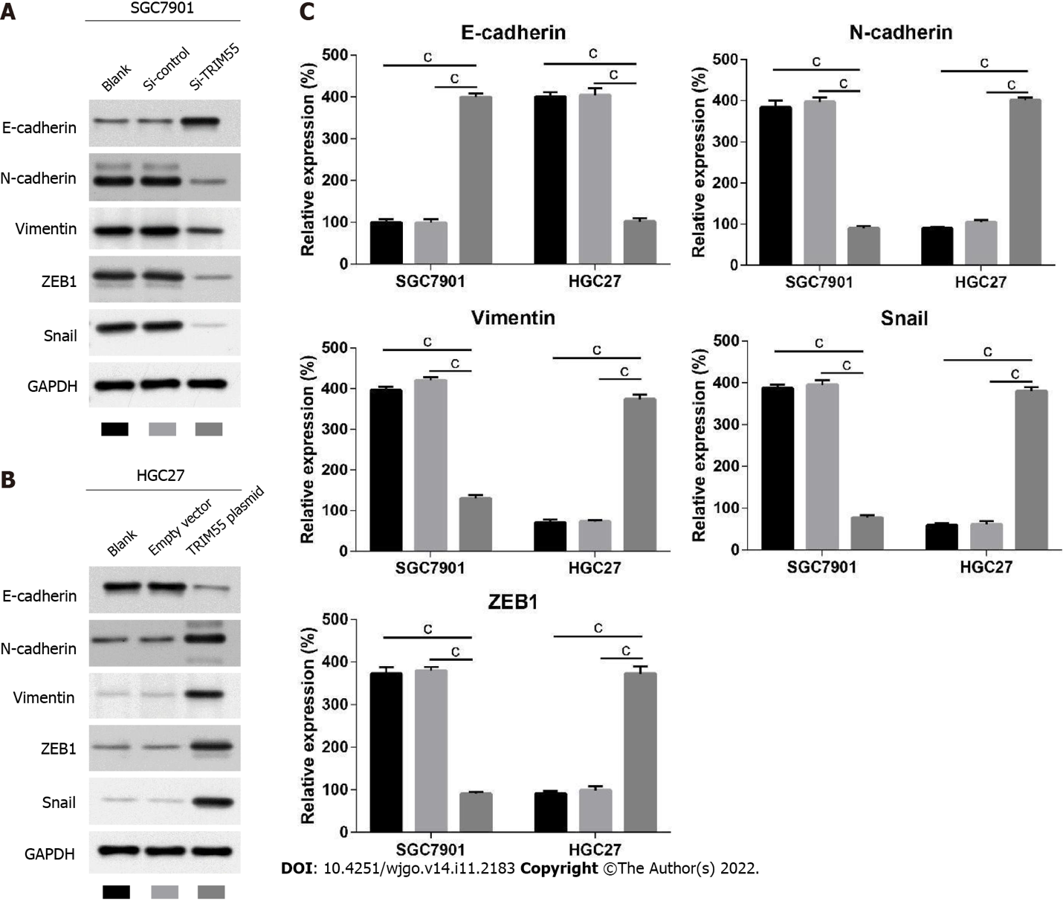
Figure 6 Western blot results of epithelial-mesenchymal transition pathway-related proteins in gastric cancer cells. A and B: Western blot analysis of E-cadherin, N-cadherin, Vimentin, ZEB1, and Snail after TRIM55 knockdown and overexpression in SGC7901 and HGC27 cells; C: Histogram of the expression of E-cadherin, N-cadherin, Vimentin, Snail, and ZEB1 proteins related to metastasis after knockdown or overexpression of TRIM55. ^{c}P < 0.001.
Table 1 Immunohistochemical expression of TIRM55 in gastric cancer and normal tissues
Tissue | N | High expression | Low expression | P value
Gastric cancer | 91 | 40 | 51 | < 0.001
Normal | 91 | 3 | 89
Table 2 Association between TRIM55 expression and clinicopathological characteristics
Variables | NO. of case | TRIM55 expression |  | χ² | P value
 |  | High (n = 40) | Low (n = 51)
Gender |  |  |  | 0.284 | 0.594
Male | 61 | 28 | 33
Female | 30 | 12 | 18
Age (n) |  |  |  | 0.216 | 0.642
≤ 65 | 48 | 20 | 28
> 65 | 43 | 20 | 23
Tumor location |  |  |  | 0.008 | 0.928
Proximal | 14 | 6 | 8
Dismatal | 77 | 34 | 43
pT stage |  |  |  | 6.232 | 0.013
T1 + T2 | 43 | 13 | 30
T3 + T4 | 48 | 27 | 21
Lymph node metastasis |  |  |  | 5.506 | 0.019
Negative | 49 | 16 | 33
Positive | 42 | 24 | 18
TNM stage |  |  |  | 5.146 | 0.023
Ⅰ + Ⅱ | 53 | 18 | 35
Ⅲ | 38 | 22 | 16
Lauren histotype |  |  |  | 3.366 | 0.067
Intestinal | 47 | 25 | 22
Diffuse | 44 | 15 | 29
Table 3 Univariate and multivariate Cox regression models for estimating the overall survival
Variable | Univariate analysis |  |  | Multivariate analysis
 | HR | 95%CI | P value | HR | 95%CI | P value
Gender | 0.79 | 0.12–1.38 | 0.463
Age | 0.56 | 0.38–1.50 | 0.517
Tumor location | 1.67 | 0.53–2.27 | 0.770
pT stage | 0.85 | 0.61–0.93 | 0.041
Lymph node metastasis | 3.29 | 2.07–5.44 | 0.005 | 2.64 | 1.35–3.08 | 0.021
TNM stage | 2.18 | 1.32–2.89 | 0.016 | 1.20 | 1.06–1.88 | 0.028
Lauren histotype | 1.45 | 0.39–2.46 | 0.433
TRIM55 | 2.37 | 1.53–3.81 | 0.028 | 1.48 | 1.17–1.92 | 0.035
HR: Hazard ratio; CI: Confidence interval.

Published by Baishideng Publishing Group Inc
7041 Koll Center Parkway, Suite 160, Pleasanton, CA 94566, USA
Telephone: +1-925-3991568
E-mail: bpgoffice@wjgnet.com
Help Desk: https://www.f6publishing.com/helpdesk
https://www.wjgnet.com

© 2022 Baishideng Publishing Group Inc. All rights reserved.

