Name of Journal: World Journal of Gastrointestinal Surgery
Manuscript NO: 90552
Manuscript Type: ORIGINAL ARTICLE

Retrospective Study
Construction of a predictive model for acute liver failure after hepatectomy based on neutrophil-to-lymphocyte ratio and albumin-bilirubin score

Li XP et al. Predicting liver failure after hepatectomy

Xiao-Pei Li, Zeng-Tao Bao, Li Wang, Chun-Yan Zhang, Wen Yang

Xiao-Pei Li, Li Wang, Department of Family Planning and Assisted Reproductive Technology, The First People’s Hospital of Lianyungang, Lianyungang 222000, Jiangsu Province, China

Zeng-Tao Bao, Department of Gastrointestinal Surgery, The First People’s Hospital of Lianyungang, Lianyungang 222000, Jiangsu Province, China

Chun-Yan Zhang, Department of Laboratory Medicine, The First People’s Hospital of Lianyungang, Lianyungang 222000, Jiangsu Province, China

Wen Yang, Department of Gynecology, The First People’s Hospital of Lianyungang, Lianyungang 222000, Jiangsu Province, China

Author contributions: Li XP designed the study and wrote the manuscript; Bao ZT designed the study and provided clinical data; Wang L and Zhang CY contributed to the data analysis; Yang W and Bao ZT reviewed the research. All authors approved this research.

Corresponding author: Wen Yang, MBBS, Chief Physician, Department of Gynecology, The First People’s Hospital of Lianyungang, No. 192 Tongguanbei Road, Haizhou District, Lianyungang 222000, Jiangsu Province, China. wen_yang0@163.com

Received: January 19, 2024
Revised: February 18, 2024
Accepted: March 21, 2024
Published online:

Abstract
BACKGROUND
Acute liver failure (ALF) is a common cause of postoperative death in patients with hepatocellular carcinoma (HCC) and is a serious threat to patient safety. The neutrophil-to-lymphocyte ratio (NLR) is a common inflammatory indicator that is associated with the prognosis of various diseases, and the albumin-bilirubin score (ALBI) is used to evaluate liver function in liver cancer patients. Therefore, this study aimed to construct a predictive model for postoperative ALF in HCC tumor integrity resection (R0) based on the NLR and ALBI, providing a basis for clinicians to choose appropriate treatment plans.

AIM
To construct an ALF prediction model after R0 surgery for HCC based on NLR and ALBI.

METHODS
In total, 194 patients with HCC who visited The First People’s Hospital of Lianyungang to receive R0 between May 2018 and May 2023 were enrolled and divided into the ALF and non-ALF groups. We compared differences in the NLR and ALBI between the two groups. The risk factors of ALF after R0 surgery for HCC were screened in the univariate analysis. Independent risk factors were analyzed by multifactorial logistic regression. We then constructed a prediction model of ALF after R0 surgery for HCC. A receiver operating characteristic curve, calibration curve, and decision curve analysis (DCA) were used to evaluate the value of the prediction model.

RESULTS
Among 194 patients with HCC who met the standard inclusion criteria, 46 cases of ALF occurred after R0 (23.71%). There were significant differences in the NLR and ALBI between the two groups (P < 0.05). The univariate analysis showed that alpha-fetoprotein (AFP) and blood loss volume (BLV) were significantly higher in the ALF group compared with the non-ALF group (P < 0.05). The multifactorial analysis showed that NLR, ALBI, AFP, and BLV were independent risk factors for ALF after R0 surgery in HCC. The predictive efficacy of NLR, ALBI, AFP, and BLV in predicting the occurrence of ALT after R0 surgery for HCC was average [area under the curve (AUC)_{NLR} = 0.767, AUC_{ALBI} = 0.755, AUC_{AFP} = 0.599, AUC_{BLV} = 0.718]. The prediction model for ALF after R0 surgery for HCC based on NLR and ALBI had a better predictive efficacy (AUC = 0.916). The calibration curve and actual curve were in good agreement. DCA showed a high net gain and that the model was safer compared to the curve in the extreme case over a wide range of thresholds.

CONCLUSION
The prediction model based on NLR and ALBI can effectively predict the risk of developing ALF after HCC R0 surgery, providing a basis for clinical prevention of developing ALF after HCC R0 surgery.

Key Words: Acute liver failure; Hepatocellular carcinoma; Hepatectomy; Neutrophil-to-lymphocyte ratio; Albumin-bilirubin score

Li XP, Bao ZT, Wang L, Zhang CY, Yang W. Construction of a predictive model for acute liver failure after hepatectomy based on neutrophil-to-lymphocyte ratio and albumin-bilirubin score. World J Gastrointest Surg 2024; In press

Core Tip: This study aimed to identify independent risk factors associated with acute liver failure (ALF) after complete tumor resection (R0) for hepatocellular carcinoma (HCC) and to investigate their efficacy in predicting the occurrence of ALF after R0 for HCC. The results showed that the prediction model of ALF after R0 surgery for HCC, constructed based on the neutrophil-to-lymphocyte ratio and albumin-bilirubin score, had a good predictive efficacy and is expected to be a promising predictive tool in future clinical work.

INTRODUCTION
The liver is one of the most important and indispensable organs in the human body. Normal liver cells have a strong ability to self-replicate; however, persistent chronic inflammation can permanently impair liver repair and regeneration, leading to fibrosis, cirrhosis, liver failure, and even liver cancer. According to the latest global cancer data released in 2020, the incidence of liver cancer ranks fifth in the incidence of malignant tumors worldwide with an increasing trend each year^{[1]}. Currently, primary liver cancer is a malignant tumor with high morbidity and mortality rates in China, accounting for more than two-thirds of the total number of liver cancers in China^{[1]}. Complete tumor resection (R0) is the most direct and effective method for treating liver tumors and is the most important factor contributing to postoperative mortality. However, R0 resection often causes a variety of complications, among which the most difficult to manage and life-threatening is liver failure, which is the leading cause of death in postoperative patients. Thus, it is important to search for possible factors causing acute liver failure (ALF) after hepatectomy, predict liver failure in advance, assist clinicians in choosing appropriate treatment options, and improve the prognosis of patients with hepatocellular carcinoma (HCC).
The serum neutrophil-to-lymphocyte ratio (NLR) is a common indicator of inflammation that can determine the inflammatory status of patients and predict the prognosis of many liver diseases^{[2]}. Several studies have reported the importance of the NLR in predicting the prognosis of liver transplantation for HCC^{[3]}, hepatic arterial chemoembolization in patients with liver cancer^{[4,5]}, and chronic ALF^{[6]}. The albumin-bilirubin score (ALBI) is a suitable method to evaluate liver function in patients with HCC because it only includes serum bilirubin and albumin and excludes subjective indicators, such as hepatic encephalopathy and ascites, making it a more convenient and objective method to evaluate liver function^{[7-9]}.
In summary, the authors concluded that the NLR and ALBI might be associated with the occurrence of ALF after R0 surgery. To study the relationship between these two factors and the occurrence of ALF, this study aimed to construct a nomogram prediction model for the occurrence of ALF after R0 surgery for HCC by retrospectively analyzing the possible risk factors for the occurrence of ALF after R0 surgery for HCC, and to evaluate the value of the nomogram prediction model to provide a possible basis for preventing the occurrence of ALF after R0 surgery.

MATERIALS AND METHODS
Study population
A total of 217 patients with HCC who visited The First People’s Hospital of Lianyungang for treatment between May 2018 and May 2023 were assessed; 23 patients were excluded, and 194 patients with HCC who underwent R0 were included in the study and were categorized into the ALF group (n = 46) and non-ALF group (n = 148), according to whether they suffered from ALF after R0 surgery. The research process is illustrated in Figure 1.

Inclusion criteria
The inclusion criteria were as follows: Age 45–80 years; patients underwent radical hepatectomy for HCC and met the criteria for R0, i.e., resection of all liver tumors visible to the naked eye; HCC was confirmed by postoperative pathological examination; and patients received hepatectomy for the first time.

Exclusion criteria
The exclusion criteria were as follows: Patients with preoperative rupture and bleeding of HCC; patients with metastasis to extrahepatic organs detected during intraoperative exploration; combined with biliary obstruction; combined with serious insufficiency of heart, lungs, kidneys, and other important organs; and patients with missing clinical data.

Diagnostic criteria for postoperative ALF
Referring to the relevant criteria proposed by the International Group for Hepatic Surgery in 2018, the diagnosis of liver failure was confirmed when a patient developed bilirubin levels > 50 mmol/L and an international normalized ratio > 1.7 on or 5 d after hepatectomy; biliary obstruction was excluded^{[10]}.

Data collection
Information on factors associated with the development of ALF after R0 was collected, including gender, age, body mass index (BMI), hypertension, diabetes mellitus, history of hepatitis B, cirrhosis, pericardial integrity, type of tumor, number of tumors, surgical procedure, portal vein cancer occlusion, alpha-fetoprotein (AFP), platelets (PLT), hemoglobin (Hb), white blood cells (WBC), direct bilirubin (DBIL), total bilirubin (TBil), plasminogen time (PT), aspartate aminotransferase (AST), alanine aminotransferase (ALT), and blood loss volume (BLV), during the procedure.

Serum test method
The patient's peripheral venous blood (6 mL) was collected before surgery, centrifuged rapidly at 2000 rpm for 15 min, and the upper layer of serum was separated for use. NLR, Hb, PLT, and WBC counts were determined using a fully automatic blood cell analyzer (Mindray: BC-6800). TBil, DBIL, AST, and ALT levels were measured using an automatic biochemical analyzer (Beckman, AU5821). AFP was detected using a fully automatic biochemical immunoassay analyzer (Roche, cobas®8000). PT was detected using an automated coagulation analyzer (Werfen: ACL Top 700). NLR = monocyte/lymphocyte. ALBI = -0.085 × [albumin (g/L) + 0.66 × lg [TBil (μmol/L)].

Statistical methods
Data were analyzed with SPSS 26.0 statistical software. Comparisons of measurement data conforming to normal distribution between the two groups were performed with the t-test and expressed as the mean ± SD; comparisons of the count data between the two groups were performed using the χ² test and expressed as [n (%)]. Variables in which there was a statistically significant difference (P < 0.05) were subjected to binary logistic regression analysis, and the risk factors affecting the occurrence of ALF after R0 surgery for HCC were screened out. R software was applied to establish the nomogram model and to plot the subjects' receiver operating characteristic curve (ROC). The nomogram model was validated for predictive performance using Bootstrap equal-volume with put-back repetitive sampling 1000 times, and calibration plots were plotted. Decision curve analysis (DCA) was also performed. Differences were statistically significant at P < 0.05.

RESULTS
Comparison of the NLR and ALBI between ALF and non-ALF groups
The NLR and ALBI were significantly higher in the ALF group than in the non-ALF group (P < 0.05; Figure 2).

Univariate analysis of the occurrence of ALF after R0 surgery for HCC
A comparison of the general data showed that there was no statistically significant difference between the ALF and non-ALF groups in terms of sex, BMI, hypertension, diabetes mellitus, pericardial integrity, tumor type, number of tumors, and portal vein cancer screening (P > 0.05). However, there was a significant difference in terms of age, history of hepatitis B, liver cirrhosis, mode of surgery, and BLV (P < 0.05) (Table 1).
Furthermore, a comparison of laboratory data showed that there was no statistically significant difference between the ALF and non-ALF groups in terms of Hb, WBC, TBil, AST, and ALT levels (P > 0.05), while there was a significant difference in AFP, PLT, PT, and DBIL levels (P < 0.05), as shown in Table 2.

Multifactorial analysis and predictive value of ALF occurrence after R0 surgery for HCC
Indicators with significant differences in the NLR and ALBI scores, and the univariate analysis, were included in the multifactorial logistic regression analysis, in which AFP less than or equal to 400 ng/mL was assigned the value of "0”, and greater than 400 ng/mL was assigned the value of "1”. The results showed that AFP, NLR, ALBI, and BLV were independent risk factors for ALF after R0 surgery for HCC (Table 3). The values of the indicators were assessed using ROC curves, and the results showed that AFP, BLV, NLR, and ALBI had a certain predictive value for ALF after R0 surgery for HCC (P < 0.05), and the predictive values of NLR and ALBI were better than those of AFP and BLV, as shown in Table 4 and Figure 3.

Construction and evaluation of the nomogram prediction model
A column-line graph model was constructed based on the indicators screened using the multifactor logistic regression analysis (Figure 4). The predictive probability of the model was calculated by adding the corresponding scores of each indicator to obtain the total score. Internal validation was performed by bootstrap sampling 1000 times, and the areas under the curve (AUC), DCA curve, and calibration curve were used to evaluate the effectiveness of the column plot. The AUC was 0.916, sensitivity was 0.826, specificity was 0.932 (P = 0.000, 95% confidence interval: 0.854–0.978). The ROC curve also showed that the model had a certain degree of predictive efficacy. In addition, the calibration curve further indicated good agreement between the nomogram prediction model and actual observations, which further indicated that the nomogram prediction model had good predictive efficacy in predicting the occurrence of ALF after R0 surgery (Figure 5).

DISCUSSION
In recent years, immunotherapy and molecular targeting have gradually become hotspots of clinical and scientific research, R0 is still the main modality for the treatment of HCC and occupies an indispensable position. However, residual liver tissue regeneration is impaired after R0, and excessive apoptosis of liver cells will lead to the imbalance between liver regeneration and injury, resulting in ALF after hepatectomy^{[11]}.
Impaired immune system function, excessive release of inflammatory factors, and sustained inflammatory responses play important roles in exacerbating hepatocyte injury and promoting an imbalance between hepatocyte regeneration and injury. Neutrophils are the first responders to inflammation and infection in the body and are important cellular components of the immune response. In the peripheral blood, the NLR is used to reflect the inflammatory and immune status of the organism and is associated with a poor prognosis in patients with colorectal^{[12]}, gastric^{[13,14]}, breast^{[15]}, prostate^{[16]}, and lung^{[17]} cancers. This study reviewed the relevant studies on ALF after HCC R0 surgery, and found that the serum NLR before surgery was higher in the ALF group, suggesting that preoperative NLR has a certain predictive value in predicting the occurrence of ALF after HCC R0 surgery. The ROC curve results showed that the NLR was not effective in predicting ALF after R0 HCC (AUC_{NLR} = 0.767).
ALBI is a hotly researched scoring model for predicting the efficacy after liver transplantation in recent years, which was first analyzed by Johnson et al^{[18]} on the survival of 1313 patients with HCC with better accuracy due to the exclusion of ascites and hepatic encephalopathy, which are subjective indicators, as well as the effect of double-counting of associated indicators. Domestic and international studies suggest that ALBI is an influential factor in the prognosis of viral hepatitis B cirrhosis^{[19]}, alcoholic cirrhosis^{[20]}, primary biliary cirrhosis^{[21]}, and autoimmune hepatitis cirrhosis^{[22]}. Furthermore, the higher the ALBI score, the worse the prognosis. The present study showed that the ALBI score was higher in the group that developed ALF than in the non-ALF group after R0 surgery for HCC, which is consistent with the findings of other scholars mentioned in the previous section. This suggests that preoperative ALBI has a predictive value for the occurrence of ALF after R0 surgery for HCC. The ROC curve showed that the efficacy of ALBI in predicting the occurrence of ALF after R0 surgery for HCC was average (AUC_{ALBI} = 0.755).
AFP is considered a diagnostic and prognostic tumor marker for HCC^{[23]}. The level of AFP in normal human serum is low. However, the expression of AFP increases in HCC, and its serum level increases sharply with the deterioration of the disease^{[24]}. Our study categorized AFP levels as less than or equal to 400 ng/mL and greater than 400 ng/mL, and it was shown that AFP levels were associated with the development of ALF after R0 surgery for HCC. In addition, its efficacy as a predictor was fair (AUC_{AFP} = 0.599).
In this study, intraoperative BLV was considered an independent risk factor for the occurrence of ALF after R0 for HCC. Albumin is the most important protein in human plasma, accounting for approximately 50% of the total human plasma proteins, and is the basic physiological substance for maintaining the nutrition of the body. Some studies have shown that nutritional status affects disease prognosis^{[25]}. Intraoperative massive blood loss in HCC R0 resection leads to a consequent massive loss of serum albumin, resulting in nutritional deficiencies and reduced immunity, which ultimately leads to the development of hepatic failure. This may be the reason why the amount of intraoperative blood loss is an independent risk factor for postoperative hepatic failure. As a predictor of ALF after R0 HCC, the predictive efficacy was average (AUC_{BLV} = 0.718).
The prognostic efficacy of a single factor to predict the disease has some limitations. To avoid this problem, we constructed a nomogram prediction model using NLR, ALBI, AFP, and BLV as predictors for the occurrence of ALF after R0 surgery for HCC in this research. After model validation, we found that the calibration curves fit the ideal curves to a high degree, the predictive efficacy of the nomogram prediction model was better (AUC = 0.916), and the efficacy of the combined prediction was much higher than that of the single-factor prediction. It has been shown that ALBI combined with residual liver volume can be used to predict ALF in patients with HBV-associated primary HCC (AUC = 0.890)^{[26]}. However, this requires three-dimensional reconstruction of preoperative abdominal computed tomography imaging data to measure the residual liver volume in patients with HCC, which often requires a skillful base for two-dimensional image reading. In addition, the reconstruction results vary from person to person, with instability and other shortcomings. In this study, we constructed a prediction model of ALF after R0 surgery for HCC based on NLR and ALBI, and its predictive efficacy was excellent, with an AUC of 0.916. The NLR, ALBI, AFP, and BLV can be obtained quickly in the clinic, which can help clinicians predict the occurrence of ALF after R0 surgery for HCC with high efficiency and prepare for the prevention of ALF in advance.
In summary, the prediction model of ALF after R0 surgery for HCC based on NLR combined with ALBI has good predictive value and is expected to be a promising predictive tool in future clinical work. This was a clinical retrospective study, which was limited by the sample size. Therefore, the value of constructing a prediction model of ALF after R0 surgery for HCC based on NLR combined with ALBI needs to be further verified in a larger sample size or prospective clinical cohort study.

CONCLUSION
The construction of a prediction model for ALF after R0 surgery for HCC based on NLR and ALBI had good predictive value and is expected to be a promising predictive tool in future clinical work.

REFERENCES
1 Sung H, Ferlay J, Siegel RL, Laversanne M, Soerjomataram I, Jemal A, Bray F. Global Cancer Statistics 2020: GLOBOCAN Estimates of Incidence and Mortality Worldwide for 36 Cancers in 185 Countries. CA Cancer J Clin 2021; 71: 209-249 [PMID: 33538338 DOI: 10.3322/caac.21660]
2 Mouchli M, Reddy S, Gerrard M, Boardman L, Rubio M. Usefulness of neutrophil-to-lymphocyte ratio (NLR) as a prognostic predictor after treatment of hepatocellular carcinoma." Review article. Ann Hepatol 2021; 22: 100249 [PMID: 32896610 DOI: 10.1016/j.aohep.2020.08.067]
3 Hung HC, Lee JC, Wang YC, Cheng CH, Wu TH, Wu TJ, Chou HS, Chan KM, Lee WC, Lee CF. Living-Donor Liver Transplantation for Hepatocellular Carcinoma: Impact of the MELD Score and Predictive Value of NLR on Survival. Curr Oncol 2022; 29: 3881-3893 [PMID: 35735419 DOI: 10.3390/curroncol29060310]
4 Wang S, Zhang X, Chen Q, Jin ZC, Lu J, Guo J. A Novel Neutrophil-to-Lymphocyte Ratio and Sarcopenia Based TACE-Predict Model of Hepatocellular Carcinoma Patients. J Hepatocell Carcinoma 2023; 10: 659-671 [PMID: 37113464 DOI: 10.2147/JHC.S407646]
5 Minici R, Siciliano MA, Ammendola M, Santoro RC, Barbieri V, Ranieri G, Laganà D. Prognostic Role of Neutrophil-to-Lymphocyte Ratio (NLR), Lymphocyte-to-Monocyte Ratio (LMR), Platelet-to-Lymphocyte Ratio (PLR) and Lymphocyte-to-C Reactive Protein Ratio (LCR) in Patients with Hepatocellular Carcinoma (HCC) undergoing Chemoembolizations (TACE) of the Liver: The Unexplored Corner Linking Tumor Microenvironment, Biomarkers and Interventional Radiology. Cancers (Basel) 2022; 15 [PMID: 36612251 DOI: 10.3390/cancers15010257]
6 Wang N, He S, Zheng Y, Wang L. The value of NLR versus MLR in the short-term prognostic assessment of HBV-related acute-on-chronic liver failure. Int Immunopharmacol 2023; 121: 110489 [PMID: 37327515 DOI: 10.1016/j.intimp.2023.110489]
7 Li Z, Jiao D, Han X, Si G, Li Y, Liu J, Xu Y, Zheng B, Zhang X. Transcatheter arterial chemoembolization combined with simultaneous DynaCT-guided microwave ablation in the treatment of small hepatocellular carcinoma. Cancer Imaging 2020; 20: 13 [PMID: 32000862 DOI: 10.1186/s40644-020-0294-5]
8 Zhong X, Tang H, Lu B, You J, Piao J, Yang P, Li J. Differentiation of Small Hepatocellular Carcinoma From Dysplastic Nodules in Cirrhotic Liver: Texture Analysis Based on MRI Improved Performance in Comparison Over Gadoxetic Acid-Enhanced MR and Diffusion-Weighted Imaging. Front Oncol 2019; 9: 1382 [PMID: 31998629 DOI: 10.3389/fonc.2019.01382]
9 Kong FH, Miao XY, Zou H, Xiong L, Wen Y, Chen B, Liu X, Zhou JJ. End-stage liver disease score and future liver remnant volume predict post-hepatectomy liver failure in hepatocellular carcinoma. World J Clin Cases 2019; 7: 3734-3741 [PMID: 31799298 DOI: 10.12998/wjcc.v7.i22.3734]
10 Sultana A, Brooke-Smith M, Ullah S, Figueras J, Rees M, Vauthey JN, Conrad C, Hugh TJ, Garden OJ, Fan ST, Crawford M, Makuuchi M, Yokoyama Y, Büchler M, Padbury R. Prospective evaluation of the International Study Group for Liver Surgery definition of post hepatectomy liver failure after liver resection: an international multicentre study. HPB (Oxford) 2018; 20: 462-469 [PMID: 29287736 DOI: 10.1016/j.hpb.2017.11.007]
11 Sparrelid E, Olthof PB, Dasari BVM, Erdmann JI, Santol J, Starlinger P, Gilg S. Current evidence on posthepatectomy liver failure: comprehensive review. BJS Open 2022; 6 [PMID: 36415029 DOI: 10.1093/bjsopen/zrac142]
12 Naszai M, Kurjan A, Maughan TS. The prognostic utility of pre-treatment neutrophil-to-lymphocyte-ratio (NLR) in colorectal cancer: A systematic review and meta-analysis. Cancer Med 2021; 10: 5983-5997 [PMID: 34308567 DOI: 10.1002/cam4.4143]
13 Miyamoto R, Inagawa S, Sano N, Tadano S, Adachi S, Yamamoto M. The neutrophil-to-lymphocyte ratio (NLR) predicts short-term and long-term outcomes in gastric cancer patients. Eur J Surg Oncol 2018; 44: 607-612 [PMID: 29478743 DOI: 10.1016/j.ejso.2018.02.003]
14 Mellor KL, Powell AGMT, Lewis WG. Systematic Review and Meta-Analysis of the Prognostic Significance of Neutrophil-Lymphocyte Ratio (NLR) After R0 Gastrectomy for Cancer. J Gastrointest Cancer 2018; 49: 237-244 [PMID: 29949048 DOI: 10.1007/s12029-018-0127-y]
15 Grassadonia A, Graziano V, Iezzi L, Vici P, Barba M, Pizzuti L, Cicero G, Krasniqi E, Mazzotta M, Marinelli D, Amodio A, Natoli C, Tinari N. Prognostic Relevance of Neutrophil to Lymphocyte Ratio (NLR) in Luminal Breast Cancer: A Retrospective Analysis in the Neoadjuvant Setting. Cells 2021; 10 [PMID: 34359855 DOI: 10.3390/cells10071685]
16 Kumano Y, Hasegawa Y, Kawahara T, Yasui M, Miyoshi Y, Matsubara N, Uemura H. Pretreatment Neutrophil to Lymphocyte Ratio (NLR) Predicts Prognosis for Castration Resistant Prostate Cancer Patients Underwent Enzalutamide. Biomed Res Int 2019; 2019: 9450838 [PMID: 30800682 DOI: 10.1155/2019/9450838]
17 Platini H, Ferdinand E, Kohar K, Prayogo SA, Amirah S, Komariah M, Maulana S. Neutrophil-to-Lymphocyte Ratio and Platelet-to-Lymphocyte Ratio as Prognostic Markers for Advanced Non-Small-Cell Lung Cancer Treated with Immunotherapy: A Systematic Review and Meta-Analysis. Medicina (Kaunas) 2022; 58 [PMID: 36013536 DOI: 10.3390/medicina58081069]
18 Johnson PJ, Berhane S, Kagebayashi C, Satomura S, Teng M, Reeves HL, O'Beirne J, Fox R, Skowronska A, Palmer D, Yeo W, Mo F, Lai P, Iñarrairaegui M, Chan SL, Sangro B, Miksad R, Tada T, Kumada T, Toyoda H. Assessment of liver function in patients with hepatocellular carcinoma: a new evidence-based approach-the ALBI grade. J Clin Oncol 2015; 33: 550-558 [PMID: 25512453 DOI: 10.1200/JCO.2014.57.9151]
19 Wang J, Zhang Z, Yan X, Li M, Xia J, Liu Y, Chen Y, Jia B, Zhu L, Zhu C, Huang R, Wu C. Albumin-Bilirubin (ALBI) as an accurate and simple prognostic score for chronic hepatitis B-related liver cirrhosis. Dig Liver Dis 2019; 51: 1172-1178 [PMID: 30765220 DOI: 10.1016/j.dld.2019.01.011]
20 Shao L, Han B, An S, Ma J, Guo X, Romeiro FG, Mancuso A, Qi X. Albumin-to-bilirubin score for assessing the in-hospital death in cirrhosis. Transl Gastroenterol Hepatol 2017; 2: 88 [PMID: 29264426 DOI: 10.21037/tgh.2017.09.11]
21 Ito T, Ishigami M, Morooka H, Yamamoto K, Imai N, Ishizu Y, Honda T, Nishimura D, Tada T, Yasuda S, Toyoda H, Kumada T, Fujishiro M. The albumin-bilirubin score as a predictor of outcomes in Japanese patients with PBC: an analysis using time-dependent ROC. Sci Rep 2020; 10: 17812 [PMID: 33082429 DOI: 10.1038/s41598-020-74732-3]
22 Song Y, Yang H, Lin L, Jiang K, Liu WT, Wang BM, Lin R. [Albumin-to-bilirubin scores for assessing the prognosis in autoimmune hepatitis-related cirrhosis]. Zhonghua Gan Zang Bing Za Zhi 2019; 27: 772-776 [PMID: 31734991 DOI: 10.3760/cma.j.issn.1007-3418.2019.10.007]
23 Zheng Y, Zhu M, Li M. Effects of alpha-fetoprotein on the occurrence and progression of hepatocellular carcinoma. J Cancer Res Clin Oncol 2020; 146: 2439-2446 [PMID: 32725355 DOI: 10.1007/s00432-020-03331-6]
24 Galle PR, Foerster F, Kudo M, Chan SL, Llovet JM, Qin S, Schelman WR, Chintharlapalli S, Abada PB, Sherman M, Zhu AX. Biology and significance of alpha-fetoprotein in hepatocellular carcinoma. Liver Int 2019; 39: 2214-2229 [PMID: 31436873 DOI: 10.1111/liv.14223]
25 Moisey LL, Merriweather JL, Drover JW. The role of nutrition rehabilitation in the recovery of survivors of critical illness: underrecognized and underappreciated. Crit Care 2022; 26: 270 [PMID: 36076215 DOI: 10.1186/s13054-022-04143-5]
26 Zou H, Wen Y, Yuan K, Miao XY, Xiong L, Liu KJ. Combining albumin-bilirubin score with future liver remnant predicts post-hepatectomy liver failure in HBV-associated HCC patients. Liver Int 2018; 38: 494-502 [PMID: 28685924 DOI: 10.1111/liv.13514]

Footnotes
Institutional review board statement: The study was reviewed and approved by the Ethics Committee of the First People’s Hospital of Lianyungang, No. LW-20231120001-01.

Informed consent statement: As this was a retrospective study, the Ethics Committee of The First People’s Hospital of Lianyungang approved the exemption for informed consent.

Conflict-of-interest statement: The authors declare no conflicts of interest.

Data sharing statement: The data used in this study can be obtained from the corresponding author upon request.

Open-Access: This article is an open-access article that was selected by an in-house editor and fully peer-reviewed by external reviewers. It is distributed in accordance with the Creative Commons Attribution NonCommercial (CC BY-NC 4.0) license, which permits others to distribute, remix, adapt, build upon this work non-commercially, and license their derivative works on different terms, provided the original work is properly cited and the use is non-commercial. See: https://creativecommons.org/Licenses/by-nc/4.0/

Provenance and peer review: Unsolicited article; Externally peer reviewed.

Peer-review model: Single blind

Peer-review started: January 19, 2024
First decision: February 5, 2024
Article in press:

Specialty type: Gastroenterology and hepatology
Country/Territory of origin: China
Peer-review report’s scientific quality classification
Grade A (Excellent): 0
Grade B (Very good): 0
Grade C (Good): C, C
Grade D (Fair): 0
Grade E (Poor): 0

P-Reviewer: Katila T, Finland; Victor D, United States S-Editor: Fan JR L-Editor: A P-Editor:
Figure Legends
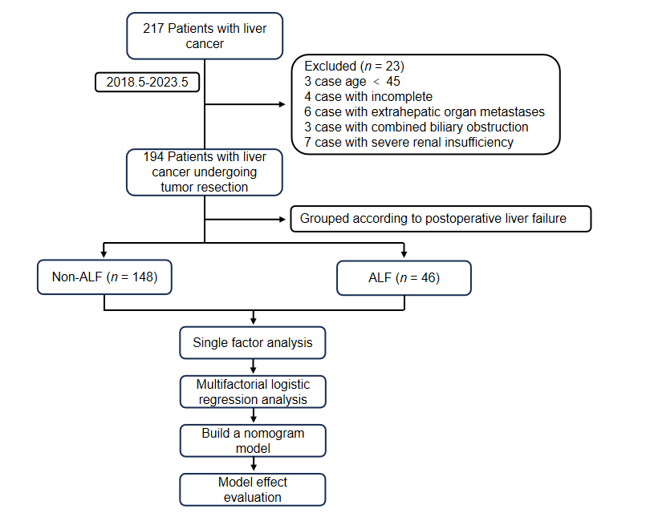
Figure 1 Experimental flow chart. ALF: Acute liver failure.
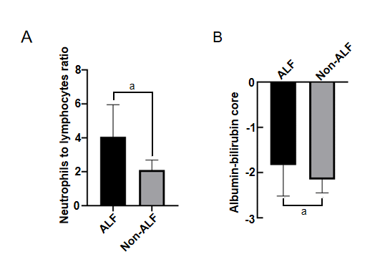
Figure 2 Comparison of the differences between the acute liver failure group and non-acute liver failure group. A: Neutrophil-to-lymphocyte ratio; B: Albumin-bilirubin score. ªP < 0.05. ALF: Acute liver failure.

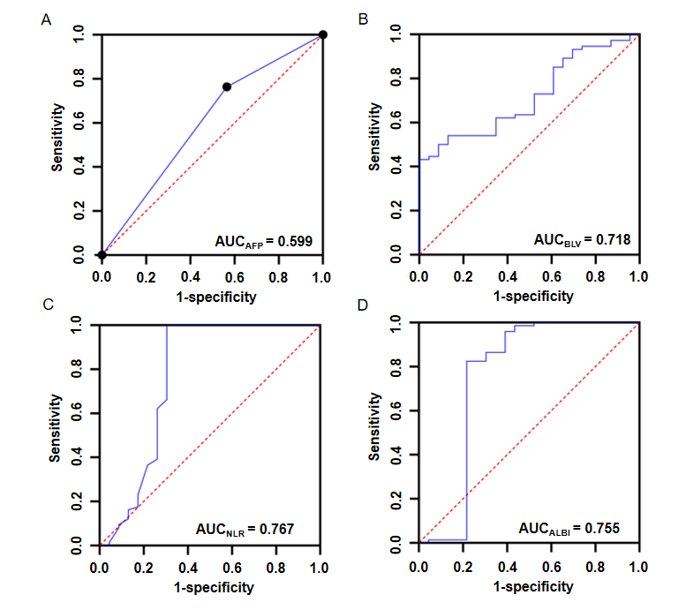
Figure 3 Receiver operating characteristic curves of predicting the occurrence of acute liver failure after R0 surgery for hepatocellular carcinoma. A: Acute liver failure; B: Blood loss volume; C: Neutrophil-to-lymphocyte ratio; D: Albumin-bilirubin score. AFP: Acute liver failure; BLV: Blood loss volume; NLR: Neutrophil-to-lymphocyte ratio; ALBI: Albumin-bilirubin score; AUC: Area under the curve.

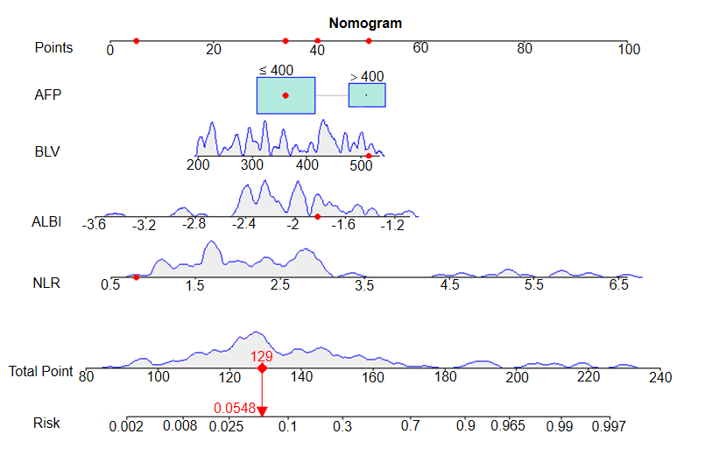
Figure 4 Nomogram prediction model for the occurrence of acute liver failure after R0 surgery for hepatocellular carcinoma. AFP: Acute liver failure; BLV: Blood loss volume; NLR: Neutrophil-to-lymphocyte ratio; ALBI: Albumin-bilirubin score.

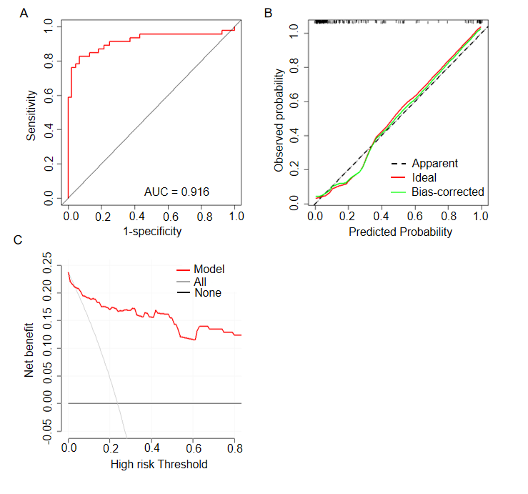
Figure 5 Evaluation of the nomogram prediction model. A: Receiver operating characteristic curve; B: Calibration curve; C: Decision curve analysis. AUC: Area under the curve.
Table 1 Comparison of general information, n (%)/mean ± SD
Factor | Non-ALF | ALF | t/z/χ² | P value
 | (n = 148) | (n = 46)
Gender |  |  | 0.382 | 0.537
Male | 88 (59.5) | 24 (52.2)
Female | 60 (40.5) | 22 (47.8)
Age | 49.0 ± 4.0 | 51.1 ± 5.9 | -2.719 | 0.007
BMI (kg/m²) | 23.454 ± 1.29 | 23.830 ± 1.424 | -1.620 | 0.110
Hypertension |  |  | 0.65 | 0.42
Yes | 52 (35.1) | 12 (26.1)
None | 96 (64.9) | 34 (73.9)
Diabetes |  |  | 0.394 | 0.53
Yes | 42 (28.4) | 10 (21.7)
None | 106 (71.6) | 36 (78.3)
History of hepatitis | 23.454 ± 1.29 | 23.830 ± 1.424 | -2.026 | 0.043
Yes | 103 (69.6) | 39 (84.8)
None | 45 (30.4) | 7 (15.2)
Liver cirrhosis |  |  | -2.026 | 0.043
Yes | 103 (69.6) | 39 (84.8)
None | 45 (30.4) | 7 (15.2)
Envelope integrity |  |  | -1.548 | 0.122
Complete | 127 (85.8) | 35 (76.1)
Incomplete | 21 (14.2) | 11 (23.9)
Tumor type |  |  | -0.331 | 0.74
Isolated | 119 (80.4) | 38 (82.6)
Nodal fusion | 29 (19.6) | 8 (17.4)
Number of tumors |  |  | -0.975 | 0.33
Single | 125 (84.5) | 36 (78.3)
Multiple | 23 (15.5) | 10 (21.7)
Surgical procedure |  |  | -2.269 | 0.023
Open | 85 (57.4) | 35 (76.1)
Abdominal | 63 (42.6) | 11 (23.9)
Portal vein cancer plug |  |  | -1.804 | 0.071
Negative | 136 (91.9) | 38 (8236)
Positive | 12 (8.1) | 8 (17.4)
BLV (mL) | 343.8 ± 97.9 | 418.2 ± 72.7 | -5.554 | 0.000
ALF: Acute liver failure; BMI: Body mass index; BLV: Blood loss volume.
Table 2 Comparison of laboratory data, n (%)/mean ± SD
Factor | Non-ALF | ALF | t/z/χ² | P value
 | (n = 148) | (n = 46)
AFP |  |  | -2.6 | 0.009
≤ 400 (ng/mL) | 113 (76.4) | 26 (56.5)
> 400 (ng/mL) | 35 (23.6) | 20 (43.5)
Hb (g/L) | 134.47 ± 21.418 | 129.74 ± 19.509 | 1.336 | 0.183
PLT (× 10⁹/L) | 155.107 ± 31.693 | 135.661 ± 27.468 | 3.746 | 0
WBC (× 10⁹/L) | 5.669 ± 0.956 | 5.613 ± 0.970 | 0.345 | 0.73
PT (s) | 12.2 ± 1.2 | 12.9 ± 1.2 | -3.337 | 0.001
TBil (μmol/L) | 16.778 ± 7.345 | 19.152 ± 7.472 | -1.907 | 0.058
DBIL (μmol/L) | 4.0 ± 2.8 | 5.0 ± 2.6 | -2.221 | 0.027
ALT (u/L) | 50.692 ± 15.477 | 48.687 ± 14.367 | 0.78 | 0.436
AST (u/L) | 43.562 ± 14.151 | 45.339 ± 13.180 | 0.756 | 0.451
ALF: Acute liver failure; AFP: Alpha-fetoprotein; Hb: Hemoglobin; PLT: Platelet count; WBC: White blood cell count; PT: Prothrombin time; TBil: Total bilirubin; DBIL: Direct bilirubin; ALT: Alanine aminotransferase; AST: Aspartate aminotransferase.
Table 3 Multifactorial analysis influencing the occurrence of alanine aminotransferase after R0 for hepatocellular carcinoma
Factor | β | SE | OR value | 95%CI | Wald value | P value
AFP | 1.401 | 0.539 | 4.058 | 1.411-11.670 | 6.755 | 0.009
BLV | 0.009 | 0.003 | 1.009 | 1.003-1.016 | 9.166 | 0.002
NLR | 1.464 | 0.277 | 4.318 | 2.511-7.426 | 27.969 | 0.000
ALBI | 2.157 | 0.665 | 8.646 | 2.350-31.816 | 10.531 | 0.001
AFP: Alpha-fetoprotein; BLV: Blood loss volume; NLR: Neutrophil-to-lymphocyte ratio; ALBI: Albumin-bilirubin score; OR: Odds ratio; CI: Confidence interval.
Table 4 Value of alpha-fetoprotein, blood loss volume, neutrophil-to-lymphocyte ratio, and albumin-bilirubin score in predicting the development of acute liver failure after R0 surgery for hepatocellular carcinoma
Indicator | Cut-off value | AUC | 95%CI | Specificity | Sensitivity | P value
AFP | 400 | 0.599 | 0.643-0.793 | - | - | 0.042
BLV | 302.850 | 0.718 | 0.643-0.793 | 1.000 | 0.432 | 0.000
NLR | 3.150 | 0.767 | 0.659-0.875 | 1.000 | 0.696 | 0.000
ALBI | -1.942 | 0.755 | 0.640-0.870 | 0.824 | 0.783 | 0.000
AFP: Alpha-fetoprotein; BLV: Blood loss volume; NLR: Neutrophil-to-lymphocyte ratio; ALBI: Albumin-bilirubin score; AUC: Area under the curve; CI: Confidence interval.

