Name of journal: World Journal of Gastroenterology
ESPS Manuscript NO: 11762
Columns: EVIDENCE-BASED MEDICINE

Prognostic value of ¹⁸F-FDG PET/CT in liver transplantation for hepatocarcinoma

Detry O et al. Prognostic value of ¹⁸F-FDG PET/CT in LT

Olivier Detry, Laurence Govaerts, Arnaud Deroover, Morgan Vandermeulen, Nicolas Meurisse, Serge Malenga, Noella Bletard, Charles Mbendi, Anne Lamproye, Pierre Honoré, Paul Meunier, Jean Delwaide, Roland Hustinx

Olivier Detry, Arnaud Deroover, Morgan Vandermeulen, Nicolas Meurisse, Pierre Honoré¹, Department of Abdominal Surgery and Transplantation, CHU Liege, University of Liege, ULg CHU, B4000 Liege, Belgium

Laurence Govaerts, Roland Hustinx, Department of Nuclear Medicine, CHU Liege, University of Liege, ULg CHU, B4000 Liege, Belgium

Serge Malenga, Paul Meunier, Department of Radiology, CHU Liege, University of Liege, ULg CHU, B4000 Liege, Belgium

Noella Bletard, Department of Pathology, CHU Liege, University of Liege, ULg CHU, B4000 Liege, Belgium

Charles Mbendi, Anne Lamproye, Jean Delwaide, Department of Hepato-Gastroenterology, CHU Liege, University of Liege, ULg CHU, B4000 Liege, Belgium

Author contribution: Detry O wrote the manuscript; Govaerts L and Hustinx R collected the data and analyzed the results; Bletard N reviewed the pathology of the explanted livers; all authors significantly contributed to the conception and design of the study, and to the interpretation of the data; all authors actively reviewed the manuscript, and approved its last version.

Supported by An unrestricted research grant from Astellas Belgium; SM and CM are PhD fellows with grants from the Académie de Recherche et d’Enseignement Supérieur (ARES) of the Wallonia-Brussels Federation

Correspondence to: Dr. Olivier Detry, Department of Abdominal Surgery and Transplantation, CHU Liege, Sart Tilman B35, B4000 Liege, Wallonia, Belgium. olivier.detry@transplantation.be
Telephone: +32-3667645 Fax: +32-43667069

Received: June 2, 2014 Revised: August 29, 2014
Accepted: September 29, 2014

Published online:

Abstract
AIM: To evaluate the prognostic value of pretreatment FDG positron emission tomography computed tomography (PET-CT) in patients with hepatocarcinoma treated by liver transplantation.

METHODS: The authors retrospectively analyzed the data of 27 patients (mean age 58 ± 9 years) who underwent FDG PET-CT before liver transplantation for hepatocarcinoma. Mean follow-up was 26 ± 18 mo. The FDG PET/CT was performed according to a standard clinical protocol: 4 MBqFDG/kg body weight, uptake 60 min, low-dose non-enhanced CT. The authors measured the SUVmax and SUVmean of the tumor and the normal liver. The tumor/liver activity ratios (RSUVmax and RSUVmean) were tested as prognostic factors and compared to the following conventional prognostic factors: MILAN, CLIP, OKUDA, TNM stage, alphafoetoprotein level, portal thrombosis, size of the largest nodule, tumor differentiation, microvascular invasion, underlying cirrhosis and liver function.

RESULTS: Overall and recurrence free survivals were 80.7% and 67.4% at 3 years, and 70.6 % and 67.4% at 5 years, respectively. According to a multivariate Cox model, only FDG PET/CT RSUVmax predicted recurrence free survival. Even though the MILAN criteria alone were not predictive, it is worth noting that none of the patients outside the MILAN criteria and with RSUVmax < 1.15 relapsed.

CONCLUSION: FDG PET/CT with an RSUVmax cut-off value of 1.15 is a strong prognostic factor for recurrence and death in patients with HCC treated by liver transplantation in this retrospective series. Further prospective studies should test whether this metabolic index should be systematically included in the preoperative assessment.

Key words: Cancer; Hepatoma; Hepatocellular cancer; Liver transplantation

Core tip: Patients suffering from hepatocarcinoma are selected for liver transplantation according to the Milan criteria that were established two decades ago. The aggressiveness of the tumor has also a particular importance, but there is still no ideal way of predicting the risk of recurrence according to pretransplant tumor metabolism. This study confirms that FDG positron emission tomography computed tomography with a tumor/liver activity ratios (RSUVmax) cut-off value of 1.15 is a strong prognostic factor for recurrence and death in patients with hepatocellular cancer (HCC) treated by liver transplantation. In addition, in this series, none of the patients outside the MILAN criteria with RSUVmax < 1.15 suffered from recurrence in the follow-up. Further prospective studies should test whether this metabolic index should be systematically included in the pretransplant assessment of HCC patients.

Detry O, Govaerts L, Deroover A, Vandermeulen M, Meurisse N, Malenga S, Bletard N, Lamproye A, Honoré P, Meunier P, Delwaide J, Hustinx R. Prognostic value of 18F-FDG PET/CT in liver transplantation for hepatocarcinoma. World J Gastroenterol 2014; In press

INTRODUCTION
Hepatocellular carcinoma (HCC) is the fifth most common cancer, and the third cause of cancer related-death worldwide. HCC incidence is particularly elevated in regions where hepatitis-B virus infection is endemic^{[1]}, but is also rising in Western countries^{[2]}. Liver transplantation (LT) has been established as the standard of care in selected candidates with underlying cirrhosis. However, the scarcity of organ donors has forced the development of strict criteria to limit LT to patients who are likely to have excellent outcomes. The universally accepted LT criteria for HCC are the Milan criteria (1 nodule ≤ 5 cm or 3 nodules ≤ 3 cm) that lead to a very low rate of post-LT recurrence^{[3]}, but many patients suffers from HCC outside the Milan criteria at the time of diagnosis. It is considered that some of these patients may benefit from LT with an acceptable risk of recurrence. This fact leads to the extension of LT criteria for HCC, as in the University of California San Francisco (UCSF)^{[4]} criteria or up-to-seven criteria^{[5]}.
However, it is clear that size and number of tumor nodules are not sufficient to precisely predict the risk of post LT HCC recurrence, and that the aggressiveness or differentiation of HCC should be taken into consideration. Microvascular invasion, AFP levels^{[6]}, and recently captation of ¹⁸F-fluorodeoxyglucose (¹⁸FDG) at positron emission tomography (PET)^{[7,8]} have all been proposed to evaluate the biological staging of HCC.
At the University of Liege LT program, ¹⁸FDG- PET/ computed tomography (CT) has been introduced in the pretransplant evaluation of LT candidates suffering from HCC. The objective of this study was to retrospectively analyze the value of ¹⁸FDG- PET/CT in predicting post-LT recurrence of HCC by comparison with other prognostic factors.

MATERIALS AND METHODS
This study is a retrospective evaluation of the 52 patients suffering from HCC and transplanted at the University of Liege hospital transplantation center between January 2006 and December 2011. Amongst these patients, 41 underwent ¹⁸FDG- PET/ CT evaluation before transplantation. Five patients were excluded as they had a past history of unrelated neoplasia, five others as they had undergone neoadjuvant therapy (mainly chemoembolization) prior to ¹⁸FDG- PET/ CT, 3 patients were lost to follow-up, and in one patient pathology of the explanted liver showed total tumoral necrosis. Twenty-seven patients were therefoe available for complete retrospective evaluation and their basic characteristics are presented in Table 1. Amongst the 27 patients, 13 suffered from HCC within the Milan criteria according to radiology and were granted Standard Exception (SE) status within the patient-oriented Eurotransplant liver graft allocation, and 14 were classified outside Milan criteria and received their liver graft in a centre-oriented rescue allocation^{[9]}. Nine patients underwent neo-adjuvant chemoembolization between PET/CT and LT. After transplant, basic immunosuppression consisted of regular triple therapy using tacrolimus, mycophenolate mofetil, and steroids that were progressively withdrawn after 4 wk.
Collected clinical data included age, gender, viral status, Child-Turcotte-Pugh classification, tumor stage, tumor number, preoperative alphafoetoprotein (AFP) levels, the Okuda score^{[10]}, the Cancer of the Liver Italian Program (CLIP) score^{[11]}, histological grade, vascular invasion, recurrence and date of recurrence, and survival. Data are presented as mean ± SD and ranges. Median post transplantation follow-up was 732 d (range: 37-2,016 d). Mean interval between ¹⁸FDG- PET/ CT evaluation and LT was 77 d (range: 7-363 d).
¹⁸FDG- PET/ low-dose CT were performed in a standard manner using Gemini TF 16 and Gemini Big Bore scanners (Philips, Amsterdam, The Netherlands). Patients were fasted at least 6 hours before injection of 4 MBq/kg of ¹⁸FDG. Patients’ glycaemia was checked and lower than 140 mg/dl before ¹⁸FDG injection, and they received 500 mL NaCl 0.9% intravenously after ¹⁸FDG injection and before image acquisition. Static emission scanning was performed 60 min after ¹⁸FDG injection. The ¹⁸FDG- PET/ CT images were first visually analyzed, then were semi-quantitatively evaluated to assess whether the ¹⁸FDG uptake in the tumor was significantly higher than the surrounding hepatic tissue. Regions of interest (ROI) were drawn over the normal liver and the tumor, and the standardized uptake values (SUV) in each ROI was measured. The ROI was drawn to encircle the highest activity of each tumor, with guidance from the CT scans that were acquired from PET/CT. The maximum SUV (SUVmax), the mean SUV (SUVmean), the ratio of tumor SUVmax to normal liver SUVmax (TSUVmax/LSUVmax), and the ratio of tumor SUVmax to normal liver SUVmean (TSUVmax/ LSUVmean) were calculated as described^{[12]}.

Statistical analysis
Data were analysed using the Prism 6.0c software for Macintosh OSX (GraphPad Software, San Diego, CA). Mean values ± SD and ranges are presented. A Receiver Operating Curve (ROC) analysis was performed in order to define the optimal cut-off for the metabolic variables to predict the outcome. Survival rates were calculated with the Kaplan-Meier method and compared with the log-rank (Mantel-Cox) test. Parameters being predictive for global survival and recurrence-free survival were assessed in a univariate analysis. All variables with a P value less than 0.05 were then included in a multivariate analysis applying the Cox multiple backward stepwise model to identify parameters being independently predictive. A value of P < 0.05 was considered significant.

RESULTS
Patients’ characteristics
The characteristics of the 27 patients are presented in Table 1. The majority of patients were male, older than 50 years-of-age, and suffering from viral or post-alcoholic cirrhosis. Amongst patients with viral cirrhosis, 8 had past hepatitis B virus infection, 7 hepatitis C virus related liver disease and one had both.

Global and recurrence free survivals
During the follow-up period, 5 patients developed HCC recurrence and 6 patients died. Within the whole series, one-, three- and five-year global patient survivals were 85.2%, 80.7% and 70.6%, respectively. One-, three- and five-year recurrence-free survivals were 77.4%, 67.4% and 67.4%, respectively (Fig 1). When comparing recurrence-free survivals according to ¹⁸FDG intake, there was a significant difference between ¹⁸FDG avid HCC compared to non-avid tumors P < 0.001) (Figure 2). The ROC curve analysis showed that 1.15 was the optimal cut-off value for predicting tumor recurrence, using the tumor to liver SUVmax activity ratios (Figure 3). When considering combination of the Milan criteria and ¹⁸FDG, there was a significantly worse survival rate for patients transplanted for ¹⁸FDG avid HCC outside the Milan criteria (Figure 4) compared to the other groups of patients (P < 0.001), with 0% recurrence-free survival at 2 years. Interestingly, there was no difference of recurrence-free survival between patients with HCC within the Milan criteria and the patients outisde Milan criteria but who had ¹⁸FDG negative HCC (P = 0.782) (Figure 5).

Comparison between ¹⁸FDG PET/CT and other prognostic factors
According to univariate analysis, TSUVmax/LSUVmax, TSUVmean/ LSUVmean were prognostic factors for survival without HCC recurrence, and TSUVmax/LSUVmax, TSUVmean/ LSUVmean, the size of the largest nodule, and the CLIP classification were prognostic factors for global survival in this series (Table 2). According to multivariate analysis, only TSUVmax/LSUVmax was a prognostic factor for survival without HCC recurrence (HR = 14.38; P = 0.0176).

DISCUSSION
This retrospective study confirms that ¹⁸FDG- PET with a TSUVmax/LSUVmax cut-off of 1.15 could be used as a selection criteria in the setting of LT for HCC. Particularly, HCC with a ¹⁸FDG RSUVmax < 1.15 uptake seem to have a low risk of recurrence after LT. It is therefore possible that ¹⁸FDG-PET could be used as a means of enlarging the Milan criteria for LT, allowing transplantation of HCC patients outside the Milan criteria but with an ¹⁸FDG RSUVmax < 1.15 uptake with good chances of long term recurrence free survival.
The standard care for curative management of HCC in Western countries remains surgical resection and/or LT. Compared to hepatectomy, LT has two major advantages: first LT is possible in patients with impaired liver function that would not withstand liver resection, and second, as LT removes the whole cirrhotic liver, it avoids the main cause of HCC recurrence i.e., the development of a second HCC within the diseased liver. However, LT availability is limited by the number of available (deceased or living) grafts^{[13]}, and LT carries a high risk of recurrence and death if the HCC is not limited to the removed diseased liver. For these reasons, prognostic criteria for long-term recurrence-free survival after LT have been evaluated for more than 30 years. Up to now, the Milan criteria have still been universally used as the best criteria for recurrence-free survival after LT for HCC, but these criteria are not ideal. Firstly, the Milan criteria are pretransplant radiologic criteria that were evaluated more than two decades ago, and liver imaging and particularly MRI are now revealing hypervascularised nodules that could not be detected at the time of the Milan study. In addition, the Milan criteria are very restrictive and a small proportion of patients with HCC are diagnosed within the Milan criteria; finally, it is now clear that the size and number of HCC nodules are not the only prognostic factors for recurrence, and that somehow the aggressiveness of tumors should be taken into account. Tumor differentiation and AFP levels are now evaluated as markers of tumor aggressiveness, and AFP is included in the liver graft allocation scheme in France. Differentiation is difficult to use clinically, as not all HCC are biopsied before LT, and that differentiation of HCC may vary between tumoral nodules, or even within the same nodule. In this setting, ¹⁸FDG-PET could be a useful non-invasive pretransplant tool that could evaluate the metabolism and the aggressiveness of the primary HCC tumor, and could also detect the extrahepatic spread of cancer^{[7, 14, 15]}.
This study confirms the experience of other groups evaluating the role of ¹⁸FDG-PET in the pretransplant evaluation of HCC patients. This series confirms that TSUVmax/LSUVmax cut-off of 1.15 is probably the best level that should be used to characterize HCC for LT. In addition, this series shows that patients with Milan out HCC with a ¹⁸FDG RSUVmax < 1.15 uptake could benefit from LT^{[16]}. In our series, recurrence-free survival of Milan out/ ¹⁸FDG PET negative patients was not decreased compared to patients with Milan in HCC. If confirmed, this finding could be used as a means to enlarge LT indications for HCC, allowing LT for some Milan out patients. This series also shows that Milan out and ¹⁸FDG/PET positive HCC have a very poor prognosis after LT, as all patients suffering from these aggressive cancers died from early recurrence. Finally, we hypothesise patients with Milan in but ¹⁸FDG/PET positive HCC might be a particular group of high-risk patients who should benefit from neoadjuvant therapy.
The limitations of this study are multiple. This is a retrospective evaluation of patients who were selected for LT, and it is probable that a prospective intention-to-treat study would demonstrate more precisely the role of ¹⁸FDG-PET in the setting of LT for HCC. In addition, this series is rather small, and a larger group of patients might help to more accurately define if Milan in but ¹⁸FDG/PET positive HCC have a worse prognosis than Milan in ¹⁸FDG/PET negative HCC after transplantation. Finally, the ¹⁸FDG/PET should be compared to other criteria that extend the Milan criteria, as the UCSF criteria or the up-to-seven criteria.
In conclusion, this study confirms that ¹⁸FDG/PET could be an interesting tool in the pre-LT evaluation of HCC patients and that the TSUVmax/LSUVmax cut-off of 1.15 should be used as a means to characterize HCC. Particularly, it deserves to be evaluated in a large prospective study if patients with HCC outside Milan criteria but with negative ¹⁸FDG PET, could be at low risk of recurrence after LT.

COMMENTS
Background
Liver transplantation is the standard treatment of patients suffering from cirrhosis complicated with hepatocarcinoma (HCC), a cancer whose incidence is increasing. However, liver transplantation is usually applied to patients with small HCC corresponding to the so-called Milan criteria (one nodule ≤ 5cm, ≤ 3 nodules ≤ 3 cm). However, the Milan criteria are very restrictive and only a small proportion of patients with HCC are diagnosed within the Milan criteria and might benefit of liver transplantation. Other factors than size are needed to determine if some patients outside the Milan criteria could benefit from liver transplantation.

Research frontiers
¹⁸FDG/PET is a very useful tool in the management of many cancers. The role of ¹⁸FDG/PET in HCC is not established yet, particularly in HCC patients who could benefit from liver transplantation. Some groups advocated that ¹⁸FDG/PET could help to differentiate HCC patients with low or high risk of recurrence after transplantation.

Innovations and breakthroughs
This retrospective study confirms that patients with HCC outside the Milan criteria that have a low intake at ¹⁸FDG/PET might be good candidates for liver transplantation with a low risk of cancer recurrence.

Applications
This finding has to be confirmed by prospective studies that should prospectively determine if patients with HCC outside Milan criteria that do not have an intake at ¹⁸FDG/PET should be candidate for liver transplantation.

Terminology
Hepatocarcinoma is the primary cancer of the liver that often complicates a chronic liver disease named cirrhosis. ¹⁸FDG/PET is non invasive medical exam that allows a better evaluation of cancer metabolism and evolution.

Peer review
This is an interesting article describing the prognostic value of FDG PET-CT for Liver transplantation (LT) recipients with HCC, even though similar researches have been conducted in recent years. The author found that FDG PET-CT could be a useful tool to select HCC patients for LT.
REFERENCES
1 El-Serag HB. Hepatocellular carcinoma. N Engl J Med 2011; 365: 1118-1127 [PMID: 21992124 DOI: 10.1056/NEJMra1001683]
2 El-Serag HB, Mason AC. Rising incidence of hepatocellular carcinoma in the United States. N Engl J Med 1999; 340: 745-750 [PMID: 10072408]
3 Mazzaferro V, Regalia E, Doci R, Andreola S, Pulvirenti A, Bozzetti F, Montalto F, Ammatuna M, Morabito A, Gennari L. Liver transplantation for the treatment of small hepatocellular carcinomas in patients with cirrhosis. N Engl J Med 1996; 334: 693-699 [PMID: 8594428]
4 Yao FY, Ferrell L, Bass NM, Watson JJ, Bacchetti P, Venook A, Ascher NL, Roberts JP. Liver transplantation for hepatocellular carcinoma: expansion of the tumor size limits does not adversely impact survival. Hepatology 2001; 33: 1394-1403 [PMID: 11391528 DOI: 10.1053/jhep.2001.24563]
5 Mazzaferro V, Llovet JM, Miceli R, Bhoori S, Schiavo M, Mariani L, Camerini T, Roayaie S, Schwartz ME, Grazi GL, Adam R, Neuhaus P, Salizzoni M, Bruix J, Forner A, De Carlis L, Cillo U, Burroughs AK, Troisi R, Rossi M, Gerunda GE, Lerut J, Belghiti J, Boin I, Gugenheim J, Rochling F, Van Hoek B, Majno P. Predicting survival after liver transplantation in patients with hepatocellular carcinoma beyond the Milan criteria: a retrospective, exploratory analysis. Lancet Oncol2009; 10: 35-43 [PMID: 19058754 DOI: 10.1016/S1470-2045(08)70284-5]
6 Duvoux C, Roudot-Thoraval F, Decaens T, Pessione F, Badran H, Piardi T, Francoz C, Compagnon P, Vanlemmens C, Dumortier J, Dharancy S, Gugenheim J, Bernard PH, Adam R, Radenne S, Muscari F, Conti F, Hardwigsen J, Pageaux GP, Chazouillères O, Salame E, Hilleret MN, Lebray P, Abergel A, Debette-Gratien M, Kluger MD, Mallat A, Azoulay D, Cherqui D. Liver transplantation for hepatocellular carcinoma: a model including α-fetoprotein improves the performance of Milan criteria.Gastroenterology 2012; 143: 986-94.e3; quiz e14-5 [PMID: 22750200 DOI: 10.1053/j.gastro.2012.05.052]
7 Pant V, Sen IB, Soin AS. Role of ¹⁸F-FDG PET CT as an independent prognostic indicator in patients with hepatocellular carcinoma. Nucl Med Commun 2013; 34: 749-757 [PMID: 23689586 DOI: 10.1097/MNM.0b013e3283622eef]
8 Hustinx R, Detry O. Hepatobiliary disease: primary and metastatic tumors. In: Cook G, Maisey M, Britton K, Chengazi V, editors. Clinical nuclear medicine. 4th edition ed. London, UK: Hodder Arnold, 2006
9 Detry O, Deroover A, Meurisse N, Hans MF, Delwaide J, Lauwick S, Kaba A, Joris J, Meurisse M, Honoré P. Donor age as a risk factor in donation after circulatory death liver transplantation in a controlled withdrawal protocol programme. Br J Surg 2014; 101: 784-792 [PMID: 24771475 DOI: 10.1002/bjs.9488]
10 Okuda K, Ohtsuki T, Obata H, Tomimatsu M, Okazaki N, Hasegawa H, Nakajima Y, Ohnishi K. Natural history of hepatocellular carcinoma and prognosis in relation to treatment. Study of 850 patients. Cancer 1985; 56: 918-928 [PMID: 2990661]
11 Llovet JM, Bruix J. Prospective validation of the Cancer of the Liver Italian Program (CLIP) score: a new prognostic system for patients with cirrhosis and hepatocellular carcinoma. Hepatology 2000; 32: 679-680 [PMID: 10991637 DOI: 10.1053/jhep.2000.16475]
12 Lee JW, Paeng JC, Kang KW, Kwon HW, Suh KS, Chung JK, Lee MC, Lee DS. Prediction of tumor recurrence by 18F-FDG PET in liver transplantation for hepatocellular carcinoma. J Nucl Med 2009; 50: 682-687 [PMID: 19372474 DOI: 10.2967/jnumed.108.060574]
13 Detry O, De Roover A, Delwaide J, Coimbra C, Kaba A, Joris J, Damas P, Meurisse M, Honoré P. Living related liver transplantation in adults: first year experience at the University of Liège. Acta Chir Belg 2004; 104: 166-171 [PMID: 15154573]
14 Yang SH, Suh KS, Lee HW, Cho EH, Cho JY, Cho YB, Yi NJ, Lee KU. The role of (18)F-FDG-PET imaging for the selection of liver transplantation candidates among hepatocellular carcinoma patients. Liver Transpl 2006; 12: 1655-1660 [PMID: 16964589 DOI: 10.1002/lt.20861]
15 Kornberg A, Freesmeyer M, Bärthel E, Jandt K, Katenkamp K, Steenbeck J, Sappler A, Habrecht O, Gottschild D, Settmacher U. 18F-FDG-uptake of hepatocellular carcinoma on PET predicts microvascular tumor invasion in liver transplant patients. Am J Transplant 2009; 9: 592-600 [PMID: 19191771 DOI: 10.1111/j.1600-6143.2008.02516.x]
16 Kornberg A, Küpper B, Tannapfel A, Büchler P, Krause B, Witt U, Gottschild D, Friess H. Patients with non-[18 F]fludeoxyglucose-avid advanced hepatocellular carcinoma on clinical staging may achieve long-term recurrence-free survival after liver transplantation. Liver Transpl 2012; 18: 53-61 [PMID: 21850692 DOI: 10.1002/lt.22416]

P-Reviewer: Jahromi A, Romagnoli R, Xia Q S-Editor: Qi Y L-Editor: E-Editor:

Table 1 Patients characteristics (n = 27)

Characteristics |  | mean ± SD or n | Ranges
Age (yr) |  | 58 ± 10 | 29-72
Gender (Male/Female) |  | 24/3
Underlying liver disease
 | Alcohol | 8
 | Viral | 15
 | Other cirrhosis | 2
 | Non-cirrhotic liver | 2
AFP at transplant (ng/mL) |  | 199 ± 476 | 0.9-1957
Milan at listing | in/out | 13/14
Neoadjuvant treatment | yes/no | 9/18
CHILD | A/B/C | 9/10/8
OKUDA | I/II/III | 7/15/5
CLIP | 0/1/2/3/4 | 1/7/9/6/4
Pathology
Number of nodules | 1/2/3/>3 | 5/6/3/13
Size of largest lesion (cm) |  | 3.8 ± 2.2 | 1.5-1.5
Differentiation | Low/intermediate/high grade | 1/13/13
Microvascular invasion | N/Y | 17/10
pTNM (7th) | T1/T2/T3a/T3b/T4 | 4/16/5/1/1
pTNM (Yao) | T1/T2/T3a/T3b/T4a/T4b | 0/8/5/1/12/1

Table 2 Univariate comparison of prognostic factors

 | Recurrence free survival |  |  | Global survival
 | HR | P |  | HR | P
TSUVmax/LSUVmax > 1.15 | 14.4 | 0.01 |  | 5.62 | 0.04
TSUVmean/ LSUVmean >1.15 | 14.4 | 0.01 |  | 5.62 | 0.04
Pretransplant treatment | 1.01 | 0.99 |  | 0.32 | 0.30
AFP | 0.99 | 0.47 |  | 1 | 0.52
Milan | 3.97 | 0.21 |  | 1.97 | 0.43
Portal vein thrombosis | 5.56 | 0.06 |  | 0.13 | 0.14
TNM (7th) | 1.93 | 0.36 |  | 1.93 | 0.30
Differentiation
Low grade | 20.3 | 0.05 |  | 12.4 | 0.08
Intermediate grade | 2.37 | 0.46 |  | 2.78 | 0.37
High grade | 1
Number of nodules | > 10⁷ | 0.99 |  | > 10⁷ | 0.99
Size of the largest nodule | 1.29 | 0.05 |  | 1.33 | 0.009
Microvascular invasion | 3.32 | 0.19 |  | 1.88 | 0.44
OKUDA | 1.54 | 0.51 |  | 2.92 | 0.09
CLIP | 1.26 | 0.60 |  | 2.39 | 0.03
AFP: Alphafoetoprotein; CLIP: Cancer of the liver italian program.

Figure 1 Global and recurrence-free survivals (P = 0.52).

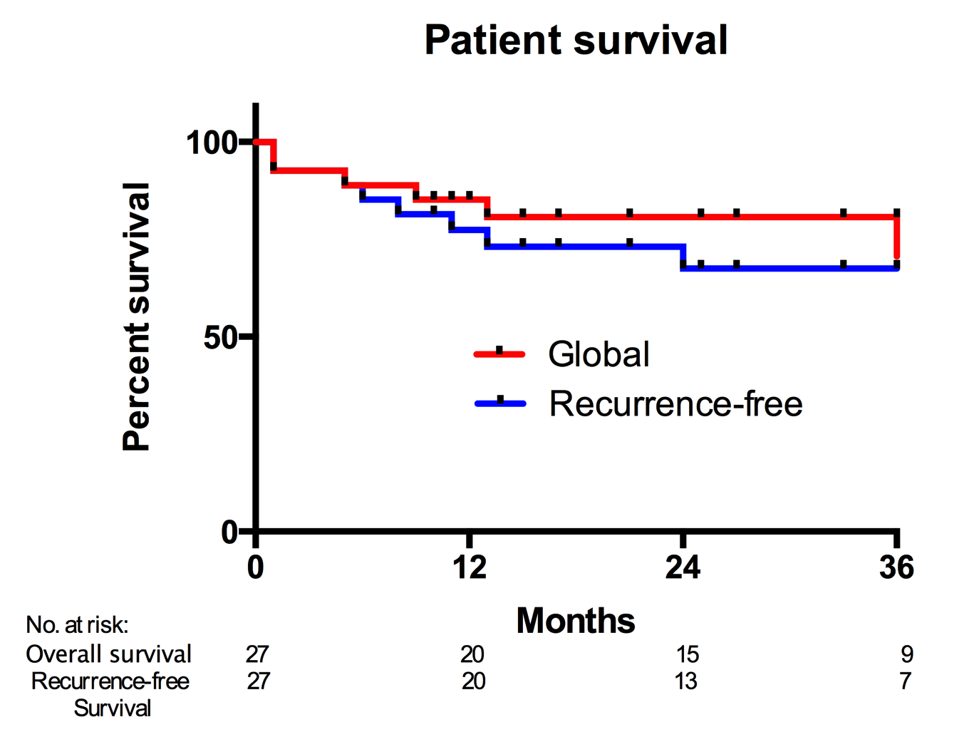
Figure 2 Recurrence-free survival curves according to ¹⁸FDG-PET intake with a cut-off at 1.15 (P = 0.0004).

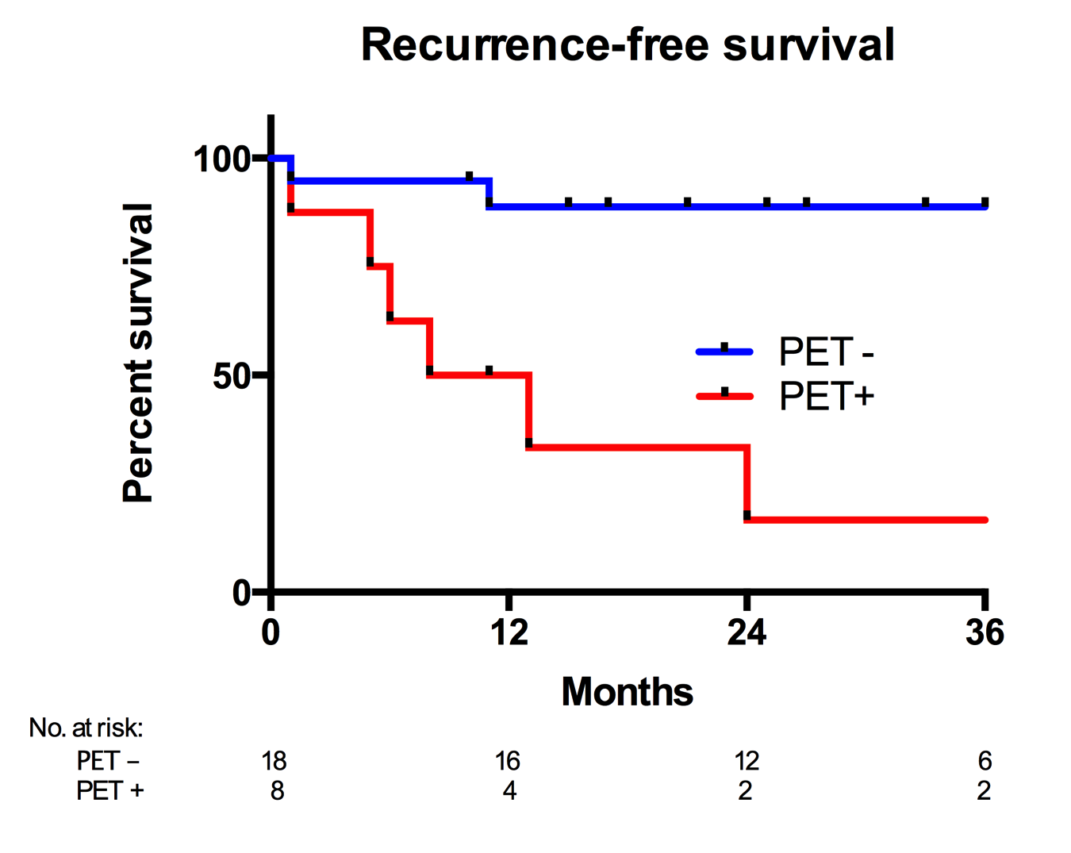

Figure 3 Receiver operating curve curve for recurrence.

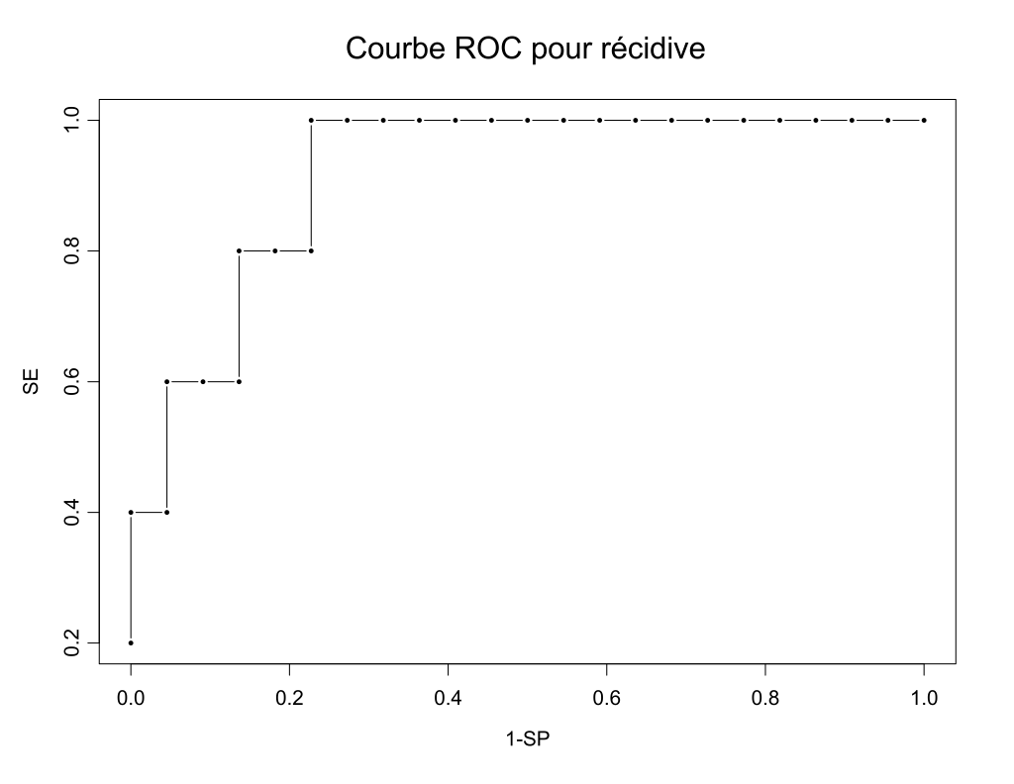
AUC=0.836

Figure 4 Recurrence-free survival curves according to Milan criteria combined with ¹⁸FDG- PET intake with a cut-off at 1.15 (P = 0.0008).

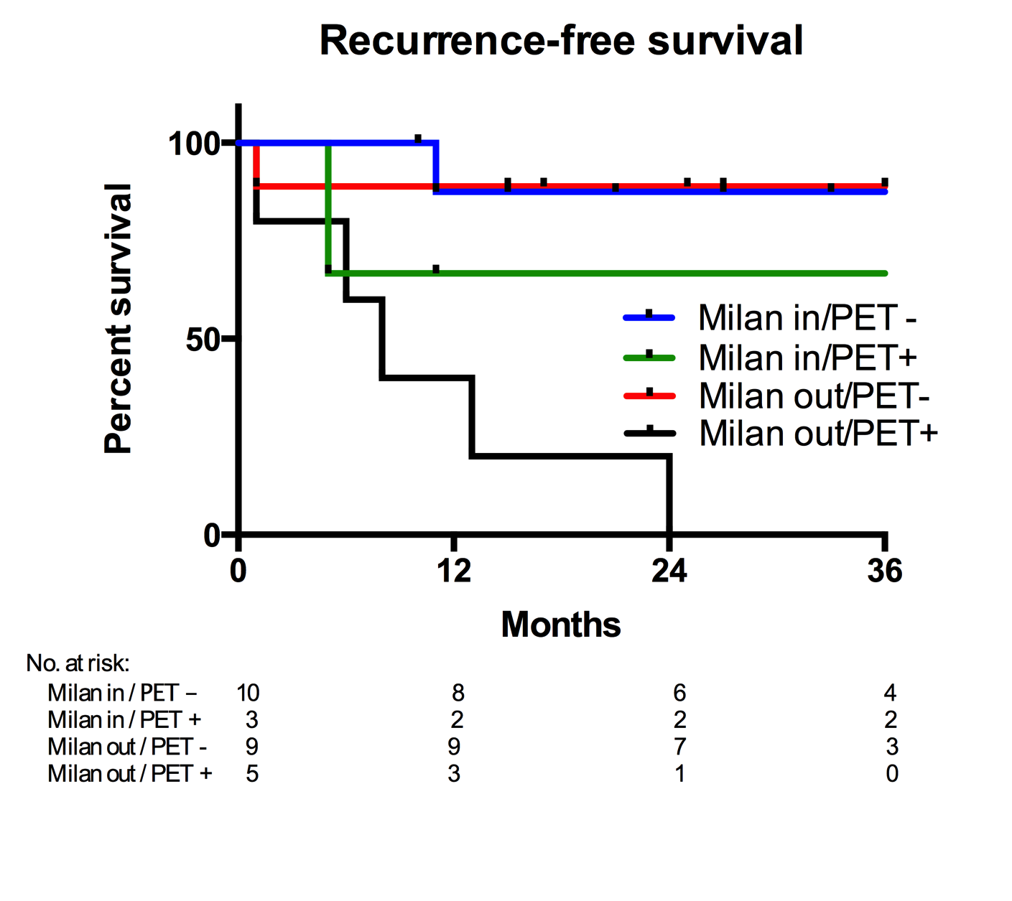

Figure 5 Recurrence-free survival curves comparing Milan in (PET-and PET +) and Milan out with ¹⁸FDG- PET intake lower than 1.15 (P = 0.78).
