Name of journal: World Journal of Gastroenterology
ESPS Manuscript NO: 23636
Manuscript Type: CASE REPORT

Application of cystoscope in surgical treatment of hepatocellular carcinoma with portal vein tumor thrombus

LI N, et al. Cystoscope in portal vein tumor thrombus

Nan Li, Xu-Biao Wei, Shu-Qun Cheng

Nan Li, Xu-Biao Wei, Shu-Qun Cheng, Department of Hepatic Surgery, Eastern Hepatobiliary Surgery Hospital, the Second Military Medical University, Shanghai 200433, China

Author contribution: Cheng SQ designed the report, carried out the operation; Li N and Wei XB collected the clinic data and wrote the paper; Li N and Wei XB contributed equally to the article.

Institutional review board statement: The study was reviewed and approved by the Institutional Review Board of Eastern Hepatobiliary Surgery Hospital.

Informed consent statement: All study participants, or their legal guardian, provided informed written consent prior to study enrollment.

Conflict-of-interest statement: No potential conflicts of interest relevant to this article were reported.

Open-Access: This article is an open-access article which was selected by an in-house editor and fully peer-reviewed by external reviewers. It is distributed in accordance with the Creative Commons Attribution Non Commercial (CC BY-NC 4.0) license, which permits others to distribute, remix, adapt, build upon this work non-commercially, and license their derivative works on different terms, provided the original work is properly cited and the use is non-commercial. See: http://creativecommons.org/licenses/by-nc/4.0/

Correspondence to: Shu-Qun Cheng, MD, Department of Hepatic Surgery, Eastern Hepatobiliary Surgery Hospital, Second Military Medical University, 168 Changhai Road, Yangpu District, Shanghai 200433, China. chengshuqun@aliyun.com
Telephone: +86-211-3901746
Fax: +86-218-1875251

Received: February 7, 2016
Peer-review started: February 7, 2016
First decision: January 13, 2016
Revised: March 6, 2016
Accepted: April 7, 2016
Article in press:
Published online:

Abstract
Development of portal vein tumor thrombus deteriorated the prognosis of hepatocellular carcinoma, while surgical treatment could offer a promising prognosis for selected patients. However, possible residual lesions in portal vein after conventional thrombectomy was a main risk factor leading to postoperative recurrence. Therefore, ensuring the complete removal of tumor thrombus during operation is critical to improve the prognosis. For the first time, we reported one case of hepatocellular carcinoma with portal vein tumor thrombus in which cystoscope was successfully applied as a substitute of intravascular endoscope to visualize the cavity of portal vein. It was a 61-year-old man with a 7-cm tumor in the right lobe of liver, with tumor thrombus invaded the right branch and was adjacent to the conjunction of portal vein. After removal of tumor, the Olympus CYF-VA2 cystoscope was used to check the portal vein from the opening stump of right branch of portal vein. In this case, residual thrombus tissue was found near the opening stump and the conjunction of portal vein. The residual lesion was carefully retrieved from the stump after retraction of the cystoscope. The procedure was repeated until no residual lesion was found. The whole duration time of thrombectmy was 22.5 (15 + 7.5) min. The patient was free from recurrence 8 months after the procedure. Our work indicated that the cystoscope is a suitable substitute with a proper size and function to check the portal vein system and ensure the curability of thrombectomy. Although well-designed clinic trails are still needed, this procedure may further improve the post-operative prognosis of hepatocellular carcinoma with portal vein tumor thrombus.

Key words: Hepatocellular carcinoma; Portal vein tumor thrombus; Surgical treatment; Thrombectomy; Cystoscope

© The Author(s) 2016. Published by Baishideng Publishing Group Inc. All rights reserved.

Core tip: Unable to ensure the curability of the thrombectomy was a main obstacle to improve the postoperative prognosis of hepatocellular carcinoma with portal vein tumor thrombus, especially for which invaded the main trunk of portal vein. In this report, we firstly applied the cystoscope as an intravascular endoscope to investigate the cavity of portal vein after removal of primary tumor. The cystoscope offered a clear view of the portal vein cavity from the main trunk to the secondary-branch, indicating it is a suitable substitute with a proper size and function to check the portal vein system.

Li N, Wei X, Cheng S. Application of cystoscope in surgical treatment of hepatocellular carcinoma with portal vein tumor thrombus. World J Gastroenterol 2016; In press

INTRODUCTION
Hepatocellular carcinoma (HCC) has a propensity to invade the intrahepatic vasculature, especially the portal vein system, leading to the formation of portal vein tumor thrombus (PVTT). PVTT is the most important significant factor for a poor prognosis, with a median survival of only 2.7 mo if the patients were untreated^{[1]}. Although Sorafenib was recommended by the Barcelona Clinic Liver Cancer (BCLC) guideline as the only therapy for these patients, recent studies have proven that surgical resection may offer a more promising prognosis for selected HCC patients with PVTT^{[2,3]}.
In the surgical operation, when the PVTT and tumor couldn’t be resected en-bloc, thrombectomy was carried out after the removal of tumor. Theoretically, when thrombectomy was performed, squeezing or fragmenting the tumor thrombus could not be avoided, which would increase the risk of scattering tumor tissue within the portal vein cavity. What’s more, there will be a possibility of residual PVTT tissues adhering to the inner wall of portal vein even after careful extraction^{[4-6]}. Those factors may lead to the early intrahepatic recurrence of tumor or PVTT^{[6]}. Therefore, ensuring the complete removal of PVTT during operation is critical to improve the prognosis. With the development of endoscopy, it is theoretically ideal to achieve this goal by direct visual observation under intravascular endoscope. However, to the best of our knowledge, there has been no angioscope specially designed for the portal vein system. Here we describe one case of HCC patient with PVTT in which cystoscope was successfully applied as a substitute of intravascular endoscope to visualize the cavity of portal vein.

CASE REPORT
The study was approved by our Institutional Review Board and written informed consent was obtained from the patient for this research. A 61-year-old man with hepatitis B virus infection presented to our department with a 7-cm HCC in the right lobe of liver, with tumor thrombus invaded the right branch and was adjacent to the conjunction of portal vein. Figure 1 shows a 3D reconstruction of the tumor and PVTT. The patient had Child-Pugh class A liver function and the other laboratory tests were normal. Intraoperative assessment confirmed the preoperative diagnosis. During operation, Pringle’s maneuver was applied distal to the PVTT to occlude the blood inflow using a clamp/unclamp cycle of 15 min/5 min. According to the tumor and the PVTT characteristics, a right semi-hepatectomy was carried out with a clamp crushing method.
After removal of tumor, the Olympus CYF-VA2 cystoscope was used to check the portal vein. First, the streamlined tip was inserted into the opening stump on the right branch of portal vein. The function of flush and suction was used to keep the field of view clear. In this case, scattered PVTT tissue was found near the opening stump. Further inspection revealed residual lesion near the conjunction of portal vein (Figure 2 A and B). Then, the cystoscope was retracted from the stump and the residual PVTT was carefully retrieved using a clamp. After that, the portal vein cavity was reexamined meticulously from the main trunk to the left secondary branch by bending the flexible tip and drawing in/out the insertion tube. The procedure was repeated until no residual lesion was found (Figure 2 C and D). Then the stump was closed using a continuous suture. The whole duration time of thrombectomy was 22.5 (15+7.5) min. The patient was discharged home without complications on postoperative day 7 and was free from recurrence 8 months after the procedure at the last follow-up.

DISSCUSSION
Curative resection of tumor and complete removal of PVTT is essential to improve the oncological prognosis of HCC patients with PVTT. For PVTT confined to the ipsilateral branch of portal vein, en-bloc resection of ipsilateral portal vein branch containing the tumor thrombus was recommended, whenever the liver remnant was sufficient^{[4,7]}. However, for patients with PVTT extended to the main portal trunk, or patients with insufficient liver remnant after en-bloc resection, thrombectomy would be inevitably carried out after the resection of primary tumor. Patients underwent thrombectomy was reported to have a poor prognosis, with a 6-month PVTT recurrence rate of 63.8% and the 1-year intrahepatic recurrence rate of 78.8%^{[4]}. For these patients, residual or disseminated tumor thrombus in portal vein may be a significant risk factor leading to the high recurrence rate^{[6]}. Therefore, it is crucial to eliminate the risk of residual thrombus while performing thrombectomy. Fortunately, the portal vein has no blood flow inside with the application of Pringle’s maneuver, allowing the possibility of endoscopic inspection. In this case, the cystoscope we used could view the portal vein cavity clearly from the main trunk to the secondary-branch, indicating it is a suitable substitute with a proper size and function to check the portal vein system. Despite microscopic lesion may still exist, this procedure theoretically eliminated the possibility of residual and scattered macroscopic tumor thrombus in portal vein and further ensured the curability of thrombectomy. This procedure may further improve the post-operative prognosis of hepatocellular carcinoma with portal vein tumor thrombus. It is also worth to carry out a well-designed clinic trail to measure the significance of intravascular endoscopy in proving the postoperative prognosis of HCC with PVTT.

COMMENTS
Case characteristics
A 61-year-old man presented to our department with a 7-cm HCC in the right lobe of liver, with tumor thrombus invaded the right branch and was adjacent to the conjunction of portal vein.

Treatment
Using a cystoscope to check the portal vein cavity after removal of tumor in surgical treatment of hepatocellular carcinoma with portal vein tumor thrombus.

Term explanation
PVTT means “Portal vein tumor thorombus”.

Experiences and lessons
The cystoscope we used could view the portal vein cavity clearly from the main trunk to the secondary-branch, indicating it is a suitable substitute with a proper size and function to check the portal vein system in the surgical treatment of hepatocellular carcinoma with portal vein tumor thrombus.

Peer-review
This a novel idea to ensure the curability of hepatectomy for hepatocellular carcinoma with portal vein tumor thrombus. While the effectiveness of the treatment need well-designed clinic trail to further confirm.

REFERENCE
1 Llovet JM, Bustamante J, Castells A, Vilana R, Ayuso Mdel C, Sala M, Brú C, Rodés J, Bruix J. Natural history of untreated nonsurgical hepatocellular carcinoma: rationale for the design and evaluation of therapeutic trials. Hepatology 1999; 29: 62-67 [PMID: 9862851 DOI: 10.1002/hep.510290145]
2 Shi J, Lai EC, Li N, Guo WX, Xue J, Lau WY, Wu MC, Cheng SQ. Surgical treatment of hepatocellular carcinoma with portal vein tumor thrombus. Ann Surg Oncol 2010; 17: 2073-2080 [PMID: 20131013 DOI: 10.1245/s10434-010-0940-4]
3 Shi J, Lai EC, Li N, Guo WX, Xue J, Lau WY, Wu MC, Cheng SQ. A new classification for hepatocellular carcinoma with portal vein tumor thrombus. J Hepatobiliary Pancreat Sci 2011; 18: 74-80 [PMID: 20686792 DOI: 10.1007/s00534-010-0314-0]
4 Chen XP, Qiu FZ, Wu ZD, Zhang ZW, Huang ZY, Chen YF, Zhang BX, He SQ, Zhang WG. Effects of location and extension of portal vein tumor thrombus on long-term outcomes of surgical treatment for hepatocellular carcinoma. Ann Surg Oncol 2006; 13: 940-946 [PMID: 16788755 DOI: 10.1245/ASO.2006.08.007]
5 Ikai I, Yamamoto Y, Yamamoto N, Terajima H, Hatano E, Shimahara Y, Yamaoka Y. Results of hepatic resection for hepatocellular carcinoma invading major portal and/or hepatic veins. Surg Oncol Clin N Am 2003; 12: 65-75, ix [PMID: 12735130]
6 Inoue Y, Hasegawa K, Ishizawa T, Aoki T, Sano K, Beck Y, Imamura H, Sugawara Y, Kokudo N, Makuuchi M. Is there any difference in survival according to the portal tumor thrombectomy method in patients with hepatocellular carcinoma? Surgery 2009; 145: 9-19 [PMID: 19081470 DOI: 10.1016/j.surg.2008.09.005]
7 Chok KS, Cheung TT, Chan SC, Poon RT, Fan ST, Lo CM. Surgical outcomes in hepatocellular carcinoma patients with portal vein tumor thrombosis. World J Surg 2014; 38: 490-496 [PMID: 24132826 DOI: 10.1007/s00268-013-2290-4]

P-Reviewer: Peltec A, Sirin G S-Editor: Qi Y L-Editor: E-Editor:

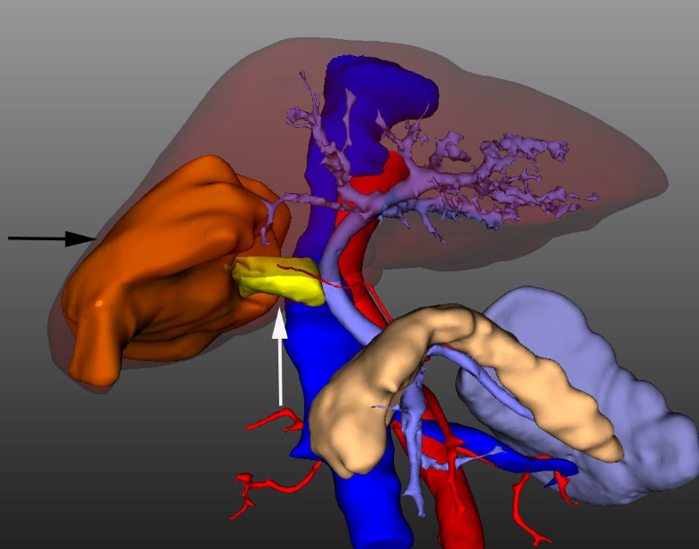
Figure 1 3D reconstruction of the tumor and portal vein tumor thrombus. A 7 cm hepatocellular carcinoma (white arrow) located in the segments V, VI, VII. The tumor thrombus (Black arrow) extended into the right branch and was adjacent to the conjunction of portal vein.
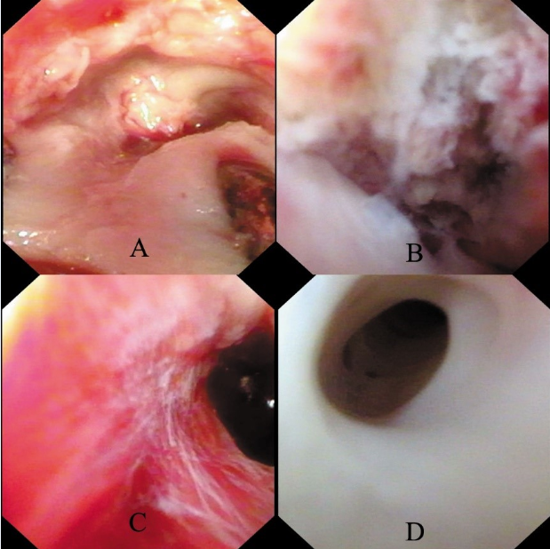
Figure 2 Function of flush and suction. A: Before thrombectomy, endoscopy revealed scattered tissue of tumor thrombus near the opening stump; B: Residual tumor thrombus adhered to the inner wall of portal vein near the conjunction; C: After repeated retraction of residual tumor thrombus, endoscopy revealed clean inner wall of portal vein with no macroscopic thrombus left; D: The left secondary branch of portal vein was clean with no scattered thrombus.

