Name of Journal: World Journal of Clinical Cases
Manuscript NO: 68846
Manuscript Type: CASE REPORT

Biopsy-confirmed fenofibrate-induced severe jaundice: A case report

Lee H.Y et al. Fenofibrate-induced severe jaundice

Hye Young Lee, Ae-Ra Lee, Jeong-Ju Yoo, Susie Chin, Sang Gyune Kim, Young Seok Kim

Hye Young Lee, Ae-Ra Lee, Jeong-Ju Yoo, Sang Gyune Kim, Young Seok Kim, Department of Internal Medicine, Soonchunhyang University Bucheon Hospital, Bucheon 14584, South Korea

Susie Chin, Department of Pathology, Soonchunhyang University Bucheon Hospital, Soonchunhyang University College of Medicine, Bucheon 14584, South Korea

Author contributions: Lee HY and Lee AR contributed equally to this manuscript; Lee HY and Lee AR draft the original manuscript and managed the data; Yoo JJ contributed to the conceptualization, investigation, project administration and reviewed and edited the manuscript; Lee HY contributed to the formal analysis, visualization and provided the resources; Kim SG contributed to the methodology and supervision; all authors approval of final manuscript.

Supported by Soonchunhyang University Research Fund, No. 20200037.

Corresponding author: Jeong-Ju Yoo, MD, Professor, Department of Internal Medicine, Soonchunhyang University Bucheon Hospital, Jomaruro, Bucheon 14584, South Korea. puby17@naver.com

Received: June 6, 2021
Revised: July 5, 2021
Accepted: August 27, 2021
Published online:

Abstract
BACKGROUND
Drug-induced liver injury (DILI) is the leading cause of acute liver failure in the United States. DILI is mainly caused by painkillers and fever reducers, and it is often characterized by the type of hepatic injury (hepatocellular or cholestatic). This report presents a case of fenofibrate-induced severe jaundice in a 65-year-old Korean male with no prior history of liver disease. We offer a strategy for patients who present signs of severe liver injury with jaundice and high elevations in serum transaminases.

CASE SUMMARY
A 65-year-old male visited the gastroenterology outpatient clinic of a tertiary hospital due to increased levels of liver enzyme and total bilirubin which were incidentally detected through a preoperative screening test. Abdominal ultrasound and computed tomography showed no biliary obstruction or non-specific findings in the liver. Liver biopsy was performed and the patient was finally diagnosed with acute cholestatic hepatitis. Following the biopsy, steroid therapy was initiated and after 3 wk of treatment, the total bilirubin level was reduced to 7.22 mg/dL.

CONCLUSION
In patients with hyperlipidemia, treatment including fenofibric acid induces rare complications such as severe jaundice and acute cholestatic hepatitis, warranting clinical attention.

Key Words: Drug-induced liver injury; Toxic hepatitis; Fenofibrate; Fenofibric acid; Jaundice; Hepatotoxicity; Hyperlipidemia; Case report

Lee HY, Lee AR, Yoo JJ, Chin S, Kim SG, Kim YS. Biopsy-confirmed fenofibrate-induced severe jaundice: A case report. World J Clin Cases 2021; In press

Core Tip: In patients with hyperlipidemia, treatment including fenofibric acid causes rare complications such as severe jaundice and acute cholestatic hepatitis, which requires clinical attention.

INTRODUCTION
Drug-induced liver injury (DILI) accounts for approximately 10% of all cases of acute hepatitis, and it is the most common cause of acute liver failure in the United States^{[1]}. DILI is usually caused by medications, herbal medications, ethanol and dietary supplements. In particular, painkillers and fever reducers taken in doses more than recommended are the main causes of DILI^{[2]}. DILI is often characterized by the type of hepatic injury, which is divided into hepatocellular or cholestatic injury^{[3]}. Hepatocellular injury leads to increased serum aminotransferases in comparison to alkaline phosphatase. Cholestatic liver injury causes elevated alkaline phosphatase (ALP) levels compared to serum aminotransferases. DILI cholestasis is defined as an increase in ALP > 2 × upper limit of normal (ULN) and an alanine aminotransferase (ALT)-to-ALP ratio less than 2^{[4]}.
This report presents a case of fenofibrate-induced severe jaundice in a 65-year-old Korean male patient with no prior history of liver disease. We discuss our investigative and management approach, and present a review of prior cases. A strategy for patients with signs of severe liver injury accompanied by jaundice and elevation in serum transaminases is also suggested.

CASE PRESENTATION
Chief complaints
A 65-year-old male with severe jaundice visited the outpatient referral university hospital.

History of present illness
A 65-year-old male was referred to a gastroenterology outpatient clinic of a tertiary hospital due to jaundice and increased levels of liver enzyme which were incidentally detected during a preoperative screening at a local clinic.
In early February 2021, the patient was treated with 135 mg of fenofibric acid due to hyperlipidemia. In mid-February 2021, he was incidentally diagnosed with a ureteric stone and was recommended to undergo surgery at a local hospital. In Korea, routine blood tests are performed prior to surgery in clinical practice that requires general anesthesia. The patient’s jaundice was discovered incidentally through a preoperative blood test. Prior to visiting the outpatient clinic, the patient experienced symptoms of mild itching and jaundice for 2 wk. Thus, we can assume that the patient developed jaundice during the first week of March, four weeks after the initiation of the drug.
Laboratory tests showed increased ALT (172 U/L), aspartate aminotransferase (AST) (133 U/L), ALP (1182 U/L), and total bilirubin (15.99 mg/dL) (Figure 3). Abdominal ultrasound and computed tomography (Figure 1) showed non-specific findings in the liver and no evidence of biliary obstruction.

History of past illness
The patient was a non-drinker and former smoker who quit smoking 10 years ago. He was diagnosed with hypertension 5 years ago and was administered with a daily dosage of amlodipine 5 mg and valsartan 160 mg.

Personal and family history
There is no personal and family history.

Physical examination
At the time of admission, his height was 165.9 cm, weight 66.3kg, and BMI 24 kg/m². His blood pressure was normal with a systolic blood pressure of 125 mmHg and a diastolic blood pressure of 80 mmHg. He had a normal body temperature (36.5°C) and normal heart rate (100 bpm). He also showed a normal breathing rate at 18 breaths per minute. He had a soft abdomen. He had a slight itching sensation and jaundice.

Laboratory examinations
Before visiting our hospital, the patient underwent blood tests at a local hospital. His AST, ALT, and ALP counts were 133 U/L, 172 U/L, and 1182 U/L, respectively. Initial PT and aPTT values were 12.4 s and 34.2 s, respectively. The total bilirubin level was 15.99 mg/dL. However, after admission, the AST, ALT and ALP counts were reduced to 120 U/L, 144 U/L, and 366 U/L, respectively. Over the course of several days after admission, the patient’s serum bilirubin level rose up to a maximum of 22.13 mg/dL (Figure 3). His prothrombin time international normalized ratio (PT INR) was 0.92. All viral hepatitis markers (hepatitis B virus surface antigen, immunoglobulin M antibody to hepatitis A, hepatitis C antibody, immunoglobulin M antibody to hepatitis E virus) were negative. Serum ferritin and ceruloplasmin were in the normal range at 128 ng/mL and 36.9 mg/dL, respectively. All of the following autoantibody tests showed negative results: anti-nuclear antibody, anti-mitochondrial antibody, anti-smooth muscle antibody, anti-liver/kidney microsomal antibodies type 1. Factor V levels were not determined.

Imaging examinations
Contrast-enhanced abdominal computed tomography revealed a few small cysts in both liver lobes. The patient’s gall bladder was not well expanded and the wall showed diffuse thickening, without bile duct obstruction (Figure 1A and B).

FINAL DIAGNOSIS
A liver biopsy to establish the cause of jaundice was performed. Liver biopsy showed acute cholestatic hepatitis consistent with toxic hepatitis (Figure 2). The Roussel Uclaf Causality Assessment Method score was 6 (time to onset from the beginning of the drug/herb: 2 points; course of ALP after cessation of the drug/herb: 2 points; risk factors such as age: 1 point; search for alternative causes: 1 point) which indicates that fenofibrate is the probable cause of DILI. Thus, we diagnosed the patient with severe DILI due to fenofibrate.

TREATMENT
After the biopsy, the patient was treated empirically for DILI with prednisolone 40 mg daily for one week. The dose of prednisolone was subsequently rapidly reduced.

OUTCOME AND FOLLOW-UP
Steroid therapy was initiated the day after liver biopsy. At the time of discharge, the AST and ALT levels of the patient were reduced to 53 U/L and 27 U/L, respectively. The total bilirubin level decreased to 10.03 mg/dL. The patient was discharged after 3 wk of inpatient treatment. After discontinuation of fibrate treatment, jaundice improved rapidly and the patient is currently being observed in the outpatient clinic (Figure 3).

DISCUSSION
Fenofibrate is a fibric acid derivative commonly used to reduce cholesterol and triglycerides^{[5,6]}. The most common adverse effects of fibrates include gastrointestinal upset, nausea, headache and muscle cramps and rash, which are mostly mild and generally transient symptoms^{[5,7-9]}. Despite its widespread use, fenofibrate rarely causes clinically significant hepatotoxicity^{[5,10-12]}. Mild and transient elevations in serum aminotransferase develop in 5%-10% of patients^{[6]}. DILI associated with fenofibrate occurs very rarely, in only 0.6% of patients^{[6]}. Although most fenofibrate-induced liver injuries are self-limited, serious DILIs associated with fenofibrate can occur, if discontinuation of drug is delayed.

Characteristics of fibrate-induced liver injury
The characteristics of fibrate-induced hepatitis are not well known due to its rare occurrence. Demographic and clinical characteristics of the 11 cases are presented in Table 1. Fenofibrate-induced liver injury appears to afflict older men. Seven of the 11 patients were male (63.6%) and the median age was 54 years, with an age range of 37-74 years^{[6,7,13,14]}. BMI was reported in 7 patients. All patients reported BMI values which were either overweight [body mass index (BMI) 25–30 kg/m²] or obese (BMI > 30 kg/m²)^{[6]}. Four out of the 11 total patients had diabetes mellitus. The onset of injury was variable. Latency was short (2 d to 8 wk) in 7 patients ^{[7,8,13]}, and prolonged up to 2 years (18 wk-2 years) in the other 4 patients^{[6,14]}.

Biochemical and histopathological findings
Biochemically, the initial pattern of liver injury (based on the R ratio) was variable but patients who manifested initial cholestatic patterns of liver injury showed severe clinical outcomes. In particular, the clinical prognosis was poor when the initial prolongation of PT INR was high. Both patients with severe injury and PT prolongation were characterized by delayed drug discontinuation. In the case of death, PT INR was 1.4 and in the case of liver transplantation 4.3. Data from published cases reflect an average elevation of ALT of 13 × ULN (539.88), ALP 3 × ULN (373), and total bilirubin of 6 × ULN (7.23).
Patients with high levels of serum total bilirubin at the time of admission were hospitalized longer and showed delayed recovery. Of the 4 cases with prolonged hospital stay or slow recovery, one recovered in a relatively short time, and all of them showed acute hepatitis on biopsy. In this case, the total bilirubin level rose to 22.13 mg/dL, but recovered within 3 wk, and histological findings showed acute hepatitis.
The common pathological findings of toxic hepatitis include necrosis and cholestasis, although these are not specific to toxic hepatitis. Five of the 11 cases reviewed underwent liver biopsy. Liver biopsy showed diverse patterns of injury, based on published literature, with most of the cases showing cholestasis. The clinical prognosis was worse in the case of chronic cholestasis in the liver biopsy than in the case of acute cholestasis. Chronic cholestasis was associated with duct injury that was characterized by reactive epithelial changes rather than direct inflammation^{[6]}.

Outcomes of fibrate-induced liver injury
While the majority of DILIs resolve with prompt discontinuation of the offending drug, DILIs can worsen and progress to liver failures that require transplantation or result in death, particularly if drug withdrawal is delayed. Nine of the 11 cases with acute hepatotoxicity fully recovered and 2 developed a severe clinical course. One underwent liver transplantation at 8 mo and the other eventually died of renal failure at 26 mo. Both severe cases had delayed cessation of fenofibrate therapy, which resulted in chronic progressive cholestatic liver injury^{[6]}. Reported cases of fenofibrate-induced hepatitis appear to be idiosyncratic. The mechanism of idiosyncratic DILI remains unresolved. However, sufficient evidence exists that most idiosyncratic cases are mediated by adaptive immune systems which depend on stimulation of the innate immune system, although the triggering factors are unknown. One of the patients receiving the minimal recommended dose (48 mg) died.

Possible risk factors for fibrate-induced liver injury
Possible risk factors for severe hepatic injury may include older age, prolonged PT, cholestatic pattern of initial liver injury, multiple gallstones and history of cholecystectomy. In patients with these risk factors, delayed drug discontinuation can lead to poor outcomes. However, well-controlled studies are needed to corroborate these findings.
High BMI is frequently reported in patients with fibrate-induced liver injury. Hyperlipidemia is one of the metabolic syndrome items, and such patients are often accompanied by obesity. In fact, in most of the previous case reports of fibrate-induced jaundice, the majority of patients were obese with a BMI of 25 mg/m² or higher. However, it is not yet known whether high BMI is a simple bias or a real risk factor. Further research is needed to determine whether the two factors have a simple association or a temporal causal relationship. In our case as well, the patient's BMI was 24, demonstrating that fibrate-induced jaundice can sufficiently occur even in patients with low BMI.

CONCLUSION
Fenofibrate is widely prescribed for patients with hypertriglycemia to decrease the risk of cardiovascular diseases. Fenofibrate-induced hepatitis is a rare type of DILI. However, fenofibrate–induced DILI can be severe and prolonged with the potential for chronicity due to delayed discontinuation. Older males with high BMI, prolonged PT, cholestatic pattern of liver injury, and history of cholestatic hepatobiliary disease are more likely to develop severe liver injury associated with jaundice and high elevations in serum transaminases.
Routine liver biochemistry monitoring is recommended at least 2 wk after initial fenofibrate ingestion followed by regular monitoring every 3 mo within the first 1 to 2 years of therapy. Discontinuation is recommended if liver enzymes persist at levels above 3 times the ULN or if jaundice is detected. Clinicians need to discontinue treatment in patients with jaundice and highly elevated liver enzymes during fenofibrate therapy.

REFERENCES
1 Ghabril M, Chalasani N, Björnsson E. Drug-induced liver injury: a clinical update. Curr Opin Gastroenterol 2010; 26: 222-226 [PMID: 20186054 DOI: 10.1097/MOG.0b013e3283383c7c]
2 Kumar N, Surani S, Udeani G, Mathew S, John S, Sajan S, Mishra J. Drug-induced liver injury and prospect of cytokine based therapy; A focus on IL-2 based therapies. Life Sci 2021; 278: 119544 [PMID: 33945827 DOI: 10.1016/j.lfs.2021.119544]
3 Yu YC, Mao YM, Chen CW, Chen JJ, Chen J, Cong WM, Ding Y, Duan ZP, Fu QC, Guo XY, Hu P, Hu XQ, Jia JD, Lai RT, Li DL, Liu YX, Lu LG, Ma SW, Ma X, Nan YM, Ren H, Shen T, Wang H, Wang JY, Wang TL, Wang XJ, Wei L, Xie Q, Xie W, Yang CQ, Yang DL, Yu YY, Zeng MD, Zhang L, Zhao XY, Zhuang H; Drug-induced Liver Injury (DILI) Study Group; Chinese Society of Hepatology (CSH); Chinese Medical Association (CMA). CSH guidelines for the diagnosis and treatment of drug-induced liver injury. Hepatol Int 2017; 11: 221-241 [PMID: 28405790 DOI: 10.1007/s12072-017-9793-2]
4 Katarey D, Verma S. Drug-induced liver injury. Clin Med (Lond) 2016; 16: s104-s109 [PMID: 27956449 DOI: 10.7861/clinmedicine.16-6-s104]
5 Bhardwaj SS, Chalasani N. Lipid-lowering agents that cause drug-induced hepatotoxicity. Clin Liver Dis 2007; 11: 597-613, vii [PMID: 17723922 DOI: 10.1016/j.cld.2007.06.010]
6 Ahmad J, Odin JA, Hayashi PH, Chalasani N, Fontana RJ, Barnhart H, Cirulli ET, Kleiner DE, Hoofnagle JH. Identification and Characterization of Fenofibrate-Induced Liver Injury. Dig Dis Sci 2017; 62: 3596-3604 [PMID: 29119413 DOI: 10.1007/s10620-017-4812-7]
7 Dohmen K, Wen CY, Nagaoka S, Yano K, Abiru S, Ueki T, Komori A, Daikoku M, Yatsuhashi H, Ishibashi H. Fenofibrate-induced liver injury. World J Gastroenterol 2005; 11: 7702-7703 [PMID: 16437706 DOI: 10.3748/wjg.v11.i48.7702]
8 Ho CY, Kuo TH, Chen TS, Tsay SH, Chang FY, Lee SD. Fenofibrate-induced acute cholestatic hepatitis. J Chin Med Assoc 2004; 67: 245-247 [PMID: 15357112]
9 Kiskac M, Zorlu M, Cakirca M, Karatoprak C, Peru C, Erkoc R, Yavuz E. A case of rhabdomyolysis complicated with acute renal failure after resumption of fenofibrate therapy: a first report. Indian J Pharmacol 2013; 45: 305-306 [PMID: 23833382 DOI: 10.4103/0253-7613.111912]
10 Parra JL, Reddy KR. Hepatotoxicity of hypolipidemic drugs. Clin Liver Dis 2003; 7: 415-433 [PMID: 12879992 DOI: 10.1016/s1089-3261(03)00024-2]
11 Chitturi S, George J. Hepatotoxicity of commonly used drugs: nonsteroidal anti-inflammatory drugs, antihypertensives, antidiabetic agents, anticonvulsants, lipid-lowering agents, psychotropic drugs. Semin Liver Dis 2002; 22: 169-183 [PMID: 12016548 DOI: 10.1055/s-2002-30102]
12 Keech A, Simes RJ, Barter P, Best J, Scott R, Taskinen MR, Forder P, Pillai A, Davis T, Glasziou P, Drury P, Kesäniemi YA, Sullivan D, Hunt D, Colman P, d'Emden M, Whiting M, Ehnholm C, Laakso M; FIELD study investigators. Effects of long-term fenofibrate therapy on cardiovascular events in 9795 people with type 2 diabetes mellitus (the FIELD study): randomised controlled trial. Lancet 2005; 366: 1849-1861 [PMID: 16310551 DOI: 10.1016/S0140-6736(05)67667-2]
13 Ma S, Liu S, Wang Q, Chen L, Yang P, Sun H. Fenofibrate-induced hepatotoxicity: A case with a special feature that is different from those in the LiverTox database. J Clin Pharm Ther 2020; 45: 204-207 [PMID: 31518450 DOI: 10.1111/jcpt.13042]
14 Rigal J, Furet Y, Autret E, Breteau M. [Severe mixed hepatitis caused by fenofibrate? A review of the literature apropos of a case]. Rev Med Interne 1989; 10: 65-67 [PMID: 2655052 DOI: 10.1016/s0248-8663(89)80119-5]

Footnotes
Informed consent statement: Informed consent statement was waived due to the retrospective nature of this case report.

Conflict-of-interest statement: The authors declare that they have no conflict of interest.

CARE Checklist (2016) statement: The authors have read the CARE Checklist (2016). The manuscript was prepared and revised according to the CARE Checklist (2016).

Open-Access: This article is an open-access article that was selected by an in-house editor and fully peer-reviewed by external reviewers. It is distributed in accordance with the Creative Commons Attribution NonCommercial (CC BY-NC 4.0) license, which permits others to distribute, remix, adapt, build upon this work non-commercially, and license their derivative works on different terms, provided the original work is properly cited and the use is non-commercial. See: http://creativecommons.org/Licenses/by-nc/4.0/

Manuscript source: Unsolicited manuscript

Peer-review started: June 6, 2021
First decision: June 25, 2021
Article in press:

Specialty type: Gastroenterology and hepatology
Country/Territory of origin: South Korea
Peer-review report’s scientific quality classification
Grade A (Excellent): 0
Grade B (Very good): B
Grade C (Good): C
Grade D (Fair): 0
Grade E (Poor): 0

P-Reviewer: Malnick SDH S-Editor: Wu YXJ L-Editor: P-Editor:

Figure Legends
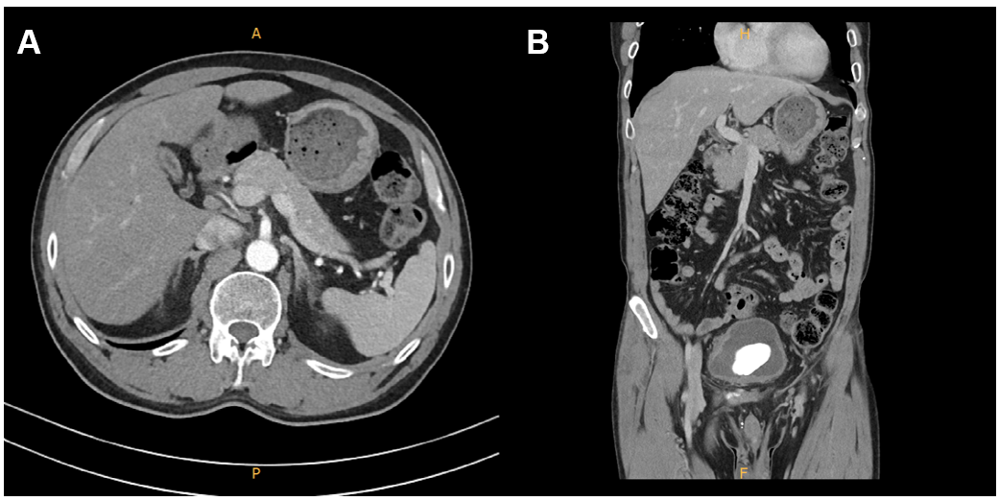
Figure 1 Computed tomography of the patient. Contrast-enhanced abdominal computed tomography revealed no bile duct obstruction. A: Transverse plane; B: Coronal view.

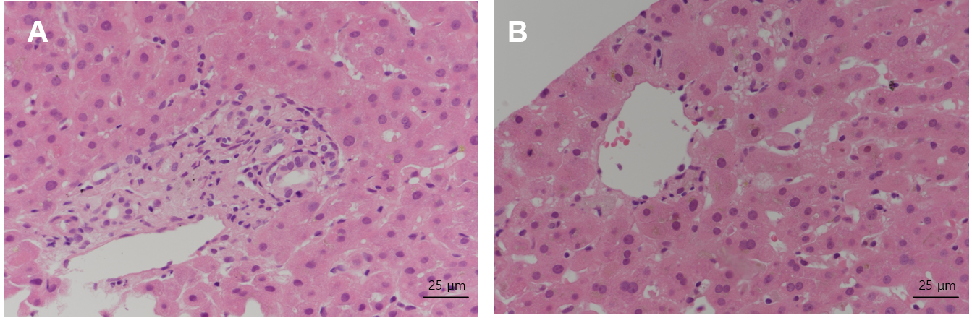
Figure 2 Results of liver biopsy. Magnification: 400 ×; scale bar: 25 μm. A: The overall findings of sinusoidal inflammation in the portal tract increased. Hepatocytes are pinkish and ballooned. Portal vein fibrosis and increased nodular activity are found. Bile pigment is deposited in cytoplasm, resulting in a yellow tinge; B: Central vein is visible and cholestasis necrosis is concentrated around it. The lobule is concentrated in zone 3 with typical findings of acute cholestatic hepatitis.

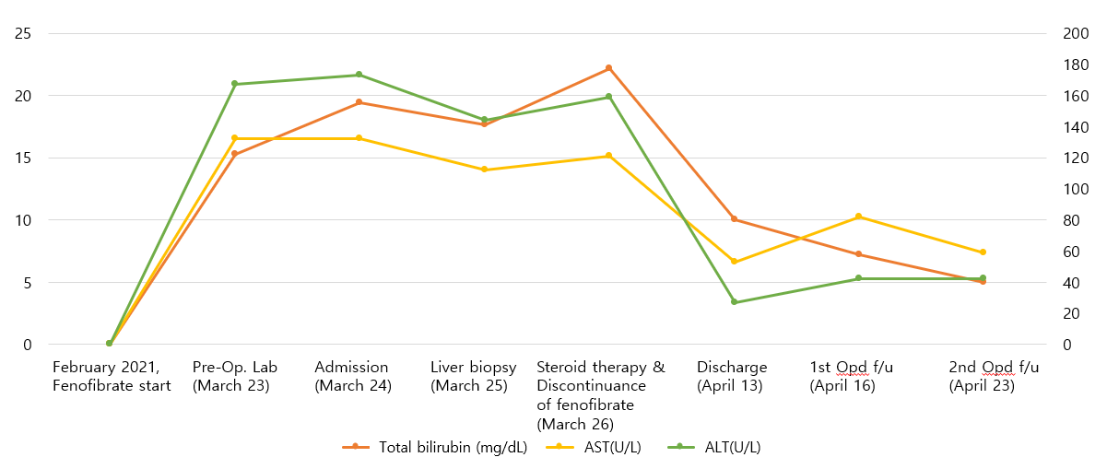
Figure 3 Clinical course of the patient. AST: Aspartate aminotransferase; ALT: Alanine aminotransferase.

Table 1 Characteristics of fenofibrate-induced liver injury based on prior case reports
Ref. | Demographic and clinical characteristics |  |  |  | Course of illness |  |  | Initial values
 | Location | Sex | Age, yr | Daily dose (mg) | Symptoms | Latency | Outcome | ALT(U/L) | ALP(U/L) | Total Bilirubin  (mg/dL) | INR
Present case | South Korea | M | 65 | 135 mg | Jaundice, pruritis | 6 wk | Recovery, 3 wk | 172 | 1182 | 15.99 | 0.92
Ma et al^{[13]}, 2019 | China | M | 65 | 200 mg | Epigastric discomfort, nausea,  fatigue | 2 d | Recovery, 2 wk | 1136.7 | 279.7 | 1.91 | NA
Dohmen et al^{[7]}, 2005 | Japan | F | 66 | 150 mg | Fever, anorexia, hypochondrial discomfort | 11 d | Recovery, 2 wk | 216 | 537 | 1.8 | NA
Rigal et al^{[14]}, 1989 | France | F | 74 | 200 mg | Jaundice | 2 yr | Recovery, 2 mo | 1430 | 315 | 4.6 | NA
Ho et al^{[8]}, 2004 | Taiwan | M | 61 | 300 mg | Jaundice, dark urine, fatigue | 2 wk | Recovery, 2 mo | 249 | 259 | 9.3 | NA
Case 1 (Ahmad et al^{[6]}, 2017) | Caucasian | M | 43 | 145 mg | Jaundice, dark urine, pale stool,  pruritis | 6 wk | Recovery | 533 | 440 | 20.6 | 1.04
Case 2 (poor prognosis) (Ahmad et al^{[6]}, 2017) | Caucasian | M | 61 | 48 mg | Jaundice, rash,  pruritis | 8 wk | Death (renal failure) at 26 mo | 83 | 518 | 4.7 | 1.40
Case 3 (Ahmad et al^{[6]}, 2017) | Hispanic | F | 37 | 160 mg | Jaundice, nausea, fatigue, myalgia, abdo pain | 5 wk | Recovery | 332 | 344 | 8.4 | 0.80
Case 4 (Ahmad et al^{[6]}, 2017) | Caucasian | M | 43 | 145 mg | Jaundice, nausea, fatigue, dark urine, pale stool, fever, pruritis | 7 wk | Unknown | 100 | 218 | 5.9 | 1.00
Case 5 (poor prognosis) (Ahmad et al^{[6]}, 2017)  Jaward et al. 2017^{[6]} | Caucasian | M | 41 | 160 mg | Jaundice, abdominal pain, nausea | 40 wk | Liver Transplant, at 8 mo | 78 | 195 | 8.0 | 4.3
Case 6 (Ahmad et al^{[6]}, 2017) | Hispanic | M | 54 | 134 mg | Fatigue | 56 wk | Recovery | 584 | 106 | 0.5 | NA
Case 7 (Ahmad et al^{[6]}, 2017) | Caucasian | F | 44 | 48 mg | Jaundice, dark urine, fatigue | 18 wk | Recovery | 1197 | 79 | 5.1 | 1.00
M: Male; F: Female; ALT: Alanine aminotransferase; ALP: Alkaline phosphatase; INR: International normalized ratio; NA: Not available.

