Name of Journal: World Journal of Gastroenterology
Manuscript NO: 57310
Manuscript Type: MINIREVIEWS

Imaging-based algorithmic approach to gallbladder wall thickening

Gupta P et al. Algorithmic approach to gallbladder wall thickening

Pankaj Gupta, Yashi Marodia, Akash Bansal, Naveen Kalra, Praveen Kumar-M, Vishal Sharma, Usha Dutta, Manavjit Singh Sandhu

Pankaj Gupta, Yashi Marodia, Akash Bansal, Naveen Kalra, Manavjit Singh Sandhu, Department of Radiodiagnosis and Imaging, Postgraduate Institute of Medical Education and Research, Chandigarh 160012, India

Praveen Kumar-M, Department of Pharmacology, Postgraduate Institute of Medical Education and Research, Chandigarh 160012, India

Vishal Sharma, Usha Dutta, Department of Gastroenterology, Postgraduate Institute of Medical Education and Research, Chandigarh 160012, India

Author contributions: Gupta P acquired the data, designed the outline of the paper, performed the writing and did the major revisions; Marodia Y and Bansal A did the majority of the writing, and prepared the figures and tables; Sharma V and Dutta U contributed to data acquisition as well as to writing; Kalra N and Sandhu MS provided useful input for the writing of the paper; all authors have read and approve the final manuscript.

Corresponding author: Pankaj Gupta, MD, Assistant Professor, Department of Radiodiagnosis and Imaging, Postgraduate Institute of Medical Education and Research, Sector 12, Chandigarh 160012, India. pankajgupta959@gmail.com

Received: June 8, 2020
Revised: August 12, 2020
Accepted: September 16, 2020
Published online: October 28, 2020

Abstract
Gallbladder (GB) wall thickening is a frequent finding caused by a spectrum of conditions. It is observed in many extracholecystic as well as intrinsic GB conditions. GB wall thickening can either be diffuse or focal. Diffuse wall thickening is a secondary occurrence in both extrinsic and intrinsic pathologies of GB, whereas, focal wall thickening is mostly associated with intrinsic GB pathologies. In the absence of specific clinical features, accurate etiological diagnosis can be challenging. The survival rate in GB carcinoma (GBC) can be improved if it is diagnosed at an early stage, especially when the tumor is confined to the wall. The pattern of wall thickening in GBC is often confused with benign diseases, especially chronic cholecystitis, xanthogranulomatous cholecystitis, and adenomyomatosis. Early recognition and differentiation of these conditions can improve the prognosis. In this minireview, the authors describe the patterns of abnormalities on various imaging modalities (conventional as well as advanced) for the diagnosis of GB wall thickening. This paper also illustrates an algorithmic approach for the etiological diagnosis of GB wall thickening and suggests a formatted reporting for GB wall abnormalities.

Key Words: Gallbladder diseases; Cholecystitis; Rokitansky-Aschoff sinuses of the gallbladder; Xanthogranulomatous cholecystitis; Neoplasms; Acute cholecystitis

Citation: Gupta P, Marodia Y, Bansal A, Kalra N, Kumar-M P, Sharma V, Dutta U, Sandhu MS. Imaging-based algorithmic approach to gallbladder wall thickening. World J Gastroenterol 2020; 26(40): 6163-6181
URL: https://www.wjgnet.com/1007-9327/full/v26/i40/6163.htm
DOI: https://dx.doi.org/10.3748/wjg.v26.i40.6163

Core Tip: Etiological diagnosis of gallbladder (GB) wall thickening can be challenging. Therefore, a thorough knowledge of the patterns and causes is crucial. Diffuse GB wall thickening is mostly related to inflammatory conditions intrinsic to the GB or extra-cholecystic causes. Focal GB wall thickening, on the other hand, presents a diagnostic challenge. An understanding of the imaging patterns of GB wall thickening, including the degree of mural thickening, internal mural characteristics such as enhancement features, and relationship with adjacent structures including liver and bile ducts may point towards the likelihood of GB carcinoma. We present a concise review of the differential diagnoses of GB wall thickening on various imaging modalities. We also discuss the specific features that may aid to distinguish individual benign pathologies (chronic cholecystitis, xanthogranulomatous cholecystitis, and adenomyomatosis) from GB carcinoma. Finally, we suggest an approach to GB wall thickening and propose a reporting format.
INTRODUCTION
Gallbladder (GB) wall normally appears as a pencil-thin line^{[1,2]}. Most studies suggest a wall thickness of 3 mm as the upper limit of normal thickening^{[3,4]}. In a retrospective review of 4119 patients, it was found that the GB wall in normal subjects measured 2.6 ± 1.6 mm^{[5]}. The thickened GB wall frequently seen in diagnostic imaging is mostly attributed to intrinsic GB pathologies. However, as GB wall thickening is a nonspecific finding, it frequently leads to diagnostic dilemmas, especially in asymptomatic individuals. Diffuse GB wall thickening can be seen in extracholecystic conditions and misinterpretation in such cases can lead to unnecessary cholecystectomy^{[6]}. Besides, both focal and diffuse GB wall thickening can be seen in benign and malignant lesions. An accurate radiological characterization of the causes of wall thickening is of utmost importance for instituting appropriate management. Studies have suggested certain imaging features that help differentiate benign from malignant GB wall thickening. Despite this, many cases are still reported as equivocal on preoperative imaging. This is partly due to a lack of awareness among radiologists and physicians regarding the different imaging criteria for differential diagnosis.

CAUSES OF GB WALL THICKENING
GB wall thickening can be classified into diffused and focal^{[2]}. Diffuse wall thickening can be due to either intrinsic or extrinsic causes. The most important causes of diffuse thickening include acute and chronic cholecystitis, adenomyomatosis (ADM), xanthogranulomatous cholecystitis (XGC), and wall thickening type of GB carcinoma (GBC)^{[1]}. Systemic diseases that lead to diffuse thickening include hepatitis, congestive heart failure, renal failure, sepsis, and hypoalbuminemia. Other causes are the spread of inflammation from adjacent organs as in the cases of pancreatitis, pyelonephritis, colitis, and peritonitis^{[1,3,7]}. Immunoglobulin G 4 related sclerosing cholecystitis is a rare cause of diffuse GB wall thickening^{[8]}. Focal wall thickening most commonly occurs due to the intrinsic causes. The malignant causes include GBC, GB lymphoma, and metastasis (most commonly from melanoma), while the most common benign causes include focal XGC, focal ADM, and localized chronic cholecystitis^{[9]}.

THE ROLE OF IMAGING MODALITIES IN DIFFERENTIATING BENIGN AND MALIGNANT GB WALL THICKENING
Ultrasonography (USG) is the initial imaging test of choice for the evaluation of suspected GB pathology^{[10]}. USG is widely available, has a low cost, and the advantage of real-time assessment. Computed tomography (CT) and magnetic resonance imaging (MRI) are utilized for cases with inconclusive findings on USG, the staging of GBC, and suspected complications in acute inflammatory GB conditions. Endoscopic ultrasound is an advanced technique with the advantage of the proximity of the probe to the GB wall leading to higher resolution, and providing safe access for tissue sampling. Contrast-enhanced ultrasonography (CEUS) and shear wave elastography (SWE) are useful adjuncts to USG for assessment of the GB wall.

USG
USG allows direct visualization of the GB wall due to its superficial location. It is an accurate modality for the measurement of the GB wall thickness^{[10]}. A normal GB wall on USG appears as a thin echogenic rim ≤ 3 mm. GB USG examination should always be done in a fasting state, as pseudo-thickening seen in contracted GB (consisting of a double concentric hyperechoic layer with sonolucency in-between) can also be observed in some pathological conditions^{[11]}.
There are some specific features on USG which must be recognized to distinguish between benign and malignant causes of GB wall thickening (Table 1). Asymmetric and irregular wall thickening is typical of GBC. However, in the early stages, the thickening can be smooth and can be misdiagnosed as benign wall thickening. Echo-layering of GB wall (defined as alternate hypoechoic and hyperechoic layers) with a distinct specular mucosal lining favors a benign etiology (Figure 1A). The discontinuity of the mucosal echo is more commonly seen in patients with GBC (Figure 1B)^{[12]}. This striated wall thickening of GB was earlier considered to be a specific sign of acute cholecystitis but can occur in a variety of conditions, such as renal failure, heart failure, acute hepatitis, ascites, acute pancreatitis, and prominent Rokitansky-Aschoff sinuses^{[13]}. A mesh-like wall thickening has been considered a distinctive feature of GB edema due to extracholecystic causes and helps differentiate these conditions from acute cholecystitis, which may prevent unnecessary cholecystectomy (Figure 1C)^{[6]}. Teefey et al^{[13]} suggested that striations in the thickened wall in acute cholecystitis suggest gangrenous changes. However, greyscale USG has its limitations as it only demonstrates the morphological changes in the GB wall. The use of color Doppler helps in assessing vascularity and improving diagnostic accuracy^{[14-17]}. Studies have shown that the malignant causes of GB wall thickening show a higher peak systolic velocity than benign conditions^{[14-16]}. Sensitivity and specificity of 100% and 96%, respectively, have been reported by Hayakawa S et al^{[16]} at a cut off value of 30 cm/s for flow velocity. A few studies have highlighted the synergistic role of SWE for differentiating benign from malignant wall thickening^{[17-19]}. In the study by Kapoor A et al^{[17]}, SWE was reported to have a sensitivity and specificity of 100% and 91.3% respectively, for distinguishing benign from malignant GB wall thickening. The cut-off value of 2.7 m/s was proposed for this differentiation. High shear wave velocity favors malignancy. SWE has been shown to improve the diagnostic accuracy of USG for the diagnosis of acute cholecystitis^{[20]}. SWE has also been shown to increase the sensitivity and specificity of grading of acute cholecystitis into moderate and severe^{[21]}.

CEUS
CEUS has an established role in the evaluation of lesions in the liver and kidney. It is now increasingly recognized as a useful tool for the characterization of GB lesions. A normal GB on CEUS has a uniformly enhancing wall without discontinuity and an anechoic lumen^{[20]}. Two phases of enhancement are observed after a micro-bubble injection: An arterial phase at 10-20 s and a late phase at 30-180 s^{[21]}.
CEUS significantly improves the diagnostic accuracy of USG in differentiating benign and malignant GB lesions especially for the wall thickening type lesions (Table 2)^{[22]}. Studies have shown the better diagnostic performance of CEUS as compared to MRI for differentiating malignant and benign lesions^{[23]}. Various characteristics including enhancement time, extent and dynamicity of enhancement, the pattern of vascularity, intactness of GB wall, degree of thickness, and infiltration into adjacent liver parenchyma should be assessed. Benign diseases show symmetrical wall thickening, preserved layered appearance, washout time of > 40 s, and dotted linear vascularity. Features such as arterial phase irregular intralesional vascularity, late phase hypoenhancement, disruption of GB wall and infiltration into the adjacent liver are highly predictive of malignant lesions (Figure 2)^{[24,25]}. A specificity of 92.4% for detection of malignant GB wall thickening was shown in a study when two out of the following three features were present: An irregular shape, branched intralesional vessels, and hypo-enhancement in the late phase^{[26]}. The most important predictor of malignancy is an inhomogeneous enhancement in the arterial phase, followed by interrupted inner layer, early washout (≤ 40 s), and wall thickness > 1.6 cm^{[27]}.

CT
Currently, the widespread use of abdominal CT has led to the increased detection of conditions associated with GB wall thickening^{[28]}. A normal GB wall on contrast-enhanced CT usually appears as a thin enhancing rim of soft tissue density. A mural thickening of up to 3 mm is considered normal^{[28]}. However, the thickness depends upon the degree of GB distension.
There are a few direct and indirect findings that help in differentiating benign and malignant GB wall thickening (Table 3). Irregularity in the wall, focal wall thickening, discontinuous mucosa, submucosal edema, polypoidal mass, and direct invasion into an adjacent organ are the direct findings observed in malignant lesions (Figure 3A). The indirect signs predictive of malignancy include biliary obstruction, regional lymphadenopathy, paraaortic lymphadenopathy, and distant metastasis (Figure 3B-D). However, CT has limited sensitivity for the detection of metastases to lymph nodes < 10 mm^{[29]}. Also, regional lymphadenopathy has been reported in 62.5% of cases with XGC. This overlapping feature can be a limitation in diagnosis on CT^{[30]}. Various studies have reported the enhancement patterns to distinguish benign from malignant wall thickening. Kim et al^{[31]} has suggested five patterns of GB wall enhancement in diffuse wall thickening. The two-layer pattern with strong enhancement of the thick inner layer (≥ 2.6 mm) and a weak enhancing of the outer layer (≤ 3.4 mm), and the one-layer pattern with a heterogeneous and thick enhancing wall, were significantly associated with GBC (Figure 4). Corwin et al^{[32]} studied the enhancement pattern in cases of focal fundal wall thickening. They proposed six morphological patterns of thickening. Malignant cases were identified most in Type 6 (heterogeneous enhancement of the focal fundal wall thickening without discrete cystic spaces). A few cases of malignancy were also seen in Type 3 (enhancement of the entire focal fundal thickening).

MRI
MRI is used in the evaluation of GB pathologies to resolve diagnostic dilemmas because of its superior soft tissue delineation. A normal GB wall is hypointense on T2-weighted images, isointense on T1-weighted images and shows homogenous post-contrast enhancement. The bile within GB is hyperintense on T2-weighted images and shows variable signal intensity on T1-weighted images depending on the bile concentration^{[33]}.
On non-contrast MRI, benign GB wall thickening usually shows T1-weighted and T2-weighted hyperintensity (Figure 5). Malignant thickening shows moderate T2 hyperintensity with papillary appearance and diffusion restriction^{[34]}. On dynamic contrast enhanced MRI, benign wall thickening shows relatively slow enhancement, whereas malignant wall thickening demonstrates early enhancement (Figure 6). The early enhancement seen in malignant lesions is due to neovascularization. No significant difference in enhancement in the delayed phase is observed, probably due to an equal amount of fibrous interstitium in benign and malignant wall thickening^{[35]}. The MRI features to differentiate between benign and malignant GB wall thickening are presented in Table 4. Attempts have been made to differentiate benign and malignant wall thickening on the basis of classification of wall thickening into 4 patterns, as described by Jung et al^{[36]} on heavily T2 weighted images (half–Fourier acquisition single short turbo spin echo). Type 1 shows a thin hypointense inner layer and a thick hyperintense outer layer which corresponds to the pathological diagnosis of chronic cholecystitis. Type 2 consists of two layers of ill-defined margins, suggestive of acute cholecystitis. Type 3 shows multiple hyperintense cystic spaces in the wall, correlating with the pathological diagnosis of ADM. While type 4 shows diffuse nodular thickening without layering, seen mostly in malignant cases. Several studies have reported the usefulness of diffusion-weighted images (DWI) for the differentiation of malignant and benign GB wall thickening. Kitazume et al^{[37]} suggested an apparent diffusion coefficient (ADC) value of less than 1.2 × 10⁻³ mm²/s or lesion to spinal cord ratio of more than 0.48 in malignant thickening. When this cutoff value was combined with morphological patterns such as massive thickening, disrupted mucosal line, and absence of a two-layered pattern, sensitivity, and specificity of 73.0% and 96.2% respectively was reported. Solak et al^{[38]} reported that ADC value below 0.86 × 10⁻³ mm²/s is significantly associated with malignancy. A mean ADC value of 1.83 ± 0.69 × 10⁻³ mm²/s and 2.60 ± 0.54 × 10⁻³ mm²/s has been reported in malignant and benign GB pathology respectively by Ogawa et al^{[39]}. DWI should always be interpreted along with the findings of other MRI sequences.

18F-fluorodeoxyglucose-positron emission tomography-CT
Fluorodeoxyglucose-positron emission tomography-CT (FDG-PET) has better sensitivity and specificity for distinguishing between benign and malignant tumors as compared to other diagnostic modalities^{[40,41]}. FDG uptake in GB can be due to both inflammatory and malignant conditions. PET-CT in the evaluation of GB wall thickening is indicated when there is any diagnostic dilemma on conventional imaging such as USG, CT, or MRI^{[42,43]}. The thickness of the GB wall and standardized uptake value (SUV_{max}) has a complementary role in addition to visual analysis for the differentiation of benign and malignant lesions. Benign conditions show less SUV_{max} value than malignant lesions. Diagnostic accuracy of 95.9% was reported by Font et al^{[44]} when a cut off value of 3.62 was used. Gupta et al^{[45]} reported a sensitivity and specificity of 92% and 79%, respectively at a cutoff value of SUV_{max} of 5.95. Using a cut off value of mean GB wall thickening 8.5 mm, sensitivity and specificity of 94% and 67%, respectively was reported. In addition to differentiating between benign and malignant conditions, PET-CT helps in the staging of malignant lesions.

DIFFERENTIATION OF SPECIFIC ENTITIES
GBC vs ADM
The focal as well as the diffuse GB wall thickening can be seen in both GBC and ADM. A preoperative diagnosis is required to avoid unnecessary cholecystectomies in asymptomatic patients with ADM.
Diffuse ADM shows symmetrical mural thickening, intramural cystic spaces, and echogenic foci (causing twinkling artefacts on USG). Irregular mural thickening of the outer layer, irregularity or focal discontinuity of innermost hyperechoic layer (thickness > 1 mm), loss of multilayer pattern, and intralesional vascularity are significantly associated with GBC^{[46]}. The comet-tail artefact was earlier considered to be specific to ADM. This artefact is caused by the accumulation of cholesterol crystals in the Rokitansky-Aschoff sinuses and can also be seen in the other benign conditions of GB. Studies have shown comet tail artefact to be a reliable sign of benignity of the lesion^{[47]}. Certain MRI features help to differentiate ADM from GBC. The pearl necklace sign, defined as linear hyperintense foci on T2-weighted images, has been described as a specific sign, especially for diffuse ADM (Figure 7)^{[48]}. However, T2 hyperintense foci can also be seen in well-differentiated mucin-producing GBC. The size, shape, number, and arrangement of the cystic components may help in the differential diagnosis. The cystic component in ADM is smaller, rounded, arranged in a linear fashion, and the wall shows a flat contour with a regular surface^{[49]}. Well-differentiated GBC shows larger, multilobulated cystic components and the wall shows an irregular surface contour. On CEUS, ADM shows arterial phase heterogeneous enhancement with small non-enhancing spaces within. The mucosal and serosal layers of the GB wall surrounding the lesions are enhanced and can be observed as two hyperechoic lines in the arterial phase. The smaller non-enhancing spaces are more clearly seen during the venous phase^{[50]}.
Differentiation of focal ADM from GBC can be challenging as the intramural echogenic foci in GB fundus can be severely deteriorated by volume artefacts on USG^{[51]}. CEUS combined with conventional USG can improve the diagnostic accuracy in such cases. Location of the lesion in GB fundus, lack of blood flow, intramural anechoic spaces, iso to hypo-enhancement of the inner wall, and intactness of GB wall on CEUS are useful markers for differentiating focal ADM from early-stage GBC^{[52]}. The distinction between GBC and ADM may be challenging on CT. However, if small cystic spaces are seen within the thickened GB wall, ADM is the likely diagnosis^{[53]}. Cotton ball sign i.e. fuzzy grey dots in the mural thickening or a dotted outer border of the inner layer (with enhancement being less than the renal cortex) is specific for ADM^{[54]}. Both focal ADM and focal GBC show early homogenous enhancement. Smooth mucosal continuity with surrounding GB epithelium is seen in cases of ADM^{[55]}. Although ADM is not considered to have malignant potential, there have been few case reports which have shown concomitant existence of ADM and GBC^{[55,56]}. Morikawa et al^{[57]} performed a retrospective study in 624 patients who underwent surgical resection of GB with Rokitansky-Aschoff sinuses. Three of the resected specimens showed evidence of early-stage GBC, out of the 93 histologically proven ADM. The authors concluded that preoperative diagnosis of primary GBC in the setting of concurrent ADM is difficult.

GBC vs xanthogranulomatous cholecystitis
Intramural hypoechoic nodules with a continuous mucosal line are characteristic sonographic features of XGC^{[58]}. It has also been suggested that if the nodules occupy an area of more than 60% of the GB wall circumference, the speciﬁcity for the diagnosis of XGC is significantly increased^{[59]}. GB wall thickness, hypoechoic nodules, and the boundary between GB and adjacent liver parenchyma are better evaluated on CEUS as compared to USG. Diffuse GB wall thickening with an intact inner layer has been the most valuable indicator of XGC. Hypo-enhancement time > 80.5 s and hypoechoic nodules are other important indicators of XGC^{[60]}. Bo et al^{[61]} reported a sensitivity and specificity of 90% and 93% respectively, for differentiating GBC and XGC on CEUS. On MRI, XGC shows a continuous mucosal line with T2 hyperintense foci in the thickened wall. GBC shows early enhancement and lower ADC values as compared to XGC^{[62]}. There is an emerging role of chemical shift imaging for the diagnosis of XGC in cases where hypoattenuating nodules are obscured. Few case reports have shown that the presence of fat within the thickened GB can help in distinguishing XGC from GBC^{[63-65]}. Features such as diffuse GB wall thickening, intact mucosa, intramural hypoattenuating nodules, absence of hepatic invasion, and intrahepatic dilatation favor the diagnosis of XGC (Figure 8)^{[66-68]}. Sensitivity and specificity of 83% and 100% respectively were reported if three out of these five features were used for the diagnosis of XGC^{[66]}. However, preoperative diagnosis may be challenging and the diagnosis of XGC can be made confidently only on histopathology^{[69]}. XGC shows some overlapping features with GBC. Regional lymphadenopathy has been associated with approximately 62.5% of XGC cases according to a study. In the same study, hypoattenuating nodules were more commonly seen in XGC than GBC (P < 0.001)^{[30]}. CT has been shown to have moderate sensitivity (67%-78%), poor specificity (22%-33%), and moderate to substantial overall inter-reader reliability (ƙ-0.43-0.70) in differentiating GBC from benign GB pathologies (acute cholecystitis and XGC)^{[70]}. Sureka et al^{[71]} reported a discontinuous mucosal line in 73.3% of the patients with XGC in a series of 30 patients. Few case reports of XGC have shown irregularly thickened walls with infiltration into adjacent organs^{[72]}. XGC can be mistaken for GBC intraoperatively on gross examination. A combination of gross examination of the mucosa and intraoperative frozen section examination, especially in areas of high suspicion of cancer, can accurately differentiate XGC and GBC and can also detect the simultaneous presence of both entities^{[73]}. This may prevent extended resections in cases of XGC.

GBC vs chronic cholecystitis
Generally, arterial enhancement of the thick inner layer that shows isoattenuation to hepatic parenchyma during the venous phase; or enhancing thick inner layer in both phases, is seen in GBC. Cases of chronic cholecystitis show an isoattenuating thin inner layer during both the phases^{[74].} On dynamic contrast-enhanced MRI, chronic cholecystitis shows early smooth enhancement, whereas GBC shows early irregular enhancement. The outer margin of early enhancement in GBC correlates with the extent of the tumor^{[75]}.

Acute vs chronic cholecystitis/XGC
USG findings of acute cholecystitis include GB wall thickening of more than 3 mm, presence of mural edema, GB distension > 40 mm, and presence of pericholecystic or perihepatic fluid (C sign)^{[76]}. Eliciting a positive sonographic Murphy’s sign has a sensitivity of 92% in the diagnosis of acute cholecystitis. The presence of gallstones along with diffuse GB wall thickening has a positive predictive value of 95% for the diagnosis of acute cholecystitis^{[76]}. Diffuse GB thickening and gallstones are also seen in chronic cholecystitis, however, due to associated mural fibrosis, the GB is usually contracted and pericholecystic fluid is generally absent^{[7,76]}. As previously described, XGC is associated with cholelithiasis, GB wall thickening (focal or diffuse), and the presence of intramural hypoechoic nodules with continuous mucosal line^{[7,58]}.
In a recent retrospective study to differentiate acute and chronic cholecystitis on CT, it was found that acute cholecystitis had significantly increased GB dimensions (both long and short axes), increased wall thickening, mural striations, pericholecystic fluid and adjacent liver parenchyma enhancement (P < 0.001). Increased mural enhancement was more commonly seen in chronic cholecystitis (P = 0.001)^{[77]}.

Rare causes of GB wall thickening
Tuberculosis, lymphoma, neuroendocrine tumor, and metastasis represent rare causes of GB involvement^{[78-81]}. The features of these lesions are tabulated in Table 5.

ROLE OF INTERVENTIONAL RADIOLOGY IN GB PATHOLOGIES
Despite the advances in imaging, an accurate diagnosis of GB wall thickening may be challenging at times, and tissue sampling may be required. USG guided fine needle aspiration cytology is a quick, reliable, and cost-effective method, which can be done as an outdoor procedure. USG allows real-time monitoring of the needle tip, and accurate and safe sampling can be done. Studies have shown an accuracy rate of 97%, with false-negative rates of 11% to 41% depending on the expertise^{[82-85]}. However, sensitivity is reduced when malignancy is associated with XGC^{[86]}. Percutaneous biopsy is required for cases that appear unresectable on imaging to look for genetic aberrations, such as ERBB2 amplification, mutations or amplification of the P13 kinase family genes, FGFR mutations or fusion, and aberrations of the chromatin modulating genes^{[87]}. This allows the use of targeted therapy.
Interventional radiologist plays an adjunctive role in preoperative management of cholangitis and postoperative biliary leaks by placing percutaneous drains under USG, CT, or fluoroscopic guidance^{[88]}. Percutaneous drainage of the biliary system and biliary stenting are widely used methods for palliative care in GBC^{[89]}. Percutaneous cholecystostomy is an interventional technique that is primarily employed in biliary emergencies like acute severe cholecystitis and cholangitis. Other indications include a second-line approach to access biliary tract for decompression when intra-hepatic radicles are not accessible, to dilate a benign stricture, or stent a malignant stricture^{[90]}.
Portal vein embolization is an effective method to facilitate hypertrophy of the residual liver when contemplating extended liver resections. The aim of such a procedure is to achieve a future liver remnant hypertrophy of > 20% of the initial functional liver to prevent postoperative hepatic failure^{[91]}. Various minimally invasive locoregional therapies such as transarterial embolization and percutaneous ablation are under investigation for the treatment of liver metastasis in GBC cases. The commonly used embolization agents are drug-eluting beads and Yttrium-90^{[92]}. Another evolving option is the implantation of hepatic artery infusion pumps, which enable continuous infusion of cytotoxic agents directly into the metastatic lesion^{[93]}. Celiac plexus block is another palliative care therapy offered by interventional radiologists for pain control in advanced cases. The various analgesics agents used are lidocaine, steroids, ethanol, or phenol. Studies have reported improved quality of life and decreased dependence on opioids using this method^{[94]}.

APPROACH TO GB WALL THICKENING
It is important to recognize the patterns of GB wall thickening, diffuse or focal, as the conditions associated with these patterns are different. Ancillary findings further help in the characterization of the cause.
The diffuse pattern of wall thickening can be seen in conditions intrinsic as well as extrinsic to the GB. If a mesh-like diffuse wall thickening is seen in a patient with known systemic disease or adjacent inflammatory reaction, the thickening can be attributed to these extrinsic causes. The presence of Murphy’s sign, with pericholecystic fluid and hydropic distension, as well as cholelithiasis is specific for acute cholecystitis. Absence of Murphy’s sign in a markedly thickened GB with intraluminal membranes should prompt the diagnosis of gangrenous cholecystitis. Dirty shadowing within the thickened GB wall in patients with other features of acute cholecystitis should raise the suspicion for emphysematous cholecystitis, and a CT is warranted in such cases. The absence of cholelithiasis in a critically ill patient with other features of acute calculous cholecystitis is suggestive of acute acalculous cholecystitis. Diagnostic dilemma usually arises in the differential diagnosis of ADM, XGC, and GBC. A multimodality imaging approach may be helpful in such conditions. The focal pattern of GB wall thickening has a narrow differential diagnosis and is seen in conditions intrinsic to GB. An algorithmic approach for the diffuse and focal wall thickening has been outlined in respective flow charts (Figures 9-11).

REPORTING FORMAT
In order to increase the objectivity as well as the diagnostic accuracy of imaging findings, it is important to adopt a standardized reporting format that takes into account the key characteristics of the GB, adjacent liver, and distant sites (Figure 12).

CONCLUSION
The radiologist must be aware of the different causes of GB wall thickening. A correct diagnosis is usually established using a combination of multimodality imaging findings, clinical presentation, and laboratory parameters. An understanding of the diagnostic pitfalls in the early stages of GBC and its differentiation from benign conditions is essential for appropriate management.

REFERENCES
1 van Breda Vriesman AC, Engelbrecht MR, Smithuis RH, Puylaert JB. Diffuse gallbladder wall thickening: differential diagnosis. AJR Am J Roentgenol 2007; 188: 495-501 [PMID: 17242260 DOI: 10.2214/ajr.05.1712]
2 Runner GJ, Corwin MT, Siewert B, Eisenberg RL. Gallbladder wall thickening. AJR Am J Roentgenol 2014; 202: W1-W12 [PMID: 24370153 DOI: 10.2214/AJR.12.10386]
3 Fiske CE, Laing FC, Brown TW. Ultrasonographic evidence of gallbladder wall thickening in association with hypoalbuminemia. Radiology 1980; 135: 713-716 [PMID: 7384460 DOI: 10.1148/radiology.135.3.7384460]
4 Engel JM, Deitch EA, Sikkema W. Gallbladder wall thickness: sonographic accuracy and relation to disease. AJR Am J Roentgenol 1980; 134: 907-909 [PMID: 6768264 DOI: 10.2214/ajr.134.5.907]
5 Matcuk GR Jr, Grant EG, Ralls PW. Ultrasound measurements of the bile ducts and gallbladder: normal ranges and effects of age, sex, cholecystectomy, and pathologic states. Ultrasound Q 2014; 30: 41-48 [PMID: 24901778 DOI: 10.1097/RUQ.0b013e3182a80c98]
6 Matsui Y, Hirooka S, Kotsuka M, Yamaki S, Kosaka H, Yamamoto T, Satoi S. Prognosis in Patients With Gallbladder Edema Misdiagnosed as Cholecystitis. JSLS 2019; 23: [PMID: 31223228 DOI: 10.4293/jsls.2019.00022]
7 Smith EA, Dillman JR, Elsayes KM, Menias CO, Bude RO. Cross-sectional imaging of acute and chronic gallbladder inflammatory disease. AJR Am J Roentgenol 2009; 192: 188-196 [PMID: 19098200 DOI: 10.2214/AJR.07.3803]
8 Takahashi K, Ito H, Katsube T, Tsuboi A, Hashimoto M, Ota E, Mita K, Asakawa H, Hayashi T, Fujino K, Okamoto S. Immunoglobulin G4-related sclerosing cholecystitis presenting as gallbladder cancer: a case report. Surg Case Rep 2015; 1: 120 [PMID: 26943444 DOI: 10.1186/s40792-015-0123-4]
9 Lee JM, Boll DT. Disease of the Gallbladder and Biliary Tree. In: Hodler J, Kubik-Huch RA, von Schulthess GK. Diseases of the Abdomen and Pelvis 2018-2021. NewYork: Springer International Publishing; 2018: 49-56
10 Gupta P, Kumar M, Sharma V, Dutta U, Sandhu MS. Evaluation of gallbladder wall thickening: a multimodality imaging approach. Expert Rev Gastroenterol Hepatol 2020; 14: 463-473 [PMID: 32323586 DOI: 10.1080/17474124.2020.1760840]
11 Marchal G, Van de Voorde P, Van Dooren W, Ponette E, Baert A. Ultrasonic appearance of the filled and contracted normal gallbladder. J Clin Ultrasound 1980; 8: 439-442 [PMID: 6773996 DOI: 10.1002/jcu.1870080509]
12 Wibbenmeyer LA, Sharafuddin MJ, Wolverson MK, Heiberg EV, Wade TP, Shields JB. Sonographic diagnosis of unsuspected gallbladder cancer: imaging findings in comparison with benign gallbladder conditions. AJR Am J Roentgenol 1995; 165: 1169-1174 [PMID: 7572497 DOI: 10.2214/ajr.165.5.7572497]
13 Teefey SA, Baron RL, Bigler SA. Sonography of the gallbladder: significance of striated (layered) thickening of the gallbladder wall. AJR Am J Roentgenol 1991; 156: 945-947 [PMID: 2017956 DOI: 10.2214/ajr.156.5.2017956]
14 Li D, Dong BW, Wu YL, Yan K. Image-directed and color Doppler studies of gallbladder tumors. J Clin Ultrasound 1994; 22: 551-555 [PMID: 7806663 DOI: 10.1002/jcu.1870220906]
15 Komatsuda T, Ishida H, Konno K, Hamashima Y, Naganuma H, Sato M, Watanabe S. Gallbladder carcinoma: color Doppler sonography. Abdom Imaging 2000; 25: 194-197 [PMID: 10675466 DOI: 10.1007/s002619910044]
16 Hayakawa S, Goto H, Hirooka Y, Itoh A, Taki T, Watanabe Y, Hayakawa T, Naitoh Y. Colour Doppler-guided spectral analysis of gall-bladder wall flow. J Gastroenterol Hepatol 1998; 13: 181-185 [PMID: 10221821 DOI: 10.1111/j.1440-1746.1998.tb00635.x]
17 Kapoor A, Kapoor A, Mahajan G. Differentiating malignant from benign thickening of the gallbladder wall by the use of acoustic radiation force impulse elastography. J Ultrasound Med 2011; 30: 1499-1507 [PMID: 22039022 DOI: 10.7863/jum.2011.30.11.1499]
18 Kim JE, Choi DS, Bae K, Cho JM, Jeong CY, Kim HO. Added value of point shear-wave elastography in the diagnosis of acute cholecystitis. Eur Radiol 2017; 27: 1517-1526 [PMID: 27510624 DOI: 10.1007/s00330-016-4509-x]
19 Li SL, Ding Y, Zhou FS, Chen J, Jiang X, Zhou H, Wu PX. [Clinical study of real-time shear wave elastography for diagnosis of severity of acute cholecystitis]. Zhonghua Yi Xue Za Zhi 2018; 98: 3903-3906 [PMID: 30585040 DOI: 10.3760/cma.j.issn.0376-2491.2018.47.019]
20 Gerstenmaier JF, Hoang KN, Gibson RN. Contrast-enhanced ultrasound in gallbladder disease: a pictorial review. Abdom Radiol (NY) 2016; 41: 1640-1652 [PMID: 27056746 DOI: 10.1007/s00261-016-0729-4]
21 Meacock LM, Sellars ME, Sidhu PS. Evaluation of gallbladder and biliary duct disease using microbubble contrast-enhanced ultrasound. Br J Radiol 2010; 83: 615-627 [PMID: 20603412 DOI: 10.1259/bjr/60619911]
22 Kong WT, Shen HY, Qiu YD, Han H, Wen BJ, Wu M. Application of contrast enhanced ultrasound in gallbladder lesion: is it helpful to improve the diagnostic capabilities? Med Ultrason 2018; 20: 420-426 [PMID: 30534647 DOI: 10.11152/mu-1626]
23 Negrão de Figueiredo G, Mueller-Peltzer K, Schwarze V, Zhang L, Rübenthaler J, Clevert DA. Performance of contrast-enhanced ultrasound (CEUS) compared to MRI in the diagnostic of gallbladder diseases. Clin Hemorheol Microcirc 2019; 73: 85-93 [PMID: 31561332 DOI: 10.3233/CH-199202]
24 Dong Y, Liu L, Cao Q, Zhang Q, Qiu Y, Yang D, Yu L, Wang WP. Differential diagnosis of focal gallbladder lesions: The added value of contrast enhanced ultrasound with liner transducers. Clin Hemorheol Microcirc 2020; 74: 167-178 [PMID: 31306115 DOI: 10.3233/CH-190639]
25 Dong Y, Xu B, Cao Q, Zhang Q, Qiu Y, Yang D, Yu L, Wang WP. Incidentally detected focal fundal gallbladder wall thickening: Differentiation contrast enhanced ultrasound features with high-resolution linear transducers. Clin Hemorheol Microcirc 2020; 74: 315-325 [PMID: 31524151 DOI: 10.3233/CH-190697]
26 Zhuang B, Li W, Wang W, Lin M, Xu M, Xie X, Lu M, Xie X. Contrast-enhanced ultrasonography improves the diagnostic specificity for gallbladder-confined focal tumors. Abdom Radiol (NY) 2018; 43: 1134-1142 [PMID: 28765975 DOI: 10.1007/s00261-017-1268-3]
27 Chen LD, Huang Y, Xie XH, Chen W, Shan QY, Xu M, Liu JY, Nie ZQ, Xie XY, Lu MD, Shen SL, Wang W. Diagnostic nomogram for gallbladder wall thickening mimicking malignancy: using contrast-enhanced ultrasonography or multi-detector computed tomography? Abdom Radiol (NY) 2017; 42: 2436-2446 [PMID: 28447109 DOI: 10.1007/s00261-017-1162-z]
28 Zissin R, Osadchy A, Shapiro-Feinberg M, Gayer G. CT of a thickened-wall gall bladder. Br J Radiol 2003; 76: 137-143 [PMID: 12642285 DOI: 10.1259/bjr/63382740]
29 de Savornin Lohman EAJ, de Bitter TJJ, van Laarhoven CJHM, Hermans JJ, de Haas RJ, de Reuver PR. The diagnostic accuracy of CT and MRI for the detection of lymph node metastases in gallbladder cancer: A systematic review and meta-analysis. Eur J Radiol 2019; 110: 156-162 [PMID: 30599854 DOI: 10.1016/j.ejrad.2018.11.034]
30 Rammohan A, Cherukuri SD, Sathyanesan J, Palaniappan R, Govindan M. Xanthogranulomatous cholecystitis masquerading as gallbladder cancer: can it be diagnosed preoperatively? Gastroenterol Res Pract 2014; 2014: 253645 [PMID: 25404941 DOI: 10.1155/2014/253645]
31 Kim SJ, Lee JM, Lee JY, Kim SH, Han JK, Choi BI, Choi JY. Analysis of enhancement pattern of flat gallbladder wall thickening on MDCT to differentiate gallbladder cancer from cholecystitis. AJR Am J Roentgenol 2008; 191: 765-771 [PMID: 18716107 DOI: 10.2214/AJR.07.3331]
32 Corwin MT, Khera SS, Loehfelm TW, Yang NT, Fananapazir G. Incidentally Detected Focal Fundal Gallbladder Wall Thickening at Contrast-Enhanced Computed Tomography: Prevalence and Computed Tomography Features of Malignancy. J Comput Assist Tomogr 2019; 43: 149-154 [PMID: 30371615 DOI: 10.1097/RCT.0000000000000802]
33 Demas BE, Hricak H, Moseley M, Wall SD, Moon K, Goldberg HI, Margulis AR. Gallbladder bile: an experimental study in dogs using MR imaging and proton MR spectroscopy. Radiology 1985; 157: 453-455 [PMID: 2996051 DOI: 10.1148/radiology.157.2.2996051]
34 Cha SY, Kim YK, Min JH, Lee J, Cha DI, Lee SJ. Usefulness of noncontrast MRI in differentiation between gallbladder carcinoma and benign conditions manifesting as focal mild wall thickening. Clin Imaging 2019; 54: 63-70 [PMID: 30551027 DOI: 10.1016/j.clinimag.2018.12.001]
35 Yoshimitsu K, Honda H, Kaneko K, Kuroiwa T, Irie H, Ueki T, Chijiiwa K, Takenaka K, Masuda K. Dynamic MRI of the gallbladder lesions: differentiation of benign from malignant. J Magn Reson Imaging 1997; 7: 696-701 [PMID: 9243391 DOI: 10.1002/jmri.1880070415]
36 Jung SE, Lee JM, Lee K, Rha SE, Choi BG, Kim EK, Hahn ST. Gallbladder wall thickening: MR imaging and pathologic correlation with emphasis on layered pattern. Eur Radiol 2005; 15: 694-701 [PMID: 15565318 DOI: 10.1007/s00330-004-2539-2]
37 Kitazume Y, Taura S, Nakaminato S, Noguchi O, Masaki Y, Kasahara I, Kishino M, Tateishi U. Diffusion-weighted magnetic resonance imaging to differentiate malignant from benign gallbladder disorders. Eur J Radiol 2016; 85: 864-873 [PMID: 26971436 DOI: 10.1016/j.ejrad.2016.02.003]
38 Solak A, Solak I, Genç B, Sahin N. The role of diffusion-weighted examination in non-polyploid gallbladder malignancies: A preliminary study. Turk J Gastroenterol 2013; 24: 148-153 [PMID: 23934462 DOI: 10.4318/tjg.2013.0659]
39 Ogawa T, Horaguchi J, Fujita N, Noda Y, Kobayashi G, Ito K, Koshita S, Kanno Y, Masu K, Sugita R. High b-value diffusion-weighted magnetic resonance imaging for gallbladder lesions: differentiation between benignity and malignancy. J Gastroenterol 2012; 47: 1352-1360 [PMID: 22576026 DOI: 10.1007/s00535-012-0604-1]
40 Kunishima S, Taniguchi H, Yamaguchi A, Koh T, Yamagishi H. Evaluation of Abdominal Tumors with Clin Positron Imaging 2000; 3: 91-96 [PMID: 11008098 DOI: 10.1016/S1095-0397(00)00047-9]
41 Kubota K, Yokoyama J, Yamaguchi K, Ono S, Qureshy A, Itoh M, Fukuda H. FDG-PET delayed imaging for the detection of head and neck cancer recurrence after radio-chemotherapy: comparison with MRI/CT. Eur J Nucl Med Mol Imaging 2004; 31: 590-595 [PMID: 14722678 DOI: 10.1007/s00259-003-1408-6]
42 Oe A, Kawabe J, Torii K, Kawamura E, Higashiyama S, Kotani J, Hayashi T, Kurooka H, Tsumoto C, Kubo S, Shiomi S. Distinguishing benign from malignant gallbladder wall thickening using FDG-PET. Ann Nucl Med 2006; 20: 699-703 [PMID: 17385310 DOI: 10.1007/BF02984683]
43 Rodríguez-Fernández A, Gómez-Río M, Llamas-Elvira JM, Ortega-Lozano S, Ferrón-Orihuela JA, Ramia-Angel JM, Mansilla-Roselló A, Martínez-del-Valle MD, Ramos-Font C. Positron-emission tomography with fluorine-18-fluoro-2-deoxy-D-glucose for gallbladder cancer diagnosis. Am J Surg 2004; 188: 171-175 [PMID: 15249245 DOI: 10.1016/j.amjsurg.2003.12.070]
44 Ramos-Font C, Gómez-Rio M, Rodríguez-Fernández A, Jiménez-Heffernan A, Sánchez Sánchez R, Llamas-Elvira JM. Ability of FDG-PET/CT in the detection of gallbladder cancer. J Surg Oncol 2014; 109: 218-224 [PMID: 24165875 DOI: 10.1002/jso.23476]
45 Gupta V, Vishnu KS, Yadav TD, Sakaray YR, Irrinki S, Mittal BR, Kalra N, Vaiphei K. Radio-pathological Correlation of 18F-FDG PET in Characterizing Gallbladder Wall Thickening. J Gastrointest Cancer 2019; 50: 901-906 [PMID: 30397856 DOI: 10.1007/s12029-018-0176-2]
46 Joo I, Lee JY, Kim JH, Kim SJ, Kim MA, Han JK, Choi BI. Differentiation of adenomyomatosis of the gallbladder from early-stage, wall-thickening-type gallbladder cancer using high-resolution ultrasound. Eur Radiol 2013; 23: 730-738 [PMID: 23247807 DOI: 10.1007/s00330-012-2641-9]
47 Oh SH, Han HY, Kim HJ. Comet tail artifact on ultrasonography: is it a reliable finding of benign gallbladder diseases? Ultrasonography 2019; 38: 221-230 [PMID: 30481951 DOI: 10.14366/usg.18029]
48 Haradome H, Ichikawa T, Sou H, Yoshikawa T, Nakamura A, Araki T, Hachiya J. The pearl necklace sign: an imaging sign of adenomyomatosis of the gallbladder at MR cholangiopancreatography. Radiology 2003; 227: 80-88 [PMID: 12601186 DOI: 10.1148/radiol.2271011378]
49 Yoshimitsu K, Irie H, Aibe H, Tajima T, Nishie A, Asayama Y, Matake K, Yamaguchi K, Matsuura S, Honda H. Well-differentiated adenocarcinoma of the gallbladder with intratumoral cystic components due to abundant mucin production: a mimicker of adenomyomatosis. Eur Radiol 2005; 15: 229-233 [PMID: 15662477 DOI: 10.1007/s00330-004-2516-9]
50 Tang S, Huang L, Wang Y, Wang Y. Contrast-enhanced ultrasonography diagnosis of fundal localized type of gallbladder adenomyomatosis. BMC Gastroenterol 2015; 15: 99 [PMID: 26239485 DOI: 10.1186/s12876-015-0326-y]
51 Skolnick ML, Meire HB, Lecky JW. Common artifacts in ultrasound scanning. J Clin Ultrasound 1975; 3: 273-280 [PMID: 829531 DOI: 10.1002/jcu.1870030408]
52 Yuan HX, Wang WP, Guan PS, Lin LW, Wen JX, Yu Q, Chen XJ. Contrast-enhanced ultrasonography in differential diagnosis of focal gallbladder adenomyomatosis and gallbladder cancer. Clin Hemorheol Microcirc 2018; 70: 201-211 [PMID: 29630529 DOI: 10.3233/CH-180376]
53 Ching BH, Yeh BM, Westphalen AC, Joe BN, Qayyum A, Coakley FV. CT differentiation of adenomyomatosis and gallbladder cancer. AJR Am J Roentgenol 2007; 189: 62-66 [PMID: 17579153 DOI: 10.2214/ajr.06.0866]
54 Yang HK, Lee JM, Yu MH, Lee SM, Park J, Han NY, Lee K, Jang JY, Han JK. CT diagnosis of gallbladder adenomyomatosis: importance of enhancing mucosal epithelium, the "cotton ball sign". Eur Radiol 2018; 28: 3573-3582 [PMID: 29633001 DOI: 10.1007/s00330-018-5412-4]
55 Suzuki K, Abe K, Ohbu M. A Resected Gallbladder Carcinoma Coexisting With Adenomyomatosis Involving Varied Degrees of Intraepithelial Dysplasia: A Case Report and Literature Review. Surg Laparosc Endosc Percutan Tech 2019; 29: 290-296 [PMID: 30570538 DOI: 10.1097/SLE.0000000000000617]
56 Shi XC, Tang SS, Zhao W. Contrast-enhanced ultrasound imaging characteristics of malignant transformation of a localized type gallbladder adenomyomatosis: A case report and literature review. J Cancer Res Ther 2018; 14: S263-S266 [PMID: 29578186 DOI: 10.4103/0973-1482.183208]
57 Morikawa T, Okabayashi T, Shima Y, Sumiyoshi T, Kozuki A, Saisaka Y, Tokumaru T, Sui K, Iwata J, Matsumoto M, Morita S, Nishioka Y. Adenomyomatosis Concomitant with Primary Gallbladder Carcinoma. Acta Med Okayama 2017; 71: 113-118 [PMID: 28420892 DOI: 10.18926/AMO/54979]
58 Liu C, Huang P, Wang Y, Zhang X, You X. [Value of ultrasonography in diagnosis of xanthogranulomatous cholecystitis]. Zhejiang Da Xue Xue Bao Yi Xue Ban 2017; 46: 552-556 [PMID: 29488724 DOI: 10.3785/j.issn.1008-9292.2017.10.16]
59 Chun KA, Ha HK, Yu ES, Shinn KS, Kim KW, Lee DH, Kang SW, Auh YH. Xanthogranulomatous cholecystitis: CT features with emphasis on differentiation from gallbladder carcinoma. Radiology 1997; 203: 93-97 [PMID: 9122422 DOI: 10.1148/radiology.203.1.9122422]
60 Yuan HX, Wang WP, Wen JX, Ji ZB, Ding H, Huang BJ, Li CL. Xanthogranulomatous cholecystitis: contrast-enhanced ultrasound features and differential diagnosis from wall-thickening gallbladder carcinoma. Discov Med 2016; 21: 89-98 [PMID: 27011044]
61 Bo X, Chen E, Wang J, Nan L, Xin Y, Wang C, Lu Q, Rao S, Pang L, Li M, Lu P, Zhang D, Liu H, Wang Y. Diagnostic accuracy of imaging modalities in differentiating xanthogranulomatous cholecystitis from gallbladder cancer. Ann Transl Med 2019; 7: 627 [PMID: 31930028 DOI: 10.21037/atm.2019.11.35]
62 Kang TW, Kim SH, Park HJ, Lim S, Jang KM, Choi D, Lee SJ. Differentiating xanthogranulomatous cholecystitis from wall-thickening type of gallbladder cancer: added value of diffusion-weighted MRI. Clin Radiol 2013; 68: 992-1001 [PMID: 23622795 DOI: 10.1016/j.crad.2013.03.022]
63 Hatakenaka M, Adachi T, Matsuyama A, Mori M, Yoshikawa Y. Xanthogranulomatous cholecystitis: importance of chemical-shift gradient-echo MR imaging. Eur Radiol 2003; 13: 2233-2235 [PMID: 12928971 DOI: 10.1007/s00330-002-1731-5]
64 Uchiyama K, Ozawa S, Ueno M, Hayami S, Hirono S, Ina S, Kawai M, Tani M, Yamaue H. Xanthogranulomatous cholecystitis: the use of preoperative CT findings to differentiate it from gallbladder carcinoma. J Hepatobiliary Pancreat Surg 2009; 16: 333-338 [PMID: 19280109 DOI: 10.1007/s00534-009-0067-9]
65 Chang BJ, Kim SH, Park HY, Lim SW, Kim J, Lee KH, Lee KT, Rhee JC, Lim JH, Lee JK. Distinguishing xanthogranulomatous cholecystitis from the wall-thickening type of early-stage gallbladder cancer. Gut Liver 2010; 4: 518-523 [PMID: 21253302 DOI: 10.5009/gnl.2010.4.4.518]
66 Zhao F, Lu PX, Yan SX, Wang GF, Yuan J, Zhang SZ, Wang YX. CT and MR features of xanthogranulomatous cholecystitis: an analysis of consecutive 49 cases. Eur J Radiol 2013; 82: 1391-1397 [PMID: 23726123 DOI: 10.1016/j.ejrad.2013.04.026]
67 Goshima S, Chang S, Wang JH, Kanematsu M, Bae KT, Federle MP. Xanthogranulomatous cholecystitis: diagnostic performance of CT to differentiate from gallbladder cancer. Eur J Radiol 2010; 74: e79-e83 [PMID: 19446416 DOI: 10.1016/j.ejrad.2009.04.017]
68 Pandey A, Kumar D, Masood S, Chauhan S, Kumar S. Is Final Histopathological Examination the Only Diagnostic Criteria for Xanthogranulomatous Cholecystitis? Niger J Surg 2019; 25: 177-182 [PMID: 31579373 DOI: 10.4103/njs.NJS_1_19]
69 Makino I, Yamaguchi T, Sato N, Yasui T, Kita I. Xanthogranulomatous cholecystitis mimicking gallbladder carcinoma with a false-positive result on fluorodeoxyglucose PET. World J Gastroenterol 2009; 15: 3691-3693 [PMID: 19653352 DOI: 10.3748/wjg.15.3691]
70 Wasnik AP, Davenport MS, Kaza RK, Weadock WJ, Udager A, Keshavarzi N, Nan B, Maturen KE. Diagnostic accuracy of MDCT in differentiating gallbladder cancer from acute and xanthogranulomatous cholecystitis. Clin Imaging 2018; 50: 223-228 [PMID: 29679780 DOI: 10.1016/j.clinimag.2018.04.010]
71 Sureka B, Singh VP, Rajesh SR, Laroia S, Bansal K, Rastogi A, Bihari C, Bhadoria AS, Agrawal N, Arora A. Computed Tomography (CT) and Magnetic Resonance (MR) Findings in Xanthogranulomatous Cholecystitis: Retrospective Analysis of Pathologically Proven 30 Cases - Tertiary Care Experience. Pol J Radiol 2017; 82: 327-332 [PMID: 28685006 DOI: 10.12659/PJR.901728]
72 Martins PN, Sheiner P, Facciuto M. Xanthogranulomatous cholecystitis mimicking gallbladder cancer and causing obstructive cholestasis. Hepatobiliary Pancreat Dis Int 2012; 11: 549-552 [PMID: 23060404 DOI: 10.1016/s1499-3872(12)60223-9]
73 Suzuki H, Wada S, Araki K, Kubo N, Watanabe A, Tsukagoshi M, Kuwano H. Xanthogranulomatous cholecystitis: Difficulty in differentiating from gallbladder cancer. World J Gastroenterol 2015; 21: 10166-10173 [PMID: 26401081 DOI: 10.3748/wjg.v21.i35.10166]
74 Yun EJ, Cho SG, Park S, Park SW, Kim WH, Kim HJ, Suh CH. Gallbladder carcinoma and chronic cholecystitis: differentiation with two-phase spiral CT. Abdom Imaging 2004; 29: 102-108 [PMID: 15160762 DOI: 10.1007/s00261-003-0080-4]
75 Demachi H, Matsui O, Hoshiba K, Kimura M, Miyata S, Kuroda Y, Konishi K, Tsuji M, Miwa A. Dynamic MRI using a surface coil in chronic cholecystitis and gallbladder carcinoma: radiologic and histopathologic correlation. J Comput Assist Tomogr 1997; 21: 643-651 [PMID: 9216777 DOI: 10.1097/00004728-199707000-00025]
76 O'Connor OJ, Maher MM. Imaging of cholecystitis. AJR Am J Roentgenol 2011; 196: W367-W374 [PMID: 21427298 DOI: 10.2214/AJR.10.4340]
77 Yeo DM, Jung SE. Differentiation of acute cholecystitis from chronic cholecystitis: Determination of useful multidetector computed tomography findings. Medicine (Baltimore) 2018; 97: e11851 [PMID: 30113479 DOI: 10.1097/MD.0000000000011851]
78 Xu XF, Yu RS, Qiu LL, Shen J, Dong F, Chen Y. Gallbladder tuberculosis: CT findings with histopathologic correlation. Korean J Radiol 2011; 12: 196-202 [PMID: 21430936 DOI: 10.3348/kjr.2011.12.2.196]
79 Gupta P, Kumar S, Sharma V, Mandavdhare H, Dhaka N, Sinha SK, Dutta U, Kochhar R. Common and uncommon imaging features of abdominal tuberculosis. J Med Imaging Radiat Oncol 2019; 63: 329-339 [PMID: 30932343 DOI: 10.1111/1754-9485.12874]
80 Ono A, Tanoue S, Yamada Y, Takaji Y, Okada F, Matsumoto S, Mori H. Primary malignant lymphoma of the gallbladder: a case report and literature review. Br J Radiol 2009; 82: e15-e19 [PMID: 19095809 DOI: 10.1259/bjr/30768802]
81 Kim TH, Kim SH, Lee KB, Han JK. Outcome and CT differentiation of gallbladder neuroendocrine tumours from adenocarcinomas. Eur Radiol 2017; 27: 507-517 [PMID: 27225621 DOI: 10.1007/s00330-016-4394-3]
82 Fine GC, Smith TA, Stein SI, Madoff DC. Interventional radiology's role in the diagnosis and management of patients with gallbladder carcinoma. Chin Clin Oncol 2019; 8: 40 [PMID: 31431037 DOI: 10.21037/cco.2019.07.09]
83 Barbhuiya M, Bhunia S, Kakkar M, Shrivastava B, Tiwari PK, Gupta S. Fine needle aspiration cytology of lesions of liver and gallbladder: An analysis of 400 consecutive aspirations. J Cytol 2014; 31: 20-24 [PMID: 25190979 DOI: 10.4103/0970-9371.130634]
84 Yadav R, Jain D, Mathur SR, Sharma A, Iyer VK. Gallbladder carcinoma: An attempt of WHO histological classification on fine needle aspiration material. Cytojournal 2013; 10: 12 [PMID: 23858322 DOI: 10.4103/1742-6413.113627]
85 Shukla VK, Pandey M, Kumar M, Sood BP, Gupta A, Aryya NC, Shukla RC, Verma DN. Ultrasound-guided fine needle aspiration cytology of malignant gallbladder masses. Acta Cytol 1997; 41: 1654-1658 [PMID: 9390120 DOI: 10.1159/000333156]
86 Krishnani N, Shukla S, Jain M, Pandey R, Gupta RK. Fine needle aspiration cytology in xanthogranulomatous cholecystitis, gallbladder adenocarcinoma and coexistent lesions. Acta Cytol 2000; 44: 508-514 [PMID: 10934941 DOI: 10.1159/000328522]
87 Javle M, Rashid A, Churi C, Kar S, Zuo M, Eterovic AK, Nogueras-Gonzalez GM, Janku F, Shroff RT, Aloia TA, Vauthey JN, Curley S, Mills G, Roa I. Molecular characterization of gallbladder cancer using somatic mutation profiling. Hum Pathol 2014; 45: 701-708 [PMID: 24508317 DOI: 10.1016/j.humpath.2013.11.001]
88 Nikpour AM, Knebel RJ, Cheng D. Diagnosis and Management of Postoperative Biliary Leaks. Semin Intervent Radiol 2016; 33: 307-312 [PMID: 27904250 DOI: 10.1055/s-0036-1592324]
89 Deipolyi AR, Covey AM. Palliative Percutaneous Biliary Interventions in Malignant High Bile Duct Obstruction. Semin Intervent Radiol 2017; 34: 361-368 [PMID: 29249860 DOI: 10.1055/s-0037-1608827]
90 Gulaya K, Desai SS, Sato K. Percutaneous Cholecystostomy: Evidence-Based Current Clinical Practice. Semin Intervent Radiol 2016; 33: 291-296 [PMID: 27904248 DOI: 10.1055/s-0036-1592326]
91 Li D, Madoff DC. Portal vein embolization for induction of selective hepatic hypertrophy prior to major hepatectomy: rationale, techniques, outcomes and future directions. Cancer Biol Med 2016; 13: 426-442 [PMID: 28154774 DOI: 10.20892/j.issn.2095-3941.2016.0083]
92 Hoffmann RT, Paprottka PM, Schön A, Bamberg F, Haug A, Dürr EM, Rauch B, Trumm CT, Jakobs TF, Helmberger TK, Reiser MF, Kolligs FT. Transarterial hepatic yttrium-90 radioembolization in patients with unresectable intrahepatic cholangiocarcinoma: factors associated with prolonged survival. Cardiovasc Intervent Radiol 2012; 35: 105-116 [PMID: 21431970 DOI: 10.1007/s00270-011-0142-x]
93 Lewis HL, Bloomston M. Hepatic Artery Infusional Chemotherapy. Surg Clin North Am 2016; 96: 341-355 [PMID: 27017868 DOI: 10.1016/j.suc.2015.11.002]
94 Yamamuro M, Kusaka K, Kato M, Takahashi M. Celiac plexus block in cancer pain management. Tohoku J Exp Med 2000; 192: 1-18 [PMID: 11128864 DOI: 10.1620/tjem.192.1]

Footnotes
Conflict-of-interest statement: There is no conflict of interest associated with any of the senior author or other coauthors contributed their efforts in this manuscript.

Open-Access: This article is an open-access article that was selected by an in-house editor and fully peer-reviewed by external reviewers. It is distributed in accordance with the Creative Commons Attribution NonCommercial (CC BY-NC 4.0) license, which permits others to distribute, remix, adapt, build upon this work non-commercially, and license their derivative works on different terms, provided the original work is properly cited and the use is non-commercial. See: http://creativecommons.org/Licenses/by-nc/4.0/

Manuscript source: Invited manuscript

Peer-review started: June 8, 2020
First decision: July 29, 2020
Article in press: September 16, 2020

Specialty type: Gastroenterology and hepatology
Country/Territory of origin: India
Peer-review report’s scientific quality classification
Grade A (Excellent): 0
Grade B (Very good): B, B, B, B, B
Grade C (Good): 0
Grade D (Fair): 0
Grade E (Poor): 0

P-Reviewer: Wang SY, Wasnik A, Yang Y S-Editor: Gao CC L-Editor: A P-Editor: Zhang YL

Figure Legends
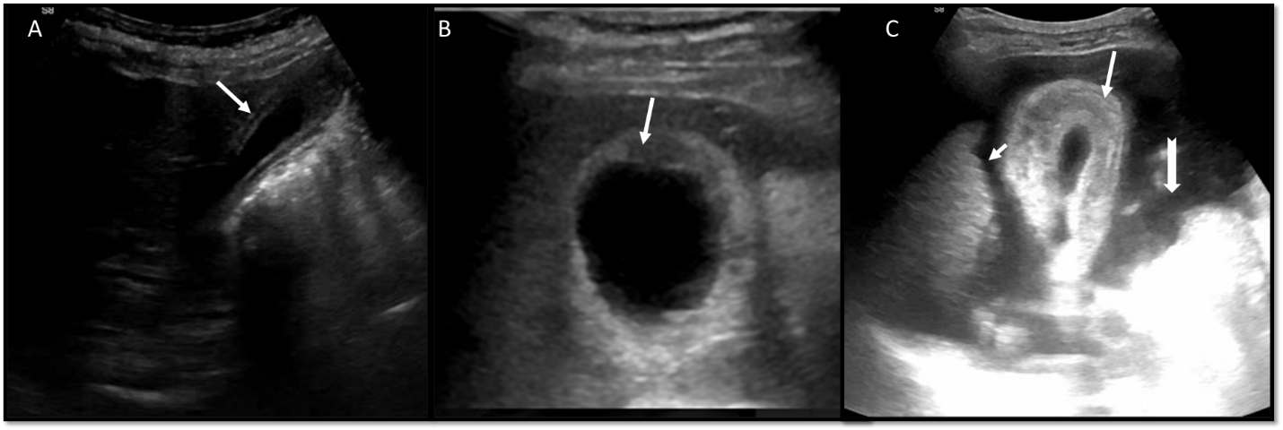
Figure 1 Ultrasound features of benign and malignant gallbladder wall thickening. A: Mild symmetrical mural thickening with clearly defined layers (arrow) suggestive of benign thickening; B: Asymmetrical mural thickening with foal discontinuity of mucosa (arrow) suggestive of malignant thickening; C: Marked circumferential mural thickening with mesh like architecture (arrow) is seen. Also note the nodular outline of liver (short arrow) and ascites (bold arrow) suggestive of decompensated ascites as the underlying cause.
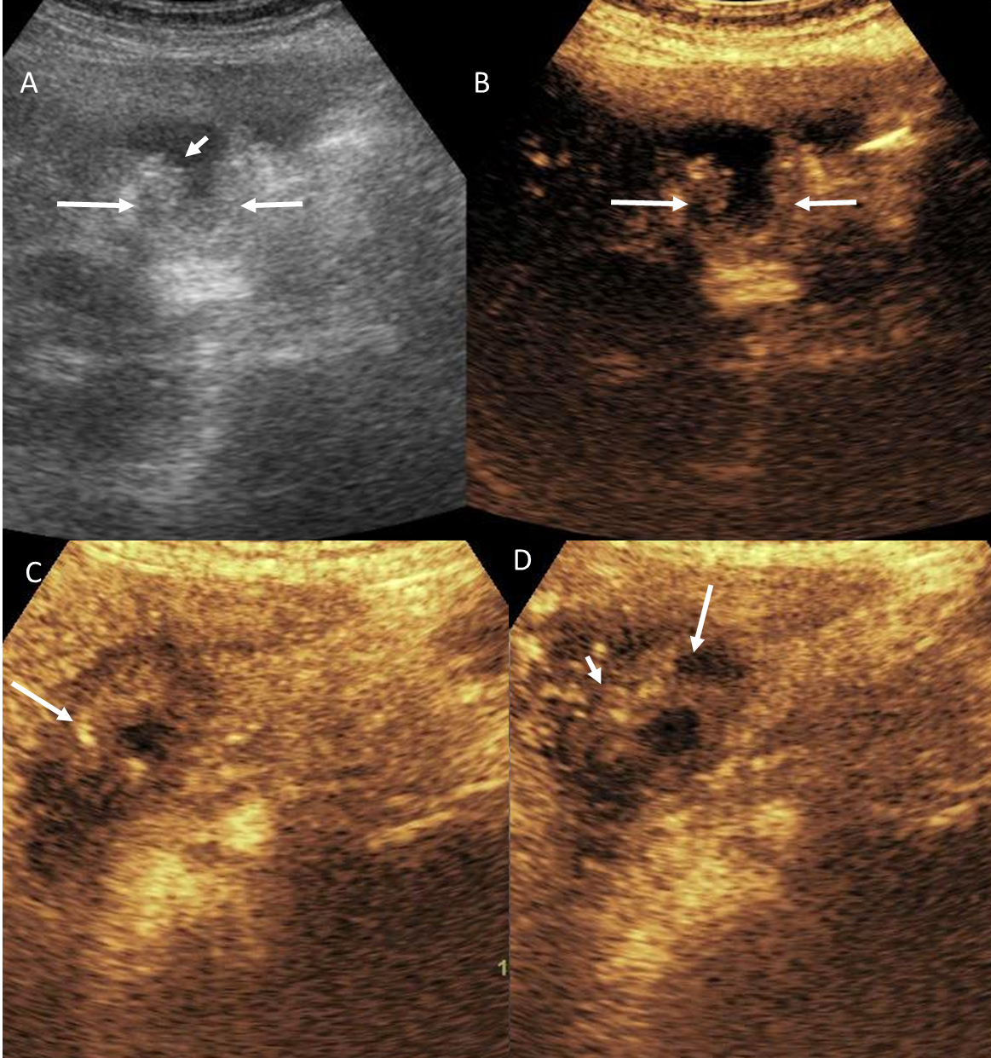
Figure 2 Contrast enhanced ultrasound in gallbladder wall thickening. A: Grey scale image shows asymmetrical mural thickening in the neck and body of gallbladder (arrows), short arrow shows the lumen of gallbladder; B: Image before contrast injection shows the baseline status of the gallbladder (arrows show the wall); C: Image at 17 s after contrast injection shows heterogenous mural enhancement (arrow); D: Image at 35 s shows washout (arrow). The infiltration of adjacent liver (short arrow) is well visualized on this image.
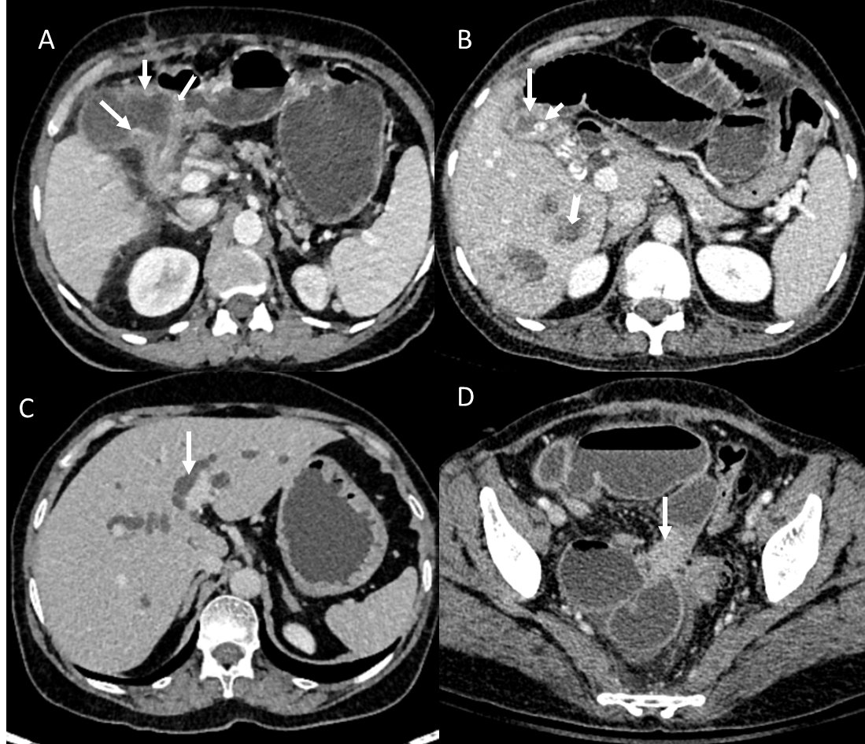
Figure 3 Direct and indirect findings of malignant gallbladder wall thickening on computed tomography. A: There is asymmetrical mural thickening of the gallbladder neck (arrow). Also note the nodularity of the gallbladder wall in the body (short arrow) and loss of fat plane with the antropyloric region of stomach (bold arrow); B: Gallbladder wall is thickened and heterogeneous (arrow). There is a calculus at the neck (short arrow). Multiple hypodense lesions are seen in right lobe (bold arrow). Fine needle aspiration cytology from one of these lesions revealed metastasis; C: There is bilobar intrahepatic biliary radicle dilatation in a patient with gallbladder cancer (arrow); D: A soft tissue deposit is seen in subserosal location in pelvis causing bowel obstruction (arrow).
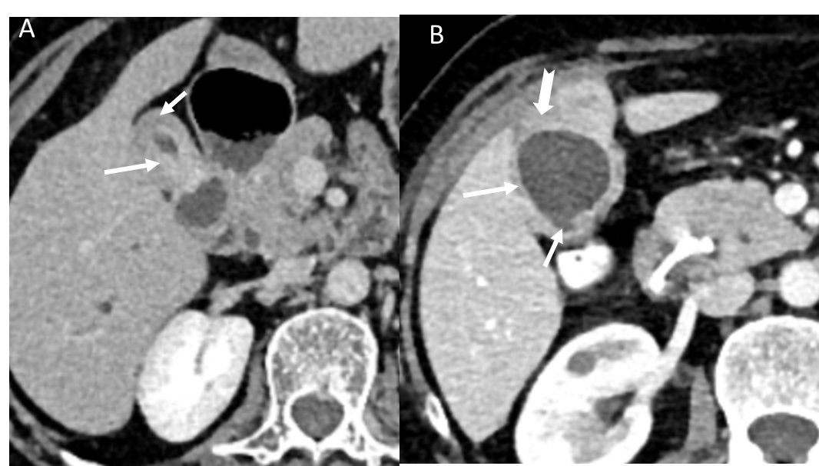
Figure 4 Patterns of malignant gallbladder wall thickening on computed tomography. A: There is thick enhancing inner layer (arrow) and relatively hypoenhancing outer layer (short arrow); B: There is heterogeneously enhancing gallbladder wall (arrow) with focal disruption of mucosa (short arrow) and serosa (bold arrow) at certain places.
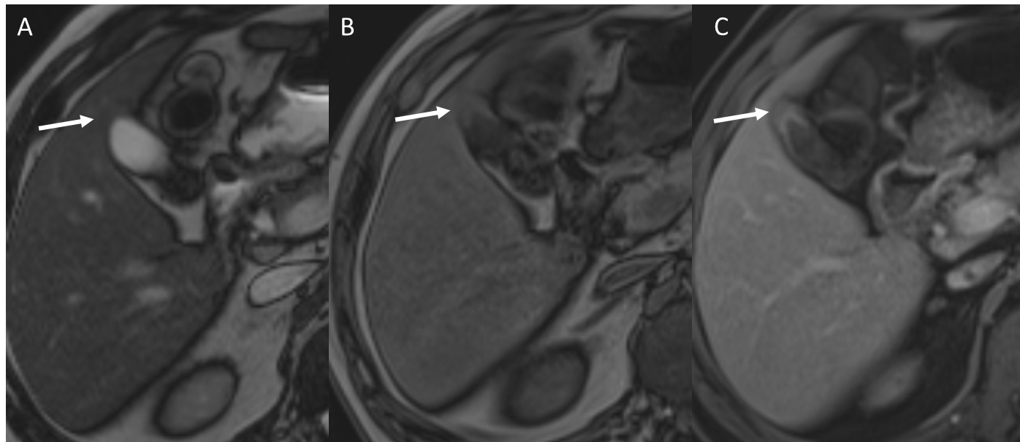
Figure 5 Benign gallbladder wall thickening on magnetic resonance imaging. A: T2-weighted magnetic resonance imaging shows hypointense thickening of the gallbladder fundus (arrow); B: The thickening shows subtle hyperintensity on T1-weighted image (arrow); C: There is homogeneous contrast enhancement on gadolinium enhanced image (arrow).
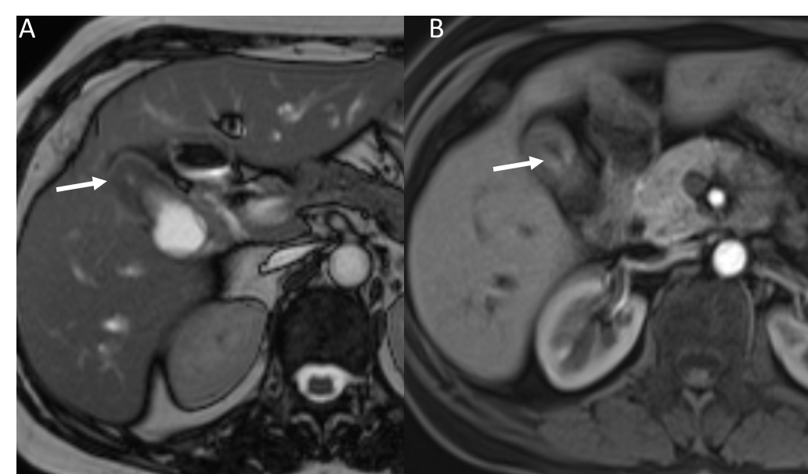
Figure 6 Malignant gallbladder wall thickening on magnetic resonance image. A: True fast imaging with steady state precession image shows marked thickening of the gallbladder fundus (arrow); B: Arterial phase of contrast enhancement shows early enhancement (arrow).
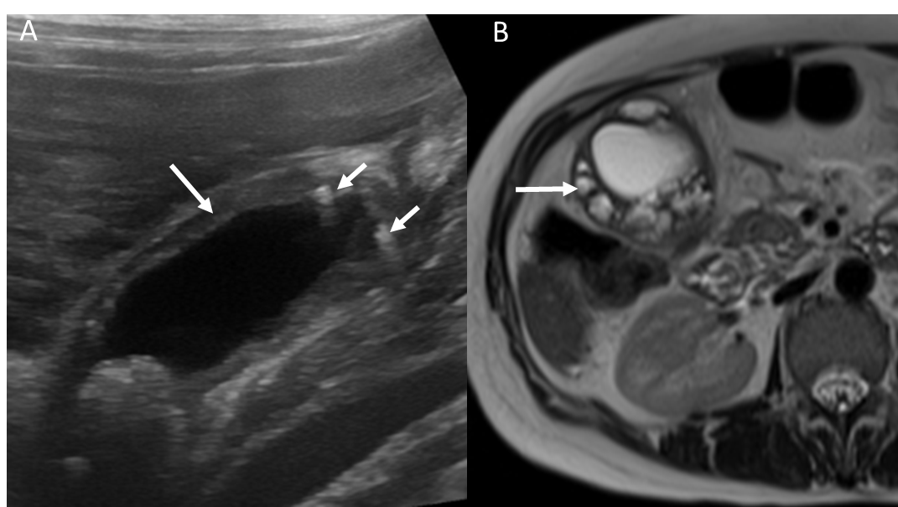
Figure 7 Imaging findings in adenomyomatosis. A: Ultrasound image shows symmetrical mural thickening (arrow) with echogenic foci showing comet tail artifacts (short arrows); B: T2-weighted magnetic resonance imaging shows multiple intramural cystic lesions (arrow).
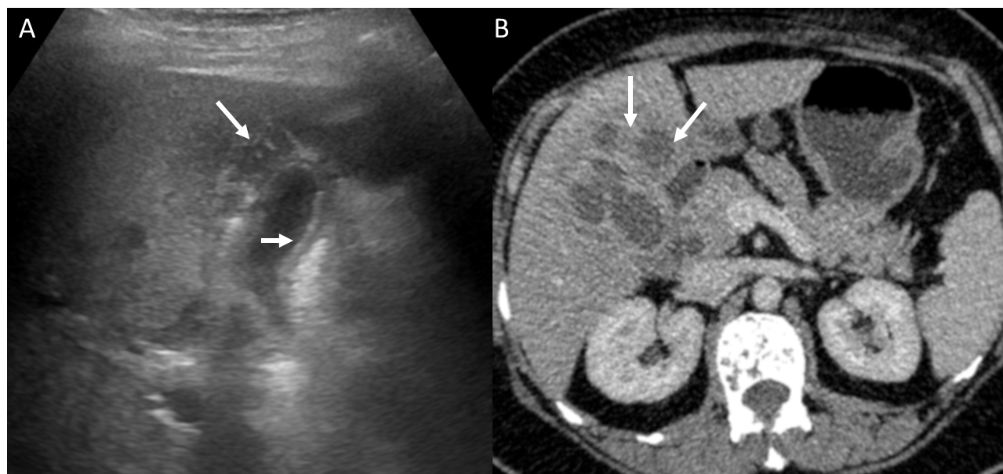
Figure 8 Imaging findings in xanthogranulomatous cholecystitis. A: Ultrasound image shows symmetrical echogenic inner layer (short arrow) with multiple hypoechoic intramural lesions (arrow); B: Contrast enhanced computed tomography image shows multiple intramural hypodense lesions (arrows).
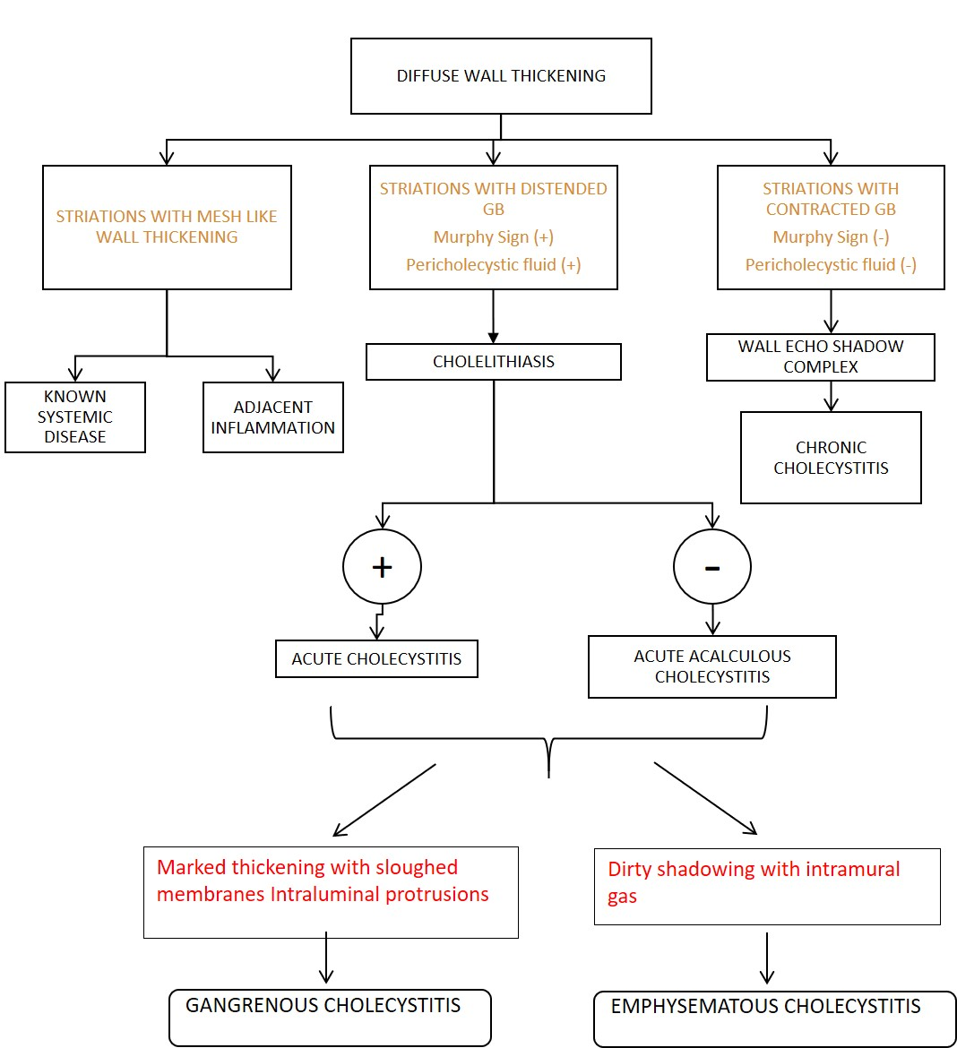
Figure 9 Flow diagram of the algorithmic approach to diagnose diffuse gallbladder wall thickening.
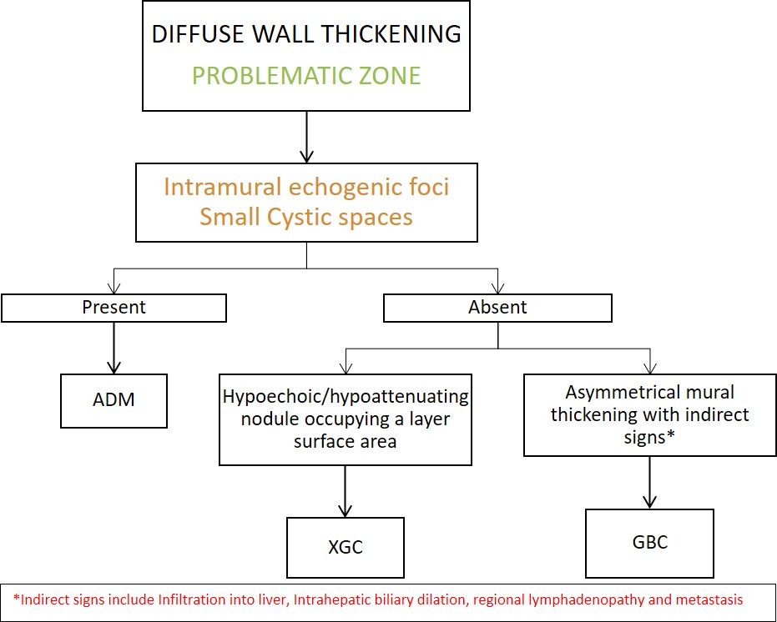
Figure 10 Flow diagram of the algorithmic approach to diagnose diffuse gallbladder wall thickening: adenomyomatosis vs xanthogranulomatous cholecystitis vs gallbladder carcinoma. ADM: Adenomyomatosis; XGC: Xanthogranulomatous cholecystitis; GBC: Gallbladder carcinoma.
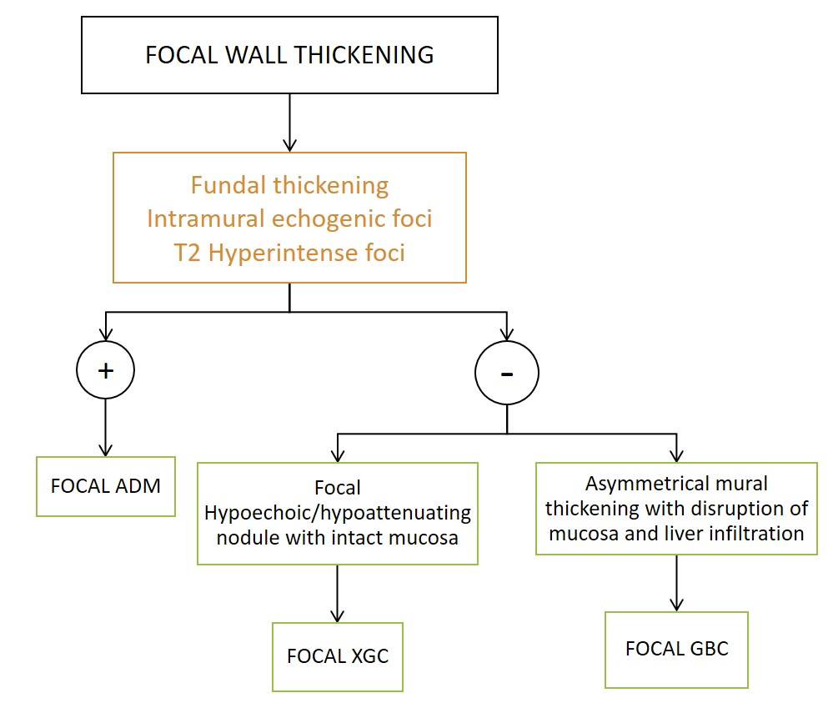
Figure 11 Flow diagram of the algorithmic approach to diagnose focal gallbladder wall thickening. ADM: Adenomyomatosis; XGC: Xanthogranulomatous cholecystitis; GBC: Gallbladder carcinoma.
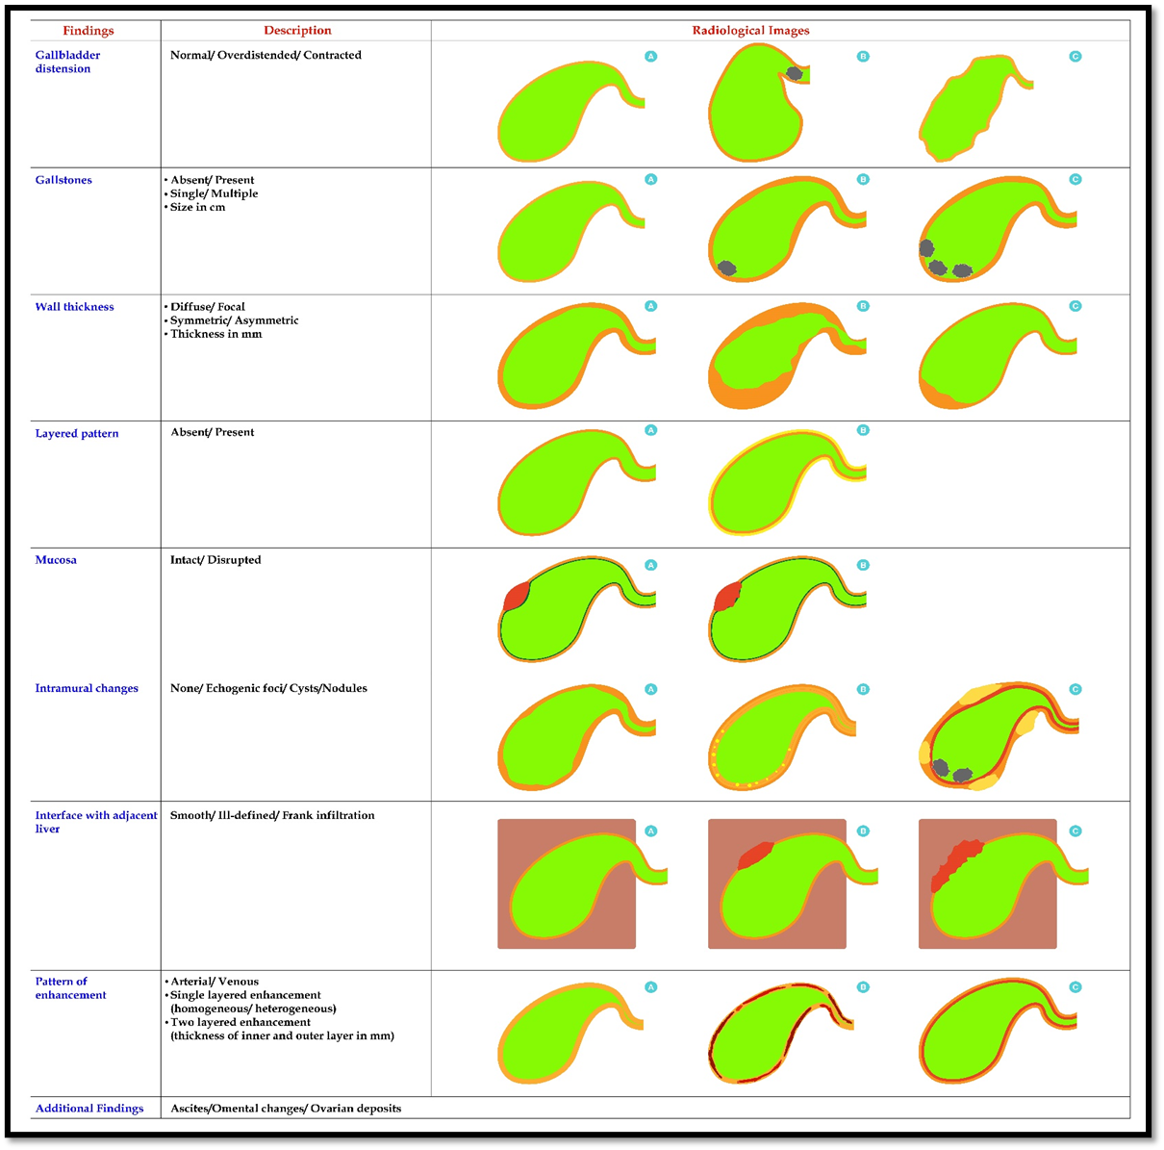
Figure 12 Reporting format of the gallbladder wall thickening.
Table 1 Features of ultrasonography which help in differentiation of benign and malignant gallbladder wall thickening
USG features | Benign wall thickening | Malignant wall thickening
Type of thickening | Diffuse and symmetric | Diffuse/focal and asymmetric
Mucosa | Intact | Discontinuous
Layered pattern of GB wall | Preserved | Lost
Color doppler findings | Low mean flow velocity and peak systolic velocity | High mean flow velocity and peak systolic velocity
Shear wave elastography parameters | Low shear wave velocity | High shear wave velocity
USG: Ultrasonography; GB: Gallbladder.
Table 2 Features of contrast-enhanced ultrasonography which help in differentiation of benign and malignant gallbladder wall thickening
 | Benign wall thickening | Malignant wall thickening
Type of enhancement | Homogenous arterial phase enhancement | Non-homogenous arterial phase enhancement
Pattern of vascularization | Branched or tortuous intralesional vascularity | Dotted intralesional vascularity
Dynamic change of enhancement | Washout time > 40 s | Washout time < 40 s
Infiltration into liver parenchyma | Absent | Present

Table 3 Features of computed tomography which help in differentiation of benign and malignant gallbladder wall thickening
CT findings | Benign wall thickening | Malignant wall thickening
Patterns of enhancement | Single layer: Homogenous enhancement; two layered patterns: Inner layer isoattenuating to liver | Single layer: Strongly heterogeneously enhancing; two layered patterns: Inner layer enhancing in arterial phase and isoattenuating in venous phase
Biliary obstruction | Not seen | More likely to be seen
Regional lymphadenopathy | Not present | Present
Infiltration into liver | Not seen | May be present
CT: Computed tomography.
Table 4 Features of magnetic resonance imaging which help in differentiation of benign and malignant gallbladder wall thickening
MRI findings | Benign wall thickening | Malignant wall thickening
Pattern of thickening | On T2, thin hypointense inner layer and thick hyperintense outer layer or multiple T2 hyperintense foci in wall | Diffuse nodular thickening without layering
Dynamic contrast enhancement | Relatively slow enhancement | Early enhancement
Diffusion restriction | High ADC value and low lesion to spinal cord ratio | Low ADC value and high lesion to spinal cord ratio
MRI: Magnetic resonance imaging; ADC: Apparent diffusion coefficient.
Table 5 Rare causes of gallbladder wall thickening and their imaging findings
Cause | CT findings
Tuberculosis | (1) micronodular type: Micronodular or polypoidal lesions in GB wall; (2) thickened wall type: Most common. Diffuse or focal, nonspecific, homogeneous, or heterogeneous enhancement. Halo of edema may be present; (3) mass-forming type: Large mass with multicentric necrosis and foci of calcification
Primary lymphoma | (1) high grade: Solid and bulky mass in the GB fossa or marked GB wall thickening; (2) low grade: Mild GB wall thickening with intact mucosa
Neuroendocrine tumor | Most common as mass replacing GB with well-defined margins and intact mucosa as compared to GBC. Arterial hyperenhancement. More extensive and bulky lymph node and hepatic metastasis compared to GBC
CT: Computed tomography; GB: Gallbladder; GBC: Gallbladder carcinoma.

