Name of Journal: World Journal of Clinical Cases
Manuscript NO: 50502
Manuscript Type: CASE REPORT

Giant gastroduodenal trichobezoar: A case report

Dong ZH et al. Giant gastroduodenal trichobezoar

Zhi-Hui Dong, Feng Yin, Shi-Lin Du, Zhe-Heng Mo

Zhi-Hui Dong, Shi-Lin Du, Zhe-Heng Mo, Department of Radiology, Luoyang Central Hospital Affiliated to Zhengzhou University, Luoyang 471009, Henan Province, China

Feng Yin, Pharmacology Department, Luoyang Central Hospital Affiliated to Zhengzhou University, Luoyang 471009, Henan Province, China

ORCID number: Zhi-Hui Dong (0000-0002-9790-3059); Feng Yin (0000-0001-6481-0836); Shi-Lin Du (0000-0002-7342-7502); Zhe-Heng Mo (0000-0002-8452-149X).

Author contributions: Dong ZH and Feng Y contributed equally to this paper and should be regarded as co-first authors; Dong ZH, Mo ZH, and Du SL performed the operation and wrote the paper; Feng Y helped draft the manuscript and prepared the figures; all the authors read and approved the final manuscript.

Informed consent statement: Written informed consent was obtained from the patient for publication of this report and any accompanying images.

Conflict-of-interest statement: No potential conflicts of interest relevant to this article are reported.

CARE Checklist (2016) statement: The authors have read the CARE Checklist (2016), and the manuscript was prepared and revised according to the CARE Checklist (2016).

Open-Access: This article is an open-access article that was selected by an in-house editor and fully peer-reviewed by external reviewers. It is distributed in accordance with the Creative Commons Attribution Non Commercial (CC BY-NC 4.0) license, which permits others to distribute, remix, adapt, build upon this work non-commercially, and license their derivative works on different terms, provided the original work is properly cited and the use is non-commercial. See: http://creativecommons.org/licenses/by-nc/4.0/

Manuscript source: Unsolicited manuscript

Corresponding author: Zhi-Hui Dong, PhD, Associate Professor, Surgeon, Department of Radiology, Luoyang Central Hospital Affiliated to Zhengzhou University, No. 288, Zhongzhou Zhong Road, Luoyang 471009, Henan Province, China. dongzhih@163.com
Telephone: +86-379-63892008
Fax: +86-379-63892003

Received: August 18, 2019
Peer-review started: August 18, 2019
First decision: September 9, 2019
Revised: September 23, 2019
Accepted: October 5, 2019
Article in press: October 5, 2019
Published online: November 6, 2019

Abstract
BACKGROUND
We report a case of giant gastroduodenal trichobezoar, an extremely rare upper gastrointestinal bezoar due to trichotillomania and trichophagia.

CASE SUMMARY
The patient was a 10-year-old girl who presented with an abdominal mass that was discovered at palpation and noninvasive imaging examinations. Computed tomography (CT) showed a well-circumscribed heterogeneous mass extending from the stomach into the duodenum. The patient underwent a laparotomy to pull out the trichobezoar. Although these imaging findings are nonspecific, trichobezoar should be included in the differential diagnosis of gastric mass, especially with the history of an irresistible urge to pull out and swallow their hair.

CONCLUSION
Laparotomy is useful and practical for the management of giant gastroduodenal trichobezoar.

Key words: Tomography; X-ray; Trichobezoar; Trichotillomania; Trichophagia; Case report

© The Author(s) 2019. Published by Baishideng Publishing Group Inc. All rights reserved.

Core tip: A case of giant gastroduodenal trichobezoar, an extremely rare upper gastrointestinal bezoar due to trichotillomania and trichophagia, is reported. The patient was a 10-year-old girl who presented with an abdominal mass that was discovered at palpation and noninvasive imaging examinations. Computed tomography showed a well-circumscribed heterogeneous mass extending from the stomach into the duodenum. Laparotomy is useful and effective for the treatment of giant gastroduodenal trichobezoar.

Dong ZH, Yin F, Du SL, Mo ZH. Giant gastroduodenal trichobezoar: A case report. World J Clin Cases 2019; 7(21): 3649-3654 URL: https://www.wjgnet.com/2307-8960/full/v7/i21/3649.htm DOI: https://dx.doi.org/10.12998/wjcc.v7.i21.3649

INTRODUCTION
A trichobezoar is a rarely encountered mass of hair, wool, and similar material in the stomach and intestine of some patients with trichotillomania and trichophagia. The accumulated hair within the stomach and intestine is resistant to digestion, which occasionally presents as trichobezoar-induced bowel or gastric outlet obstruction^{[1-6]}. Moreover, trichobezoar frequently leads to a spectrum of nonspecific clinical findings, including early satiety, anorexia, vomiting, and vague abdominal pain^{[7,8]}. Clinically, most of the trichobezoars are usually found in young females between 15 and 20 years of age because of their nonspecific presentations or even lack of clinical symptoms in the early stage^{[9,10]}. Herein, we describe the clinical and imaging features of a 10-year-old girl determined as having a giant gastroduodenal trichobezoar with a history of an uncontrolled urge to pull out her hair (trichotillomania) and swallow it (trichophagia).

CASE PRESENTATION
Chief complaints
A ten-year-old girl presented to our emergency department with a one-day history of abdominal pain after intermitten vomiting of gastric contents and inappetence for approximately 9 d.

History of present illness
Acute gastritis was initially suspected, while it was not supported by the symptoms and therapy history.

History of past illness
It is noteworthy that her mother admitted that this girl had developed an irresistible habit of pulling and swallowing her hair from two years old, which mainly happened unconsciously during sleep or when she was lonely.

Personal and family history
Her parents had no history of swallowing hair.

Physical examination
On physical examination, a movable mass was palpable in the left upper quadrant, and no sign of a rebound, peritonitis, or apparent hair loss was noted.

Laboratory examinations
Laboratory results indicated anemia, hypoproteinemia, and hyponatremia, with a hemoglobin level of 115 g/L (normal range, 120–160 g/L), hematocrit 33.5% (normal range, 35.0%-49.0%), total protein 58 g/L (normal range, 63-82 g/L), albumin 28 g/L (normal range, 35-50 g/L), and natrium 136 mEq/L (normal range, 137-145 mEq/L). An elevated white blood cell count of 10050/µL (normal range, 4000–10000/µL) and a neutrophil ratio of 80% (normal range, 50.0%-70.0%) were demonstrated.

Imaging examinations
Noninvasive imaging examinations were performed, including plain chest radiography, ultrasound, and computed tomography (CT). Plain radiographs showed that the the chest was normal. Abdominal ultrasound demonstrated an intragastric hyperechoic mass, with a prominent posterior acoustic shadow of 13 cm in the maximum diameter. The residualdual gastric cavity could be detected at the fundus of 1.3 cm in width after drinking 300 mL of water. Noncontrasted-enhanced CT clearly showed a heterogeneous, meshlike mass with air sign filling the gastric cavity, from the fundus to the pylorus, measuring approximately 12.7 cm × 9.4 cm × 5.3 cm in size (Figure 1). On the coronal CT images, the mass extended from the stomach into the duodenum (Figure 2). Furthermore, the well-defined margin of the mass was outlined by the surrounding air in the stomach on the three-dimensional (3D) maximum intensity projection images (Figure 3).

FINAL DIAGNOSIS
Based on the clinical, imaging, and surgical outcomes, the final diagnosis was a giant gastroduodenal trichobezoar due to trichotillomania and trichophagia.

TREATMENT
Since the mass was so large, laparotomy was considered (Figure 4). Under general anesthesia, all the imaging findings mentioned above were confirmed during the surgical process.

OUTCOME AND FOLLOW-UP
The postoperative course was uneventful, and the girl was referred to behavioral and mental health providers after discharge.

DISCUSSION
In 1779, Baudamant described the first case of trichobezoar that is one of the bezoars with intraluminal accumulations of indigestible ingested hair. Trichotillomania is an uncommon disorder affecting about 1% of the population, and one-third of these patients have trichophagia^{[11]}. It usually occurs in patients with mental retardation, personality or psychiatric abnormalities, and sufferers have an irresistible urge to pull out and swallow their hair, termed as trichotillomania and trichophagia. Occasionally, Rapunzel syndrome is encountered as an infrequent complication of trichobezoar formation in which the gastric bezoar is extended into the duodenum and small intestine, which can increase the risk of complications such as obstruction and perforation. Trichobezoar with Rapunzel syndrome is predominantly found in emotionally disturbed or developmentally disabled youngsters because of their nonspecific presentations or even lack of clinical symptoms in the early stage^{[12]}.
Clinically, patients with trichobezoar frequently present nonspecific symptoms and signs including loss of appetite, weight loss, vomiting, and abdominal pain^{[10,13,14]}. After long periods of time, the epigastric mass can be palpable when it is gradually enlarged, even associated with trichobezoar-induced gastric pylorus or bowel obstruction. In clinical practice, early diagnosis may be difficult for these nonspecific symptoms and signs. However, advanced noninvasive imaging modalities, including conventional upper gastrointestinal radiography, ultrasound, CT, and nuclear magnetic resonance imaging (MRI), are beneficial for making preoperative diagnosis and clinical management decision as previously reported^{[13,15-19]}. In our case, the little girl was initially suspected with acute gastritis based on the nonspecific symptoms and laboratory results such as abdominal pain, anemia, hypoproteinemia, and hyponatremia. Fortunately, ultrasound and CT provided the positive information for the diagnosis, especially combined with 3D reconstructed CT images. As a noninvasive and nonirradiated tool, MRI is also useful for detecting this entity, especially in the pediatric population^{[20]}. More importantly, the history of mental disorder, the uncontrolled urge to pull out one’s hair and swallow it, is vital as a critical clue for making a clinical diagnosis. After the diagnosis is made, treatment modalities, including observation, dissolution, and surgery, could be considered. When a thickened mass is detected, surgical approach severing as an optimal choice could either be laparoscopic or open laparotomy^{[6,8,12,21,22]}. Before the operation, noninvasive imaging modalities are beneficial for the pre- and post-operative assessment of trichobezoar and its possible complications, which can help make management decisions to reduce the frequency of clinical hazards.

CONCLUSION
As above, laparotomy is useful and practical for the treatment of giant gastroduodenal trichobezoar.

REFERENCES
1 Al-Wadan AH, Al-Absi M, Al-Saadi AS, Abdoulgafour M. Rapunzel syndrome. Saudi Med J 2006; 27: 1912-1914 [PMID: 17143376 DOI: 10.4103/0256-4947.51511]
2 Balik E, Ulman I, Taneli C, Demircan M. The Rapunzel syndrome: a case report and review of the literature. Eur J Pediatr Surg 1993; 3: 171-173 [PMID: 8353119 DOI: 10.1055/s-2008-1063536]
3 Dalshaug GB, Wainer S, Hollaar GL. The Rapunzel syndrome (trichobezoar) causing atypical intussusception in a child: a case report. J Pediatr Surg 1999; 34: 479-480 [PMID: 10211659 DOI: 10.1016/s0022-3468(99)90504-3]
4 Dindyal S, Bhuva Nj, Dindyal S, Ramdass M, Narayansingh V. Trichobezoar presenting with the 'comma sign' in Rapunzel Syndrome: a case report and literature review. Cases J 2008; 1: 286 [PMID: 18973682 DOI: 10.1186/1757-1626-1-286]
5 Duncan ND, Aitken R, Venugopal S, West W, Carpenter R. The Rapunzel syndrome. Report of a case and review of the literature. West Indian Med J 1994; 43: 63-65 [PMID: 7941500]
6 Hassan AA, Panesar KJ. The Rapunzel syndrome: a rare presentation of trichobezoar. Ulster Med J 1989; 58: 94-96 [PMID: 2672527]
7 Fallon SC, Slater BJ, Larimer EL, Brandt ML, Lopez ME. The surgical management of Rapunzel syndrome: a case series and literature review. J Pediatr Surg 2013; 48: 830-834 [PMID: 23583142 DOI: 10.1016/j.jpedsurg.2012.07.046]
8 Gorter RR, Kneepkens CM, Mattens EC, Aronson DC, Heij HA. Management of trichobezoar: case report and literature review. Pediatr Surg Int 2010; 26: 457-463 [PMID: 20213124 DOI: 10.1007/s00383-010-2570-0]
9 Lalith S, Gopalakrishnan KL, Ilangovan G, Jayajothi A. Rapunzel Syndrome. J Clin Diagn Res 2017; 11: TD01-TD02 [PMID: 29207806 DOI: 10.7860/jcdr/2017/28593.10594]
10 Mathai J, Chacko J, Kumar TS, Scott JX, Agarwal I, Varkki S. Rapunzel syndrome: a diagnosis overlooked. Acta Paediatr 2007; 96: 135-137 [PMID: 17187622 DOI: 10.1111/j.1651-2227.2007.00012.x]
11 Frey AS, McKee M, King RA, Martin A. Hair apparent: Rapunzel syndrome. Am J Psychiatry 2005; 162: 242-248 [PMID: 15677585 DOI: 10.1176/appi.ajp.162.2.242]
12 Gonuguntla V, Joshi DD. Rapunzel syndrome: a comprehensive review of an unusual case of trichobezoar. Clin Med Res 2009; 7: 99-102 [PMID: 19625498 DOI: 10.3121/cmr.2009.822]
13 Mehta P, Bhutiani R. The Rapunzel syndrome: is it an Asian problem? (case report and review of literature). Eur J Gastroenterol Hepatol 2009; 21: 937-940 [PMID: 19322101 DOI: 10.1097/MEG.0b013e3283140ed2]
14 Middleton E, Macksey LF, Phillips JD. Rapunzel syndrome in a pediatric patient: a case report. AANA J 2012; 80: 115-119 [PMID: 22586880]
15 Nour I, Abd Alatef M, Megahed A, Yahia S, Wahba Y, Shabaan AE. Rapunzel syndrome (gastric trichobezoar), a rare presentation with generalised oedema: case report and review of the literature. Paediatr Int Child Health 2019; 39: 76-78 [PMID: 29057712 DOI: 10.1080/20469047.2017.1389809]
16 Obinwa O, Cooper D, Khan F, O'Riordan JM. Rapunzel syndrome is not just a mere surgical problem: A case report and review of current management. World J Clin Cases 2017; 5: 50-55 [PMID: 28255548 DOI: 10.12998/wjcc.v5.i2.50]
17 Palanivelu C, Rangarajan M, Senthilkumar R, Madankumar MV. Trichobezoars in the stomach and ileum and their laparoscopy-assisted removal: a bizarre case. Singapore Med J 2007; 48: e37-e39 [PMID: 17304375]
18 Tayyem R, Ilyas I, Smith I, Pickford I. Rapunzel syndrome and gastric perforation. Ann R Coll Surg Engl 2010; 92: W27-W28 [PMID: 20056057 DOI: 10.1308/147870810x476700]
19 Western C, Bokhari S, Gould S. Rapunzel syndrome: a case report and review. J Gastrointest Surg 2008; 12: 1612-1614 [PMID: 18027058 DOI: 10.1007/s11605-007-0408-4]
20 Ben Cheikh A, Gorincour G, Dugougeat-Pilleul F, Dupuis S, Basset T, Pracros JP. [Gastric trichobezoar in an adolescent presenting with anemia: ultrasound and MRI findings]. J Radiol 2004; 85: 411-413 [PMID: 15213652 DOI: 10.1016/S0221-0363(04)97601-9]
21 Jones GC, Coutinho K, Anjaria D, Hussain N, Dholakia R. Treatment of recurrent Rapunzel syndrome and trichotillomania: case report and literature review. Psychosomatics 2010; 51: 443-446 [PMID: 20833945 DOI: 10.1176/appi.psy.51.5.443]
22 Morales-Fuentes B, Camacho-Maya U, Coll-Clemente FL, Vázquez-Minero JC. Trichotillomania, recurrent trichobezoar and Rapunzel syndrome: case report and literature review. Cir Cir 2010; 78: 265-266 [PMID: 20642912]
P-Reviewer: Ishibashi H, Zimmerman M
S-Editor: Wang JL L-Editor: Wang TQ E-Editor: Liu MY

Specialty type: Medicine, Research and Experimental
Country of origin: China
Peer-review report classification
Grade A (Excellent): A
Grade B (Very good): B
Grade C (Good): 0
Grade D (Fair): 0
Grade E (Poor): 0

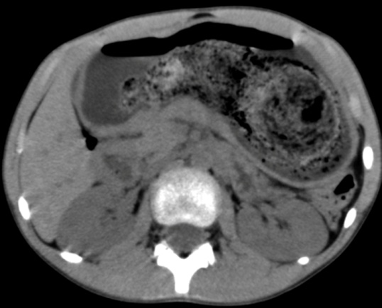
Figure 1 Axial computed tomography image showing a hairball in the stomach.

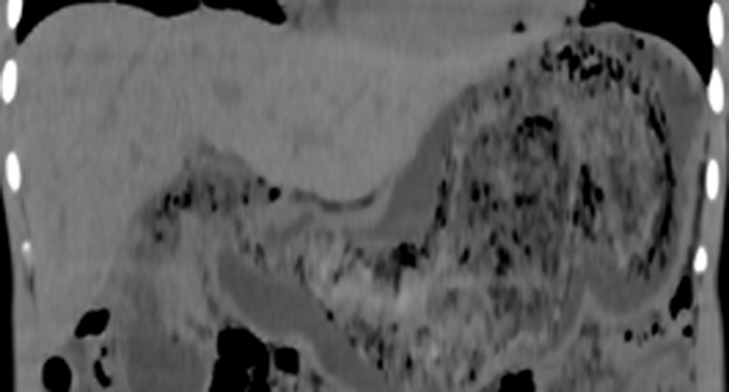
Figure 2 Coronary multiplanar reconstruction computed tomogrpahy image showing the extension of a hairball from the stomach into the second part of the duodenum.

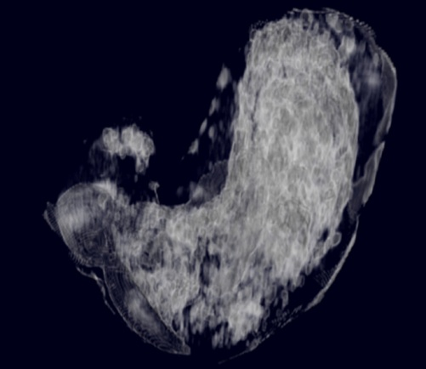
Figure 3 Three-dimension maximum intensity projection image showing the outline of a hairball defined by the air pockets in it.

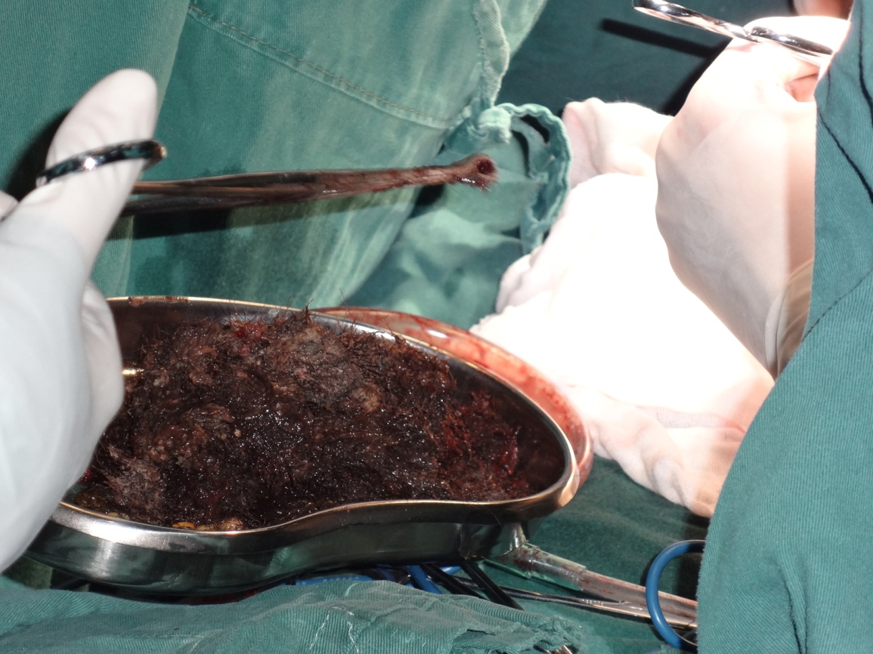
Figure 4 Postoperative photograph of the hair pulled from the stomach.

