Name of Journal: World Journal of Gastroenterology
Manuscript NO: 77938
Manuscript Type: MINIREVIEWS

Efficacy of cytapheresis in patients with ulcerative colitis showing insufficient or lost response to biologic therapy

Iizuka M et al. Cytapheresis in UC refractory to biologics

Masahiro Iizuka, Takeshi Etou, Shiho Sagara

Masahiro Iizuka, Shiho Sagara, Akita Health Care Center, Akita Red Cross Hospital, Akita 010-0001, Japan

Masahiro Iizuka, Takeshi Etou, Department of Gastroenterology, Akita Red Cross Hospital, Akita 010-1495, Japan

Author contributions: Iizuka M was responsible for the conception and design of the study, literature review and analysis, drafting and critical revision and editing, and final approval of the final version; Etou T and Sagara S was responsible for the critical revision and final approval of the final version.

Corresponding author: Masahiro Iizuka, MD, PhD, Director, Doctor, Akita Health Care Center, Akita Red Cross Hospital, 3-4-23 Nakadori, Akita 010-0001, Japan. maiizuka@woody.ocn.ne.jp

Received: May 30, 2022
Revised: July 16, 2022
Accepted: August 16, 2022
Published online:

Abstract
For the optimal management of refractory ulcerative colitis (UC), secondary loss of response (LOR) and primary non-response to biologics is a critical issue. This article aimed to summarize the current literature on the use of cytapheresis (CAP) in patients with UC showing a poor response or LOR to biologics and discuss its advantages and limitations. Further, we summarized the efficacy of CAP in patients with UC showing insufficient response to thiopurines or immunomodulators (IM). Eight studies evaluated the efficacy of CAP in patients with UC with inadequate responses to thiopurines or IM. There were no significant differences in the rate of remission and steroid-free remission between patients exposed or not exposed to thiopurines or IM. Three studies evaluated the efficacy of CAP in patients with UC showing an insufficient response to biologic therapies. Mean remission rates of biologics exposed or unexposed patients were 29.4 % and 44.2%, respectively. Fourteen studies evaluated the efficacy of CAP in combination with biologics in patients with inflammatory bowel disease showing a poor response or LOR to biologics. The rates of remission/response and steroid-free remission in patients with UC ranged 32%-69% (mean: 48.0%, median: 42.9%) and 9%-75% (mean: 40.7%, median: 38%), respectively. CAP had the same effectiveness for remission induction with or without prior failure on thiopurines or IM but showed little benefit in patients with UC refractory to biologics. Although heterogeneity existed in the efficacy of the combination therapy with CAP and biologics, these combination therapies induced clinical remission/response and steroid-free remission in more than 40% of patients with UC refractory to biologics on average. Given the excellent safety profile of CAP, this combination therapy can be an alternative therapeutic strategy for UC refractory to biologics. Extensive prospective studies are needed to understand the efficacy of combination therapy with CAP and biologics.

Key Words: Ulcerative colitis; Inflammatory bowel disease; Cytapheresis; Granulocyte and monocyte adsorptive apheresis; Anti-tumor necrosis factor-α antibody; Combination therapy

Iizuka M, Etou T, Sagara S. Efficacy of cytapheresis in patients with ulcerative colitis showing insufficient or lost response to biologic therapy. World J Gastroenterol 2022; In press

Core Tip: Management of refractory ulcerative colitis (UC) experiencing primary non-response or loss of response to biologics is a critical issue. We first summarized the efficacy of cytapheresis (CAP) for such patients. Although CAP tended to have lower effects for induction of remission in patients with UC who were refractory to biologics, combination therapies with CAP and biologics induced clinical remission or response in more than 40% of such patients with UC on average. Given the excellent safety profile of CAP, we believe that this combination therapy can be an alternative therapeutic strategy for such refractory UC patients.
INTRODUCTION
Ulcerative colitis (UC) is a chronic inflammatory bowel disease (IBD) of the colon characterized by a relapsing and remittent course^{[1,2]}. Multiple factors, such as genetic background, environmental and luminal factors, and mucosal immune dysregulation, have been suggested to contribute to UC pathogenesis^{[1]}. Several treatments for UC are available to induce and maintain the clinical remission of the disease. For patients with mild to moderate UC, 5-aminosalicylic acid (5-ASA) is generally used, and more than 90% of patients receive 5-ASA within 1 year of diagnosis^{[3]}. Corticosteroids (CSs) are the first-line treatment to induce remission in moderate to severe UC^{[2]}. It was reported that immediate outcomes from CSs were complete remission in 54%, partial remission in 30%, and no response in 16% of patients^{[4]}. Despite the effectiveness of CSs in patients with UC, it has been reported that the rate of steroid dependence was 17%-22% at 1 year following treatment with the initial CS therapy and increased to 38% mostly within 2 years^{[4-8]}.
Thiopurines have been conventionally used for the treatment of steroid-dependent UC^{[9-14]}. The rates of the induction of CS-free remission with thiopurines in steroid-dependent patients with UC were reported to be 44% and 53%, respectively^{[13,14]}. However, it has also been reported that thiopurine therapy has failed in approximately 25% of IBD patients within 3 mo after treatment initiation, mostly due to drug intolerance or toxicity^{[11]}.
Along with the recent advancements in the treatment for UC, effective treatments, including biologics [anti- tumor necrosis factor-α (TNF-α) antibodies^{[15-25]}, anti-integrin monoclonal antibody^{[26]}], Janus kinase (JAK) inhibitor^{[27]} and tacrolimus^{[28,29]}, have been developed for refractory UC. A meta-analysis showed that anti-TNF-α antibodies had more clinical benefits than placebo as evidenced by the former’s increased frequency of clinical, steroid-free, and endoscopic remission and decreased frequency of colectomy^{[30]}. It has been reported that the rates of induction of steroid-free remission in refractory patients with UC with anti-TNF-α antibodies ranged from 40.0%-76.5%^{[2,16,18,21,22,24]}. Vedolizumab (VDZ) is an anti-integrin monoclonal antibody. Studies on VDZ showed that clinical response and remission were achieved in 51% and 30% of patients with UC by week 14, respectively^{[31]}. However, despite the significant efficacy of biologics for UC, secondary loss of response (LOR) is a common clinical problem. It was reported that the rate of LOR to anti-TNF-α antibodies in UC ranged from 23%-46% at 12 mo after anti-TNF-α initiation^{[32]}. It was also reported that the incidence rates of LOR to adalimumab (ADA) and infliximab (IFX) were 58.3% and 59.1% during maintenance therapy, respectively (mean follow-up: 139 and 158.8 wk, respectively)^{[33]}. Recent data from a systematic review showed that the pooled incidence rates of LOR to VDZ were 47.9 and 39.8 per 100 person-years of follow-up among patients with Crohn's disease (CD) and UC, respectively^{[34]}. Considering these results, secondary LOR as well as primary non-response to biologics, are a critical issue for the optimal management of refractory UC. In this context, recent studies have shown the efficacy of use of cytapheresis (CAP) in such patients with UC^{[35-51]}.
CAP is a non-pharmacological extracorporeal therapy and has been developed as a treatment for UC^{[52-58]}. CAP is performed using two methods, namely, granulocyte and monocyte adsorptive apheresis (GMA), which uses cellulose acetate beads (Adacolumn, JIMRO Co., Ltd., Takasaki, Japan), and leukocytapheresis (LCAP), which uses polyethylene phthalate fibers (Cellsorba., Asahi Kasei Medical Co., Ltd., Tokyo, Japan)^{[42,52]}. GMA selectively depletes elevated levels of granulocytes and monocytes from the patients’ circulation, but spares most of the lymphocytes^{[52]}. LCAP exerts its anti-inflammatory effects by removing activated leukocytes or platelets from the peripheral blood through extracorporeal circulation^{[42]}. It has been reported that CAP is an effective therapeutic strategy for active refractory UC with fewer adverse effects^{[52-59]}. In addition, it is notable that there have been no reports showing LOR to CAP during the treatment.
As described above, recent studies have shown the efficacy of the use of CAP in patients with UC showing a poor response or LOR to biologics, but the results of these studies have not been summarized to date. The purpose of this article is to summarize the current literature on the use of CAP as an alternative therapeutic strategy for patients with UC showing insufficient response or LOR to biologics and discuss the advantages and limitations of this strategy. We also summarized the efficacy of CAP for patients with UC showing insufficient response to thiopurines or immunomodulators (IM)^{[36,37,42,58-62]}.

LITERATURE SEARCH STRATEGY
Electric search for studies published before December 2021 was performed in the PubMed databases. The search terms used were as follows; ulcerative colitis, inflammatory bowel disease, cytapheresis, GMA, biologics, loss of response, anti-TNF-α antibody, infliximab, adalimumab, golimumab, vedolizumab, ustekinumab, combination therapy, thiopurine, and immunomodulator. Reference lists of all relevant articles were searched for further studies. The search was restricted to articles in the English language and included prospective studies, retrospective studies, case series, case reports, and randomized control studies. Subsequently, we generated a state-of-the-art comprehensive review by summarizing the data on the efficacy of CAP in patients with UC (or IBD) showing insufficient or lost response to biologic therapy, and efficacy of CAP in patients with UC showing insufficient response to thiopurines or IM.

EFFICACY OF CAP IN PATIENTS WITH UC SHOWING INSUFFICIENT RESPONSE TO THIOPURINES OR IM
There were eight studies that evaluated the efficacy of CAP in patients having UC with insufficient response to thiopurines (Table 1)^{[36,37,42,58-62]}. These studies include three prospective studies, two retrospective studies, one historical cohort study, one single-arm, open-label, multicentre trial, and one multicenter cohort study. Among them, four studies showed remission rates, and four studies showed steroid-free remission rates in CAP therapy in patients with UC concomitantly treated with thiopurines or IM. Although the background of the patients in these studies were different, the remission rates in CAP therapy ranged from 40.3%-73% (mean ± SD: 56.25 ± 16.03%, median: 55.85%, interquartile range: 41.475%-71.425%) and the steroid-free remission rates in CAP therapy ranged from 36%-56.3% (mean ± SD: 47.25 ± 9.99%, median: 48.35%, interquartile range: 37.425%-55.975%) (Figure 1). Among these studies, four^{[37,42,58,59]} compared the rates of clinical remission between the patients exposed to thiopurines or IM and the patients unexposed to them. In all four studies significant differences were not observed in the rates of remission between patients exposed to thiopurines or IM and control. In three of the four studies, the remission rates in patients with UC concomitantly exposed to thiopurines or IM ranged from 45%-73% (mean ± SD: 61.57 ± 14.69%, median: 66.7%), and those in patients unexposed to thiopurines or IM ranged from 48%-71% (mean ± SD: 62.7 ± 12.8%, median: 69.1%) (Figure 2A).
Specifically, Yokoyama et al^{[42]} used LCAP in their study and demonstrated that the clinical remission rate of the patients concomitantly using thiopurines was 73% and that of the patients without using thiopurines was 71%. They showed that in univariate analysis, concomitant use of thiopurine did not show statistically significant differences between the remission and nonremission groups (P = 0.623). Yamamoto et al^{[37]} used GMA in their study and showed that the clinical remission rate of patients exposed to immunosuppressants was 45%, and that of the patients unexposed to immunosuppressants was 48%. They showed that in the univariate analysis, exposure to immunosuppressants did not affect the likelihood of clinical remission in the treatment of GMA (P = 0.61).
Regarding the rate of steroid-free remission, two studies^{[59,62]} compared the rates of steroid-free remission between the patients concomitantly treated with thiopurines or IM and the patients treated without them. These studies showed that significant differences were not observed between the patients concomitantly treated with thiopurines or IM and patients treated without them. The steroid-free remission rates in patients with UC concomitantly treated with thiopurines or IM were 41.7% and 56.3% (mean: 49%) and the rates of steroid-free remission in patients with UC treated without thiopurines or IM were 45.5% and 53.5% (mean: 49.5%), respectively (Figure 2B). Specifically, Ishiguro et al^{[62]} showed that in the univariate analysis, IM therapy was not associated with remission induction rate by GMA (P = 1.00). However, they also showed that in the multivariate analysis, only IM therapy was associated with an increased risk of relapse (OR: 37.6877, 95%CI: 2.4178-587.4632; P = 0.0013).
In summary, it was suggested that CAP has the same effectiveness for induction of remission in patients with UC with and without prior failure to thiopurines or IM.

EFFICACY OF CAP IN PATIENTS WITH UC SHOWING PREVIOUS BIOLOGICS FAILURE
Three studies have evaluated the efficacy of CAP in patients with UC showing an insufficient response to anti-TNF-α therapy or exposure to biologics compared with biologic naïve patients with UC^{[35-37]} (Table 2). These studies include two retrospective studies and one single-arm open-label multicentre trial. Among these studies, Yamamoto et al^{[37]} showed that the clinical remission rate of the patients exposed to biologics was 31%, and that of the patients unexposed to biologics was 48% (P = 0.01). They showed that in the univariate analysis, biologic naïve patients responded well to GMA (P = 0.01). In multivariate analysis, exposure to biologics was an independent significant factor affecting the clinical efficacy of GMA (P = 0.01). Dignass et al^{[36]} conducted a study on a large cohort of steroid-dependent patients with UC refractory to immunosuppressant and /or biologic treatment to provide additional clinical data regarding the safety and efficacy of Adacalumn (GMA). They showed that remission was achieved at week 12 in 31/77 [40.3% (95%CI: 29.2, 52.1)] of patients who failed on immunosuppressants, 10/36 [27.8% (95%CI: 14.2, 45.2)] of patients who failed on anti-TNF-α treatment, and 9/30 [30.0% (95%CI: 14.7, 49.4)] of patients who failed on both immunosuppressants and anti-TNF-αtreatment. Their results suggested that the remission rate using Adacalumn tended to be lower in patients who failed on anti-TNF-α treatment or on both immunosuppressants and anti-TNF-α treatment compared to that of the patients who failed on immunosuppressants. The remission rates in patients with UC exposed to anti-TNF-α treatment in the two studies were 27.8% and 31% (mean: 29.4%), and the remission rates in patients with UC unexposed to anti-TNF-α treatment were 40.3% and 48% (mean: 44.15%), respectively (Figure 3).
Cabriada et al^{[35]} conducted a clinical study including 142 steroid-dependent patients with UC [previous thiopurines failure 98 (69%), previous IFX failure 33 (23%)] to evaluate the short and long-term effectiveness and safety of leukocytapheresis therapy by means of a nationwide registry of clinical practice. Although the rate of remission in patients who were refractory to thiopurines or IFX was not described in the paper, no differences in clinical remission were found among those with previous thiopurine or IFX failure.
In summary, it is controversial whether CAP has a similar clinical effect in patients with UC who failed biologics treatment and in biologic naïve patients with UC due to limited studies. However, based on these studies, it is suggested that CAP tended to have less efficacy for induction of clinical remission in patients with UC who failed on anti-TNF-α treatment compared to biologic naïve patients with UC.

EFFICACY OF COMBINATION THERAPY WITH CAP AND BIOLOGICS IN IBD PATIENTS SHOWING INSUFFICIENT RESPONSE OR LOSS OF RESPONSE TO BIOLOGICS
Efficacy of the combination therapy with CAP and biologics
There have been 14 studies that evaluated the efficacy of the combination therapy of CAP and biologics in IBD patients that were refractory to biologics^{[38-51]} (Table 3). These studies include two prospective studies, four retrospective studies, one preliminary study, and seven case reports. These studies include eight studies evaluating combination therapy with GMA or LCAP and anti-TNF-α (IFX: 6 studies; ADA: 1 study; IFX, ADA, golimumab: 1 study), four studies with GMA and VDZ, one study with GMA and ustekinumab, and one exceptional study with GMA and a pan-JAK inhibitor tofacitinib. Among these 12 studies, seven studies^{[42,44,45,47-50]} examined the efficacy of combination therapies in patients with UC, five studies^{[38-41,46]} examined its efficacy for CD patients, and two studies^{[43,51]} examined its efficacy for both UC and CD patients.
As shown in Table 3, there were differences in the background of the patients and methods of combination therapies among the studies, and heterogeneity existed in the efficacy of the combination therapies with CAP and biologics among the studies. The rates of remission or response to combination therapies in IBD (UC and CD) patients in these studies excluding seven case reports ranged from 32%-100% (mean ± SD: 62.72 ± 26.65%, median: 57.85%, interquartile range: 40.175%-89.275%) and the rates of steroid-free remission ranged from 9%-75% (mean ± SD: 43 ± 27.4%, median: 44%, interquartile range: 16.25%-68.75%), respectively (Figure 4). Regarding the efficacy of the combination therapies in patients with UC, three studies showed the rates of remission or response, and three studies showed steroid-free remission in the combination therapies of CAP and biologics in patients with UC refractory to biologics. The rates of remission or response ranged from 32%-69% (mean ± SD: 47.97 ± 19.0%, median: 42.9%), and the rates of steroid-free remission in patients with UC ranged from 9%-75% (mean ± SD: 40.7 ± 33.1%, median: 38%), respectively (Figure 5). On the other hand, the rates of remission or response in CD patients ranged from 46.7%-100% (mean ± SD: 77.5 ± 27.6%, median 85.7%), and the rate of steroid-free remission in CD patients was 50%.
Regarding the efficacy of the combination therapy, Rodríguez-Lago et al^{[47]} found no differences in the efficacy depending on the type of anti-TNF received during the combination therapy. They also reported that the response to the combination therapy was inversely proportional to the number of previous anti-TNF agents, but it was not influenced by the presence of primary non-response or secondary LOR. Another important aspect being considered is the regimen of CAP prescribed because an intensified regimen with longer and biweekly sessions has demonstrated rapid and higher efficacy rates without increasing the number of adverse events (AEs)^{[47,57]}. In Table 3, it seems that the studies using a higher frequency of biweekly CAP or intensive CAP tended to demonstrate good clinical efficacy.

Safety of the combination therapy
One of the strengths of CAP is its safety profile^{[63]}. Of note, several studies have reported the excellent safety of CAP^{[36,42,52,56,63]}. Among these studies, Hibi et al^{[56]} evaluated the safety of Adacolumn in 697 patients with UC in 53 medical institutions. They reported that no serious AEs were observed, and only mild to moderate adverse events were observed in 7.7% of patients. In addition, Motoya et al^{[52]} showed that the incidence of AEs among elderly patients was similar in all patients. Regarding the safety of the combination therapy with CAP and biologics, eight out of 14 studies listed in Table 3 reported the rate of AEs^{[39,41,44,46-48,50,51]}. Six of the eight studies reported no adverse events. On the other hand, Rodríguez-Lago et al^{[47]} reported 4% (2/47) AEs related to the technique (anxiety and headache), and Tanida et al^{[50]} reported 43% (3/7) AEs (one had orolabial herpes, one had a transient increase in creatinine phosphokinase due to intense physical exercise, and one had triglyceride increase). However, Tanida et al^{[50]} described that AEs observed in their study were consistent with the AEs reported in the oral clinical trials for tofacitinib in ulcerative colitis induction 1 and 2 trials, suggesting that AEs observed in their study were due to AEs from tofacitinib. In summary, AEs were observed in five out of 86 patients (5.8%) in the eight studies.
Based on these results, combination therapy with CAP and biologics is safe and well- tolerated.

Possible mechanisms of the efficacy of the combination therapy with CAP and biologics
Regarding the mechanism of the efficacy of the combination therapy of CAP and biologics, Rodriguez-Largo et al^{[47]} suggested that the benefit may be related to multiple mechanisms of action. They suggested that GMA could reduce the circulating inflammatory burden in addition to direct improvement in disease activity, thus allowing the anti-TNF to restore its response. They also suggested an alternative hypothesis that states that the benefits come from the possible interaction between both treatments. This interaction could be an improvement in blood trough levels of the drug, a reduction of anti-drug antibodies, or both. In this context, several studies supported their hypothesis. Soluble TNF receptors are known to neutralize TNF without invoking a TNF-like response. Saniabadi et al^{[64]} reported that blood levels of soluble TNF-α receptors I and II increased in IBD patients who underwent Adacolumn therapy. Hanai et al^{[65]} also showed that soluble TNF-α receptor I/II, which are believed to have potent anti-inflammatory actions, were significantly increased in the peripheral blood at the end of the GMA session. Sono et al^{[40]} showed an increase in plasma IL-10 and a decrease in circulating immune complexes and anti-nuclear antibodies during GMA therapy in GMA-responder CD patients with LOR to IFX. Furthermore, Yokoyama et al^{[43]} showed that upon GMA therapy, the average plasma trough IFX increased from 0.91 μg/mL to 1.46 μg/mL, with concomitant decreases in C-reactive protein, IL-6, and IL-17A in IBD patients experiencing LOR to IFX. In their recent study, Yokoyama et al^{[51]} showed that the levels of antibodies to IFX in patients with LOR to IFX were significantly elevated compared with those indicating a sustained clinical remission. They also showed that in patients who received IFX + GMA combination therapy, the IBD symptoms significantly improved together with a decrease in antibodies to IFX. These studies suggest the possibility that GMA therapy can decrease IFX antibodies and increase plasma trough IFX in patients with LOR to IFX.
Regarding combination therapy with GMA and VDZ, it was hypothesized that this strategy might target the migration of leukocytes into the inflamed tissue by combining their mechanism of action. The peripheral inflammatory cells affected by VDZ may be removed by the ability of GMA to adsorb multiple immune cells^{[48]}. Nakamura et al^{[49]} also suggested that VDZ and GMA were able to strengthen the suppression of the migration of leukocytes into the inflamed tissue by combining their mechanisms of action. Since the migration of peripheral inflammatory cells from the blood vessels is blocked by VDZ, multiple immune cells-including the congested ones in the peripheral blood- can be removed by GMA. Thus, considering the mechanism of action of GMA and VDZ, it is suggested that this combination therapy can synergically strengthen the therapeutic effects of each therapy.

Summary of the combination therapies with CAP and biologics
In summary, combination therapies of CAP and biologics can safely induce clinical remission or response and steroid-free remission in 32%-100% (mean: 62.72%, median: 57.85%) and 9%-75% (mean: 43%, median: 44%) of the IBD patients and in 32%-69% (mean: 47.97%, median: 42.9%) and 9%-75% (mean: 40.7%, median: 38%) of patients with UC refractory to biologics, respectively. In addition, it is a strong point of CAP that there have been no reports showing LOR to CAP during treatment. Given the excellent safety profile of CAP, these results suggest that this combination therapy can be an effective and alternative therapeutic strategy for patients with UC that experienced primary non-response or LOR to biologics. The economic burden of GMA may also be considered in decision-making^{[63]}. A recent study showed that the availability of biosimilars had reduced the costs of anti-TNF agents, but GMA still has a cost slightly below the new biologicals (i.e., ustekinumab and vedolizumab) with an even better safety profile^{[63]}. In this context, Tominaga et al^{[66]} evaluated the efficacy, safety, and treatment cost of prednisolone (PSL) and GMA in 41 patients with active UC who had achieved remission with GMA or with orally administered PSL. They showed that adverse events were reported in 12.5% of the GMA group and 35.3% of the PSL group. The average medical cost was 12739.4€/patient in the GMA group and 8751.3€ in the PSL group (P < 0.05). From these results, they concluded that the higher cost of GMA is offset by its good safety profile.

CONCLUSION
Summarizing the results of previous studies, it is suggested that CAP has the same effectiveness for induction of remission in patients having UC with or without prior failure of thiopurines or IM. It is controversial whether CAP has a similar clinical effect in patients with UC that failed on previous biologics therapy and in biologic naïve patients. However, it seems that CAP tended to be less effective for induction of clinical remission in patients with UC that were refractory to biologics therapy. Although there was heterogeneity in the efficacy of the combination therapy with CAP and biologics in patients with IBD refractory to biologics, it is notable that combination therapies with CAP and biologics induced clinical remission or response and steroid-free remission in more than 40% of patients with UC that failed on previous biologics therapy on average. Given the excellent safety profile of CAP, it is suggested that this combination therapy can be an alternative therapeutic strategy for patients with UC that were refractory to biologics. However, the number of studies examining this combination therapy has been small and limited to date. Larger prospective studies are needed to better understand the efficacy of the combination therapy of CAP and biologics for refractory patients with UC.

REFERENCES
1 Kobayashi T, Siegmund B, Le Berre C, Wei SC, Ferrante M, Shen B, Bernstein CN, Danese S, Peyrin-Biroulet L, Hibi T. Ulcerative colitis. Nat Rev Dis Primers 2020; 6: 74 [PMID: 32913180 DOI: 10.1038/s41572-020-0205-x]
2 Khan HM, Mehmood F, Khan N. Optimal management of steroid-dependent ulcerative colitis. Clin Exp Gastroenterol 2015; 8: 293-302 [PMID: 26648749 DOI: 10.2147/CEG.S57248]
3 Nguyen NH, Fumery M, Dulai PS, Prokop LJ, Sandborn WJ, Murad MH, Singh S. Comparative efficacy and tolerability of pharmacological agents for management of mild to moderate ulcerative colitis: a systematic review and network meta-analyses. Lancet Gastroenterol Hepatol 2018;3:742-753 [DOI: 10.1016/S2468-1253(18)30231-0]
4 Faubion WA Jr, Loftus EV Jr, Harmsen WS, Zinsmeister AR, Sandborn WJ. The natural history of corticosteroid therapy for inflammatory bowel disease: a population-based study. Gastroenterology 2001; 121: 255-260 [PMID: 11487534]
5 Ho GT, Chiam P, Drummond H, Loane J, Arnott ID, Satsangi J. The efficacy of corticosteroid therapy in inflammatory bowel disease: analysis of a 5-year UK inception cohort. Aliment Pharmacol Ther 2006; 24: 319-330 [PMID: 16842459]
6 EDWARDS FC, TRUELOVE SC. THE COURSE AND PROGNOSIS OF ULCERATIVE COLITIS. Gut 1963; 4: 299-315 [PMID: 14084741]
7 Farmer RG, Easley KA, Rankin GB. Clinical patterns, natural history, and progression of ulcerative colitis. A long-term follow-up of 1116 patients. Dig Dis Sci 1993; 38: 1137-1146 [PMID: 8508710]
8 Khan N, Abbas A, Williamson A, Balart L. Prevalence of corticosteroids use and disease course after initial steroid exposure in ulcerative colitis. Dig Dis Sci 2013; 58: 2963-2969 [PMID: 23812861 DOI: 10.1007/s10620-013-2748-0]
9 Park SK, Yang SK, Ye BD, Kim KJ, Yang DH, Jung KW, Park SH, Kim JW, Byeon JS, Myung SJ, Kim JH. The long-term efficacy of azathioprine in steroid-dependent ulcerative colitis. Scand J Gastroenterol 2013; 48: 1386-1393 [PMID: 24164382 DOI: 10.3109/00365521.2013.845908]
10 Bär F, Sina C, Fellermann K. Thiopurines in inflammatory bowel disease revisited. World J Gastroenterol 2013; 19: 1699-1706 [PMID: 23555158 DOI: 10.3748/wjg.v19.i11.1699]
11 Jharap B, Seinen ML, de Boer NK, van Ginkel JR, Linskens RK, Kneppelhout JC, Mulder CJ, van Bodegraven AA. Thiopurine therapy in inflammatory bowel disease patients: analyses of two 8-year intercept cohorts. Inflamm Bowel Dis 2010; 16: 1541-1549 [PMID: 20155846 DOI: 10.1002/ibd.21221]
12 van Gennep S, de Boer NK, D'Haens GR, Löwenberg M. Thiopurine Treatment in Ulcerative Colitis: A Critical Review of the Evidence for Current Clinical Practice. Inflamm Bowel Dis 2017; 24: 67-77 [PMID: 29272488 DOI: 10.1093/ibd/izx025]
13 Ardizzone S, Maconi G, Russo A, Imbesi V, Colombo E, Bianchi Porro G. Randomised controlled trial of azathioprine and 5-aminosalicylic acid for treatment of steroid dependent ulcerative colitis. Gut 2006; 55: 47-53 [PMID: 15972298]
14 Rosenberg JL, Wall AJ, Levin B, Binder HJ, Kirsner JB. A controlled trial of azathioprine in the management of chronic ulcerative colitis. Gastroenterology 1975; 69: 96-99 [PMID: 1097295]
15 Rutgeerts P, Sandborn WJ, Feagan BG, Reinisch W, Olson A, Johanns J, Travers S, Rachmilewitz D, Hanauer SB, Lichtenstein GR, de Villiers WJ, Present D, Sands BE, Colombel JF. Infliximab for induction and maintenance therapy for ulcerative colitis. N Engl J Med 2005; 353: 2462-2476 [PMID: 16339095 DOI: 10.1056/NEJMoa050516]
16 Armuzzi A, Pugliese D, Danese S, Rizzo G, Felice C, Marzo M, Andrisani G, Fiorino G, Sociale O, Papa A, De Vitis I, Rapaccini GL, Guidi L. Infliximab in steroid-dependent ulcerative colitis: effectiveness and predictors of clinical and endoscopic remission. Inflamm Bowel Dis 2013; 19: 1065-1072 [PMID: 23448790 DOI: 10.1097/MIB.0b013e3182802909]
17 Sjöberg M, Magnuson A, Björk J, Benoni C, Almer S, Friis-Liby I, Hertervig E, Olsson M, Karlén P, Eriksson A, Midhagen G, Carlson M, Lapidus A, Halfvarson J, Tysk C; Swedish Organization for the Study of Inflammatory Bowel Disease (SOIBD). Infliximab as rescue therapy in hospitalised patients with steroid-refractory acute ulcerative colitis: a long-term follow-up of 211 Swedish patients. Aliment Pharmacol Ther 2013; 38: 377-387 [PMID: 23799948 DOI: 10.1111/apt.12387]
18 Barreiro-de Acosta M, Lorenzo A, Mera J, Dominguez-Muñoz JE. Mucosal healing and steroid-sparing associated with infliximab for steroid-dependent ulcerative colitis. J Crohns Colitis 2009; 3: 271-276 [PMID: 21172286 DOI: 10.j.crohns]
19 Mocciaro F, Orlando A, Scimeca D, Cottone M. [Infliximab in moderate to severe steroid-dependent or steroid-refractory ulcerative colitis]. Recenti Prog Med 2007; 98: 560-564 [PMID: 18044405]
20 Gavalas E, Kountouras J, Stergiopoulos C, Zavos C, Gisakis D, Nikolaidis N, Giouleme O, Chatzopoulos D, Kapetanakis N. Efficacy and safety of infliximab in steroid-dependent ulcerative colitis patients. Hepatogastroenterology 2007; 54: 1074-1079 [PMID: 17629042]
21 Sandborn WJ, van Assche G, Reinisch W, Colombel JF, D'Haens G, Wolf DC, Kron M, Tighe MB, Lazar A, Thakkar RB. Adalimumab induces and maintains clinical remission in patients with moderate-to-severe ulcerative colitis. Gastroenterology 2012; 142: 257-65.e1-3 [PMID: 22062358 DOI: 10.1053/j.gastro.2011.10.032]
22 Italian Group for the Study of Inflammatory Bowel Disease, Armuzzi A, Biancone L, Daperno M, Coli A, Pugliese D, Annese V, Aratari A, Ardizzone S, Balestrieri P, Bossa F, Cappello M, Castiglione F, Cicala M, Danese S, D'Incà R, Dulbecco P, Feliciangeli G, Fries W, Genise S, Gionchetti P, Gozzi S, Kohn A, Lorenzetti R, Milla M, Onali S, Orlando A, Papparella LG, Renna S, Ricci C, Rizzello F, Sostegni R, Guidi L, Papi C. Adalimumab in active ulcerative colitis: a "real-life" observational study. Dig Liver Dis 2013; 45: 738-743 [PMID: 23683530 DOI: 10.1016/j.dld.2013.03.018]
23 Sandborn WJ, Feagan BG, Marano C, Zhang H, Strauss R, Johanns J, Adedokun OJ, Guzzo C, Colombel JF, Reinisch W, Gibson PR, Collins J, Järnerot G, Hibi T, Rutgeerts P; PURSUIT-SC Study Group. Subcutaneous golimumab induces clinical response and remission in patients with moderate-to-severe ulcerative colitis. Gastroenterology 2014; 146: 85-95; quiz e14-5 [PMID: 23735746 DOI: 10.1053/j.gastro.2013.05.048]
24 Bosca-Watts MM, Cortes X, Iborra M, Huguet JM, Sempere L, Garcia G, Gil R, Garcia M, Muñoz M, Almela P, Maroto N, Paredes JM. Short-term effectiveness of golimumab for ulcerative colitis: Observational multicenter study. World J Gastroenterol 2016; 22: 10432-10439 [PMID: 28058024 DOI: 10.3748/wjg.v22.i47.10432]
25 Tursi A, Allegretta L, Buccianti N, Della Valle N, Elisei W, Forti G, Faggiani R, Gallina S, Hadad Y, Larussa T, Lauria A, Luzza F, Lorenzetti R, Mocci G, Penna A, Polimeni N, Pranzo G, Ricciardelli C, Zampaletta C, Picchio M. Effectiveness and Safety of Golimumab in Treating Outpatient Ulcerative Colitis: A Real-Life Prospective, Multicentre, Observational Study in Primary Inflammatory Bowel Diseases Centers. J Gastrointestin Liver Dis 2017; 26: 239-244 [PMID: 28922435 DOI: 10.15403/jgld.2014.1121.263.trs]
26 Feagan BG, Rutgeerts P, Sands BE, Hanauer S, Colombel JF, Sandborn WJ, Van Assche G, Axler J, Kim HJ, Danese S, Fox I, Milch C, Sankoh S, Wyant T, Xu J, Parikh A; GEMINI 1 Study Group. Vedolizumab as induction and maintenance therapy for ulcerative colitis. N Engl J Med 2013; 369: 699-710 [PMID: 23964932 DOI: 10.1056/NEJMoa1215734]
27 Sandborn WJ, Su C, Sands BE, D'Haens GR, Vermeire S, Schreiber S, Danese S, Feagan BG, Reinisch W, Niezychowski W, Friedman G, Lawendy N, Yu D, Woodworth D, Mukherjee A, Zhang H, Healey P, Panés J; OCTAVE Induction 1, OCTAVE Induction 2, and OCTAVE Sustain Investigators. Tofacitinib as Induction and Maintenance Therapy for Ulcerative Colitis. N Engl J Med 2017; 376: 1723-1736 [PMID: 28467869 DOI: 10.1056/NEJMoa1606910]
28 Ogata H, Matsui T, Nakamura M, Iida M, Takazoe M, Suzuki Y, Hibi T. A randomised dose finding study of oral tacrolimus (FK506) therapy in refractory ulcerative colitis. Gut 2006; 55: 1255-1262 [PMID: 16484504 DOI: 10.1136/gut.2005.081794]
29 Baumgart DC, Pintoffl JP, Sturm A, Wiedenmann B, Dignass AU. Tacrolimus is safe and effective in patients with severe steroid-refractory or steroid-dependent inflammatory bowel disease--a long-term follow-up. Am J Gastroenterol 2006; 101: 1048-1056 [PMID: 16573777]
30 Lv R, Qiao W, Wu Z, Wang Y, Dai S, Liu Q, Zheng X. Tumor necrosis factor alpha blocking agents as treatment for ulcerative colitis intolerant or refractory to conventional medical therapy: a meta-analysis. PLoS One 2014; 9: e86692 [PMID: 24475168 DOI: 10.1371/journal.pone.0086692]
31 Engel T, Ungar B, Yung DE, Ben-Horin S, Eliakim R, Kopylov U. Vedolizumab in IBD-Lessons From Real-world Experience; A Systematic Review and Pooled Analysis. J Crohns Colitis 2018; 12: 245-257 [PMID: 29077833 DOI: 10.1093/ecco-jcc/jjx143]
32 Ben-Horin S, Kopylov U, Chowers Y. Optimizing anti-TNF treatments in inflammatory bowel disease. Autoimmun Rev 2014; 13: 24-30 [PMID: 23792214]
33 Ma C, Huang V, Fedorak DK, Kroeker KI, Dieleman LA, Halloran BP, Fedorak RN. Outpatient Ulcerative Colitis Primary Anti-TNF Responders Receiving Adalimumab or Infliximab Maintenance Therapy Have Similar Rates of Secondary Loss of Response. J Clin Gastroenterol 2015; 49: 675-682 [PMID: 25389599 DOI: 10.1097/MCG.0000000000000265]
34 Peyrin-Biroulet L, Danese S, Argollo M, Pouillon L, Peppas S, Gonzalez-Lorenzo M, Lytras T, Bonovas S. Loss of Response to Vedolizumab and Ability of Dose Intensification to Restore Response in Patients With Crohn's Disease or Ulcerative Colitis: A Systematic Review and Meta-analysis. Clin Gastroenterol Hepatol 2019; 17: 838-846.e2 [PMID: 29935327 DOI: 10.1016/j.cgh.2018.06.026]
35 Cabriada JL, Domènech E, Ibargoyen N, Hernández V, Clofent J, Ginard D, Gutiérrez-Ibarluzea I, Hinojosa J. Leukocytapheresis for steroid-dependent ulcerative colitis in clinical practice: results of a nationwide Spanish registry. J Gastroenterol 2012; 47: 359-365 [PMID: 22105230 DOI: 10.1007/s00535-011-0499-2]
36 Dignass A, Akbar A, Hart A, Subramanian S, Bommelaer G, Baumgart DC, Grimaud JC, Cadiot G, Makins R, Hoque S, Bouguen G, Bonaz B. Safety and Efficacy of Granulocyte/Monocyte Apheresis in Steroid-Dependent Active Ulcerative Colitis with Insufficient Response or Intolerance to Immunosuppressants and/or Biologics [the ART Trial]: 12-week Interim Results. J Crohns Colitis 2016; 10: 812-820 [PMID: 26818659 DOI: 10.1093/ecco-jcc/jjw032]
37 Yamamoto T, Iida T, Ikeya K, Kato M, Matsuura A, Tamura S, Takano R, Tani S, Osawa S, Sugimoto K, Shimoyama T, Hanai H. A multicenter retrospective study aiming to identify patients who respond well to adsorptive granulomonocytapheresis in moderately to severely active ulcerative colitis. Clin Transl Gastroenterol 2018; 9: 170 [PMID: 29977035 DOI: 10.1038/s41424-018-0037-0]
38 González Carro P, Pérez Roldán F, Roncero García Escribano O, Lafuente R, Legaz Huidobro ML, Amigo Echenagusía A. Case report: combination therapy with granulocyte apheresis and infliximab for refractory Crohn's disease. J Clin Apher 2006; 21: 249-251 [PMID: 16607627 DOI: 10.1002/jca.20093]
39 Fukunaga K, Yokoyama Y, Kamikozuru K, Yoshida K, Kikuyama R, Nagase K, Nakamura S, Takei Y, Miwa H, Matsumoto T. Selective depletion of peripheral granulocyte/monocyte enhances the efficacy of scheduled maintenance infliximab in Crohn's disease. J Clin Apher 2010; 25: 226-228 [PMID: 20544712 DOI: 10.1002/jca.20242]
40 Sono K, Yamada A, Yoshimatsu Y, Takada N, Suzuki Y. Factors associated with the loss of response to infliximab in patients with Crohn's disease. Cytokine 2012; 59: 410-416 [PMID: 22633084 DOI: 10.1016/j.cyto.2012.04.026]
41 Ozeki K, Tanida S, Mizoshita T, Tsukamoto H, Ebi M, Mori Y, Kataoka H, Kamiya T, Joh T. Combination Therapy with Intensive Granulocyte and Monocyte Adsorptive Apheresis plus Adalimumab: Therapeutic Outcomes in 5 Cases with Refractory Crohn's Disease. Case Rep Gastroenterol 2012; 6: 765-771 [PMID: 23341799 DOI: 10.1159/000346312]
42 Yokoyama Y, Matsuoka K, Kobayashi T, Sawada K, Fujiyoshi T, Ando T, Ohnishi Y, Ishida T, Oka M, Yamada M, Nakamura T, Ino T, Numata T, Aoki H, Sakou J, Kusada M, Maekawa T, Hibi T. A large-scale, prospective, observational study of leukocytapheresis for ulcerative colitis: treatment outcomes of 847 patients in clinical practice. J Crohns Colitis 2014; 8: 981-991 [PMID: 24556083 DOI: 10.1016/j.crohns.2014.01.027]
43 Yokoyama Y, Kamikozuru K, Watanabe K, Nakamura S. Inflammatory bowel disease patients experiencing a loss of response to infliximab regain long-term response after undergoing granulocyte/monocyte apheresis: A case series. Cytokine 2018; 103: 25-28 [PMID: 29291447 DOI: 10.1016/j.cyto.2017.12.030]
44 Scrivo B, Vitello A, Cappello M. Response to "The combination therapy with cytapheresis plus vedolizumab in a corticosteroid-dependent patient with ulcerative colitis and previous Anti-TNF alfa failure". Dig Liver Dis 2018; 50: 1103-1104 [PMID: 29871799 DOI: 10.1016/j.dld.2018.05.001]
45 Sáez-González E, Aguas M, Huguet JM, Nos P, Beltrán B. Combination therapy with cytapheresis plus vedolizumab in a corticosteroid-dependent patient with ulcerative colitis and previous ANTI-TNF-α drug failure. Dig Liver Dis 2018; 50: 415-417 [PMID: 29397323 DOI: 10.1016/j.dld.2018.01.124]
46 Tanida S, Mizoshita T, Ozeki K, Katano T, Tanaka M, Nishie H, Shimura T, Okamoto Y, Kubota E, Kataoka H, Joh T. Combination Therapy With Intensive Granulocyte and Monocyte Adsorptive Apheresis Plus Ustekinumab in Patients With Refractory Crohn's Disease. Ther Apher Dial 2018; 22: 295-300 [PMID: 29790276 DOI: 10.1111/1744-9987.12697]
47 Rodríguez-Lago I, Sempere L, Gutiérrez A, Núñez A, Leo Carnerero E, Hinojosa E, Mora M, Cañete F, Mañosa M, Herrera C, Beltrán B, Forés A, Arjona D, Barreiro-de Acosta M, Khorrami S, Aguirre U, Ginard D, Cabriada JL. Granulocyte-monocyte apheresis: an alternative combination therapy after loss of response to anti-TNF agents in ulcerative colitis. Scand J Gastroenterol 2019; 54: 459-464 [PMID: 30982369 DOI: 10.1080/00365521.2019.1600715]
48 Rodríguez-Lago I, Benítez JM, Sempere L, Sáez-González E, Barreiro-de Acosta M, de Zárate JO, Cabriada JL. The combination of granulocyte-monocyte apheresis and vedolizumab: A new treatment option for ulcerative colitis? J Clin Apher 2019; 34: 680-685 [PMID: 31518013 DOI: 10.1002/jca.21746]
49 Nakamura M, Yamamura T, Maeda K, Sawada T, Mizutani Y, Ishikawa E, Ohashi A, Kajikawa G, Furukawa K, Ohno E, Honda T, Kawashima H, Ishigami M, Fujishiro M. Refractory Ulcerative Colitis Improved by Scheduled Combination Therapy of Vedolizumab and Granulocyte and Monocyte Adsorptive Apheresis. Intern Med 2020; 59: 3009-3014 [PMID: 32727993 DOI: 10.2169/internalmedicine.5302-20]
50 Tanida S, Ozeki K, Mizoshita T, Kitagawa M, Ozeki T, Tanaka M, Nishie H, Shimura T, Kubota E, Kataoka H. Combination Therapy With Tofacitinib Plus Intensive Granulocyte and Monocyte Adsorptive Apheresis as Induction Therapy for Refractory Ulcerative Colitis. J Clin Med Res 2020; 12: 36-40 [PMID: 32010420 DOI: 10.14740/jocmr4037]
51 Yokoyama Y, Sawada K, Aoyama N, Yoshimura N, Sako M, Hirai F, Kashiwagi N, Suzuki Y. Efficacy of Granulocyte and Monocyte Adsorptive Apheresis in Patients With Inflammatory Bowel Disease Showing Lost Response to Infliximab. J Crohns Colitis 2020; 14: 1264-1273 [PMID: 32166331 DOI: 10.1093/ecco-jcc/jjaa051]
52 Motoya S, Tanaka H, Shibuya T, Osada T, Yamamoto T, Hongo H, Mizuno C, Saito D, Aoyama N, Kobayashi T, Ito H, Tanida S, Nojima M, Kokuma S, Hosoi E. Safety and effectiveness of granulocyte and monocyte adsorptive apheresis in patients with inflammatory bowel disease in special situations: a multicentre cohort study. BMC Gastroenterol 2019; 19: 196 [PMID: 31752695 DOI: 10.1186/s12876-019-1110-1]
53 Yamamoto T, Umegae S, Matsumoto K. Mucosal healing in patients with ulcerative colitis during a course of selective leukocytapheresis therapy: a prospective cohort study. Inflamm Bowel Dis 2010; 16: 1905-1911 [PMID: 20310015 DOI: 10.1002/ibd.21260]
54 Lindberg A, Eberhardson M, Karlsson M, Karlén P. Long-term follow-up with Granulocyte and Monocyte Apheresis re-treatment in patients with chronically active inflammatory bowel disease. BMC Gastroenterol 2010; 10: 73 [PMID: 20604939 DOI: 10.1186/1471-230X-10-73]
55 Sandborn WJ. Preliminary data on the use of apheresis in inflammatory bowel disease. Inflamm Bowel Dis 2006; 12 Suppl 1: S15-S21 [PMID: 16378006]
56 Hibi T, Sameshima Y, Sekiguchi Y, Hisatome Y, Maruyama F, Moriwaki K, Shima C, Saniabadi AR, Matsumoto T. Treating ulcerative colitis by Adacolumn therapeutic leucocytapheresis: clinical efficacy and safety based on surveillance of 656 patients in 53 centres in Japan. Dig Liver Dis 2009; 41: 570-577 [PMID: 19211314 DOI: 10.1016/j.dld]
57 Sakuraba A, Motoya S, Watanabe K, Nishishita M, Kanke K, Matsui T, Suzuki Y, Oshima T, Kunisaki R, Matsumoto T, Hanai H, Fukunaga K, Yoshimura N, Chiba T, Funakoshi S, Aoyama N, Andoh A, Nakase H, Mizuta Y, Suzuki R, Akamatsu T, Iizuka M, Ashida T, Hibi T. An open-label prospective randomized multicenter study shows very rapid remission of ulcerative colitis by intensive granulocyte and monocyte adsorptive apheresis as compared with routine weekly treatment. Am J Gastroenterol 2009; 104: 2990-2995 [PMID: 19724269 DOI: 10.1038/ajg.2009.453]
58 Takayama T, Kanai T, Matsuoka K, Okamoto S, Sujino T, Mikami Y, Hisamatsu T, Yajima T, Iwao Y, Ogata H, Hibi T. Long-term prognosis of patients with ulcerative colitis treated with cytapheresis therapy. J Crohns Colitis 2013; 7: e49-e54 [PMID: 22633997 DOI: 10.1016/j.crohns.2012.05.005]
59 Iizuka M, Etou T, Shimodaira Y, Hatakeyama T, Sagara S. Cytapheresis re-induces high-rate steroid-free remission in patients with steroid-dependent and steroid-refractory ulcerative colitis. World J Gastroenterol 2021; 27: 1194-1212 [PMID: 33828394 DOI: 10.3748/wjg.v27.i12.1194]
60 Cabriada JL, Ibargoyen N, Hernández A, Bernal A, Castiella A. Sustained remission after steroids and leukocytapheresis induced response in steroid-dependent ulcerative colitis: results at 1 year. Dig Liver Dis 2010; 42: 432-435 [PMID: 19833566 DOI: 10.1016/j.dld.2009.09.001]
61 Imperiali G, Amato A, Terpin MM, Beverina I, Bortoli A, Devani M, Viganò C; Study Group on IBD (GSMII) . Granulocyte-Monocyte Apheresis in Steroid-Dependent, Azathioprine-Intolerant/Resistant Moderate Ulcerative Colitis: A Prospective Multicenter Study. Gastroenterol Res Pract 2017; 2017: 9728324 [PMID: 29403531 DOI: 10.1155/2017/9728324]
62 Ishiguro Y, Ohmori T, Umemura K, Iizuka M. Factors associated with the outcomes in ulcerative colitis patients undergoing granulocyte and monocyte adsorptive apheresis as remission induction therapy: A multicenter cohort study. Ther Apher Dial 2021; 25: 502-512 [PMID: 33029920 DOI: 10.1111/1744-9987.13594]
63 Domènech E, Grífols JR, Akbar A, Dignass AU. Use of granulocyte/monocytapheresis in ulcerative colitis: A practical review from a European perspective. World J Gastroenterol 2021; 27: 908-918 [PMID: 33776362 DOI: 10.3748/wjg.v27.i10.908]
64 Saniabadi AR, Hanai H, Suzuki Y, Ohmori T, Sawada K, Yoshimura N, Saito Y, Takeda Y, Umemura K, Kondo K, Ikeda Y, Fukunaga K, Nakashima M, Beretta A, Bjarnason I, Lofberg R. Adacolumn for selective leukocytapheresis as a non-pharmacological treatment for patients with disorders of the immune system: an adjunct or an alternative to drug therapy? J Clin Apher 2005; 20: 171-184 [PMID: 15892107 DOI: 10.1002/jca.20046]
65 Hanai H, Watanabe F, Yamada M, Sato Y, Takeuchi K, Iida T, Tozawa K, Tanaka T, Maruyama Y, Matsushita I, Iwaoka Y, Saniabadi A. Correlation of serum soluble TNF-alpha receptors I and II levels with disease activity in patients with ulcerative colitis. Am J Gastroenterol 2004; 99: 1532-1538 [PMID: 15307873 DOI: 10.1111/j.1572-0241.2004.30432.x]
66 Tominaga K, Nakano M, Hoshino M, Kanke K, Hiraishi H. Efficacy, safety and cost analyses in ulcerative colitis patients undergoing granulocyte and monocyte adsorption or receiving prednisolone. BMC Gastroenterol 2013; 13: 41 [PMID: 23452668 DOI: 10.1186/1471-230X-13-41]

Footnotes
Conflict-of-interest statement: There is no conflicts of interest associated with any of the senior author or other coauthors contributed their efforts in this manuscript.

Open-Access: This article is an open-access article that was selected by an in-house editor and fully peer-reviewed by external reviewers. It is distributed in accordance with the Creative Commons Attribution NonCommercial (CC BY-NC 4.0) license, which permits others to distribute, remix, adapt, build upon this work non-commercially, and license their derivative works on different terms, provided the original work is properly cited and the use is non-commercial. See: https://creativecommons.org/Licenses/by-nc/4.0/

Provenance and peer review: Invited article; Externally peer reviewed.
Peer-review model: Single blind

Peer-review started: May 30, 2022
First decision: June 18, 2022
Article in press:

Specialty type: Gastroenterology and hepatology
Country/Territory of origin: Japan
Peer-review report’s scientific quality classification
Grade A (Excellent): 0
Grade B (Very good): B
Grade C (Good): C, C, C
Grade D (Fair): 0
Grade E (Poor): 0

P-Reviewer: Ali SNH, Jordan; Li HY, China; Sitkin S, Russia; Wen XL, China S-Editor: Zhang H L-Editor: A P-Editor:

Figure Legends
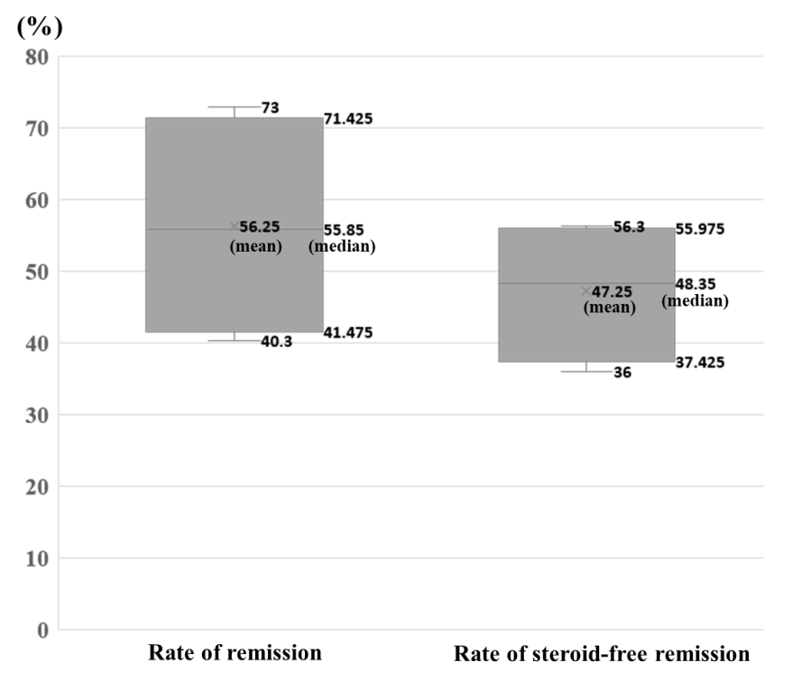
Figure 1 Remission and steroid-free remission rates in cytapheresis therapy in patients with ulcerative colitis concomitantly treated with thiopurines or immunomodulators. Box plot shows that, in cytapheresis therapy, the remission rates range from 40.3%-73% (mean: 56.25%, median: 55.85%, interquartile range: 41.475%-71.425%) and the rates of steroid-free remission range from 36%-56.3% (mean: 47.25%, median: 48.35%, interquartile range: 37.425%-55.975%).
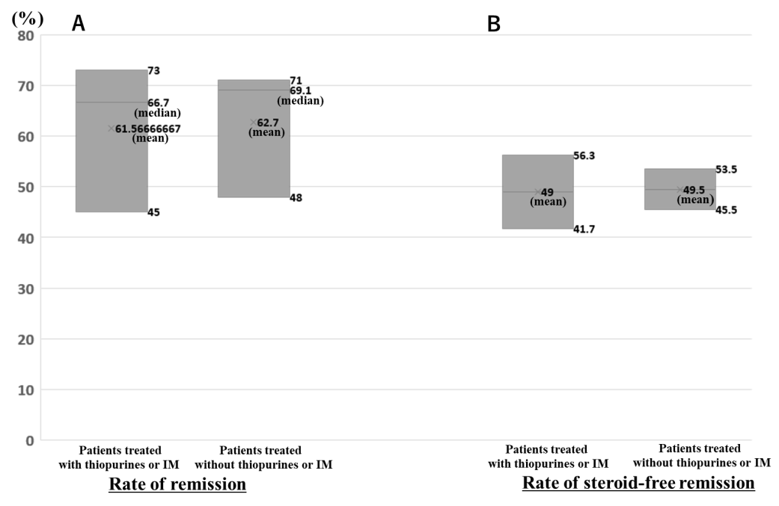
Figure 2 Remission and steroid-free remission rates in cytapheresis therapy in patients with ulcerative colitis concomitantly treated with thiopurines or immunomodulators and in those treated without thiopurines or immunomodulators. A: Box plot shows that the rates of remission in patients concomitantly treated with thiopurines or immunomodulators (IM) and in those treated without thiopurines or IM range from 45%-73% (mean: 61.57%, median: 66.7%) and 48%-71% (mean: 62.7%, median: 69.1%), respectively; B: The rates of steroid-free remission in patients with ulcerative colitis (UC) concomitantly treated with thiopurines or IM are 41.7% and 56.3% (mean: 49%), and those in patients with UC treated without thiopurines or IM are 45.5% and 53.5% (mean: 49.5%), respectively.
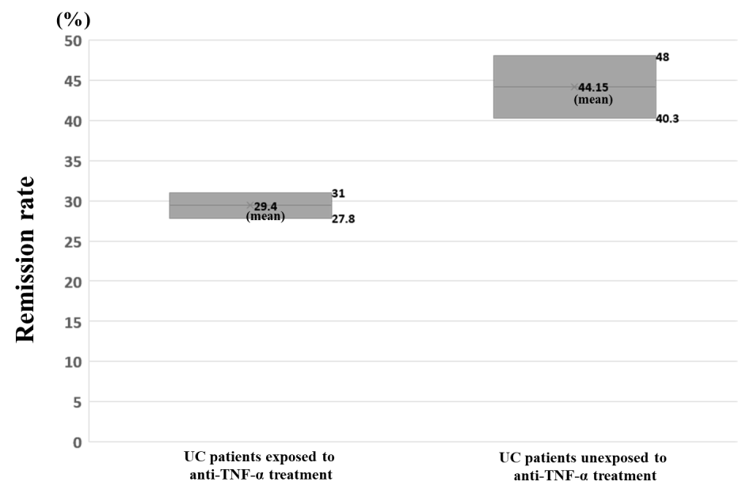
Figure 3 Remission rates in cytapheresis therapy in patients with ulcerative colitis exposed to anti-tumor necrosis factor-α treatment and in those unexposed to anti-tumor necrosis factor-α treatment. The remission rates in patients with ulcerative colitis (UC) exposed to anti-tumor necrosis factor-α (TNF-α) treatment are 27.8% and 31% (mean: 29.4%), and those in patients with UC unexposed to anti-TNF-α treatment are 40.3% and 48% (mean: 44.15%), respectively.
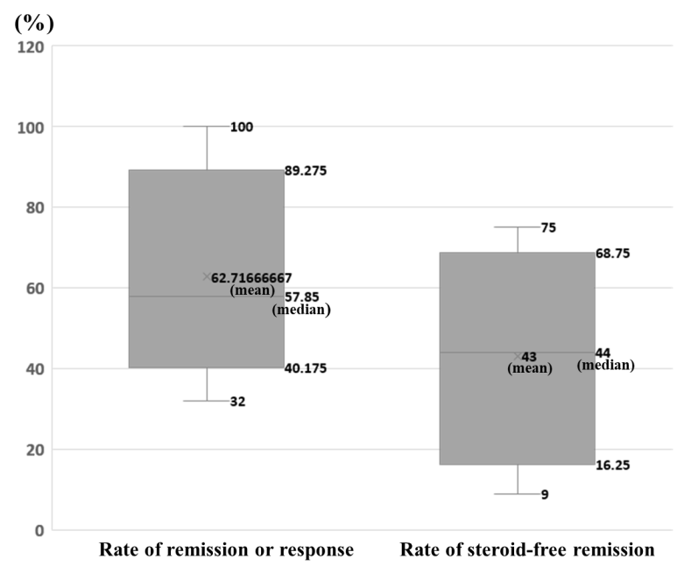
Figure 4 Rates of remission or response and steroid-free remission in the combination therapies of cytapheresis and biologics in inflammatory bowel disease patients showing insufficient response or loss of response to biologics. Box plot shows that the remission rates in the combination therapies of cytapheresis and biologics range from 32%-100% (mean: 62.72%, median: 57.85%, interquartile range: 40.175%-89.275%), and the rates of steroid-free remission in the combination therapies range from 9%-75% (mean: 43%, median: 44%, interquartile range: 16.25%-68.75%).
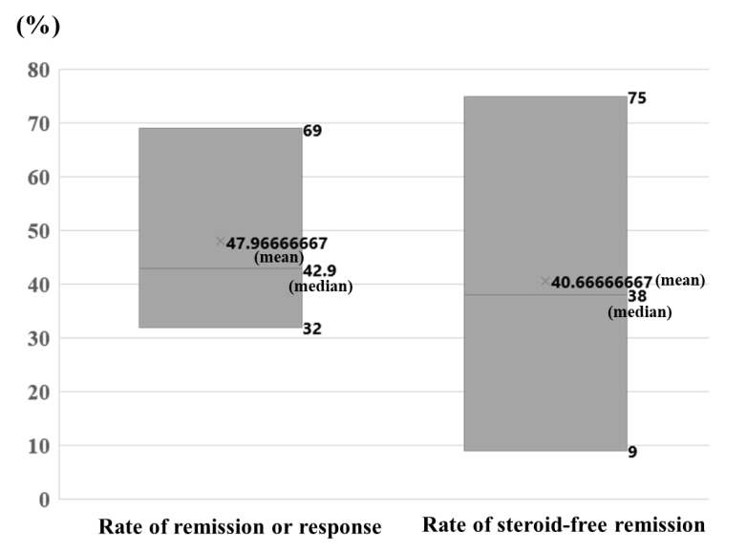
Figure 5 Rates of remission or response and steroid-free remission in the combination therapies of cytapheresis and biologics in patients with ulcerative colitis showing insufficient response or loss of response to biologics. Box plot shows that the remission rates in the combination therapies of cytapheresis and biologics range from 32%-69% (mean: 47.97%, median: 42.9%), and the rates of steroid-free remission in the combination therapies range from 9%-75% (mean: 40.7%, median: 38%).

Table 1 Efficacy of cytapheresis in patients with ulcerative colitis showing insufficient response to thiopurine or immunomodulators
Ref. | Study type | Total number of patients included in the study | Number of patients insufficient response to thiopurine or IM | Regimen of CAP | Rate of remission | Rate of steroid- free remission
Cabriada et al^{[60]}, 2010 | Prospective study | 18 (SD) | 18 | GMA or LCAP (5-10 sessions, 1 session/wk) |  | 55%
Takayama et al^{[58]}, 2013 | Historical cohort study | 90 | 14 | GMA or LCAP (5-10 sessions, 1-2/wk) | 49% (total Pts), pre-use of IM had little effects on the response to therapy
Yokoyama et al^{[42]}, 2014 | Prospective Observation Study | 623 (for efficacy assessment) | 196 | LCAP (5-10 sessions, mean 8.4), intensive LCAP was performed in > 70% of Pts | 73% (Pts concomitantly treated with thiopurine), 71% (Pts treated without thiopurine), P = 0.623
Imperiali et al^{[61]}, 2017 | Prospective multicenter  study | 33 (SD) | 33 | GMA (5 sessions, 1 session/wk) |  | 36%
Yamamoto et al^{[37]}, 2018 | Retrospective  study | 593 | 159 | GMA (5 sessions, 1 to 5 sessions/wk), 5 or 6 GMA were added in Pts who did not achieve clinical remission | 45% (Pts exposed to IM), 48% (Pts unexposed to IM), P = 0.61
Dignass et al^{[36]}, 2016 | Single-arm, open-label, multicentre trial | 86 (SD) | 83 | GMA (5-10 sessions, 1 session/wk) | 40.3%
Ishiguro et al^{[62]}, 2020 | Multicenter cohort study | 102, SD or SR UC Pts were not included | 16 | GMA (mean number of GMA 9.9 sessions, 1-3 sessions/wk) |  | 56.3% (Pts concomitantly treated with IM), 53.5% (Pts treated without IM), P = 1.00
Iizuka et al^{[59]}, 2021 | Retrospective  study | 55 (SD: 33, SR: 21) | 12 | GMA or LCAP [5-20 sessions (mean 8.8), 1-2 sessions/wk (in principle)] | 66.7% (Pts concomitantly treated with thiopurine), 69.1% (all Pts), no significant differences | 41.7% (Pts concomitantly treated with thiopurine), 45.5% (all Pts), no significant differences
CAP: Cytapheresis; GMA: Granulocyte and monocyte adsorptive apheresis; LCAP: Leukocytapheresis; IM: Immunomodulators (or immunosuppressants); Pts: Patients; SD: Steroid dependent patients; SR: Steroid refractory patients; Intensive LCAP: Defined as performing ≥ 4 leukocytapheresis treatment within the first 2 wk.
Table 2 Efficacy of cytapheresis in patients with ulcerative colitis showing previous biologics failure
Ref. | Study type | Biologics exposure | Number of patients (total number of patients in the study) | Regimen of CAP | Rate of remission | Rate of steroid-free remission
Cabriada et al^{[35]}, 2012 | Retrospective study (results of nationwide Spanish registry) | IFX | 33 (total: 142 SD) | GMA (95% of the Pts), 1-10 sessions (median 5 sessions) |  | 37% (all Pts), no differences in clinical remission were found among those Pts with previous thiopurine or IFX failure
Dignass et al^{[36]}, 2016 | Single-arm, open-label, multicentre trial | TNF-α | 37 (total: 86 SD) | GMA (5-10 sessions, 1 session/wk) | 27.8% (Pts who failed on TNF-α), 40.3% (Pts who failed on immunosuppressants
Yamamoto et al^{[37]}, 2018 | Retrospective study | (1) IFX; and (2) ADA | (1) 31; and (2) 36 (total: 593) | GMA (5 sessions, 1 to 5 sessions/wk), 5 or 6 GMA were added in Pts who did not achieve clinical remission | 31% (Pts exposed to biologics), 48% (Pts unexposed to biologics), P = 0.01
CAP: Cytapheresis; SD: Steroid dependent patients; GMA: Granulocyte and monocyte adsorptive apheresis; Pts: Patients; IFX: Infliximab; TNF-α: Tumor necrosis factor-α; ADA: Adalimumab.
Table 3 Efficacy of combination therapy with cytapheresis and biologics in inflammatory bowel disease patients showing insufficient response or loss of response to biologics
Ref. | Study type | Biologics to which insufficient response or LOR was shown | Number of patients | Methods of combination therapy | Regimen of CAP | Rate of remission | Rate of response | Rate of steroid-free remission | Rate of AE (%)
González Carro et al^{[38]}, 2006 | Case report | IFX (LOR) | CD 1 | IFX + GMA | GMA 1 session/8 wk, 12 mo | 100%
Fukunaga et al^{[39]}, 2010 | Case report | IFX (LOR) | CD 1 | IFX + GMA | GMA 1 sessions/wk, 3 consecutive weeks × 3 courses and maintenance therapy | 100% |  |  | 0/1 (0%)
Sono et al^{[40]}, 2012 | Prospective study | IFX (LOR) | CD 15 | IFX + GMA | GMA 1 session/wk, 5 consecutive wk |  | 46.7%; a fall in CDAI by more than 15%
Ozeki et al^{[41]}, 2012 | Case report | (1) IFX (failure); (2) ADA (failure); (3) Steroid refractory and etc. | (1) CD 1; (2) CD 1; and (3) CD 3 | ADA + GMA | GMA 2 sessions/wk, 5 consecutive wk | 100% |  |  | 0/5 (0%)
Yokoyama et al^{[42]}, 2014 | Prospective observational study | IFX | UC 42 | IFX + LCAP | LCAP 5-10 sessions (mean 8.4), intensive LCAP was performed in > 70% of Pts | 69.0% (Pts concomitantly treated with IFX)
Yokoyama et al^{[43]}, 2018 | Case report | IFX (LOR) | UC 2; CD 1 | IFX + GMA | GMA 1 session/wk, 3 consecutive wk or more | UC 100%, CD 100%
Scrivo et al^{[44]}, 2018 | Case report | VDZ (primary nonresponse to VDZ; Previous LOR to IFX; Primary non-response to ADA) | UC 1 | VDZ + GMA | GMA 1 session/wk,  5 wk |  |  | 100% | 0/1 (0%)
Sáez-González et al^{[45]}, 2018 | Case report | VDZ (primary nonresponse to VDZ; Primary nonresponse to ADA and IFX) | UC 1 | VDZ + GMA | GMA 2 sessions/wk, 5 wk + 14 monthly maintenance sessions |  |  | 100%
Tanida et al^{[46]}, 2018 | Retrospective study | (1) IFX (LOR); (2) ADA (LOR); (3) Steroid refractory | (1) CD 1; (2) CD 1; and (3) CD 1 | UST + GMA | GMA: 2 sessions/wk, for 5 consecutive wk | 100% |  | 50% | 0/3 (0%)
Rodríguez-Lago et al^{[47]}, 2019 | Retrospective  multicentre study | Anti-TNF therapy (IFX 23, ADA 18, GLM 6); Primary nonresponse 49%, LOR 51% | UC 47 | Anti-TNF therapy + GMA | GMA 1 sessions/wk 45%, 2 sessions/wk 55%; 5-10 sessions 51%, > 10 sessions 19% (median of 10 sessions) |  | 32% | 9% | 2/47 (4%)
Rodríguez-Lago et al^{[48]}, 2019 | Retrospective  multicentre pilot study | VDZ (primary nonresponse 25%, secondary LOR 75%); All Pts had previously received anti-TNF agents (IFX 88%, ADA 50%, GLM 38%) | UC 8 | VDZ + GMA | GMA: 5-38 sessions (median 15), biweekly 75%, weekly 25%; maintenance GMA 75%, monthly 38%, every 2 wk 25% |  | Partial Mayo score decreased (P = 0.01) | 38% | 0/8 (0%)
Nakamura et al^{[49]}, 2020 | Case report | VDZ (primary nonresponse to VDZ; Serious allergy to IFX) | UC 1 | VDZ + GMA | semiweekly GMA, 4 wk | 100%
Tanida et al^{[50]}, 2020 | Retrospective study | (1) IFX(LOR); (2) ADA (LOR); (3) Steroid refractory or dependent | (1) UC 2; (2) UC 2; and (3) UC 3 | TOF + GMA | GMA: 2 sessions/wk, total 10 sessions |  |  | 75% | 3/7 (43%)
Yokoyama et al^{[51]}, 2020 | Preliminary study | IFX (LOR) | UC 7; CD 7 | IFX + GMA | 1 or 2 sessions/wk, for 5 consecutive wk, Pts who did not achieved remission by week 8 underwent another GMA (1 session/wk, 5 consecutive wk) | All IBD 64.3%, UC 42.9%, CD 85.7% |  |  | 0/14 (0%) (0/14)
LOR: Loss of response; CAP: Cytapheresis; CD: Crohn’s disease; GMA: Granulocyte and monocyte adsorptive apheresis; UC: Ulcerative colitis; LCAP: Leukocytapheresis; AE: Adverse events; IFX: Infliximab; ADA: Adalimumab; Pts: Patients; VED: Vedolizumab; UST: Ustekinumab; TNF-α: Tumor necrosis factor-α; GLM: Golimumab; TOF: Tofacitinib; Intensive LCAP: Defined as performing ≥ 4 leukocytapheresis within the first 2 wk.

