Name of Journal: World Journal of Gastroenterology
Manuscript NO: 84369
Manuscript Type: CASE REPORT

Inflammatory myofibroblastic tumor of the pancreatic neck misdiagnosed as neuroendocrine tumor: A case report

Liu JB et al. Misdiagnosis of pancreatic IMT

Jia-Bei Liu, Qian-Biao Gu, Peng Liu

Jia-Bei Liu, Department of Radiology, The First Affiliated Hospital of Hunan Normal University, Hunan Provincial People’s Hospital, Changsha 410005, Hunan Province, China

Qian-Biao Gu, Peng Liu, Department of Radiology, The First Affiliated Hospital of Hunan Normal University (Hunan Provincial People’s Hospital), Changsha 410005, Hunan Province, China

Author contributions: Liu JB contributed to manuscript writing and editing, and data collection; Liu P and Gu QB contributed to conceptualization and supervision; and all authors have read and approved the final manuscript.

Supported by the Clinical Medical Technology Innovation Guiding Project of Hunan Province, No. 2021SK50911; and Scientific Research Project of Hunan Health Commission, No. 202209010030.

Corresponding author: Peng Liu, MD, Chief Doctor, Department of Radiology, The First Affiliated Hospital of Hunan Normal University (Hunan Provincial People’s Hospital), No. 61 Jiefang West Road, Changsha 410005, Hunan Province, China. lpradiology@163.com

Received: March 10, 2023
Revised: April 21, 2023
Accepted: May 4, 2023
Published online: May 28, 2023

Abstract
BACKGROUND
Inflammatory myofibroblastic tumor (IMT) is a relatively rare tumor. The global incidence of IMT is less than 1%. There is no specific clinical manifestation. It usually occurs in the lungs, but the pancreas is not the predilection site.

CASE SUMMARY
We present a case of a male patient, 51 years old, who was diagnosed with a pancreatic neck small mass on ultrasound one year ago during a physical examination. As he had no clinical symptoms and the mass was relatively small, he did not undergo treatment. However, the mass was found to be larger on review, and he was referred to our hospital. Since the primal clinical diagnosis was pancreatic neuroendocrine tumor, the patient underwent surgical treatment. However, the case was confirmed as pancreatic IMT by postoperative pathology.

CONCLUSION
Pancreatic IMT is relatively rare and easily misdiagnosed. We can better understand and correctly diagnose this disease by this case report.

Key Words: Inflammatory myofibroblastic tumor; Diagnosis; Imaging; Pancreas; Case report

©The Author(s) 2023. Published by Baishideng Publishing Group Inc. All rights reserved.

Citation: Liu JB, Gu QB, Liu P. Inflammatory myofibroblastic tumor of the pancreatic neck misdiagnosed as neuroendocrine tumor: A case report. World J Gastroenterol 2023; 29(20): 3216-3221
URL: https://www.wjgnet.com/1007-9327/full/v29/i20/3216.htm
DOI: https://dx.doi.org/10.3748/wjg.v29.i20.3216

Core Tip: Inflammatory myofibroblastic tumor (IMT) is a rare mesenchymal tumor composed of spindle-shaped myofibroblasts accompanied by a mixed inflammatory infiltrate, and is particularly rare in the pancreas. The diagnosis of pancreatic IMT is made on the basis of histopathology and immunohistochemistry. Different lesions exhibit diverse biological characteristics, and there are several surgical treatment protocols. This case emphasizes the importance of correct preoperative diagnosis of IMT and reminds us to broaden our thinking in relation to the diagnosis of pancreatic lesions.

INTRODUCTION
Inflammatory myofibroblastic tumor (IMT) is a rare mesenchymal tumor. This concept of IMT was first put forward by Pettinato et al^{[1]} in 1990. According to the current World Health Organisation (WHO) guidelines, IMTs are typically low-grade neoplasms with occasional malignant potential^{[2]}. An IMT can occur anywhere at any age. This report describes a case of pancreatic IMT.

CASE PRESENTATION
Chief complaints
A 51-year-old male patient was found to have a pancreatic mass more than one year ago.

History of present illness
The patient found a small pancreatic tumor in a physical examination one year ago. However, two months ago, the follow-up of the physical examination center found that the tumor became bigger, then he was referred to our hospital. There were no clinical symptoms throughout the course of the disease.

History of past illness
The patient had a history of hypertension, hyperglycemia, hyperlipidemia, thyroid nodule, prediabetes, and urticaria.

Personal and family history
The patient had no family history of malignant tumors, psychological, or genetic disorders.

Physical examination
The physical examination did not reveal any obvious abnormalities.

Laboratory examinations
Uric acid and triglyceride levels were elevated. Other blood parameters and tumor markers (carcinoembryonic antigen and cancer antigen 19-9) levels were within the normal range.

Imaging examinations
An abdominal contrast-enhanced computed tomography (CECT) scan showed a round, well-defined, low-density mass 3.5 cm in diameter in the neck of the pancreas. On the CECT scan, the mass showed lower attenuation than the normal pancreatic parenchyma in the pre-contrast phase and arterial phase, and heterogeneous hyperenhancement in the portal venous phase (Figure 1). A pancreatic neuroendocrine tumour was strongly suspected.

FINAL DIAGNOSIS
The patient was diagnosed with IMT of the pancreas by postoperative pathology (Figure 2).

TREATMENT
After completion of preoperative investigations, a laparoscopic middle pancreatectomy was performed.

OUTCOME AND FOLLOW-UP
Postoperative pancreatic leakage occurred in the patient. However, he was discharged in good clinical condition after 40 d. No apparent events were observed at the 2-mo postoperative follow-up.

DISCUSSION
IMT is a rare mesenchymal tumor. Due to its rarity and the fact that the etiology is unknown, there are only a few cases reported. It has been revealed that IMT may have gene rearrangement with anaplastic lymphoma kinase (ALK)^{[3]}, and ALK positivity was also associated with a higher recurrence and less chance of distant metastasis^{[4]}. A recent literature review by Chen et al^{[5]} in 2021, included 30 patients with IMT occurring in the pancreas. The reported mean age of the patients was 40 years (range, 0-82 years) with an obvious male preponderance. The tumor was mostly located in the head of the pancreas (21/30 patients). In this series, abdominal pain was the most frequent symptom followed by jaundice. Only five cases of asymptomatic pancreatic IMT have been reported in the medical literature^{[5-9]}. Our patient had no clinical symptoms and the pancreatic mass was found on physical examination. Among the previously reported cases of pancreatic IMT, many were initially misdiagnosed as pancreatic cancer, while the present case was misdiagnosed as pancreatic neuroendocrine tumor. Therefore, it is meaningful to collect more cases and information to obtain reliable diagnosis and treatment methods for IMT.
As the low incidence of pancreatic IMT, there is no specific clinical manifestations has been established. It commonly manifests as abdominal pain or jaundice, and can sometimes be asymptomatic. Although IMT is considered a low-grade tumor, one case of pulmonary metastasis has been reported^{[10]}.
At present, pancreatic IMT is mainly diagnosed by histopathology and immunohistochemistry^{[11]}. Under the light microscope, the tumour tissue in this case consisted mainly of spindle-shaped myofibroblasts accompanied by a mixed inflammatory infiltrate. The histopathological findings of this case were consistent with previous reports. Myofibroblasts in IMT stain positive for alpha-smooth muscle antigen (SMA), vimentin, and fibronectin, and stain negative for desmin and caldesmon^{[12]}. In this case, immunohistochemistry report showed positive for IgG4, SMA and actin, and negative for desmin, ALK, CD30, S-100, and Catenin B, similar to those in the literature.
To date, pancreatic IMT is easily misdiagnosed as pancreatic neuroendocrine tumour and pancreatic cancer due to the lack of specific imaging features, and its diagnosis is unclear in clinical practice. A circular low-density mass was observed in the pancreatic IMT reported here. After enhancement, the arterial mass is mildly enhanced, the venous phase is significantly enhanced, and the density is progressively higher than that of the surrounding normal pancreas.
However, in some cases, CECT did not show an enhancing mass and was suspected to be ductal adenocarcinoma, which was ultimately confirmed by pathology to be pancreatic IMT. Hence, the radiologic features of pancreatic IMT require further data.
Pancreatic IMT needs to be differentiated from pancreatic neuroendocrine tumor, pancreatic cancer, and solid-pseudopapillary neoplasm. Pancreatic neuroendocrine tumor is uncommon and has no gender predilection^{[13]}. Additionally, the mass shows high enhancement in the arterial or portal phases due to the rich capillary network in the stroma. Pancreatic cancer is typically seen in patients over 60 years old, with a slight male predominance. It is a hypovascular mass with extensive fibrosis on histopathologic examination^{[14]}. Typical ductal adenocarcinomas appear as poorly defined masses with extensive surrounding desmoplastic reaction and they enhance poorly compared to adjacent normal pancreatic tissue. The presence of abrupt pancreatic duct cutoff, upstream pancreatic duct dilatation, upstream pancreatic parenchymal atrophy, and decreased enhancement in the distal pancreatic parenchyma favors a diagnosis of malignancy^{[15]}. Solid-pseudopapillary neoplasms of the pancreas are cystic-solid masses with a complete capsule. They are prone to bleeding, necrosis and calcification. The solid portion shows enhancement in the arterial phase and can continue to enhance in the delayed phase. However, the imaging features of pancreatic IMT from some pancreatic lesions overlap.
In the present case, a wrong diagnosis was made for several reasons. First, the patient had no clinical manifestations, and the clinical history and laboratory indices are unremarkable. Second, the preoperative imaging findings were difficult to distinguish from a pancreatic neuroendocrine tumour. The border of the lesion was distinct, with persistent hyperenhancement of the mass, and typical double duct sign and vascular involvement were not observed. Accordingly, preliminary diagnosis of imaging was limited to benign mass. In general, IMT of the pancreas is lack of characteristic in terms of clinic-radiological features. Therefore, for more accurate diagnosis and treatment of pancreatic IMT, there is a need to obtain more meaningful information.

CONCLUSION
Given the rarity of pancreatic IMT, this case can contribute to further understanding of the etiology, mechanism, imaging characteristics of this disease. Obtaining a better understanding of all aspects of this disease will help provide a more precise diagnosis.

ACKNOWLEDGEMENTS
We are very grateful to Dr. Liu Yu (Hunan Provincial People’s Hospital, First Affiliated Hospital of Hunan Normal University) for providing professional guidance to the pathological analysis.

REFERENCES
1 Pettinato G, Manivel JC, De Rosa N, Dehner LP. Inflammatory myofibroblastic tumor (plasma cell granuloma). Clinicopathologic study of 20 cases with immunohistochemical and ultrastructural observations. Am J Clin Pathol 1990; 94: 538-546 [PMID: 2239820 DOI: 10.1093/ajcp/94.5.538]
2 Choi JH, Ro JY. The 2020 WHO Classification of Tumors of Soft Tissue: Selected Changes and New Entities. Adv Anat Pathol 2021; 28: 44-58 [PMID: 32960834 DOI: 10.1097/PAP.0000000000000284]
3 Zhu L, Li J, Liu C, Ding W, Lin F, Guo C, Liu L. Pulmonary inflammatory myofibroblastic tumor vs IgG4-related inflammatory pseudotumor: differential diagnosis based on a case series. J Thorac Dis 2017; 9: 598-609 [PMID: 28449468 DOI: 10.21037/jtd.2017.02.89]
4 Coffin CM, Hornick JL, Fletcher CD. Inflammatory myofibroblastic tumor: comparison of clinicopathologic, histologic, and immunohistochemical features including ALK expression in atypical and aggressive cases. Am J Surg Pathol 2007; 31: 509-520 [PMID: 17414097 DOI: 10.1097/01.pas.0000213393.57322.c7]
5 Chen ZT, Lin YX, Li MX, Zhang T, Wan DL, Lin SZ. Inflammatory myofibroblastic tumor of the pancreatic neck: A case report and review of literature. World J Clin Cases 2021; 9: 6418-6427 [PMID: 34435007 DOI: 10.12998/wjcc.v9.i22.6418]
6 Pungpapong S, Geiger XJ, Raimondo M. Inflammatory myofibroblastic tumor presenting as a pancreatic mass: a case report and review of the literature. JOP 2004; 5: 360-367 [PMID: 15365204]
7 Yamamoto H, Watanabe K, Nagata M, Tasaki K, Honda I, Watanabe S, Soda H, Takenouti T. Inflammatory myofibroblastic tumor (IMT) of the pancreas. J Hepatobiliary Pancreat Surg 2002; 9: 116-119 [PMID: 12021906 DOI: 10.1007/s005340200013]
8 Dulundu E, Sugawara Y, Makuuchi M. Inflammatory myofibroblastic tumor of the pancreas--a case report. Biosci Trends 2007; 1: 167-169 [PMID: 20103888]
9 Berhe S, Goldstein S, Thompson E, Hackam D, Rhee DS, Nasr IW. Challenges in Diagnosis and Management of Pancreatic Inflammatory Myofibroblastic Tumors in Children. Pancreas 2019; 48: e27-e29 [PMID: 30973469 DOI: 10.1097/MPA.0000000000001290]
10 Walsh SV, Evangelista F, Khettry U. Inflammatory myofibroblastic tumor of the pancreaticobiliary region: morphologic and immunocytochemical study of three cases. Am J Surg Pathol 1998; 22: 412-418 [PMID: 9537467 DOI: 10.1097/00000478-199804000-00004]
11 A G H, Kumar S, Singla S, Kurian N. Aggressive Inflammatory Myofibroblastic Tumor of Distal Pancreas: A Diagnostic and Surgical Challenge. Cureus 2022; 14: e22820 [PMID: 35399449 DOI: 10.7759/cureus.22820]
12 Chan JK, Cheuk W, Shimizu M. Anaplastic lymphoma kinase expression in inflammatory pseudotumors. Am J Surg Pathol 2001; 25: 761-768 [PMID: 11395553 DOI: 10.1097/00000478-200106000-00007]
13 Lewis RB, Lattin GE Jr, Paal E. Pancreatic endocrine tumors: radiologic-clinicopathologic correlation. Radiographics 2010; 30: 1445-1464 [PMID: 21071369 DOI: 10.1148/rg.306105523]
14 Frampas E, Morla O, Regenet N, Eugène T, Dupas B, Meurette G. A solid pancreatic mass: tumour or inflammation? Diagn Interv Imaging 2013; 94: 741-755 [PMID: 23751230 DOI: 10.1016/j.diii.2013.03.013]
15 Tamada T, Ito K, Kanomata N, Sone T, Kanki A, Higaki A, Hayashida M, Yamamoto A. Pancreatic adenocarcinomas without secondary signs on multiphasic multidetector CT: association with clinical and histopathologic features. Eur Radiol 2016; 26: 646-655 [PMID: 26084602 DOI: 10.1007/s00330-015-3880-3]

Footnotes
Informed consent statement: Informed written consent was obtained from the patient for publication of this report and any accompanying images.

Conflict-of-interest statement: The authors declare that they have no conflict of interest to disclose.

CARE Checklist (2016) statement: The authors have read the CARE Checklist (2016), and the manuscript was prepared and revised according to the CARE Checklist (2016).

Open-Access: This article is an open-access article that was selected by an in-house editor and fully peer-reviewed by external reviewers. It is distributed in accordance with the Creative Commons Attribution NonCommercial (CC BY-NC 4.0) license, which permits others to distribute, remix, adapt, build upon this work non-commercially, and license their derivative works on different terms, provided the original work is properly cited and the use is non-commercial. See: https://creativecommons.org/Licenses/by-nc/4.0/

Provenance and peer review: Unsolicited article; Externally peer reviewed.
Peer-review model: Single blind

Peer-review started: March 10, 2023
First decision: April 14, 2023
Article in press: May 4, 2023

Specialty type: Gastroenterology and hepatology
Country/Territory of origin: China
Peer-review report’s scientific quality classification
Grade A (Excellent): 0
Grade B (Very good): B, B
Grade C (Good): C
Grade D (Fair): 0
Grade E (Poor): 0

P-Reviewer: Kamer E, Turkey; Kumar M, India; Yarmahmoodi F, Iran S-Editor: Chen YL L-Editor: A P-Editor: Chen YL

Figure Legends
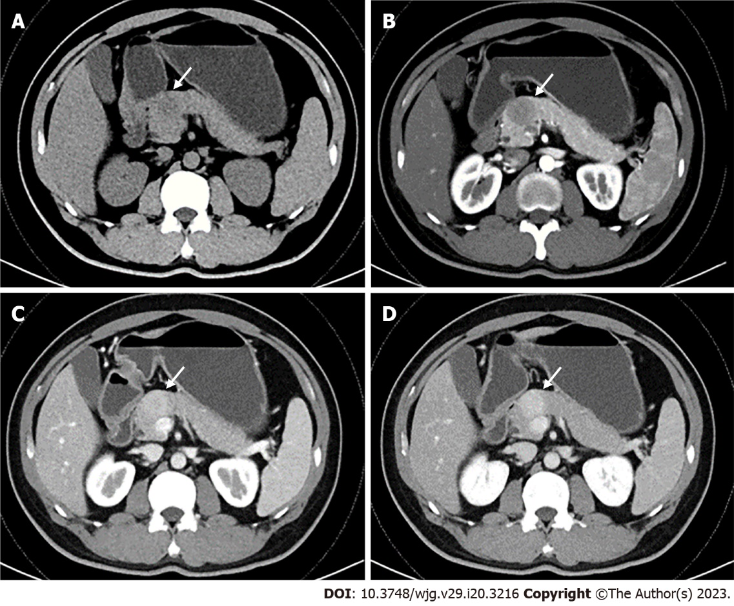
Figure 1 Abdominal contrast-enhanced computed tomography. A: Axial non-contrast showed a low-density mass in the neck of the pancreas; B: Arterial phase indicated a distinct hypoattenuating mass; C and D: Venous phase revealed persistent hyperenhancement of the mass (magnetic resonance imaging is similar to computed tomography in enhancement mode and characteristics).
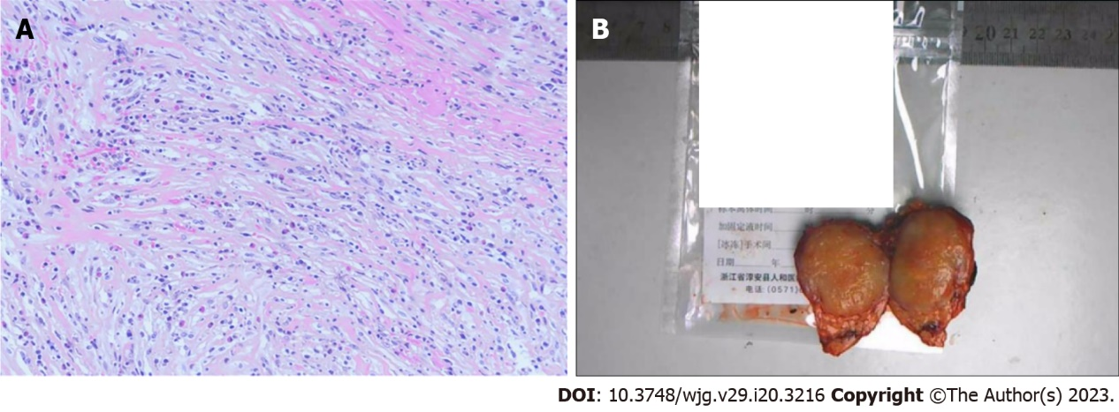
Figure 2 Histopathological image and resected tumor specimen. A: Spindle-shaped myofibroblasts accompanied by large amounts of plasma cells. B: The resected specimen showing a well-defined neoplasm (some information has been excluded due to patient privacy).

Published by Baishideng Publishing Group Inc
7041 Koll Center Parkway, Suite 160, Pleasanton, CA 94566, USA
Telephone: +19253991568
Email: bpgoffice@wjgnet.com
Help Desk: https://www.f6publishing.com/helpdesk
https://www.wjgnet.com

© 2023 Baishideng Publishing Group Inc. All rights reserved.

