Name of Journal: World Journal of Clinical Cases
Manuscript NO: 76772
Manuscript Type: CASE REPORT

Solitary fibrous tumor of the renal pelvis: A case report

Liu M et al. Renal pelvis solitary fibrous tumor

Min Liu, Chao Zheng, Jin Wang, Ji-Xue Wang, Liang He

Min Liu, Jin Wang, Ji-Xue Wang, Liang He, Department of Urology, The First Hospital of Jilin University, Changchun 130021, Jilin Province, China

Chao Zheng, Department of Neurology and Neuroscience Center, The First Hospital of Jilin University, Changchun 130021, Jilin Province, China

Author contributions: Liu M and Zheng C collected the information; Wang J conducted the follow-up; Wang JX validated the figures; Zheng C examined and photographed the pathological findings; He L conceptualized and organized the study, reviewed the literature and drafted the manuscript.

Supported by The Youth Foundation of The First Hospital of Jilin University, No. JDYY102019001 and JDYY11202010, the Science and Technology Development Program of Jilin Province, No. 2020122256JC, and the Project of Jilin Provincial Department of Education, No. JJKH20221072KJ.

Corresponding author: Liang He, Doctor, Doctor, Department of Urology, The First Hospital of Jilin University, No. 71 Xinmin Road, Chaoyang District, Changchun 130021, Jilin Province, China. lianghe9278@jlu.edu.cn

Received: March 30, 2022
Revised: March 30, 2022
Accepted: August 16, 2022
Published online:

Abstract
BACKGROUND
Solitary fibrous tumor (SFT) is a rare mesenchymal neoplasm. SFT derived from the renal pelvis is an exceedingly rare entity. In this study, we report a case of renal pelvis SFT and review the relevant literature on this rare tumor.

CASE SUMMARY
A 76-year-old man was hospitalized due to right lumbar and abdominal pain. Abdominal computed tomography showed a hypervascular space-occupying renal lesion, sized 2.3 cm × 1.8 cm. Based on the computed tomography findings, the patient was diagnosed with right renal pelvis tumor and underwent nephrectomy. Postoperative immunohistochemical results confirmed the diagnosis. As of the 3-year follow-up, there were no signs of recurrence, and the patient has recovered well.

CONCLUSION
We report a rare case of SFT derived from the renal pelvis and discuss the imaging and histopathological features that distinguish renal pelvis SFT from other renal pelvis tumors.

Key Words: Renal pelvis; Solitary fibrous tumor; Surgery; Computed tomography; Case report

Liu M, Zheng C, Wang J, Wang J, He L. Solitary fibrous tumor of the renal pelvis: A case report. World J Clin Cases 2022; In press

Core Tip: Extrapleural solitary fibrous tumor is an extremely rare mesenchymal neoplasm, especially in cases of origination from the renal pelvis. We report a rare case of renal pelvis solitary fibrous tumor and discuss the detailed radiologic and pathologic findings. The differential diagnosis of renal pelvis solitary fibrous tumor is discussed based on literature review.

INTRODUCTION
Solitary fibrous tumors (SFTs) were reported for the first time by Wagner et al^{[1]} in 1870. As hemangiopericytomas, SFTs are usually benign and arise from mesenchymal spindle cells, typically of the pleura. Extrapleural SFTs are relatively rare^{[2]}. Although several cases of SFT have been reported, the cause of SFT remains unknown^{[3]}. Most of the SFTs are benign lesions with slow progress, but some have malignant potential^{[4]}. Renal pelvis SFT is an extremely rare entity, with only 11 cases reported in the published literature^{[5]}. Renal pelvis SFT is liable to be misdiagnosed as renal cell carcinoma (RCC), upper-tract urothelial cancers (UTUCs) or renal angiomyolipoma (RAML). The diagnosis and treatment of renal pelvis SFT is challenging. In this work, we report a rare case of renal pelvis SFT. In addition, we review the relevant literature to facilitate accurate diagnosis and treatment of renal pelvis SFT.

CASE PRESENTATION
Chief complaints
A 76-year-old man (height: 167 cm; weight: 70 kg) presented in our hospital for persistent right lumbar and abdominal pain.

History of present illness
The right lumbar and abdominal pain had persisted for more than 3 years and gradually aggravated in the last 3 mo. There was no associated nausea or vomiting.

History of past illness
The illness history of the patient was unremarkable.

Personal and family history
The patient had no specific personal or family history of illnesses.

Physical examination
The vital parameters of the patient on the day of admission were as follows: body temperature, 36.3 °C; heart rate, 80 beats per min; respiratory rate, 18 breaths per min; blood pressure, 125/80 mmHg; and oxygen saturation in room air, 98%. There was mild tenderness in the left lumbar and abdominal area.

Laboratory examinations
Urinalysis, routine blood tests, coagulation indices, blood urea nitrogen, and liver function were normal. Urinary cytology revealed no heterocytes.

Imaging examinations
Abdominal contrast-enhanced computed tomography (CT) showed a right renal intrapelvic hypervascular space-occupying lesion sized 2.3 cm × 1.8 cm (Figure 1).
Histopathological findings identified the tumor as renal pelvis SFT (Figure 2). The size of the tumor was 2.7 cm × 2.5 cm × 1.6 cm. The mitotic image of the tumor was higher than 4/10 high power field. There were no signs of neurovascular invasion by tumor cells.
Immunohistochemical results were as follows: CD34 (+), desmin (-), H-caldesmon (-), SMA (+), STAT6 (+), vimentin (+), Bcl-2 (+), CD117 (-), Dog-1 (-), HMB45 (-), S-100 (-), Ki-67 (+10%), CD99 (+) and EMA (-). The immunohistochemical results confirmed the diagnosis of renal pelvis SFT (Figure 3).

FINAL DIAGNOSIS
The patient was diagnosed with left renal pelvis tumor.

TREATMENT
After weighing different treatment options, the patient underwent laparoscopic right nephroureterectomy.

OUTCOME AND FOLLOW-UP
The patient recovered well after the operation and was discharged after 5 d. The outcome was satisfactory, and there were no signs of recurrence during the 3-year follow-up.

DISCUSSION
SFTs are rare mesenchymal tumors accounting for < 2% of all soft tissue tumors with an estimated annual incidence of 2 cases per million population^{[6]}. The age of reported cases of SFT patients ranges between 4 years and 85 years, and there is no clear predilection for any particular sex^{[3]}. SFTs mainly occur in the pleura. However, SFTs have also been reported at extrapulmonary sites, such as the liver, mediastinum, breast, lung, meninges, and urogenital organs^{[7]}. According to previous reports, 15% of SFTs originating in the kidneys are located in the renal capsule, 6% are located around the pelvis, 3% are located in the renal pelvis, and 76% do not have a clear site of origin^{[8]}. The first case of renal pelvis SFT was reported by Yazaki et al^{[9]} in 2001. Until now, only 15 cases of renal pelvis SFTs have been reported. Renal pelvis SFT cases are summarized in Table 1.
Renal pelvis SFTs need to be differentiated from the more common renal pelvis tumors such as RCC, RAMLs, and UTUCs. Contrast-enhanced CT is the main method for the diagnosis of RCCs^{[10]}. RCC is characterized by abundant blood supply, and tumor blood vessels and tumor staining can be observed on renal angiography. Contrast enhancement of renal pelvis SFTs is much lower than that of RCCs. UTUCs are another kind of common renal pelvis malignant tumor. Patients with UTUCs typically have a history of hematuria^{[11]}. In contrast, symptoms of renal pelvis SFTs are mostly due to pressure effect of the lesion, and these patients rarely develop urinary symptoms. The UTUCs show signs of infiltrative growth in CT images. Compared with UTUCs, renal pelvis SFT appears as a well-defined, heterogeneous or homogeneous mass showing moderate to marked contrast-enhancement. RAML is the most common renal benign tumor. Most RAMLs exhibit mixed density on CT imaging, due to the complex fatty vascular components.
In addition to RCCs, UTUCs, and RAMLs, there are also some rare tumor types including hemangiopericytomas, renal pelvis fibroepithelial polyps, fibromas, renal leiomyoma and inflammatory myofibroblastic tumors^{[12]}. The imaging characteristics of renal pelvis SFTs are usually indistinguishable from these rare tumors, and the differential diagnosis is based on immunohistochemistry^{[13]}.
According to the literature, some renal pelvis SFTs show areas of calcification, cystic change or necrosis^{[14]}. These changes indicate the aggressive nature of the tumor and poor prognosis.
In this case, the surgical method was laparoscopic right kidney and ureterectomy. There are currently no treatment guidelines for renal pelvis SFTs, but radical resection is generally chosen. Whether preoperative biopsy or nephron preservation surgery can improve the treatment efficacy and prognosis is not clear. For most cases of SFT, due to the malignant potential of SFTs and lack of recurrence after radical nephrectomy, a complete removal is recommended^{[15]}.
Immunohistochemistry plays a key role in arriving at a definitive diagnosis. SFTs stain positive for CD34, CD99 and Bcl-2. STAT6 is also an antibody with high sensitivity for SFT diagnosis. These surface antigens are useful diagnostic markers of SFT^{[3]}. It has been reported that CD34 and Bcl-2 negativity may indicate increased malignant potential^{[16]}. Although STAT6 is expressed in most SFTs, SFTs located in the renal pelvis have not been evaluated. Whether STAT6-negative status increases the malignant potential of renal pelvis SFTs is unknown. In this case, tumor tissue stained positive for CD34, vimentin, Bcl-2, STAT6 and CD99. It was considered as a benign renal SFT, and there was no local or distant metastasis after 3 years of follow-up. However, benign renal pelvis SFT may also have the ability for distant metastasis. Therefore, renal pelvis SFT is considered to be a “moderately malignant tumor that rarely metastasizes.” Metastasis may occur in the lungs, liver and bones^{[17]}. There are also reports of retroperitoneal recurrence^{[18]}. Rarely, the SFTs can also cause paraneoplastic syndromes such as Doege-Potter syndrome^{[19]}. Hence, all renal pelvis SFT patients need long-term follow-up and regular review, such as abdominal and lung CT.

CONCLUSION
We reported a rare case of renal pelvis SFT. Compared to the previously reported renal pelvis SFT tumors, the tumor in our patient was small in size and localized in the renal pelvis. Clinicians should pay attention to clarifying the source of kidney SFT and differentiate it from other renal pelvis cancers, so as to reduce the occurrence of misdiagnosis.

REFERENCES
1 Bacalbasa N, Balescu I, Jinescu G, Marcu M, Contolenco A, Pop D, Dobritoiu D, Ionescu O, Ionescu P, Stoica C. Fat-forming Solitary Fibrous Tumor of the Kidney - A Case Report and Literature Review. In Vivo 2018; 32: 649-652 [PMID: 29695573 DOI: 10.21873/invivo.11288]
2 Cheung F, Talanki VR, Liu J, Davis JE, Waltzer WC, Corcoran AT. Metachronous Malignant Solitary Fibrous Tumor of Kidney: Case Report and Review of Literature. Urol Case Rep 2016; 4: 45-47 [PMID: 26793578 DOI: 10.1016/j.eucr.2015.09.004]
3 De Luca L, Creta M, Barone B, Crocetto F, Cieri M, Campanino MR, Insabato L, Mangiapia F, Fusco F, Imbimbo C, Mirone V, Longo N. A case of incidentally discovered solitary fibrous tumor of the kidney: A case study. Mol Clin Oncol 2020; 13: 39 [PMID: 32832082 DOI: 10.3892/mco.2020.2109]
4 Yan XJ, Zheng C, Wang J, et al Transcatheter arterial embolization of malignant pelvic solitary fibrous tumor: case report and literature review. Translational Cancer Research 2021; 10(11): 4979-87. [DOI:10.21037/tcr-21-887]
5 Zhang Q, Qin J, Li Y, Wu T. Primary solitary fibrous tumor of kidney: A case report and literature review. Urol Case Rep 2019; 23: 92-94 [PMID: 30719410 DOI: 10.1016/j.eucr.2019.01.012]
6 Zhou SY, Zhan R, Qiao ZG, Wu JZ. Giant solitary fibrous tumor: A clinically silent tumor. Asian Journal of Surgery 2021; 44(8): 1085-6. [DOI:10.1016/j.asjsur.2021.05.018]
7 Zaghbib S, Chakroun M, Essid MA, Saadi A, Bouzouita A, Derouiche A, Slama MRB, Ayed H, Chebil M. Solitary fibrous tumor of the kidney: A case report. Int J Surg Case Rep 2019; 62: 112-114 [PMID: 31494455 DOI: 10.1016/j.ijscr.2019.08.004]
8 Kopel J, Sharma P, Warriach I. A solitary fibrous tumor of the kidney. Urol Case Rep 2020; 28: 101072 [PMID: 31763174 DOI: 10.1016/j.eucr.2019.101072]
9 Yazaki T, Satoh S, Iizumi T, Umeda T, Yamaguchi Y. Solitary fibrous tumor of renal pelvis. International journal of urology : official journal of the Japanese Urological Association 2001; 8(9): 504-8. [DOI:10.1046/j.1442-2042.2001.00360.x]
10 Chen M, Yin F, Yu Y, Zhang H, Wen G. CT-based multi-phase Radiomic models for differentiating clear cell renal cell carcinoma. Cancer Imaging 2021; 21: 42 [PMID: 34162442 DOI: 10.1186/s40644-021-00412-8]
11 Sahin TK, Aladag E, Setterzade E, Guven GS, Haznedaroglu IC, Aksu S. Spontaneous subepithelial hemorrhage of renal pelvis and ureter (Antopol-Goldman lesion) in hemophilia A patient with inhibitor: Case report and review of the literature. Medicine (Baltimore) 2020; 99: e20851 [PMID: 32590782 DOI: 10.1097/MD.0000000000020851]
12 Khater N, Khauli R, Shahait M, Degheili J, Khalifeh I, Aoun J. Solitary fibrous tumors of the kidneys: presentation, evaluation, and treatment. Urol Int 2013; 91: 373-383 [PMID: 24008397 DOI: 10.1159/000354394]
13 Raman SP, Hruban RH, Fishman EK. Beyond renal cell carcinoma: rare and unusual renal masses. Abdom Imaging 2012; 37: 873-884 [PMID: 22581271 DOI: 10.1007/s00261-012-9903-5]
14 Fursevich D, Derrick E, O'Dell MC, Vuyyuru S, Burt J. Solitary Fibrous Tumor of the Kidney: A Case Report and Literature Review. Cureus 2016; 8: e490 [PMID: 27014524 DOI: 10.7759/cureus.490]
15 Kuroda N, Ohe C, Sakaida N, Uemura Y, Inoue K, Nagashima Y, Hes O, Michal M. Solitary fibrous tumor of the kidney with focus on clinical and pathobiological aspects. Int J Clin Exp Pathol 2014; 7: 2737-2742 [PMID: 25031693]
16 Usuba W, Sasaki H, Yoshie H, Kitajima K, Kudo H, Nakazawa R, Sato Y, Takagi M, Chikaraishi T. Solitary Fibrous Tumor of the Kidney Developing Local Recurrence. Case Rep Urol 2016; 2016: 2426874 [PMID: 27239363 DOI: 10.1155/2016/2426874]
17 Dozier J, Jameel Z, McCain DA, Hassoun P, Bamboat ZM. Massive malignant solitary fibrous tumor arising from the bladder serosa: a case report. J Med Case Rep 2015; 9: 46 [PMID: 25884588 DOI: 10.1186/s13256-014-0505-4]
18 Manica M, Roscigno M, Naspro R, Sodano M, Milesi L, Gianatti A, Da Pozzo LF. Recurrent retroperitoneal solitary fibrous tumor: a case report. Tumori 2021; 107: NP11-NP14 [PMID: 33238803 DOI: 10.1177/0300891620974763]
19 Mohammed T, Ozcan G, Siddique AS, Araneta RN, Slater DE, Khan A. Doege-Potter Syndrome with a Benign Solitary Fibrous Tumor: A Case Report and Literature Review. Case Reports in Oncology 2021; 14(1): 470-6. [DOI:10.1159/000512823]
20 Magro G, Cavallaro V, Torrisi A, Lopes M, Dell'Albani M, Lanzafame S. Intrarenal solitary fibrous tumor of the kidney report of a case with emphasis on the differential diagnosis in the wide spectrum of monomorphous spindle cell tumors of the kidney. Pathol Res Pract 2002; 198: 37-43 [PMID: 11866209 DOI: 10.1078/0344-0338-00182]
21 Marzi M, D'Alpaos M, Piras P, Paiusco A, Minervini MS, Di Zitti P. [Solitary fibrous tumor of the kidney. A propos of a case]. Urologia 2009; 76: 112-114 [PMID: 21086310]
22 Sasaki H, Kurihara T, Katsuoka Y, Nakano T, Yoshioka M, Miyano S, Sato Y, Uejima I, Hoshikawa M, Takagi M, Chikaraishi T. Distant metastasis from benign solitary fibrous tumor of the kidney. Case Rep Nephrol Urol 2013; 3: 1-8 [PMID: 23466873 DOI: 10.1159/000346850]
23 Hirano D, Mashiko A, Murata Y, Satoh K, Ichinose T, Takahashi S, Jike T, Sugitani M. A case of solitary fibrous tumor of the kidney: an immunohistochemical and ultrastructural study with a review of the literature. Med Mol Morphol 2009; 42: 239-244 [PMID: 20033371 DOI: 10.1007/s00795-009-0456-9]
24 Naveen HN, Nelivigi GN, Venkatesh GK, Suriraju V. A case of solitary fibrous tumor of the kidney. Urol Ann 2011; 3: 158-160 [PMID: 21976931 DOI: 10.4103/0974-7796.84956]
25 Dong B, Zhang JJ, Wang G, et al Renal solitary fibrous tumour: A rare pathological entity. Cuaj-Canadian Urological Association Journal 2014; 8(9-10): E657-E9. [DOI:10.5489/cuaj.1854]
26 Mearini E, Cochetti G, Barillaro F, Fatigoni S, Roila F. Renal malignant solitary fibrous tumor with single lymph node involvement: report of unusual metastasis and review of the literature. Onco Targets Ther 2014; 7: 679-685 [PMID: 24855378 DOI: 10.2147/OTT.S51664]
27 Wang H, Liao Q, Liao X, Wen G, Li Z, Lin C, Zhao L. A huge malignant solitary fibrous tumor of kidney: case report and review of the literature. Diagn Pathol 2014; 9: 13 [PMID: 24443842 DOI: 10.1186/1746-1596-9-13]
Footnotes
Informed consent statement: Informed written consent was obtained from the patient for publication of this report and any accompanying images.

Conflict-of-interest statement: All authors disclose no relevant relationships.

CARE Checklist (2016) statement: The authors have read the CARE Checklist (2016), and the manuscript was prepared and revised according to the CARE Checklist (2016).

Open-Access: This article is an open-access article that was selected by an in-house editor and fully peer-reviewed by external reviewers. It is distributed in accordance with the Creative Commons Attribution NonCommercial (CC BY-NC 4.0) license, which permits others to distribute, remix, adapt, build upon this work non-commercially, and license their derivative works on different terms, provided the original work is properly cited and the use is non-commercial. See: https://creativecommons.org/Licenses/by-nc/4.0/

Provenance and peer review: Unsolicited article; Externally peer reviewed.
Peer-review model: Single blind

Peer-review started: March 30, 2022
First decision: May 30, 2022
Article in press:

Specialty type: Urology and Nephrology
Country/Territory of origin: China
Peer-review report’s scientific quality classification
Grade A (Excellent): 0
Grade B (Very good): B, B
Grade C (Good): 0
Grade D (Fair): D
Grade E (Poor): 0

P-Reviewer: Bellini MI, Italy; Sahin TK, Turkey; Straksyte V, Lithuania S-Editor: Ma YJ L-Editor: Filipodia P-Editor: Ma YJ

Figure Legends
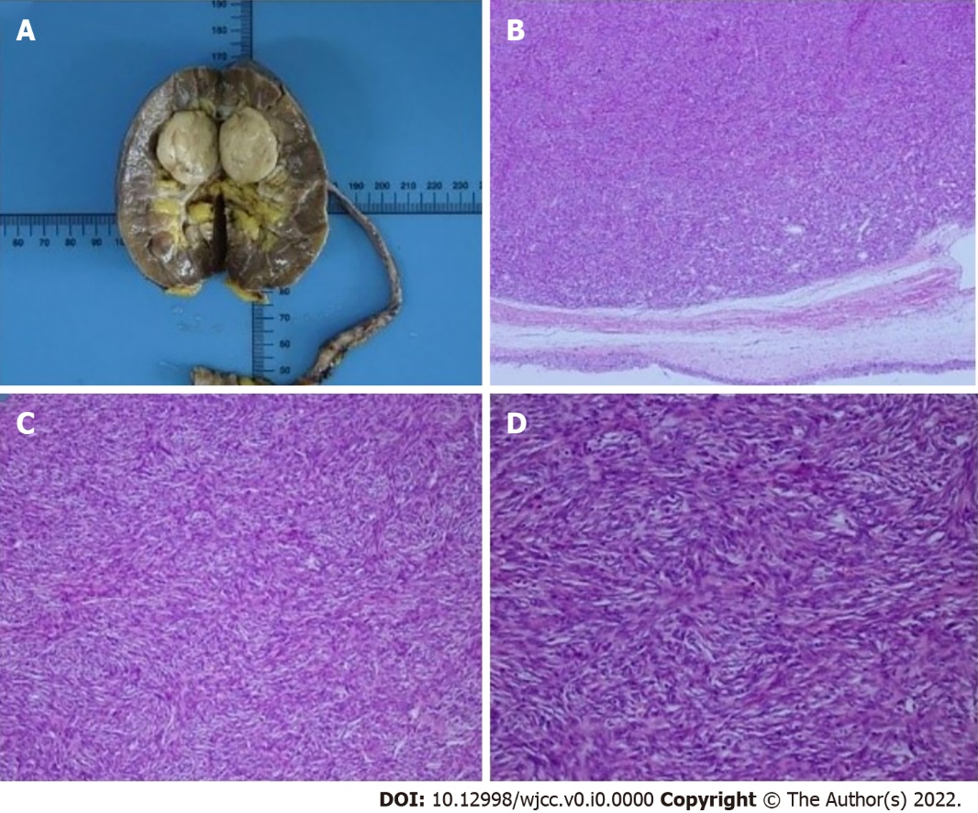
Figure 1 Computed tomography images showed a mass in the right renal pelvis (diameter: 2.3 cm × 1.8 cm). Contrast-enhanced image showed a well delineated outline of the mass. A: Arterial phase computed tomography (CT); B: Cross-section CT (venous phase); C: Coronal contrast-enhanced CT image; D: Sagittal surface contrast-enhanced CT image. Red arrows indicate right renal pelvis solitary fibrous tumor lesion.

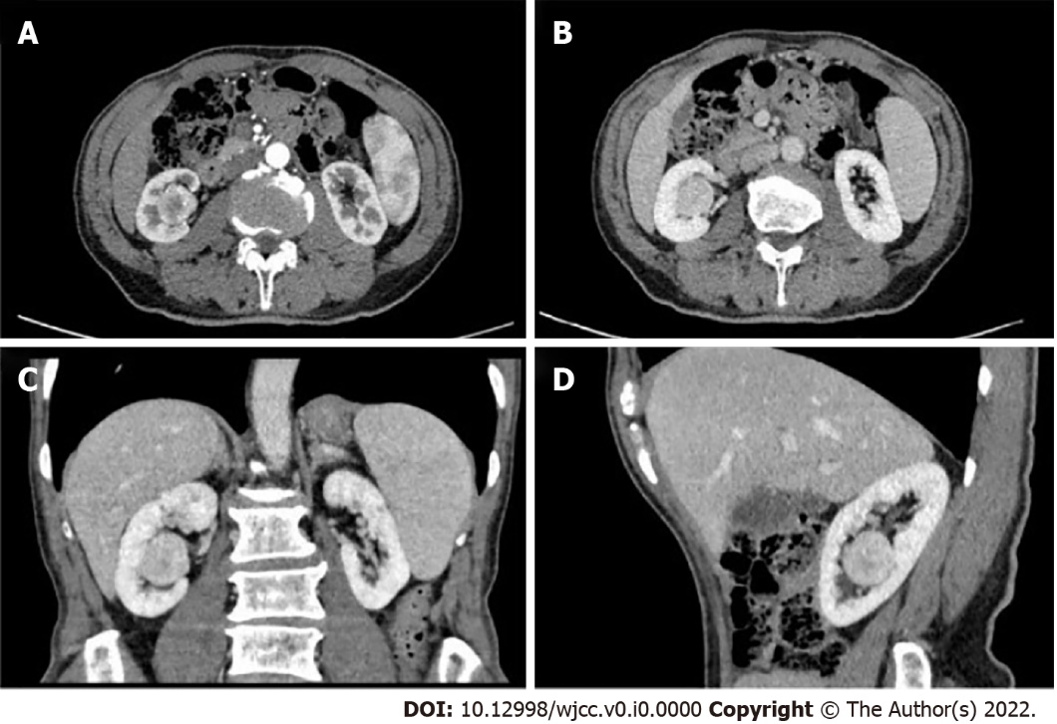
Figure 2 Pathological specimen of the kidney and ureter. A: Photograph of the tumor; B: Hematoxylin and eosin (H&E)-stained section (magnification × 5); C: H&E-stained section (magnification × 40); D: H&E-stained section (magnification × 200).

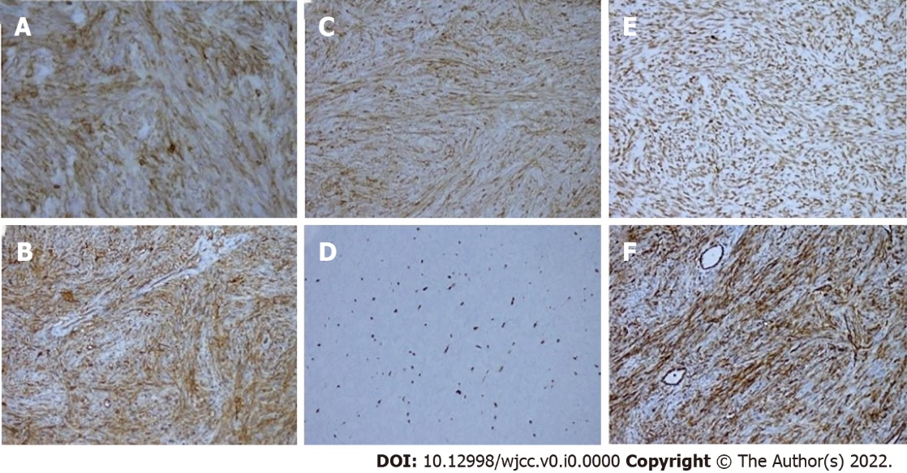
Figure 3 Immunohistochemistry results (× 20). A: Bcl-2; B: CD34; C: CD99; D: Ki67; E: STAT6; F: Vimentin.

Table 1 Previous case reports of renal pelvis solitary fibrous tumor
No | Ref. | Age/Sex/Side | Size | Treatment
1 | Yazaki et al^{[9]} | 70/M/R | 6 cm × 4.5 cm × 4 cm | Radical nephrectomy
2 | Magro et al^{[20]} | 31/F/R | Approximately 8.6 cm | Radical nephrectomy
3 | Marzi et al^{[21]} | 72/F/L | Approximately 19 cm | Radical nephrectomy
4 | Sasaki et al^{[22]} | 48/M/R | 28 cm × 18 cm × 10 cm | Radical nephrectomy
5 | Usuba et al^{[16]} | 50/M/L | 17 cm × 11 cm × 8 cm | Radical nephrectomy
6 | Zhang et al^{[5]} | 45/F/L | 4 cm × 2.5 cm × 2 cm | Radical nephrectomy
7 | Hirano et al^{[23]} | 75/F/L | 4.5 cm × 3.5 cm | Radical nephrectomy
8 | Naveen et al^{[24]} | 52/F/R | 17 cm × 10 cm × 10 cm | Radical nephrectomy
9 | Dong et al^{[25]} | 71/F/L | 4 cm × 3.5 cm × 4 cm | Radical nephrectomy
10 | Mearini et al^{[26]} | 17/F/L | 17 cm × 9.8 cm × 12 cm | Radical nephrectomy
11 | Wang et al^{[27]} | 66/F/R | 23 cm × 18 cm × 12 cm | Radical nephrectomy
12 | Cheung et al^{[2]} | 49/F/L | 19 cm × 12 cm × 10 cm | Radical nephrectomy
13 | Fursevich et al^{[14]} | 66/F/L | 9.3 cm × 7.9 cm × 9.4 cm | Radical nephrectomy
14 | Bacalbasa et al^{[1]} | 49/M/R | 15 cm × 15 cm × 10 cm | Radical nephrectomy
15 | De Luca et al^{[3]} | 52/F/R | 7.4 cm × 6.3 cm × 5.8 cm | Radical nephrectomy
M: Male; F: Female; L: Left; R: Right.

