Name of Journal: World Journal of Clinical Cases
Manuscript NO: 70701
Manuscript Type: CASE REPORT

Effective response to crizotinib of concurrent KIF5B-MET and MET-CDR2-rearranged non-small cell lung cancer: A case report

Liu L et al. Crizotinib effective in a novel MET fusion

Lian-Fang Liu, Jia-Ying Deng, Analyn Lizaso, Jing Lin, Si Sun

Lian-Fang Liu, Department of Oncology, Zhangjiagang Hospital of Traditional Chinese Medicine Affiliated to Nanjing University of Chinese Medicine, Zhangjiagang 215600, Jiangsu Province, China

Jia-Ying Deng, Department of Radiation Oncology, Fudan University Shanghai Cancer Center, Department of Oncology, Shanghai Medical College, Fudan University, Shanghai 200032, China

Analyn Lizaso, Jing Lin, Burning Rock Biotech, Guangzhou 510300, Guangdong Province, China

Si Sun, Department of Medical Oncology, Fudan University Shanghai Cancer Center; Department of Oncology, Shanghai Medical College, Fudan University, Shanghai 200032, China

Author contributions: Liu LF and Deng JY contributed to the study concept and design and performed the statistical analysis; Liu LF, Deng JY, and Lin J contributed to the acquisition, analysis, and interpretation of the data; Liu L, Deng J, and Lizaso A contributed to the drafting of the manuscript; Sun S contributed to the critical revision of the manuscript for important intellectual content.

Supported by the National Key R&D Program of China, No. 2017YFC0907900 and 2017YFC0907904.

Corresponding author: Si Sun, MD, Chief Doctor, Department of Medical Oncology, Fudan University Shanghai Cancer Center; Department of Oncology, Shanghai Medical College, Fudan University, No. 270 Dong An Road, Shanghai 200032, China. sunsi123sun@hotmail.com

Received: August 26, 2021
Revised: November 12, 2021
Accepted: February 10, 2022
Published online: March 16, 2022

Abstract
BACKGOUND
Due to the rarity of mesenchymal-epithelial transition factor (MET) fusions, the clinical efficacy of crizotinib has only been described in a few patients with MET fusions involving various fusion partners. Herein, we report the clinical response to crizotinib of a patient with advanced poorly differentiated non-small cell carcinoma (NSCLC) having concurrent MET fusions.

CASE SUMMARY
A 46-year-old woman was diagnosed with poorly differentiated NSCLC (T4N3M1). With no classic driver mutations, she was treated with two cycles of gemcitabine and cisplatin without clinical benefit. Targeted sequencing revealed the detection of two concurrent MET fusions, KIF5B-MET and novel MET-CDR2. Crizotinib was initiated at a dose of 250 mg twice daily. Within 4 wk of crizotinib therapy, repeat computed chromatography revealed a dramatic reduction in primary and metastatic lesions, assessed as partial response. She continued to benefit from crizotinib for 3 mo until disease progression and died within 1 mo despite receiving nivolumab therapy.

CONCLUSION
Crizotinib sensitivity was observed in an advanced poorly differentiated NSCLC patient with concurrent MET fusions KIF5B-MET and MET-CDR2. Crizotinib can serve as a therapeutic option for patients with MET fusions. In addition, our case also highlights the importance of comprehensive genomic profiling particularly in patients with no classic driver mutation for guiding alternative therapeutic decisions.

Key Words: Poorly differentiated; Non-small cell carcinoma; Mesenchymal-epithelial transition factor fusion; Crizotinib; Case report

©The Author(s) 2022. Published by Baishideng Publishing Group Inc. All rights reserved.

Citation: Liu LF, Deng JY, Lizaso A, Lin J, Sun S. Effective response to crizotinib of concurrent KIF5B-MET and MET-CDR2-rearranged non-small cell lung cancer: A case report. World J Clin Cases 2022; 10(8): 2529-2536
URL: https://www.wjgnet.com/2307-8960/full/v10/i8/2529.htm
DOI: https://dx.doi.org/10.12998/wjcc.v10.i8.2529

Core Tip: The most common mesenchymal-epithelial transition factor (MET) gene aberrations are gene amplifications and exon 14 splice variants found in approximately 2% to 10% of lung cancer patients. Chromosomal rearrangements resulting in gene fusions involving MET are generally rare but could account for MET-driven oncogenesis. The rarity and diversity of MET fusions in non-small cell lung cancer (NSCLC) limit the volume of evidence documenting the clinical efficacy of crizotinib in treating MET-rearranged NSCLC patients. Herein, we report the clinical response to crizotinib of a patient with advanced poorly differentiated NSCLC harboring concurrent MET-involving rearrangements, including a novel MET-CDR2 gene fusion.

INTRODUCTION
The mesenchymal-epithelial transition (MET) gene, located on chromosome 7q21-31, encodes a receptor tyrosine kinase and is activated by its ligand, hepatocyte growth factor^{[1,2]}. The MET signaling pathway is often upregulated in various human malignancies, including non-small cell lung cancer (NSCLC)^{[2]}. The most common MET gene aberrations are gene amplifications and exon 14 splice variants found de novo in approximately 2% to 10% of lung cancer patients^{[3]}. Chromosomal rearrangements resulting in gene fusions involving MET are generally rare but could account for MET-driven oncogenesis^{[4]}. Currently, a total of five MET fusion partner genes have been reported in NSCLC, including KIF5B^{[5,6]}, STARD3NL^{[5]}, HLA-DRB1^{[7,8]}, UBE2H^{[9]}, and ATXN7L1^{[10]} (Table 1). Crizotinib, an FDA-approved tyrosine kinase inhibitor for ALK-rearranged and ROS1-rearranged NSCLC, has been originally designed to target MET amplifications and mutations^{[11]}. Several cases and clinical studies have reported the efficacy of crizotinib and cabozantinib in targeting MET amplification^{[12,13]}, exon 14 skipping^{[14]}, and certain rearrangements^{[5-7,10]} in NSCLC patients. A recent meta-analysis analyzed six clinical trials (cohort size range: 8-69) on MET-altered NSCLC revealed an objective response rate of 40.6% (95%CI: 28.3%–53.0%) and disease control rate of 78.9% (95%CI: 70.3%–87.4%) for crizotinib, with a median progression-free survival and overall survival of 5.2 and 12.7 mo, respectively^{[15]}. Most of these studies enrolled few MET fusion-positive patients, because they are exceedingly rare. Current knowledge regarding MET fusions is mostly derived from two cohort studies in Chinese lung cancer patients, which identified one (0.04%, 1/2410) fusion^{[16]} and fifteen (0.26%, 15/5695) fusions involving the MET kinase domain^{[17]}, respectively.
Herein, we report the clinical efficacy of crizotinib in a patient with poorly differentiated NSCLC with KIF5B-MET and a concurrent novel MET-CDR2 fusion.

CASE PRESENTATION
Chief complaints
In November 2018, a 46-year-old female never-smoker presented in our clinic with a complaint of persistent dry cough.

History of present illness
The cough had been lasted for over a week.

History of past illness
Past medical history was not remarkable for this patient.

Laboratory examinations
Histopathological analysis of tissue biopsy samples collected from the right lung revealed poorly differentiated NSCLC (Figure 1) with the immunohistochemistry results of AE1/AE3 (+), SMACA4 BRG1 (+), CK18 (+), INI-1 (+), CD56 (-), chromogranin A (-), synaptophysin (-), CK7 (-), ERG (-), GATA3 (-), CD34 (-), CDX2 (-), P40 (-), SALL4 (-), TTF-1 (-), Desmin (-), and S-100 (-). In addition, PD-L1 expression analysis revealed a tumor proportion score of 80%. Molecular analysis of the biopsies detected no driver alterations in EGFR, ALK, or ROS1.

Imaging examinations
Computed tomography (CT) and magnetic resonance imaging revealed a tumor in the lower lobe of the right lung, right hilar and mediastinal lymph node involvement, and multi-organ metastasis including the left pleura, liver, pericardium, and bone.

FINAL DIAGNOSIS
The final diagnosis of the patient was NSCLC stage IV (T4N3M1).

TREATMENT
Based on the findings presented above, the patient was then treated with two cycles of gemcitabine (1.0 g/m² on days 1 and 8) plus cisplatin (75 mg/m² on day 1) with no clinical benefit.

OUTCOME AND FOLLOW-UP
In January 2019, an abdominal CT scan revealed the enlargement of the lung primary and liver metastases. To explore potentially actionable mutations, tumor biopsy samples were submitted for capture-based targeted sequencing using a panel with 520 cancer-related genes (OncoScreen Plus, Burning Rock, China). As shown in Figure 2, the analysis revealed the detection of two concurrent MET fusions with respective partner genes KIF5B (K24:M15) and CDR2 (M15:C3). No other classic lung cancer driver mutations were detected apart from TP53 C277X. Due to economic and insurance conditions and out of concern over evidence suggesting reduced efficacy of immunotherapy in non-small cell lung cancer patients carrying oncogenic driver alterations^{[18]}, crizotinib (250 mg, p.o. bid) was started as the second line treatment in February 2019. After 4 wk of therapy, review of chest CT revealed a dramatic reduction of the lesions in the left and right lobes of the lungs with no new lesions, which was evaluated as partial response with Response Evaluation Criteria in Solid Tumors v.1.1 (RECIST 1.1) (Figure 3A and B). At approximately 3 mo from the start of targeted therapy, the patient continued to benefit from crizotinib without side effects. However, the disease progressed afterwards in May, 2019 as per RECIST 1.1. Specifically, compared with the previous evaluation (Figure 3B), new lesions emerged mostly in the right lung, accompanied by growth of the previously reduced tumor (Figure 3C and D).
After crizotinib failure, we chose nivolumab (a human IgG4 PD-1 antibody) as a salvage therapy because of the high PD-L1 expression. However, the patient did not benefit from nivolumab and her condition was declining significantly. She was hospitalized for worsening respiratory function and died shortly thereafter with an overall survival (OS) of 7 mo from diagnosis.

DISCUSSION
Gene alterations in MET are emerging as clinically relevant biomarker for predicting the response to MET inhibitors^{[2]}. However, due to the rarity of MET fusions, treatment responses have only been clinically evaluated for MET amplification and exon 14 skipping^{[12-14]} and only a few case reports have reported the efficacy of crizotinib in patients with MET fusions with various partners^{[5-7]}. In our report, we describe the detection of KIF5B-MET co-occurring with a novel gene fusion involving MET and CDR2 and provided the clinical evidence of the efficacy of crizotinib in a KIF5B-MET and MET-CDR2-rearranged poorly differentiated NSCLC patient. KIF5B-MET K24:M15 has been reported in 0.5% (1/206) of adenocarcinoma and 4% (2/28) of sarcomatoid lung cancer patients in a recent study in Taiwanese patients^{[19]}. In vitro and in vivo studies consistently demonstrated the oncogenic potential of KIF5B-MET fusion and sensitivity to crizotinib^{[19]}. Consistently, several case reports have observed clinical efficacy of crizotinib in K24:M14^{[6]} and K24:M15^{[5]} KIF5B-MET-rearranged NSCLC^{[5,6]}. The dramatic response to crizotinib observed in our patient highly suggests that the fusions acting either solely or in synergy served as oncogenic driver/s in the patient’s tumor which confers sensitivity to crizotinib. The oncogenic potential and sensitivity to crizotinib or other MET inhibitors of the novel gene fusion MET-CDR2 as well as the presence of two concurrent MET fusions require further investigations.
The negative results for histopathologic markers TTF-1, CK7, P40, and CDX2 and classic driver mutations in EGFR, ALK, and ROS1 provided neither clear indication of the cell differentiation nor any therapeutic targets. With a poor response to the first-line chemotherapy regimen, our patient had a very poor prognosis. Comprehensive genomic profiling allowed us to understand the mutation landscape of the tumor and explore alternative therapeutic targets that provided benefit to our patient. The detection of the potentially targetable MET fusions in our patient with poorly differentiated NSCLC highlights the importance of comprehensive genomic profiling regardless of tumor histology, particularly in patients with no known driver mutations to guide therapeutic decisions.
After the failure of crizotinib, we chose an immune checkpoint inhibitor (ICI) as a salvage therapy. Although with high PD-L1 expression, the patient did not benefit from the ICI. This is similar with the finding of previous studies that ICIs are less effective in NSCLC with EGFR mutation or EML4-ALK fusion^{[18,20]}.
Attention should be paid to managing toxicities associated with crizotinib monotherapy. In a study of 2028 Japanese ALK-rearranged patients receiving crizotinib, adverse drug reactions occurred in 91.6% of patients, the most common (incidence ≥ 15%) of which were nausea (32.2%), diarrhea (24.3%), photopsia (18.9%), vomiting (17.5%), and dysgeusia (16.8%). A considerable proportion of patients (623, 30.7%) discontinued treatment within 12 wk after therapy initiation due to adverse events. Only 68.2% of patients remained on crizotinib after 3 mo, 55.2% after 6 mo, and 36.1% after 12 mo, with a median duration of 7.9 mo^{[10]}. Therefore, it is advised to monitor patients for these adverse reactions during the clinical use of crizotinib.

CONCLUSION
The efficacy of crizotinib in an advanced poorly differentiated NSCLC patient with concurrent KIF5B-MET and MET-CDR2 gene fusions suggests that crizotinib can serve as a therapeutic option in patients with MET fusions. Further clinical studies are required to confirm the clinical value of crizotinib or other MET inhibitors in patients with MET fusion.

ACKNOWLEDGEMENTS
The authors thank the patient and her family. We also thank the investigators, study coordinators, operation staff, and the whole project team who worked on this case. We are grateful to Xiao Zou and Lei Lei at Burning Rock Biotech for technical assistance.

REFERENCES
1 Matsumoto K, Umitsu M, De Silva DM, Roy A, Bottaro DP. Hepatocyte growth factor/MET in cancer progression and biomarker discovery. Cancer Sci 2017; 108: 296-307 [PMID: 28064454 DOI: 10.1111/cas.13156]
2 Comoglio PM, Trusolino L, Boccaccio C. Known and novel roles of the MET oncogene in cancer: a coherent approach to targeted therapy. Nat Rev Cancer 2018; 18: 341-358 [PMID: 29674709 DOI: 10.1038/s41568-018-0002-y]
3 Go H, Jeon YK, Park HJ, Sung SW, Seo JW, Chung DH. High MET gene copy number leads to shorter survival in patients with non-small cell lung cancer. J Thorac Oncol 2010; 5: 305-313 [PMID: 20107422 DOI: 10.1097/JTO.0b013e3181ce3d1d]
4 Stransky N, Cerami E, Schalm S, Kim JL, Lengauer C. The landscape of kinase fusions in cancer. Nat Commun 2014; 5: 4846 [PMID: 25204415 DOI: 10.1038/ncomms5846]
5 Plenker D, Bertrand M, de Langen AJ, Riedel R, Lorenz C, Scheel AH, Müller J, Brägelmann J, Daßler-Plenker J, Kobe C, Persigehl T, Kluge A, Wurdinger T, Schellen P, Hartmann G, Zacherle T, Menon R, Thunnissen E, Büttner R, Griesinger F, Wolf J, Heukamp L, Sos ML, Heuckmann JM. Structural Alterations of MET Trigger Response to MET Kinase Inhibition in Lung Adenocarcinoma Patients. Clin Cancer Res 2018; 24: 1337-1343 [PMID: 29284707 DOI: 10.1158/1078-0432.CCR-17-3001]
6 Cho JH, Ku BM, Sun JM, Lee SH, Ahn JS, Park K, Ahn MJ. KIF5B-MET Gene Rearrangement with Robust Antitumor Activity in Response to Crizotinib in Lung Adenocarcinoma. J Thorac Oncol 2018; 13: e29-e31 [PMID: 29102694 DOI: 10.1016/j.jtho.2017.10.014]
7 Davies KD, Ng TL, Estrada-Bernal A, Le AT, Ennever PR, Camidge DR, Doebele RC, Aisner DL. Dramatic Response to Crizotinib in a Patient with Lung Cancer Positive for an HLA-DRB1-MET Gene Fusion. JCO Precis Oncol 2017; 2017: PO.17.00117 [PMID: 29527595 DOI: 10.1200/PO.17.00117]
8 Kunte S, Stevenson J. A Case of HLA-DRB1-MET Rearranged Lung Adenocarcinoma With Rapid Response to Crizotinib. Clin Lung Cancer 2021; 22: e298-e300 [PMID: 32654927 DOI: 10.1016/j.cllc.2020.05.005]
9 Zhu YC, Wang WX, Song ZB, Zhang QX, Xu CW, Chen G, Zhuang W, Lv T, Song Y. MET-UBE2H Fusion as a Novel Mechanism of Acquired EGFR Resistance in Lung Adenocarcinoma. J Thorac Oncol 2018; 13: e202-e204 [PMID: 30244854 DOI: 10.1016/j.jtho.2018.05.009]
10 Zhu YC, Wang WX, Xu CW, Zhang QX, Du KQ, Chen G, Lv TF, Song Y. Identification of a novel crizotinib-sensitive MET-ATXN7L1 gene fusion variant in lung adenocarcinoma by next generation sequencing. Ann Oncol 2018; 29: 2392-2393 [PMID: 30339198 DOI: 10.1093/annonc/mdy455]
11 Tanizaki J, Okamoto I, Okamoto K, Takezawa K, Kuwata K, Yamaguchi H, Nakagawa K. MET tyrosine kinase inhibitor crizotinib (PF-02341066) shows differential antitumor effects in non-small cell lung cancer according to MET alterations. J Thorac Oncol 2011; 6: 1624-1631 [PMID: 21716144 DOI: 10.1097/JTO.0b013e31822591e9]
12 Caparica R, Yen CT, Coudry R, Ou SI, Varella-Garcia M, Camidge DR, de Castro G Jr. Responses to Crizotinib Can Occur in High-Level MET-Amplified Non-Small Cell Lung Cancer Independent of MET Exon 14 Alterations. J Thorac Oncol 2017; 12: 141-144 [PMID: 27664533 DOI: 10.1016/j.jtho.2016.09.116]
13 Camidge DR, Otterson GA, Clark JW, Ou SHI, Weiss J, Ades S, Conte U, Tang YY, Wang SCE, Murphy D, Wilner KD, Villaruz LC. Crizotinib in patients (pts) with MET-amplified non-small cell lung cancer (NSCLC): Updated safety and efficacy findings from a phase 1 trial. J Clin Oncol 2018; 36: 9062 [DOI: 10.1200/jco.2018.36.15_suppl.9062]
14 Paik PK, Drilon A, Fan PD, Yu H, Rekhtman N, Ginsberg MS, Borsu L, Schultz N, Berger MF, Rudin CM, Ladanyi M. Response to MET inhibitors in patients with stage IV lung adenocarcinomas harboring MET mutations causing exon 14 skipping. Cancer Discov 2015; 5: 842-849 [PMID: 25971939 DOI: 10.1158/2159-8290.CD-14-1467]
15 Vuong HG, Nguyen TQ, Nguyen HC, Nguyen PT, Ho ATN, Hassell L. Efficacy and Safety of Crizotinib in the Treatment of Advanced Non-Small-Cell Lung Cancer with ROS1 Rearrangement or MET Alteration: A Systematic Review and Meta-Analysis. Target Oncol 2020; 15: 589-598 [PMID: 32865687 DOI: 10.1007/s11523-020-00745-7]
16 Wang WX, Xu C, Chen Y, Zhu YC, Liu YP, Wang H, Zhuang W, Chen XH, Huang YJ, Lai JH, Fang MY, Zhang ZH, Tao Y, Xu SG, Qian X, Zhao HY, Cai SL, Chen G, Lv TF, Song Y. MET gene fusions in non-small cell lung cancer (NSCLC) in the Chinese population: A multicenter study. J Clin Oncol 2018; 36: e13539 [DOI: 10.1200/jco.2018.36.15_suppl.e13539]
17 Zhuo M, Liang Z, Yi Y, Wu N, Yang X, Zhong J, Chen X, Huang Y, Yu Z, Liu C, Zeng X, Gu W, Zhao J. Analysis of MET kinase domain rearrangement in NSCLC. Lung Cancer 2020; 145: 140-143 [PMID: 32447117 DOI: 10.1016/j.lungcan.2020.04.040]
18 Mazieres J, Drilon A, Lusque A, Mhanna L, Cortot AB, Mezquita L, Thai AA, Mascaux C, Couraud S, Veillon R, Van den Heuvel M, Neal J, Peled N, Früh M, Ng TL, Gounant V, Popat S, Diebold J, Sabari J, Zhu VW, Rothschild SI, Bironzo P, Martinez-Marti A, Curioni-Fontecedro A, Rosell R, Lattuca-Truc M, Wiesweg M, Besse B, Solomon B, Barlesi F, Schouten RD, Wakelee H, Camidge DR, Zalcman G, Novello S, Ou SI, Milia J, Gautschi O. Immune checkpoint inhibitors for patients with advanced lung cancer and oncogenic driver alterations: results from the IMMUNOTARGET registry. Ann Oncol 2019; 30: 1321-1328 [PMID: 31125062 DOI: 10.1093/annonc/mdz167]
19 Gow CH, Liu YN, Li HY, Hsieh MS, Chang SH, Luo SC, Tsai TH, Chen PL, Tsai MF, Shih JY. Oncogenic Function of a KIF5B-MET Fusion Variant in Non-Small Cell Lung Cancer. Neoplasia 2018; 20: 838-847 [PMID: 30015159 DOI: 10.1016/j.neo.2018.06.007]
20 Ueno N, Banno S, Endo Y, Tamura M, Sugaya K, Hashigaki S, Ohki E, Yoshimura A, Gemma A. Treatment status and safety of crizotinib in 2028 Japanese patients with ALK-positive NSCLC in clinical settings. Jpn J Clin Oncol 2019; 49: 676-686 [PMID: 31008509 DOI: 10.1093/jjco/hyz049]

Footnotes
Informed consent statement: Written informed consent was obtained from the patient for publication of this manuscript and any accompanying images.

Conflict-of-interest statement: Lizaso A and Lin J were employees of Burning Rock Biotech during the conduct of the study. All other authors declare no competing interests.

CARE Checklist (2016) statement: The case was reported in accordance with the CARE reporting checklist (2016).

Open-Access: This article is an open-access article that was selected by an in-house editor and fully peer-reviewed by external reviewers. It is distributed in accordance with the Creative Commons Attribution NonCommercial (CC BY-NC 4.0) license, which permits others to distribute, remix, adapt, build upon this work non-commercially, and license their derivative works on different terms, provided the original work is properly cited and the use is non-commercial. See: https://creativecommons.org/Licenses/by-nc/4.0/

Provenance and peer review: Unsolicited article; Externally peer reviewed.
Peer-review model: Single blind

Peer-review started: August 26, 2021
First decision: October 29, 2021
Article in press: February 10, 2022

Specialty type: Oncology
Country/Territory of origin: China
Peer-review report’s scientific quality classification
Grade A (Excellent): 0
Grade B (Very good): 0
Grade C (Good): C, C, C
Grade D (Fair): 0
Grade E (Poor): 0

P-Reviewer: Imai Y, Jang HJ, Kung WM S-Editor: Zhang H L-Editor: Wang TQ P-Editor: Zhang H

Figure Legends

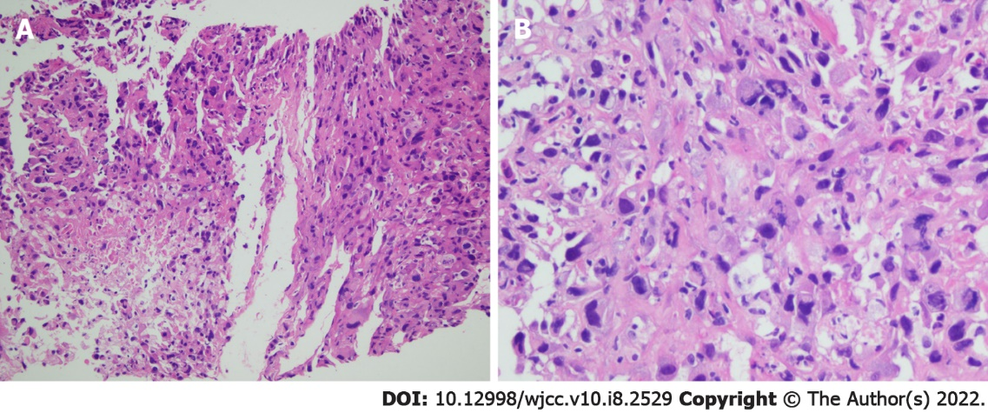
Figure 1 Hematoxylin and eosin staining photomicrographs of a right lung tumor tissue biopsy. A: Original magnification (×20); B: Original magnification (×40).
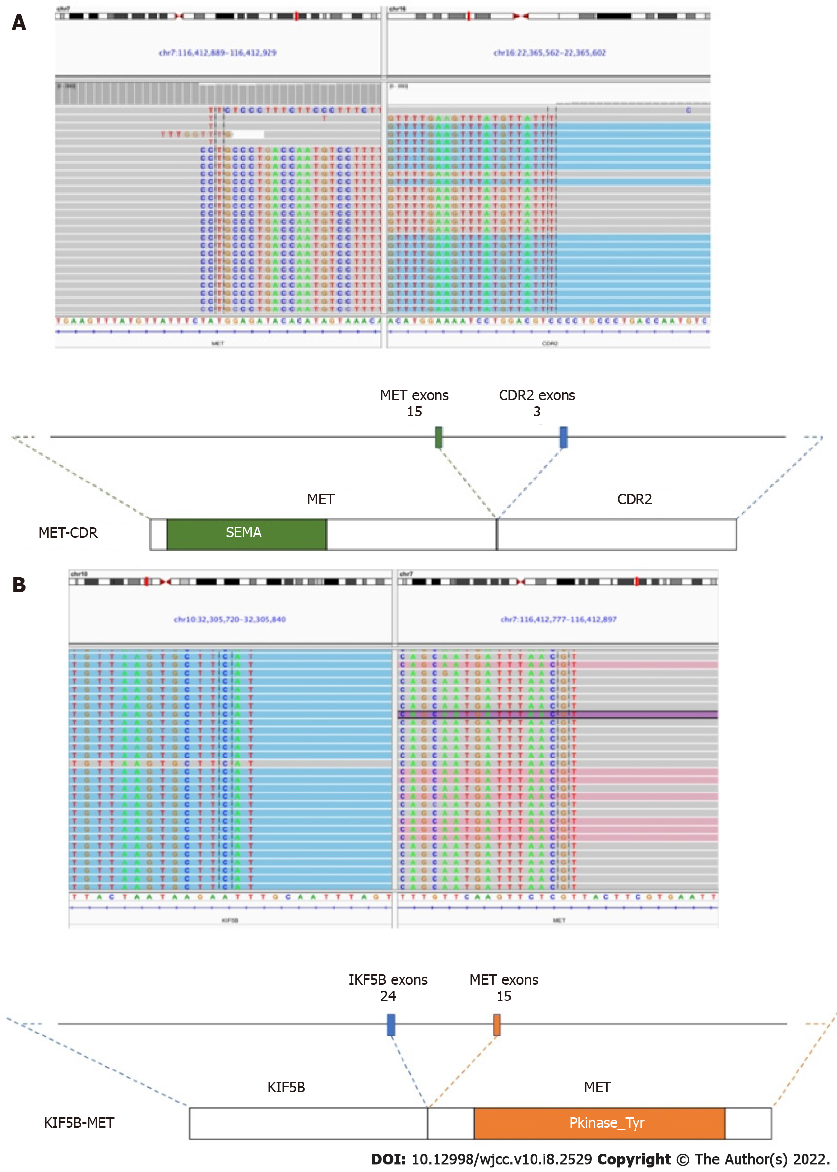
Figure 2 Next-generation sequencing revealed two concurrent MET fusions with different fusion partners, MET-CDR2 and KIF5B-MET. A: Images from the Integrative Genomics Viewer demonstrating the chromosomal rearrangement involving MET (chromosome 7, sequencing reads with gray background) and CDR2 (chromosome 16, sequencing reads with blue background); B: KIF5B (chromosome 10, sequencing reads with blue background). Illustrations below demonstrate the protein structure resulting from the gene fusions indicating the breakpoints of the nearby exons.
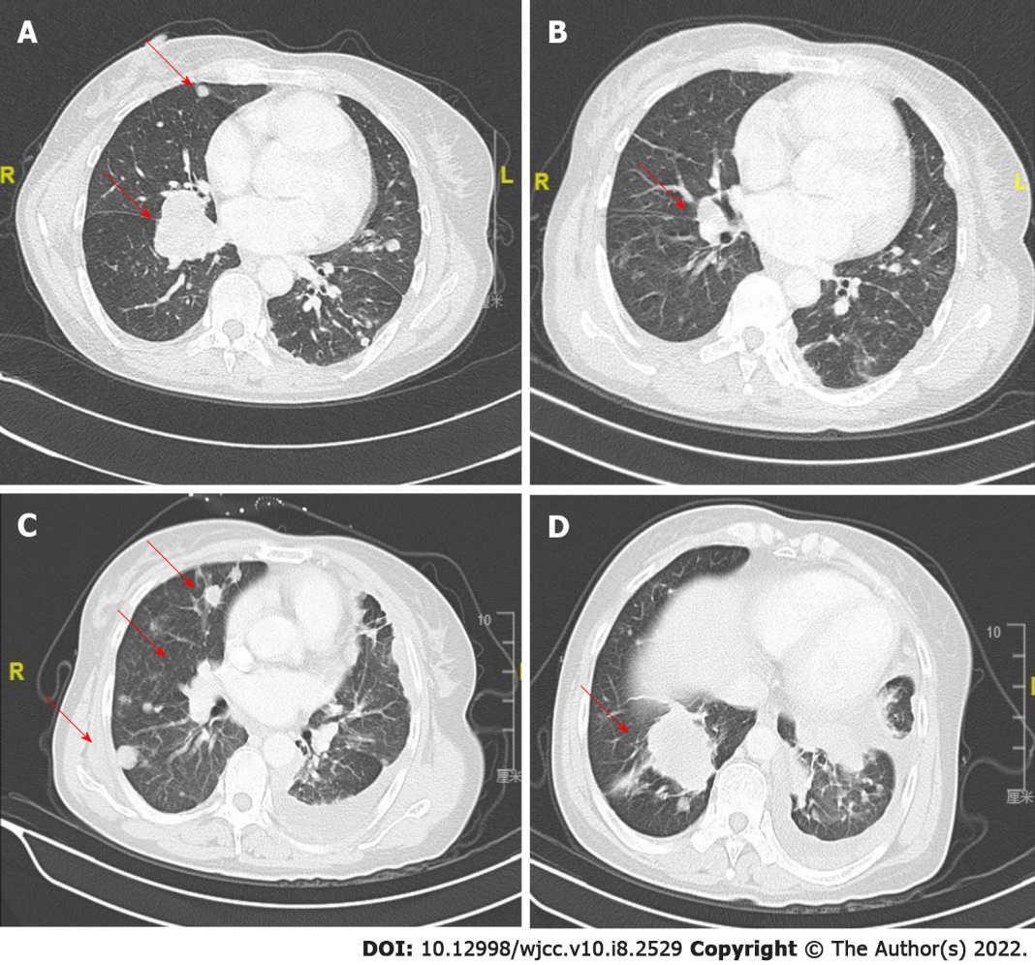
Figure 3 Clinical efficacy of crizotinib treatment in a patient with KIF5B-MET and MET-CDR2-rearranged, poorly differentiated lung cancer. A: Thoracic computed tomographic image at baseline; B: 1 mo after initiating crizotinib therapy; C and D: After disease progression and another 2 mo later in May, 2019.

Table 1 Summary of case reports of crizotinib (250 mg/b.i.d. orally) in treating MET-rearranged non-small cell carcinoma
Ref. | Age | Sex | Smoker | Stage | Histology | MET fusion | Best overall response | PFS (mo) | Grade ≥ 3 AEs | Notes
[5] | 33 | F | Yes | IV | ADC | KIF5B-MET | PR | 8 | NR
[5] | 62 | F | No | IV | ADC | STARD3NL-MET | PR | 14 | NR
[6] | 51 | F | No | IV | ADC | KIF5B-MET | PR | 10 | NR
[7] | 74 | F | No | Recurrent | ADC | HLA-DRB1-MET | Complete resolution of nodules while pleural effusion persisted | 8 | No
[8] | 59 | F | No | Recurrent | ADC | HLA-DRB1-MET | Complete radiographic response | / | No
[9] | 43 | F | No | IV | ADC | MET-UBE2H | PR | 6.5 | NR | MET fusion was acquired on EGFR-targeted therapy.
[10] | 56 | F | No | IV | ADC | MET–ATXN7L1 | PR | 4 | NR
ADC: Adenocarcinoma; AE: Adverse event; NR: Not reported; PR: Partial response.

Published by Baishideng Publishing Group Inc
7041 Koll Center Parkway, Suite 160, Pleasanton, CA 94566, USA
Telephone: +1-925-3991568
E-mail: bpgoffice@wjgnet.com
Help Desk: https://www.f6publishing.com/helpdesk
https://www.wjgnet.com

© 2022 Baishideng Publishing Group Inc. All rights reserved.

