Name of Journal: World Journal of Clinical Cases
Manuscript NO: 66722
Manuscript Type: CASE REPORT

Paraneoplastic focal segmental glomerulosclerosis associated with gastrointestinal stromal tumor with cutaneous metastasis: A case report

Zhou J et al. Cutaneous metastatic GIST accompanied by FSGS

Jun Zhou, Zhen Yang, Cui-Shun Yang, Hua Lin

Jun Zhou, Zhen Yang, Cui-Shun Yang, Department of Nephrology and Rheumatology, Haikou People’s Hospital Affiliated to Xiangya School of Medicine of Central South University, Haikou 570208, Hainan Province, China

Hua Lin, Department of Nursing, Haikou Affiliated Hospital of Central South University Xiangya School of Medicine, Haikou 570208, Hainan Province, China

Author contributions: Zhou J wrote the manuscript, conducted the literature review, and participated in paper submission and revision; Yang Z, Yang CS, and Lin H participated in the clinical care of the patient; all authors assisted with the interpretation of the results and manuscript revision, and read and approved the final manuscript.

Supported by the Hainan Provincial Natural Science Foundation of China, No. 820RC785; and the Healthy Department of Hainan Province, No. 2001320243A2011.

Corresponding author: Hua Lin, BM BCh, Nurse, Department of Nursing, Haikou Affiliated Hospital of Central South University Xiangya School of Medicine, No. 43 Renmin Road, Haidian Island, Haikou 570208, Hainan Province, China. 2894993270@qq.com

Received: April 3, 2021
Revised: July 25, 2021
Accepted: August 5, 2021
Published online:

Abstract
BACKGROUND
Gastrointestinal stromal tumor (GIST) with cutaneous metastasis is very rare. As a result, cutaneous GISTs have not been well characterized. Focal segmental glomerulosclerosis (FSGS) is also a rare symptom among paraneoplastic nephritic syndromes (PNS).

CASE SUMMARY
In this case report, we describe a patient with cutaneous metastatic GIST accompanied by nephrotic syndrome occurring as a malignancy-associated PNS, for whom symptomatic treatment was ineffective, but clinical remission was achieved after surgery. Moreover, the patient has a missense mutation in NPHP4, which can explain the occurrences of GIST and FSGS in this patient and indicates that the association is not random.

CONCLUSION
This is the first reported case of a GIST with cutaneous metastasis accompanied by nephrotic syndrome manifesting as a PNS.

Key Words: Gastrointestinal stromal tumors; Cutaneous metastasis; Paraneoplastic nephritic syndromes; NPHP4; CD34; DOG1; Case report

Zhou J, Yang Z, Yang CS, Lin H. Paraneoplastic focal segmental glomerulosclerosis associated with gastrointestinal stromal tumor with cutaneous metastasis: A case report. World J Clin Cases 2021; In press

Core Tip: This paper reports the case of patient with cutaneous metastatic gastrointestinal stromal tumor accompanied by nephrotic syndrome occurring as a malignancy-associated paraneoplastic nephritic syndromes. Moreover, the patient has a missense mutation in NPHP4. A review of other relevant cases from the literature is presented, and the potential challenges, treatment, and prognosis are discussed.

INTRODUCTION
Gastrointestinal stromal tumor (GIST) is one of the most common mesenchymal neoplasms that occurs in different areas of the gastrointestinal tract. The most frequent site of GIST is the stomach (60%), followed by the small intestine (35%) and the colon and rectum (< 5%)^{[1]}. Immunohistochemistry is helpful for the diagnosis because GISTs show immunoreactivity for CD117 (95%), CD34 (70%), and DOG1, a complementary marker to CD117^{[2]}. GISTs are usually benign with a malignant transformation rate of 10-30%. With regard to metastatic GISTs, DeMatteo’s group^{[3]} has previously reviewed 200 cases and reported that 61% of the metastases involved the liver, 20% involved the intraabdominal region, and 6% involved the bone. Since 2002, ten cases of cutaneous metastasis from GIST have been described, and in one report, these occurrences were estimated to represent 1% of advanced GISTs^{[4]}. Paraneoplastic syndrome (PNS) is a disorder or symptom caused by cancer or a reaction to tumors but does not result from the local presence of cancer cells^{[5]}. The signs and symptoms of PNS are diverse, but include some common features of PNS, such as neuropathy, skin disease, and nephrotic syndrome.
In this case report, we describe a patient with cutaneous metastatic GIST accompanied by nephrotic syndrome occurring as a malignancy-associated PNS for whom symptomatic treatment was ineffective but clinical remission was achieved after surgery. To the best of our knowledge, this is the first time that we present a unique case of cutaneous metastatic GIST accompanied by focal segmental glomerulosclerosis (FSGS) occurring as a malignancy-associated PNS.

CASE PRESENTATION
Chief complaints
A 64-year-old Chinese man was admitted to our hospital with edema that had persisted over 4 mo.

History of present illness
The patient reported edema of the face and lower limbs, particularly in the afternoon, and he had not received any special treatment for this symptom.

History of past illness
No other relevant history of past illness was reported.

Personal and family history
No other relevant family history was reported.

Physical examination
On examination, the patient presented with multiple nodules and lumps with a smooth surface that could be seen throughout the body (Figure 1A). Enlargement of the cervical, axillary, and inguinal lymph nodes was clearly observed.

Laboratory examinations
Laboratory examinations revealed severe proteinuria (3.77 g/24 h; normal range, 0–0.15 g/24 h), hypoalbuminemia (1.8 g/dL), hyperlipidemia (cholesterol 15.7 mmoL, triglyceride 3.34 mmol/L), and increased serum creatinine levels (152 μmoL; normal range, 44–133 μmoL). These clinical parameters suggested that the patient’s symptoms were a result of nephrotic syndrome.

Imaging examinations
A kidney biopsy was performed and the analysis of nine glomeruli revealed one glomerulus indicative of glomerulosclerosis and one indicative of segmental glomerulosclerosis with peripheral podocytosis, vacuolation, and granular degeneration in the renal tubular epithelial cells (Figure 1B and C). These pathological findings were indicative of FSGS, not otherwise specified (NOS). Immunohistochemistry of the kidney revealed that the glomerular capillary loop, peritubular capillary, and arterioles were positive for CD34 (Figure 1D), and the proximal tubule cells were positive for CD117 (Figure 1E) but negative for DOG1. Fat degeneration and necrosis were observed in the lymph node, and no tumor metastasis was revealed (Figure 1F). Hematoxylin and eosin staining of the skin showed spindle cell tumor-like hyperplasia, which was slightly heteromorphic with focal necrosis and rarely mitotic (Figure 1G). Immunohistochemistry staining revealed that the tumor cells were positive for CD34, Bcl-2, CD99, Ki67, and vimentin but negative for smooth muscle actin (SMA) and S-100. Representative immunohistochemical staining for CD34 is shown in Figure 1H. The diagnosis was a desmoid tumor (DT) based on the above immunohistochemistry results.
Then, gastroscopy was performed and the results revealed a 0.6 cm mucosal mass that was hard to the touch, and poor mobility could be seen in the greater curvature of the stomach (Figure 2A). Several 0.4-2 cm masses were observed in the anterior wall of the middle and upper of the gastric fundus with fractured surfaces and fresh blood (Figure 2B). Moreover, pathological examination revealed the destruction of the gastric solid membrane structure and spindle cell tumor-like hyperplasia with mild dysplasia (Figure 2C), and epithelioid cells were occasionally seen with 6-8 mitotic figures/50 high power fields (Figure 2D). CD117 (Figure 2E), CD34 (Figure 2F), and SMA were positive by immunohistochemistry, and DOG1 was probably positive, and S-100 and CK were negative. These findings supported the diagnosis of GIST. Additional immunohistochemistry revealed that the skin was positive for CD117 (Figure 2G) and DOG1 (Figure 2H), the two most sensitive and specific markers for the diagnosis of GIST^{[6]}. In addition, a heterozygous missense mutation was found in the NPHP4 gene of the patient (NPHP4: NM_015102: exon17: c.2198G>A: p.G733D), which explained the occurrence of GIST and FSGS and indicated that this was not a random association^{[6]}.

FINAL DIAGNOSIS
The final diagnosis of the patient presented in this case report was a metastatic cutaneous GIST.

TREATMENT
Cyclosporine was administered in an outpatient setting for 3 d, and the discomfort of the patient was alleviated. Moreover, the patient received prednisone acetate 50 mg QD for 3 mo. After 4 mo, a partial gastrectomy was performed.

OUTCOME AND FOLLOW-UP
Despite receiving prednisone for 3 mo, the patient’s severe proteinuria and hypoalbuminemia did not improve. After 4 mo of follow-up, a partial gastrectomy was performed. Two weeks after the tumor was removed by surgery, the patient’s serum albumin and urinary protein levels improved remarkably (Figure 3).

DISCUSSION
GISTs arise from the interstitial cells of Cajal, which serve as a pacemaker for the gastrointestinal tract by creating slow wave potentials that direct smooth muscle to contract. GISTs primarily metastasize to the liver and peritoneum, while cutaneous metastases are the least common. However, the mechanism of GIST metastasis to the skin remains unknown. It is hypothesized that the presence of skin metastases may indicate multiple internal metastases^{[3]}. This patient’s disease was initially misdiagnosed as DT prior to the recognition of cutaneous metastatic GIST by assessing the expression of CD117, CD34, and DOG1 in the skin. Patients with a history of GISTs should be advised to undergo a full skin examination to detect visible clues that indicate metastatic tumor burden.
In our case, the patient had a missense mutation of NPHP4. NPHP4 is located on chromosome 1p36 and encodes nephrocystin-4/nephroretinin^{[7]}. Nephrocystin-4 colocalizes and interacts with nephrocystins 1 and 3 in primary cilia and associated appendages, adherens junctions, and focal adhesions^{[8]}. Individuals with mutations in NPHP4 most frequently present with nephronophthisis^{[9]}. Some researchers have determined that NPHP4 is a negative regulator of the Hippo pathway^{[10]}. In acute renal injury, the Hippo signaling pathway may be involved in the apoptosis of tubule epithelial cells, epithelial-mesenchymal transition, and acute renal injury progression to chronic kidney disease, among other processes^{[11]}. In addition, the Hippo signaling pathway is involved in the development and progression of several chronic kidney diseases, including FSGS, diabetic nephropathy, and polycystic kidney disease^{[12]}. The conserved Hippo signaling pathway regulates organ size in Drosophila melanogaster and mammals and plays an essential role in tumor suppression and cell proliferation^{[13]}. NPHP4 is indeed a driving force of the proliferation of tumor cells. Therefore, the mutation of NPHP4 in this patient could explain the occurrence of GIST and FSGS and this was therefore not a random association.
Our patient presented with cutaneous metastatic GIST which needed to be differentiated from Gardner’s syndrome, an autosomal hereditary disease characterized by multiple adenomatous polyps in the colorectal region and the presence of some extracolonic lesions. Gardner’s syndrome is characterized by multiple adenomatous polyps in the colorectal region with osteoma, soft-tissue tumor, and tooth abnormality. In addition, 30%-75% of patients with Gardner’s syndrome also have dental abnormalities^{[14]}. Osteomas are a requirement for the diagnosis of Gardner’s syndrome. The molecular genetic basis of Gardner’s syndrome is the mutation of the APC gene located at 5q21. Unfortunately, this patient did not undergo colonoscopy. However, based on the absence of an APC mutation, family history, and the fact that the patient had no osteoma or dental abnormalities, the patient’s etiology could be differentiated from Gardner’s syndrome.
Theoretically, the diagnosis of paraneoplastic glomerulopathy should rely on three strong criteria. First, clinical and histologic remission occurs after complete surgical removal of the tumor or chemotherapy-induced complete remission of the disease. In our patient, symptomatic treatment was ineffective but clinical remission was achieved after surgery. Therefore, the patient’s nephrotic syndrome could be diagnosed as a PNS. Second, a renal relapse accompanies the recurrence of neoplasia. In other words, proteinuria should directly correlate with tumor activity. Third, a pathophysiologic link is established between the two diseases, including the detection of tumor antigens and antitumor antibodies within subepithelial immune deposits^{[15]}. In our patient, the immunohistochemistry of the kidney revealed positivity for CD117 and CD34, but negativity for DOG1. Telocytes (TCs) were indicated as a distinctive cell type after being previously described as “interstitial Cajal-like cells”^{[16]}. Qi et al^{[17]} reported TCs in the interstitium of the human kidney cortex. Renal TCs were found to express CD34 and CD117 with variable intensity^{[17]}. Therefore, the positive CD34 and CD117 results in the kidney were not significant. Nephrotic syndrome can occur as malignancy-associated PNS, and it has been estimated that cancer occurs in 11%–22% of patients with nephrotic syndrome^{[5]}. The most common pathological type of tumor-associated nephropathy is membranous nephropathy (44%–49%). FSGS is extremely rare among PNS patients and has been observed in association with renal cell carcinoma, invasive thymoma, and lung cancer^{[18]}. There has been only one reported case of GIST of the stomach that was associated with nephrotic syndrome occurring as a malignancy-associated PNS. Nephrotic syndrome improves after surgery in 78% of patients^{[5]}. Considering that cancer is a potential cause of nephrotic syndrome, surgical resection should be performed in the presence of PNS. In our case, the patient’s proteinuria and hypoalbuminemia did not respond to symptomatic treatment. After tumor removal, clinical remission of nephrotic syndrome was immediately achieved. Thus, FSGS can be considered a GIST-associated PNS. However, the variant of FSGS that has been reported in PNS is the collapsing variant, due to the overexpression of vascular endothelial growth factor, which leads to collapsing FSGS. Our patient, on the other hand, had FSGS NOS.
Some studies have indicated that α-actinin-4 mutations play an important role in the development of PNS^{[19]}. Unfortunately, this patient did not have any ACTN4 mutations. However, these hypotheses seem insufficient to explain the occurrence of GIST accompanied by FSGS occurring as a malignancy-associated PNS. Tyrosine kinase inhibitors (TKIs) are effective for treating GISTs, but researchers have mainly focused on TKI-associated renal injury leading to FSGS. In the future, we will use cytotoxic chemotherapy for this patient with intensive follow-up. GISTs are currently regarded as potentially malignant tumors. Discrimination of benign GISTs from malignant GISTs is performed by postoperative histological analysis (tumor diameter, mitotic index, whether the tumor has metastasized, and Ki67 expression level)^{[20]}. The diagnosis of cutaneous metastatic GIST indicates that this case represents a high-risk patient with a poor prognosis. Joensuu’s group recommended shorter imaging intervals of approximately 3-4 mo for high-risk patients during a period of approximately 2 years following discontinuation of imatinib^{[21]}. Our patient’s risk for recurrence would be reduced by this follow-up schedule.

CONCLUSION
In conclusion, FSGS caused by cutaneous metastatic GIST is extremely rare, and to the best of our knowledge, this is the first report of such a case. The NPHP4 mutation in this case can explain that the occurrence of GISTs and FSGS was not a random association.

ACKNOWLEDGEMENTS
We thank Professor Qiu P for editing the manuscript.

REFERENCES
1 Vassos N, Agaimy A, Hohenberger W, Croner RS. Coexistence of gastrointestinal stromal tumours (GIST) and malignant neoplasms of different origin: prognostic implications. Int J Surg 2014; 12: 371-377 [PMID: 24632413 DOI: 10.1016/j.ijsu.2014.03.004]
2 Phan M, Jones S, Jenkins J, Pant S, Khawandanah M. Pancreatic GIST in a Patient with Limited Stage Small Cell Lung Cancer: A Case Report and Review of Published Cases. Case Rep Oncol Med 2016; 2016: 9604982 [PMID: 27579203 DOI: 10.1155/2016/9604982]
3 Kim YJ, Lee WJ, Won CH, Choi JH, Lee MW. Metastatic Cutaneous Duodenal Gastrointestinal Stromal Tumor: A Possible Clue to Multiple Metastases. Ann Dermatol 2018; 30: 345-347 [PMID: 29853751 DOI: 10.5021/ad.2018.30.3.345]
4 Aickara DJ, McBride J, Morrison B, Romanelli P. Multidrug resistant gastrointestinal stromal tumor with multiple metastases to the skin and subcutaneous soft tissue: A case report and review of literature. J Cutan Pathol 2020; 47: 398-401 [PMID: 31702819 DOI: 10.1111/cup.13611]
5 Takane K, Midorikawa Y, Yamazaki S, Kajiwara T, Yoshida N, Kusumi Y, Takayama T. Gastrointestinal stromal tumor with nephrotic syndrome as a paraneoplastic syndrome: a case report. J Med Case Rep 2014; 8: 108 [PMID: 24669929 DOI: 10.1186/1752-1947-8-108]
6 Novelli M, Rossi S, Rodriguez-Justo M, Taniere P, Seddon B, Toffolatti L, Sartor C, Hogendoorn PC, Sciot R, Van Glabbeke M, Verweij J, Blay JY, Hohenberger P, Flanagan A, Dei Tos AP. DOG1 and CD117 are the antibodies of choice in the diagnosis of gastrointestinal stromal tumours. Histopathology 2010; 57: 259-270 [PMID: 20716168 DOI: 10.1111/j.1365-2559.2010.03624.x]
7 Salomon R, Saunier S, Niaudet P. Nephronophthisis. Pediatr Nephrol 2009; 24: 2333-2344 [PMID: 18607645 DOI: 10.1007/s00467-008-0840-z]
8 Delous M, Hellman NE, Gaudé HM, Silbermann F, Le Bivic A, Salomon R, Antignac C, Saunier S. Nephrocystin-1 and nephrocystin-4 are required for epithelial morphogenesis and associate with PALS1/PATJ and Par6. Hum Mol Genet 2009; 18: 4711-4723 [PMID: 19755384 DOI: 10.1093/hmg/ddp434]
9 Simms RJ, Hynes AM, Eley L, Sayer JA. Nephronophthisis: a genetically diverse ciliopathy. Int J Nephrol 2011; 2011: 527137 [PMID: 21660307 DOI: 10.4061/2011/527137]
10 Habbig S, Bartram MP, Müller RU, Schwarz R, Andriopoulos N, Chen S, Sägmüller JG, Hoehne M, Burst V, Liebau MC, Reinhardt HC, Benzing T, Schermer B. NPHP4, a cilia-associated protein, negatively regulates the Hippo pathway. J Cell Biol 2011; 193: 633-642 [PMID: 21555462 DOI: 10.1083/jcb.201009069]
11 Zhao S, Yin J, Zhou L, Yan F, He Q, Huang L, Peng S, Jia J, Cheng J, Chen H, Tao W, Ji X, Xu Y, Yuan Z. Hippo/MST1 signaling mediates microglial activation following acute cerebral ischemia-reperfusion injury. Brain Behav Immun 2016; 55: 236-248 [PMID: 26721416 DOI: 10.1016/j.bbi.2015.12.016]
12 Mistry K, Ireland JH, Ng RC, Henderson JM, Pollak MR. Novel mutations in NPHP4 in a consanguineous family with histological findings of focal segmental glomerulosclerosis. Am J Kidney Dis 2007; 50: 855-864 [PMID: 17954299 DOI: 10.1053/j.ajkd.2007.08.009]
13 Zanconato F, Piccolo S. Eradicating tumor drug resistance at its YAP-biomechanical roots. EMBO J 2016; 35: 459-461 [PMID: 26711176 DOI: 10.15252/embj.201593584]
14 Seehra J, Patel S, Bryant C. Gardner's Syndrome revisited: a clinical case and overview of the literature. J Orthod 2016; 43: 59-64 [PMID: 25907321 DOI: 10.1179/1465313315Y.0000000008]
15 Ronco PM. Paraneoplastic glomerulopathies: new insights into an old entity. Kidney Int 1999; 56: 355-377 [PMID: 10411717 DOI: 10.1046/j.1523-1755.1999.00548.x]
16 Popescu LM, Faussone-Pellegrini MS. TELOCYTES - a case of serendipity: the winding way from Interstitial Cells of Cajal (ICC), via Interstitial Cajal-Like Cells (ICLC) to TELOCYTES. J Cell Mol Med 2010; 14: 729-740 [PMID: 20367664 DOI: 10.1111/j.1582-4934.2010.01059.x]
17 Qi G, Lin M, Xu M, Manole CG, Wang X, Zhu T. Telocytes in the human kidney cortex. J Cell Mol Med 2012; 16: 3116-3122 [PMID: 23241355 DOI: 10.1111/j.1582-4934.2012.01582.x]
18 Jeyabalan A, Geara AS, Frey NV, Palmer MD, Hogan JJ. Paraneoplastic Focal Segmental Glomerulosclerosis Associated With Acute Lymphocytic Leukemia. Kidney Int Rep 2019; 4: 1494-1498 [PMID: 31701062 DOI: 10.1016/j.ekir.2019.06.010]
19 Meng L, Cao S, Lin N, Zhao J, Cai X, Liang Y, Huang K, Lin M, Chen X, Li D, Wang J, Yang L, Wei A, Li G, Lu Q, Guo Y, Wei Q, Tan J, Huang M, Huang Y, Wang J, Liu Y. Identification of a Novel ACTN4 Gene Mutation Which Is Resistant to Primary Nephrotic Syndrome Therapy. Biomed Res Int 2019; 2019: 5949485 [PMID: 31930129 DOI: 10.1155/2019/5949485]
20 Akahoshi K, Oya M, Koga T, Shiratsuchi Y. Current clinical management of gastrointestinal stromal tumor. World J Gastroenterol 2018; 24: 2806-2817 [PMID: 30018476 DOI: 10.3748/wjg.v24.i26.2806]
21 Joensuu H, Martin-Broto J, Nishida T, Reichardt P, Schöffski P, Maki RG. Follow-up strategies for patients with gastrointestinal stromal tumour treated with or without adjuvant imatinib after surgery. Eur J Cancer 2015; 51: 1611-1617 [PMID: 26022432 DOI: 10.1016/j.ejca.2015.05.009]

Footnotes
Informed consent statement: Written informed consent was obtained from the patient. A copy of the consent form is available for review and can be provided on request.

Conflict-of-interest statement: The authors declare that they have no competing interests to report.

CARE Checklist (2016) statement: The authors have read the CARE Checklist (2016), and the manuscript was prepared and revised according to the CARE Checklist (2016).

Open-Access: This article is an open-access article that was selected by an in-house editor and fully peer-reviewed by external reviewers. It is distributed in accordance with the Creative Commons Attribution NonCommercial (CC BY-NC 4.0) license, which permits others to distribute, remix, adapt, build upon this work non-commercially, and license their derivative works on different terms, provided the original work is properly cited and the use is non-commercial. See: http://creativecommons.org/Licenses/by-nc/4.0/

Manuscript source: Unsolicited manuscript

Peer-review started: April 3, 2021
First decision: July 15, 2021
Article in press:

Specialty type: Medicine, research and experimental
Country/Territory of origin: China
Peer-review report’s scientific quality classification
Grade A (Excellent): 0
Grade B (Very good): B
Grade C (Good): 0
Grade D (Fair): 0
Grade E (Poor): 0

P-Reviewer: Shalaby MN S-Editor: Fan JR L-Editor: Wang TQ P-Editor:
Figure Legends
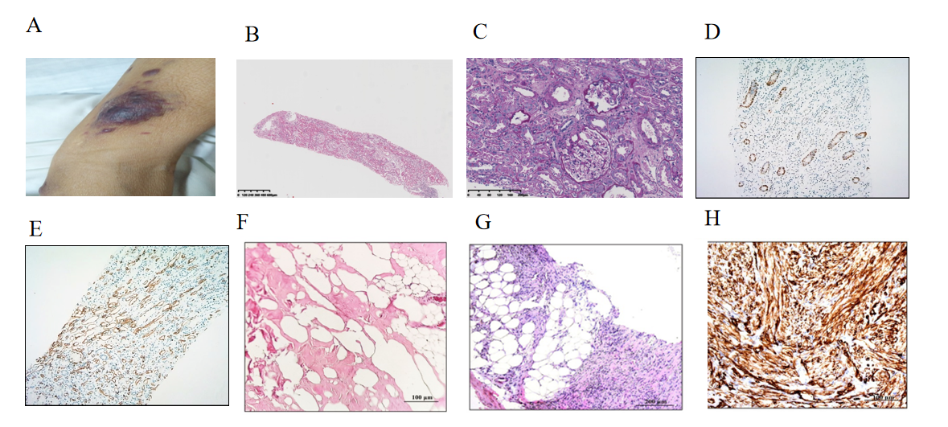
Figure 1 Histological features of the kidney biopsy and dermatological manifestation. A: Infiltrative plaques are scattered throughout the body; B: Hematoxylin and eosin (H&E) staining of kidney biopsy; C: Periodic acid-silver methenamine staining of the kidney; D: Representative immunohistochemical staining for CD34 in the kidney; E: Representative immunohistochemical staining for CD117 in the kidney; F: H&E staining of the lymph node; G: H&E staining of the skin; H: Representative immunohistochemical staining for CD34.
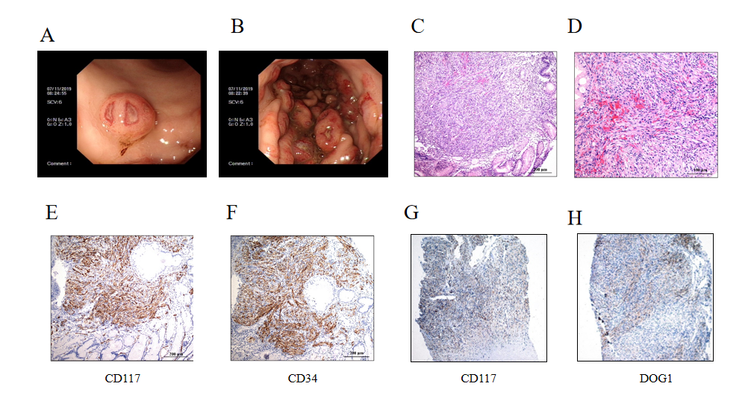
Figure 2 Gastroscopic and pathological findings of the tumors. A: A representative photomicrograph was taken by gastroscopy, showing a mucosal mass with a diameter of 0.6 cm on the greater curvature of the stomach; B: A representative photomicrograph was taken by gastroscopy, showing 0.4-2 cm masses in the anterior wall of the middle and upper part of the gastric fundus; C: Hematoxylin and eosin (H&E) staining of the muscular layer of the gastric wall showing that the tumor was composed of spindle cells; D: H&E staining of epithelioid cells was occasionally seen with 6-8 mitotic figures/50 high power fields; E: Representative immunohistochemical staining for CD117 in the stomach; F: Representative immunohistochemical staining for CD34 in the stomach; G: Representative immunohistochemical staining for CD117 in the skin; H: Representative immunohistochemical staining for DOG1 in the skin.
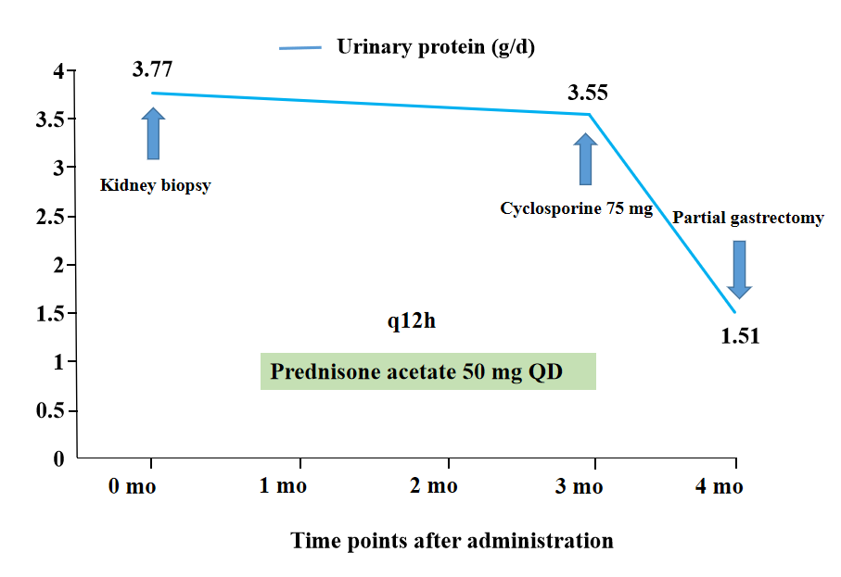
Figure 3 The patient’s clinical course. A graph of the urine protein levels after the administration is shown.

