Name of Journal: World Journal of Clinical Cases
Manuscript NO: 88949
Manuscript Type: ORIGINAL ARTICLE

Clinical and Translational Research
Causal associations between gastroesophageal reflux disease and essential hypertension: A bidirectional Mendelian randomization study

Wei N et al. GERD and essential hypertension

Ning Wei, Ming-Hui Liu, Yu-Hu Song

Ning Wei, Ming-Hui Liu, Yu-Hu Song, Department of Gastroenterology, Union Hospital, Tongji Medical College, Huazhong University of Science and Technology, Wuhan 430022, Hubei Province, China

Author contributions: Song YH and Wei N concept of the study and grant obtain; Liu MH data analysis; Liu MH and Wei H preparation of manuscript; Song YH and Wei N administrative, technical, or material support; study supervision; all the authors read and approved the paper.

Supported by National Natural Science Foundation of China (General Program), No. 82070631.

Corresponding author: Yu-Hu Song, MD, PhD, Professor, Department of Gastroenterology, Union Hospital, Tongji Medical College, Huazhong University of Science and Technology, No. 1277 Jiefang Avenue, Wuhan 430022, Hubei Province, China. yuhusong@163.com

Received: October 16, 2023
Revised: December 12, 2023
Accepted: January 16, 2024
Published online:

Abstract
BACKGROUND
Clinical studies have reported that patients with gastroesophageal reflux disease (GERD) have a higher prevalence of hypertension.

AIM
To performed a bidirectional Mendelian randomization (MR) analysis to investigate the causal link between GERD and essential hypertension.

METHODS
Eligible single nucleotide polymorphisms (SNPs) were selected, and weighted median, inverse variance weighted (IVW) as well as MR egger (MR-Egger) regression were used to examine the potential causal association between GERD and hypertension. The MR-Pleiotropy RESidual Sum and Outlier analysis was used to detect and attempt to reduce horizontal pleiotropy by removing outliers SNPs. The MR-Egger intercept test, Cochran’s Q test and “leave-one-out” sensitivity analysis were performed to evaluate the horizontal pleiotropy, heterogeneities, and stability of single instrumental variable.

RESULTS
IVW analysis exhibited an increased risk of hypertension (OR = 1.46, 95%CI = 1.33-1.59, P = 2.14E-16) in GERD patients. And the same result was obtained in replication practice (OR = 1.002, 95%CI = 1.0008-1.003, P = 0.000498). Meanwhile, the IVW analysis showed an increased risk of systolic blood pressure (β = 0.78, 95%CI = 0.11-1.44, P = 0.021) and hypertensive heart disease (OR = 1.68, 95%CI = 1.36-2.08, P = 0.0000016) in GERD patients. Moreover, we found an decreased risk of Barrett's esophagus (OR = 0.91, 95%CI = 0.83-0.99, P = 0.043) in essential hypertension patients.

CONCLUSION
We found that GERD would increase the risk of essential hypertension, which provided a novel prevent and therapeutic perspectives of essential hypertension.

Key Words: Gastroesophageal reflux disease; Essential hypertension; Hypertensive heart disease; Mendelian randomization study

Wei N, Liu MH, Song YH. Causal associations between gastroesophageal reflux disease and essential hypertension: A bidirectional Mendelian randomization study. World J Clin Cases 2024; In press

Core Tip: This study used a method of bidirectional Mendelian randomization, and its results highlighted that gastroesophageal reflux disease (GERD) was positively associated with the risk of essential hypertension, suggesting a new prevent strategy and therapeutic perspectives of essential hypertension in patients with GERD.

INTRODUCTION
Gastroesophageal reflux disease (GERD) is a disease in which gastric acid, bile acids and other gastric contents reflux into the esophagus for etiologies like hiatal hernia or abnormal movement of the lower esophagus^{[1,2]}. Even in East Asia, where the prevalence is relatively low, GERD has an prevalence of 5%-10%, while in Europe and the United States, that could be as high as 15%-30%^{[3-5]}. Gastroesophageal reflux can not only lead to esophagitis, Barrett's esophagus (BE), but also a risk factor for esophageal cancer. GERD is also closely linked to heart disease^{[6]}. A Mendelian randomized study showed that GERD can lead to heart diseases such as myocardial infarction and atrial fibrillation^{[7]}. As another common disease, essential hypertension can damage the heart, kidneys, and increase the risk of cerebral hemorrhage, but the cause of essential hypertension remains unclear^{[8]}.
Previous clinical studies showed that patients with GERD may have a higher prevalence of essential hypertension, but the results might be influenced by sample size and potentially confounding factors such as lifestyle, socioeconomic status, and underlying medical conditions, and that conclusions may not be accurate^{[9-11]}. There were a few studies on this topic and little attention was paid. Mendelian randomization (MR) is an increasingly popular clinical research method that applies instrumental variable (IV) techniques to assess causal relationships between risk factors and complex human characteristics^{[12,13]}. For exposed IV randomly assigned during conception and was not affected by disease state, MR studies can rule out the influence of confounding factors and reverse causation on causation between exposure and outcome^{[14]}.
Our study used the MR method to investigate the causal role of GERD and BE in the development of essential hypertension, and then studied the relationship between GERD and hypertensive heart failure, and further explored the protective effect of gastroesophageal reflux treatment on essential hypertension.

MATERIALS AND METHODS
Data sources
In order to examine the causal connection between GERD/BE and essential hypertension, we used data from two different genome-wide association studies (GWAS) to perform this MR analysis. Data of GERD and BE were obtained from the largest and latest GWAS conducted by Ong et al^{[15]}. They applied multitrait GWAS models combining 129080 cases and 473524 controls to identify risk loci of GERD and BE. GERD and BE cases were defined through the International Classification of Disease, tenth version code [for GERD Multi-trait Analysis of GWAS (MTAG)] and confirmed BE diagnosis pathologically (for BE MTAG).
GWAS of essential hypertension (55917 cases and 162837 controls), hypertensive heart disease (3938 cases and 162837 controls), and hypertensive heart and/or renal disease (4363 cases and 162837 controls) were obtained from FinnGen R7 study. Summary statistics for replication practice of essential hypertension (1237 cases and 359957 controls) and diastolic blood pressure (436424 individuals) were obtained from the United Kingdom Biobank. Summary statistics for systolic blood pressure (97656 individuals) were obtained from the IEU study in 2022.

Procedures of MR analysis
Schematic diagram of the bidirectional MR study on the causal relationship between GERD and hypertension was shown in Figure 1. In our study, we firstly performed MR analysis with all eligible single nucleotide polymorphisms (SNPs). The outlier variants were eliminated if the MR-Pleiotropy RESidual Sum and Outlier (MR-PRESSO) analysis identified a significant horizontal pleiotropy (with a P value smaller than the cutoff in the MR-PRESSO outlier test). After detecting heterogeneity with Cochran's Q test, we eliminated all the SNPs whose P value in the MR-PRESSO outlier test was less than 1 if the heterogeneity was still significant. At last, we performed MR PRESSO and Cochran's Q test again, MR analysis, “leave-one-out” sensitivity analysis and MR-Egger intercept test to draw the conclusion with caution.

IVs
SNPs are used in MR analyses to assess the causal relationship; the SNPs chosen should meet three key assumptions: (1) Genetic instruments predict the exposure (P < 5 × 10⁻⁸); (2) genetic instruments are not associated with potential confounders; and (3) genetic instruments affect the outcome only through the exposure^{[16]}. We undertook a number of procedures to choose eligible SNPs.
First, P < 5 × 10⁻⁸, linkage disequilibrium (R20.001), Hardy-Weinberg equilibrium, and genetic distance 10000kb were necessary for SNPs related with GERD/BE. The effect alleles, allele frequencies, P-values, SEs, and P-values for each SNP were then gathered. The exposure SNPs were then retrieved from the selected outcome data, and SNPs that were substantially (P < 5 × 10⁻⁸) linked with the outcomes were excluded. Thirdly, the palindromic and incompatible SNPs were deleted while harmonizing the exposure and result SNPs to maintain the concordance of the effect alleles. The F-statistic was determined in order to avoid bias brought on by weak proxies, although no IV had a F statistic of less than 10^{[17]}.

Statistical analysis
In this investigation, various techniques were utilized to determine whether there was a causal relationship between GERD/BE and essential hypertension. These techniques included inverse variance weighted (IVW), weighted median (WM), and MR-Egger regression. For SNPs, which showed the greatest power but was subject to biases, IVW computed a weighted average of the Wald ratio on the premise that all the instruments were valid^{[18]}. Because the random-effect model maintains conservative estimates even when heterogeneity is identified, it was used in this work for IVW. When at least half of the IVs were valid, WM investigated the median effects of all instrumental SNPs, which made it harder to create biases^{[19]}. Independent of the validity of IVs, the MR-Egger regression model yielded a reasonably reliable estimate. But the MR-Egger approach was susceptible to being influenced by outliers^{[20]}.
In this study, the Cochran's Q test P-value was utilized to determine whether there was heterogeneity in the MR analysis. When P ≥ 0.05, it was decided that there was no heterogeneity in the analysis. A symmetry plot showed that there was no heterogeneity, and the funnel plot was also utilized to find it.
Pleiotropy was discovered using the intercept term in MR-Egger regression and MR-PRESSO^{[21]}. The MR-Egger intercept test with P < 0.05 indicated the existence of directional horizontal pleiotropy^{[22]}. The MR-PRESSO analysis detected and attempted to reduce horizontal pleiotropy by removing significant outliers. Global test in MR-PRESSO with P < 0.05 indicated the existence of horizontal pleiotropy and outlier test P value was used to correct the results, which can eliminate horizontal pleiotropy by removing outlier SNPs. The total effect of each remaining SNP was also estimated using the leave-one-out method in order to evaluate the impact of each SNP. All statistical tests were performed by the “TwoSampleMR” package for the R program (version 4.2.1).

Ethics
We used publicly accessible GWAS summary data or published trial data for our analyses. For this manuscript, no original data were gathered, and no ethics committee permission was needed. The institutional ethics review committees for each of the included studies gave their approval, and all participants gave their written informed permission.

RESULTS
MR analysis for causal link between GERD and hypertension
As shown in Table 1, the result of IVW demonstrated that the strong causal link of GERD and essential hypertension (OR = 1.46, 95%CI = 1.33-1.59, P = 2.14E-16). However, heterogeneity and horizontal pleiotropy were detected (Supplementary Figure 1), so we repeated the validation by changing data of hypertension. In replication practice of GERD on essential hypertension, after MR-PRESSO test and heterogeneity analysis, there were no outliers SNPs or heterogeneity or horizontal pleiotropy (Supplementary Table 1), and the IVW analysis also exhibited an increased risk of essential hypertension (OR = 1.002, 95%CI = 1.0008-1.003, P = 0.000498) in GERD patients.
Moreover, we assessed causal relationship of GERD and blood pressure. The IVW analysis exhibited an increased risk of systolic blood pressure in GWRD patients (β = 0.78, 95%CI = 0.11-1.44, P = 0.021) and an increased risk of diastolic blood pressure in GWRD patients (β = 0.09, 95%CI = 0.08-0.12, P = 1.2E-17), but heterogeneity and horizontal pleiotropy were detected in diastolic blood pressure, making the result doubtful. Meanwhile, the IVW analysis exhibited an increased risk of hypertensive heart disease (OR = 1.68, 95%CI = 1.36-2.08, P = 0.0000016) in GERD patients and an increased risk of hypertensive heart and/or renal disease in GERD patients (OR = 1.61, 95%CI = 1.33-1.94, P = 0.000001), indicating a strong causal relationship between GERD and hypertensive heart/renal disease.
As the results mentioned above, we could conclude the causal effect of genetically predicted GERD on hypertension, hypertensive heart/renal disease, and systolic blood pressure.

MR analysis for causal link of BE with hypertension
The results of Table 1 showed no causal link of BE and essential hypertension (OR = 1.000058, 95%CI = 0.9993-1.00079, P = 0.88). However, in replication practice, there was strong causal link of BE and essential hypertension (OR = 1.054, 95%CI = 1.00035-1.1097, P = 0.048). There were no heterogeneity or horizontal pleiotropy in the MR analysis of BE on essential hypertensive in both practices. Therefore, the causal link of BE and essential hypertension need more study to prove.

MR analysis for causal link between hypertension and GERD/BE
Scatter plots were used to display the individual SNP effects and combined effects from each MR approach for each outcome database (Figures 2-5).
In Table 2, we displayed the relationship between hypertension and GERD/BE and the credibility of results was judged using heterogeneity test and pleiotropy test (Supplementary Table 2). There was no causal relationship between essential hypertension and GERD (OR = 1.02, 95%CI = 0.98-1.05, P = 0.344) (Figure 6). Similarly, diastolic blood pressure and systolic blood pressure are not related to the prevalence rate of GERD, with IVW as (β = 0.04, 95%CI = -0.02-0.1, P = 0.179) and (β = -0.003, 95%CI = -0.009-0.003, P = 0.311) respectively (Figure 7). However, we found an decreased risk of BE (OR = 0.91, 95%CI = 0.83-0.99, P = 0.043) in essential hypertension patients, and there were no heterogeneity or horizontal pleiotropy, proving the reliability of this result.
Funnel plots indicated the locations of each outcome's heterogeneity, and leave-one-out plots revealed that the relationships were unlikely to be caused by specific extreme SNPs (Supplementary Figures 1-4).

DISCUSSION
Clinical and mendelian randomized studies had shown that gastroesophageal reflux was a risk factor for heart diseases such as atrial fibrillation and coronary heart disease^{[9,23-25]}. Proton-pump inhibitors (PPI) used to treat gastroesophageal reflux may also relieve pain due to cardiovascular disease^{[26,27]}. The β-blockers used to treat hypertension can also reduce the tone of the lower esophageal sphincter while lowering blood pressure, resulting in aggravation of gastroesophageal reflux symptoms in some hypertensive patients at the beginning of medication^{[28]}.
The prevalence of GERD in East Asia is low, ranging from 5 to 10 percent^{[29]}. However, after studying some populations in central China, Li et al^{[27]} found that 44.2% (38/86) of essential hypertensive patients had gastroesophageal reflux. Suyu et al^{[11]} also found that the proportion of patients with hypertension with GERD was as high as 31.4% (137/436). Our findings clearly suggest that gastroesophageal reflux can lead to elevated blood pressure and essential hypertension.
Gudlaugsdottir et al^{[30]} concluded that hypertension was more prevalent in patients with BE (OR = 5.1, P < 0.0001) and also had a higher prevalence in patients with reflux esophagitis (OR = 3.8, P < 0.001). But our study did not clarify the role of BE in hypertension. PPI therapy, anti-reflux mucosectomy (ARMS), and fundoplication are other treatments for gastroesophageal reflux, which may play a protective role against hypertension by relieving gastroesophageal reflux^{[31]}. Some clinical studies have found that the hypertension was well controlled in some patients after the treatment of gastroesophageal reflux by fundoplication^{[10]}. We were failed to determine the possible protective effects of PPI/ARMS/fundoplication on hypertension due to insufficient SNP/databases. In addition, our study suggested that gastroesophageal reflux can also lead to hypertensive heart failure.
The anterior wall of the esophagus is closely adjacent to the posterior wall of the heart, and the autonomic nerves of the esophagus and heart also overlap and cross^{[32,33]}. Some studies believe that the presence of gastroesophageal reflux is often accompanied by pain, which would stimulate the patient's sympathetic nerve excitation, resulting in increased blood pressure^{[34]}. In addition, gastroesophageal reflux can lead to arrhythmias, and arrhythmias such as bradycardia can also lead to hypertension^{[35,36]}. Gastroesophageal reflux may also cause hypertension by affecting the level of mediators in plasma that regulate hypertension. Some studies found that plasma concentrations of nitric oxide metabolites increased significantly after 8 wk of inhibition of gastric acid secretion^{[37,38]}.
Several limitations should be considered in our MR analysis. Firstly, the summary GWAS data only concern individuals of European, so results may not be representative of the whole population. Secondly, although we took steps to exclude outlier SNPs, horizontal pleiotropy and heterogeneity still exited in our analysis. However, we used different methods to draw a conclusion to eliminate the impact of pleiotropy and heterogeneity.

CONCLUSION
Gastroesophageal reflux can lead to increased blood pressure, hypertension, and hypertensive heart failure. Patients with essential hypertension should be examined and treated for gastroesophageal reflux, and patients with gastroesophageal reflux should also be monitored for hypertension.

ARTICLE HIGHLIGHTS
Research background
Some clinical studies have suggested that gastroesophageal reflux disease (GERD) may have a causal relationship with essential hypertension, but the relevant conclusions may be affected by confounding factors and small sample sizes.

Research motivation
Determining the causal relationship between GERD and essential hypertension could provide new perspectives for the treatment of patients with GERD and hypertension.

Research objectives
We would perform a bidirectional Mendelian randomization (MR) analysis to investigate the causal link between GERD and essential hypertension.

Research methods
A series of steps were conducted to select eligible single nucleotide polymorphisms, and inverse variance weighted (IVW), weighted median and MR egger regression were used to examine whether there was a causal association between GERD and hypertension.

Research results
IVW analysis exhibited an increased risk of hypertension (OR = 1.46, 95%CI = 1.33-1.59, P = 2.14E-16) in GERD patients. Meanwhile, the IVW analysis showed an increased risk of systolic blood pressure and hypertensive heart disease in GERD patients.

Research conclusions
GERD was positively associated with the risk of essential hypertension, suggesting a new prevent strategy and therapeutic perspectives of essential hypertension in patients with GERD.

Research perspectives
The specific mechanisms associated with GERD and essential hypertension need to be further clarified.

REFERENCES
1 Mikami DJ, Murayama KM. Physiology and pathogenesis of gastroesophageal reflux disease. Surg Clin North Am 2015; 95: 515-525 [PMID: 25965127 DOI: 10.1016/j.suc.2015.02.006]
2 Zheng Z, Shang Y, Wang N, Liu X, Xin C, Yan X, Zhai Y, Yin J, Zhang J, Zhang Z. Current Advancement on the Dynamic Mechanism of Gastroesophageal Reflux Disease. Int J Biol Sci 2021; 17: 4154-4164 [PMID: 34803489 DOI: 10.7150/ijbs.65066]
3 Maret-Ouda J, Markar SR, Lagergren J. Gastroesophageal Reflux Disease. JAMA 2020; 324: 2565 [PMID: 33351044 DOI: 10.1001/jama.2020.21573]
4 Sandhu DS, Fass R. Current Trends in the Management of Gastroesophageal Reflux Disease. Gut Liver 2018; 12: 7-16 [PMID: 28427116 DOI: 10.5009/gnl16615]
5 El-Serag HB, Sweet S, Winchester CC, Dent J. Update on the epidemiology of gastro-oesophageal reflux disease: a systematic review. Gut 2014; 63: 871-880 [PMID: 23853213 DOI: 10.1136/gutjnl-2012-304269]
6 Clarrett DM, Hachem C. Gastroesophageal Reflux Disease (GERD). Mo Med 2018; 115: 214-218 [PMID: 30228725]
7 Sun X, Chen L, Zheng L. A Mendelian randomization study to assess the genetic liability of gastroesophageal reflux disease for cardiovascular diseases and risk factors. Hum Mol Genet 2022; 31: 4275-4285 [PMID: 35861629 DOI: 10.1093/hmg/ddac162]
8 Elliott WJ. Systemic hypertension. Curr Probl Cardiol 2007; 32: 201-259 [PMID: 17398315 DOI: 10.1016/j.cpcardiol.2007.01.002]
9 Chen CH, Lin CL, Kao CH. Association between gastroesophageal reflux disease and coronary heart disease: A nationwide population-based analysis. Medicine (Baltimore) 2016; 95: e4089 [PMID: 27399102 DOI: 10.1097/MD.0000000000004089]
10 Hu Z, Chen M, Wu J, Song Q, Yan C, Du X, Wang Z. Improved control of hypertension following laparoscopic fundoplication for gastroesophageal reflux disease. Front Med 2017; 11: 68-73 [PMID: 28213877 DOI: 10.1007/s11684-016-0490-7]
11 Suyu H, Liu Y, Jianyu X, Luo G, Cao L, Long X. Prevalence and Predictors of Silent Gastroesophageal Reflux Disease in Patients with Hypertension. Gastroenterol Res Pract 2018; 2018: 7242917 [PMID: 29849598 DOI: 10.1155/2018/7242917]
12 Davey Smith G, Hemani G. Mendelian randomization: genetic anchors for causal inference in epidemiological studies. Hum Mol Genet 2014; 23: R89-R98 [PMID: 25064373 DOI: 10.1093/hmg/ddu328]
13 Birney E. Mendelian Randomization. Cold Spring Harb Perspect Med 2022; 12 [PMID: 34872952 DOI: 10.1101/cshperspect.a041302]
14 Sekula P, Del Greco M F, Pattaro C, Köttgen A. Mendelian Randomization as an Approach to Assess Causality Using Observational Data. J Am Soc Nephrol 2016; 27: 3253-3265 [PMID: 27486138 DOI: 10.1681/ASN.2016010098]
15 Ong JS, An J, Han X, Law MH, Nandakumar P; 23andMe Research team; Esophageal cancer consortium, Schumacher J, Gockel I, Bohmer A, Jankowski J, Palles C, Olsen CM, Neale RE, Fitzgerald R, Thrift AP, Vaughan TL, Buas MF, Hinds DA, Gharahkhani P, Kendall BJ, MacGregor S. Multitrait genetic association analysis identifies 50 new risk loci for gastro-oesophageal reflux, seven new loci for Barrett's oesophagus and provides insights into clinical heterogeneity in reflux diagnosis. Gut 2022; 71: 1053-1061 [PMID: 34187846 DOI: 10.1136/gutjnl-2020-323906]
16 Boef AG, Dekkers OM, le Cessie S. Mendelian randomization studies: a review of the approaches used and the quality of reporting. Int J Epidemiol 2015; 44: 496-511 [PMID: 25953784 DOI: 10.1093/ije/dyv071]
17 Burgess S, Thompson SG; CRP CHD Genetics Collaboration. Avoiding bias from weak instruments in Mendelian randomization studies. Int J Epidemiol 2011; 40: 755-764 [PMID: 21414999 DOI: 10.1093/ije/dyr036]
18 Burgess S, Butterworth A, Thompson SG. Mendelian randomization analysis with multiple genetic variants using summarized data. Genet Epidemiol 2013; 37: 658-665 [PMID: 24114802 DOI: 10.1002/gepi.21758]
19 Bowden J, Davey Smith G, Haycock PC, Burgess S. Consistent Estimation in Mendelian Randomization with Some Invalid Instruments Using a Weighted Median Estimator. Genet Epidemiol 2016; 40: 304-314 [PMID: 27061298 DOI: 10.1002/gepi.21965]
20 Burgess S, Thompson SG. Interpreting findings from Mendelian randomization using the MR-Egger method. Eur J Epidemiol 2017; 32: 377-389 [PMID: 28527048 DOI: 10.1007/s10654-017-0255-x]
21 Verbanck M, Chen CY, Neale B, Do R. Publisher Correction: Detection of widespread horizontal pleiotropy in causal relationships inferred from Mendelian randomization between complex traits and diseases. Nat Genet 2018; 50: 1196 [PMID: 29967445 DOI: 10.1038/s41588-018-0164-2]
22 Burgess S, Thompson SG. Erratum to: Interpreting findings from Mendelian randomization using the MR-Egger method. Eur J Epidemiol 2017; 32: 391-392 [PMID: 28664250 DOI: 10.1007/s10654-017-0276-5]
23 Mohamed A, Ochoa Crespo D, Kaur G, Ashraf I, Peck MM, Maram R, Malik BH. Gastroesophageal Reflux and Its Association With Atrial Fibrillation: A Traditional Review. Cureus 2020; 12: e10387 [PMID: 33062508 DOI: 10.7759/cureus.10387]
24 Maruyama T, Fukata M, Akashi K. Association of atrial fibrillation and gastroesophageal reflux disease: Natural and therapeutic linkage of the two common diseases. J Arrhythm 2019; 35: 43-51 [PMID: 30805043 DOI: 10.1002/joa3.12125]
25 Chang CS, Chen HJ, Liao CH. Patients with Cerebral Stroke Have an Increased Risk of Gastroesophageal Reflux Disease: A Population-Based Cohort Study. J Stroke Cerebrovasc Dis 2018; 27: 1267-1274 [PMID: 29325919 DOI: 10.1016/j.jstrokecerebrovasdis.2017.12.001]
26 Dong H, Li X, Cai M, Zhang C, Mao W, Wang Y, Xu Q, Chen M, Wang L, Huang X. Integrated bioinformatic analysis reveals the underlying molecular mechanism of and potential drugs for pulmonary arterial hypertension. Aging (Albany NY) 2021; 13: 14234-14257 [PMID: 34016786 DOI: 10.18632/aging.203040]
27 Li ZT, Ji F, Han XW, Wang L, Yue YQ, Wang ZG. The Role of Gastroesophageal Reflux in Provoking High Blood Pressure Episodes in Patients With Hypertension. J Clin Gastroenterol 2018; 52: 685-690 [PMID: 28961574 DOI: 10.1097/MCG.0000000000000933]
28 Lazebnik LB, Komissarenko IA, Mikheeva OM. [Cardiovascular pathology associated with digestive system diseases]. Eksp Klin Gastroenterol 2011: 69-74 [PMID: 21919242]
29 Zhang D, Liu S, Li Z, Wang R. Global, regional and national burden of gastroesophageal reflux disease, 1990-2019: update from the GBD 2019 study. Ann Med 2022; 54: 1372-1384 [PMID: 35579516 DOI: 10.1080/07853890.2022.2074535]
30 Gudlaugsdottir S, Verschuren W, Dees J, Stijnen T, Wilson J. Hypertension is frequently present in patients with reflux esophagitis or Barrett's esophagus but not in those with non-ulcer dyspepsia. Eur J Intern Med 2002; 13: 369 [PMID: 12225781 DOI: 10.1016/s0953-6205(02)00090-0]
31 Katzka DA, Kahrilas PJ. Advances in the diagnosis and management of gastroesophageal reflux disease. BMJ 2020; 371: m³786 [PMID: 33229333 DOI: 10.1136/bmj.m³786]
32 Sánchez-Quintana D, Cabrera JA, Climent V, Farré J, Mendonça MC, Ho SY. Anatomic relations between the esophagus and left atrium and relevance for ablation of atrial fibrillation. Circulation 2005; 112: 1400-1405 [PMID: 16129790 DOI: 10.1161/CIRCULATIONAHA.105.551291]
33 Celebi OO, Celebi S, Aydogdu S. A dangerous and risky relationship: Esophagus and left atrium. Pacing Clin Electrophysiol 2019; 42: 568-569 [PMID: 30758845 DOI: 10.1111/pace.13630]
34 Blackshaw LA, Haupt JA, Omari T, Dent J. Vagal and sympathetic influences on the ferret lower oesophageal sphincter. J Auton Nerv Syst 1997; 66: 179-188 [PMID: 9406123 DOI: 10.1016/s0165-1838(97)00082-9]
35 Bayés-Genís A, Guindo J, Viñolas X, Tomás L, Elosua R, Duran I, Bayés de Luna A. Cardiac arrhythmias and left ventricular hypertrophy in systemic hypertension and their influences on prognosis. Am J Cardiol 1995; 76: 54D-59D [PMID: 7495219 DOI: 10.1016/s0002-9149(99)80493-7]
36 Afzal MR, Savona S, Mohamed O, Mohamed-Osman A, Kalbfleisch SJ. Hypertension and Arrhythmias. Heart Fail Clin 2019; 15: 543-550 [PMID: 31472889 DOI: 10.1016/j.hfc.2019.06.011]
37 Kato S, Kitamura M, Korolkiewicz RP, Takeuchi K. Role of nitric oxide in regulation of gastric acid secretion in rats: effects of NO donors and NO synthase inhibitor. Br J Pharmacol 1998; 123: 839-846 [PMID: 9535011 DOI: 10.1038/sj.bjp.0701691]
38 Takeuchi K, Sugamoto S, Yamamoto H, Kawauchi S, Tashima K. Interactive roles of endogenous prostaglandin and nitric oxide in regulation of acid secretion by damaged rat stomachs. Aliment Pharmacol Ther 2000; 14 Suppl 1: 125-134 [PMID: 10807414 DOI: 10.1046/j.1365-2036.2000.014s1125.x]

Footnotes
Institutional review board statement: We used publicly accessible GWAS summary data or published trial data for our analyses. For this manuscript, no original data were gathered, and no ethics committee permission was needed.

Clinical trial registration statement: We used publicly accessible GWAS summary data or published trial data for our analyses. For this manuscript, no original data were gathered, and no ethics committee permission was needed. The institutional ethics review committees for each of the included studies gave their approval, and all participants gave their written informed permission.

Informed consent statement: We used publicly accessible GWAS summary data or published trial data for our analyses. For this manuscript, no original data were gathered, and no ethics committee permission was needed. The institutional ethics review committees for each of the included studies gave their approval, and all participants gave their written informed permission.

Conflict-of-interest statement: There are no conflicts of interest to report.

Data sharing statement: No additional data are available.

Open-Access: This article is an open-access article that was selected by an in-house editor and fully peer-reviewed by external reviewers. It is distributed in accordance with the Creative Commons Attribution NonCommercial (CC BY-NC 4.0) license, which permits others to distribute, remix, adapt, build upon this work non-commercially, and license their derivative works on different terms, provided the original work is properly cited and the use is non-commercial. See: https://creativecommons.org/Licenses/by-nc/4.0/

Provenance and peer review: Unsolicited article; Externally peer reviewed.

Peer-review model: Single blind

Peer-review started: October 16, 2023
First decision: November 28, 2023
Article in press:

Specialty type: Medicine, research and experimental
Country/Territory of origin: China
Peer-review report’s scientific quality classification
Grade A (Excellent): 0
Grade B (Very good): B
Grade C (Good): C
Grade D (Fair): 0
Grade E (Poor): 0

P-Reviewer: Kreisel W, Germany; Skrypnyk I, Ukraine S-Editor: Qu XL L-Editor: A P-Editor:
Figure Legends
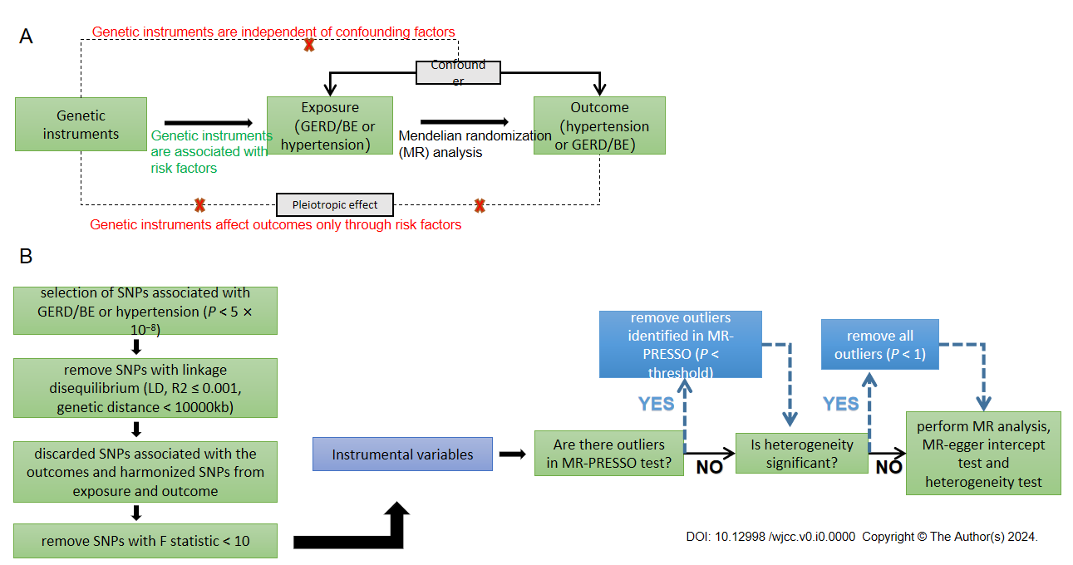
Figure 1 Schematic representation of the bidirectional Mendelian randomization study on the causal relationship between gastroesophageal reflux disease and hypertension. A: Schematic diagram showing the design of the bidirectional Mendelian randomization (MR) analysis; B: Flow chart of the MR analysis. MR: Mendelian randomization; GERD: Gastroesophageal reflux disease; SNPs: Single nucleotide polymorphism; MR-PRESSO: MR-Pleiotropy RESidual Sum and Outlier; BE: Barret's esophagus.

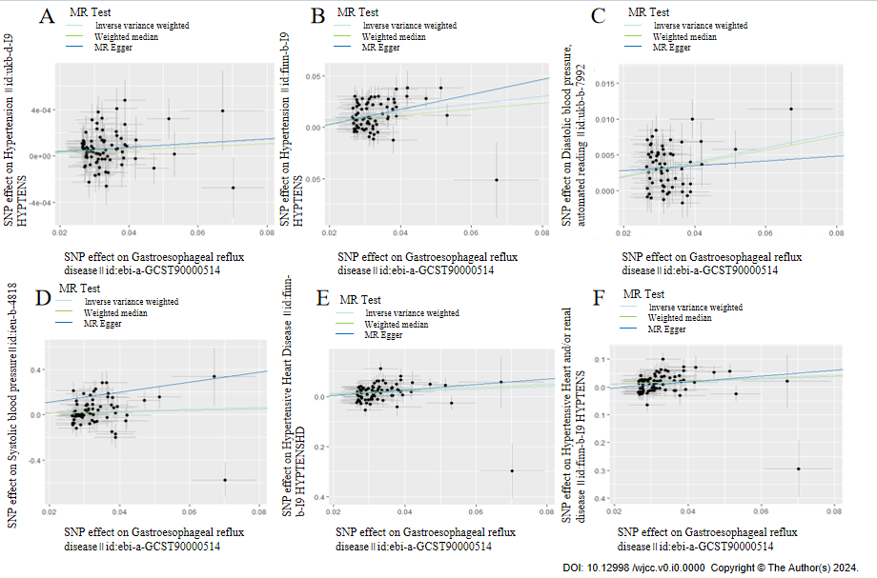
Figure 2 Scatter plots for the causal association between gastroesophageal reflux disease and hypertension. A: Gastroesophageal reflux disease (GERD) on essential hypertension; B: Replication practice for GERD on essential hypertension; C: GERD on diastolic blood pressure; D: GERD on systolic blood pressure; E: GERD on hypertensive heart disease; F: GERD on hypertensive heart and/or renal disease. MR: Mendelian randomization; SNPs: Single nucleotide polymorphism.
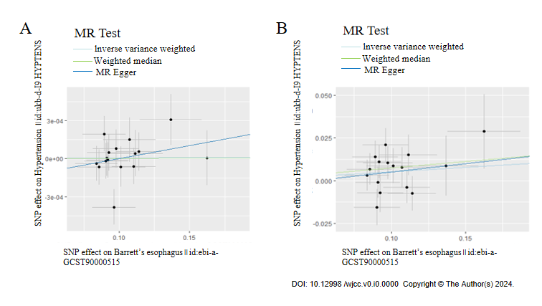
Figure 3 Scatter plots for the causal association between Barret's esophagus and hypertension. A: Barret's esophagus (BE) on essential hypertension; B: Replication practice for BE on essential hypertension. MR: Mendelian randomization; SNPs: Single nucleotide polymorphism.

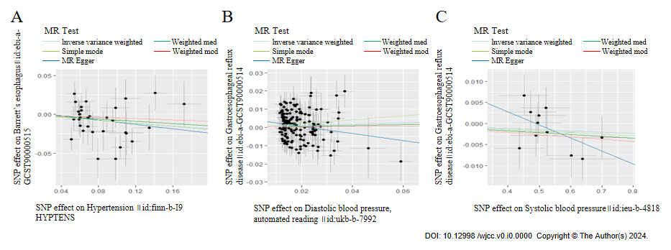
Figure 4 Scatter plots for the causal association between hypertension and Gastroesophageal reflux disease. A: Duplicate essential hypertension on Gastroesophageal reflux disease (GERD); B: Diastolic blood pressure and GERD; C: Systolic blood pressure and GERD. MR: Mendelian randomization; SNPs: Single nucleotide polymorphism.

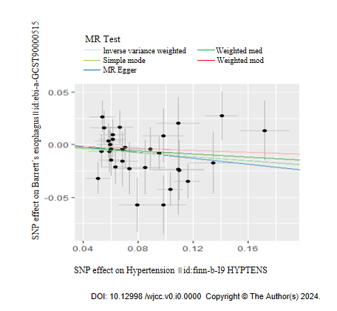
Figure 5 Scatter plots for the causal association between hypertension and Barret's esophagus: Duplicate essential hypertension on Barret's esophagus. MR: Mendelian randomization; SNPs: Single nucleotide polymorphism.

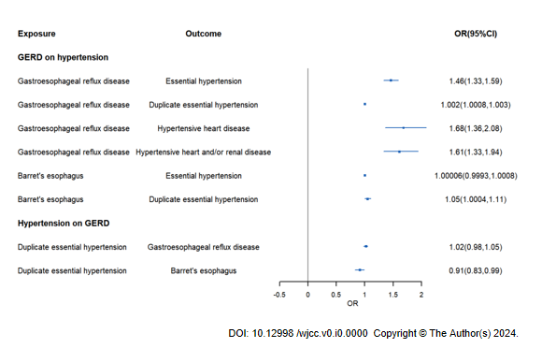
Figure 6 Forest plot for the causal association between hypertension and Gastroesophageal reflux disease. GERD: Gastroesophageal reflux disease.

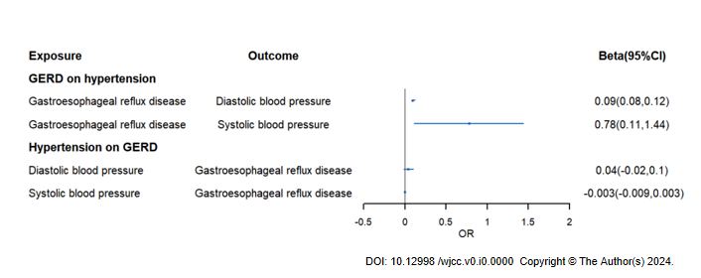
Figure 7 Forest plot for the causal association between hypertension and Barret's esophagus. GERD: Gastroesophageal reflux disease.

Table 1 Mendelian randomization estimates from different methods of assessing the causal effect between gastroesophageal reflux disease/Barret's esophagus and essential hypertension.
Exposure | Outcome | Step | Nsnp | IVW |  |  | WM |  |  | MR-Egger
 |  |  |  | OR or beta | 95%CI | P value | OR or beta | 95%CI | P value | OR or beta | 95%CI | P value
Gastroesophageal reflux disease | Essential hypertension | 3 | 69 | 1.46 | 1.33, 1.59 | 2.14E-16 | 1.34 | 1.19, 1.50 | 6.80E-07 | 2.073 | 1.23, 3.50 | 0.0082
 | Duplicate essential hypertension | 1 | 77 | 1.002 | 1.0008, 1.003 | 4.98E-04 | 1.0013 | 0.9998, 1.0028 | 0.084 | 1.0018 | 0.996, 1.0076 | 0.54
 | Diastolic blood pressure¹ | 3 | 58 | 0.09 | 0.08, 0.12 | 1.2E-17 | 0.095 | 0.066, 0.12 | 7.8E-11 | 0.034 | -0.12, 0.19 | 0.66
 | Systolic blood pressure¹ | 3 | 61 | 0.78 | 0.11, 1.44 | 0.021 | 0.59 | -0.36, 1.53 | 0.23 | 4.42 | 0.28, 8.55 | 0.04
 | Hypertensive heart disease | 1 | 75 | 1.68 | 1.36, 2.08 | 1.60E-06 | 1.82 | 1.38, 2.42 | 2.90E-05 | 2.99 | 0.85, 10.48 | 0.09
 | Hypertensive heart and/or renal disease | 2 | 73 | 1.61 | 1.33, 1.94 | 1.00E-06 | 1.72 | 1.31, 2.26 | 8.91772E-05 | 2.89 | 0.96, 8.75 | 0.064
Barret's esophagus | Essential hypertension | 1 | 16 | 1.00006 | 0.9993, 1.0008 | 0.88 | 1.000033 | 0.999, 1.001 | 0.95 | 1.002 | 0.997, 1.0067 | 0.4
 | Duplicate essentialhypertension | 1 | 16 | 1.05 | 1.0004, 1.11 | 0.048 | 1.078 | 1.001, 1.16 | 0.046 | 1.1 | 0.75, 1.61 | 0.62
¹Except that the results of diastolic blood pressure and diastolic blood pressure were expressed in beta, other results were expressed in OR. Step: (1) Mendelian randomization (MR) analysis without removing single nucleotide polymorphisms (SNPs); 2, MR analysis after removing the SNPs [with P value less than threshold in MR-Pleiotropy RESidual Sum and Outlier (MR-PRESSO) test]; (3) MR analysis after removing all the SNPs (with P value less than 1 in MR-PRESSO outlier test). N snp: Number of single nucleotide polymorphisms; IVW: Inverse variance weighted; WM: Weighted median; MR-Egger: Mendelian randomization egger.

Table 2 Mendelian randomization estimates from different methods of assessing the causal effect between essential hypertension and gastroesophageal reflux disease/Barret's esophagus
Exposure | Outcome | Step | Nsnp | IVW |  |  | WM |  |  | MR-Egger
 |  |  |  | OR or beta | 95%CI | P value | OR or beta | 95%CI | P value | OR or beta | 95%CI | P value
Duplicate essential hypertension | Gastroesophageal  reflux disease | 3 | 31 | 1.015 | 0.98, 1.05 | 0.344 | 1.027 | 0.99, 1.07 | 0.202 | 1.038 | 0.94, 1.15 | 0.471
Diastolic blood pressure¹ |  | 3 | 154 | 0.042 | -0.02, 0.104 | 0.179 | 0.026 | -0.05, 0.103 | 0.518 | -0.194 | -0.39, 0.003 | 0.056
Systolic blood pressure¹ |  | 3 | 11 | -0.003 | -0.009, 0.003 | 0.311 | -0.004 | -0.01, 0.003 | 0.274 | -0.031 | -0.07, 0.007 | 0.148
essentialhypertension | Barret's esophagus | 3 | 31 | 0.911 | 0.83, 0.997 | 0.043 | 0.929 | 0.82, 1.05 | 0.254 | 0.869 | 0.65, 1.16 | 0.345
¹Except that the results of diastolic blood pressure and diastolic blood pressure were expressed in beta, other results were expressed in OR. Step: (1) Mendelian randomization (MR) analysis without removing single nucleotide polymorphisms (SNPs); 2, MR analysis after removing the SNPs [with P value less than threshold in MR-Pleiotropy RESidual Sum and Outlier (MR-PRESSO) test]; (3) MR analysis after removing all the SNPs (with P value less than 1 in MR-PRESSO outlier test). N snp: Number of single nucleotide polymorphisms; IVW: Inverse variance weighted; WM: Weighted median; MR-Egger: Mendelian randomization egger.

