Name of Journal: World Journal of Gastroenterology
Manuscript NO: 53276
Manuscript Type: REVIEW

Alternative uses of lumen apposing metal stents

Sharma P et al. Uses of lumen apposing metal stents

Prabin Sharma, Thomas R McCarty, Ankit Chhoda, Antonio Costantino, Caroline Loeser, Thiruvengadam Muniraj, Marvin Ryou, Christopher C Thompson

Prabin Sharma, Antonio Costantino, Caroline Loeser, Department of Gastroenterology and Hepatology, Yale-New Haven Health-Bridgeport Hospital, Bridgeport, CT 06610, United States

Thomas R McCarty, Marvin Ryou, Christopher C Thompson, Division of Gastroenterology, Hepatology and Endoscopy, Brigham and Women’s Hospital, Harvard Medical School, Boston, MA 02115, United States

Ankit Chhoda, Department of Internal Medicine, Yale-New Haven Health-Bridgeport Hospital, Bridgeport, CT 06708, United States

Thiruvengadam Muniraj, Section of Digestive Diseases, Yale University School of Medicine, New Haven, CT 06520, United States

Author Contributions: Study concept and design: Sharma P and McCarty TR; Paper preparation: Sharma P and McCarty TR; Critical revisions: Sharma P, McCarty TR, Chhoda A, Costantino A, Loeser C, Muniraj T, Ryou M, and Thompson CC.

Corresponding author: Prabin Sharma, MBBS, MD, Department of Gastroenterology and Hepatology, Yale New Haven Health- Bridgeport Hospital, 267 Grant Street, Bridgeport, CT 06610, United States. prabin.sharma@bpthosp.org

Received: January 1, 2020
Revised: March 27, 2020
Accepted: May 13, 2020
Published online:

Abstract
The advent of lumen apposing metal stents (LAMS) has revolutionized the management of many complex gastroenterological conditions that previously required surgical or radiological interventions. These procedures have garnered popularity due to their minimally invasive nature, higher technical and clinical success rate and lower rate of adverse events. By virtue of their unique design, LAMS provide more efficient drainage, serve as conduit for endoscopic access, are associated with lower rates of leakage and are easy to be removed. Initially used for drainage of pancreatic fluid collections, the use of LAMS has been extended to gallbladder and biliary drainage, treatment of luminal strictures, creation of gastrointestinal fistulae, pancreaticobiliary drainage, improved access for surgically altered anatomy, and drainage of intra-abdominal and pelvic abscesses as well as post-surgical fluid collections. As new indications of endosonographic techniques and LAMS continue to evolve, this review summarizes the current role of LAMS in the management of these various complex conditions and also highlights clinical pearls to guide successful placement of LAMS.

Key words: Lumen apposing metal stents; Walled off necrosis; Gallbladder drainage; Biliary drainage; Gastric access temporary for endoscopy; Gastric outlet obstruction; Therapeutic endoscopy

Sharma P, McCarty TR, Chhoda A, Costantino A, Loeser C, Muniraj T, Ryou M, Thompson CC. Alternative uses of lumen apposing metal stents. World J Gastroenterol 2020; In press

Core tip: Lumen apposing metal stents have become widely adopted as a preferred modality in the treatment of pancreatic walled-off necrosis, with even broader applications for multiple alternative conditions. Current literature suggests that the use of these novel stents may significantly improve treatment response and provide a much needed minimally invasive therapeutic option to patients in need.

INTRODUCTION
The introduction of novel lumen apposing metal stents (LAMS) over the past decade has ushered in a new era of therapeutic gastrointestinal endoscopy. Originally approved by the United States food and drug administration (FDA) in 2013, with a primary goal of managing pancreatic fluid collections, LAMS have become widely adopted as a preferred modality in the treatment of walled-off necrosis (WON), with even broader applications for multiple alternative conditions. Alternative uses that have not yet become FDA approved include treatment of luminal strictures, creation of gastrointestinal fistulae, achievement of pancreaticobiliary drainage, improved access for surgically altered anatomy, and drainage of intra-abdominal and pelvic abscesses as well as post-surgical fluid collections. In this review, we highlight both FDA approved as well as non-FDA approved uses of LAMS and provide a detailed summary of the current evidence to support the alternative uses for a variety of conditions.

DESIGN AND FUNCTIONALITY OF LUMEN APPOSING METAL STENTS
The advent of LAMS has radically changed the landscape of therapeutic endoscopy, allowing for multiple minimally invasive treatments for conditions previously thought to require surgical management. Among the various types of stents available, LAMS have revolutionized the field of therapeutic endoscopy given their unique advantages over traditional plastic stents. While variability in design exists between individual stent types, LAMS possess a barbell or saddle shape that allows for the ability to hold two luminal structures in apposition–leading to a lower risk of leakage. Additional benefits of LAMS include a large intraluminal diameter which is able to accomplish more efficient drainage. Furthermore, by virtue of this wider lumen, LAMS may serve as a conduit providing endoscopic access for interventions to various structures abutting the gastrointestinal tract. These bi-flange stents are covered by a silicone layer which helps prevent tissue ingrowth and thus facilitates easy removal. At present, different types of LAMS have been developed and used for transluminal interventions. While there are various similarities between the types, there are subtle differences in terms of their features and delivery mechanisms as summarized on Figure 1. The most commonly utilized LAMS, and the only stent approved in the United States, is the AXIOS stent (Boston Scientific, Natick, MA). Although four additional stents are commercially available, the majority of research and literature is based upon use with the AXIOS stent. However, we have included all available stents within this review to appeal to a more global audience who may be more familiar with alternative LAMS.

PANCREATIC FLUID COLLECTIONS AND PANCREATIC WALLED-OFF NECROSIS
Pancreatic fluid collections typically develop as sequelae of acute pancreatitis or may arise from chronic injury to the pancreas. While these collections resolve spontaneously in most cases, patients with collections that persist beyond four weeks and develop a mature wall (i.e., pancreatic pseudocyst or pancreatic WON) may develop obstructive symptoms such as abdominal pain, early satiety, malnutrition, or infection and warrant drainage^{[1]}. Traditionally, these collections have been drained via a percutaneous and surgical approach; however, these strategies may be associated with significant morbidity and high rates of adverse events. With the evolution and common adoption of endoscopic ultrasound (EUS)-guided drainage, the morbidity of drainage has decreased as have the associated adverse events–thereby becoming the preferred approach due to its superiority or comparability in terms of efficacy, cost-effectiveness, and safety^{[2-5]}.
Early EUS-guided drainage previously relied upon double pigtail plastic stents in an effort to create a communication between the bowel lumen and the cyst or fluid collection cavity. Plastic stents, however, have various limitations that include longer length and narrow luminal diameter predisposing to occlusion, ineffective drainage of solid debris, long procedure times, and frequent need for repeat intervention. Therefore, development of large diameter, bi-flanged LAMS were able to overcome the shortcomings of plastic stents with subsequent FDA approval in 2013 for treatment of WON with less than 30% solid necrosis. Appropriate patient selection and location of WON is very important to achieve successful LAMS placement as proximity to the gastric wall is ideal with the collection within approximately 1 to 1.5 cm of the bowel wall (Table 1). For this procedure, a transgastric approach is typically recommended; transduodenal route is also possible though may be associated with a longer course^{[6,7]}. From experience, these authors also have noted that large collections extending into the paracolic gutters may not be ideal for endoscopic drainage though this approach may be preferred for patients with a history of gastric varices given EUS-guided visualization.
Treatment of pancreatic pseudocysts and WON were first described by Itoi et al^{[9]} in 2012 and Gornals et al^{[8]} in 2013, respectively. The first study reported outcomes of 15 patients with resolution of all pseudocysts after a single drainage procedure with a technical success rate of 100%^{[9]}. In this study by Itoi et al^{[9]}, one stent migration was reported with a median time to removal of 35 d. In the Gornals et al^{[8]} study evaluating pancreatic fluid collections, 9 patients were enrolled and technical success rate of 89% was reported. Two stent migrations occurred with 2 patients developing recurrence. Additional literature evaluating the efficacy and safety of LAMS for pancreatic fluid collections has shown impressive results^{[10]}. A landmark prospective multi-center study was performed by Shah and colleagues in 2015, evaluating stent placement in 33 patients with symptomatic pancreatic pseudocysts or WON^{[11]}. The mean size of these collections was 9.0 ± 3.3 cm with a technical success (defined as the ability to place LAMS successfully) of 91% and resolution of the pancreatic fluid collections in 27 of the 29 patients (93.1%). Additionally, these stents allowed for endoscopic debridement in 11 patients with mild-to-moderate adverse events reported in 15% of cases. Multiple systematic reviews and meta-analyses have since demonstrated similar efficacy and safety results for LAMS and support the notion that metal stents are advantageous compared to plastic stents for pancreatic fluid collections^{[12-14]}. Given these impressive results for pancreatic fluid collections, it is no surprise that the use of LAMS is being increasingly adopted for the treatment of alternative conditions.

GALLBLADDER DRAINAGE FOR HIGH-RISK SURGICAL PATIENTS
Although laparoscopic cholecystectomy remains the mainstay of treatment for patients with acute cholecystitis, percutaneous transhepatic gallbladder drainage (termed cholecystostomy) performed by interventional radiology has been traditionally utilized for poor surgical candidates or in the setting of acute illness when surgical removal is contraindicated. Percutaneous drainage has been a preferred treatment strategy for symptomatic gallbladder disease among high-risk surgical candidates; however, it is limited by significant risk of inadvertent self-removal of the catheter and risk of serious adverse events such as pneumoperitoneum, pneumothorax, and catheter leakage associated with this technique^{[15,16]}. To avoid or reduce some of the complications, endoscopic drainage via a transpapillary or transmural approach has been devised (Figure 2).
While transpapillary drainage is a well-established endoscopic technique for gallbladder drainage, achieved through an endoscopic retrograde cholangiography (ERC) approach, traversing the cystic duct can be challenging due to anatomy. A more novel approach, utilizing EUS-guided stent placement via a transgastric or transduodenal approach, is also able to achieve drainage of the gallbladder. In the transmural approach, a cholecystogastric or cholecystoduodenal fistula is created using EUS-guided placement of LAMS (Figure 3). To accomplish this, the echoendoscope is advanced into the gastric antrum or duodenal bulb. Next, the decision should be made on how to create a fistulous tract from the stomach or duodenum to the gallbladder lumen. Once the route of access (i.e., transgastric vs transduodenal) is determined, two options are typically recommended: (1) performing freehand placement of an electrocautery-enhanced LAMS; or (2) placement of non-cautery enhanced LAMS over a wire after fine-needle injection and dilation of the tract (Table 1). The decision regarding these strategies is based primarily on the type of LAMS as well as individual provider expertise.
This technique with LAMS drainage, was first successfully described by Itoi et al^{[9]} in 2012 with 5 patients with acute cholecystitis who underwent four cholecystoduodenostomies and one cholecystogastrostomy. Technical and clinical success was 100% with resolution of acute cholecystitis observed immediately after stent implantation at a follow-up period of 5 mo. Another pilot study by de la Serna-Higuera and colleagues utilized a transgastric approach in 12 patients and transduodenal in one patient^{[17]}. Technical success in this initial series was 84.6% with two failures reported. Overall, clinical success was 100% for patients that underwent drainage with LAMS, and the stents were left in place in 10 of 11 patients without further symptom recurrence at a median follow-up of 100 d. In another patient with acute cholecystitis who had previously failed percutaneous cholecystostomy drainage, Teoh et al^{[18]}, demonstrated the feasibility of a single-step EUS-guided puncture and delivery of a LAMS for gallbladder drainage using a novel cautery-tipped stent delivery system. While use is limited to centers with expertise, Walter and others performed the first multi-center, prospective study of LAMS for EUS-guided gallbladder drainage among high-risk surgical patients with acute cholecystitis^{[19]}. Thirty patients were included in this study and demonstrated a technical success rate of 90% and clinical success of 96%; however, there were 4 LAMS-related adverse events reported. Despite this high adverse event rate, subsequent studies have not confirmed this data, with only one adverse event of a post-operative fever reported among 15 patients in a study by Irani et al^{[20]}. A meta-analysis of LAMS use in EUS-guided gallbladder drainage revealed a procedure-related adverse event rate of 10.6% with a majority (5.7%) developing delayed events at a median follow-up of 6 mo^{[21]}. These conflicting results underscore the importance of proper patient selection prior to EUS-guided LAMS placement for gallbladder drainage.
More recently, a meta-analysis was performed by Luk et al^{[22]} comparing EUS-guided versus percutaneous transhepatic gallbladder drainage. On subgroup analyses of only studies utilizing LAMS, three studies were found and demonstrated no difference in pooled technical success [OR 0.21 (95%CI, 0.04 to 1.10)], clinical success [OR 1.43 (95%CI, 0.42 to 4.81)], or rate of adverse events [OR 0.42 (95%CI 0.14 to 1.28)]. However, all three studies found that hospital length of stay was shorter (mean difference of 2.76 d; P = 0.03) with fewer readmissions [OR 0.14 (95% CI, 0.03 to 0.70)] and fewer reinterventions [OR 0.15 (95% CI, 0.02 to 0.98)] in the LAMS treatment arm compared to percutaneous cholecystostomy. Additional authors have concluded, that for patients with terminal diagnoses, EUS-guided gallbladder drainage may provide a better quality of life than other non-surgical techniques such as percutaneous cholecystostomy due to need for repeated intervention^{[23,24]}.

BILIARY DRAINAGE FOR MALIGNANT DISTAL BILIARY OBSTRUCTION
Along with EUS-guided gallbladder drainage, drainage of the biliary system via EUS-guided hepaticogastrostomy, choledochoduodenostomy, and cholecystostomy are feasible treatments with LAMS when or if ERCP is not feasible^{[25,26]}. Although other non-lumen apposing metal stents may achieve choledochoduodenostomy, the bi-flanged design may improve drainage and decrease the risk of stent migration. From the same authors that originally described EUS-guided gallbladder drainage, Itoi and Binmoeller also first reported EUS-guided choledochoduodenostomy in a patient with pancreatic cancer who failed traditional transpapillary access via ERCP^{[27]}. In this study, LAMS was utilized to prevent leakage with the proximal and distal anchor flanges designed to hold the bile duct and the duodenal wall in apposition. The procedure was successful with subsequent studies demonstrating similar successful results. A multi-center study in Europe included 57 patients with malignant distal biliary obstruction^{[28]}. In this study, cautery-enhanced and non-cautery LAMS were used with a technical success of 98.2% with a range of sizes employed. Clinical success was 94.7% with a low adverse event rate of 7.0%. A prospective multi-center study by Tsuchiya et al^{[29]} was recently performed to evaluate the long-term effectiveness of EUS-guided choledochoduodenostomy with LAMS placement. This study included 19 patients (all of which had failed prior ERCP) and found a technical success rate of 100% with no immediate adverse events reported. Moreover, 18 of the 19 stents remained in place at 6 mo follow-up period although there were four reported episodes of stent occlusion.
While promising, LAMS may not, in fact be required to achieve EUS-guided choledochoduodenostomy as traditional metal stents have shown similarly impressive results. Furthermore, use of LAMS typically requires a larger diameter bile duct and may increase the risk for sump syndrome after placement. We recommend the use of a pigtail stent through the LAMS to decrease this risk of sump syndrome post-choledochoduodenostomy (Table 1). Therefore, these authors typically reserve the use of LAMS for specific individuals that may less optimal candidates for traditional metal stent placement.

ACCESS TO THE REMNANT STOMACH AND POST-BARIATRIC SURGICAL ANATOMY
Given the prevalence of obesity and subsequent bariatric surgery in the United States and worldwide, gastroenterologists may increasingly encounter difficult pancreaticobiliary conditions in patients with surgically altered anatomy. Rapid weight loss following bariatric surgery is associated with a higher incidence of cholelithiasis and risk for choledocholithiasis among patients with their gallbladders in situ. In patients with Roux-en-Y gastric bypass (RYGB) anatomy, access to the biliary and pancreatic tract via ERCP is not easily achieved with need to advance the endoscope distally from the gastric pouch to the jejunojejunostomy and then retrograde through the biliopancreatic limb to access the biliary system. While enteroscopy- and laparoscopy-assisted ERCP may provide alternative treatment options to access the pancreaticobiliary system, gastric access temporary for endoscopy (GATE) is a minimally invasive alternative. This procedure utilizes the unique LAMS design with large intraluminal diameter to create a fistulous tract and a working channel between the gastric pouch and remnant stomach.
Although multiple other descriptions or terminology have been proposed to describe this procedure [endoscopic ultrasound-guided transgastric fistula (EUS-TG), endoscopic ultrasound-guided gastro-gastric-endoscopic cholangiopancreatography (EUS-GG-ERCP), EUS-directed transgastric ERCP (EGDE), or EUS-directed transgastric intervention (EDGI)], these authors will use the common term GATE as this can be applied to procedures other than ERCP. The procedure entails EUS-guided access to the excluded stomach using the large diameter of the LAMS as a working channel–allowing access for not just ERCP but other procedures such as EUS, endoscopic mucosal resection, and endoscopic submucosal dissection of the foregut^{[30]}.
Using an echoendoscope, the excluded stomach is located to create a gastro-gastric fistula. We suggest accessing the remnant or excluded stomach from the proximal pouch to create a favorable angle and minimize chances of stent dislodgement when advancing the endoscope through the LAMS and pylorus. The LAMS is deployed under fluoroscopic and endosonographic guidance with the distal flange in the excluded stomach and the proximal flange in the gastric pouch. The lumen of the stent is then dilated up to the diameter of the stent lumen, thereby allowing for easy passage of any wider endoscope to access the remnant stomach to complete the desired procedure (Figure 4). It is important to avoid penetration of the diaphragm to minimize patient discomfort as well as avoidance of the gastric staple line to reduce the risk of a persistent gastro-gastric fistula (Table 1). Early LAMS removal with placement of a double pigtail stent to maintain the tract may also help to minimize subsequent gastro-gastric fistula. It may also be possible to create a fistulous tract from the jejunum to the remnant stomach; however, creation of a gastro-gastric connection is generally recommended when possible as a transjejunal approach may carry a higher risk of LAMS dislodgement.
Kedia and colleagues first performed this procedure in a single stage using a LAMS to create a gastro-gastric fistula in a patient with a history of RYGB^{[31]}. Since the first successful report of this technique, there have not yet been large scale studies to date. However, a few case series have been published which have demonstrated the efficacy of the GATE procedure. In a multi-center case series of 13 patients using LAMS to create an EUS-guided gastro-gastric fistula to facilitate per-oral ERCP, technical success was reported to be 100% with LAMS dislodgement noted in 2 patients^{[32]}. One retrospective study by these authors reported duodenal endoscopic submucosal dissection and sutured defect closure after performing GATE in a patient with RYGB^{[33]}. In another study by authors of this review, 10 patients underwent the GATE procedure using a novel algorithmic approach using gastric and jejunal access points for LAMS deployment^{[30]}. This study demonstrated a clinical and technical success rate of 100% with GATE and concluded that it was a safe and effective procedure to be considered as the preferred approach to ERCP in patients with RYGB anatomy at centers with LAMS experience. A comparator study was also performed by Bukhari et al^{[34]} to compare GATE with ERCP versus enteroscopy-assisted ERCP .Technical success was significantly higher in the GATE group versus enteroscopy-assisted group (100% vs 60%; P < 0.001) with decreased total procedure time (49.8 vs 90.7 min; P < 0.001) and length of hospital stay (1 vs 10.5 d; P = 0.02) and no difference in adverse events (10% vs 6.7% P = 1.0). A more recent study by Kedia and colleagues, sought to compare outcomes of GATE versus laparoscopy-assisted ERCP and found no difference in technical or clinical success, as well as adverse events; however, noted that GATE was associated with significantly shorter procedure times and length of hospital stay^{[35]}. In 2018, a case report of successful drainage of a large, isolated fluid collection in the gastric remnant was described by Schulman and Thompson ^{[36]}. In this case, a GATE procedure was first performed followed by placement of a second LAMS to reconstitute dependent flow from the remnant stomach to the jejunum.
These results are no doubt promising; however, similar to EUS-guided gallbladder drainage, LAMS use for GATE is limited to centers with expertise. Furthermore, it is important to understand that the two potential ramifications of this procedure are the potential for weight regain due to creation of a gastro-gastric fistula, as well as the potential for stent migration. However, despite these concerns, this procedure improves access to the remnant stomach, provides the ability to perform the procedure in a single session, and is a minimally invasive alternative to traditional laparoscopic-assisted techniques.

MANAGEMENT OF GASTRIC OUTLET OBSTRUCTION
Traditionally, surgical gastrojejunostomy has been the primary treatment for both benign and malignant gastric outlet obstruction despite the procedure being associated with a high complication rate approaching nearly 40%^{[37,38]}. Given this significant adverse event profile, enteral stenting has been widely utilized, though stent occlusion and migration have also resulted in an increased need for repeat intervention^{[39]}. As such, EUS-guided gastroenterostomy (EUS-GE) has emerged as an attractive procedure to treat patients with gastric outlet obstruction as an alternative to surgery (Figure 5)^{[40,41]}.
This EUS-GE procedure first requires precise location of the small bowel distal to the gastric outlet obstruction (either distal duodenum or jejunum) endosonographically from the gastric antrum or body. Typically, a guidewire is passed beyond the area of obstruction under direct fluoroscopic guidance as well as the use of a catheter to fill the distal small bowel with a mixture of contrast and sterile water. Then using fluoroscopy and EUS-guidance, the bi-flanged LAMS is placed from the stomach to the small bowel – thus creating a newly formed fistulous tract and thereby bypassing the point of gastric outlet obstruction. The positioning of the patient in a prone/swimmer’s position and use of fluoroscopy is essential. Distention of the bowel with dilute contrast with or without methylene blue and use of water (not saline), and use of glucagon to decrease motility of the bowel is also key. A freehand technique may also be adopted as placement of a wire may push small bowel away from the stomach (Table 1).
Technical feasibility of EUS-GE was first demonstrated by Binmoeller and colleagues using 5 porcine models in 2012^{[42]}. Since that initial animal study, translation to humans has been achieved with more widespread adoption of the EUS-GE procedure. The first report of LAMS associated gastroenterostomy was performed by Ikeuchi et al^{[43]} in 2015. Subsequent literature with variable techniques has suggested EUS-GE is safe and effective for the treatment of gastric outlet obstruction. Kashab et al^{[44]} reported outcomes for 10 patients with gastric outlet obstruction. This study showed technical of 90% with no associated adverse events. A similarly high technical and clinical success rate was observed in a multi-center study of 26 patients by Tyberg et al^{[45]} at 92% and 85% respectively. Itoi and colleagues also demonstrated similarly impressive results and demonstrated the efficacy of EUS-GE predominantly as palliative treatment of malignant gastric outlet obstruction^{[46]}. In a patient with both biliary and duodenal obstruction, a case report by Abidi and Thompson described successful choledochoduodenostomy and gastrojejunostomy with LAMS as well. In this case, initial ERCP and EUS-guided rendezvous were unsuccessful, prompting placement of a LAMS to create a choledochoduodenostomy and subsequent electrocautery-enhanced LAMS without an initial needle or wire access to create an endoscopic gastrojejunostomy to relieve biliary and duodenal obstruction in an 84-year-old gentleman^{[47]}.
A recent meta-analysis including benign and malignant gastric outlet obstructions by the authors of this review showed a technical success rate of 92.90% and clinical success of 90.11%^{[41]}. More importantly, serious adverse events occurred in 5.61% of cases with a reintervention rate of 11.43%. In a study by Manuel Perez-Miranda et al^{[48]} comparing surgical and EUS-guided strategies, technical success was not different between an EUS-GE cohort and patients undergoing laparoscopic gastrojejunostomy (88% vs 100%, P = 0.11); however, EUS-GE was associated with a significantly lower rate of adverse events (12% vs 41%, P = 0.0386). Another study by the authors of this review examined EUS-GE versus enteral stenting and found EUS-GE was associated higher rate of initial clinical success (95.8% vs 76.3%; P = 0.042) and a lower rate of stent failure requiring repeat intervention (8.3% vs 32.0%; P = 0.021)^{[49]}. Not only does the current literature support the feasibility, efficacy, and safety of EUS-GE as a treatment for gastric outlet obstruction, but it also appears to suggest EUS-GE may be a preferred treatment strategy compared to surgical gastrojejunostomy and enteral stenting.

TREATMENT OF BENIGN GASTROINTESTINAL STRICTURES
Current management options for benign gastrointestinal strictures include endoscopic balloon dilation, incisional treatment, steroid injection, and self-expandable metal stents (SEMS)^{[50-54]}. These endoscopic management techniques are effective but limited by recurrence rates requiring repeated interventions^{[55]}. Additionally, due to the bi-flanged design, LAMS have a lower risk of stent migration compared to fully-covered SEMS^{[56,57]}. When performing the procedure, it is recommended to first traverse the entire length of the stricture with a smaller diameter endoscope (if possible) to ensure that the one cm length of the LAMS is adequate. Use of a guidewire is also important to prevent trauma and reduce the risk of perforation as the LAMS deployment catheter is relatively rigid and may navigate tortuous downstream bowel without wire guidance (Table 1).
Current literature has demonstrated LAMS use for the management of multiple types of strictures including refractory esophageal strictures, pyloric stenoses, and gastrojejunostomy stricturing after RYGB^{[58]}. Successful placement of LAMS for esophageal or gastric strictures as well as small bowel and colonic stenoses have been reported in numerous case series to date^{[59-66]}. A retrospective study by the authors of this review demonstrated that non-electrocautery enhanced LAMS could be an effective treatment for RYGB patients with persistent gastrojejunal anastomosis stenosis^{[67]}. This study examined 18 patients with a technical success rate of 100% and clinic success reported in 94% of patients with 6 patients developing adverse events. In another multi-center study, a total of 49 patients underwent 56 LAMS procedures with a technical success rate of 100% and clinical success rate of 96.4 %^{[68]}. Despite these impressive results, stent migration occurred in 17.9 % of procedures, notably more likely to occur for strictures in the lower gastrointestinal tract. Although LAMS were well-tolerated by patients in this study, symptom recurrence at the time of removal was also common. In a systematic review of 8 studies (n = 192 patients) evaluating LAMS for benign gastrointestinal strictures, LAMS demonstrated statistically better outcomes in regards to stent migration and post-procedure pain when compared with fully-covered SEMS and biodegradable stents. In our practice, we typically recommend removal of LAMS after approximately 3 mo with determination at that time whether a second LAMS placement is needed based upon response.

DRAINAGE OF POST-SURGICAL FLUID COLLECTIONS AND PELVIC ABSCESSES
Post-surgical fluid collections are a common cause of morbidity and mortality in post-operative patients^{[69-71]}. Common causes of collections may include peripancreatic fluid collections after pancreatic surgery, bile leaks post-cholecystectomy, and pelvic fluid collections or abscesses after low anterior resection, colectomy, appendectomy, and gynecologic surgeries^{[72]}. Though these collections can be drained surgically, for over a decade the mainstay of management has been percutaneous drainage under radiologic guidance. A percutaneous approach has classically been preferred due to lower mortality and morbidity compared to surgical drainage and has a lower associated procedure cost. However, percutaneous drainage requires external percutaneous drain placement that may remain in situ for weeks to months and may be associated with an increased risk of fluid and electrolyte loss, catheter or drain dislodgement, as well as formation of a cutaneous fistulae^{[69, 70]}.
More recently, with the advent of EUS-guided drainage and the innovation of LAMS, there has been a transition in the management of post-surgical fluid collections from a percutaneous to endoscopic-guided approach. The advantage of EUS-guided transmural drainage lies in the ability to internally drain the fluid – minimizing the risk of infection as well as fluid and electrolyte derangement associated with percutaneous drainage. This has been further associated with higher clinical success rates, lower costs, and an overall improvement in the quality of life^{[73,74]}. Favorable locations for endoscopic drainage with LAMS and avoidance of percutaneous or surgical drainage include collections that are located adjacent to the stomach, duodenum or rectum (Table 1). Prior case series have also demonstrated successful drainage of distal pancreatectomy-related collections as well as pelvic abscesses using EUS-guided placement of plastic stents^{[71,75,76]}. However, the literature on the use of LAMS for drainage of post-surgical fluid collection was lacking until 2017 when Mudireddy et al^{[72]} published the first study on the role of LAMS for this purpose. In this retrospective study, they reported technical and clinical success rates of 93.6% and 89.3%, respectively. Further studies on the use of LAMS for this purpose are still scarce. In a recent multi-center study evaluating the safety and efficacy of the use of LAMS in the management of postsurgical fluid collections, technical success rate was 96.8% and clinical success rate was 91.9% with no procedure-related mortality but intraoperative adverse events of 1.6% and postoperative adverse events of 11.3%^{[77]}. To date, there is a paucity of literature available regarding EUS-guided LAMS drainage of post-surgical fluid collections and pelvic abscesses, though available literature suggests a promising role for LAMS.

CONCLUSION
In conclusion, LAMS have revolutionized the role of interventional endoscopists in the management of a variety of complex conditions. These expanded indications include not only treatment of pancreatic fluid collections, but also broader applications to treat acute cholecystitis, distal malignant biliary obstruction, post-bariatric surgery complications, benign gastrointestinal strictures, gastric outlet obstruction, and intra-abdominal, pelvic, and post-surgical fluid collections. Current literature suggests the use of these novel stents may significantly improve treatment response and provide a much needed minimally invasive therapeutic option to patients in need. We have provided a comprehensive literature review of current LAMS indications as well as clinical pearls to achieve a successful placement. We anticipate that the next decade will see expanded applications for LAMS providing minimally invasive treatment options for more patients.

ACKNOWLEDGEMENTS
All authors approved the final version of the manuscript.

REFERENCES
1 Banks PA, Bollen TL, Dervenis C, Gooszen HG, Johnson CD, Sarr MG, Tsiotos GG, Vege SS; Acute Pancreatitis Classification Working Group. Classification of acute pancreatitis-2012: revision of the Atlanta classification and definitions by international consensus. Gut 2013; 62: 102-111 [PMID: 23100216 DOI: 10.1136/gutjnl-2012-302779]
2 Bakker OJ, van Santvoort HC, van Brunschot S, Geskus RB, Besselink MG, Bollen TL, van Eijck CH, Fockens P, Hazebroek EJ, Nijmeijer RM, Poley JW, van Ramshorst B, Vleggaar FP, Boermeester MA, Gooszen HG, Weusten BL, Timmer R; Dutch Pancreatitis Study Group. Endoscopic transgastric vs surgical necrosectomy for infected necrotizing pancreatitis: a randomized trial. JAMA 2012; 307: 1053-1061 [PMID: 22416101 DOI: 10.1001/jama.2012.276]
3 Varadarajulu S, Bang JY, Sutton BS, Trevino JM, Christein JD, Wilcox CM. Equal efficacy of endoscopic and surgical cystogastrostomy for pancreatic pseudocyst drainage in a randomized trial. Gastroenterology 2013; 145: 583-90.e1 [PMID: 23732774 DOI: 10.1053/j.gastro.2013.05.046]
4 Varadarajulu S, Bang JY, Sutton BS, Trevino JM, Christein JD, Wilcox CM. Equal efficacy of endoscopic and surgical cystogastrostomy for pancreatic pseudocyst drainage in a randomized trial. Gastroenterology 2013; 145: 583-90.e1 [PMID: 23732774 DOI: 10.1053/j.gastro.2013.05.046]
5 Bang JY, Arnoletti JP, Holt BA, Sutton B, Hasan MK, Navaneethan U, Feranec N, Wilcox CM, Tharian B, Hawes RH, Varadarajulu S. An Endoscopic Transluminal Approach, Compared With Minimally Invasive Surgery, Reduces Complications and Costs for Patients With Necrotizing Pancreatitis. Gastroenterology 2019; 156: 1027-1040.e3 [PMID: 30452918 DOI: 10.1053/j.gastro.2018.11.031]
6 Muniraj T, Jamidar PA, Nealon WH, Aslanian HR. Endoscopic Management of Pancreatic Fluid Collections. J Clin Gastroenterol 2017; 51: 19-33 [PMID: 27548730 DOI: 10.1097/MCG.0000000000000644]
7 Yip HC, Teoh AYB. Endoscopic Management of Peri-Pancreatic Fluid Collections. Gut Liver 2017; 11: 604-611 [PMID: 28494574 DOI: 10.5009/gnl16178]
8 Gornals JB, De la Serna-Higuera C, Sánchez-Yague A, Loras C, Sánchez-Cantos AM, Pérez-Miranda M. Endosonography-guided drainage of pancreatic fluid collections with a novel lumen-apposing stent. Surg Endosc 2013; 27: 1428-1434 [PMID: 23232994 DOI: 10.1007/s00464-012-2591-y]
9 Itoi T, Binmoeller KF, Shah J, Sofuni A, Itokawa F, Kurihara T, Tsuchiya T, Ishii K, Tsuji S, Ikeuchi N, Moriyasu F. Clinical evaluation of a novel lumen-apposing metal stent for endosonography-guided pancreatic pseudocyst and gallbladder drainage (with videos). Gastrointest Endosc 2012; 75: 870-876 [PMID: 22301347 DOI: 10.1016/j.gie.2011.10.020]
10 Yang D, Perbtani YB, Mramba LK, Kerdsirichairat T, Prabhu A, Manvar A, Ho S, Pannu D, Keswani RN, Strand DS, Wang AY, Quintero E, Buscaglia JM, Muniraj T, Aslanian HR, Draganov PV, Siddiqui AS. Safety and rate of delayed adverse events with lumen-apposing metal stents (LAMS) for pancreatic fluid collections: a multicenter study. Endosc Int Open 2018; 6: E1267-E1275 [PMID: 30302385 DOI: 10.1055/a-0732-502]
11 Shah RJ, Shah JN, Waxman I, Kowalski TE, Sanchez-Yague A, Nieto J, Brauer BC, Gaidhane M, Kahaleh M. Safety and efficacy of endoscopic ultrasound-guided drainage of pancreatic fluid collections with lumen-apposing covered self-expanding metal stents. Clin Gastroenterol Hepatol 2015; 13: 747-752 [PMID: 25290534 DOI: 10.1016/j.cgh.2014.09.047]
12 Hammad T, Khan MA, Alastal Y, Lee W, Nawras A, Ismail MK, Kahaleh M. Efficacy and Safety of Lumen-Apposing Metal Stents in Management of Pancreatic Fluid Collections: Are They Better Than Plastic Stents? A Systematic Review and Meta-Analysis. Dig Dis Sci 2018; 63: 289-301 [PMID: 29282638 DOI: 10.1007/s10620-017-4851-0]
13 Saunders R, Ramesh J, Cicconi S, Evans J, Yip VS, Raraty M, Ghaneh P, Sutton R, Neoptolemos JP, Halloran C. A systematic review and meta-analysis of metal versus plastic stents for drainage of pancreatic fluid collections: metal stents are advantageous. Surg Endosc 2019; 33: 1412-1425 [PMID: 30191310 DOI: 10.1007/s00464-018-6416-5]
14 Han D, Inamdar S, Lee CW, Miller LS, Trindade AJ, Sejpal DV. Lumen Apposing Metal Stents (LAMSs) for Drainage of Pancreatic and Gallbladder Collections: A Meta-analysis. J Clin Gastroenterol 2018; 52: 835-844 [PMID: 29016384 DOI: 10.1097/MCG.0000000000000934]
15 Bakkaloglu H, Yanar H, Guloglu R, Taviloglu K, Tunca F, Aksoy M, Ertekin C, Poyanli A. Ultrasound guided percutaneous cholecystostomy in high-risk patients for surgical intervention. World J Gastroenterol 2006; 12: 7179-7182 [PMID: 17131483 DOI: 10.3748/wjg.v12.i44.7179]
16 Chaudhary S, Sun S. Endoscopic ultrasound-guided gallbladder drainage: Redefines the boundaries. Endosc Ultrasound 2016; 5: 281-283 [PMID: 27803899 DOI: 10.4103/2303-9027.191605]
17 de la Serna-Higuera C, Pérez-Miranda M, Gil-Simón P, Ruiz-Zorrilla R, Diez-Redondo P, Alcaide N, Sancho-del Val L, Nuñez-Rodriguez H. EUS-guided transenteric gallbladder drainage with a new fistula-forming, lumen-apposing metal stent. Gastrointest Endosc 2013; 77: 303-308 [PMID: 23206813 DOI: 10.1016/j.gie.2012.09.021]
18 Teoh AY, Binmoeller KF, Lau JY. Single-step EUS-guided puncture and delivery of a lumen-apposing stent for gallbladder drainage using a novel cautery-tipped stent deliverysystem. Gastrointest Endosc 2014; 80: 1171 [PMID: 24830582 DOI: 10.1016/j.gie.2014.03.038]
19 Walter D, Teoh AY, Itoi T, Pérez-Miranda M, Larghi A, Sanchez-Yague A, Siersema PD, Vleggaar FP. EUS-guided gall bladder drainage with a lumen-apposing metal stent: a prospective long-term evaluation. Gut 2016; 65: 6-8 [PMID: 26041748 DOI: 10.1136/gutjnl-2015-309925]
20 Irani S, Baron TH, Grimm IS, Khashab MA. EUS-guided gallbladder drainage with a lumen-apposing metal stent (with video). Gastrointest Endosc 2015; 82: 1110-1115 [PMID: 26142558 DOI: 10.1016/j.gie.2015.05.045]
21 Manta R, Mutignani M, Galloro G, Conigliaro R, Zullo A. Endoscopic ultrasound-guided gallbladder drainage for acute cholecystitis with a lumen-apposing metal stent: a systematic review of case series. Eur J Gastroenterol Hepatol 2018; 30: 695-698 [PMID: 29578866 DOI: 10.1097/MEG.0000000000001112]
22 Luk SW, Irani S, Krishnamoorthi R, Wong Lau JY, Wai Ng EK, Teoh AY. Endoscopic ultrasound-guided gallbladder drainage versus percutaneous cholecystostomy for high risk surgical patients with acute cholecystitis: a systematic review and meta-analysis. Endoscopy 2019; 51: 722-732 [PMID: 31238375 DOI: 10.1055/a-0929-6603]
23 Kwan V, Eisendrath P, Antaki F, Le Moine O, Devière J. EUS-guided cholecystenterostomy: a new technique (with videos). Gastrointest Endosc 2007; 66: 582-586 [PMID: 17725950 DOI: 10.1016/j.gie.2007.02.065]
24 Siddiqui A, Kunda R, Tyberg A, Arain MA, Noor A, Mumtaz T, Iqbal U, Loren DE, Kowalski TE, Adler DG, Saumoy M, Gaidhane M, Mallery S, Christiansen EM, Nieto J, Kahaleh M. Three-way Comparative Study of Endoscopic Ultrasound-Guided Transmural Gallbladder Drainage Using Lumen-Apposing Metal Stents Versus Endoscopic Transpapillary Drainage Versus Percutaneous Cholecystostomy for Gallbladder Drainage in High-Risk Surgical Patients With Acute Cholecystitis: Clinical Outcomes and Success in an International, Multicenter Study. Surg Endosc 2019; 33: 1260-1270 [PMID: 30209610 DOI: 10.1007/s00464-018-6406-7]
25 Salerno R, Davies SEC, Mezzina N, Ardizzone S. Comprehensive review on EUS-guided biliary drainage. World J Gastrointest Endosc 2019; 11: 354-364 [PMID: 31205596 DOI: 10.4253/wjge.v11.i5.354]
26 Mussetto A, Fugazza A, Fuccio L, Triossi O, Repici A, Anderloni A. Current uses and outcomes of lumen-apposing metal stents. Ann Gastroenterol 2018; 31: 535-540 [PMID: 30174389 DOI: 10.20524/aog.2018.0287]
27 Itoi T, Binmoeller KF. EUS-guided choledochoduodenostomy by using a biflanged lumen-apposing metal stent. Gastrointest Endosc 2014; 79: 715 [PMID: 24424399 DOI: 10.1016/j.gie.2013.11.021]
28 Kunda R, Pérez-Miranda M, Will U, Ullrich S, Brenke D, Dollhopf M, Meier M, Larghi A. EUS-guided choledochoduodenostomy for malignant distal biliary obstruction using a lumen-apposing fully covered metal stent after failed ERCP. Surg Endosc 2016; 30: 5002-5008 [PMID: 26969661 DOI: 10.1007/s00464-016-4845-6]
29 Tsuchiya T, Teoh AYB, Itoi T, Yamao K, Hara K, Nakai Y, Isayama H, Kitano M. Long-term outcomes of EUS-guided choledochoduodenostomy using a lumen-apposing metal stent for malignant distal biliary obstruction: a prospective multicenter study. Gastrointest Endosc 2018; 87: 1138-1146 [PMID: 28843583 DOI: 10.1016/j.gie.2017.08.017]
30 Wang TJ, Thompson CC, Ryou M. Gastric access temporary for endoscopy (GATE): a proposed algorithm for EUS-directed transgastric ERCP in gastric bypass patients. Surg Endosc 2019; 33: 2024-2033 [PMID: 30805786 DOI: 10.1007/s00464-019-06715-z]
31 Kedia P, Kumta NA, Sharaiha R, Kahaleh M. Bypassing the bypass: EUS-directed transgastric ERCP for Roux-en-Y anatomy. Gastrointest Endosc 2015; 81: 223-224 [PMID: 24836746 DOI: 10.1016/j.gie.2014.04.007]
32 Ngamruengphong S, Nieto J, Kunda R, Kumbhari V, Chen YI, Bukhari M, El Zein MH, Bueno RP, Hajiyeva G, Ismail A, Chavez YH, Khashab MA. Endoscopic ultrasound-guided creation of a transgastric fistula for the management of hepatobiliary disease in patients with Roux-en-Y gastric bypass. Endoscopy 2017; 49: 549-552 [PMID: 28395382 DOI: 10.1055/s-0043-105072]
33 Ge PS, Aihara H, Thompson CC, Ryou M. Duodenal endoscopic submucosal dissection and sutured defect closure across a lumen-apposing metal stent. VideoGIE 2019; 4: 172-175 [PMID: 31025028 DOI: 10.1016/j.vgie.2018.08.001]
34 Bukhari M, Kowalski T, Nieto J, Kunda R, Ahuja NK, Irani S, Shah A, Loren D, Brewer O, Sanaei O, Chen YI, Ngamruengphong S, Kumbhari V, Singh V, Aridi HD, Khashab MA. An international, multicenter, comparative trial of EUS-guided gastrogastrostomy-assisted ERCP versus enteroscopy-assisted ERCP in patients with Roux-en-Y gastric bypass anatomy. Gastrointest Endosc 2018; 88: 486-494 [PMID: 29730228 DOI: 10.1016/j.gie.2018.04.2356]
35 Kedia P, Tarnasky PR, Nieto J, Steele SL, Siddiqui A, Xu MM, Tyberg A, Gaidhane M, Kahaleh M. EUS-directed Transgastric ERCP (EDGE) Versus Laparoscopy-assisted ERCP (LA-ERCP) for Roux-en-Y Gastric Bypass (RYGB) Anatomy: A Multicenter Early Comparative Experience of Clinical Outcomes. J Clin Gastroenterol 2019; 53: 304-308 [PMID: 29668560 DOI: 10.1097/MCG.0000000000001037]
36 Schulman AR, Thompson CC. Endoscopic reconstruction of Roux-en-Y gastric bypass with placement of gastrojejunal and remnant-jejunal lumen-apposing metal stents. Gastrointest Endosc 2018; 87: 890-891 [PMID: 28989007 DOI: 10.1016/j.gie.2017.09.032]
37 Itoi T, Baron TH, Khashab MA, Tsuchiya T, Irani S, Dhir V, Bun Teoh AY. Technical review of endoscopic ultrasonography-guided gastroenterostomy in 2017. Dig Endosc 2017; 29: 495-502 [PMID: 28032663 DOI: 10.1111/den.12794]
38 Khashab M, Alawad AS, Shin EJ, Kim K, Bourdel N, Singh VK, Lennon AM, Hutfless S, Sharaiha RZ, Amateau S, Okolo PI, Makary MA, Wolfgang C, Canto MI, Kalloo AN. Enteral stenting versus gastrojejunostomy for palliation of malignant gastric outlet obstruction. Surg Endosc 2013; 27: 2068-2075 [PMID: 23299137 DOI: 10.1007/s00464-012-2712-7]
39 Jeurnink SM, Steyerberg EW, van Hooft JE, van Eijck CH, Schwartz MP, Vleggaar FP, Kuipers EJ, Siersema PD; Dutch SUSTENT Study Group. Surgical gastrojejunostomy or endoscopic stent placement for the palliation of malignant gastric outlet obstruction (SUSTENT study): a multicenter randomized trial. Gastrointest Endosc 2010; 71: 490-499 [PMID: 20003966 DOI: 10.1016/j.gie.2009.09.042]
40 Rimbas M, Larghi A, Costamagna G. Endoscopic ultrasound-guided gastroenterostomy: Are we ready for prime time? Endosc Ultrasound 2017; 6: 235-240 [PMID: 28820145 DOI: 10.4103/eus.eus_47_17]
41 McCarty TR, Garg R, Thompson CC, Rustagi T. Efficacy and safety of EUS-guided gastroenterostomy for benign and malignant gastric outlet obstruction: a systematic review and meta-analysis. Endosc Int Open 2019; 7: E1474-E1482 [PMID: 31673620 DOI: 10.1055/a-0996-8178]
42 Binmoeller KF, Shah JN. Endoscopic ultrasound-guided gastroenterostomy using novel tools designed for transluminal therapy: a porcine study. Endoscopy 2012; 44: 499-503 [PMID: 22531985 DOI: 10.1055/s-0032-1309382]
43 Ikeuchi N, Itoi T, Tsuchiya T, Nagakawa Y, Tsuchida A. One-step EUS-guided gastrojejunostomy with use of lumen-apposing metal stent for afferent loop syndrome treatment. Gastrointest Endosc 2015; 82: 166 [PMID: 25887724 DOI: 10.1016/j.gie.2015.01.010]
44 Khashab MA, Kumbhari V, Grimm IS, Ngamruengphong S, Aguila G, El Zein M, Kalloo AN, Baron TH. EUS-guided gastroenterostomy: the first U.S. clinical experience (with video). Gastrointest Endosc 2015; 82: 932-938 [PMID: 26215646 DOI: 10.1016/j.gie.2015.06.017]
45 Tyberg A, Perez-Miranda M, Sanchez-Ocaña R, Peñas I, de la Serna C, Shah J, Binmoeller K, Gaidhane M, Grimm I, Baron T, Kahaleh M. Endoscopic ultrasound-guided gastrojejunostomy with a lumen-apposing metal stent: a multicenter, international experience. Endosc Int Open 2016; 4: E276-E281 [PMID: 27004243 DOI: 10.1055/s-0042-101789]
46 Itoi T, Ishii K, Ikeuchi N, Sofuni A, Gotoda T, Moriyasu F, Dhir V, Teoh AY, Binmoeller KF. Prospective evaluation of endoscopic ultrasonography-guided double-balloon-occluded gastrojejunostomy bypass (EPASS) for malignant gastric outlet obstruction. Gut 2016; 65: 193-195 [PMID: 26282674 DOI: 10.1136/gutjnl-2015-310348]
47 Abidi WM, Thompson CC. Endoscopic choledochoduodenostomy and gastrojejunostomy in the treatment of biliary and duodenal obstruction. Gastrointest Endosc 2016; 83: 1287-1288 [PMID: 26684602 DOI: 10.1016/j.gie.2015.11.045]
48 Perez-Miranda M, Tyberg A, Poletto D, Toscano E, Gaidhane M, Desai AP, Kumta NA, Fayad L, Nieto J, Barthet M, Shah R, Brauer BC, Sharaiha RZ, Kahaleh M. EUS-guided Gastrojejunostomy Versus Laparoscopic Gastrojejunostomy: An International Collaborative Study. J Clin Gastroenterol 2017; 51: 896-899 [PMID: 28697151 DOI: 10.1097/MCG.0000000000000887]
49 Ge PS, Young JY, Dong W, Thompson CC. EUS-guided gastroenterostomy versus enteral stent placement for palliation of malignant gastric outlet obstruction. Surg Endosc 2019; 33: 3404-3411 [PMID: 30725254 DOI: 10.1007/s00464-018-06636-3]
50 Kochhar R, Kochhar S. Endoscopic balloon dilation for benign gastric outlet obstruction in adults. World J Gastrointest Endosc 2010; 2: 29-35 [PMID: 21160676 DOI: 10.4253/wjge.v2.i1.29]
51 Ramage JI Jr, Rumalla A, Baron TH, Pochron NL, Zinsmeister AR, Murray JA, Norton ID, Diehl N, Romero Y. A prospective, randomized, double-blind, placebo-controlled trial of endoscopic steroid injection therapy for recalcitrant esophageal peptic strictures. Am J Gastroenterol 2005; 100: 2419-2425 [PMID: 16279894 DOI: 10.1111/j.1572-0241.2005.00331.x]
52 Fuccio L, Hassan C, Frazzoni L, Miglio R, Repici A. Clinical outcomes following stent placement in refractory benign esophageal stricture: a systematic review and meta-analysis. Endoscopy 2016; 48: 141-148 [PMID: 26528754 DOI: 10.1055/s-0034-1393331]
53 Jain D, Sandhu N, Singhal S. Endoscopic electrocautery incision therapy for benign lower gastrointestinal tract anastomotic strictures. Ann Gastroenterol 2017; 30: 473-485 [PMID: 28845102 DOI: 10.20524/aog.2017.0163]
54 Larson B, Adler DG. Lumen-apposing metal stents for gastrointestinal luminal strictures: current use and future directions. Ann Gastroenterol 2019; 32: 141-146 [PMID: 30837786 DOI: 10.20524/aog.2018.0337]
55 DiSario JA, Fennerty MB, Tietze CC, Hutson WR, Burt RW. Endoscopic balloon dilation for ulcer-induced gastric outlet obstruction. Am J Gastroenterol 1994; 89: 868-871 [PMID: 8198096]
56 Hirdes MM, Siersema PD, Vleggaar FP. A new fully covered metal stent for the treatment of benign and malignant dysphagia: a prospective follow-up study. Gastrointest Endosc 2012; 75: 712-718 [PMID: 22284093 DOI: 10.1016/j.gie.2011.11.036]
57 Ham YH, Kim GH. Plastic and biodegradable stents for complex and refractory benign esophageal strictures. Clin Endosc 2014; 47: 295-300 [PMID: 25133114 DOI: 10.5946/ce.2014.47.4.295]
58 Saumoy M, Yarber C, Kahaleh M. Novel Uses of Lumen-Apposing Metal Stents. Gastrointest Endosc Clin N Am 2018; 28: 197-205 [PMID: 29519332 DOI: 10.1016/j.giec.2017.11.007]
59 Yang D, Nieto JM, Siddiqui A, Riff BP, DiMaio CJ, Nagula S, Ismail AM, Ngamreungphong S, Khashab MA, Wagh MS, Tzimas D, Buscaglia JM, Strand DS, Wang AY, Chauhan SS, Forsmark CE, Draganov PV. Lumen-apposing covered self-expandable metal stents for short benign gastrointestinal strictures: a multicenter study. Endoscopy 2017; 49: 327-333 [PMID: 28114688 DOI: 10.1055/s-0042-122779]
60 Irani S, Jalaj S, Ross A, Larsen M, Grimm IS, Baron TH. Use of a lumen-apposing metal stent to treat GI strictures (with videos). Gastrointest Endosc 2017; 85: 1285-1289 [PMID: 27633158 DOI: 10.1016/j.gie.2016.08.028]
61 Santos-Fernandez J, Paiji C, Shakhatreh M, Becerro-Gonzalez I, Sanchez-Ocana R, Yeaton P, Samarasena J, Perez-Miranda M. Lumen-apposing metal stents for benign gastrointestinal tract strictures: An international multicenter experience. World J Gastrointest Endosc 2017; 9: 571-578 [PMID: 29290912 DOI: 10.4253/wjge.v9.i12.571]
62 Adler DG. Lumen-Apposing Metal Stents for the Treatment of Refractory Benign Esophageal Strictures. Am J Gastroenterol 2017; 112: 516-517 [PMID: 28270670 DOI: 10.1038/ajg.2016.566]
63 Trindade AJ, Hung CK, Zimmerman HM, Benias PC. Placement of a lumen-apposing metal stent for palliation of malignant pyloric stenosis. Endoscopy 2018; 50: E210-E211 [PMID: 29895067 DOI: 10.1055/a-0624-1140]
64 Pinson R, Pathirana I, Magulick J, Domanski J, Okoh E, Womeldorph C. Novel Use of a Uniquely Designed, Lumen-Apposing, Metal Stent in Benign Gastric Outlet Obstruction in Two Patients. ACG Case Rep J 2017; 4: e20 [PMID: 28184377 DOI: 10.14309/crj.2017.20]
65 Uchima H, Abu-Suboh M, Mata A, Cruz M, Espinos J. Lumen-apposing metal stent for the treatment of refractory gastrojejunal anastomotic stricture after laparoscopic gastric bypass. Gastrointest Endosc 2016; 83: 251 [PMID: 26255145 DOI: 10.1016/j.gie.2015.07.008]
66 Martínez Alcalá F, Martínez-Alcalá García FR, Sánchez-Yague A, Martínez-Alcalá García A, Ciria Avila JA, Perez Pozo JM. Treatment of a benign, anastomotic refractory rectal stricture with an AXIOS stent. Endoscopy 2015; 47: E413-E414 [PMID: 26397845 DOI: 10.1055/s-0034-1392676]
67 Jirapinyo P, Ge PS, Young JY, Ryou M, Thompson CC. Efficacy of lumen-apposing metal stents in the treatment of gastrojejunal anastomotic stenosis. Gastrointest Endosc 2018; 87: Supplement (AB295) [DOI: https://doi.org/10.1016/j.gie.2018.04.1635]
68 Bazerbachi F, Heffley JD, Abu Dayyeh BK, Nieto J, Vargas EJ, Sawas T, Zaghlol R, Buttar NS, Topazian MD, Wong Kee Song LM, Levy M, Keilin S, Cai Q, Willingham FF. Safety and efficacy of coaxial lumen-apposing metal stents in the management of refractory gastrointestinal luminal strictures: a multicenter study. Endosc Int Open 2017; 5: E861-E867 [PMID: 28924591 DOI: 10.1055/s-0043-114665]
69 Cronin CG, Gervais DA, Castillo CF, Mueller PR, Arellano RS. Interventional radiology in the management of abdominal collections after distal pancreatectomy: a retrospective review. AJR Am J Roentgenol 2011; 197: 241-246 [PMID: 21701036 DOI: 10.2214/AJR.10.5447]
70 Marano I, Mainenti PP, Selva G, Cannavale M, Sodano A. [Computerized tomography-guided drainage of postoperative abdominal fluid collections]. Radiol Med 1999; 97: 160-165 [PMID: 10363058]
71 Tilara A, Gerdes H, Allen P, Jarnagin W, Kingham P, Fong Y, DeMatteo R, D'Angelica M, Schattner M. Endoscopic ultrasound-guided transmural drainage of postoperative pancreatic collections. J Am Coll Surg 2014; 218: 33-40 [PMID: 24099888 DOI: 10.1016/j.jamcollsurg.2013.09.001]
72 Mudireddy PR, Sethi A, Siddiqui AA, Adler DG, Nieto J, Khara H, Trindade A, Ho S, Benias PC, Draganov PV, Yang D, Mok S, Confer B, Diehl DL. EUS-guided drainage of postsurgical fluid collections using lumen-apposing metal stents: a multicenter study. Gastrointest Endosc 2018; 87: 1256-1262 [PMID: 28843581 DOI: 10.1016/j.gie.2017.08.011]
73 Varadarajulu S, Trevino JM, Christein JD. EUS for the management of peripancreatic fluid collections after distal pancreatectomy. Gastrointest Endosc 2009; 70: 1260-1265 [PMID: 19660749 DOI: 10.1016/j.gie.2009.06.007]
74 Varadarajulu S, Wilcox CM, Christein JD. EUS-guided therapy for management of peripancreatic fluid collections after distal pancreatectomy in 20 consecutive patients. Gastrointest Endosc 2011; 74: 418-423 [PMID: 21679939 DOI: 10.1016/j.gie.2011.03.1242]
75 Poincloux L, Caillol F, Allimant C, Bories E, Pesenti C, Mulliez A, Faure F, Rouquette O, Dapoigny M, Abergel A, Giovannini M. Long-term outcome of endoscopic ultrasound-guided pelvic abscess drainage: a two-center series. Endoscopy 2017; 49: 484-490 [PMID: 28196390 DOI: 10.1055/s-0042-122011]
76 Téllez-Ávila F, Carmona-Aguilera GJ, Valdovinos-Andraca F, Casasola-Sánchez LE, González-Aguirre A, Casanova-Sánchez I, Elizondo-Rivera J, Ramírez-Luna MÁ. Postoperative abdominal collections drainage: Percutaneous versus guided by endoscopic ultrasound. Dig Endosc 2015; 27: 762-766 [PMID: 25808136 DOI: 10.1111/den.12475]
77 Yang J, Kaplan JH, Sethi A, Dawod E, Sharaiha RZ, Chiang A, Kowalski T, Nieto J, Law R, Hammad H, Wani S, Wagh MS, Yang D, Draganov PV, Messallam A, Cai Q, Kushnir V, Cosgrove N, Ahmed AM, Anderloni A, Adler DG, Kumta NA, Nagula S, Vleggaar FP, Irani S, Robles-Medranda C, El Chafic AH, Pawa R, Brewer O, Sanaei O, Dbouk M, Singh VK, Kumbhari V, Khashab MA. Safety and efficacy of the use of lumen-apposing metal stents in the management of postoperative fluid collections: a large, international, multicenter study. Endoscopy 2019; 51: 715-721 [PMID: 31174225 DOI: 10.1055/a-0924-5591]

Footnotes
Conflict-of-interest statement: Sharma P has no conflicts to disclose. McCarty TR has no conflicts to disclose. Chhoda A has no conflicts to disclose. Costantino A has no conflicts to disclose. Loeser C has no conflicts to disclose. Muniraj T has no conflicts to disclose. Ryou M has the following disclosures: Medtronic/Covidien (Consultant), Boston Scientific, Olympus (Consultant), and Pentax (Consultant). Christopher C Thompson has the following disclosures: Apollo Endosurgery–Consultant/Research Support (Consulting fees/Institutional Research Grants), Aspire Bariatrics–Research Support (Institutional Research Grant), BlueFlame Healthcare Venture Fund–General Partner, Boston Scientific–Consultant (Consulting fees), Covidien/Medtronic–Consultant (Consulting Fees), EnVision Endoscopy (Board Member), Fractyl–Consultant/Advisory Board Member (Consulting Fees), GI Dynamics–Consultant (Consulting Fees)/ Research Support (Institutional Research Grant), GI Windows–Ownership interest, Olympus/Spiration–Consultant (Consulting Fees)/Research Support (Equipment Loans), Spatz–Research Support (Institutional Research Grant), USGI Medical–Consultant (Consulting Fees)/Advisory Board Member (Consulting fees)/Research Support (Research Grant).

Open-Access: This article is an open-access article that was selected by an in-house editor and fully peer-reviewed by external reviewers. It is distributed in accordance with the Creative Commons Attribution NonCommercial (CC BY-NC 4.0) license, which permits others to distribute, remix, adapt, build upon this work non-commercially, and license their derivative works on different terms, provided the original work is properly cited and the use is non-commercial. See: http://creativecommons.org/licenses/by-nc/4.0/

Manuscript source: Invited manuscript

Corresponding Author's Membership in Professional Societies: American College of Gastroenterology, American Society for Gastrointestinal Endoscopy

Peer-review started: January 01, 2020
First decision: February 19, 2020
Article in press:

Specialty type: Gastroenterology and hepatology
Country/Territory of origin: United States
Peer-review report’s scientific quality classification
Grade A (Excellent): A
Grade B (Very good): B
Grade C (Good): 0
Grade D (Fair): 0
Grade E (Poor): 0

P- Reviewer: Inal V, Kitamura K S- Editor: Zhang H L- Editor: E- Editor:

Figures Legends
 | Axios  (Boston Scientific, Natick, MA, United States) | Spaxus  (Taewoong Medical, Gimposi, South Korea) | Nagi  (Taewoong Medical, Gimposi, South Korea) | Aixstent  (Leufen Medical, Berlin, Germany) | Hanarostent Plumber  (M.I Tech, Pyeongtaek-si, South Korea)
Stents | 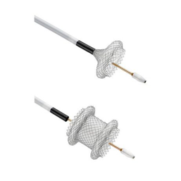 | 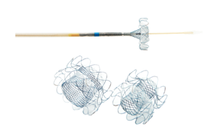 | 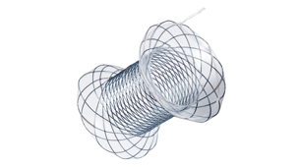 | 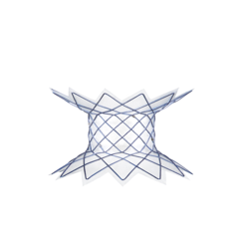 | 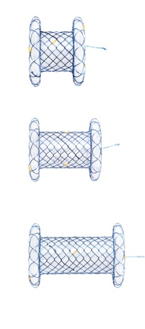
Availability in United States | Yes | No | No | No | No
Flange diameter (mm) | 21, 24, 29 | 23, 25, 31 | 20 | 25 | 22 to 28
Length (mm) | 10 | 20 | 10, 20, 30 | 30 | 10, 30
Lumen diameter (mm) | 10, 15 and 20 | 8, 10, 16 | 10, 12, 14, 16 | 10, 15 | 10, 12, 14, 16
Delivery catheter (Fr) | 10.8 | 10 | 9, 10 | 10 | 10.5
Material | Silicone-covered  Nitinol-braided stent | Silicone-covered  Nitinol stent | Silicone-covered  Nitinol stent | Silicone-covered  Nitinol stent | Silicone-covered  Nitinol stent
Deployment through-the-scope | Yes | Yes | Yes | Yes | Yes
Delivery in single step | Yes | No | No | No | No
Figure 1 Types of lumen-apposing metal stents All stent images available on manufacturer website.

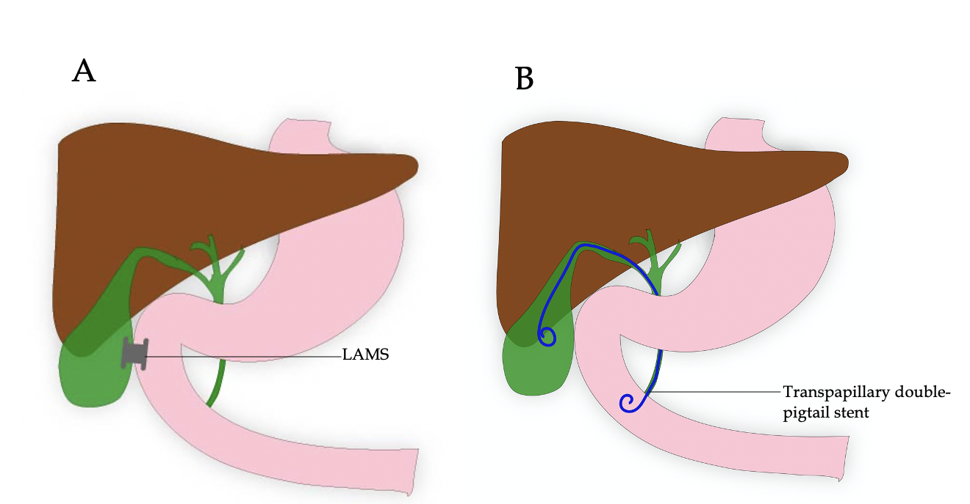
Figure 2 Endoscopic drainage via a transpapillary or transmural approach. A: Endoscopic ultrasound-guided transmural gallbladder drainage using lumen apposing metal stent; B: Endoscopic ultrasound-guided transpapillary drainage of gallbladder. LAMS: Lumen apposing metal stent.

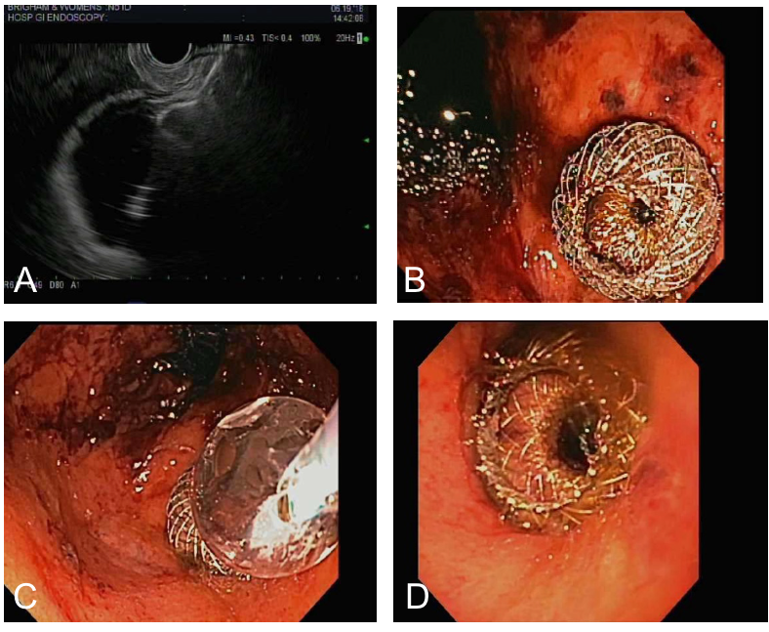
Figure 3 Transmural approach. A: Endoscopic ultrasound-guided gallbladder drainage with proximal lumen apposing metal stent (LAMS) deployment in gallbladder; B: Endoscopic view status post LAMS placement; C: Dilation of the LAMS with through-the-scope balloon; D: Successful endoscopic ultrasound-guided cholecystogastric fistula formation using LAMS.

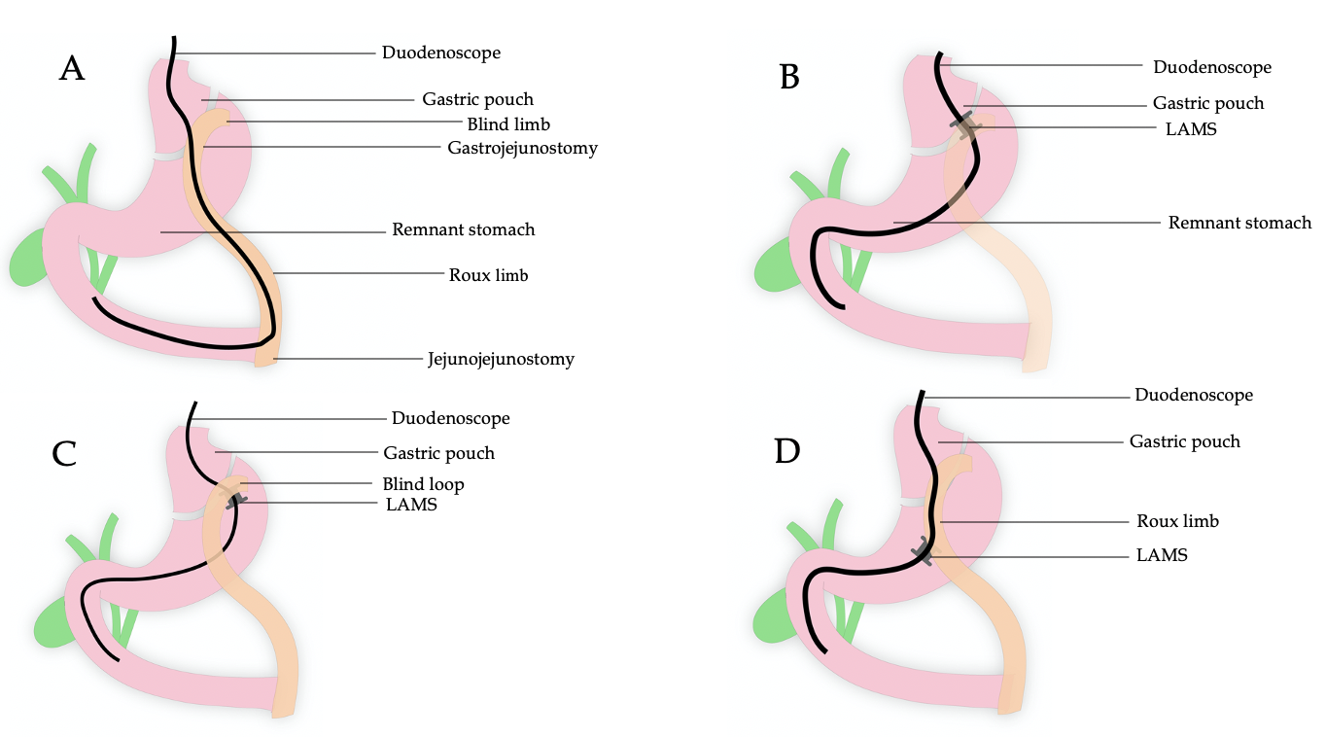
Figure 4 A: Normal RYGB anatomy and issue of traversing a long route B: LAMS between gastric pouch and remnant stomach C: LAMS between blind limb and remnant stomach D: LAMS between Roux Limb and remnant stomach component

Figure 4 The lumen of the stent is then dilated up to the diameter of the stent lumen, thereby allowing for easy passage of any wider endoscope to access the remnant stomach to complete the desired procedure. A: Normal Roux-en-Y gastric bypass (RYGB) anatomy showing long endoscopic route to be traversed to access the biliary system; B: Lumen apposing metal stent (LAMS) placement between gastric pouch and remnant stomach in RYGB anatomy; C: LAMS placement between blind limb and remnant stomach in RYGB anatomy; D: LAMS placement between Roux Limb and remnant stomach in RYGB anatomy. LAMS: Lumen apposing metal stent.

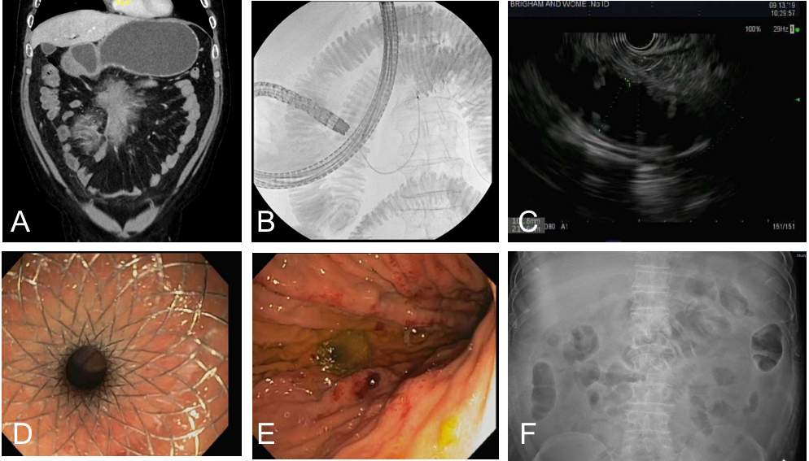
Figure 5 An attractive procedure to treat patients with gastric outlet obstruction as an alternative to surgery. A: Initial computed tomography demonstrating gastric outlet obstruction; B: Fluoroscopy with duodenal stenosis and distal filling with contrast diluted in sterile water; C: Endoscopic ultrasound-guided gastroenterostomy demonstrating filling of distal bowel; D: Successful placement of lumen apposing metal stent (LAMS); E: Endoscopic image of gastroenterostomy placement with LAMS; F: Follow-up radiograph demonstrating successful LAMS placement to achieve gastroenterostomy.

Table 1 Clinical pearls when performing procedures with lumen apposing metal stent
Type of procedure | Summary of keys to success
Pancreatic fluid collection and walled-off necrosis | Transgastric approach is typically recommended
 | Ensure collection is within one cm of the gastric wall
 | May be less effective for large collections extending into the paracolic gutters
EUS-guided gallbladder drainage | Ensure the echoendoscope is advanced into the gastric antrum or duodenal bulb
 | Transgastric or transduodenal approach is recommended (transgastric preferred)
 | Freehand placement or over a wire after fine needle injection and dilation of tract
EUS-guided choledochoduodenostomy | Use of a pigtail stent through LAMS to decrease risk of sump syndrome
 | Reserve LAMS use for optimal candidates for traditional metal stent placement
Gastric access temporary for endoscopy | Avoid penetration of the diaphragm to minimize patient discomfort
 | Avoidance of gastric staple line to reduce risk of persistent gastro-gastric fistula
 | Consider gastro-gastric fistula to decrease risk of LAMS dislodgement
EUS-guided gastroenterostomy | Prone/swimmer’s positing prior to beginning procedure
 | Distention of the bowel with dilute contrast and sterile water
 | Use of glucagon to decrease motility of the bowel
 | Placement of a wire may push small bowel away from the stomach
Benign gastrointestinal strictures | First traverse entire length of stricture (if possible)
 | Use of a guidewire is also important to prevent trauma
Post-surgical fluid collections | Favorable collection locations include adjacent to stomach, duodenum, or rectum
EUS: Endoscopic ultrasound; LAMS: Lumen apposing metal stent.

