Name of Journal: World Journal of Gastroenterology Oncology
Manuscript NO: 52609
Manuscript Type: REVIEW

Hepatic Hemangioendothelioma: An update

Virarkar et al. Hepatic hemangioendothelioma

Mayur Virarkar, Mohammed Saleh, Radwan Diab, Melissa Taggart, Peeyush Bhargava, Priya Bhosale

Mayur Virarkar, Mohammed Saleh, Radwan Diab, Priya Bhosale, Department of Diagnostic Radiology, The University of Texas MD Anderson Cancer Center, Houston, TX 77030, United States

Melissa Taggart, Department of Pathology, The University of Texas MD Anderson Cancer Center, Houston, TX 77030, United States

Peeyush Bhargava, Department of Radiology, The University of Medical Branch, Galveston, TX 77555, United States

Author contributions: All authors equally contributed to this paper with conception and design of the study, literature review and analysis, drafting, critical revision, editing, and approval of the final version.

Corresponding author: Mayur Virarkar, MD, Doctor, Department of Diagnostic Radiology, The University of Texas M.D. Anderson Cancer Center, 1515 Holcombe Blvd, Houston, TX 77030, United States. mkvirarkar@mdanderson.org

Received: December 10, 2019
Revised: February 21, 2020
Accepted: February 23, 2020
Published online: March 15, 2020

Abstract
Primary epithelioid hemangioendotheliomas of the liver (EHL) are rare tumors with a low incidence. The molecular background of EHL is still under investigation, with WWTR1-CAMPTA1 mutation may function as a tumor marker. Commonly, this tumor is misdiagnosed with angiosarcoma, cholangiocarcinomas, metastatic carcinoma, and hepatocellular carcinoma (sclerosing variant). Characteristic features on imaging modalities such as ultrasound, computed tomography, magnetic resonance imaging and positron emission tomography/computed tomography guide in diagnosis and staging. The “halo sign” and the “lollipop sign” on computed tomography and magnetic resonance imaging are described in the literature. Currently, there are no standardized guidelines for treating EHL with treatment options are broad including: chemotherapy, ablation, surgery and liver transplantation with inconsistent results.

Key words: Epithelioid hemangioendotheliomas; Halo sign; Lollipop sign; Angiosarcoma; Cholangiocarcinomas; Hepatocellular carcinoma

Citation: Virarkar M, Saleh M, Diab R, Taggart M, Bhargava P, Bhosale P. Hepatic Hemangioendothelioma: An update. World J Gastrointest Oncol 2020; 12(3): 248-266
URL: https://www.wjgnet.com/1948-5204/full/v12/i3/248.htm
DOI: https://dx.doi.org/10.4251/wjgo.v12.i3.248

Core tip: Primary epithelioid hemangioendotheliomas of the liver are rare tumors with an incidence rate of less than 0.1 per 100000 population. The molecular background of epithelioid hemangioendotheliomas is still under investigation. The “halo sign” and the “lollipop sign” on computed tomography and magnetic resonance imaging are described in the literature. The differential diagnosis includes angiosarcoma, cholangiocarcinomas, metastatic carcinoma, and hepatocellular carcinoma (sclerosing variant). Currently, there are no standardized guidelines for treating EHL with treatment options are broad and include: chemotherapy, ablation, surgery and liver transplantation with inconsistent results.

INTRODUCTION
Epithelioid hemangioendotheliomas (EH) are vascular tumors that may affect the liver, lungs, mediastinum, and multiple other sites. However, the most commonly involved organ is the liver^{[1]}. Primary epithelioid hemangioendotheliomas of the liver (EHL) are rare tumors with an incidence rate of less than 0.1 per 100000 population. Due to the low incidence rate, not a lot is understood regarding the pathogenesis of this tumor. However, it has been shown that EHL have a predilection for females, with a female-to-male ratio of 3:2, and affects the right lobe of the liver more than the left lobe. These tumors may be asymptomatic (24.8%), or symptomatic, with right upper quadrant pain being the most common presenting symptom (48.6%)^{[2]}. The lungs, regional lymph nodes, peritoneum, bone, spleen, and diaphragm are the most common sites of extrahepatic involvement^{[2,3]}.

GENETICS
The molecular background of EH is still under investigation. To date, many genes involved in cell cycle control, signaling pathways, epigenetic modification, and DNA repair have been implicated in the pathogenesis of EH. A study by Errani et al^{[4]} sought to determine the genetic alterations of EH irrespective of the site of the tumor. They found that a WWTR1-CAMTA1 was a recurrent mutation in EH. WWTR1 is involved in transcriptional co-activation and is usually inhibited by the Hippo pathway, which causes the protein to translocate from the nucleus to the cytoplasm^{[5]}. Mutations that cause WWTR1 to be retained in the nucleus by transcriptions factors such as TEAD 1-4, are thought to cause the oncogenesis^{[6]}. On the other hand, CAMTA1 is a transcription activator that belongs to the calmodulin-binding protein family^{[7]}. The downstream targets are yet to be determined. CAMTA1 seems to behave as a tumor suppressor gene, as its deletion also results in oncogenesis^{[8,9]}. However, the conserved regions in the fusion protein function in transcription and binding calmodulin, which might help promote tumorigenesis^{[7,10]}. Additionally, the WWTR1-CAMPTA1 fusion protein seems to be specific to EH, whereby Errani et al^{[4]} demonstrated that it is not detected in tumors that mimic EH, such as epithelioid hemangioma and epithelioid angiosarcoma. As such, the authors recommended that WWTR1-CAMPTA1 may function as a tumor marker allowing physicians to identify EH when the diagnosis is unclear.

PATHOLOGY
Macroscopically, EHL seems to have two growth patterns, nodular and diffuse. The patterns represent different stages of the disease. Early disease presents as a nodular growth, and can be seen in 11.1% of patients. The nodular lesions are usually multiple (66.5%) and affect both lobes of the liver (82.2%)^{[11-13]}. Later stages present as diffuse lesions due to nodular tumors growing in size and coalescing together. As the tumor infiltrates the surrounding structures, portal hypertension may develop^{[11,14]}.
The World Health Organization describe this tumor as malignant tumor with metastatic potential and variable clinical course (indolent to progressive)^{[15,16]}. Microscopically, EH can have three cell types: intermediate, dendritic, and epithelioid cells. Epithelioid cells are present in all cases, are of endothelial origin, and may present with vacuoles causing it to resemble signet cell morphology (Figure 1). Dendritic cells are stellate in shape and have multiple processes. The intermediate cells share features of both cell types^{[17]}.
Due to its endothelial origin, these tumors usually express the FLI-1 protein, which has been shown to be sensitive in identifying vascular tumors. In a single study, FLI-1 allowed for the identification of 100% of endometrioid hemangioendotheliomas with an 85% specificity. This marker showed to have a higher sensitivity than other endothelial markers such as CD31 and 34. Additionally, CD34 is not a specific marker for EH since it is expressed by most vascular tumors (90%). In the liver, the expression of podoplanin proved to be specific to EHL, allowing for accurate identification^{[18]}.
Pathologically, EH can be misdiagnosed in up to 80% of cases^{[2]}. Most commonly, EH is misdiagnosed with angiosarcoma, cholangiocarcinomas (CC), metastatic carcinoma, and hepatocellular carcinoma (HCC) (sclerosing variant)^{[2,17,19,20]}. Therefore, awareness of pathological differences is necessary to accurately diagnose these tumors.
EHL and angiosarcoma have similar presentations on immunohistochemistry profiling and hematoxylin-eosin staining, however differentiating features may still be found. On high power fields, angiosarcoma shows greater atypia, mitotic activity, and nuclear pleomorphism. Additionally, relative to angiosarcomas, EHL demonstrates greater sclerosis but less parenchymal destruction on low power fields^{[17]}. Although both tumors may stain for CD34, factor VIII, and CD31, some markers such as D2-40 are more common in EHL^{[21]}.
Unlike EHL, intrahepatic cholangiocarcinomas (ICC), metastatic carcinomas, and HCCs do not usually express CD34, factor VIII, or CD 31, but are more likely to express cytokeratins. Finally, unlike EHL, HCC stains for CD10, arginase and HepPar-1 with polyclonal carcinoembryonic antigen and CD10 showing canalicular pattern. Some HCC’s may contain vessels that express CD34 due to capillarization of sinusoids, however, this stain is not positive n the neoplastic cells proper and is only expressed along the affected sinusoids^{[21,22]}. On the other hand, the neoplastic cell composing EHL expresses CD34 diffusely.

IMAGING
Imaging is an indispensable component in initial tumor staging, treatment response evaluation, and recurrence identification. Lung or multiorgan involvement, disease progression, the presence of ascites, age more than 55 years, and male gender were found to be associated with a worse prognosis^{[23]}. Extrahepatic tumor extension beyond portal lymph nodes is a negative prognostic factor^{[1]}.
There are two different types of EHL with different stages. The early stages of the disease present as the nodular type, while advanced stages appear as diffuse disease with coalescence of different lesions that may invade hepatic vasculature. The discrete nodules of EHL range in size from 0.5 cm to 12 cm and may progress to complex and confluent masses^{[2,24-26]}. They are located peripherally and extend up to the liver capsule. Fibrosis and compensatory hypertrophy of the unaffected liver segments causes flattening or retraction of the liver capsule^{[27]}. Because of the tumors metastatic potential and risk of recurrence after surgical approaches, imaging is pivotal for identifying the prognostic markers that can guide treatment. Imaging findings should include the exact number, dimensions, location, vascular or ductal involvement, locoregional lymphadenopathy and extrahepatic extension, as they are important factors for surgical decision on resectability^{[1]}.

ULTRASOUND
The appearance of EHL on ultrasound is important to recognize, since ultrasound might be the first modality used to assess right upper quadrant pain, which is the most common presenting symptom of EHL^{[28]}. On ultrasound (US), EHL usually appear as hypoechoic lesions that may demonstrate heterogeneous echotexture (Figure 2). The presence of capsular retraction, calcifications, and multifocal lesions may further support the diagnosis^{[29]}.
EHL shows intratumoral vascularity and better visualized on color Doppler. Multifocal disease may cause intrahepatic congestion which will decrease the portal vein flow and result in portal hypertension with splenomegaly and hepatomegaly^{[30]}.
Another beneficial form of US is contrast enhanced US (CEUS). In a single study, EHL mostly depicts rim enhancement in the arterial phase on CEUS, but some masses may display heterogeneous hyperenhancement. Additionally, in one study all the lesions expressed early wash-out of the contrast agent on late and portal phases, secondary to the absence of portal veins in the tumor^{[29]}. Though this is not specific for EHL, the presence of early contrast wash-out on late and portal phases signifies that the lesion is not benign and requires further investigation, be it biopsy or other imaging modalities^{[28]}.

COMPUTED TOMOGRAPHY
On non-contrast enhanced computed tomography (CT) scans, most lesions appear hypodense relative to the surrounding liver parenchyma^{[31]}. Occasionally, a hyperdense rim may be evident due to the hypercellularity of the periphery. Relative to contrast enhanced CT scans, non-contrast enhanced CT scans can better visualize the bulk of the tumor, since they can additionally detect capsular retraction and coarse/nodular intratumoral calcifications, which can be present in up to 25% of cases^{[32-34]}. The capsular retraction is due to hypertrophy of normal tissue in response to fibrosis of diseased tissue^{[35-37]}. However, though capsular retraction is suggestive of EHL, it is not specific to it and other pathologies such as metastatic lesions and cholangiocarcinomas may cause capsular retraction^{[35,38,39]}.
On contrasted enhanced studies, three patterns of enhancement have been described. In the arterial phase, some tumors demonstrate mild homogeneous enhancement that does not increase in the delayed or portal vein phases. Other tumors develop a ring like enhancement during the arterial phase, with central filling on the delayed and portal phases, which is termed a “halo sign”. Lastly, some tumors demonstrate a heterogeneous pattern that progresses during the delayed and portal phases. The type of enhancement expressed seems to depend on the size of the tumor, as tumors more than 3 cm exhibited delayed heterogeneous enhancement, tumors 2 to 3 cm exhibited ring like enhancement, and tumors less than 2 cm exhibited homogenous enhancement (Figures 2)^{[40]}. An imaging finding on contrast enhanced CT/MRI that is rather specific to EHL was first described by Alomari, which he termed the “lollipop sign” (Figure 3). EHL infiltrate sinusoids, venules, and veins, leading to narrowing or obstruction of these structures. Radiologically, this histological feature causes tapering and termination of the portal and hepatic vein and their branches as they approach the lesion. These occluded vessels are likened to the stick of the lollipop, while the hypodense well-defined tumor itself is likened to the candy, giving rise to the lollipop appearance. In its original description, only vessels that terminate within or at the edge of the rim meet the criteria of the lollipop sign. Additionally, lesions that enhance irregularly, are hyperdense, and/or have a central scar are excluded^{[41]}. Relative to the other imaging characteristics, the lollipop sign is the least likely to be seen in other malignant or benign liver malignancies, making this imaging finding the most characteristic for EHL^{[40]}.

MAGNETIC RESONANCE IMAGING
Magnetic resonance imaging (MRI) is preferred over CT for the diagnosis of EHL due to its ability to detect smaller subcapsular lesions^{[11,12,42,43]}. On non-contrast enhanced images, EHL typically demonstrates a “halo sign”, consisting of three layers of varying signal. These tumors usually demonstrate a hypointense core with a hyperintense rim on T1-Weighted Imaging (T1WI), while the tumor core is hyperintense on T2-Weighted Imaging (T2WI) with heterogeneous signal intensity with a hypointense rim^{[40]}. This is secondary to a hypocellular center that may exhibit necrosis, prior hemorrhage, thrombosis, and/or calcification^{[44]}. With contrast administration, EHL demonstrate findings similar to contrast enhanced CT, with three patterns of enhancement. In the arterial phase, tumors may demonstrate mild homogeneous enhancement, ring like enhancement, or a heterogeneous pattern depending on the size of the lesion (Figures 2 and 3).
Similar to T1WI and T2WI, most lesions (60%) exhibit a “target sign” on diffusion weighted imaging (DWI) with a hyperintense external rim and core. On higher b-values, the periphery’s signal increases, signifying restricted diffusion. On the other hand, the core exhibits a lower signal, which once again highlights the hypocellular core and hypercellular periphery^{[28,34]}. Likewise, on ADC map, tumors typically demonstrate high signal intensity centrally and low signal intensity peripherally. The high ADC values centrally help differentiate EHL from other tumors, as other tumors in the liver rarely exhibit high ADC values^{[34]}.

POSITRON EMISSION TOMOGRAPHY/ COMPUTED TOMOGRAPHY
The healthy hepatocytes express high levels of glucose-6-phosphatase, which generally leads to rapid dissolution of the FDG avid signal relative to malignant tissue^{[45]}. However, since EHL may exhibit variable levels of glucose-6-phosphatase, uptake and excretion of FDG is unpredictable, which limits evaluation of EHL in the early phase. Secondary to the unpredictability of FDG uptake, it has been recommended to review positron emission tomography/computed tomography (PET/CT) studies of EHL at two different time points to improve detection (Figures 4, 5, 6 and 7)^{[45-47]}.
Similar to MRI and CT, EHL tumors demonstrate different patterns of FDG uptake. The lesions in the same patient may demonstrate different behavior on PET/CT, as well as appear at different time interval following FDG administration. Most EHL lesions demonstrate increased uptake relative to the surrounding liver parenchyma, however, up to one third of EHLs may demonstrate similar FDG uptake to the surround tissue. Additionally, the hypercellular periphery may cause higher uptake near the edge of the tumor which appears as a hypermetabolic rim^{[40,48]}. Hence, the performance of PET/CT in the evaluation of metastatic disease and recurrence requires further assessment.

MANAGEMENT
There are no standardized guidelines for treating EHL. The treatment options are broad with inconsistent results and include chemotherapy, ablation, surgery and liver transplantation^{[49-53]}. In fact, one study reported that there was no significant difference in 5-year survival rates among the different treatments^{[54]}. Consequently, few studies have been conducted on EHL and thus natural history of the disease is unpredictable ranging from localized and indolent to aggressive and metastatic.
Furthermore, observation alone can yield favorable outcomes including spontaneous regression or disease stabilization if the tumor is non-aggressive. For example, a retrospective study on pediatric cases reported spontaneous remission without treatment in 60% of patients with focal disease (n = 10) and 42% of patients with multifocal disease (n = 12)^{[55]}. Consequently, another study also demonstrated that overall survival does not significantly differ between local and metastatic or unilateral and bilateral disease^{[54]}. These findings reinforce the unpredictability of tumor behavior, thus complicating the treatment. However, the general consensus is to begin with observation to assess tumor behavior before intervention, if applicable at all.

MEDICATIONS
Prednisone and propranolol are described in literature for medical management of EHL with variable results (Table 1). In a group of nine children with focal, multifocal, and diffuse disease assigned to propranolol (n = 3) or a combination of propranolol/prednisolone (n = 6), 100% of them in each treatment achieved tumor regression. Interestingly, three out of six of all patients with diffuse disease and five out of twelve patients with multifocal disease achieved tumor regression after receiving propranolol or propranolol/prednisolone^{[55]}. Due to EHL’s association with hypothyroidism, L-thyroxine might be needed for patients with severely low T3 and T4 levels^{[55,56]}. Emad et al^{[55]} concludes that treatment for EHL should be escalated gradually according to disease’s response to treatment beginning with close observation for focal disease, then medical therapy and followed by chemotherapy.

CHEMOTHERAPY
Chemotherapy such as interferon, vincristine, or cyclophosphamide have variable results and should be added in patients not responsive to medical therapy such as propranolol or prednisolone (Table 2). Furthermore, patients presenting with early and aggressive disease tend to respond poorly to the medical management^{[55]}. A study reported that regardless of disease severity and initial diagnosed stage, chemotherapy consistently and significantly decreased overall survival (OS) compared to those without chemotherapy^{[54]}. However, some studies have advocated that chemotherapy should be used to reduce tumor burden and slow disease progression, and hepatic transplantation adopted as the optimal management due to favorable prognosis^{[57-59]}. Thalidomide has been suggested as a front-runner for tackling metastatic disease due to its anti-angiogenic properties^{[60]}. In addition, sorafenib and intra-arterial 5-fluorouracil have demonstrated encouraging results for overall survival^{[14,61,62]}. Due to its ability to block vascular endothelial growth factor (VEGF), a signaling protein highly expressed in EHL, Bevacizumab has been utilized for the management of EHL^{[19,63,64]}.

INTERVENTIONAL
Alternative treatment modalities include radiotherapy and radiofrequency (RFA)/microwave ablation (Figure 8). A case report described significant remission of EHL lesions two months after performing selective internal radiotherapy (SIRT), with a single dose 1.8 GBq 90-yttrium (48.6 mCi)^{[65]}. On the other hand, RFA has proved to be a safe and efficient intervention for EHL lesions up to three centimeters large with up to 1% and 7% mortality and complication rates, respectively. RFA could eventually be proposed as an alternative to hepatic resection^{[66,67]}.

SURGERY
The hepatic resection is reserved for single, intrahepatic and resectable lesions (Table 3), while liver transplant is performed for patients with multiple bilobar hepatic lesions (Table 4). The surgical intervention for EHL includes hepatic resection, hepatic transplantation, and hepatic artery ligation (HAL)^{[68]}. Due to the lack of established guidelines for EHL management, there has been a debate on the most effective surgical intervention. Rodriguez et al^{[69]} argued that liver transplants should be adopted at higher rates due to EHL’s ability to metastasize and difficulty to resect, and to avoid liver failure in complicated intrahepatic disease. Some studies provided conflicting recommendations for extrahepatic disease. For example, two studies suggested extrahepatic spread as an acceptable criteria for liver transplants, since its resection did not necessarily correlate with survival^{[2]}, while a study considered it as a surgical contraindication^{[57,70]}. Therefore, clear criteria for surgical procedures are yet to be established.
In a retrospective single center study from 2003-2014, three out of six patients who underwent hepatic resection had disease relapse and all of them survived (Figure 9). On the other hand, one out of two patients who underwent liver transplants died from complications of metastasis^{[70]}. Consequently, there was an overall decrease in disease free survival rates for both surgical interventions. For the hepatic resection group, the disease-free survival rate decreased from 83.3% to 44.4% for one and three years respectively, while only one out of two patients had recurrence after two months (with the other surviving without recurrence) in the liver transplant group. Another case report showed rapid recurrence after only 1-month post liver transplant^{[71]}. Conversely, larger studies have demonstrated that hepatic resection has better OS rates than liver transplants. Mehrabi et al^{[2]} reported that the 5-year survival rate of patients that underwent hepatic resection and liver transplant was 75% and 54.5%, respectively, while Grotz et al^{[57]} reported 86% and 73% 5-year survival rates, respectively. Consequently, disease free survival is higher in hepatic resection compared to liver transplants 62% and 46%, respectively. However, due higher number of hepatic resections compared to liver transplants, large patient cohort studies are required to achieve statistically significant results.
Interestingly, a retrospective study of 149 patients from the European Liver and Transplant Registry proposed an EHL -LT scoring system to predict the risk of post-transplant recurrence^{[72]}. This study recommended liver transplants rather than observation as the main intervention due to better prognosis and concluded that extrahepatic disease was not found to be a significant risk factor. In fact, this study suggested that lymph node metastasis should not necessarily delay liver transplant. Consequently, macrovascular invasion, waiting time of 120 d or less for transplant, and hilar lymph node invasion were all found to be risk factors for post-transplant recurrence in multivariate regression analysis. This can potentially impact management of EHL, since macrovascular invasion can be detected before transplant, but imaging modalities still need further refinement to increase sensitivity and specificity. This scoring system has the potential to guide health care providers on whether or not to pursue liver transplant and to determine the frequency of post-transplant follow up. On the other hand, in order to provide a chance for administering neoadjuvant therapy, a mandatory waiting time from diagnosis to liver transplant is recommended to provide a chance for administering neoadjuvant therapy. In addition, increasing waiting time could help prevent avoid inappropriate liver transplants for cases misdiagnosed as EHL such as hepatic hemangiosarcoma which is associated with poorer prognosis post-transplant^{[72,73]}. Consequently, a 93.9% 5-year survival rate was observed for patients with prognostic score of two or less based on the analysis of the European Liver Transplant Registry- European Liver and Intestinal Transplant Association (ELTR-ELITA) registry, while patients with a prognostic score of six or higher had a significantly lower (P < 0.001) 5-year survival rate of 38.5%^{[72]}. Furthermore, adjuvant therapy could be assigned according to the new prognostic scoring system. Patients with a low score should have the priority for liver transplants, due to lower risk of post-transplant recurrence, while those with a high score should be given low doses of immunosuppression or antineoplastic immunosuppression combined with other neoadjuvant therapy^{[61,63,64,74,75]}.
The left hepatic artery ligation (HAL) has been used in treatment of disseminated disease complicated by severe congestive heart failure (CHF). Bachmann et al^{[68]} described a case of neonatal CHF refractory to digitalis that resolved with uncomplicated left HAL under Doppler ultrasound. According to literature, HAL generates favorable outcomes for EHL related CHF refractory to medical treatment. However, it is discouraged for EHL related CHF associated with other severe symptoms due to higher rates of complication including death. For example, one patient with thrombocytopenia and another with portal hypertension both died from diffuse intravascular coagulation^{[76]} and biliary complications^{[77]}, respectively. Therefore, more research is required to define optimum criteria for surgical candidates and prevent ineffective and unnecessary surgery.

CONCLUSION
EHL has a very low incidence rate, and the pathogenesis is not completely known. The imaging characteristic “halo sign” and “lollipop sign” on CT and MRI can aid in diagnosis. The differential diagnosis includes angiosarcoma, cholangiocarcinomas (CC), metastatic carcinoma, and HCC (sclerosing variant). The histological and IHC findings confirms the diagnosis. Currently, there are no standardized guidelines for the management. The treatment options are broad and include chemotherapy, ablation, surgery and liver transplantation, with inconsistent results.

REFERENCES
1 Lau K, Massad M, Pollak C, Rubin C, Yeh J, Wang J, Edelman G, Yeh J, Prasad S, Weinberg G. Clinical patterns and outcome in epithelioid hemangioendothelioma with or without pulmonary involvement: insights from an internet registry in the study of a rare cancer. Chest 2011; 140: 1312-1318 [PMID: 21546438 DOI: 10.1378/chest.11-0039]
2 Mehrabi A, Kashfi A, Fonouni H, Schemmer P, Schmied BM, Hallscheidt P, Schirmacher P, Weitz J, Friess H, Buchler MW, Schmidt J. Primary malignant hepatic epithelioid hemangioendothelioma: a comprehensive review of the literature with emphasis on the surgical therapy. Cancer 2006; 107: 2108-2121 [PMID: 17019735 DOI: 10.1002/cncr.22225]
3 Gurung S, Fu H, Zhang WW, Gu YH. Hepatic epithelioid hemangioendothelioma metastasized to the peritoneum, omentum and mesentery: a case report. Int J Clin Exp Pathol 2015; 8: 5883-5889 [PMID: 26191313]
4 Errani C, Zhang L, Sung YS, Hajdu M, Singer S, Maki RG, Healey JH, Antonescu CR. A novel WWTR1-CAMTA1 gene fusion is a consistent abnormality in epithelioid hemangioendothelioma of different anatomic sites. Genes Chromosomes Cancer 2011; 50: 644-653 [PMID: 21584898 DOI: 10.1002/gcc.20886]
5 Chan SW, Lim CJ, Chen L, Chong YF, Huang C, Song H, Hong W. The Hippo pathway in biological control and cancer development. J Cell Physiol 2011; 226: 928-939 [PMID: 20945341 DOI: 10.1002/jcp.22435]
6 Chan SW, Lim CJ, Loo LS, Chong YF, Huang C, Hong W. TEADs mediate nuclear retention of TAZ to promote oncogenic transformation. J Biol Chem 2009; 284: 14347-14358 [PMID: 19324876 DOI: 10.1074/jbc.M901568200]
7 Bouché N, Scharlat A, Snedden W, Bouchez D, Fromm H. A novel family of calmodulin-binding transcription activators in multicellular organisms. J Biol Chem 2002; 277: 21851-21861 [PMID: 11925432 DOI: 10.1074/jbc.M200268200]
8 Nakatani K, Nishioka J, Itakura T, Nakanishi Y, Horinouchi J, Abe Y, Wada H, Nobori T. Cell cycle-dependent transcriptional regulation of calmodulin-binding transcription activator 1 in neuroblastoma cells. Int J Oncol 2004; 24: 1407-1412 [PMID: 15138581]
9 Attiyeh EF, London WB, Mossé YP, Wang Q, Winter C, Khazi D, McGrady PW, Seeger RC, Look AT, Shimada H, Brodeur GM, Cohn SL, Matthay KK, Maris JM; Children's Oncology Group. Chromosome 1p and 11q deletions and outcome in neuroblastoma. N Engl J Med 2005; 353: 2243-2253 [PMID: 16306521 DOI: 10.1056/NEJMoa052399]
10 Finkler A, Ashery-Padan R, Fromm H. CAMTAs: calmodulin-binding transcription activators from plants to human. FEBS Lett 2007; 581: 3893-3898 [PMID: 17689537 DOI: 10.1016/j.febslet.2007.07.051]
11 Furui S, Itai Y, Ohtomo K, Yamauchi T, Takenaka E, Iio M, Ibukuro K, Shichijo Y, Inoue Y. Hepatic epithelioid hemangioendothelioma: report of five cases. Radiology 1989; 171: 63-68 [PMID: 2648478 DOI: 10.1148/radiology.171.1.2648478]
12 Miller WJ, Dodd GD 3rd, Federle MP, Baron RL. Epithelioid hemangioendothelioma of the liver: imaging findings with pathologic correlation. AJR Am J Roentgenol 1992; 159: 53-57 [PMID: 1302463 DOI: 10.2214/ajr.159.1.1302463]
13 Shin MS, Carpenter JT Jr, Ho KJ. Epithelioid hemangioendothelioma: CT manifestations and possible linkage to vinyl chloride exposure. J Comput Assist Tomogr 1991; 15: 505-507 [PMID: 2026821]
14 Läuffer JM, Zimmermann A, Krähenbühl L, Triller J, Baer HU. Epithelioid hemangioendothelioma of the liver. A rare hepatic tumor. Cancer 1996; 78: 2318-2327 [PMID: 8941001 DOI: 10.1002/(sici)1097-0142(19961201)78:11<2318::aid-cncr8>3.0.co;2-i]
15 Bosman FT, Carneiro F, Hruban RH, Theise ND. WHO classification of tumours of the digestive system: World Health Organization, 2010
16 Nagtegaal ID, Odze RD, Klimstra D, Paradis V, Rugge M, Schirmacher P, Washington KM, Carneiro F, Cree IA; WHO Classification of Tumours Editorial Board. The 2019 WHO classification of tumours of the digestive system. Histopathology 2020; 76: 182-188 [PMID: 31433515 DOI: 10.1111/his.13975]
17 Ishak KG, Sesterhenn IA, Goodman ZD, Rabin L, Stromeyer FW. Epithelioid hemangioendothelioma of the liver: a clinicopathologic and follow-up study of 32 cases. Hum Pathol 1984; 15: 839-852 [PMID: 6088383 DOI: 10.1016/s0046-8177(84)80145-8]
18 Gill R, O'Donnell RJ, Horvai A. Utility of immunohistochemistry for endothelial markers in distinguishing epithelioid hemangioendothelioma from carcinoma metastatic to bone. Arch Pathol Lab Med 2009; 133: 967-972 [PMID: 19492891 DOI: 10.1043/1543-2165-133.6.967]
19 Makhlouf HR, Ishak KG, Goodman ZD. Epithelioid hemangioendothelioma of the liver: a clinicopathologic study of 137 cases. Cancer 1999; 85: 562-582 [PMID: 10091730 DOI: 10.1002/(SICI)1097-0142(19990201)85:3<562::AID-CNCR7>3.0.CO;2-T]
20 Weiss SW, Enzinger FM. Epithelioid hemangioendothelioma: a vascular tumor often mistaken for a carcinoma. Cancer 1982; 50: 970-981 [PMID: 7093931 DOI: 10.1002/1097-0142(19820901)50:5<970::aid-cncr2820500527>3.0.co;2-z]
21 Studer LL, Selby DM. Hepatic Epithelioid Hemangioendothelioma. Arch Pathol Lab Med 2018; 142: 263-267 [PMID: 29372848 DOI: 10.5858/arpa.2016-0171-RS]
22 Muto J, Shirabe K, Sugimachi K, Maehara Y. Review of angiogenesis in hepatocellular carcinoma. Hepatol Res 2015; 45: 1-9 [PMID: 24533487 DOI: 10.1111/hepr.12310]
23 Lazăr DC, Avram MF, Romoșan I, Văcariu V, Goldiș A, Cornianu M. Malignant hepatic vascular tumors in adults: Characteristics, diagnostic difficulties and current management. World J Clin Oncol 2019; 10: 110-135 [PMID: 30949442 DOI: 10.5306/wjco.v10.i3.110]
24 d'Annibale M, Piovanello P, Carlini P, Del Nonno F, Sciarretta F, Rossi M, Berloco P, Iappelli M, Lonardo MT, Perrone R, Donnorso R. Epithelioid hemangioendothelioma of the liver: case report and review of the literature. Transplant Proc 2002; 34: 1248-1251 [PMID: 12072330 DOI: 10.1016/s0041-1345(02)02751-3]
25 Fukayama M, Nihei Z, Takizawa T, Kawaguchi K, Harada H, Koike M. Malignant epithelioid hemangioendothelioma of the liver, spreading through the hepatic veins. Virchows Arch A Pathol Anat Histopathol 1984; 404: 275-287 [PMID: 6437065 DOI: 10.1007/bf00694893]
26 Lyburn ID, Torreggiani WC, Harris AC, Zwirewich CV, Buckley AR, Davis JE, Chung SW, Scudamore CH, Ho SG. Hepatic epithelioid hemangioendothelioma: sonographic, CT, and MR imaging appearances. AJR Am J Roentgenol 2003; 180: 1359-1364 [PMID: 12704052 DOI: 10.2214/ajr.180.5.1801359]
27 Hu HJ, Jin YW, Jing QY, Shrestha A, Cheng NS, Li FY. Hepatic epithelioid hemangioendothelioma: Dilemma and challenges in the preoperative diagnosis. World J Gastroenterol 2016; 22: 9247-9250 [PMID: 27895413 DOI: 10.3748/wjg.v22.i41.9247]
28 Mulazzani L, Alvisi M. Imaging findings of hepatic epithelioid hemangioendothelioma and fibrolamellar hepatocellular carcinoma: a critical appraisal of current literature about imaging features of two rare liver cancers. Translational Cancer Research 2018; 8: S297-S310 [DOI: 10.21037/tcr.2018.11.33]
29 Dong Y, Wang WP, Cantisani V, D'Onofrio M, Ignee A, Mulazzani L, Saftoiu A, Sparchez Z, Sporea I, Dietrich CF. Contrast-enhanced ultrasound of histologically proven hepatic epithelioid hemangioendothelioma. World J Gastroenterol 2016; 22: 4741-4749 [PMID: 27217705 DOI: 10.3748/wjg.v22.i19.4741]
30 Piscaglia F, Donati G, Serra C, Muratori R, Solmi L, Gaiani S, Gramantieri L, Bolondi L. Value of splanchnic Doppler ultrasound in the diagnosis of portal hypertension. Ultrasound Med Biol 2001; 27: 893-899 [PMID: 11476921 DOI: 10.1016/s0301-5629(01)00390-8]
31 Epelboym Y, Engelkemier DR, Thomas-Chausse F, Alomari AI, Al-Ibraheemi A, Trenor CC 3rd, Adams DM, Chaudry G. Imaging findings in epithelioid hemangioendothelioma. Clin Imaging 2019; 58: 59-65 [PMID: 31238187 DOI: 10.1016/j.clinimag.2019.06.002]
32 Radin DR, Craig JR, Colletti PM, Ralls PW, Halls JM. Hepatic epithelioid hemangioendothelioma. Radiology 1988; 169: 145-148 [PMID: 3420251 DOI: 10.1148/radiology.169.1.3420251]
33 Lin J, Ji Y. CT and MRI diagnosis of hepatic epithelioid hemangioendothelioma. Hepatobiliary Pancreat Dis Int 2010; 9: 154-158 [PMID: 20382586]
34 Bruegel M, Muenzel D, Waldt S, Specht K, Rummeny EJ. Hepatic epithelioid hemangioendothelioma: findings at CT and MRI including preliminary observations at diffusion-weighted echo-planar imaging. Abdom Imaging 2011; 36: 415-424 [PMID: 20730424 DOI: 10.1007/s00261-010-9641-5]
35 Soyer P. Capsular retraction of the liver in malignant tumor of the biliary tract MRI findings. Clin Imaging 1994; 18: 255-257 [PMID: 8000952 DOI: 10.1016/0899-7071(94)90003-5]
36 Sans N, Fajadet P, Galy-Fourcade D, Trocart J, Jarlaud T, Chiavassa H, Giron J, Railhac JJ. Is capsular retraction a specific CT sign of malignant liver tumor? Eur Radiol 1999; 9: 1543-1545 [PMID: 10525861 DOI: 10.1007/s003300050880]
37 Blachar A, Federle MP, Brancatelli G. Hepatic capsular retraction: spectrum of benign and malignant etiologies. Abdom Imaging 2002; 27: 690-699 [PMID: 12395258 DOI: 10.1007/s00261-001-0094-8]
38 Soyer P, Bluemke DA, Vissuzaine C, Beers BV, Barge J, Levesque M. CT of hepatic tumors: prevalence and specificity of retraction of the adjacent liver capsule. AJR Am J Roentgenol 1994; 162: 1119-1122 [PMID: 8165994 DOI: 10.2214/ajr.162.5.8165994]
39 Outwater E. Capsular retraction in hepatic tumors. AJR Am J Roentgenol 1993; 160: 422-423 [PMID: 8424375 DOI: 10.2214/ajr.160.2.8424375]
40 Zhou L, Cui MY, Xiong J, Dong Z, Luo Y, Xiao H, Xu L, Huang K, Li ZP, Feng ST. Spectrum of appearances on CT and MRI of hepatic epithelioid hemangioendothelioma. BMC Gastroenterol 2015; 15: 69 [PMID: 26088585 DOI: 10.1186/s12876-015-0299-x]
41 Alomari AI. The lollipop sign: a new cross-sectional sign of hepatic epithelioid hemangioendothelioma. Eur J Radiol 2006; 59: 460-464 [PMID: 16644166 DOI: 10.1016/j.ejrad.2006.03.022]
42 Gan LU, Chang R, Jin H, Yang LI. Typical CT and MRI signs of hepatic epithelioid hemangioendothelioma. Oncol Lett 2016; 11: 1699-1706 [PMID: 26998064 DOI: 10.3892/ol.2016.4149]
43 Van Beers B, Roche A, Mathieu D, Menu Y, Delos M, Otte JB, Lalonde L, Pringot J. Epithelioid hemangioendothelioma of the liver: MR and CT findings. J Comput Assist Tomogr 1992; 16: 420-424 [PMID: 1592925 DOI: 10.1097/00004728-199205000-00014]
44 Roth CG, Mitchell DG. Hepatocellular carcinoma and other hepatic malignancies: MR imaging. Radiol Clin North Am 2014; 52: 683-707 [PMID: 24889167 DOI: 10.1016/j.rcl.2014.02.015]
45 Shamim SA, Tripathy S, Mukherjee A, Bal C, Roy SG. 18-F-FDG PET-CT in Monitoring of Chemotherapeutic Effect in a Case of Metastatic Hepatic Epithelioid Hemangioendothelioma. Indian J Nucl Med 2017; 32: 237-238 [PMID: 28680215 DOI: 10.4103/ijnm.IJNM_171_16]
46 Kitapci MT, Akkaş BE, Gullu I, Sokmensuer C. FDG-PET/CT in the evaluation of epithelioid hemangioendothelioma of the liver: the role of dual-time-point imaging. A case presentation and review of the literature. Ann Nucl Med 2010; 24: 549-553 [PMID: 20414751 DOI: 10.1007/s12149-010-0379-5]
47 Lin E, Agoff N. Recurrent hepatic epithelioid hemangioendothelioma: detection by FDG PET/CT. Clin Nucl Med 2007; 32: 949-951 [PMID: 18030050 DOI: 10.1097/RLU.0b013e31815969bc]
48 Dong A, Dong H, Wang Y, Gong J, Lu J, Zuo C. MRI and FDG PET/CT findings of hepatic epithelioid hemangioendothelioma. Clin Nucl Med 2013; 38: e66-e73 [PMID: 22996250 DOI: 10.1097/RLU.0b013e318266ceca]
49 Mascarenhas RC, Sanghvi AN, Friedlander L, Geyer SJ, Beasley HS, Van Thiel DH. Thalidomide inhibits the growth and progression of hepatic epithelioid hemangioendothelioma. Oncology 2004; 67: 471-475 [PMID: 15714004 DOI: 10.1159/000082932]
50 Galvão FH, Bakonyi-Neto A, Machado MA, Farias AQ, Mello ES, Diz ME, Machado MC. Interferon alpha-2B and liver resection to treat multifocal hepatic epithelioid hemangioendothelioma: a relevant approach to avoid liver transplantation. Transplant Proc 2005; 37: 4354-4358 [PMID: 16387119 DOI: 10.1016/j.transproceed.2005.11.022]
51 Idilman R, Dokmeci A, Beyler AR, Bastemir M, Ormeci N, Aras N, Ekinci C, Uzunalimoglu O, De Maria N, Van Thiel DH. Successful medical treatment of an epithelioid hemangioendothelioma of liver. Oncology 1997; 54: 171-175 [PMID: 9075791 DOI: 10.1159/000227683]
52 St Peter SD, Moss AA, Huettl EA, Leslie KO, Mulligan DC. Chemoembolization followed by orthotopic liver transplant for epithelioid hemangioendothelioma. Clin Transplant 2003; 17: 549-553 [PMID: 14756273 DOI: 10.1046/j.1399-0012.2003.00055.x]
53 Woodall CE, Scoggins CR, Lewis AM, McMasters KM, Martin RC. Hepatic malignant epithelioid hemangioendothelioma: a case report and review of the literature. Am Surg 2008; 74: 64-68 [PMID: 18274433]
54 Thomas RM, Aloia TA, Truty MJ, Tseng WH, Choi EA, Curley SA, Vauthey JN, Abdalla EK. Treatment sequencing strategy for hepatic epithelioid haemangioendothelioma. HPB (Oxford) 2014; 16: 677-685 [PMID: 24308564 DOI: 10.1111/hpb.12202]
55 Emad A, Fadel S, El Wakeel M, Nagy N, Zamzam M, Kieran MW, El Haddad A. Outcome of Children Treated for Infantile Hepatic Hemangioendothelioma. J Pediatr Hematol Oncol 2020; 42: 126-130 [PMID: 31233466 DOI: 10.1097/MPH.0000000000001536]
56 Dickie B, Dasgupta R, Nair R, Alonso MH, Ryckman FC, Tiao GM, Adams DM, Azizkhan RG. Spectrum of hepatic hemangiomas: management and outcome. J Pediatr Surg 2009; 44: 125-133 [PMID: 19159729 DOI: 10.1016/j.jpedsurg.2008.10.021]
57 Grotz TE, Nagorney D, Donohue J, Que F, Kendrick M, Farnell M, Harmsen S, Mulligan D, Nguyen J, Rosen C, Reid-Lombardo KM. Hepatic epithelioid haemangioendothelioma: is transplantation the only treatment option? HPB (Oxford) 2010; 12: 546-553 [PMID: 20887322 DOI: 10.1111/j.1477-2574.2010.00213.x]
58 Lerut JP, Orlando G, Adam R, Schiavo M, Klempnauer J, Mirza D, Boleslawski E, Burroughs A, Sellés CF, Jaeck D, Pfitzmann R, Salizzoni M, Söderdahl G, Steininger R, Wettergren A, Mazzaferro V, Le Treut YP, Karam V; European Liver Transplant Registry. The place of liver transplantation in the treatment of hepatic epitheloid hemangioendothelioma: report of the European liver transplant registry. Ann Surg 2007; 246: 949-57; discussion 957 [PMID: 18043096 DOI: 10.1097/SLA.0b013e31815c2a70]
59 Mehrabi A, Kashfi A, Schemmer P, Sauer P, Encke J, Fonouni H, Friess H, Weitz J, Schmidt J, Büchler MW, Kraus TW. Surgical treatment of primary hepatic epithelioid hemangioendothelioma. Transplantation 2005; 80: S109-S112 [PMID: 16286886 DOI: 10.1097/01.tp.0000186904.15029.4a]
60 Soape MP, Verma R, Payne JD, Wachtel M, Hardwicke F, Cobos E. Treatment of Hepatic Epithelioid Hemangioendothelioma: Finding Uses for Thalidomide in a New Era of Medicine. Case Rep Gastrointest Med 2015; 2015: 326795 [PMID: 26167310 DOI: 10.1155/2015/326795]
61 Chevreau C, Le Cesne A, Ray-Coquard I, Italiano A, Cioffi A, Isambert N, Robin YM, Fournier C, Clisant S, Chaigneau L, Bay JO, Bompas E, Gauthier E, Blay JY, Penel N. Sorafenib in patients with progressive epithelioid hemangioendothelioma: a phase 2 study by the French Sarcoma Group (GSF/GETO). Cancer 2013; 119: 2639-2644 [PMID: 23589078 DOI: 10.1002/cncr.28109]
62 Kobayashi N, Shimamura T, Tokuhisa M, Goto A, Ichikawa Y. Sorafenib Monotherapy in a Patient with Unresectable Hepatic Epithelioid Hemangioendothelioma. Case Rep Oncol 2016; 9: 134-137 [PMID: 27293400 DOI: 10.1159/000443986]
63 Lau A, Malangone S, Green M, Badari A, Clarke K, Elquza E. Combination capecitabine and bevacizumab in the treatment of metastatic hepatic epithelioid hemangioendothelioma. Ther Adv Med Oncol 2015; 7: 229-236 [PMID: 26136854 DOI: 10.1177/1758834015582206]
64 Agulnik M, Yarber JL, Okuno SH, von Mehren M, Jovanovic BD, Brockstein BE, Evens AM, Benjamin RS. An open-label, multicenter, phase II study of bevacizumab for the treatment of angiosarcoma and epithelioid hemangioendotheliomas. Ann Oncol 2013; 24: 257-263 [PMID: 22910841 DOI: 10.1093/annonc/mds237]
65 Bostancı EB, Karaman K, Turhan N, Dalgıç T, Özer İ, Soydal C, Küçük Ö, Ökten RS. Selective internal radiotherapy for hepatic epithelioid hemangioendothelioma. Turk J Gastroenterol 2014; 25 Suppl 1: 252-253 [PMID: 25910326 DOI: 10.5152/tjg.2014.4286]
66 Kamarajah SK, Robinson D, Littler P, White SA. Small, incidental hepatic epithelioid haemangioendothelioma the role of ablative therapy in borderline patients. J Surg Case Rep 2018; 2018: rjy223 [PMID: 30151113 DOI: 10.1093/jscr/rjy223]
67 Shiina S, Tateishi R, Arano T, Uchino K, Enooku K, Nakagawa H, Asaoka Y, Sato T, Masuzaki R, Kondo Y, Goto T, Yoshida H, Omata M, Koike K. Radiofrequency ablation for hepatocellular carcinoma: 10-year outcome and prognostic factors. Am J Gastroenterol 2012; 107: 569-77; quiz 578 [PMID: 22158026 DOI: 10.1038/ajg.2011.425]
68 Bachmann R, Genin B, Bugmann P, Belli D, Hanquinet S, Liniger P, Le Coultre C. Selective hepatic artery ligation for hepatic haemangioendothelioma: case report and review of the literature. Eur J Pediatr Surg 2003; 13: 280-284 [PMID: 13680501 DOI: 10.1055/s-2003-42245]
69 Rodriguez JA, Becker NS, O'Mahony CA, Goss JA, Aloia TA. Long-term outcomes following liver transplantation for hepatic hemangioendothelioma: the UNOS experience from 1987 to 2005. J Gastrointest Surg 2008; 12: 110-116 [PMID: 17710508 DOI: 10.1007/s11605-007-0247-3]
70 Jung DH, Hwang S, Hong SM, Kim KH, Lee YJ, Ahn CS, Moon DB, Ha TY, Song GW, Park GC, Yu E, Lee SG. Clinicopathological Features and Prognosis of Hepatic Epithelioid Hemangioendothelioma After Liver Resection and Transplantation. Ann Transplant 2016; 21: 784-790 [PMID: 28031549 DOI: 10.12659/AOT.901172]
71 Abdoh QA, Alnajjar AM, Abaalkhail FA, Al Sebayel M, Al-Hussaini HF, Al-Hamoudi WK, Helmy H, Almansour M, Elsiesy HA. Aggressive Recurrence of Primary Hepatic Epithelioid Haemangioendothelioma after Liver Transplantation. Can J Gastroenterol Hepatol 2016; 2016: 6135297 [PMID: 27446853 DOI: 10.1155/2016/6135297]
72 Lai Q, Feys E, Karam V, Adam R, Klempnauer J, Oliverius M, Mazzaferro V, Pascher A, Remiszewski P, Isoniemi H, Pirenne J, Foss A, Ericzon BG, Markovic S, Lerut JP; European Liver Intestine Transplant Association (ELITA). Hepatic Epithelioid Hemangioendothelioma and Adult Liver Transplantation: Proposal for a Prognostic Score Based on the Analysis of the ELTR-ELITA Registry. Transplantation 2017; 101: 555-564 [PMID: 28212256 DOI: 10.1097/TP.0000000000001603]
73 Orlando G, Adam R, Mirza D, Soderdahl G, Porte RJ, Paul A, Burroughs AK, Seiler CA, Colledan M, Graziadei I, Garcia Valdecasas JC, Pruvot FR, Karam V, Lerut J. Hepatic hemangiosarcoma: an absolute contraindication to liver transplantation--the European Liver Transplant Registry experience. Transplantation 2013; 95: 872-877 [PMID: 23354302 DOI: 10.1097/TP.0b013e318281b902]
74 Calabrò L, Di Giacomo AM, Altomonte M, Fonsatti E, Mazzei MA, Volterrani L, Miracco C, Maio M. Primary hepatic epithelioid hemangioendothelioma progressively responsive to interferon-alpha: is there room for novel anti-angiogenetic treatments? J Exp Clin Cancer Res 2007; 26: 145-150 [PMID: 17550144]
75 Emamaullee JA, Edgar R, Toso C, Thiesen A, Bain V, Bigam D, Kneteman N, Shapiro AM. Vascular endothelial growth factor expression in hepatic epithelioid hemangioendothelioma: Implications for treatment and surgical management. Liver Transpl 2010; 16: 191-197 [PMID: 20104492 DOI: 10.1002/lt.21964]
76 Pereyra R, Andrassy RJ, Mahour GH. Management of massive hepatic hemangiomas in infants and children: a review of 13 cases. Pediatrics 1982; 70: 254-258 [PMID: 7099792]
77 Davenport M, Hansen L, Heaton ND, Howard ER. Hemangioendothelioma of the liver in infants. J Pediatr Surg 1995; 30: 44-48 [PMID: 7722828 DOI: 10.1016/0022-3468(95)90607-x]
78 Salech F, Valderrama S, Nervi B, Rodriguez JC, Oksenberg D, Koch A, Smok G, Duarte I, Pérez-Ayuso RM, Jarufe N, Martínez J, Soza A, Arrese M, Riquelme A. Thalidomide for the treatment of metastatic hepatic epithelioid hemangioendothelioma: a case report with a long term follow-up. Ann Hepatol 2011; 10: 99-102 [PMID: 21301019]
79 Raphael C, Hudson E, Williams L, Lester JF, Savage PM. Successful treatment of metastatic hepatic epithelioid hemangioendothelioma with thalidomide: a case report. J Med Case Rep 2010; 4: 413 [PMID: 21176188 DOI: 10.1186/1752-1947-4-413]
80 Kassam A, Mandel K. Metastatic hepatic epithelioid hemangioendothelioma in a teenage girl. J Pediatr Hematol Oncol 2008; 30: 550-552 [PMID: 18797205 DOI: 10.1097/MPH.0b013e31816e22d1]
81 Bölke E, Gripp S, Peiper M, Budach W, Schwarz A, Orth K, Reinecke P, van de Nes JA. Multifocal epithelioid hemangioendothelioma: case report of a clinical chamaeleon. Eur J Med Res 2006; 11: 462-466 [PMID: 17182357]
82 Kim YH, Mishima M, Miyagawa-Hayashino A. Treatment of pulmonary epithelioid hemangioendothelioma with bevacizumab. J Thorac Oncol 2010; 5: 1107-1108 [PMID: 20581581 DOI: 10.1097/JTO.0b013e3181e2bc5d]
83 Mizota A, Shitara K, Fukui T. Bevacizumab chemotherapy for pulmonary epithelioid hemangioendothelioma with severe dyspnea. J Thorac Oncol 2011; 6: 651-652 [PMID: 21317750 DOI: 10.1097/JTO.0b013e31820b9e23]
84 Kayler LK, Merion RM, Arenas JD, Magee JC, Campbell DA, Rudich SM, Punch JD. Epithelioid hemangioendothelioma of the liver disseminated to the peritoneum treated with liver transplantation and interferon alpha-2B. Transplantation 2002; 74: 128-130 [PMID: 12134111 DOI: 10.1097/00007890-200207150-00022]
85 Marsh Rde W, Walker MH, Jacob G, Liu C. Breast implants as a possible etiology of epithelioid hemangioendothelioma and successful therapy with interferon-alpha2. Breast J 2005; 11: 257-261 [PMID: 15982392 DOI: 10.1111/j.1075-122X.2005.21663.x]
86 Lakkis Z, Kim S, Delabrousse E, Jary M, Nguyen T, Mantion G, Heyd B, Lassabe C, Borg C. Metronomic cyclophosphamide: an alternative treatment for hepatic epithelioid hemangioendothelioma. J Hepatol 2013; 58: 1254-1257 [PMID: 23402747 DOI: 10.1016/j.jhep.2013.01.043]
87 Sangro B, Iñarrairaegui M, Fernández-Ros N. Malignant epithelioid hemangioendothelioma of the liver successfully treated with Sorafenib. Rare Tumors 2012; 4: e34 [PMID: 22826791 DOI: 10.4081/rt.2012.e34]
88 Wang LR, Zhou JM, Zhao YM, He HW, Chai ZT, Wang M, Ji Y, Chen Y, Liu C, Sun HC, Wu WZ, Ye QH, Zhou J, Fan J, Tang ZY, Wang L. Clinical experience with primary hepatic epithelioid hemangioendothelioma: retrospective study of 33 patients. World J Surg 2012; 36: 2677-2683 [PMID: 22890877 DOI: 10.1007/s00268-012-1714-x]
89 Nudo CG, Yoshida EM, Bain VG, Marleau D, Wong P, Marotta PJ, Renner E, Watt KD, Deschênes M. Liver transplantation for hepatic epithelioid hemangioendothelioma: the Canadian multicentre experience. Can J Gastroenterol 2008; 22: 821-824 [PMID: 18925305 DOI: 10.1155/2008/418485]
90 Mosoia L, Mabrut JY, Adham M, Boillot O, Ducerf C, Partensky C, Baulieux J. Hepatic epithelioid hemangioendothelioma: long-term results of surgical management. J Surg Oncol 2008; 98: 432-437 [PMID: 18792957 DOI: 10.1002/jso.21132]
91 Cardinal J, de Vera ME, Marsh JW, Steel JL, Geller DA, Fontes P, Nalesnik M, Gamblin TC. Treatment of hepatic epithelioid hemangioendothelioma: a single-institution experience with 25 cases. Arch Surg 2009; 144: 1035-1039 [PMID: 19917940 DOI: 10.1001/archsurg.2009.121]

Footnotes
Conflict-of-interest statement: Authors declare no conflict of interests for this article.

Open-Access: This article is an open-access article that was selected by an in-house editor and fully peer-reviewed by external reviewers. It is distributed in accordance with the Creative Commons Attribution Non Commercial (CC BY-NC 4.0) license, which permits others to distribute, remix, adapt, build upon this work non-commercially, and license their derivative works on different terms, provided the original work is properly cited and the use is non-commercial. See: http://creativecommons.org/licenses/by-nc/4.0/

Manuscript source: Invited Manuscript

Peer-review started: April 26, 2020
First decision: May 24, 2020
Article in press: February 23, 2020

Specialty type: Oncology
Country of origin: United States
Peer-review report classification
Grade A (Excellent): A
Grade B (Very good): B
Grade C (Good): C, C, C
Grade D (Fair): D
Grade E (Poor): 0

P-Reviewer: Bramhall SR, Cerwenka H, Gencdal G, Mizuguchi T, Qin JM, Ramia JM S-Editor: Wang J L-Editor: A E-Editor: Qi LL
Figure Legends
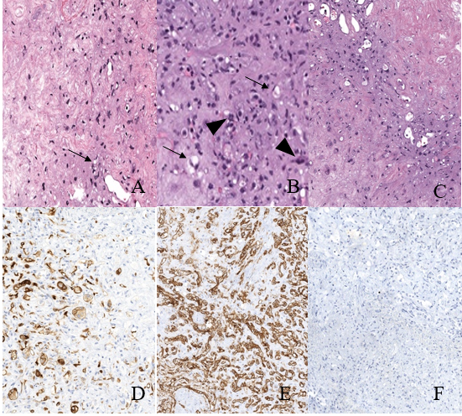
Figure 1 Epithelioid hemangioendothelioma microscopic features. There is variable cellularity, ranging from stromal-rich areas, mimicking cartilage to highly cellular regions. A: The tumor consists mostly of stellate cells with only rare epithelioid cells containing intracytoplasmic lumen/vacuoles (arrows); B: In more cellular areas, the intracellular lumens (arrows) are more prominent. In addition, the tumor infiltrates sinusoids forming tufted foci (arrowheads); C: Transitional areas between fibrous and moderately cellular areas. To confirm and differentiate epithelioid hemangioendothelioma from tumors with similar histologic features (most commonly cholangiocarcinoma, hepatocellular carcinoma and metastatic signet ring cell carcinoma), immunohistochemical stains are needed; D: Patchy staining for cytokeratin 7, a stain commonly expressed in adenocarcinomas of the upper gastrointestinal tract and pancreaticobiliary tree; E: Diffusely positive for the endothelial marker cluster of differentiation-31 (CD31); F: Negative for the hepatocellular marker, Hepatocyte Paraffin 1 (HepPar1). CD31: Cluster of differentiation-31; HepPar1: Hepatocyte Paraffin 1.

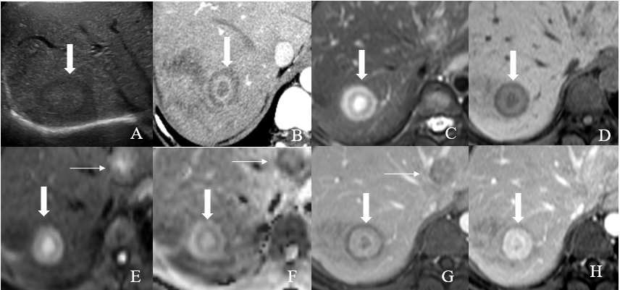
Figure 2 Hepatic hemangioepithelioma imaging feature. A: Transverse ultrasound of the right upper abdomen reveals a iso to mildly hypoechoic lesion (arrow) in the liver; B: Axial contrast enhanced CT image of the liver; C: Axial T2 weighted images (T2WI); D: Axial pre contrast T1 weighted images (T1WI); E: Axial diffusion weighted image (DWI); F: Apparent diffusion coefficient; G: Axial post contrast T1WI portovenous; and H: Axial post contrast T1WI venous magnetic resonance imaging (MRI) images. On T2WI, a target appearance consists of a core with high signal intensity (similar to fluid), a thin ring with low signal intensity, and a peripheral halo with slight hyperintense signal (thick arrows). On dynamic study, it consists of an hypodense/hypointense core, surrounded by a layer of enhancement and a thin peripheral hypodense/hypointense halo (thick arrows). Other hepatic hemangioepithelioma nodules are also noted (thin nodules). T2WI: T2 Weighted Images; T1WI: T1 weighted images; DWI: diffusion weighted image; MRI: Magnetic resonance imaging.

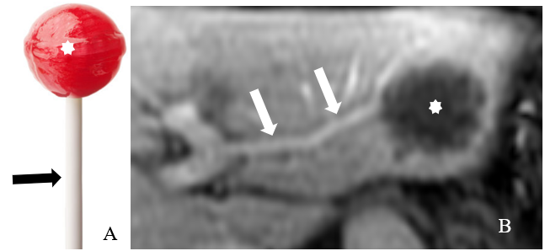
Figure 3 Hepatic hemangioepithelioma imaging feature. A: A lollipop; B: Axial post contrast T1 Weighted Images images. Hepatic hemangioepithelioma nodule (star) with portal veins entering and terminating in the periphery of the lesion (arrow). This configuration resembles a lollipop. The ‘‘Lollipop sign’’ is a combination of two structures: the well-defined tumor mass on enhanced images (the candy in the lollipop) and the adjacent occluded vein (the stick), because hepatic hemangioepithelioma has the tendency to spread within the portal and hepatic vein branches. The vein should terminate smoothly at the edge or just within the rim of the lesion; vessels that traverse the entire lesion or are displaced and collateral veins cannot be included in the sign.

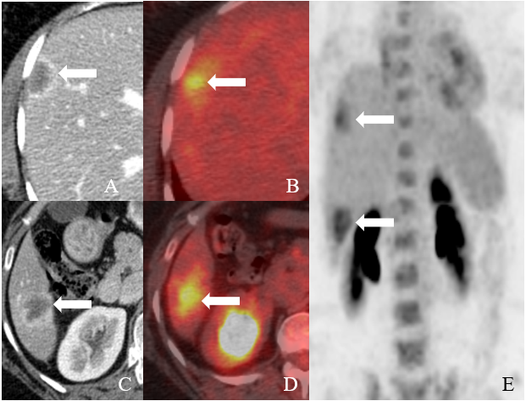
Figure 4 Imaging of hepatic hemangioepithelioma. A and B: Axial contrast enhanced (Computed Tomography) CT images show hepatic hemangioepithelioma nodules (arrows); C and D: Axial ¹⁸F-labeled fluoro-2-deoxyglucose positron emission tomography/computed tomography; E: Coronal maximum intensity projection images shows fluoro-2-deoxyglucose avid hepatic hemangioepithelioma nodules (arrows).

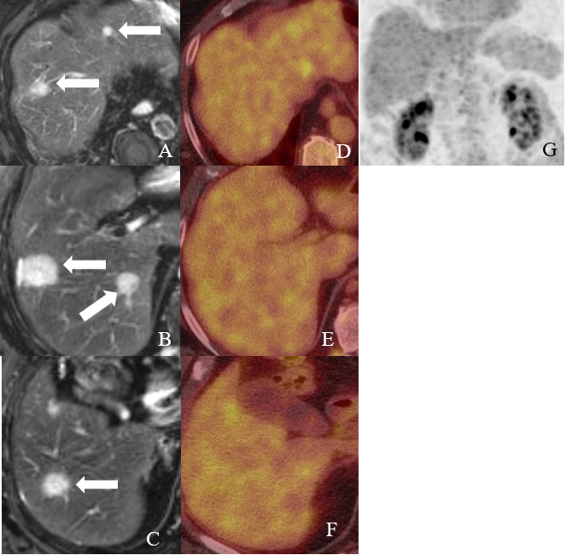
Figure 5 Imaging of hepatic hemangioepithelioma. A, B and C: Axial T2 Weighted Image Magnetic Resonance Imaging images show hepatic hemangioepithelioma nodules (arrows); D, E and F: Axial ¹⁸F-labeled fluoro-2-deoxyglucose positron emission tomography/computed tomography and G: Coronal maximum intensity projection images show no fluoro-2-deoxyglucose update by the hepatic hemangioepithelioma nodules.

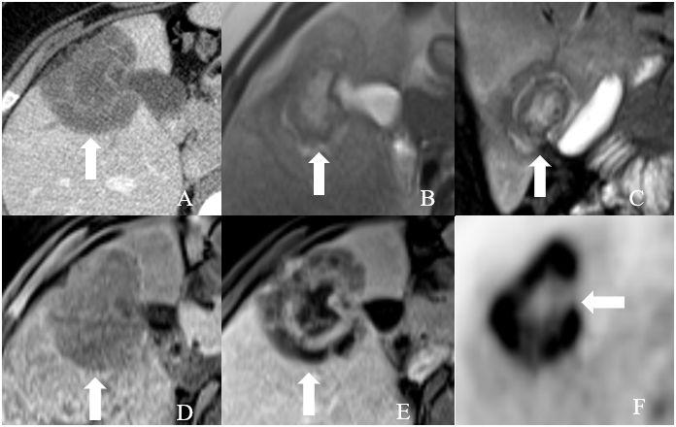
Figure 6 Imaging of hepatic hemangioepithelioma. A: Axial contrast enhanced CT image; B: Axial T2 weighted images; C: coronal T2 weighted images; D: Axial pre contrast T1 Weighted Image; E: Axial post contrast T1 Weighted Image MRI Images; and F: Axial ¹⁸F-labeled fluoro-2-deoxyglucose positron emission tomography/computed tomography attenuation corrected image show a hepatic hemangioepithelioma nodule (thick arrow) with fluoro-2-deoxyglucose update.

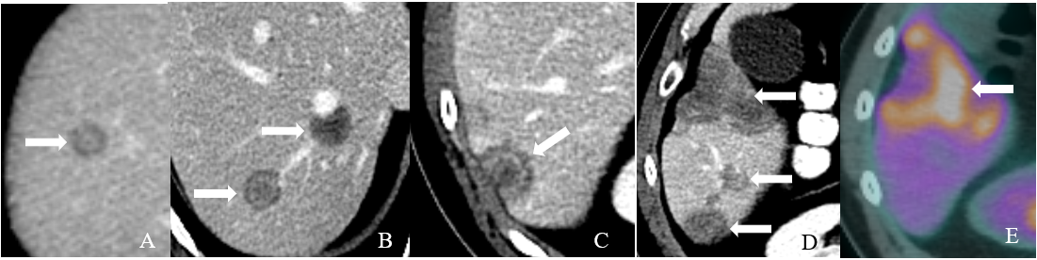
Figure 7 Imaging of hepatic hemangioepithelioma. A, B, C and D: Axial contrast enhanced CT images show hepatic hemangioepithelioma nodules (arrows); E: Axial ¹⁸F-labeled fluoro-2-deoxyglucose positron emission tomography/computed tomography image shows a heterogeneous uptake by hepatic hemangioepithelioma nodule (thick arrow), while rest of the nodules showed no fluoro-2-deoxyglucose update.

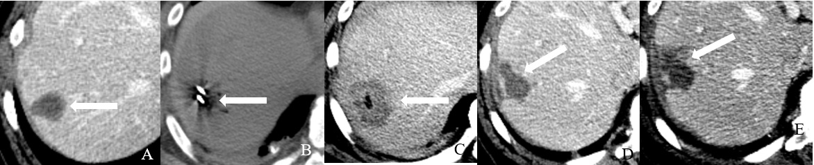
Figure 8 Ablation of hepatic hemangioepithelioma. A: Axial contrast enhanced CT image shows a 3 cm hepatic hemangioepithelioma nodule (arrow) in segment 7 of the liver; B: Axial non-contrast CT image shows microwave ablation of liver of the segment 7 nodule (arrow); C: Immediate post ablation axial contrast enhanced CT image shows an ablation cavity (arrow); D: Follow up axial contrast CT image after 3 mo and; E: Axial contrast CT image 6 mo show an evolving post ablation cavity and tract (arrow).

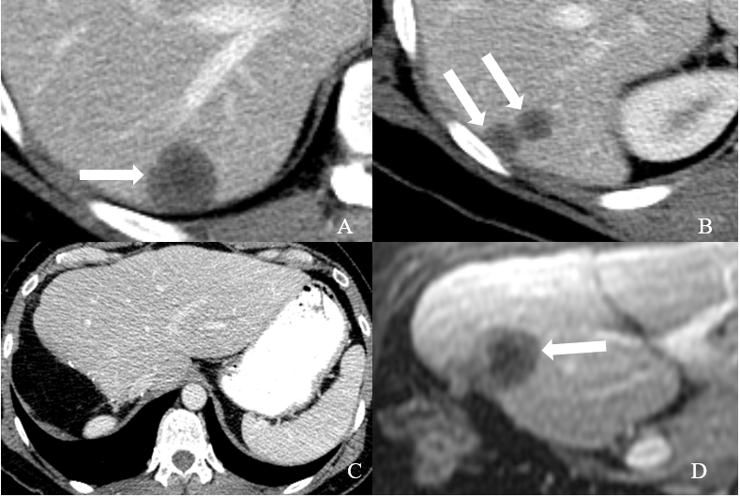
Figure 9 Recurrent hepatic hemangioepithelioma. A and B: Axial contrast enhanced CT images show hepatic hemangioepithelioma nodules (arrows); C: Axial contrast enhanced CT image shows post-surgical changes related to right hepatectomy; D: 3 mo follow up axial post contrast T1 Weighted Image Magnetic Resonance Imaging image shows a recurrent hepatic hemangioepithelioma (arrow).

Table 1 Summaries of medical management studies for hepatic hemangioepithelioma
Study | Year | Country | Patients | Medical management | Dose | Outcome | Duration of  follow up
Salech et al^{[78]} | 2010 | Chile | 1 | Thalidomide | 300 mg daily | Partial response | 109 mo
Raphael et al^{[79]} | 2010 | United Kingdom | 1 | Thalidomide | 400 mg daily | Stable disease | 84 mo
Kassam and Mandel^{[80]} | 2008 | Canada | 1 | Thalidomide | 400 mg twice daily | Progressive disease | Not available
Bolke et al^{[81]} | 2006 | Germany | 1 | Thalidomide | Unknown | Progressive disease/death | Not available
Mascarenhas et al^{[49]} | 2005 | United States | 1 | Thalidomide | Unknown | Partial response | Not available
Soape et al^{[60]} | 2015 | United States | 1 | Thalidomide | 200 mg nightly | Progressive disease | 12 mo

Table 2 Summaries of chemotherapeutics management studies for hepatic hemangioepithelioma
Study | Year | Country | Patients | Chemotherapy agent | Dose | Outcome | Duration of  follow up
Emad et al^{[55]} | 2019 | Egypt | 9/28 | Propranolol, prednisolone, vincristine, cyclophosphamide. | First line therapy: 0.6–1.2 mg/kg/d  propranolol and/or 0.5-2 mg/kg/d prednisolone  Salvage therapy: 1 million units/m²/wk interferon, 1.5 mg/m²/wk vincristine | Regression on propranolol, propranolol/prednisolone, propranolol/prednisolone/ vincristine, propranolol/prednisolone/cyclophosphamide, propranolol/prednisolone/vincristine/cyclophosphamide, prednisolone/interferon (1/2)¹  Progression on prednisolone/interferon (1/2)¹, prednisolone/vincristine/cyclophosphamide, Prednisolone/embolization/cyclophosphamide | Minimum of 12 mo
Kim et al^{[82]} | 2010 | Japan | 1 | Carboplatin, paclitaxel, and bevacizumab | 15 mg/kg, every 21 d (bevacizumab) | Progression | Not available
Mizota et al^{[83]} | 2011 | Japan | 1 | Carboplatin, paclitaxel, and bevacizumab | 15 mg/kg, every 21 d (bevacizumab) | Progression | 3 mo
Calabro et al^{[74]} | 2007 | Italy | 1 | Interferon α-2a | Not available | Stable disease | Not available
Kayler et al^{[84]} | 2002 | United States | 1 | Interferon α-2a | 3 million units daily | Partial response | 4 mo
Marsh R et al^{[85]} | 2005 | United States | 1 | Interferon α | 3 million units, 5 d/wk for 1 yr | Complete response | 84 mo
Galvão et al^{[50]} | 2005 | Brazil | 1 | Interferon alpha 2b | 3 million units daily 9 weeks before and 1 week after liver resection | Complete response | 36 mo
Agulnik et al^{[64]} | 2013 | United States | 1 | Bevacizumab | 15 mg/kg, every 21 d | Partial response | Not available
Lau et al^{[63]} | 2015 | United States | 1 | Capecitabine and bevacizumab | Not available | Partial response | 6 mo
Lakkis et al^{[86]} | 2013 | France | 2 | Cyclophosphamide | 50 mg daily continuous | Complete response (1/2) and Partial response (1/2) | 6 and 24 mo
Sangro et al^{[87]} | 2012 | Spain | 1 | Sorafenib | 200 mg every 36 hours | Partial response | 6 mo
Kobayashi et al^{[62]} | 2016 | Japan | 1 | Sorafenib | 400-800 mg twice daily | Partial response | 60 mo
¹On prednisolone/interferon treatment, regression was reported in 1 patient and progression in the other patient.

Table 3 Summary of surgical management studies for hepatic hemangioepithelioma
Study | Year | Country | Patients | Study Design | Surgical management | Outcome | Duration of  follow up
Bachman et al^{[68]} | 2003 | Switzerland | 1 | Case report | Selective hepatic artery ligation | Stable, asymptomatic, heart failure signs disappeared | 48 mo
Bostancı et al^{[65]} | 2014 | Turkey | 1 | Case report | Selective internal radiotherapy | Partial response | 12 mo
Grotz et al^{[57]} | 2010 | United States | 11/30 | Retrospective | Hepatic resection | A 1-, 3- and 5-year overall survival of 100%, 86% and 86% and a disease free survival of 78%, 62% and 62%, respectively | 60 mo
Wang et al^{[88]} | 2012 | China | 17/33 | Retrospective | Hepatic resection | No significant difference in overall survival between the 17 patients who underwent liver resection alone 3-year survival rate 74.1% | 1 patient underwent liver transplant and died 12 mo post-transplant

Table 4 Summary of liver transplant studies for hepatic hemangioepithelioma
Study | Year | Country | Liver transplant patients | Study Design | Reason for liver transplant | Outcome
Emamaullee et al^{[75]} | 2010 | Canada | 5/6  (1 patient did chemotherapy and surgical resection) | Retrospective | EHL (5/5), Recurrence (1/5) | 1 patient had recurrence twice after two transplants but 2nd transplant resulted in stable disease. 1 patient had recurrence in less than 6 mo post-transplant and passed away less than 1 year post-transplant. 4 patients have stable disease post-transplant
Nudo et al^{[89]} | 2008 | Canada | 11/11 | Retrospective | EHL | 3/11 patients died (2 had recurrence while 1 died due to hepatic artery thrombosis). 4/11 patients had recurrence. 2/5 did surgical resection (both failed and 1/2 patients died at 61 mo post-resection while other patient did a second transplant and patient is still alive). 1/11 patients did radiotherapy. 1/11 patients assigned pegylated interferon and died 11 mo later
Rodriguez et al^{[69]} | 2007 | United States | 110/110 | Retrospective | EHL | 1/110 had operative death and 2/110 patients died within 30 d post-transplant. 1-year, 3-year, and 5-year overall survivals were 80%, 68%, and 64%, respectively. 31/110 were 5-year survivors. 38/110 patients died during follow-up. 12/38 patients died of recurrent EHL with distant involvement. 12/110 required re-transplantation including four patients who did a third transplant. For re-transplantation patients: 1-year, 3-year, and 5-year allograft survivals were 70%, 60%, and 55%, respectively
Mosoia et al^{[90]} | 2008 | France | 6/9 | Retrospective | EHL | 2/6 had recurrence and died (1 patient had recurrence and died at 56 mo while other patient had liver recurrence and died at 6 mo)
Lerut et al^{[58]} | 2007 | France | 59/59 | Retrospective | EHL | Early (< 3 mo) and late (> 3 mo) post-LT mortality was 1.7% (1 patient) and 22% (14 patients). 14 (23.7%) patients with recurrence after a median time of 49 mo (range, 6-98). 9 (15.3%) patients died of recurrence and 5 survived with recurrent disease. Disease-free survival rates at 1, 5, and 10 yr post-liver transplant are 90%, 82%, and 64%
Mehrabi et al^{[2]} | 2006 | Germany | 128/286 | Review | EHL | The most common management has been liver transplantation  (44.8% of patients), followed by no treatment (24.8%), chemotherapy or radiotherapy (21%), and liver resection (9.4%). The 1-year and 5-year patient survival rates were 96% and 54.5%, respectively, after liver transplant; 39.3% and 4.5%, respectively, after no treatment, 73.3% and 30%, respectively, after chemotherapy or radiotherapy; and 100% and 75%, respectively, after liver resection
Jung et al^{[70]} | 2016 | Korea | 2/8 | Retrospective | EHL | One patient died from tumor recurrence at 9 mo and the other is alive after 5 years without recurrence
Cardinal et al^{[91]} | 2009 | United States | 17/25 | Retrospective | EHL | Mean survival of 172 (124-220) mo in the liver transplant group
Abdoh et al^{[71]} | 2017 | Finland | 1 | Retrospective | EHL | Recurrence after 1 month and died 1 month later
Grotz et al^{[57]} | 2010 | United States | 11/30 | Retrospective | EHL | 1-, 3- and 5-year overall survival of 91%, 73% and 73% and a disease free survival of 64%, 46% and 46% respectively
EHL: Hepatic hemangioepithelioma.

