Name of journal: World Journal of Gastroenterology
ESPS Manuscript NO:3212
Columns: META-ANALYSIS

Diabetes mellitus carries a risk of gastric cancer: A meta-analysis

Shimoyama S et al. Diabetes mellitus and gastric cancer

Shouji Shimoyama

Shouji Shimoyama, Gastrointestinal Unit, Settlement Clinic 4-20-7, Tokyo 120-0003, Japan

Author contributions: Shimoyama S solely contributed to this paper.

Correspondence to: Shouji Shimoyama, MD, Gastrointestinal Unit, Settlement Clinic, 4-20-7, Towa, Adachi-ku, Tokyo 120-0003, Japan. shimoyama@apost.plala.or.jp

Telephone: +81-3-36057747 Fax: +81-3-36050244

Received: May 14, 2013 Revised: June 27, 2013
Accepted: July 30, 2013

Published online:

Abstract
AIM: To investigate the association and quantifying the relationship between diabetes mellitus (DM) and gastric cancer (GC) by updating meta-analysis.

METHODS: The initial PubMed search identified 1233 publications. Studies not reporting GC or those not reporting actual number of GC were excluded. Twelve pertinent studies were retrieved from the PubMed database or from manual search and considered for the meta-analysis. Pooled risk ratios and 95% confidence intervals were estimated by random effects model. Subgroup analysis was performed according to gender or geographical regions. Heterogeneity and publication bias were evaluated by I² measure and funnel plot analysis, respectively.

RESULTS: DM was significantly associated with GC with a risk ratio (RR) of 1.41 (P = 0.006) (95%CI: 1.10-1.81). Subgroup analyses revealed that both sexes showed a significant association with GC, with a greater magnitude of risk in females (RR =1.90, 95%CI: 1.27-2.85, P = 0.002) than in males (RR = 1.24, 95%CI: 1.08-1.43, P = 0.002). In addition, the link between DM and GC was significant in East Asian DM patients (RR = 1.77, 95%CI: 1.38-2.26, P < 0.00001) but not in Western DM patients (RR = 1.23, 95%CI: 0.90-1.68, P = 0.2). There was no evidence of publication bias, but the results indicated significant heterogeneity.

CONCLUSION: This updated meta-analysis has provided evidence of positive DM-GC associations. The limited information on potentially important clinical confounding factors in each study deserves further investigation.

© 2013 Baishideng. All rights reserved.

Key words: Gastric cancer; Diabetes mellitus; Meta-analysis; Hyperglycemia; Hyperinsulinemia

Core tip: Diabetes mellitus (DM) was significantly associated with gastric cancer (GC) with a risk ratio of 1.41. This positive DM-GC association was also observed in both sexes with a greater magnitude of risk in females than male, as well as in East Asian DM patients but not in the Western patients. This study could provide one answer to current inconsistent knowledge across trials concerning positive/inverse DM-GC association. Since DM patients are less likely to be screened for cancers, clinicians caring for DM patients should remain alert to detect GC especially in female, since female GC patients is less preponderant than male in the general population.

Shimoyama S. Diabetes mellitus carries a risk of gastric cancer: A meta-analysis

Available from:
DOI:

INTRODUCTION
A growing body of evidence-derived largely from case-control studies, cohort studies, and meta-analyses-suggests that diabetes mellitus (DM) is associated with an increased risk of a number of cancers. The risk increases twofold for cancer of the liver, pancreas, and endometrium, and 1.2-1.5-fold for cancer of the colon and rectum, breast, bladder, and kidney^{[1]}, while prostate cancer shows a positive^{[2]} or inverse^{[1]} association with DM. In fact, DM is a disease of global epidemic proportions. The DM population has increased from 171 million in 2000 to 366 million in 2011, a figure projected to increase to 552 million by 2030^{[3,4]}. This rising prevalence of DM with its anticipated 200 million more patients over the next two decades suggests that even a small increase in cancer risk will have an undeniable impact on the health of the general population. Therefore, in addition to the dramatic increase in the prevalence of DM and the consequences of its complications, a DM-cancer association may greatly affect worldwide health levels.
Despite the heightening clinical awareness of the DM-cancer association, however, the risk of gastric cancer (GC) in DM patients has seemingly attracted little attention among diabetes researchers and health care providers, and this topic has been scarcely addressed-if at all-in the English literature with contradictory findings. This dearth of data may be attributable to the fact that the disease per se has been paid little attention in the West with fewer established regular screening programs for GC. Consequently, the risk of GC in DM patients is still overshadowed by the more common acute and chronic DM complications such as cardiovascular and renal diseases, which largely account for the twofold increase in mortality associated with DM^{[5]}. Under these circumstances, the reported risks of GC in DM patients have been inconsistent, being high^{[6,7]}, neutral^{[8]}, or inverse^{[9]} with an odds ratio or incidence risk ratio of 1.14 (95%CI: 1.03-1.31)-2.07 (95%CI: 1.40-3.08), 1.2 (95%CI: 0.74-1.70)-1.6 (95%CI: 0.79-2.32), and 0.67 (95%CI: 0.46-0.99), respectively. Mixed results were also observed while evaluating the association between fasting glucose and GC risk; the Japanese Hisayama study^{[10]} showed a positive association but European^{[11]} and Korean^{[12]} studies did not. Furthermore, the studies investigating DM-GC associations comprised heterogeneous participants without distinguishing between type 1 DM (T1DM) and type 2 DM (T2DM)^{[13]}, or were based on the different DM criteria such as treatment-based^{[14,15]}, fasting blood glucose^{[11]}, or even self-reported^{[16,17]}. Even three recent metaanalyses have provided mixed results with neutral^{[18]}, marginal^{[19]}, and positive^{[20]} DM-GC associations. This article aims to update the DM-GC association by including several of the most recent articles as well as others investigating the actual number of GC patients in DM and non DM cohorts.

MATERIALS AND METHODS
All publications concerning the DM-GC association on cancer were retrieved from the English literature. A computerized literature search between the years 1950 and January 2013 was conducted in PubMed using Boolean operators, with (“cancer” OR “carcinoma”) AND “diabetes” as keywords. Additional studies that were considered pertinent were sought by manual search through reference lists in the retrieved publications. The reference retrieval was additionally complemented by a manual search of references from previous metaanalyses^{[18-20]}. When more than one analysis of the same cohort was published, the most recent was selected. The articles which apparently reported other cancers than GC from their title/abstract were excluded. Afterwards, following a thorough review of the selected articles, 12 studies reporting comparisons on actual numbers of GC patients between DM and non DM subjects were finally judged to qualify^{[11,15-17,21-28]}. The reference lists of the identified metaanalyses were searched to identify original research reports on this topic. Reports from Japan^{[16,21,22]} and Taiwan^{[15,23]} were defined as East Asian studies, and those from the United States^{[17,24,25]} and Europe^{[11,26,27]} defined as Western studies.
Each GC incidence in each publication was treated as a dichotomous variable. Data from all relevant studies were combined to estimate the pooled risk ratio (RR) with a 95%CI using the random effects model^{[29]}, provided by the Cochrane Library software Review Manager 5. An RR less than or greater than 1.0 meant respectively negative or positive DM-GC associations. Heterogeneity was quantified using the I² measure, in which an I² of < 30% indicated mild heterogeneity, 30%-70% moderate, and substantially > 70%, severe heterogeneity^{[30]}. Publication bias was evaluated by funnel plot analysis using a software of Comprehensive Meta Analysis version 2. All statistics of P < 0 .05 were considered significant.

RESULTS
The initial PubMed search identified 1233 publications. After the title and abstract review, studies reporting other cancers than GC in DM patients were excluded, and 152 articles deemed potentially relevant were retrieved for further evaluation. Excluding studies not reporting the actual number of GC patients in DM and nonDM cohorts, 12 publications were ultimately selected (Figure 1), yielding a total of 16725 GC patients: 2150 in DM and 14575 in non DM. T1DM and T2DM were not differentiated in these publications except for two publications in which only T2DM patients were investigated. Five^{[15,16,21-23]} studies were from East Asia, 6^{[11,17,24-27]} were from the West, and one^{[28]} from Israel. Each publication provided mixed results concerning DM-GC association with adjustment of confounders (Table 1).
The pooled results showed a significant increase in GC risk in the DM cohort (RR = 1.41, 95%CI: 1.10-1.81, P = 0.006) with significant statistical heterogeneity (I² = 95%, P< 0.00001) (Figure 2A). The subgroup analyses stratified by gender or geographical regions revealed that positive GC associations were observed in both sexes, with the larger magnitude of correlation in females (RR = 1.90, 95%CI: 1.27-2.85, P = 0.002) than in male (RR = 1.24, 95%CI: 1.08-1.43, P = 0.002) (Figures 2B and C). East Asian subjects showed a 77% increased risk of GC (RR = 1.77, 95%CI: 1.38-2.26, P < 0.00001) but Western subjects did not (RR = 1.23, 95%CI: 0.90-1.68, P = 0.2) (Figures 2D and E). The visual inspection of the funnel plots seemed basically symmetric, and Egger’s test did not indicate statistically significant asymmetry for all included studies (intercept = 0.70, one-tailed P = 0.37), indicating no evidence of publication bias (Figure 3).

DISCUSSION
This updated metaanalysis, with GC as the disease in focus in articles published up to January 2013, has elucidated a positive DM-GC association, the findings being consistent with one previous metaanalysis^{[20]}. A subgroup analysis has provided the first evidence of a significantly increased risk of GC in both sexes, with a more prominent association in females than in males. Furthermore, the DM-GC association was positive for East Asia but not for the West.
This metaanalysis focused on the GC incidence rather than GC mortality, because GC mortality could be mainly influenced by the treatment modalities for GC such as extent of surgery and chemotherapy regimens, which differ largely between countries. These are the reasons for the relatively less number of papers included in this metaanalysis as compared with the previous ones^{[19,20]}. However, against the background of controversial findings^{[18-20]} in this matter in the literature, this study provided one direction supporting positive DM-GC association.
There is a consensus that T2DM is associated with a spectrum of cancers. Although the exact underlying mechanisms linking DM and cancers remain unknown, several possible mechanisms have been debated and proposed: (1) the association between DM and cancer is direct through hyperglycemia; (2) diabetes is preceded by hyperinsulinemia and insulin resistance that alter cancer risk; and (3) DM-cancer association is due to common risk factors such as obesity. Each of these represents a hallmark metabolic abnormality identified in T2DM and can potentially underlie the association between DM and GC. First, Swedish T1DM patients had greater than twice the relative risk of GC than the general population^{[31,32]}, suggesting that the associations between GC and hyperglycemia are biologically plausible since T1DM is an autoimmune disease manifesting hyperglycemia due to pancreatic beta-cell destruction and insulin deficiency. Several mechanisms have been proposed that could explain the relationship between hyperglycemia and cancer. Hyperglycemia causes oxidative stress which promotes the formation of advanced glycation products (AGEs) and the expression of its receptor (RAGE); the AGE/RAGE interaction in turn stimulates oxidative stress. Furthermore, the crosstalk between the AGE/RAGE system and oxidative stress has been known to activate numerous cell signaling pathways related to cell growth and apoptosis^{[33]} that could eventually promote carcinogenesis and cell invasion^{[34]}. Indeed, in vitro analyses have revealed AGE/RAGE interaction positively correlating with the invasion and metastasis of gastric^{[35]}, pancreatic^{[36]}, and biliary^{[37]} cancers. However, considering that epidemiological studies failed to find any increased risk of pancreatic, breast, colorectal, kidney, liver, or bladder cancers in T1DM patients^{[31,32]}, which in turn are associated with the cases of T2DM, and that the association between T1DM and a greater risk of developing cancer is equivocal^{[38]}, factors other than glucose may play an important role. Besides hyperglycemia, a second hallmark of T2DM is hyperinsulinemia, resulting from insulin resistance in peripheral tissues for many years both before and after diagnosis; in fact, hyperinsulinemia may be the main culprit for cancer development. Insulin is capable of activating the insulin-like growth factor (IGF)-I by enhancing hepatic IGF-I synthesis and is also capable of increasing bioavailable IGF-I by reducing hepatic production of the IGF-binding proteins^{[39,40]}. Enhanced insulin and IGF-I signals through insulin and IGF-I receptors, respectively, promote cell proliferation and growth via multiple cellular signaling cascades^{[39-41]}. Indeed, the overexpression of IGFs and the IGF-I receptor was observed in GC tissues^{[42,43]}, and increased expression of the IGF-I receptor was correlated with cancer aggressiveness^{[44]} or poor survival^{[45]}, suggesting a functional insulin-IGF axis in GC.
Third, the etiology of GC is multifactorial and may be associated with several confounding factors such as increased body mass index and Helicobacter pylori (H. pylori) infection. Visceral fat per se contributes to cancer risk^{[46]}, and possible underlying molecular mechanisms linking with obesity that foster cancer development have been demonstrated^{[39,46,47]}. Accordingly, one recent metaanalysis has revealed overweight and obesity correlating with GC^{[48]}, findings which are consistent with other types of cancer^{[39,46,47]}. Regarding H. pylori infection, DM patients showed a higher frequency than non DM subjects both in the West^{[49]} and in the East^{[50]}, and H. pylori infection was in turn correlated with insulin resistance^{[51]}, suggesting that DM is liable to cause H. pylori infection and vice versa. Accordingly, GC risk was dramatically increased when DM and H. pylori infection coexisted^{[21]}.
One novel finding in this study is a positive DM-GC association in both sexes with a more prominent association in females than in males, which contrasts with the male preponderance of GC in the general population. Such a seemingly inverse sex distribution of GC in DM subjects may be attributable to the decreased sex hormone-binding globulin under the increased IGF-I and hyperinsulinemia^{[52]}, leading to increased bioavailable estrogen in both sexes and increased levels of bioavailable testosterone in women but not in men^{[53]}. These mechanisms are plausible explanations for an increased risk of hormone-dependent cancers such as breast cancer in female DM patients. Therefore, it can be speculated that the alterations of sex hormones may influence the magnitude of GC risk by gender in DM patients. On the other hand, the present study revealed the increased risk of GC in populations in East Asia but not in the West, findings which are consistent with one previous study^{[20]}. These results can be explained partly by the geographical difference in GC risk^{[54]}, and partly by the more established screening program in East Asian countries than in the Western countries. This speculation is supported by the similar findings for the more gastric cardia cancer risk in East Asia than in the West among the H. pylori-infected patients^{[55]}. Interestingly, the similar geographic difference was also observed in DM-prostate cancer association^{[1,2]}.
There are several limitations to this meta-analysis. First, besides obesity and H. pylori infection, GC development appear to be confounded by the possible presence of shared cancer-promoting or -preventing factors such as an imprudent diet (e.g., high salt intake^{[56]} or heavy alcohol drinking^{[57]}), sedentary lifestyle with lack of physical activity, duration of the DM state, and the consumption of vegetables, fruit^{[58]}, and green tea^{[59]}. In addition, some diabetes treatments may increase or decrease cancer risk. These confounding factors make it difficult to accurately assess GC risk in DM patients. Therefore, investigation into the actual GC risk in DM patients requires adjustment based on these confounding factors. This is reflected by the significant heterogeneity, which has been also observed in the previous three meta-analyses; thus, further analyses are warranted. A second limitation is that most studies included in this study reported a DM and GC risk without distinction between T1DM and T2DM. Since T1DM is less frequent than T2DM^{[38]}, most patients in this meta-analysis can be regarded as T2DM. However, the DM-GC association should be further elucidated with distinction between the two types since they differ considerably in metabolic characteristics.
The diversity of DM conditions and cancer biology, as well as the complexity of potentially involved mechanisms, presently preclude a definitive description of the association between DM and cancer risk. Although the precise biological mechanisms that might link DM to cancer remain a matter of debate, the recent surge in attempts to explore the relationship between the two diseases has motivated considerable investigation among the clinical and research communities. This meta-analysis suggests that newer, comprehensive approaches must be developed for the treatment of DM patients as a whole rather than as a single disease. However, it is also true that DM patients are less likely to be screened for several types of cancers^{[60-62]}, which may be attributable to the patient preference to focus on the treatment of DM rather than prevention of cancer^{[62]} when DM consumes his/her attention. Clinicians caring for patients with DM should remain alert to GC and minimize the number of missed opportunities for its treatment.

COMMENTS
Background
Besides cardiovascular complications, evidence has accumulated that diabetes mellitus (DM) patients are highly predisposed to many types of cancer. Among the cancer subtypes investigated, however, knowledge on the link between gastric cancer (GC) and DM has been insufficient and inconsistent even in previous meta-analyses.

Research frontiers
Several meta-analyses have been published to investigate the association between DM and GC, however, the results have been inconsistent and varied, from inverse to positive DM–GC association, indicating that the link between the two diseases have been unclear.

Innovations and breakthroughs
DM exhibited significantly increased GC risk by 41% in overall, also by 90% in female, 24% in male, and 77% in East Asian by subgroup analyses. These findings render evidence to a current matter of debate concerning DM-GC association. Furthermore, a larger GC risk in female DM patients than in male is found to be noticeable.

Applications
Evidence of a positive DM-GC association, together with the positive link between DM and many other types of cancer, suggest a need for a development of newer, comprehensive approaches for the treatment of DM patients as a whole rather than a single disease. Clinicians caring for DM patients should remain alert to GC and minimize the number of missed opportunities for its treatment.

Terminology
Advanced glycation end products (AGEs) are proteins or lipids that become glycated after exposure to sugars. AGEs contribute to a variety of microvascular and macrovascular complications by engaging the receptor for advanced glycation end products.

Peer review
This meta-analysis provides useful information to clinical and research field for establishing comprehensive management to DM patients.

REFERENCES
1 Vigneri P, Frasca F, Sciacca L, Pandini G, Vigneri R. Diabetes and cancer. Endocr Relat Cancer 2009; 16: 1103-1123 [PMID: 19620249 DOI: 10.1677/ERC-09-0087]
2 Tseng CH. Diabetes and risk of prostate cancer: a study using the National Health Insurance. Diabetes Care 2011; 34: 616-621 [PMID: 21273499 DOI: 10.2337/dc10-1640]
3 Wild S, Roglic G, Green A, Sicree R, King H. Global prevalence of diabetes: estimates for the year 2000 and projections for 2030. Diabetes Care 2004; 27: 1047-1053 [PMID: 15111519]
4 IDF diabetes atlas. Available from URL.www.idf.org/diabetesatlas/5e/diabetes
5 Seshasai SR, Kaptoge S, Thompson A, Di Angelantonio E, Gao P, Sarwar N, Whincup PH, Mukamal KJ, Gillum RF, Holme I, Njølstad I, Fletcher A, Nilsson P, Lewington S, Collins R, Gudnason V, Thompson SG, Sattar N, Selvin E, Hu FB, Danesh J. Diabetes mellitus, fasting glucose, and risk of cause-specific death. N Engl J Med 2011; 364: 829-841 [PMID: 21366474 DOI: 10.1056/NEJMoa1008862]
6 Gong Y, Yang YS, Zhang XM, Su M, Wang J, Han JD, Guo MZ. ABO blood type, diabetes and risk of gastrointestinal cancer in northern China. World J Gastroenterol 2012; 18: 563-569 [PMID: 22363124 DOI: 10.3748/wjg.v18.i6.563]
7 Tseng CH. Diabetes, Insulin Use, and Gastric Cancer: A Population-based Analysis of the Taiwanese. J Clin Gastroenterol 2013; 47: e60-e64 [PMID: 23269314]
8 Zhang PH, Chen ZW, Lv D, Xu YY, Gu WL, Zhang XH, Le YL, Zhu HH, Zhu YM. Increased risk of cancer in patients with type 2 diabetes mellitus: a retrospective cohort study in China. BMC Public Health 2012; 12: 567 [PMID: 22839452 DOI: 10.1186/1471-2458-12-567]
9 Khan M, Mori M, Fujino Y, Shibata A, Sakauchi F, Washio M, Tamakoshi A. Site-specific cancer risk due to diabetes mellitus history: evidence from the Japan Collaborative Cohort (JACC) Study. Asian Pac J Cancer Prev 2006; 7: 253-259 [PMID: 16839219]
10 Yamagata H, Kiyohara Y, Nakamura S, Kubo M, Tanizaki Y, Matsumoto T, Tanaka K, Kato I, Shirota T, Iida M. Impact of fasting plasma glucose levels on gastric cancer incidence in a general Japanese population: the Hisayama study. Diabetes Care 2005; 28: 789-794 [PMID: 15793174]
11 Rapp K, Schroeder J, Klenk J, Ulmer H, Concin H, Diem G, Oberaigner W, Weiland SK. Fasting blood glucose and cancer risk in a cohort of more than 140,000 adults in Austria. Diabetologia 2006; 49: 945-952 [PMID: 16557372]
12 Jee SH, Ohrr H, Sull JW, Yun JE, Ji M, Samet JM. Fasting serum glucose level and cancer risk in Korean men and women. JAMA 2005; 293: 194-202 [PMID: 15644546]
13 Lo SF, Chang SN, Muo CH, Chen SY, Liao FY, Dee SW, Chen PC, Sung FC. Modest increase in risk of specific types of cancer types in type 2 diabetes mellitus patients. Int J Cancer 2013; 132: 182-188 [PMID: 22510866 DOI: 10.1002/ijc.27597]
14 Swerdlow AJ, Laing SP, Qiao Z, Slater SD, Burden AC, Botha JL, Waugh NR, Morris AD, Gatling W, Gale EA, Patterson CC, Keen H. Cancer incidence and mortality in patients with insulin-treated diabetes: a UK cohort study. Br J Cancer 2005; 92: 2070-2075 [PMID: 15886700]
15 Chen YL, Cheng KC, Lai SW, Tsai IJ, Lin CC, Sung FC, Lin CC, Chen PC. Diabetes and risk of subsequent gastric cancer: a population-based cohort study in Taiwan. Gastric Cancer 2012; [Epub ahead of print] [ PMID:23053824]
16 Inoue M, Iwasaki M, Otani T, Sasazuki S, Noda M, Tsugane S. Diabetes mellitus and the risk of cancer: results from a large-scale population-based cohort study in Japan. Arch Intern Med 2006; 166: 1871-1877 [PMID: 17000944]
17 Szerlip HM, Heeger P, Feldman GM. Comparison between acetate and bicarbonate dialysis for the treatment of lithium intoxication. Am J Nephrol 1992; 12: 116-120 [PMID: 1415356 DOI: 10.1158/1055-9965.EPI-10-1244]
18 Marimuthu SP, Vijayaragavan P, Moysich KB, Jayaprakash V. Diabetes mellitus and gastric carcinoma: Is there an association? J Carcinog 2011; 10: 30 [PMID: 22190872 DOI: 10.4103/1477-3163.90481]
19 Ge Z, Ben Q, Qian J, Wang Y, Li Y. Diabetes mellitus and risk of gastric cancer: a systematic review and meta-analysis of observational studies. Eur J Gastroenterol Hepatol 2011; 23: 1127-1135 [PMID: 21934509 DOI: 10.1097/MEG.0b013e32834b8d73]
20 Tian T, Zhang LQ, Ma XH, Zhou JN, Shen J. Diabetes mellitus and incidence and mortality of gastric cancer: a meta-analysis. Exp Clin Endocrinol Diabetes 2012; 120: 217-223 [PMID: 22187293 DOI: 10.1055/s-0031-1297969]
21 Ikeda F, Doi Y, Yonemoto K, Ninomiya T, Kubo M, Shikata K, Hata J, Tanizaki Y, Matsumoto T, Iida M, Kiyohara Y. Hyperglycemia increases risk of gastric cancer posed by Helicobacter pylori infection: a population-based cohort study. Gastroenterology 2009; 136: 1234-1241 [PMID: 19236964 DOI: 10.1053/j.gastro.2008.12.045]
22 Kuriki K, Hirose K, Tajima K. Diabetes and cancer risk for all and specific sites among Japanese men and women. Eur J Cancer Prev 2007; 16: 83-89 [PMID: 17220709]
23 Hsieh MC, Lee TC, Cheng SM, Tu ST, Yen MH, Tseng CH. The influence of type 2 diabetes and glucose-lowering therapies on cancer risk in the Taiwanese. Exp Diabetes Res 2012; 2012: 413782 [PMID: 22719752 DOI: 10.1155/2012/413782]
24 Atchison EA, Gridley G, Carreon JD, Leitzmann MF, McGlynn KA. Risk of cancer in a large cohort of U.S. veterans with diabetes. Int J Cancer 2011; 128: 635-643 [PMID: 20473855 DOI: 10.1002/ijc.25362]
25 O'Mara BA, Byers T, Schoenfeld E. Diabetes mellitus and cancer risk: a multisite case-control study. J Chronic Dis 1985; 38: 435-441 [PMID: 3998058]
26 La Vecchia C, Negri E, Franceschi S, D'Avanzo B, Boyle P. A case-control study of diabetes mellitus and cancer risk. Br J Cancer 1994; 70: 950-953 [PMID: 7947103]
27 Ogunleye AA, Ogston SA, Morris AD, Evans JM. A cohort study of the risk of cancer associated with type 2 diabetes. Br J Cancer 2009; 101: 1199-1201 [PMID: 19690547 DOI: 10.1038/sj.bjc.6605240]
28 Chodick G, Heymann AD, Rosenmann L, Green MS, Flash S, Porath A, Kokia E, Shalev V. Diabetes and risk of incident cancer: a large population-based cohort study in Israel. Cancer Causes Control 2010; 21: 879-887 [PMID: 20148361 DOI: 10.1007/s10552-010-9515-8]
29 DerSimonian R, Laird N. Meta-analysis in clinical trials. Control Clin Trials 1986; 7: 177-188 [PMID: 3802833]
30 Higgins JP, Thompson SG. Quantifying heterogeneity in a meta-analysis. Stat Med 2002; 21: 1539-1558 [PMID: 12111919]
31 Zendehdel K, Nyrén O, Ostenson CG, Adami HO, Ekbom A, Ye W. Cancer incidence in patients with type 1 diabetes mellitus: a population-based cohort study in Sweden. J Natl Cancer Inst 2003; 95: 1797-1800 [PMID: 14652242]
32 Shu X, Ji J, Li X, Sundquist J, Sundquist K, Hemminki K. Cancer risk among patients hospitalized for Type 1 diabetes mellitus: a population-based cohort study in Sweden. Diabet Med 2010; 27: 791-797 [PMID: 20636960 DOI: 10.1111/j.1464-5491.2010.03011.x]
33 Rojas A, González I, Morales E, Pérez-Castro R, Romero J, Figueroa H. Diabetes and cancer: Looking at the multiligand/RAGE axis. World J Diabetes 2011; 2: 108-113 [PMID: 21860695 DOI: 10.4239/wjd.v2.i7.108]
34 Abe R, Yamagishi S. AGE-RAGE system and carcinogenesis. Curr Pharm Des 2008; 14: 940-945 [PMID: 18473843]
35 Yamada K, Urisu A, Komada H, Inagaki Y, Yamada M, Nakamura R, Torii S. [The involvement of rice protein 16KD in cross-allergenicity between antigens in rice, wheat, corn, Japanese millet, Italian millet]. Arerugi 1991; 40: 1485-1492 [PMID: 1793367]
36 Takada M, Koizumi T, Toyama H, Suzuki Y, Kuroda Y. Differential expression of RAGE in human pancreatic carcinoma cells. Hepatogastroenterology 2001; 48: 1577-1578 [PMID: 11813576]
37 Hirata K, Takada M, Suzuki Y, Kuroda Y. Expression of receptor for advanced glycation end products (RAGE) in human biliary cancer cells. Hepatogastroenterology ; 50: 1205-1207 [PMID: 14571699]
38 Gordon-Dseagu VL, Shelton N, Mindell JS. Epidemiological evidence of a relationship between type-1 diabetes mellitus and cancer: a review of the existing literature. Int J Cancer 2013; 132: 501-508 [PMID: 22753195]
39 Cowey S, Hardy RW. The metabolic syndrome: A high-risk state for cancer? Am J Pathol 2006; 169: 1505-1522 [PMID: 17071576]
40 Adachi Y, Yamamoto H, Ohashi H, Endo T, Carbone DP, Imai K, Shinomura Y. A candidate targeting molecule of insulin-like growth factor-I receptor for gastrointestinal cancers. World J Gastroenterol 2010; 16: 5779-5789 [PMID: 21154998]
41 Rozengurt E, Sinnett-Smith J, Kisfalvi K. Crosstalk between insulin/insulin-like growth factor-1 receptors and G protein-coupled receptor signaling systems: a novel target for the antidiabetic drug metformin in pancreatic cancer. Clin Cancer Res 2010; 16: 2505-2511 [PMID: 20388847 DOI: 10.1158/1078-0432.CCR-09-2229]
42 Zhao MD, Hu XM, Sun DJ, Zhang Q, Zhang YH, Meng W. Expression of some tumor associated factors in human carcinogenesis and development of gastric carcinoma. World J Gastroenterol 2005; 11: 3217-3221 [PMID: 15929170]
43 Pavelić K, Kolak T, Kapitanović S, Radosević S, Spaventi S, Kruslin B, Pavelić J. Gastric cancer: the role of insulin-like growth factor 2 (IGF 2) and its receptors (IGF 1R and M6-P/IGF 2R). J Pathol 2003; 201: 430-438 [PMID: 14595755]
44 Jiang Y, Wang L, Gong W, Wei D, Le X, Yao J, Ajani J, Abbruzzese JL, Huang S, Xie K. A high expression level of insulin-like growth factor I receptor is associated with increased expression of transcription factor Sp1 and regional lymph node metastasis of human gastric cancer. Clin Exp Metastasis 2004; 21: 755-764 [PMID: 16035620]
45 Matsubara J, Yamada Y, Hirashima Y, Takahari D, Okita NT, Kato K, Hamaguchi T, Shirao K, Shimada Y, Shimoda T. Impact of insulin-like growth factor type 1 receptor, epidermal growth factor receptor, and HER2 expressions on outcomes of patients with gastric cancer. Clin Cancer Res 2008; 14: 3022-3029 [PMID: 18483367 DOI: 10.1158/1078-0432.CCR-07-1898]
46 Hillon P, Guiu B, Vincent J, Petit JM. Obesity, type 2 diabetes and risk of digestive cancer. Gastroenterol Clin Biol 2010; 34: 529-533 [PMID: 20864282 DOI: 10.1016/j.gcb.2010.07.021]
47 Khandekar MJ, Cohen P, Spiegelman BM. Molecular mechanisms of cancer development in obesity. Nat Rev Cancer 2011; 11: 886-895 [PMID: 22113164 DOI: 10.1038/nrc3174]
48 Yang P, Zhou Y, Chen B, Wan HW, Jia GQ, Bai HL, Wu XT. Overweight, obesity and gastric cancer risk: results from a meta-analysis of cohort studies. Eur J Cancer 2009; 45: 2867-2873 [PMID: 19427197 DOI: 10.1016/j.ejca.2009.04.019]
49 Oldenburg B, Diepersloot RJ, Hoekstra JB. High seroprevalence of Helicobacter pylori in diabetes mellitus patients. Dig Dis Sci 1996; 41: 458-461 [PMID: 8617115]
50 Tseng CH. Diabetes, insulin use and Helicobacter pylori eradication: a retrospective cohort study. BMC Gastroenterol 2012; 12: 46 [PMID: 22571603 DOI: 10.1186/1471-230X-12-46]
51 Aydemir S, Bayraktaroglu T, Sert M, Sokmen C, Atmaca H, Mungan G, Gun BD, Borazan A, Ustundag Y. The effect of Helicobacter pylori on insulin resistance. Dig Dis Sci 2005; 50: 2090-2093 [PMID: 16240220]
52 Kaaks R, Lukanova A. Energy balance and cancer: the role of insulin and insulin-like growth factor-I. Proc Nutr Soc 2001; 60: 91-106 [PMID: 11310428]
53 Calle EE, Kaaks R. Overweight, obesity and cancer: epidemiological evidence and proposed mechanisms. Nat Rev Cancer 2004; 4: 579-591 [PMID: 15286738]
54 Crew KD, Neugut AI. Epidemiology of gastric cancer. World J Gastroenterol 2006; 12: 354-362 [PMID: 16489633]
55 Dawsey SM, Mark SD, Taylor PR, Limburg PJ. Gastric cancer and H pylori. Gut 2002; 51: 457-458 [PMID: 12171977]
56 Tsugane S, Sasazuki S, Kobayashi M, Sasaki S. Salt and salted food intake and subsequent risk of gastric cancer among middle-aged Japanese men and women. Br J Cancer 2004; 90: 128-134 [PMID: 14710219]
57 Tramacere I, Negri E, Pelucchi C, Bagnardi V, Rota M, Scotti L, Islami F, Corrao G, La Vecchia C, Boffetta P. A meta-analysis on alcohol drinking and gastric cancer risk. Ann Oncol 2012; 23: 28-36 [PMID: 21536659 DOI: 10.1093/annonc/mdr135]
58 Kobayashi M, Tsubono Y, Sasazuki S, Sasaki S, Tsugane S. Vegetables, fruit and risk of gastric cancer in Japan: a 10-year follow-up of the JPHC Study Cohort I. Int J Cancer 2002; 102: 39-44 [PMID: 12353232]
59 Inoue M, Sasazuki S, Wakai K, Suzuki T, Matsuo K, Shimazu T, Tsuji I, Tanaka K, Mizoue T, Nagata C, Tamakoshi A, Sawada N, Tsugane S. Green tea consumption and gastric cancer in Japanese: a pooled analysis of six cohort studies. Gut 2009; 58: 1323-1332 [PMID: 19505880 DOI: 10.1136/gut.2008.166710]
60 Zhao G, Ford ES, Ahluwalia IB, Li C, Mokdad AH. Prevalence and trends of receipt of cancer screenings among US women with diagnosed diabetes. J Gen Intern Med 2009; 24: 270-275 [PMID: 19089511 DOI: 10.1007/s11606-008-0858-8]
61 Lipscombe LL, Hux JE, Booth GL. Reduced screening mammography among women with diabetes. Arch Intern Med 2005; 165: 2090-2095 [PMID: 16216998]
62 Fontana SA, Baumann LC, Helberg C, Love RR. The delivery of preventive services in primary care practices according to chronic disease status. Am J Public Health 1997; 87: 1190-1196 [PMID: 9240111]
P-Reviewer Hajifathalian K S-Editor Zhai HH L-Editor E-Editor
Figure 1 Flow chart of the publication selection process.
A
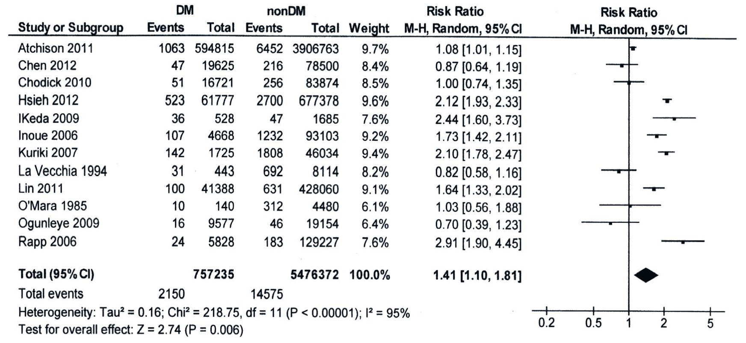

B
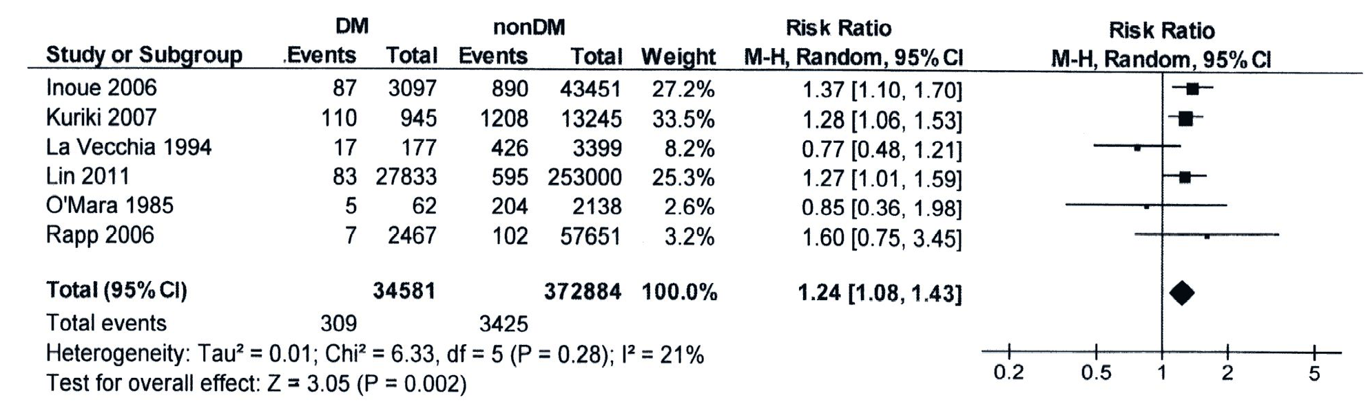
C
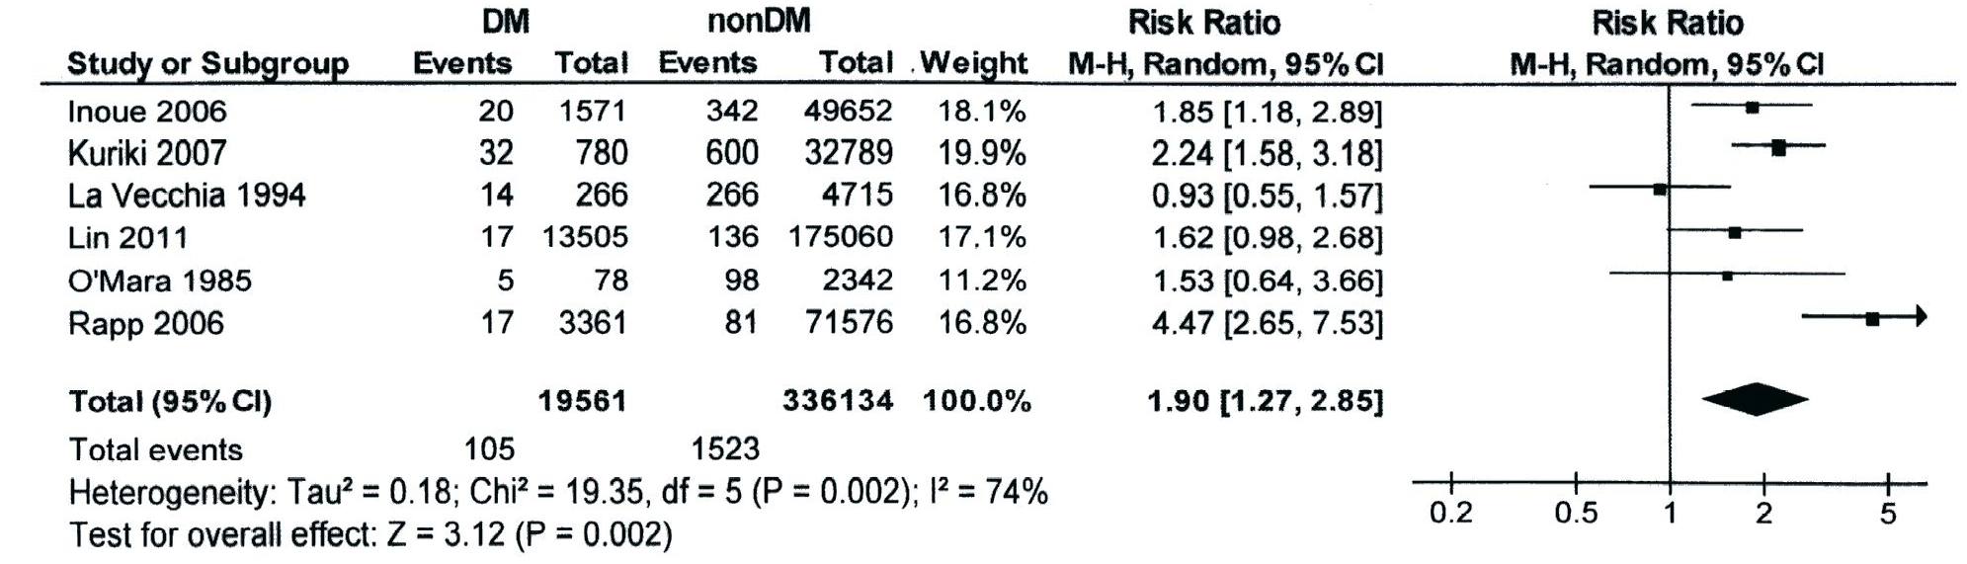

D
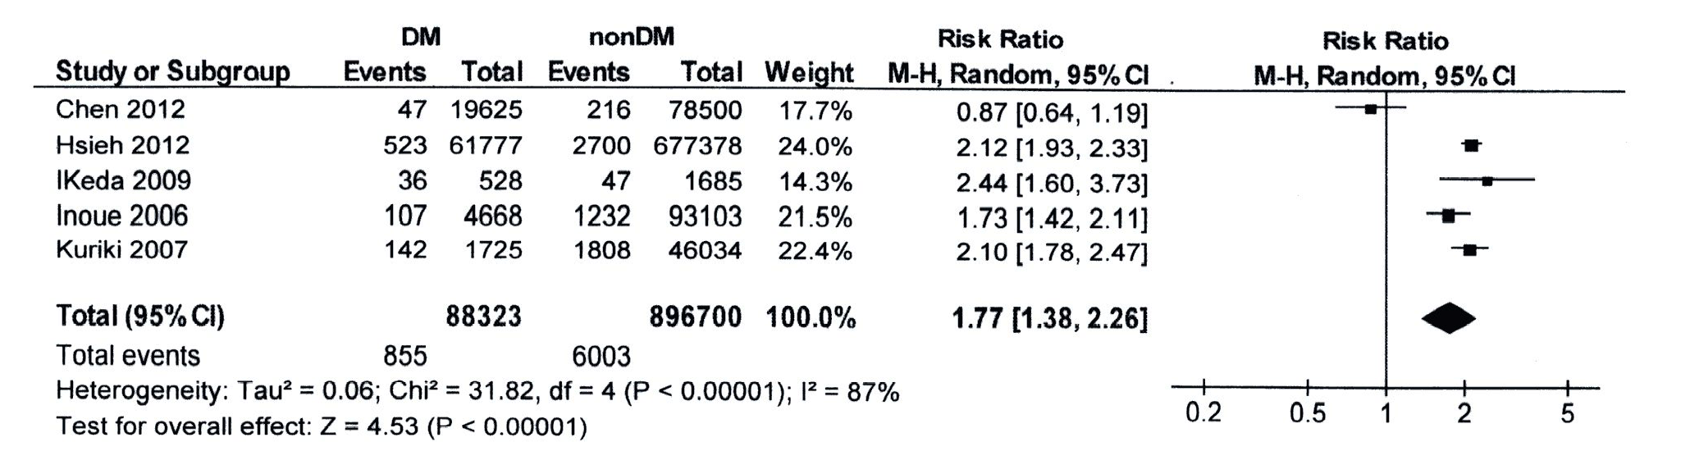

E
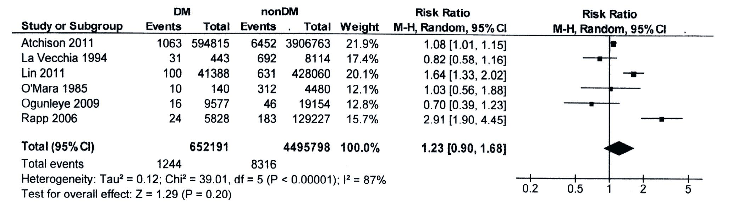
Figure 2 Forest plot representation-random-effects model of the all included publications. A: Stratified by sex; B: Male; C: Female, and stratified by geographical area; D: East Asia; E: The West. The individual block squares denote the risk ratio (RR) for each study of gastric cancer risk among diabetes mellitus (DM) patients, with an area proportional to the amount of statistical information in each study. The horizontal line denotes a 95%CI, ending with an arrowhead when CI extends beyond the scale. The pooled estimate and its 95%CI are represented by a diamond. Squares or diamonds plotted in the right half indicate increased gastric cancer risk. The risk is considered significant only if the horizontal line or diamond does not overlap the solid vertical line.

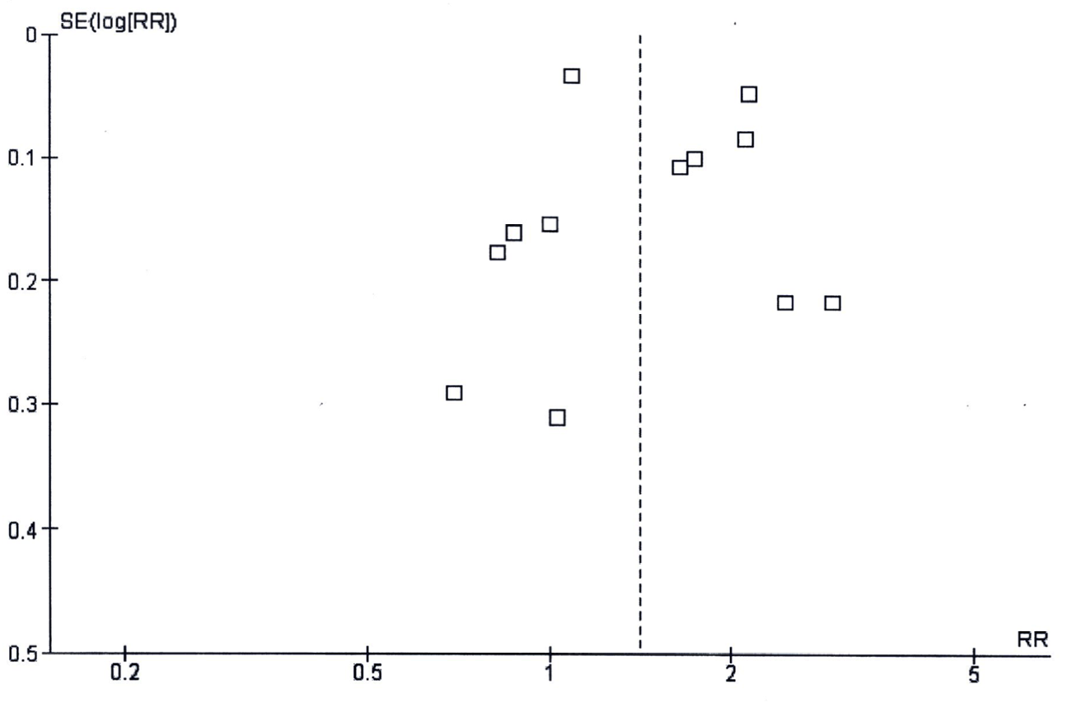
Figure 3 Funnel plot analysis of all the included publications.RR: risk ratio.

Table 1 Summary of included studies
Authors, Year | Country | Study population | Diagnosis of DM | RR of GC (95%CI) | Confounders or Adjustments
Atchison et al^{[24]} | United States | Veteran men | Hospital disease record | 0.95 (0.89-1.02) | age, time, latency, race, number of visits, alcohol, obesity, chronic obstructive pulmonary diseases
Chen et al^{[15]} | Taiwan | National Health Insurance database | Antidiabetic drug | 0.90 (0.65-1.23) | age, gastric polyp, partial gastrectomy, gastric ulcer, pneumoconiosis
Chodicket al^{[28]} | Israel | Healthcare service registry | Antidiabetic drug | Men 1.44 (0.98-2.11) Women 0.99 (0.55-1.80) | age, region, use of healthcare service, BMI, cardiovascular disease
Hsieh et al^{[23]} | Taiwan | National Health Insurance database | Ambulatory or inpatient care | 0.92 (0.84-1.01) | age, sex
Ikeda et al^{[21]} | Japan | Hisayama, population-based | Oral glucose tolerance test, fasting plasma glucose | 2.13(1.30-3.47)¹ 2.69 (1.24-5.85)² | age, sex, helicobacter pylori, peptic ulcer, BMI, total cholesterol, alcohol, smoking, dietary factors
Inoue et al^{[16]} | Japan | Public Health Center-based prospective study | Questionnaire | Men 1.23 (0.98-1.54) Women 1.61 (1.02-2.54) | age, study area, cerebrovascular disease, ischemic heart disease, smoking, alcohol, BMI, physical activity, green vegetable intake, coffee intake
Kuriki et al^{[22]} | Japan | Hospital-based epidemiologic research program | Questionnaire | Men 1.16 (0.93-1.44) Women 1.70 (1.16-2.48) | age, BMI, drinking and smoking, physical activity, bowel movement, family history of cancer or diabetes, dietary restriction, raw vegetable intake, greasy food intake
La Vecchia, et al^{[26]} | Italy | Case-control study | Questionnaire | 0.6 (0.4-0.9) | age, sex
Ge et al^{[19]} | United States | National Institutes of Health American Association of Retired Ppersons diet and health study | Questionnaire | Cardia 1.89 (1.43-2.50) Noncardia 0.98 (0.70-1.37) | age, sex, calories, alcohol, smoking, fruit intake, vegetable intake, ethnicity, education, physical activity
O'Mara et al^{[25]} | United States | Case-control study | Questionnaire | Men 0.7 (ND) Women 1.2 (ND) | age
Ogunleye et al^{[27]} | United Kingdom | Health Informatics Center | Registry | 0.73 (0.41-1.29) | deprivation decile
Rapp et al^{[11]} | Austria | Vorarlberg Health Monitoring and Promotion Programme | Fasting blood glucose | Men 0.84 (0.38-1.87)³ Women 1.16 (0.66-2.05)⁴ | age, smoking, occupational group, BMI

¹Hemoglobin A1c, 6.0%-6.9%; ²Hemoglobin A1c, equal or more than 7.0%; ³Fasting blood glucose, equal or more than 7 mmol/L; ⁴Fasting blood glucose, 6.1-6.9 mmol/L.
RR: relative risk; GC: gastric cancer; ND: not described; BMI: body mass index.

