ORIGINAL ARTICLES
Notch2 regulates MMP9 via PI3K/AKT signaling in human gastric carcinoma cell MKN-45

Lingyun Guo et al. Notch2 and gastric cancer

Lingyun Guo, Yumin Li, Liang Qiao, Tao Liu, Yuanyuan Du, Junqiang Zhang, Wenting He, Yongxun Zhao , Dongqiang He

Lingyun Guo, Yuanyuan Du, Junqiang Zhang, Yongxun Zhao, Dongqiang He the Second Clincal Medical school of Lanzhou University, the Second Hospital of Lanzhou University, Lanzhou 730030, Gansu Province, China.

Yumin Li, Department of General surgery, the Second Hospital of Lanzhou University, Key Laboratory of Digestive System Tumors , Lanzhou 730030, Gansu Province, China

Liang Qiao, Storr Liver Unit at the Westmead Millennium Institute, the University of Sydney at Westmead Hospital, Westmead, NSW 2145, Australia

Tao Liu, Wenting He, the Second Hospital of Lanzhou University, Key Laboratory of Digestive System Tumors , Lanzhou 730030, Gansu Province, China

Yongxun Zhao, Department of Oncological Surgery, the First Hospital of Lanzhou University, Lanzhou 730000, Gansu Province, China

Author contributions: Lingyun Guo, Junqiang Zhang and Yongxun Zhao performed the majority of experiments; Tao Liu and Wenting He provided vital reagents and analytical tools and were also involved in editing the manuscript; Yuanyuan Du, Lingyun Guo and Dongqiang He analyzed and interpreted data; Yumin Li, Liang Qiao and Lingyun Guo designed the study ,wrote and edited the manuscript.

Supported by the National Natural Science Foundation of China (Grant ID: 30870364); Foundation of Key Laboratory of Digestive System Tumors, Gansu Province (Grant ID: lzujbky-2011-t03)

Correspondence to: Professor Yumin Li, Department of General surgery, The Second Hospital of Lanzhou University, Key Laboratory of Digestive System Tumors, Lanzhou 730030, Gansu Province, China, Email: liym@lzu.edu.cn,
Telephone: +86-138-93615421, Fax: +86-931-8943092

Received: Revised: Accepted:
Published online:

Abstract

AIM: To clarify the role of activated Notch2 in the invasiveness of gastric cancer.

METHODS: To investigate the invasiveness of silencing Notch2 gene expression, we established a Notch2 siRNA transfected cell line using the MKN-45 gastric cancer cell line. After confirming the successful transfection by real-time reverse transcription-polymerase chain reaction (RT-PCR) and Western blotting, migration and invasion assays were employed to evaluate the aggressiveness. RT-PCR and Western blots were employed to confirm the down-regulation of Notch2 and to evaluate the expression of epithelial mesenchymal transition (EMT)-Related gene MMP9(Matrix metallopeptidase 9), Akt, p-Akt. To confirm the relationship between PI3K-Akt and MMP9, the PI3K inhibitor LY294002 was used to treat MKN-45 cells.

RESULTS: Notch2 expression was dramatically decreased after Notch2 siRNA transfection(1.0000±0.0974% vs. 0.1161±0.0385% p<0.01 by qRT-PCR). there was also a marked reduction of Notch target gene Hes1 (1.0000±0.0474% vs. 0.6161±0.0358% p<0.05) at the mRNA, indicating an inhibition of Notch signaling. Inhibition of Notch signaling was also confirmed by the marked reduction of Notch2 intracellular domain (N2ICD) at the protein levels(100.00±9.74% vs. 65.61±7.58% p<0.05). Down-regulation of Notch2 by siRNA also increased tumor cell invasion(100.00±21.64% vs. 162.22±16.84% p<0.05), enhanced expression of MMP9 (1.56-fold p<0.05) and activated the pro-MMP9 protein to its active form(1.48-fold p<0.05), There were no significant differences in the protein levels of Akt between the two groups(100.00±10.87% vs. 96.61±7.33% p>0.05), while down-regulation of Notch2 elevated p-Akt expression(100.00±9.87% vs. 154.61±13.10% p<0.05). Furthermore, p-Akt and MMP9 was downregualted in response to the inhibitor LY294002(p-Akt 100.00±8.87% vs. 58.27±5.01% p<0.05; MMP9 100.00±9.17% vs. 50.03±4.88% p<0.05).

CONCLUSIONS: Progression to invasion may be associated with elevated p-Akt expression mediated via Notch2 silencing. The results suggest that Notch2 may negatively regulate cell invasion by inhibiting the PI3K-Akt signaling pathway in gastric cancer.

© 2011 Baishideng. All rights reserved.

Key words: Notch2; Stomach; Cancer; Invasion; Epithelial mesenchymal transition; MMP9; RNA interference

Peer reviewer:

Available from:

DOI:

INTRODUCTION
Gastric carcinoma is one of the most common malignancies and one of the most important causes of the cancer-related death worldwide ^{[1]}. Most of the current available therapeutic approaches for advanced gastric cancer such as chemotherapy and chemoembolization are less optimal, thus the prognosis of gastric cancer is rather poor. This is largely attributable to a lack of complete understanding of the exact cause and mechanisms leading to this malignancy. Hence, identification of critical molecular pathways leading to the development of gastric cancer would greatly facilitate the development of more effect therapies.
Notch signaling pathway is involved in several cellular processes, such as proliferation, differentiation, apoptosis, cell fate decision, and maintenance of stem cells^{[2-5]}. It also plays an important role in the control of tumorigenesis. Activated Notch receptor can be oncogenic or tumor suppressive depending on the tumour type and cellular context^{[6]}. However, the mechanisms by which Notch signaling activates or suppresses tumorigenesis remain unclear. Recently, activation of Notch signaling pathway has been found to stimulate tumorigenesis via regulating epithelial mesenchymal transition (EMT) ^{[7]} .
EMT is a unique process by which epithelial cells undergo remarkable morphologic changes characterized by a transition from epithelial cobblestone phenotype to mesenchymal phenotype leading to increased motility and invasion ^{[4]}. During the acquisition of EMT characteristics, epithelial cells lose cell-cell junction, which is associated with actin cytoskeleton reorganization, expression of proteins that promote cell-cell contact, and appearance of the expression of mesenchymal markers. Recently, Notch signaling pathway was found to be involved in the acquisition of EMT in both physiological and pathological processes^{[8]}. However, how Notch signaling regulates EMT is largely unknown.
The Notch pathway includes a conserved family of transmembrane receptors (Notch1-4) that interact with a number of speciﬁc ligands (DLL1, DLL3, DLL4, Jagged1 and Jagged2) to regulate cell fate. Notch signaling initiates following the binding of the Notch ligands to the Notch receptors causing an enzymatic cleavage of Notch receptors by -secretase to release the intracellular domain of the Notch receptor (NICD). NICD is the active form of Notch receptors which can translocate into the nucleus, where it assembles a large transcriptional activation complex that interacts with the conserved transcription factor CSL (CBF-1, Su (H) and Lag-2), and then activates the transcription of CSL-dependent downstream targets^{[9]}. Many target genes of Notch signaling have been identiﬁed in various cell contexts, but the Hairy/Enhancer of Split (Hes) family of basic helix-loop-helix (bHLH) proteins are believed to be the direct Notch targets, including Hes1 and Hey1.
Among the Notch signaling genes, Notch2 appears to function as a biological antagonist for Notch1 in many cancers, such as breast cancer^{[10]}, colorectal cancer^{[11]}, malignant mesothelioma^{[12]}, multiple myeloma^{[13]}, and embryonal brain tumors^{[14]}. Although major advances were made in the understanding of the opposite effects of Notch2 and Notch1 in cancer development, the exact molecular mechanisms leading to a biological interaction between Notch1 and Notch2 remain unclear, and no study has been done on the possible relationship between Notch1 and Notch2 in gastric cancer.
Notch2 signal pathway plays potential oncogenic or tumor suppressive roles in several malignancies, for oncogenic roles, hematologic malignancies including multiple myeloma ^{[15]}, B cell chronic lymphocytic leukemia, and B cell and T cell acute lymphoblastic leukemia ^{[16]} ^{[17]}, solid tumors such as glioblastoma ^{[18]}, colon cancer ^{[19]}. For tumor suppressive roles, solid tumors such as breast cancer ^{[20]}, and small cell lung cancer ^{[21]} ^{[22]}. In gastric cancer, Notch2 has been proved to be overexpressed by Li et al ^{[23]} and He ^{[24]}.
In this study, we aimed to address whether Notch2 is also involved in control of gastric cancer progression and investigate the effects of Notch2 signaling on gastric cancer aggressiveness.

MATERIALS AND METHODS
Cell culture and transfections
Human gastric cancer cell line MKN-45 (Cell Collection of the Chinese Academy of Science, Shanghai, China) was cultured in RPMI 1640 (HyClone Laboratories Inc., Logan, USA) supplemented with 10% fetal bovine serum (FBS) (HyClone Laboratories Inc., Logan, USA), 100U/ml penicillin and streptomycin, in a 5% CO2 atmosphere at 37°C.
Small interfering RNA (siRNA) knockdown of Notch2
MKN-45 cells were transfected with siRNA against Notch2 and scrambled siRNA (Santa Cruz Biotechnology, CA, USA) constructs using the commercial transfection reagent (Santa Cruz Biotechnology, CA, USA) according to the manufacturer’s instructions. Following transfection, cells were incubated at 37°C in a CO2 incubator for 48 h before being harvested for the assays described below.
Real-time quantitative reverse transcription-PCR (qPCR) analysis for gene expression
Total RNA was isolated by the RNAiso plus reagent (TaKaRa Biotechnology Co., Dalian, China) and then reverse transcribed into complimentary DNA (cDNA) using the Primescript™ reverse transcription (RT) Master Mix (TaKaRa Biotechnology Co., Dalian, China) according to manufacturer’s instructions. Reverse transcription reaction was performed at 37°C for 15 minutes followed by 85°C for 5 seconds. The primers used in the PCR reactions are described in Table 1. One L of reverse transcription reaction product was used for qPCR reaction in a total volume of 20μL. The qPCR cycles are as follows: 95°C for 30 seconds, followed by 40 cycles of 95°C for 5 seconds and 60°C for 34 seconds. PCR amplifications were undertaken in the Applied Biosystems 7500/7500 Fast Real-Time PCR Software (Applied Biosystems, CA, USA) using the SYBR® Premix Ex Taq™ Ⅱ (TaKaRa Biotechnology Co., Dalian, China). Data were analyzed according to the comparative Ct method and were normalized to GAPDH expression in each sample. All qPCR assays were performed in triplicate.
Protein extraction and Western blot analysis
Total protein was extracted from the treated cells using RIPA lysis buffer (Beyotime Biotechnology, Haimen, China) supplemented with 1 mM phenylmethanesulfonyl fluoride (PMSF). The protein concentration was measured by BCA protein assay system (Beyotime Biotechnology, Haimen, China). Total proteins (40-50μg) were separated by 10% SDS-polyacrylamide gel electrophoresis (SDS-PAGE) and transferred onto polyvinylideneﬂuoride (PVDF) membranes. The blots were blocked with 5% skim milk in Tris buffered saline containing 0.1% Tween-20 (TBST) for 2 h at room temperature, incubated with primary antibodies against N2ICD (Abcam Inc., Cambridge, UK) (1:1000), Hes1 (Abcam Inc., Cambridge, UK) (1:500), MMP9 (Abcam Inc., Cambridge, UK) (1:1000), Akt(Cell Signaling Technology, Inc., Danvers, MA, USA) (1:1000), and p-Akt (Cell Signaling Technology, Inc., Danvers, MA, USA) (1:1000). β-actin (Zhongshan Golden Bridge Biotech, Beijing, China) (1:10000) was used as a loading control. The membranes were reacted with respective primary antibodies for overnight at 4°C. After being washed in TBST for three times, the membranes were incubated with horseradish peroxidase (HRP)-conjugated anti-rabbit or anti-mouse IgG (Zhongshan Golden Bridge Biotech, Beijing, China)(1:10000)for 1 h at room temperature. The protein bands were detected using the SuperSignal West Pico Chemiluminescent Substrate (Thermo Fisher Scientific Inc., Rockford, IL, USA) and imaged using a VersaDoc Imaging System (Bio-Rad Laboratories Co., Ltd. Hercules, CA, USA). Densitometric analysis was performed using Quantity One software v4.62 (Bio-Rad Laboratories Co., Ltd. Hercules, CA, USA) and the results were presented as the mean of three independent experiments.
Migration and invasion assays in vitro
The effects of Notch2 siRNA on the migratory and invasive abilities of MKN-45 cells were assayed in 24-well plates using relevant kits (BD Biosciences, USA). Approximately 3×104 cells were seeded for the 12 h migration assay, and 3×105 cells for the 24 h invasion assay and the invasive activity of the Notch-2 siRNA-transfected MKN-45 cells was tested by using BD Falcon™ Cell culture inserts coated with BD Matrigel™ Basement Membrane Matrix (BD Biosciences, USA). Briefly, transfected MKN-45 cells were resuspended in serum-free medium and seeded into the upper chamber of the assay system. The bottom wells of the system were filled with complete grow medium. After 12 and 24 h of incubation, the migrated and invaded cells were washed twice with ice-cold PBS and then ﬁxed with 4% paraformaldehyde for 15 minutes and stained with methyl violet(0.01% v/v) for 30 minutes. The numbers of migrated or invaded cells were then counted from 5 random ﬁelds under 200 and 400 magniﬁcation.
MMP9 activity assay
The culture media from Notch2 siRNA- and scrambled siRNA-transfected MKN-45 cells grown in 6-well plates were collected, spun at 12,000g for 10 minutes at 4°C to remove cell debris, and the supernatant collected for MMP9 assay using a commercial ELISA kits (R&D Systems, Inc., Minneapolis, MN), as per the manufacturer’s instructions.

- Statistical analysis.
Data analysis was performed using SPSS19. 0 (IBM, Armonk, New York, USA) and displayed using Sigma Plot10. 0 (Systat Software Inc, San Jose, CA, USA).Comparison of the differences between the groups was performed using a one-way ANOVA followed by the Bonferroni correction. All data were expressed as the mean±SD. A p value of <0.05 was considered statistically significant.

RESULTS
Knockdown of Notch2 enhanced the migration and invasion of MKN-45 cells
After successful transfection of Notch2 siRNA into MKN-45 cells (Figure 1 A) and a marked knockdown of Notch2 (>90%) at mRNA (Figure 1,B) and protein (Figure 1, C, D) levels, there was a marked reduction of Notch target gene Hes1 at the mRNA (Figure 1, E), indicating an inhibition of Notch signaling. Inhibition of Notch signaling was also confirmed by the marked reduction of Notch2 intracellular domain (N2ICD) at the mRNA (Figure 1 D) and protein (Figure 1 C) levels.
In the cells with confirmed knockdown of Notch2, the ability of cells to migrate and invade were evaluated as described in the “Materials and Methods”. MKN-45 cells with Notch2 knockdown showed an increased cell migration (Figure 2, B, C) compared to cells transfected with scrambled siRNA(Scra, Figure 2, A, C). Similarly, MKN-45 cells with Notch2 knockdown showed an increased cell invasion (Figure 2, E, F) compared to cells transfected with scrambled siRNA(Scra, Figure 2, D, F).

Knockdown of Notch2 enhanced the expression and activity of MMP9 in MKN-45 cells
Tumor metastasis occurs by a series of steps, including cell invasion, degradation of basement membranes, and the stromal extracellular matrix, ultimately leading to tumor cell invasion and metastasis. The MMPs are a family of related enzymes that degrade extracellular matrix, which are considered to be important factors in facilitating tumor invasion and metastasis. Among these MMPs, MMP9 has been considered an important factorinvolved in the degradation of basement membrane collagen in facilitating invasion and metastases in gastric cancer. Knockdown of Notch2 in MKN-45 cells markedly enhanced the expression of MMP9 at mRNA (Figure 3, A) and protein (Figure 3, B, C) levels. Additionally, knockdown of Notch2 led to an 1.48-fold increase in MMP9 activity (Figure 3, D).

Effect of Notch2 knockdown on the expression of PI3K/Akt pathway in MKN-45 cells
In order to elucidate the mechanisms of Notch2 mediated alteration in MMP9, we measured the expression of PI3K downstream target Akt in MKN-45 cells transfected with or without Notch2 siRNA. Knockdown of Notch2 by siRNA led to increased Akt phosphorylation (Figure 4, A, B). Blocking the PI3K/Akt pathwayby PI3K inhibitor LY294002 resulted in a reduced expression of MMP9 (Figure 4, C, D).

DISCUSSION
Aberrant expression of Notch pathway has been found in a variety of human cancers, including cancers from breast, brain, cervix, lung, colon, head and neck, kidney, bone marrow, lymph nodes and stomach ^{[25-27]}. Abnormal Notch signaling also has been linked to EMT. Notch signaling is known to suppress apoptosis and promote cell proliferation through a growth factor-mediated survival pathway ^{[28-30]}. However, the precise role and mechanism of Notch for tumor invasion remains unclear. In this study, we have showed that siRNA mediated down-regulation of Notch2 in gastric cancer cells could (1) increase tumor cell invasion; (2) enhance MMP9 expression and increase its activities, and(3)promote the phosphorylation of PI3K pathway as demonstrated by increased p-Akt level.
Tumor metastasis occurs by a series of steps, including cell invasion, degradation of basement membranes, and the stromal extracellular matrix, ultimately leading to tumor cell invasion and metastasis. The MMPs are a family of related enzymes that degrade extracellular matrix, which are considered to be important factors in facilitating tumor invasion and metastasis^{[31-33]}. Among these MMPs, MMP9 has been considered an important factorinvolved in the degradation of basement membrane collagen in facilitating invasion and metastases in gastric cancer^{[34, 35]}. MMP9 is a downstream target for PI3K/Akt pathway, which is an important signaling pathway in controlling cell proliferation ^{[36, 37]}. In physiological circumstances, MMP9 plays an important role in tissue remodeling associated with various physiological and pathological processes such as morphogenesis, angiogenesis, tissue repair, cirrhosis, arthritis, and metastasis ^{[38]}. MMP9 is required for maintaining normal tissue structure and epithelial integrity. Under the pathological conditions, particularly in various cancers, abnormal expression and activity of MMP9 have been reported ^{[34, 39-42]}. Abnormal function of MMP9 has been linked to tumor cell migration, invasion and metastasis^{[35, 39]}. The role of MMP9 in the development of gastric cancer has been reported that the expression of metalloproteinase-9 or its inhibitor is related to a more aggressive phenotype of gastric cancer or correlated with lymph node metastasis in advanced gastric carcinoma ^{[35, 43]}, but how MMP9 is regulated in gastric cancer is less clear.
Based on our study, we propose that physiological cellular level of Notch2 may be required for the maintenance of normal MMP9 function. Reduced Notch2 may enhance the proliferative and invasive potential of cancer cells, likely through activation of PI3K/Akt pathway and ensuing increase in MMP9 activities. In this perspective, Notch2 appears to function as a tumor suppressor gene in gastric cancer.
Here, we showed that the facilitation of MMP9 expression by down-regulation of Notch2 may be mediated by the upregulation of p-Akt. Thus, these results suggest that up-regulation of Notch2 could potentiate the antitumor and antimetastasis activities partly through the up-regulation of MMP expression. Because we observed that down-regulation of Notch2 promoted MMP9 expression, we tested the effects of Notch2 on the invasion of MKN-45 cells. We found that down-regulation of Notch2 promoted the cell invasion of MKN-45 cells. These results were consistent with MMP9 data, showing that down-regulation of Notch2 could promote cancer cell invasion partly through up-regulation of MMP9. On the basis of our results, we propose a hypothetical pathway by which Notch2 may inhibit invasion of MKN-45 cells, partly through PI3K-Akt signaling pathway.
Notch has been reported to cross-talk with other major cell growth and apoptotic regulatory pathways among which is PI3K-Akt pathway ^{[44]}. Hyperactivation of PI3K/Akt pathway has previously been observed in human gastric cancer ^{[45]}. It has recently been shown that activation of Notch1 enhanced the survival of melanoma cells^{[29]} and leukemia cells via activation of the PI3/Akt pathway^{[46]}. In our study, down-regulation of Notch2 by siRNA led to an activation of PI3K/Akt pathway, which is associated with an increased expression and function of MMP9, suggesting Notch2 can regulate MMP9 via PI3K/Akt pathway, increased Akt phosphorylation. Interestingly, we also observed that inactivation of Akt by LY294002 eliminated Akt phosphorylationand MMP9 expression. These results suggest Notch2 can induce Akt signaling.
In summary, the role of Notch2 in malignant tumor is uncertain. Although the overexpression of Notch2 has been confirmed, Notch2 also appears to function as a tumor suppressor gene in gastric cancer in this study. Further studies are warrented before Notch inhibitor based therapeutic approaches are employed in the treatment of advanced gastric cancer.

COMMENTS
Background
Notch is one of the most important signaling pathways involved in cell fate determination. Activation of the Notch pathway requires the binding of a membrane-bound ligand to the Notch receptor in the adjacent cell which induces proteolytic cleavages and the activation of the receptor. A unique feature of the Notch signaling is that processes such as modification, endocytosis or recycling of the ligand have been reported to play critical roles during Notch signaling, however, the underlying molecular mechanism appears context-dependent and often controversial.
Research frontiers
There are four Notch receptors (Notch 1-4) and five ligands [Jagged 1, Jagged 2, Delta-like ligand-1, -3 and -4 (DLL1, DLL3, DLL4)] in mammals. Recently, it’s reported to be involved in tumorigenesis as oncogenes or as tumor suppressors, and proposed as prognostic factors or anti-cancer targets in aggressive or advanced cancers.
This study was undertaken to investigate whether whether Notch2 is also involved in control of gastric cancer progression and investigate the effects of Notch2 signaling on gastric cancer aggressiveness.
Innovations and breakthroughs
Abnormal Notch signaling has been reported in many human solid tumors. This is the first study to characterize the role of Notch signaling on gastric cancer aggressiveness. This finding indicated that Notch2 may contribute to could negatively regulate cell invasion in human gastric carcinoma cells.
Terminology
Four Notch receptors (Notch 1-4) and five ligands (Jagged 1, Jagged 2, DLL1, DLL3, DLL4) are found in mammals. Ligand-receptor interaction between two neighboring cells is involved in developmental, physiologic and pathologic processes.
Peer review
The Notch signaling pathway plays crucial roles in the maintenance and in the development of several tissues. Ectopic expression of Notch has been found in a variety of human cancers. In this work, the authors indicate that Notch2 could negatively regulate cell invasion in human gastric carcinoma cells. By this way, the authors describe Notch2 as a tumor suppressor gene in gastric cancers. At the same time the authors detected an increased expression and activity of MMP9, arguing that such increase could be related to the enhanced migration and invasiveness. The results are clear and support the authors´ hypothesis.

REFERENCES

1 GLOBOCAN 2008. 2008 http://globocan.iarc.fr/factsheets/cancers/stomach.asp
2 Allenspach EJ, Maillard I, Aster JC, Pear WS. Notch signaling in cancer. Cancer Biol Ther 2002; 1: 466-476 [PMID: 12496471 DOI: 091802136 [pii]]
3 Bray SJ. Notch signalling: a simple pathway becomes complex. Nat Rev Mol Cell Bio 2006; 7: 678-689 [PMID: ISI:000240025300018 DOI: Doi 10.1038/Nrm2009]
4 Ranganathan P, Weaver KL, Capobianco AJ. Notch signalling in solid tumours: a little bit of everything but not all the time. Nat Rev Cancer 2011; 11: 338-351 [PMID: 21508972 DOI: nrc3035 [pii]
10.1038/nrc3035]
5 Hu YY, Zheng MH, Zhang R, Liang YM, Han H. Notch signaling pathway and cancer metastasis. Adv Exp Med Biol 2012; 727: 186-198 [PMID: 22399348 DOI: 10.1007/978-1-4614-0899-4_14]
6 South AP, Cho RJ, Aster JC. The double-edged sword of Notch signaling in cancer. Semin Cell Dev Biol 2012 [PMID: 22309843 DOI: S1084-9521(12)00027-4 [pii]
10.1016/j.semcdb.2012.01.017]
7 Sarkar FH, Wang ZW, Li YW, Kong DJ. The Role of Notch Signaling Pathway in Epithelial-Mesenchymal Transition (EMT) During Development and Tumor Aggressiveness. Curr Drug Targets 2010; 11: 745-751 [PMID: ISI:000277123000009]
8 de la Pompa JL, Timmerman LA, Grego-Bessa J, Raya A, Bertran E, Perez-Pomares JM, Diez J, Aranda S, Palomo S, McCormick F, Izpisua-Belmonte JC. Notch promotes epithelial-mesenchymal transition during cardiac development and oncogenic transformation. Gene Dev 2004; 18: 99-115 [PMID: ISI:000188195300010 DOI: Doi 10.1101/Gad.276304]
9 Koch U, Radtke F. Notch and cancer: a double-edged sword. Cell Mol Life Sci 2007; 64: 2746-2762 [PMID: 17687513 DOI: 10.1007/s00018-007-7164-1]
10 Liaw L, O'Neill CF, Urs S, Cinelli C, Lincoln A, Nadeau RJ, Leon R, Toher J, Mouta-Bellum C, Friesel RE. Notch2 signaling induces apoptosis and inhibits human MDA-MB-231 xenograft growth. Am J Pathol 2007; 171: 1023-1036 [PMID: ISI:000249146200029 DOI: DOI 10.2353/ajpath.2007.061029]
11 Chu D, Zhang Z, Zhou Y, Wang W, Li Y, Zhang H, Dong G, Zhao Q, Ji G. Notch1 and Notch2 have opposite prognostic effects on patients with colorectal cancer. Ann Oncol 2011; 22: 2440-2447 [PMID: 21378202 DOI: mdq776 [pii]
10.1093/annonc/mdq776]
12 Graziani I, Eliasz S, De Marco MA, Chen Y, Pass HI, De May RM, Strack PR, Miele L, Bocchetta M. Opposite effects of Notch-1 and Notch-2 on mesothelioma cell survival under hypoxia are exerted through the Akt pathway. Cancer Res 2008; 68: 9678-9685 [PMID: 19047145 DOI: 68/23/9678 [pii]
10.1158/0008-5472.CAN-08-0969]
13 Gabrilovich DI, Nefedova Y, Cheng PY, Alsina M, Dalton WS. Involvement of Notch-1 signaling in bone marrow stroma-mediated de novo drug resistance of myeloma and other malignant lymphoid cell lines. Blood 2004; 103: 3503-3510 [PMID: ISI:000221565600049]
14 Eberhart CG, Fan X, Mikolaenko I, Elhassan I, Ni XZ, Wang YY, Ball D, Brat DJ, Perry A. Notch1 and Notch2 have opposite effects on embryonal brain tumor growth. Cancer Res 2004; 64: 7787-7793 [PMID: ISI:000224790600023]
15 Zweidler-McKay PA, He Y, Xu L, Rodriguez CG, Karnell FG, Carpenter AC, Aster JC, Allman D, Pear WS. Notch signaling is a potent inducer of growth arrest and apoptosis in a wide range of B-cell malignancies. Blood 2005; 106: 3898-3906 [PMID: 16118316 PMCID: 1895093 DOI: 2005-01-0355 [pii]
10.1182/blood-2005-01-0355]
16 Troen G, Wlodarska I, Warsame A, Hernandez Llodra S, De Wolf-Peeters C, Delabie J. NOTCH2 mutations in marginal zone lymphoma. Haematologica 2008; 93: 1107-1109 [PMID: 18508802 DOI: haematol.11635 [pii]
10.3324/haematol.11635]
17 Jundt F, Probsting KS, Anagnostopoulos I, Muehlinghaus G, Chatterjee M, Mathas S, Bargou RC, Manz R, Stein H, Dorken B. Jagged1-induced Notch signaling drives proliferation of multiple myeloma cells. Blood 2004; 103: 3511-3515 [PMID: 14726396 DOI: 10.1182/blood-2003-07-2254
2003-07-2254 [pii]]
18 Fan X, Khaki L, Zhu TS, Soules ME, Talsma CE, Gul N, Koh C, Zhang J, Li YM, Maciaczyk J, Nikkhah G, Dimeco F, Piccirillo S, Vescovi AL, Eberhart CG. NOTCH pathway blockade depletes CD133-positive glioblastoma cells and inhibits growth of tumor neurospheres and xenografts. Stem Cells 2010; 28: 5-16 [PMID: 19904829 PMCID: 2878196 DOI: 10.1002/stem.254]
19 Zagouras P, Stifani S, Blaumueller CM, Carcangiu ML, Artavanis-Tsakonas S. Alterations in Notch signaling in neoplastic lesions of the human cervix. Proc Natl Acad Sci U S A 1995; 92: 6414-6418 [PMID: 7604005 PMCID: 41528]
20 Parr C, Watkins G, Jiang WG. The possible correlation of Notch-1 and Notch-2 with clinical outcome and tumour clinicopathological parameters in human breast cancer. Int J Mol Med 2004; 14: 779-786 [PMID: 15492845]
21 Sriuranpong V, Borges MW, Ravi RK, Arnold DR, Nelkin BD, Baylin SB, Ball DW. Notch signaling induces cell cycle arrest in small cell lung cancer cells. Cancer Res 2001; 61: 3200-3205 [PMID: 11306509]
22 Zheng Q, Qin H, Zhang H, Li J, Hou L, Wang H, Zhang X, Zhang S, Feng L, Liang Y, Han H, Yi D. Notch signaling inhibits growth of the human lung adenocarcinoma cell line A549. Oncol Rep 2007; 17: 847-852 [PMID: 17342326]
23 Li H, Sun Y, Gao X, Liu J, Kong QY, Wang XW, Chen XY, Wang Q, Cheng YF, Qu XX. Differential Notch1 and Notch2 Expression and Frequent Activation of Notch Signaling in Gastric Cancers. Arch Pathol Lab Med 2011; 135: 451-458 [PMID: ISI:000289217200012]
24 He W. The expression of the key factor of Notch Pathway and effects of Notch receptor-blocker on gastric cancer cell. Lanzhou: Lanzhou University, 2011.
25 Qian C, Yao J. Over-activated Notch-1 protects gastric carcinoma BGC-823 cells from TNF alpha-induced apoptosis. Digest Liver Dis 2009; 41: 867-874 [PMID: ISI:000272909800007 DOI: DOI 10.1016/j.dld.2009.03.013]
26 Yeh TS, Wu CW, Hsu KW, Liao WJ, Yang MC, Li AFY, Wang AM, Kuo ML, Chi CW. The Activated Notch1 Signal Pathway Is Associated with Gastric Cancer Progression through Cyclooxygenase-2. Cancer Res 2009; 69: 5039-5048 [PMID: ISI:000267506400017 DOI: Doi 10.1158/0008-5472.Can-08-4021]
27 Tseng YC, Tsai YH, Tseng MJ, Hsu KW, Yang MC, Huang KH, Li AFY, Chi CW, Hsieh RH, Ku HH, Yeh TS. Notch2-induced COX-2 expression enhancing gastric cancer progression. Mol Carcinogen 2011
28 Jundt F, Anagnostopoulos I, Forster R, Mathas S, Stein H, Dorken B. Activated Notch1 signaling promotes tumor cell proliferation and survival in Hodgkin and anaplastic large cell lymphoma. Blood 2002; 99: 3398-3403 [PMID: 11964309]
29 Liu ZJ, Xiao M, Balint K, Smalley KS, Brafford P, Qiu R, Pinnix CC, Li X, Herlyn M. Notch1 signaling promotes primary melanoma progression by activating mitogen-activated protein kinase/phosphatidylinositol 3-kinase-Akt pathways and up-regulating N-cadherin expression. Cancer Res 2006; 66: 4182-4190 [PMID: 16618740 DOI: 66/8/4182 [pii]
10.1158/0008-5472.CAN-05-3589]
30 Wang Z, Zhang Y, Li Y, Banerjee S, Liao J, Sarkar FH. Down-regulation of Notch-1 contributes to cell growth inhibition and apoptosis in pancreatic cancer cells. Mol Cancer Ther 2006; 5: 483-493 [PMID: 16546962 DOI: 5/3/483 [pii]
10.1158/1535-7163.MCT-05-0299]
31 Matsumura S, Oue N, Nakayama H, Kitadai Y, Yoshida K, Yamaguchi Y, Imai K, Nakachi K, Matsusaki K, Chayama K, Yasui W. A single nucleotide polymorphism in the MMP-9 promoter affects tumor progression and invasive phenotype of gastric cancer. J Cancer Res Clin Oncol 2005; 131: 19-25 [PMID: 15565457 DOI: 10.1007/s00432-004-0621-4]
32 Tian B, Li Y, Ji XN, Chen J, Xue Q, Ye SL, Liu YK, Tang ZY. Basement membrane proteins play an active role in the invasive process of human hepatocellular carcinoma cells with high metastasis potential. J Cancer Res Clin Oncol 2005; 131: 80-86 [PMID: 15480781 DOI: 10.1007/s00432-004-0614-3]
33 Valastyan S, Weinberg RA. Tumor metastasis: molecular insights and evolving paradigms. Cell 2011; 147: 275-292 [PMID: 22000009 PMCID: 3261217 DOI: S0092-8674(11)01085-3 [pii]
10.1016/j.cell.2011.09.024]
34 Zheng H, Takahashi H, Murai Y, Cui Z, Nomoto K, Niwa H, Tsuneyama K, Takano Y. Expressions of MMP-2, MMP-9 and VEGF are closely linked to growth, invasion, metastasis and angiogenesis of gastric carcinoma. Anticancer Res 2006; 26: 3579-3583 [PMID: 17094486]
35 de Mingo M, Moran A, Sanchez-Pernaute A, Iniesta P, Diez-Valladares L, Perez-Aguirre E, de Juan C, Garcia-Aranda C, Diaz-Lopez A, Garcia-Botella A, Martin-Antona E, Benito M, Torres A, Balibrea JL. Expression of MMP-9 and TIMP-1 as prognostic markers in gastric carcinoma. Hepatogastroenterology 2007; 54: 315-319 [PMID: 17419282]
36 Shukla S, Maclennan GT, Hartman DJ, Fu P, Resnick MI, Gupta S. Activation of PI3K-Akt signaling pathway promotes prostate cancer cell invasion. Int J Cancer 2007; 121: 1424-1432 [PMID: 17551921 DOI: 10.1002/ijc.22862]
37 Chen JS, Wang Q, Fu XH, Huang XH, Chen XL, Cao LQ, Chen LZ, Tan HX, Li W, Bi J, Zhang LJ. Involvement of PI3K/PTEN/AKT/mTOR pathway in invasion and metastasis in hepatocellular carcinoma: Association with MMP-9. Hepatol Res 2009; 39: 177-186 [PMID: 19208038 DOI: HEP449 [pii]
10.1111/j.1872-034X.2008.00449.x]
38 Wroblewski LE, Pritchard DM, Carter S, Varro A. Gastrin-stimulated gastric epithelial cell invasion: the role and mechanism of increased matrix metalloproteinase 9 expression. Biochem J 2002; 365: 873-879 [PMID: 11971760 PMCID: 1222716 DOI: 10.1042/BJ20020068
BJ20020068 [pii]]
39 Lee LY, Wu CM, Wang CC, Yu JS, Liang Y, Huang KH, Lo CH, Hwang TL. Expression of matrix metalloproteinases MMP-2 and MMP-9 in gastric cancer and their relation to claudin-4 expression. Histol Histopathol 2008; 23: 515-521 [PMID: 18283635]
40 Pellikainen JM, Ropponen KM, Kataja VV, Kellokoski JK, Eskelinen MJ, Kosma VM. Expression of matrix metalloproteinase (MMP)-2 and MMP-9 in breast cancer with a special reference to activator protein-2, HER2, and prognosis. Clin Cancer Res 2004; 10: 7621-7628 [PMID: 15569994 DOI: 10/22/7621 [pii]
10.1158/1078-0432.CCR-04-1061]
41 Hashimoto T, Wen G, Lawton MT, Boudreau NJ, Bollen AW, Yang GY, Barbaro NM, Higashida RT, Dowd CF, Halbach VV, Young WL. Abnormal expression of matrix metalloproteinases and tissue inhibitors of metalloproteinases in brain arteriovenous malformations. Stroke 2003; 34: 925-931 [PMID: 12649522 DOI: 10.1161/01.STR.0000061888.71524.DF
01.STR.0000061888.71524.DF [pii]]
42 Sakata K, Shigemasa K, Nagai N, Ohama K. Expression of matrix metalloproteinases (MMP-2, MMP-9, MT1-MMP) and their inhibitors (TIMP-1, TIMP-2) in common epithelial tumors of the ovary. Int J Oncol 2000; 17: 673-681 [PMID: 10995877]
43 Czyzewska J, Guzinska-Ustymowicz K, Kemona A, Bandurski R. The expression of matrix metalloproteinase 9 and cathepsin B in gastric carcinoma is associated with lymph node metastasis, but not with postoperative survival. Folia Histochem Cytobiol 2008; 46: 57-64 [PMID: 18296264 DOI: H31U31J16155404R [pii]
10.2478/v10042-008-0007-6]
44 Wang ZW, Li YW, Banerjee S, Kong DJ, Ahmad A, Nogueira V, Hay N, Sarkar FH. Down-Regulation of Notch-1 and Jagged-1 Inhibits Prostate Cancer Cell Growth, Migration and Invasion, and Induces Apoptosis Via Inactivation of Akt, mTOR, and NF-kappa B Signaling Pathways. J Cell Biochem 2010; 109: 726-736 [PMID: ISI:000275559000011 DOI: Doi 10.1002/Jcb.22451]
45 Yu HG, Ai YW, Yu LL, Zhou XD, Liu J, Li JH, Xu XM, Liu S, Chen J, Liu F, Qi YL, Deng Q, Cao J, Liu SQ, Luo HS, Yu JP. Phosphoinositide 3-kinase/Akt pathway plays an important role in chemoresistance of gastric cancer cells against etoposide and doxorubicin induced cell death. Int J Cancer 2008; 122: 433-443 [PMID: 17935137 DOI: 10.1002/ijc.23049]
46 Palomero T, Dominguez M, Ferrando AA. The role of the PTEN/AKT Pathway in NOTCH1-induced leukemia. Cell Cycle 2008; 7: 965-970 [PMID: 18414037 PMCID: 2600414 DOI: 5753 [pii]]

Figure 1 Verification of successful transfection and knockdown of Notch2. *: p<0.05; **: p<0.01, compared to the Mock or Scra groups. Scra, scrambled siRNA

Figure 2 Knockdown of Notch2led to an increased migration and invasion of MKN-45 cells. Cells were transfected with scrambled siRNA (Scra, A, D) or Notch2 siRNA(B, E) for 48 h, and the effect of the migration (A, B, C) and invasion (D, E, F) were assayed as described in “Materials and Methods”. The number of migrated cells or invaded cells were quantitated (C, F, respectively)(x 200 and x 400).*: p<0. 05 compared to the Scra groups.

Figure 3 Knockdown of Notch2 enhanced the expression and activity of MMP9. The siRNA mediated knockdown of Notch2 (A) and N2ICD (B, C) was associated with a marked increase in the expression (A, B, C) and activity (D) of MMP9. *: p<0.05, compared to the blank control groups.

Figure 4 Knockdown of Notch2 enhanced the expression of MMP9 via increased phosphorylation of p-Akt in MKN-45 cells. Knockdown of Notch2 led to an increased phosphorylation of Akt (p-Akt, A, B). Blockade of PI3K/Akt pathway by LY294002 (20μM)abolished the effect of Notch siRNA on Akt phosphorylation and MMP9 (C, D).*: p<0.05, compared to the all control groups.

Table 1. Primer sequences used for the real-time PCR analysis

Primer | Sense (5’-3’) |  | Anti-sense (5’-3’)
Notch2 |  | CCTGGGCTATACTGGGAGCTACTG |  | ACACCCTGATAGCCTGGGACAC
MMP9 |  | ACGCACGACGTCTTCCAGTA |  | CCACCTGGTTCAACTCACTCC
Hes1 |  | AGCGGGCGCAGATGAC |  | CGTTCATGCACTCGCTGAA
GAPDH |  | GCACCGTCAAGGCTGAGAAC |  | TGGTGAAGACGCCAGTGGA

Fig 1 A

Fig 1 B
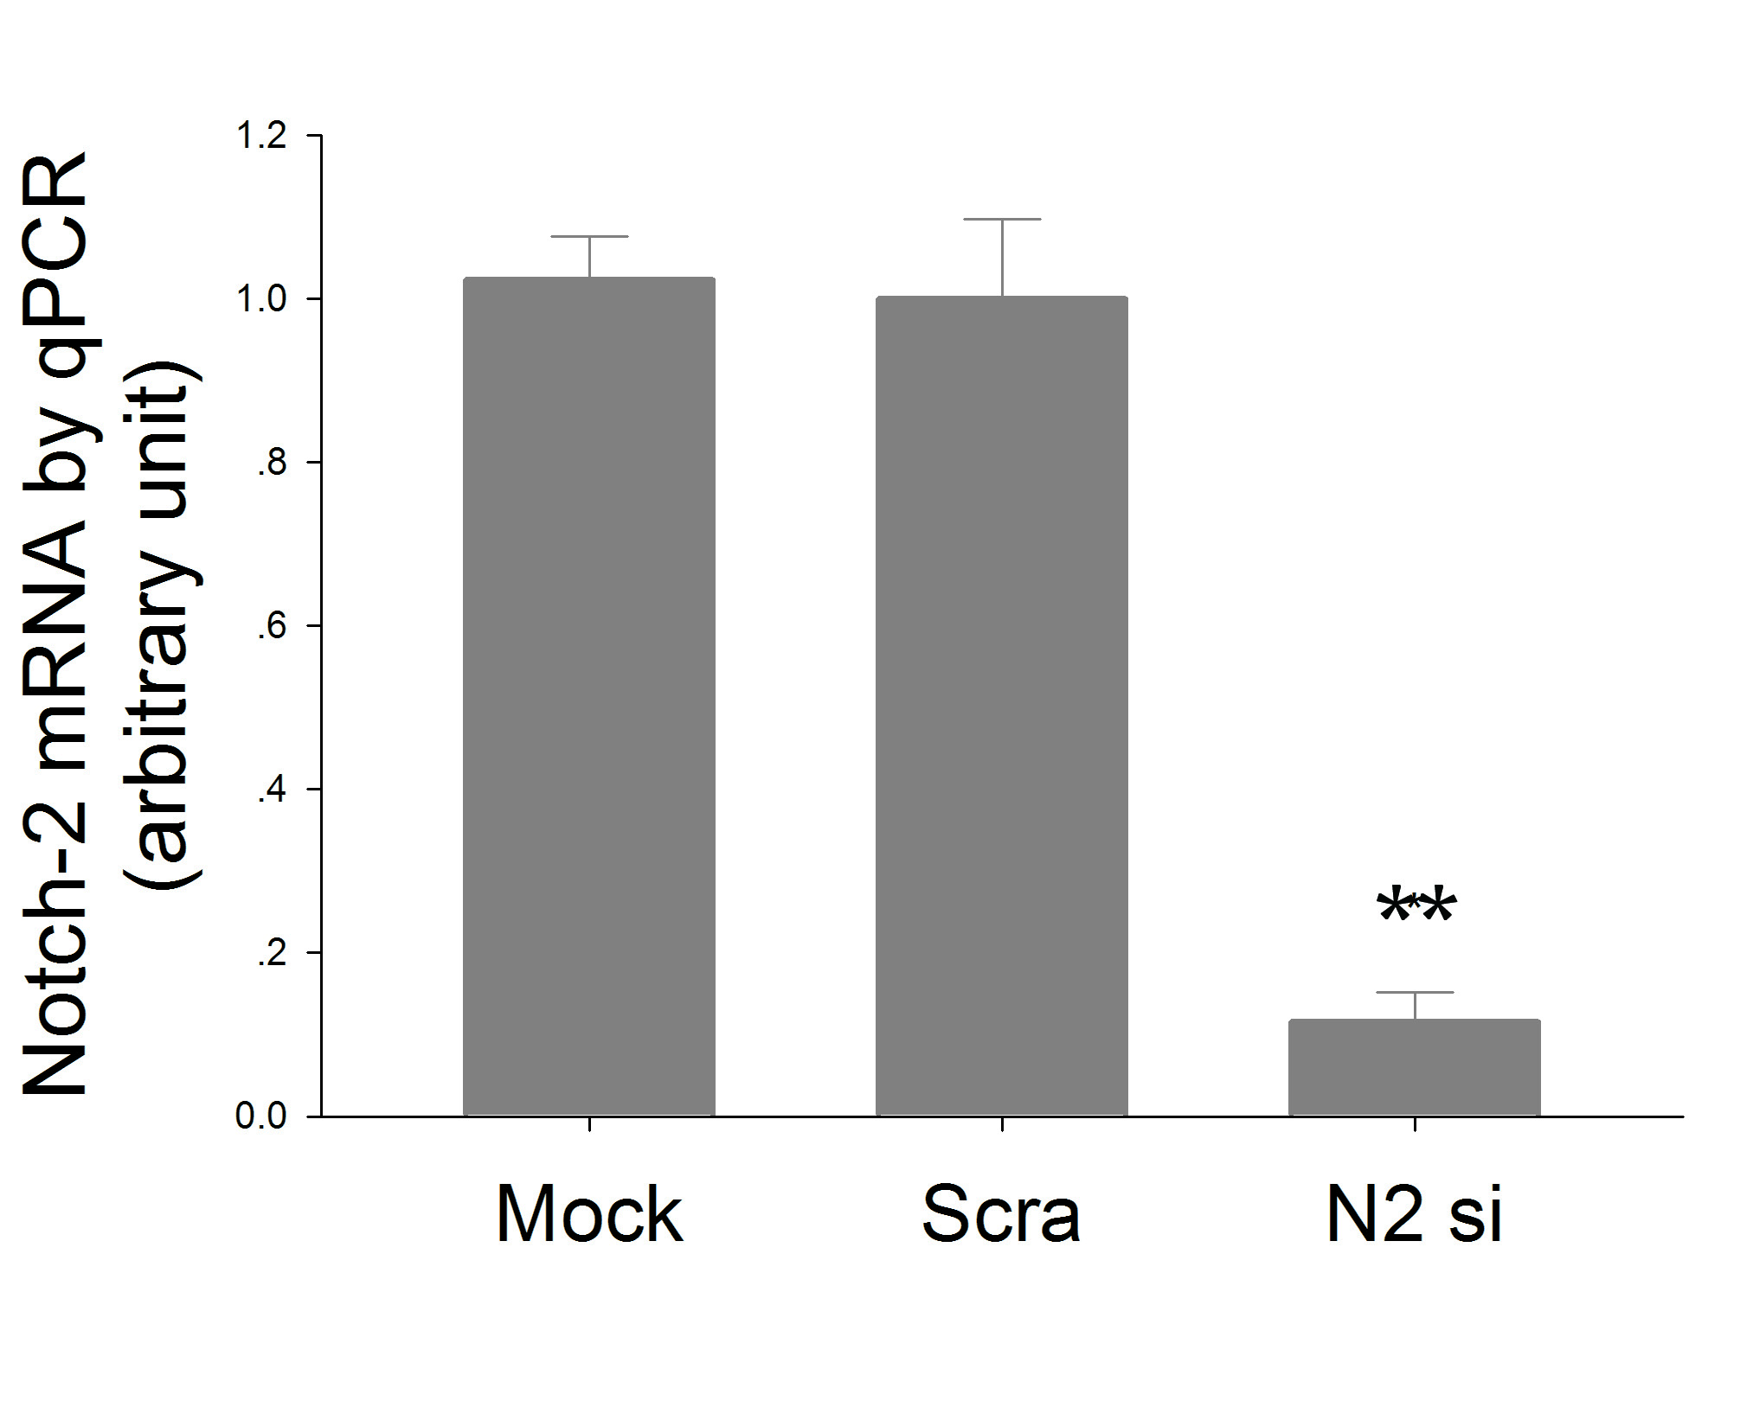

Fig 1 C

Fig 1D
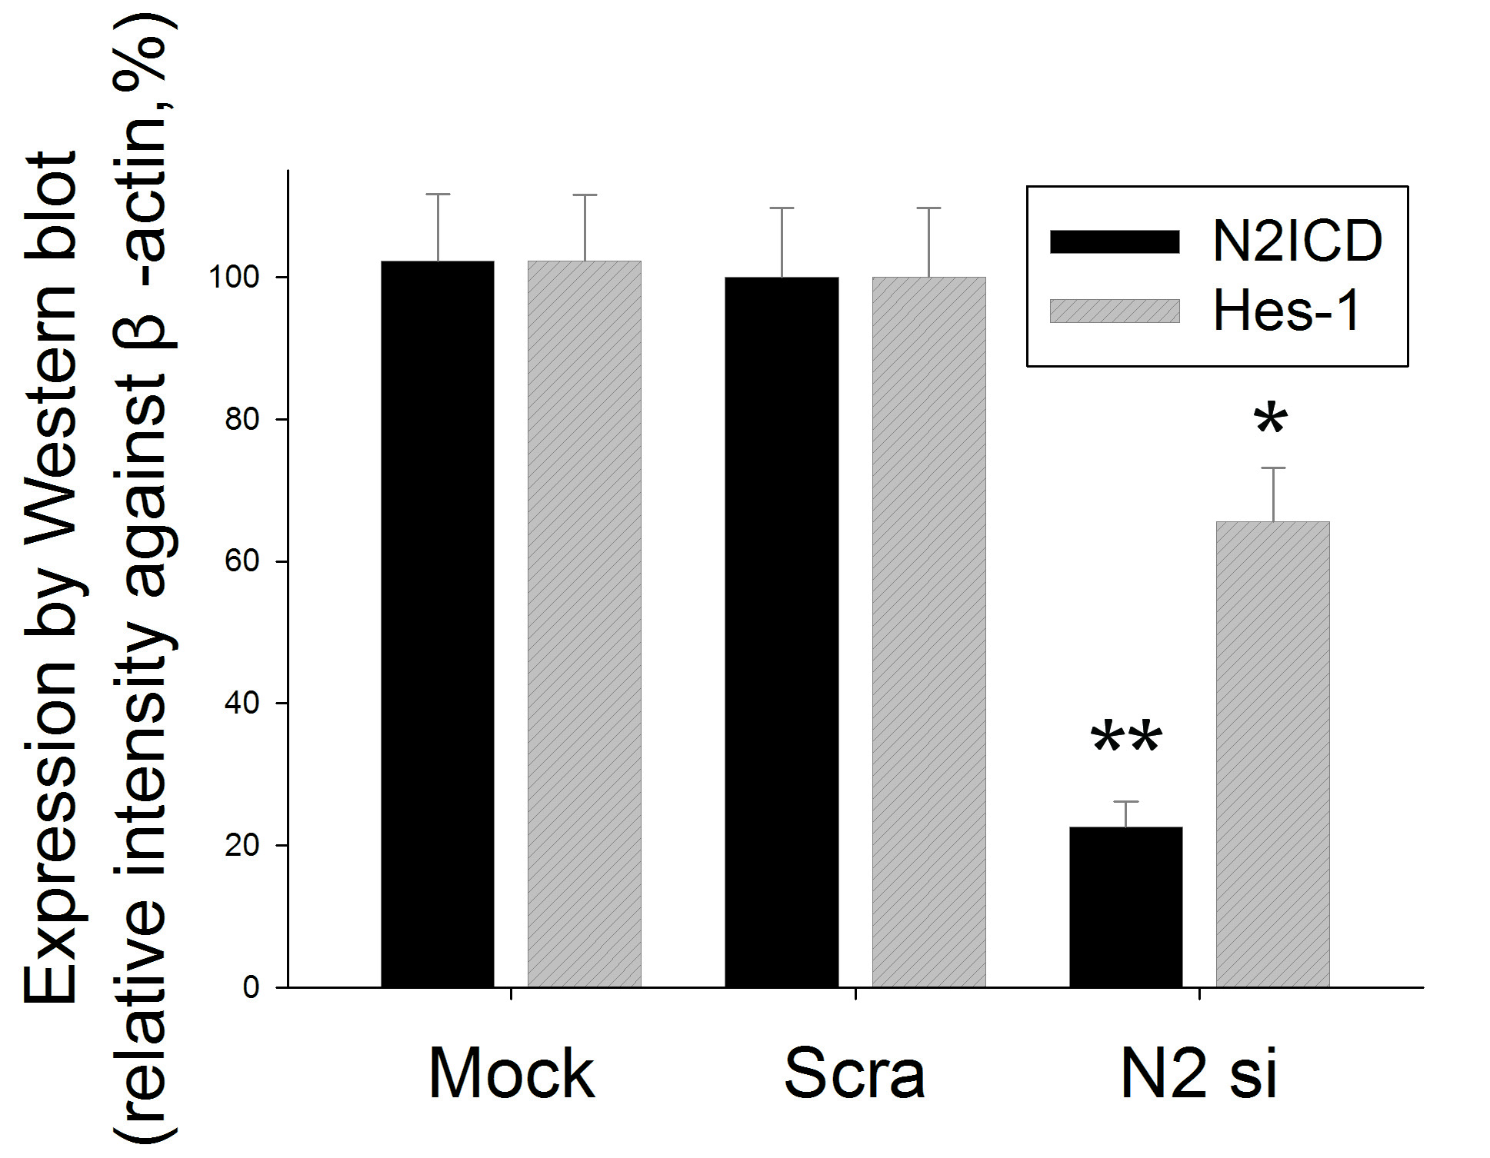

Fig 1 E
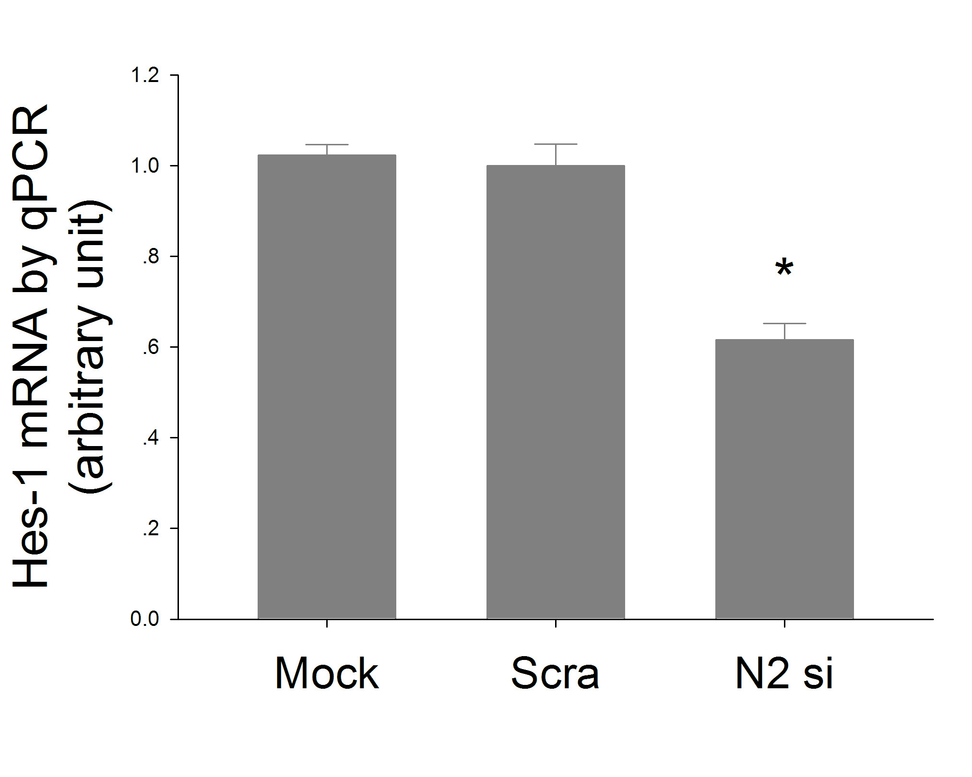

Fig 2 ABDE
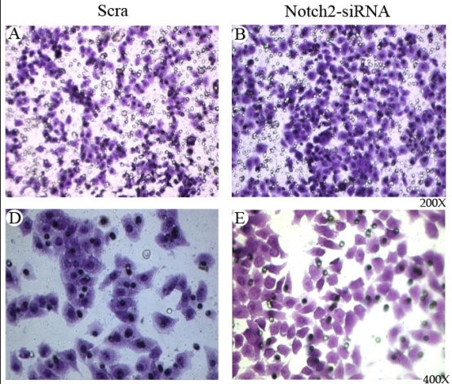

Fig 2 C
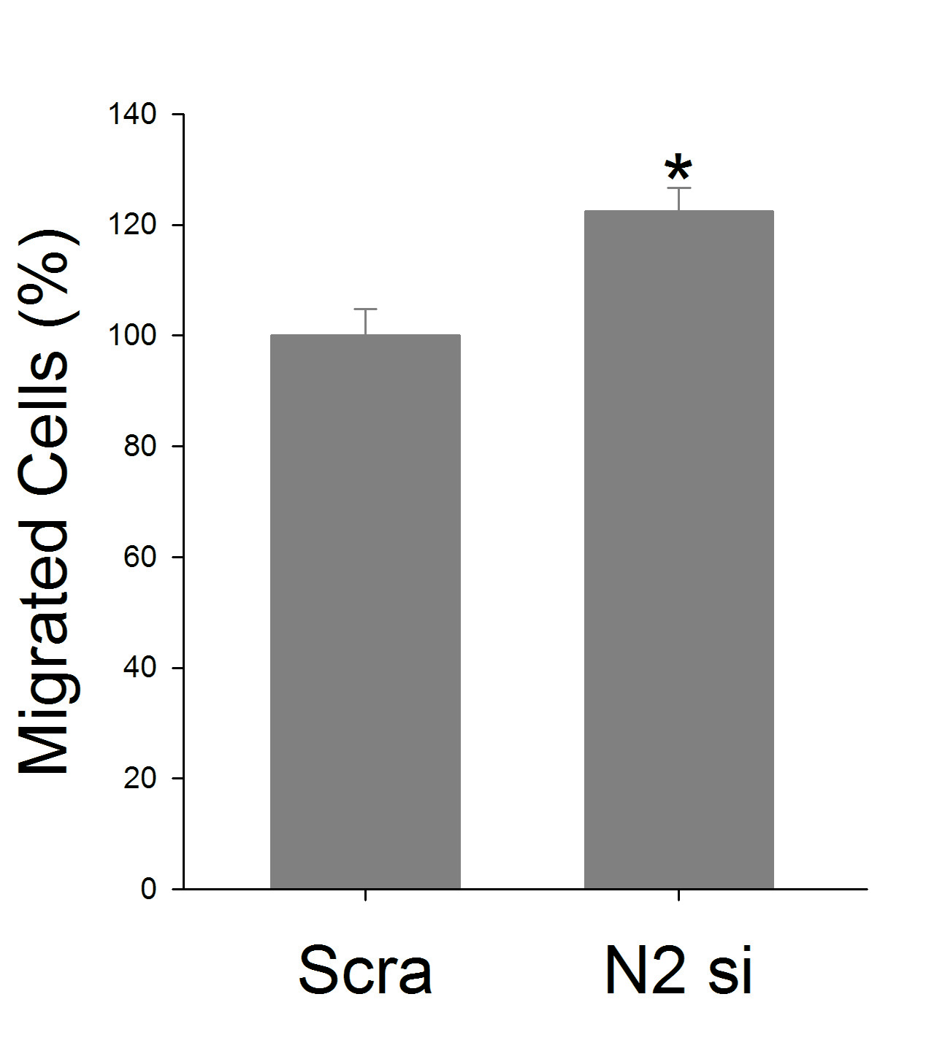

Fig 2 F
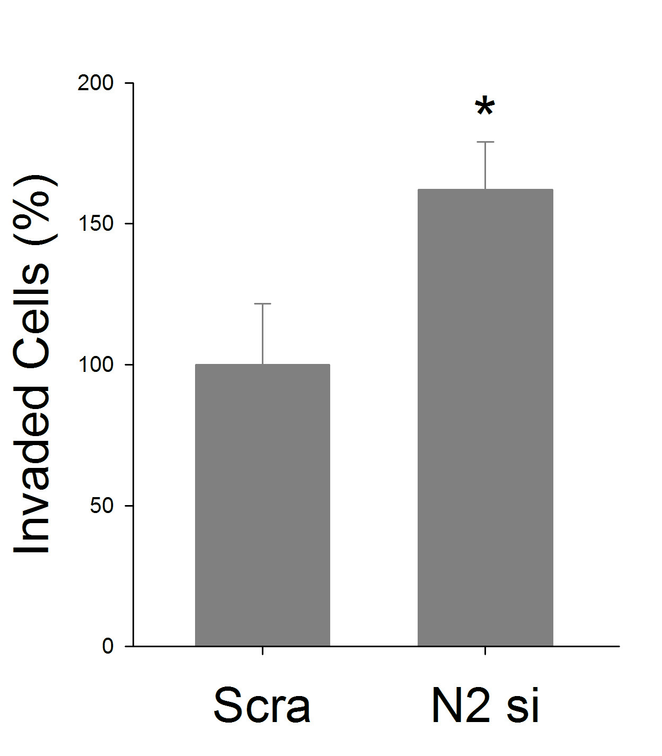

Fig 3 A
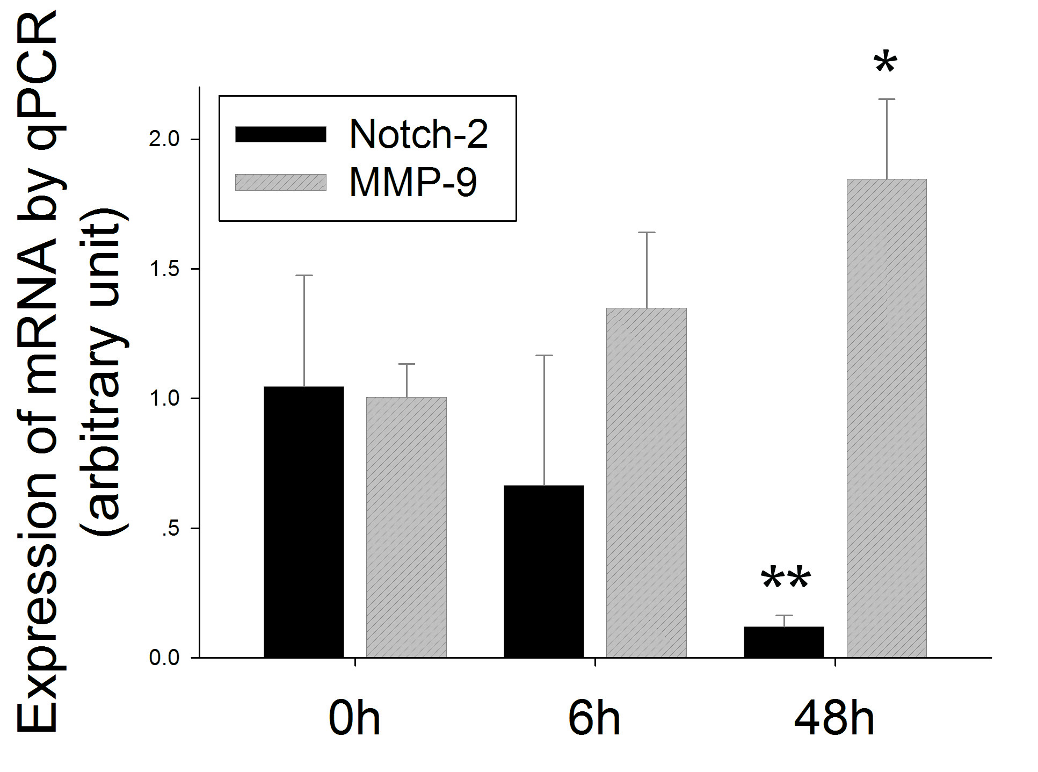

Fig 3 B

Fig 3 C
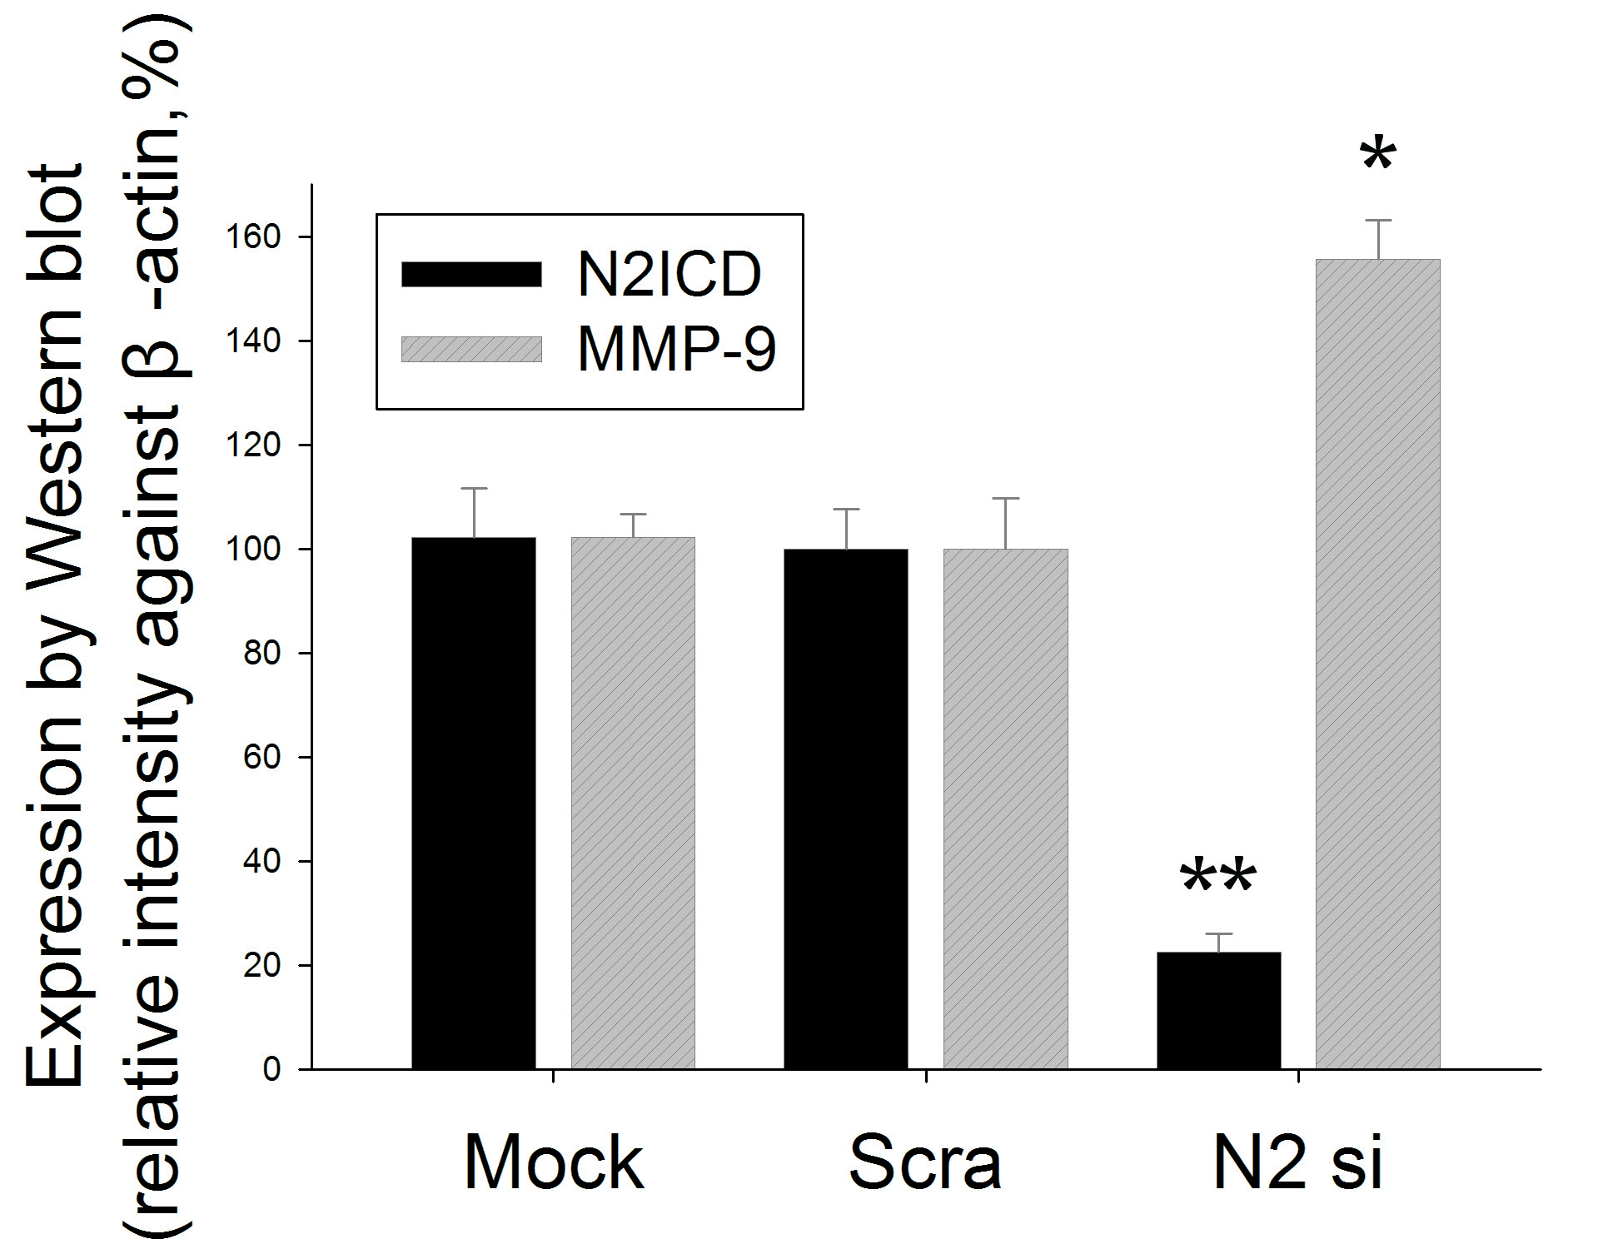

Fig 3 D
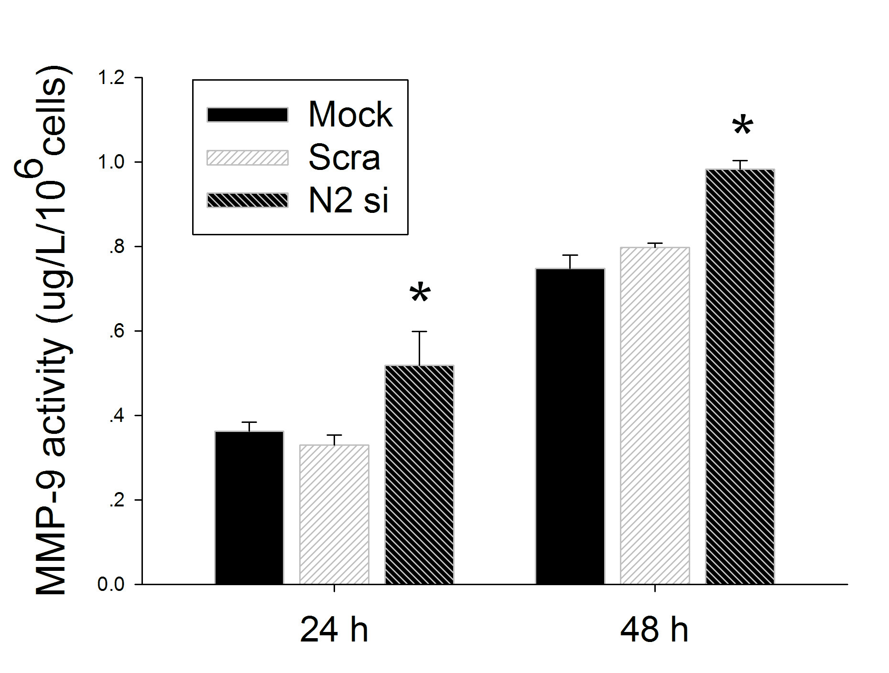

Fig 4 A

Fig 4 B
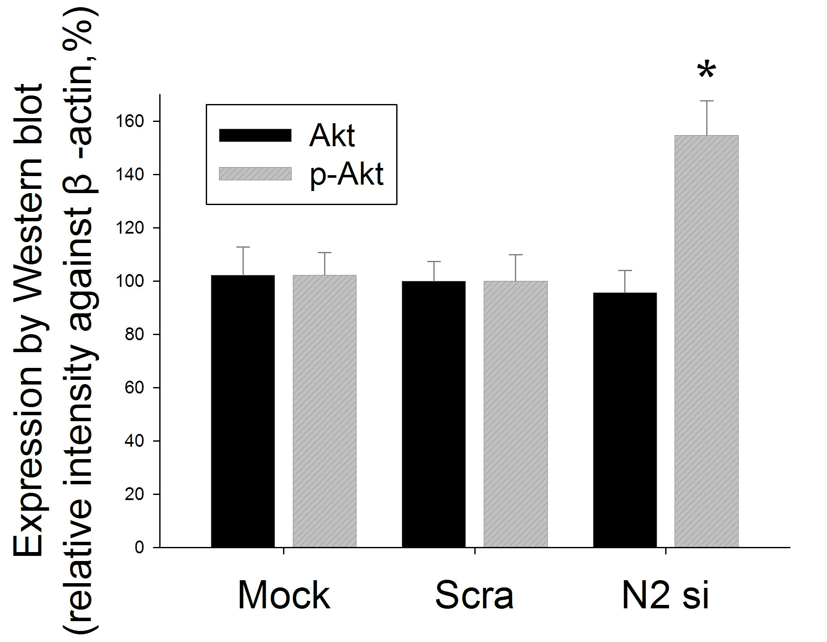

Fig 4 C

Fig 4 D
