Name of journal: World Journal of Gastroenterology
Manuscript NO: 35799
Manuscript Type: ORIGINAL ARTICLE

Basic Study
Hypothermic machine perfusion with metformin-University of Wisconsin solution for ex vivo preservation of standard and marginal liver grafts in a rat model

Chai YC et al. Hypothermic machine perfusion with metformin-UW for ex vivo liver grafts

Yi-Chao Chai, Guo-Xin Dang, Hai-Qi He, Jian-Hua Shi, Hong-Ke Zhang, Rui-Tao Zhang, Bo Wang, Liang-Shuo Hu, Yi Lv

Yi-Chao Chai, Hai-Qi He, Jian-Hua Shi, Hong-Ke Zhang, Bo Wang, Liang-Shuo Hu, Yi Lv, Department of Hepatobiliary Surgery, First Affiliated Hospital of Xi’an Jiaotong University, Xi'an 710061, Shaanxi Province, China

Yi-Chao Chai, Guo-Xin Dang, Hai-Qi He, Jian-Hua Shi, Hong-Ke Zhang, Liang-Shuo Hu, Yi Lv, Institute of Advanced Surgical Techniques and Engineering, Regenerative Medicine and Surgery Engineering Research Center of Shaanxi Province, Xi'an Jiaotong University, Xi'an 710061, Shaanxi Province, China

Guo-Xin Dang, Rui-Tao Zhang, Department of Hepatobiliary and Vascular Surgery, the 521 Hospital of Ordnance Industry, Xi'an 710065, Shaanxi Province, China

Author contributions: Chai YC and Dang GX contribute equally to this study; Dang GX and Hu LS conceived and designed the experimental study; Chai YC and Dang GX performed the surgical procedure; Chai YC and Zhang HK collected the data. Zhang HK provided statistical analysis; Dang GX and Zhang RT contributed to interpretate the data. He HQ and Shi JH reviewed all histopathological specimens and performed morphometric measurements. Chai YC written the article; Hu LS, LvY and Wang B executed critical revision of the article; all authors participated in the revision of the manuscript, and all authors read and approved the final manuscript.

Supported by the National Natural Science Foundation, No. 81470896; the Project of Development and Innovation Team of Ministry of Education, No. IRT_16R57.

Institutional review board statement: The animal experiment protocol of this paper was approved by the Laboratory Animal Administration Committee of Xi’an Jiaotong University (approval number No.XJTULAC 2013001), carried out according to the Guidelines for Animal Experimentation of Xi’an Jiaotong University and Guide for the Care and Use of Laboratory Animals published by the US National Institutes of Health (NIH Publication number 85-23, revised 2011).

Conflict-of-interest statement: All the authors declare no conflict of interest related to this publication, all authors participate in the revision of the manuscript and approve the final version of the manuscript.

Data sharing statement: No additional data are available.

Open-Access: This article is an open-access article which was selected by an in-house editor and fully peer-reviewed by external reviewers. It is distributed in accordance with the Creative Commons Attribution Non Commercial (CC BY-NC 4.0) license, which permits others to distribute, remix, adapt, build upon this work non-commercially, and license their derivative works on different terms, provided the original work is properly cited and the use is non-commercial. See: http://creativecommons.org/licenses/by-nc/4.0/

Manuscript source: Unsolicited manuscript

Correspondence to: Liang-Shuo Hu, MD, Department of Hepatobiliary Surgery, First Affiliated Hospital of Xi’an Jiaotong University, No. 277 West Yan-ta Road, Xi’an 710061, Shaanxi Province, China. huliangshuo1983@hotmail.com
Telephone: +86-29-85323900
Fax: +86-29-85252580

Received: August 18, 2017
Peer-review started: August 19, 2017
First decision: August 29, 2017
Revised: September 10, 2017
Accepted: September 20, 2017
Article in press:
Published online:

Abstract
AIM
To compare the effect of University of Wisconsin (UW) solution with or without metformin, an AMP-activated protein kinase (AMPK) activator, for preserving standard and marginal criteria liver grafts of young and aged rats ex vivo by hypothermic machine perfusion (HMP).

METHODS
Eighteen young (4-mo-old) and 18 aged (17-mo-old) healthy male SD rats were selected and randomly divided into 3 groups-the control group, the UW solution perfusion group (UWP), and the UW solution with metformin perfusion group (MUWP). Aspartate aminotransferase (AST), alanine aminotransferase (ALT), lactate dehydrogenase (LDH), interleukin-18 (IL-18), and tumor necrosis factor-alpha (TNF-α) from the perfused liquid were tested. The expression levels of AMPK and endothelial nitric oxide synthase (eNOS) from liver sinusoidal endothelial cells were also examined. Additionally, microscopic evaluation was done to the harvested perfused liver tissue samples.

RESULTS
AST, ALT, LDH, IL-18 and TNF-α levels of the young and aged liver-perfused liquid in the MUWP group were, respectively, significantly lower than that in the UWP group (P < 0.05), but no significant differences between the young and aged MUWP groups were found. Metformin increased the expression of AMPK and eNOS protein level, and promoted the extracellular release of nitric oxide through activation of the AMPK-eNOS mediated pathway. Histological examination revealed that in the MUWP group, the extent of liver cells and tissue damage was significantly reduced compared with the UWP group.

CONCLUSION
The addition of metformin to the UW preservative solution can reduce rat liver injury during cold ischemia ex vivo by HMP, with significant protective effects of livers, especially of aged rats.

Key words：Metformin; AMP-activated protein kinase; Cold ischemia injury; Hypothermic machine perfusion; Liver Grafts

© The Author(s) 2017.Published by Baishideng Publishing Group Inc. All rights reserved.

Core tip: Metformin can activate AMP-activated protein kinase pathway that could enhance the activity of endothelial nitric oxide synthase and finally increase the generation of nitric oxide, which plays an important role in the protection of liver sinusoidal endothelial cells. Hence, our study was designed to evaluate protective effect of University of Wisconsin storage solution with metformin for preserving standard and marginal criteria liver grafts of young and aged rats ex vivo by hypothermic machine perfusion (HMP). According to the results, HMP of extracorporeal circulation with metformin can play a significant protective role for liver grafts during cold ischemia, with significant effects especially for the aged-marginal donor.

Chai YC, Dang GX, He HQ, Shi JH, Zhang HK, Zhang RT, Wang B, Hu LS, Lv Y. Hypothermic machine perfusion with metformin-University of Wisconsin solution for ex vivo preservation of standard and marginal liver grafts in a rat model. World J Gastroenterol 2017; In press

INTRODUCTION
Currently, liver transplantation is the only effective therapy for end-stage liver disease^{[1]}. Both preservation of donor organs and post-transplant ischemic reperfusion injury (IRI) are important factors affecting the prognosis of transplantation^{[2]}. At present, due to the shortage of liver donation, marginal donation, which includes aged donation, adipo-hepatic donation, and donation after cardiac death (DCD), increases the risk for more severe IRI because of suboptimal function and long-term warm and cold ischemia^{[3-5]}. Cold ischemia injury plays an important role in the IRI mechanism after revascularization of transplants. In this period, the liver sinusoidal endothelial cells are the first to be injured in a donor liver, causing damage of the stable hepatic microenvironment, hepatic microcirculation disturbance, and exacerbation of IRI^{[6]}. Therefore, there is a current pressing need to explore and improve methods of organ preservation and minimize IRI of donor livers during transplantation^{[7,8]}.
In recent years, machine perfusion (MP) has been explored as an alternate method of organ preservation to static cold storage. Clinically, hypothermic machine perfusion (HMP, 4-6℃) has been effective for kidney transplantation, but MP methods have not been widely used in liver transplantation. According to the latest research, MP has been meaningful for the preservation and repair of marginal liver donation^{[9]}, but this still needs further clinical verification^{[10,11]}.
Another important direction of research on donor liver cold preservation is the auxiliary protective intervention of donor livers against IRI factors of microcirculation^{[12]} and hepatocyte metabolism^{[13]} through drugs. Activation of adenosine 5'-monophosphate-activated protein kinase (AMPK) signaling pathways increases endothelial nitric oxide synthase (eNOS) activity generating nitric oxide causing ischemia. This provides a cytoprotective effect to the hepatic sinusoidal endothelium of the donor liver and has been considered for preconditioning of the donor liver to reduce IRI. In addition, AMPK signaling is also known to regulate glucose metabolism and prevent cell death extending the cytoprotective effect of hepatocytes^{[14]}. Thus, it plays an important role in protecting hepatic sinusoidal endothelium and reducing injury of donor livers^{[15]}. As an agonist of AMPK, metformin additionally lowers the blood glucose by reducing hepatic gluconeogenesis and strengthening glucose uptake of peripheral tissue^{[16]}.
Hence, we assumed that liver sinusoidal endothelial cells can be protected from injury by activating AMPK signaling pathways with the addition of metformin perfused in vitro, and could ultimately lead to an improvement of liver donor organ preservation. Consequently, in this experiment, we added metformin to University of Wisconsin (UW) solution, ex vivo, to HMP models of livers of young and aged rats and investigated the effects on biochemical indicators and sinusoidal cell morphology.

MATERIALS AND METHODS
A total of 18 young healthy male SD rats (4-mo-old, weighing 250–300 g) and 18 aged (17-mo-old, weighing 600–630 g) SD rats were randomly selected for the study. The experimental animals were provided by Animal Experiment Center of Xi’an Jiaotong University.
LongerPump® DG-2-B/D Precise Miniature Peristaltic Pump (Longer Precision Pump Co., Ltd., Baoding, China) with a rotation speed of 0-100 rpm and flow rates of 0-48 mL/min; SPS-1® Static Preservation Solution (UW solution, Organ Recovery Systems, Inc.); and metformin (1,1-dimethylbiguanidine hydrochloride, CAS # 1115–70-4, Biomol GmbH) were used. A 165 mg/L stock solution of metformin was prepared by adding 2.5 mL of metformin solution at a concentration of 1 g/10 mL to 1000 mL sterile water, stirring until dissolved, and then adding this (0.66 mL) to 1000 mL of UW solution. A final metformin concentration of 0.165 mg/L or 1 mmol/L was used. Serum interleukin-18 (IL-18) and tumor necrosis-alpha (TNF-α)levels were measured by enzyme-linked immunosorbent assay (ELISA) technique (Rat Interleukin 18 ELISA kit, CLOUD-CLONE CORP., TX, United States; Rat TNF-alpha ELISA kit, MultiSciences Biotech Co., Ltd, Shanghai, China).

Study design
Young and aged rats were randomly divided into three groups, with six rats in each group, respectively. The groups were: control groups A (young rats) and D (aged rats), UW solution perfusion (UWP) groups B (young rats) and E (aged rats), and the experimental groups C (young rats) and F (aged rats) that were perfused with metformin-UW solution (MUWP).

Step one - Block design for establishing the experimental model
The rats were fasted for 8 h and general anesthesia by with 5% pentobarbital sodium intraperitoneal injection in 20 mg/kg was given to all the rats. Fixation, skin preparation, and disinfection were completed, and then a large median and transverse abdominal incision for laparotomy was made. The liver was isolated and heparinized and perfused in situ with cold UW solution until the liver turned into a khaki color and rapidly harvested at room temperature. The ex vivo liver was then placed into a basin filled with cold UW solution and made to lie in the basin on an ice pad. All ex vivo livers were grouped and underwent HMP with circulating UW solution at 4 °C at a flow rate of 4 mL/min maintained at 80 mL of the total circulation volume by constant flow of the peristaltic pump: Groups A and D: did not require extended period of HMP (only 2 h); Groups B and E: were perfused with UW solution for 12 h; Groups C and F: were perfused mechanically with UW solution with 0.165 mg/L of metformin for 12 h. Then, 6 mL of the perfused liquid was collected after HMP from every group, and stored in -20 °C, respectively

Step two - Examination of the expression level of p-eNOS, t-eNOS, p-AMPK, and t-AMPK from liver sinusoidal endothelial cells of young rats
Extraction of liver sinusoidal endothelial cells of young rats: After step one, the ex vivo livers of every group were perfused with GBSS solution (150 mL get rid of Ca²⁺ and Mg²⁺, mixed with pronase 400 mg and collagenase 40 mg) for 7 min at 37 °C at a flow rate of 20 mL/min. Then the resulting mixture was centrifuged with Krebs-Henseleit 1x stock Buffer solution (with 10% FCS and 0.002% DNase I) perfused at a flow rate of 10 mL/min and the centrifugal speed is maintained at 2500 rpm. Cell pellet was then resuspended in DMEM supplemented with 20% FCS and 10 mL of antibiotic (100 U/L penicillin G) and loaded carefully in the centrifuge for 3 min at a flow perfusion rate of 15 mL/min, and accelerated at 18 mL/min for 1 min. The input flow rate was increased again by 20 mL/min, while 50 mL of the cell suspension of the effluent was collected. Once more, a 50 mL cell suspension was collected by 25 mL/min. The 100 mL homogenate was centrifuged at 2000 rpm for 5 min. The supernatant liquid was extracted out, and the liver sinusoidal endothelial cell-debris pellet collected in the bottom of collection tube.

Extraction of total protein and examination of the expression level of target proteins: The cell debris was lysed by Cell Lysis Buffer (Cell Signaling Technology; Beverly, MA, United States) for 30 min on the ice carefully chilling 1x stock buffer on ice and add 1 mmol/L PMSF was added immediately just prior to use, and then centrifuged at 12000 rpm for 5 min at 4 °C. The supernatant with total cellular proteins were collected from every group, determined, and transferred to a sterile tube, 1.5 mL each, and stored at -20 °C, respectively. Then, the 2-DE gel maps of target proteins were set up by Western blot to examine the expression levels and the amounts of expression of AMPK and eNOS were analyzed with gray scale from the maps.
Testsincluded: (1) Biochemical indicator tests: values of aspartate transaminase (AST), alanine aminotransaminase (ALT), lactate dehydrogenase (LDH), IL-8, and TNF-α from the perfused liquid were examined; (2) Histo-morphological examination was performed by light microscopy: the liver tissues after perfusion were fixed with 10% formalin and immersed as transparent samples in the wax for sections and hematoxylin-eosin (HE) dye. A scoring system to grade the degree of histologic structural damage was quantitatively assessed (by blinding) at the Department of Pathology, based on the following histologic features: hydropic degeneration of hepatocyte and liver sinusoidal endothelial cell, stenosis of the hepatic sinusoid, amount of Kupffer cells. Each feature was graded as absent, mild, moderate, or massive, with a score of 0-3; (3) Electron microscopy examination: The specimens of perfused hepatic tissue were fixed to observe under transmission electron microscopy.

Statistical analysis
All calculations were performed with the SPSS 22.0 software. The grayscale of 2-DE gel maps of target proteins was analyzed with ImageProPlus 6.0 software. Quantitative data were expressed as mean ± SD and assessed by one- or two-way analysis of variance, and multiple comparison between the groups was performed using Student-Newman-Keuls method, differences were considered statistically significant at the level of the test α = 0.05, (P < 0.05).Scoring data were analyzed by Kruskal-Wallis one-way analysis of variance on ranks and compared between any two groups using Mann-Whitney U test, with the level of the test α = 0.05, P < 0.05 was considered statistically significant.

RESULTS
Data analysis of the biochemical indicators
Control group (groups A and D) were subject to HMP for only 2 h. Group UWP (groups B and E) and the MUWP group (groups C and F) all had to begin with HMP for 12 h.
After completing the perfusion of each group, AST, ALT, and LDH levels in the perfused liquid were determined (Figure 1). (1) There were no significant differences in the AST, ALT and LDH between the young rat control group (group A) and the aged rat control group (group D); (2) The AST, ALT, and LDH of groups HMP with UW solution (groups B and E of UWP) were significantly higher than groups A and D (P < 0.05), Besides, the AST and ALT of aged group E were significantly higher than young group B (P < 0.05); (3) The AST, ALT, and LDH of groups HMP with metformin-UW solution (MUWP), which was divided into young group C and aged group F were, respectively, significantly lower than the young group B and aged group E of UWP (P < 0.05), furthermore, no significant differences between the young and the aged group were found.
Detection of IL-18 and TNF-α levels in the perfused liquid were measured by enzyme-linked immunosorbent assay (ELISA) technique (Figure 2). There were no significant differences in levels of IL-18 and TNF-α between the young rat control group (group A) and the aged rat control group (group D); IL-18 and TNF-α levels of groups UWP were significantly higher than control group (P < 0.05), nevertheless, there were no significant differences between the young group B and the aged group E of UWP; IL-18 and TNF-α levels of the young group C and the aged group F of MUWP were, respectively, appreciably lower than the young group B and the aged group E of UWP (P < 0.05), but no significant differences between the young group C and the aged group F of MUWP were found.

Result of the expression level of target proteins
Discriminant analysis of grayscale relative value with histogram was used to determine the expression level of p-eNOS, t-eNOS, p-AMPK, and t-AMPK from the liver sinusoidal endothelial cells of young rats (Figure 3). (1) The expression level of p-eNOS in the MUWP group, which with the addition of metformin, was significantly higher (80.1%) than the control group (P = 0.036) and 205.88% higher than group UWP (P = 0.008), which was significantly (41.1%) lower than group control (P = 0.045) (Figure 3B); (2) Expression levels of t-eNOS exhibited no significant differences between the control group with the UWP and MUWP groups (P = 0.251) (Figure 3C); (3) The expression level of p-AMPK in group MUWP was significantly higher (51.7%) than the control group (P = 0.038) and 78.5% higher than the UWP group (P = 0.018), even though there were no significant differences between the control and the UWP groups (P = 0.217) (Figure 3D); (4) Expression levels of t-AMPK demonstrated no significant differences between the control group with the UWP and the MUWP groups (P = 0.868) (Figure 3E).

Histo-morphological examination
The HE staining of the sections were observed under the microscope. (1) The hepatocyte in the young rat control group (group A) and the aged rat control group (group D) were shaped normally with no stenos is observed in the hepatic sinusoid and no swelling in the sinusoidal endothelial cells. The size of hepatocytes in group D were slightly larger than that in group A (Figure 4A-D); (2) Cellular swelling was obvious, accompanied by appearing to be narrower of the hepatic sinusoid and, widely distributed in groups B and E of UWP without metformin, particularly, more severely in the aged group E. The swelling of the sinusoidal endothelial cells, as well as the Kupffer cells were observed in both groups of B and E (Figure 4B-E). (3) Hepatocytes of MUWP group showed mild edema; slightly more severe in group F than that in group C, and there were no obvious differences in the hepatic sinusoid between each other. Cellular swelling of sinusoidal endothelial cells was inconspicuous in both the groups; however, a small amount of Kupffer cells were observed (Figure 4C-F); (4) There were no significant differences in the histologic scores between the young rat control group (group A) and the aged rat control group (group D) (P < 0.05); The histologic scores of the young rat group and the aged rat group of UWP and MUWP were, respectively, appreciably higher than young rat control group (group A) and the aged rat control group (group D), and that histologic scores of the young group C and the aged group F of MUWP were, respectively, appreciably lower than the young group B and the aged group E of UWP (P < 0.05); Besides, the histologic scores of aged group E were significantly higher than young group B of UWP (P < 0.05), furthermore, no significant differences between the young group C and the aged group F of MUWP (Figure 4G) were found.

Electron microscopy histological observation
The ultrastructural changes in the hepatocyte were observed under electron microscope: (1) Structure of the hepatocytes in the young control group A and aged control group D were generally normal with a round and clear nucleus that lay in the center of the cells, while lipid droplets in the cytoplasm increased in the aged group D, and fat-storing cells were seen in the Disse's space with irregular cell shapes, and the cytoplasm in it contained a large amount of lipid droplets. In contrast, lipid droplets and fat-storing cells were not found in the young group A, but contained rich cytoplasmic organelles (Figure 5A-D); (2) Hepatocyte swelling, nucleus chromatin condensation, obviously wide mitochondrial swelling, and crista fragmentation were observed in groups B and E of UWP, more severe in the aged group E. Likewise, fat-storing cells in the Disse's space increased in the aged group E; and not found in the young group E (Figure 5B-E); (3) In contrast, the hepatocytes of the MUWP group showed mild edema with the round shape of the nucleus, slightly more evident in the young group C than in the aged group F, and also the mitochondrial swelling degree was slightly higher in the young group C. In addition, lipid droplets in the cytoplasm increased, increase in the amount of fat-storing cells, dilation of the smooth endoplasmic reticulum and intercellular collagenous fibrosis were only seen in the aged group F (Figure 5C-F).
The ultrastructural changes of the hepatic sinusoid were observed under the electron microscope: (1) Structure of the hepatic sinusoidal endothelial cells in the young control group A and the aged control group D remained generally complete with protrusion into the sinusoid, being clear in the young group A, Kupffer cells were seen in the aged group D, though (Figure 6A-D); (2) Sinusoidal endothelial cells were kept meristematic and flat-shaped, with chromatin showing mild margination, and cell debris-like structure together with Kupffer cells in the sinusoids were increased in groups B and E of UWP, particularly, more severely in aged group E. Likewise, fat-storing cells increased in the aged group E, while they were not found in the young group E (Figure 6B-E); (3) The structure of the hepatic sinusoidal endothelial cells of MUWP groups remained generally normal, while a slightly larger cell-volume were seen in the aged group F, cubic-shaped with protrusion into the sinusoid in the young group C. In addition, the low-electron-density protein substance could be seen in the sinusoid in the aged group F.

DISCUSSION
An increasing number of patients with liver disease await liver transplantation; the acute shortage of donor livers is only likely to continue. It was believed that aged livers from donors above 60 years old were characterized by small sizes, atherosclerosis, steatosis, and decreased function of metabolism, and were not suitable for donation^{[17]}. However, to cope with the demand for donor livers, marginal liver donation has been applied clinically after following strict screening protocols with good transplantation outcomes and breaking the myth for the age limit of liver donors^{[18,19]}. Unlike hearts, lungs, and kidneys, livers are much less influenced by age in respect of pathophysiological changes. However, aged livers also show morphologic changes, such as hepatic fibrosis, swelling of hepatocyte, trend for multinucleation, increase of lipofuscin, and reduction in the size of the hepatocyte. Compared with young donors, aged donors show reduced and shrunken fenestra of liver sinusoidal endothelial cells, thickened hepatic sinusoidal endothelium, and pseudo capillarization formed by discontinuous basement membranes, leading to potential microcirculatory disturbance and a risk of aggravating IRI^{[20]}. Thus, easier apoptosis and detachment of liver sinusoidal endothelial cells of aged livers further aggravate microcirculatory disturbance, seriously influence post-transplant effects and even cause failure of some liver transplantation^{[21]}. According to the results of this experiment, aged groups appear to be more sensitive to the possible protective effect of metformin. Furthermore, the histological observations of light and electron microscopy also support this conclusion.
In order to prevent cold ischemia injury, auxiliary protective intervention by drugs with different mechanisms of action, including the MAPK agonist is being explored^{[22]}. Scientists from different academic institution shave published research articles in which they revealed the molecular mechanism by which metformin could activate AMPK and inhibit the mTORC1 signaling pathway within livers via the AXIN/ LKB1-v-ATPase-Ragulator pathway^{[23,24]}, protect the integrity of epithelial cells in multiple stressed conditions (such as inflammation, infection and anoxia), and even demonstrate an anticancer effect^{[25-27]}. Before revealing this molecular mechanism, it was known that AMPK activation played a critical role in reducing liver IRI. However, how AMPK and eNOS phosphorylation direct their effects on the endothelial function is still elusive^{[28]}, even if there is plenty of evidence to show that AMPK activation can enhance the activity of eNOS, resulting in generation of nitric oxide^{[15,29,30]}.Extension of cold preservation by maintaining a supercooled state, donor liver cells can remain viable up to 96 h; human livers showed improvement in endothelial function with 2 h of HMP^{[31]}. In the current study, the AMPK activator metformin was added to ex vivo HMP models of rat livers in UW solution after HMP for 12 h Our results showed all the biochemical indexes and inflammatory factors in the UWP group were significantly higher than the control group, but HMP with the addition of metformin beforehand, all the indexes in both young and the aged group of MUWP, respectively, were appreciably lower than the young and aged group of UWP. By the histological observation of light and electron microscopy, injury of the related microstructure of MUWP was lighter than UWP. To a certain extent, it can be deduced that metformin activated protective mechanisms. Expression level of eNOS and AMPK in the liver sinusoidal endothelial cells of young rats showed that phosphorylation of AMPK and eNOS were increased in group of MUWP at 12 h after HMP; this can be inferred as the AMPK/eNOS pathway was activated ex vivo by metformin.
The experiment confirmed that the addition of metformin into organ preservation solution, can activate the AMPK/eNOS pathway, and can not only significantly decrease inevitable injury of donor livers caused by long-term HMP, but can reduce the difference between aged and young livers after HMP, protecting livers of aged rats, which should probably improve the utilization of marginal liver donor tissues. However, whether metformin can sequentially improve hepatic injury during reperfusion-ischemia requires further investigation. But at least, we provided a novel idea, which is also a simple procedure for drug auxiliary intervention with HMP in ex vivo rats’ donor liver and deserves further research with a promising prospect.
In conclusion, this experiment confirmed that metformin can activate the AMPK/eNOS pathway and reduce injury of ex vivo rat liver during cold ischemia in MP. The combination of metformin with the organ preservation solution effectively enhanced the quality of donor livers, with significant protective effects of livers especially of aged rats, which could be used to improve the utilization of marginal liver.

ARTICLE HIGHLIGHTS
Research background
Liver transplantation is the only effective therapy for the end-stage liver disease. At present, due to the shortage of liver donation, marginal donation, which includes aged donation, adipo-hepatic donation, and donation after cardiac death, increases the risk for more severe ischemic reperfusion injury (IRI) because of suboptimal function and long-term warm and cold ischemia. Therefore, there is a current pressing need to explore and improve methods of organ preservation and minimize IRI of donor livers during transplantation.

Research motivation
According to the latest research, machine perfusion has been meaningful for the preservation and repair of marginal liver donation. Another important direction of research on donor liver cold preservation is the auxiliary protective intervention of donor livers against IRI factors of microcirculation and hepatocyte metabolism through drugs. Activation of adenosine 5'-monophosphate-activated protein kinase (AMPK) signaling pathways increases eNOS activity generating nitric oxide (NO), which plays an important role in the protection of liver sinusoidal endothelial cells. Metformin is an agonist of AMPK. Hence, we assumed that liver sinusoidal endothelial cells can be protected from injury by activating AMPK signaling pathways with the addition of metformin perfused in vitro, and could ultimately cause an improvement of liver donor organ preservation.

Research objectives
Consequently, in this experiment, we added metformin to University of Wisconsin (UW) solution, to compare the effect of UW solution with or without metformin, an AMPK activator, for preserving standard and marginal criteria liver grafts of young and aged rats ex vivo by hypothermic machine perfusion (HMP).

Research methods
Eighteen young (4-mo-old) and 18 aged (17-mo-old) healthy male SD rats were selected and randomly divided into 3 groups-the control group, the UW solution perfusion group (UWP), and the UW solution with metformin perfusion group (MUWP). Aspartate aminotransferase (AST), alanine aminotransferase (ALT), lactate dehydrogenase (LDH), interleukin-18 (IL-18), and tumor necrosis factor-alpha (TNF-α) from the perfused liquid were tested. The expression levels of AMPK and eNOS from liver sinusoidal endothelial cells were also examined. Additionally, microscopic evaluation was done to the harvested perfused liver tissue samples.

Research results
AST, ALT, LDH, IL-18 and TNF-α levels of the young and aged liver-perfused liquid in the MUWP group were, respectively, significantly lower than that in the UWP group (P < 0.05), but no significant differences between the young and aged MUWP groups were found. Metformin increased the expression of AMPK and eNOS protein level, and promoted the extracellular release of nitric oxide through activation of the AMPK-eNOS mediated pathway. Histological examination revealed that in the MUWP group, the extent of liver cells and tissue damage was significantly reduced compared with the UWP group.

Research conclusions
This experiment confirmed that the addition of metformin into organ preservation solution, can activate AMPK/eNOS pathway, and can not only reduce injury of ex vivo rat liver during cold ischemia, but can reduce the difference between aged and young livers after HMP, with especially significant effects of protecting livers of aged rats, which should probably improve the utilization of marginal liver donor tissues. However, whether metformin can sequentially improve hepatic injury during reperfusion-ischemia requires further investigation. But at least, we provided a novel idea, which is also a simple procedure for drug auxiliary intervention with HMP in ex vivo rats’ donor liver and deserves further research with a promising prospect.

REFERENCES
1 Potosek J, Curry M, Buss M, Chittenden E. Integration of palliative care in end-stage liver disease and liver transplantation. J Palliat Med 2014; 17: 1271-1277 [PMID: 25390468 DOI: 10.1089/jpm.2013.0167]
2 Matsuno N, Uchida K, Furukawa H. Impact of machine perfusion preservation of liver grafts from donation after cardiac death. Transplant Proc 2014; 46: 1099-1103 [PMID: 24815138 DOI: 10.1016/j.transproceed.2013.11.135]
3 Guan Z, Lv Y. The research progress of improving the quality of the marginal donor liver in liver transplantation. Medical recapitulate 2015; v.21: 101-104
4 Seehofer D, Eurich D, Veltzke-Schlieker W, Neuhaus P. Biliary complications after liver transplantation: old problems and new challenges. Am J Transplant 2013; 13: 253-265 [PMID: 23331505 DOI: 10.1111/ajt.12034]
5 He T, Zheng Z, Wu Y. Advances in research on ischemia/reperfusion injury in liver transplantation[J]. Medical recapitulate. 2011; v.17: 1640-1642
6 Miyashita T, Nakanuma S, Ahmed AK, Makino I, Hayashi H, Oyama K, Nakagawara H, Tajima H, Takamura H, Ninomiya I, Fushida S, Harmon JW, Ohta T. Ischemia reperfusion-facilitated sinusoidal endothelial cell injury in liver transplantation and the resulting impact of extravasated platelet aggregation. EurSurg 2016; 48: 92-98 [PMID: 27110233 DOI: 10.1007/s10353-015-0363-3]
7 Lowalekar SK, Cao H, Lu XG, Treanor PR, Thatte HS. Sub-normothermic preservation of donor hearts for transplantation using a novel solution, Somah: a comparative pre-clinical study. J Heart Lung Transplant 2014; 33: 963-970 [PMID: 25001113 DOI: 10.1016/j.healun.2014.05.006]
8 Chinese college of cransplant doctors, Division of branch of surgery, Chinese medical association china liver transplant registry scientific committ. Chinese expert consensus on the organ protection of transplantation (2016 edition).Chinese journal of digestive surgery 2016; v.15: 645-654
9 Dirkes MC, Post IC, Heger M, van Gulik TM. A novel oxygenated machine perfusion system for preservation of the liver. Artif Organs 2013; 37: 719-724 [PMID: 23614839 DOI: 10.1111/aor.12071]
10 Dutkowski P, Schlegel A, de Oliveira M, Müllhaupt B, Neff F, Clavien PA. HOPE for human liver grafts obtained from donors after cardiac death. J Hepatol 2014; 60: 765-772 [PMID: 24295869 DOI: 10.1016/j.jhep.2013.11.023]
11 Ravikumar R, Jassem W, Mergental H, Heaton N, Mirza D, Perera MT, Quaglia A, Holroyd D, Vogel T, Coussios CC, Friend PJ. Liver Transplantation After Ex Vivo Normothermic Machine Preservation: A Phase 1 (First-in-Man) Clinical Trial. Am J Transplant 2016; 16: 1779-1787 [PMID: 26752191 DOI: 10.1111/ajt.13708]
12 Hara Y, Akamatsu Y, Maida K, Kashiwadate T, Kobayashi Y, Ohuchi N, Satomi S. A new liver graft preparation method for uncontrolled non-heart-beating donors, combining short oxygenated warm perfusion and prostaglandin E1. J Surg Res 2013; 184: 1134-1142 [PMID: 23688794 DOI: 10.1016/j.jss.2013.04.030]
13 Padrissa-Altés S, Zaouali MA, Boncompagni E, Bonaccorsi-Riani E, Carbonell T, Bardag-Gorce F, Oliva J, French SW, Bartrons R, Roselló-Catafau J. The use of a reversible proteasome inhibitor in a model of Reduced-Size Orthotopic Liver transplantation in rats. ExpMolPathol 2012; 93: 99-110 [PMID: 22475623 DOI: 10.1016/j.yexmp.2012.03.011]
14 Yang YM, Han CY, Kim YJ, Kim SG. AMPK-associated signaling to bridge the gap between fuel metabolism and hepatocyte viability. World J Gastroenterol 2010; 16: 3731-3742 [PMID: 20698033 DOI: 10.3748/wjg.v16.i30.3731]
15 Tabka D, Bejaoui M, Javellaud J, Roselló-Catafau J, Achard JM, Abdennebi HB. Effects of Institut Georges Lopez-1 and Celsior preservation solutions on liver graft injury. World J Gastroenterol 2015; 21: 4159-4168 [PMID: 25892865 DOI: 10.3748/wjg.v21.i14.4159]
16 Dumitrescu R, Mehedintu C, Briceag I, Purcărea VL, Hudita D. Metformin-clinical pharmacology in PCOs. J Med Life 2015; 8: 187-192 [PMID: 25866577]
17 Jiménez-Romero C, Caso Maestro O, CambraMolero F, Justo Alonso I, AlegreTorrado C, ManriqueMunicio A, CalvoPulido J, LoinazSegurola C, Moreno González E. Using old liver grafts for liver transplantation: where are the limits? World J Gastroenterol 2014; 20: 10691-10702 [PMID: 25152573 DOI: 10.3748/wjg.v20.i31.10691]
18 Chedid MF, Rosen CB, Nyberg SL, Heimbach JK. Excellent long-term patient and graft survival are possible with appropriate use of livers from deceased septuagenarian and octogenarian donors. HPB (Oxford) 2014; 16: 852-858 [PMID: 24467292 DOI: 10.1111/hpb.12221]
19 Jiménez-Romero C, Cambra F, Caso O, Manrique A, Calvo J, Marcacuzco A, Rioja P, Lora D, Justo I. Octogenarian liver grafts: Is their use for transplant currently justified? World J Gastroenterol 2017; 23: 3099-3110 [PMID: 28533667 DOI: 10.3748/wjg.v23.i17.3099]
20 Pezzati D, Ghinolfi D, De Simone P, Balzano E, Filipponi F. Strategies to optimize the use of marginal donors in liver transplantation. World J Hepatol 2015; 7: 2636-2647 [PMID: 26609341 DOI: 10.4254/wjh.v7.i26.2636]
21 Ghinolfi D, Marti J, De Simone P, Lai Q, Pezzati D, Coletti L, Tartaglia D, Catalano G, Tincani G, Carrai P, Campani D, Miccoli M, Biancofiore G, Filipponi F. Use of octogenarian donors for liver transplantation: a survival analysis. Am J Transplant 2014; 14: 2062-2071 [PMID: 25307037 DOI: 10.1111/ajt.12843]
22 Kosieradzki M, Pratschke J, Kupiec-Węgliński J, Rowiński W. Ischemia/Reperfusion injury, its mechanisms, and prevention. J Transplant 2012; 2012: 610370 [PMID: 23320144 DOI: 10.1155/2012/610370]
23 Zhang CS, Li M, Ma T, Zong Y, Cui J, Feng JW, Wu YQ, Lin SY, Lin SC. Metformin Activates AMPK through the Lysosomal Pathway. Cell Metab 2016; 24: 521-522 [PMID: 27732831 DOI: 10.1016/j.cmet.2016.09.003]
24 Zhang CS, Jiang B, Li M, Zhu M, Peng Y, Zhang YL, Wu YQ, Li TY, Liang Y, Lu Z, Lian G, Liu Q, Guo H, Yin Z, Ye Z, Han J, Wu JW, Yin H, Lin SY, Lin SC. The lysosomal v-ATPase-Ragulator complex is a common activator for AMPK and mTORC1, acting as a switch between catabolism and anabolism. Cell Metab 2014; 20: 526-540 [PMID: 25002183 DOI: 10.1016/j.cmet.2014.06.014]
25 Lei Y, Yi Y, Liu Y, Liu X, Keller ET, Qian CN, Zhang J, Lu Y. Metformin targets multiple signaling pathways in cancer. Chin J Cancer 2017; 36: 17 [PMID: 28126011 DOI: 10.1186/s40880-017-0184-9]
26 Kang JI, Hong JY, Lee HJ, Bae SY, Jung C, Park HJ, Lee SK. Anti-Tumor Activity of Yuanhuacine by Regulating AMPK/mTOR Signaling Pathway and Actin Cytoskeleton Organization in Non-Small Cell Lung Cancer Cells. PLoS One 2015; 10: e0144368 [PMID: 26656173 DOI: 10.1371/journal.pone.0144368]
27 Carling D. AMPK signalling in health and disease. Curr Opin Cell Biol 2017; 45: 31-37 [PMID: 28232179 DOI: 10.1016/j.ceb.2017.01.005]
28 Anavi S, Madar Z, Tirosh O. Non-alcoholic fatty liver disease, to struggle with the strangle: Oxygen availability in fatty livers. Redox Biol 2017; 13: 386-392 [PMID: 28667907 DOI: 10.1016/j.redox.2017.06.008]
29 Fu P,Li W. Nitric Oxide in Liver Ischemia–Reperfusion Injury. Liver Pathophysiology 2017; 125-127 p.
30 Bektas S, Karakaya K, Can M, Bahadir B, Guven B, Erdogan N, Ozdamar SO. The effects of tadalafil and pentoxifylline on apoptosis and nitric oxide synthase in liver ischemia/reperfusion injury. Kaohsiung J Med Sci 2016; 32: 339-347 [PMID: 27450022 DOI: 10.1016/j.kjms.2016.05.005]
31 Burlage LC, Karimian N, Westerkamp AC, Visser N, Matton APM, van Rijn R, Adelmeijer J, Wiersema-Buist J, Gouw ASH, Lisman T, Porte RJ. Oxygenated hypothermic machine perfusion after static cold storage improves endothelial function of extended criteria donor livers. HPB (Oxford) 2017; 19: 538-546 [PMID: 28351756 DOI: 10.1016/j.hpb.2017.02.439]
P-Reviewer: Gilbert MR, Jones G, Otto G S-Editor: Wei LJ
L-Editor: E-Editor:
Specialty type: Gastroenterology and hepatology
Country of origin: China
Peer-review report classification
Grade A (Excellent): A
Grade B (Very good): B, B
Grade C (Good): 0
Grade D (Fair): 0
Grade E (Poor): 0

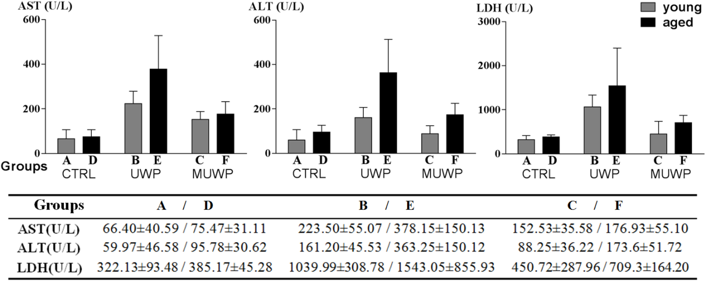
Figure 1 Content analysis of biochemical indicators in the perfused liquid. Aspartate aminotransferase (AST), alanine transaminase (ALT) and lactate dehydrogenase (LDH) levels (mean ± SD) in the perfused liquid of the ex vivo livers of the three groups, the CTRL (control groups A and D), UWP (UW solution perfusion groups B and E), and the MUWP (metformin perfusion groups C and F). Data are presented as means ± SD (n= 6) and compared by two-way analysis of variance and method of the Sidak's multiple comparisons test.

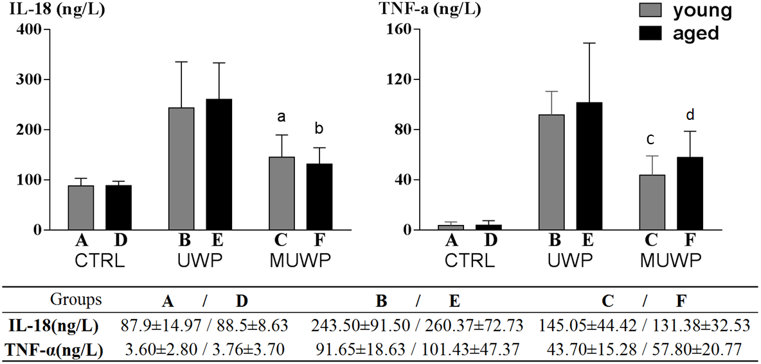
Figure 2 Content analysis of inflammatory factors in the perfused liquid. The IL-18 and TNF-α levels in the perfused liquid (mean ± SD)of the ex vivo livers of the three groups, the CTRL (control groups A and D), UWP (UW solution perfusion groups B and E), and the MUWP (metformin perfusion groups C and F). Data are presented as means ± SD (n= 6) and compared by two-way analysis of variance, method of the Tukey's and Sidak's multiple comparisons test: ªP < 0.05 vs group B; ^{b}P < 0.05 vsgroup E; ^{c}P < 0.05 vs group B; ^{d}P < 0.05 vs group E.

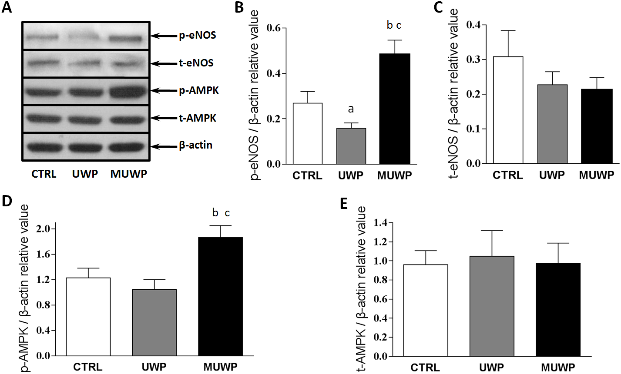
Figure 3 Histograms of grayscale relative value of the expression level of p-eNOS, t-eNOS, p-AMPK, and t-AMPK from the liver sinusoidal endothelial cells of young rats. AMPK/eNOS pathway was activated ex vivo by metformin. A: Phosphorylation of AMPK and eNOS were increased in the MUWP group at 12 h after HMP; B-E: Quantitative analysis of total AMPK, total NOS, phosphorylated AMPK, and eNOS expression are presented. CTRL (control groups A and D), UWP (UW solution perfusion groups B and E), and the MUWP (metformin perfusion groups C and F). Data are presented as means ± SD (n= 3) and compared by ordinary one-way analysis of variance and method of the Dunnett's multiple comparisons test: ªP < 0.05 vs group of CTRL; ^{b}P < 0.05 vs group of CTRL; ^{c}P < 0.05 vs group of UWP.

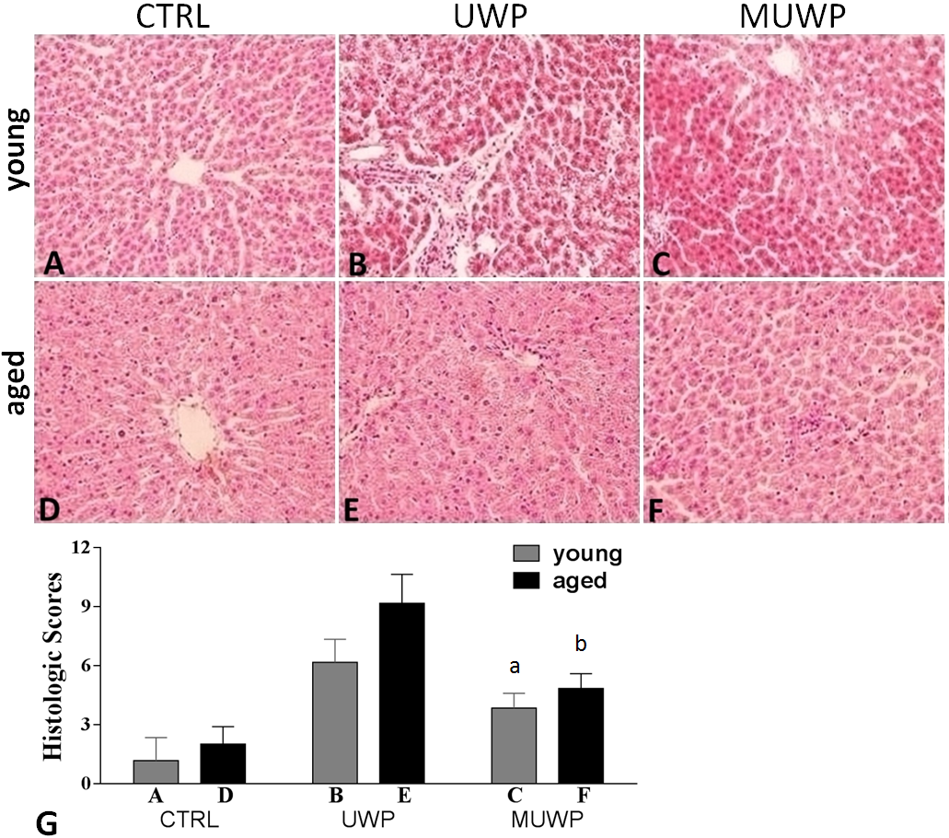
Figure 4 Staining of the slices of the ex vivo rat liver tissue, magnification by 40 x. A and D: Respectively, are the young control group A and the aged control group D; B and E: Respectively, are the young group B and aged group E of UWP without metformin; C and F:Respectively, are the young group C and the aged group F of MUWP; G:Ishistopathologic scoring of structural injury in each group. Data are presented as means ± SD (n = 6) and compared by Kruskal-Wallis one-way analysis of variance on ranks and Mann-Whitney U test: ªP < 0.05 vs group B of UWP; ^{b}P < 0.05 vs group E of UWP. Original magnification (A–F): × 400. UW: University of Wisconsin; UWP: UW solution perfusion; MUWP: Metformin perfusion solution.

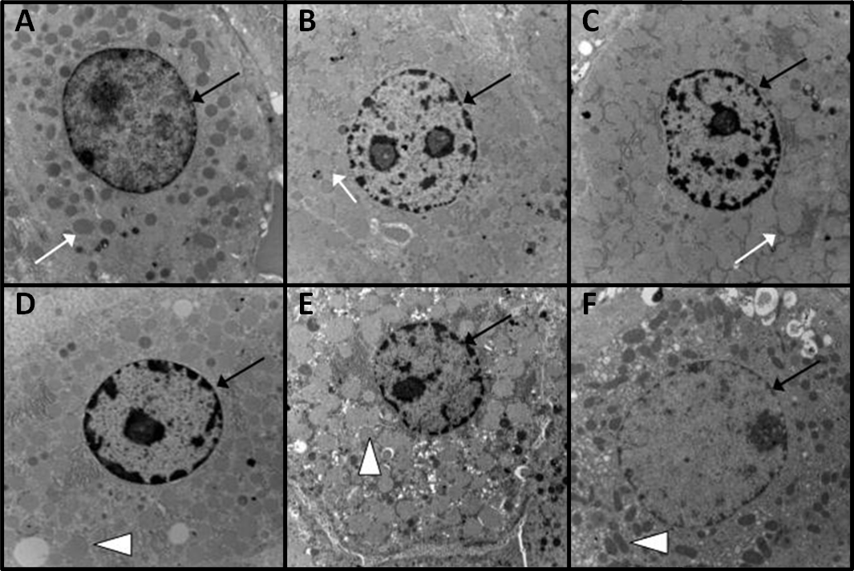
Figure 5 Ultrastructural changes of the hepatocyte. Images A and D: Respectively, are hepatocytes of the young control group A and the aged control group D; Images B and E: Respectively, are hepatocytes of the young group B and aged group E of the UWP without metformin; Images C and F: Respectively, are hepatocytes of the young group C and aged group F of the MUWP group. The black arrow indicates the nucleus, the white arrow indicates the intracellular mitochondria of the young groups, and the white triangles indicate the intracellular mitochondria of the aged groups. UW: University of Wisconsin; UWP: UW solution perfusion; MUWP: Metformin perfusion solution. Original magnification (A–F): × 10000.

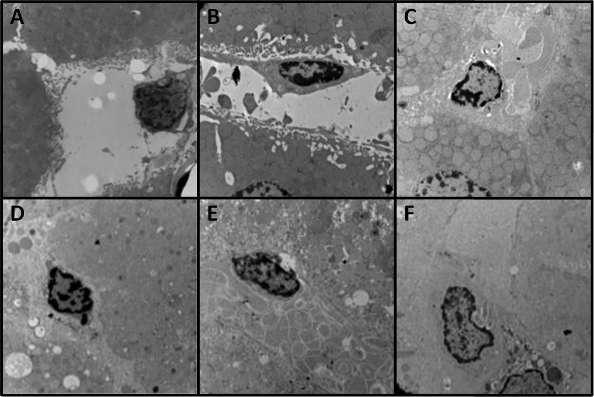
Figure 6 Ultrastructural changes of the liver sinusoidal endothelial cell. Images A and D: Respectively, are sinusoidal endothelial cells of the young control group A and the aged control group D; Images B and E: Respectively, are sinusoidal endothelial cells of the young group B and aged group E of UWP; Images C and F: Respectively, are sinusoidal endothelial cells of the young group C and aged group F of MUWP. UW: University of Wisconsin; UWP: UW solution perfusion; MUWP: Metformin perfusion solution. Original magnification (A–F): × 10000.

