Name of Journal: World Journal of Clinical Cases
Manuscript NO: 62004
Manuscript Type: CASE REPORT

Malignant giant cell tumor in the left upper arm soft tissue of an adolescent: A case report

Huang WP et al. Malignant giant cell tumor

Wen-Peng Huang, Li-Na Zhu, Rui Li, Li-Ming Li, Jian-Bo Gao

Wen-Peng Huang, Li-Na Zhu, Rui Li, Li-Ming Li, Jian-Bo Gao, Department of Radiology, The First Affiliated Hospital of Zhengzhou University, Zhengzhou 450052, Henan Province, China

Author contributions: Gao JB was the principal investigator and takes primary responsibility for the manuscript; Huang WP and Zhu LN analyzed and interpreted the patient data and wrote the manuscript draft, which was amended by Gao JB; All authors read and approved the final version of the manuscript.

Corresponding author: Jian-Bo Gao, MD, Professor, Department of Radiology, The First Affiliated Hospital of Zhengzhou University, No. 1 East Jianshe Road, Zhengzhou 450052, Henan Province, China. jianbogaochina@163.com

Received: January 7, 2021
Revised: January 25, 2021
Accepted: March 12, 2021
Published online: May 26, 2021

Abstract
BACKGROUND
Giant cell tumor of soft tissue (GCT-ST) is an extremely rare low-grade soft tissue tumor that is originates in superficial tissue and rarely spreads deeper. GCT-ST has unpredictable behavior. It is mainly benign, but may sometimes become aggressive and potentially increase in size within a short period of time.

CASE SUMMARY
A 17-year-old man was suspected of having a fracture, based on radiography following left shoulder trauma. One month later, the swelling of the left shoulder continued to increase and the pain was obvious. Computed tomography (CT) revealed a soft tissue mass with strip-like calcifications in the left shoulder. The mass invaded the adjacent humerus and showed an insect-like area of destruction at the edge of the cortical bone of the upper humerus. The marrow cavity of the upper humerus was enlarged, and a soft tissue density was seen in the medullary cavity. Thoracic CT revealed multiple small nodules beneath the pleura of both lungs. A bone scan demonstrated increased activity in the left shoulder joint and proximal humerus. The mass showed mixed moderate hypointensity and hyperintensity on T1-weighted images, and mixed hyperintensity on T2-weighted fat-saturated images. The final diagnosis of GCT-ST was confirmed by pathology.

CONCLUSION
GCT-STs should be considered in the differential diagnosis of soft tissue tumors and monitored for large increases in size.

Key Words: Bone scan; Giant cell tumor; Soft tissue; Tomography; X-ray computed; Magnetic resonance imaging; Case report

©The Author(s) 2021. Published by Baishideng Publishing Group Inc. All rights reserved.

Citation: Huang WP, Zhu LN, Li R, Li LM, Gao JB. Malignant giant cell tumor in the left upper arm soft tissue of an adolescent: A case report. World J Clin Cases 2021; 9(15): 3704-3710
URL: https://www.wjgnet.com/2307-8960/full/v9/i15/3704.htm
DOI: https://dx.doi.org/10.12998/wjcc.v9.i15.3704

Core Tip: Giant cell tumor of soft tissue (GCT-ST) is a rare primary soft tissue tumor that sometimes leads to local recurrence, but rarely to distant metastasis. In this case, the tumor exhibited strip-like calcifications, and the mass destroyed the cortical bone and invaded the bone marrow cavity. Magnetic resonance imaging was performed to establish the extent of the mass. We found multiple small nodules beneath the pleura of both lungs, which we considered as metastases. Development of an aggressive GCT-ST after adolescent trauma is rare. GCT-ST should be considered when interpreting limb masses that involve calcification and bone destruction.
INTRODUCTION
Giant cell tumor of soft tissue (GCT-ST) is a rare primary soft tissue tumor; most originate from the subcutaneous superficial soft tissue of the extremities. The clinical manifestations are not specific, most are asymptomatic masses, and they rarely invade the deeper tissue^{[1,2]}. Histologically and immunohistochemically, GCT-STs are similar to giant cell tumors (GCTs) of bone, and GCT-STs are thought to be their counterparts^{[3]}. As GCT-STs are rare, they are often initially misdiagnosed, and imaging is necessary for a better preoperative diagnosis. GCT-ST is considered a tumor with low malignant potential. In this report, we describe the imaging findings of a locally invasive GCT-ST on the left upper limb in a young patient.

CASE PRESENTATION
Chief complaints
A 17-year-old man with a 1-mo history of left shoulder trauma was admitted to our hospital.

History of present illness
One month prior to admission, the patient’s left shoulder accidentally touched a staircase handrail and he experienced mild pain. Abduction of the left upper limb was slightly limited and there was no swelling. Radiographic examination of the left shoulder joint at the local hospital, showed no obvious bone and joint lesions and no treatment was carried out. Persistent swelling and pain in the left shoulder continued after 15 d of treatment with nonsteroidal anti-inflammatory drugs; the pain was not relieved and gradually worsened.

History of past illness
The patient was in good health prior to the present illness.

Personal and family history
The patient had no previous or family history of similar illnesses.

Physical examination
Physical examination revealed a left shoulder joint in forced adduction. The lateral and anterior sides of the left shoulder were obviously swollen, tender, with no pulsation, and the local skin temperature was increased. The patient was conscious of spontaneous illness, had a poor mental state, and had experienced no weight loss.

Laboratory examinations
A complete blood count revealed that the patient’s serum C-reactive protein level (70.92 mg/L, normal range 0-5 mg/L), lactate dehydrogenase (751 U/L, normal range 313-618 U/L), fibrinogen (6.29 g/L, normal range 2-4 g/L), D-dimer (5.997 mg/L, normal range 0-0.3 mg/L), alkaline phosphatase (453 U/L, normal range 35-105 U/L), and ferritin (790.80 μg/L, normal range 15-200 μg/L) were increased. Tumor-marker assays revealed that neuron-specific enolase was increased to 41.43 ng/L (normal range 0-25 ng/L).

Imaging examinations
Posteroanterior shoulder joint radiography showed a linear low-density shadow at the greater tuberosity of the left humerus and small low-density flakes in the upper medullary cavity of the left humerus (Figure 1). Computed tomography (CT) of the left shoulder joint revealed a soft tissue mass in the left shoulder (Figure 2). Strip-like calcifications in the mass (Figure 2A), the cortical edge, and marrow cavity were seen to be invaded on axial and coronal CT images (Figure 2B, D and E), and the adjacent bone showed an insect-like zone of destruction and needle-like periosteal reaction. Thoracic CT revealed multiple small, solid, rounded nodules with clear boundaries beneath the pleura of both lungs. These were more common in the lower lobe of the right lung, and the larger nodules were approximately 6 mm in size (Figure 2C).
Upper arm magnetic resonance imaging (MRI) was conducted to further assess the extent of the mass (Figure 3). A huge mass was observed surrounding the left humeral head and the proximal shaft of humerus. It had a clear outer boundary and a size of 10.3 cm × 10.5 cm × 13.6 cm (anterior-posterior × left-right × superior-inferior). The mass showed mixed moderate hypointensity and hyperintensity on T1-weighted images (Figure 3A and B) and mixed hyperintensity on coronal fat-saturated T2-weighted images (Figure 3C). T1-weighted images with contrast demonstrated heterogeneous enhancement of the lesion (Figure 3D). The humeral cortex was discontinuous, with worm-eaten-like bone destruction seen on the axial T1-weighted images. The inside of the cancellous bone showed irregular patches of hypointensity on coronal T1-weighted images and mixed hyperintensity on fat-saturated T2-weighted images. Based on the findings of multimodality imaging, a primary locally invasive soft tissue tumor with a pathological fracture was suspected. The patient underwent a whole-body ^{99m}Tc-methylene diphosphonate bone scan to check the condition of the other bones (Figure 4). The bone scan demonstrated clearly visible scoliosis, an abnormal distribution of radioactive label concentrations, and increased activity in the left shoulder joint and proximal humerus, corresponding to the mass seen on MRI.
Finally, histopathology after surgery showed that the tumor was composed of polygonal mononuclear cells and multinucleated osteoclast-like giant cells (Figure 5A). Immunohistochemical staining was positive for CD163 and CD68 (Figure 5B and C), and negative for cytokeratin and S-100, corresponding to the phenotypic profile of a giant cell tumor.

FINAL DIAGNOSIS
Primary GCT-ST of the left proximal humerus.

TREATMENT
After hospitalization, the left shoulder joint was punctured and approximately 10 mL of bloody fluid was withdrawn. The pain gradually increased and was not relieved after blood stasis treatment. To confirm the diagnosis, the patient was prepared to undergo a biopsy of the left shoulder lesion. During the operation, the skin, subcutaneous tissue, and deep fascia were cut sequentially, and after blunt separation along the deltoid space of the pectoralis major muscle, a large amount of bloody fluid was removed from the anterior side of the proximal left humerus. The lateral outflow and finger probe revealed that the anterior and lateral cortical bone of the proximal left humerus was damaged. A curette was used to scrape out the dark red tissue around the anterior side of the proximal left humerus and around the lateral cortical bone. After packing with hemostatic cotton and gelatin sponges, the deep fascia, subcutaneous tissue, and skin were tightly sutured. The tissues were sent for pathological examination after surgery. After surgery, the patient’s temperature was 36.5 °C, heart rate was 97 bpm, respiratory rate was 20 breaths/min, and blood pressure was 106/66 mmHg. The patient was conscious, and there was a small amount of exudation at the distal end of the incision. The patient’s left forearm and upper arm were also obviously swollen. Antibiotics were administered to prevent an incision infection, and sodium aescinate was used to reduce swelling in the limb. Sixteen days after the operation, the incision had still not fully healed and bloody fluid was exuding from the distal end of the incision. Symptomatic and nutritional therapies were administered.

OUTCOME AND FOLLOW-UP
The family members refused to transfer the patient to the oncology department to continue treatment and asked to discharge the patient to a local hospital for treatment. Telephone follow-up conducted 3 mo later found that the patient’s lung nodules had increased. After 6 mo, the patient was lost to follow-up by telephone.

DISCUSSION
GCT-ST is an extremely rare primary soft tissue tumor that sometimes leads to local recurrence and rarely to distant metastasis. The World Health Organization classifies these types of tumors as GCT-STs with low malignant potential or as malignant GCT-STs. Until now, etiological factors for GCT-STs have not been identified. In clinical practice, GCT-ST is known to be extremely rare and to have unpredictable behavior^{[1]}. GCT-STs are mainly benign, but some are aggressive and have the potential to increase in size within a short period of time^{[4]}. Imaging examinations have high sensitivity in the diagnosis of patients with local invasiveness and distant metastasis. Histologically and immunohistochemically, a GCT-ST is characterized by the presence of multinucleate osteoclast-like giant cells and spindles, or polygonal mononuclear cells. Because they are similar to the GCTs of bone, GCT-STs are thought to be their counterparts. In many cases, GCT-ST immunohistochemistry is positive for CD163 and CD68. Atypia and necrosis are present in the malignant form of GCT-STs, which is why those tumors can progress rapidly and aggressively if not properly and promptly treated^{[3-6]}. The most common site is the superficial soft tissue of the limbs, with the thigh being the most commonly affected^{[1,7,8]}. Only a few cases of this type of tumor have been reported in the deep soft tissues of the extremities^{[1,4]}. They were found in people 36-66 years of age, without gender difference. Most tumors were located in the lower extremities, with sizes ranging from 1.5 cm to 35 cm. None of the previous cases had calcification or bone involvement. In the present case, the tumor exhibited strip-like calcifications. The mass had destroyed the cortical bone and had invaded the bone marrow cavity. The patient was examined with MRI to establish the extent of the mass. The mass showed mixed moderate hypointensity and hyperintensity on T1-weighted images, and mixed hyperintensity on coronal fat-saturated T2-weighted images. T1-weighted images with contrast demonstrated heterogeneous enhancement of the lesion. Based on the findings of multimodality imaging, a primary locally invasive soft tissue tumor with a pathological fracture was suspected. In addition, we found multiple small nodules beneath the pleura of both lungs. Clinicians consider lung nodules as metastases. The formation of an aggressive GCT-ST after adolescent trauma is rare.
Given its appearance on a bone scan and other imaging modalities, the differential diagnosis should include epithelioid sarcoma and extraskeletal osteosarcoma. Epithelioid sarcomas show nodules or masses involving subcutaneous or deep soft tissue, along with ulcers, hemorrhage, necrotic cysts, occasional calcification, invasion of the adjacent soft tissue, and sometimes even bone invasion. The volume of an extraskeletal osteosarcoma is often large, and most CT findings involve round or quasi-round nonhomogeneous masses. Cotton-like bone tumors can be seen or bone-like materials can be seen in the tumor, as well as cystic degeneration, necrosis, and bleeding. Enhanced scans may show moderate enhancement that may be reduced in the delayed phase and can easily invade the surrounding tissue.

CONCLUSION
As this case demonstrates, the possibility of GCT-ST should be considered when interpreting masses in limbs that exhibit calcification and bone destruction. Here, we present a rare case of a malignant GCT-ST in the upper left arm of an adolescent. The lesion was suspected on CT and was well characterized by MRI.

ACKNOWLEDGEMENTS
The authors acknowledge the contribution of all investigators at all participating study sites.

REFERENCES
1 Mensah D, Chhantyal K, Lu YX, Li ZY. Malignant Giant Cell Tumor of Soft Tissue: A Case Report of Intramuscular Malignant Giant Cell Carcinoma of the Tensor Fasciae Latae. J Orthop Case Rep 2019; 9: 70-73 [PMID: 31245324]
2 Mavrogenis AF, Tsukamoto S, Antoniadou T, Righi A, Errani C. Giant Cell Tumor of Soft Tissue: A Rare Entity. Orthopedics 2019; 42: e364-e369 [PMID: 31323108 DOI: 10.3928/01477447-20190624-04]
3 Lee JC, Liang CW, Fletcher CD. Giant cell tumor of soft tissue is genetically distinct from its bone counterpart. Mod Pathol 2017; 30: 728-733 [PMID: 28084336 DOI: 10.1038/modpathol.2016.236]
4 O'Connell JX, Wehrli BM, Nielsen GP, Rosenberg AE. Giant cell tumors of soft tissue: a clinicopathologic study of 18 benign and malignant tumors. Am J Surg Pathol 2000; 24: 386-395 [PMID: 10716152 DOI: 10.1097/00000478-200003000-00007]
5 Chen H, Fan Q, Su M. Mediastinal 99mTc-Methylene Diphosphonate Accumulation in a Patient With Primary Mediastinal Soft Tissue Giant Cell Tumor. Clin Nucl Med 2020; 45: 477-479 [PMID: 32366789 DOI: 10.1097/RLU.0000000000003037]
6 Hu Q, Peng J, Xia L. Recurrent primary mediastinal giant cell tumor of soft tissue with radiological findings: a rare case report and literature review. World J Surg Oncol 2017; 15: 137 [PMID: 28747182 DOI: 10.1186/s12957-017-1205-5]
7 Hafiz SM, Bablghaith ES, Alsaedi AJ, Shaheen MH. Giant-cell tumors of soft tissue in the head and neck: A review article. Int J Health Sci (Qassim) 2018; 12: 88-91 [PMID: 30022909 DOI: 10.1016/j.ehpc.2017.04.004]
8 Kishi S, Monma H, Hori H, Kinugasa S, Fujimoto M, Nakamura T. First Case Report of a Huge Giant Cell Tumor of Soft Tissue Originating from the Retroperitoneum. Am J Case Rep 2018; 19: 642-650 [PMID: 29867073 DOI: 10.12659/AJCR.909261]

Footnotes
Informed consent statement: Informed written consent was obtained from the patient for publication of this report and any accompanying images.

Conflict-of-interest statement: The authors declare that they have no conflicts of interest.

CARE Checklist (2016) statement: The authors have read the CARE Checklist (2016), and the manuscript was prepared and revised according to the CARE Checklist (2016).

Open-Access: This article is an open-access article that was selected by an in-house editor and fully peer-reviewed by external reviewers. It is distributed in accordance with the Creative Commons Attribution NonCommercial (CC BY-NC 4.0) license, which permits others to distribute, remix, adapt, build upon this work non-commercially, and license their derivative works on different terms, provided the original work is properly cited and the use is non-commercial. See: http://creativecommons.org/Licenses/by-nc/4.0/

Manuscript source: Unsolicited manuscript

Peer-review started: January 7, 2021
First decision: January 24, 2021
Article in press: March 12, 2021

Specialty type: Medicine, research and experimental
Country/Territory of origin: China
Peer-review report’s scientific quality classification
Grade A (Excellent): 0
Grade B (Very good): 0
Grade C (Good): C
Grade D (Fair): 0
Grade E (Poor): 0

P-Reviewer: D'Orazi V S-Editor: Gao CC L-Editor: Filipodia P-Editor: Yuan YY
Figure Legends
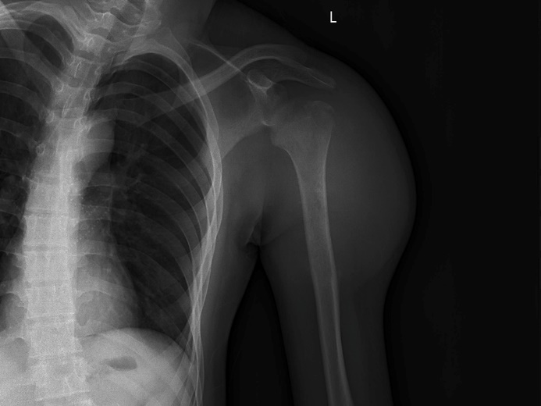
Figure 1 Posteroanterior shoulder joint radiograph. A linear low-density shadow at the greater tuberosity of the left humerus and small flakes in the upper medullary cavity of the left humerus with slightly reduced density are seen.
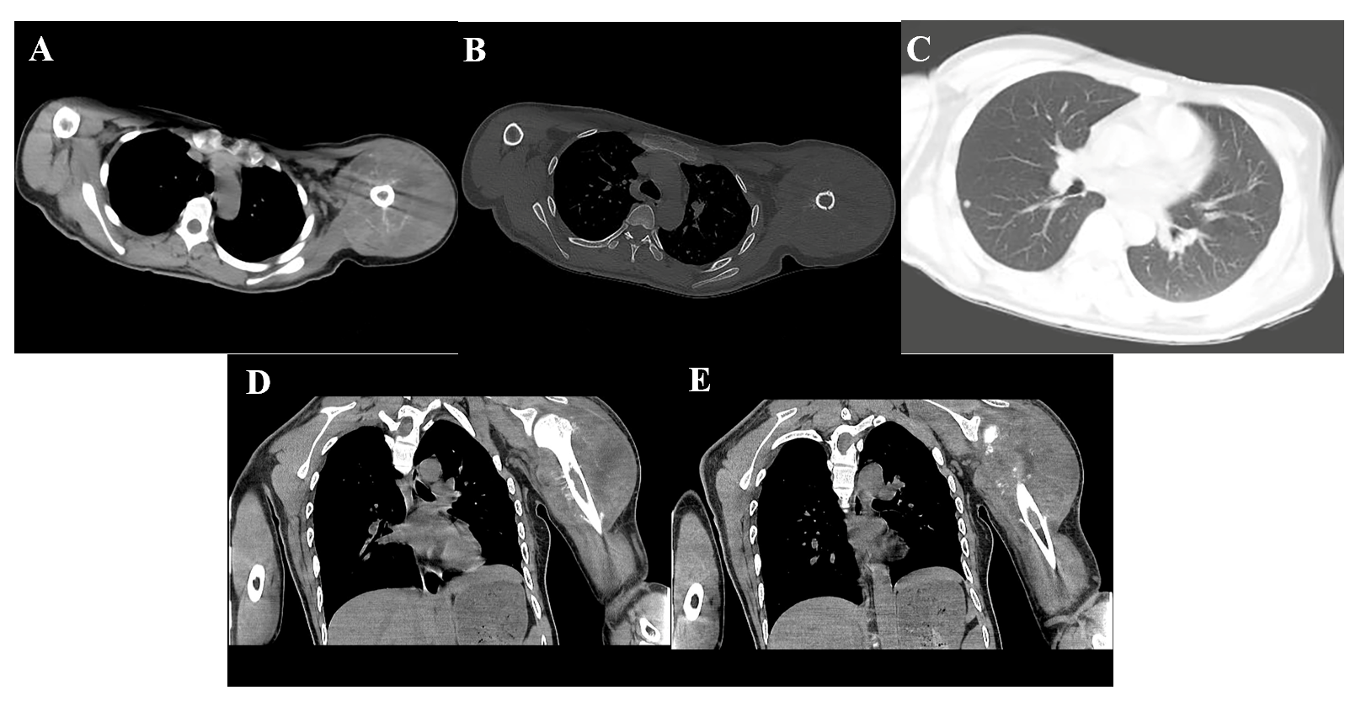
Figure 2 Computed tomography of left shoulder joint reveals a soft tissue mass of the left shoulder. A: Strip-like calcifications in the mass; B: The adjacent bone shows an insect-like zone of destruction; C: Small, rounded solid nodules in the lower lobe of the right lung; D: The adjacent bone shows a needle-like periosteal reaction; E: Invasion of the marrow cavity.
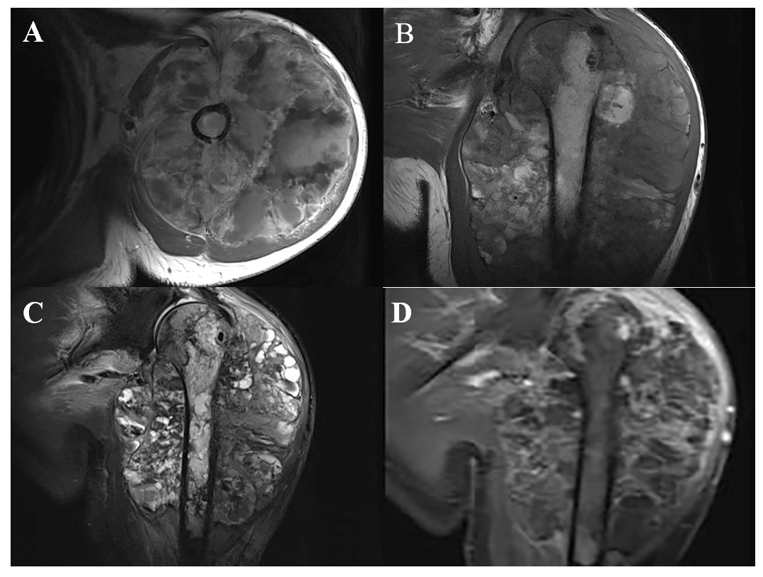
Figure 3 Upper arm magnetic resonance imaging. A and B: Mixed moderate hypointensity and hyperintensity on axial (A) and coronal (B) T1-weighted images; C: mixed hyperintensity on coronal fat-saturated T2-weighted images; D: T1-weighted images with contrast demonstrate heterogeneous enhancement of the lesion.
Figure 4 Whole-body ^{99m}Tc-methylene diphosphonate bone scan imaging. Abnormal distribution of radioactive label concentration and increased activity are seen in the left shoulder joint and proximal humerus.
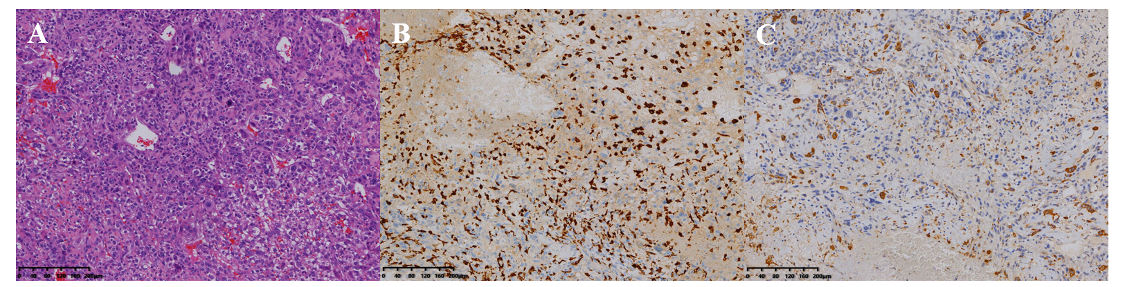
Figure 5 Histopathological images. A: A giant cell tumor with polygonal mononuclear cells and multinucleated osteoclast-like giant cells (hematoxylin and eosin, × 200); B: Immunohistochemical staining revealed strong CD163 positivity (hematoxylin and eosin, × 200); C: Immunohistochemical staining revealed high CD68 positivity (hematoxylin and eosin, × 200).

Published by Baishideng Publishing Group Inc
7041 Koll Center Parkway, Suite 160, Pleasanton, CA 94566, USA
Telephone: +1-925-3991568
E-mail: bpgoffice@wjgnet.com
Help Desk: https://www.f6publishing.com/helpdesk
https://www.wjgnet.com

© 2021 Baishideng Publishing Group Inc. All rights reserved.

