Name of Journal: World Journal of Clinical Cases
Manuscript NO: 70373
Manuscript Type: CASE REPORT

Treatment with sorafenib plus camrelizumab after splenectomy for primary splenic angiosarcoma with liver metastasis: A case report and literature review

Pan D et al. Treatment of PSA with liver metastasis

Dan Pan, Tai-Ping Li, Jian-Hui Xiong, Shu-Bo Wang, Yao-Xu Chen, Jian-Feng Li, Qi Xiao

Dan Pan, Tai-Ping Li, Jian-Hui Xiong, Jian-Feng Li, Qi Xiao, Department of General Surgery, The First Affiliated Hospital of Nanchang University, Nanchang 330006, Jiangxi Province, China

Shu-Bo Wang, Yao-Xu Chen, The Medical Department, 3D Medicines Inc., Shanghai 201114, Shanghai Province, China

Author contributions: Xiao Q was the physician in charge, confirmed the diagnosis and contributed the details on the histologic diagnosis; Pan D contributed to the case report design and manuscript drafting, and provided the histologic image; Wang SB and Chen YX were responsible for NGS testing; Li TP and Xiong JH reviewed the manuscript; Xiao Q and Li JF were the principal authors of the paper, had full access to all data, and are the guarantors; and all authors read and confirmed the final version of this article.

Supported by the Natural Science Foundation of Jiangxi Province (No. 20192BAB215012 and No. 20212BAB206027), the Health Commission of Jiangxi Province (No. 20203206).

Corresponding author: Qi Xiao, PhD, Chief Doctor, Department of General Surgery, The First Affiliated Hospital of Nanchang University, No.17 Yongwai Zheng Road, Donghu District, Nanchang 330006, Jiangxi Province, China. xiaoqidoctor@163.com

Received: August 9, 2021
Revised: December 4, 2021
Accepted: February 19, 2022
Published online:

Abstract
BACKGROUND
Primary splenic angiosarcoma (PSA) is an extremely rare and aggressive mesenchymal malignancy with high metastatic potential and a poor prognosis. There are no established treatment guidelines for PSA, even for adjuvant therapy. This rare case may provide a reliable therapeutic regime for a better prognosis.

CASE SUMMARY
A 49-year-old female who complained of right-upper quadrant abdominal pain was diagnosed as having PSA with splenic rupture and liver metastasis. After splenectomy and liver tumor resection, she received sorafenib and camrelizumab therapy. After 15 mo of follow-up, she is in good condition, without recurrence or any identified metastasis.

CONCLUSION
Immunotherapy combined with targeted therapy could be a potential option for the adjuvant therapy of PSA.

Key Words: Primary splenic angiosarcoma; Immunotherapy; Targeted therapy; Prognosis; Case report

Pan D, Li TP, Xiong JH, Wang SB, Chen YX, Li JF, Xiao Q. Treatment with sorafenib plus camrelizumab after splenectomy for primary splenic angiosarcoma with liver metastasis: A case report and literature review. World J Clin Cases 2022; In press

Core Tip: Splenectomy is the preferred treatment for primary splenic angiosarcoma (PSA); however, PSA patients may experience a good or poor prognosis after splenectomy. Although the prognosis in patients with liver metastases or rupture of the spleen is extremely poor, immunotherapy or targeted therapy has not been attempted after surgery. This case is the first report of a PSA patient with liver metastasis and splenic rupture, receiving sorafenib plus camrelizumab as adjuvant therapy. After 15 mo of follow-up, the patient is in good condition without recurrence or identified metastasis. Apart from chemotherapy and radiotherapy, targeted therapies and immunotherapy may also be an option for adjuvant therapy.

INTRODUCTION
Primary splenic angiosarcoma (PSA), a subtype of soft tissue sarcoma (STS) with an annual incidence of 0.14-0.25 per million^{[1]}, is an extremely rare and aggressive mesenchymal malignancy with high metastatic potential and a poor prognosis. Upon histopathological examination, abnormal, pleomorphic, malignant patterns of endothelial cells, which can be rounded, polygonal, or fusiform (the hallmark of angiosarcoma or mitotic bodies), are commonly observed^{[2]}. The typically expressed endothelial markers include von Willebrand factor, CD34, CD31, Ulex europaeus agglutinin-1, and vascular endothelial growth factor (VEGF)^{[2]}.
PSA patients with liver metastasis have a poor prognosis, especially when the spleen ruptures. Although immunotherapy and targeted therapy are widely used in other tumors, they are rarely considered in the treatment of PSA. In several cases, immunotherapy or targeted therapy is very effective in patients with angiosarcoma^{[3-5]}. We believe that this form of therapy may have great potential in the treatment of PSA.

CASE PRESENTATION
Chief complaints
The patient developed pain in the right upper quadrant of the abdomen for one month, which exacerbated within a day, along with significant weight loss (Figure 1).

History of present illness
On 16 February 2020, a 49-year-old female with the complaint described above was brought to our emergency department. The patient did not report any abdominal trauma but complained of significant weight loss. According to the computed tomography (CT) scan on 16 February 2020 and other examinations (Figure 2), the diagnosis was non-traumatic splenic rupture and hemorrhage, with the suspected presence of liver cancer. Splenic artery embolization was suggested, which was refused by the patient and her family. Two days later, her abdominal pain was worse, after which, she and her family finally agreed to undergo splenic artery embolization (Figure 3). The patient recovered uneventfully and was discharged nine days later. One month later, she was admitted to our hospital again due to abdominal pain. According to the contrast-enhanced CT performed on 6 April 2020, the preliminary diagnosis was splenic angiosarcoma with peripheral and intrahepatic metastasis (Figure 4).

History of past illness
Surgical history included total thyroidectomy two years ago, followed by I131 therapy, hysteromyomectomy performed ten years ago, and pancreatic stone removal. The patient did not present a history of hepatitis or diabetes mellitus.

Personal and family history
There was no notable family medical history, such as cancer.

Physical examination
The patient’s temperature was 36.6 °C, and blood pressure was 92/62 mmHg. Her heart rate was 101 bpm, and her respiratory rate was 20 breaths/min. Physical examination revealed a tender abdominal mass in the left upper abdomen and distension of the abdomen. Deep palpation showed diffuse pain, although without clinical signs of peritonitis.

Laboratory examinations
Liver function tests, hematology parameters, as well as tumor markers such as α-fetoprotein (AFP), carbohydrate antigen 199, carcinoembryonic antigen, and chromogranin A, were all normal, except for a white blood cell count of 13.54 × 10⁹/L [normal range: (4.0-10.0) × 10⁹/L] and hemoglobin concentration of 177 g/L (normal range: 120-160 g/L), which were beyond the normal range. The D-dimer level of 35.65 mg/L (normal range: 0.0-0.55 mg/L) indicated high coagulation function, while the remaining parameters were normal. Electrolyte levels, electrocardiogram, and chest X-ray were normal.

Imaging examinations
Multiple masses were observed in the liver and spleen on abdominal CT and magnetic resonance imaging on 16 February 2020 (Figure 2). Contrast-enhanced CT on 6 April 2020 revealed multiple round shadows of low-density in the spleen and liver (Figure 4).

FINAL DIAGNOSIS
The patient was diagnosed as having PSA with a liver tumor.

TREATMENT
Splenectomy and liver tumor resection were performed not only to perform radical excision of the tumor but also for histopathological diagnosis. Intraoperatively, we observed a large scleroid tumor mass of 4 cm × 6 cm in size in the upper pole of the spleen. A cross-section of the specimen revealed a demarcated yellowish-white lesion accompanied by hemorrhage and necrosis (Figure 5). The intraoperative observation of neoplasms was in line with the imaging findings. Histopathological biopsy and next-generation sequencing (NGS) were carried out (733 gene panel genetic testing provided by 3D Medicines Inc.). The histopathology revealed that the tumor cells were arranged in sheets, fissures, or papillae, with the cytoplasm in fusiform, oval, or irregular nuclei, and mitosis was easily seen. Immunohistochemical examination revealed that the tumor cells were positive for CD31, S-100 and Ki-67 (positive rate of 60%), and negative for CD34 (Figure 6). The final pathological diagnosis was hepatic angiosarcoma and splenic angiosarcoma. From imaging, it was observed that the splenic tumors were large and numerous, while the liver tumors were relatively small and uniform in size, which was consistent with the characteristics of metastatic liver cancer. In addition, our patient had no history of hepatitis, preoperative AFP was normal, CT examination showed no obvious characteristics of primary liver cancer, and blood from the spleen returned to the liver which is the way the tumor metastasizes, and further supported the diagnosis of spleen tumor metastasized to the liver. Although the primary site was indistinguishable pathologically, the diagnosis of primary splenic malignancy with hepatic metastasis was suggested based on the characteristics of imaging and blood metastasis. The NGS revealed somatic mutations in the PDGFRA (gene amplification), KIT (gene amplification), KDR (VEGFR2) (gene amplification), and TP53 (c.376-4_380del, mutation abundance: 65.31%), while immunohistochemistry (IHC) showed the expression of programmed death ligand-1 (PD-L1) (Figure 7).
One month after the operation, the patient was given an intravenous infusion of sorafenib (400 mg) twice daily and camrelizumab (200 mg) in a 21-d cycle. After three weeks of combination therapy, she developed hand-foot syndrome and was unable to walk, after which, sorafenib was reduced to 600 mg daily.

OUTCOME AND FOLLOW-UP
Three and a half months after the operation, no metastasis was observed on single-photon emission tomography-CT (Figure 8). After 15 mo of frequent follow-up, we happily report that the patient is in good condition without any recurrence or metastasis. Also, the side effects of sorafenib and camrelizumab were tolerable. The patient believed that the treatment had little impact on her quality of life.

DISCUSSION
Since the first case of PSA reported in 1879, only about 200 cases had been reported in the literature worldwide^{[1]}. We summarized the characteristics of PSA from case reports in the last ten years (Table 1). Unlike hepatic angiosarcoma, we observed no correlation between splenic angiosarcoma and risk factors such as thorium dioxide, vinyl chloride, or arsenic^{[6]}. The symptoms of PSA are nonspecific, and although it may occur at any age, it is commonly observed in females aged over 60 years old^{[6]}.
Due to its low incidence, there are no recommended standardized treatments, guidelines, or even a consensus. Splenectomy is the preferred treatment for splenic angiosarcoma^{[2]}. According to a retrospective analysis by Li et al^{[7]}, the mean overall survival (OS) for PSA patients was less than 8.1 mo after diagnosis. Despite the long survival of some patients, the prognosis for patients with liver metastases or splenic rupture after splenectomy was generally poor (Table 1).
Almost 30% of the patients experienced splenic rupture associated with hemoperitoneum^{[6]}. When the spleen ruptures, the prognosis for PSA patients is poor. Kornmann et al^{[8]} reported that a 69-year-old male with PSA who had splenic rupture associated with hemoperitoneum died within one month after surgery (Table 1). Abbott et al^{[9]} reported that the mean OS among patients who had splenectomy after spontaneous splenic rupture was 4.4 mo. If splenectomy was performed before rupture, the mean OS increased to 14.4 mo.
PSA is also a highly aggressive tumor, which can not only spread via direct invasion but also metastasize via the hematal and lymphatic system^{[2,7]}. The most common site involved is the liver, followed by the lungs, bones, lymph nodes, and ovaries^{[7]}. Metastasis in the liver, peritoneum, bone, and lung may occur in PSA patients, and approximately half of such patients died within one year after diagnosis (Table 1). The prognosis of PSA is abysmal, particularly in patients with metastases^{[6]}. Splenic rupture and liver metastases may serve as high-risk factors for PSA. Thus, the patients with either may need more measures for prolonged survival. Adjuvant therapy may be a potential treatment strategy after surgery to reduce the likelihood of recurrence or spread to other sites.
Postoperative radiotherapy and adjuvant chemotherapy provide a promising choice for sarcomas of the extremities, although the efficacy for PSA was questionable as only a few patients have been enrolled in clinical trials^{[10,11]}. For unresectable angiosarcoma, treatment with single-agent doxorubicin or paclitaxel is recommended based on the available evidence. However, there is no precise evidence for adjuvant chemotherapy^{[12]}. Given its extensive use in other tumors, targeted therapy and immunotherapy may provide new options for adjuvant therapy against PSA.
Immunotherapy has become a significant option for the treatment of advanced cancer^{[13]}. A retrospective analysis reported that a cohort of patients with unresectable sarcomas, who were treated with nivolumab combined with pazopanib, presented clinical benefit in 50% of the patients after at least four cycles^{[14]}. This may be due to increased lymphocytic infiltration and PD-L1 expression in patients with sarcomas^{[15,16]}. Hence, it is reasonable to perform immunotherapy. Studies have demonstrated that the activity of anti-PD-1 therapy in all types of STS is consistent^{[17]}. Targeted therapies such as bevacizumab, sorafenib, and pazopanib have shown great efficacy in the treatment of advanced STS^{[13]}. A retrospective analysis reported that sorafenib had activity against angiosarcoma^{[4]}. In a phase-III trial for metastatic STS, 372 patients with advanced STS whose disease had progressed despite at least one line of chemotherapy were randomly assigned to either the pazopanib arm or a placebo arm. The difference in progression-free survival (PFS) between the two arms was statistically significant, with a median PFS of 4.6 mo for pazopanib, compared to just 1.6 mo for placebo^{[18]}. Pazopanib has received approval for the treatment of certain STSs in 2012^{[14]}. In an open-label, multicenter, phase-II study, bevacizumab showed great potential in the treatment of angiosarcoma in 30 patients, whose disease was deemed surgically unresectable, with a mean survival of 26 wk. Four patients showed partial response, and half of the patients had stable disease^{[3]}. Notably, all the reported targeted drugs were anti-angiogenic agents, possibly because angiogenesis or VEGF plays an important role in carcinosarcoma^{[4]}. Moreover, a previous study suggested that combining immunotherapy and targeted therapies may have complementary roles in cancer treatment and that combinatorial therapy might be synergistic^{[5]}. That study gave us great inspiration and confidence.
In the present case, the patient was treated with sorafenib combined with camrelizumab as adjuvant therapy, instead of chemotherapy, because we found that the prognoses of patients on chemotherapy were stratified, that is, chemotherapy worked well in some patients and presented unsatisfactory clinical outcomes in others^{[19-22]}. Therefore, we performed NGS and IHC for PD-L1. The patient may be sensitive to sorafenib (targets BRAF, CRAF, KIT, FLT3, RET, VEGFR-1/-2/-3, and PDGFRα/β) and PD-L1 inhibitor, as deduced from the mechanism of these drugs and thus received periodic treatment. This was a meaningful attempt of off label use. Now, after 15 mo of follow-up, there is no progress or recurrence of the disease, and the prognosis is good compared to most PSA patients with rupture of the spleen or liver metastases without adjuvant therapy among cases published in the last 10 years (Table 1).

CONCLUSION
Our data provide excellent evidence that adjuvant targeted therapy and immunotherapy may improve the prognosis in patients with PSA. Meanwhile, more evidence-based medical data and the specific cycle of targeted immunotherapy need to be further explored. NGS can be considered for patients suffering from angiosarcoma, which may suggest possible clinical treatment.

REFERENCES
1 Badiani R, Schaller G, Jain K, Swamy R, Gupta S. Angiosarcoma of the spleen presenting as spontaneous splenic rupture: A rare case report and review of the literature. Int J Surg Case Rep 2013; 4: 765-767 [PMID: 23856255 DOI: 10.1016/j.ijscr.2013.06.007]
2 Young RJ, Brown NJ, Reed MW, Hughes D, Woll PJ. Angiosarcoma. Lancet Oncol 2010; 11: 983-991 [PMID: 20537949 DOI: 10.1016/S1470-2045(10)70023-1]
3 Agulnik M, Yarber JL, Okuno SH, von Mehren M, Jovanovic BD, Brockstein BE, Evens AM, Benjamin RS. An open-label, multicenter, phase II study of bevacizumab for the treatment of angiosarcoma and epithelioid hemangioendotheliomas. Ann Oncol 2013; 24: 257-263 [PMID: 22910841 DOI: 10.1093/annonc/mds237]
4 Maki RG, D'Adamo DR, Keohan ML, Saulle M, Schuetze SM, Undevia SD, Livingston MB, Cooney MM, Hensley ML, Mita MM, Takimoto CH, Kraft AS, Elias AD, Brockstein B, Blachère NE, Edgar MA, Schwartz LH, Qin LX, Antonescu CR, Schwartz GK. Phase II study of sorafenib in patients with metastatic or recurrent sarcomas. J Clin Oncol 2009; 27: 3133-3140 [PMID: 19451436 DOI: 10.1200/JCO.2008.20.4495]
5 Vanneman M, Dranoff G. Combining immunotherapy and targeted therapies in cancer treatment. Nat Rev Cancer 2012; 12: 237-251 [PMID: 22437869 DOI: 10.1038/nrc3237]
6 Falk S, Krishnan J, Meis JM. Primary angiosarcoma of the spleen. A clinicopathologic study of 40 cases. Am J Surg Pathol 1993; 17: 959-970 [PMID: 8372948 DOI: 10.1097/00000478-199310000-00001]
7 Li R, Li M, Zhang LF, Liu XM, Hu TZ, Xia XJ, Chi JS, Jiang XX, Xu CX. Clinical Characteristics and Prognostic Factors of Primary Splenic Angiosarcoma: A Retrospective Clinical Analysis from China. Cell Physiol Biochem 2018; 49: 1959-1969 [PMID: 30235449 DOI: 10.1159/000493656]
8 Kornmann V, van Rijn P, Mulder D, Reijnders K. Delayed diagnosis of angiosarcoma of the spleen: clinically presenting as recurrent haemoperitoneum following embolisation. BMJ Case Rep 2015; 2015 [PMID: 25858933 DOI: 10.1136/bcr-2014-208956]
9 Abbott RM, Levy AD, Aguilera NS, Gorospe L, Thompson WM. From the archives of the AFIP: primary vascular neoplasms of the spleen: radiologic-pathologic correlation. Radiographics 2004; 24: 1137-1163 [PMID: 15256634 DOI: 10.1148/rg.244045006]
10 Adjuvant chemotherapy for localised resectable soft-tissue sarcoma of adults: meta-analysis of individual data. Sarcoma Meta-analysis Collaboration. Lancet 1997; 350: 1647-1654 [PMID: 9400508]
11 Pawlik TM, Paulino AF, McGinn CJ, Baker LH, Cohen DS, Morris JS, Rees R, Sondak VK. Cutaneous angiosarcoma of the scalp: a multidisciplinary approach. Cancer 2003; 98: 1716-1726 [PMID: 14534889 DOI: 10.1002/cncr.11667]
12 Penel N, Bui BN, Bay JO, Cupissol D, Ray-Coquard I, Piperno-Neumann S, Kerbrat P, Fournier C, Taieb S, Jimenez M, Isambert N, Peyrade F, Chevreau C, Bompas E, Brain EG, Blay JY. Phase II trial of weekly paclitaxel for unresectable angiosarcoma: the ANGIOTAX Study. J Clin Oncol 2008; 26: 5269-5274 [PMID: 18809609 DOI: 10.1200/JCO.2008.17.3146]
13 Qiao Y, Yang J, Liu L, Zeng Y, Ma J, Jia J, Zhang L, Li X, Wu P, Wang W, Liu D, Chen H, Zhao Y, Xi H, Wang Y. Successful treatment with pazopanib plus PD-1 inhibitor and RAK cells for advanced primary hepatic angiosarcoma: a case report. BMC Cancer 2018; 18: 212 [PMID: 29466964 DOI: 10.1186/s12885-018-3996-3]
14 Paoluzzi L, Cacavio A, Ghesani M, Karambelkar A, Rapkiewicz A, Weber J, Rosen G. Response to anti-PD1 therapy with nivolumab in metastatic sarcomas. Clin Sarcoma Res 2016; 6: 24 [PMID: 28042471 DOI: 10.1186/s13569-016-0064-0]
15 Pollack SM, He Q, Yearley JH, Emerson R, Vignali M, Zhang Y, Redman MW, Baker KK, Cooper S, Donahue B, Loggers ET, Cranmer LD, Spraker MB, Seo YD, Pillarisetty VG, Ricciotti RW, Hoch BL, McClanahan TK, Murphy E, Blumenschein WM, Townson SM, Benzeno S, Riddell SR, Jones RL. T-cell infiltration and clonality correlate with programmed cell death protein 1 and programmed death-ligand 1 expression in patients with soft tissue sarcomas. Cancer 2017; 123: 3291-3304 [PMID: 28463396 DOI: 10.1002/cncr.30726]
16 Tseng WW, Malu S, Zhang M, Chen J, Sim GC, Wei W, Ingram D, Somaiah N, Lev DC, Pollock RE, Lizée G, Radvanyi L, Hwu P. Analysis of the intratumoral adaptive immune response in well differentiated and dedifferentiated retroperitoneal liposarcoma. Sarcoma 2015; 2015: 547460 [PMID: 25705114 DOI: 10.1155/2015/547460]
17 Monga V, Skubitz KM, Maliske S, Mott SL, Dietz H, Hirbe AC, Van Tine BA, Oppelt P, Okuno S, Robinson S, O'Connor M, Seetharam M, Attia S, Charlson J, Agulnik M, Milhem M. A Retrospective Analysis of the Efficacy of Immunotherapy in Metastatic Soft-Tissue Sarcomas. Cancers (Basel) 2020; 12 [PMID: 32664595 DOI: 10.3390/cancers12071873]
18 van der Graaf WT, Blay JY, Chawla SP, Kim DW, Bui-Nguyen B, Casali PG, Schöffski P, Aglietta M, Staddon AP, Beppu Y, Le Cesne A, Gelderblom H, Judson IR, Araki N, Ouali M, Marreaud S, Hodge R, Dewji MR, Coens C, Demetri GD, Fletcher CD, Dei Tos AP, Hohenberger P; EORTC Soft Tissue and Bone Sarcoma Group; PALETTE study group. Pazopanib for metastatic soft-tissue sarcoma (PALETTE): a randomised, double-blind, placebo-controlled phase 3 trial. Lancet 2012; 379: 1879-1886 [PMID: 22595799 DOI: 10.1016/S0140-6736(12)60651-5]
19 Batouli A, Fairbrother SW, Silverman JF, Muniz Mde L, Taylor KB, Welnick MA, Mancini SA, Hartman MS. Primary Splenic Angiosarcoma: Clinical and Imaging Manifestations of This Rare Aggressive Neoplasm. Curr Probl Diagn Radiol 2016; 45: 284-287 [PMID: 26321379 DOI: 10.1067/j.cpradiol.2015.07.004]
20 de Azevedo OS, do Nascimento Santos B, de Souza Liboni N, da Costa JF, de Campos OD. Splenic Angiosarcoma: A Diagnostic Splenectomy Finding. Case Rep Oncol 2016; 9: 733-737 [PMID: 27920710 DOI: 10.1159/000452619]
21 Kranzfelder M, Bauer M, Richter T, Rudelius M, Huth M, Wagner P, Friess H, Stadler J. Littoral cell angioma and angiosarcoma of the spleen: report of two cases in siblings and review of the literature. J Gastrointest Surg 2012; 16: 863-867 [PMID: 22068970 DOI: 10.1007/s11605-011-1773-6]
22 Vakkalanka B, Milhem M. Paclitaxel as neoadjuvant therapy for high grade angiosarcoma of the spleen: a brief report and literature review. Clin Med Insights Oncol 2010; 4: 107-110 [PMID: 20981134 DOI: 10.4137/CMO.S5329]
23 Fiorentino MD, Monteiro JMC, de Siqueira REB, Kim EIM, Curi AP, Ferrreira CR, Nardo M, de Campos FPF. Primary splenic angiosarcoma: a rare entity often associated with rupture and hemoperitoneum. Autops Case Rep 2019; 9: e2019100 [PMID: 31372360 DOI: 10.4322/acr.2019.100]
24 Gao BQ, Zhou DK, Qian XH, Zhang W, Ying LX, Wang WL. Spindle cell hemangioma of the spleen: A case report. Medicine (Baltimore) 2019; 98: e14555 [PMID: 30817572 DOI: 10.1097/MD.0000000000014555]
25 Levy ACJ, DeFilipp M, Blakely M, Asiry S, Jormark S, Goodman A. Splenic Angiosarcoma Diagnosed on Bone Marrow Biopsy: Case Report and Literature Review. Radiol Case Rep 2019; 14: 390-395 [PMID: 30627296 DOI: 10.1016/j.radcr.2018.12.008]
26 Sharma S, Singh P, Gupta P, Lal A, Srinivasan R. Primary Splenic Angiosarcoma with Liver Metastasis: A Rare Neoplasm Diagnosed on Fine-needle Aspiration Cytology and Cell Block Immunocytochemistry. J Cytol 2018; 35: 114-116 [PMID: 29643660 DOI: 10.4103/JOC.JOC_148_16]
27 Ishii S, Omori S, Uesugi N, Tsuyukubo T, Ito A, Kikuchi D, Onoda M, Takata R, Sugai T, Obara W. A case of angiosarcomas which occurred in an adrenal gland and spleen synchronously. Int Cancer Conf J 2018; 7: 134-136 [PMID: 31149532 DOI: 10.1007/s13691-018-0337-y]
28 Bilski M, Surdyka D, Paśnik I, Bilska M, Cisek P, Korona P, Szumiło J, Grzybowska-Szatkowska L. Adjuvant Radiochemotherapy with a 23-Month Overall Survival Time in a Patient after a Surgery due to Splenic Hemangiosarcoma Rupture: A Case Report with the Literature Review. Case Rep Oncol Med 2018; 2018: 8672407 [PMID: 29607237 DOI: 10.1155/2018/8672407]
29 Chen X, Li H, Wang F, Liu H. Early detection and integral resection are keys to extend survival in patients suffered from primary angiosarcoma of the spleen: A care-compliant case report and literature review. Medicine (Baltimore) 2018; 97: e9718 [PMID: 29384853 DOI: 10.1097/MD.0000000000009718]
30 Coppola S, Leva A, Pagni F, Famularo S, Gianotti L. Demanding Diagnosis of Splenic Angiosarcoma as Cause of Delayed Treatment of Spontaneous Splenic Rupture: A Case Report and Literature Review. Case Rep Surg 2017; 2017: 6256102 [PMID: 28261515 DOI: 10.1155/2017/6256102]
31 Abdallah RA, Abdou AG, Asaad NY, Al-Sharaky DR, Alhanafy AM. Primary Epithelioid Angiosarcoma of Spleen: A Case Report and Review of Literature. J Clin Diagn Res 2016; 10: ED05-ED07 [PMID: 26894076 DOI: 10.7860/JCDR/2016/16978.7075]
32 Xu L, Zhang Y, Zhao H, Chen Q, Ma W, Li L. Well-differentiated angiosarcoma of spleen: a teaching case mimicking hemagioma and cytogenetic analysis with array comparative genomic hybridization. World J Surg Oncol 2015; 13: 300 [PMID: 26462621 DOI: 10.1186/s12957-015-0716-1]
33 Cho EA, Choi WY, Kim SH, Hong JY, Jung SH, Kim MJ, Hwang JE, Bae WK, Shim HJ, Lee KH, Cho SH, Chung IJ. Rapidly progressing primary splenic angiosarcoma with fatal hemorrhagic event. J Chemother 2014; 26: 248-252 [PMID: 24139479 DOI: 10.1179/1973947813Y.0000000146]
34 Kamocki Z, Steward A, Zaręba KP, Kukliński A, Kędra B. Primary splenic angiosarcoma - the same diagnosis yielding two different clinical pictures. Case report. Contemp Oncol (Pozn) 2013; 17: 218-221 [PMID: 23788995 DOI: 10.5114/wo.2013.34628]
35 Alexandrino H, Julião MJ, Tralhão JG, Sousa FC. Rupture of splenic angiosarcoma: a rare cause of spontaneous haemoperitoneum. BMJ Case Rep 2013; 2013 [PMID: 23709556 DOI: 10.1136/bcr-2013-009748]
36 Duan YF, Jiang Y, Wu CX, Zhu F. Spontaneous rupture of primary splenic angiosarcoma: a case report and literature review. World J Surg Oncol 2013; 11: 53 [PMID: 23497454 DOI: 10.1186/1477-7819-11-53]
37 Muroni M, Ravaioli M, Del Gaudio M, Nigri G, D'Angelo F, Uccini S, Ramacciato G. Pancreas-preserving segmental duodenectomy for gastrointestinal stromal tumor of the duodenum and splenectomy for splenic angiosarcoma. Hepatobiliary Pancreat Dis Int 2012; 11: 325-329 [PMID: 22672829 DOI: 10.1016/s1499-3872(12)60169-6]
38 Qi R, Yu JQ, Xu H, Zhou XP, Li XM. Primary angiosarcoma of the spleen as depicted on computed tomography. Clin Imaging 2012; 36: 619-622 [PMID: 22920376 DOI: 10.1016/j.clinimag.2011.12.016]
39 Hasiloglu ZI, Metin DY, Ozbayrak M, Havan N. Locally invasive primary splenic angiosarcoma. Eurasian J Med 2010; 42: 160-163 [PMID: 25610150 DOI: 10.5152/eajm.2010.44]
40 Hara T, Tsurumi H, Kasahara S, Ogawa K, Takada J, Imai K, Takai K, Kitagawa J, Kiyama S, Imai N, Oyama M, Takami T, Moriwaki H. Long-term survival of a patient with splenic angiosarcoma after resection, high-dose chemotherapy, and autologous peripheral blood stem cell transplantation. Intern Med 2010; 49: 2253-2257 [PMID: 20962445 DOI: 10.2169/internalmedicine.49.3969]
41 Suzuki K, Nakazato T, Mihara A, Sanada Y, Kakimoto T. Primary splenic angiosarcoma mimicking splenic lymphoma. Intern Med 2010; 49: 203-204 [PMID: 20075594 DOI: 10.2169/internalmedicine.49.2918]
42 Jobke B, Werner M, Jundt G, Ostertag H, Freyschmidt J. Protracted disseminated skeletal metastases from angiosarcoma of the spleen. Clin Exp Metastasis 2010; 27: 117-122 [PMID: 20174857 DOI: 10.1007/s10585-010-9308-1]
43 Hadidy A, Alsharif A, Sheikh-Ali R, Abukhalaf M, Awidi A, Abukaraki A, Nimri C, Omari A. Odontogenic myxofibroma synchronous with primary angiosarcoma of the spleen. Br J Radiol 2010; 83: e10-e13 [PMID: 20139242 DOI: 10.1259/bjr/14078580]

Footnotes
Informed consent statement: Written informed consent was obtained from the patient for publication of this case report and any accompanying images.

Conflict-of-interest statement: There is no conflict of interest to disclose.

CARE Checklist (2016) statement: The authors have read the CARE Checklist (2016), and the manuscript was prepared and revised according to the CARE Checklist (2016).

Open-Access: This article is an open-access article that was selected by an in-house editor and fully peer-reviewed by external reviewers. It is distributed in accordance with the Creative Commons Attribution NonCommercial (CC BY-NC 4.0) license, which permits others to distribute, remix, adapt, build upon this work non-commercially, and license their derivative works on different terms, provided the original work is properly cited and the use is non-commercial. See: https://creativecommons.org/Licenses/by-nc/4.0/

Provenance and peer review: Unsolicited article; Externally peer reviewed.
Peer-review model: Single blind

Peer-review started: August 9, 2021
First decision: November 16, 2021
Article in press:

Specialty type: Medicine, research and experimental
Country/Territory of origin: China
Peer-review report’s scientific quality classification
Grade A (Excellent): 0
Grade B (Very good): B
Grade C (Good): 0
Grade D (Fair): 0
Grade E (Poor): 0

P-Reviewer: Li C S-Editor: Wang JJ L-Editor: Webster JR P-Editor:

Figure Legends
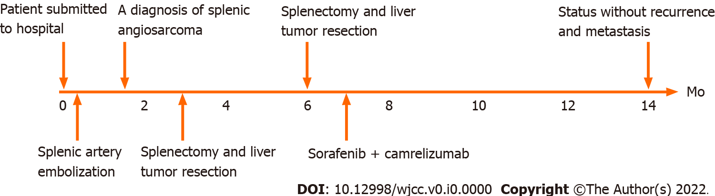
Figure 1 Treatment course.

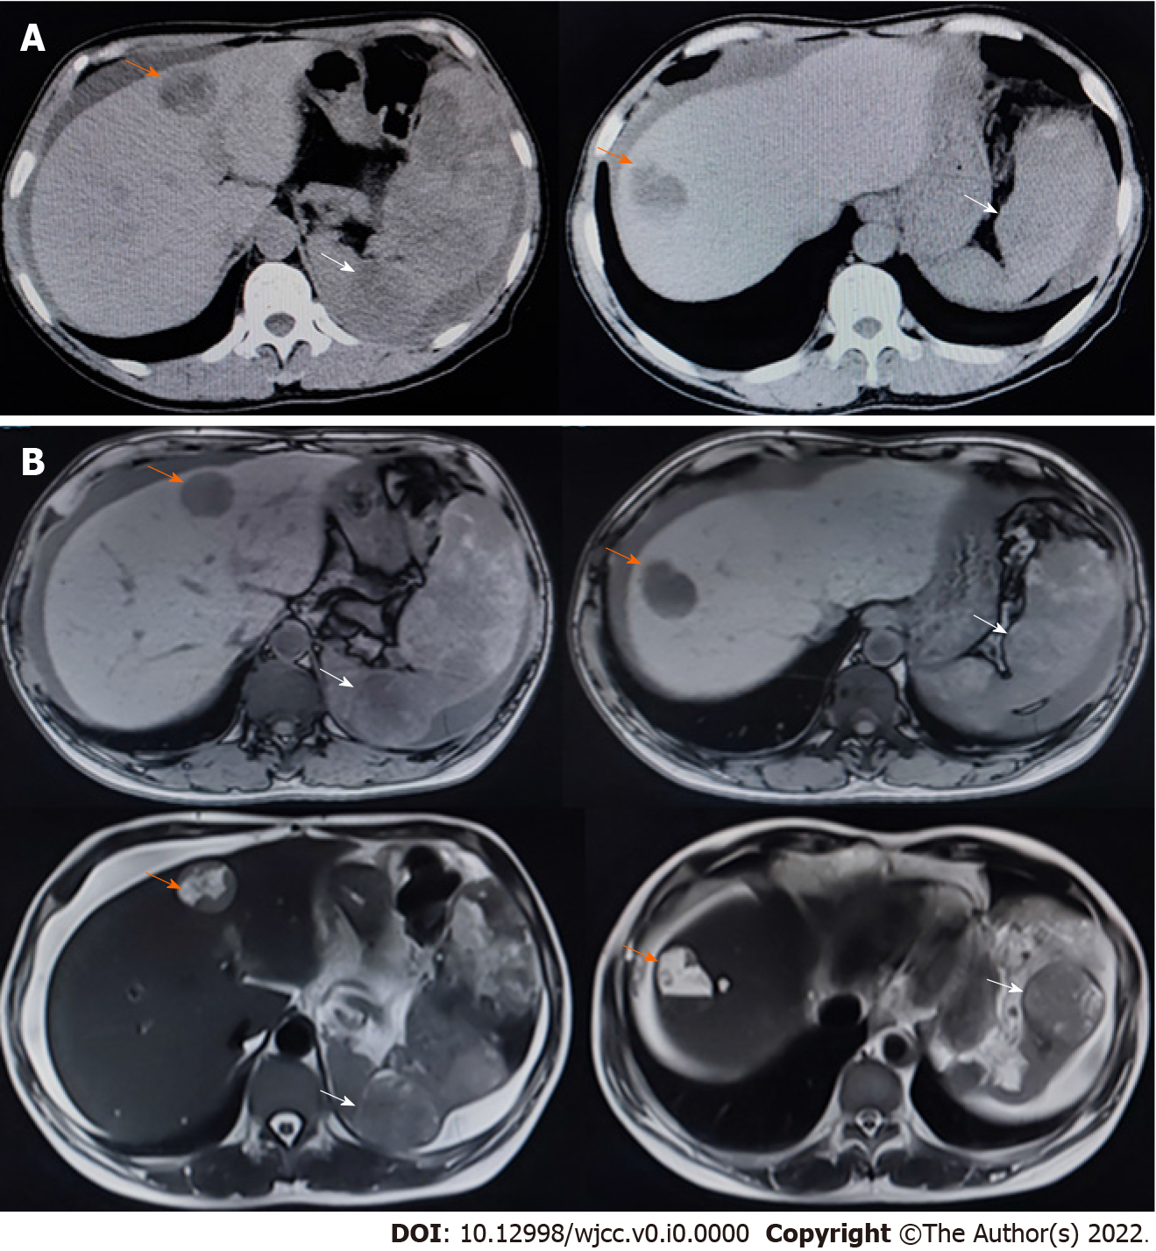
Figure 2 Computed tomography and magnetic resonance imaging performed soon after the first hospitalization. Scale bar: 10 cm. A: We observed multiple masses in the liver and spleen on computed tomography; B: We observed multiple masses in the liver and spleen on magnetic resonance imaging. Orange arrows indicate masses in the liver, while the white arrows indicate masses in the spleen.

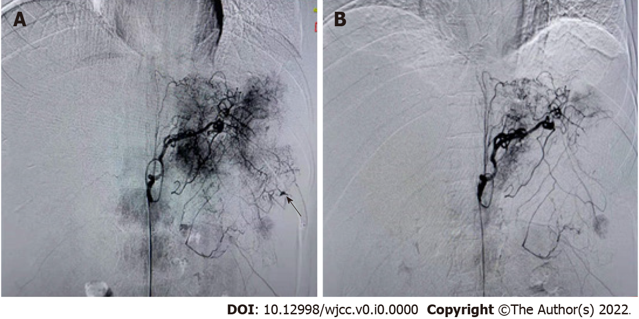
Figure 3 Digital subtraction angiography revealed the condition of the spleen before and after artery embolization. A: Imaging before splenic artery embolization. The black arrow indicates bleeding points; B: Imaging after splenic artery embolization.

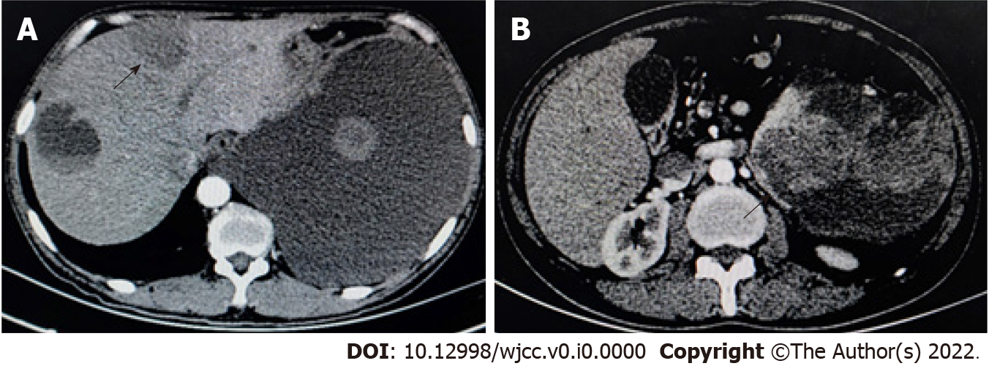
Figure 4 Plain and enhanced computed tomography revealed multiple round shadows of low density in the spleen and liver. A: Computed tomography scan revealed that, in the left and right liver parenchyma, circular hypodensity reduction was observed with uneven density. On enhanced scan, the solid components showed slight enhancement, and no enhancement of hypodensity was observed. Massive pleural effusion; B: The spleen was enlarged, and multiple abnormal cystic solid density shadows were observed in and around the spleen. Enhanced scanning showed mild enhancement and partial fusion. The black arrows indicate circular hypo-density regions.

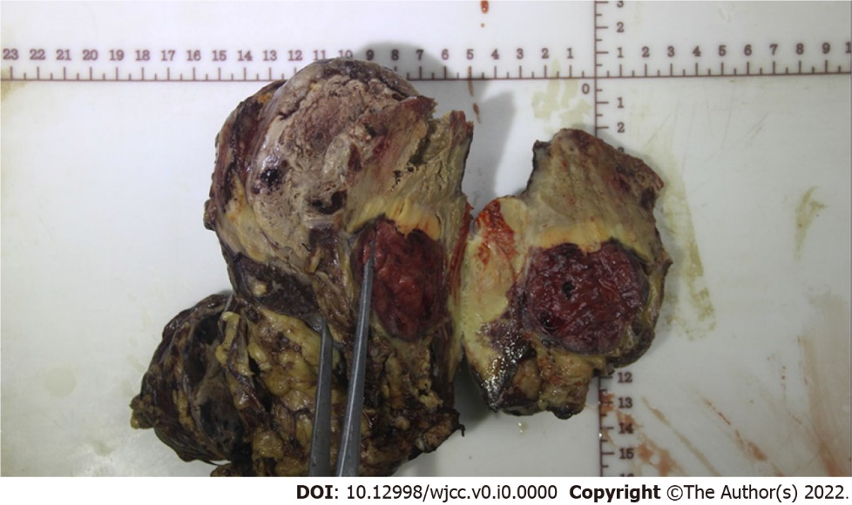
Figure 5 The resected tumor tissue. Specimen cross-sectioning revealed a demarcated yellowish-white lesion accompanied by hemorrhage and necrosis, which was 4 cm × 6 cm in size.

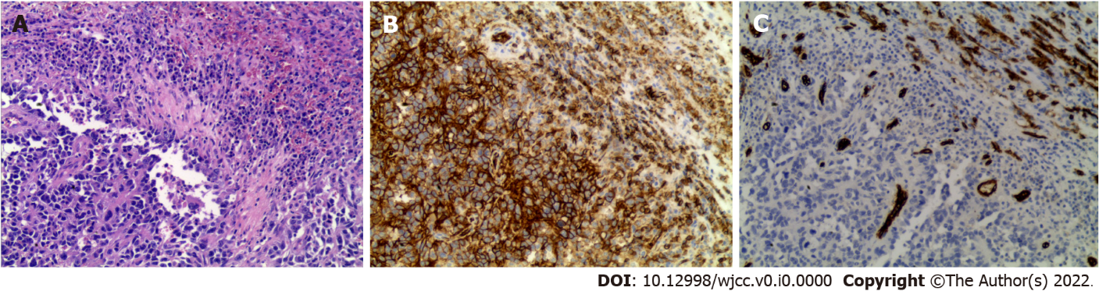
Figure 6 Hematoxylin and eosin staining and immunohistochemistry of the specimen. A: Hematoxylin and eosin staining showed the morphology of the tumor cells; B: Immunohistochemistry (IHC) revealed that the patient was positive for CD31, which was characteristic of tumor cells derived from vascular endothelium; C: The results of IHC revealed that the patient was negative for CD34. Shown at × 100 original magnification.

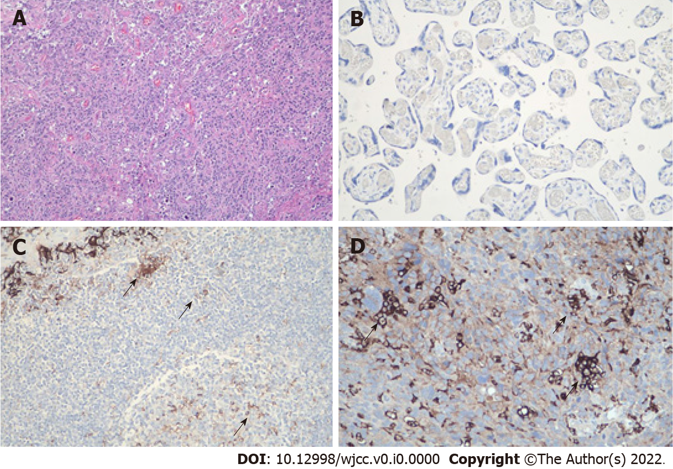
Figure 7 The level of programmed death ligand-1 protein was detected using immunohistochemistry by the Dako programmed death ligand-1 immunohistochemistry 22c3 PharmDx kit. A: Hematoxylin and eosin staining of the specimen, shown at × 100 original magnification; B: Negative control for the test, shown at × 200 original magnification; C: Positive control for the test, shown at × 200 original magnification; D: Immunohistochemistry revealed that this patient was positive for programmed death ligand-1 (PD-L1) in the cytomembrane of tumor cells (trehalose-6-phosphate synthase = 20%, cervical pedicle screws = 22), shown at × 200 original magnification. The black arrows indicate cells with high PD-L1 expression.

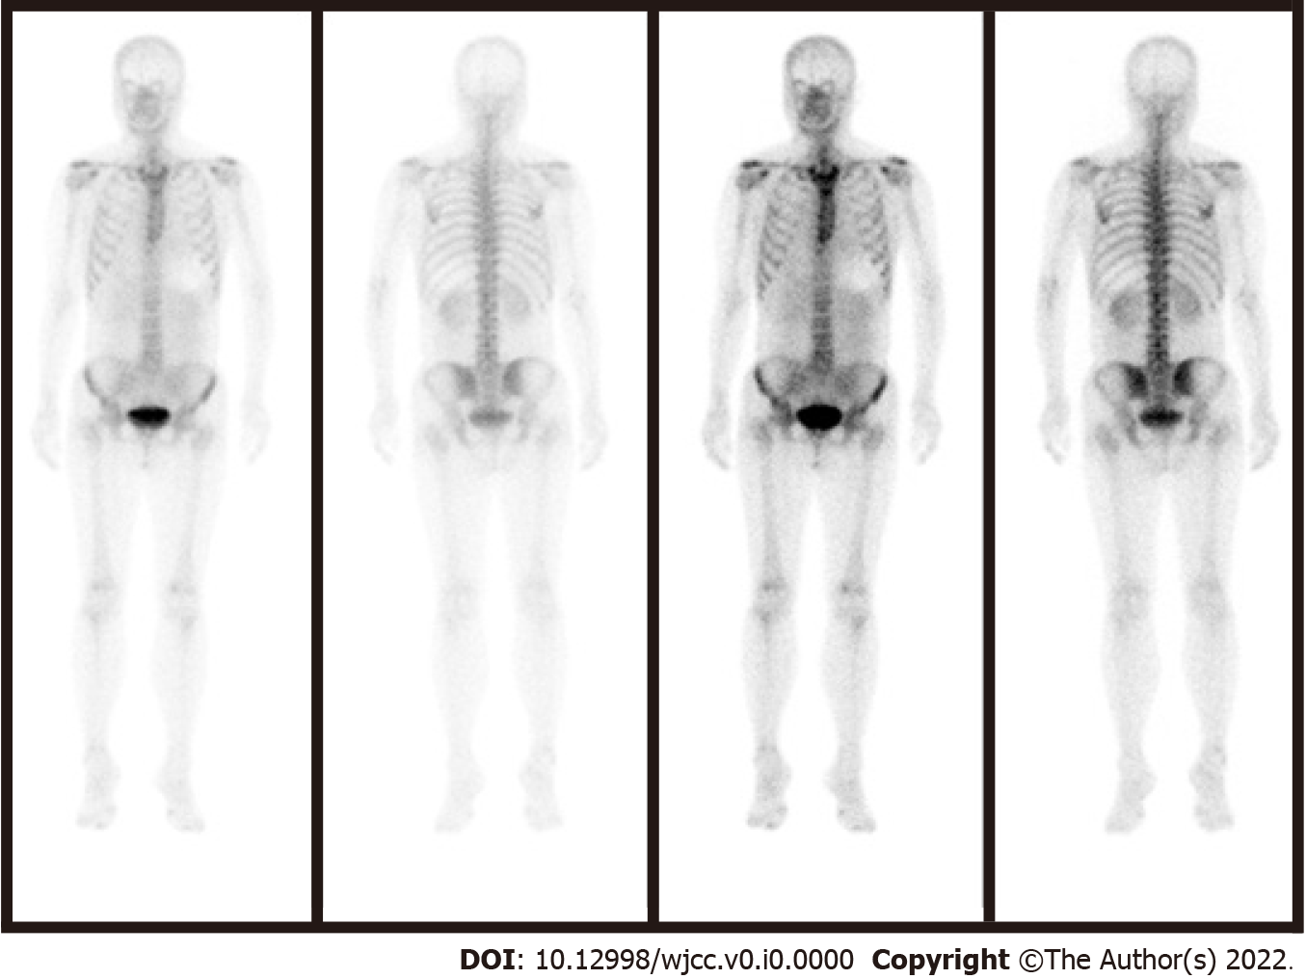
Figure 8 Single-photon emission tomography combined with computed tomography showed no signs of metastasis.

Table 1 Review of case reports published in the last 10 years (2011 to 2021)
Ref. | Report year | Age | Sex | Etiology | Clinical manifestations | Extrasplenic metastasis | Treatment | OS
[23] | 2019 | 80 | Female | None | Progressive abdominal pain, weight loss, fatigue, and pallor | Liver and peritoneum metastases | Splenectomy | 6 mo
[24] | 2019 | 41 | Male | None | Headaches, nausea, vomiting persisting | None | Splenectomy | More than 4 yr
[25] | 2019 | 83 | Female | None | Splenomegaly, acute abdominal pain | None | Splenectomy | Less than 6 mo
[26] | 2018 | 55 | Female | None | Abdominal pain and hepatosplenomegaly | Liver metastases | Palliative care | NA
[27] | 2018 | 56 | Female | None | A spleen nodule was  incidentally diagnosed | None | Splenectomy | More than 18 mo
[28] | 2019 | 42 | Male | None | Severe abdominal pain | Liver and lungs metastases | Splenectomy, adjuvant chemoradiotherapy and radiation therapy | 23 mo
[29] | 2018 | 35 | Female | None | Routine physical examination | Bone and abdominal cavity metastases | Laparoscopic-assisted splenectomy, radiation therapy | 57 mo
[30] | 2017 | 49 | Male | None | Left upper quadrant abdominal pain, fatigue, insomnia, severe weight loss, nocturnal sweating, and impotence | Peritoneal metastases | Splenectomy and nodal sampling | 11 mo
[31] | 2016 | 55 | Female | Rudimentary vascular channels | Severe tenderness in the left upper abdominal quadrant | Liver and lungs metastases | Splenectomy and adjuvant chemotherapy (paclitaxel). Second line chemotherapy (ifosfamide/doxorubicin) | NA
[20] | 2016 | 57 | Female | None | Gastrointestinal discomfort | Distant metastases | Splenectomy and adjuvant chemotherapy (paclitaxel chemotherapy and pazopanib) | 3 yr
[5] | 2015 | 69 | Male | Rupture of the spleen | Fatigue, reduced fitness, shortness of breath on exercise, anorexia, and abdominal and back pain, weight loss | Peritoneal tumor deposits | Splenectomy | Less than 1 mo
[19] | 2015 | 45 | Female | None | Left upper quadrant and left flank pain | Liver metastases | Splenectomy and adjuvant chemotherapy (paclitaxel) | 5 mo
[32] | 2014 | 38 | Female | None | Upper abdominal pain and fatigue for about 1 wk | Liver metastasis | Splenectomy | Passed away 3 yr after diagnosis, that is 3 mo after recurrence and liver metastasis
[33] | 2015 | 38 | Male | None | Multiple liver masses | Liver metastases | Paclitaxel monotherapy | Less than 3 mo
[34] | 2013 | 54 | Male | None | Nonspecific complaints of abdominal pain and loss of appetite | Liver metastases | Splenectomy | 3 mo
[34] | 2013 | 77 | Female | None | Hematochezia and fatigue | None | Splenectomy | 1 mo
[35] | 2013 | 80 | Female | None | Syncope, hypotension, vomiting | None | Splenectomy | More than 6 mo
[36] | 2013 | 65 | Male | None | Diffuse abdominal pain and distension. | Liver metastases | Splenectomy | NA
[37] | 2012 | 70 | Male | Hodgkin lymphoma treated with radiotherapy and chemotherapy 30 yr ago | Abdominal pain upper quadrants and jaundice | None | Splenectomy | More than 6 mo
[38] | 2012 | 73 | Female | None | Asymptomatic | None | Splenectomy | NA
[38] | 2012 | 23 | Female | None | Left upper quadrant pain | None | Splenectomy | NA
[21] | 2011 | 62 | Male | None | Acute onset of abdominal pain | Liver metastases | Splenectomy, palliative chemotherapy with etoposide, ifosfamide and doxorubicin | 8 mo
[39] | 2010 | 48 | Male | None | Left upper quadrant pain and early satiation | Multiple pleural metastases lesions | Splenectomy | NA
[40] | 2010 | 48 | Female | None | Weight loss general fatigue, and left hypochondrial pain | Liver metastases | Splenectomy, high-dose chemotherapy with autologous peripheral blood stem cell transplantation, hepatic lobectomy, radiofrequency ablations and administration of recombinant interleukin-2 | 67 mo
[22] | 2010 | 69 | Female | None | Pain in the left upper quadrant of the abdomen, weight loss, progressive shortness of breath | None | Paclitaxel as neoadjuvant therapy, splenectomy and adjuvant chemoradiotherapy | More than 14 mo
[41] | 2010 | 76 | Female | None | Left upper abdominal pain | Extensive metastases | Splenectomy | NA
[42] | 2010 | 55 | Female | Radiation treatment | NA | None | Splenectomy | More than 4 yr
[43] | 2009 | 15 | Male | None | Severe right-upper quadrant abdominal and epigastric pain | Liver, bone, lymph nodes, adrenal metastasis | Splenectomy with hilar lymph node excision, chemotherapy | 26.5 mo
NA: Not available; OS: Overall survival.

