Name of Journal: World Journal of Orthopedics
Manuscript NO: 72355
Manuscript Type: SYSTEMATIC REVIEWS

Prophylactic fixation of the unaffected contralateral side in children with slipped capital femoral epiphysis seems favorable: A systematic review

Vink SJC et al. Contralateral fixation in slipped capital femoral epiphysis

Steven J C Vink, Renée A van Stralen, Sophie Moerman, Christiaan J A van Bergen

Steven J C Vink, Renée A van Stralen, Department of Orthopedic Surgery, Erasmus Medical Center, Rotterdam 3015GD, Netherlands

Sophie Moerman, Department of Orthopedic Surgery, University Medical Center Groningen, Groningen 9713GZ, Netherlands

Christiaan J A van Bergen, Department of Orthopedic Surgery, Amphia Hospital, Breda 4818CK, Netherlands

Author contributions: Vink SJC drafted and finalized the manuscript; van Stralen RA and Moerman S contributed to the data collection; van Bergen CJA supervised the writing process; All authors contributed to the inclusion and assessment of the study quality of eligible articles, reviewed and commented on the text and approved the final version.

Corresponding author: Steven J C Vink, MD, Department of Orthopedic Surgery, Erasmus Medical Center, Doctor Molewaterplein 40, Rotterdam 3015GD, Netherlands. s.j.c.vink@erasmusmc.nl

Received: October 12, 2021
Revised: March 21, 2022
Accepted: April 25, 2022
Published online:

Abstract
BACKGROUND
Slipped capital femoral epiphysis (SCFE) occurs in adolescents and has an incidence of around 10 per 100000 children. Children presenting with a unilateral SCFE are 2335 times more likely to develop a contralateral SCFE than the general population. Prognostic factors that have been suggested to increase the risk of contralateral slip include a younger patient, an underlying endocrine disorder, growth hormone use and a higher radiographic posterior sloping angle. However, there is still much debate on the advantages and disadvantages of prophylactic fixation of the unaffected side in an otherwise healthy patient.

AIM
To investigate the risk rate of contralateral SCFE and assess the (dis)advantages of prophylactic fixation of the contralateral hip.

METHODS
A systematic literature search was performed in the Embase, Medline, Web of Science Core Collection and Cochrane databases. Search terms included ‘slipped capital femoral epiphysis,’ ‘fixation,’ ‘contralateral,’ and derivatives. The eligibility of the acquired articles was independently assessed by the authors and additional relevant articles were included through cross-referencing. Publications were considered eligible for inclusion if they presented data about otherwise healthy children with primarily unilateral SCFE and the outcomes of prophylactically pinning their unaffected side, or about the rates of contralateral slips and complications thereof. The study quality of the included articles was assessed independently by the authors by means of the methodological index for non-randomized studies criteria.

RESULTS
Of 293 identified unique publications, we included 26 studies with a total of 12897 patients. 1762 patients (14%) developed a subsequent symptomatic contralateral slip. In addition, 38% of patients developed a subsequent slip on the contralateral side without experiencing clinical symptoms. The most outspoken advantage of prophylactic fixation of the contralateral hip in the literature is prevention of an (asymptomatic) slip, thus reducing the increased risk of avascular necrosis (AVN), cam morphology and osteoarthritis. Disadvantages include an increased risk of infection, AVN, peri-implant fractures, loss of fixation as well as migration of hardware and morphologic changes as a consequence of growth guidance. These risks, however, appeared to only occur incidentally and were usually mild compared to the risks involved with an actual SCFE.

CONCLUSION
The advantages of prophylactic pinning of the unaffected side in otherwise healthy patients with unilateral SCFE seem to outweigh the disadvantages. The final decision for treatment remains to be patient-tailored.

Key Words: Slipped capital femoral epiphysis; Primary prevention; Postoperative complications; Risk factors; Radiography

Vink SJC, van Stralen RA, Moerman S, van Bergen CJA. Prophylactic fixation of the unaffected contralateral side in children with slipped capital femoral epiphysis seems favorable: A systematic review. World J Orthop 2022; In press

Core Tip: The aim of this article is to provide an evidence-based review of the epidemiology, risk factors, radiographic imaging, treatment and outcomes of the unaffected contralateral side in otherwise healthy children with unilateral slipped capital femoral epiphysis. It provides a systematically reviewed comprehensive assessment of the advantages and disadvantages that should be considered when deciding on whether or not to prophylactically pin the healthy side.

INTRODUCTION
Slipped capital femoral epiphysis (SCFE) is a medical condition of the hip that occurs in adolescents. The name of this condition is in itself misleading, as it is rather the metaphysis that moves in relation to the epiphysis, while the latter remains in its position in the acetabulum. When suffering from SCFE, a patient will usually have intermittent pain in the groin area. The hip, thigh and knee may also be painful. If the slip is more severe, the patient might also present with a complete inability to bear weight on the affected leg, which is defined as unstable^{[1]}. Furthermore, slips can be categorized according to the duration of symptoms; referred to as acute (< 3 wk of pain), chronic (≥ 3 wk) or acute-on-chronic (a traumatic event occurring in a chronic SCFE)^{[2]}. For the diagnostic process, plain anteroposterior and frog-leg lateral hip or pelvic radiographs are generally used (Figure 1).
The overall incidence of SCFE is approximately 10.8 per 100000 children, which differs with gender, race, and seasonal variations^{[3,4]}. The average age of onset is reported to be 12.7 years for boys and 11.2 years for girls^{[4]}. The cause of the slip is unknown but is thought to be multifactorial and has been related to obesity, renal failure, endocrinological disorders (e.g., hypothyroidism, hypogonadism, or hypopituitarism) and radiation therapy^{[5-8]}. SCFE appears to be more apparent around the time of the growth spurt and it is more common in boys than girls^{[5-8]}.
The long-term outcome of SCFE is related to the severity of the slip. This can be classified as mild (Southwick angle ≤ 29°), moderate (30°-50°), or severe (> 50°)^{[2]}. A higher-grade slip causes decreased range of motion and higher risk of chondrolysis, avascular necrosis (AVN) of the femoral head and osteoarthritis at a later age^{[9]}. The overall incidence of chondrolysis in SCFE patients is estimated to be 7%^{[10]}. AVN rates vary from 7% to 21%, depending on the stability of the slip^{[11-13]}. The etiology of AVN in SCFE patients is not fully known, but it is suggested that it is the result of a disturbance in epiphyseal blood supply and intracapsular tamponade^{[11]}. Additionally, it has been reported that the anatomical features of a post-SCFE hip are significantly altered, even after adequate treatment, with up to 40% developing femoroacetabular impingement (FAI) and 53% developing osteoarthritis^{[14-16]}.
Percutaneous in situ fixation is the gold standard for treatment of mild and moderate grade SCFE, whereas open reduction and internal fixation is sometimes performed for severe slips^{[17]}. Nowadays, the most commonly used surgical method is pinning with a single screw. The screw is aimed to start from the anterior aspect of the femoral neck, in order to cross to the physis perpendicularly and enter into the central portion of the femoral head (Figure 2). In severe slips, insertion may have to be relatively oblique at the intertrochanteric region in order to prevent impingement. Another reported method is by means of double screw fixation, in which screws are inserted in a similar orientation as fixation with a single screw. In bovine femurs, this was measured to yield a 33% increase in stiffness^{[18]}. In addition, some surgeons use Kirschner wires/pins (K-wires) rather than screws for in situ fixation^{[19,20]}.
For years, research has been conducted on the fate of the contralateral hip, which is at an increased risk of slipping in patients with unilateral SCFE^{[21,22]}. The exact incidence of contralateral slips is unknown, as various rates have been reported in the literature^{[14,23,24]}.
When presented with a unilateral SCFE, the attending physician has several options with regard to the contralateral side. The first is to observe the patient with regular monitoring and radiographic imaging until closure of the physis, after which the risk of developing a slip has ceased to exist. Alternatively, the surgeon may choose to prophylactically pin the contralateral side in order to prevent a potential slip. Finally, one may consider several stratifications and risk factors of the specific patient in order to estimate the risk of a contralateral slip, and decide based on this risk analysis. Recently, several risk factors have been analyzed in a systematic review and meta-analysis^{[25]}. To this day, however, no consensus has been reached on the indication for prophylactic pinning of the contralateral side of otherwise healthy children. The present systematic review aims to provide an overall risk rate of contralateral SCFE, and a comprehensive assessment of the advantages and disadvantages that can be considered when deciding on whether or not to pin the contralateral hip of unilateral SCFE in otherwise healthy patients.

MATERIALS AND METHODS
A systematic literature search was performed on April 21, 2020, in the Embase, Medline, Web of Science Core Collection and Cochrane databases. Search terms included ‘slipped capital femoral epiphysis,’ ‘fixation,’ ‘contralateral,’ and derivatives thereof (Supplementary material). The searches rendered 293 unique results (Figure 3). Two authors (SV and RvS) first assessed eligibility independently by reviewing titles and abstracts, after which 89 articles remained. 73 of these were available in English and were partitioned between the four authors and again assessed independently by reviewing the full texts. Articles were considered eligible for inclusion in the current review if they reported about children with primarily unilateral SCFE that were otherwise healthy and the outcomes of prophylactically pinning the unaffected contralateral side (e.g., prevention of slip and perioperative and mid- to long-term complications), or about rates of contralateral slips and their complications. Cross-referencing led to a further inclusion of relevant publications. A total of 26 articles that specifically addressed the incidence and follow-up of contralateral SCFE were included (Table 1). The study quality of these 26 articles was then assessed independently by the authors by means of the methodological index for non-randomized studies (MINORS) criteria (Table 1, primary data available upon request)^{[26]}. Considering the results of Loder et al^{[27]} and Swarup et al^{[28]}, a follow-up period of 18 mo was deemed to be adequate, since a contralateral slip takes place in the first 18 mo in 88% of children^{[27,28]}. In addition, 39 articles were found that described advantages or disadvantages of contralateral pinning.

RESULTS
This systematic review of the literature identified 26 studies including a total of 12897 healthy patients presenting with unilateral SCFE (Table 1). The included articles report on the incidence of symptomatic contralateral slips where researchers chose not to prophylactically pin the unaffected side. In general, authors had a follow-up of at least 18 mo (mean, 46 mo) after the initial slip. When evaluating the articles eligible for inclusion in this review, the mean time after which the contralateral side slipped was 9 mo, based on 1250 slips, with a range extending to 50 mo^{[28]}. The methodological quality of the included articles was assessed by means of the MINORS criteria for non-randomized surgical studies^{[26]}. The methodological quality was scored at an average of 63% (Table 1).

Risk rates of contralateral SCFE and advantages of prophylactic pinning
The literature provides a substantial discussion about prophylactic fixation. Prophylactically pinning the unaffected contralateral hip has been reported to be advantageous for several reasons. It is mainly aimed at preventing the potential short- and long-term adverse effects on the development of the contralateral hip.
As slipping of the epiphysis causes evident negative short- and long-term outcomes, the main purpose of prophylactic pinning is to prevent the epiphysis from slipping. To assess whether this might be an appropriate measure, it is important to better understand the magnitude of the problem. Castro et al^{[2]} reported that children who present with unilateral SCFE are 2335 times more likely to develop a second SCFE than the general population^{[2]}.
The incidence of a consecutive symptomatic slip on the contralateral side in SCFE patients was reported to be between 9% and 69%, with a total of 1762 patients (14%, Table 1). In addition to symptomatic slips, several authors report on the incidence of clinically asymptomatic slips. Hägglund et al^{[14]} was the first in the available literature to report on the matter and noted that 104 of 237 patients (44%) presenting with unilateral SCFE had signs of an asymptomatic contralateral slip at a follow-up of 16 years to 66 years after initial presentation^{[14]}. Since then, several other authors have reported on patients who developed asymptomatic contralateral slips, as objectified on plain radiography^{[29-33]}. The prevalence of an asymptomatic contralateral slip varied between 19% and 49%. The combined data from these and Hägglund’s reports add up to a 174 of 456 hips, a mean incidence of 38% (Table 1).
Evidence suggests that, despite being subclinical at adolescence, patients with asymptomatic slips are also at an increased risk of developing negative outcomes in adulthood, such as a pistol-grip deformity and cam morphology. Subsequently, such patients suffer from decreased hip function, femoral acetabular impingement syndrome, and are at an increased risk of developing early osteoarthritis^{[21,34-37]}. Specifically, Hägglund et al^{[14]} reported that 28 of the 104 patients with asymptomatic slips (27%) showed osteoarthritis of that side at a later age^{[14]}. Jensen et al^{[30]} noted that 4 of 16 patients (25%) with asymptomatic slips showed signs of osteoarthritis at follow-up, merely 22 years after the primary operation for unilateral SCFE and at an average age of 36 years^{[30]}.
In addition, Hesper et al^{[38]} reviewed 39 patients that had undergone computed tomography (CT) imaging of the pelvis between 2008 and 2014 after unilateral SCFE and compared the untreated contralateral hips to those of healthy age- and sex-matched controls^{[38]}. They recorded that the unaffected hips of SCFE patients showed decreased concavity of the head-neck junction with a higher alpha angle, as well as a reduced head-neck offset. Thus they noted a lower epiphyseal extension but a more posteriorly tilted epiphysis. These resembled a mild slip deformity and subsequent cam morphology, hence also posing an increased risk of developing early osteoarthritis.
In conclusion, prophylactically pinning may prevent 14% of children with a primarily unilateral SCFE from developing a consecutive symptomatic slip, as well as another 38% from developing an asymptomatic one. Both types of consecutive slips, as well as untreated contralateral hips that do not slip, are prone to developing disadvantageous morphological and functional outcomes at a later age.

Disadvantages of prophylactic pinning
Simultaneously, prophylactic pinning poses several potential disadvantages, which have to be weighed against the advantages.

Infection
There is a small risk of postoperative infection. O’Beirne et al^{[39]} reported that after inserting a single pin via an open lateral approach, 1 of 15 hips (7%) developed a deep wound infection which was resolved by removal of the pin^{[39]}. Emery et al^{[40]} mostly used three pins at a time to fixate 95 hips of which 5 (5%) developed a superficial wound infection^{[40]}. These rates have decreased more recently. Seller et al^{[19]} and Woelfle et al^{[20]} noted that none of 94 and 1 of 65 (2%) patients, respectively, developed infections after fixation with three or four K-wires^{[19,20]}. When using a single percutaneous screw fixation, the risk of infection seems very low; Kumm et al^{[41]} (0 of 34), Dewnany and Radford^{[36]} [1 of 65 (2%)], Sankar et al^{[42]} (0 of 99) and Bhattacharjee et al^{[43]} [1 of 44 (2%)] all report low rates of wound infections^{[36,41-43]}.

AVN and chondrolysis
AVN of the femoral head, although infrequent, is another risk of surgical fixation. Even though prophylactic fixation aims to prevent slip and thereby also AVN, this complication may also develop after the procedure itself. In retrospective studies, Sankar et al^{[42]} reported that AVN developed in 2 of 99 patients (2%), whereas none of the 26 and 24 prophylactically pinned hips reviewed by Seller et al^{[44]} and Cousins et al^{[45]}, respectively, developed AVN^{[42,44,45]}. Herngren et al^{[37]} reported no cases of AVN in the prophylactically treated group of their prospective cohort study^{[37]}. Other studies report no cases of AVN^{[19,20,36,39-43]}. Chondrolysis was also not seen by any of the referenced authors.

Implant-related problems
Peri-implant fractures may occur shortly or at a later stage after surgery. These are usually subtrochanteric fractures starting around the entrance site of the screw. Sankar et al^{[42]} reported that 2 of their patients (2%) developed peri-implant fractures^{[42]}. They suggested that there is a higher fracture rate if the screw enters distal to the level of the lesser trochanter or medial to the intertrochanteric line. Likewise, Herngren et al^{[37]} noted 2 peri-implant fractures (1%) in their prospective study^{[37]}.
Several authors also report on the displacement, migration and loss of fixation of the hardware, especially with use of non-threaded pins and wires. Emery et al^{[40]} reported that at the time of radiological fusion of the epiphyseal plate, the femoral head had grown off of as much as 29% of their Crawford Adams pins^{[40]}. As such, the pins did not cross the epiphyseal plate anymore and thus only penetrated the femoral neck and trochanteric area of the shaft, rendering them useless. Additionally, in 17% of the cases of both Seller et al^{[19]} and Woelfle et al^{[20]}, a reoperation was necessary because the K-wires did not catch the epiphysis anymore due to the physiological growth of the proximal femur, especially when it concerned very young patients^{[19,20]}.

Growth alteration and morphologic changes
Some authors argue that the surgical procedure increases the risk of the development of dysmorphology of the prophylactically pinned hip in the long term, with functional limitations as a result. Lerch et al^{[46]} performed a follow-up study of 33 prophylactically pinned hips after an average of 12 years^{[46]}. Although noting no intra- or postoperative complications, they did find radiographic evidence of cam morphology in 10 patients (30%), of whom four (12%) developed FAI syndrome as a result and required additional surgery. No patient had developed radiographic signs of osteoarthritis by then. Dodds et al^{[16]} reported that 4 out of 7 prophylactically pinned hips (57%) developed a pistol grip deformity, though none of these patients experienced FAI syndrome^{[16]}. These findings were recently supported by Kulkarni et al^{[47]}, who reported femoral head asphericity in 37% of their patients, rendering them at risk of developing FAI syndrome^{[47]}. The question remains whether the secondary deformities are caused by the surgery or by the natural history of these hips.
A similar concern of pinning the unaffected hip is the possibility of premature closure of the physis. Cousins et al^{[45]} compared the articulo-trochanteric distance (ATD), the trochanteric-trochanteric distance (TTD), and the neck length shortly after surgery and on average 20 mo thereafter between 24 prophylactically pinned hips and 26 observed unaffected hips^{[45]}. The difference in TTD:ATD ratio proved to be significant, suggesting that pinning resulted in a coxa breva and relative coxa vara. It was suggested that these morphological alterations could lead to FAI syndrome and therewith osteoarthritis. Moreover, the neck length was significantly higher at follow-up in the observed group, thereby concluding that the pinned group showed less residual growth. The mean difference in final leg length between the SCFE side and the prophylactically pinned hip has been reported to be 5.7 millimeters, with a maximum of 1 centimeter^{[19,44]}. The residual growth might be dependent on the type of fixation; Wölfle-Roos et al^{[48]} reported that the residual growth was a mean of 4.4 millimeters more when using three or four K-wires, as compared to a single screw^{[48]}. Considering the primary SCFE side, one may argue that a reduced residual growth after pinning the contralateral side is actually an advantage. The primary SCFE side also shows less residual growth as compared to healthy hips, therefore the difference in final leg length will thus decrease as compared to children who have not undergone prophylactic pinning.

Risk factors
Numerous studies have aimed to identify risk factors for developing sequential contralateral involvement in unilateral SCFE patients. Swarup et al^{[25]} performed a comprehensive systematic review and meta-analysis of potential risk factors^{[25]}. The most significant demographic factors that were reported to be associated with a contralateral slip were a body mass index (BMI) greater than the 95th percentile and a younger age at presentation. Clinically, a shorter duration of symptoms before the actual first slip was also reported to be a risk factor. When evaluating the anteroposterior and frog-leg lateral hip or pelvis radiographs, several suggested risk factors can be assessed including the posterior sloping angle (PSA, Figure 1), alpha angle and modified Oxford score (i.e. a measure for skeletal maturity)^{[25,49]}. In the included studies of the meta-analysis, conflicting results were reported in regard to the slip angle, with studies showing an increased risk of contralateral slip when a lower angle was found, while other researchers reported the risk to be increased when a higher angle was present^{[25]}. The alpha angle of the primary SCFE was reported to be a weak but significant prognostic factor. Patients with a mean angle of 51 degrees were at a higher risk of developing contralateral SCFE compared to a mean angle of 45 degrees. The PSA of the healthy side was reported to be significantly higher in patients that developed a subsequent contralateral slip. A mean of 16 degrees was related to a higher risk of subsequent slip compared to a mean of 12 degrees. According to the meta-analysis by Swarup et al^{[25]}, a younger age at the time of the first slip (mean difference, -0.9 years) and a higher PSA (mean difference, 4.7 degrees) remained independent significant risk factors. For other factors, such as sex, BMI, endocrine abnormality, slip stability and modified Oxford score, no significant differences were identified in the meta-analysis.
Several researchers have specifically studied additional imaging modalities to further evaluate the risk of a contralateral slip in order to detect early evidence of morphologic changes preceding symptomatic and asymptomatic slips. Balch Samora et al^{[50]} assessed the use of focal or diffuse physeal widening, abnormal signal and bone marrow edema adjacent to the physis on magnetic resonance imaging (MRI) in predicting contralateral SCFE^{[50]}. Eleven of 33 enrolled patients developed a contralateral SCFE. Overall, the sensitivity of the MRI predictors was reported to be 80%, specificity 92.9%, positive predictive value 66.7% and negative predictive value 96.3%, with an interrater reliability of 100%. In addition, Futami et al^{[51]} evaluated unilateral SCFE cases and their unaffected counterparts with MRI^{[51]}. They scanned 10 patients for a total of 33 times. In all SCFE cases, physeal widening was observed. In 4 of the 10 patients, the unaffected side showed physeal widening without a slip. Lesions were observed in the physis which were similar to lesions in the affected hips. These were then prophylactically pinned. Neither these, nor the other observed hips that did not show physeal widening, slipped during a mean follow-up time of 36 mo. Nevertheless, the authors suggested that the physeal widening, clearly visible on MRI, may reduce epiphyseal stability and requires prophylactic pinning. Wensaas et al^{[52]} also reported on MRI scans of 22 primarily unilateral SCFEs^{[52]}. They measured the MRI slip angle, greatest focal widening of the physis, global widening of the physis measured at three locations, periphyseal bone marrow edema, the presence of pathological joint effusion and the amount of joint effusion measured from the lateral edge of the greater trochanter. These parameters were significantly altered in primarily affected hips. However, they could not discern a significant difference between the 6 hips of patients who did and the remainder who did not develop contralateral SCFE.

DISCUSSION
This article aims to provide a comprehensive review and summary of the scientific evidence regarding the prevalence of contralateral SCFE and fixation in otherwise healthy patients with unilateral SCFE. According to the reviewed data, prophylactic fixation of the contralateral side would prevent 14% of patients from developing sequential symptomatic contralateral involvement. Another 38% of asymptomatic slips may also be prevented. Because prevention of a contralateral slip may drastically reduce the possible negative outcomes, such as osteoarthritis in the long term, these rates may outweigh the small risk of complications due to the additional surgery. However, multiple patient, surgical and radiographic factors should be taken into account in the shared-decision process with the patients and their parents. The most important risk factors of a subsequent contralateral SCFE are a younger age at the time of presentation and a higher PSA on plain radiography^{[25]}.
When surgical fixation is considered, a decision with regard to the surgical technique needs to be made. K-wires as a method of fixation, may cause that the wires unintentionally migrated within the femur mostly due to physiologic growth of the proximal femur^{[19,20,40,53]}. However, this migration rarely led to epiphysiolysis or other symptoms such as pain. Nonetheless, it can be argued that this migration does pose additional risks. On the other hand, fixation with threaded screws has a higher impact on the residual growth of the femur. One might argue that the reduced residual growth of the unaffected side can be considered an advantage, as the difference in leg length between the unaffected and affected sides at follow-up is decreased when the unaffected side is pinned as well^{[42]}. Recently, researchers have also tested a new type of free-gliding screw, which is intended to allow growth of the physis and thereby decrease the influence of fixation on the final leg length. The first results of biomechanical studies have been reported and appear to be promising^{[54]}. Thus, some of the possible negative effects of pinning on growth could be overcome within the foreseeable future for either side.
Opponents of prophylactic fixation argue that the patient is exposed to the risk of iatrogenic injury to an otherwise healthy hip^{[55]}. Indeed, some of the associated complications such as AVN and chondrolysis are serious. However, they are minor in incidence, with only 0%-2% of cases developing AVN and no cases of chondrolysis reported at all in the presently reviewed literature. Other reported complications include anatomic changes such as cam morphology. However, various studies have shown that the ‘unaffected’ side often has dysmorphic features without having been operated on, as visualized on CT and MRI^{[34,50-52]}. This finding questions whether the morphologic changes are a result of the surgical procedure or rather a result of the natural course of these hips.
In an attempt to be able to make a more protocolized decision, researchers have developed different decision analysis models. However, the outcomes of their respective research are contradictory. Kocher et al^{[55]} described an expected-value decision analysis on the indication for strategy-prophylactic in situ pinning vs observation^{[55]}. According to their systematic review, the expected value of prophylactic pinning remained lower than for observation. They therefore concluded that careful observation is the better strategy unless the probability of a contralateral slip exceeds 27%. In contrast, Schultz et al^{[56]} concluded in a different model that prophylactic pinning of the contralateral hip is, in general, favorable for long-term outcomes^{[56]}. Taking these conclusions to heart, the discussion on the indication for prophylactic fixation is still open, and careful education of patients and meticulous clinical and radiographic follow-up could provide an alternative to prophylactic pinning. However, one might argue that prophylactic pinning of the hip saves the time and trouble of an intensive follow-up process until physeal closure with the associated necessary additional radiographic imaging.
The present review has some limitations. Although the literature was searched systematically, there might be additional relevant research in the literature that would add to our data. Methodological quality of the included studies was quantified, but showed that the research conducted did not meet all of the MINORS criteria, averaging at 63% of the total applicable score. In addition, few authors reported about the severity of the contralateral slips that developed after initial unilateral involvement. Therefore, no definitive conclusions could be drawn as to the distribution of mild, moderate and severe contralateral slips. Additional data on the distribution of severity within this population may prove more insightful in whether the risks of surgery outweigh the possible complications related to (severe) slips. However, with our search terms, we have sought to include a representative and comprehensive amount of data on the basis of which we present the considerations and conclusions.

CONCLUSION
The contralateral hip in otherwise healthy patients presenting with a unilateral symptomatic SCFE remains a controversial subject. Literature suggests that a substantial rate of these patients are at risk of developing a subsequent slip of the contralateral side or in fact simultaneously have an asymptomatic slip. Such slips consequently may lead to morphologic changes, decreased hip function and early osteoarthritis. Fixation of the contralateral hip may thus prevent these negative long-term outcomes.
On the other hand, fixation of the contralateral side also involves risks. However, surgical complications occur only incidentally and the clinical implications of secondary morphologic changes as a result of surgical intervention remain unclear. Hence, the disadvantages appear to be relatively infrequent and insignificant as compared to the possible advantages that can be achieved through fixation. Nonetheless, both perspectives should be taken into consideration, and the choice as to whether or not to pin the unaffected side should remain a patient-tailored one.

ARTICLE HIGHLIGHTS
Research background
Slipped capital femoral epiphysis (SCFE) is an important medical condition occurring in adolescents. It may cause severe short and long term complications. At present, there is no clear consensus on whether or not to prophylactically fixate the unaffected side in unilateral SCFE. The current review provides a comprehensive assessment of the deliberations to be made when treating this condition.

Research motivation
The risks of subsequent contralateral slipping after primary unilateral SCFE are discussed. Consequently, the advantages, but also the risks, rendered by prophylactic fixation are outlined.

Research objectives
The risk rates of subsequent contralateral slipping and its sequelae after primary unilateral SCFE are evaluated. Several imaging modalities and their interpretation in regard to the risk assessment are presented. The advantages and disadvantages of prophylactic pinning are evaluated and an overall outline is presented as to the treatment strategy.

Research methods
A systematic review of the literature was performed and the results were presented in a qualitative manner with descriptive statistics.

Research results
When presenting with unilateral SCFE, a patient has a 2335 times increased likelihood of developing a consecutive contralateral slip, with 14% developing a symptomatic and 38% asymptomatic slip. Both clinical and subclinical slips are at an increased risk of developing harmful sequelae of the hip. Prophylactic pinning of the contralateral side negates the development of such sequelae. This surgical intervention renders complications such as infection, avascular necrosis, implant related problems and morphologic changes, albeit only at very low rates. A number of methods to assess the risk of a contralateral slip have been described in the current literature, most significantly the posterior sloping angle (PSA) on plain radiographs.

Research conclusions
A substantial rate of patients presenting with unilateral SCFE develop a contralateral slip, posing an increased risk to developing harmful sequelae. The advantages of negating these developments by prophylactic pinning of the primarily unaffected side appear to be outweighing the infrequently occurring disadvantages of the surgical intervention. The decision remains to be patient-tailored and can be aided by evaluation of the PSA on plain radiographs.

Research perspectives
Additional studies evaluating a watchful waiting strategy that elaborate on the severity of subsequent slips and its sequelae may prove insightful to better weigh this against the surgery associated risks. In addition, further research directly comparing the short and long term outcomes of watchful waiting and prophylactic pinning may aid in formulating an unambiguous treatment strategy. Also, research concerning the risks for developing a primary SCFE may further the prevention of the condition arising in the first place in the adolescent population, thereby improving their long term functioning.

ACKNOWLEDGEMENTS
The authors wish to thank Wichor Bramer from the Erasmus Medical Centre Medical Library for developing the search strategies.

REFERENCES
1 Loder RT, Richards BS, Shapiro PS, Reznick LR, Aronson DD. Acute slipped capital femoral epiphysis: the importance of physeal stability. J Bone Joint Surg Am 1993; 75: 1134-1140 [PMID: 8354671 DOI: 10.2106/00004623-199308000-00002]
2 Castro FP Jr, Bennett JT, Doulens K. Epidemiological perspective on prophylactic pinning in patients with unilateral slipped capital femoral epiphysis. J Pediatr Orthop 2000; 20: 745-748 [PMID: 11097247 DOI: 10.1097/00004694-200011000-00009]
3 Lehmann CL, Arons RR, Loder RT, Vitale MG. The epidemiology of slipped capital femoral epiphysis: an update. J Pediatr Orthop 2006; 26: 286-290 [PMID: 16670536 DOI: 10.1097/01.bpo.0000217718.10728.70]
4 Witbreuk MM, van Royen BJ, Van Kemenade FJ, Witte BI, van der Sluijs JA. Incidence and gender differences of slipped capital femoral epiphysis in the Netherlands from 1998-2010 combined with a review of the literature on the epidemiology of SCFE. J Child Orthop 2013; 7: 99-105 [PMID: 24432066 DOI: 10.1007/s11832-012-0479-y]
5 Loder RT. The demographics of slipped capital femoral epiphysis. An international multicenter study. Clin Orthop Relat Res 1996: 8-27 [PMID: 8542716]
6 Loder RT, Hensinger RN. Slipped capital femoral epiphysis associated with renal failure osteodystrophy. J Pediatr Orthop 1997; 17: 205-211 [PMID: 9075097 DOI: 10.1097/00004694-199703000-00013]
7 Aronsson DD, Loder RT, Breur GJ, Weinstein SL. Slipped capital femoral epiphysis: current concepts. J Am Acad Orthop Surg 2006; 14: 666-679 [PMID: 17077339 DOI: 10.5435/00124635-200611000-00010]
8 Witbreuk M, van Kemenade FJ, van der Sluijs JA, Jansma EP, Rotteveel J, van Royen BJ. Slipped capital femoral epiphysis and its association with endocrine, metabolic and chronic diseases: a systematic review of the literature. J Child Orthop 2013; 7: 213-223 [PMID: 24432080 DOI: 10.1007/s11832-013-0493-8]
9 Carney BT, Weinstein SL, Noble J. Long-term follow-up of slipped capital femoral epiphysis. J Bone Joint Surg Am 1991; 73: 667-674 [PMID: 2045391]
10 Lubicky JP. Chondrolysis and avascular necrosis: complications of slipped capital femoral epiphysis. J Pediatr Orthop B 1996; 5: 162-167 [PMID: 8866280 DOI: 10.1097/01202412-199605030-00005]
11 Roaten J, Spence DD. Complications Related to the Treatment of Slipped Capital Femoral Epiphysis. Orthop Clin North Am 2016; 47: 405-413 [PMID: 26772949 DOI: 10.1016/j.ocl.2015.09.013]
12 Loder RT. What is the cause of avascular necrosis in unstable slipped capital femoral epiphysis and what can be done to lower the rate? J Pediatr Orthop 2013; 33 Suppl 1: S88-S91 [PMID: 23764800 DOI: 10.1097/BPO.0b013e318277172e]
13 Tucker A, Ballard J, Cosgrove A. Temporal changes in slipped upper femoral epiphysis at a regional level: a declining incidence and literature review. J Child Orthop 2019; 13: 445-456 [PMID: 31695811 DOI: 10.1302/1863-2548.13.190037]
14 Hägglund G, Hansson LI, Ordeberg G, Sandström S. Bilaterality in slipped upper femoral epiphysis. J Bone Joint Surg Br 1988; 70: 179-181 [PMID: 3346283 DOI: 10.1302/0301-620X.70B2.3346283]
15 Fraitzl CR, Käfer W, Nelitz M, Reichel H. Radiological evidence of femoroacetabular impingement in mild slipped capital femoral epiphysis: a mean follow-up of 14.4 years after pinning in situ. J Bone Joint Surg Br 2007; 89: 1592-1596 [PMID: 18057358 DOI: 10.1302/0301-620X.89B12.19637]
16 Dodds MK, McCormack D, Mulhall KJ. Femoroacetabular impingement after slipped capital femoral epiphysis: does slip severity predict clinical symptoms? J Pediatr Orthop 2009; 29: 535-539 [PMID: 19700979 DOI: 10.1097/BPO.0b013e3181b2b3a3]
17 Loder RT, Dietz FR. What is the best evidence for the treatment of slipped capital femoral epiphysis? J Pediatr Orthop 2012; 32 Suppl 2: S158-S165 [PMID: 22890456 DOI: 10.1097/BPO.0b013e318259f2d1]
18 Karol LA, Doane RM, Cornicelli SF, Zak PA, Haut RC, Manoli A 2nd. Single versus double screw fixation for treatment of slipped capital femoral epiphysis: a biomechanical analysis. J Pediatr Orthop 1992; 12: 741-745 [PMID: 1452743 DOI: 10.1097/01241398-199211000-00008]
19 Seller K, Raab P, Wild A, Krauspe R. Risk-benefit analysis of prophylactic pinning in slipped capital femoral epiphysis. J Pediatr Orthop B 2001; 10: 192-196 [PMID: 11497360]
20 Woelfle JV, Fraitzl CR, Reichel H, Nelitz M. The asymptomatic contralateral hip in unilateral slipped capital femoral epiphysis: morbidity of prophylactic fixation. J Pediatr Orthop B 2012; 21: 226-229 [PMID: 22406770 DOI: 10.1097/BPB.0b013e3283524bae]
21 MacLean JG, Reddy SK. The contralateral slip. An avoidable complication and indication for prophylactic pinning in slipped upper femoral epiphysis. J Bone Joint Surg Br 2006; 88: 1497-1501 [PMID: 17075097 DOI: 10.1302/0301-620X.88B11.17523]
22 Baghdadi YM, Larson AN, Sierra RJ, Peterson HA, Stans AA. The fate of hips that are not prophylactically pinned after unilateral slipped capital femoral epiphysis. Clin Orthop Relat Res 2013; 471: 2124-2131 [PMID: 23283674 DOI: 10.1007/s11999-012-2762-0]
23 Segal LS, Davidson RS, Robertson WW Jr, Drummond DS. Growth disturbances of the proximal femur after pinning of juvenile slipped capital femoral epiphysis. J Pediatr Orthop 1991; 11: 631-637 [PMID: 1918351]
24 Nowicki PD, Silva S, Toelle L, Strohmeyer G, Wahlquist T, Li Y, Farley FA, Caird MS. Severity of Asynchronous Slipped Capital Femoral Epiphyses in Skeletally Immature Versus More Skeletally Mature Patients. J Pediatr Orthop 2017; 37: e23-e27 [PMID: 26523702 DOI: 10.1097/BPO.0000000000000678]
25 Swarup I, Goodbody C, Goto R, Sankar WN, Fabricant PD. Risk Factors for Contralateral Slipped Capital Femoral Epiphysis: A Meta-analysis of Cohort and Case-control Studies. J Pediatr Orthop 2020; 40: e446-e453 [PMID: 32501913 DOI: 10.1097/BPO.0000000000001482]
26 Slim K, Nini E, Forestier D, Kwiatkowski F, Panis Y, Chipponi J. Methodological index for non-randomized studies (minors): development and validation of a new instrument. ANZ J Surg 2003; 73: 712-716 [PMID: 12956787 DOI: 10.1046/j.1445-2197.2003.02748.x]
27 Loder RT, Aronson DD, Greenfield ML. The epidemiology of bilateral slipped capital femoral epiphysis. A study of children in Michigan. J Bone Joint Surg Am 1993; 75: 1141-1147 [PMID: 8354672 DOI: 10.2106/00004623-199308000-00003]
28 Swarup I, Williams BA, Talwar D, Sankar WN. Rates of Contralateral SCFE in the United States: Analysis of the Pediatric Health Information System. J Pediatr Orthop 2020; 40: e587-e591 [PMID: 31688819 DOI: 10.1097/BPO.0000000000001465]
29 Stott S, Bidwell T. Epidemiology of slipped capital femoral epiphysis in a population with a high proportion of New Zealand Maori and Pacific children. N Z Med J 2003; 116: U647 [PMID: 14583805]
30 Jensen HP, Steinke MS, Mikkelsen SS, Thomsen PB. Hip physiolysis. Bilaterality in 62 cases followed for 20 years. Acta Orthop Scand 1990; 61: 419-420 [PMID: 2239165 DOI: 10.3109/17453679008993553]
31 Jerre R, Billing L, Hansson G, Wallin J. The contralateral hip in patients primarily treated for unilateral slipped upper femoral epiphysis. Long-term follow-up of 61 hips. J Bone Joint Surg Br 1994; 76: 563-567 [PMID: 8027141]
32 Hurley JM, Betz RR, Loder RT, Davidson RS, Alburger PD, Steel HH. Slipped capital femoral epiphysis. The prevalence of late contralateral slip. J Bone Joint Surg Am 1996; 78: 226-230 [PMID: 8609113 DOI: 10.2106/00004623-199602000-00009]
33 Lehmann TG, Engesæter IØ, Laborie LB, Rosendahl K, Lie SA, Engesæter LB. In situ fixation of slipped capital femoral epiphysis with Steinmann pins. Acta Orthop 2011; 82: 333-338 [PMID: 21504367 DOI: 10.3109/17453674.2011.579520]
34 Goodman DA, Feighan JE, Smith AD, Latimer B, Buly RL, Cooperman DR. Subclinical slipped capital femoral epiphysis. Relationship to osteoarthrosis of the hip. J Bone Joint Surg Am 1997; 79: 1489-1497 [PMID: 9378734 DOI: 10.2106/00004623-199710000-00005]
35 Hägglund G. The contralateral hip in slipped capital femoral epiphysis. J Pediatr Orthop B 1996; 5: 158-161 [PMID: 8866279 DOI: 10.1097/01202412-199605030-00004]
36 Dewnany G, Radford P. Prophylactic contralateral fixation in slipped upper femoral epiphysis: is it safe? J Pediatr Orthop B 2005; 14: 429-433 [PMID: 16200019 DOI: 10.1097/01202412-200511000-00007]
37 Herngren B, Stenmarker M, Vavruch L, Hagglund G. Slipped capital femoral epiphysis: a population-based study. BMC Musculoskelet Disord 2017; 18: 304 [PMID: 28720145 DOI: 10.1186/s12891-017-1665-3]
38 Hesper T, Bixby SD, Maranho DA, Miller P, Kim YJ, Novais EN. Morphologic Features of the Contralateral Femur in Patients With Unilateral Slipped Capital Femoral Epiphysis Resembles Mild Slip Deformity: A Matched Cohort Study. Clin Orthop Relat Res 2018; 476: 890-899 [PMID: 29481345 DOI: 10.1007/s11999.0000000000000127]
39 O'Beirne J, McLoughlin R, Dowling F, Fogarty E, Regan B. Slipped upper femoral epiphysis: internal fixation using single central pins. J Pediatr Orthop 1989; 9: 304-307 [PMID: 2723049]
40 Emery RJ, Todd RC, Dunn DM. Prophylactic pinning in slipped upper femoral epiphysis. Prevention of complications. J Bone Joint Surg Br 1990; 72: 217-219 [PMID: 2312558 DOI: 10.1302/0301-620X.72B2.2312558]
41 Kumm DA, Schmidt J, Eisenburger SH, Rütt J, Hackenbroch MH. Prophylactic dynamic screw fixation of the asymptomatic hip in slipped capital femoral epiphysis. J Pediatr Orthop 1996; 16: 249-253 [PMID: 8742295 DOI: 10.1097/00004694-199603000-00023]
42 Sankar WN, Novais EN, Lee C, Al-Omari AA, Choi PD, Shore BJ. What are the risks of prophylactic pinning to prevent contralateral slipped capital femoral epiphysis? Clin Orthop Relat Res 2013; 471: 2118-2123 [PMID: 23129473 DOI: 10.1007/s11999-012-2680-1]
43 Bhattacharjee A, Freeman R, Roberts AP, Kiely NT. Outcome of the unaffected contralateral hip in unilateral slipped capital femoral epiphysis: a report comparing prophylactic fixation with observation. J Pediatr Orthop B 2016; 25: 454-458 [PMID: 27258363 DOI: 10.1097/BPB.0000000000000337]
44 Seller K, Wild A, Westhoff B, Raab P, Krauspe R. Radiological evaluation of unstable (acute) slipped capital femoral epiphysis treated by pinning with Kirschner wires. J Pediatr Orthop B 2006; 15: 328-334 [PMID: 16891959 DOI: 10.1097/01202412-200609000-00005]
45 Cousins GR, Campbell DM, Wilson NI, Maclean JG. Prophylactic pinning for slipped capital femoral epiphysis: does it affect proximal femoral morphology? J Pediatr Orthop B 2016; 25: 202-206 [PMID: 26588834 DOI: 10.1097/BPB.0000000000000252]
46 Lerch TD, Novais EN, Schmaranzer F, Ziebarth K, Steppacher SD, Tannast M, Siebenrock KA. What Is the Prevalence of Cam Deformity After Prophylactic Pinning of the Contralateral Asymptomatic Hip in Unilateral Slipped Capital Femoral Epiphysis? A 10-year Minimum Followup Study. Clin Orthop Relat Res 2019; 477: 1111-1122 [PMID: 30550402 DOI: 10.1097/CORR.0000000000000592]
47 Kulkarni VA, Boyles AD, Carl J, Boakes JL, Wilson B, Bagley AM, Muchow RD. Proximal Femoral Deformity Following Threaded Prophylactic Fixation for Slipped Capital Femoral Epiphysis: Risk Stratification Using the Modified Oxford Score. J Pediatr Orthop 2020; 40: e592-e597 [PMID: 32218015 DOI: 10.1097/BPO.0000000000001552]
48 Wölfle-Roos JV, Urlaub S, Reichel H, Taurman R. Significantly lower femoral neck growth in screw fixation of the asymptomatic contralateral hip in unilateral slipped capital femoral epiphysis. J Pediatr Orthop B 2016; 25: 197-201 [PMID: 26919622 DOI: 10.1097/BPB.0000000000000285]
49 Stasikelis PJ, Sullivan CM, Phillips WA, Polard JA. Slipped capital femoral epiphysis. Prediction of contralateral involvement. J Bone Joint Surg Am 1996; 78: 1149-1155 [PMID: 8753706 DOI: 10.2106/00004623-199608000-00004]
50 Balch Samora J, Adler B, Druhan S, Brown SA, Erickson J, Samora WP, Klingele KE. MRI in idiopathic, stable, slipped capital femoral epiphysis: evaluation of contralateral pre-slip. J Child Orthop 2018; 12: 454-460 [PMID: 30294369 DOI: 10.1302/1863-2548.12.170204]
51 Futami T, Suzuki S, Seto Y, Kashiwagi N. Sequential magnetic resonance imaging in slipped capital femoral epiphysis: assessment of preslip in the contralateral hip. J Pediatr Orthop B 2001; 10: 298-303 [PMID: 11727372]
52 Wensaas A, Wiig O, Hellund JC, Khoshnewiszadeh B, Terjesen T. Magnetic resonance imaging at primary diagnosis cannot predict subsequent contralateral slip in slipped capital femoral epiphysis. Skeletal Radiol 2017; 46: 1687-1694 [PMID: 28785827 DOI: 10.1007/s00256-017-2735-1]
53 Vlachopoulos L, Huber H, Dierauer S, Ramseier LE. Persisting growth after prophylactic single-screw epiphysiodesis in upper femoral epiphysis. J Pediatr Orthop 2013; 33: 816-820 [PMID: 24096449 DOI: 10.1097/BPO.0000000000000098]
54 Leblanc E, Bellemore JM, Cheng T, Little DG, Birke O. Biomechanical considerations in slipped capital femoral epiphysis and insights into prophylactic fixation. J Child Orthop 2017; 11: 120-127 [PMID: 28529660 DOI: 10.1302/1863-2548-11-170012]
55 Kocher MS, Bishop JA, Hresko MT, Millis MB, Kim YJ, Kasser JR. Prophylactic pinning of the contralateral hip after unilateral slipped capital femoral epiphysis. J Bone Joint Surg Am 2004; 86: 2658-2665 [PMID: 15590850 DOI: 10.2106/00004623-200412000-00011]
56 Schultz WR, Weinstein JN, Weinstein SL, Smith BG. Prophylactic pinning of the contralateral hip in slipped capital femoral epiphysis : evaluation of long-term outcome for the contralateral hip with use of decision analysis. J Bone Joint Surg Am 2002; 84: 1305-1314 [PMID: 12177258 DOI: 10.2106/00004623-200208000-00003]
57 Greenough CG, Bromage JD, Jackson AM. Pinning of the slipped upper femoral epiphysis--a trouble-free procedure? J Pediatr Orthop 1985; 5: 657-660 [PMID: 4066937 DOI: 10.1097/01241398-198511000-00005]
58 Koenig KM, Thomson JD, Anderson KL, Carney BT. Does skeletal maturity predict sequential contralateral involvement after fixation of slipped capital femoral epiphysis? J Pediatr Orthop 2007; 27: 796-800 [PMID: 17878787 DOI: 10.1097/BPO.0b013e3181558bd9]
59 Kohno Y, Nakashima Y, Kitano T, Nakamura T, Takamura K, Akiyama M, Hara D, Yamamoto T, Motomura G, Ohishi M, Hamai S, Yukihide I. Subclinical bilateral involvement of the hip in patients with slipped capital femoral epiphysis: a multicentre study. Int Orthop 2014; 38: 477-482 [PMID: 24114248 DOI: 10.1007/s00264-013-2131-y]
60 Phillips PM, Phadnis J, Willoughby R, Hunt L. Posterior sloping angle as a predictor of contralateral slip in slipped capital femoral epiphysis. J Bone Joint Surg Am 2013; 95: 146-150 [PMID: 23324962 DOI: 10.2106/JBJS.L.00365]
61 Boyle MJ, Lirola JF, Hogue GD, Yen YM, Millis MB, Kim YJ. The alpha angle as a predictor of contralateral slipped capital femoral epiphysis. J Child Orthop 2016; 10: 201-207 [PMID: 27052742 DOI: 10.1007/s11832-016-0732-x]
62 Chan CX, Yang YO, Cheng GHM, Gera SK, Mohammad ABZ. Alpha Angle as a Predictor of Impending Contralateral Slipped Capital Femoral Epiphysis in an Asian Population. Clin Orthop Surg 2019; 11: 466-473 [PMID: 31788171 DOI: 10.4055/cios.2019.11.4.466]
63 Maranho DA, Ferrer MG, Kim YJ, Miller PE, Novais EN. Predicting Risk of Contralateral Slip in Unilateral Slipped Capital Femoral Epiphysis: Posterior Epiphyseal Tilt Increases and Superior Epiphyseal Extension Reduces Risk. J Bone Joint Surg Am 2019; 101: 209-217 [PMID: 30730480 DOI: 10.2106/JBJS.18.00440]
64 Tomaru Y, Kamada H, Tsukagoshi Y, Nakagawa S, Onishi M, Tanaka K, Takeuchi R, Mataki Y, Miyakawa S, Yamazaki M. Prophylactic pinning should be considered in patients at risk for slipped capital femoral epiphysis. J Rural Med 2019; 14: 191-195 [PMID: 31788141 DOI: 10.2185/jrm.3011]
65 Maranho DA, Miller P, Kim YJ, Novais EN. Contralateral slip after unilateral slipped capital femoral epiphysis is associated with acetabular retroversion but not increased acetabular depth and overcoverage. J Pediatr Orthop B 2020; 29: 275-282 [PMID: 31305365 DOI: 10.1097/BPB.0000000000000643]
66 Yildirim Y, Bautista S, Davidson RS. Chondrolysis, osteonecrosis, and slip severity in patients with subsequent contralateral slipped capital femoral epiphysis. J Bone Joint Surg Am 2008; 90: 485-492 [PMID: 18310697 DOI: 10.2106/JBJS.F.01027]

Footnotes
Conflict-of-interest statement: The authors declare no conflict of interests for this article. This study did not receive funding.

PRISMA 2009 Checklist statement: The authors have read the PRISMA 2009 Checklist, and the manuscript was prepared and revised according to the PRISMA 2009 Checklist.

Open-Access: This article is an open-access article that was selected by an in-house editor and fully peer-reviewed by external reviewers. It is distributed in accordance with the Creative Commons Attribution NonCommercial (CC BY-NC 4.0) license, which permits others to distribute, remix, adapt, build upon this work non-commercially, and license their derivative works on different terms, provided the original work is properly cited and the use is non-commercial. See: https://creativecommons.org/Licenses/by-nc/4.0/

Provenance and peer review: Invited article; Externally peer reviewed.

Peer-review model: Single blind

Peer-review started: October 12, 2021
First decision: March 7, 2022
Article in press:

Specialty type: Orthopedics
Country/Territory of origin: Netherlands
Peer-review report’s scientific quality classification
Grade A (Excellent): A
Grade B (Very good): 0
Grade C (Good): C
Grade D (Fair): 0
Grade E (Poor): 0

P-Reviewer: Konya MN, Turkey; Zhang Y, China S-Editor: Fan JR L-Editor: Filipodia P-Editor: Fan JR

Figure Legends
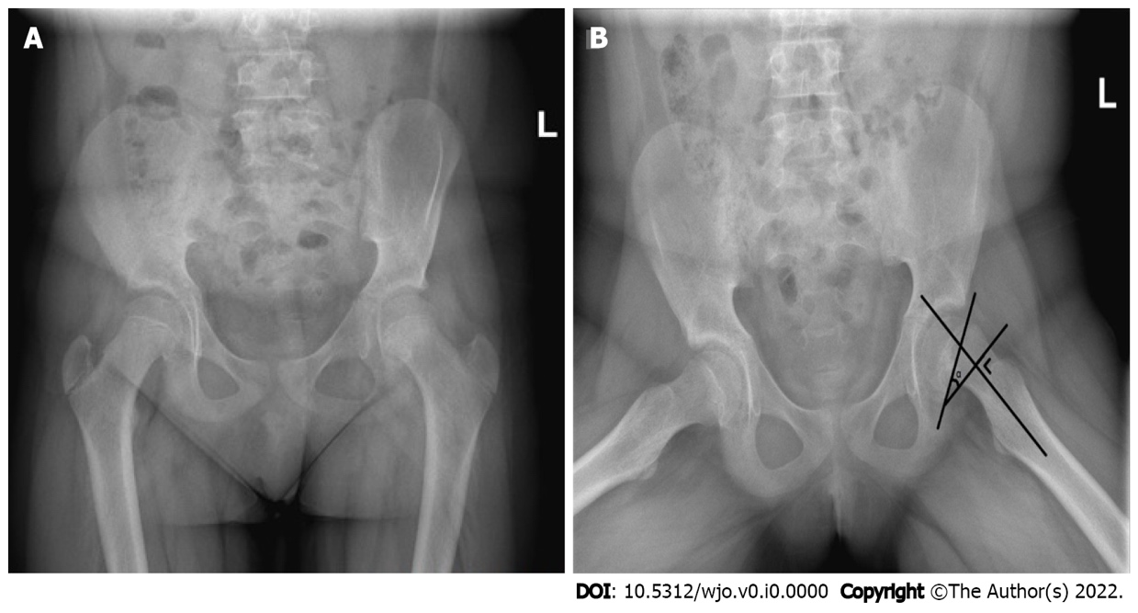
Figure 1 Plain pelvic radiographs of a left-sided slipped capital femoral epiphysis showing the posterior sloping angle of the affected side. A high posterior sloping angle of the unaffected side is considered an independent risk factor for subsequent contralateral disease. The posterior sloping angle (α), here presented on the affected side to increase visibility, is measured as the angle formed by the line along the physeal plane and the line perpendicular to the femoral neck-diaphyseal axis. A: Anteroposterior view; B: Lauenstein view.

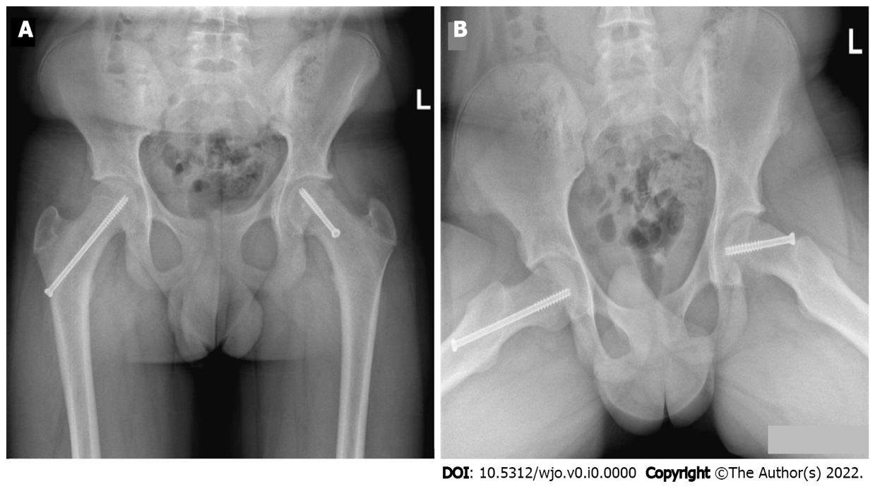
Figure 2 Pelvic radiographs showing in situ fixation of a left slipped capital femoral epiphysis and prophylactic fixation of the right proximal femur with a single screw. Note the difference in screw direction and length due to the epiphysiolysis on the left side. A: Anteroposterior view; B: Lauenstein view.

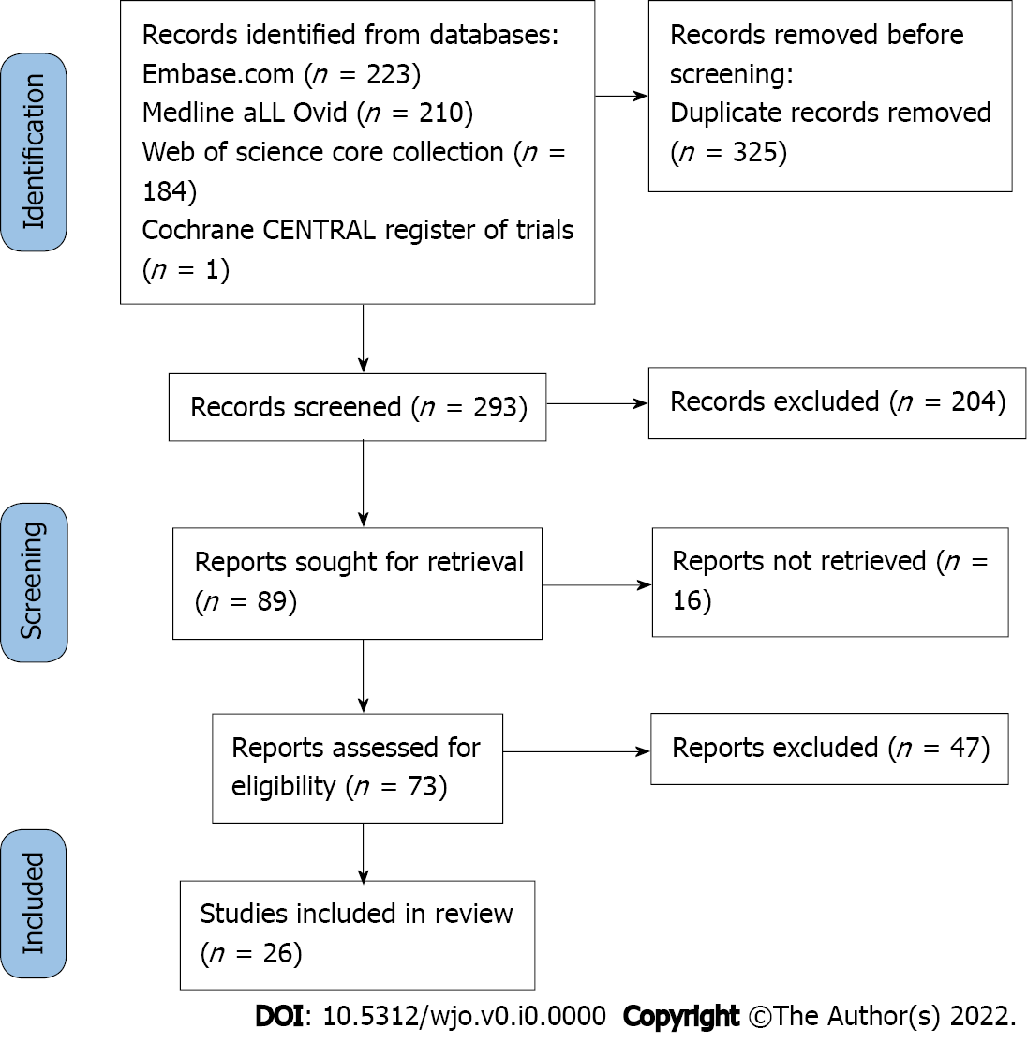
Figure 3 PRISMA flow diagram.
Table 1 Incidence and follow-up of symptomatic contralateral slipped capital femoral epiphysis in the literature
Ref. | Incidence | Time between slips in mo | Follow-up in mo | Minors score
Greenough et al^{[57]} | 16 of 61 (26%) | NA¹ | NA | 8 of 16
Hägglund et al^{[14]} | 32 of 237 (14%) | NA | NA | 10 of 16
Jensen et al^{[30]} | 9 of 57 (16%) | NA | 264 (median) | 9 of 16
Segal et al^{[23]} | 9 of 13 (69%) | 14 (mean) | 37 (mean) | 15 of 24
Hurley et al^{[32]} | 61 of 169 (36%) | NA | 34 (mean) | 10 of 16
Stasikelis et al^{[49]} | 20 of 50 (40%) | 10 (mean) | 34 (mean) | 13 of 16
Stott and Bidwell^{[29]} | 56 of 171 (33%) | 77% < 12 | 24 (mean) | 7 of 16
MacLean and Reddy^{[21]} | 9 of 53 (17%) | 13 (mean) | NA | 6 of 16
Koenig et al^{[58]} | 12 of 71 (17%) | NA | 60 (mean) | 9 of 16
Lehmann et al^{[33]} | 15 of 62 (24%) | 6 (mean) | 72 (mean) | 8 of 16
Baghdadi et al^{[22]} | 20 of 133 (15%) | 12 (mean) | 192 (mean) | 9 of 16
Kohno et al^{[59]} | 11 of 65 (17%) | NA | 36 (mean) | 15 of 24
Phillips et al^{[60]} | 42 of 132 (32%) | NA | 24 (mean) | 11 of 16
Bhattacharjee et al^{[43]} | 10 of 36 (28%) | NA | 36 (mean) | 15 of 24
Boyle et al^{[61]} | 45 of 168 (27%) | NA | 44 (mean) | 11 of 16
Wensaas et al^{[52]} | 6 of 22 (27%) | NA | 33 (mean) | 9 of 16
Nowicki et al^{[24]} | 45 of 496 (9%) | NA | 40 (mean) | 19 of 24
Herngren et al^{[37]} | 43 of 201 (21%) | NA | 36 (mean) | 14 of 16
Balch Samora et al^{[50]} | 11 of 33 (33%) | NA | 20 (mean) | 11 of 16
Tucker et al^{[13]} | 11 of 40 (28%) | 6 (mean) | 24 (minimum) | 10 of 16
Chan et al^{[62]} | 7 of 43 (16%) | 11 (mean) | 18 (mean) | 9 of 16
Maranho et al^{[63]} | 70 of 318 (22%) | 42 (median) | 18 (minimum) | 13 of 16
Tomaru et al^{[64]} | 3 of 34 (9%) | NA | 58 (mean) | 6 of 16
Swarup et al^{[28]} | 1077 of 9755 (11%) | 9 (mean), 88% < 18 | 24 (minimum) | 8 of 16
Maranho et al^{[65]} | 40 of 250 (28%) | NA | 49 (mean) | 14 of 16
Yildirim et al^{[66]} | 82 of 227 (36%) | 7 (mean) | 26 (mean) | 9 of 16
Total | 1762 of 12897 (14%) | Average: 9 (n = 1250) | Average: 46 | Average: 63%
¹NA: Not available.

