Name of Journal: World Journal of Gastroenterology
Manuscript NO: 80874
Manuscript Type: MINIREVIEWS

Approach to thromboelastography-based transfusion in cirrhosis: An alternative perspective on coagulation disorders

Kataria S et al. TEG-based transfusion in cirrhosis

Sahil Kataria, Deven Juneja, Omender Singh

Sahil Kataria, Deven Juneja, Omender Singh, Institute of Critical Care Medicine, Max Super Speciality Hospital, New Delhi 110017, India

Author contributions: Kataria S and Juneja D wrote the manuscript, researched the project, prepared the figures and tables, and performed data acquisition; Singh O reviewed draft and final versions of the manuscript.

Corresponding author: Deven Juneja, DNB, FCCP, MBBS, Director, Institute of Critical Care Medicine, Max Super Speciality Hospital, Saket, 1, Press Enclave Road, New Delhi 110017, India. devenjuneja@gmail.com

Received: October 15, 2022
Revised: January 12, 2023
Accepted: February 27, 2023
Published online:

Abstract
Viscoelastic tests, specifically thromboelastography and rotational thromboelastometry, are increasingly being used in the management of postoperative bleeding in surgical intensive care units (ICUs). However, life-threatening bleeds may complicate the clinical course of many patients admitted to medical ICUs, especially those with underlying liver dysfunction. Patients with cirrhosis have multiple coagulation abnormalities that can lead to bleeding or thrombotic complications. Compared to conventional coagulation tests, a comprehensive depiction of the coagulation process and point-of-care availability are advantages favoring these devices, which may aid physicians in making a rapid diagnosis and instituting early interventions. These tests may help predict bleeding and rationalize the use of blood products in these patients.

Key Words: Bleeding; Chronic liver disease; Cirrhosis; Thromboelastography; Viscoelastic tests

Kataria S, Juneja D, Singh O. Approach to thromboelastography-based transfusion in cirrhosis: An alternative perspective of coagulation disorders. World J Gastroenterol 2023; In press

Core Tip: Viscoelastic hemostatic assays are increasingly used as “point-of-care” tests, providing real-time, dynamic insight into the complex coagulation aberrations seen in cirrhotic patients. In cirrhosis, all patients undergoing a high-risk invasive procedure or who are actively bleeding should undergo thromboelastography (TEG) on initial evaluation, if this testing is available. Any reasonable TEG-based strategy will likely represent an improvement over strategies using traditional coagulation tests. The best approach will be to use TEG supplemented by standard platelet count and fibrinogen testing. TEG is a promising diagnostic modality and may help in predicting bleeding and aid in the rationalization of the use of blood products in these patients.

INTRODUCTION
The liver is essential in maintaining hemostasis^{[1]}. Patients with cirrhosis may demonstrate altered coagulation and are often considered “auto-anticoagulated”^{[2]}. However, the current understanding of coagulopathy is that patients with cirrhosis have a rebalanced coagulation status^{[3]}. This balance is precarious due to alterations in the hepatic synthesis of pro- and anticoagulant factors. The resilience of the hemostatic system can be further decreased in cirrhotic patients by acute clinical conditions like systemic infection, altered volume status, and impaired renal function.
Given our current understanding of coagulation status in cirrhosis patients, there is considerable interest in tests of coagulation that could provide a truly global view of the coagulation system. Conventional coagulation tests (CCTs), like prothrombin time (PT) and activated partial thromboplastin time (aPTT), are indicators of general liver dysfunction. However, these tests fail to depict the totality of in vivo coagulation dysfunction, and lack insight into factors such as blood flow dynamics, endothelial tissue factor (TF), platelet function. They are also limited in their ability to aid in the decision of whether to administer plasma or whole blood^{[4,5]}. Despite such concerns, these CCTs are commonly used to drive clinical decisions.
Thromboelastography (TEG) provides a more physiologically accurate assessment of the coagulation system. TEG has been used effectively as a rapid point-of-care test to assess hypercoagulable, hypocoagulable, and rebalanced coagulation states to evaluate blood transfusion requirements, suggest whether anticoagulation is required, and, if so, aid in the selection of anticoagulant therapy^{[6]}.
However, the ideal strategy for using TEG to guide the determination of blood product transfusion is unclear. Although the literature is replete with prospective data demonstrating the superiority of TEG over CCTs for non-surgical patients in terms of the requirement of blood transfusion, a mortality benefit has not been established^{[7-9]}. The present article aims to review the current evidence supporting the use of TEG and the clinical significance of this testing modality in the guidance of blood transfusion in cirrhosis patients.

HEMOSTATIC SYSTEM IN LIVER DISEASE
Per the cell-based model of hemostasis, coagulation occurs not as a “cascade” but in 3 overlapping stages: (1) The initiation phase ensues on tissue factor (TF)-carrying cells. If the procoagulant stimulus is sufficiently strong, factors Xa, IXa, and thrombin are formed in adequate levels to initiate the coagulation process; (2) The amplification phase occurs as the activity moves from the TF-carrying cell to the platelet surface. The procoagulant stimulus is intensified causing platelets to attach, activate, and hoard activated cofactors on their surfaces; and (3) The propagation phase in which the “tenase” and “prothrombinase” complexes gather on the platelet surface and generate the large amounts of thrombin necessary to form a hemostatic fibrin clot^{[10]}.
In cirrhosis, all three phases are limited by hepatic synthetic dysfunction and portal hypertension, resulting in a delicate state of “new equilibrium” (Figure 1)^{[11]}. However, this balance can be altered by concomitant conditions such as sepsis or acute kidney injury (AKI) as a result of the interaction between platelets and released inflammatory mediators (Figure 2). Thus, the coagulation profile in cirrhotic patients is dynamic, with possible resolution of global coagulation deficiencies once the acute critical illness resolves. The cell-based model of coagulation also explains why regional hemostatic changes at an injury site do not override the systemic hemostatic equilibrium. Accordingly, CCTs may remain unchanged in patients with liver dysfunction, even with clinically evident bleeding.
According to Hoffman's concept of the cell-based coagulation model, bleeding can arise from disorders of primary hemostasis (abnormal platelet plug formation) or secondary hemostasis (reduced thrombin generation and subsequent fibrin clot formation). The liver plays a critical role in maintaining both primary and secondary hemostasis^{[11]}. In fact, the liver is the site of synthesis of most coagulation factors, with the exception of von Willebrand factor (vWF), factor VIII (only partly synthesized in the liver), and calcium^{[12]}.
Bleeding complications in cirrhotic patients may occur due to hemostatic failure or non-hemostatic causes. The term “spontaneous hemostasis-related bleeding” has recently been introduced to distinguish bleeding due to hemostatic anomalies from that related to portal hypertension, trauma, or peptic ulcers. It is defined as an unprovoked hemorrhage of unexplained cause. However, it should be emphasized that spontaneous bleeding is uncommon in patients with cirrhosis, and bleeding is typically related to portal hypertension caused by increased portal pressure rather than hemostatic failure. This was conclusively demonstrated by the inability of recombinant factor VII to achieve better control of variceal rebleeding^{[13,14]}. Notably, a bleed not primarily caused by hemostatic failure can evolve into a hemostatic bleed due to severe blood loss and consumptive coagulopathy. Bleeding (tertiary hemostasis disorder) can also be due to premature platelet or fibrin clot dissolution or excessive fibrinolysis, which in cirrhotic patients has been termed “accelerated intravascular coagulation and fibrinolysis” (AICF). AICF manifests as mucosal or puncture wound bleeding, and the pathophysiology of this disorder is not entirely understood. Hyperfibrinolysis parallels the severity of liver disease: mild systemic fibrinolysis is encountered in 30%-45% of cirrhotic patients, with clinically detectable fibrinolysis in only 5%-10%. AICF can be distinguished from disseminated intravascular coagulation by increased factor VIII levels (Figure 1)^{[15,16]}. The 3 phases of coagulation in liver disease resulting in a “rebalancing” of hemostasis are summarized in Table 1^{[17,18]}.
For the past several decades, bleeding has been a major concern in the management of cirrhotic patients. However, thrombotic complications are being increasingly acknowledged and are attributed to shifts in hemostatic balance. In one case-control study, the relative risk of venous thromboembolism (VTE) in patients with cirrhosis was 1.74 (95%CI: 1.54-1.95)^{[19]}. These conclusions were mirrored in a study by Wu et al^{[20]}, which showed an increased likelihood of VTE in cirrhosis [odds ratio (OR) 1.23 in compensated cirrhotic patients; OR 1.39 in decompensated cirrhotic patients]. Dysfibrinogenemia (i.e. altered fibrinogen) may result in decreased permeability of the formed clot, as well as other factors that contribute to coagulopathy. It may even confer hypercoagulable features, manifesting as macro- and micro-thrombotic complications. A hypercoagulable state also frequently occurs in cirrhosis patients due to concomitant primary biliary cholangitis, non-alcoholic fatty liver disease, or primary sclerosing cholangitis^{[21]}.
The most common macro-thrombotic presentation in liver disease is portal vein thrombosis (PVT), occurring in 8% to 18% of cirrhosis patients^{[18]}. The incidence of PVT increases with deteriorating liver function and decreased portal flow. Deep venous thrombosis and pulmonary embolism (PE) are other macro-thrombotic complications, which have been reported in 5% of hospitalized patients with chronic liver disease (CLD)^{[17,22]}. Micro-thrombotic complications include intrahepatic microthrombi (“parenchymal extinction”), resulting in nodules, porto-pulmonary hypertension, and cirrhosis arising as an ischemic/reinjury process. These complications often merit exigent consideration of anticoagulant usage.

TESTS OF COAGULATION IN CIRRHOSIS
As of this article, all available laboratory hemostasis measures have significant limitations when applied to patients with liver disease. The paradigm of this phenomenon is the cirrhotic patient, for which PT and international normalized ratio (INR) were developed to monitor warfarin-treated patients by measuring the activity of an added commercially available thromboplastin reagent. PT and aPTT indicate the onset of thrombin generation; however, they do not reflect enzymatic coagulation. PT/INR has been validated as a prognostic marker for mortality in liver disease, but has never been validated to predict bleeding risk or guide transfusion of blood products, especially for pre-procedure risk mitigation^{[14]}. Nonetheless, this measure has been used for decades as a surrogate for bleeding risk in cirrhosis despite the fact that the arbitrary cut-off points used as clinical targets for the prevention of bleeding are not supported by scientific evidence. Furthermore, using fresh frozen plasma (FFP) to normalize a raised INR in cirrhosis does not alter thrombin (factor II) production, but exacerbates portal hypertension^{[23-25]}.
Thrombocytopenia is the most common hematological abnormality in patients with liver disease. Platelet count thresholds are often specified for invasive procedures in patients with severe cirrhosis-related thrombocytopenia. In vitro data suggest that a threshold of 50-55 × 10⁹/L is necessary for adequate platelet activity, and levels below this range fail to promote thrombin generation^{[26]}. However, the platelet function associated with primary hemostasis (i.e. adhesiveness and aggregation) has not been evaluated. Current guidelines and expert opinion recommend considering platelet-raising treatments before high-risk procedures, or in patients with active bleeding with platelet counts < 50 × 10⁹/L. However, there is no firm evidence that prophylactic platelet transfusion to achieve this target enhances hemostasis^{[15,23]}.
As mentioned previously, platelet count alone does not account for other factors affecting platelet function in cirrhosis^{[27]}. For example, uremic platelet dysfunction (e.g., hepatorenal syndrome) can result in impaired platelet activity with decreased serotonin in alpha granules and dysregulated metabolism of thromboxane A2. Anemia can also affect platelet function. In patients with hematocrit < 25%, erythrocyte concentration is inadequate to facilitate platelet margination, impairing the clotting process. Sepsis and endotoxemia due to bacterial translocation also can affect platelet function.
Recently, fibrinogen levels have replaced INR to couple with platelet count in the evaluation of bleeding risk. The Clauss method for detecting fibrinogen is turbidimetric and relies on thrombin-induced fibrin formation. Nevertheless, fibrinogen levels do not account for the synthesis of abnormal fibrinogen in cirrhotic patients caused by hypersialylation of the fibrinogen, leading to impaired fibrinogen-to-fibrin conversion^{[28]}. In trauma surgery patients without underlying liver disorder, administration of fibrinogen factor to accomplish levels of fibrinogen > 200 mg/dL is associated with improved hemostasis. However, in routine clinical practice, the most agreed-upon cut-off for fibrinogen in cirrhotic patients with active bleeding is > 120 mg/dL^{[29]}. In cirrhotic patients, spontaneous or procedure-related bleeding is relatively common when plasma fibrinogen levels are less than 100 mg/dL. Whether this relationship is causal or reflects disease severity is unclear. As such, the available evidence suggests that tests measuring clot formation and strength (i.e. fibrinogen) may have better predictive value for bleeding events than coagulation initiation tests^{[29,30]}.
Primary hyperfibrinolysis is an increasingly vital pathophysiological process in CLD, resulting in an increased risk of variceal bleeding. D-dimer is a nonspecific marker of fibrin degradation. While evidence suggests that elevated D-dimer indicates hyperfibrinolysis and can predict gastrointestinal bleeding in this population, elevated D-dimer alone provides limited information regarding an individual's fibrinolytic state^{[31,32]}.
Thrombin generation assays (TGAs) evaluate the time of thrombin generation and its decline when plasma is triggered by TF and phospholipids. Thus, TGA can reflect the activity of both pro- and anticoagulant factors^{[33,34]}. Nevertheless, clinical trials are needed to test this conjecture. Similar to PT and aPTT, TGA is performed on plasma rather than whole blood. However, because of their method, TGAs approximate the in vivo coagulation balance better than CCTs.
TEG quantitatively assesses the capability of whole blood to form a clot, providing a comprehensive picture of coagulation status compared to standard laboratory tests, which are confined to developing the first fibrin strands. However, TEG is insensitive to the platelet adhesion and aggregation activity of vWF and the anticoagulant actions of protein C and protein S; therefore, it may lead to an underestimation of hemostatic capacity^{[17]} (Table 2).

PRINCIPLES OF TEG
The principle of the in vitro TEG test is to detect and quantify dynamic changes in the viscoelastic properties of whole blood during clotting under low shear stress (Figure 3A). TEG results are depicted as 2-dimensional graphs, with time on the x-axis and amplitude (in millimeters) on the y-axis (Figure 3B). A normal TEG trace appears similar to a cognac glass lying on its side (Figure 4)^{[17]}. An evident prolongation of R is associated with clotting factor levels of 30% or less^{[35]}. Different activators can be added to the blood to better assess various aspects of the clotting cascade (Table 3). Conventional TEG involves clot initiation by adding kaolin, simulating the intrinsic coagulation pathway. In contrast, rapid TEG involves the addition of kaolin and TF, causing massive thrombin burst and providing initial results (K time) within 6 min and alpha angle/MA within 15 min^{[36,37]}. Thus, the results of rapid TEG can be achieved approximately 10 min earlier than the kaolin TEG and about 30 min earlier than CCTs^{[37]}. This could guide critical resuscitations more competently, enabling real-time monitoring and goal-directed therapy. Though the activators reduce the test turnaround time (e.g., kaolin), the sensitivity of viscoelastic tests (VETs) could be blunted, and subtle changes in coagulation and clot lysis might not be detected^{[17]} (Table 4).

Correlation of CCTs and VETs
A strong correlation between TEG measures of clot formation and clot strength and conventional fibrinogen level has been observed in CLD patients who are critically ill. Nevertheless, weak or unpredictable correlations exist between TEG and CCTs in measuring coagulation initiation (i.e. TEG R-time and PT/INR/aPTT), TEG and conventional platelet count, and measures of fibrinolysis (TEG LY30 and traditional D-dimer)^{[38-40]}. The absence of a correlation between PT/INR and R may be explained by several elements, such as the use of different activators, the use of whole blood vs plasma, and the fact that R-time, unlike INR, reflects the balance of both pro- and anticoagulant factors. This supports the evidence that clotting initiation and speed measures are challenging to interpret in this cohort, while TEG maximum amplitude (MA) and conventional fibrinogen may be more reliable. Nonetheless, the results of these tests should always be correlated with the clinical situation.

CLINICAL APPLICATIONS OF TEG IN LIVER DISEASE
TEG and invasive procedures in patients with cirrhosis
Bleeding complications after invasive procedures are always a concern in cirrhotic patients, though the incidence varies widely^{[41]}. Although the risk of bleeding after the procedure is related to alterations in clotting factors, the risk is also inherent to a given procedure (Table 3) and the given clinical situation^{[41]}. In cirrhotic patients with acute illness or acute-on-chronic liver failure, the association between clotting tests and bleeding may not be as apparent or evident as in stable patients. Moreover, managing complications, such as sepsis or AKI, instead of correcting hemostatic abnormality, may result in improved outcomes. A retrospective study revealed that AKI was the only independent risk factor for post-paracentesis hemoperitoneum. In contrast, no significant difference was observed in CCTs (platelet count and INR levels) between patients with or without this complication^{[42]}.
Three recent randomized trials conducted in cirrhotic patients undergoing invasive procedures demonstrated a decreased requirement for prophylactic blood product transfusions using TEG-guided transfusions compared to standard test-based protocols^{[7-9]}. However, they could not demonstrate any relationship between abnormal TEG tracing and bleeding, primarily due to the scarcity of documented bleeding events. Similarly, TEG did not help to predict the inability to control bleeding or prevent rebleeding. Also, no impact on other clinically relevant outcomes was observed. Moreover, each study used a different transfusion protocol, making it difficult to know whether the lower cutoff for transfusion would have been more beneficial. In another study of cirrhotic patients undergoing various invasive procedures without prophylactic administration of blood products, even with abnormal CCT and TEG R-time and MA, 1 patient experienced bleeding (0.7%)^{[43]}. Also, a recent study in 90 patients with cirrhosis undergoing central venous cannulation demonstrated that a prolonged TEG K-time (≥ 3.05 min) could not predict bleeding complications (accuracy 69.4%, P = 0.047)^{[44]}. These studies indicate that post-procedural bleeding events are rare, implying that uncorrected coagulopathy does not modify the post-procedural outcome. Nevertheless, coagulation tests can be utilized to evaluate the severity of liver disease or the patient's baseline hemostatic function and to provide a baseline to guide management in the case of post-procedural bleeding.
Most of the latest guidelines recommend against using CCTs and correction of coagulopathy before undergoing common gastrointestinal procedures in patients with stable cirrhosis. Also, there are no recommendations for or against using TEG in such patient populations (Table 5)^{[15,23,45,46]}. However, in patients with severely abnormal coagulation parameters or thrombocytopenia undergoing a moderate- to high-risk procedure, clinical judgment regarding prophylactic blood transfusion should consider the possible benefits and risks (Figure 5)^{[7,15]}.

Use of TEG in cirrhosis with active bleeding
Bleeding related to portal hypertension, variceal and non-variceal, is primarily managed with local measures such as endoscopic band ligation, laser or injection therapy, and by lowering portal pressure using vasoactive drugs than pro-hemostatic therapy. The observation that variceal bleeding in patients on anticoagulants was not severe or associated with worse outcomes compared to patients who are not on anticoagulants confirms that the role of the hemostatic system in variceal bleeding, if present, is minor^{[47]}. Randomized controlled studies have shown that in cirrhotic patients with variceal and non-variceal bleeding, using VETs to guide blood product transfusion did not result in superior control of bleeding nor any morbidity or mortality benefit compared to CCTs^{[48-50]}. However, the transfusion requirement was significantly lower in the VET group. Although the study by Kumar et al^{[51]} demonstrated significantly shorter ICU stays using TEG-guided resuscitation, there was no difference in other outcomes. Nevertheless, it is questionable whether in active variceal bleeding, VETs-guided pro-hemostatic therapy is beneficial or contributes to the control of bleeding when the standard treatment with vasoactive drugs and endoscopic therapy is provided.
If local measures and portal pressure-lowering drugs cannot contain bleeding, the decision to correct coagulopathy by transfusing blood products should be considered on a case-by-case basis^{[13]}. Since VETs are quicker and more accurate than CCTs and provide a more practical understanding of fibrinolysis, which may indicate the need to start antifibrinolytic therapy, they have a theoretical advantage over CCTs in guiding the management of active bleeding.
Unlike pressure-driven bleeding, AICF arises due to disturbed hemostatic mechanisms^{[15]}. Antifibrinolytic therapy, such as epsilon aminocaproic acid or tranexamic acid, is potentially effective, inhibiting the fibrin clot's dissolution. Neither agent is thought to have inherent hypercoagulable risk, except in the case of a preexisting pathological thrombus such as PVT. The “native TEG” can detect this condition in liver disease patients by the presence of an increase in LY30^{[17]}.
TEG-based algorithms may allow targeted and specific blood product transfusions in patients with severe bleeding (e.g., FFP or cryoprecipitates)^{[17]}. However, the threshold values of various VETs to trigger transfusion are yet to be validated in appropriate clinical studies.

Heparin-like effect in cirrhosis
A stressful condition such as surgery or sepsis can trigger the release of endogenous glycosaminoglycans (GAGs) (e.g., heparin sulfate and dermatan sulfate) from the endothelium glycocalyx layer or mast cell, which, when shed, retain their anticoagulant activity^{[52,53]}. This is thought to be an adaptive reaction to maintain the patency of progressively procoagulant microvasculature through endogenous heparinization, thus preventing spontaneous thrombosis.
Endogenous GAGs may increase the bleeding risk in some patients. This was illustrated by Senzolo et al^{[54]}, where GAGs affected hemostasis in cirrhotic patients with sepsis. Another prospective analysis further confirmed the presence of an endogenous heparinoid in patients with cirrhosis and acute variceal bleeding and was found to be associated with bleeding-related mortality^{[55]}. After appropriate therapy, endogenous heparinoids are cleared with normalization of the coagulation profile, emphasizing the association between the coagulation cascade and inflammatory pathways.
Although CCTs are insensitive to this effect, the native TEG is extremely sensitive to the presence of heparin and heparin-like substances, which is detectable by an increased R-time on TEG analysis^{[56]}. Adding heparinase I, which cleaves heparin-like compounds, can demonstrate a heparin-like effect due to elevated GAGs, correlating with an anti-Xa activity^{[57]}. Therefore, heparinase TEG will normalize the prolongation of the R-value observed with native TEG. Thus, TEG helps differentiate between a coagulation factor deficiency and heparin-produced coagulopathy by using heparinase-modified TEG and the native TEG (Table 4).

TEG in orthotopic liver transplant
Kang et al^{[58]} at the University of Pittsburgh introduced TEG-based algorithms to guide blood product transfusion for correcting coagulopathy in orthotopic liver transplantation in the early 1980s (Figure 6). It was shown that TEG reduced transfusion requirements by 33% compared with a historical cohort. Secondary endpoints like re-intervention for bleeding, AKI, or hemodynamic instability were significantly lower in the VET group. Although numerous studies have described the usefulness of VET in lowering transfusion requirements in liver transplant (LT), most of these studies commonly compared the results with historical cohorts having a relatively high baseline transfusion rate^{[59,60]}. A recent study of 60 LT patients showed no significant differences with and without VET monitoring though overall transfusion was low, with many patients receiving no transfusion^{[61]}. As bleeding and transfusion management continues to evolve, the results of these earlier studies cannot be easily employed in the present era. Also, the thresholds described for VET for initiating transfusion are still to be established, and values may be substantially above the normal ranges before an intervention is advised.
A significant proportion of patients undergoing LT will inevitably have enormous blood loss, and VET can be helpful in such occasions to enable goal-targeted treatment and assess the effectiveness of any therapeutic intervention. The short turnaround times of VET (10-20 min) are vital for directing therapy and averting inappropriate transfusion during surgery and in the ICU. Monitoring coagulation with functional fibrinogen TEG (Table 4) for goal-directed fibrinogen substitution seems more appropriate and avoids unnecessary platelet transfusions. This is particularly important in LT, as platelet administration is associated with a substantial decline in 1-year survival^{[62]}.

Fibrinolysis and orthotopic liver transplant
It is well known that increased fibrinolytic activity can occur at any juncture during LT. However, it is significantly enhanced during the anhepatic period due to a lack of tissue plasminogen activator (tPA) clearance^{[63]}. Also, it may become most pronounced in the post-reperfusion stage by an erratic upsurge in tPA, leading to diffuse uncontrolled bleeding due to primary hyperfibrinolysis^{[64]}. If the graft function is good, hyperfibrinolysis after reperfusion is usually self-limiting and does not require treatment. However, in the presence of an inadequately functioning graft, it may persist^{[65]}. During LT, prophylactic antifibrinolytic agents were often used in earlier years because of the high mortality associated with tremendous blood loss, and the potential peril associated with antifibrinolytics was minor. As massive bleeding is currently less frequent, there is a preference towards the selective use of antifibrinolytics only in high-risk patients. Systemic fibrinolysis can be efficiently detected using VETs (demonstrated by increased or worsening LY30 and LY60), which may not be possible with CCTs. Thus, the transfusion requirement may be decreased with VET use in liver transplantation, where hyperfibrinolysis commonly occurs.

TEG and hypercoagulability
The risk of developing VTE is similar in cirrhotic and non-cirrhotic patients^{[15,23]}. Hypercoagulability detected on TEG can either be due to shortened R or K, enhanced clot strength (MA), or a combination of both. Huang et al^{[66]} observed a significantly shorter R in cirrhosis with non-malignancy PVT. Zanetto et al^{[67]} found that elevated MA was associated with PVT in cirrhotic patients with hepatocellular carcinoma. Given that malignancy itself could also cause hypercoagulation, the clinical use of TEG in this setting may be questionable. In another study, hypercoagulability was defined as the presence of at least 2 of the following criteria: reduced R, reduced K, raised α, or increased MA. Hypercoagulability was not associated with PVT in cirrhosis^{[68]}.
In cirrhotic patients with elevated CCTs, we tend to avoid prophylactic anticoagulation in hospitalized patients. Presently, the European Association for the Study of the Liver Clinical Practice Guidelines in cirrhosis does not recommend using VETs to identify the risk of VTE^{[23]}. Further prospective studies may explore the utility of TEG in predicting the risk of VTE during hospitalization.
Acute intracardiac thrombi and PEs are rare, although a well-recognized, potentially fatal complication of LT, associated with high mortality. Krzanicki et al^{[69]} demonstrated that a hypercoagulable state is quite common during liver transplantation. A review of 27 case reports of TE in orthotopic LT showed that TEG indicated hypercoagulability in greater than 70% of cases^{[70]}. Also, hypercoagulable TEG patterns correlated well with the formation of intracardiac thrombi. Indeed, a quick inspection of the rapid TEG after 5 or 10 min of clotting time might predict thrombosis, demonstrated by the increase in the MA. The clinical importance of hypercoagulability on TEG during LT is yet to be recognized. However, it would appear unreasonable to transfuse blood products or avoid anticoagulants based on raised CCTs when a hypercoagulable state is seen on TEG.
Patients with cirrhosis and VTE should be treated with anticoagulation, similar to other non-cirrhotic patients. In patients at increased risk of bleeding, unfractionated heparin (UFH) is the preferred anticoagulant, owing to its shorter half-life (45 min) and the availability of an effective antidote (protamine sulfate). aPTT is the most commonly used test to monitor UFH therapy. Although the anti-Xa activity assay is used explicitly for monitoring low molecular weight heparins, as they primarily inhibit factor Xa, it may also be superior to aPTT for titrating UFH^{[71]}.
Given that heparin activity mainly depends on the liver-derived activity of the heparin cofactor antithrombin III, monitoring heparin therapy with CCT in patients with cirrhosis is challenging. TEG may provide a better representation of the in vivo heparin effect than aPTT^{[72,73]}. A higher concentration of heparin tends to be associated with larger R-values with dose-dependence. Levels of anti-factor Xa activity correlate with the R-value of TEG. In addition, TEG can help diagnose and treat heparin-induced coagulopathy. Thus, platelet and enzymatic hypercoagulability demonstrated with TEG mandates aggressive treatment with a direct thrombin inhibitor.

LIMITATIONS OF TEG
Like any other test, TEG is associated with certain limitations. It measures blood coagulation in vitro instead of during flow within the vasculature, and as such does not reflect the endothelium's function in coagulation. Inherently, the test is less sensitive to platelet adhesion and interactions between vWF and protein C and S system. TEG results do not correlate with the effects of hypothermia, as TEG is performed at 37 °C. Kaolin cannot effectively detect alterations in the extrinsic coagulation pathway, as it only activates the intrinsic coagulation pathway. Thus, INR is still the gold standard for monitoring warfarin therapy, and TEG may overlook a clinically significant coagulopathy. TEG detects fibrinolysis only when tPA levels are 5 times normal. Studies have shown that using plasmin-α2-antiplasmin as a biomarker for fibrinolysis can detect fibrinolytic activation in over 80% of severely injured patients, whereas TEG detected hyperfibrinolysis in only 5%-18%. Each TEG run generally takes 30 min to an hour, and only a few tests can run simultaneously, unlike CCT. The optimization of TEG is essential in providing appropriate patient laboratory testing. Additionally, testing should be performed by trained personnel and is susceptible to technical variations.

CONCLUSION
VETs are increasingly used as “point-of-care” tests, providing a real-time, dynamic picture of complex coagulation aberrations (e.g., hypocoagulability, hypercoagulability and hyperfibrinolysis) in cirrhotic patients. In cirrhosis, all patients undergoing a high-risk invasive procedure or who are actively bleeding should undergo TEG at initial evaluation, if this testing is available. Any reasonable TEG-based strategy will likely represent an improvement over strategies using traditional coagulation tests. The best approach will be to use TEG supplemented by platelet count and fibrinogen measures. TEG is a promising diagnostic modality, but given the limited clinical trials, there are no consensus guidelines for its use. Further prospective studies are required to validate TEG algorithms for use in the context of patients with cirrhosis.

REFERENCES
1 Lisman T, Leebeek FW, de Groot PG. Haemostatic abnormalities in patients with liver disease. J Hepatol 2002; 37: 280-287 [PMID: 12127437 DOI: 10.1016/s0168-8278(02)00199-x]
2 Tripodi A, Mannucci PM. The coagulopathy of chronic liver disease. N Engl J Med 2011; 365: 147-156 [PMID: 21751907 DOI: 10.1056/NEJMra1011170]
3 Tripodi A, Primignani M, Mannucci PM, Caldwell SH. Changing Concepts of Cirrhotic Coagulopathy. Am J Gastroenterol 2017; 112: 274-281 [PMID: 27801884 DOI: 10.1038/ajg.2016.498]
4 Mannucci PM, Tripodi A. Liver disease, coagulopathies and transfusion therapy. Blood Transfus 2013; 11: 32-36 [PMID: 23058863 DOI: 10.2450/2012.0151-12]
5 Peck-Radosavljevic M. Review article: coagulation disorders in chronic liver disease. Aliment Pharmacol Ther 2007; 26 Suppl 1: 21-28 [PMID: 17958516 DOI: 10.1111/j.1365-2036.2007.03509.x]
6 Mallett SV. Clinical Utility of Viscoelastic Tests of Coagulation (TEG/ROTEM) in Patients with Liver Disease and during Liver Transplantation. Semin Thromb Hemost 2015; 41: 527-537 [PMID: 26049072 DOI: 10.1055/s-0035-1550434]
7 De Pietri L, Bianchini M, Montalti R, De Maria N, Di Maira T, Begliomini B, Gerunda GE, di Benedetto F, Garcia-Tsao G, Villa E. Thrombelastography-guided blood product use before invasive procedures in cirrhosis with severe coagulopathy: A randomized, controlled trial. Hepatology 2016; 63: 566-573 [PMID: 26340411 DOI: 10.1002/hep.28148]
8 Kovalic AJ, Khan MA, Malaver D, Whitson MJ, Teperman LW, Bernstein DE, Singal A, Satapathy SK. Thromboelastography versus standard coagulation testing in the assessment and reversal of coagulopathy among cirrhotics: a systematic review and meta-analysis. Eur J Gastroenterol Hepatol 2020; 32: 291-302 [PMID: 32012141 DOI: 10.1097/MEG.0000000000001588]
9 Vuyyuru SK, Singh AD, Gamanagatti SR, Rout G, Gunjan D, Shalimar. A Randomized Control Trial of Thromboelastography-Guided Transfusion in Cirrhosis for High-Risk Invasive Liver-Related Procedures. Dig Dis Sci 2020; 65: 2104-2111 [PMID: 31720889 DOI: 10.1007/s10620-019-05939-2]
10 Hoffman M, Monroe DM 3rd. A cell-based model of hemostasis. Thromb Haemost 2001; 85: 958-965 [PMID: 11434702]
11 Northup PG, Caldwell SH. Coagulation in liver disease: a guide for the clinician. Clin Gastroenterol Hepatol 2013; 11: 1064-1074 [PMID: 23506859 DOI: 10.1016/j.cgh.2013.02.026]
12 Rodriguez-Castro KI, Simioni P, Burra P, Senzolo M. Anticoagulation for the treatment of thrombotic complications in patients with cirrhosis. Liver Int 2012; 32: 1465-1476 [PMID: 22734713 DOI: 10.1111/j.1478-3231.2012.02839.x]
13 Bosch J, Thabut D, Albillos A, Carbonell N, Spicak J, Massard J, D'Amico G, Lebrec D, de Franchis R, Fabricius S, Cai Y, Bendtsen F; International Study Group on rFVIIa in UGI Hemorrhage. Recombinant factor VIIa for variceal bleeding in patients with advanced cirrhosis: A randomized, controlled trial. Hepatology 2008; 47: 1604-1614 [PMID: 18393319 DOI: 10.1002/hep.22216]
14 Bosch J, Thabut D, Bendtsen F, D'Amico G, Albillos A, González Abraldes J, Fabricius S, Erhardtsen E, de Franchis R; European Study Group on rFVIIa in UGI Haemorrhage. Recombinant factor VIIa for upper gastrointestinal bleeding in patients with cirrhosis: a randomized, double-blind trial. Gastroenterology 2004; 127: 1123-1130 [PMID: 15480990 DOI: 10.1053/j.gastro.2004.07.015]
15 O'Shea RS, Davitkov P, Ko CW, Rajasekhar A, Su GL, Sultan S, Allen AM, Falck-Ytter Y. AGA Clinical Practice Guideline on the Management of Coagulation Disorders in Patients With Cirrhosis. Gastroenterology 2021; 161: 1615-1627.e1 [PMID: 34579936 DOI: 10.1053/j.gastro.2021.08.015]
16 Rijken DC, Kock EL, Guimarães AH, Talens S, Darwish Murad S, Janssen HL, Leebeek FW. Evidence for an enhanced fibrinolytic capacity in cirrhosis as measured with two different global fibrinolysis tests. J Thromb Haemost 2012; 10: 2116-2122 [PMID: 22906184 DOI: 10.1111/j.1538-7836.2012.04901.x]
17 Gish RG, Stravitz RT. Correction of Coagulopathy of Liver Disease Prior to Procedures. Gastroenterol Hepatol (N Y) 2021; 17: 16-23 [PMID: 34135700]
18 Drolz A, Ferlitsch A, Fuhrmann V. Management of Coagulopathy during Bleeding and Invasive Procedures in Patients with Liver Failure. Visc Med 2018; 34: 254-258 [PMID: 30345282 DOI: 10.1159/000491106]
19 Søgaard KK, Horváth-Puhó E, Grønbaek H, Jepsen P, Vilstrup H, Sørensen HT. Risk of venous thromboembolism in patients with liver disease: a nationwide population-based case-control study. Am J Gastroenterol 2009; 104: 96-101 [PMID: 19098856 DOI: 10.1038/ajg.2008.34]
20 Wu H, Nguyen GC. Liver cirrhosis is associated with venous thromboembolism among hospitalized patients in a nationwide US study. Clin Gastroenterol Hepatol2010; 8: 800-805 [PMID: 20566312 DOI: 10.1016/j.cgh.2010.05.014]
21 Buliarca A, Horhat A, Mocan T, Craciun R, Procopet B, Sparchez Z. Viscoelastic tests in liver disease: where do we stand now? World J Gastroenterol 2021; 27: 3290-3302 [PMID: 34163112 DOI: 10.3748/wjg.v27.i23.3290]
22 Abdel-Razik A, Mousa N, Elhelaly R, Tawfik A. De-novo portal vein thrombosis in liver cirrhosis: risk factors and correlation with the Model for End-stage Liver Disease scoring system. Eur J Gastroenterol Hepatol 2015; 27: 585-592 [PMID: 25769098 DOI: 10.1097/MEG.0000000000000325]
23 European Association for the Study of the Liver. Electronic address: easloffice@easloffice.eu; European Association for the Study of the Liver. EASL Clinical Practice Guidelines on prevention and management of bleeding and thrombosis in patients with cirrhosis. J Hepatol 2022; 76: 1151-1184 [PMID: 35300861 DOI: 10.1016/j.jhep.2021.09.003]
24 Tripodi A, Chantarangkul V, Primignani M, Clerici M, Dell'era A, Aghemo A, Mannucci PM. Thrombin generation in plasma from patients with cirrhosis supplemented with normal plasma: considerations on the efficacy of treatment with fresh-frozen plasma. Intern Emerg Med 2012; 7: 139-144 [PMID: 21298360 DOI: 10.1007/s11739-011-0528-4]
25 Giannini EG, Stravitz RT, Caldwell SH. Correction of hemostatic abnormalities and portal pressure variations in patients with cirrhosis. Hepatology 2014; 60: 1442 [PMID: 24452495 DOI: 10.1002/hep.27029]
26 Giannini EG, Greco A, Marenco S, Andorno E, Valente U, Savarino V. Incidence of bleeding following invasive procedures in patients with thrombocytopenia and advanced liver disease. Clin Gastroenterol Hepatol 2010; 8: 899-902; quiz e109 [PMID: 20601131 DOI: 10.1016/j.cgh.2010.06.018]
27 Mitchell O, Feldman DM, Diakow M, Sigal SH. The pathophysiology of thrombocytopenia in chronic liver disease. Hepat Med 2016; 8: 39-50 [PMID: 27186144 DOI: 10.2147/HMER.S74612]
28 Arif S, Khan AS, Khan AR. Changes in fibrinogen level in liver cirrhosis. J Ayub Med Coll Abbottabad 2002; 14: 19-21 [PMID: 12238339]
29 Drolz A, Horvatits T, Roedl K, Rutter K, Staufer K, Kneidinger N, Holzinger U, Zauner C, Schellongowski P, Heinz G, Perkmann T, Kluge S, Trauner M, Fuhrmann V. Coagulation parameters and major bleeding in critically ill patients with cirrhosis. Hepatology 2016; 64: 556-568 [PMID: 27124745 DOI: 10.1002/hep.28628]
30 Bolliger D, Szlam F, Molinaro RJ, Rahe-Meyer N, Levy JH, Tanaka KA. Finding the optimal concentration range for fibrinogen replacement after severe haemodilution: an in vitro model. Br J Anaesth 2009; 102: 793-799 [PMID: 19420005 DOI: 10.1093/bja/aep098]
31 Schöchl H, Frietsch T, Pavelka M, Jámbor C. Hyperfibrinolysis after major trauma: differential diagnosis of lysis patterns and prognostic value of thrombelastometry. J Trauma 2009; 67: 125-131 [PMID: 19590321 DOI: 10.1097/TA.0b013e31818b2483]
32 Violl F, Basili S, Ferro D, Quintarelli C, Alessandril C, Cordova C. Association between high values of D-dimer and tissue-plasminogen activator activity and first gastrointestinal bleeding in cirrhotic patients. CALC Group. Thromb Haemost 1996; 76: 177-183 [PMID: 8865526]
33 Tripodi A, Salerno F, Chantarangkul V, Clerici M, Cazzaniga M, Primignani M, Mannuccio Mannucci P. Evidence of normal thrombin generation in cirrhosis despite abnormal conventional coagulation tests. Hepatology 2005; 41: 553-558 [PMID: 15726661 DOI: 10.1002/hep.20569]
34 Groeneveld D, Porte RJ, Lisman T. Thrombomodulin-modified thrombin generation testing detects a hypercoagulable state in patients with cirrhosis regardless of the exact experimental conditions. Thromb Res 2014; 134: 753-756 [PMID: 25065556 DOI: 10.1016/j.thromres.2014.07.010]
35 Coleman JR, Moore EE, Chapman MP, Banerjee A, Silliman CC, Ghasabyan A, Chandler J, Samuels JM, Sauaia A. Rapid TEG efficiently guides hemostatic resuscitation in trauma patients. Surgery 2018; 164: 489-493 [PMID: 29903508 DOI: 10.1016/j.surg.2018.04.029]
36 Jeger V, Zimmermann H, Exadaktylos AK. Can RapidTEG accelerate the search for coagulopathies in the patient with multiple injuries? J Trauma 2009; 66: 1253-1257 [PMID: 19359945 DOI: 10.1097/TA.0b013e31819d3caf]
37 Cotton BA, Faz G, Hatch QM, Radwan ZA, Podbielski J, Wade C, Kozar RA, Holcomb JB. Rapid thrombelastography delivers real-time results that predict transfusion within 1 hour of admission. J Trauma 2011; 71: 407-14; discussion 414-7 [PMID: 21825945 DOI: 10.1097/TA.0b013e31821e1bf0]
38 Wang Z, Li J, Cao Q, Wang L, Shan F, Zhang H. Comparison Between Thromboelastography and Conventional Coagulation Tests in Surgical Patients With Localized Prostate Cancer. Clin Appl Thromb Hemost 2018; 24: 755-763 [PMID: 28870084 DOI: 10.1177/1076029617724229]
39 Pekelharing J, Furck A, Banya W, Macrae D, Davidson SJ. Comparison between thromboelastography and conventional coagulation tests after cardiopulmonary bypass surgery in the paediatric intensive care unit. Int J Lab Hematol 2014; 36: 465-471 [PMID: 24325756 DOI: 10.1111/ijlh.12171]
40 Park MS, Martini WZ, Dubick MA, Salinas J, Butenas S, Kheirabadi BS, Pusateri AE, Vos JA, Guymon CH, Wolf SE, Mann KG, Holcomb JB. Thromboelastography as a better indicator of hypercoagulable state after injury than prothrombin time or activated partial thromboplastin time. J Trauma 2009; 67: 266-75; discussion 275-6 [PMID: 19667878 DOI: 10.1097/TA.0b013e3181ae6f1c]
41 Intagliata NM, Argo CK, Stine JG, Lisman T, Caldwell SH, Violi F; faculty of the 7th International Coagulation in Liver Disease. Concepts and Controversies in Haemostasis and Thrombosis Associated with Liver Disease: Proceedings of the 7th International Coagulation in Liver Disease Conference. Thromb Haemost 2018; 118: 1491-1506 [PMID: 30060258 DOI: 10.1055/s-0038-1666861]
42 Hung A, Garcia-Tsao G. Acute kidney injury, but not sepsis, is associated with higher procedure-related bleeding in patients with decompensated cirrhosis. Liver Int 2018; 38: 1437-1441 [PMID: 29393567 DOI: 10.1111/liv.13712]
43 Somani V, Amarapurkar D, Shah A. Thromboelastography for Assessing the Risk of Bleeding in Patients With Cirrhosis-Moving Closer. J Clin Exp Hepatol 2017; 7: 284-289 [PMID: 29234191 DOI: 10.1016/j.jceh.2017.03.001]
44 Pandey CK, Saluja V, Gaurav K, Tandon M, Pandey VK, Bhadoria AS. K time & maximum amplitude of thromboelastogram predict post-central venous cannulation bleeding in patients with cirrhosis: A pilot study. Indian J Med Res 2017; 145: 84-89 [PMID: 28574019 DOI: 10.4103/ijmr.IJMR_749_14]
45 Roberts LN, Lisman T, Stanworth S, Hernandez-Gea V, Magnusson M, Tripodi A, Thachil J. Periprocedural management of abnormal coagulation parameters and thrombocytopenia in patients with cirrhosis: Guidance from the SSC of the ISTH. J Thromb Haemost 2022; 20: 39-47 [PMID: 34661370 DOI: 10.1111/jth.15562]
46 Northup PG, Garcia-Pagan JC, Garcia-Tsao G, Intagliata NM, Superina RA, Roberts LN, Lisman T, Valla DC. Vascular Liver Disorders, Portal Vein Thrombosis, and Procedural Bleeding in Patients With Liver Disease: 2020 Practice Guidance by the American Association for the Study of Liver Diseases. Hepatology 2021; 73: 366-413 [PMID: 33219529 DOI: 10.1002/hep.31646]
47 Cerini F, Gonzalez JM, Torres F, Puente Á, Casas M, Vinaixa C, Berenguer M, Ardevol A, Augustin S, Llop E, Senosiaín M, Villanueva C, de la Peña J, Bañares R, Genescá J, Sopeña J, Albillos A, Bosch J, Hernández-Gea V, Garcia-Pagán JC. Impact of anticoagulation on upper-gastrointestinal bleeding in cirrhosis. A retrospective multicenter study. Hepatology 2015; 62: 575-583 [PMID: 25773591 DOI: 10.1002/hep.27783]
48 Rout G, Shalimar, Gunjan D, Mahapatra SJ, Kedia S, Garg PK, Nayak B. Thromboelastography-guided Blood Product Transfusion in Cirrhosis Patients With Variceal Bleeding: A Randomized Controlled Trial. J Clin Gastroenterol 2020; 54: 255-262 [PMID: 31008867 DOI: 10.1097/MCG.0000000000001214]
49 Maria A, Lal BB, Khanna R, Sood V, Mukund A, Bajpai M, Alam S. Rotational thromboelastometry-guided blood component use in cirrhotic children undergoing invasive procedures: Randomized controlled trial. Liver Int 2022; 42: 2492-2500 [PMID: 35977053 DOI: 10.1111/liv.15398]
50 Wei H, Child LJ. Clinical utility of viscoelastic testing in chronic liver disease: A systematic review. World J Hepatol 2020; 12: 1115-1127 [PMID: 33312434 DOI: 10.4254/wjh.v12.i11.1115]
51 Kumar M, Ahmad J, Maiwall R, Choudhury A, Bajpai M, Mitra LG, Saluja V, Mohan Agarwal P, Bihari C, Shasthry SM, Jindal A, Bhardwaj A, Kumar G, Sarin SK. Thromboelastography-Guided Blood Component Use in Patients With Cirrhosis With Nonvariceal Bleeding: A Randomized Controlled Trial. Hepatology 2020; 71: 235-246 [PMID: 31148204 DOI: 10.1002/hep.30794]
52 McKee RF, Hodson S, Dawes J, Garden OJ, Carter DC. Plasma concentrations of endogenous heparinoids in portal hypertension. Gut 1992; 33: 1549-1552 [PMID: 1452082 DOI: 10.1136/gut.33.11.1549]
53 Montalto P, Vlachogiannakos J, Cox DJ, Pastacaldi S, Patch D, Burroughs AK. Bacterial infection in cirrhosis impairs coagulation by a heparin effect: a prospective study. J Hepatol 2002; 37: 463-470 [PMID: 12217599 DOI: 10.1016/s0168-8278(02)00208-8]
54 Senzolo M, Agarwal S, Zappoli P, Vibhakorn S, Mallett S, Burroughs AK. Heparin-like effect contributes to the coagulopathy in patients with acute liver failure undergoing liver transplantation. Liver Int 2009; 29: 754-759 [PMID: 19220741 DOI: 10.1111/j.1478-3231.2009.01977.x]
55 Thalheimer U, Triantos C, Samonakis D, Patch D, Burroughs AK, Riddell A, Perry D. Endogenous heparinoids in acute variceal bleeding. Gut 2005; 54: 310-311 [PMID: 15647203 DOI: 10.1136/gut.2004.051474]
56 Chau TN, Chan YW, Patch D, Tokunaga S, Greenslade L, Burroughs AK. Thrombelastographic changes and early rebleeding in cirrhotic patients with variceal bleeding. Gut 1998; 43: 267-271 [PMID: 10189856 DOI: 10.1136/gut.43.2.267]
57 Triantos C, Louvros E, Kalafateli M, Riddell A, Thalheimer U, Michailidou M, Thomopoulos K, Lampropoulou-Karatza C, Gogos C, Nikolopoulou V, Burroughs AK. Endogenous heparinoids detected by anti-Xa activity are present in blood during acute variceal bleeding in cirrhosis. A prospective study. J Gastrointestin Liver Dis2014; 23: 187-194 [PMID: 24949611 DOI: 10.15403/jgld.2014.1121.232.cht1]
58 Kang YG, Martin DJ, Marquez J, Lewis JH, Bontempo FA, Shaw BW Jr, Starzl TE, Winter PM. Intraoperative changes in blood coagulation and thrombelastographic monitoring in liver transplantation. Anesth Analg 1985; 64: 888-896 [PMID: 3896028]
59 Trzebicki J, Flakiewicz E, Kosieradzki M, Blaszczyk B, Kołacz M, Jureczko L, Pacholczyk M, Chmura A, Lagiewska B, Lisik W, Wasiak D, Kosson D, Kwiatkowski A, Lazowski T. The use of thromboelastometry in the assessment of hemostasis during orthotopic liver transplantation reduces the demand for blood products. Ann Transplant 2010; 15: 19-24 [PMID: 20877262]
60 Wang SC, Shieh JF, Chang KY, Chu YC, Liu CS, Loong CC, Chan KH, Mandell S, Tsou MY. Thromboelastography-guided transfusion decreases intraoperative blood transfusion during orthotopic liver transplantation: randomized clinical trial. Transplant Proc 2010; 42: 2590-2593 [PMID: 20832550 DOI: 10.1016/j.transproceed.2010.05.144]
61 Roullet S, Freyburger G, Cruc M, Quinart A, Stecken L, Audy M, Chiche L, Sztark F. Management of bleeding and transfusion during liver transplantation before and after the introduction of a rotational thromboelastometry-based algorithm. Liver Transpl 2015; 21: 169-179 [PMID: 25331016 DOI: 10.1002/lt.24030]
62 Pereboom IT, de Boer MT, Haagsma EB, Hendriks HG, Lisman T, Porte RJ. Platelet transfusion during liver transplantation is associated with increased postoperative mortality due to acute lung injury. Anesth Analg 2009; 108: 1083-1091 [PMID: 19299765 DOI: 10.1213/ane.0b013e3181948a59]
63 Ferro D, Celestini A, Violi F. Hyperfibrinolysis in liver disease. Clin Liver Dis 2009; 13: 21-31 [PMID: 19150306 DOI: 10.1016/j.cld.2008.09.008]
64 Porte RJ, Bontempo FA, Knot EA, Lewis JH, Kang YG, Starzl TE. Systemic effects of tissue plasminogen activator-associated fibrinolysis and its relation to thrombin generation in orthotopic liver transplantation. Transplantation 1989; 47: 978-984 [PMID: 2499962 DOI: 10.1097/00007890-198906000-00012]
65 Homatas J, Wasantapruek S, Von Kaulla E, Von Kaulla KN, Eiseman B. Clotting abnormalities following orthotopic and heterotopic transplantation of marginally preserved pig livers. Acta Hepatosplenol 1971; 18: 14-26 [PMID: 4927688]
66 Huang X, Fan X, Zhang R, Jiang S, Yang K, Chen S. Systemic inflammation and portal vein thrombosis in cirrhotic patients with gastroesophageal varices. Eur J Gastroenterol Hepatol 2020; 32: 401-405 [PMID: 31356372 DOI: 10.1097/MEG.0000000000001526]
67 Zanetto A, Senzolo M, Vitale A, Cillo U, Radu C, Sartorello F, Spiezia L, Campello E, Rodriguez-Castro K, Ferrarese A, Farinati F, Burra P, Simioni P. Thromboelastometry hypercoagulable profiles and portal vein thrombosis in cirrhotic patients with hepatocellular carcinoma. Dig Liver Dis 2017; 49: 440-445 [PMID: 28109767 DOI: 10.1016/j.dld.2016.12.019]
68 He Y, Yuan S, Guo X, Yi F, Xu X, An Y, Xu S, Ageno W, Qi X. Association of thromboelastography profile with severity of liver cirrhosis and portal venous system thrombosis. BMC Gastroenterol 2021; 21: 253 [PMID: 34098892 DOI: 10.1186/s12876-021-01832-3]
69 Krzanicki D, Sugavanam A, Mallett S. Intraoperative hypercoagulability during liver transplantation as demonstrated by thromboelastography. Liver Transpl2013; 19: 852-861 [PMID: 23696318 DOI: 10.1002/lt.23668]
70 Lerner AB, Sundar E, Mahmood F, Sarge T, Hanto DW, Panzica PJ. Four cases of cardiopulmonary thromboembolism during liver transplantation without the use of antifibrinolytic drugs. Anesth Analg 2005; 101: 1608-1612 [PMID: 16301227 DOI: 10.1213/01.ANE.0000184256.28981.2B]
71 Ha NB, Regal RE. Anticoagulation in Patients With Cirrhosis: Caught Between a Rock-Liver and a Hard Place. Ann Pharmacother 2016; 50: 402-409 [PMID: 26861989 DOI: 10.1177/1060028016631760]
72 Artang R, Frandsen NJ, Nielsen JD. Application of basic and composite thrombelastography parameters in monitoring of the antithrombotic effect of the low molecular weight heparin dalteparin: an in vivo study. Thromb J 2009; 7: 14 [PMID: 19903343 DOI: 10.1186/1477-9560-7-14]
73 Dias JD, Lopez-Espina CG, Panigada M, Dalton HJ, Hartmann J, Achneck HE. Cartridge-Based Thromboelastography Can Be Used to Monitor and Quantify the Activity of Unfractionated and Low-Molecular-Weight Heparins. TH Open 2019; 3: e295-e305 [PMID: 31523746 DOI: 10.1055/s-0039-1696658]

Footnotes
Conflict-of-interest statement: No conflict-of-interest to declare.

Open-Access: This article is an open-access article that was selected by an in-house editor and fully peer-reviewed by external reviewers. It is distributed in accordance with the Creative Commons Attribution NonCommercial (CC BY-NC 4.0) license, which permits others to distribute, remix, adapt, build upon this work non-commercially, and license their derivative works on different terms, provided the original work is properly cited and the use is non-commercial. See: https://creativecommons.org/Licenses/by-nc/4.0/

Provenance and peer review: Invited article; Externally peer reviewed.
Peer-review model: Single blind

Peer-review started: October 15, 2022
First decision: January 3, 2023
Article in press:

Specialty type: Gastroenterology and hepatology
Country/Territory of origin: India
Peer-review report’s scientific quality classification
Grade A (Excellent): 0
Grade B (Very good): B, B
Grade C (Good): 0
Grade D (Fair): 0
Grade E (Poor): 0

P-Reviewer: Ding X, China; Saito H, Japan S-Editor: Zhang H L-Editor: Filipodia P-Editor: Zhang H

Figure Legends
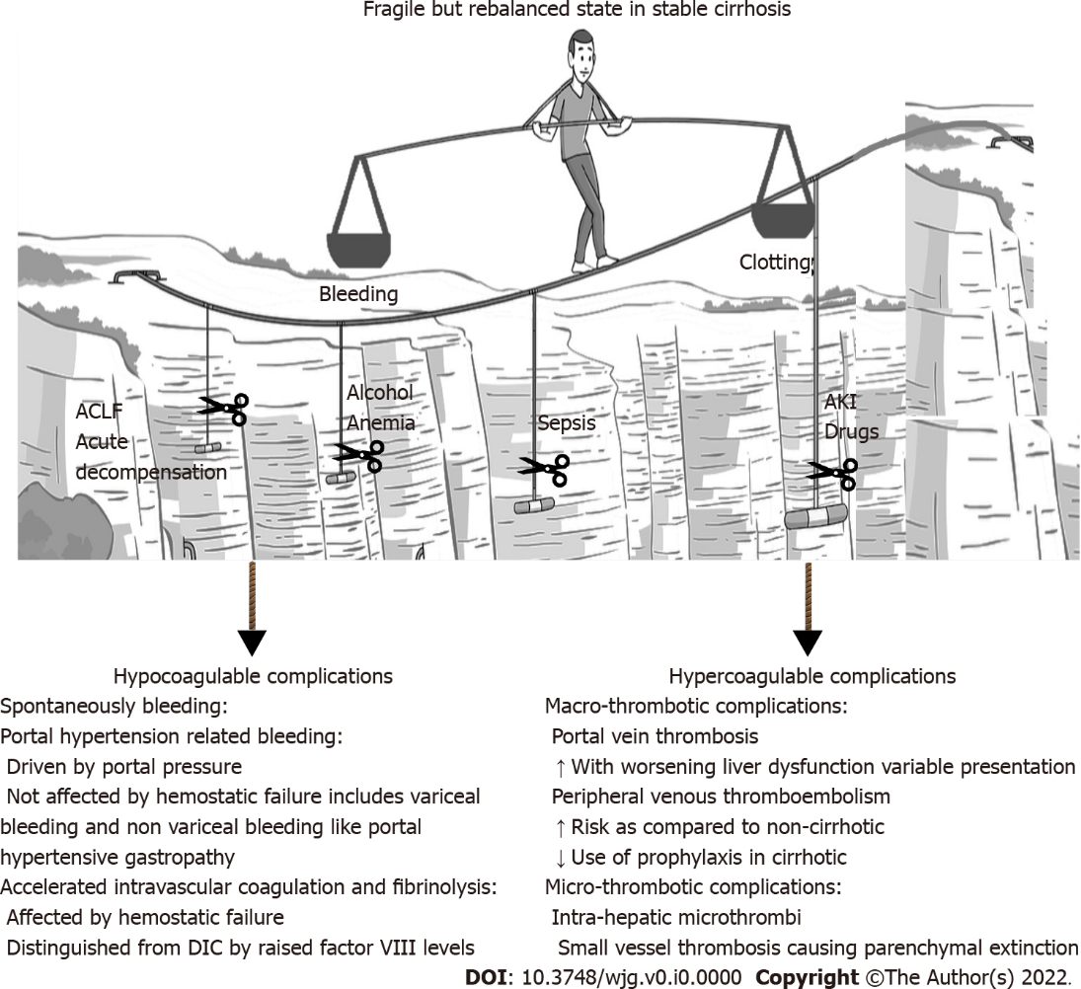
Figure 1 Rebalanced hemostasis in cirrhosis. ACLF: Acute-on-chronic liver failure; AKI: Acute kidney injury; DIC: Disseminated intravascular coagulation.

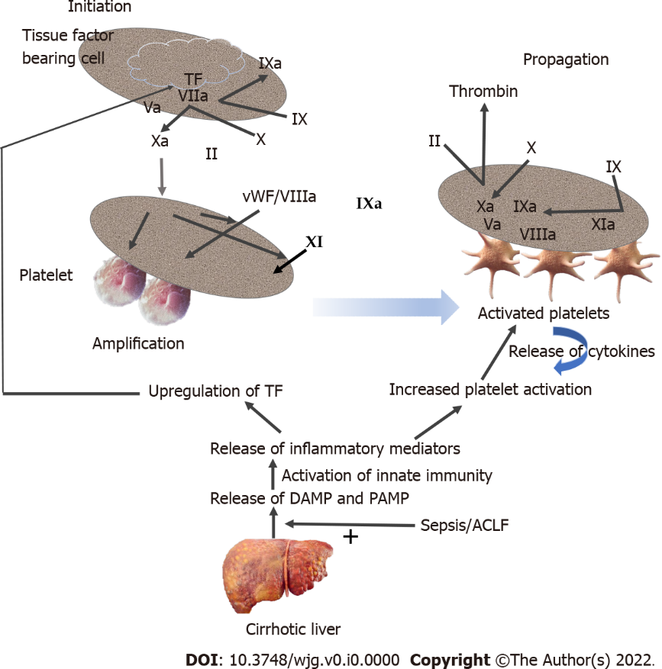
Figure 2 Dynamic coagulation profile in cirrhosis. ACLF: Acute-on-chronic liver failure; DAMP: Damage-associated molecular patterns; PAMP: Pathogen-associated molecular patterns; TF: Tissue factor.

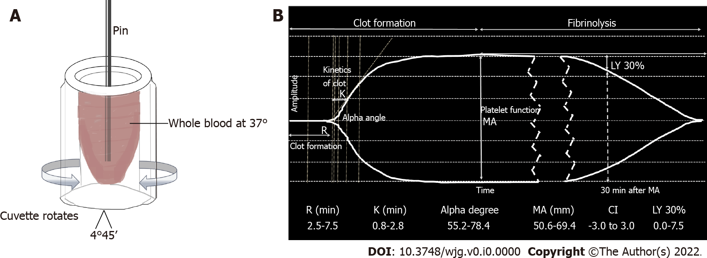
Figure 3 Basis and results of the thromboelastography. A: Basis of the thromboelastography (TEG) test; B: TEG tracing and relevant parameters (kaolin-activated). MA: Maximum amplitude.

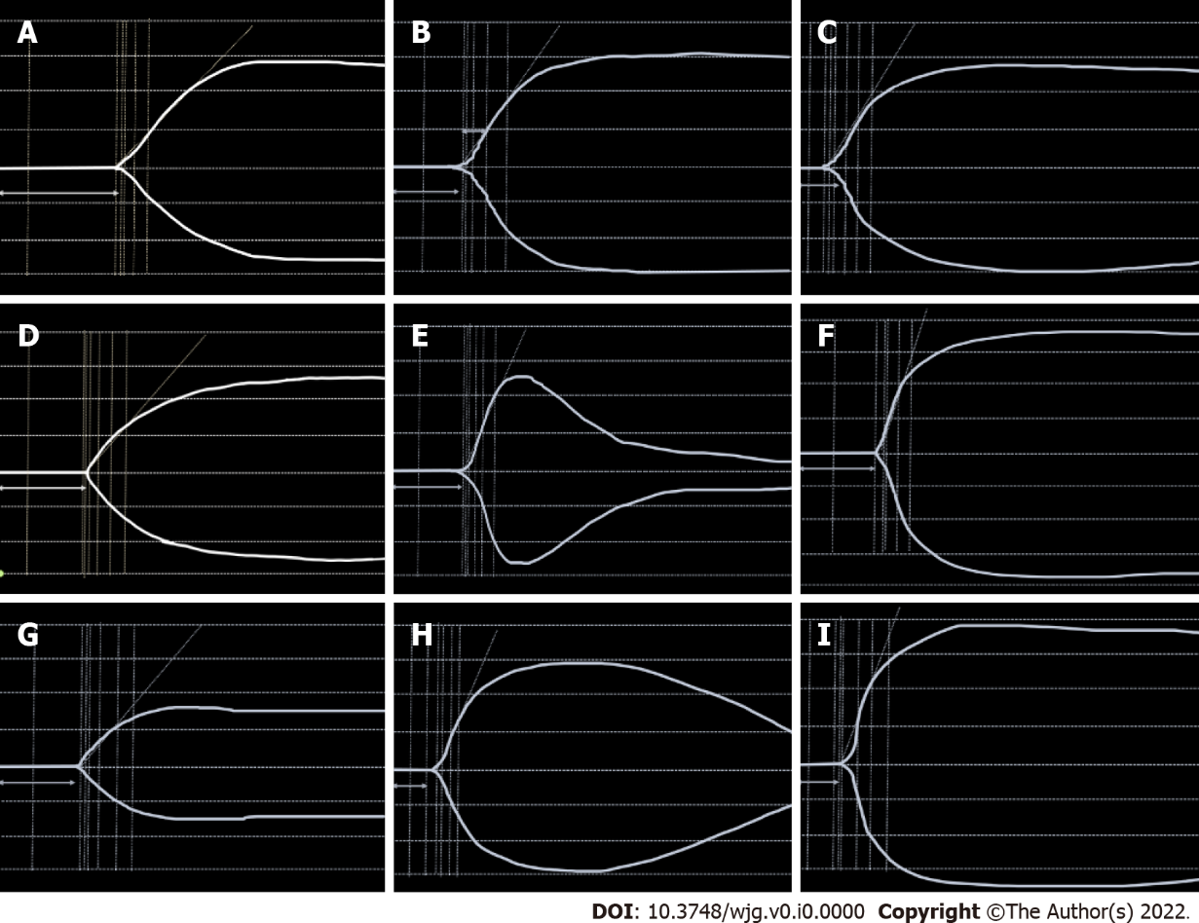
Figure 4 Tracing of thromboelastography in various clinical conditions. A: Low clotting factors; B: Normal trace; C: Enzymatic hypercoagulability; D: Low fibrinogen levels; E: Primary fibrinolysis; F: Platelet hypercoagulability; G: Low platelet function; H: Secondary fibrinolysis; I: Enzymatic and platelet hypercoagulability.

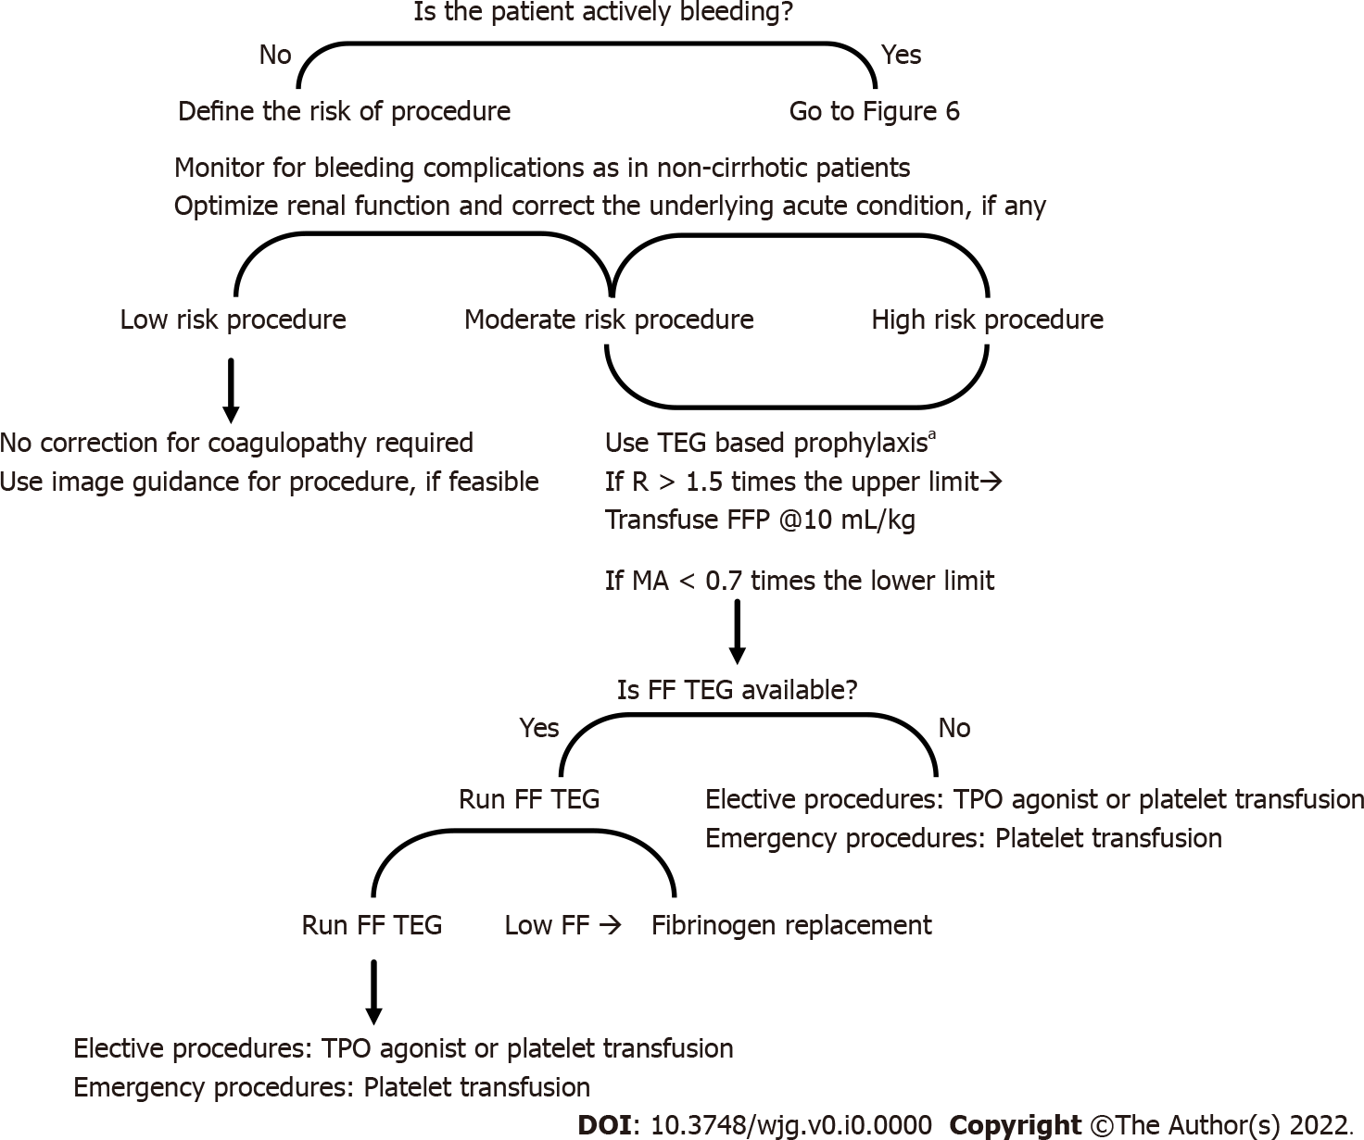
Figure 5 Algorithm for coagulation factor administration in the cirrhotic patient with coagulopathy undergoing an invasive procedure. FF: Functional fibrinogen; FFP: Fresh frozen plasma; MA: Maximum amplitude; TEG: Thromboelastography; TPO: Thrombopoietin.

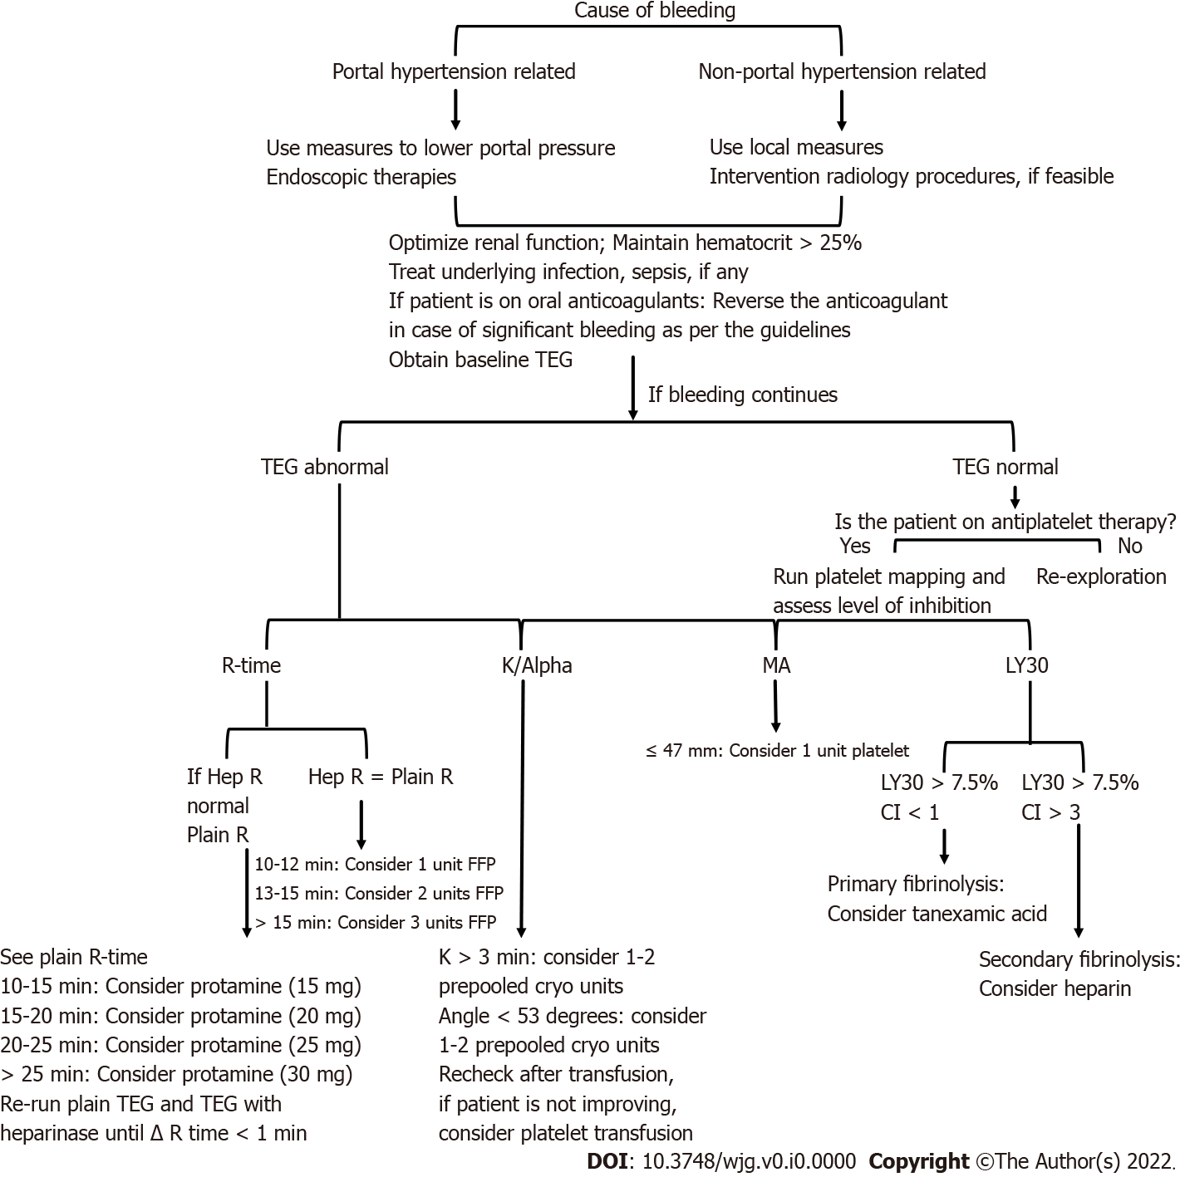
Figure 6 Algorithm for guiding blood product transfusion by thromboelastography. Cryo: Cryoprecipitate; FFP: Fresh frozen plasma; Hep R: Heparinase R-Time; MA: Maximum amplitude; TEG: Thromboelastography.

Table 1 Three phases of coagulation in liver disease
Hemostasis stage | Hypocoagulable state | Hypercoagulable state
Primary hemostasis: Platelet activation and interaction with injured endothelium | Thrombocytopenia: (1) Decreased amount: Splenic sequestration, decreased thrombopoietin levels, bone marrow suppression, autoantibody destruction; and (2) Poor function: Uremia, changes to the vessel wall phospholipid composition, anemia (Hgb < 7 g/dL), decreased margination | Low levels of ADAMTS-13; Increased levels of vWF; Increased number of activated platelets
Secondary hemostasis: Fibrin clot formation | Low levels of factors II, V, VII, IX, X, and XI; Low levels of fibrinogen; Vitamin K deficiency (malabsorption in cholestatic disorders) | Elevated levels of factor VIII; Decreased levels of proteins C and S; Decreased levels of antithrombin, and heparin cofactor II
Fibrinolysis | Accelerated intravascular coagulation and fibrinolysis: (1) Low levels of factor XIII and thrombin-activated fibrinolysis inhibitor; (2) Elevated levels of tPA; (3) Decreased level of α2-antiplasmin; and (4) Dysfibrinogenemia | Low plasminogen levels; Dysfibrinogenemia; High plasminogen activator inhibitor
Hgb: Hemoglobin; tPA: Tissue plasminogen activator; vWF: von Willebrand factor.
Table 2 Thromboelastography components and their clinical implications
Nomenclature | Definition | Function | Significance | Most closely related CCT
Reaction time or R-time | Time (min) to reach an amplitude of 2 mm | Clot initiation | Informs about enzymatic reaction leading to thrombin and fibrin generation. Increased R-time, factor deficiency or reduced function, resulting in hypocoagulability; Shortened R-time, factor hypercoagulability | PT and aPTT
K-time | Time (min) from 2-20 mm amplitude | Clot kinetics | Depicts rate of clot development–fibrin polymerization, cross-linking, and platelet interaction. Long K-time, hypocoagulability; Short K-time, hypercoagulability | Fibrinogen level and platelet count
Angle or α | Slope between R and K | Clot kinetics | Also depicts the kinetics of clot development. Low-angle, hypocoagulability; High-angle, hypercoagulability
MA | Highest level of amplitude achieved by the clot | Clot strength | Provides assessment of overall clot strength | Platelet count and fibrinogen levels
Coagulation index | Composite indicator of coagulation profile |  | A linear combination of the above parameters serving as a global view of the patient’s hemostatic profile. Increased in hypercoagulable states; Decreased in hypocoagulable states
LY30 | Degree of lysis (%) 30 min after MA is reached | Clot stability | Measure of fibrinolysis. Above normal LY30 suggests hyperfibrinolysis | No equivalent test
aPTT: Activated partial thromboplastin time; CCT: Conventional coagulation test; MA: Maximum amplitude; PT: Prothrombin time.

Table 3 Procedural bleeding risk in patients with cirrhosis
High-risk procedures | Intermediate-risk procedures | Lower-risk procedures
Intrabdominal/orthopedic/cardiac surgery | Percutaneous endoscopic gastrostomy | Paracentesis
Brain or spinal surgery | Percutaneous or transjugular liver biopsy | Thoracentesis
Intracranial catheter insertion | Transjugular intrahepatic portosystemic shunt | Central line placement
Endoscopic mucosal resection or endoscopic submucosal dissection | Endoscopy (e.g., percutaneous gastrostomy placement, cystogastrostomy, biliary sphincterotomy) | Endoscopy (e.g., diagnostic, variceal ligation, uncomplicated polypectomy)
Complicated polypectomy | Percutaneous biopsy of extra-hepatic organ or lesions | Cardiac catheterization
Natural orifice transluminal endoscopic surgery | Trans-arterial or percutaneous hepatocellular carcinoma therapies | Hepatic venous pressure gradient measurement
 | Lumbar puncture

Table 4 Various types of thromboelastography assays
TEG channel | Activator | Function
Native TEG | None | Theoretically most sensitive to subtle coagulopathic changes and hyperfibrinolysis
Conventional TEG | Kaolin | Activates clotting cascade to expedite results
Rapid TEG | Tissue factor + kaolin | Activates clotting cascade to expedite results
Functional fibrinogen TEG | Glycoprotein IIb/IIIa inhibitor | Inhibits platelets to isolate the contribution of fibrinogen
Heparinase TEG | Heparinase | Inhibits heparin; the presence of heparin (endogenous or exogenous) is suggested when this channel shows improved clotting compared to other channels
TEG: Thromboelastography.

Table 5 Thresholds for coagulation parameters prior to high-risk procedures in patients with cirrhosis
Parameters | EASL 2022 | ISTH 2021 | AASLD 2021 | AGA 2021
PT/INR | Against routine evaluation and correction | Against correction | Against correction | Against routine evaluation and correctionª
Platelet count | Against correction^{b} | Against correction^{b} | Against correction | Against routine evaluation and correctionª
Fibrinogen | Against routine correction | Against routine evaluation | Against correction | No specific recommendation
TEG | Against routine evaluation^{c} | Do not use routinely | Do not use routinely | No specific recommendation
ªIn case of severe coagulopathy, prophylactic blood transfusions should be considered on case-to-case basis by evaluating potential benefits and risks in consultation with a hematologist.
^{b}If the bleeding cannot be controlled by the local hemostasis method, administration of platelet concentrate or thrombopoietin receptor agonist can be considered if the platelet count is < 50000 × 10⁶/L.
^{c}May provide a baseline coagulation status and guide in the case of bleeding events.
AASLD: American Association for the Study of Liver Diseases; AGA: American Gastroenterological Association; EASL: European Association for the Study of the Liver; INR: International normalized ratio; ISTH: International Society on Thrombosis and Hemostasis; PT: Prothrombin time; TEG: Thromboelastography.

