Name of Journal: World Journal of Gastroenterology
Manuscript NO: 80836
Manuscript Type: ORIGINAL ARTICLE

Basic Study
Locked nucleic acid real-time polymerase chain reaction method identifying two polymorphisms of hepatitis B virus genotype C2 infections, rt269L and rt269I

Kim K et al. LNA-RT-PCR identifying rt269L and rt269I

Kijeong Kim, Yu-Min Choi, Dong Hyun Kim, Junghwa Jang, Won Hyeok Choe, Bum-Joon Kim

Kijeong Kim, Department of Microbiology, College of Medicine, Chung-Ang University, Seoul 06974, South Korea

Yu-Min Choi, Dong Hyun Kim, Junghwa Jang, Bum-Joon Kim, Department of Microbiology and Immunology, College of Medicine, Seoul National University, Seoul 03080, South Korea

Won Hyeok Choe, Department of Internal Medicine, Konkuk University School of Medicine, Seoul 05030, South Korea

Bum-Joon Kim, Department of Biomedical Sciences, College of Medicine, Seoul National University, Seoul 03080, South Korea

Bum-Joon Kim, Liver Research Institute, College of Medicine, Seoul National University, Seoul 03080, South Korea

Bum-Joon Kim, Seoul National University Medical Research Center, Seoul 03080, South Korea

Author contributions: Kim K and Kim BJ contributed to study conception and design, and designed and performed experiments; Choe WH contributed to collection of clinical data; Kim K, Choi YM, Kim DH, Jang J, Choe WH, and Kim BJ contributed to data acquisition, data analysis and interpretation; Kim K, Choi YM, Choe WH, and Kim BJ contributed to writing of article, editing, reviewing and final approval of article.

Supported by the National Research Foundation of Korea, No. 2022R1A2B5B01001421; and the Korea Health Technology R&D Project through the Korea Health Industry Development Institute, the Ministry of Health & Welfare, Republic of Korea, No. HI22C0476.

Corresponding author: Bum Joon Kim, PhD, Professor, Department of Microbiology and Immunology, College of Medicine, Seoul National University, 103 Daehak-ro, Jongno-gu, Seoul 03080, South Korea. kbumjoon@snu.ac.kr

Received: October 14, 2022
Revised: January 13, 2023
Accepted: February 27, 2023
Published online:

Abstract
BACKGROUND
The presence of two distinct hepatitis B virus (HBV) Pol RT polymorphisms, rt269L and rt269I, could contribute to the unique clinical or virological phenotype of HBV genotype C2. Therefore, a simple and sensitive method capable of identifying both types in chronic hepatitis B (CHB) patients infected with genotype C2 should be developed.

AIM
To develop a novel simple and sensitive locked nucleic acid (LNA)-real time-polymerase chain reaction (RT-PCR) method capable of identifying two rt269 types in CHB genotype C2 patients.

METHODS
We designed proper primer and probe sets for LNA-RT-PCR for the separation of rt269 types. Using synthesized DNAs of the wild type and variant forms, melting temperature analysis, detection sensitivity, and endpoint genotyping for LNA-RT-PCR were performed. The developed LNA-RT-PCR method was applied to a total of 94 CHB patients of genotype C2 for the identification of two rt269 polymorphisms, and these results were compared with those obtained by a direct sequencing protocol.

RESULTS
The LNA-RT-PCR method could identify two rt269L and rt269I polymorphisms of three genotypes, two rt269L types [‘L1’ (WT) and ‘L2’] and one rt269I type (‘I’) in single (63 samples, 72.4%) or mixed forms (24 samples, 27.6%) in 87 (92.6% sensitivity) of 94 samples from Korean CHB patients. When the results were compared with those obtained by the direct sequencing protocol, the LNA-RT-PCR method showed the same results in all but one of 87 positive detected samples (98.9% specificity).

CONCLUSION
The newly developed LNA-RT-PCR method could identify two rt269 polymorphisms, rt269L and rt269I, in CHB patients with genotype C2 infections. This method could be effectively used for the understanding of disease progression in genotype C2 endemic areas.

Key Words: Hepatitis B virus; Genotype C2; Polymerase; rt269; Locked nucleic acid-real time-polymerase chain reaction; Chronic hepatitis B

Kim K, Choi YM, Kim DH, Jang J, Choe WH, Kim BJ. Locked nucleic acid real-time polymerase chain reaction method identifying two polymorphisms of hepatitis B virus genotype C2 infections, rt269L and rt269I. World J Gastroenterol 2023; In press

Core Tip: Hepatitis B virus (HBV) genotype C2 infections have distinct clinical or virological traits, including a higher risk of hepatocellular carcinoma, lower response rate to interferon or prolonged hepatitis B e antigen-positive phase. We recently reported that the presence of two HBV Pol RT polymorphisms, rt269L and rt269I, contributed to unique traits of HBV genotype C2. Here, instead of time- or labor-consuming direct sequencing, we developed a new locked nucleic acid (LNA)-real time-polymerase chain reaction (RT-PCR) method for the separation between rt269L (L1 and L2) and I type from Korean chronic hepatitis B patients of genotype C2. The newly developed LNA-RT-PCR could be effectively used for the understanding of epidemiology and disease progression in genotype C2 endemic areas.

INTRODUCTION
Although vaccines and therapeutic agents are currently available against hepatitis B virus (HBV), HBV infection is still a high-risk global health issue. More than 350 million people are chronically infected, and approximately 786000 patients die annually worldwide due to HBV-related diseases, including cirrhosis and hepatocellular carcinoma (HCC)^{[1,2]}.
HBV belongs into hepadnaviridae and is an enveloped and partially double-stranded DNA virus. Its genome is approximately 3.2 kb in length and contains 4 overlapping open reading frames: Surface antigens (S), core proteins (C), polymerase (Pol), and X proteins (X)^{[3]}. The HBV reverse transcriptase can lead to HBV mutations of higher frequency than that of other DNA viruses due to its lack of proofreading ability^{[4,5]}. This results in the failure of antiviral therapy with nucleos(t)ide analogs and liver disease progression via persistent infections^{[5-9]}. According to the criteria of an 8% divergence in HBV genome sequences, HBV has been grouped into 10 genotypes as A-J^{[10-12]}. A number of studies on HBV genotypes have reported that they play significant roles in the development of different disease profiles during chronic hepatitis B (CHB) infection as well as distinct geographic and ethnic distributions^{[13,14]}. Of note, genotype C, particularly C2, vs genotype B showed a higher HBV replication capacity and higher tendency of chronicity and more frequently developed into liver cirrhosis (LC) and HCC in CHB patients of HBV endemic Asian nations, such as China, Japan and South Korea^{[11,15-19]}. In addition, incomplete response to interferon (IFN) therapy and higher levels of mutations were also reported in genotype C2 infections^{[18,20-22]}. However, thus far, which factor can explain several distinct characteristics in clinical and virological aspects found in genotype C2 infections remains elusive.
As one likely answer to this issue, we have recently reported that the presence of two HBV Pol RT polymorphisms, rt269L and rt269I, that are found only in HBV genotype C could affect viral phenotypes and clinical outcomes and cause worse responses to IFN therapy in genotype C2 infections. In particular, we showed that the wild rt269L type infection that is distinct in genotype C vs the rt269I type is more strongly related to higher HBV replication and hepatitis B e antigen (HBeAg) positive serostatus, which are two distinct traits of genotype C infections^{[23-25]}. This suggests that the presence of RT polymorphisms, particularly the wild rt269L type, could at least partly contribute into clinical or virological traits that are distinct in genotype C infections. However, our previous study has limitations in exploring the distribution of rt269 polymorphisms in CHB patients due to use of a conventional nested polymerase chain reaction (PCR) based direct sequencing protocol, which could underestimate genuine HBV quasispecies in patient sera^{[23]}. A locked nucleic acid (LNA) is a nucleic acid analog containing a methylene bridge that connects the 2’-oxygen of ribose with the 4’-carbon^{[26,27]}. The real time PCR method using a LNA-based probe capable of improving the hybridization affinity for complementary sequences shows strong mismatch discriminatory power^{[28,29]}. Therefore, without the application of nested PCR, it could discriminate HBV mutations from CHB patients with high sensitivity and specificity.
Therefore, in this study, for the first time, we sought to develop a novel simple and sensitive locked nucleotide probe (LNA probe)-based RT-PCR (LNA-RT-PCR) method that is capable of separating two different rt269 polymorphisms, the wild-type rt269L (CTC/A) and rt269I type (ATC), in CHB patients of genotype C2.

MATERIALS AND METHODS
Patient sera, HBV DNA extraction and genotyping
For this study, serum samples from 94 patients who visited Seoul National University Hospital (2005-2007), met the inclusion criteria of hepatitis B surface antigen (HBsAg) positivity and HBV DNA positivity (for more than 6 mo), and were lamivudine, adefovir dipivoxil, entecavir, telbivudine, tumor necrosis factor, and peg-IFN treatment-naïve were used. All patients had negative tests for hepatitis C virus, human immunodeficiency virus and markers for coexisting autoimmune liver disease and did not have an alcohol or drug addiction. HBV DNA was extracted from 200 μL of serum samples using the QIAamp DNA Blood Mini Kit (QIAGEN Inc, Hilden, Germany). To analyze the genotyping, a nested PCR-based sequencing protocol targeting partial HBsAg sequences was used as previously described^{[30]}. This study was approved by Seoul National University Hospital (IRB-1012-131-346).

Synthesis of positive control DNAs for variants at the HBV rt269 codon
We prepared six positive control DNAs for L1 [CTC, wild type (WT)] and the variants I (ATC) and L2 (CTA) at the HBV rtL269I locus. The DNAs were synthesized based on the HBV C2 polymerase sequence by Integrated DNA Technologies, Inc. They were 473 bp long and included the three variant sequences, with one of the ‘A/G’ polymorphisms near the variant sequence (Figure 1, Supplementary Table 1). These were used for the development of the methods for the application of LNA real-time PCR to a rapid differential and quantitative identification of the WT and variants. We used these DNAs to intentionally mix DNA templates with WT control DNA and variant control DNA in different ratios in a range of amounts to mimic clinical samples. We also used positive controls for melting temperature (T_{m}) analysis, detection sensitivity, and endpoint genotyping and for the construction of quantification standard graphs for LNA-RT-PCR to estimate the quantity of HBV WT and variant DNA in clinical samples.

Primer and LNA probe design
Primers were designed using LightCycler Probe Design Software 2.0 (LC PDS 2.0) Version 1.0.R.36 (Roche). The primers were designed to have high melting temperatures (> 65 °C) and to be highly conserved in the target DNA region of HBV. We used LC PDS (version 2.0) software for the probe design and referred to the design guidelines of the LNA manufacturer (Integrated DNA Technologies). The potential presence of cross-complementarities among all the primers and LNA probes was checked by using LC PDS 2.0 software. The LNA probes were purchased from Integrated DNA Technologies, and primers were purchased from Macrogen.

RT-PCR
A LightCycler Version 96 system (Roche) was used for LNA-RT-PCR, and three channels were used for the experiment. An optimal reaction mixture was established for the sensitive and specific detection of target sequences. A 10-μL reaction mixture was prepared for each sample as follows: 1 μL PCR buffer for Taq (Ex Taq HS, Takara), 2 mmol/L MgCl₂, 0.2 mmol/L deoxynucleoside triphosphate mixture (Takara), 0.2 μM forward primer, 0.8 μM reverse primer, 0.4 μM LNA FAM probe (L_CTC), 0.4 μM LNA Hex probe (I_ATC), 0.2 μM LNA Cy5 probe (L2_CTA), 0.25 u Ex Taq HS (Takara), 1 mg/mL bovine serum albumin (Ambion, ThermoFisher), 2 μL template DNA, and PCR-grade water (Roche). The cycling conditions were as follows, with default ramping speed rates if not specified: 60 s at 95 °C; four cycles of 10 s at 95 °C, 10 s at 58 °C, and 25 s at 72 °C with a 2.2 °C/s ramp; 46 cycles of 10 s at 95 °C, 10 s at 58 °C (with a single fluorescence acquisition), 25 s at 72 °C with a 2.2 °C/s ramp, and melting-curve analysis with 10 s at 95 °C, 60 s at 53 °C, and 1 s at 80 °C with a 0.08 °C/s ramp under continuous fluorescence acquisition at a rate of 4 readings/°C.

Identification of the WT and variant forms
Identification of the WT and variant forms ‘I’ and ‘L2’ at the rt269 codon in a sample was performed based on the three different LNA probe-specific T_{m} measurements at their own specified channels. To establish the diagnostic T_{m} range for the WT and variant forms, the control DNAs of the WT form, the variant forms and their mixtures at a variety of ratios were tested to observe melting peak formation and measure the specific T_{m} values for the WT and variant forms.

Construction of standard quantification curves
Six types of standard quantification curves for the WT and variant forms were generated with known amounts of positive control DNAs for their application to the estimation of the amount of the target DNAs in unknown samples. The standard curves were produced by duplicate LNA real-time PCR for each target DNA with known amounts (4.0E + 08 to 4.0E + 01 copies) of control DNAs. The R² correlation for all the standard curves was greater than 0.99. The limit of detection and limit of quantification of the WT and variant forms were determined among the series of diluted copies. These standard curves were applied to the quantification of DNA samples in a pure form and dominant type of variants in a mixed form.

Construction of standard genotyping plots to determine a dominant type in a mixture sample
To determine a dominant type of rtL269I variant in a mixture of a sample, standard genotyping plots were constructed using LNA real-time PCR with positive control DNA mixture sets in various ratios and the endpoint genotyping tool of LC 96 system software. These plots were based on the endpoint fluorescence (EPF) values at the two channels for comparison. These plots were applied to determine the dominant type in the clinical samples (Figure 2).

Application of LNA-RT-PCR to clinical samples
The DNA of a total of 94 human sera was tested for the identification of the WT and ‘I’ and ‘L2’ variant forms of the HBV RT gene by LNA-RT-PCR. The quantification cycle (Cq), EPF, and T_{m} produced by the WT- and variant-targeting LNA probes with sample DNA were measured. Identification of the WT and variant forms was determined by comparing their T_{m} values obtained from their specific channel (FAM for WT, Hex for ‘I’, and Cy5 for ‘L2’) with their diagnostic T_{m} ranges obtained from standard assays.

Comparison of LNA-RT-PCR and direct sequencing for identification of WT and variant DNA
A total of 94 clinical samples were tested for the comparison of the LNA-RT-PCR method and directing sequencing method in the accurate identification of the rt269 variant and WT DNA. Direct sequencing was performed using the same primer sets producing the 128-bp LNA-RT-PCR amplicon.

RESULTS
Primer and probe design for LNA-based RT-PCR
First, we investigated the full-length HBV reverse transcriptase sequences from 131 treatment-naïve Korean patients chronically infected with HBV genotype C2 (GenBank No CH patients (GenBank Nos: KX264864-KX264922) and HCC patients (GenBank Nos: KX264792-KX264863)^{[30]}. SeqMan II software Version 5.03 (DNASTAR) was used to search for appropriate primer sequences for LNA-based RT-PCR that are highly conserved to first obtain the shortest possible amplification product of the rt269 codon for efficient PCR (Figure 1).
We found three distinct sequence types in the rt269 codon from 131 patients, two types in rt269L, CTC (designated L1) and CTA (designated L2), and one rt269I type, ATC (designated I). Therefore, we designed three different LNA probes for specific simultaneous detection in a single reaction of the ‘L’ (WT), ‘I’, and ‘L2’ variants of HBV. The sequences of primers and LNA probes are shown in Table 1 and Figure 1.

Determination of the diagnostic T_{m} range for the identification of the WT and variant forms
Identification of the three sequence types, “L1”, “I” and “L2”, was accomplished by LNA-RT-PCR melting curve analysis by observation of their melting peak formation and their specific T_{m} measurement at their specified channel (Table 2, Figure 3). LNA-RT-PCR with samples of WT control DNA (n = 68) in amounts ranging from 4.0E + 00 to 4.0E + 08 copies resulted in a 100% positive detection rate and 100% specificity. A distinct melting peak formation at the FAM channel in all the tested WT control DNA samples with T_{m}s of 62.4 ± 0.4 °C for ‘L’ and 58.0 ± 0.2 °C for ‘L'’ was observed, but no significant melting peak formation at the other channels (Hex and Cy5) was observed. LNA-RT-PCR with samples of the ‘I’ positive control DNA (n = 76) also resulted in a 100% positive detection rate and 100% specificity. A distinct melting peak formation in the Hex channel, 60.2 ± 0.7 °C for ‘I’ and 56.6 ± 0.2 °C for ‘I'’, was observed, but no significant melting peak formation in the other channels (FAM and Cy5) was observed. LNA-RT-PCR with samples of the ‘L2’ positive control DNA (n = 52) also resulted in a 100% positive detection rate and 100% specificity. A distinct melting peak formation at the Cy5 channel, 64.6 ± 0.1 °C for ‘L2’ and 61.2 ± 0.2 °C for ‘L2'’, was observed, but no significant melting peak formation at the other channels (FAM and Hex) was observed.
LNA-RT-PCR with samples (n = 320) of the ‘L’ WT positive control DNA plus ‘I’ control DNA or ‘L2’ plus ‘I’, mixed in different ratios (1:1, 1:2, 1:4, 1:8, 2:1, 4:1, and 8:1) in amounts ranging from 4.0E + 01 to 4.0E + 08 copies resulted in a nearly 100% positive detection rate (only three samples undetected in the smallest amount of DNA) for both the variant and WT DNA. A distinct melting peak formation at the FAM, Hex, and Cy5 channels in all the mixed DNA samples with detectable T_{m}s was observed. The measured T_{m}s were shifted slightly downward from the range of the T_{m}s measured only with nonmixed DNAs, as shown in Table 1. These slight changes did not affect the identification of the sequence types in the samples.

Application of LNA-RT-PCR to clinical samples and comparison with the results of the direct sequencing protocol
Of the 94 clinical samples tested by our LNA-RT-PCR method, 87 samples (92.6% sensitivity) were positively identified as ‘L1’ (WT), ‘I’, and ‘L2’ variants in single or mixed forms. Among the positively identified samples (n = 87), all samples produced a distinct melting peak or peaks with a T_{m} or T_{m}s within the diagnostic T_{m} range for the WT form “L1” or the two variant forms “I” and “L2”. Of the 87 positively detected samples, 63 (72.4%) and 24 samples (27.6%) were identified either singly or in a mixed manner, respectively. Of the 63 samples identified singly, the prevalence of the ‘L1’ type, ‘I’ type and ‘L2’ type was 82.5% (n = 52), 12.7% (n = 8) and 4.8% (n = 3), respectively (Table 3). Of the 24 mixed form samples (27.6%), the prevalence of samples with almost the same ratio of L1 and I (codominant cases) was 29.2% (n = 7). The prevalence of L1 (L1 + I or L1 + L2) and I dominant (L1 + I) cases was 54.2% (n = 13) and 16.7% (n = 4), respectively. Given that the dominant cases included the respective exclusive cases, of the 87 positively detected samples, the prevalence of L, I and coinfection with L and I was 78.2% [n = 68, L1(65) + L2(3)], 13.8% (n = 12), and 8.0% (n = 7), respectively. PCR direct sequencing using the same primer set used in the LNA-RT-PCR method enabled the successful separation between the L1, L2 and I sequence types in all 94 clinical samples (100% sensitivity). Comparison between results obtained by both direct sequencing and LNA-RT-PCR protocols showed that of the 87 samples identified by LNA-RT-PCR, all (86 samples, 98.9% specificity) but one sample (SNU3-479) produced completely identical results between the two protocols (Figure 4). A mismatched sample was identified as I dominant (L1:I = 1:4) by LNA and exclusive I type by the direct sequencing protocol. The distinct results between both protocols may be due to the difference in sensitivity between the protocols. All seven samples not detected by the LNA-RT-PCR method were demonstrated to have mutations in their respective probe binding sequences by a direct sequencing protocol, which could interfere with normal LNA-RT-PCR (Table 4).

DISCUSSION
LNA-based RT-PCR assays have been widely applied to viral single-nucleotide polymorphism analysis as well as simple viral detection in clinical settings instead of the less sensitive traditional RT-PCR or nested RT-PCR assays prone that are to cross-contamination^{[31,32]}. In particular, it has recently been reported that this method could successfully identify YMDD mutations of HBV from Korean patients with chronic HBV infections^{[30,33]}. In the present study, we developed an LNA-RT-PCR assay using melting curve analysis for the identification of two polymorphisms within codon 269 of HBV Pol, rt269L and rt269I (three genotypes, rt269L1, rt269L2 and rt269I), with the advantages of easy performance and a low likelihood of cross-contamination. The clinical application of the LNA-RT-PCR assay was also compared in parallel with a direct sequencing protocol using clinical samples. Our data showed that the LNA-RT-PCR assay can separate the two polymorphisms in the rt269 codon of HBV Pol in clinical specimens with high sensitivity (92.6%, 87/94 samples) and specificity (98.9%, 86/87 samples) (Table 3). Of note, this assay can determine an almost exact ratio between two types within specimens from mixed cases (23/24 cases), suggesting its feasibility in the analysis of quasispecies distribution in mixed samples (Table 3, Figure 4).
Our LNA-based RT-PCR assays showed that the WT ‘L1’ type (n = 65, 74.7%) was found at the highest frequency in our cohort, followed by the ‘I’ type (n = 12, 13.8%) and ‘L2’ type (n = 3, 3.4%) (Table 3). This finding suggests that the ‘L1’ type is responsible for the majority of HBV infections in South Korea and that the WT form is prevalent in genotype C2 infections. Additionally, these findings suggest that the I type may be a variant of L1 rather than an independent polymorphism. Indeed, our previous study based on a direct sequencing protocol also showed that the ‘L1’ type vs the ‘I’ type is more closely related to higher HBV replication, higher HBsAg levels and HBeAg positive serostatus^{[23]}, suggesting that the majority of the ‘L1’ type infections in our cohort may be due to its enhanced viral infectivity. Therefore, it is tempting to speculate that the ‘L1’ type uniquely found in genotype C2 infections may contribute to some distinct traits of the genotype C2 infections, including an enhanced duration of the HBeAg-positive stage^{[34-36]}, higher infectivity^{[37,38]} and a higher prevalence of occult infection via vertical transmission^{[33,39,40]}. Since our LNA-based RT-PCR assays can identify L1 of higher infectivity and other variants (L2 or I type) related to disease progression from large serum samples without time-consuming or labor intensive sequencing procedures, it could help in the management or treatment of chronic patients in genotype C2 endemic nations, including China, Japan and South Korea.
In 7 (7.4%) of the 94 samples, despite successful amplification, our LNA-based RT-PCR assays failed to separate the two polymorphisms in the rt269 codon (Table 4). Comparison with the direct sequencing protocol revealed that all seven samples amplified but not identified by LNA-based RT-PCR assays had one more mismatch mutation that was different from the probe binding sequences. This was enough to interfere with normal detection due to the lower meting temperature than the respective probe. Therefore, in the samples amplified but not identified by our LNA-based RT-PCR assays, a further direct sequencing protocol should be recommended for the identification of the two polymorphisms.
A total of 24 (27.6%) of the 87 positively detected samples were identified in a mixed manner, and L1, in most cases of mixed infections, was dominant or codominant over I or L2. These findings further support our hypothesis that I or L2 may be a variant of the L1 type rather than an independent polymorphism. However, to clarify whether mixed infection in a patient is due to simple mutation of L1 to L2 or I type or superinfection of another type, further quasispecies analysis should be investigated in the future.
The limitation of this study is that all the samples included were obtained from patients at the initial stage of drug use and are from one medical institution. To determine the exact clinical significance of L1, L2 and I infections or mixed infections in genotype C2-infected chronic patients, our LNA-based RT-PCR assays should be applied to a larger population-based cohort of multicenter registries in future studies.

CONCLUSION
In conclusion, our data showed that the LNA-RT-PCR method developed in this study can successfully identify two different polymorphisms, rt269L (L1 and L2) and rt269I, in the rt269 codon of HBV Pol from CHB patients with genotype C2 infections. The wildtype ‘L1’ form is more prevalent than the rt269I form in Korean CHB patients with genotype C2 infections, which is possibly due to its higher infectivity. Therefore, our LNA-RT-PCR method enables the separation of rt269 types and could be effectively used for a deeper understanding of epidemiology and disease progression in genotype C2 endemic areas.

ARTICLE HIGHLIGHTS
Research background
Hepatitis B virus (HBV) genotype C infections has distinct clinical or virological traits including higher risk of hepatocellular carcinoma, lower response rate to interferon or prolonged hepatitis B e antigen-positive phase. As a likely answer to this issue, we have recently reported that the presence of two HBV Pol RT polymorphisms, rt269L and rt269I could contribute to unique traits of HBV genotype C.

Research motivation
For the identification between two rt269 types from chronic patients of genotype C2 endemic areas instead of time or labor consuming direct sequencing protocol, we sought to develop a novel simple and sensitive locked nucleotide probe based real-time polymerase chain reaction (LNA-RT-PCR) method capable of separating two rt269 types, rt269L type encoding leucine, ‘L’ (L1: CTC, L2: CTA) and rt269I type encoding isoleucine (ATC) from chronic hepatitis B (CHB) genotype C2 patients.

Research objectives
To develop a novel simple and sensitive LNA-RT-PCR method capable of identifying two rt269 types in CHB genotype C2 patients.

Research methods
We designed appropriate primer and probe sets for LNA-RT-PCR for the separation of rt269 types. The developed LNA-RT-PCR method was applied to a total of 94 CHB patients of genotype C2 for the identification of two rt269 polymorphisms, and these results were compared with those obtained by a direct sequencing protocol.

Research results
The LNA-RT-PCR method could identify two rt269L and rt269I polymorphisms of three genotypes, two rt269L types [‘L1’ (WT) and ‘L2’] and one rt269I type (‘I’) in single (63 samples, 72.4%) or mixed forms (24 samples, 27.6%) in 87 (92.6% sensitivity) of 94 samples from Korean CHB patients.

Research conclusions
The newly developed LNA-RT-PCR method could identify two rt269 polymorphisms, rt269L and rt269I, in CHB patients with genotype C2 infections. This method could be effectively used for the understanding of disease progression in genotype C2 endemic areas.

Research perspectives
The newly developed LNA-RT-PCR method could identify three rt269 types, L1, L2 and I from CHB patients of genotype C2 with high-sensitivity and specificity. It could play a relevant role in the clinical management of CHB patients of genotype C2 infection.

REFERENCES
1 Nannini P, Sokal EM. Hepatitis B: changing epidemiology and interventions. Arch Dis Child 2017; 102: 676-680 [PMID: 27986700 DOI: 10.1136/archdischild-2016-312043]
2 Abara WE, Qaseem A, Schillie S, McMahon BJ, Harris AM; High Value Care Task Force of the American College of Physicians and the Centers for Disease Control and Prevention, Abraham GM, Centor R, DeLong DM, Gantzer HE, Horwitch CA, Humphrey LL, Jokela JA, Li JMW, Lohr RH, López AM, McLean RM. Hepatitis B Vaccination, Screening, and Linkage to Care: Best Practice Advice From the American College of Physicians and the Centers for Disease Control and Prevention. Ann Intern Med 2017; 167: 794-804 [PMID: 29159414 DOI: 10.7326/M17-1106]
3 Yuen MF, Chen DS, Dusheiko GM, Janssen HLA, Lau DTY, Locarnini SA, Peters MG, Lai CL. Hepatitis B virus infection. Nat Rev Dis Primers 2018; 4: 18035 [PMID: 29877316 DOI: 10.1038/nrdp.2018.35]
4 Liang TJ. Hepatitis B: the virus and disease. Hepatology 2009; 49: S13-S21 [PMID: 19399811 DOI: 10.1002/hep.22881]
5 Fu Y, Wu S, Hu Y, Chen T, Zeng Y, Liu C, Ou Q. Mutational characterization of HBV reverse transcriptase gene and the genotype-phenotype correlation of antiviral resistance among Chinese chronic hepatitis B patients. Emerg Microbes Infect 2020; 9: 2381-2393 [PMID: 33124952 DOI: 10.1080/22221751.2020.1835446]
6 Wang J, Liu J, Yu Q, Jin L, Yao N, Yang Y, Yan T, Hu C, He Y, Zhao Y, Chen T, Zheng J. High Prevalence of Preexisting HBV Polymerase Mutations in Pregnant Women Does Not Limit the Antiviral Therapy Efficacy. Can J Infect Dis Med Microbiol 2021; 2021: 6653546 [PMID: 33986897 DOI: 10.1155/2021/6653546]
7 Choi YM, Lee SY, Kim BJ. Naturally occurring hepatitis B virus reverse transcriptase mutations related to potential antiviral drug resistance and liver disease progression. World J Gastroenterol 2018; 24: 1708-1724 [PMID: 29713126 DOI: 10.3748/wjg.v24.i16.1708]
8 Peck KM, Lauring AS. Complexities of Viral Mutation Rates. J Virol 2018; 92 [PMID: 29720522 DOI: 10.1128/JVI.01031-17]
9 Al-Sadeq DW, Taleb SA, Zaied RE, Fahad SM, Smatti MK, Rizeq BR, Al Thani AA, Yassine HM, Nasrallah GK. Hepatitis B Virus Molecular Epidemiology, Host-Virus Interaction, Coinfection, and Laboratory Diagnosis in the MENA Region: An Update. Pathogens 2019; 8 [PMID: 31083509 DOI: 10.3390/pathogens8020063]
10 Kurbanov F, Tanaka Y, Mizokami M. Geographical and genetic diversity of the human hepatitis B virus. Hepatol Res 2010; 40: 14-30 [PMID: 20156297 DOI: 10.1111/j.1872-034X.2009.00601.x]
11 Sunbul M. Hepatitis B virus genotypes: global distribution and clinical importance. World J Gastroenterol 2014; 20: 5427-5434 [PMID: 24833873 DOI: 10.3748/wjg.v20.i18.5427]
12 Yin Y, He K, Wu B, Xu M, Du L, Liu W, Liao P, Liu Y, He M. A systematic genotype and subgenotype re-ranking of hepatitis B virus under a novel classification standard. Heliyon 2019; 5: e02556 [PMID: 31687483 DOI: 10.1016/j.heliyon.2019.e02556]
13 Lin CL, Kao JH. Hepatitis B virus genotypes and variants. Cold Spring Harb Perspect Med 2015; 5: a021436 [PMID: 25934462 DOI: 10.1101/cshperspect.a021436]
14 Guettouche T, Hnatyszyn HJ. Chronic hepatitis B and viral genotype: the clinical significance of determining HBV genotypes. Antivir Ther 2005; 10: 593-604 [PMID: 16152753]
15 Jeong H, Kim DH, Choi YM, Choi H, Kim D, Kim BJ. rt269I Type of Hepatitis B Virus (HBV) Polymerase versus rt269L Is More Prone to Mutations within HBV Genome in Chronic Patients Infected with Genotype C2: Evidence from Analysis of Full HBV Genotype C2 Genome. Microorganisms 2021; 9 [PMID: 33803998 DOI: 10.3390/microorganisms9030601]
16 Ginzberg D, Wong RJ, Gish RG. Hepatitis B virus diagnostics: anything new? In: Foster GR, Reddy KR. Clinical Dilemmas in Viral Liver Disease. London: John Wiley & Sons, 2020: 220-230
17 McMahon BJ, Nolen LD, Snowball M, Homan C, Negus S, Roik E, Spradling PR, Bruden D. HBV Genotype: A Significant Risk Factor in Determining Which Patients With Chronic HBV Infection Should Undergo Surveillance for HCC: The Hepatitis B Alaska Study. Hepatology 2021; 74: 2965-2973 [PMID: 34292609 DOI: 10.1002/hep.32065]
18 Lin CL, Kao JH. Natural history of acute and chronic hepatitis B: The role of HBV genotypes and mutants. Best Pract Res Clin Gastroenterol 2017; 31: 249-255 [PMID: 28774406 DOI: 10.1016/j.bpg.2017.04.010]
19 An P, Xu J, Yu Y, Winkler CA. Host and Viral Genetic Variation in HBV-Related Hepatocellular Carcinoma. Front Genet 2018; 9: 261 [PMID: 30073017 DOI: 10.3389/fgene.2018.00261]
20 Kim H, Lee SA, Kim BJ. X region mutations of hepatitis B virus related to clinical severity. World J Gastroenterol 2016; 22: 5467-5478 [PMID: 27350725 DOI: 10.3748/wjg.v22.i24.5467]
21 Jiang S, Wang X, Chen K, Yang P. Establishment of an inducible cell line for Hepatitis B virus genotype C2 and its pharmacological responses to interferons. Pharmacol Res 2022; 178: 106142 [PMID: 35218895 DOI: 10.1016/j.phrs.2022.106142]
22 Chen H, Sun J, Zhou B, Xie Q, Liang X, Fan R, Conran C, Xu J, Ji Y, Zhang X, Sun L, Jia J, Wang G, Hou J, Jiang DK. Variants in STAT4 Associated With Cure of Chronic HBV Infection in HBeAg-positive Patients Treated With Pegylated Interferon-alpha. Clin Gastroenterol Hepatol 2020; 18: 196-204.e8 [PMID: 31042581 DOI: 10.1016/j.cgh.2019.04.044]
23 Lee SY, Choi YM, Oh SJ, Yang SB, Lee J, Choe WH, Kook YH, Kim BJ. rt269I Type of Hepatitis B Virus (HBV) Leads to HBV e Antigen Negative Infections and Liver Disease Progression via Mitochondrial Stress Mediated Type I Interferon Production in Chronic Patients With Genotype C Infections. Front Immunol 2019; 10: 1735 [PMID: 31402915 DOI: 10.3389/fimmu.2019.01735]
24 Tai CS, Wu JF, Chen HL, Ni YH, Hsu HY, Chang MH. The Impact of Hepatitis B Vaccine Failure on Long-term Natural Course of Chronic Hepatitis B Virus Infection in Hepatitis B e Antigen-Seropositive Children. J Infect Dis 2017; 216: 662-669 [PMID: 28934424 DOI: 10.1093/infdis/jix339]
25 Yang HC. Viral Factors Affecting Disease Progression. In: Hepatitis B Virus and Liver Disease. Switzerland: Springer, 2018: 119-133
26 Ishige T, Itoga S, Matsushita K. Locked Nucleic Acid Technology for Highly Sensitive Detection of Somatic Mutations in Cancer. Adv Clin Chem 2018; 83: 53-72 [PMID: 29304903 DOI: 10.1016/bs.acc.2017.10.002]
27 Braasch DA, Corey DR. Locked nucleic acid (LNA): fine-tuning the recognition of DNA and RNA. Chem Biol 2001; 8: 1-7 [PMID: 11182314 DOI: 10.1016/s1074-5521(00)00058-2]
28 Ugozzoli LA, Latorra D, Puckett R, Arar K, Hamby K. Real-time genotyping with oligonucleotide probes containing locked nucleic acids. Anal Biochem 2004; 324: 143-152 [PMID: 14654057 DOI: 10.1016/j.ab.2003.09.003]
29 You Y, Moreira BG, Behlke MA, Owczarzy R. Design of LNA probes that improve mismatch discrimination. Nucleic Acids Res 2006; 34: e60 [PMID: 16670427 DOI: 10.1093/nar/gkl175]
30 Kim JE, Lee SY, Kim H, Kim KJ, Choe WH, Kim BJ. Naturally occurring mutations in the reverse transcriptase region of hepatitis B virus polymerase from treatment-naïve Korean patients infected with genotype C2. World J Gastroenterol 2017; 23: 4222-4232 [PMID: 28694662 DOI: 10.3748/wjg.v23.i23.4222]
31 Matsuda K. PCR-Based Detection Methods for Single-Nucleotide Polymorphism or Mutation: Real-Time PCR and Its Substantial Contribution Toward Technological Refinement. Adv Clin Chem 2017; 80: 45-72 [PMID: 28431642 DOI: 10.1016/bs.acc.2016.11.002]
32 Chu SV, Vu ST, Nguyen HM, Le NT, Truong PT, Vu VTT, Phung TTB, Nguyen ATV. Fast and Sensitive Real-Time PCR Detection of Major Antiviral-Drug Resistance Mutations in Chronic Hepatitis B Patients by Use of a Predesigned Panel of Locked-Nucleic-Acid TaqMan Probes. J Clin Microbiol 2021; 59: e0093621 [PMID: 34319801 DOI: 10.1128/JCM.00936-21]
33 Kim H, Lee SA, Kim DW, Lee SH, Kim BJ. Naturally occurring mutations in large surface genes related to occult infection of hepatitis B virus genotype C. PLoS One 2013; 8: e54486 [PMID: 23349904 DOI: 10.1371/journal.pone.0054486]
34 Chan HL, Hui AY, Wong ML, Tse AM, Hung LC, Wong VW, Sung JJ. Genotype C hepatitis B virus infection is associated with an increased risk of hepatocellular carcinoma. Gut 2004; 53: 1494-1498 [PMID: 15361502 DOI: 10.1136/gut.2003.033324]
35 Zhong YW, Li J, Song HB, Duan ZP, Dong Y, Xing XY, Li XD, Gu ML, Han YK, Zhu SS, Zhang HF. Virologic and clinical characteristics of HBV genotypes/subgenotypes in 487 Chinese pediatric patients with CHB. BMC Infect Dis 2011; 11: 262 [PMID: 21961963 DOI: 10.1186/1471-2334-11-262]
36 Coffin CS, Zhou K, Terrault NA. New and Old Biomarkers for Diagnosis and Management of Chronic Hepatitis B Virus Infection. Gastroenterology 2019; 156: 355-368.e3 [PMID: 30472225 DOI: 10.1053/j.gastro.2018.11.037]
37 Liu Z, Zhang Y, Xu M, Li X, Zhang Z. Distribution of hepatitis B virus genotypes and subgenotypes: A meta-analysis. Medicine (Baltimore) 2021; 100: e27941 [PMID: 34918643 DOI: 10.1097/MD.0000000000027941]
38 Kumar R. Review on hepatitis B virus precore/core promoter mutations and their correlation with genotypes and liver disease severity. World J Hepatol 2022; 14: 708-718 [PMID: 35646275 DOI: 10.4254/wjh.v14.i4.708]
39 Kim H, Kim BJ. Association of preS/S Mutations with Occult Hepatitis B Virus (HBV) Infection in South Korea: Transmission Potential of Distinct Occult HBV Variants. Int J Mol Sci 2015; 16: 13595-13609 [PMID: 26084041 DOI: 10.3390/ijms160613595]
40 Liao H, Liu Y, Chen J, Ding W, Li X, Xu Z, Yang Y, Chen R, Si L, Xu X, Guo J, Xu D. Characterization of hepatitis B virus (HBV) preS/S gene mutations in blood donors with occult HBV infection in the Baoji area of North China. Transfusion 2017; 57: 857-866 [PMID: 28236303 DOI: 10.1111/trf.14046]

Footnotes
Institutional review board statement: The study was reviewed and approved by the Institutional Review Board at Seoul National University Hospital.

Informed consent statement: Informed consent was waived because of the retrospective nature of the study and the analysis used anonymous clinical data.

Conflict-of-interest statement: All the authors report no relevant conflicts of interest for this article.

Data sharing statement: No additional data are available.

Open-Access: This article is an open-access article that was selected by an in-house editor and fully peer-reviewed by external reviewers. It is distributed in accordance with the Creative Commons Attribution NonCommercial (CC BY-NC 4.0) license, which permits others to distribute, remix, adapt, build upon this work non-commercially, and license their derivative works on different terms, provided the original work is properly cited and the use is non-commercial. See: https://creativecommons.org/Licenses/by-nc/4.0/

Provenance and peer review: Unsolicited article; Externally peer reviewed.
Peer-review model: Single blind
Corresponding Author’s Membership in Professional Societies: Department of Microbiology and Immunology, College of Medicine, Seoul National University; Department of Biomedical Sciences, College of Medicine, Seoul National University; Liver Research Institute, College of Medicine, Seoul National University; Seoul National University Medical Research Center (SNUMRC).

Peer-review started: October 14, 2022
First decision: January 3, 2023
Article in press:

Specialty type: Gastroenterology and hepatology
Country/Territory of origin: South Korea
Peer-review report’s scientific quality classification
Grade A (Excellent): 0
Grade B (Very good): B, B
Grade C (Good): C
Grade D (Fair): 0
Grade E (Poor): 0

P-Reviewer: Gao YT, China; Kao JT, Taiwan; Min X, China S-Editor: Wang JJ L-Editor: A P-Editor:
Figure Legends
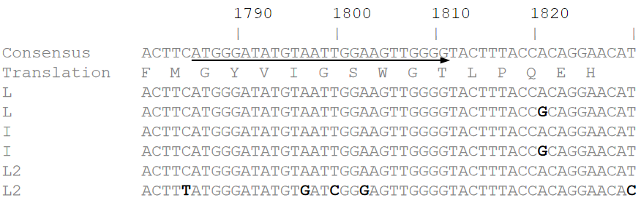
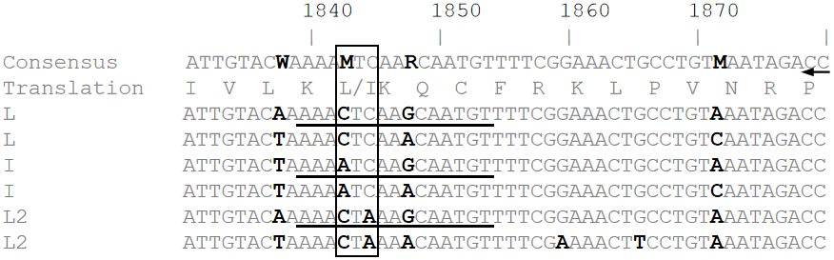
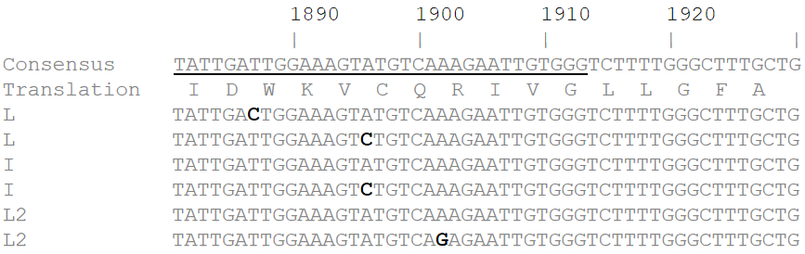
Figure 1 Primer and locked nucleic acid probe positions designed for the detection of three genotypes of polymorphisms in the rt269 codon, ‘L1’, ‘I’ and ‘L2’. Arrows indicate the primer positions. Underlines indicate the probe positions. The numbers designate the nucleotide position on the hepatitis B virus P gene sequence. Boldface bases denote the different bases. The box represents the codon and amino acid sequences of rtL269 variants. This single nucleotide difference is the basis of their discriminative identification by locked nucleic acid probes in this study. The amino acid sequence is shown as one-letter amino acid symbols.

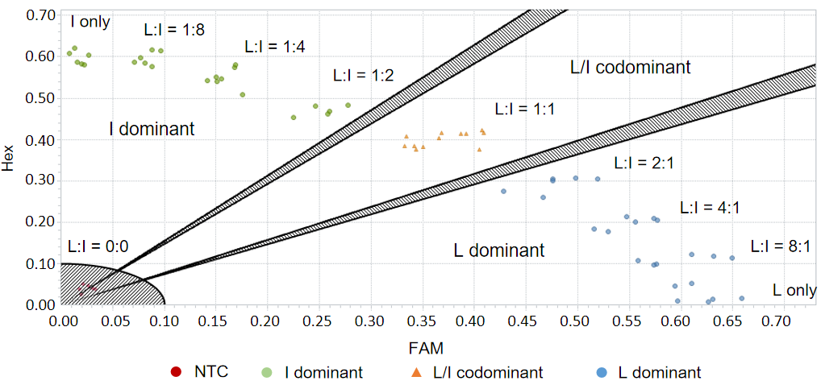
Figure 2 Differentiation of dominant hepatitis B virus rtL269 genotype variants using an endpoint genotyping method (LC96 software). L plus I genotype mixtures were prepared with known amounts of the genotypes in various ratios. I-dominant mixtures were positioned closer to axis Hex with higher Hex-fluorescence values, whereas L-dominant ones were located closer to axis FAM with higher FAM-fluorescence values. NTC: Nontemplate control.

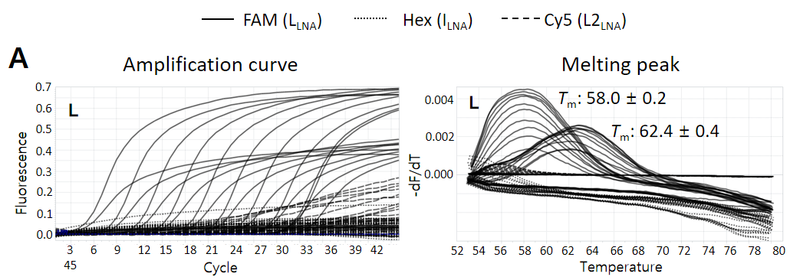
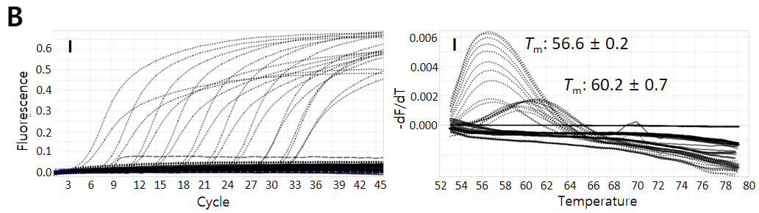
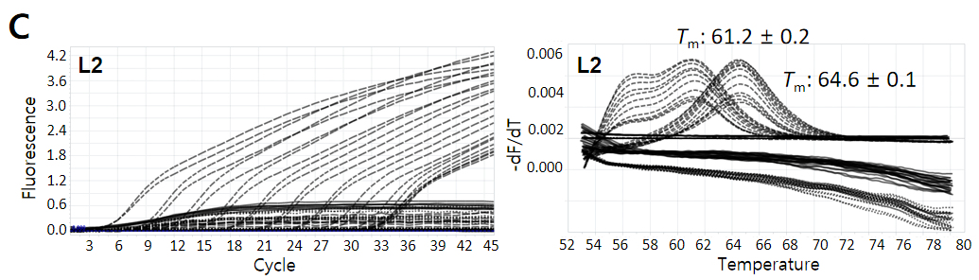
Figure 3 Multiprobe locked nucleic acid real-time polymerase chain reaction for discrimination among three types of polymorphisms in the rt269 codon. Amplification curves are shown on the left, and melting peaks are shown on the right. A: With L1 wild-type DNA templates, L1-type specific signals in the FAM channel (solid) were detected, showing their dominant amplification and distinct melting temperatures (T_{m}), with minimal cross signals of amplification and melting peaks generated by weak cross hybridizations of the other probes (I and L2), which were differentiated from the T_{m} values for I and L2 detection; B: For I variant-type DNA templates, I-type specific signals in the Hex channel (dotted) were detected, showing their exclusive amplifications and distinct T_{m} values, with no cross signals; C: For L2 variant-type DNA templates, amplification curves showed weak cross signals, but melting peaks were distinct with no cross signals.

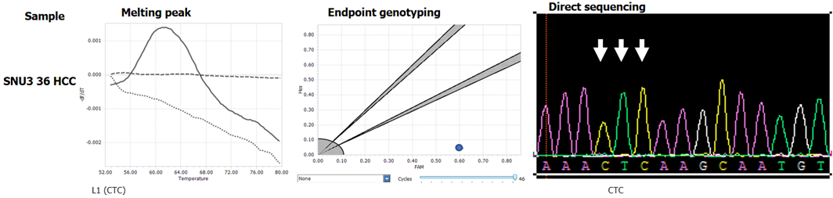
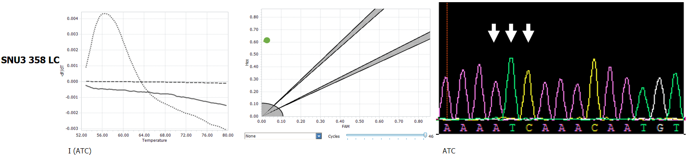
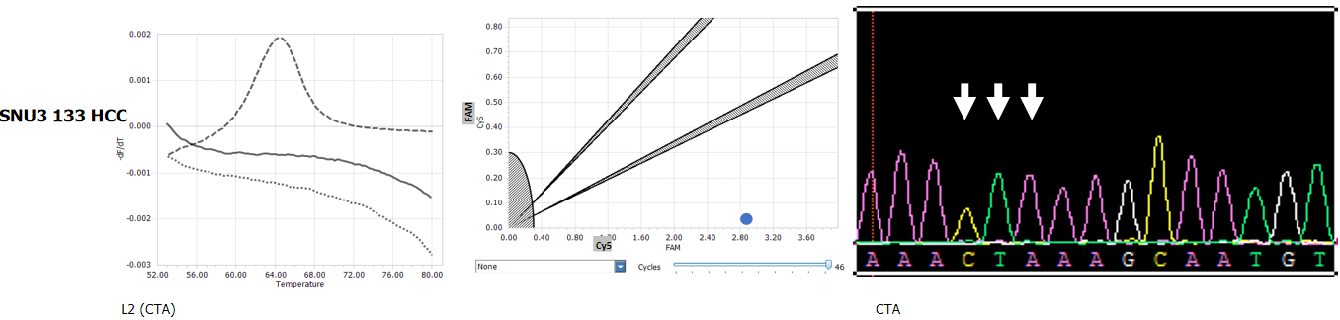
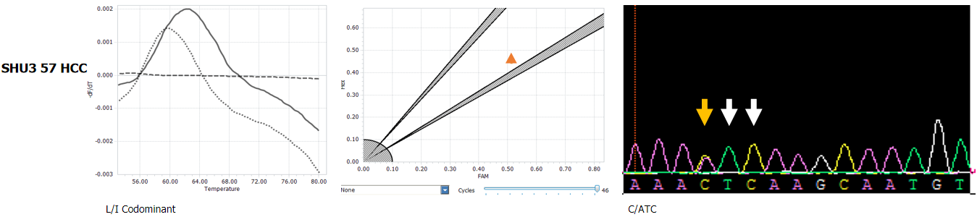

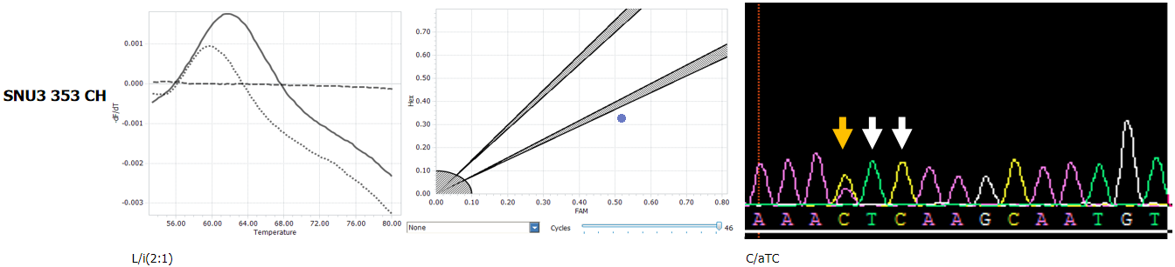
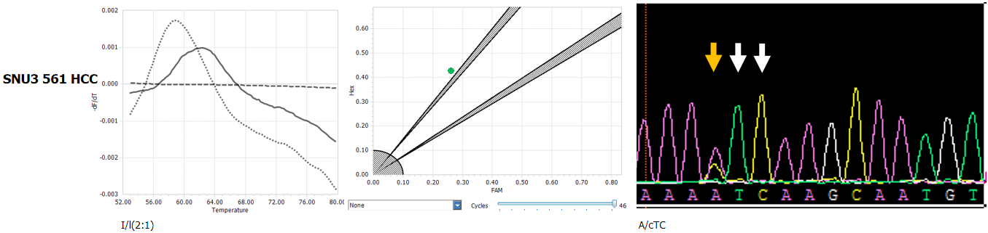
Figure 4 Confirmation of multiprobe locked nucleic acid real-time polymerase chain reaction identification results of hepatitis B virus rtL269 variants by direct sequencing. Nucleotide bases are shown in the parentheses. Lowercase letters represent the base present in a lower amount relative to the dominant variant. Bold indicates the dominant amino acids and bases. Arrows represent the codon sequence positions for leucine or isoleucine; yellow, mixed bases.

Table 1 Primers and locked nucleic acid probes developed for the identification of the hepatitis B virus L/I/L2 variants by multiprobe locked nucleic acid real-time polymerase chain reaction
Primer/probe | Sequence (5’ to 3’)¹ | T_{m} (°C)² | Target | CH
Primers
(product: 128 bp)
Forward | ATGGGATATGTAATTGGAAGtTGGGG | 65-67 | HBV P gene
Reverse | CCCACAATTCttTGACATACTTTCCAATCAATAGG | 67-69 | HBV P gene
LNA Probes
L_CTC | 5’ 6-FAM-AAA+C+T+CAAR+CA+ATGT - 3’ IABkFQ | 61-64 | L (WT) | FAM
I_ATC | 5’ HEX-AAA+A+T+CAAR+CAA+T+GT - 3’ IABkFQ | 61-64 | I | HEX
L2_CTA | 5’ CY5-AAA+C+T+AAAR+CAA+T+GT - 3’ IABkFQ | 60-63 | L2 | CY5
¹Locked nucleic acid nucleotides are written +A, +C, +T or +G.
²Primer T_{m} was calculated by using LC PDS software version 2.0, and probe T_{m} was calculated by https://www.exiqon.com/ls/pages/exiqontmpredictiontool.aspx.
T_{m}: Melting temperature; CH: Channel; HBV: Hepatitis B virus; WT: Wild type; LNA: Locked nucleic acid.

Table 2 Measurement of melting temperatures of the L/I/L2 variants by multiprobe locked nucleic acid real-time polymerase chain reaction
Genotype of positive control DNA [copies, (4.0E + 00)-(4.0E + 08)] | Target sequence¹ | Measured T_{m} (°C) in channel²
 |  | Min³ | Max³ | mean ± SD (detection)³ | Min⁴ | Max⁴ |  | mean ± SD (detection)⁴ | Min⁵ | Max⁵ | mean ± SD (detection) ⁵
L (n = 34) | AAACTCAAGCAATGTT | 61.6 | 63.1 | 62.4 ± 0.4  (34, 100%) | - | - |  | - (0, 0%) | 55.2 | 56.2 | 55.8 ± 0.2  (26, 76.4%)
L’ (n = 34) | AAACTCAAACAATGTT | 57.8 | 58.7 | 58.0 ± 0.2  (34, 100%) | - |  | - | - (0, 0%) | - | - | - (0, 0%)
I (n = 42) | AAAATCAAGCAATGTT | - | - | - (0, 0%) | 59.0 |  | 61.6 | 60.2 ± 0.7  (42, 100%) | - | - | - (0, 0%)
I’ (n = 34) | AAAATCAAACAATGTT | - | - | - (0, 0%) | 56.3 |  | 57.1 | 56.6 ± 0.2  (34, 100%) | - | - | - (0, 0%)
L2 (n = 34) | AAACTAAAGCAATGTT | - | - | - (0, 0%) | - |  | - | - (0, 0%) | 64.4 | 64.8 | 64.6 ± 0.1  (26, 100%)
L2’ (n = 18) | AAACTAAAACAATGTT | - | - | - (0, 0%) | - | - |  | - (0, 0%) | 60.9 | 61.4 | 61.2 ± 0.2  (18, 100%)
¹Bold, target codon; underline, A/G polymorphism.
²Bold, target specific melting temperature.
³FAM.
⁴Hex.
⁵Cy5.
Bold words represent genotype-specific T_{m}s.
T_{m}: Melting temperature; -: No significant melting temperature; SD: Standard deviation.

Table 3 Rates of positive detection of the hepatitis B virus L/I/L2 variants in a total of 94 clinical samples by locked nucleic acid real-time polymerase chain reaction
Type of detection | No. of samples | Percentage
Clinical samples | 94 | 100
Single | 63 | 67.0
L | 55 | 58.5
I | 8 | 8.5
Mixed | 24 | 24.5
L + I (1:1) | 7 | 7.4
L dominant | 13 | 4.3
I dominant | 4 | 12.8
Unidentified | 7 | 7.4
Inconsistent with direct sequencing | 1 | 1.1

Table 4 Samples which cannot be identified by locked nucleic acid real-time polymerase chain reaction assay
No. | Patients | Direct sequencing (AAACTCAARCAATGT) | Type | LNA-RT-PCR
1 | SNU3 30 HCC | AAAATCAAGCACTGT | I | Not detected
2 | SNU3 70 HCC | AAAATTAAGCAATGT | I | Not detected
3 | SNU3 82 CH | AAAATCAAACTATGT | I | Not detected
4 | SNU3 123 HCC | AAACTTAAGCAATGT | L | Not detected
5 | SNU3 31 CH | AAAATCCAGCAATGT | I | Not detected
6 | SNU3 355 LC | AAAATTAAGCAATG | I | Not detected
7 | SNU3 388 LC | AAACTTAAGCAATGT | L | Not detected
Bases in bold indicate the different ones from the target probe sequence. LNA-RT-PCR: Locked nucleic acid real-time polymerase chain reaction; HCC: Hepatocellular carcinoma; CH: Chronic hepatitis; LC: Liver cirrhosis.

