Name of Journal: World Journal of Clinical Cases
Manuscript NO: 90017
Manuscript Type: CASE REPORT

Idiopathic mesenteric phlebosclerosis missed by a radiologist at initial diagnosis: A case report

Wang M et al. Idiopathic mesenteric phlebosclerosis

Min Wang, Yu-Xia Wan, Jin-Wen Liao, Fei Xiong

Min Wang, Department of Gastroenterology, Changning County People’s Hospital, Yibin 644300, Sichuan Province, China

Yu-Xia Wan, Department of Gastroenterology, Qianwei People’s Hospital, Leshan 614400, Sichuan Province, China

Jin-Wen Liao, Department of Gastroenterology, The People’s Hospital of Jianyang City, Chengdu 641400, Sichuan Province, China

Fei Xiong, Department of Gastroenterology, Sichuan Provincial People’s Hospital, University of Electronic Science and Technology of China, Chengdu 610000, Sichuan Province, China

Co-first authors: Min Wang and Yu-Xia Wan.

Author contributions: Wang M, Wan YX, Liao JW, and Xiong F designed the research study; Wang M and Wan YX drafted the manuscript and provided the images; Liao JW and Xiong F performed the review; Wang M and Wan YX contributed equally to this work as co-first authors; all authors have read and approved the final manuscript.

Corresponding author: Fei Xiong, MD, Attending Doctor, Department of Gastroenterology, Sichuan Provincial People's Hospital, University of Electronic Science and Technology of China, No. 18 Huanhua North Road, Chengdu 610000, Sichuan Province, China. feiji19841984@gmail.com

Received: November 20, 2023
Revised: January 31, 2024
Accepted: March 7, 2024
Published online:

Abstract
BACKGROUND
Idiopathic mesenteric phlebosclerosis (IMP) is a rare type of ischemic colitis characterized by thickening of the wall of the right hemicolon and calcification, sclerosis, and fibrosis of mesenteric veins. The diagnosis of IMP is based on typical clinical features and imaging findings. We report a case of IMP that was initially missed by the radiologist.

CASE SUMMARY
A 77-year-old woman was admitted to the hospital due to chronic diarrhea for over 2 months. She had been consuming Chinese patent medicines (CPM) containing fructus gardeniae for more than 15 years. Colonoscopy revealed an edematous mucosa, bluish-purple discoloration, erosions, and ulcerations throughout the colorectal area. Abdominal computed tomography (CT) showed diffuse mural thickening of the entire colorectum, with tortuous thread-like calcifications in the right hemicolon, left hemicolon, and rectum. Most of the calcifications were located in the mesenteric vein. The diagnosis of IMP was established based on medical history, colonoscopy, CT findings, and histopathological examination. The patient was treated conservatively with papaverine and rifaximin, and CPM was stopped. Her diarrhea symptoms improved, indicating the effectiveness of the treatment. Over the next several years, she took opium alkaloids for an extended period and did not require hospitalization for the aforementioned gastrointestinal disorder.

CONCLUSION
IMP is a rare gastrointestinal disease affecting Asian populations, possibly related to long-term herbal medicine intake. Accurate imaging analysis is crucial for diagnosis, but insufficient understanding of the disease can lead to misdiagnosis or missed diagnosis. Treatment strategies should be personalized.

Key Words: Idiopathic mesenteric phlebosclerosis; Computed tomography; Colonoscopy; Chinese patent medicines; Fructus gardeniae; Case report

Wang M, Wan YX, Liao JW, Xiong F. Idiopathic mesenteric phlebosclerosis missed by a radiologist at initial diagnosis: A case report. World J Clin Cases 2024; In press

Core Tip: Idiopathic mesenteric phlebosclerosis (IMP) is a rare type of ischemic colitis characterized by thickening of the wall of the right hemicolon and calcification, sclerosis, and fibrosis of mesenteric veins. The diagnosis is based on typical clinical features and abdominal imaging. We report a case of IMP that was initially missed by the radiologist. Finally, IMP was diagnosed by a clinically experienced endoscopist.

INTRODUCTION
Idiopathic mesenteric phlebosclerosis (IMP) is a rare form of ischemic colitis characterized by thickening of the wall of the right hemicolon and calcification, sclerosis, and fibrosis of mesenteric veins^{[1]}. This clinical entity was first described by Yao et al^{[2]} in 1989, and it was proposed to be named as IMP in 2003^{[3]}. In the early stages of the disease, patients may be asymptomatic or have atypical symptoms. As the disease progresses, patients may present with abdominal pain, abnormal stool, or intestinal obstruction^{[4]}. The diagnosis of IMP is based on the characteristic clinical features and abdominal imaging findings^{[5]}. However, we encountered a case of IMP that was initially missed by the radiologist.

CASE PRESENTATION
Chief complaints
A 77-year-old woman was admitted to the hospital with chronic diarrhea for more than 2 months.

History of present illness
Symptoms started more than 2 months before presentation with chronic diarrhea.

History of past illness
The patient had a history of taking Chinese patent medicines (CPM) containing fructus gardeniae for more than 15 years for treatment of constipation. Four years back, she was diagnosed with chronic obstructive pulmonary disease. There was no history of infectious diseases (such as hepatitis or tuberculosis), hypertension, coronary heart disease, or diabetes.

Personal and family history
There was no family history of malignant tumors.

Physical examination
On physical examination, there was severe edema in the patient’s lower legs and her abdomen was distended and mildly tender.

Laboratory examinations
Initial laboratory investigations showed hypoalbuminemia (albumin: 30.8 g/L), electrolyte imbalance (K⁺: 2.38 mmol/L; Na⁺: 128.4 µmol/L; Cl⁻: 90.8 mmol/L), and anemia (hemoglobin: 78 g/L). Other laboratory indices were normal. Polymerase chain reaction for Mycobacterium tuberculosis, Epstein-Barr virus-encoded RNA, cytomegalovirus (CMV)-BD, and CMV-KT were all negative. The enzyme immunoassay for Clostridium difficile toxins A and B were also negative. The stool bacterium culture was negative.

Imaging examinations
Carotid color Doppler flow imaging showed carotid atherosclerosis plaque. Abdominal sonography showed the presence of ascites. The initial abdominal computed tomography (CT) scan did not clearly depict numerous thread-like calcifications within the right-side mesenteric veins and their branches. These calcifications appeared denser in intramural tributaries, marginal veins, and vena recti peripherally. Colonoscopy revealed an edematous mucosa with bluish-purple discoloration, erosions, and ulcerations throughout the colorectal region (Figure 1). Histopathological examination showed mild inflammation and granulomatous reactions (Figure 2).

MULTIDISCIPLINARY EXPERT CONSULTATION
After reevaluating the abdominal CT images in conjunction with colonoscopy findings, a tentative diagnosis of IMP was considered. Further observation of the abdominal CT images exhibited diffuse mural thickening of the entire colon and rectum, with tortuous thread-like calcifications in the right hemicolon, left hemicolon, and rectum. Notably, most of these calcifications were located within the mesenteric vein (Figure 3). Arterial calcification usually occurs in the major arteries. However, it exhibits an irregular and patchy appearance, and usually there are no large areas of point-like fine linear calcifications. Our patient had a plaque in the abdominal aorta and showed stratified calcification in the intestinal wall (Figure 4A and B). The number of point-like intensifications in the arterial and venous phases in similar areas at the same level varied. There was more punctate reinforcement in the arterial phase than in the venous phase, and the punctate reinforcement in the venous phase indicates the foci of calcification (Figure 4C and D). Mesenteric venous calcification points, usually compared to the same level of the venous phase, can be found in the relatively dense occurrence of punctate and linear enhanced areas. In contrast to the arterial phase, the point of disappearance and the position of linear enhancement in the venous phase are usually near the calcification point, and some of the linear enhancement sites become point-like locations, suggesting that there may be arterial enhancement near the calcification point at the same time, which makes the imaging turn linear. It becomes punctate calcification only after the venous phase, relatively in a nearby concomitant position, similar to the relative position of the arteriovenous mesentery. In the arterial phase, the vanishing points in the venous phase will appear randomly, and there will be no similar concomitant relationship between the vanishing points and the calcification points in the same area, and there will be no possibility of linear calcification becoming punctate calcification.

FINAL DIAGNOSIS
A diagnosis of IMP was established based on the patient’s medical history, colonoscopy and CT findings.

TREATMENT
The patient was immediately advised to discontinue the use of CPM. Intravenous papaverine (30 mg twice a day) was administered for 3 d, but there was no significant improvement in diarrhea. Although fecal occult blood test was positive and fecal flora was normal, the levels of C-reactive protein (25.03 mg/L) and procalcitonin (0.13 ng/mL) were raised. Therefore, oral rifaximin 0.2 g three times a day was initiated to cover potential intestinal infection. The patient’s diarrhea significantly improved, with 1-2 bowel movements per day and improved stool consistency. After discharge, oral rifaximin was continued for 2 wk, while oral papaverine 30 mg is being continued till date, without any side effects.

OUTCOME AND FOLLOW-UP
Nearly 5 years after discharge, the patient has not been readmitted to the hospital for the above disease.

DISCUSSION
IMP is a rare chronic disease characterized by non-thrombotic, non-inflammatory stenosis or occlusion of the mesenteric veins^{[6]}. It primarily affects the right hemicolon, often involving the proximal colon, and may extend to the terminal ileum or the distal colon^{[7]}. According to a literature review, IMP is more prevalent in middle-aged and elderly men [median age at onset: 61 years (range, 22-87 years)]^{[8]}. Guo et al^{[9]} observed that the majority of patients were Asians, predominantly from Japan, Taiwan, and mainland China. The exact etiology and pathogenesis of IMP remain elusive but long-term exposure to toxins and biochemical substances may play a role^{[10]}. Nearly all reported cases of IMP had a history of prolonged use of medicinal herbs containing geniposide, such as oldenlandia herbacea, plantaginis semen, eucommiae cortex, herba paederiae scandentis, radix scrophulariae, and fructus gardeniae^{[11]}. Notably, licorice has also been reported as a possible causative agent of IMP^{[11]}. Our patient was a 77-year-old Chinese woman who had a history of taking CPM containing fructus gardeniae for over 15 years, consistent with previous literature reports, and ultimately developed IMP.
Some scholars have proposed that geniposide can be transformed into genipin in the intestinal tract through hydrolysis under the influence of various microenvironmental factors such as the intestinal flora, amino acids, and sulfuric acid. The absorbed genipin then reacts with proteins in the mesenteric vein plasma^{[6,8]}. Additionally, the gradual submucosal accumulation of collagen leads to intimal hyperplasia, venous wall thickening, and fibrosis, resulting in a condition known as “mummification”^{[6,12]}. This process leads to obstruction of venous lumen, impedes venous return, and induces intestinal wall thickening, edema, gliosis, and sclerosis^{[8,12]}. However, geniposide undergoes hydrolysis only after entering the colon and is then transformed to its metabolite, genipin. Genipin then permeates the enterocyte membrane under the influence of various colon microenvironments^{[6]}. This explains why the characteristic lesion sites of IMP are the right-sided colon and transverse colon, which can spread to the entire colorectal area as the disease progresses.
In the early stage, many patients with IMP (10%-27.7%) are asymptomatic^{[8,13-15]}. However, as the disease progresses, patients may present with nonspecific symptoms such as abdominal pain, diarrhea, constipation, nausea, vomiting, abdominal distension, fever, and bloody stool^{[8,15]}. These symptoms complicate the diagnosis of IMP, necessitating the use of abdominal CT and colonoscopy for diagnostic purposes, with histopathological examination ultimately confirming the diagnosis^{[8]}. The typical abdominal CT findings are colonic wall thickening and diffuse calcifications in small mesenteric veins and their intramural branches^{[16]}. Although the right-sided colon is more commonly involved, the entire colon may be involved in severe cases^{[16]}. The typical colonoscopy findings are a blue or bluish-purple mucosa, which may also display hyperemia, edema, erosion, or ulceration^{[6]}. Histopathologically, IMP is characterized by venous wall thickening, fibrosis, and calcification, venous narrowing, atrophy, and submucosal fibrosis with intrinsic myometrium thickening^{[10]}. Our patient presented with chronic diarrhea. Abdominal CT showed diffuse mural thickening of the entire colorectum and tortuous thread-like calcifications in the right and left hemicolon and rectum, with most calcifications located in the mesenteric veins. Colonoscopy revealed lesions involving the entire colorectal region. Histopathological examination revealed mild inflammation and granulomatous changes. These findings were consistent with the diagnosis of IMP.
As there are currently no standardized treatment guidelines or specific therapeutic agents for IMP, discontinuation of herbal medicine is considered the first-line therapy for early-stage IMP, which, when combined with proper treatment, generally leads to a favorable prognosis^{[17,18]}. According to a large-scale nationwide survey, discontinuation of herbal medicines led to alleviation of symptoms in 84.3% of patients, with none of the cases requiring surgery post-discontinuation^{[13]}. However, the choice between conservative and surgical treatment in patients with IMP is challenging. Surgical treatment will be necessary in case of severe complications, such as colonic obstruction, necrosis, perforation, or massive intestinal bleeding^{[19]}. Sze et al^{[20]} reported a 45-year-old Chinese woman with IMP who had stopped consuming Chinese herbs for 3 years and still had recurrent episodes of abdominal pain and flatulence. She eventually had to be treated surgically for intestinal obstruction. However, the presence of poor circulation may mean that colon surgery is not an appropriate treatment, and it must be chosen with care^{[6]}. Our patient received conservative treatment with papaverine and rifaximin and discontinued using CPM. This led to improvement in diarrhea. The patient has been followed for 5 years without any readmissions related to the aforementioned conditions.

CONCLUSION
IMP is a rare intestinal disease that is more prevalent among Asians. The pathogenesis of IMP remains unclear, but it may be associated with the long-term intake of medicinal herbs. While it is crucial to analyze the imaging features on CT or colonoscopy, a lack of awareness about the disease can easily lead to missed or misdiagnoses. The treatment strategy for IMP should be individualized to achieve the best possible outcome.

REFERENCES
1 Zheng Q, Zhang B, Cao Z, Wang L. Idiopathic mesenteric phlebosclerosis associated with long-term oral intake of herb drug occurring in a mother and her daughter. Clin Res Hepatol Gastroenterol 2021; 45: 101467 [PMID: 32565200 DOI: 10.1016/j.clinre.2020.05.015]
2 Yao K, Iwashita A. Diagnosis of Early Gastric Cancer: Endoscopic Diagnosis and Classification: VS Classification System for the Diagnosis of Early Gastric Cancer by Magnifying Endoscopy. In: Chiu PWY, Sano Y, Uedo N, Singh R. Endoscopy in Early Gastrointestinal Cancers, Volume 1. Singapore: Springer [DOI: 10.1007/978-981-10-6769-3_6]
3 Iwashita A, Yao T, Schlemper RJ, Kuwano Y, Yao T, Iida M, Matsumoto T, Kikuchi M. Mesenteric phlebosclerosis: a new disease entity causing ischemic colitis. Dis Colon Rectum 2003; 46: 209-220 [PMID: 12576895 DOI: 10.1097/01.DCR.0000044720.43258.6E]
4 Ding J, Zhang W, Wang L, Zhu Z, Wang J, Ma J. Idiopathic mesenteric phlebosclerosis: clinical and CT imaging characteristics. Quant Imaging Med Surg 2021; 11: 763-771 [PMID: 33532275 DOI: 10.21037/qims-20-301]
5 Takasaki T, Motomura Y, Shioya K. Idiopathic Mesenteric Phlebosclerosis. Clin Gastroenterol Hepatol 2022; 20: A19 [PMID: 35218953 DOI: 10.1016/j.cgh.2022.02.038]
6 Wen Y, Chen YW, Meng AH, Zhao M, Fang SH, Ma YQ. Idiopathic mesenteric phlebosclerosis associated with long-term oral intake of geniposide. World J Gastroenterol 2021; 27: 3097-3108 [PMID: 34168411 DOI: 10.3748/wjg.v27.i22.3097]
7 Jiang Y, Huang S, Chen K, Chen X. [Idiopathic mesenteric phlebosclerosis: one case report and literature review]. Zhong Nan Da Xue Xue Bao Yi Xue Ban 2017; 42: 117-120 [PMID: 28216508 DOI: 10.11817/j.issn.1672-7347.2017.01.019]
8 Wang J, Shao J, Lu H, Wang B, Chen J. Idiopathic mesenteric phlebosclerosis: one case report and systematic literature review of 240 cases. Am J Transl Res 2021; 13: 13156-13166 [PMID: 34956536]
9 Guo F, Zhou YF, Zhang F, Yuan F, Yuan YZ, Yao WY. Idiopathic mesenteric phlebosclerosis associated with long-term use of medical liquor: two case reports and literature review. World J Gastroenterol 2014; 20: 5561-5566 [PMID: 24833888 DOI: 10.3748/wjg.v20.i18.5561]
10 Wen Y, Zhao M, Huang W, Fang S, Lin C. Idiopathic mesenteric phlebosclerosis associated with use of Chinese herbal medicine: Two case reports. Medicine (Baltimore) 2020; 99: e22813 [PMID: 33080758 DOI: 10.1097/MD.0000000000022813]
11 Jin YR, Zhou H, Liu ZZ, Li XF, Liang J. Idiopathic mesenteric phlebosclerosis occurring after long-term medication with licorice: A case report. J Dig Dis 2022; 23: 183-185 [PMID: 35156308 DOI: 10.1111/1751-2980.13087]
12 Young Chuah Y, Yeh Lee Y. Geniposide Causes Idiopathic Mesenteric Phlebosclerosis. Turk J Gastroenterol 2023; 34: 890-891 [PMID: 37434401 DOI: 10.5152/tjg.2023.23208]
13 Shimizu S, Kobayashi T, Tomioka H, Ohtsu K, Matsui T, Hibi T. Involvement of herbal medicine as a cause of mesenteric phlebosclerosis: results from a large-scale nationwide survey. J Gastroenterol 2017; 52: 308-314 [PMID: 27220772 DOI: 10.1007/s00535-016-1218-9]
14 Chen W, Zhu H, Chen H, Shan G, Xu G, Chen L, Dong F. Phlebosclerotic colitis: Our clinical experience of 25 patients in China. Medicine (Baltimore) 2018; 97: e12824 [PMID: 30412073 DOI: 10.1097/MD.0000000000012824]
15 Chou JW, Chang CH, Wu YH, Chang KC, Cheng KS, Huang PJ. Idiopathic Mesenteric Phlebosclerosis: A Single-Institute Experience in Taiwan. Turk J Gastroenterol 2023; 34: 483-489 [PMID: 36789983 DOI: 10.5152/tjg.2023.22335]
16 Li H, Liu H. Idiopathic Mesenteric Phlebosclerosis. Radiology 2023; 306: 76 [PMID: 36098638 DOI: 10.1148/radiol.220443]
17 Shan J, Chen F, Yu P. Intestinal obstruction due to idiopathic mesenteric phlebosclerosis colitis: A case report. Front Surg 2022; 9: 969154 [PMID: 36061039 DOI: 10.3389/fsurg.2022.969154]
18 Kawashima A, Shimomura A, Inagaki T. Idiopathic Mesenteric Phlebosclerosis Secondary to Chinese Herbal Medicine Intake in an Older Adult. Am J Trop Med Hyg 2023; 109: 715-716 [PMID: 37696511 DOI: 10.4269/ajtmh.22-0772]
19 Washington C, Carmichael JC. Management of ischemic colitis. Clin Colon Rectal Surg 2012; 25: 228-235 [PMID: 24294125 DOI: 10.1055/s-0032-1329534]
20 Sze SF, Lam PWY, Lam JTW, Chung CCC, Lee YT. Idiopathic mesenteric phlebosclerosis: A rare cause of chronic diarrhea. JGH Open2020; 4: 769-770 [PMID: 32782970 DOI: 10.1002/jgh3.12335]

Footnotes
Informed consent statement: Written informed consent was obtained from the patient for the publication of this case report.

Conflict-of-interest statement: The authors declare no potential conflicts of interest concerning the research, authorship, and/or publication of this article.

CARE Checklist (2016) statement: The authors have read the CARE Checklist (2016), and the manuscript was prepared and revised according to the CARE Checklist (2016).

Open-Access: This article is an open-access article that was selected by an in-house editor and fully peer-reviewed by external reviewers. It is distributed in accordance with the Creative Commons Attribution NonCommercial (CC BY-NC 4.0) license, which permits others to distribute, remix, adapt, build upon this work non-commercially, and license their derivative works on different terms, provided the original work is properly cited and the use is non-commercial. See: https://creativecommons.org/Licenses/by-nc/4.0/

Provenance and peer review: Unsolicited article; Externally peer reviewed.
Peer-review model: Single blind

Peer-review started: November 20, 2023
First decision: January 17, 2024
Article in press:

Specialty type: Gastroenterology & hepatology
Country/Territory of origin: China
Peer-review report’s scientific quality classification
Grade A (Excellent): A
Grade B (Very good): 0
Grade C (Good): 0
Grade D (Fair): 0
Grade E (Poor): 0

P-Reviewer: Sharma D, India S-Editor: Zhang H L-Editor: Wang TQ P-Editor:
Figure Legends
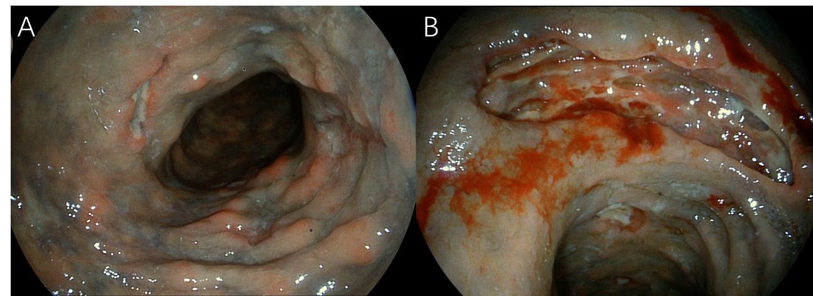
Figure 1 Colonoscopy findings. A: Bluish purple mucosa with multiple ulcers in the ascending colon; B: A deep ulcer in the rectum.
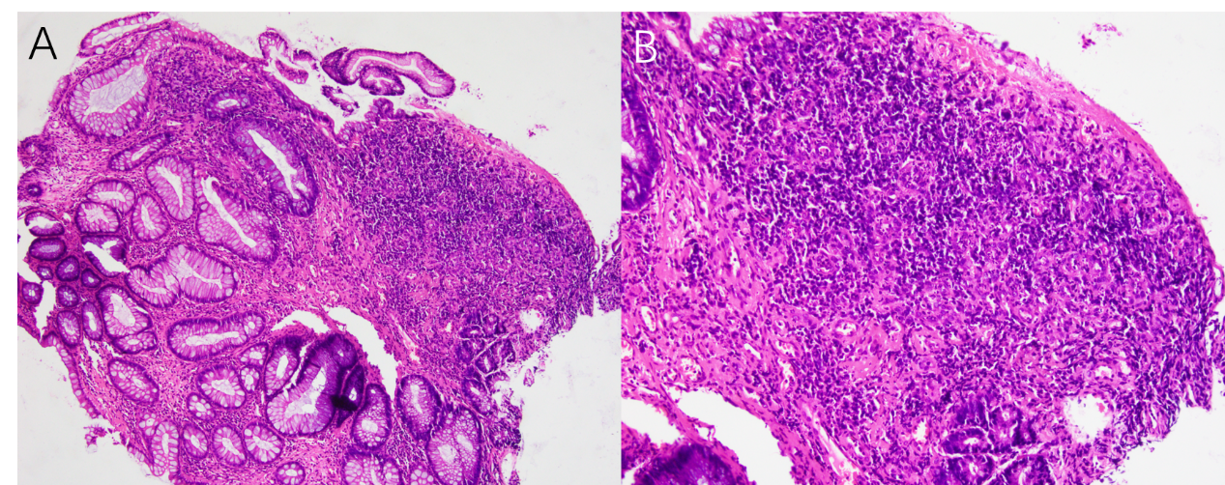
Figure 2 Histological examination. A and B: Mild inflammation and granulomatous reaction were observed.
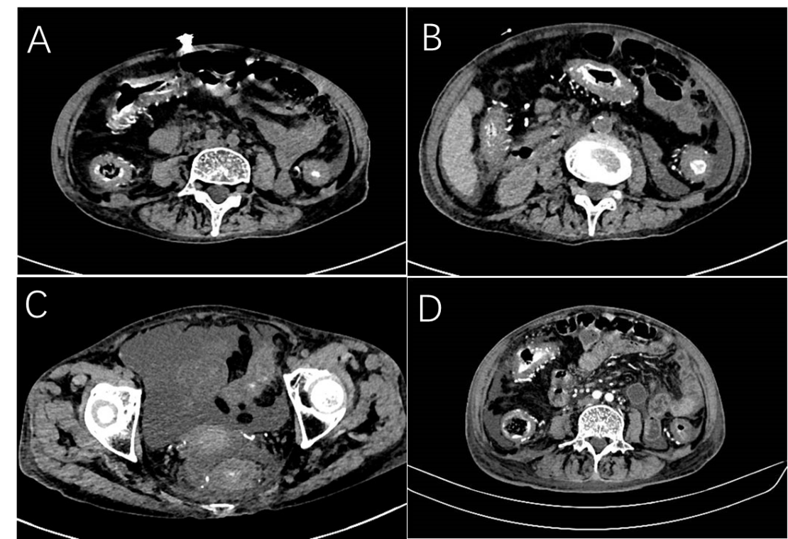
Figure 3 Plain abdominal computed tomography. A-C: Diffuse mural thickening of the total colorectum and tortuous thread-like calcification were observed in the right hemicolon, left hemicolon, and rectum; D: Multiphase, contrast-enhanced computed tomography showed that most calcifications are located in the mesenteric vein.
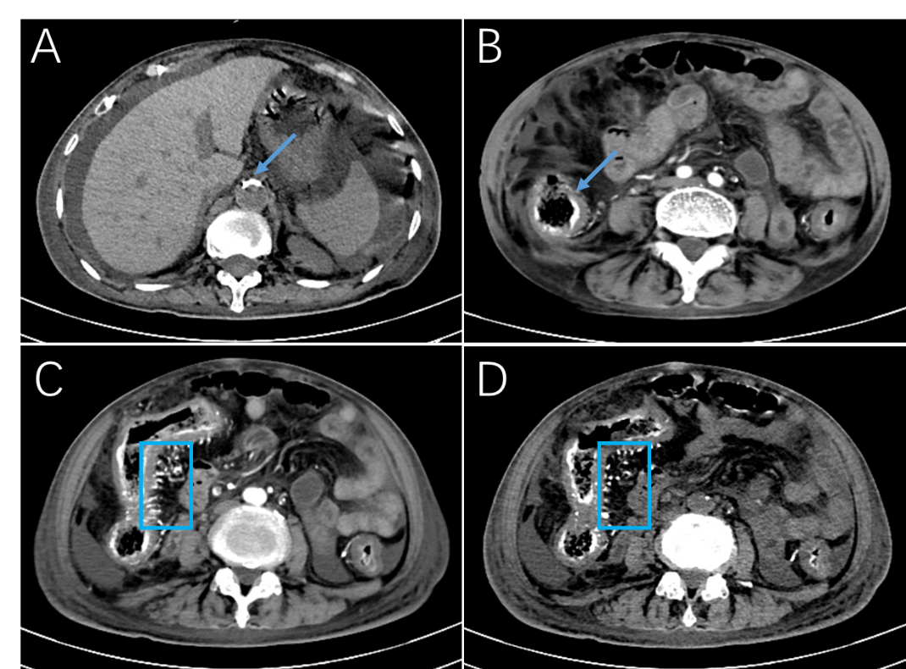
Figure 4 Contrast-enhanced abdominal computed tomography. A: Calcification of the abdominal aorta (arrow); B: Stratified calcification of the intestinal wall (arrow); C and D: The number of point intensifications in the arterial and venous phases in similar areas at the same level were seen to vary (box). There is more punctate reinforcement in the arterial phase than in the venous phase, and the punctate reinforcement in the venous phase is the calcification point.

