Name of Journal: World Journal of Clinical Cases
Manuscript NO: 64982
Manuscript Type: META-ANALYSIS

Helicobacter pylori infection and peptic ulcer disease in cirrhotic patients: An updated meta-analysis

Wei L et al. H. pylori infection and PU in cirrhotic patients

Lin Wei, Hui-Guo Ding

Lin Wei, Hui-Guo Ding, Department of Gastroenterology and Hepatology, Beijing You’an Hospital Affiliated with Capital Medical University, Beijing 100069, China

Author contributions: Wei L contributed to collecting the data and writing the manuscript; Ding HG designed the project and was in charge of the manuscript; all the authors have read and approved the manuscript.

Supported by The State Key Projects Specialized on Infectious Diseases, No. 2017ZX10203202-004-B07; and The Digestive Medical Coordinated Development Center of Beijing Hospitals Authority, No. XXZ0801.

Corresponding author: Hui-Guo Ding, MD, PhD, Chief Physician, Professor, Director, Department of Gastroenterology and Hepatology, Beijing You’an Hospital affiliated with Capital Medical University, No. 8 Xitoutiao, Youanmenwai, Fengtai District, Beijing 100069, China. dinghuiguo@ccmu.edu.cn

Received: March 23, 2021
Revised: July 4, 2021
Accepted: July 13, 2021
Published online:

Abstract
BACKGROUND
Peptic ulcer (PU) is more prevalent in patients with liver cirrhosis. The role of Helicobacter pylori (H. pylori) infection in the pathogenesis of PU in patients with cirrhosis is still not elucidated.

AIM
To perform a meta-analysis on the prevalence of H. pylori infection and PU and their association in liver cirrhosis patients.

METHODS
We searched PubMed, EMBASE, Web of Science, Cochrane, CNKI, Wangfang, and CQVIP databases from inception to July 10, 2020. Odds ratio (OR) and 95% confidence interval (CI) were pooled using a random-effects model. The statistical heterogeneity among studies (I²-index), subgroup analyses, regression analysis, sensitivity analysis, and the possibility of publication bias were assessed.

RESULTS
A total of 14 studies (13 cross-sectional studies; 1 cohort study) involving 2775 individuals (611 cases with PU and 2164 controls) were included in our meta-analysis. The prevalence of PU in patients with cirrhosis was 22%. The prevalence of H. pylori infection was 65.6% in cirrhotic patients with PU, and 52.5% in those without. The pooled overall OR was 1.73 (95%CI: 1.16-2.56, I² = 66.2%, P < 0.001, Z = 2.7, P_{z} < 0.05). We did not find the cause of heterogeneity in the subgroup analyses and meta-regression analysis except for one study. Funnel plot did not show significant publication bias. The results of Begg’s test and Egger’s test indicated no evidence of substantial publication bias (P_{Begg} = 0.732, P_{Egger} = 0.557).

CONCLUSION
There is a weakly positive association between H. pylori infection and PU in patients with liver cirrhosis. It is suggested that H. pylori infection may play a role in the pathogenesis of PU in liver cirrhotic patients.

Key Words: Helicobacter pylori; Peptic ulcer; Cirrhosis; Meta-analysis; Infection

Wei L, Ding HG. Helicobacter pylori infection and peptic ulcer disease in cirrhotic patients: An updated meta-analysis. World J Clin Cases 2021; In press

Core Tip: Peptic ulcer (PU) is more prevalent in patients with liver cirrhosis than in the general population. What's more, cirrhotic patients with PU have a high risk of PU bleeding than the general population. So, if studies can prove that Helicobacter pylori (H. pylori) is also an independent risk factor for PU in patients with liver cirrhosis, the eradication of H. pylori can indirectly prevent PU bleeding in cirrhotic patients. This study showed that there is a weak positive association between H. pylori infection and PU in patients with liver cirrhosis.

INTRODUCTION
Based on endoscopy screening, the prevalence of peptic ulcer (PU) in cirrhotic patients has been reported to be approximately 5%-20% compared to 2%-4% in the general population^{[1-5]}. It has been shown that cirrhotic patients have a significantly higher risk of PU bleeding than the general population^{[6]}. There are data indicating that upper gastrointestinal hemorrhage (UGIB) due to PU worsens the prognosis of cirrhotic patients. The morbidity and mortality of patients with liver cirrhosis and PUs are very high. Leontiadis et al^{[7]} performed a meta-analysis on the effect of comorbidities on mortality in patients with PU bleeding and showed that the mortality rate of PU bleeding patients with liver diseases was 26.9% compared with the mortality rate of 6.3% among those who had no hepatic diseases^{[7,8]}. In the general population, Helicobacter pylori (H. pylori) infection is central to the pathogenesis of PU. If studies can prove that H. pylori is also an independent risk factor for PU in patients with liver cirrhosis, the eradication of H. pylori can indirectly prevent PU bleeding in cirrhotic patients. Therefore, it is very important for cirrhotic patients that also have H. pylori infection to eradicate H. pylori in advance of developing PU, and the relationship between H. pylori infection and PU in liver cirrhosis is of great clinical significance. Whether patients with liver cirrhosis should be treated with anti-H. pylori drugs in advance has become a very important clinical problem. There is debate concerning the relationship between H. pylori infection and PU in patients with liver cirrhosis^{[5,9-21]}. Some of the results suggest that H. pylori infection is not related to PU in liver cirrhosis, while others suggest that H. pylori infection is related or weakly related to PU in liver cirrhosis patients. Therefore, we summarized the articles published in recent years on the H. pylori and PU in patients with liver cirrhosis and performed a meta-analysis to assess the prevalence and the association between H. pylori infection and PU in patients with cirrhosis.

MATERIALS AND METHODS
Registration of review protocol
This meta-analysis was conducted following the Preferred Reporting Items for Systematic Reviews and Meta-Analyses guidelines, and the protocol for this meta-analysis is available on international prospective register of systematic reviews (PROSPERO; registration number CRD42020218033).

Data sources and search strategy
PubMed, EMBASE, Web of Science, Cochrane, CNKI, Wangfang, and CQVIP databases were electronically searched from inception to July 10, 2020 without language restrictions. The search terms were as follows: (“H. pylori” OR “Campylobacter pylori” OR “H. pylori” OR “HP” OR “Helicobacter spp.” OR “H. pylori”) AND (“liver cirrhosis” OR “cirrhosis” OR “cirrhosis hepatis” OR “cirrhosis, liver” OR “cryptogenic liver cirrhosis” OR “dietary cirrhosis” OR “dietary liver cirrhosis” OR “hepatic cirrhosis” OR “postnecrotic liver cirrhosis” OR “Fibrosis, Liver” OR “Liver Fibrosis”) AND (“ulcer” OR ”peptic ulcer” OR ”duodenal ulcer” OR ” Curling ulcer” OR ”stomach ulcer” OR ”gastric ulcer”). Both Medical Subject Heading and free words were used. We also reviewed references from relevant original papers and review articles to identify further eligible studies not covered by the original database research. This review was performed according to the guidelines for meta-analyses and systematic reviews of observational studies^{[22]}.

Inclusion and exclusion criteria
The inclusion criteria were as follows: (1) Cross-sectional, case-control, or cohort studies published as original articles that explored the association between PU and H. pylori in cirrhotic patients; (2) H. pylori infection had to be confirmed by at least one positive test as follows: Serological testing (using H. pylori immunoglobulin G enzyme-linked immunosorbent assays), 13C-labeled or 14C-labeled urea breath test (UBT), rapid urease test (RUT), histology, or fecal antigen test; (3) cirrhosis had to be diagnosed by histology, or by clinical, analytical, and imaging (mostly ultrasonography) methods; etiology and Child-Pugh score were specified; (4) the diagnosis of PU was obtained by endoscopy; and (5) all the studies included a control group.
Criteria for exclusion were as follows: (1) Letters, abstracts, case reports, animal studies, editorials, reviews, and meta-analyses; (2) irrelevant literature and duplicate studies; and (3) the lack of data made it impossible to derive an exact number of patients with or without H. pylori and with or without PU by endoscopy.
Two investigators (Ding HG and Wei L) independently screened the titles and abstracts of all studies identified using the previously described search criteria to identify studies meeting the inclusion criteria. Each study meeting the requirements of the inclusion criteria then underwent an independent full-text review by both investigators. Disagreements about the inclusion of studies between investigators were resolved by discussion.

Data extraction and quality assessment
We extracted the following data from each study: (1) Study characteristics, including the name of the first author, publication year, country of publication, study design, and sample size; and (2) the number of positive/ negative H. pylori infections in the PU with liver cirrhosis group, the number of positive/negative H. pylori infections in the control group, method of detection of H. pylori infection, method of detection of liver cirrhosis, and case/control ratio. We assessed the quality of each study according to the Agency for Health care Research and Quality (AHRQ), which is a validated scale for cross-sectional studies^{[23]}.

Data synthesis and analysis
We used STATA version 12.0 software (Stata Corporation, College Station, TX, United States) to perform meta-analyses. Odds ratio (OR) with 95% confidence interval (CI) was pooled to describe the ratio of the prevalence of H. pylori infection in cirrhotic patients with and without PU. Heterogeneity was assessed by Chi-square-based Q test and I² index was used to evaluate the statistical heterogeneity between the studies^{[24]}. The significance for the Q test was defined as P value < 0.1. Heterogeneity was classified as follows: I² value of 0%-25% indicated no heterogeneity, 26%-50% indicated low heterogeneity, 51%-75% indicated moderate heterogeneity, and 76%-100% indicated high heterogeneity. A fixed effect model was used when I² value was < 50%, and a random effect model was used when I² value was > 50%^{[24]}. Subgroup analysis and regression analysis were performed to explore sources of heterogeneity. The forest plot was used to assess the relationship between H. pylori infection and PU in cirrhotic patients. The funnel plot and Begg’s and Egger’s tests were used to investigate publication bias. P < 0.05 was considered statistically significant.

RESULTS
Data search and study characteristics
The initial database search identified 327 records. After removing 137 duplicates, 190 records remained. Of these 190 studies, 176 were excluded. Thus, 14 studies were included in the meta-analysis. A flow diagram of the literature search is shown in Figure 1. The main characteristics of the 14 studies are summarized in Table 1. A total of 14 studies involving 2775 individuals were included in our meta-analysis^{[5,9-21]}. These studies were published between 1994 and 2019. Our meta-analysis contained 13 cross-sectional studies and 1 cohort study^{[19]}. Figure 2 shows the results of quality assessment according to the AHRQ.

Prevalence of H. pylori infection in cirrhotic patients with and without PU
The prevalence of PU in patients with cirrhosis was 22%. The prevalence of H. pylori infection in cirrhotic patients with PU was 65.6%, and the prevalence in those without PU was 52.5%. Figure 3 shows the forest plot and pooled estimates of H. pylori infection for cirrhotic patients with and without PU in the 14 studies (involving 2775 middle-aged individuals, 611 cases with PU, and 2164 controls). The pooled overall OR was 1.73 (95%CI: 1.16-2.56, I² = 66.2%, P < 0.005, Z = 2.7 P_{z} < 0.05). This result suggests that patients with H. pylori infection were 1.73 times more likely to develop PU than those without.
Given the heterogeneity in the results, we carried out subgroup analyses and meta-regression of the studies according to the publication year, location, diagnosis of H. pylori infection, sample size, case/control ratio, diagnosis of H. pylori infection, diagnosis of liver cirrhosis, and language. Unfortunately, we did not find the cause of the heterogeneity in the subgroup analyses and meta-regression analysis. The results of the subgroup and meta-regression analyses are shown in Table 2. Notably, the prevalence of H. pylori infection in cirrhotic patients with and without PU was consistent in most subgroups examined.
We performed a sensitivity analysis using the one-study removed (leave-one-out) approach to examine the influence of each study on the overall effect size. As shown in Figure 4, through sensitivity analysis, we found one study may be the source of the statistical heterogeneity. The pooled I² was 56%, and the OR was 1.55 (95%CI: 1.07-2.23, I² = 56%, P = 0.007, Z = 2.35, P_{z} = 0.02).
We used a funnel plot to qualitatively detect publication bias, and Egger’s and Begg’s tests were used to quantify publication bias. The funnel plots were almost symmetric (Figure 5A). The results of Begg’s test and Egger’s test indicated no evidence of substantial publication bias (P_{Begg} = 0.732, P_{Egger} = 0.557) and are shown in Figure 5B.

H. pylori infection in cirrhotic patients with and without duodenal or gastric ulcer
We also performed two other analyses of H. pylori infection in cirrhotic patients with and without duodenal or gastric ulcer diseases. The results showed that H. pylori was essentially equally associated with duodenal and gastric ulcer in cirrhotic patients. Figure 6 shows that the OR was 1.83 (95%CI: 1.25-2.67, I² = 0.0%, P = 0.454, Z = 3.11, P_{z} = 0.002) for duodenal ulcer and 1.89 (95%CI: 1.06-3.35, I² = 42.8%, P = 0.105, Z = 2.16, P_{z} = 0.031) for gastric ulcer. These two results are basically consistent with the previous results of liver cirrhosis with PU.

DISCUSSION
The exact mechanism underlying the association between H. pylori infection and PU in patients with liver cirrhosis has not been fully elucidated. At present, there are some hypotheses. Since the PU prevalence is considerably higher in liver cirrhosis patients than in the general population, it is reasonable to postulate that there are “ulcerogenic mechanisms” specific to cirrhotic patients which may cause PU in the absence of H. pylori infection and which could additionally increase the ulcerogenic effects of H. pylori infection. Several possible ulcerogenic mechanisms have been suggested in cirrhotic patients: A decrease in gastric prostaglandin E2 levels, hypergastrinemia, portosystemic shunting allowing the ulcerogenic factors to escape hepatic clearance, and an impairment of gastric mucosal defense secondary to portal hypertension and congestive gastropathy which may make the mucosa more susceptible to damage from other agents or reduce its capacity to repair damage^{[25-31]}. Taken together, the pathogenic mechanisms of PU in cirrhotic patients seems to be a multifactorial event, which may increase the ulcerogenic effects of H. pylori infection.
Our meta-analysis included 14 studies, of which 9 showed that there was no significant difference in the incidence of H. pylori infection in cirrhotic patients with or without PU^{[10-13,15-18,21]}. The other five studies showed that H. pylori infection was positively or weakly correlated with PU in liver cirrhosis^{[5,9,14,19,20]}. The results of the 14 studies showed that the incidence of liver cirrhosis complicated with PU was 22%, and the H. pylori infection rate of patients with liver cirrhosis complicated with PU was 65.6%. This study found that there was a weakly positive correlation between H. pylori infection and PU in patients with liver cirrhosis. In other words, H. pylori infection may be a reason why patients with liver cirrhosis are more likely to develop PU than the general population, and H. pylori may be one of the factors causing PU. However, because of the weak correlation and data from retrospective studies, more prospective studies are needed to evaluate the incidence of H. pylori infection in patients with liver cirrhosis complicated with PU in the future.
In 2002, Vergara et al^{[3]} published a meta-analysis of the relationship between H. pylori infection and PU in patients with liver cirrhosis. The meta-analysis included seven studies, four of which suggested that H. pylori infection did not increase the risk of PU in liver cirrhosis, while three others suggested a positive or weak correlation^{[3]}. That meta-analysis suggested that H. pylori infection increases the risk of PU in patients with liver cirrhosis. The OR was 2.70 (95%CI: 1.91–3.82), which is consistent with our collective results. And the meta-analysis of Vergara et al^{[3]} showed that the relationship between H. pylori infection and PU in patients with liver cirrhosis does not seem to be as intense as in the general population. The reason may be that in most studies, H. pylori infection is diagnosed by serology. Although serology is the preferred technique in epidemiological investigation, its reliability is lower than that of other diagnostic tools such as histology or urea breath test, which affects the sample size of H. pylori positive cases to some extent. It increases the size of the sample needed to find an association, increases the risk of type-β error, and decreases the power of the estimated association.
Our meta-analysis has some limitations. First and foremost, only the study of Voulgaris et al^{[16]} had a prospective design, and most of original studies are retrospective or cross-sectional design, which can only at best demonstrate an association but not causality^{[16]}. And the results of observational studies are generally more susceptible to bias and confounding factors than randomized studies. Furthermore, large-scale prospective studies verifying the causal relationship are needed. Second, the etiologies of liver cirrhosis are alcohol, viral hepatitis, cholestasis, nonalcoholic fatty liver disease, parasites, hepatic-venous outflow obstruction, etc. Most of the involving patients had some additional risk factors for PU, such as alcohol, non-steroidal anti-inflammatory drugs, antiplatelet medication, and anticoagulants. All these factors might affect the incidence of PU. Although viral hepatitis and alcohol abuse were the most common causes of the liver cirrhosis patients included, not all the studies have controlled the etiological effect of liver cirrhosis on the occurrence of ulcers. Third, patients with liver cirrhosis are mainly male, with low socioeconomic status, usually between 40 and 70 years old. Age and socioeconomic status may also be factors affecting the prevalence of PU in patients with liver cirrhosis. Fourth, in some studies, the severity of cirrhosis was scored according to the Child-Pugh classification, while in the other studies, the severity was classified by compensatory stage and decompensation stage. Fifth, the diagnosis of cirrhosis was based on elastography, liver biopsy, or a combination of clinical, biochemical, and imaging data. The diagnosis of H. pylori infection was based on serological test (enzyme linked immunosorbent assay), RUT, UBT, histology, or multiple means. These standards are not uniform, and these may be the root causes of bias. All of the above limitations should be considered or controlled in future research and study design. Sixth, there is a moderate heterogeneity in the overall results. Heterogeneity may reduce the reliability of our conclusions. However, we conducted numerous subgroup analyses, meta-regression analyses, and sensitivity analyses with the hope of detecting potential factors for such heterogeneities. Many results of subgroup analyses were consistent with overall results, indicating the robustness and reliability of our results.
Therefore, the relationship between H. pylori infection and PU in patients with liver cirrhosis is of great clinical significance. Future prospective studies and reliable clinical trial designs are of great importance to determine whether H. pylori is an independent risk factor for PU in liver cirrhosis. If studies can prove that H. pylori is also an independent risk factor for PU in patients with liver cirrhosis, the eradication of H. pylori can indirectly prevent bleeding in patients with liver cirrhosis complicated with PU. Therefore, it is very important for cirrhotic patients that also have H. pylori infection to eradicate H. pylori in advance. In addition, microbiome is booming, especially intestinal microbiome, and many studies describe the role of bacterial microbiome in H. pylori-associated diseases. Whether bacterial microbiome can be applied to cirrhotic patients with PU is a subject worth studying^{[32]}.

CONCLUSION
There is a weakly positive association between H. pylori infection and PU in patients with cirrhosis. It is suggested that H. pylori infection may increase the PU risk and play a role in the pathogenesis of PU in patients with cirrhosis. In the future, prospective studies and reliable experimental designs should be used to determine if H. pylori is an independent risk factor for PU in liver cirrhotic patients. If this link is confirmed in the near future, the eradication of H. pylori may become a new specific strategy to prevent PU bleeding.

ARTICLE HIGHLIGHTS
Research background
Peptic ulcer (PU) is more prevalent in patients with liver cirrhosis than in the general population. What's more, cirrhotic patients with PU have a significantly higher risk of PU bleeding than the general population. The role of Helicobacter pylori (H. pylori) infection in the pathogenesis of PU in patients with cirrhosis is still not elucidated.

Research motivation
Why cirrhotic patients have a higher risk of peptic ulcer? Whether this is related to H. pylori infection? If studies can prove that H. pylori is also an independent risk factor for PU in patients with liver cirrhosis, eradication of H. pylori can indirectly prevent PU bleeding in cirrhotic patients. With these doubts and questions, we performed this meta-analysis.

Research objectives
To perform a meta-analysis on the prevalence of H. pylori infection and PU and their association in liver cirrhosis patients.

Research methods
We searched PubMed, EMBASE, Web of Science, Cochrane, CNKI, Wangfang, and CQVIP databases from inception to July 10, 2020. Odds ratio (OR) and 95% confidence interval (CI) were pooled with a random-effects model. The statistical heterogeneity among studies (I²-index), subgroup analyses, regression analysis, sensitivity analysis, and the possibility of publication bias were assessed.

Research results
The prevalence of PU in patients with cirrhosis was 22%. The prevalence of H. pylori infection was 65.6% in cirrhotic patients with PU, and 52.5% in those without. The pooled overall OR was 1.73 (95%CI: 1.16-2.56, I² = 66.2%, P < 0.001, Z = 2.7, P_{z} < 0.05). We did not find the cause of heterogeneity in the subgroup analyses and meta-regression analysis. We found that one study may be the source of the statistical heterogeneity through sensitivity analysis.

Research conclusions
There is a weakly positive association between H. pylori infection and PU in patients with liver cirrhosis.

Research perspectives
Prospective studies and reliable experimental designs should be further used to determine if H. pylori is an independent risk factor for PU in liver cirrhotic patients. If this link is confirmed in the near future, the eradication of H. pylori may become a new specific strategy to prevent non-variceal bleeding, especially PU hemorrhage in cirrhotic patients.

REFERENCES
1 Chen LS, Lin HC, Hwang SJ, Lee FY, Hou MC, Lee SD. Prevalence of gastric ulcer in cirrhotic patients and its relation to portal hypertension. J Gastroenterol Hepatol 1996; 11: 59-64 [PMID: 8672743 DOI: 10.1111/j.1440-1746.1996.tb00011.x]
2 Siringo S, Burroughs AK, Bolondi L, Muia A, Di Febo G, Miglioli M, Cavalli G, Barbara L. Peptic ulcer and its course in cirrhosis: an endoscopic and clinical prospective study. J Hepatol 1995; 22: 633-641 [PMID: 7560857 DOI: 10.1016/0168-8278(95)80219-3]
3 Vergara M, Calvet X, Roqué M. Helicobacter pylori is a risk factor for peptic ulcer disease in cirrhotic patients. A meta-analysis. Eur J Gastroenterol Hepatol 2002; 14: 717-722 [PMID: 12169979 DOI: 10.1097/00042737-200207000-00002]
4 Lo GH, Yu HC, Chan YC, Chen WC, Hsu PI, Lin CK, Lai KH. The effects of eradication of Helicobacter pylori on the recurrence of duodenal ulcers in patients with cirrhosis. Gastrointest Endosc 2005; 62: 350-356 [PMID: 16111950 DOI: 10.1016/s0016-5107(05)01633-0]
5 Tsai CJ. Helicobacter pylori infection and peptic ulcer disease in cirrhosis. Dig Dis Sci 1998; 43: 1219-1225 [PMID: 9635611 DOI: 10.1023/a:1018899506271]
6 Luo JC, Leu HB, Hou MC, Huang CC, Lin HC, Lee FY, Chang FY, Chan WL, Lin SJ, Chen JW. Cirrhotic patients at increased risk of peptic ulcer bleeding: a nationwide population-based cohort study. Aliment Pharmacol Ther 2012; 36: 542-550 [PMID: 22817655 DOI: 10.1111/j.1365-2036.2012.05225.x]
7 Leontiadis GI, Molloy-Bland M, Moayyedi P, Howden CW. Effect of comorbidity on mortality in patients with peptic ulcer bleeding: systematic review and meta-analysis. Am J Gastroenterol 2013; 108: 331-45; quiz 346 [PMID: 23381016 DOI: 10.1038/ajg.2012.451]
8 Marmo R, Koch M, Cipolletta L, Capurso L, Pera A, Bianco MA, Rocca R, Dezi A, Fasoli R, Brunati S, Lorenzini I, Germani U, Di Matteo G, Giorgio P, Imperiali G, Minoli G, Barberani F, Boschetto S, Martorano M, Gatto G, Amuso M, Pastorelli A, Torre ES, Triossi O, Buzzi A, Cestari R, Della Casa D, Proietti M, Tanzilli A, Aragona G, Giangregorio F, Allegretta L, Tronci S, Michetti P, Romagnoli P, Nucci A, Rogai F, Piubello W, Tebaldi M, Bonfante F, Casadei A, Cortini C, Chiozzini G, Girardi L, Leoci C, Bagnalasta G, Segato S, Chianese G, Salvagnini M, Rotondano G. Predictive factors of mortality from nonvariceal upper gastrointestinal hemorrhage: a multicenter study. Am J Gastroenterol 2008; 103: 1639-47; quiz 1648 [PMID: 18564127 DOI: 10.1111/j.1572-0241.2008.01865.x]
9 Zullo A, Rinaldi V, Meddi P, Folino S, Lauria V, Diana F, Winn S, Attili AF. Helicobacter pylori infection in dyspeptic cirrhotic patients. Hepatogastroenterology 1999; 46: 395-400 [PMID: 10228829]
10 Kirchner GI, Beil W, Bleck JS, Manns MP, Wagner S. Prevalence of Helicobacter pylori and occurrence of gastroduodenal lesions in patients with liver cirrhosis. Int J Clin Exp Med 2011; 4: 26-31 [PMID: 21394283]
11 Wu CS, Lin CY, Liaw YF. Helicobacter pylori in cirrhotic patients with peptic ulcer disease: a prospective, case controlled study. Gastrointest Endosc 1995; 42: 424-427 [PMID: 8566632 DOI: 10.1016/s0016-5107(95)70044-7]
12 Siringo S, Vaira D, Menegatti M, Piscaglia F, Sofia S, Gaetani M, Miglioli M, Corinaldesi R, Bolondi L. High prevalence of Helicobacter pylori in liver cirrhosis: relationship with clinical and endoscopic features and the risk of peptic ulcer. Dig Dis Sci 1997; 42: 2024-2030 [PMID: 9365129 DOI: 10.1023/a:1018849930107]
13 Kim DJ, Kim HY, Kim SJ, Hahn TH, Jang MK, Baik GH, Kim JB, Park SH, Lee MS, Park CK. Helicobacter pylori infection and peptic ulcer disease in patients with liver cirrhosis. Korean J Intern Med 2008; 23: 16-21 [PMID: 18363275 DOI: 10.3904/kjim.2008.23.1.16]
14 Calvet X, Navarro M, Gil M, Lafont A, Sanfeliu I, Brullet E, Campo R, Dalmau B, Rivero E, Mas P. Epidemiology of peptic ulcer disease in cirrhotic patients: role of Helicobacter pylori infection. Am J Gastroenterol 1998; 93: 2501-2507 [PMID: 9860415 DOI: 10.1111/j.1572-0241.1998.00711.x]
15 Wang CH, Ma LR, Lin RC, Kuo JY, Chang KK. Helicobacter pylori infection and risk of peptic ulcer among cirrhotic patients. J Formos Med Assoc 1997; 96: 55-58 [PMID: 9033184]
16 Voulgaris T, Karagiannakis D, Siakavellas S, Kalogera D, Angelopoulos T, Chloupi E, Karamanolis G, Papatheodoridis G, Vlachogiannakos J. High prevalence of asymptomatic peptic ulcers diagnosed during screening endoscopy in patients with cirrhosis. Ann Gastroenterol 2019; 32: 451-456 [PMID: 31474790 DOI: 10.20524/aog.2019.0399]
17 Chen JJ, Changchien CS, Tai DI, Chiou SS, Lee CM, Kuo CH. Role of Helicobacter pylori in cirrhotic patients with peptic ulcer. A serological study. Dig Dis Sci 1994; 39: 1565-1568 [PMID: 8026271 DOI: 10.1007/BF02088065]
18 Chen LS, Lin HC, Lee FY, Hou MC, Lee SD. Prevalence of duodenal ulcer in cirrhotic patients and its relation to Helicobacter pylori and portal hypertension. Zhonghua Yi Xue Za Zhi (Taipei) 1995; 56: 226-231 [PMID: 8548663]
19 Yeh JL, Peng YC, Tung CF, Chen GH, Chow WK, Chang CS, Yeh HZ, Poon SK. Role of Helicobacter pylori in cirrhotic patients with dyspepsia: a 13C-urea breath test study. Adv Ther 2001; 18: 140-150 [PMID: 11571826 DOI: 10.1007/BF02850302]
20 Hu ZW, Guo JW, Luo J. Study on Helicobacter pylori infection in patients with liver cirrhosis. Zhonghua Xiaohua Neijing Zazhi 2002; 19: 349-350 [DOI: 10.3760/cma.j.issn.1007-5232.2002.06.009]
21 Tuo BG, Yu AY, Zhou DS, Zhao K, Wen XQ. Association between Helicobacter pylori and peptic ulcer with liver cirrhosis. Zhonghua Neike Zazhi 2000; 39: 44-45
22 Preferred reporting items for systematic review and meta-analysis protocols (PRISMA-P) 2015: elaboration and explanation. BMJ 2016; 354: i4086 [PMID: 27444514 DOI: 10.1136/bmj.i4086]
23 Pede S, Uguccioni M. [AHCPR/AHRQ guidelines. Agency for Health Care Policy and Research and Agency for Health Care Research and Quality]. Ital Heart J 2001; 2 Suppl 1: 60-68 [PMID: 11347031]
24 Higgins JP, Thompson SG, Deeks JJ, Altman DG. Measuring inconsistency in meta-analyses. BMJ 2003; 327: 557-560 [PMID: 12958120 DOI: 10.1136/bmj.327.7414.557]
25 Arakawa T, Satoh H, Fukuda T, Nakamura H, Kobayashi K. Endogenous prostaglandin E2 in gastric mucosa of patients with alcoholic cirrhosis and portal hypertension. Gastroenterology 1987; 93: 135-140 [PMID: 3472989 DOI: 10.1016/0016-5085(87)90325-8]
26 Samloff IM. Multiple gastric red spots, capillary ectasia, hypergastrinemia and hypopepsinogenemia I in cirrhosis: a new syndrome? Hepatology 1988; 8: 699-700 [PMID: 3259532 DOI: 10.1002/hep.1840080350]
27 Guslandi M, Foppa L, Sorghi M, Pellegrini A, Fanti L, Tittobello A. Breakdown of mucosal defences in congestive gastropathy in cirrhotics. Liver 1992; 12: 303-305 [PMID: 1447963 DOI: 10.1111/j.1600-0676.1992.tb00577.x]
28 Balan KK, Jones AT, Roberts NB, Pearson JP, Critchley M, Jenkins SA. The effects of Helicobacter pylori colonization on gastric function and the incidence of portal hypertensive gastropathy in patients with cirrhosis of the liver. Am J Gastroenterol 1996; 91: 1400-1406 [PMID: 8678003]
29 Perini RF, Camara PR, Ferraz JG. Pathogenesis of portal hypertensive gastropathy: translating basic research into clinical practice. Nat Clin Pract Gastroenterol Hepatol 2009; 6: 150-158 [PMID: 19190600 DOI: 10.1038/ncpgasthep1356]
30 Batmanabane V, Kate V, Ananthakrishnan N. Prevalence of Helicobacter pylori in patients with portal hypertensive gastropathy--a study from south India. Med Sci Monit 2004; 10: CR133-CR136 [PMID: 15039642]
31 Bahnacy A, Kupcsulik P, Elés ZS, Jàray B, Flautner L. Helicobacter pylori and congestive gastropathy. Z Gastroenterol 1997; 35: 109-112 [PMID: 9066100]
32 Pichon M, Burucoa C. Impact of the Gastro-Intestinal Bacterial Microbiome on Helicobacter-Associated Diseases. Healthcare (Basel) 2019; 7 [PMID: 30813360 DOI: 10.3390/healthcare7010034]

Footnotes
Conflict-of-interest statement: The authors deny any conflict of interest related to this manuscript.

PRISMA 2009 Checklist statement: The authors have read the PRISMA 2009 Checklist, and the manuscript was prepared and revised according to the PRISMA 2009 Checklist.

Open-Access: This article is an open-access article that was selected by an in-house editor and fully peer-reviewed by external reviewers. It is distributed in accordance with the Creative Commons Attribution NonCommercial (CC BY-NC 4.0) license, which permits others to distribute, remix, adapt, build upon this work non-commercially, and license their derivative works on different terms, provided the original work is properly cited and the use is non-commercial. See: http://creativecommons.org/Licenses/by-nc/4.0/

Manuscript source: Unsolicited manuscript

Peer-review started: March 23, 2021
First decision: June 24, 2021
Article in press:

Specialty type: Medicine, research and experimental
Country/Territory of origin: China
Peer-review report’s scientific quality classification
Grade A (Excellent): 0
Grade B (Very good): B, B, B
Grade C (Good): C
Grade D (Fair): 0
Grade E (Poor): 0

P-Reviewer: Cho JH, Dahiya DS, Pichon M, Sezgin O S-Editor: Fan JR L-Editor: Wang TQ P-Editor:

Figure Legends
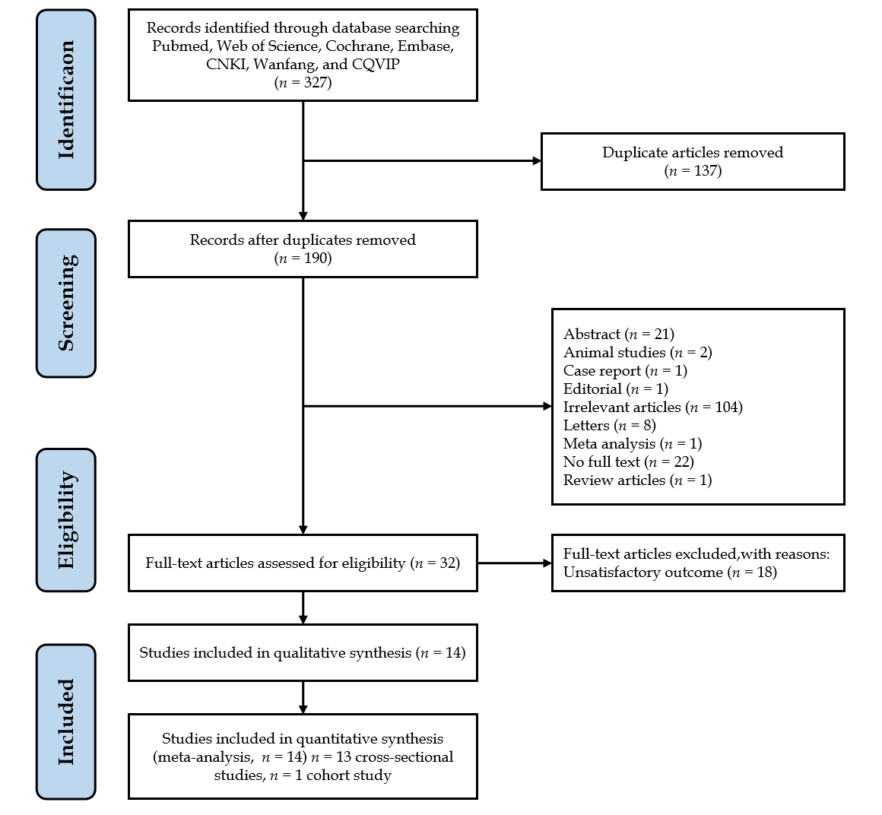
Figure 1 Flow diagram of the literature search and PRISMA.
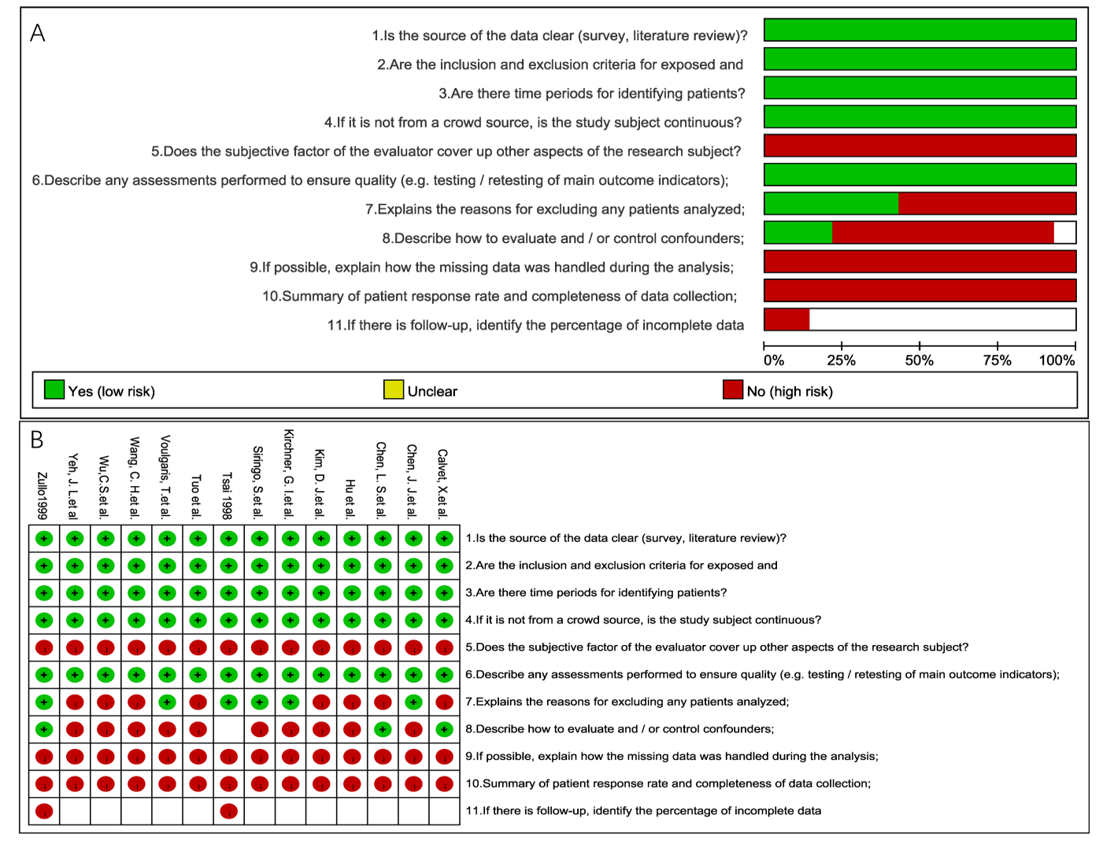
Figure 2 Quality assessment according to the Agency for Healthcare Research and Quality.
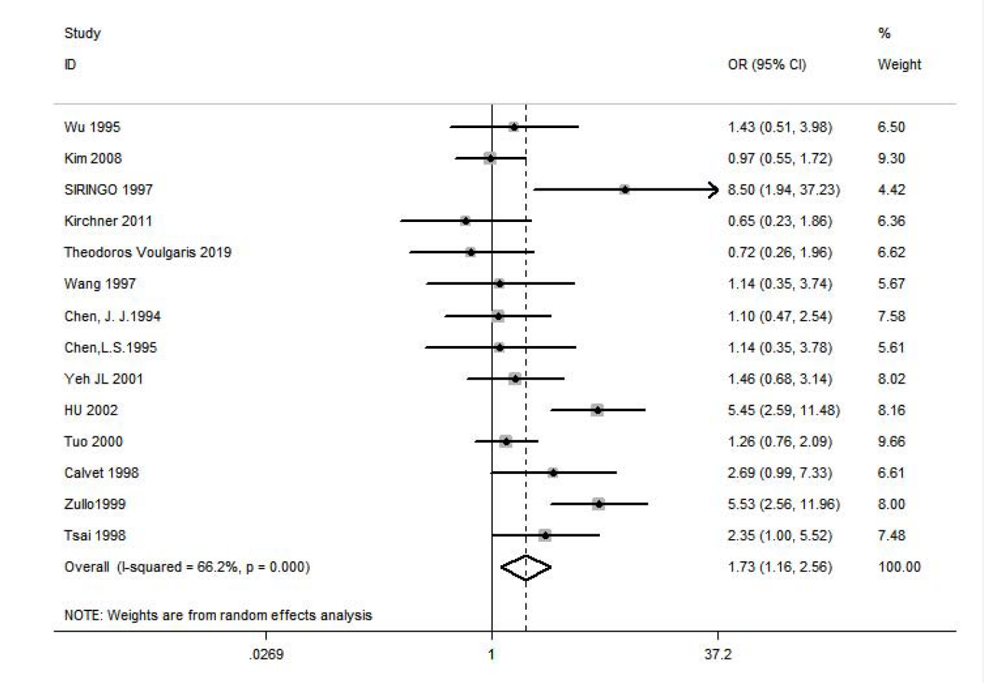
Figure 3 Forest plot and pooled estimates of Helicobacter pylori infection in cirrhotic patients with and without peptic ulcer. CI: Confidence interval; OR: Odds ratio.
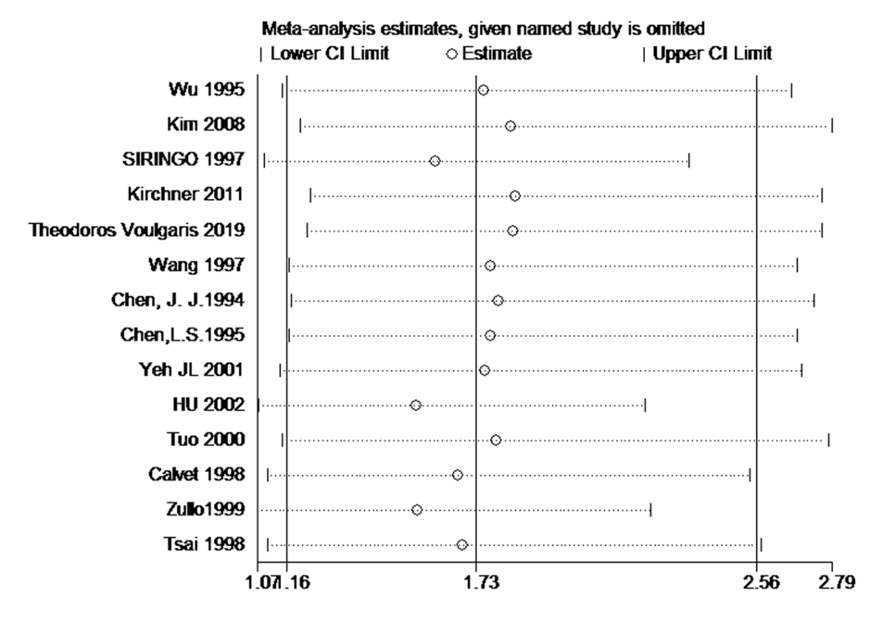
Figure 4 Sensitivity analysis by the one-study removed (leave-one-out) approach.
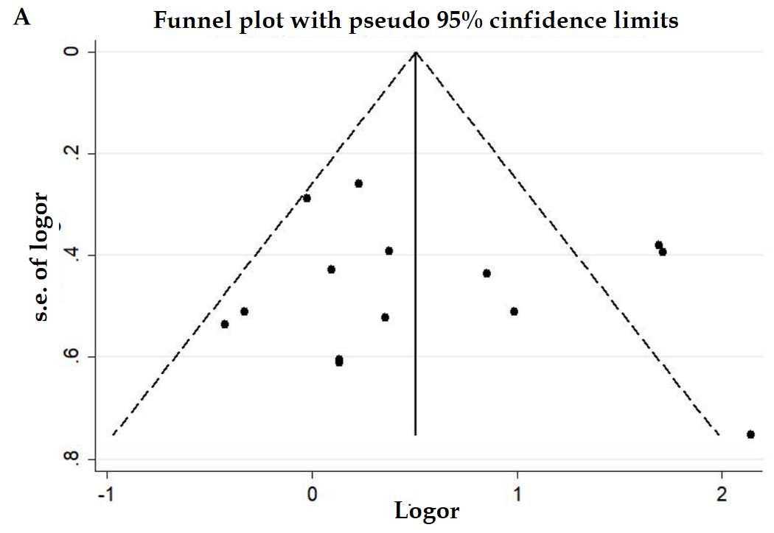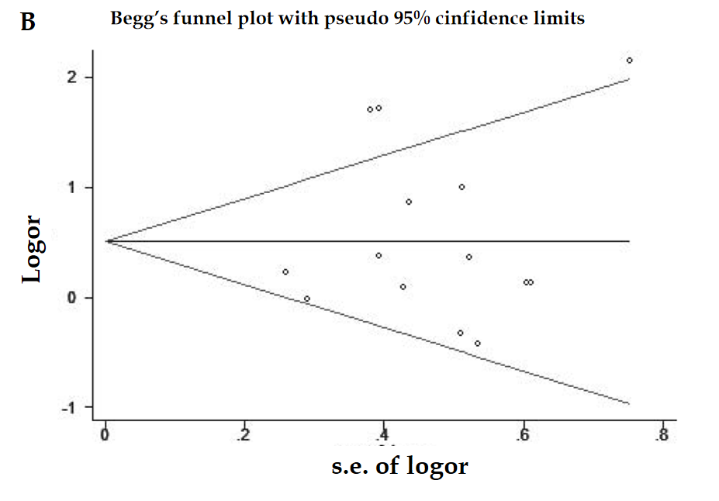
Figure 5 Funnel plot and Begg's funnel plot of association between Helicobacter pylori infection and peptic ulcer in patients with cirrhosis. A: Funnel plot; B: Begg's funnel plot.
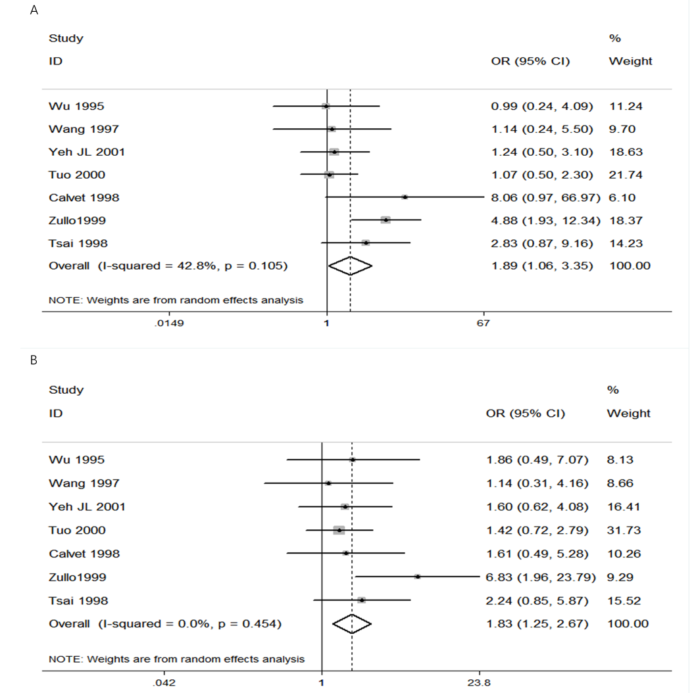
Figure 6 Forest plots and pooled estimates. A: Forest plot and pooled estimates of Helicobacter pylori (H. pylori) infection for cirrhotic patients with and without gastric ulcer; B: Forest plot and pooled estimates of H. pylori infection for cirrhotic patients with and without duodenal ulcer. CI: Confidence interval; OR: Odds ratio.

Table 1 Main characteristics of included studies in the meta-analysis
Study | Area | Study type | Peptic ulcer (Hp+/Hp-) | Prevalence | Non-ulcer (Hp+/Hp-) | Prevalence | D of Hp | D of LC
Wu et al^{[11]}, 1995 | Asia | Cross-sectional | 23/6 | 82.1% | 59/32 | 64.8% | ELISA | Ultrosound
Kim et al^{[13]}, 2008 | Asia | Cross-sectional | 24/46 | 34.3% | 76/142 | 34.9% | Multiple | Multiple
Siringo et al^{[12]}, 1997 | Europe | Cross-sectional | 39/2 | 95.1% | 78/34 | 69.4% | ELISA | Multiple
Kirchner et al^{[10]}, 2011 | Europe | Cross-sectional | 11/7 | 61.1% | 65/27 | 70.7% | ELISA | Multiple
Voulgaris et al^{[16]}, 2019 | Europe | Cross-sectional | 9/10 | 47.4% | 45/36 | 55.6% | Multiple | Multiple
Wang et al^{[15]}, 1997 | Asia | Cross-sectional | 12/18 | 40.0% | 7/12 | 36.8% | Multiple | Multiple
Chen et al^{[17]}, 1994 | Asia | Cross-sectional | 14/17 | 45.2% | 33/44 | 42.9% | ELISA | Multiple
Chen et al^{[18]}, 1995 | Asia | Cross-sectional | 9/7 | 56.3% | 18/16 | 52.9% | RUT | Multiple
Yeh et al^{[19]}, 2001 | Asia | Cohort | 26/19 | 57.8% | 31/33 | 48.4% | UBT | Multiple
Hu et al^{[20]}, 2002 | Asia | Cross-sectional | 86/8 | 91.5% | 373/189 | 66.4% | Multiple | Multiple
Tuo et al^{[21]}, 2000 | Asia | Cross-sectional | 29/45 | 39.2% | 143/279 | 33.9% | Multiple | Multiple
Calvet et al^{[14]}, 1998 | Europe | Cross-sectional | 14/6 | 70.0% | 79/91 | 46.5% | Multiple | Multiple
Zullo et al^{[9]}, 1999 | Europe | Cross-sectional | 51/9 | 85.0% | 84/82 | 50.6% | Multiple | Multiple
Tsai^{[5]}, 1998 | Asia | Cross-sectional | 54/10 | 84.4% | 46/20 | 69.7% | Multiple | Multiple
Cross-sectional studies (n = 13); Cohort study (n = 1). Hp: Helicobacter pylori; LC: Liver cirrhosis; UBT: Urea breath test; RUT: rapid urease test; ELISA: Enzyme linked immunosorbent assay; D: Diagnostic method.
Table 2 Subgroup analyses and meta-regression
Subcategory |  | Random-effects model |  |  | Meta-regression
 | n | OR (95%CI) | P value | I² | Ajusted-R² | P value | c²
Year | 14 | 1.73 (1.16-2.56) | < 0.01 | 66.20% | 4.64% | 0.241 | 33.29%
Before 2000 | 8 | 2.19 (1.31-3.67) | 0.039 | 52.60%
After 2000(2000) | 6 | 1.34 (0.75-2.38) | 0.02 | 73.50%
Area | 14 | 1.73 (1.16-2.56) | < 0.01 | 66.20% | -5.48% | 0.467 | 36.82%
Asia | 9 | 2.19 (0.81-5.97) | 0.001 | 79.0%
Europe | 5 | 1.67 (0.56-4.97) | 0.09 | 74%
Study type | 14 | 1.73 (1.16-2.56) | < 0.01 | 66.20% | -14.28% | 0.817 | 39.89%
Cross-sectional study | 13 | 1.75 (1.14-2.70) | < 0.01 | 68.7%
Cohort study | 1 | 1.46 (0.68-3.14)
Diagnosis of Hp | 14 | 1.73 (1.16-2.56) | < 0.01 | 66.20% | -13.83% | 0.935 | 39.73%
ELISA | 4 | 1.52 (0.62-3.74) | 0.036 | 64.80%
Multiple | 8 | 1.95 (1.12-3.39) | 0.003 | 75.30%
RUT | 1 | 1.14 (0.35-3.78)
UBT | 1 | 1.46 (0.68-3.14)
Diagnosis of liver cirrhosis | 14 | 1.73 (1.16-2.56) | < 0.01 | 66.20% | -11.75% | 0.817 | 39.01%
Ultrasound | 1 | 1.43 (0.51-3.98)
Multiple | 13 | 1.75 (1.15-2.67) | < 0.01 | 68.70%
Case/control ratio | 14 | 1.73 (1.16-2.56) | < 0.01 | 66.20% | -14.36% | 0.787 | 39.92%
≥ 0.3 | 9 | 1.80 (1.11-2.90) | 0.009 | 60.60%
< 0.3 | 5 | 1.59 (0.73-3.47) | 0.001 | 77.90%
Sample size | 14 | 1.73 (1.16-2.56) | < 0.01 | 66.20% | 5.11% | 0.24 | 33.12%
≥ 100 | 12 | 1.89 (1.23-2.91) | < 0.01 | 68.70%
< 100 | 2 | 0.87 (0.40-1.88) | 0.5611
Language | 14 | 1.73 (1.16-2.56) | < 0.01 | 66.20% | -7.60% | 0.439 | 37.56%
English | 12 | 1.59 (1.05-2.42) | 0.005 | 58.7%
Chinese | 2 | 2.55 (0.58-11.14) | 0.001 | 90.6%
UBT: Urea breath test; RUT: Rapid urease test; ELISA: Enzyme linked immunosorbent assay; Hp: Helicobacter pylori; CI: Confidence interval; OR: Odds ratio.

