Name of Journal: World Journal of Gastroenterology
ESPS Manuscript NO: 27945
Manuscript Type: CASE REPORT

Choroidal and skin metastases from colorectal cancer

Ha JY et al. Choroidal cutaneous metastases from CRC

Joo Young Ha, Edward Hynseung Oh, Moon Ki Jung, Song Ee Park, Ji Tak Kim, In Gyu Hwang

Joo Young Ha, Edward Hynseung Oh, Moon Ki Jung, Department of Internal Medicine, Chung-Ang University College of Medicine, Seoul 156-861, South Korea

Ji Tak Kim, Department of Ophthalmology, Chung-Ang University College of Medicine, Seoul 156-861, South Korea

Song Ee Park, In Gyu Hwang, Department of Internal Medicine, Division of Hemato-oncology, Chung-Ang University College of Medicine, Seoul 156-861, South Korea

Author contributions: All authors contributed to acquisition of data, writing, and revision of this manuscript.

Institutional review board statement: This case report was exempt from the Institutional Review Board standards at Chung-Ang University College of Medicine

Informed consent statement: The patient involved in this study gave her written informed consent authorizing use and disclosure of her protected health information.

Conflict-of-interest statement: All the authors have no conflicts of interests to declare.

Open-Access: This article is an open-access article which was selected by an in-house editor and fully peer-reviewed by external reviewers. It is distributed in accordance with the Creative Commons Attribution Non Commercial (CC BY-NC 4.0) license, which permits others to distribute, remix, adapt, build upon this work non-commercially, and license their derivative works on different terms, provided the original work is properly cited and the use is non-commercial. See: http://creativecommons.org/licenses/by-nc/4.0/

Manuscript source: Unsolicited manuscript

Correspondence to: In Gyu Hwang, MD, PhD, Associate Professor, Department of Internal Medicine, Division of Hemato-oncology, Chung-Ang University College of Medicine, 224-1 Heukseok-dong, Dongjak-gu, Seoul 156-861, South Korea. hematoonco@naver.com
Telephone: +82-2-62991403
Fax: +82-2-62992114

Received: June 22, 2016
Peer-review started: June 24, 2016
First decision: August 8, 2016
Revised: August 17, 2016
Accepted: August 30, 2016
Article in press:
Published online:

Abstract
Choroidal and skin metastasis of colon cancer is rare. In women, the frequency of cutaneous metastasis from colon cancer as the primary lesion in is 9% and skin metastasis occurs in 0.81% of all colorectal cancers. We report a patient with colonic adenocarcinoma who presented with visual disorder in her right eye and scalp pain as her initial symptoms. Contrast-enhance orbital magnetic resonance imaging with fat suppression revealed an infrabulbar mass, and skin biopsy of the posterior parietal scalp confirmed adenocarcinoma. These symptoms were diagnosed as being caused by choroidal and skin metastases of colonic adenocarcinoma. We started palliative chemotherapy with oral capecitabine (1000 mg/m², twice a day, on days 1-14) every 3 wk, which was effective at shrinking the brain masses and improving the visual disorder. This is the first report that capecitabine is effective at reducing a choroidal and cutaneous metastatic lesion from right-sided colorectal cancer.

Key words: Colon cancer; Choroid cancer; Skin cancer; Capecitabine

© The Author(s) 2016. Published by Baishideng Publishing Group Inc. All rights reserved.

Core tip: This case report describes a rare choroidal and skin metastasis of colon cancer and demonstrates that capecitabine is effective at reducing a choroidal and skin metastatic lesion from right-sided colorectal cancer.

Ha JY, Oh EH, Jung MK, Park SE, Kim JT, Hwang IG. Choroidal and skin metastases from colorectal cancer. World J Gastroenterol 2016; In press

INTRODUCTION
Choroidal and skin metastases from colorectal cancer are very rare, and it has never been reported in Korea. The uvea consists of the iris, ciliary body, and choroid. Uveal metastasis is reported in 4% of patients who have a primary cancer in the gastrointestinal tract. Metastasis has been found in the iris in 90 (9%), the ciliary body in 22 (2%), and the choroid in 838 (88%) of the 950 metastatic foci in the uvea^{[1]}. Choroidal metastasis from colon cancer has only been reported in 14 cases in the literature, and the frequency of skin metastasis in colorectal carcinoma has been reported in only 2.3%-6% of cases. Here, we report a patient with colon cancer who presented with visual disturbance and a palpable mass in her scalp.

CASE REPORT
A 78-year-old woman visited our hospital in May 2013 complaining of epigastric pain and indigestion. To evaluate these problems, a biopsy was conducted by gastroduodenoscopy and colonoscopy, and colon cancer was diagnosed with no metastasis (cT2N1M0). Laparoscopic right colectomy was performed, and stage IIA (pT3N0M0) colon cancer was determined. The final pathological findings revealed no residual tumor cells in the colon and no metastasis in the lymph nodes (0/19).
The patient received postoperative adjuvant chemotherapy with 5-fluorouracil (5-FU) plus leucovorin for 12 cycles. Six months after adjuvant chemotherapy, chest computed tomography (CT) revealed a 4-mm enhanced lung nodule that remained aggravated for 3 mo. Hematogenous lung metastasis was identified by ¹⁸F-fluorodeoxyglucose-positron emission tomography/computed tomography (18-FDG-PET/CT) (Figure 1). At the same time, the patient complained about visual disturbances and multiple flesh-colored palpable masses on her scalp (Figure 2). Orbit CT and magnetic resonance imaging (MRI) revealed intraocular enhancing masses located nasally and temporally in the right eye, with a diagnosis of choroidal metastasis (Figure 3). Brain MRI was performed to evaluate the palpable mass in her scalp, obtaining enhancing lesions in the right parietal and posterior parietal scalp. Adenocarcinoma was confirmed by skin biopsy (Figure 4). Thus, we made a final diagnosis of stage IV colon cancer with multiple metastases (scalp, right choroid, and lung).
We started palliative chemotherapy with oral capecitabine (1000 mg/m², twice a day, on days 1 -14) every 3 wk^{[2]}, which was effective at shrinking the brain masses and improving the visual disorder (Figure 3C). After 8 months, the level of serum carcinoembryonic antigen was elevated from 2.83 ng/mL to 4.61 ng/mL. All the masses had increased in size, and disease progression was confirmed. Although second-line chemotherapy was administered, the disease was worsening. The patient consequently died.

DISCUSSION
Choroidal and skin metastases from colorectal cancer are a rare event. When it is present, the metastasis suggests dissemination of the disease and a poor prognosis. However, palliative chemotherapy can be an effective method of treatment for these metastases. The median survival time for patients with ocular metastasis due to cancer is 7.4 mo from the time of ocular operation^{[3]}.
The frequency of skin metastasis is relatively low and varies with gender according to the type of underlying malignancy. The most common origins of skin metastasis in women^{[4]} are breast cancer, colon cancer, melanoma, ovarian cancer and lung cancer. In women, the frequency of colon cancer as the primary lesion in skin metastasis is 9%^{[5]}, and skin metastasis occurs in 0.81% of all colorectal cancer^{[6]}.
In this case, we could not pathologically diagnose the choroidal tumor of this patient as a metastatic tumor. Because the posterior choroid is particularly susceptible to the hematogenous dissemination of cancer cells due to its high vascularity, melanomas and metastatic tumors are typically the most common malignant choroid tumors^{[7]}. Therefore, we need to differentiate between melanomas and metastatic tumors. MRI of the orbits demonstrated a well-circumscribed subretinal mass. The lesion was hypointense on the T1-weigthed image without enhancement of the mass and hyperintense on the T2-weighted image. The MRI findings were compatible with a metastatic tumor and not melanoma^{[8]}.
Regarding the treatment of choroidal metastasis, systemic chemotherapy^{[9]}, radiotherapy^{[10]}, chemoradiotherapy, and intravitreal bevacizumab therapy^{[11]} have all been reported. However, the current literature has few recommendations on the appropriate treatment of choroidal metastasis from colorectal cancer. In our case, capecitabine was effective for the choroidal metastasis. And the patients with KRAS wild type, was not administered in anti-EGFR therapy (panitumumab, cetuximab) insurance issues in Korea.
In summary, choroidal or cutaneous metastasis of colon cancer is rare. We report a patient with colon adenocarcinoma who presented with both choroidal and cutaneous metastases of colon cancer as her initial symptoms. This is the first report that capecitabine is effective at reducing a choroidal and cutaneous metastatic lesion from colorectal cancer.

COMMENTS
Case characteristics
A 78-year-old woman with stage IIA colon cancer performed laparoscopic right colectomy and adjuvant chemotherapy 1 years ago, complained about visual disturbances and multiple flesh-colored palpable masses on her scalp.

Clinical diagnosis
The patient had impaired the visual field, and palpable mass on her scalp was non tenderness.

Differential diagnosis
Metastatic colon cancer, Melanoma.

Laboratory diagnosis
Serum carcinoembryonic antigen was elevated.

Imaging diagnosis
Chest computed tomography revealed a 4-mm enhanced lung nodule that remained aggravated and orbital MRI showed a right infrabulbar mass of 12 mm x 5 mm.

Pathological diagnosis
Adenocarcinoma from colon cancer.
.
Treatment
Palliative chemotherapy with oral capecitabine (1000 mg/m², twice a day, on days 1 -14) every 3 wk

Related reports
Choroidal or cutaneous metastasis of colon cancer is rare. This is entity is commonly confused for melanoma and choroidal metastasis from colorectal cancer.

Term explanation
KRAS known as V-Ki-ras2 Kirsten rat sarcoma viral oncogene is a GTPase that in humans is encoded by the KRAS gene. KRAS mutation is predictive of a very poor response to anti-EGFR therapy (panitumumab, cetuximab) in colorectal cancer.

Experiences and lessons
This is commonly confused for melanomas and metastatic tumors in orbit mass. MRI of the orbits demonstrated a well-circumscribed subretinal mass. The lesion was hypointense on the T1-weigthed image without enhancement of the mass and hyperintense on the T2-weighted image. It means not melanoma but metastatic colon cancer.

Peer-review
The authors describe differential diagnosis and treatment of choroidal and skin metastasis from colorectal cancer. Images of the choroidal finding (diagnosis ex juvantibus) are rare and of interest.
REFERENCES
1 Shields CL, Shields JA, Gross NE, Schwartz GP, Lally SE. Survey of 520 eyes with uveal metastases. Ophthalmology 1997; 104: 1265-1276 [PMID: 9261313]
2 Tol J, Koopman M, Cats A, Rodenburg CJ, Creemers GJ, Schrama JG, Erdkamp FL, Vos AH, van Groeningen CJ, Sinnige HA, Richel DJ, Voest EE, Dijkstra JR, Vink-Börger ME, Antonini NF, Mol L, van Krieken JH, Dalesio O, Punt CJ. Chemotherapy, bevacizumab, and cetuximab in metastatic colorectal cancer. N Engl J Med 2009; 360: 563-572 [PMID: 19196673 DOI: 10.1056/NEJMoa0808268]
3 Ferry AP, Font RL. Carcinoma metastatic to the eye and orbit. I. A clinicopathologic study of 227 cases. Arch Ophthalmol 1974; 92: 276-286 [PMID: 4412321]
4 Brownstein MH, Helwig EB. Metastatic tumors of the skin. Cancer 1972; 29: 1298-1307 [PMID: 4336632]
5 Brownstein MH, Helwig EB. Patterns of cutaneous metastasis. Arch Dermatol 1972; 105: 862-868 [PMID: 5030236]
6 Hu SC, Chen GS, Wu CS, Chai CY, Chen WT, Lan CC. Rates of cutaneous metastases from different internal malignancies: experience from a Taiwanese medical center. J Am Acad Dermatol 2009; 60: 379-387 [PMID: 19056145 DOI: 10.1016/j.jaad.2008.10.007]
7 Tong KA, Osborn AG, Mamalis N, Harrie RP, Call NB. Ocular melanoma. AJNR Am J Neuroradiol 1993; 14: 1359-1366 [PMID: 8279332]
8 Peyster RG, Augsburger JJ, Shields JA, Hershey BL, Eagle R, Haskin ME. Intraocular tumors: evaluation with MR imaging. Radiology 1988; 168: 773-779 [PMID: 3406407 DOI: 10.1148/radiology.168.3.3406407]
9 Cole MD, Farah NB. The choroid--an unusual site for metastasis in patients with adenocarcinoma of the rectum--a case report. Eur J Surg Oncol 1985; 11: 275-278 [PMID: 4029408]
10 Linares P, Castanon C, Vivas S, Diz P, Garcia-Palomo A, Llano C, Olcoz JL. Bilateral choroidal metastasis as the initial manifestation of a rectal cancer. J Gastroenterol Hepatol 2004; 19: 726-727 [PMID: 15151641 DOI: 10.1111/j.1440-1746.2004.03465.x]
11 Lin CJ, Li KH, Hwang JF, Chen SN. The effect of intravitreal bevacizumab treatment on choroidal metastasis of colon adenocarcinoma--case report. Eye (Lond) 2010; 24: 1102-1103 [PMID: 19893587 DOI: 10.1038/eye.2009.257]
P-Reviewer: Kleeff J, Lakatos PL, Sunakawa Y S-Editor: Yu J L-Editor: E-Editor:
Specialty type: Gastroenterology and hepatology
Country of origin: South Korea
Peer-review report classification
Grade A (Excellent): 0
Grade B (Very good): B
Grade C (Good): C, C
Grade D (Fair): 0
Grade E (Poor): 0

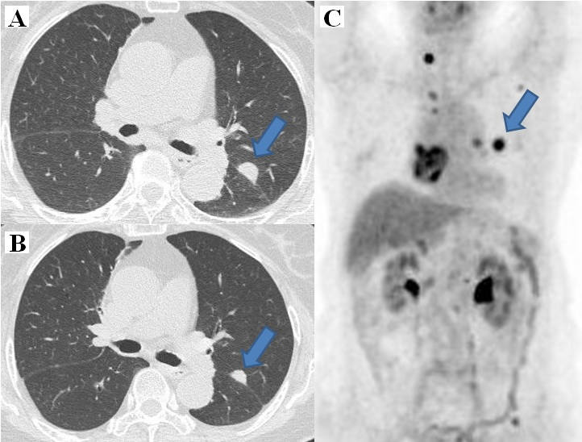Figure 1 Lung metastasis lesion. A: 12 mm enhanced lung nodule was detected by initial chest computed tomography (CT); B: CT 3 mo after capecitabine; C: Initial ¹⁸F-fluorodeoxyglucose-positron emission tomography/CT.

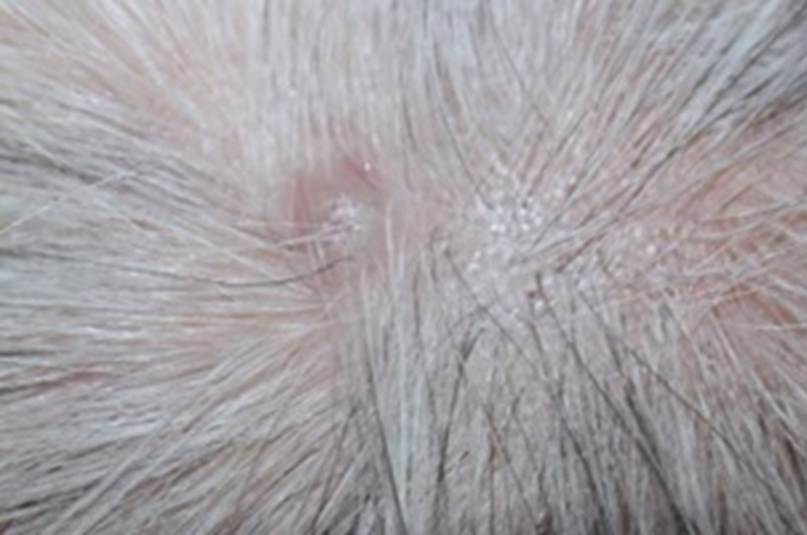Figure 2 Cutaneous metastasis lesions in the head.

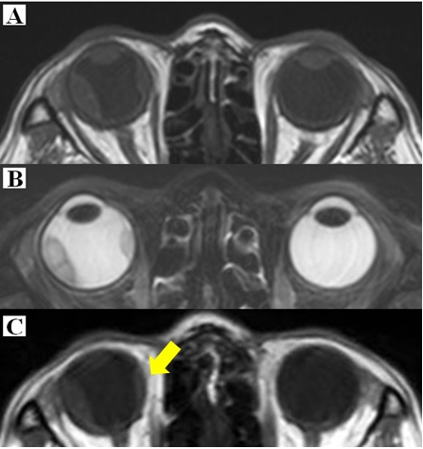
Figure 3 An elevated choroidal neoplasm. A: T1-wieghted with low signal on the enhanced T1-weighted and higher signal on the T2-weighted image, contrast-enhanced orbital magnetic resonance imaging (MRI) with fat suppression revealed an infrabulbar mass of 12 × 5 mm; B: MRI T2-weighted image; C: MRI 3 mo after initiation of therapy (T1-weighed).

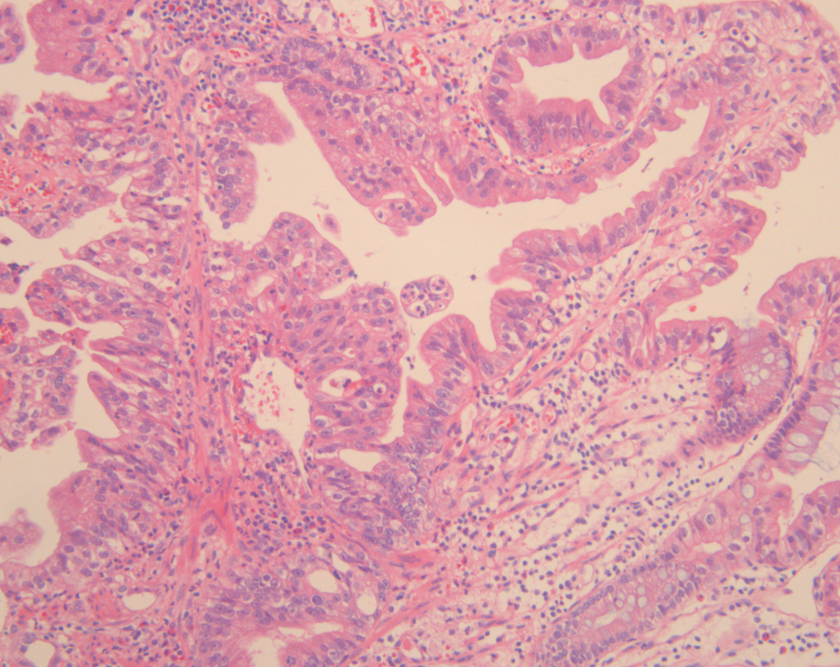Figure 4 Pathologic findings of skin (hematoxylin-eosin staining, magnification × 100).

