Name of Journal: World Journal of Clinical Oncology
Manuscript NO: 81112
Manuscript Type: CORRECTION

Correction: Propensity-matched analysis of patients with intrahepatic cholangiocarcinoma or mixed hepatocellular-cholangiocarcinoma and hepatocellular carcinoma undergoing a liver transplant

Brandão ABM et al. ICC or HCC-CC after LT

Ajacio Bandeira de Mello Brandão, Santiago Rodriguez, Alfeu de Medeiros Fleck Jr, Claudio Augusto Marroni, Mário B Wagner, Alex Hörbe, Matheus V Fernandes, Carlos TS Cerski, Gabriela Perdomo Coral

Ajacio Bandeira de Mello Brandão, Santiago Rodriguez, Claudio Augusto Marroni, Matheus V Fernandes, Gabriela Perdomo Coral, Graduate Program in Medicine: Hepatology, School of Medicine, Universidade Federal de Ciências da Saúde de Porto Alegre, Porto Alegre 90050170, RS, Brazil

Ajacio Bandeira de Mello Brandão, Alfeu de Medeiros Fleck Jr, Claudio Augusto Marroni, Liver Transplantation Group, Santa Casa de Misericórdia de Porto Alegre, Porto Alegre 90020090, RS, Brazil

Santiago Rodriguez, Department of Hepatology, Hospital Vozandes Quito-HVQ, Quito 170521, Ecuador

Mário B Wagner, School of Medicine, Universidade Federal do Rio Grande do Sul (UFRGS), Porto Alegre 90035002, RS, Brazil

Alex Hörbe, Interventional Radiology Unit, Santa Casa de Misericórdia de Porto Alegre, Porto Alegre 90020090, RS, Brunei Darussalam

Carlos TS Cerski, Department of Pathology, School of Medicine, Universidade Federal do Rio Grande do Sul (UFRGS), Porto Alegre 90035002, RS, Brazil

Author contributions: All the authors solely contributed to this paper.

Corresponding author: Ajacio Bandeira de Mello Brandão, PhD, Researcher, Graduate Program in Medicine: Hepatology, School of Medicine, Universidade Federal de Ciências da Saúde de Porto Alegre, R. Eng. Álvaro Nunes Pereira, 400/402, Porto Alegre 90050170, RS, Brazil. ajaciob@gmail.com

Received: October 25, 2022
Revised: December 6, 2022
Accepted: February 1, 2023
Published online: June 24, 2023

Abstract
Rereading the article “Propensity-matched analysis of patients with intrahepatic cholangiocarcinoma or mixed hepatocellular-cholangiocarcinoma and hepatocellular carcinoma undergoing a liver transplant” (DOI: 10.5306/wjco.v13.i8.688), published on August 24, we observe, with concern, that figures 3 and 4 are wrong. The authors have attached the correct figures for correction.

Key Words: Cholangiocarcinoma; Hepatocellular carcinoma; Liver; Prognosis; Recurrence; Survival analysis; Correction

©The Author(s) 2023. Published by Baishideng Publishing Group Inc. All rights reserved.

Citation: Brandão ABM, Rodriguez S, Fleck Jr AM, Marroni CA, Wagner MB, Hörbe A, Fernandes MV, Cerski CT, Coral GP. Correction: Propensity-matched analysis of patients with intrahepatic cholangiocarcinoma or mixed hepatocellular-cholangiocarcinoma and hepatocellular carcinoma undergoing a liver transplant. World J Clin Oncol 2022; 14(6): 227-229
URL: https://www.wjgnet.com/2218-4333/full/v14/i6/227.htm
DOI: https://dx.doi.org/10.5306/wjco.v14.i6.227

Core Tip: The authors have attached the correct figures for correction rereading the article “Propensity-matched analysis of patients with intrahepatic cholangiocarcinoma or mixed hepatocellular-cholangiocarcinoma and hepatocellular carcinoma undergoing a liver transplant” (DOI: 10.5306/wjco.v13.i8.688).

TO THE EDITOR
Rereading our article “Propensity-matched analysis of patients with intrahepatic cholangiocarcinoma or mixed hepatocellular-cholangiocarcinoma and hepatocellular carcinoma undergoing a liver transplant”^{[1]} (DOI: 10.5306/wjco.v13.i8.688), published on August 24, we observe, with concern, that figures 3 and 4 are wrong. At some point, we have mistakenly forwarded a wrong file. Therefore, we attach the correct figures for correction (Figures 1 and 2). We hope that it will be possible to replace the wrong figures with the correct ones and that this process will not be difficult. We apologize in advance for this unfortunate mistake. Of note, correction does not change the interpretation of results or conclusion.

REFERENCES
1 Brandão ABM, Rodriguez S, Fleck AM Jr, Marroni CA, Wagner MB, Hörbe A, Fernandes MV, Cerski CT, Coral GP. Propensity-matched analysis of patients with intrahepatic cholangiocarcinoma or mixed hepatocellular-cholangiocarcinoma and hepatocellular carcinoma undergoing a liver transplant. World J Clin Oncol 2022; 13: 688-701 [PMID: 36160465 DOI: 10.5306/wjco.v13.i8.688]

Footnotes
Conflict-of-interest statement: All authors have no conflicts of interest to disclose.

Open-Access: This article is an open-access article that was selected by an in-house editor and fully peer-reviewed by external reviewers. It is distributed in accordance with the Creative Commons Attribution NonCommercial (CC BY-NC 4.0) license, which permits others to distribute, remix, adapt, build upon this work non-commercially, and license their derivative works on different terms, provided the original work is properly cited and the use is non-commercial. See: https://creativecommons.org/Licenses/by-nc/4.0/

Provenance and peer review: Unsolicited article; Externally peer reviewed.
Peer-review model: Single blind

Peer-review started: October 25, 2022
First decision: November 25, 2022
Article in press: February 1, 2023

Specialty type: Transplantation
Country/Territory of origin: Brazil
Peer-review report’s scientific quality classification
Grade A (Excellent): A, A
Grade B (Very good): 0
Grade C (Good): 0
Grade D (Fair): 0
Grade E (Poor): E

P-Reviewer: Rizzo A, Italy; Wei W, China; Zharikov YO, Russia S-Editor: Chen YL L-Editor: A P-Editor: Chen YL

Figure Legends
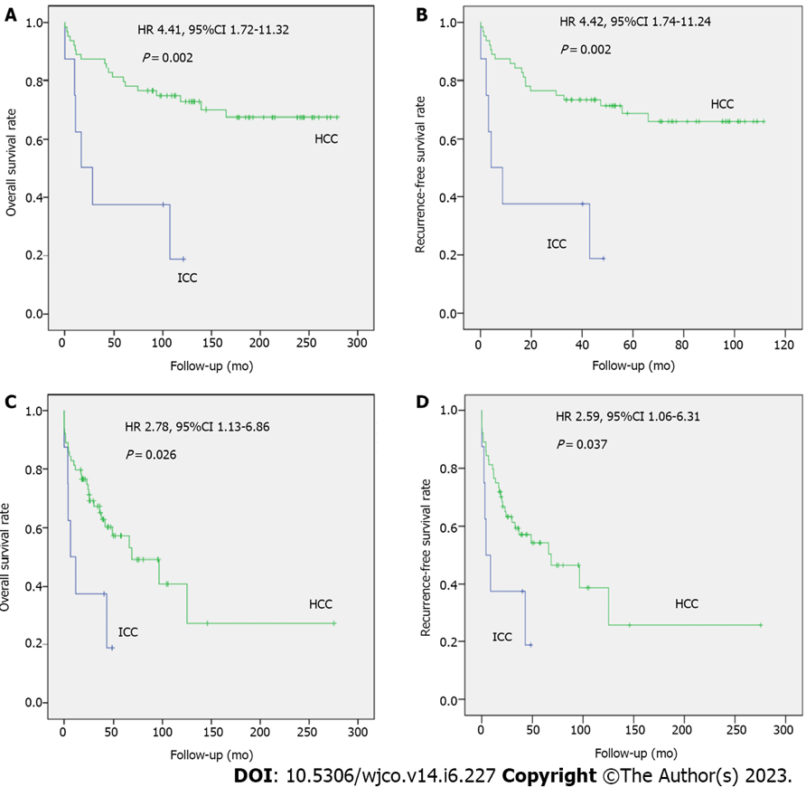
Figure 1 Corrected “Figure 3”. A-D: Kaplan-Meier curves representing post-liver transplant overall survival and recurrence-free survival in patients with intrahepatic cholangiocarcinoma (ICC) compared with patients with hepatocellular carcinoma (HCC), matched 1:8 for pretransplant tumor characteristics (A and B) and posttransplant tumor characteristics (C and D). HRs: Hazard ratios; CI: Confidence interval.

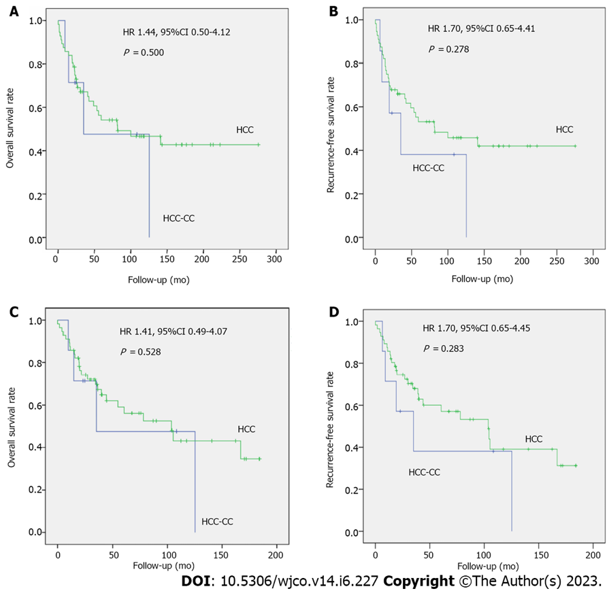
Figure 2 Corrected “Figure 4”. A-D: Kaplan-Meier curves representing post-liver transplant overall survival and recurrence-free survival in patients with mixed hepatocellular-cholangiocarcinoma (HCC-CC) compared with patients with HCC, matched 1:8 for pretransplant tumor characteristics (A and B) and posttransplant tumor characteristics (C and D). HRs: Hazard ratios; CI: Confidence interval.

Published by Baishideng Publishing Group Inc
7041 Koll Center Parkway, Suite 160, Pleasanton, CA 94566, USA
Telephone: +1-925-3991568
E-mail: bpgoffice@wjgnet.com
Help Desk: https://www.f6publishing.com/helpdesk
https://www.wjgnet.com

© 2023 Baishideng Publishing Group Inc. All rights reserved.

