Name of Journal: World Journal of Gastroenterology
ESPS Manuscript NO: 29434
Manuscript Type: ORIGINAL ARTICLE

Observational study
Early thrombomodulin-alfa administration outcome for acute disseminated intravascular coagulopathy in gastrointestinal surgery

Konishi H et al. DIC treatment with TM-α in gastrointestinal surgery

Hirotaka Konishi, Kazuma Okamoto, Katsutoshi Shoda, Tomohiro Arita, Toshiyuki Kosuga, Ryo Morimura, Shuhei Komatsu, Yasutoshi Murayama, Atsushi Shiozaki, Yoshiaki Kuriu, Hisashi Ikoma, Masayoshi Nakanishi, Daisuke Ichikawa, Hitoshi Fujiwara, Eigo Otsuji

Hirotaka Konishi, Kazuma Okamoto, Katsutoshi Shoda, Tomohiro Arita, Toshiyuki Kosuga, Ryo Morimura, Shuhei Komatsu, Yasutoshi Murayama, Atsushi Shiozaki, Yoshiaki Kuriu, Hisashi Ikoma, Masayoshi Nakanishi, Daisuke Ichikawa, Hitoshi Fujiwara, Eigo Otsuji, Division of Digestive Surgery, Department of Surgery, Kyoto Prefectural University of Medicine, Kajii-cho, Kyoto city 6028566, Japan

Author contributions: Konishi H, Okamoto K, Ichikawa D, Fujiwara H and Otsuji E designed the research; Konishi H, Shoda K, Arita T, Kosuga T, Morimura R, Komatsu S, Murayama Y, Shiozaki A, Kuriu Y, Ikoma H, and Nakanishi M performed the research and treated the patients; Konishi H and Okamoto K analyzed the data; Konishi H, Okamoto K and Otsuji E wrote the manuscript.

Institutional review board statement: We did not seek individual ethical approval by the Facility of Science Committee at Kyoto Prefectural University of Medicine because this study was a retrospective observational study without interpositions and with the medical practice necessary for therapeutic purposes.

Informed consent statement: All study participants provided informed written consent prior to their treatments and study enrollment.

Conflict-of-interest statement: All authors declare no conflict of interest related to this study or its publication.

Data sharing statement: The technical appendix, statistical code and dataset are available from the corresponding author at h-koni7@koto.kpu-m.ac.jp.

Open-Access: This article is an open-access article which was selected by an in-house editor and fully peer-reviewed by external reviewers. It is distributed in accordance with the Creative Commons Attribution Non Commercial (CC BY-NC 4.0) license, which permits others to distribute, remix, adapt, build upon this work non-commercially, and license their derivative works on different terms, provided the original work is properly cited and the use is non-commercial. See: http://creativecommons.org/licenses/by-nc/4.0/

Manuscript source: Unsolicited manuscript

Correspondence to: Hirotaka Konishi, MD, PhD, Assistant Researcher, Division of Digestive Surgery, Department of Surgery, Kyoto Prefectural University of Medicine, Kamigyo-ku, 465 Kajii-cho, Kyoto city 6028566, Japan. h-koni7@koto.kpu-m.ac.jp
Telephone: +81-75-2515527
Fax: +81-75-2515522

Received: August 13, 2016
Peer-review started: August 15, 2016
First decision: October 28, 2016
Revised: November 11, 2016
Accepted: November 23, 2016
Article in press:
Published online:
Abstract
AIM
To investigate the efficacy of thrombomodulin (TM)-α for treatment of disseminated intravascular coagulopathy (DIC) in the field of gastrointestinal surgery.

METHODS
Thirty-six peri-operative DIC patients in the field of gastrointestinal surgery who were treated with TM-α were retrospectively investigated. The relationships between patient demographics and the efficacy of TM-α were examined. Analysis of survival at 28 d was also performed on some parameters by means of the Kaplan-Meier method. Relationships between the initiation of TM-α and patient demographics were also evaluated.

RESULTS
Abscess formation or bacteremia was the most frequent cause of DIC (33%), followed by digestive tract perforation (31%). Twenty-six patients developed DIC after surgery, frequently within 1 wk (81%). TM-α was most often administered within 1 d of the DIC diagnosis (72%) and was continued for more than 3 d (64%). Although bleeding tendency was observed in 7 patients (19%), a hemostatic procedure was not needed. DIC scores, systemic inflammatory response syndrome (SIRS) scores, quick-sequential organ failure assessment (qSOFA) scores, platelet counts, and prothrombin time ratios significantly improved after 1 wk (P < 0.05, for all). The overall rate of survival at 28 d was 71%. The duration of TM-α administration (≥ 4 , ≤ 6) and improvements in DIC-associated scores (DIC, SIRS and qSOFA) at 1 wk were significantly better prognostic factors for 28-d survival (P < 0.05, for all). TM-α was administered significantly earlier to patients with severe clinical symptoms, such as high qSOFA scores, sepsis, shock or high lactate values (P < 0.05, for all).

CONCLUSION
Early administration of TM-α and improvements in each parameter were essential for treatment of DIC. The diagnosis of patients with mild symptoms requires further study.

Key words: Acute disseminated intravascular coagulopathy; Thrombomodulin-α; Gastrointestinal surgery; Systemic inflammatory response syndrome; Quick-sequential organ failure assessment

© The Author(s) 2016. Published by Baishideng Publishing Group Inc. All rights reserved.

Core tip: The present study investigated the efficacy of thrombomodulin (TM)-α for treatment of disseminated intravascular coagulopathy (DIC) in the field of gastrointestinal surgery. DIC frequently developed within 1 wk of surgery. TM-α was frequently administered within 1 d of the DIC diagnosis and was continued for more than 3 d. The duration of TM-α administration and improvements in DIC-associated parameters at 1 wk were better prognostic factors for 28-d survival. TM-α was administered significantly earlier to patients with severe clinical symptoms. The early administration of TM-α and improvements in DIC parameters were essential for the treatment of DIC.

Konishi H, Okamoto K, Shoda K, Arita T, Kosuga T, Morimura R, Komatsu S, Murayama Y, Shiozaki A, Kuriu Y, Ikoma H, Nakanishi M, Ichikawa D, Fujiwara H, Otsuji E. Early thrombomodulin-alfa administration outcome for acute disseminated intravascular coagulopathy in gastrointestinal surgery. World J Gastroenterol 2016; In press

INTRODUCTION
Disseminated intravascular coagulopathy (DIC) is characterized by the systemic activation of blood coagulation and continuous generation of intravascular fibrin, which contribute to multiple organ dysfunction syndrome or other life-threating conditions^{[1,2]}. In the field of gastrointestinal surgery, DIC has been reported as a consequence of emergency surgery, severe complications or some types of malignancies^{[3-5]}, and as a frequent complicating factor for conditions leading to sepsis or a shock status. The acute DIC scoring system put forth by the Japanese Association for Acute Medicine (JAAM) is in widespread use for diagnosis of acute DIC^{[6,7]}. In order to effectively treat DIC, the underlying causes need to be improved and appropriate drugs need to be administered intensively in the earliest stage possible. However, survival rates are never high, as has been previously reported^{[1,2]}.
In DIC, the activation of coagulation and inhibition of fibrinolysis lead to a hypercoagulable state and the deposition of fibrin in micro-vessels. Thrombomodulin-α (TM-α) is a recombinant human soluble thrombomodulin, which is a thrombin receptor on endothelial cell surfaces^{[8-10]}. Thrombin binds to TM-α, and the thrombin-TM-α complex inactivates intravascular coagulation by activating the protein C pathway. The subsequent formation of thrombin and triggering of inflammatory reactions are regulated by TM-α, after which hypercoagulable DIC states become improved. Therefore, TM-α was approved as a curative medicine for the treatment of DIC in 2008, and its effects on DIC have been investigated in multicenter randomized clinical trials in Japan^{[8,11]}. Resolution rates for DIC and bleeding symptoms were found to be significantly better for patients treated with TM-α than those treated with heparin^{[12,13]}.
Previous studies have determined the efficacy of TM-α treatments for DIC associated with gastroenterological surgery^{[4,5]}; however, the data are still insufficient to establish the optimal therapeutic strategies for hematological malignancies or infections such as sepsis. The optimal initiation time or duration of the administration of TM-α and the predictive factors for therapeutic efficacy remain unclear for actual clinical practice. In the present study, the treatment of DIC by TM-α in the field of gastrointestinal surgery was retrospectively summarized, and outcomes were investigated.

MATERIALS AND METHODS
Patients and treatment courses
Thirty-six patients were retrospectively investigated. Each had been diagnosed with DIC in the peri-operative period and treated with TM-α between January 2012 and December 2015 at the Division of Digestive Surgery in Kyoto Prefectural University of Medicine (Japan). The JAAM DIC scoring system was applied as the diagnostic criteria for DIC (DIC score ≥ 4)^{[6,7]}. The baseline demographics and characteristics of patients are summarized in Tables 1 and 2. Some types of digestive cancers were the cause of DIC in 13 patients (cancer-associated).
TM-α (Recomodulin® injection; Asahi Kasei Pharma Corporation, Tokyo, Japan) was administered intravenously at a dose of 380 U/kg per day and continued as necessary^{[8-10]}. This dose was decreased to 130 U/kg in a patient with severe renal failure, according to attending physicians’ decision and the manufacturer’s instructions. Particularly, the patients who needed dialysis or were considered to have increased creatinine and decreased eGFR were given a reduced dose of TM-α. The duration of the administration of TM-α, and its combined usage with other treatment drugs, were also decided by the attending physicians. Clinicopathological and laboratory data obtained at 1 wk and 2 wk after the initiation of TM-α administration were investigated, and the mortality rate at 28 d was determined.
This study was conducted in accordance with the principles of the Declaration of Helsinki, and written informed consent for the treatment and data collection was obtained from all patients. We did not seek individual ethical approval by the Facility of Science Committee at Kyoto Prefectural University of Medicine because this was a retrospective observational study without interpositions and with the medical practice necessary for therapeutic purposes.

Diagnostic criteria for DIC
In the present study, the following criteria were employed to diagnose DIC and compare treatment efficacies. Systemic inflammatory response syndrome (SIRS) scores were evaluated according to a previous study^{[14]} and a SIRS score of ≥ 3 was converted to 1 point for the JAAM DIC score^{[7]}. Quick sequential organ failure assessment (qSOFA) scores were determined by more than 1 point of altered mentation, systolic blood pressure of ≤ 100 mmHg, and respiratory rate of ≥ 22/min^{[15]}. With respect to updates to the definitions for sepsis and septic shock criteria, sepsis was determined by more than 1 point of the qSOFA score in the present study^{[15]}, while traditional sepsis was defined by the existence of infection and SIRS. Shock was defined by a serum lactate level of > 2 mmol/L and a requirement for vasopressors to maintain mean arterial pressure despite adequate fluid resuscitation^{[15]}.

Statistical analysis
Statistical analyses were performed using the JMP 12 software program. The Wilcoxon signed-rank test was used to analyze the relationships between various biochemical measurements. A survival curve for overall survival was derived using the Kaplan-Meier method and compared by the stratified log-rank test. A P-value less than 0.05 was considered significant.

RESULTS
Baseline demographics and characteristics of patients
Clinical data of the 36 patients in this study are summarized in Tables 1 and 2. DIC was caused by a wide variety of diseases, with abscess formation or bacteremia after surgery being the most frequent cause (12/36, 33%), followed by perforation of the digestive tract (11/36, 31%). Twenty-six patients (72%) developed DIC after surgery, frequently within 1 wk of surgery (21/26, 81%). TM-α was frequently used in conjunction with other drugs and treatments, such as combined administration with anti-thrombin concentrates, γ-globulin agents, and vasopressors. Unfractionated heparins were administered to 4 patients (11%) as an alternative to TM-α.
A number of patients were diagnosed as having DIC with JAAM score of 4 or 5 (24/36, 67%). At the time of the DIC diagnosis, 5 (14%) and 14 (39%) patients did not fulfill the criteria of SIRS (≥ 2) and qSOFA (≥ 2), respectively. For most patients, TM-α was administered within 1 d of the DIC diagnosis (26/36, 72%) and was continued for more than 3 d (23/36, 64%). However, 5 patients (14%) were administered TM-α for only 1 d; the reasons for the discontinuation of its administration are listed in Table 3. Although bleeding tendency was observed in 7 patients (19%), severe bleeding was not observed and a hemostatic procedure was not required.

Effects of TM-α administration on DIC parameters
Figure 1 shows alterations in each DIC-associated parameter between before and after 1 wk of the treatment in patients administered TM-α for more than 1 d. DIC scores (P = 0.003), SIRS scores (P = 0.04), qSOFA scores (P = 0.003), platelet counts (P = 0.01) and prothrombin time ratios (P = 0.006) were significantly improved after 1 wk of the treatment. C-reactive protein and creatinine values were also improved (data not shown).

Survival after TM-α administration
The overall survival at 28 d for all patients administered TM-α for more than 1 d is shown in Figure 2, and the overall survival rate was 71%. A survival analysis on some parameters is shown in Table 4. The duration of administration (≥ 4, ≤ 6; P = 0.03) and improvements in DIC scores (P = 0.01), SIRS scores (P = 0.09) and qSOFA scores (P = 0.001) at 1 wk were significant prognostic factors for 28-d survival.

Relationships between the initiation of treatment and patient demographics
In the survival analysis, patients administered TM-α within 1 d of the DIC diagnosis had slightly better prognoses than those administered it after 2 d (74% vs 50%; Table 4). TM-α was administered significantly earlier for patients with severe clinical symptoms at the time of DIC diagnosis, such as high qSOFA scores (P = 0.001), sepsis (P = 0.001), shock (P = 0.02) or high lactate values (P = 0.02) (Table 5).

DISCUSSION
DIC is not prevalent in the field of gastrointestinal surgery, but it is life-threating once it develops^{[4]}. Early intensive care, including the administration of anti-thrombin concentrates and γ-globulin agents, has been shown to effectively improve the prognosis of patients with DIC^{[13,16]}. The early administration of TM-α has also been reported to improve severe DIC and prognoses in the field of gastrointestinal surgery^{[3-6]}.
In the present study, peri-operative DIC patients in the field of gastrointestinal surgery who were treated with TM-α were retrospectively investigated. Some DIC-associated parameters, such as DIC (JAAM), SIRS and qSOFA scores, were significantly improved at 1 wk after the initiation of the TM-α treatment, and these improvements correlated with the better 28-d survival rate. On the other hand, in spite of the diagnosis of DIC, the administration of TM-α was significantly delayed in patients with mild symptoms, such as low SIRS or qSOFA scores, and the absence of sepsis or shock.
In order to achieve an early and accurate diagnosis of DIC, not only the counts of each parameter but also the changes in platelet counts are important. In the present study, the DIC scores of 4 patients were decided by changes in platelet counts measured in a 24-h period (data not shown). DIC scores were found to increase due to decrease in platelet counts of > 30% or 50% in a 24-h period, and further reductions of platelet counts were observed on the next day. Therefore, the rate of decreases in platelet counts is also important for reaching an early decision on the DIC score.
In the survival analysis, the overall survival rate at 28 d (71%) was similar to previous findings^{[4]}. On the other hand, the survival rate of patients administered TM-α at 2 d after the DIC diagnosis was slightly worse (74% vs 50%). Early treatments, including TM-α, are generally considered to be advantageous for improving the prognosis of DIC patients^{[5,6,10]}. In the present study, the administration of TM-α was significantly delayed (by more than 1 d after the DIC diagnosis) in patients who were less symptomatic (i.e., not meeting the criteria of qSOFA, sepsis or shock and having low lactate values). Therefore, early and accurate diagnosis of DIC and initiation of treatments will be needed for all patients with mild symptoms who are suspected of having DIC.
The definitions of sepsis and shock were recently revised^{[15]}. Previously, traditional sepsis had been defined as the presence of infection and SIRS, but it is now defined by an increase in the SOFA score (≥ 2). Moreover, shock is defined by a requirement for vasopressors and enhanced serum lactate levels (> 2 mmol/L). In the present study, we used qSOFA scores exclusively because we were unable to confirm all data to provide an accurate SOFA score.
The indication of TM-α administration is decided by the JAAM DIC score (≥ 4) only, and these DIC patients frequently present with accompanying severe complications such as shock or sepsis^{[2, 13-16]}. It remains controversial whether these severe conditions can influence the therapeutic effects of DIC. In the present study, the parameters showing severe conditions were also investigated, but were found to not significantly affect the efficacy of TM-α or prognosis of patients.
The present study had some limitations. The number of patients examined was small because DIC is not prevalent in the field of gastrointestinal surgery. Furthermore, DIC scores were retrospectively evaluated by only the JAAM acute DIC scoring system, and we did not confirm that the attending physicians gave accurate DIC scores at diagnosis. In the future, the comparisons with other criteria, such as the International Society for Thrombosis and Haemostasis (ISTH) DIC score, will be needed. In previous studies, DIC patients treated with TM-α for approximately 6 d have been commonly evaluated^{[4, 10]}, while patients in the present study were treated for shorter or longer durations. Some of our patients who were administered TM-α for a shorter duration showed amelioration of the DIC, whereas many patients with a shorter or longer duration of administration had worse prognoses. A 6-d administration is needed if patient conditions permit it, and the advantages and disadvantages of the early discontinuation of administration due to improvements in DIC require further investigations. Another limitation is that all patients in this study were treated with TM-α and other drugs, and comparisons of the efficacy of the treatments, prognosis of patients or development of side effects between TM-α and the other drugs were not performed.
In conclusion, although the number of patients examined in the present study was small, we herein demonstrated that the early diagnosis of DIC and initiation of the TM-α administration are effective for achieving improvements in DIC in the field of gastrointestinal surgery. The diagnosis of patients with mild symptoms requires further study.

COMMENTS
Background
Disseminated intravascular coagulopathy (DIC) has been reported in the field of gastrointestinal surgery as a consequence of emergency surgery, severe complications or some types of malignancies, and has been shown to frequently complicate conditions leading to sepsis or a shock status. In order to effectively treat DIC, the underlying causes need to be resolved, or at least improved, and appropriate drugs need to be administered intensively at earlier stage. However, survival rates are never high, as has been reported consistently.

Research frontiers
Thrombomodulin-α (TM-α) was approved as a curative medicine for the treatment of DIC, and previous studies have reported its efficacy for DIC associated with gastrointestinal surgery. However, the data are still insufficient to establish optimal therapeutic strategies. The research hotspot is the introduction of an optimized treatment with TM-α and identification and clinical application of predictive factors to improve therapeutic efficacy of DIC in the field of gastrointestinal surgery.

Innovations and breakthroughs
DIC is not prevalent in the field of gastrointestinal surgery, but is life-threating once it develops. In the present study, some DIC-associated parameters, such as DIC (Japanese Association for Acute Medicine, JAAM), systemic inflammatory response syndrome (SIRS) and quick-sequential organ failure assessment (qSOFA) scores, were significantly improved at 1 wk after the initiation of TM-α treatment, and these improvements correlated with better 28-d survival. Early diagnosis of DIC and initiation of the TM-α administration are effective for achieving improvements in DIC in the field of gastrointestinal surgery. On the other hand, in spite of DIC diagnosis, administration of TM-α was significantly delayed in patients with mild symptoms, such as low SIRS or qSOFA scores, and the absence of sepsis or shock.

Applications
The data in this study suggested that early diagnosis of DIC and initiation of the TM-α administration are clinically effective for DIC treatment in the field of gastrointestinal surgery. Furthermore, this study also provided readers with important information regarding the delay of TM-α administration for less symptomatic DIC patients.

Terminology
DIC leads to a hypercoagulable state and the deposition of fibrin in micro-vessels. TM-α is a recombinant human soluble thrombomodulin, which is a thrombin receptor on endothelial cell surfaces. Thrombin binds to TM-α, and the thrombin-TM-α complex inactivates intravascular coagulation by activating the protein C pathway. Therefore, the further formation of thrombin and triggering of inflammatory reactions are regulated by TM-α, and hypercoagulable DIC states are improved.

Peer-review
This manuscript reports on the early diagnosis and earlier initiation of recombinant thrombomodulin for DIC patients in the field of digestive surgery. Identification of an optimized treatment with TM-α and clinical application of predictive factors will be very useful for DIC treatment, improving the therapeutic efficacy.
REFERENCES
1 Levi M. Disseminated intravascular coagulation. Crit Care Med 2007; 35: 2191-2195 [PMID: 17855836 DOI: 10.1097/01.CCM.0000281468.94108.4B]
2 Okamoto K, Tamura T, Sawatsubashi Y. Sepsis and disseminated intravascular coagulation. J Intensive Care 2016; 4: 23 [PMID: 27011792 DOI: 10.1186/s40560-016-0149-0]
3 Tamura K, Saito H, Asakura H, Okamoto K, Tagawa J, Hayakawa T, Aoki N. Recombinant human soluble thrombomodulin (thrombomodulin alfa) to treat disseminated intravascular coagulation in solid tumors: results of a one-arm prospective trial. Int J Clin Oncol 2015; 20: 821-828 [PMID: 25385713 DOI: 10.1007/s10147-014-0768-1]
4 Hashimoto D, Chikamoto A, Miyanari N, Ohara C, Kuramoto M, Horino K, Ohshima H, Baba H. Recombinant soluble thrombomodulin for postoperative disseminated intravascular coagulation. J Surg Res 2015; 197: 405-411 [PMID: 25972310 DOI: 10.1016/j.jss.2015.04.048]
5 Ito T, Nagahara A, Osada T, Kato J, Ueyama H, Saito H, Taniki N, Kanazawa R, Shimizu R, Sai J, Shiina S, Watanabe S. Efficacy of recombinant human soluble thrombomodulin in patients with sepsis and disseminated intravascular coagulation in the gastroenterology field. Biomed Rep 2015; 3: 457-460 [PMID: 26171148 DOI: 10.3892/br.2015.464]
6 Mimuro J, Takahashi H, Kitajima I, Tsuji H, Eguchi Y, Matsushita T, Kuroda T, Sakata Y. Impact of recombinant soluble thrombomodulin (thrombomodulin alfa) on disseminated intravascular coagulation. Thromb Res 2013; 131: 436-443 [PMID: 23566534 DOI: 10.1016/j.thromres.2013.03.008]
7 Gando S, Saitoh D, Ogura H, Fujishima S, Mayumi T, Araki T, Ikeda H, Kotani J, Kushimoto S, Miki Y, Shiraishi S, Suzuki K, Suzuki Y, Takeyama N, Takuma K, Tsuruta R, Yamaguchi Y, Yamashita N, Aikawa N. A multicenter, prospective validation study of the Japanese Association for Acute Medicine disseminated intravascular coagulation scoring system in patients with severe sepsis. Crit Care 2013; 17: R111 [PMID: 23787004 DOI: 10.1186/cc12783]
8 Saito H, Maruyama I, Shimazaki S, Yamamoto Y, Aikawa N, Ohno R, Hirayama A, Matsuda T, Asakura H, Nakashima M, Aoki N. Efficacy and safety of recombinant human soluble thrombomodulin (ART-123) in disseminated intravascular coagulation: results of a phase III, randomized, double-blind clinical trial. J Thromb Haemost 2007; 5: 31-41 [PMID: 17059423 DOI: 10.1111/j.1538-7836.2006.02267.x]
9 Tsuruta K, Yamada Y, Serada M, Tanigawara Y. Model-based analysis of covariate effects on population pharmacokinetics of thrombomodulin alfa in patients with disseminated intravascular coagulation and normal subjects. J Clin Pharmacol 2011; 51: 1276-1285 [PMID: 21098690 DOI: 10.1177/0091270010381900]
10 Eguchi Y, Gando S, Ishikura H, Saitoh D, Mimuro J, Takahashi H, Kitajima I, Tsuji H, Matsushita T, Tsujita R, Nagao O, Sakata Y. Post-marketing surveillance data of thrombomodulin alfa: sub-analysis in patients with sepsis-induced disseminated intravascular coagulation. J Intensive Care 2014; 2: 30 [PMID: 25520842 DOI: 10.1186/2052-0492-2-30]
11 Aikawa N, Shimazaki S, Yamamoto Y, Saito H, Maruyama I, Ohno R, Hirayama A, Aoki Y, Aoki N. Thrombomodulin alfa in the treatment of infectious patients complicated by disseminated intravascular coagulation: subanalysis from the phase 3 trial. Shock 2011; 35: 349-354 [PMID: 21068698 DOI: 10.1097/SHK.0b013e318204c019]
12 Yamakawa K, Ogura H, Fujimi S, Morikawa M, Ogawa Y, Mohri T, Nakamori Y, Inoue Y, Kuwagata Y, Tanaka H, Hamasaki T, Shimazu T. Recombinant human soluble thrombomodulin in sepsis-induced disseminated intravascular coagulation: a multicenter propensity score analysis. Intensive Care Med 2013; 39: 644-652 [PMID: 23361628 DOI: 10.1007/s00134-013-2822-2]
13 Iba T, Thachil J. Present and future of anticoagulant therapy using antithrombin and thrombomodulin for sepsis-associated disseminated intravascular coagulation: a perspective from Japan. Int J Hematol 2016; 103: 253-261 [PMID: 26588929 DOI: 10.1007/s12185-015-1904-z]
14 American College of Chest Physicians/Society of Critical Care Medicine Consensus Conference: definitions for sepsis and organ failure and guidelines for the use of innovative therapies in sepsis. Crit Care Med 1992; 20: 864-874 [PMID: 1597042]
15 Singer M, Deutschman CS, Seymour CW, Shankar-Hari M, Annane D, Bauer M, Bellomo R, Bernard GR, Chiche JD, Coopersmith CM, Hotchkiss RS, Levy MM, Marshall JC, Martin GS, Opal SM, Rubenfeld GD, van der Poll T, Vincent JL, Angus DC. The Third International Consensus Definitions for Sepsis and Septic Shock (Sepsis-3). JAMA 2016; 315: 801-810 [PMID: 26903338 DOI: 10.1001/jama.2016.0287]
16 Yoshimura J, Yamakawa K, Ogura H, Umemura Y, Takahashi H, Morikawa M, Inoue Y, Fujimi S, Tanaka H, Hamasaki T, Shimazu T. Benefit profile of recombinant human soluble thrombomodulin in sepsis-induced disseminated intravascular coagulation: a multicenter propensity score analysis. Crit Care 2015; 19: 78 [PMID: 25883031 DOI: 10.1186/s13054-015-0810-3]
P-Reviewer: Fareed J, Garcia-Olmo D S-Editor: Yu J L-Editor: E-Editor:
Specialty type: Gastroenterology and hepatology
Country of origin: Japan
Peer-review report classification
Grade A (Excellent): 0
Grade B (Very good): B
Grade C (Good): C
Grade D (Fair): 0
Grade E (Poor): 0

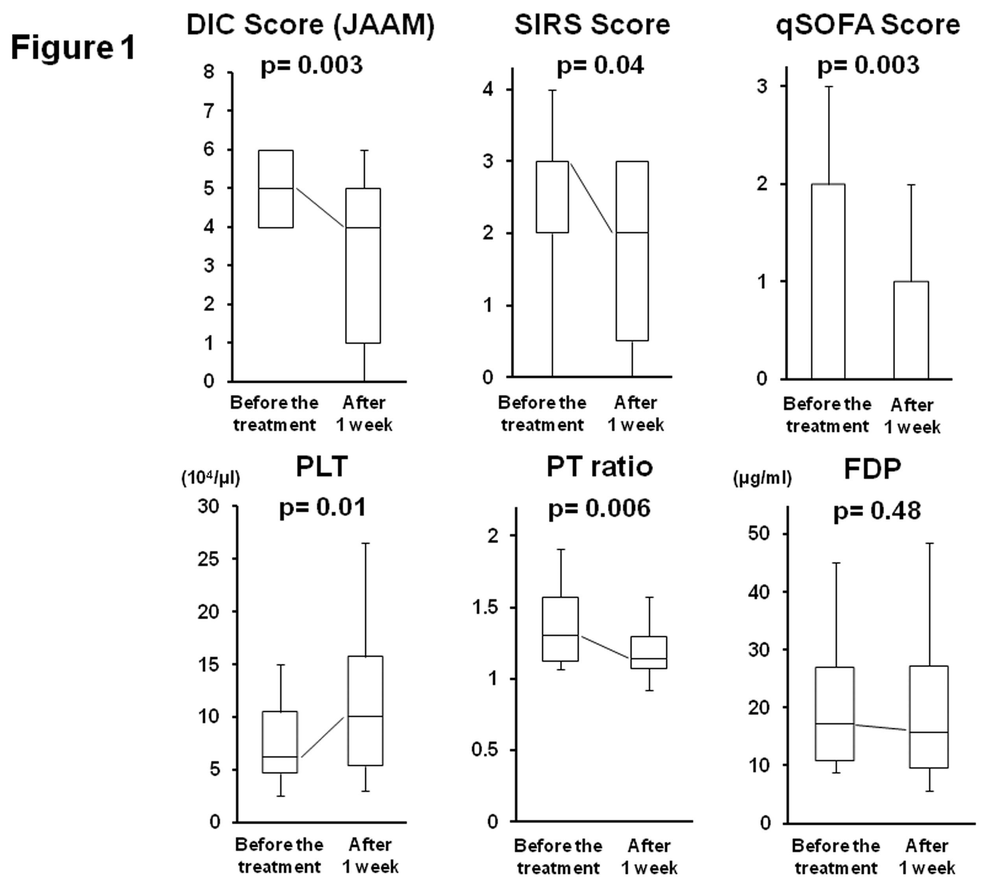
Figure 1 Alterations in disseminated intravascular coagulopathy -associated parameters between before and after 1 wk of treatment with thrombomodulin-α. Disseminated intravascular coagulopathy (DIC) scores (Japanese Association for Acute Medicine, JAAM), systemic inflammatory response syndrome (SIRS) scores, quick-sequential organ failure assessment (qSOFA) scores, platelet (PLT) counts, prothrombin time (PT) ratios, and fibrin degradation products (FDP) values were compared for before and after 1 wk of thrombomodulin-α (TM-α) treatment. All parameters, except for FDP values, were significantly improved by TM-α administration after 1 wk. The Mann-Whitney U-test was used for the analysis.
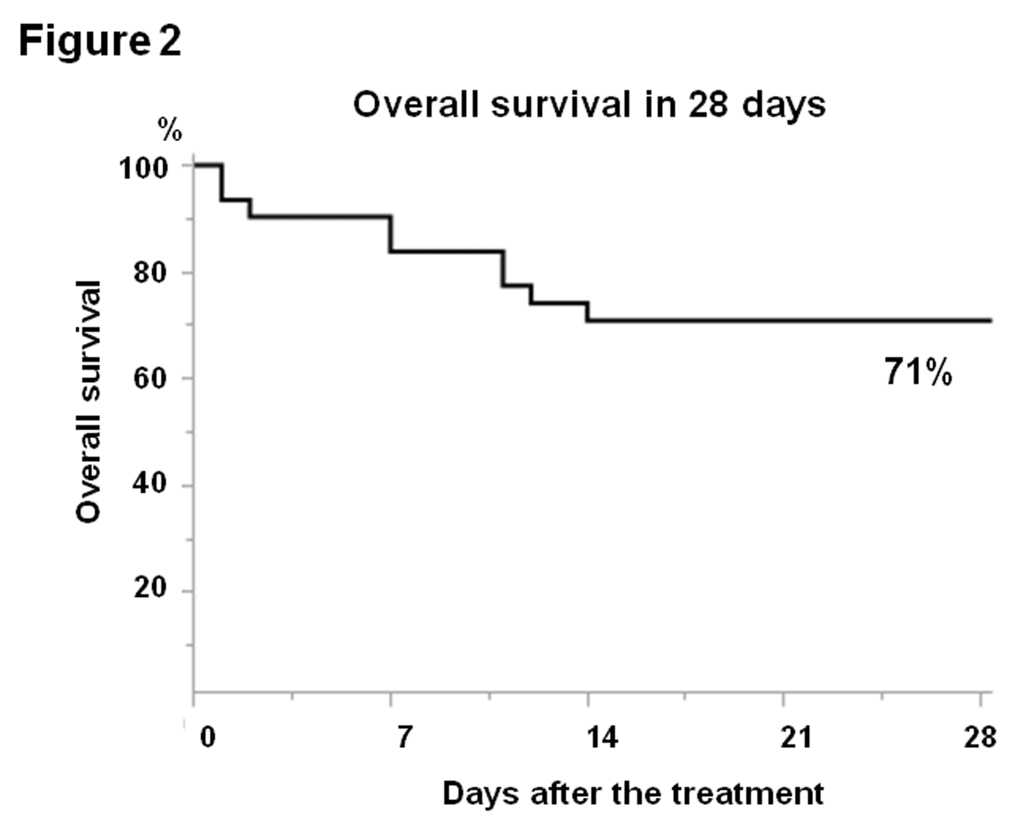
Figure 2 Survival analysis of the disseminated intravascular coagulopathy patients treated with thrombomodulin-α. Overall survival at 28 d was examined using the Kaplan-Meier method (n = 31) in order to evaluate the efficacy of thrombomodulin-α (TM-α) administration. The patients used in this analysis were treated with TM-α more than 1 d, and the overall survival rate was 71%.

Table 1 Baseline demographics
 | Subjects |  | n = 36
Sex, F/M |  |  | 12/24
Age, median (range) |  |  | 71 (48-86)
Underlying disease
 | Perforation | Gastric | 1
 |  | Small intestine | 2
 |  | Colo/Rectal | 8
 | Abscess/Bacteremia |  | 12
 | Ileus |  | 3
 | Pancreatitis |  | 2
 | Pneumonia |  | 5
 | Drug-induced |  | 3
Peri-operative, No/Yes |  |  | 10/26
Cancer-associated, No/Yes |  |  | 23/13
Post-operative day, ≤ 7/> 7 |  |  | 21/5
Combination treatment for DIC
 | Unfractionated heparins |  | 4
 | Anti-thrombin concentrates |  | 28
 | γ-globulin agents |  | 29
 | Vasopressors |  | 26
 | Protease inhibitors |  | 4
 | Sivelestat sodium hydrates |  | 4
 | Steroid preparations |  | 7
 | Dialysis |  | 5
 | Blood transfusion |  | 4
DIC: Disseminated intravascular coagulopathy.

Table 2 Patient characteristics
Subjects |  | n = 36
DIC scores | 4 | 15
Before the treatment | 5 | 9
(JAAM criteria) | 6 | 8
 | 7 | 1
 | 8 | 3
SIRS scores | 0/1 | 5
Before the treatment | 2 | 9
 | 3 | 15
 | 4 | 7
qSOFA scores | 0 | 10
Before the treatment | 1 | 4
 | 2 | 17
 | 3 | 5
Duration of DIC | -2/-1 | 4
Before the administration of TM-α (d) | 0 | 16
 | 1 | 10
 | 2 | 1
 | 3 | 4
 | ≥ 4 | 1
Duration of administration | 1 | 5
 | 2 | 5
 | 3 | 3
 | 4 | 3
 | 5 | 9
 | 6 | 4
 | ≥ 7 | 7
DIC: Disseminated intravascular coagulopathy; JAAM: Japanese Association for Acute Medicine; qSOFA: Quick-sequential organ failure assessment; SIRS: Systemic inflammatory response syndrome.

Table 3 Reasons for discontinuation of thrombomodulin-α
Duration (d) | Total number | Cases | Reasons
1 | 5 | 2 | Dialysis
 |  | 3 | Bleeding tendency
2 | 5 | 3 | Death
 |  | 2 | Bleeding tendency
3 | 3 | 1 | Resolved
 |  | 2 | Bleeding tendency
4 | 3 | 3 | Resolved

Table 4 Survival analysis at 28 d after thrombomodulin-α administration
Factor |  | n = 31 | 28-d survival rate | P value
Sex | Male | 22 | 73% | 0.83
 | Female | 9 | 67%
Age | ≤ 70 | 14 | 64% | 0.54
 | > 70 | 17 | 76%
Duration of | ≥ 4, ≤ 6 | 16 | 88% | 0.03
administration | ≤ 3, ≥ 7 | 15 | 53%
Initiation of administration | ≤ 1 | 27 | 74% | 0.43
after DIC (d) | ≥ 2 | 4 | 50%
DIC scores | ≤ 5 | 21 | 67% | 0.52
Before the treatment | ≥ 6 | 10 | 80%
Improvement in DIC scores | ≤ 3 | 14 | 93% | 0.01
at 1 wk | ≥ 4 | 17 | 53%
SIRS scores | ≤ 2 | 12 | 58% | 0.2
Before the treatment | ≥ 3 | 19 | 79%
Improvement in SIRS scores | ≤ 2 | 21 | 86% | 0.09
at 1 wk | ≥ 3 | 7 | 57%
qSOFA scores | ≤ 1 | 11 | 73% | 0.8
Before the treatment | ≥ 2 | 20 | 70%
Improvement in qSOFA scores | ≤ 1 | 22 | 91% | 0.001
at 1 wk | ≥ 2 | 6 | 33%
Sepsis | present | 20 | 70% | 0.8
 | absent | 11 | 73%
Shock | present | 16 | 81% | 0.24
 | absent | 15 | 60%
Lactate values | ≥ 2 | 8 | 75% | 0.69
Before the treatment | < 2 | 18 | 83%
DIC: Disseminated intravascular coagulopathy; qSOFA: Quick-sequential organ failure assessment; SIRS: Systemic inflammatory response syndrome.
Table 5 Relationships between treatment initiation and patient demographics
 |  | Treatment initiation after DIC
Factor |  | ≤ 0 d | ≥ 1 d | P value
Duration of | ≥ 4, ≤ 6 | 9 | 7 | 0.94
administration | ≤ 3, ≥ 7 | 11 | 9
DIC scores | ≤ 5 | 12 | 12 | 0.34
Before the treatment | ≥ 6 | 8 | 4
SIRS scores | ≤ 2 | 6 | 8 | 0.22
Before the treatment | ≥ 3 | 14 | 8
qSOFA scores | ≤ 1 | 3 | 11 | 0.001
Before the treatment | ≥ 2 | 17 | 5
Sepsis | present | 17 | 5 | 0.001
 | absent | 3 | 11
Shock | present | 13 | 4 | 0.02
 | absent | 7 | 12
Lactate values | ≤ 3 | 6 | 10 | 0.02
Before the treatment | > 3 | 11 | 3
DIC: Disseminated intravascular coagulopathy; qSOFA: Quick-sequential organ failure assessment; SIRS: Systemic inflammatory response syndrome.

