Name of Journal: World Journal of Clinical Cases
Manuscript NO: 65369
Manuscript Type: CASE REPORT

Endoscopic management of biliary ascariasis: A case report

Wang X et al. Biliary ascariasis

Xing Wang, Yan-Lin Lv, Sheng-Nan Cui, Chang-Hao Zhu, Ying Li, Yao-Zhen Pan

Xing Wang, Yan-Lin Lv, Yao-Zhen Pan, Department of Hepatobiliary Surgery, The Affiliated Cancer Hospital of Guizhou Medical University, Guiyang 550001, Guizhou Province, China

Sheng-Nan Cui, Chang-Hao Zhu, Ying Li, Graduate School, Guizhou Medical University, Guiyang 550001, Guizhou Province, China

Author contributions: Pan YZ and Wang X contributed to conception and design of the study and performed the operation for the patient; Lv YL and Cui SN collected the medical history, reviewed the literature, and wrote the initial draft of the manuscript; Zhu CH and Li Y participated in the clinical management and follow-up of the patient and analysis and interpretation of data; All authors issued final approval for the version to be submitted.

Supported by National Natural Science Foundation of China, No. 81960535; and Big Health Cooperation Project of Guiyang Science and Technology Bureau, Zhuke Contract, 2019, No. 9-7-35.

Corresponding author: Yao-Zhen Pan, MD, Chief Doctor, Department of Hepatobiliary Surgery, The Affiliated Cancer Hospital of Guizhou Medical University, No. 1 Beijing West Road (next to Qianling Park), Guiyang 550001, Guizhou Province, China. panyaozhen112@163.com

Received: March 5, 2021
Revised: April 21, 2021
Accepted: April 23, 2021
Published online:

Abstract
BACKGROUND
Biliary ascariasis is rare but remains the most common parasitic infection in remote areas and in people with poor medical conditions. Here, we reported a case of biliary ascariasis in order to raise awareness of possible parasitic infections.

CASE SUMMARY
A 68-year-old female was admitted to the emergency room of the Affiliated Hospital of Guizhou Medical University on 28 September 2017, with chief complaint of pain in the right upper abdomen. Ultrasonography of the abdomen showed that the upper segment of the common bile duct was slightly dilated with parallel tubular structures, indicative of biliary ascariasis. Endoscopic retrograde cholangiopancreatography was performed under general anesthesia on 29 September 2017, and an adult Ascaris lumbricoides worm was observed. After the worm was removed from the bile duct, the patient’s pain immediately subsided. The patient was successfully cured, without any complications.

CONCLUSION
This report emphasizes the need for physicians to consider biliary ascariasis as a possible cause when treating cases of biliary colic.

Key Words: Biliary ascariasis; Ultrasonography; Endoscopic retrograde cholangiopancreatography; Lumbricoides; Biliary colic; Case report

Wang X, Lv YL, Cui SN, Zhu CH, Li Y, Pan YZ. Endoscopic management of biliary ascariasis: A case report. World J Clin Cases 2021; In press

Core Tip: As far as we know, biliary ascariasis is an extremely rare infectious disease. The clinical symptoms of biliary ascariasis are similar to those of biliary calculi, so the differential diagnosis is very important. This case is a typical biliary ascariasis. After detailed physical examination, biochemical examination, abdominal ultrasound and endoscopic retrograde cholangiopancreatography technology, we finally successfully diagnosed and treated biliary ascariasis. In order to attract clinical attention and effective treatment, this article reviews the literature on the diagnosis and treatment of biliary ascariasis.

INTRODUCTION
Ascaris infections are usually asymptomatic. However, among the surgical complications of ascariasis, biliary metastasis is the most common. It not only causes severe pain but even endangers the patient’s life. Although the natural habitat of ascaris is usually in the jejunum, they can still enter the biliary tract, causing biliary colic, obstructive jaundice, and cholelithiasis. Biliary ascaris itself not only causes severe pain but it too can even endanger the life of the patient. We report this rare case of biliary ascariasis in order to improve the understanding of ascariasis and make a differential diagnosis for patients with abdominal colic.

CASE PRESENTATION
Chief complaints
A 68-year-old female was admitted to the Emergency Department of the Affiliated Hospital of Guizhou Medical University on 28 September 2017, with chief complaint of colic in the right upper abdomen that radiated into the back. She had no nausea, vomiting, fever, night sweats, chest tightness nor palpitations.

History of present illness
Upon enquiry, the patient revealed that she had been suffering from recurrent pain in the right upper abdomen for 2 years and received no special treatment for her symptoms. The pain had worsened in the past 2 d.

History of past illness
Additionally, the patient had a history of gastritis and urethritis for many years. She mentioned that she enjoyed eating raw and cold vegetables and fruits.

Personal and family history
The patient had no remarkable personal or family history.

Physical examination
The patient’s vital signs were normal and abdominal examination revealed a soft abdomen, mild tenderness in the right upper abdomen, with no rebound pain or cholecystitis.

Laboratory examinations
The vital parameters were recorded as follows: eosinophils 0.54 G/L; red blood cells 3.52 T/L; and, hemoglobin 112.00 g/L. Normal results were acquired for testing of hepatic and kidney functions, electrolyte levels and blood coagulation function.

Imaging examinations
Abdominal ultrasound revealed that the gallbladder was normal in size and shape; the upper segment of the common bile duct was about 28 mm long and 4 mm wide, slightly dilated and parallel to the tubular structure, without obvious peristalsis (Figure 1). A preliminary diagnosis of biliary ascariasis was made. No abnormalities were found in the liver, pancreas, spleen and kidneys. Cholangitis due to biliary ascaris was suspected.

FINAL DIAGNOSIS
A diagnosis of ascaris worm was made by microbiological analysis.

TREATMENT
Therefore, the patient was referred for endoscopic retrograde cholangiopancreatography (ERCP) (Figure 2). No dilatation of intrahepatic bile ducts was detected, and an active worm shadow was seen from the common bile duct to the right hepatic duct. The worm was extracted from the bile duct using a stone net. Subsequently, the contrast agent was re-injected and there was no worm residue in the common bile duct cavity. The lower end of the common bile duct was unblocked, and a large amount of contrast agent was found in the intestinal tract. An endoscopic nasobiliary drainage tube was placed.

OUTCOME AND FOLLOW-UP
The patient's pain rapidly eased after the worm was extracted and the anthelminthic drug albendazole was administered. The endoscopic nasobiliary drainage tube was removed on the third day when bile drainage had ceased, and the patient was discharged without any complications. She was advised to take rest and maintain dietary hygiene to improve nutrition. The patient was doing well at a follow-up visit 1 year after discharge, and no recurrence of biliary ascariasis was found during ongoing surveillance.

DISCUSSION
With the development of the health industry, improvement of people's living standards and enhancement of health awareness worldwide, the incidence of ascariasis has been steadily decreasing. However, in some remote rural areas, its incidence remains relatively high^{[1,2]}. In China, ascariasis is very common among rural residents^{[3]}.
Ascaris lumbricoides worm rarely enters the biliary system. However, in case of duodenal papillary muscle dysfunction or changes in the intestinal parasitic environment, the Ascaris lumbricoides worm may move to the duodenum and enter the biliary tract through the opening of the papillary muscle, causing spasms in the sphincter of Oddi and bile duct, and paroxysmal abdominal cramps. Its typical feature is paroxysmal colic on the right side of the xiphoid process, which may be accompanied by nausea, vomiting, jaundice, etc.^{[4]}. If the patient is not referred to the hospital in time, severe dehydration and toxic shock will occur, known as biliary ascariasis, which will endanger the life and health of the patient. Biliary ascaris worm can be located anywhere in the biliary tract, but is more commonly found in the bile duct and rarely in the gallbladder. This is because the angle between the gallbladder tube and bile duct is larger, so the ascaris worm cannot easily enter the gallbladder^{[5,6]}.
Biliary ascariasis cannot be definitively diagnosed solely based on clinical manifestations and fecal egg examination. With the development of modern imaging diagnostic techniques, the diagnosis of biliary tract diseases has greatly progressed. At present, there are many imaging diagnostic methods for biliary tract diseases, such as B-ultrasound, computed tomography, magnetic resonance imaging, etc., which enable direct and vivid diagnosis of biliary obstruction^{[7,8]}. Ultrasonic diagnosis of biliary ascariasis is non-invasive and easy, with high sensitivity, strong specificity and safety, and is often used as the first choice. It shows the shape of ascaris worm and can reveal the characteristic movement of the worm in the biliary tree. The typical B-ultrasound image of ascaris worm shows tubular echo structure without shadow^{[9]}.
The treatment of biliary ascariasis involves the following three clinical modalities: "non-surgical treatment with integrated traditional Chinese and Western medicine"; "surgical treatment"; and, "endoscopic treatment"^{[3]}. Non-surgical treatment of biliary ascariasis includes antispasmodic, analgesic, antibacterial and choleretic agents, which shows slow progress with uncertain therapeutic effect^{[10,11]}. Moreover, it may lead to death of ascaris worm in the biliary tract, causing gallstones and other complications^{[12]}.
For patients with poor medical treatment or with severe hepatobiliary infection, surgical treatment may be considered^{[13-15]}. When there are no complications of biliary ascariasis, choledocholithotomy and T-tube drainage can be used. However, the worms often move out of the biliary tract when the biliary tract is explored. There are also cases where ascaris worms reenter the biliary tract after surgery and relapse. Moreover, choledocholithotomy and T-tube drainage involve major trauma, slow recovery and long recovery time^{[16]}.
With the development of endoscopic diagnosis and treatment, removal or deworming of Ascaris lumbricoides worms by endoscopy has achieved great success^{[17]}. ERCP is a confirmatory test to determine the presence of Ascaris lumbricoides worms in the biliary system, and can be simultaneously used to visualize and treat ascariasis, which is both diagnostic and therapeutic method. During ERCP in the present case, it was found that the Ascaris lumbricoides worm did not completely enter the common bile duct and was incarcerated in the duodenal papilla. Hence, it could be extracted by placing a stone net through a fiber duodenoscope. In case of complete entry of worm into the biliary tract, duodenal papillary sphincter incision can be performed through the fiberoptic duodenoscope to remove the worm, which can also be used for examination purposes, local irrigation and medication^{[18-20]}. ERCP can be simultaneously used for the treatment of biliary ascariasis at the time of diagnosis. The operation is performed through the normal physiological channels, which not only reduces the damage to the body but also treats the common bile duct-associated diseases while eliminating the etiology, thus reducing the risk of surgery and the occurrence of complications. It is a safe and effective method for the treatment of biliary ascariasis^{[21,22]}.

CONCLUSION
A clear diagnosis upon admission is extremely important. The main symptom of biliary ascariasis is abdominal pain, which can be easily misdiagnosed as other hepatobiliary diseases that cause abdominal pain, such cholecystitis, gallstone, liver cancer, various hepatitis and other diseases^{[23]}. Therefore, the medical history should be inquired in detail, physical examination should be carefully performed, necessary laboratory and instrument examinations should be conducted in a timely manner, such as ultrasound, and attention should be paid to differential diagnosis. Endoscopic treatment and postoperative anti-ascariasis therapy can achieve better efficacy for biliary ascariasis^{[24,25]}. Given the high incidence of biliary ascariasis in rural areas in China, strengthening information and education is an important measure to prevent this disease. Hence, health knowledge should be widely publicized, so that the people living in rural areas develop good hygiene habits, wash hands before meals, do not eat unwashed fruits and vegetables, do not drink dirty water, etc.

REFERENCES
1 Khuroo MS, Rather AA, Khuroo NS, Khuroo MS. Hepatobiliary and pancreatic ascariasis. World J Gastroenterol 2016; 22: 7507-7517 [PMID: 27672273 DOI: 10.3748/wjg.v22.i33.7507]
2 Ramzan Z, Anzengruber F. A case of biliary ascariasis. Isr Med Assoc J 2014; 16: 324-325 [PMID: 24979844]
3 Wang Y, Liu J. Biliary ascariasis: particular cause of biliary tract infection. Hepatobiliary Surg Nutr 2020; 9: 119-120 [PMID: 32140497 DOI: 10.21037/hbsn.2019.11.01]
4 Mansilla-Vivar R, Sainza Caballero E, Saldaña Dueñas C, Casanova Ortiz L, Fernandez-Urien I, Vila Costas JJ. Biliary ascariasis as etiology of recurrent abdominal pain. Endoscopy 2016; 48 Suppl 1: E196 [PMID: 27285651 DOI: 10.1055/s-0042-107593]
5 Choi JH, Seo M. A Case of Biliary Ascariasis in Korea. Korean J Parasitol 2017; 55: 659-660 [PMID: 29320821 DOI: 10.3347/kjp.2017.55.6.659]
6 Thandassery RB, Jha AK, Goenka MK. Biliary ascariasis: an uncommon cause for recurrent biliary colic after biliary sphincterotomy and common bile duct stone removal. Trop Doct 2014; 44: 108-109 [PMID: 24407145 DOI: 10.1177/0049475513518199]
7 Villa-Gómez Roig G, Mahler MA, Manazzoni D, Villa-Gomez M, Vidales G, Marcolongo M. Spectrum of biliary parasites affecting the biliary tree (Fasciola hepatica, Echinococcus granulosus, and Ascaris lumbricoides). Endoscopy 2018; 50: E224-E226 [PMID: 29895068 DOI: 10.1055/a-0624-2083]
8 Stojanov D, Slavkovic A, Bukvić N. Biliary ascariasis in a 6-month old child. Hippokratia 2015; 19: 288 [PMID: 27418801]
9 Darlington CD MBBS, MS, Anitha GFS MBBS, MD. Ascaridial Volvulus: An Uncommon Cause of Ileal Perforation. Iran J Med Sci 2018; 43: 432-435 [PMID: 30046214]
10 Azhar M, Sheikh AS, Khan A, Mustafa S, Shah IA, Hameed B. Hepatobiliary ascaeiasis complicated by pancreatitis. J Ayub Med Coll Abbottabad 2015; 27: 479-481 [PMID: 26411145]
11 Das AK. Hepatic and biliary ascariasis. J Glob Infect Dis 2014; 6: 65-72 [PMID: 24926166 DOI: 10.4103/0974-777X.132042]
12 Balasubramanian G. An unusual cause of biliary colic. BMJ Case Rep 2014; 2014 [PMID: 24792027 DOI: 10.1136/bcr-2014-204200]
13 Keshvala C, Naidu L. Not everything in the gallbladder is gallstones: an unusual case of biliary ascariasis. BJR Case Rep 2019; 5: 20180123 [PMID: 31938556 DOI: 10.1259/bjrcr.20180123]
14 Sharma M, Somani P, Prasad R, Jindal S, Pathak A. Biliary ascariasis: mimicker of biliary stent. VideoGIE 2017; 2: 179-181 [PMID: 29905283 DOI: 10.1016/j.vgie.2017.04.001]
15 Sharma M, Shoukat A, Kirnake V, Bennett A. Idiopathic Acute Pancreatitis: Role of EUS With Reference to Biliary and Pancreatic Ascariasis. Am J Gastroenterol 2015; 110: 1367-1369 [PMID: 26348307 DOI: 10.1038/ajg.2015.222]
16 Sharma M, Showkat A, Somani P. An Unusual Cause of Biliary Colic. Gastroenterology 2017; 153: e1-e2 [PMID: 28780014 DOI: 10.1053/j.gastro.2017.01.018]
17 Lohala N, Gurung RB, Bhattarai R, Lama A. An Unwanted Guest in the Biliary Tract: A Case Report. JNMA J Nepal Med Assoc 2019; 57: 371-372 [PMID: 32329468 DOI: 10.31729/jnma.4612]
18 Sharma A, Jariwala P, Kaur N. Biliary ascariasis presenting with gangrenous perforation of the gall bladder: report of a case and brief review of literature. Trop Doct 2018; 48: 242-245 [PMID: 29649951 DOI: 10.1177/0049475518768103]
19 Somani P, Sharma M, Jindal S. Endoscopic ultrasound appearance of dead Ascaris lumbricoides in the biliary tract. Endoscopy 2017; 49: E275-E276 [PMID: 28799147 DOI: 10.1055/s-0043-117601]
20 Kong F, Xi H, Bai Y, Li Z. Ascaris infestation of biliary tree mimicking gallbladder cancer. Dig Liver Dis 2015; 47: e3 [PMID: 25308610 DOI: 10.1016/j.dld.2014.09.012]
21 de Almeida BL, Silva DV, do Rosário MS, Gonçalves BSD, Nunes MG, Ney ALCM, Silvany C, de Siqueira IC. Biliary ascariasis and severe bacterial outcomes: Report of three cases from a paediatric hospital in Brazil. Int J Infect Dis 2020; 95: 115-117 [PMID: 32240824 DOI: 10.1016/j.ijid.2020.03.045]
22 Bundela V, Gupta P, Mandavdhare HS, Dutta U, Sharma V. Gastrointestinal: An unusual cause of biliary colic: Biliary ascariasis. J Gastroenterol Hepatol 2018; 33: 975 [PMID: 29659086 DOI: 10.1111/jgh.14094]
23 Mohd Noor NA, Goh SN, Tan CH. Biliary Ascariasis: An Unusual Case of Obstructive Jaundice. Clin Gastroenterol Hepatol 2020; 18: A16 [PMID: 30710698 DOI: 10.1016/j.cgh.2019.01.032]
24 Sundriyal D, Mittal G, Kumar S, Manjunath S, Sharma N, Gupta M. Biliary Ascariasis Mimicking Colonic Tumor Infiltration of the Biliary System. Indian J Surg Oncol 2015; 6: 280-281 [PMID: 27217679 DOI: 10.1007/s13193-015-0395-y]
25 Lynser D, Handique A, Daniala C, Phukan P, Marbaniang E. Sonographic images of hepato-pancreatico-biliary and intestinal ascariasis: A pictorial review. Insights Imaging 2015; 6: 641-646 [PMID: 26373649 DOI: 10.1007/s13244-015-0428-7]

Footnotes
Informed consent statement: The patient provided informed written consent for publication of this case and accompanying images.

Conflict-of-interest statement: The authors declare that they have no conflicts of interest.

CARE Checklist (2016) statement: The authors have read the CARE Checklist (2016), and the manuscript was prepared and revised according to the CARE Checklist (2016).

Open-Access: This article is an open-access article that was selected by an in-house editor and fully peer-reviewed by external reviewers. It is distributed in accordance with the Creative Commons Attribution NonCommercial (CC BY-NC 4.0) license, which permits others to distribute, remix, adapt, build upon this work non-commercially, and license their derivative works on different terms, provided the original work is properly cited and the use is non-commercial. See: http://creativecommons.org/Licenses/by-nc/4.0/

Manuscript source: Unsolicited manuscript

Peer-review started: March 5, 2021
First decision: April 13, 2021
Article in press:

Specialty type: Medicine, research and experimental
Country/Territory of origin: China
Peer-review report’s scientific quality classification
Grade A (Excellent): 0
Grade B (Very good): 0
Grade C (Good): C
Grade D (Fair): 0
Grade E (Poor): 0

P-Reviewer: Marusic M S-Editor: Fan JR L-Editor: Filipodia P-Editor:

Figure Legends
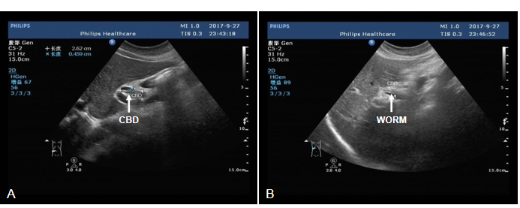
Figure 1 Abdominal ultrasonic diagnosis. A: Abdominal ultrasound showed a slight dilation of upper part of the common bile duct; B: Abdominal ultrasound showed parallel tube-like structures (white arrow). The common bile duct is dilated, about 8 mm in diameter.
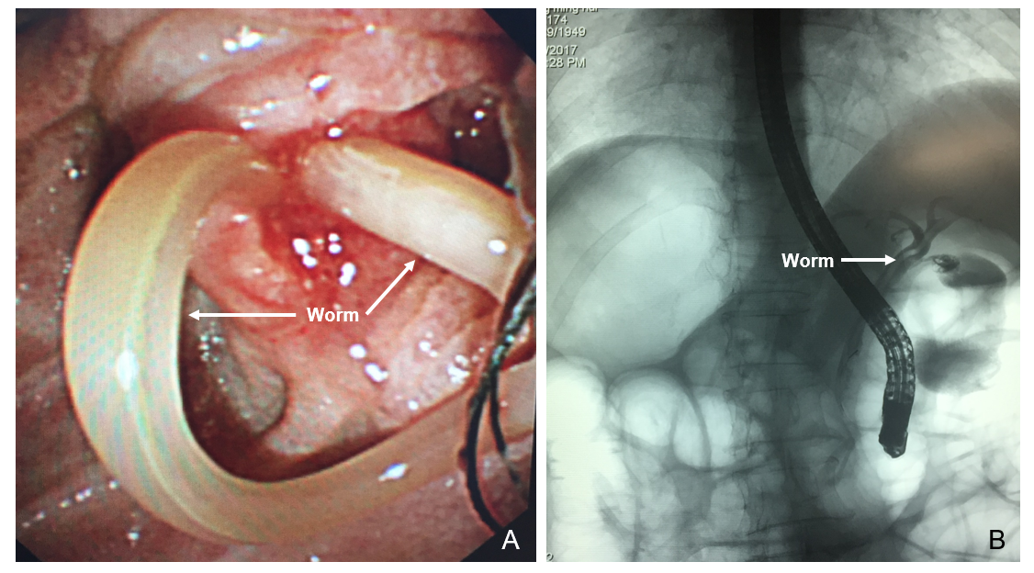
Figure 2 Endoscopic retrograde cholangiopancreatography showed that the intrahepatic bile duct was not dilated, and an active worm shadow was seen from the common bile duct to the right hepatic duct. A: Common bile duct (white arrow); B: Right hepatic duct (white arrow).

