Name of Journal: World Journal of Gastroenterology
Manuscript NO: 72974
Manuscript Type: ORIGINAL ARTICLE

Basic Study
Gut mucosal microbiota profiles linked to colorectal cancer recurrence

Huo RX et al. Colorectal cancer and gut mucosal microbiota

Rui-Xue Huo, Yi-Jia Wang, Shao-Bin Hou, Wei Wang, Chun-Ze Zhang, Xue-Hua Wan

Rui-Xue Huo, Department of Oncology, Tianjin Union Medical Center, Nankai University, Tianjin 300121, China

Yi-Jia Wang, Laboratory of Oncologic Molecular Medicine, Tianjin Union Medical Center, Nankai University, Tianjin 300121, China

Shao-Bin Hou, Advanced Studies in Genomics, Proteomics and Bioinformatics, University of Hawaii at Manoa, Honolulu, HI 96822, United States

Wei Wang, Xue-Hua Wan, TEDA Institute of Biological Sciences and Biotechnology, Nankai University, Tianjin 300457, China

Chun-Ze Zhang, Department of Colorectal Surgery, Tianjin Union Medical Center, Nankai University, Tianjin 300121, China

Chun-Ze Zhang, Tianjin Institute of Coloproctology, Tianjin 300121, China

Author contributions: Wan XH contributed to the conception of the study; Huo RX and Wang YJ contributed significantly to follow-up, analysis and manuscript preparation; Huo RX, Hou SB and Wan XH performed the data analyses and wrote the manuscript; Wang W and Zhang CZ helped perform the analysis with constructive discussions; Zhang CZ collected the samples; All authors have read and approve the final manuscript.

Supported by Tianjin Science and Technology Plan Project, No. 19YFZCSY00170; Tianjin Union Medical Center, No. 2019YJ007; Beijing Medical and Health Foundation, No. F1814B; Key R&D Projects in the Tianjin Science and Technology Pillar Program, No. 19YFZCSY00420; National Key R&D Program of China, No. 2017YFC1700606 and 2017YFC1700604.

Corresponding author: Xue-Hua Wan, PhD, Assistant Professor, Senior Researcher, TEDA Institute of Biological Sciences and Biotechnology, Nankai University, No. 23 Hongda Street, Tianjin 300457, China. xuehua.wan@nankai.edu.cn

Received: December 7, 2021
Revised: February 1, 2022
Accepted: March 25, 2022
Published online: May 14, 2022

Abstract
BACKGROUND
Emerging evidence links gut microbiota to various human diseases including colorectal cancer (CRC) initiation and development. However, gut microbiota profiles associated with CRC recurrence and patient prognosis are not completely understood yet, especially in a Chinese cohort.

AIM
To investigate the relationship between gut mucosal microbiota profiles and CRC recurrence and patient prognosis.

METHODS
We obtained the composition and structure of gut microbiota collected from 75 patients diagnosed with CRC and 26 healthy controls. The patients were followed up by regular examination to determine whether tumors recurred. Triplet-paired samples from on-tumor, adjacent-tumor and off-tumor sites of patients diagnosed with/without CRC recurrence were analyzed to assess spatial-specific patterns of gut mucosal microbiota by 16S ribosomal RNA sequencing. Next, we carried out bioinformatic analyses, Kaplan-Meier survival analyses and Cox regression analyses to determine the relationship between gut mucosal microbiota profiles and CRC recurrence and patient prognosis.

RESULTS
We observed spatial-specific patterns of gut mucosal microbiota profiles linked to CRC recurrence and patient prognosis. A total of 17 bacterial genera/families were identified as potential biomarkers for CRC recurrence and patient prognosis, including Anaerotruncus, Bacteroidales, Coriobacteriaceae, Dialister, Eubacterium, Fusobacterium, Filifactor, Gemella, Haemophilus, Mogibacteriazeae, Pyramidobacter, Parvimonas, Porphyromonadaceae, Slackia, Schwartzia, TG5 and Treponema.

CONCLUSION
Our work suggests that intestinal microbiota can serve as biomarkers to predict the risk of CRC recurrence and patient death.

Key Words: Gut microbiota; Colorectal cancer; Prognosis; Colorectal cancer recurrence; Biomarker; 16S rRNA sequencing analysis

©The Author(s) 2022. Published by Baishideng Publishing Group Inc. All rights reserved.

Citation: Huo RX, Wang YJ, Hou SB, Wang W, Zhang CZ, Wan XH. Gut mucosal microbiota profiles linked to colorectal cancer recurrence. World J Gastroenterol 2022; 28(18): 1946-1964
URL: https://www.wjgnet.com/1007-9327/full/v28/i18/1946.htm
DOI: https://dx.doi.org/10.3748/wjg.v28.i18.1946

Core Tip: Emerging evidence indicates that besides genetic and epigenetic factors, the gut microbiota is capable of driving colorectal cancer (CRC) progression. Here, we analyzed the gut mucosal microbiota of 75 triplet-paired samples collected from on-tumor, adjacent-tumor and off-tumor sites of patients diagnosed with/without CRC recurrence and 26 healthy controls. After a long-term follow-up, we identified spatial-specific bacterial taxa whose abundances are associated with overall survival and disease-free survival. Our data reveal the profiles of gut mucosal microbiota that increase risk of CRC recurrence and affect patient prognosis, which may serve as potential new biomarkers for CRC diagnosis.

INTRODUCTION
Colorectal cancer (CRC) is a major cause of cancer-related deaths with the third highest mortality and the fourth highest incidence worldwide, according to GLOBOCAN 2020 (global cancer statistics)^{[1]}, which indicates a public health issue. Although many new treatment options of CRC have doubled, survival prognosis for early-stage patients with non-metastasized disease is still better than that for advanced-stage patients^{[2]}. Currently, treatment of CRC mainly depends upon tumor-node-metastasis (TNM) stage of disease, and the patient’s physical fitness and intent. However, previous studies showed that disease recurrence was observed in 40% of treated patients with stage Ι-II CRC (lymph node negative postoperative) and 70% of those with stage ΙΙΙ CRC^{[3]}, which is proposed to be related to rat sarcoma viral oncogene and microsatellite status^{[4]}. Thus, treatment strategy merely depending on CRC TNM stage may cause over-treatment or under-treatment, leading to CRC recurrence. Moreover, the molecular mechanisms behind CRC recurrence are not yet completely understood. Therefore, we still need to explore more suitable biomarkers for assessing prognosis of CRC patients in order to achieve optimal personalized treatment.
In addition to hereditary and lifestyle factors, the human gut microbiota is considered as an important risk factor for CRC initiation as well as development. With the continuous development of high-throughput sequencing, the compositional structure of the human gut microbiota is revealed to be closely involved in CRC initiation, development and treatment^{[5]}. Moreover, pathogenic bacteria have been identified from the human gut microbiota and their procarcinogenic properties have been demonstrated to play a role in causing gut microbial dysbiosis in the complex environment of the human intestinal tract. Certain bacterial species, including Bacteroides fragilis (B. fragilis), Clostridium septicum, Enterococcus faecalis, Escherichia coli, Fusobacterium spp., Helicobacter pylori and Streptococcus bovis have been identified to play a role in driving colorectal carcinogenesis^{[6]}. The mechanisms behind these pathogenic bacteria involve bacterial-derived genotoxicity and other virulence factors that regulate host defense systems, metabolism, oxidative stress and antioxidative defense modulation^{[6]}.
Evidence has linked gut microbiota to prognosis of CRC. A pilot study has shown that high abundance of Fusobacterium nucleatum (F. nucleatum) and B. fragilis were independent indicators for poor patient survival, while high abundance of Faecalibacterium prausnitzii predicted improved survival rate^{[7]}. In addition, most studies supported that increased relative abundance of B. fragilis and F. nucleatum were associated with short-term survival and late stage of CRC^{[8]}. Enterotoxigenic B. fragilis (ETBF) and Fusobacterium spp. levels were significantly higher in late stage (III/IV) CRC than those in early stage (I/II) CRC, and high abundance of Fusobacterium was reported to be associated with high microsatellite instability (MSI)^{[9,10]}. Compared to F. nucleatum-negative cases, multivariable hazard ratio for CRC-specific mortality in F. nucleatum-high cases was 1.58^{[9]}. After neoadjuvant chemoradiotherapy, F. nucleatum persistence was associated with high relapse rates in locally advanced CRC^{[11]}. CRC patients with low levels of F. nucleatum had significantly longer overall survival (OS) and disease-free survival (DFS) than patients with moderate and high levels of F. nucleatum that were obvious in late-stage CRC patients^{[12-15]}. However, extensive bacterial taxa associated with prognosis of CRC are unclear, especially in a Chinese cohort.
To investigate the profiles of gut mucosal microbiota associated with CRC recurrence and survival of CRC patients, we collected gut mucosal microbiota from CRC patients when they received radical resection or palliative surgery in Tianjin Union Medical Center, China. For each patient, triplet-paired CRC samples were collected from on-tumor, adjacent-tumor and off-tumor sites. Additional samples were collected from 26 healthy controls. We performed 16S ribosomal RNA (rRNA) gene sequencing and analyses on these gut mucosal microbiota. Next, we carried out Kaplan-Meier survival curve analyses for OS and DFS. Our data suggest that a number of bacterial genera/families, including Anaerotruncus, Bacteroidales, Coriobacteriaceae, Dialister, Eubacterium, Fusobacterium, Filifactor, Gemella, Haemophilus, Mogibacteriazeae, Pyramidobacter, Parvimonas, Porphyromonadaceae, Slackia, Schwartzia, TG5 and Treponema, are associated with survival of CRC patients and CRC recurrence. We further performed the univariate and multivariate Cox regression analyses. Our data reveal that high abundance of Anaerotruncus, Bacteroidales, Coriobacteriaceae, Dialister, Eubacterium, Filifactor, Haemophilus, Mogibacteriazeae, Pyramidobacter, Slackia, Treponema and TG5 are associated with worse OS or DFS.

MATERIALS AND METHODS
Patients and sample collection procedures
This study analyzed 69 pathologically confirmed CRC patients, who received radical or palliative surgeries at Tianjin Union Medical Center, Tianjin, China from December 2016 to September 2017. These patients were followed up by regular examination or telephone survey. DFS was defined as the time period from the date of surgery to the time of tumor recurrence, and OS was defined as the time period from the date of surgery to the time of death. Our study was conducted in accordance with the Declaration of Helsinki. Every patient provided written informed consent for the collection of samples and subsequent analysis when required, and the study was approved by the Ethics Committee of Tianjin Union Medical Center. The TNM staging was determined according to the American Joint Committee on Cancer staging handbook (8th edition). Whether a patient received chemotherapy or not depended on his/her TNM stage, physical state score and intention. Imaging examination was arranged for every 2-6 mo or when a patient’s condition changed to determine whether the disease recurrence occurred.

DNA library preparation and 16S rRNA sequencing
ZR Fungal/Bacterial DNA kit (Zymo Research, Irvine, CA, United States) was used to isolate bacterial DNA from intestinal microbiota samples according to the manufacturer’s instructions. Quant-iT PicoGreen dsDNA assay kit (Thermo Fisher, Sunnyvale, CA, United States) was used to quantify the DNA amounts. The hypervariable regions of 16S rRNA gene amplicon libraries targeting the V3-V4 regions were prepared according to the Illumina manufacturer’s manual. The amplification primers were used according to the Illumina manufacturer’s manual. The forward and reverse primers were used as follows: 5’-TCGTCGGCAGCGTCAGATGTGTATAAGAGACAGCCTACGGGNGGCWGCAG and 5’-GTCTCGTGGGCTCGGAGATGTGTATAAGAGACAGGACTACHVGGGTATCTAATCC. The products of polymerase chain reaction were examined using agarose gel electrophoresis (1% concentration of agarose gel; 100 V; 40 min electrophoresis time). The AMPure XP beads (Beckman Coulter, Fullerton, CA, United States) were used to purify the amplified DNA libraries, and Quant-iT PicoGreen dsDNA assay kit (Thermo Fisher, Sunnyvale, CA, United States) was used to quantify the DNA library amounts. All the DNA samples were stored at -20°C until used.

Quality control, operational taxonomic unit picking and diversity analyses of 16S rRNA amplicons
The 16S rRNA amplicon libraries were sequenced for 2 × 300 bp on Illumina MiSeq platform. The read information was listed in Supplementary Table 1. The FastQC program was used to perform quality control and filtering of raw paired-end reads (https://www.bioinformatics.babra ham.ac.uk/projects/fastqc/, accessed on 5 June 2019). Next, PandaSeq v2.10 was used to assemble paired-end reads with default parameters^{[16]}. The QIIME pipeline v1.9.1 (http://qiime.org/home_static/dataFiles.html, accessed on June 5, 2019) and Greengenes database v13.8 were used for de novo operational taxonomic unit (OTU) picking and taxonomic assignment^{[17]}. Briefly, we generated the mapping file that contains all the information about the sequencing samples including sample ID, barcode sequences and sample types. The python command, pick_otus.py, was used to pick OTUs based on sequence similarity (threshold of 97%) of the assembled reads, which is commonly used to define bacterial species. The python command, pick_rep_set.py, was used to pick the representative sequences for each OTU. USEARCH 6.1 was used for chimera detection and filtering. The python command, assign_taxonomy.py, was used to assign taxonomy to OTU representative sequences. The python command, make_rarefaction_plots.py and online MicrobiomeAnalyst (https://dev.microbiomeanalyst.ca/MicrobiomeAnalyst/home.xhtml, accessed on 28 August 2021) were used to calculate alpha diversities within the samples^{[18,19]}. The 16S rRNA paired-end reads have been submitted to the Sequence Read Archive database at the National Center for Biotechnology Information website under accession number PRJNA606879.

Bioinformatic analyses of gut mucosal microbiota for CRC patients
The beta diversity of gut mucosal microbiota among the samples collected from CRC patients with and without recurrence was calculated using principal component analysis on MicrobiomeAnalyst website^{[18,19]}. The linear discriminant analysis (LDA) effect size was analyzed using online MicrobiomeAnalyst^{[18,19]}.

Statistical analysis
Statistical analyses were performed using SPSS Version 23. The statistical significance of multiple sample comparisons were calculated using one-way analysis of variance with Kruskal-Wallis test. The Kaplan-Meier survival curves for OS and DFS and the optimal cutoff value of RiskScore were calculated using R software package maxstat (maximally selected rank statistics with several P value approximations version: 0.7-25)^{[20]}. We set the minimum number of samples in the grouping to be greater than 25% and the maximum number of samples in the grouping to be less than 75% and finally obtained the optimal cutoff value of each bacterial taxa. Based on this cutoff threshold, the patients were divided into groups with high and low abundance of the bacterial taxa. Furthermore, the survivfit function of R software was used to analyze the prognostic differences between the two groups, and the significance of prognostic differences between the two groups was evaluated by logrank test. According to the cutoff value of each bacterial taxon, we divided the patients into groups with high and low abundance of the bacterial taxa and then conducted Cox regression analyses. The Cox regression analyses based on the proportional hazards model were carried out using SPSS v. 23 program.

RESULTS
Clinicopathological features of CRC patients
We summarized the patients’ clinicopathological data in Table 1. The median age of 75 patients was 63.4 years, and 60% of them were males. The pathological type of all patients was categorized as adenocarcinoma, and most of the tumor cells were poorly differentiated. Most patients were diagnosed as microsatellite stable based on immunohistochemical evaluation of components of the mismatch repair machinery, including MLH1, MSH2, MSH6 and PMS2. All patients did not receive chemotherapy or other antitumor therapy before surgery. After surgery, 44 of 75 patients received chemotherapy based on FOLFOX (CapeOX) or FOLFIRI regimen, 4 of them received radiotherapy, and 6 of them received targeted therapy. The median follow-up duration for all cases after surgery was 51.2 mo (2.90-57.03 mo). There were 6 patients who failed to be followed up. Until August 23, 2021, a total of 17 patients diagnosed with Ι-ΙΙΙ stages had relapsed and 20 patients had died.

Altered alpha-diversity of gut mucosal microbiota at adjacent-tumor sites for CRC recurrence
Although tumor tissues can be removed by surgery, the microbiota residing in the tumor surrounding tissues, e.g., those at the adjacent-tumor sites as well as those in the remaining intestinal tissues where tumors are removed, may retain pathogenic bacteria that have the capabilities to drive CRC, leading to CRC recurrence. Therefore, we hypothesize that gut mucosal microbiota profiles at on-tumor or adjacent-tumor sites may be linked to CRC recurrence. To examine this, we assessed microbial alpha-diversities of biopsy samples collected from on-tumor, adjacent-tumor and off-tumor sites of patients with and without CRC recurrence. The 16S rRNA gene hypervariable V3-V4 regions were sequenced and analyzed for five α-diversity indices including Chao1, Fisher, Observed OTU, Shannon and Simpson (Figure 1). Analyses of species variations based on these five metrics consistently indicated that species diversities at on-tumor or off-tumor sites of patients with and without CRC recurrence showed no significant differences (Student t-test, P < 0.05) (Figure 1). Analyses of species variations based on Chao1 (Student t-test, P = 0.0092), Fisher (Student t-test, P = 0.0092) and observed OTU (Student t-test, P = 0.0092), but not Shannon (Student t-test, P = 0.1314) and Simpson (Student t-test, P = 0.2513), showed significant differences at adjacent-tumor sites of patients with and without CRC recurrence (Figure 1). Although Shannon and Simpson metrics did not show statistical significance, analyses of the α-diversities based on the five metrics suggested that at adjacent-tumor sites, those from patients with CRC recurrence were higher than those from patients without recurrence (Figure 1). These data suggest that there is no significant difference of composition of gut mucosal species at on-tumor and off-tumor sites between patients with and without CRC recurrence. However, compositions of internal species showed differences at adjacent-tumor sites between patients with and without CRC recurrence.

Microbiota profiles linked to CRC recurrence
To assess whether the structure diversities (beta-diversity) of gut microbiota show differences between patients with and without CRC recurrence, we performed principal component analysis for abundance of genera identified at on-tumor, adjacent tumor and off-tumor sites of CRC patients diagnosed with and without disease recurrence. The microbiota structure diversities at on-tumor, adjacent tumor and off-tumor sites of CRC patients diagnosed with and without disease recurrence showed differences (Figure 2), suggesting that the structures of gut microbiota were different at these sites in patients with and without CRC recurrence.
We next compared the differential relative abundance of bacterial taxa at the phylum level between patients with and without CRC recurrence. Among all the samples, Firmicutes, Proteobacteria, Bacteroidetes and Fusobacteria showed the top relative abundance (Figure 3). Firmicutes, Bacteroidetes and Fusobacteria showed higher relative abundance at on-tumor sites of patients diagnosed with CRC recurrence than those at on-tumor sites of patients diagnosed without CRC recurrence (Figure 3). At adjacent-tumor sites, the relative abundance of Fusobacteria in patients with CRC recurrence were dramatically higher than those in patients without CRC recurrence (Figure 3). By contrast, the relative abundance of Fusobacteria at off-tumor sites showed no differences between patients with and without CRC recurrence (Figure 3). The relative abundance of Firmicutes and Bacteroidetes at off-tumor sites of patients with CRC recurrence were lower than those of patients without CRC recurrence (Figure 3). Collectively, these data suggest that species from Fusobacteria, Bacteroidetes and Firmicutes may play roles in worsening or improving the patient prognosis.

Altered gut mucosal microbiota signatures in CRC recurrence
We next carried out the linear discriminant analysis effect size to predict site-specific biomarkers that are associated with CRC recurrence. By setting LDA score > 3.0 [false discovery rate (FDR) adjusted P value < 0.1], a total of 100 genera were identified to show significant differences of relative abundance between patients with and without CRC recurrence (Figure 4, Supplementary Table 2). The top 10 genera/families with the highest LDA scores were Fusobacterium (LDAscore = 5.56, FDR adjusted P = 0.0026), Faecalibacterium (LDAscore = 5.29, FDR adjusted P = 0.0176), Peptostreptococcus (LDAscore = 5.13, FDR adjusted P = 0.0026), Streptococcus (LDAscore = 5.08, FDR adjusted P = 0.0639), Parvimonas (LDAscore = 5.04, FDR adjusted P = 0.0072), Burkholderiales (LDAscore = 5.03, FDR adjusted P = 0.0018), Pseudomonas (LDAscore = 4.82, FDR adjusted P = 0.0301), Caulobacteraceae (LDAscore = 4.77, FDR adjusted P = 0.0043), Mitsuokelia (LDAscore = 4.77, FDR adjusted P = 0.0011) and Pseudomonadales (LDAscore = 4.76, FDR adjusted P = 0.0106) (Supplementary Table 2). Seven genera/families, including Fusobacterium, Pyramidobacter, Mogibacteriaceae, Coriobacteriaceae, Anaerotruncus, Slackia and Bacteroidales, showed higher abundance at on-tumor and adjacent-tumor sites (but not off-tumor sites of patients with CRC recurrence than those without CRC recurrence and healthy controls (Supplementary Table 2). Four genera, including Dialister, Selenomonas, TG5 and Schwartzia, showed higher abundance at on-tumor, adjacent-tumor and off-tumor sites of patients with CRC recurrence than those without CRC recurrence and healthy controls (Supplementary Table 2). By contrast, some well-recognized CRC drivers, e.g., Peptostreptococcus and Streptococcus, showed lower abundance at on-tumor sites of patients with CRC recurrence than those without CRC recurrence. These CRC-recurrence-associated genera may play roles in interacting with host cells and worsening patient prognosis.

Gut mucosal microbiota profiles associated with prognosis and survival of CRC patients
Next, we selected those genera/families that were significantly associated with CRC recurrence based on LDA effect size analysis and used their abundance to evaluate their effects on prognosis and patient survival. The Kaplan-Meier survival analysis curves showed that seven bacterial genera at on-tumor sites and nine bacterial genera at adjacent-tumor sites were capable of significantly predicting the OS of patients (P < 0.05) (Figure 5). High abundance of Anaerotruncus, Bacteroidales, Fusobacterium, Pyramidobacter, Pseudoramibacter_Eubacterium and TG5 at on-tumor sites predicted shorter OS, whereas high abundance of Parvimonas was associated with longer OS (Figure 5A). At adjacent-tumor sites, high abundance of Anaerotruncus, Coriobacteriaceae, Dialister, Filifactor, Mogibacteriazeae, Pyramidobacter and Treponema predicted shorter OS, whereas high abundance of Haemophilus and Bacteroidales indicated longer OS (Figure 5B). The cutoff values were shown in Supplementary Table 3.
We next performed Kaplan-Meier survival analyses to analyze DFS between patients with high and low abundance of specific bacterial taxa. A total of eleven genera at on-tumor sites and eight genera at adjacent-tumor sites were capable of predicting DFS obviously (P < 0.05) (Figure 6). High abundance of Anaerotruncus, Bacteroidales, Erysipelotrichaceae_Eubacterium, Filifactor, Mogibacteriazeae, Pyramidobacter, Pseudoramibacter_Eubacterium, Porphyromonadaceae, Slackia and TG5 at on-tumor sites were associated with shorter DFS, whereas high abundance of Gemella was associated with longer DFS (Figure 6A). At the adjacent-tumor sites, high abundance of Anaerotruncus, Coriobacteriaceae, Dialister, Filifactor, Pyramidobacter and Schwartzia showed shorter DFS, while high abundance of Haemophilus and Bacteroidales were associated with longer DFS (Figure 6B).
According to the abundance cutoff value of each genus calculated by Kaplan-Meier survival analyses (Supplementary Table 3), we divided the patients into two groups with high or low abundance of each genus. Then, we investigated the survival risk associated with the abundance of each genus/family and other clinicopathological features via univariate and multivariate COX regression analyses. According to the univariate Cox regression analysis results, we chose bacterium or clinicopathological feature with significance (P < 0.1) and additional bacterium with significance in Kaplan-Meier analysis (P < 0.05) to further perform multivariate Cox regression analysis.
Interestingly, although gender, age, differentiation, smoking and drinking histories showed no significance (P > 0.05) in univariate DFS or OS Cox regression analyses (Supplementary Tables 4 and 5), the TNM stage and location of tumor in intestine showed significant influences on patient survival based on multivariate OS Cox regression analysis (P < 0.05) (Supplementary Figures 1 and 2). CRC ΙΙΙ/ΙV stage and CRC located in the right colon revealed shorter OS than CRC Ι/ΙΙ stage and CRC located in the left colon or rectum, respectively. Moreover, only CRC ΙΙΙ/ΙV stage showed shorter DFS than CRC I/II stage (Supplementary Figure 2). In addition, MSI was associated with improved DFS rates in all patients based on multivariate Cox regression analysis (Supplementary Figure 3). Univariate Cox regression OS analysis indicated patients with high abundance of Anaerotruncus, Bacteroidales, Pyramidobacter, Pseudoramibacter_Eubacterium and TG5 at on-tumor sites were associated with shorter OS rates (Supplementary Figure 1). However, no significant differences were found between these bacteria and OS in multivariate analysis (Supplementary Figure 1). At adjacent-tumor sites, univariate analysis showed high abundance of Anaerotruncus, Coriobacteriaceae, Dialister, Filifactor, Mogibacteriazeae, Pyramidobacter and Treponema and low abundance of Bacteroidales were associated with shorter OS rates. In multivariate analysis, high abundance of Anaerotruncus and low abundance of Haemophilus were associated with shorter OS rates (Supplementary Figure 2).
High abundance of Anaerotruncus, Bacteroidales, Erysipelotrichaceae_Eubacterium, Mogibacteriazeae, Pyramidobacter and Pseudoramibacter_Eubacterium at on-tumor sites predicted shorter DFS rates in univariate analysis, whereas high abundance of Mogibacteriazeae and Slackia were associated with shorter DFS rates in multivariate analysis (Supplementary Figure 3). In univariate analysis of bacterial taxa at adjacent-tumor sites, high abundance of Anaerotruncus, Coriobacteriaceae, Dialister, Filifactor, Pyramidobacter and Schwartzia indicated shorter DFS rates (Supplementary Figure 4). Meanwhile, low abundance of Bacteroidales was associated with shorter DFS rates (Supplementary Figure 4). In multivariate analysis, there was no correlation between these bacteria and DFS rates (Supplementary Figure 4).

DISCUSSION
Emerging evidence indicates that the gut microbiota plays pivotal roles in CRC incidence and progression^{[21]}. Most previous studies have focused on identifying gut microbiota profiles linked to CRC carcinogenesis and revealing the physiological roles of specific species, e.g., F. nucleatum, Peptostreptococcus anaerobius, B. fragilis and Eubacterium rectale, in CRC tumorigenesis and development^{[22-25]}. However, few reports have fully screened the gut microbiota profiles linked to prognosis and survival of CRC patients^{[7]}. Up to date, only F. nucleatum and B. fragilis were evaluated for their impacts on patient prognosis^{[7,8,13,14]}. Therefore, our understanding of bacterial taxa associated with clinical outcomes of CRC is incomplete. Profiling these bacterial taxa will pave a way for further understanding their functional roles in impairing clinical outcome of CRC and development of novel strategies for prevention of CRC recurrence. In this study, we explored large-scale screening of gut mucosal microbiota of triplet-paired biopsy samples collected from on-tumor, adjacent-tumor and off-tumor sites of CRC patients and identified critical bacterial taxa that were linked to prognosis and survival of CRC patients.
Our data revealed that a number of bacterial genera/families at on-tumor and adjacent-tumor sites are capable of influencing DFS and OS rates. High abundance of Anaerotruncus and Pyramidobacter indicated shorter DFS and OS rates in Kaplan-Meier survival analyses and increased the risk of CRC recurrence and patient death according to our Cox regression analyses (P < 0.05). High abundance of Coriobacteriaceae, Dialister and Filifactor at adjacent-tumor sites and high abundance of Bacteroidales, Pseudoramibacter_Eubacterium and TG5 at on-tumor sites indicated shorter DFS and OS rates and increased the risk of CRC recurrence and patient death (P < 0.05). Conversely, high abundance of Parvimonas at on-tumor sites showed longer OS rates. Meanwhile, high abundances of Bacteroidales and Haemophilus at adjacent-tumor sites indicated longer DFS and OS rates, but only Haemophilus decreased the risk of death in multivariate Cox regression analysis (P < 0.05). High abundances of Fusobacterium at on-tumor sites and Treponema at adjacent-tumor sites indicated shorter OS rates, but only Treponema increased the risk of death (P < 0.05). High abundance of Erysipelotrichaceae_Eubacterium, Gemella, Porphyromonadaceae and Slackia at on-tumor sites and Coriobacteriaceae at adjacent-tumor sites indicated shorter DFS rates, and Erysipelotrichaceae_Eubacterium, Gemella, Slackia and Schwartzia increased the risk of recurrence (P < 0.05). In multivariate regression analysis, Haemophilus showed a protective effect and Anaerotruncus showed a detrimental effect when referred to death (P < 0.05), and Mogibacteriazeae and Slackia showed obvious detrimental effects when referred to recurrence (P < 0.05).
As well-recognized oral pathogens, F. nucleatum, Parvimonas micra and Gemella morbillorum were significantly enriched in both right- and left-sided CRC tumors^{[26]}. F. nucleatum in tumor samples was reported to be associated with worse outcomes in terms of OS, DFS or cancer-specific survival, with hazard ratios ranging from 1.58 to 19.96^{[27]}. However, our data showed that the abundance of F. nucleatum only affected OS but not DFS rates. This observation is consistent with two previous studies. Wei et al^{[7]} reported that high abundance of F. nucleatum or B. fragilis was associated with poor OS rates after surgery. A meta-analysis found that enrichment of F. nucleatum in tumor tissue was associated with worse OS among CRC patients (n = 5 studies, HR = 1.87; 95%CI: 1.12–3.11; I² = 60.6%) but was not associated with DFS (n = 3 studies, HR = 1.48; 95%CI: 0.84–2.59; I² = 88.5%)^{[28]}.
F. nucleatum may contribute to CRC progression in an established tumor microenvironment due to its highly adherent, invasive and proinflammatory nature that can take advantage of a compromised colonic epithelial cell layer. Moreover, F. nucleatum is an asaccharolytic bacterium that will not compete for glucose, a preferred substrate in tumor metabolism, and F. nucleatum can tolerate the hypoxic tumor environment^{[26,29]}. In addition, F. nucleatum is capable of functioning as a bridge-forming bacterium to interact with other bacterial colonizers, leading to a complex biofilm formation in the human body^{[30,31]}. The increases in F. nucleatum abundance were observed in both biopsy site and saliva samples of CRC^{[32]}.
Flynn et al^{[33]} proposed a polymicrobial synergy model that certain oral pathogens may cooperate to fight off the host immune system for survival and be able to establish a niche containing mixed species in the gut. The intestinal mucosa and epithelium are falling off and replaced constantly, which provide available nutrients and binding sites for adhesive bacteria. Intestinal and oral environments share similar pH, which is conducive for bacteria to form biofilm and persist in the host. Initiation or progression of tumorigenesis benefit these bacteria for proliferation because local inflammatory responses during tumorigenesis increase available nutrients in the niche^{[33]}. Polymicrobial colonization at the tumor site by bacterial species that are phylogenetically related to those classified as oral pathogens (e.g., Fusobacterium, Anaerococcus and Parvimonas) could promote tumorigenesis by modifying the tumor microenvironment and eliciting an elevated response of T helper 17 cells, which is linked to a poor prognosis of CRC patients^{[34]}.
The order Bacteroidales contains more than 35 species, including the best studied genus Bacteroides, which is highly abundant in gut microbiota of a healthy human^{[35-39]}. Due to its high density, it is proposed that the species in this order may form mutualistic relationships with the host gut and play a role in stabilizing the compositional structure of the gut microbiota. However, certain species from this order are pathogenic and considered as potential driver bacteria for CRC. For example, ETBF secretes a zinc metalloprotease toxin, known as B. fragilis toxin, that is associated with inflammatory bowel disease and CRC^{[40]}. ETBF can induce production of reactive oxygen species in host cells that cause oxidative DNA damage, induce inflammation and disrupt the integrity of the epithelial barrier. In addition, ETBF is able to activate the β-catenin nuclear signaling cascade and induce proliferation of host cells^{[41]}. Although B. fragilis may enhance the efficiency of immune checkpoint inhibitor therapy^{[42]}, ETBF has been reported to decrease OS and DFS of CRC patients^{[27,42]}.
Unexpectedly, our data showed that Bacteroides at on-tumor and adjacent-tumor sites displayed distinguishable effects on OS and DFS (Figures 5 and 6). High abundance of Bacteroides at on-tumor sites manifested worse OS and DFS, whereas those at adjacent-tumor sites showed better OS and DFS. It was reported that high levels of defined chemokines (e.g., CCL5 and CCL17) in CRC tissues may attract beneficial T cells [cytotoxic T lymphocytes, T-helper (Th) 1 cells, interleukin-17-producing Th cells and regulatory T cells] and lead to improved patient survival. Titers of Bacteroidales were positively correlated with expression levels of individual chemokines and the extent of T cell infiltration^{[43]}. Loading Bacteroidales to tumor xenografts recruited T cells, indicating that Bacteroidales is capable of controlling the extent of tumor infiltration by beneficial immune cells^{[43]}. However, CRC tissue was infiltrated by more “not effector” T cells (Th2/Th0/regulatory T cells/Tnull) with regulatory or anergic properties, which are unable to kill CRC cells and may contribute to CRC promotion^{[44]}. Therefore, Bacteroidales at off-tumor sites here may play a protective role in recruiting beneficial T cells (e.g., Th1, Th17, etc), leading to improved prognosis of CRC patients. On the other hand, Bacteroidales at on-tumor sites may contribute to CRC recurrence as pathogens or thrive as passenger bacteria.
In our Kaplan-Meier survival analyses, high abundance of Anaerotruncus at either on-tumor sites or adjacent-tumor sites was associated with shorter OS and DFS, suggesting that the genus increases the risk of CRC recurrence and patient death. The genus Anaerotruncus contains only one validly published species, namely Anaerotruncus colihominis. Anaerotruncus colihominis was first identified as a Gram-positive, anaerobic bacillus that was isolated from the stool specimens of two children^{[45]}. Moreover, this species was isolated from the blood culture of humans with nosocomial bacteremia^{[45]}. Significant enrichment of Anaerotruncus was found in the endometrium of patients with endometrial cancer, suggesting that this bacterium promotes inflammation and tumorigenesis^{[46]}. High fat diets are generally considered as a high risk factor for CRC. Abundance of Anaerotruncus is considered to be linked to consumption of saturated fatty acids in both men and women^{[47]}. In mouse model experiments, high fat diets and high sucrose diets led to conditional pathogenic bacterial growth, such as Anaerotruncus and Bacteroides. These bacteria played a proinflammatory role in disrupting the integrity of epithelial barrier function^{[48-50]}.
Several genera, including Pyramidobacter and Mogibacteriaceae, are sulfidogenic and associated with CRC^{[51-55]}. Pyramidobacter is mainly isolated from the human oral cavity, upper gastrointestinal tract and bile^{[56,57]}. The genus Pyramidobacter contains anaerobic, Gram-negative bacilli that produce acetic, isovaleric acids and many other trace chemicals as metabolism products^{[51]}. Abundance of Pyramidobacter was found to be higher in older adults and was positively correlated with proinflammatory cytokine interleukin-6 that promotes CRC development^{[58]}. In addition, the family Mogibacteriaceae was reported to be associated with CRC and observed to co-occur with F. nucleatum^{[53,59]}. Our previous study also reported that Mogibacterium from the family Mogibacteriaceae was associated with Peptostreptococcus in gut microbiota isolated from CRC patients^{[60]}.
Several genera identified in this study were reported to be associated with CRC previously. The role of Eubacterium in CRC initiation was underestimated for a long time. Recently, we identified Eubacterium as a potential driver bacteria contributing to CRC and experimentally showed that the lipopolysaccharide of Eubacterium rectale activates the transcription factor NF-кB, which regulates innate and adaptive immune responses in normal colon epithelial cells^{[22]}. The genus Dialister was detected in the blood of patients with oral infections that cause bacteremia^{[61]}. A meta-analysis based on 26 studies that used next-generation sequencing to analyze microbiota showed that the relative abundance of Dialister was significantly higher in cancer patients than those in control samples^{[62]}. The metabolism end products of Dialister include acetate, lactate and propionate that may cause carcinogenesis^{[62]}. Treponema denticola is an oral pathogen and associated with an increased risk of CRC^{[63]}. The genus Schwartzia is linked to CRC carcinogenesis-related gene methylation^{[64]}. The family Coriobacteriaceae is considered a commensal or probiotic bacteria residing in the human gut^{[65]}. Their roles in driving CRC recurrence are unknown.
Unlike other critical genera analyzed in this study, low abundance of Haemophilus at adjacent-tumor sites indicated longer OS and DFS than those with high abundance in our Kaplan-Meier analyses. Haemophilus is a commensal microorganism, which belongs to the phylum Proteobacteria. It is an opportunistic pathogen that may lead to infections such as endocarditis and pneumonia. Haemophilus in stool samples showed significantly higher proportions in the CRC group than in the control group^{[66]}. The proportions of Haemophilus decreased after tumor removal via surgery, indicating it is a carcinogenesis pathogen indirectly^{[67]}. However, decreased abundance of Haemophilus was observed in stage I/II CRC compared to stage 0 (earliest) CRC, which may be due to overgrowth of other harmful bacteria that acted as competitors during the transition from precancerous lesions to late-stage CRC^{[68]}.
According to our COX regression analysis, location (right/left colon or rectum) is another risk factor for patient death. Compared to left colon or rectum, right colon obviously increased risk of death. Consistent with our results, a study showed that the 10-year OS of patients with CRC at the right-sided colon was shorter than that of patients with CRC at the left-sided colon^{[68]}. There is a more abundant blood supply in the right-sided colon than other parts of colon, which benefits tumor growth and results in common clinical symptoms including anemia, emaciation, fever and dyscrasia. Tight-sided CRC exhibits more mucinous and advanced TNM stage^{[69]}. Obviously different patterns of microbiota structures and abundances were found between left-sided and right-sided colons of CRC patients^{[69]}. Moreover, invasive bacterial biofilms were found in 89% of right-sided CRC cases but in only 12% of left-sided CRC cases^{[69]}. Therefore, right-sided CRC specific bacterial species with concomitant procarcinogenic epithelial responses may contribute to the development of right-sided CRC^{[70]}.
We further identified that TNM stage showed an obvious impact on survival of CRC patients. Patients with stage ΙΙΙ/ΙV CRC had a higher risk of death and disease recurrence, which is consistent with previously reported results^{[71]}. At the same time, microsatellite status was another factor that influenced patient survival in our study. MSI may decrease the risk of CRC recurrence compared to microsatellite stable patients. Moreover, it was reported that MSI shows stage-specific impacts on the prognosis of CRC patients^{[70]}. In stages II and III CRC, high MSI tumors had superior prognosis compared with high microsatellite stable tumors. In stage IV CRC, although 4% of tumors were identified as high MSI tumors, these tumors were recognized to be associated with inferior survival^{[70]}. Sequencing paired colon tumor and normal-adjacent tissue and mucosa samples revealed significant enrichment of B. fragilis and F. nucleatum in deficient mismatch repair CRC but not in proficient mismatch repair CRC^{[72]}.

CONCLUSION
In this work, we identified critical bacterial taxa that are associated with prognosis and survival of CRC patients. Our work suggests that intestinal microbiota can serve as biomarkers to predict the risk of CRC recurrence and patient death. Unexpectedly, most of these identified genera have not been investigated for their physiological roles in interacting with host intestinal cells. On the other hand, some well-recognized CRC drivers, e.g., Peptostreptococcus and Streptococcus, are not associated with CRC recurrence according to our observations. Thus, the mechanism behind bacteria-driving CRC recurrence may be different from those proposed for bacteria-driving CRC development. The activities of complex immune cells, e.g., various types of T cells (e.g., Th1, Th2 and Th17) and macrophages, in response to these bacterial activities may need to be considered. Further functional analyses of physiological roles of these bacteria in patient prognosis and CRC recurrence will shed light on developing novel strategies for CRC treatment and prevention.

ARTICLE HIGHLIGHTS
Research background
Colorectal cancer (CRC) is one of the most common malignant tumors. Gut mucosal microbiota is considered to be one of the key factors promoting CRC. There is evidence that certain gut bacteria are linked to the prognosis (recurrence, overall survival and disease-free survival) of CRC, but there is a lack of research on the relationship between large-scale intestinal microbiota profiles and CRC recurrence/patient prognosis.

Research motivation
Our study focused on the relationship between the abundance of intestinal microbiota at different positions and CRC recurrence/patient prognosis. This study provides novel potential biomarkers for patient prognosis in the future.

Research objectives
The main objective of this study was to evaluate whether the abundance of intestinal microbiota at on-tumor or adjacent-tumor sites can predict CRC recurrence and patient prognosis. Our study has preliminarily suggested that some gut bacteria may have predictive values for CRC recurrence and patient prognosis. These results can provide new biomarkers for prediction of CRC recurrence in the future.

Research methods
We collected intestinal bacteria from different locations of the intestinal mucosa of patients and healthy controls. The bacterial taxa and abundance were determined by high-throughput 16S ribosomal RNA sequencing. The relationship between gut mucosal microbiota profiles and CRC recurrence and patient prognosis was explored by bioinformatics analysis, Kaplan-Meier survival analysis and Cox regression analysis. These methods have been well established in the field.

Research results
Through analysis, gut mucosal microbiota profiles are associated with CRC recurrence and patient prognosis. Abundance of some bacterial genera/families, e.g., Anaerotruncus, Bacteroidales and Fusobacterium, may have prognostic value for CRC recurrence and patient prognosis. The mechanism studies exploring the roles of gut mucosal microbiota in CRC recurrence and patient prognosis need to be carried out in the future.

Research conclusions
This study provides new potential biomarkers identified from gut mucosal microbiota for CRC recurrence and patient prognosis.

Research perspectives
In the future, it is necessary to explore the mechanism of how gut mucosal bacteria affect CRC recurrence and patient prognosis.

REFERENCES
1 Sung H, Ferlay J, Siegel RL, Laversanne M, Soerjomataram I, Jemal A, Bray F. Global Cancer Statistics 2020: GLOBOCAN Estimates of Incidence and Mortality Worldwide for 36 Cancers in 185 Countries. CA Cancer J Clin 2021; 71: 209-249 [PMID: 33538338 DOI: 10.3322/caac.21660]
2 Dekker E, Tanis PJ, Vleugels JLA, Kasi PM, Wallace MB. Colorectal cancer. Lancet 2019; 394: 1467-1480 [PMID: 31631858 DOI: 10.1016/S0140-6736(19)32319-0]
3 Chen SL, Bilchik AJ. More extensive nodal dissection improves survival for stages I to III of colon cancer: a population-based study. Ann Surg 2006; 244: 602-610 [PMID: 16998369 DOI: 10.1097/01.sla.0000237655.11717.50]
4 Ogunwobi OO, Mahmood F, Akingboye A. Biomarkers in Colorectal Cancer: Current Research and Future Prospects. Int J Mol Sci 2020; 21 [PMID: 32726923 DOI: 10.3390/ijms21155311]
5 Yang Y, Han Z, Li X, Huang A, Shi J, Gu J. Epidemiology and risk factors of colorectal cancer in China. Chin J Cancer Res 2020; 32: 729-741 [PMID: 33446996 DOI: 10.21147/j.issn.1000-9604.2020.06.06]
6 Gagnière J, Raisch J, Veziant J, Barnich N, Bonnet R, Buc E, Bringer MA, Pezet D, Bonnet M. Gut microbiota imbalance and colorectal cancer. World J Gastroenterol 2016; 22: 501-518 [PMID: 26811603 DOI: 10.3748/wjg.v22.i2.501]
7 Wei Z, Cao S, Liu S, Yao Z, Sun T, Li Y, Li J, Zhang D, Zhou Y. Could gut microbiota serve as prognostic biomarker associated with colorectal cancer patients' survival? A pilot study on relevant mechanism. Oncotarget 2016; 7: 46158-46172 [PMID: 27323816 DOI: 10.18632/oncotarget.10064]
8 Colov EP, Degett TH, Raskov H, Gögenur I. The impact of the gut microbiota on prognosis after surgery for colorectal cancer - a systematic review and meta-analysis. APMIS 2020; 128: 162-176 [PMID: 32017196 DOI: 10.1111/apm.13032]
9 Mima K, Nishihara R, Qian ZR, Cao Y, Sukawa Y, Nowak JA, Yang J, Dou R, Masugi Y, Song M, Kostic AD, Giannakis M, Bullman S, Milner DA, Baba H, Giovannucci EL, Garraway LA, Freeman GJ, Dranoff G, Garrett WS, Huttenhower C, Meyerson M, Meyerhardt JA, Chan AT, Fuchs CS, Ogino S. Fusobacterium nucleatum in colorectal carcinoma tissue and patient prognosis. Gut 2016; 65: 1973-1980 [PMID: 26311717 DOI: 10.1136/gutjnl-2015-310101]
10 Viljoen KS, Dakshinamurthy A, Goldberg P, Blackburn JM. Quantitative profiling of colorectal cancer-associated bacteria reveals associations between fusobacterium spp., enterotoxigenic Bacteroides fragilis (ETBF) and clinicopathological features of colorectal cancer. PLoS One 2015; 10: e0119462 [PMID: 25751261 DOI: 10.1371/journal.pone.0119462]
11 Serna G, Ruiz-Pace F, Hernando J, Alonso L, Fasani R, Landolfi S, Comas R, Jimenez J, Elez E, Bullman S, Tabernero J, Capdevila J, Dienstmann R, Nuciforo P. Fusobacterium nucleatum persistence and risk of recurrence after preoperative treatment in locally advanced rectal cancer. Ann Oncol 2020; 31: 1366-1375 [PMID: 32569727 DOI: 10.1016/j.annonc.2020.06.003]
12 Flanagan L, Schmid J, Ebert M, Soucek P, Kunicka T, Liska V, Bruha J, Neary P, Dezeeuw N, Tommasino M, Jenab M, Prehn JH, Hughes DJ. Fusobacterium nucleatum associates with stages of colorectal neoplasia development, colorectal cancer and disease outcome. Eur J Clin Microbiol Infect Dis 2014; 33: 1381-1390 [PMID: 24599709 DOI: 10.1007/s10096-014-2081-3]
13 Liu Y, Baba Y, Ishimoto T, Iwatsuki M, Hiyoshi Y, Miyamoto Y, Yoshida N, Wu R, Baba H. Progress in characterizing the linkage between Fusobacterium nucleatum and gastrointestinal cancer. J Gastroenterol 2019; 54: 33-41 [PMID: 30244399 DOI: 10.1007/s00535-018-1512-9]
14 Yamaoka Y, Suehiro Y, Hashimoto S, Hoshida T, Fujimoto M, Watanabe M, Imanaga D, Sakai K, Matsumoto T, Nishioka M, Takami T, Suzuki N, Hazama S, Nagano H, Sakaida I, Yamasaki T. Fusobacterium nucleatum as a prognostic marker of colorectal cancer in a Japanese population. J Gastroenterol 2018; 53: 517-524 [PMID: 28823057 DOI: 10.1007/s00535-017-1382-6]
15 Yan X, Liu L, Li H, Qin H, Sun Z. Clinical significance of Fusobacterium nucleatum, epithelial-mesenchymal transition, and cancer stem cell markers in stage III/IV colorectal cancer patients. Onco Targets Ther 2017; 10: 5031-5046 [PMID: 29081665 DOI: 10.2147/OTT.S145949]
16 Masella AP, Bartram AK, Truszkowski JM, Brown DG, Neufeld JD. PANDAseq: paired-end assembler for illumina sequences. BMC Bioinformatics 2012; 13: 31 [PMID: 22333067 DOI: 10.1186/1471-2105-13-31]
17 Caporaso JG, Kuczynski J, Stombaugh J, Bittinger K, Bushman FD, Costello EK, Fierer N, Peña AG, Goodrich JK, Gordon JI, Huttley GA, Kelley ST, Knights D, Koenig JE, Ley RE, Lozupone CA, McDonald D, Muegge BD, Pirrung M, Reeder J, Sevinsky JR, Turnbaugh PJ, Walters WA, Widmann J, Yatsunenko T, Zaneveld J, Knight R. QIIME allows analysis of high-throughput community sequencing data. Nat Methods 2010; 7: 335-336 [PMID: 20383131 DOI: 10.1038/nmeth.f.303]
18 Chong J, Liu P, Zhou G, Xia J. Using MicrobiomeAnalyst for comprehensive statistical, functional, and meta-analysis of microbiome data. Nat Protoc 2020; 15: 799-821 [PMID: 31942082 DOI: 10.1038/s41596-019-0264-1]
19 Dhariwal A, Chong J, Habib S, King IL, Agellon LB, Xia J. MicrobiomeAnalyst: a web-based tool for comprehensive statistical, visual and meta-analysis of microbiome data. Nucleic Acids Res 2017; 45: W180-W188 [PMID: 28449106 DOI: 10.1093/nar/gkx295]
20 Ogłuszka M, Orzechowska M, Jędroszka D, Witas P, Bednarek AK. Evaluate Cutpoints: Adaptable continuous data distribution system for determining survival in Kaplan-Meier estimator. Comput Methods Programs Biomed 2019; 177: 133-139 [PMID: 31319941 DOI: 10.1016/j.cmpb.2019.05.023]
21 Song M, Chan AT. The Potential Role of Exercise and Nutrition in Harnessing the Immune System to Improve Colorectal Cancer Survival. Gastroenterology 2018; 155: 596-600 [PMID: 30076837 DOI: 10.1053/j.gastro.2018.07.038]
22 Wang Y, Wan X, Wu X, Zhang C, Liu J, Hou S. Eubacterium rectale contributes to colorectal cancer initiation via promoting colitis. Gut Pathog 2021; 13: 2 [PMID: 33436075 DOI: 10.1186/s13099-020-00396-z]
23 Long X, Wong CC, Tong L, Chu ESH, Ho Szeto C, Go MYY, Coker OO, Chan AWH, Chan FKL, Sung JJY, Yu J. Peptostreptococcus anaerobius promotes colorectal carcinogenesis and modulates tumour immunity. Nat Microbiol 2019; 4: 2319-2330 [PMID: 31501538 DOI: 10.1038/s41564-019-0541-3]
24 Zhang S, Cai S, Ma Y. Association between Fusobacterium nucleatum and colorectal cancer: Progress and future directions. J Cancer 2018; 9: 1652-1659 [PMID: 29760804 DOI: 10.7150/jca.24048]
25 Rhee KJ, Wu S, Wu X, Huso DL, Karim B, Franco AA, Rabizadeh S, Golub JE, Mathews LE, Shin J, Sartor RB, Golenbock D, Hamad AR, Gan CM, Housseau F, Sears CL. Induction of persistent colitis by a human commensal, enterotoxigenic Bacteroides fragilis, in wild-type C57BL/6 mice. Infect Immun 2009; 77: 1708-1718 [PMID: 19188353 DOI: 10.1128/IAI.00814-08]
26 Drewes JL, White JR, Dejea CM, Fathi P, Iyadorai T, Vadivelu J, Roslani AC, Wick EC, Mongodin EF, Loke MF, Thulasi K, Gan HM, Goh KL, Chong HY, Kumar S, Wanyiri JW, Sears CL. High-resolution bacterial 16S rRNA gene profile meta-analysis and biofilm status reveal common colorectal cancer consortia. NPJ Biofilms Microbiomes 2017; 3: 34 [PMID: 29214046 DOI: 10.1038/s41522-017-0040-3]
27 Lauka L, Reitano E, Carra MC, Gaiani F, Gavriilidis P, Brunetti F, de'Angelis GL, Sobhani I, de'Angelis N. Role of the intestinal microbiome in colorectal cancer surgery outcomes. World J Surg Oncol 2019; 17: 204 [PMID: 31791356 DOI: 10.1186/s12957-019-1754-x]
28 Gethings-Behncke C, Coleman HG, Jordao HWT, Longley DB, Crawford N, Murray LJ, Kunzmann AT. Fusobacterium nucleatum in the Colorectum and Its Association with Cancer Risk and Survival: A Systematic Review and Meta-analysis. Cancer Epidemiol Biomarkers Prev 2020; 29: 539-548 [PMID: 31915144 DOI: 10.1158/1055-9965.EPI-18-1295]
29 Hurtado CG, Wan F, Housseau F, Sears CL. Roles for Interleukin 17 and Adaptive Immunity in Pathogenesis of Colorectal Cancer. Gastroenterology 2018; 155: 1706-1715 [PMID: 30218667 DOI: 10.1053/j.gastro.2018.08.056]
30 Wu C, Al Mamun AAM, Luong TT, Hu B, Gu J, Lee JH, D'Amore M, Das A, Ton-That H. Forward Genetic Dissection of Biofilm Development by Fusobacterium nucleatum: Novel Functions of Cell Division Proteins FtsX and EnvC. mBio 2018; 9 [PMID: 29691334 DOI: 10.1128/mBio.00360-18]
31 Kolenbrander PE, Palmer RJ Jr, Periasamy S, Jakubovics NS. Oral multispecies biofilm development and the key role of cell-cell distance. Nat Rev Microbiol 2010; 8: 471-480 [PMID: 20514044 DOI: 10.1038/nrmicro2381]
32 Russo E, Bacci G, Chiellini C, Fagorzi C, Niccolai E, Taddei A, Ricci F, Ringressi MN, Borrelli R, Melli F, Miloeva M, Bechi P, Mengoni A, Fani R, Amedei A. Preliminary Comparison of Oral and Intestinal Human Microbiota in Patients with Colorectal Cancer: A Pilot Study. Front Microbiol 2017; 8: 2699 [PMID: 29375539 DOI: 10.3389/fmicb.2017.02699]
33 Flynn KJ, Baxter NT, Schloss PD. Metabolic and Community Synergy of Oral Bacteria in Colorectal Cancer. mSphere 2016; 1 [PMID: 27303740 DOI: 10.1128/mSphere.00102-16]
34 Flemer B, Lynch DB, Brown JM, Jeffery IB, Ryan FJ, Claesson MJ, O'Riordain M, Shanahan F, O'Toole PW. Tumour-associated and non-tumour-associated microbiota in colorectal cancer. Gut 2017; 66: 633-643 [PMID: 26992426 DOI: 10.1136/gutjnl-2015-309595]
35 Coyne MJ, Roelofs KG, Comstock LE. Type VI secretion systems of human gut Bacteroidales segregate into three genetic architectures, two of which are contained on mobile genetic elements. BMC Genomics 2016; 17: 58 [PMID: 26768901 DOI: 10.1186/s12864-016-2377-z]
36 Faith JJ, Guruge JL, Charbonneau M, Subramanian S, Seedorf H, Goodman AL, Clemente JC, Knight R, Heath AC, Leibel RL, Rosenbaum M, Gordon JI. The long-term stability of the human gut microbiota. Science 2013; 341: 1237439 [PMID: 23828941 DOI: 10.1126/science.1237439]
37 Kurokawa K, Itoh T, Kuwahara T, Oshima K, Toh H, Toyoda A, Takami H, Morita H, Sharma VK, Srivastava TP, Taylor TD, Noguchi H, Mori H, Ogura Y, Ehrlich DS, Itoh K, Takagi T, Sakaki Y, Hayashi T, Hattori M. Comparative metagenomics revealed commonly enriched gene sets in human gut microbiomes. DNA Res 2007; 14: 169-181 [PMID: 17916580 DOI: 10.1093/dnares/dsm018]
38 Eckburg PB, Bik EM, Bernstein CN, Purdom E, Dethlefsen L, Sargent M, Gill SR, Nelson KE, Relman DA. Diversity of the human intestinal microbial flora. Science 2005; 308: 1635-1638 [PMID: 15831718 DOI: 10.1126/science.1110591]
39 Zitomersky NL, Coyne MJ, Comstock LE. Longitudinal analysis of the prevalence, maintenance, and IgA response to species of the order Bacteroidales in the human gut. Infect Immun 2011; 79: 2012-2020 [PMID: 21402766 DOI: 10.1128/IAI.01348-10]
40 Zamani S, Taslimi R, Sarabi A, Jasemi S, Sechi LA, Feizabadi MM. Enterotoxigenic Bacteroides fragilis: A Possible Etiological Candidate for Bacterially-Induced Colorectal Precancerous and Cancerous Lesions. Front Cell Infect Microbiol 2019; 9: 449 [PMID: 32010637 DOI: 10.3389/fcimb.2019.00449]
41 Saus E, Iraola-Guzmán S, Willis JR, Brunet-Vega A, Gabaldón T. Microbiome and colorectal cancer: Roles in carcinogenesis and clinical potential. Mol Aspects Med 2019; 69: 93-106 [PMID: 31082399 DOI: 10.1016/j.mam.2019.05.001]
42 Kaźmierczak-Siedlecka K, Daca A, Fic M, van de Wetering T, Folwarski M, Makarewicz W. Therapeutic methods of gut microbiota modification in colorectal cancer management - fecal microbiota transplantation, prebiotics, probiotics, and synbiotics. Gut Microbes 2020; 11: 1518-1530 [PMID: 32453670 DOI: 10.1080/19490976.2020.1764309]
43 Cremonesi E, Governa V, Garzon JFG, Mele V, Amicarella F, Muraro MG, Trella E, Galati-Fournier V, Oertli D, Däster SR, Droeser RA, Weixler B, Bolli M, Rosso R, Nitsche U, Khanna N, Egli A, Keck S, Slotta-Huspenina J, Terracciano LM, Zajac P, Spagnoli GC, Eppenberger-Castori S, Janssen KP, Borsig L, Iezzi G. Gut microbiota modulate T cell trafficking into human colorectal cancer. Gut 2018; 67: 1984-1994 [PMID: 29437871 DOI: 10.1136/gutjnl-2016-313498]
44 Niccolai E, Ricci F, Russo E, Nannini G, Emmi G, Taddei A, Ringressi MN, Melli F, Miloeva M, Cianchi F, Bechi P, Prisco D, Amedei A. The Different Functional Distribution of "Not Effector" T Cells (Treg/Tnull) in Colorectal Cancer. Front Immunol 2017; 8: 1900 [PMID: 29375559 DOI: 10.3389/fimmu.2017.01900]
45 Lau SK, Woo PC, Woo GK, Fung AM, Ngan AH, Song Y, Liu C, Summanen P, Finegold SM, Yuen K. Bacteraemia caused by Anaerotruncus colihominis and emended description of the species. J Clin Pathol 2006; 59: 748-752 [PMID: 16467163 DOI: 10.1136/jcp.2005.031773]
46 Walther-António MR, Chen J, Multinu F, Hokenstad A, Distad TJ, Cheek EH, Keeney GL, Creedon DJ, Nelson H, Mariani A, Chia N. Potential contribution of the uterine microbiome in the development of endometrial cancer. Genome Med 2016; 8: 122 [PMID: 27884207 DOI: 10.1186/s13073-016-0368-y]
47 Bailén M, Bressa C, Martínez-López S, González-Soltero R, Montalvo Lominchar MG, San Juan C, Larrosa M. Microbiota Features Associated With a High-Fat/Low-Fiber Diet in Healthy Adults. Front Nutr 2020; 7: 583608 [PMID: 33392236 DOI: 10.3389/fnut.2020.583608]
48 Gao Z, Wu H, Zhang K, Hossen I, Wang J, Wang C, Xu D, Xiao J, Cao Y. Protective effects of grape seed procyanidin extract on intestinal barrier dysfunction induced by a long-term high-fat diet. J Funct Foods 2020; 64: 103663 [DOI: 10.1016/j.jff.2019.103663]
49 Kong C, Gao R, Yan X, Huang L, Qin H. Probiotics improve gut microbiota dysbiosis in obese mice fed a high-fat or high-sucrose diet. Nutrition 2019; 60: 175-184 [PMID: 30611080 DOI: 10.1016/j.nut.2018.10.002]
50 Zhang X, Coker OO, Chu ES, Fu K, Lau HCH, Wang YX, Chan AWH, Wei H, Yang X, Sung JJY, Yu J. Dietary cholesterol drives fatty liver-associated liver cancer by modulating gut microbiota and metabolites. Gut 2021; 70: 761-774 [PMID: 32694178 DOI: 10.1136/gutjnl-2019-319664]
51 Downes J, Vartoukian SR, Dewhirst FE, Izard J, Chen T, Yu WH, Sutcliffe IC, Wade WG. Pyramidobacter piscolens gen. nov., sp. nov., a member of the phylum 'Synergistetes' isolated from the human oral cavity. Int J Syst Evol Microbiol 2009; 59: 972-980 [PMID: 19406777 DOI: 10.1099/ijs.0.000364-0]
52 Gao Z, Guo B, Gao R, Zhu Q, Qin H. Microbiota disbiosis is associated with colorectal cancer. Front Microbiol 2015; 6: 20 [PMID: 25699023 DOI: 10.3389/fmicb.2015.00020]
53 Yazici C, Wolf PG, Kim H, Cross TL, Vermillion K, Carroll T, Augustus GJ, Mutlu E, Tussing-Humphreys L, Braunschweig C, Xicola RM, Jung B, Llor X, Ellis NA, Gaskins HR. Race-dependent association of sulfidogenic bacteria with colorectal cancer. Gut 2017; 66: 1983-1994 [PMID: 28153960 DOI: 10.1136/gutjnl-2016-313321]
54 Fang CY, Chen JS, Hsu BM, Hussain B, Rathod J, Lee KH. Colorectal Cancer Stage-Specific Fecal Bacterial Community Fingerprinting of the Taiwanese Population and Underpinning of Potential Taxonomic Biomarkers. Microorganisms 2021; 9 [PMID: 34442626 DOI: 10.3390/microorganisms9081548]
55 McCann SE, Hullar MAJ, Tritchler DL, Cortes-Gomez E, Yao S, Davis W, O'Connor T, Erwin D, Thompson LU, Yan L, Lampe JW. Enterolignan Production in a Flaxseed Intervention Study in Postmenopausal US Women of African Ancestry and European Ancestry. Nutrients 2021; 13: 919 [PMID: 33809130 DOI: 10.3390/nu13030919]
56 Ye F, Shen H, Li Z, Meng F, Li L, Yang J, Chen Y, Bo X, Zhang X, Ni M. Influence of the Biliary System on Biliary Bacteria Revealed by Bacterial Communities of the Human Biliary and Upper Digestive Tracts. PLoS One 2016; 11: e0150519 [PMID: 26930491 DOI: 10.1371/journal.pone.0150519]
57 Saab M, Mestivier D, Sohrabi M, Rodriguez C, Khonsari MR, Faraji A, Sobhani I. Characterization of biliary microbiota dysbiosis in extrahepatic cholangiocarcinoma. PLoS One 2021; 16: e0247798 [PMID: 33690612 DOI: 10.1371/journal.pone.0247798]
58 Xu Y, Wang Y, Li H, Dai Y, Chen D, Wang M, Jiang X, Huang Z, Yu H, Huang J, Xiong Z. Altered Fecal Microbiota Composition in Older Adults With Frailty. Front Cell Infect Microbiol 2021; 11: 696186 [PMID: 34485176 DOI: 10.3389/fcimb.2021.696186]
59 Nakazawa F, Sato M, Poco SE, Hashimura T, Ikeda T, Kalfas S, Sundqvist G, Hoshino E. Description of Mogibacterium pumilum gen. nov., sp. nov. and Mogibacterium vescum gen. nov., sp. nov., and reclassification of Eubacterium timidum (Holdeman et al 1980) as Mogibacterium timidum gen. nov., comb. nov. Int J Syst Evol Microbiol 2000; 50 Pt 2: 679-688 [PMID: 10758875 DOI: 10.1099/00207713-50-2-679]
60 Wang Y, Zhang C, Hou S, Wu X, Liu J, Wan X. Analyses of Potential Driver and Passenger Bacteria in Human Colorectal Cancer. Cancer Manag Res 2020; 12: 11553-11561 [PMID: 33209059 DOI: 10.2147/CMAR.S275316]
61 Kogure M, Suzuki H, Ishiguro S, Ueda A, Nakahara T, Tamai K, Notake S, Shiotani S, Umemoto T, Morishima I, Ueno E. Dialister pneumosintes bacteremia caused by dental caries and sinusitis. Intern Med 2015; 54: 663-667 [PMID: 25786460 DOI: 10.2169/internalmedicine.54.2904]
62 Sertkaya Z. Re: Sancar S, Demirci H, Guzelsoy M, et. al. Fear of Circumcision in Boys Considerably Vanishes within Ten Days of Procedure. Urol J. 2016 Mar 5-2541:)1(13;5. Urol J 2016; 13: 2735-2736 [PMID: 27351332]
63 Yang Y, Cai Q, Shu XO, Steinwandel MD, Blot WJ, Zheng W, Long J. Prospective study of oral microbiome and colorectal cancer risk in low-income and African American populations. Int J Cancer 2019; 144: 2381-2389 [PMID: 30365870 DOI: 10.1002/ijc.31941]
64 Rezasoltani S, Asadzadeh-Aghdaei H, Nazemalhosseini-Mojarad E, Dabiri H, Ghanbari R, Zali MR. Gut microbiota, epigenetic modification and colorectal cancer. Iran J Microbiol 2017; 9: 55-63 [PMID: 29213996]
65 Tjalsma H, Boleij A, Marchesi JR, Dutilh BE. A bacterial driver-passenger model for colorectal cancer: beyond the usual suspects. Nat Rev Microbiol 2012; 10: 575-582 [PMID: 22728587 DOI: 10.1038/nrmicro2819]
66 Kasai C, Sugimoto K, Moritani I, Tanaka J, Oya Y, Inoue H, Tameda M, Shiraki K, Ito M, Takei Y, Takase K. Comparison of human gut microbiota in control subjects and patients with colorectal carcinoma in adenoma: Terminal restriction fragment length polymorphism and next-generation sequencing analyses. Oncol Rep 2016; 35: 325-333 [PMID: 26549775 DOI: 10.3892/or.2015.4398]
67 Park SS, Kim B, Kim MJ, Roh SJ, Park SC, Kim BC, Han KS, Hong CW, Sohn DK, Oh JH. The effect of curative resection on fecal microbiota in patients with colorectal cancer: a prospective pilot study. Ann Surg Treat Res 2020; 99: 44-51 [PMID: 32676481 DOI: 10.4174/astr.2020.99.1.44]
68 Yang TW, Lee WH, Tu SJ, Huang WC, Chen HM, Sun TH, Tsai MC, Wang CC, Chen HY, Huang CC, Shiu BH, Yang TL, Huang HT, Chou YP, Chou CH, Huang YR, Sun YR, Liang C, Lin FM, Ho SY, Chen WL, Yang SF, Ueng KC, Huang HD, Huang CN, Jong YJ, Lin CC. Enterotype-based Analysis of Gut Microbiota along the Conventional Adenoma-Carcinoma Colorectal Cancer Pathway. Sci Rep 2019; 9: 10923 [PMID: 31358825 DOI: 10.1038/s41598-019-45588-z]
69 Xi Y, Yuefen P, Wei W, Quan Q, Jing Z, Jiamin X, Shuwen H. Analysis of prognosis, genome, microbiome, and microbial metabolome in different sites of colorectal cancer. J Transl Med 2019; 17: 353 [PMID: 31665031 DOI: 10.1186/s12967-019-2102-1]
70 Lee MS, Menter DG, Kopetz S. Right Versus Left Colon Cancer Biology: Integrating the Consensus Molecular Subtypes. J Natl Compr Canc Netw 2017; 15: 411-419 [PMID: 28275039 DOI: 10.6004/jnccn.2017.0038]
71 Flemer B, Herlihy M, O'Riordain M, Shanahan F, O'Toole PW. Tumour-associated and non-tumour-associated microbiota: Addendum. Gut Microbes 2018; 9: 369-373 [PMID: 29420132 DOI: 10.1080/19490976.2018.1435246]
72 Temraz S, Nassar F, Nasr R, Charafeddine M, Mukherji D, Shamseddine A. Gut Microbiome: A Promising Biomarker for Immunotherapy in Colorectal Cancer. Int J Mol Sci 2019; 20 [PMID: 31450712 DOI: 10.3390/ijms20174155]

Footnotes
Institutional review board statement: The study was reviewed and approved by the Tianjin Union Medical Center Institutional Review Board (Approval No. B31).

Conflict-of-interest statement: The authors declare that there is no conflict of interest.

Data sharing statement: Technical appendix, statistical code, and dataset available from the corresponding author at xuehua.wan@nankai.edu.cn.

Open-Access: This article is an open-access article that was selected by an in-house editor and fully peer-reviewed by external reviewers. It is distributed in accordance with the Creative Commons Attribution NonCommercial (CC BY-NC 4.0) license, which permits others to distribute, remix, adapt, build upon this work non-commercially, and license their derivative works on different terms, provided the original work is properly cited and the use is non-commercial. See: https://creativecommons.org/Licenses/by-nc/4.0/

Provenance and peer review: Invited article; Externally peer reviewed.
Peer-review model: Single blind

Peer-review started: December 7, 2021
First decision: January 27, 2022
Article in press: March 25, 2022

Specialty type: Microbiology
Country/Territory of origin: China
Peer-review report’s scientific quality classification
Grade A (Excellent): 0
Grade B (Very good): B
Grade C (Good): C
Grade D (Fair): 0
Grade E (Poor): 0

P-Reviewer: Amedei A, Italy; Moochhala S, Singapore S-Editor: Zhang H L-Editor: Filipodia P-Editor: Wu RR

Figure Legends
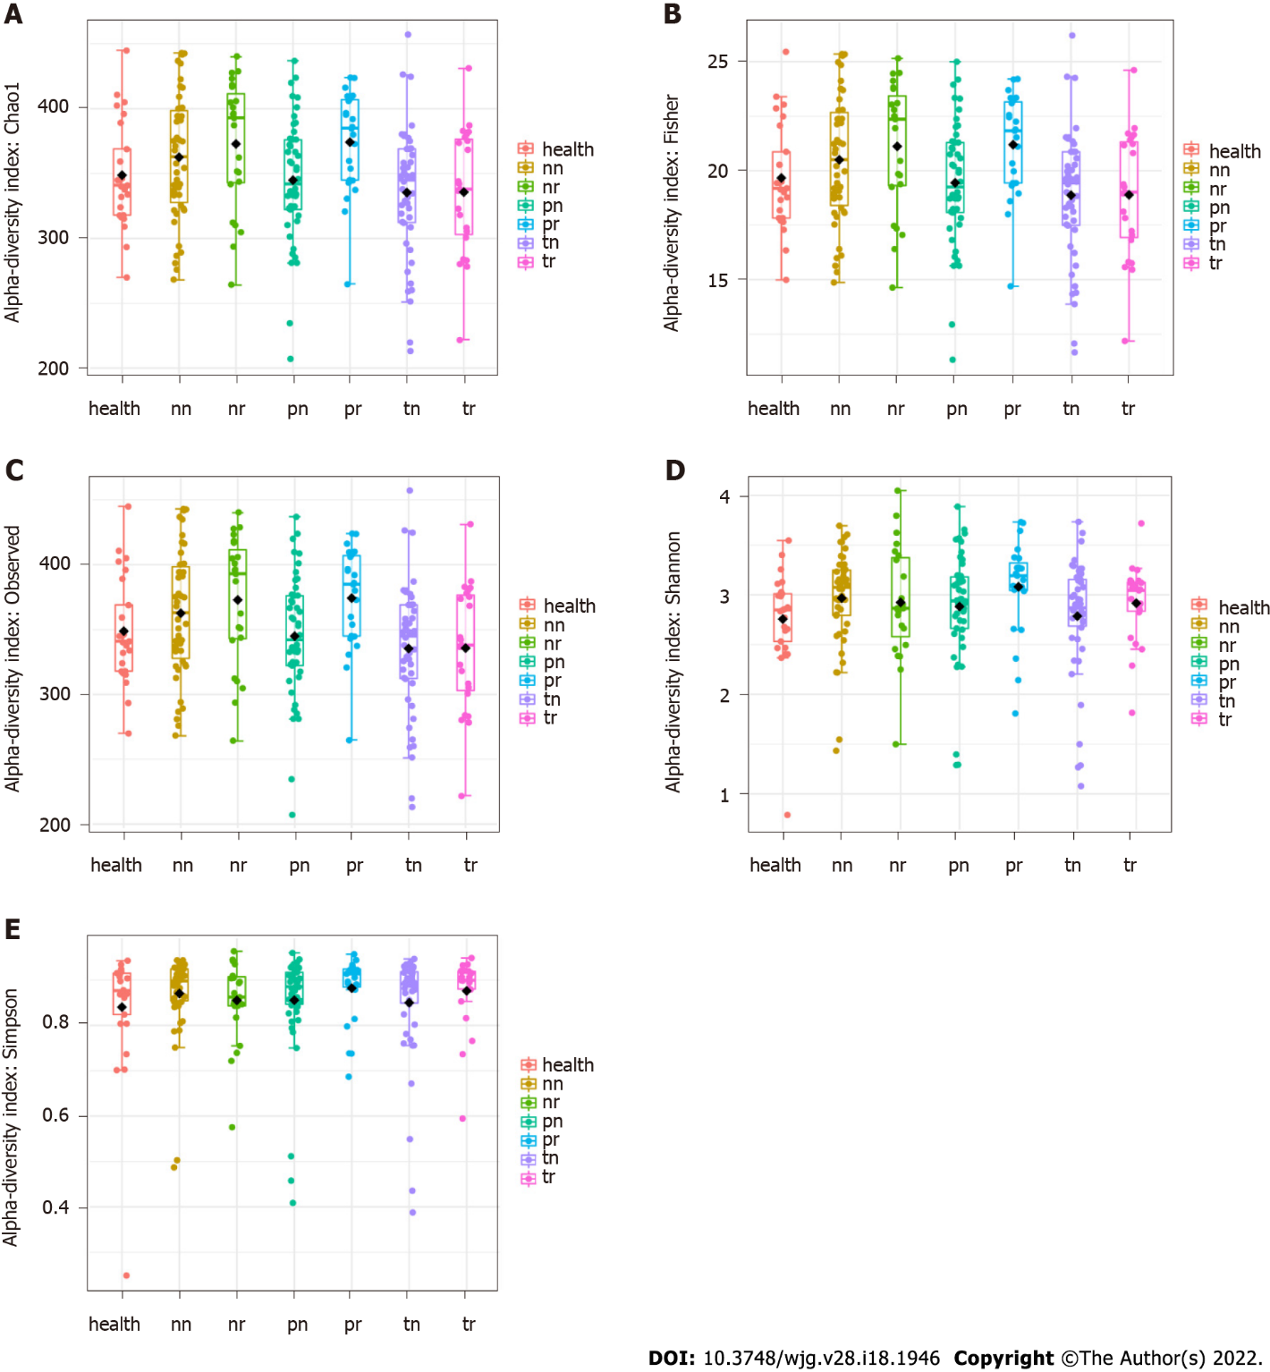
Figure 1 Microbial alpha-diversities showing significant differences at adjacent-tumor site. A: Alpha diversity evaluated using Chao1 index; B: Alpha diversity evaluated using Fisher index; C: Alpha diversity evaluated using observed operational taxonomic unit index; D: Alpha diversity evaluated using Shannon index; E: Alpha diversity evaluated using Simpson index. health: Healthy control; nn: Off-tumor site of patient without colorectal cancer (CRC) recurrence; nr: Off-tumor site of patient with CRC recurrence; pn: Adjacent-tumor site of patient without CRC recurrence; pr: Adjacent-tumor site of patient with CRC recurrence; tn: On-tumor site of patient without CRC recurrence; tr: On-tumor site of patient with CRC recurrence. Alpha-diversity differences were compared using student’s t-test.

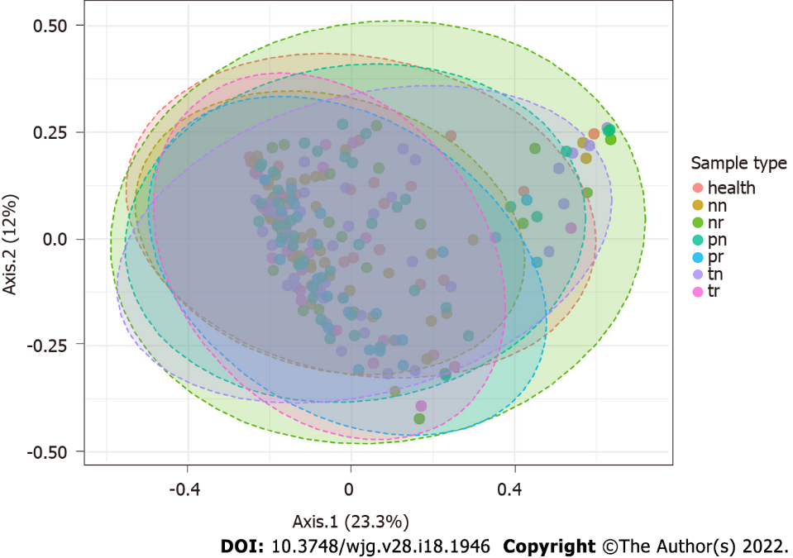
Figure 2 Principal component analysis showed spatial- and recurrence-specific patterns of microbiota profiles. health: Healthy control; nn: Off-tumor site of patient without colorectal cancer (CRC) recurrence; nr: Off-tumor site of patient with CRC recurrence; pn: Adjacent-tumor site of patient without CRC recurrence; pr: Adjacent-tumor site of patient with CRC recurrence; tn: On-tumor site of patient without CRC recurrence; tr: On-tumor site of patient with CRC recurrence.

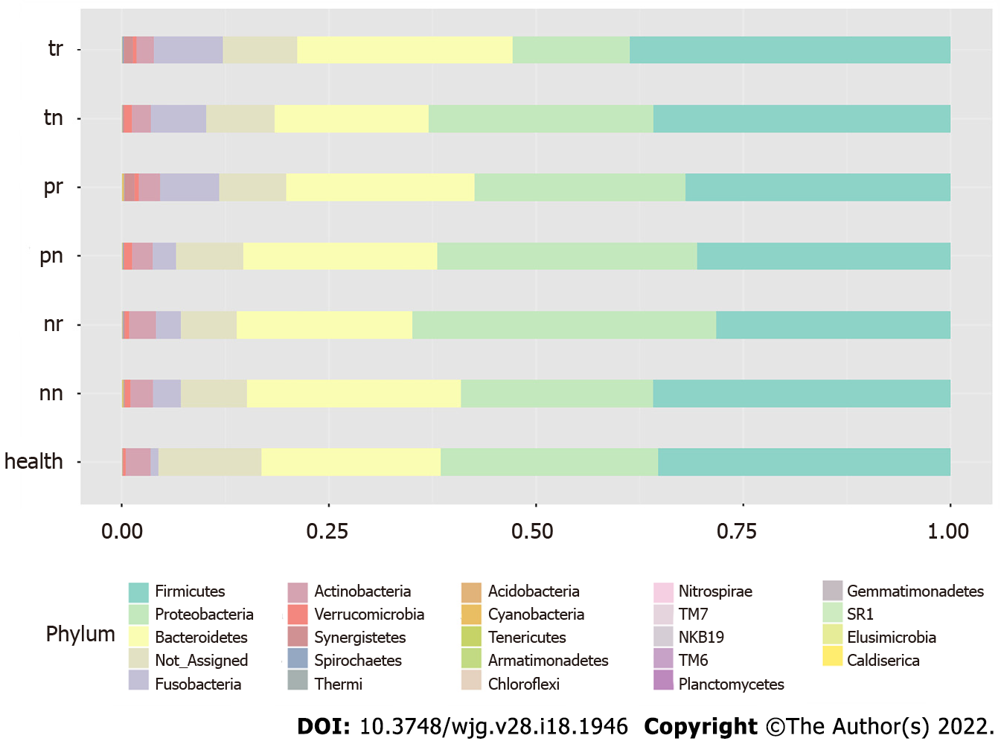
Figure 3 Patterns of bacterial taxonomy at the phylum level collected from spatial-specific sites of patients with or without colorectal cancer recurrence. health: Healthy control; nn: Off-tumor site of patient without colorectal cancer (CRC) recurrence; nr: Off-tumor site of patient with CRC recurrence; pn: Adjacent-tumor site of patient without CRC recurrence; pr: Adjacent-tumor site of patient with CRC recurrence; tn: On-tumor site of patient without CRC recurrence; tr: On-tumor site of patient with CRC recurrence.

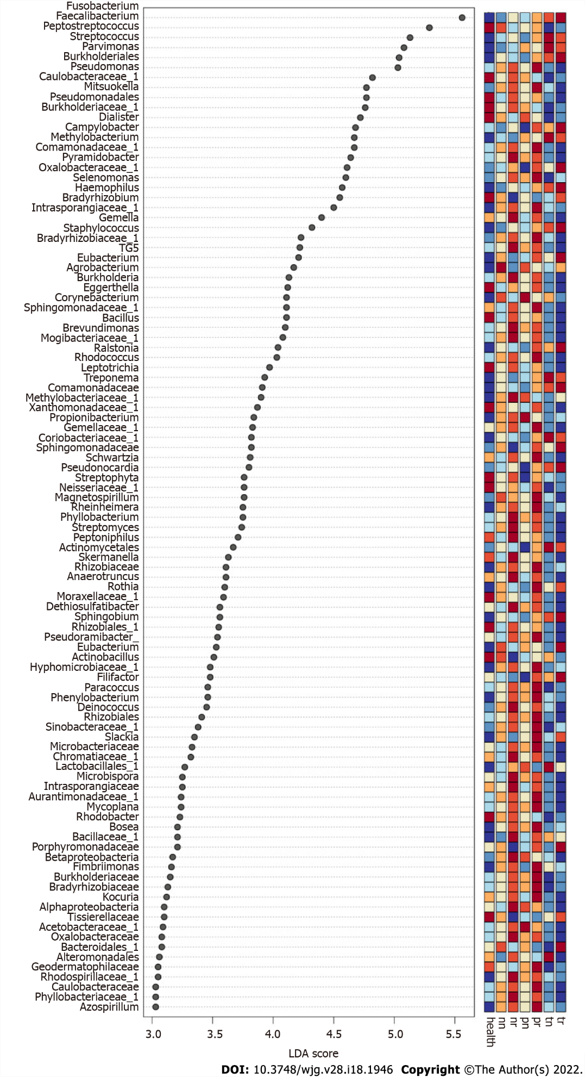
Figure 4 Linear discriminant analysis effect size analysis showed the genera or families with unknown genus with significant differential abundances at off-tumor, adjacent-tumor or on-tumor sites of patients with and without colorectal cancer recurrence. The colors in the heatmap represent the abundance of genera/families with unknown genus. Red: High abundance; Blue: low abundance. health: Healthy control; nn: Off-tumor site of patient without colorectal cancer (CRC) recurrence; nr: Off-tumor site of patient with CRC recurrence; pn: Adjacent-tumor site of patient without CRC recurrence; pr: Adjacent-tumor site of patient with CRC recurrence; tn: On-tumor site of patient without CRC recurrence; tr: On-tumor site of patient with CRC recurrence; LDA: The linear discriminant analysis.

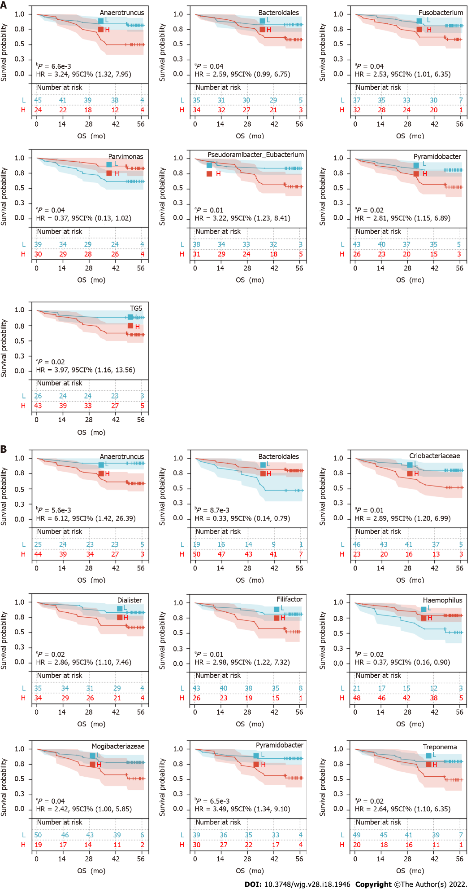
Figure 5 The relationship between bacterial abundance and overall survival. A: Kaplan-Meier curves of bacteria at on-tumor site and overall survival (OS); B: Kaplan-Meier curves of bacteria at adjacent-tumor site and OS. ªP < 0.05; ^{b}P < 0.01; ^{c}P < 0.001; ^{d}P < 0.0001. X-axis: OS (mo), Y-axis: Survival probability.

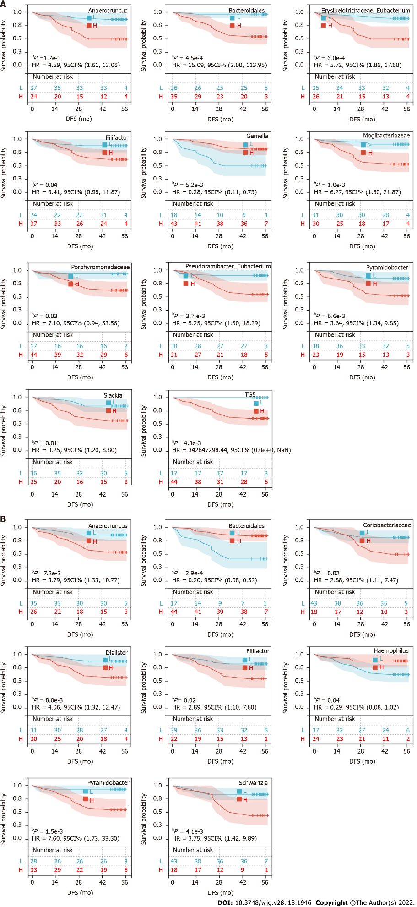
Figure 6 The relationship between bacterial abundance and disease-free survival. A: Kaplan-Meier curves of bacteria at on-tumor site and disease-free survival (DFS); B: Kaplan-Meier curves of bacteria at adjacent-tumor site and DFS. ªP < 0.05; ^{b}P < 0.01; ^{c}P < 0.001; ^{d}P < 0.0001.

Table 1 Summary of clinicopathological factors of colorectal cancer patients
Characteristics | n | % | Characteristics | n | %
Age, yr |  |  | Sex
Mean | 63.4 ± 11.0 |  | Male | 45 | 60.0
Range | 29-82 |  | Female | 30 | 40.0
AJCC stage |  |  | T stage
Ι-ΙΙ | 38 | 50.7 | 1-2 | 11 | 14.7
ΙΙΙ-ΙV | 37 | 49.3 | 3-4 | 64 | 85.3
Location |  |  | Lymph node metastasis
Left colon | 21 | 28.0 | Present | 36 | 48.0
Right colon | 11 | 14.7 | Absent | 39 | 52.0
Rectum | 43 | 57.3 | Distant metastasis
History of alcohol use |  |  | Present | 11 | 14.7
Nondrinker | 50 | 66.7 | Absent | 64 | 85.3
Drinker | 25 | 33.3 | Smoking history
Differentiation |  |  | Nonsmoker | 43 | 57.3
High | 1 | 1.3 | Smoker | 32 | 42.7
High-moderately | 3 | 4.0 | Microsatellite status
Moderately | 38 | 50.7 | Stability (MSS) | 46 | 61.3
Low-moderately | 21 | 28.0 | Instability (MSI) | 24 | 32.0
Low | 12 | 16.0 | Unclear | 5 | 6.7
AJCC: American Joint Committee on Cancer; MSS: Microsatellite stable; MSI: Microsatellite instability.

Published by Baishideng Publishing Group Inc
7041 Koll Center Parkway, Suite 160, Pleasanton, CA 94566, USA
Telephone: +1-925-3991568
E-mail: bpgoffice@wjgnet.com
Help Desk: https://www.f6publishing.com/helpdesk
https://www.wjgnet.com

© 2022 Baishideng Publishing Group Inc. All rights reserved.

