Name of journal: World Journal of Gastroenterology
ESPS Manuscript NO: 9847
Columns: Topic Highlights

WJG 20th Anniversary Special Issues (18): Pancreatitis

Autoimmune pancreatitis in the context of IgG4-related disease: Review of imaging findings

Lee LK et al. Imaging findings of AIP/IgG4-related disease

Leslie K Lee, Dushyant V Sahani

Leslie K Lee, Dushyant V Sahani, Division of Abdominal Imaging and Intervention, Department of Radiology, Massachusetts General Hospital, Harvard Medical School, Boston, MA 02114, United States

Author contributions: Lee LK and Sahani DV have each made substantial contributions to the conception, drafting, and revision of the manuscript, and have given final approval of the version to be published.

Correspondence to: Leslie K Lee, MD, Division of Abdominal Imaging and Intervention, Department of Radiology, Massachusetts General Hospital, Harvard Medical School, 55 Fruit St., White Bldg. 270, Boston, MA 02114, United States. llee22@partners.org

Telephone: +1-617-7262000 Fax: +1-617-7262000
Received: March 1, 2014 Revised: May 11, 2014
Accepted: July 22, 2014

Published online:

Abstract
Current understanding of autoimmune pancreatitis (AIP) recognizes a histopathological subtype of the disease to fall within the spectrum of IgG4-related disease. Along with clinical, laboratory, and histopathological data, imaging plays an important role in the diagnosis and management of AIP, and more broadly, within the spectrum of IgG4-related disease. In addition to the defined role of imaging in consensus diagnostic protocols, an array of imaging modalities can provide complementary data to address specific clinical concerns. These include contrast-enhanced computed tomography (CT) and magnetic resonance (MR) imaging for pancreatic parenchymal lesion localization and characterization, endoscopic retrograde and magnetic resonance cholangiopancreatography (ERCP and MRCP) to assess for duct involvement, and more recently, positron emission tomography (PET) imaging to assess for extra-pancreatic sites of involvement. While the imaging appearance of AIP varies widely, certain imaging features are more likely to represent AIP than alternate diagnoses, such as pancreatic cancer. Imaging appearance that favor a diagnosis of AIP rather than pancreatic cancer include: delayed enhancement of affected pancreas, evidence of restriction diffusion by diffusion weighted MR imaging, mild dilatation of the main pancreatic duct over a long segment, the “capsule” and “penetrating duct” signs, and responsiveness to corticosteroid therapy. Systemic, extra-pancreatic sites of involvement are also often seen in AIP and IgG4-related disease, and typically respond to corticosteroid therapy. Imaging by CT, MR, and PET also play a role in the diagnosis and monitoring after treatment of involved sites.

© 2014 Baishideng Publishing Group Inc. All rights reserved.

Key words: Autoimmune pancreatitis; IgG4-related disease; Pancreatic cancer; Imaging; computed tomography; magnetic resonance; positron emission tomography; Review

Core tip: The imaging appearance of autoimmune pancreatitis (AIP) varies widely. The literature is reviewed for imaging characteristics that favor a diagnosis of AIP rather than differential considerations such as pancreatic cancer. Response to steroid therapy and the presence of extra-pancreatic lesions are often seen in AIP and in IgG4-related disease. Extra-pancreatic findings and the role of imaging in monitoring their response to therapy are also reviewed, including recent developments in positron emission tomography (PET) imaging.

Lee LK, Sahani DV. Autoimmune pancreatitis in the context of IgG4-related disease: Review of imaging findings. World J Gastroenterol 2014; In press

Introduction
Autoimmune pancreatitis (AIP) was first described by Yoshida et al^{[1]} in 1995 as a form of chronic pancreatitis. In the interval, the associated finding of abnormally elevated serum concentrations of IgG4 among AIP patients was first reported in 2001^{[2]}, and extra-pancreatic manifestations of disease were first identified among AIP patients in 2003^{[3]}. These and other developments have contributed to the evolution of the understanding of the disease^{[4]} and AIP is now recognized to represent a manifestation of IgG4-related disease^{[5,6]}.

AIP in the context of IgG4-related disease
IgG4-related disease has been recently-recognized as a systemic inflammatory disorder characterized by stereotypic histopathological features of a dense lymphoplasmacytic infiltrate, “storiform” fibrosis, and obliterative phlebitis^{[7,8]}. It is a systemic process which may involve one or multiple organs, either synchronously or metachronously. IgG4-related disease has been described in virtually every organ system, including the pancreas^{[5,6]}, demonstrating common histopathological findings. As a result, a host of organ-specific pathologies previously thought to be unrelated are now recognized in the spectrum of IgG4-related disease, including: salivary glands (Mikulicz’s syndrome), thyroid gland (Riedel’s thyroiditis), orbit (orbital pseudotumor), aorta (non-infectious/inflammatory aortitis or periaortitis), pancreas (AIP), retroperitoneum (Ormond’s disease or retroperitoneal fibrosis), and kidneys (tubulointerstitial nephritis).
Two types of AIP, 1 and 2, are presently recognized, found to share overlapping histopathological and clinical characteristics, but also important differences^{[9-11]}. Of note, while Type 1 disease demonstrates IgG4-related infiltrates and serologic abnormalities, these features are absent in Type 2 disease. Additionally, extra-pancreatic organ involvement and disease relapse are associated with Type 1 and not Type 2 disease^{[12]}. International consensus diagnostic criteria have been established for AIP, predicated on clinical, laboratory, imaging, and histopathologic data. In addition to characteristic histopathological findings, diagnostic characteristics of AIP include abnormal elevations of serum IgG4 levels, extra-pancreatic organ involvement, and responsiveness to a trial of corticosteroids. By imaging, while certain features are considered diagnostic, Types 1 and 2 cannot be reliably distinguished^{[9,11]}.

Demographics
An uncommon entity, the global burden of IgG4-related disease is difficult to assess, a problem made more challenging by its evolving characterization encompassing various organ-based pathologies which were previously thought to be disparate. However, population-based epidemiological data are available relating to AIP in Japan, where estimates based on national survey data estimate the prevalence of AIP as 0.82 to 2.2 per 100000 individuals^{[13,14]}. The disease typically involves men more than women, at a ratio of 2.9 to 3.7 to 1, and typically involves individuals older than 50 years of age. Pertaining to AIP, groups around the world have also reported on their clinical experience^{[15-18]}.

Diagnostic features of IgG4-related disease
The diagnosis of IgG4 disease relies on the synthesis of clinical, laboratory, radiologic and histopathologic findings^{[5,9,11,12]}. National consensus criteria for diagnosis from Japan^{[19]} are comprised of two central, specific, findings: the first, of abnormally elevated serum IgG4 concentration > 135 mg/dL; and the second, in histopathologic analysis, of > 40% of IgG+ plasma cell positive for IgG4, and > 10 IgG4+ cells per high power field. Additional clinical, laboratory, and histopathological findings may be less specific, but increase the sensitivity for detection of organ-specific pathology in the IgG4-related disease spectrum.
Clinically, IgG4-related disease typically presents in subacute fashion. Most patients are not constitutionally ill, and fever as a symptom is unusual; the myriad clinical presentations of IgG4-related disease have previously been summarized^{[5]}. Symptoms are typically nonspecific, and further investigations are typically necessary before the diagnosis is reached. Laboratory evaluation for IgG4-related disease has centered on serum concentration of IgG4, since this finding was first reported in AIP patients in 2001^{[2]}. However, elevated serum IgG4 levels are detected in other types of immune-mediated and allergic disorders, as well as in infectious and malignant conditions^{[20]}. Nonetheless, the generally accepted upper limit of normal of serum IgG4 concentration is 135 mg/dL; levels elevated beyond this are considered abnormal, including in the Japanese national consensus criteria. It should be noted that serum IgG4 abnormalities are not seen in Type 2 AIP, and at the diagnostic threshold of 135 mg/dL, up to 30% of patients with IgG4-related disease may have normal serum IgG4 levels^{[21]}.
Given the nonspecific nature of presenting symptoms, laboratory and radiologic investigation present complementary data in reaching a diagnosis of IgG4-related disease. Imaging may be of particular utility in identifying focal abnormalities that may represent biopsy targets. Even so, the characteristic of the disease to form tumefactive lesions often necessitates biopsy to exclude a malignant or neoplastic process.

Imaging findings of AIP
Cross-sectional imaging findings of AIP were initially described in 1998^{[22,23]}. Clinical investigators since then have reported on the imaging appearance of AIP by a multitude of imaging characteristics, including morphology of the pancreatic parenchymal and main pancreatic duct, associated tissue (fat, lymph nodes), signal, and response to administration of intravenous contrast agents. Modalities employed by investigators include cross-sectional techniques of computed tomography (CT) and magnetic resonance (MR) imaging, endoscopic techniques such as endoscopic retrograde cholangiopancreatography (ERCP) and endoscopic ultrasound (EUS), and more recently, positron emission tomography (PET).

CT and MR imaging
Morphologic and signal characteristics: The CT appearance of AIP was first described in 1998. In two case series’ of five and three patients^{[22,23]}, CT demonstrated a diffusely enlarged pancreas in all patients. Since then, studies of patients with AIP have demonstrated heterogeneity of the morphologic presentation on both CT and MR imaging: diffuse enlargement has been shown among 11%-56% of patients; focal or mass-like enlargement among 28%-59% of patients (Figure 1A); and no enlargement, or a normal appearance of the pancreas, in a minority of patients, 9%-16%^{[15,16,24,25]}. In another series, investigators also characterized a ‘mixed’ appearance of diffuse and focal enlargement in 56% of 36 patients^{[25]}.
Peri-pancreatic fat planes are typically preserved on cross-sectional imaging^{[23]}. Minimal peri-pancreatic stranding (Figure 1A), without vascular encasement, parenchymal calcification, or peripancreatic fluid collection, was seen in six patients with diffuse pancreatic enlargement, in a study of 25 patients with AIP^{[15]}. By comparison, in that study, an accessory finding more commonly observed was one of enlarged peripancreatic lymph nodes. Imaging presentation with acute pancreatitis has rarely been reported: in one series of imaging findings on 22 patients with AIP, the authors noted the appearance of one case consistent with acute pancreatitis^{[16]}.
By MR imaging, signal abnormality representing AIP typically demonstrates relative T1 hypo-intensity, and relative T2 hyper-intensity^{[22,25,26]}. Recent studies have sought to distinguish AIP from differential considerations such as pancreatic cancer using MR diffusion characteristics, and other imaging features (Section 4, below).

Enhancement characteristics: Classically, upon administration of intravenous contrast material, AIP demonstrates diminished enhancement in the early, or arterial phase, and relatively increased or prolonged enhancement in the delayed or venous phase (Figure 2)^{[22,23]}. Despite variation in acquisition and definition, subsequent studies have typically supported this pattern of enhancement by both CT^{[27,28]} and MR^{[24]} imaging. Takahashi et al^{[27]} quantitatively assessed dual-phase contrast enhanced CT among 43 AIP patients and 25 patients with normal pancreas. In the pancreatic phase, the mean CT attenuation of pancreatic parenchyma among AIP patients (85 HU) was significantly lower than that among the control group (104 HU). Delayed enhancement, defined as a 15­HU or greater increase from the pancreatic phase to the hepatic phase, was observed in seven of the 13 patients (54%) with focal AIP. In separate study of imaging related to 36 patients with AIP comprising 86 contrast-enhanced CT and MRI scans^{[25]}, investigators noted hypo-enhancement in the arterial phase in 58% and 52% for CT and MRI, respectively. In that study however, delayed enhancement was found to be significantly more pronounced by MR imaging: whereas 75% of late-venous phase enhancement in CT was iso-attenuating, 74% of late-venous enhancement was hyper-enhancing by MR.
An early report^{[22]} also noted that on CT, in four of five patients, “a capsule-like low density rim surrounded the pancreas on both early and delayed [contrast-enhanced] images,” giving rise to the “capsule” or “rim” sign of AIP (Figure 1B). The correlate on MR imaging is of a T1 and T2 hypo-intense rim, with delayed enhancement, demonstrated in three of four patients. The sensitivity of this finding for AIP has been subsequently shown to be generally low for both CT and MR imaging, ranging from 12-40%, but may potentially distinguish AIP from pancreatic malignancy^{[15,24-27,29]}.

Endoscopic techniques: ERCP and EUS
Abnormality of the intra- and extra-hepatic biliary system, including the main pancreatic duct (MPD), is common in AIP. MPD involvement varies widely, and may demonstrate irregular narrowing, in either a diffuse or segmental distribution (Figure 3)^{[26]}. In one series of 20 patients who underwent ERCP, diffuse narrowing was found in six patients (30%), and segmental narrowing was found in nine patients (45%)^{[26]}. The length of MPD narrowing was longer than 3 cm in 18 patients (90%). In another series of 19 patients who underwent ERCP, diffuse irregularity and narrowing of the MPD was observed in nine patients (47%), while focal stricture in the proximal MPD was seen in six patients (32%)^{[15]}. Biliary duct abnormalities were seen in 16 of 19 patients who underwent ERCP (84%). The most common abnormality was stricture of the distal common bile duct, present in 12 patients (60%), while multiple short-segment intrahepatic duct strictures were present in six patients (30%). Biliary involvement varies widely, and multifocal narrowing of the MPD (Figure 1C) and narrowing of the lower common bile duct have been reported in as high a proportion as 85% and 90%, respectively^{[30]}. Readers are additionally referred to a recent review for detailed discussion of IgG4-related sclerosing cholangitis, which has overlapping features^{[31]}.
The sensitivity of ERCP to diagnose AIP is limited, but can be improved with directed training of key features. A multicenter, international study^{[32]} identified four key features of AIP from a series of 20 patients: long stricture (greater than one-third the length of the MPD; upstream dilatation from the stricture less than 5 mm; multiple strictures; and side branches arising from a strictured segment. Following training with a teaching module principled upon these features, the sensitivity of an international group of physicians to detect AIP increased significantly from 44% to 71%, with specificity of 83%.
Consistent with the varied morphologic presentation of AIP seen on CT and MR imaging, endoscopic ultrasound may reveal diffuse enlargement of the pancreas with altered echotexture, or may demonstrate a focal hypoechoic mass^{[33]}. In one study among 21 patients who underwent EUS^{[15]}, diffuse enlargement with altered echotexture was seen in 13 patients (62%), while six patients had focal enlargement of the head of the pancreas (29%).

Magnetic resonance cholangiopancreatography
Magnetic resonance cholangiopancreatography (MRCP) can provide complementary data in the diagnosis of AIP and assessment of MPD involvement, depending on the pattern of involvement^{[26]}. In a series of 20 AIP patients, MRCP findings were compared with ERCP findings^{[34]}. Among patients with focal AIP, the narrowed portion of the MPD was not visualized, while among patients with diffuse AIP, the MPD was incompletely visualized or not visualized. In the latter setting, non-visualization of the MPD may limit detection of duct involvement, yet MRCP may still be helpful in follow-up after therapy. In a separate study comparing MRCP findings among cohorts of 38 AIP patients, 40 pancreatic cancer patients, and 40 normal controls, ERCP was used as the gold standard^{[35]}. The authors found MRCP to be 65% accurate (22 of 34 patients) for depicting MPD morphology among patients with AIP, significantly less than that of the cohort of patients with pancreatic cancer (89%, 23 of 26 patients) or those with normal pancreas (100%, 40 of 40 patients).

Angiography and peripancreatic vascular findings
Angiographic findings related to AIP were reported by Kamisawa et al^{[36]} in 2003. Among 13 patients with AIP, angiography demonstrated irregular narrowing of the anterior superior pancreaticoduodenal artery in seven (54%) and of the posterior superior pancreaticoduodenal artery in 4 patients (31%). Deviation of the portal or splenic vein was observed in 4 cases (31%); collateral venous circulation was observed on account of stenosis or obstruction in 3 cases (23%). The presence of irregular narrowing of the pancreatic arteries similar to encasement sometimes detected in pancreatic carcinoma; these angiographic findings can cause confusion in the diagnosis of AIP.
Subsequent studies with cross sectional imaging have reported similar rates of peripancreatic vascular involvement. Takahashi et al^{[37]} reported vascular involvement in 11 of 25 (44%) of AIP patients. Raina et al^{[38]} demonstrated splenic vein and/or artery involvement was seen in six of 26 patients (23%). Vlachou et al^{[39]} noted narrowing of the splenic vein with collateral vessel formation was seen in nine of 57 patients (16%), with normalization of vessel caliber following resolution of AIP. Ishikawa et al reviewed CT imaging among 54 AIP patients, finding 24 cases (44%) which demonstrated peripancreatic vascular involvement, with stenosis or occlusion of the splenic vein in 22 cases, of the superior mesenteric or portal vein in 13 cases, and development of collaterals in 18 cases^{[40]}. Among 16 patients who underwent steroid therapy, 14 demonstrated improvement in vascular involvement (87%).

PET imaging
Positron emission tomography (PET), typically used in clinical oncology to localize areas of normal or abnormal physiology based on uptake of radiopharmaceutical imaging agents^{[41]} has found useful application in the imaging of inflammatory disease^{[42]}. PET imaging following intravenous administration of a radiopharmaceutical such as 2-(18)F-fluoro-2-deoxy-d-glucose (¹⁸F-FDG), either alone or in combination with concurrent CT imaging (PET/CT), allows for whole body imaging to identify areas of abnormally increased cellular metabolism^{[43]}.
With regard to AIP, ¹⁸F-FDG uptake at pancreatic and extra-pancreatic lesions have been shown in case reports of AIP/IgG4-related disease since 1999^{[44-47]}. Nakamoto et al initially described two cases of AIP demonstrating diffusely and focally intense pancreatic uptake, with resolution after steroid therapy^{[44]}. Kajiwara et al^{[47]} described two cases with multifocal ¹⁸F-FDG uptake of the pancreas, corresponding to focal pancreatic masses of AIP. Kawamura et al^{[45]} and Sato et al^{[46]} additionally reported extrapancreatic findings in cases of AIP associated with sclerosing cholangitis, sialadenitis, and lymphadenopathy. As with its accepted application in clinical oncology, in the context of IgG4-related disease, ¹⁸F-FDG PET may prove valuable in providing complementary data in the delineating the extent of organ involvement, staging the extent of disease, guiding biopsy early in the diagnostic evaluation, and monitoring response to therapy^{[42]}.

Distinction of AIP from pancreatic malignancy
The varied appearance on cross-sectional imaging of AIP can make for a diagnostic quandary. For example, in a case series of the early clinical experience encompassing 37 patients with AIP between the years 1989 and 2005^{[48]}, six patients had been initially misdiagnosed with pancreatic cancer, and two patients had been initially misdiagnosed with biliary malignancy. Authors noted that five cases were misdiagnosed on account of the non-existence of, or unfamiliarity with, the entity of AIP. In another early report, nine patients among a series of 17 patients with AIP were initially suspected to have pancreatic cancer^{[36]}. The authors cited a number of variables of the cohort that raised concern for pancreatic malignancy, including: demographics (14 patients were male, 16 patients older than 60 years), clinical presentation (jaundice in 13 patients), serum studies (9 patients had elevated tumor markers), and radiologic evidence of biliary duct stenosis (16 patients).
Given the potential of overlapping clinical and radiologic presentations of AIP and important differential considerations such as pancreatic malignancy, numerous subsequent investigations have sought to discern AIP from a malignant etiology. In an early study, investigators retrospectively compared findings from nine patients with focal AIP with 80 patients with pancreatic cancer, and 11 patients with alcohol-related pancreatitis^{[49]}. Significant factors differentiating focal AIP from pancreatic cancer included: homogeneous delayed enhancement on contrast-enhanced CT, and ERCP findings of long-segment stenosis of the MPD, and a lesser degree of MPD dilatation proximal to stricture. Other groups have subsequently employed clinical and radiologic means to differentiate AIP from pancreatic cancer, using CT, MR and PET imaging, and the imaging response to a trial of steroid therapy in diagnostic protocols^{[11,50]}. Imaging features favoring a diagnosis of AIP rather than pancreatic cancer are summarized in Table 1.

Signal and enhancement characteristics
Discerning imaging features of AIP vs pancreatic cancer include morphology, attenuation, signal, and enhancement characteristics, and certain specific signs (“capsule” and “penetrating duct” signs).
International consensus guidelines recognize diffuse pancreatic enlargement with delayed enhancement to represent typical findings of AIP^{[11]}. Quantitatively, CT studies on enhancement patterns of pancreatic AIP lesions vs malignancy have demonstrated mean CT attenuation in the delayed or hepatic phase of imaging to be significantly greater in AIP than in pancreatic cancer^{[27,51]}. Contrasting data were reported however regarding enhancement in the early or pancreatic phase, possibly due to differences in contrast administration and timing. Among those two studies, Takahashi et al^{[37]} found peri-pancreatic stranding and calcifications significantly associated with AIP, while Muhi et al^{[51]} observed that the frequency at which calcifications were seen was not statistically significant.
The capsule sign of AIP, as previously described (Figure 1B), while of variable sensitivity, favors a diagnosis of AIP rather than pancreatic cancer when present: studies have shown the capsule sign is significantly more frequently associated with AIP^{[37,51,52]}, and rarely reported in pancreatic cancer.
The finding of greater delayed enhancement in AIP (Figure 2B, C) was demonstrated on MR imaging by Hur et al^{[52]}. Two groups were assessed at the lesion level, 14 among AIP patients, 28 among pancreatic cancer patients. There was significantly greater delayed enhancement at 3-minutes post contrast administration in the AIP group (10/14, 71%) in the AIP group compared to the pancreatic cancer group (57%). Signal intensity in the arterial and portal venous phase following contrast administration did not differ significantly.
Using MR imaging, other investigators have sought to discern AIP from pancreatic cancer via diffusion weighted sequences. In diffusion weighted MR imaging, the apparent diffusion coefficient (ADC) can be calculated as a measure of free diffusion of assessed water molecules; lower ADC values indicate restricted diffusion^{[53]}. Histopathological correlation of tissue with ADC values bear an inverse association of ADC value and cell density, i.e. low ADC values are associated with tissue of high cell density^{[54]}. Early AIP data using diffusion weighted imaging demonstrated significantly decreased ADC in AIP cases, compared to cases of chronic alcoholic pancreatitis and normal controls^{[55]}. Subsequently, investigators have quantitatively shown that ADC values are significantly lower in AIP than in pancreatic cancer. Following steroid therapy among AIP patients, foci of restricted diffusion decreased markedly or resolved, with ADC values increasing almost to that of normal pancreas^{[51,52,55,56]}.
In receiver-operating curve analysis, Hur et al^{[52]} found that a threshold ADC value of 1.26 x 10⁻³ mm²/s, below which would distinguish AIP from pancreatic cancer, yielded a sensitivity of 83.3% and a specificity of 79.2%. Similarly, in sensitivity analysis of ten patients with AIP and 70 patients with pathologically proven pancreatic carcinoma, Muhi et al^{[51]} applied two criteria in tandem, delayed enhancement and ADC less than 0.88 × 10⁻³ mm²/s, to suspected cases of focal AIP, achieving sensitivity and specificity of 100%.

Main pancreatic duct involvement
Dilatation of the MPD may be seen in both AIP and pancreatic cancer. However, AIP demonstrates a lesser degree of MPD dilatation by both conventional and MR/MRCP imaging than that seen in pancreatic cancer, typically less than 4 mm^{[34,35,51,52]}. This pattern reflects that seen by ERCP, where AIP typically demonstrates long segment narrowing over a segment greater than 3 cm (Figure 3A), with upstream dilatation less than 4 mm^{[49]}. In receiver-operating curve analysis conducted by Muhi et al^{[51]}, the group found that a threshold value of 4 mm of upstream MPD dilatation on MRCP yielded sensitivity of 100% and specificity of 76% for AIP. Additionally, multiple sites of MPD narrowing (Figure 1C) favor the diagnosis of AIP rather than pancreatic cancer, as per international consensus guidelines^{[11,35]}. Complete obstruction of the MPD and abrupt cut-off of the MPD however, are findings differentially associated with pancreatic cancer rather than AIP^{[37,51]}.
Studies have also evaluated the value of the 'penetrating duct sign' in differentiating AIP from pancreatic cancer. Initially associated with ultrasound or ERCP findings of focal pancreatitis^{[57]}, this sign represents the finding of a non-obstructed MPD penetrating a focal pancreatic mass lesion. Ichikawa et al^{[58]} previously assessed the penetrating duct sign on MRCP to have high specificity in determining inflammatory pancreatic mass lesions, and for distinguishing AIP from pancreatic cancer. Carbognin et al^{[24]} found the penetrating duct sign to be present in 6 of 14 AIP cases (43%) by secretin-MRCP. In studies comparing cohorts of AIP patients and pancreatic cancer patients, MRCP studies have found the penetrating duct sign to be of variable sensitivity, but with high specificity for AIP when present. Hur et al^{[52]} observed the penetrating duct sign in 3 of 9 AIP patients (33%) and in none of 29 pancreatic cancer patients (0%). Muhi et al^{[51]} observed the penetrating duct sign in 8 of 11 AIP patients (73%) and in 3 of 70 pancreatic cancer patients (4%).
Advanced endoscopic techniques, such as intraductal ultrasound (IDUS) may further discern the etiology of existing stricture, whether from mass effect, edema, or wall thickening; Hirano et al^{[59]} demonstrated advanced intrapancreatic biliary wall thickening was associated with increased severity of stricturing. Finally, EUS-guided fine needle aspiration with a 19-gauge needle allows for minimally-invasive tissue sampling, and is commonly used to exclude pancreatic malignancy^{[60]}. Endoscopic techniques and devices specific to IgG4-related disease have been recently reviewed^{[61]}.

¹⁸F-FDG PET findings
As ¹⁸F-FDG PET imaging also has high sensitivity for pancreatic cancer^{[62]}, investigators have also evaluated the ability of ¹⁸F-FDG PET imaging to differentiate AIP from pancreatic cancer^{[63-66]}. Ozaki et al^{[63]} detected ¹⁸F-FDG uptake in all 15 patients (100%) with autoimmune pancreatitis, compared to 19 of 26 patients (73%) with pancreatic cancer. Lee et al^{[64]} detected ¹⁸F-FDG uptake in 17 of 17 AIP patients (100%), vs 124 of 151 (82%) of patients with pancreatic cancer. Shigekawa et al^{[65]} compared ¹⁸F-FDG PET between 18 patients with AIP and 20 patients with pancreatic cancer, with uptake observed in 16 (89%) and 18 (90%) patients, respectively. Described patterns of uptake favoring AIP rather than pancreatic cancer include: diffuse pancreatic uptake, multiple foci of pancreatic uptake, elongated shape of focal uptake (vs a nodular pattern of uptake), and heterogeneous uptake (vs a homogeneous pattern of uptake)^{[63,64]}. Extra-pancreatic ¹⁸F-FDG uptake at the lacrimal glands, salivary glands, thoracic lymph nodes, biliary duct, kidneys, retroperitoneal space, and prostate have been observed in cases of AIP^{[63-66]}.
Overall, studies have demonstrated high sensitivity of ¹⁸F-FDG PET among patients with AIP, as well as in patients with pancreatic cancer. Extra-pancreatic foci of ¹⁸F-FDG uptake may represent associated lesions in IgG4-related disease, or metastatic foci in pancreatic cancer; the role of ¹⁸F-FDG PET imaging in the staging of IgG4-related disease is discussed below (Section 6.3). While the existing literature suggest certain patterns of uptake that favor one diagnosis vs another, correlative clinical and histopathological data remain essential to the course of management.

Imaging response to corticosteroid therapy
AIP has been widely shown to be responsive to corticosteroid therapy^{[4,5,10-12]}. Imaging plays a role both in diagnostic protocols that aim to discern AIP from pancreatic cancer by the response to a course of corticosteroids, as well as in the assessment of response to therapy.
Improvement, if not complete resolution, of imaging abnormalities in AIP is commonly seen after steroid therapy. Manfredi et al^{[67]} specifically evaluated CT examinations of 21 patients with AIP were reviewed before and after steroid therapy. Notably, baseline studies demonstrated hypo-attenuation of affected parenchyma in 19 patients (90%), contrast enhancement abnormality with contrast material retention at the portal venous phase in 18 (86%) patients and contrast material washout in three (14%), and non-visualized of the MPD within affected parenchyma in all patients (100%). Following steroid therapy, CT demonstrated size reduction of affected pancreatic parenchyma, normalization of pancreatic enhancement in 15 (71%), and normalization of the appearance of the MPD at affected areas.
Sahani et al^{[68]} assessed follow-up CT imaging of 15 AIP patients for imaging factors associated with complete vs partial clinical response after steroid therapy. Complete response to treatment was associated with baseline features of diffuse pancreatic parenchymal involvement, and peri-pancreatic stranding. By comparison, partial response was associated with cases with persistent ductal stricture and persistent focal mass-like swelling after resolution of diffuse changes.
Typically, normalization of ¹⁸F-FDG uptake abnormalities has also been observed by PET imaging following steroid therapy. In the series reported by Lee et al^{[64]}, follow-up PET/CT after steroid therapy was performed for eight patients with AIP, whereby residual intense FDG uptake was not observed in each of the eight patients. Matsubayashi et al^{[69]} reported on findings of 11 AIP cases with PET imaging both before and three months after the initiation of steroid therapy. ¹⁸F-FDG uptake was analyzed semi-quantitatively via measure of standardized uptake value (SUV). The mean of maximum SUV among pancreatic lesions differed significantly with therapy, decreasing from 5.12 at baseline to 2.69 following therapy (p < 0.001). By the group’s SUV criteria, FDG uptake resolved completely in six patients (55%), diminished to a faint level in two patients (18%), diminished but remained abnormal in two patients (18%), and increased after steroid therapy in one patient (9%).
Repeat imaging following a trial of steroid therapy of two weeks’ duration is recommended in the setting of a new AIP diagnosis, according to international consensus guidelines^{[11]}. Moon et al^{[70]} reported imaging (contrast-enhanced CT and ERCP/MRCP) results following a two-week course of steroid therapy among 22 patients with indeterminate imaging for AIP vs pancreatic cancer. After the two-week trial, surgical intervention was performed where reduction of pancreatic mass or MPD narrowing was not observed; each of the seven patients who did not demonstrate an imaging response were subsequently diagnosed with pancreatic cancer. Similarly, in the series of Shigekawa et al^{[65]}, follow-up PET was performed in six AIP patients and in three pancreatic cancer patients, and maximum SUV at follow-up was recorded within one week in five AIP patients and in all three pancreatic cancer patients. In four AIP patients, the change in maximum SUV was greater than 10%, while this value was increased or within 10% of baseline in the three patients with pancreatic cancer.

Imaging of IgG4-related disease: extra-pancreatic findings
The observation of extra-pancreatic abnormalities among patients with AIP contributed to the understanding of IgG4-related disease^{[3,5]}. The imaging of extra-pancreatic findings of IgG4-related disease has been reviewed previously^{[28,39]}. Extra-pancreatic organs that may be involved include: the biliary tree, gallbladder, kidneys, retroperitoneum, mesentery, thyroid, lacrimal glands and orbits, salivary glands, lymph nodes, lungs, gastrointestinal tract, and large and medium-caliber arteries (Figures 4 and 5). In a large retrospective series of cross-sectional imaging of 90 patients with AIP, extra-pancreatic lesions were detected in 92% of cases^{[71]}. Extra-pancreatic imaging abnormalities included: hilar lymphadenopathy (78%), wall thickening of bile ducts (78%), peri-pancreatic or para-aortic lymphadenopathy (56%), lung lesions (51%), swelling of lachrymal and salivary gland lesions (47%), retroperitoneal fibrosis (20%), renal lesions (14%), and mass lesions of the ligamentum teres (2%).
While the majority of reports on extra-pancreatic findings of IgG4-related disease center on conventional cross-sectional modalities such as CT and MR, radiopharmaceutical imaging, predominantly with ¹⁸F-FDG PET but also with gallium-67, has also been reported. In the case of gallium-67, a case series among 24 AIP patients demonstrated high pancreatic uptake in 16 patients (67%), which resolved after corticosteroid therapy^{[72]}. Pancreatic uptake was significantly associated with elevated serum IgG4 levels, as was hilar gallium-67 uptake. In a series of 13 patients who underwent gallium-67 imaging, high uptake was detected in the pancreas, bilateral hila, salivary glands, lacrimal glands, and periaortic lesions in 10 (77%), 10 (77%), 7 (54%), 7 (54%), and 2 (15%) patients, respectively^{[73]}. Compared with gallium-67, imaging with ¹⁸F-FDG is more commonly performed and reported on account of its favorable dosimetry and signal localization characteristics, and is discussed in further detail below (Section 6.3).

Renal findings
Certain extra-pancreatic findings have been specifically investigated among patients with AIP. A retrospective study of 2007 investigated renal findings on CT and MRI among patients with AIP^{[74]}. Of 40 patients with CT or MR imaging at presentation, 14 (35%) had renal involvement (12 with parenchymal involvement and five with extra-parenchymal involvement). Renal parenchymal lesions had decreased enhancement, and appeared as small peripheral cortical nodules, as round or wedge-shaped lesions, or as diffuse patchy involvement. Thirteen patients with underwent a follow-up study; renal lesions in 10 patients (77%) regressed (nine after steroid treatment, one spontaneously) but progressed in three patients without steroid treatment.
In another study of 18 patients with AIP and no history of renal disease, seven patients were found to have renal involvement (39%)^{[75]}. In four patients, lesions appeared as multiple renal parenchymal nodules showing decreased enhancement; in two cases, diffuse thickening of the renal pelvis wall was seen; in one patient, an ill-defined low-attenuation mass-like lesion was identified. None of the lesions was visible on non-contrast-enhanced CT scan. In each of these seven patients, renal lesions regressed after steroid treatment (100%).

Head and neck findings
Pertaining to the head and neck, IgG4-related disease may affect a variety of sites^{[76]}, but typically are iso- to hypo-intense on T2-weighted MR imaging. Affected sites include: salivary glands, lacrimal glands, orbits, thyroid gland, lymph nodes, sinonasal cavities, pituitary gland, and larynx (Figure 2). Multiples sites are typically involved. CT imaging of involved organs may demonstrate enlargement or decreased attenuation. MR findings vary, but lesions typically have relatively low signal T2-weighted signal intensity on account of increased cellularity and fibrosis. A retrospective study of 17 patients with IgG4-related disease of the head, neck and brain demonstrated the following distribution of abnormalities: parotid gland 14 (82%), submandibular gland 10 (59%), lacrimal gland 7 (41%), pterygopalatine fossa 3 (18%), pituitary gland 2 (12%), and skull base dura mater 2 (12%)^{[77]}. Lesions presented as either an enlarged gland or glands, or as focal nodules or masses. All lesions were well-defined, showed homogeneous enhancement, and appeared iso- to hypo-intense on T2-weighted MR imaging. No lesion showed vascular occlusion or compression, or destruction of adjacent bony structures. In a separate study of 15 patients with IgG4-related disease of the head, neck and brain^{[78]}, the distribution was as follows: lacrimal gland 8 (53%), cranial nerve involvement [7 (47%), with the infraorbital nerve involved in 4], orbital pseudotumor 5 (33%), and pituitary gland 5 (33%). All lesions were hypo-intense on T2-weighted MR images.

¹⁸F-FDG PET imaging in IgG4-related disease
Extra-pancreatic findings have been described by ¹⁸F-FDG PET imaging in IgG4-related disease in case reports^{[79-82]} and case series’ (Figures 2 and 3)^{[69,83,84]}. In one study of six patients with AIP, whole-body ¹⁸F-FDG PET or PET/CT examinations were reviewed at baseline and during or following steroid therapy in five patients (and in one patient who did not receive steroid therapy)^{[82]}. Baseline PET imaging revealed intense pancreatic in all six patients. Intense ¹⁸F-FDG uptake at pancreatic and extra-pancreatic sites resolved during or following steroid therapy in five patients; in the one other patient, who did not receive steroid therapy, pancreatic uptake resolved while uptake persisted at salivary glands and lymph nodes. In the series of Matsubayashi et al^{[69]}, extra-pancreatic uptake abnormalities were observed in 11 of 13 (85%) of cases; among 11 cases with follow-up PET imaging, abnormalities either resolved or decreased at three-month follow-up PET imaging in seven of nine (78%) cases.
The utility of FDG-PET in the staging and monitoring of IgG4-related disease was evaluated in a multicenter retrospective study involving 46 ¹⁸F-FDG PET/CT examinations among 21 patients^{[83,84]}. Imaging at diagnosis or onset of relapsed disease was available for 19 patients, with abnormal ¹⁸F-FDG uptake detected among all 19 patients (100%). Results of FDG-PET/CT before and after treatment were available for 12 patients. Follow-up ¹⁸F-FDG PET imaging demonstrated the following: complete normalization of ¹⁸F-FDG uptake in five patients (42%); mixed response in three patients (25%), with sites of complete resolution, increase in uptake at existing sites, and foci of new uptake; no change in uptake abnormality in two patients (17%); and increased ¹⁸F-FDG uptake despite treatment in two patients (17%), leading to new diagnoses of B-cell lymphoma and Castleman’s disease. Correlative concurrent imaging via other modalities (US, CT, MRI) was available for 31 PET/CT evaluations. When abnormal findings from clinical examination or other imaging modalities were taken as the reference standard, the sensitivity for the PET/CT and CT to detect IgG4-RD organ involvement was 83% and 73%, respectively. False-negative PET/CT findings were associated with small focal lesions of the lacrimal glands, kidneys, lungs, and pachymeninges, or for inactive disease.
Given the multiple modalities available by which to diagnose and monitor the response to treatment in IgG4-related disease, further investigation correlating patient outcomes to imaging features, to assess for prognostic and predictive factors of treatment response and optimize patient care, are warranted.

Conclusion
Along with clinical, laboratory, and histopathological data, imaging plays an important role in the diagnosis and management of AIP, and more broadly, within the spectrum of IgG4-related disease. In addition to the defined role of imaging in consensus diagnostic protocols which have been established in order to discern AIP from important differential considerations such as pancreatic cancer, various imaging modalities can provide complementary data to address specific clinical concerns. These include contrast-enhanced CT and MR for pancreatic parenchymal lesion localization and characterization and ERCP and MRCP to assess for duct involvement. While the imaging appearance of AIP varies widely, certain imaging features are more likely to represent AIP than alternate diagnoses such as pancreatic cancer. Multiple systemic sites of involvement are often seen in AIP and IgG4-related disease, are amenable to CT, MR, and ¹⁸F-FDG PET localization, and typically respond to corticosteroid therapy. Areas of further investigation include prognostic factors of treatment outcome, and optimal selection of imaging follow-up for treatment monitoring.

REFERENCES
1 Yoshida K, Toki F, Takeuchi T, Watanabe S, Shiratori K, Hayashi N. Chronic pancreatitis caused by an autoimmune abnormality. Proposal of the concept of autoimmune pancreatitis. Dig Dis Sci 1995; 40: 1561-1568 [PMID: 7628283 DOI: 10.1007/BF02285209]
2 Hamano H, Kawa S, Horiuchi A, Unno H, Furuya N, Akamatsu T, Fukushima M, Nikaido T, Nakayama K, Usuda N, Kiyosawa K. High serum IgG4 concentrations in patients with sclerosing pancreatitis. N Engl J Med 2001; 344: 732-738 [PMID: 11236777 DOI: 10.1056/NEJM200103083441005]
3 Kamisawa T, Funata N, Hayashi Y, Eishi Y, Koike M, Tsuruta K, Okamoto A, Egawa N, Nakajima H. A new clinicopathological entity of IgG4-related autoimmune disease. J Gastroenterol 2003; 38: 982-984 [PMID: 14614606 DOI: 10.1007/s00535-003-1175-y]
4 Finkelberg DL, Sahani D, Deshpande V, Brugge WR. Autoimmune pancreatitis. N Engl J Med 2006; 355: 2670-2676 [PMID: 17182992 DOI: 10.1056/NEJMra061200]
5 Stone JH, Zen Y, Deshpande V. IgG4-related disease. N Engl J Med 2012; 366: 539-551 [PMID: 22316447 DOI: 10.1056/NEJMra1104650]
6 Kamisawa T, Okamoto A. IgG4-related sclerosing disease. World J Gastroenterol 2008; 14: 3948-3955 [PMID: 18609677 DOI: 10.3748/wjg.14.3948]
7 Zen Y, Nakanuma Y. IgG4-related disease: a cross-sectional study of 114 cases. Am J Surg Pathol 2010; 34: 1812-1819 [PMID: 21107087 DOI: 10.1097/PAS.0b013e3181f7266b]
8 Deshpande V, Zen Y, Chan JK, Yi EE, Sato Y, Yoshino T, Klöppel G, Heathcote JG, Khosroshahi A, Ferry JA, Aalberse RC, Bloch DB, Brugge WR, Bateman AC, Carruthers MN, Chari ST, Cheuk W, Cornell LD, Fernandez-Del Castillo C, Forcione DG, Hamilos DL, Kamisawa T, Kasashima S, Kawa S, Kawano M, Lauwers GY, Masaki Y, Nakanuma Y, Notohara K, Okazaki K, Ryu JK, Saeki T, Sahani DV, Smyrk TC, Stone JR, Takahira M, Webster GJ, Yamamoto M, Zamboni G, Umehara H, Stone JH. Consensus statement on the pathology of IgG4-related disease.Mod Pathol 2012; 25: 1181-1192 [PMID: 22596100 DOI: 10.1038/modpathol.2012.72]
9 Deshpande V, Gupta R, Sainani N, Sahani DV, Virk R, Ferrone C, Khosroshahi A, Stone JH, Lauwers GY. Subclassification of autoimmune pancreatitis: a histologic classification with clinical significance. Am J Surg Pathol 2011; 35: 26-35 [PMID: 21164284 DOI: 10.1097/PAS.0b013e3182027717]
10 Zhang L, Chari S, Smyrk TC, Deshpande V, Klöppel G, Kojima M, Liu X, Longnecker DS, Mino-Kenudson M, Notohara K, Rodriguez-Justo M, Srivastava A, Zamboni G, Zen Y. Autoimmune pancreatitis (AIP) type 1 and type 2: an international consensus study on histopathologic diagnostic criteria. Pancreas 2011; 40: 1172-1179 [PMID: 21975436 DOI: 10.1097/MPA.0b013e318233bec5]
11 Shimosegawa T, Chari ST, Frulloni L, Kamisawa T, Kawa S, Mino-Kenudson M, Kim MH, Klöppel G, Lerch MM, Löhr M, Notohara K, Okazaki K, Schneider A, Zhang L. International consensus diagnostic criteria for autoimmune pancreatitis: guidelines of the International Association of Pancreatology. Pancreas 2011; 40: 352-358 [PMID: 21412117 DOI: 10.1097/MPA.0b013e3182142fd2]
12 Sah RP, Chari ST. Autoimmune pancreatitis: an update on classification, diagnosis, natural history and management. Curr Gastroenterol Rep 2012; 14: 95-105 [PMID: 22350841 DOI: 10.1007/s11894-012-0246-8]
13 Nishimori I, Tamakoshi A, Otsuki M. Prevalence of autoimmune pancreatitis in Japan from a nationwide survey in 2002. J Gastroenterol 2007; 42 Suppl 18: 6-8 [PMID: 17520216 DOI: 10.1007/s00535-007-2043-y]
14 Kanno A, Nishimori I, Masamune A, Kikuta K, Hirota M, Kuriyama S, Tsuji I, Shimosegawa T. Nationwide epidemiological survey of autoimmune pancreatitis in Japan. Pancreas 2012; 41: 835-839 [PMID: 22466167 DOI: 10.1097/MPA.0b013e3182480c99]
15 Sahani DV, Kalva SP, Farrell J, Maher MM, Saini S, Mueller PR, Lauwers GY, Fernandez CD, Warshaw AL, Simeone JF. Autoimmune pancreatitis: imaging features. Radiology 2004; 233: 345-352 [PMID: 15459324 DOI: 10.1148/radiol.2332031436]
16 Chari ST, Smyrk TC, Levy MJ, Topazian MD, Takahashi N, Zhang L, Clain JE, Pearson RK, Petersen BT, Vege SS, Farnell MB. Diagnosis of autoimmune pancreatitis: the Mayo Clinic experience. Clin Gastroenterol Hepatol 2006; 4: 1010-106; quiz 934 [PMID: 16843735 DOI: 10.1016/j.cgh.2006.05.017]
17 Frulloni L, Scattolini C, Falconi M, Zamboni G, Capelli P, Manfredi R, Graziani R, D'Onofrio M, Katsotourchi AM, Amodio A, Benini L, Vantini I. Autoimmune pancreatitis: differences between the focal and diffuse forms in 87 patients. Am J Gastroenterol 2009; 104: 2288-2294 [PMID: 19568232 DOI: 10.1038/ajg.2009.327]
18 Church NI, Pereira SP, Deheragoda MG, Sandanayake N, Amin Z, Lees WR, Gillams A, Rodriguez-Justo M, Novelli M, Seward EW, Hatfield AR, Webster GJ. Autoimmune pancreatitis: clinical and radiological features and objective response to steroid therapy in a UK series. Am J Gastroenterol 2007; 102: 2417-2425 [PMID: 17894845 DOI: 10.1111/j.1572-0241.2007.01531.x]
19 Umehara H, Okazaki K, Masaki Y, Kawano M, Yamamoto M, Saeki T, Matsui S, Yoshino T, Nakamura S, Kawa S, Hamano H, Kamisawa T, Shimosegawa T, Shimatsu A, Nakamura S, Ito T, Notohara K, Sumida T, Tanaka Y, Mimori T, Chiba T, Mishima M, Hibi T, Tsubouchi H, Inui K, Ohara H. Comprehensive diagnostic criteria for IgG4-related disease (IgG4-RD), 2011. Mod Rheumatol 2012; 22: 21-30 [PMID: 22218969 DOI: 10.3109/s10165-011-0571-z]
20 Yamamoto M, Tabeya T, Naishiro Y, Yajima H, Ishigami K, Shimizu Y, Obara M, Suzuki C, Yamashita K, Yamamoto H, Hayashi T, Sasaki S, Sugaya T, Ishida T, Takano K, Himi T, Suzuki Y, Nishimoto N, Honda S, Takahashi H, Imai K, Shinomura Y. Value of serum IgG4 in the diagnosis of IgG4-related disease and in differentiation from rheumatic diseases and other diseases. Mod Rheumatol 2012; 22: 419-425 [PMID: 21953287 DOI: 10.3109/s10165-011-0532-6]
21 Sah RP, Chari ST. Serologic issues in IgG4-related systemic disease and autoimmune pancreatitis. Curr Opin Rheumatol 2011; 23: 108-113 [PMID: 21124093 DOI: 10.1097/BOR.0b013e3283413469]
22 Irie H, Honda H, Baba S, Kuroiwa T, Yoshimitsu K, Tajima T, Jimi M, Sumii T, Masuda K. Autoimmune pancreatitis: CT and MR characteristics. AJR Am J Roentgenol 1998; 170: 1323-1327 [PMID: 9574610 DOI: 10.2214/ajr.170.5.9574610]
23 Furukawa N, Muranaka T, Yasumori K, Matsubayashi R, Hayashida K, Arita Y. Autoimmune pancreatitis: radiologic findings in three histologically proven cases. J Comput Assist Tomogr 1998; 22: 880-883 [PMID: 9843225 DOI: 10.1097/00004728-199811000-00007]
24 Carbognin G, Girardi V, Biasiutti C, Camera L, Manfredi R, Frulloni L, Hermans JJ, Mucelli RP. Autoimmune pancreatitis: imaging findings on contrast-enhanced MR, MRCP and dynamic secretin-enhanced MRCP. Radiol Med 2009; 114: 1214-1231 [PMID: 19789959 DOI: 10.1007/s11547-009-0452-0]
25 Rehnitz C, Klauss M, Singer R, Ehehalt R, Werner J, Büchler MW, Kauczor HU, Grenacher L. Morphologic patterns of autoimmune pancreatitis in CT and MRI. Pancreatology 2011; 11: 240-251 [PMID: 21625195 DOI: 10.1159/000327708]
26 Kamisawa T, Chen PY, Tu Y, Nakajima H, Egawa N, Tsuruta K, Okamoto A, Kamata N. MRCP and MRI findings in 9 patients with autoimmune pancreatitis. World J Gastroenterol 2006; 12: 2919-2922 [PMID: 16718819]
27 Takahashi N, Fletcher JG, Hough DM, Fidler JL, Kawashima A, Mandrekar JN, Chari ST. Autoimmune pancreatitis: differentiation from pancreatic carcinoma and normal pancreas on the basis of enhancement characteristics at dual-phase CT. AJR Am J Roentgenol 2009; 193: 479-484 [PMID: 19620446 DOI: 10.2214/AJR.08.1883]
28 Bodily KD, Takahashi N, Fletcher JG, Fidler JL, Hough DM, Kawashima A, Chari ST. Autoimmune pancreatitis: pancreatic and extrapancreatic imaging findings. AJR Am J Roentgenol 2009; 192: 431-437 [PMID: 19155406 DOI: 10.2214/AJR.07.2956]
29 Yang DH, Kim KW, Kim TK, Park SH, Kim SH, Kim MH, Lee SK, Kim AY, Kim PN, Ha HK, Lee MG. Autoimmune pancreatitis: radiologic findings in 20 patients. Abdom Imaging 2006; 31: 94-102 [PMID: 16333694 DOI: 10.1007/s00261-005-0047-8]
30 Horiuchi A, Kawa S, Hamano H, Hayama M, Ota H, Kiyosawa K. ERCP features in 27 patients with autoimmune pancreatitis. Gastrointest Endosc 2002; 55: 494-499 [PMID: 11923760 DOI: 10.1067/mge.2002.122653]
31 Nakazawa T, Naitoh I, Hayashi K, Miyabe K, Simizu S, Joh T. Diagnosis of IgG4-related sclerosing cholangitis. World J Gastroenterol 2013; 19: 7661-7670 [PMID: 24282356 DOI: 10.3748/wjg.v19.i43.7661]
32 Sugumar A, Levy MJ, Kamisawa T, Webster GJ, Kim MH, Enders F, Amin Z, Baron TH, Chapman MH, Church NI, Clain JE, Egawa N, Johnson GJ, Okazaki K, Pearson RK, Pereira SP, Petersen BT, Read S, Sah RP, Sandanayake NS, Takahashi N, Topazian MD, Uchida K, Vege SS, Chari ST. Endoscopic retrograde pancreatography criteria to diagnose autoimmune pancreatitis: an international multicentre study. Gut 2011; 60: 666-670 [PMID: 21131631 DOI: 10.1136/gut.2010.207951]
33 Farrell JJ, Garber J, Sahani D, Brugge WR. EUS findings in patients with autoimmune pancreatitis. Gastrointest Endosc 2004; 60: 927-936 [PMID: 15605008 DOI: 10.1016/S0016-5107(04)02230-8]
34 Kamisawa T, Tu Y, Egawa N, Tsuruta K, Okamoto A, Kodama M, Kamata N. Can MRCP replace ERCP for the diagnosis of autoimmune pancreatitis? Abdom Imaging 2009; 34: 381-384 [PMID: 18437450 DOI: 10.1007/s00261-008-9401-y]
35 Park SH, Kim MH, Kim SY, Kim HJ, Moon SH, Lee SS, Byun JH, Lee SK, Seo DW, Lee MG. Magnetic resonance cholangiopancreatography for the diagnostic evaluation of autoimmune pancreatitis. Pancreas 2010; 39: 1191-1198 [PMID: 20467343 DOI: 10.1097/MPA.0b013e3181dbf469]
36 Kamisawa T, Egawa N, Nakajima H, Tsuruta K, Okamoto A, Kamata N. Clinical difficulties in the differentiation of autoimmune pancreatitis and pancreatic carcinoma. Am J Gastroenterol 2003; 98: 2694-2699 [PMID: 14687819 DOI: 10.1111/j.1572-0241.2003.08775.x]
37 Takahashi N, Fletcher JG, Fidler JL, Hough DM, Kawashima A, Chari ST. Dual-phase CT of autoimmune pancreatitis: a multireader study. AJR Am J Roentgenol 2008; 190: 280-286 [PMID: 18212210 DOI: 10.2214/AJR.07.2309]
38 Raina A, Yadav D, Krasinskas AM, McGrath KM, Khalid A, Sanders M, Whitcomb DC, Slivka A. Evaluation and management of autoimmune pancreatitis: experience at a large US center. Am J Gastroenterol 2009; 104: 2295-2306 [PMID: 19532132 DOI: 10.1038/ajg.2009.325]
39 Vlachou PA, Khalili K, Jang HJ, Fischer S, Hirschfield GM, Kim TK. IgG4-related sclerosing disease: autoimmune pancreatitis and extrapancreatic manifestations. Radiographics 2011; 31: 1379-1402 [PMID: 21918050 DOI: 10.1148/rg.315105735]
40 Ishikawa T, Itoh A, Kawashima H, Ohno E, Itoh Y, Nakamura Y, Hiramatsu T, Miyahara R, Ohmiya N, Haruta J, Goto H, Hirooka Y. Peripancreatic vascular involvements of autoimmune pancreatitis. J Gastroenterol Hepatol 2012; 27: 1790-1795 [PMID: 22849535 DOI: 10.1111/j.1440-1746.2012.07248.x]
41 Fletcher JW, Djulbegovic B, Soares HP, Siegel BA, Lowe VJ, Lyman GH, Coleman RE, Wahl R, Paschold JC, Avril N, Einhorn LH, Suh WW, Samson D, Delbeke D, Gorman M, Shields AF. Recommendations on the use of 18F-FDG PET in oncology. J Nucl Med 2008; 49: 480-508 [PMID: 18287273 DOI: 10.2967/jnumed.107.047787]
42 Nakatani K, Nakamoto Y, Togashi K. Utility of FDG PET/CT in IgG4-related systemic disease. Clin Radiol 2012; 67: 297-305 [PMID: 22119099 DOI: 10.1016/j.crad.2011.10.011]
43 Sahani DV, Bonaffini PA, Catalano OA, Guimaraes AR, Blake MA. State-of-the-art PET/CT of the pancreas: current role and emerging indications. Radiographics 2012; 32: 1133-158; discussion 1133-158; [PMID: 22786999 DOI: 10.1148/rg.324115143]
44 Nakamoto Y, Sakahara H, Higashi T, Saga T, Sato N, Okazaki K, Imamura M, Konishi J. Autoimmune pancreatitis with F-18 fluoro-2-deoxy-D-glucose PET findings Clin Nucl Med 1999; 24: 778-780 [PMID: 10512104 DOI: 10.1097/00003072-199910000-00009]
45 Kawamura E, Habu D, Higashiyama S, Tsushima H, Shimonishi Y, Nakayama Y, Enomoto M, Kawabe J, Tamori A, Kawada N, Shiomi S. A case of sclerosing cholangitis with autoimmune pancreatitis evaluated by FDG-PET. Ann Nucl Med 2007; 21: 223-228 [PMID: 17581721]
46 Sato M, Okumura T, Shioyama Y, Imura J. Extrapancreatic F-18 FDG accumulation in autoimmune pancreatitis. Ann Nucl Med 2008; 22: 215-219 [PMID: 18498037 DOI: 10.1007/s12149-007-0107-y]
47 Kajiwara M, Kojima M, Konishi M, Nakagohri T, Takahashi S, Gotohda N, Hasebe T, Ochiai A, Kinoshita T. Autoimmune pancreatitis with multifocal lesions. J Hepatobiliary Pancreat Surg 2008; 15: 449-452 [PMID: 18670850 DOI: 10.1007/s00534-007-1254-1]
48 Nakazawa T, Ohara H, Sano H, Ando T, Imai H, Takada H, Hayashi K, Kitajima Y, Joh T. Difficulty in diagnosing autoimmune pancreatitis by imaging findings. Gastrointest Endosc 2007; 65: 99-108 [PMID: 17185087 DOI: 10.1016/j.gie.2006.03.929]
49 Wakabayashi T, Kawaura Y, Satomura Y, Watanabe H, Motoo Y, Okai T, Sawabu N. Clinical and imaging features of autoimmune pancreatitis with focal pancreatic swelling or mass formation: comparison with so-called tumor-forming pancreatitis and pancreatic carcinoma. Am J Gastroenterol 2003; 98: 2679-2687 [PMID: 14687817 DOI: 10.1111/j.1572-0241.2003.08727.x]
50 Takuma K, Kamisawa T, Gopalakrishna R, Hara S, Tabata T, Inaba Y, Egawa N, Igarashi Y. Strategy to differentiate autoimmune pancreatitis from pancreas cancer. World J Gastroenterol 2012; 18: 1015-1020 [PMID: 22416175 DOI: 10.3748/wjg.v18.i10.1015]
51 Muhi A, Ichikawa T, Motosugi U, Sou H, Sano K, Tsukamoto T, Fatima Z, Araki T. Mass-forming autoimmune pancreatitis and pancreatic carcinoma: differential diagnosis on the basis of computed tomography and magnetic resonance cholangiopancreatography, and diffusion-weighted imaging findings. J Magn Reson Imaging 2012; 35: 827-836 [PMID: 22069025 DOI: 10.1002/jmri.2288]
52 Hur BY, Lee JM, Lee JE, Park JY, Kim SJ, Joo I, Shin CI, Baek JH, Kim JH, Han JK, Choi BI. Magnetic resonance imaging findings of the mass-forming type of autoimmune pancreatitis: comparison with pancreatic adenocarcinoma. J Magn Reson Imaging 2012; 36: 188-197 [PMID: 22371378 DOI: 10.1002/jmri.23609]
53 Luypaert R, Boujraf S, Sourbron S, Osteaux M. Diffusion and perfusion MRI: basic physics. Eur J Radiol 2001; 38: 19-27 [PMID: 11287161 DOI: 10.1016/S0720-048X(01)00286-8]
54 Herneth AM, Guccione S, Bednarski M. Apparent diffusion coefficient: a quantitative parameter for in vivo tumor characterization. Eur J Radiol 2003; 45: 208-213 [PMID: 12595105 DOI: 10.1016/S0720-048X(02)00310-8]
55 Taniguchi T, Kobayashi H, Nishikawa K, Iida E, Michigami Y, Morimoto E, Yamashita R, Miyagi K, Okamoto M. Diffusion-weighted magnetic resonance imaging in autoimmune pancreatitis. Jpn J Radiol 2009; 27: 138-142 [PMID: 19412681 DOI: 10.1007/s11604-008-0311-2]
56 Kamisawa T, Takuma K, Anjiki H, Egawa N, Hata T, Kurata M, Honda G, Tsuruta K, Suzuki M, Kamata N, Sasaki T. Differentiation of autoimmune pancreatitis from pancreatic cancer by diffusion-weighted MRI. Am J Gastroenterol 2010; 105: 1870-1875 [PMID: 20216538 DOI: 10.1038/ajg.2010.87]
57 Neff CC, Simeone JF, Wittenberg J, Mueller PR, Ferrucci JT. Inflammatory pancreatic masses. Problems in differentiating focal pancreatitis from carcinoma. Radiology 1984; 150: 35-38 [PMID: 6689784]
58 Ichikawa T, Sou H, Araki T, Arbab AS, Yoshikawa T, Ishigame K, Haradome H, Hachiya J. Duct-penetrating sign at MRCP: usefulness for differentiating inflammatory pancreatic mass from pancreatic carcinomas. Radiology 2001; 221: 107-116 [PMID: 11568327 DOI: 10.1148/radiol.2211001157]
59 Hirano K, Tada M, Isayama H, Yamamoto K, Mizuno S, Yagioka H, Yashima Y, Sasaki T, Kogure H, Togawa O, Arizumi T, Matsubara S, Nakai Y, Sasahira N, Tsujino T, Kawabe T, Omata M. Endoscopic evaluation of factors contributing to intrapancreatic biliary stricture in autoimmune pancreatitis. Gastrointest Endosc 2010; 71: 85-90 [PMID: 19836737 DOI: 10.1016/j.gie.2009.08.008]
60 Iwashita T, Yasuda I, Doi S, Ando N, Nakashima M, Adachi S, Hirose Y, Mukai T, Iwata K, Tomita E, Itoi T, Moriwaki H. Use of samples from endoscopic ultrasound-guided 19-gauge fine-needle aspiration in diagnosis of autoimmune pancreatitis. Clin Gastroenterol Hepatol 2012; 10: 316-322 [PMID: 22019795 DOI: 10.1016/j.cgh.2011.09.032]
61 Kamisawa T, Ohara H, Kim MH, Kanno A, Okazaki K, Fujita N. Role of endoscopy in the diagnosis of autoimmune pancreatitis and immunoglobulin G4-related sclerosing cholangitis. Dig Endosc 2014; Epub ahead of print [PMID: 24712522 DOI: 10.1111/den.12289]
62 Higashi T, Saga T, Nakamoto Y, Ishimori T, Fujimoto K, Doi R, Imamura M, Konishi J. Diagnosis of pancreatic cancer using fluorine-18 fluorodeoxyglucose positron emission tomography (FDG PET) --usefulness and limitations in "clinical reality". Ann Nucl Med 2003; 17: 261-279 [PMID: 12932109]
63 Ozaki Y, Oguchi K, Hamano H, Arakura N, Muraki T, Kiyosawa K, Momose M, Kadoya M, Miyata K, Aizawa T, Kawa S. Differentiation of autoimmune pancreatitis from suspected pancreatic cancer by fluorine-18 fluorodeoxyglucose positron emission tomography. J Gastroenterol 2008; 43: 144-151 [PMID: 18306988 DOI: 10.1007/s00535-007-2132-y]
64 Lee TY, Kim MH, Park do H, Seo DW, Lee SK, Kim JS, Lee KT. Utility of 18F-FDG PET/CT for differentiation of autoimmune pancreatitis with atypical pancreatic imaging findings from pancreatic cancer. AJR Am J Roentgenol 2009; 193: 343-348 [PMID: 19620430 DOI: 10.2214/AJR.08.2297]
65 Shigekawa M, Yamao K, Sawaki A, Hara K, Takagi T, Bhatia V, Nishio M, Tamaki T, El-Amin H, Sayed Zel-A, Mizuno N. Is (18)F-fluorodeoxyglucose positron emission tomography meaningful for estimating the efficacy of corticosteroid therapy in patients with autoimmune pancreatitis? J Hepatobiliary Pancreat Sci 2010; 17: 269-274 [PMID: 19727541 DOI: 10.1007/s00534-009-0172-9]
66 Kamisawa T, Takum K, Anjiki H, Egawa N, Kurata M, Honda G, Tsuruta K. FDG-PET/CT findings of autoimmune pancreatitis. Hepatogastroenterology 2010; 57: 447-450 [PMID: 20698206]
67 Manfredi R, Graziani R, Cicero C, Frulloni L, Carbognin G, Mantovani W, Mucelli RP. Autoimmune pancreatitis: CT patterns and their changes after steroid treatment. Radiology 2008; 247: 435-443 [PMID: 18430876 DOI: 10.1148/radiol.2472070598]
68 Sahani DV, Sainani NI, Deshpande V, Shaikh MS, Frinkelberg DL, Fernandez-del Castillo C. Autoimmune pancreatitis: disease evolution, staging, response assessment, and CT features that predict response to corticosteroid therapy. Radiology 2009; 250: 118-129 [PMID: 19017924 DOI: 10.1148/radiol.2493080279]
69 Matsubayashi H, Furukawa H, Maeda A, Matsunaga K, Kanemoto H, Uesaka K, Fukutomi A, Ono H. Usefulness of positron emission tomography in the evaluation of distribution and activity of systemic lesions associated with autoimmune pancreatitis. Pancreatology 2009; 9: 694-699 [PMID: 19684434 DOI: 10.1159/000199439]
70 Moon SH, Kim MH, Park DH, Hwang CY, Park SJ, Lee SS, Seo DW, Lee SK. Is a 2-week steroid trial after initial negative investigation for malignancy useful in differentiating autoimmune pancreatitis from pancreatic cancer? A prospective outcome study. Gut 2008; 57: 1704-1712 [PMID: 18583399 DOI: 10.1136/gut.2008.150979]
71 Fujinaga Y, Kadoya M, Kawa S, Hamano H, Ueda K, Momose M, Kawakami S, Yamazaki S, Hatta T, Sugiyama Y. Characteristic findings in images of extra-pancreatic lesions associated with autoimmune pancreatitis. Eur J Radiol 2010; 76: 228-238 [PMID: 19581062 DOI: 10.1016/j.ejrad.2009.06.010]
72 Saegusa H, Momose M, Kawa S, Hamano H, Ochi Y, Takayama M, Kiyosawa K, Kadoya M. Hilar and pancreatic gallium-67 accumulation is characteristic feature of autoimmune pancreatitis. Pancreas 2003; 27: 20-25 [PMID: 12826901 DOI: 10.1097/00006676-200307000-00003]
73 Ishii S, Shishido F, Miyajima M, Sakuma K, Shigihara T, Kikuchi K. Whole-body gallium-67 scintigraphic findings in IgG4-related disease. Clin Nucl Med 2011; 36: 542-545 [PMID: 21637055 DOI: 10.1097/RLU.0b013e318217ae16]
74 Takahashi N, Kawashima A, Fletcher JG, Chari ST. Renal involvement in patients with autoimmune pancreatitis: CT and MR imaging findings. Radiology 2007; 242: 791-801 [PMID: 17229877 DOI: 10.1148/radiol.2423060003]
75 Triantopoulou C, Malachias G, Maniatis P, Anastopoulos J, Siafas I, Papailiou J. Renal lesions associated with autoimmune pancreatitis: CT findings. Acta Radiol 2010; 51: 702-707 [PMID: 20429758 DOI: 10.3109/02841851003738846]
76 Fujita A, Sakai O, Chapman MN, Sugimoto H. IgG4-related disease of the head and neck: CT and MR imaging manifestations. Radiographics 2012; 32: 1945-1958 [PMID: 23150850 DOI: 10.1148/rg.327125032]
77 Katsura M, Mori H, Kunimatsu A, Sasaki H, Abe O, Machida T, Ohtomo K. Radiological features of IgG4-related disease in the head, neck, and brain. Neuroradiology 2012; 54: 873-882 [PMID: 22358111 DOI: 10.1007/s00234-012-1012-1]
78 Toyoda K, Oba H, Kutomi K, Furui S, Oohara A, Mori H, Sakurai K, Tsuchiya K, Kan S, Numaguchi Y. MR imaging of IgG4-related disease in the head and neck and brain. AJNR Am J Neuroradiol 2012; 33: 2136-2139 [PMID: 22700747 DOI: 10.3174/ajnr.A3147]
79 Tanabe T, Tsushima K, Yasuo M, Urushihata K, Hanaoka M, Koizumi T, Fujimoto K, Kubo K, Uehara T, Shigematsu S, Hamano H, Kawa S. IgG4-associated multifocal systemic fibrosis complicating sclerosing sialadenitis, hypophysitis, and retroperitoneal fibrosis, but lacking pancreatic involvement. Intern Med 2006; 45: 1243-1247 [PMID: 17139126]
80 Suga K, Kawakami Y, Hiyama A, Hori K, Takeuchi M. F-18 FDG PET-CT findings in Mikulicz disease and systemic involvement of IgG4-related lesions. Clin Nucl Med 2009; 34: 164-167 [PMID: 19352281 DOI: 10.1097/RLU.0b013e3181967568]
81 Nguyen VX, De Petris G, Nguyen BD. Usefulness of PET/CT imaging in systemic IgG4-related sclerosing disease. A report of three cases. JOP 2011; 12: 297-305 [PMID: 21546713]
82 Kotani S, Wakamatsu R, Itoh A, Miyamoto K, Yoshino M, Takami K, Ishihara S, Miura N, Banno S, Imai H. Proteinase 3 anti-neutrophil cytoplasmic antibody (PR3-ANCA) positive IgG4-related retroperitoneal fibrosis: utility of PET-CT with 18F-fluorodeoxy glucose (FDG). Intern Med 2012; 51: 755-758 [PMID: 22466833]
83 Ebbo M, Grados A, Guedj E, Gobert D, Colavolpe C, Zaidan M, Masseau A, Bernard F, Berthelot JM, Morel N, Lifermann F, Palat S, Haroche J, Mariette X, Godeau B, Bernit E, Costedoat-Chalumeau N, Papo T, Hamidou M, Harlé JR, Schleinitz N. Usefulness of 2-[18F]-fluoro-2-deoxy-D-glucose-positron emission tomography/computed tomography for staging and evaluation of treatment response in IgG4-related disease: a retrospective multicenter study. Arthritis Care Res (Hoboken) 2014; 66: 86-96 [PMID: 23836437 DOI: 10.1002/acr.22058]
84 Nakajo M, Jinnouchi S, Fukukura Y, Tanabe H, Tateno R, Nakajo M. The efficacy of whole-body FDG-PET or PET/CT for autoimmune pancreatitis and associated extrapancreatic autoimmune lesions. Eur J Nucl Med Mol Imaging 2007; 34: 2088-2095 [PMID: 17713765 DOI: 10.1007/s00259-007-0562-7]

P-Reviewer: Isaji S, Kawa s, Meng Y, Nakazawa T, Nakai Y S-Editor: Ma YJ L-Editor: E-Editor:

Table 1 Imaging findings favoring a diagnosis of autoimmune pancreatitis rather than pancreatic cancer
Diffuse pancreatic enlargement
Delayed enhancement of affected pancreas
Long segment MPD narrowing
MPD dilatation not in excess of 4-5 mm
Multiple sites of MPD narrowing
“Capsule” sign
“Penetrating duct” sign
Low ADC value reflecting restricted diffusion on diffusion weighted MR imaging^{[51,52]}
Improvement of findings following short course of corticosteroid therapy
MPD: Main pancreatic duct; ADC: Apparent diffusion coefficient.

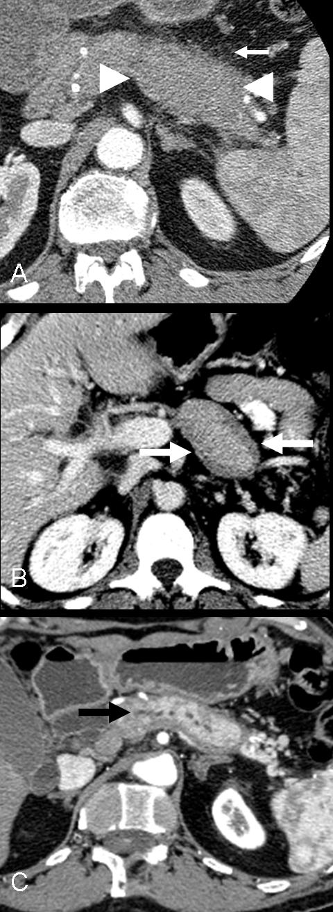
Figure 1 Contrast-enhanced computed tomography findings in autoimmune pancreatitis. A: Enlargement of the distal pancreatic body and tail (between arrowheads), with fine peri-pancreatic stranding of the adjacent fat (small arrow); B: The “capsule” or “rim” sign, a hypo-attenuating rim encircling the anterior and posterior margin of the pancreas (white arrows); C: Multifocal main pancreatic duct narrowing (black arrow).

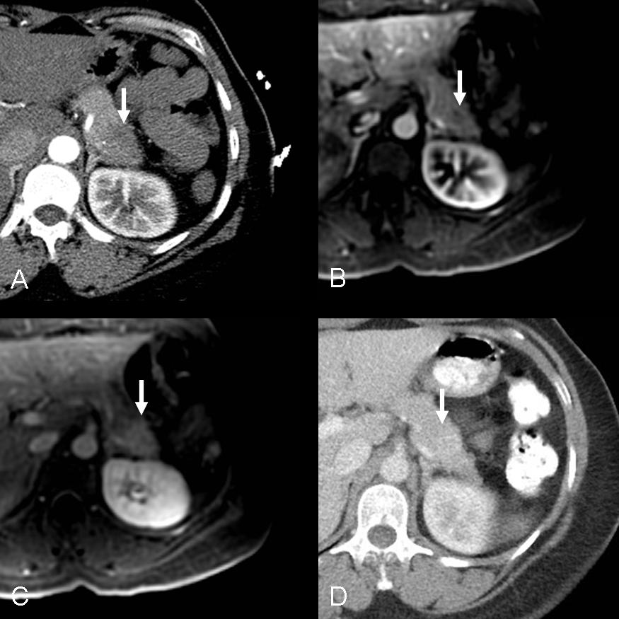
Figure 2 Delayed enhancement on computed tomography and magnetic resonance imaging in autoimmune pancreatitis. A, B, C: Focal autoimmune pancreatitis in the pancreatic tail (white arrow) with delayed early arterial enhancement on arterial phase computed tomography (CT) (A) and magnetic resonance (B, fat-saturated T1-weighted image, 30 s post-injection), with subsequent delayed enhancement (C, fat-saturated T1-weighted image, 180 s post-injection); D: Follow-up CT after corticosteroid therapy demonstrating resolution of prior enhancement abnormality (white arrow).

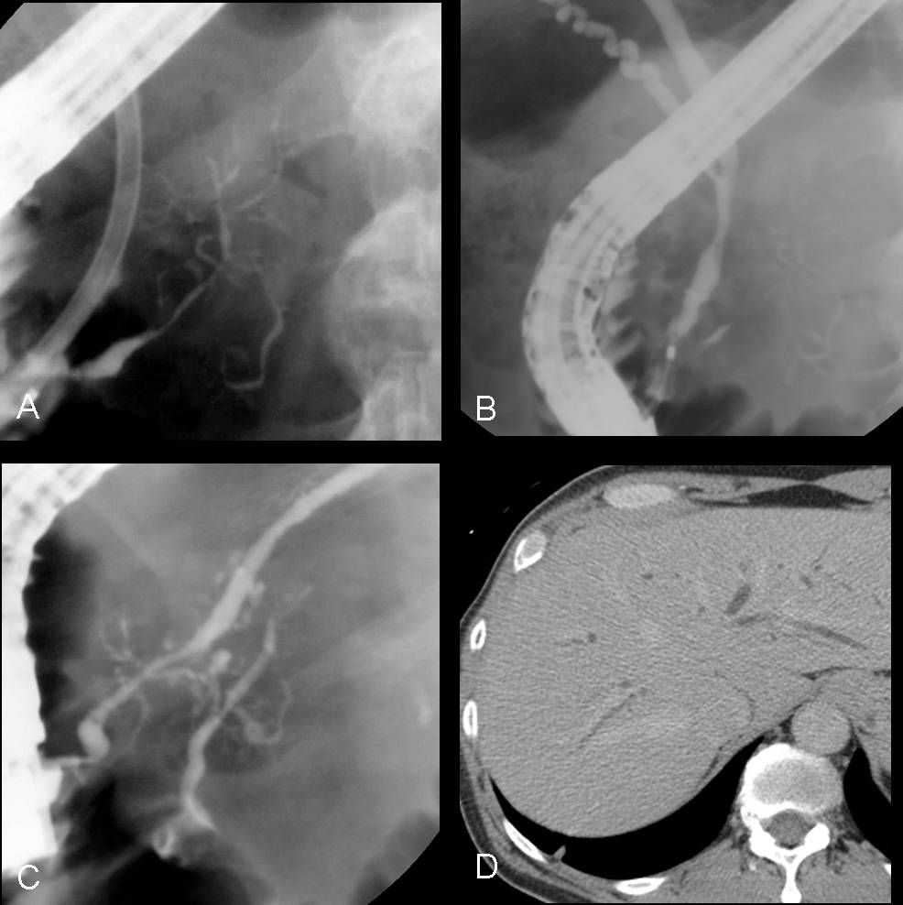
Figure 3 Biliary involvement in autoimmune pancreatitis. A, B, C: endoscopic retrograde cholangiopancreatographydemonstrating diffuse narrowing of the main pancreatic duct (A) and segmental narrowing of the lower common bile duct (B), with resolution of main pancreatic duct narrowing after therapy (C); D: Computed tomographic image demonstrating intrahepatic biliary ductal dilatation in a patient with biliary involvement from IgG4-related disease.

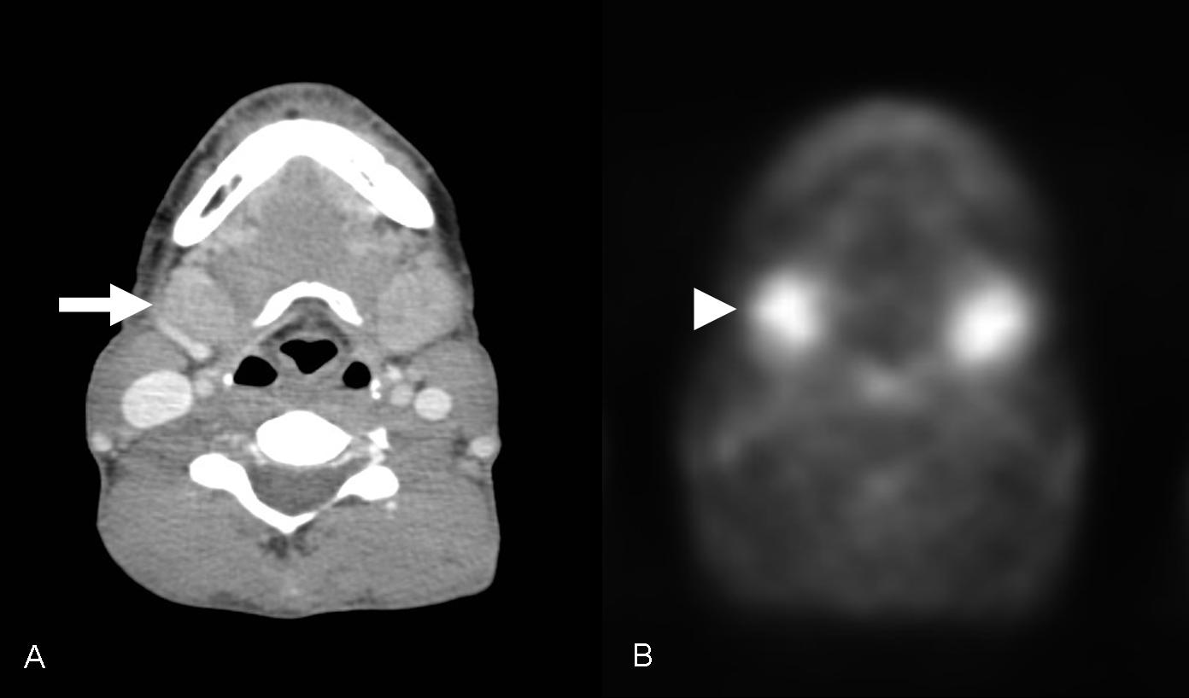

Figure 4 Head and neck findings in IgG4-related disease demonstrated by 2-(18)F-fluoro-2-deoxy-d-glucose positron emission tomography/computed tomography. A: Bilateral, enlarged submandibular glands on computed tomography (arrow); B: Corresponding intense 2-(18)F-fluoro-2-deoxy-d-glucose uptake at the submandibular glands (arrowhead).

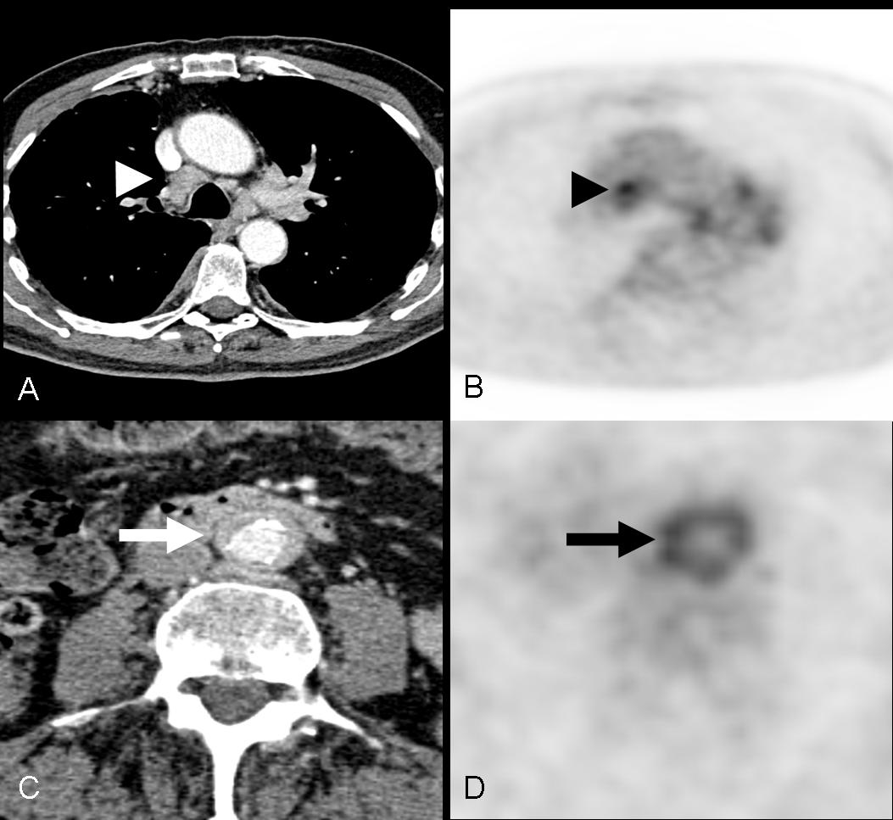
Figure 5 Thoracic and abdominal findings in IgG4-related disease demonstrated by 2-(18)F-fluoro-2-deoxy-d-glucose positron emission tomography/computed tomography. A, B: Paratracheal mediastinal lymphadenopathy on computed tomography (ct) (A, white arrowhead) and positron emission tomography (PET) (B, black arrowhead); C, D: Retroperitoneal fibrosis on CT (C, white arrow) and PET (D, black arrow).

