Name of Journal: World Journal of Gastroenterology
Manuscript NO: 91187
Manuscript Type: MINIREVIEWS

Drug-induced mucosal alterations observed during esophagogastroduodenoscopy

Iwamuro M et al. Drug-induced changes on EGD

Masaya Iwamuro, Seiji Kawano, Motoyuki Otsuka

Masaya Iwamuro, Seiji Kawano, Motoyuki Otsuka, Department of Gastroenterology and Hepatology, Okayama University Graduate School of Medicine, Dentistry, and Pharmaceutical Sciences, Okayama 700-8558, Japan

Author contributions: Iwamuro M designed the study and wrote the paper; Iwamuro M and Kawano S collected the data; Kawano S and Otsuka M critically reviewed the manuscript for important intellectual content; and Otsuka M approved the manuscript.

Corresponding author: Masaya Iwamuro, MD, PhD, Assistant Professor, Doctor, Department of Gastroenterology and Hepatology, Okayama University Graduate School of Medicine, Dentistry, and Pharmaceutical Sciences, 2-5-1 Shikata-cho, Kita-Ku, Okayama 700-8558, Japan. pr145h2k@okayama-u.ac.jp

Received: December 24, 2023
Revised: January 24, 2024
Accepted: April 1, 2024
Published online:

Abstract
Several features of drug-induced mucosal alterations have been observed in the upper gastrointestinal tract, i.e., the esophagus, stomach, and duodenum. These include pill-induced esophagitis, desquamative esophagitis, worsening of gastroesophageal reflux, chemotherapy-induced esophagitis, proton pump inhibitor-induced gastric mucosal changes, medication-induced gastric erosions and ulcers, pseudomelanosis of the stomach, olmesartan-related gastric mucosal inflammation, lanthanum deposition in the stomach, zinc acetate hydrate tablet-induced gastric ulcer, immune-related adverse event gastritis, olmesartan-associated sprue-like enteropathy, pseudomelanosis of the duodenum, and lanthanum deposition in the duodenum. For endoscopists, acquiring accurate knowledge regarding these diverse drug-induced mucosal alterations is crucial not only for the correct diagnosis of these lesions but also for differential diagnosis of other conditions. This minireview aims to provide essential information on drug-induced mucosal alterations observed on esophagogastroduodenoscopy, along with representative endoscopic images.

Key Words: Diagnosis; Esophagogastroduodenoscopy; Non-neoplastic lesions; Esophageal lesions; Gastric lesions; Duodenal lesions

Iwamuro M, Kawano S, Otsuka M. Drug-induced mucosal alterations observed during esophagogastroduodenoscopy. World J Gastroenterol 2024; In press

Core Tip: Various lesions associated with medication use are detected during esophagogastroduodenoscopy, including pill-induced esophagitis, desquamative esophagitis, deteriorating gastroesophageal reflux, chemotherapy-induced esophagitis, proton pump inhibitor-induced gastric mucosal changes, medication-induced gastric erosions and ulcers, pseudomelanosis of the stomach, olmesartan-related gastric mucosal inflammation, lanthanum deposition in the stomach, zinc acetate hydrate tablet-induced gastric lesions, immune-related adverse event (irAE) gastritis, olmesartan-associated sprue-like enteropathy, duodenal pseudomelanosis, and lanthanum deposition. Endoscopists must diagnose these mucosal alterations by acquiring pertinent knowledge regarding medication-induced lesions, concomitant with inquiries concerning patient medication history.

INTRODUCTION
The primary purpose of screening esophagogastroduodenoscopy (EGD) is to comprehensively examine the esophagus, stomach, and duodenum to detect neoplasms. Furthermore, EGD provides invaluable information for disease diagnosis, assessment of disease state, and treatment planning in symptomatic patients. This procedure can reveal a spectrum of conditions, including cancer, and can also enable the identification of mucosal changes attributed to medications taken by the patient^{[1,2]}. Although gastric and duodenal ulcers caused by nonsteroidal anti-inflammatory drugs (NSAIDs) have long been known as drug-induced upper gastrointestinal lesions^{[3,4]}, the advent of various medications on the market has led to the emergence of new types of mucosal injuries and alterations. Despite the inclusion of information on some drug-induced upper gastrointestinal mucosal lesions in the package inserts of medications, not all prescribing physicians are acquainted with these conditions due to their infrequency. Therefore, endoscopists should acquire accurate knowledge regarding diverse drug-induced mucosal alterations for appropriate diagnosis. This knowledge is also crucial for the differential diagnosis of other conditions, including neoplastic lesions. Herein, we review articles associated with drug-induced mucosal alterations in the esophagus, stomach, and duodenum, and present endoscopic images of representative lesions detected on EGD.

LITERATURE REVIEW
Search strategy
We conducted a systematic search of the PubMed database to retrieve all peer-reviewed articles published between January 1, 2013, and August 3, 2023, without imposing any study design filters. To augment our search results, we manually screened additional relevant articles using a reference list of selected publications that met our eligibility criteria. Our search used the keywords “drug-induced” and “esophagus”, “stomach”, or “duodenum”, and was performed by the principal investigator Iwamuro M. The inclusion criteria were as follows: (1) Peer-reviewed articles describing cases of drug-induced upper gastrointestinal tract lesion; and (2) Review articles, original articles, case series, and case reports. Articles were excluded if they: (1) Did not focus primarily on drug-induced upper gastrointestinal tract lesion; (2) Were animal or cell studies; (3) Were letters, editorials, or correction notices; or (4) Were written in languages other than English. All the eligible articles were evaluated.

Search results
Figure 1 presents a flow diagram summarizing the identification, screening, eligibility, and exclusion processes of the literature search. The keywords “drug-induced” and “esophagus” yielded 45 papers of which 19 were excluded for the following reasons: Not primarily focused on drug-induced upper gastrointestinal tract lesion (n = 14); animal or cell studies (n = 2); and written in languages other than English (n = 3). The keywords “drug-induced” and “stomach” yielded 173 papers, of which 149 papers were excluded for the following reasons: Not primarily focused on drug-induced upper gastrointestinal tract lesion (n = 65); animal or cell studies (n = 72); and studies written in languages other than English (n = 12). The keywords “drug-induced” and “duodenum” yielded 30 articles, of which 19 were excluded due to the following reasons: Not primarily focused on drug-induced upper gastrointestinal tract lesion (n = 8); animal or cell studies (n = 8); and studies written in languages other than English (n = 3). Finally, 61 articles were retrieved from the initial PubMed search after applying the exclusion criteria. After a manual screening, 33 additional articles were deemed relevant and included. A total of 94 articles were reviewed in detail.
Virtually all drugs may cause adverse events, including those involving the digestive tract, and various changes in the gastrointestinal mucosa due to different drugs have been reported. Drugs reported in two or more papers are presented in Table 1. In the subsequent sections, we elucidate the discernible categories of drug-induced mucosal alterations accompanied by illustrative EGD images.

PILL-INDUCED ESOPHAGITIS
Given that tablets are ingested in a supine posture or preceding sleep, accompanied by inadequate water intake, the entrapment of medication within the esophagus may result in the release of deleterious agents, imparting noxious constituents capable of inflicting damage to the esophageal wall. The mucosal injury to the esophagus due to the retention of such medications is also referred to as pill-induced esophagitis^{[5-19]}. Esophageal injury can be caused by over hundred distinct substances consumed in the form of oral pharmaceuticals. Principal contributors include antibiotics, notably tetracycline and doxycycline, along with other agents such as bisphosphonates^{[20]}, NSAIDs, potassium chloride^{[21]}, and iron pills. Acetaminophen, warfarin, colchicine, ascorbic acid, L-arginine, pinaverium, antihypertensives, and antiarrhythmic agents may also induce esophagitis. These pharmaceutical agents are believed to exert a corrosive effect on the esophageal mucosa, thereby instigating processes that lead to inflammation, irritation, erosion, and ulceration within the esophagus. Pill-induced esophagitis manifests as dysphagia, pain during swallowing, thoracic discomfort, heartburn, and general esophageal irritation. To attenuate the risk of esophageal injury, it is imperative for patients to ingest medications with a copious volume of plain water and concurrently adopt an upright posture (either sitting or standing) for a minimum of 30 min following the intake of the medication.

DESQUAMATIVE ESOPHAGITIS
Desquamative esophagitis, also known as esophagitis dissecans superficialis, or sloughing esophagitis, is an infrequent, unique endoscopic finding characterized by mucosal sloughing into the esophageal lumen. Desquamative esophagitis occurs in patients taking direct oral anticoagulants, which are commonly prescribed for the prevention and treatment of blood clots. While dabigatran is frequently implicated^{[22-26]}, rivaroxaban, apixaban, and edoxaban can also induce this condition. A typical appearance is depicted in Figure 2, illustrating the presence of diffuse white membranous deposits in the mid to distal esophagus. Endoscopic biopsy of the white membranous deposits reveals a degenerated squamous epithelium accompanied by inflammatory cell infiltration^{[26]}. A previous study found that the use of psychoactive agents, particularly selective serotonin reuptake inhibitors or serotonin-norepinephrine reuptake inhibitors, was prevalent in patients with desquamative esophagitis^{[27]}. Other medications, such as benzodiazepines, opioids, and antiepileptic agents, similarly contribute to the occurrence of desquamative esophagitis^{[8,28]}. Such esophageal mucosal injuries are believed to occur through a mechanism similar to that of pill-induced esophagitis, in which damage arises from the retention of medication in the esophagus. Therefore, for prevention, it is crucial to take medication with a full glass of water while in an upright position to ensure smooth passage into the stomach.

WORSENING OF GASTROESOPHAGEAL REFLUX
In gastroesophageal reflux, the primary precipitant of mucosal injury is the refluxed gastric acid. However, various medications may exacerbate or trigger the onset of gastroesophageal reflux^{[13,14]}. Nitrates such as nitroglycerin are commonly used to treat conditions such as angina by relaxing and dilating blood vessels. This relaxation effect is not specific to the blood vessels in the heart, but also extends to other smooth muscles, including the lower esophageal sphincter (LES), allowing stomach acid to flow back into the esophagus. Calcium channel blockers, anticholinergic medications, sedatives, tranquilizers, and theophylline may also relax the LES and contribute to acid reflux. In symptomatic individuals, it is imperative not only to administer proton pump inhibitors (PPIs), but also to evaluate the potential exacerbating effects of pharmacological agents on gastroesophageal reflux. Therefore, it is important to promptly discontinue or modify medication accordingly.

CHEMOTHERAPY-INDUCED ESOPHAGITIS
Chemotherapy-induced esophagitis refers to inflammation and irritation of the esophagus, which occurs as a side effect of chemotherapy drugs. These potent medications used to treat cancer can inadvertently damage the esophageal lining, leading to a range of symptoms and complications^{[8,11,18]}. Drugs such as 5-fluorouracil, bleomycin, dactinomycin, methotrexate, cytarabine, and vincristine have been identified as causative agents.

PPI-INDUCED GASTRIC MUCOSAL CHANGE
PPIs, a class of medications that reduce stomach acid production, are commonly prescribed to treat conditions such as gastroesophageal reflux disease and peptic ulcers. Although PPIs are generally regarded as safe with a low incidence of adverse effects, emerging evidence suggests that their long-term use can elicit diverse endoscopic and histopathological alterations in the gastric mucosa^{[29,30]}. These include multiple white and flat elevated lesions, fundic gland polyps, hyperplastic polyps, cobblestone-like mucosa, black spots, and a white globe appearance.
The term “multiple white and flat elevated lesions” was proposed in 2011 to describe a new type of polyp associated with PPI use that was observed in the gastric cardia, fornix, or corpus^{[31-34]} (Figure 3A-C). These lesions manifest as circumscribed and sharply demarcated areas characterized by a whitish appearance, exhibiting a round morphology and slight elevation of the mucosa with a smooth surface. Multiple white and flat elevated lesions were more easily identified on narrow band imaging than on normal white-light observation. Pathologically, a straight, enlarged, and hyperplastic foveolar epithelium was observed, which is a typical feature of this lesion.
Fundic gland polyps are one of the most prevalent types of gastric polyps, with an estimated incidence ranging from approximately 2% to 11%, albeit subject to variation among diverse populations (Figure 3D and E)^{[35]}. Notably, their occurrence tends to diminish in patients with Helicobacter pylori infection, but conversely increases in individuals undergoing PPI therapy. Fundic gland polyps reportedly regress after cessation of PPIs in some patients^{[36-40]}.
Several studies have explored the potential association between PPI use and the development of hyperplastic polyps in the stomach (Figure 3F-H). Some studies suggest that the long-term use of PPIs may be associated with an increased risk of gastric polyps^{[41]}. The frequency of hyperplastic polyps exhibited a propensity for elevation among individuals testing positive for Helicobacter pylori. Similar to fundic gland polyps, hyperplastic polyps reportedly regress in some patients following the discontinuation of PPIs^{[36,42]}.
Cobblestone-like mucosa refers to the manifestation of numerous, approximately 3-5 mm-sized, irregular, elevated mucosal lesions in the gastric body^{[34,43,44]} (Figure 4A-C). This distinctive mucosal pattern has a similar coloration as that of contiguous mucosa and is typically discerned as interspersed among the gastric folds. This represents a histopathological alteration attributable to prolonged PPI use. The histopathological characterization of the cobblestone-like mucosa involves the presence of parietal cell protrusions and cystic dilatation of the fundic glands, with these changes particularly accentuated in non-atrophic gastric regions.
Prolonged usage of PPIs induces the formation of black spots in the gastric mucosa, which are discerned as diminutive, dark, dot-like lesions on EGD (Figure 4D and E)^{[45]}. Histopathologically, these spots are characterized by the entrapment of brownish substances within the dilated lumina of the expanded fundic gland cysts. The cystic dilatation of fundic gland cysts induced by the use of PPIs is strongly posited as a key etiological factor contributing to the development of black spots.
The term “white globe appearance” is defined as a small (≤ 1 mm) white globe-shaped feature located beneath the gastric epithelium, observed during magnifying endoscopic observation with narrow band imaging^{[46]}. This feature is associated with early gastric cancers and is often detected near the demarcation line. It indicates cancers with a differentiated component. Conversely, a white globe appearance has also been noted in the gastric mucosa of non-cancer patients with autoimmune gastritis or during PPI use^{[47,48]} (Figure 4F and G).

MEDICATION-INDUCED GASTRIC EROSIONS AND ULCERS
Gastric mucosal damage caused by NSAIDs has long been recognized. The mechanism involves several complex interactions^{[1,3,4,49]}. NSAIDs inhibit cyclooxygenase and subsequently reduce the synthesis of prostaglandins, which play a protective role in maintaining the integrity of the gastric mucosa. NSAIDs cause vasoconstriction and thereby reduce the blood flow, which compromises the delivery of oxygen and nutrients to the gastric mucosa, resulting in mucosal damage. Some NSAIDs have direct toxic effects on the gastric mucosa. Epidemiological investigations have shown that the relative risk for the development of gastrointestinal complications escalates in patients concomitantly administered with corticosteroids and NSAIDs^{[50,51]}. Similar to pill-induced esophagitis, bisphosphonates, iron tablets, and doxycycline directly irritate the gastric mucosa due to the chemical properties of the drug and its direct contact with the lining of the stomach.

PSEUDOMELANOSIS OF THE STOMACH
Pseudomelanosis is an infrequent and benign pathological condition in which a dark pigment accumulates within macrophages located in the lamina propria. Unlike melanosis coli, the onset of gastric pseudomelanosis is unrelated to laxative use, but is thought to be associated with diuretics, beta-blockers, and iron supplementation. While gastric pseudomelanosis induces alterations in mucosal coloration, patients are devoid of accompanying clinical symptoms and do not manifest mucosal damage such as erosions or ulcers^{[52-55]}. Deemed a benign condition, a diagnosis of gastric pseudomelanosis does not necessarily mandate any modification in the prescribed medication.

OLMESARTAN-RELATED GASTRIC MUCOSAL INFLAMMATION
Olmesartan, an angiotensin II receptor antagonist commonly used to treat hypertension, induces enteropathy with sprue-like symptoms. Although infrequent, olmesartan has been reported to induce lymphocytic, collagenous, or chronic gastritis^{[18,56-59]}.

LANTHANUM DEPOSITION IN THE STOMACH
Lanthanum carbonate is used for the therapeutic management of hyperphosphatemia, primarily in patients with chronic renal insufficiency. White lesions are characteristic endoscopic features indicative of gastric lanthanum deposition^{[60-67]}. These whitish deposits are easily discernible through narrow band or blue laser imaging. We have elucidated that the endoscopic manifestations of gastric lanthanum deposition vary between mucosa with and without atrophy. In non-atrophic mucosa, lanthanum was initially deposited on the posterior wall to the greater curvature of the gastric body, presenting as diffuse white lesions, the extent of which increased over time (Figure 5A and B). The susceptibility of the posterior wall to the greater curvature of the gastric body suggests that the active ingredient of the orally ingested lanthanum remains in prolonged contact with this region. Conversely, in atrophic mucosa, particularly with intestinal metaplasia, lanthanum deposition manifested as circular or granular white lesions (Figure 5C and D), and the extent of lanthanum deposition increased concurrently with the expansion of the intestinal metaplasia. The increased permeability of lanthanum in areas with intestinal metaplasia compared to that in normal mucosa may facilitate its deposition on the gastric mucosa. We speculate that the multifocal occurrence and mosaic-like distribution of intestinal metaplasia result in the circular or granular appearance of lanthanum deposition. Confirming a history of ingestion of lanthanum carbonate is essential for diagnosing this condition.
The pathological significance of lanthanum deposition in the human gastric mucosa remains unclear. To date, there have been no reports of health impairments associated with gastric lanthanum deposition, suggesting that the diagnosis of gastric lanthanum deposition does not necessarily mandate the discontinuation of lanthanum carbonate intake. However, the long-term prognosis of this condition is currently unknown, and ongoing follow-up of individual cases is desirable.

ZINC ACETATE HYDRATE TABLET-INDUCED GASTRIC LESIONS
Zinc acetate tablets are used to treat zinc deficiency and Wilson’s disease. We found that approximately two-thirds of the patients subjected to oral administration of zinc acetate tablets manifested gastric mucosal injuries characterized by mucosal erythema, erosions, white patches, and ulcers^{[68]} (Figure 6). Localization occurred predominantly in the middle third region, followed by the upper third region. Owing to the potential occurrence of hemorrhagic gastric ulcers, patients undergoing oral administration of zinc acetate hydrate should be monitored for gastric mucosal damage.

IRAE GASTRITIS
Immune checkpoint inhibitors can alleviate T-cell deactivation by reinstating the immune response against tumor cells. However, systemic activation of immune cells simultaneously induces self-reactive T cells in organs other than the tumor, potentially leading to the onset of irAEs in various organs. Among the immune checkpoint inhibitor-induced gastrointestinal injuries, irAE colitis is well recognized^{[69]}. Although the incidence of irAE gastritis is presumed to be lower than that of irAE colitis, endoscopic features of erythema, white exudates, and friable mucosa have been documented (Figure 7)^{[70-77]}. The destruction of the glandular structure is visible upon magnifying observation with narrow band imaging^{[78]}. If such lesions are observed after the administration of immune checkpoint inhibitors, the possibility of irAE gastritis should be considered. In irAEs, the prompt cessation of the causative agent does not consistently lead to rapid symptom amelioration and often necessitates the administration of steroids.

OLMESARTAN-ASSOCIATED SPRUE-LIKE ENTEROPATHY
Olmesartan-associated sprue-like enteropathy denotes a condition associated with the usage of olmesartan, an angiotensin II receptor blocker. Sprue-like enteropathy is characterized by symptoms resembling those of celiac disease, such as chronic diarrhea, weight loss, and malabsorption of nutrients. Unlike in celiac disease, these symptoms persist even with a gluten-free diet. Villous atrophy, crypt hyperplasia, and inflammation are discernible in biopsied specimens^{[79-81]}. Consequently, if a patient presents with persistent diarrhea, weight loss, and malabsorption, particularly when using olmesartan, duodenal biopsy, along with EGD, is essential for the evaluation of these characteristic pathological features and for diagnosis. Discontinuation of olmesartan typically resolves the symptoms and mucosal changes.

PSEUDOMELANOSIS OF THE DUODENUM
A black to dark brown pigmentation can be observed in the duodenum, termed duodenal pseudomelanosis (Figure 8)^{[54,82-85]}. This condition is often observed in patients with chronic diseases such as hypertension, chronic kidney failure, and diabetes. A history of oral iron supplementation, antihypertensive agents (hydralazine), diuretics (thiazides, furosemide), and beta-blockers was noted in most cases. As mentioned in the section on gastric pseudomelanosis, this condition is considered benign and a change in oral medications is not necessarily required.

LANTHANUM DEPOSITION IN THE DUODENUM
Lanthanum deposition in the duodenum refers to the accumulation of lanthanum in patients with chronic kidney disease taking lanthanum carbonate as a phosphate binder to treat elevated phosphate levels. The representative endoscopic feature is the presence of whitish discoloration of the villi, displaying numerous pinpoint or dot-like white deposits (Figure 9)^{[86-88]}. Although this discoloration is a notable finding, the clinical significance of lanthanum deposition in the duodenum is still not fully understood, and its presence does not necessarily indicate pathology or adverse effects.

CONCLUSION
Diagnosing drug-induced mucosal alterations in the upper gastrointestinal tract is important for several reasons. First, in cases where a specific drug is identified as causing alterations in the esophageal, gastric, and duodenal mucosa, reassessment of treatment strategies is imperative. Discontinuation of the causative medication is generally recommended for patients presenting with symptoms or displaying evident mucosal damage, such as ulcers. If discontinuation of the causative agent proves challenging, dose reduction or transitioning to a medication with similar effects should be considered. Additionally, in the presence of lesions such as ulcers or erosions, acid-suppressing agents and mucosal protective agents may be administered. Second, establishing a diagnosis enables discerning whether gastrointestinal symptoms are attributable to a particular drug, prevents unnecessary examinations aimed at excluding other diseases, and facilitates the identification of appropriate interventions. In conclusion, the diagnosis of drug-induced upper gastrointestinal tract lesion is crucial for ensuring patient safety and facilitating appropriate medical management. Understanding the characteristic endoscopic images presented in this paper and conducting a thorough diagnosis will enable the implementation of suitable treatments and preventive measures.

REFERENCES
1 Bordin DS, Livzan MA, Gaus OV, Mozgovoi SI, Lanas A. Drug-Associated Gastropathy: Diagnostic Criteria. Diagnostics (Basel) 2023; 13 [PMID: 37443618 DOI: 10.3390/diagnostics13132220]
2 Joo MK, Park CH, Kim JS, Park JM, Ahn JY, Lee BE, Lee JH, Yang HJ, Cho YK, Bang CS, Kim BJ, Jung HK, Kim BW, Lee YC; Korean College of Helicobacter Upper Gastrointestinal Research. Clinical Guidelines for Drug-Related Peptic Ulcer, 2020 Revised Edition. Gut Liver 2020; 14: 707-726 [PMID: 33191311 DOI: 10.5009/gnl20246]
3 Nguyen TNM, Sha S, Chen LJ, Holleczek B, Brenner H, Schöttker B. Strongly increased risk of gastric and duodenal ulcers among new users of low-dose aspirin: results from two large cohorts with new-user design. Aliment Pharmacol Ther 2022; 56: 251-262 [PMID: 35621052 DOI: 10.1111/apt.17050]
4 Bjarnason I, Scarpignato C, Holmgren E, Olszewski M, Rainsford KD, Lanas A. Mechanisms of Damage to the Gastrointestinal Tract From Nonsteroidal Anti-Inflammatory Drugs. Gastroenterology 2018; 154: 500-514 [PMID: 29221664 DOI: 10.1053/j.gastro.2017.10.049]
5 Bordea MA, Pirvan A, Sarban C, Margescu C, Leucuta D, Samasca G, Miu N. Pill -Induced Erosive Esophagitis in Children. Clujul Med 2014; 87: 15-18 [PMID: 26527990 DOI: 10.15386/cjm.2014.8872.871.mab1]
6 Abdi S, Masbough F, Nazari M, Abbasinazari M. Drug-induced esophagitis and helpful management for healthcare providers. Gastroenterol Hepatol Bed Bench 2022; 15: 219-224 [PMID: 36311965 DOI: 10.22037/ghfbb.v15i3.2591]
7 Hu SW, Chen AC, Wu SF. Drug-Induced Esophageal Ulcer in Adolescent Population: Experience at a Single Medical Center in Central Taiwan. Medicina (Kaunas) 2021; 57 [PMID: 34946231 DOI: 10.3390/medicina57121286]
8 Mastracci L, Grillo F, Parente P, Unti E, Battista S, Spaggiari P, Campora M, Valle L, Fassan M, Fiocca R. Non gastro-esophageal reflux disease related esophagitis: an overview with a histologic diagnostic approach. Pathologica 2020; 112: 128-137 [PMID: 33179617 DOI: 10.32074/1591-951X-156]
9 Gore RM, Levine MS. Diseases of the Upper GI Tract. 2018 Mar 21. In: Diseases of the Abdomen and Pelvis 2018-2021: Diagnostic Imaging - IDKD Book [Internet]. Cham (CH): Springer; 2018– [PMID: 31314379 DOI: 10.1007/978-3-319-75019-4_10]
10 Panarelli NC. Other Forms of Esophagitis: It Is Not Gastroesophageal Reflux Disease, So Now What Do I Do? Surg Pathol Clin 2017; 10: 765-779 [PMID: 29103532 DOI: 10.1016/j.path.2017.07.001]
11 Grossi L, Ciccaglione AF, Marzio L. Esophagitis and its causes: Who is "guilty" when acid is found "not guilty"? World J Gastroenterol 2017; 23: 3011-3016 [PMID: 28533657 DOI: 10.3748/wjg.v23.i17.3011]
12 McGettigan MJ, Menias CO, Gao ZJ, Mellnick VM, Hara AK. Imaging of Drug-induced Complications in the Gastrointestinal System. Radiographics 2016; 36: 71-87 [PMID: 26761532 DOI: 10.1148/rg.2016150132]
13 Domagała-Rodacka R, Cibor D, Szczeklik K, Rodacki T, Mach T, Owczarek D. Gastrointestinal tract as a side-effect target of medications. Przegl Lek 2016; 73: 652-658 [PMID: 29688675]
14 Drug-induced lesions of the oesophageal mucosa. Prescrire Int 2015; 24: 210-211, 213 [PMID: 26417631]
15 Kim SH, Jeong JB, Kim JW, Koh SJ, Kim BG, Lee KL, Chang MS, Im JP, Kang HW, Shin CM. Clinical and endoscopic characteristics of drug-induced esophagitis. World J Gastroenterol 2014; 20: 10994-10999 [PMID: 25152603 DOI: 10.3748/wjg.v20.i31.10994]
16 Dağ MS, Öztürk ZA, Akın I, Tutar E, Çıkman Ö, Gülşen MT. Drug-induced esophageal ulcers: case series and the review of the literature. Turk J Gastroenterol 2014; 25: 180-184 [PMID: 25003679 DOI: 10.5152/tjg.2014.5415]
17 Almashat SJ, Duan L, Goldsmith JD. Non-reflux esophagitis: a review of inflammatory diseases of the esophagus exclusive of reflux esophagitis. Semin Diagn Pathol 2014; 31: 89-99 [PMID: 24815935 DOI: 10.1053/j.semdp.2014.02.002]
18 Allard FD, Stelow EB. Review of Drug-induced Injury in Mucosal Biopsies From the Tubular Gastrointestinal Tract. Adv Anat Pathol 2019; 26: 151-170 [PMID: 30870181 DOI: 10.1097/PAP.0000000000000230]
19 Kwak HA, Hart J. The Many Faces of Medication-Related Injury in the Gastrointestinal Tract. Surg Pathol Clin 2017; 10: 887-908 [PMID: 29103538 DOI: 10.1016/j.path.2017.07.007]
20 Costa MS, Gravito-Soares E, Gravito-Soares M, Figueiredo P. Severe drug-induced oesophagitis in a young male patient. BMJ Case Rep 2022; 15 [PMID: 35264388 DOI: 10.1136/bcr-2021-248291]
21 Maesaka K, Tsujii Y, Shinzaki S, Yoshii S, Hayashi Y, Iijima H, Nakamoto K, Ohtani T, Sakata Y, Takehara T. Successful treatment of drug-induced esophageal ulcer in a patient with chronic heart failure: A case report. Medicine (Baltimore) 2018; 97: e13380 [PMID: 30508933 DOI: 10.1097/MD.0000000000013380]
22 Araki T, Hayashi K, Sonoda Y, Honda T, Imamura Y, Koide Y, Hamada H, Nakao K. Dabigatran-induced esophagitis with full circumferential blue pigmentation. DEN Open 2024; 4: e271 [PMID: 37469668 DOI: 10.1002/deo2.271]
23 Lin S, Wang Y, Zhang L, Guan W. Dabigatran must be used carefully: literature review and recommendations for management of adverse events. Drug Des Devel Ther 2019; 13: 1527-1533 [PMID: 31190734 DOI: 10.2147/DDDT.S203112]
24 Cuadros Martínez M, Froilán Torres C, Gonzalo Bada N. Symptomatic exfoliative esophagitis induced by dabigatran. Rev Esp Enferm Dig 2018; 110: 743-744 [PMID: 30238767 DOI: 10.17235/reed.2018.5747/2018]
25 Zhou Y, Su Y, Li Z, Wu C, Sun W, Wang C. Analysis of the clinical characteristics of dabigatran-induced oesophagitis. Eur J Hosp Pharm 2023; 30: e24-e28 [PMID: 34301743 DOI: 10.1136/ejhpharm-2021-002889]
26 Toya Y, Nakamura S, Tomita K, Matsuda N, Abe K, Abiko Y, Orikasa S, Akasaka R, Chiba T, Uesugi N, Sugai T, Matsumoto T. Dabigatran-induced esophagitis: The prevalence and endoscopic characteristics. J Gastroenterol Hepatol 2016; 31: 610-614 [PMID: 26102078 DOI: 10.1111/jgh.13024]
27 Hart PA, Romano RC, Moreira RK, Ravi K, Sweetser S. Esophagitis Dissecans Superficialis: Clinical, Endoscopic, and Histologic Features. Dig Dis Sci 2015; 60: 2049-2057 [PMID: 25701324 DOI: 10.1007/s10620-015-3590-3]
28 Purdy JK, Appelman HD, McKenna BJ. Sloughing esophagitis is associated with chronic debilitation and medications that injure the esophageal mucosa. Mod Pathol 2012; 25: 767-775 [PMID: 22282305 DOI: 10.1038/modpathol.2011.204]
29 Shinozaki S, Osawa H, Hayashi Y, Sakamoto H, Miura Y, Lefor AK, Yamamoto H. Changes in gastric morphology during long-term use of vonoprazan compared to proton pump inhibitors. Singapore Med J 2022; 63: 283-287 [PMID: 36043274 DOI: 10.11622/smedj.2022076]
30 Kim GH. Proton Pump Inhibitor-Related Gastric Mucosal Changes. Gut Liver 2021; 15: 646-652 [PMID: 32327613 DOI: 10.5009/gnl20036]
31 Adachi K, Mishiro T, Okada M, Kinoshita Y. Prevalence of Multiple White and Flat Elevated Lesions in Individuals Undergoing a Medical Checkup. Intern Med 2018; 57: 1213-1218 [PMID: 29279510 DOI: 10.2169/internalmedicine.9808-17]
32 Hasegawa R, Yao K, Kanemitsu T, Arima H, Hirase T, Hiratsuka Y, Takeda K, Imamura K, Ohtsu K, Ono Y, Miyaoka M, Hisabe T, Ueki T, Tanabe H, Ohta A, Nimura S. Association between occurrence of multiple white and flat elevated gastric lesions and oral proton pump inhibitor intake. Clin Endosc 2024; 57: 65-72 [PMID: 37157963 DOI: 10.5946/ce.2022.257]
33 Majima K, Muraki Y, Shimamoto T. Multiple White and Flat Elevated Lesions Observed in the Stomach: A Prospective Study of Clinical Characteristics and Risk Factors. Intern Med 2018; 57: 2613-2619 [PMID: 29709960 DOI: 10.2169/internalmedicine.9889-17]
34 Kiso M, Ito M, Boda T, Kotachi T, Masuda K, Hata K, Sasaki A, Kawamura T, Yoshihara M, Tanaka S, Chayama K. Endoscopic findings of the gastric mucosa during long-term use of proton pump inhibitor - a multicenter study. Scand J Gastroenterol 2017; 52: 828-832 [PMID: 28485638 DOI: 10.1080/00365521.2017.1322137]
35 Martin FC, Chenevix-Trench G, Yeomans ND. Systematic review with meta-analysis: fundic gland polyps and proton pump inhibitors. Aliment Pharmacol Ther 2016; 44: 915-925 [PMID: 27634363 DOI: 10.1111/apt.13800]
36 Iwamuro M, Shiraha H, Okada H. Gastric polyps' regression after potassium-competitive acid blocker cessation. J Gen Fam Med 2022; 23: 358-359 [PMID: 36093226 DOI: 10.1002/jgf2.552]
37 Tanaka M, Kataoka H, Yagi T. Proton-pump inhibitor-induced fundic gland polyps with hematemesis. Clin J Gastroenterol 2019; 12: 193-195 [PMID: 30251013 DOI: 10.1007/s12328-018-0908-7]
38 Takeda T, Asaoka D, Tajima Y, Matsumoto K, Takeda N, Hiromoto T, Okubo S, Saito H, Aoyama T, Shibuya T, Sakamoto N, Hojo M, Osada T, Nagahara A, Yao T, Watanabe S. Hemorrhagic polyps formed like fundic gland polyps during long-term proton pump inhibitor administration. Clin J Gastroenterol 2017; 10: 478-484 [PMID: 28660530 DOI: 10.1007/s12328-017-0756-x]
39 Fukuda M, Ishigaki H, Sugimoto M, Mukaisho KI, Matsubara A, Ishida H, Moritani S, Itoh Y, Sugihara H, Andoh A, Ogasawara K, Murakami K, Kushima R. Histological analysis of fundic gland polyps secondary to PPI therapy. Histopathology 2019; 75: 537-545 [PMID: 31087669 DOI: 10.1111/his.13902]
40 Ochiai Y, Kikuchi D, Ito S, Takazawa Y, Hoteya S. Large Fundic Gland Polyp Associated with Long-Term Proton Pump Inhibitor Administration Mimicking Gastric-Type Neoplasm. Case Rep Gastroenterol 2021; 15: 123-130 [PMID: 33708059 DOI: 10.1159/000512399]
41 Hongo M, Fujimoto K; Gastric Polyps Study Group. Incidence and risk factor of fundic gland polyp and hyperplastic polyp in long-term proton pump inhibitor therapy: a prospective study in Japan. J Gastroenterol 2010; 45: 618-624 [PMID: 20177714 DOI: 10.1007/s00535-010-0207-7]
42 Nikaido M, Miyamoto S, Utsumi T, Shimizu T, Nakanishi Y, Kumagai K, Teramura M, Setoyama T, Seno H. Gastric Hyperplastic Polyps Can Shrink After Discontinuation of Proton Pump Inhibitors: A Case Series Compared With Continuation of Proton Pump Inhibitors. J Clin Gastroenterol 2022; 56: e216-e221 [PMID: 34107516 DOI: 10.1097/MCG.0000000000001577]
43 Hatano Y, Haruma K, Kamada T, Shiotani A, Takahari K, Matsumoto M, Uchida O. Factors Associated with Gastric Black Spot, White Flat Elevated Mucosa, and Cobblestone-Like Mucosa: A Cross-Sectional Study. Digestion 2018; 98: 185-193 [PMID: 29870991 DOI: 10.1159/000488796]
44 Takahari K, Haruma K, Ohtani H, Kiyoto S, Watanabe A, Kamada T, Manabe N, Hatano Y. Proton Pump Inhibitor Induction of Gastric Cobblestone-like Lesions in the Stomach. Intern Med 2017; 56: 2699-2703 [PMID: 28924108 DOI: 10.2169/internalmedicine.7964-16]
45 Hatano Y, Haruma K, Ayaki M, Kamada T, Ohtani H, Murao T, Manabe N, Mori H, Masaki T, Shiotani A. Black Spot, a Novel Gastric Finding Potentially Induced by Proton Pump Inhibitors. Intern Med 2016; 55: 3079-3084 [PMID: 27803398 DOI: 10.2169/internalmedicine.55.6974]
46 Doyama H, Yoshida N, Tsuyama S, Ota R, Takeda Y, Nakanishi H, Tsuji K, Tominaga K, Tsuji S, Takemura K, Yamada S, Katayanagi K, Kurumaya H, Iwashita A, Yao K. The "white globe appearance" (WGA): a novel marker for a correct diagnosis of early gastric cancer by magnifying endoscopy with narrow-band imaging (M-NBI). Endosc Int Open 2015; 3: E120-E124 [PMID: 26135651 DOI: 10.1055/s-0034-1391026]
47 Iwamuro M, Tanaka T, Kanzaki H, Kawano S, Kawahara Y, Okada H. Two Cases of White Globe Appearance in Autoimmune Atrophic Gastritis. Case Rep Gastrointest Med 2018; 2018: 7091520 [PMID: 30510814 DOI: 10.1155/2018/7091520]
48 Miwa W, Hiratsuka T, Sato K, Fujino T, Kato Y. Marked reduction in the number of white globe appearance lesions in the noncancerous stomach after exchanging vonoprazan for esomeprazole treatment: a follow-up case report. Clin J Gastroenterol 2021; 14: 1046-1051 [PMID: 33993429 DOI: 10.1007/s12328-021-01437-z]
49 Cheng H, Huang H, Guo Z, Chang Y, Li Z. Role of prostaglandin E2 in tissue repair and regeneration. Theranostics 2021; 11: 8836-8854 [PMID: 34522214 DOI: 10.7150/thno.63396]
50 Piper JM, Ray WA, Daugherty JR, Griffin MR. Corticosteroid use and peptic ulcer disease: role of nonsteroidal anti-inflammatory drugs. Ann Intern Med 1991; 114: 735-740 [PMID: 2012355 DOI: 10.7326/0003-4819-114-9-735]
51 Aalykke C, Lauritsen K. Epidemiology of NSAID-related gastroduodenal mucosal injury. Best Pract Res Clin Gastroenterol 2001; 15: 705-722 [PMID: 11566036 DOI: 10.1053/bega.2001.0230]
52 Ibrahim M, Herman M. A Rare Finding of Gastric Pseudomelanosis in Chronic Kidney Disease: A Case Report. Cureus 2023; 15: e38933 [PMID: 37309340 DOI: 10.7759/cureus.38933]
53 Qureshi NU, Younus MF, Alavi K, Sheikh MY. Gastric and Duodenal Pseudomelanosis: An Extended Unusual Finding in a Patient with End Stage Kidney Disease. Case Rep Gastrointest Med 2016; 2016: 2861086 [PMID: 27042366 DOI: 10.1155/2016/2861086]
54 Wael Mohamed M, Althahabi R, Abubaker F, Sharif O. An Incidental Finding of Gastric and Duodenal Pseudomelanosis: A Case Report. Case Rep Gastroenterol 2022; 16: 264-269 [PMID: 35702444 DOI: 10.1159/000524192]
55 Samiullah S, Bhurgri H, Babar A, Samad F, Choudhary MM, Demyen M. Peppered and rare - Gastric and Duodenal Pseudomelanosis: A case series. Pak J Med Sci 2017; 33: 757-760 [PMID: 28811809 DOI: 10.12669/pjms.333.12995]
56 Seminerio J, McGrath K, Arnold CA, Voltaggio L, Singhi AD. Medication-associated lesions of the GI tract. Gastrointest Endosc 2014; 79: 140-150 [PMID: 24119504 DOI: 10.1016/j.gie.2013.08.027]
57 Ma C, Park JY, Montgomery EA, Arnold CA, McDonald OG, Liu TC, Salaria SN, Limketkai BN, McGrath KM, Musahl T, Singhi AD. A Comparative Clinicopathologic Study of Collagenous Gastritis in Children and Adults: The Same Disorder With Associated Immune-mediated Diseases. Am J Surg Pathol 2015; 39: 802-812 [PMID: 25871617 DOI: 10.1097/PAS.0000000000000441]
58 Rubio-Tapia A, Herman ML, Ludvigsson JF, Kelly DG, Mangan TF, Wu TT, Murray JA. Severe spruelike enteropathy associated with olmesartan. Mayo Clin Proc 2012; 87: 732-738 [PMID: 22728033 DOI: 10.1016/j.mayocp.2012.06.003]
59 Shenbagaraj L, Swift G. Olmesartan-associated severe gastritis and enteropathy. BMJ Case Rep 2018; 11 [PMID: 30567227 DOI: 10.1136/bcr-2018-226133]
60 Iwamuro M, Urata H, Tanaka T, Okada H. Review of the diagnosis of gastrointestinal lanthanum deposition. World J Gastroenterol 2020; 26: 1439-1449 [PMID: 32308345 DOI: 10.3748/wjg.v26.i13.1439]
61 Goto K, Ogawa K. Lanthanum Deposition Is Frequently Observed in the Gastric Mucosa of Dialysis Patients With Lanthanum Carbonate Therapy: A Clinicopathologic Study of 13 Cases, Including 1 Case of Lanthanum Granuloma in the Colon and 2 Nongranulomatous Gastric Cases. Int J Surg Pathol 2016; 24: 89-92 [PMID: 26490721 DOI: 10.1177/1066896915613434]
62 Rothenberg ME, Araya H, Longacre TA, Pasricha PJ. Lanthanum-Induced Gastrointestinal Histiocytosis. ACG Case Rep J 2015; 2: 187-189 [PMID: 26157959 DOI: 10.14309/crj.2015.50]
63 Haratake J, Yasunaga C, Ootani A, Shimajiri S, Matsuyama A, Hisaoka M. Peculiar histiocytic lesions with massive lanthanum deposition in dialysis patients treated with lanthanum carbonate. Am J Surg Pathol 2015; 39: 767-771 [PMID: 25602800 DOI: 10.1097/PAS.0000000000000385]
64 Hoda RS, Sanyal S, Abraham JL, Everett JM, Hundemer GL, Yee E, Lauwers GY, Tolkoff-Rubin N, Misdraji J. Lanthanum deposition from oral lanthanum carbonate in the upper gastrointestinal tract. Histopathology 2017; 70: 1072-1078 [PMID: 28134986 DOI: 10.1111/his.13178]
65 Yasunaga C, Haratake J, Ohtani A. Specific Accumulation of Lanthanum Carbonate in the Gastric Mucosal Histiocytes in a Dialysis Patient. Ther Apher Dial 2015; 19: 622-624 [PMID: 26420000 DOI: 10.1111/1744-9987.12325]
66 Nishida S, Ota K, Hattori K, Iwatsubo T, Kawaguchi S, Kojima Y, Takeuchi T, Maeda T, Sakaguchi M, Higuchi K. Investigation of the clinical significance and pathological features of lanthanum deposition in the gastric mucosa. BMC Gastroenterol 2020; 20: 396 [PMID: 33228604 DOI: 10.1186/s12876-020-01545-z]
67 Yabuki K, Haratake J, Hisaoka M. Lanthanum Deposition in the Gastroduodenal Mucosa of Dialysis Patients. J UOEH 2019; 41: 387-395 [PMID: 31866656 DOI: 10.7888/juoeh.41.387]
68 Iwamuro M, Tanaka T, Kuraoka S, Hamada K, Abe M, Kono Y, Kanzaki H, Kawano S, Kawahara Y, Okada H. Zinc Acetate Dihydrate Tablet-associated Gastric Lesions. Intern Med 2022; 61: 1931-1938 [PMID: 35781269 DOI: 10.2169/internalmedicine.8625-21]
69 Xiang Z, Li J, Zhang Z, Cen C, Chen W, Jiang B, Meng Y, Wang Y, Berglund B, Zhai G, Wu J. Comprehensive Evaluation of Anti-PD-1, Anti-PD-L1, Anti-CTLA-4 and Their Combined Immunotherapy in Clinical Trials: A Systematic Review and Meta-analysis. Front Pharmacol 2022; 13: 883655 [PMID: 35694260 DOI: 10.3389/fphar.2022.883655]
70 Yip RHL, Lee LH, Schaeffer DF, Horst BA, Yang HM. Lymphocytic gastritis induced by pembrolizumab in a patient with metastatic melanoma. Melanoma Res 2018; 28: 645-647 [PMID: 30256271 DOI: 10.1097/CMR.0000000000000502]
71 Rao BB, Robertson S, Philpott J. Checkpoint Inhibitor-Induced Hemorrhagic Gastritis with Pembrolizumab. Am J Gastroenterol 2019; 114: 196 [PMID: 30353060 DOI: 10.1038/s41395-018-0366-3]
72 Gonzalez RS, Salaria SN, Bohannon CD, Huber AR, Feely MM, Shi C. PD-1 inhibitor gastroenterocolitis: case series and appraisal of 'immunomodulatory gastroenterocolitis'. Histopathology 2017; 70: 558-567 [PMID: 28000302 DOI: 10.1111/his.13118]
73 Ferrian S, Liu CC, McCaffrey EF, Kumar R, Nowicki TS, Dawson DW, Baranski A, Glaspy JA, Ribas A, Bendall SC, Angelo M. Multiplexed imaging reveals an IFN-γ-driven inflammatory state in nivolumab-associated gastritis. Cell Rep Med 2021; 2: 100419 [PMID: 34755133 DOI: 10.1016/j.xcrm.2021.100419]
74 Rovedatti L, Lenti MV, Vanoli A, Feltri M, De Grazia F, Di Sabatino A. Nivolumab-associated active neutrophilic gastritis. J Clin Pathol 2020; 73: 605-606 [PMID: 32161070 DOI: 10.1136/jclinpath-2020-206540]
75 Obeidat A, Silangcruz K, Kozai L, Wien E, Fujiwara Y, Nishimura Y. Clinical Characteristics and Outcomes of Gastritis Associated With Immune Checkpoint Inhibitors: Scoping Review. J Immunother 2022; 45: 363-369 [PMID: 35972801 DOI: 10.1097/CJI.0000000000000435]
76 Iwamuro M, Tanaka T, Kono Y, Kawano S, Okada H. Multiple White Plaques in the Esophagus: A Possible Case of Esophageal Mucosal Alteration Associated With Immune-Related Adverse Events of Immune Checkpoint Inhibitors. Cureus 2022; 14: e32710 [PMID: 36686096 DOI: 10.7759/cureus.32710]
77 Nishimura Y, Yasuda M, Ocho K, Iwamuro M, Yamasaki O, Tanaka T, Otsuka F. Severe Gastritis after Administration of Nivolumab and Ipilimumab. Case Rep Oncol 2018; 11: 549-556 [PMID: 30186138 DOI: 10.1159/000491862]
78 Johncilla M, Grover S, Zhang X, Jain D, Srivastava A. Morphological spectrum of immune check-point inhibitor therapy-associated gastritis. Histopathology 2020; 76: 531-539 [PMID: 31692018 DOI: 10.1111/his.14029]
79 Bashari DR. Severe Sprue-Like Enteropathy and Colitis due to Olmesartan: Lessons Learned From a Rare Entity. Gastroenterology Res 2020; 13: 150-154 [PMID: 32864026 DOI: 10.14740/gr1301]
80 Santos-Antunes J, Coelho R, Cardoso H, Macedo G. Drug-induced small-bowel mucosal atrophy. Endoscopy 2015; 47 Suppl 1 UCTN: E8 [PMID: 25603525 DOI: 10.1055/s-0034-1377984]
81 Nielsen JA, Steephen A, Lewin M. Angiotensin-II inhibitor (olmesartan)-induced collagenous sprue with resolution following discontinuation of drug. World J Gastroenterol 2013; 19: 6928-6930 [PMID: 24187471 DOI: 10.3748/wjg.v19.i40.6928]
82 Oduru O, Jo Gumm A, Sigurdsson L, Cook S, O'Connell DM. Pseudomelanosis Duodeni in a Child With Chronic Diarrhea. J Pediatr Gastroenterol Nutr 2023; 76: e45 [PMID: 36245084 DOI: 10.1097/MPG.0000000000003645]
83 Kanda N, Izumi Y. A case of pseudomelanosis duodeni that disappeared after discontinuation of iron pills. Gastrointest Endosc 2023; 97: 597-598 [PMID: 36209768 DOI: 10.1016/j.gie.2022.10.002]
84 Cheema HI, Raghavapuram S, Boston I, Augustine T, Tharian B. A Case of Duodenal "Spot" Diagnosis. Cureus 2022; 14: e25500 [PMID: 35800839 DOI: 10.7759/cureus.25500]
85 Lopez G, D'Ercole M, Ferrero S, Croci GA. Duodenal Pseudomelanosis: A Literature Review. Diagnostics (Basel) 2021; 11 [PMID: 34829321 DOI: 10.3390/diagnostics11111974]
86 Ching D, Houghton D, Slim Z, Kumarasinghe MP. Duodenal pigment deposition in a patient with chronic renal failure. Pathology 2020; 52: 729-731 [PMID: 32854935 DOI: 10.1016/j.pathol.2020.06.015]
87 Iwamuro M, Urata H, Tanaka T, Kawano S, Kawahara Y, Okada H. Frequent Involvement of the Duodenum with Lanthanum Deposition: A Retrospective Observational Study. Intern Med 2019; 58: 2283-2289 [PMID: 31118380 DOI: 10.2169/internalmedicine.2398-18]
88 Iwamuro M, Tanaka T, Urata H, Kimoto K, Okada H. Lanthanum phosphate deposition in the duodenum. Gastrointest Endosc 2017; 85: 1103-1104 [PMID: 27339946 DOI: 10.1016/j.gie.2016.06.012]

Footnotes
Conflict-of-interest statement: Iwamuro M has received lecture fees from Otsuka Pharmaceutical Co., Ltd. and Ono Pharmaceutical Co., Ltd., as well as grants from Taisho Pharmaceutical Co., Ltd., Zeria Pharmaceutical Co., Ltd., Mochida Pharmaceutical Co., Ltd., and Abbott Japan Co., Ltd. Kawano S has received lecture fees from Otsuka Pharmaceutical Co., Ltd., Takeda Pharmaceutical Company Limited, Astellas Pharma Inc., AstraZeneca PLC, Viatris Inc., Zeria Pharmaceutical Co., Ltd., and EA Pharma Co., Ltd., along with grants from Taisho Pharmaceutical Co., Ltd., Zeria Pharmaceutical Co., Ltd., Mochida Pharmaceutical Co., Ltd., and Abbott Japan Co., Ltd. Otsuka M has received lecture fees from Chugai Pharmaceutical Co., Ltd., Gilead Sciences, Inc., Merck & Co., Inc., Otsuka Pharmaceutical Co., Ltd., Takeda Pharmaceutical Company Limited, AbbVie GK, EA Pharma Co., Ltd., and Kowa Company, Ltd., along with grants from Taisho Pharmaceutical Co., Ltd., Zeria Pharmaceutical Co., Ltd., Mochida Pharmaceutical Co., Ltd., and Abbott Japan Co., Ltd.

Open-Access: This article is an open-access article that was selected by an in-house editor and fully peer-reviewed by external reviewers. It is distributed in accordance with the Creative Commons Attribution NonCommercial (CC BY-NC 4.0) license, which permits others to distribute, remix, adapt, build upon this work non-commercially, and license their derivative works on different terms, provided the original work is properly cited and the use is non-commercial. See: https://creativecommons.org/Licenses/by-nc/4.0/

Provenance and peer review: Invited article; Externally peer reviewed.
Peer-review model: Single blind

Specialty type: Gastroenterology and hepatology
Country/Territory of origin: Japan
Peer-review report’s scientific quality classification
Grade A (Excellent): 0
Grade B (Very good): B
Grade C (Good): 0
Grade D (Fair): 0
Grade E (Poor): 0

P-Reviewer: Liu C, China S-Editor: Wang JJ L-Editor: A P-Editor:

Figure Legends
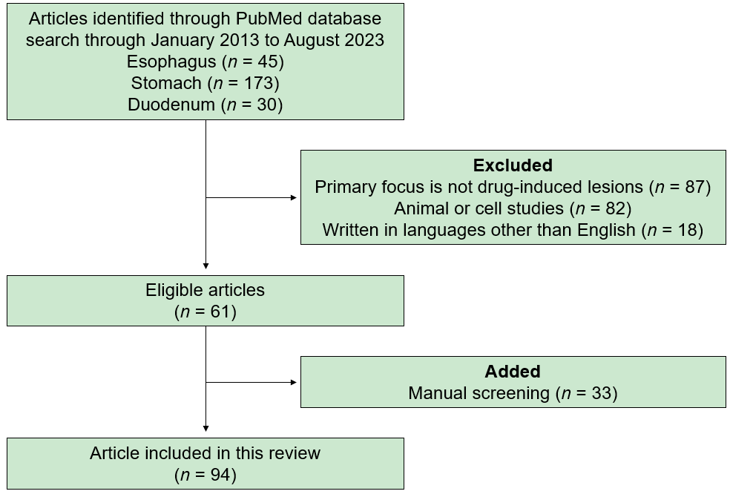
Figure 1 Flow diagram summarizing the identification, screening, eligibility, and exclusion processes of the literature search.

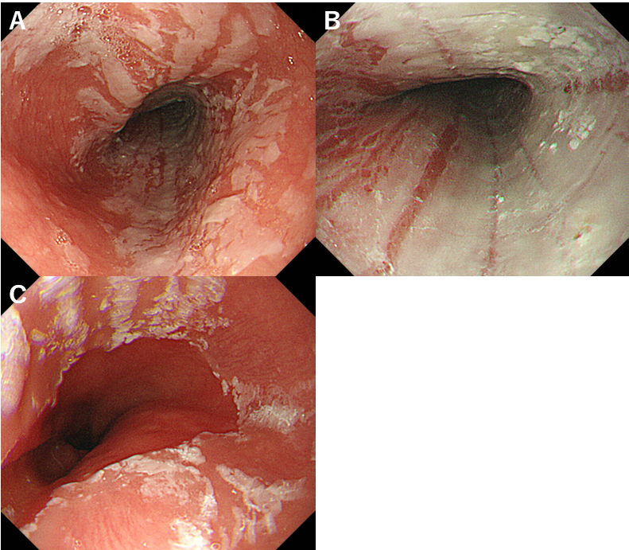
Figure 2 Dabigatran-induced desquamative esophagitis. A-C: White membranous material is observed in the middle to lower esophagus of a 73-year-old woman taking dabigatran.

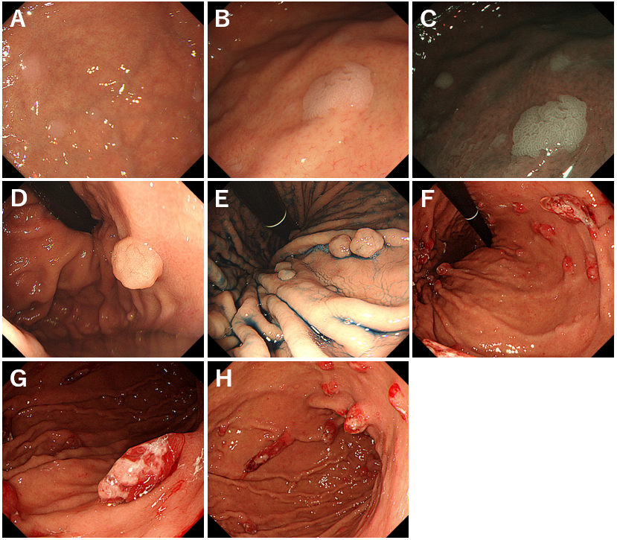
Figure 3 Proton pump inhibitor-induced gastric mucosal changes. A-C: Multiple white and flat elevated lesions. Whitish slight elevations are observed in the gastric fornix of a patient taking proton pump inhibitor (PPI). Lesions are easily identified on narrow-band imaging observation (C); D and E: Fundic gland polyps in a PPI user. After indigo carmine dye spraying (E); F-H: Hyperplastic polyps in the stomach. Multiple reddish, friable, long polyps are seen.

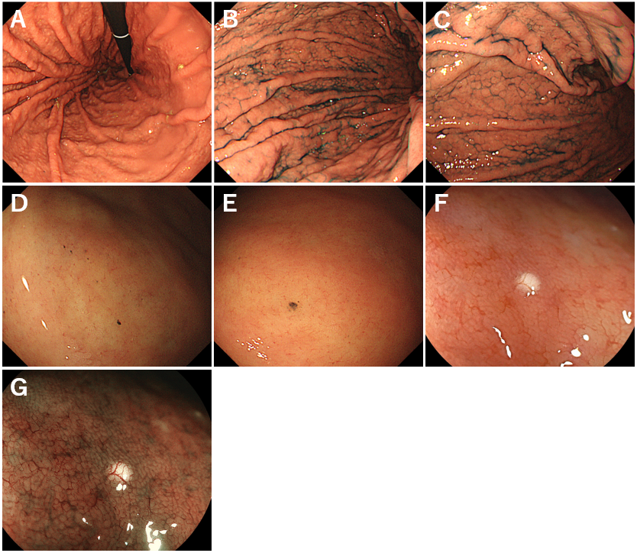
Figure 4 Proton pump inhibitor-induced gastric mucosal changes. A-C: Cobblestone-like mucosa. Numerous, approximately 3-5 mm-sized, elevated mucosal lesions are seen in the gastric body of a proton pump inhibitor user. After indigo carmine dye spraying (B and C); D and E: Black spots. Dark, dot-like spots are observed in the gastric body; F and G: White globe appearance. A small, round, white deposit observed during esophagogastroduodenoscopy. Magnifying endoscopic observation with blue laser imaging emphasized the lesion (G).

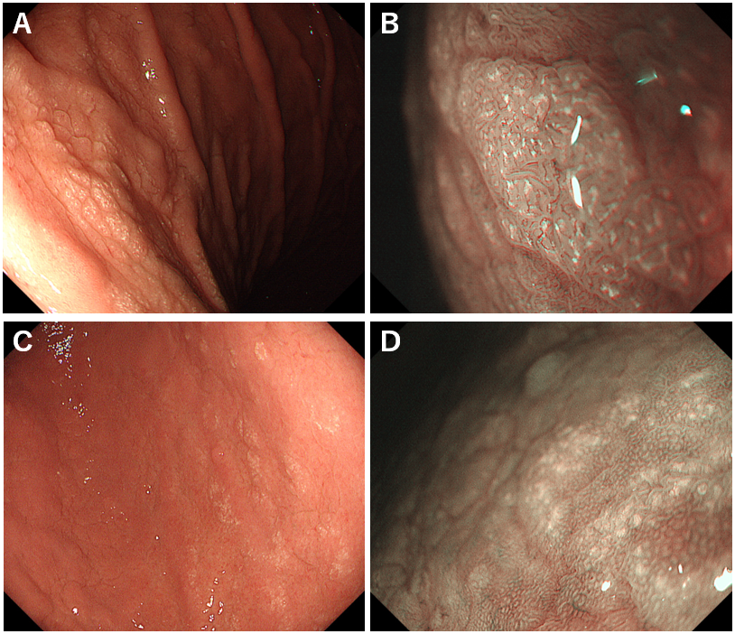
Figure 5 Lanthanum deposition in the stomach. A and B: Lanthanum deposition shows diffuse white lesions in non-atrophic mucosa. Magnifying observation with narrow-band imaging reveals tiny whitish depositions within the gastric mucosa (B); C and D: Multiple circular white lesions are seen in the gastric antrum with atrophic change. Magnifying observation with narrow-band imaging of the circular white lesions (D).

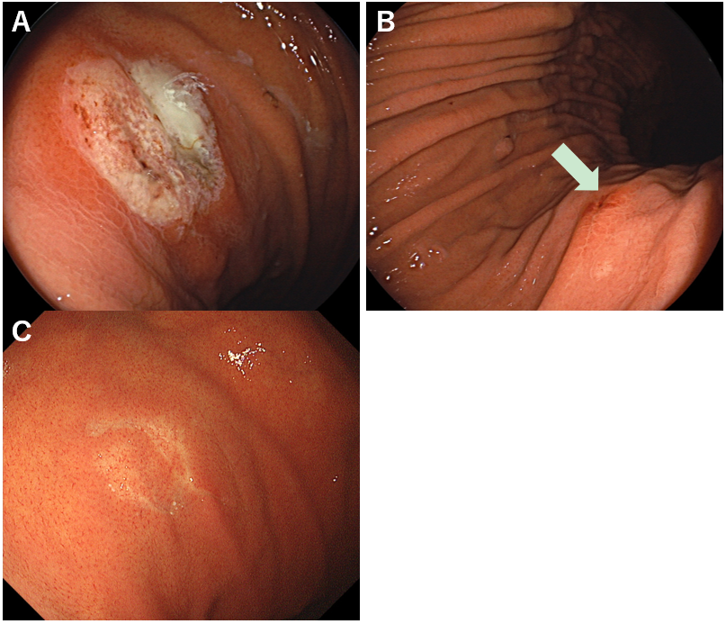
Figure 6 Zinc acetate hydrate tablet-induced gastric lesions. A 73-year-old Japanese woman had been taking zinc acetate dihydrate tablets for eight months to treat dysgeusia and hypozincemia. A: A round erosion with adhesion of the white coat is observed; B: Linear erosions are also seen in the gastric body (arrow); C: Esophagogastroduodenoscopy performed two months after cessation of zinc acetate hydrate tablet shows a resolution of erosions.

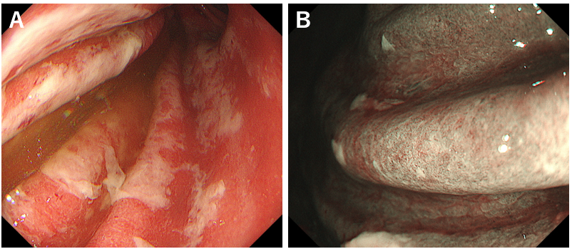
Figure 7 Immune-related adverse events gastritis. Esophagogastroduodenoscopy images after 16 wk of pembrolizumab administration in a 57-year-old female. A: White exudate and coarse mucosa are observed in the gastric body; B: Magnifying observation with narrow-band imaging shows that the glandular structures are absent.

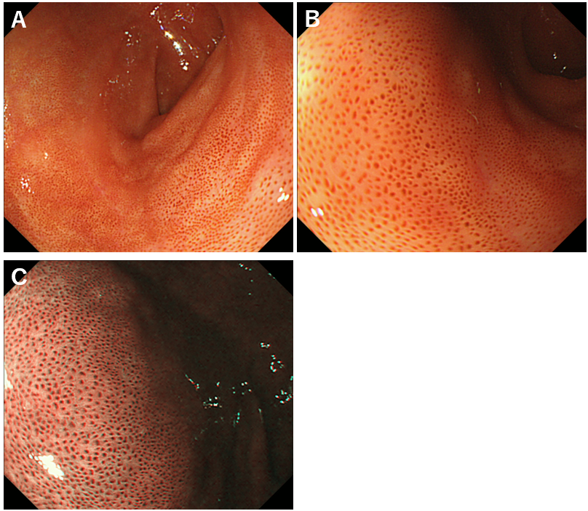
Figure 8 Pseudomelanosis of the duodenum. A-C: A dark brown pigmentation is observed in the duodenal bulb. Narrow-band imaging (C).

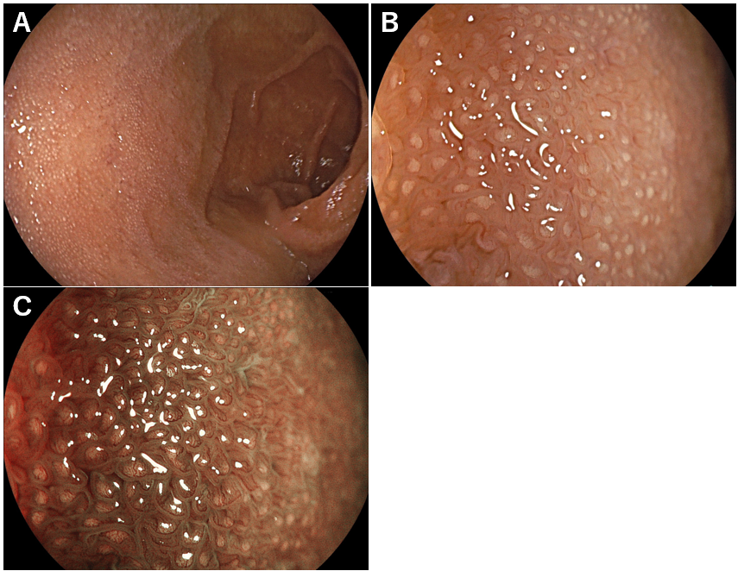
Figure 9 Lanthanum deposition in the duodenum. A: The duodenal mucosa is whitish; B: Magnifying observation reveals numerous dot-like white deposits in the duodenal villi; C: Magnifying observation with blue laser imaging emphasized the white deposits.

Table 1 Drugs described in two or more papers
Esophagus |  | Stomach | Duodenum
NSAIDs | Warfarin | PPIs | Olmesartan
Bisphosphonates | DOACs | NSAIDs | Iron tablets
Iron tablets | SSRIs | Steroids | Diuretics
Doxycycline | Benzodiazepine | Bisphosphonates | Lanthanum carbonate
Tetracycline | Phenytoin | Iron tablets
Ciprofloxacin | Pinaverium | Doxycycline
Clindamycin | Ascorbic acid | Diuretics
Amoxicillin | L-arginine | Olmesartan
Metronidazole | Opiates | Lanthanum carbonate
Rifaximin | 5-fluorouracil | Zinc acetate
Potassium chloride | Bleomycin | Immune checkpoint inhibitors
Antihypertensives | Dactinomycin
Nitrates | Methotrexate
Quinidine | Cytarabine
Acetaminophen | Vincristine
Colchicine
NSAIDs: Nonsteroidal anti-inflammatory drugs; DOACs: Direct oral anticoagulants; SSRIs: Selective serotonin reuptake inhibitors; PPIs: Proton pump inhibitors.

