Name of Journal: World Journal of Gastroenterology
ESPS Manuscript No.: 28450
Manuscript Type: CASE REPORT

Spontaneous rupture of hepatic metastasis from a thymoma: A case report

Kim HJ et al. Spontaneous rupture of hepatic metastasis

Ho Jae Kim, Yong Eun Park, Min Seo Ki, Se Ju Lee, Seung Hun Beom, Dai Hoon Han, Young Nyun Park, Jun Yong Park

Ho Jae Kim, Yong Eun Park, Min Seo Ki, Se Ju Lee, Seung Hun Beom, Jun Yong Park, Department of Internal Medicine, Yonsei University College of Medicine, Seoul 120–752, South Korea

Dai Hoon Han, Department of Surgery, Yonsei University College of Medicine, Seoul 120–752, South Korea

Young Nyun Park, Department of Pathology, Yonsei University College of Medicine, Seoul 120–752, South Korea

Author contributions: Park YE, Lee SJ and Park YN analyzed the data; Kim HJ, Ki MS, Beom SH, Han DH and Park JY treated the patient; Kim HJ and Park JY wrote the paper.

Institutional review board statement: This study was performed in accordance with the ethical guidelines of the 1975 Declaration of Helsinki and approved by the institutional review board of Severance Hospital. A written informed consent was not required due to the retrospective nature of this study.

Informed consent statement: The patient reported in this article provided informed written consent prior to manuscript preparation.

Conflict-of-interest statement: There is no conflict of interest to declare.

Open-Access: This article is an open-access article, which was selected by an in-house editor and fully peer-reviewed by external reviewers. It is distributed in accordance with the Creative Commons Attribution Non-Commercial (CC BY-NC 4.0) license, which permits others to distribute, remix, adapt, build upon this work non-commercially, and license their derivative works on different terms, provided the original work is properly cited and the use is non-commercial. See: http://creativecommons.org/licenses/by-nc/4.0/

Manuscript source: Unsolicited manuscript

Correspondence to: Jun Yong Park, MD, PhD, Department of Internal Medicine, Yonsei University College of Medicine, 250 Seongsanno, Seodaemun-gu, Seoul 120–752, South Korea. drpjy@yuhs.ac
Telephone: +82-2-22281994
Fax: +82-2-3936884

Received: June 30, 2016
Peer-review started: July 5, 2016
First decision: August 8, 2016
Revised: September 7, 2016
Accepted: September 14, 2016
Article in press:
Published online:

Abstract
Bleeding resulting from spontaneous rupture of the liver is an infrequent but potentially life threatening complication that may be associated with an underlying liver disease. A hepatocellular carcinoma or hepatic adenoma is frequently reported is such cases. However, hemoperitoneum resulting from a hepatic metastatic thymoma is extremely rare. Here, we present a case of a 62-year-old man with hypovolemic shock induced by ruptured hepatic metastasis from a thymoma. At the first hospital admission, the patient had a 45-mm anterior mediastinal mass that was eventually diagnosed as a type A thymoma. The mass was excised, and the patient was disease-free for 6 years. He experienced sudden-onset right upper quadrant pain and was again admitted to our hospital. We noted large hemoperitoneum with a 10-cm encapsulated mass in S5/8 and a 2.3-cm nodular lesion in the right upper quadrant of the abdomen. He was diagnosed with hepatic metastasis from the thymoma, and he underwent chemotherapy and surgical excision.

Key words: Spontaneous rupture; Hepatic metastasis; Thymoma; Hemoperitoneum; Transarterial chemoembolization

© The Author(s) 2016. Published by Baishideng Publishing Group Inc. All rights reserved.

Core tip: Spontaneous rupture of hepatic metastasis from a thymoma is extremely rare. This case report presents a rare case of spontaneous rupture of hepatic metastasis from a thymoma and describes its management. To our knowledge, no such case of rupture of a metastatic liver tumor associated with a thymoma has been reported previously.

Kim HJ, Park YE, Ki MS, Lee SJ, Beom SH, Han DH, Park YN, Park JY. Spontaneous rupture of hepatic metastasis from a thymoma: A case report. World J Gastroenterol 2016; In press
INTRODUCTION
The most common cause of a tumor in the anterior mediastinum is a thymic tumor. They have the ability to invade local structures and the capacity to metastasize to distant organs. The sites of metastasis include the lymph nodes, lungs, bones, liver, spleen, brain, and adrenal glands. However, hepatic metastasis is uncommon, and it is extremely rare for a metastatic liver tumor to rupture and cause hemoperitoneum. Recently, we experienced a patient who underwent transarterial chemoembolization for spontaneous rupture of hepatic metastasis from a thymoma. Here, we present this extremely rare case. To our knowledge, no such case of rupture of a metastatic liver tumor associated with a thymoma has been reported previously.

CASE REPORT
A 62-year-old man underwent an annual health checkup. A chest radiogram obtained during the checkup showed widening of the mediastinum. Chest computed tomography showed a 45-mm anterior mediastinal mass (Figure 1), and he underwent excision of the mass. A biopsy specimen from the mass demonstrated that the tumor was a type A thymoma according to the World Health Organization classification system, with fat tissue invasion. The tumor included bland spindle cells and few lymphocytes (Figure 2). According to the Masaoka classification system, the tumor stage was IIA, and he received radiotherapy (total 50 Gy in 25 fractions).
He was disease-free for 6 years; however, he experienced sudden-onset right upper quadrant pain and was referred to our hospital. He did not have a history of abdominal trauma and did not experience fever, vomiting, or diarrhea. On examination, his blood pressure was 77/50 mmHg and pulse rate was 70 beats/min. Blood analysis revealed a white blood cell count of 15370/mm³ (reference range, 4000–10800/mm³), hemoglobin level of 10.5 g/dL (reference range, 13–17.4 g/dL), platelet count of 154000/mm³ (reference range, 150000–400000/mm³), C-reactive protein level of 6 mg/L (reference range, 0–8 mg/L), aspartate aminotransferase level of 19 IU/L (reference range, 13–34 IU/L), alanine aminotransferase level of 17 IU/L (reference range, 5–46 IU/L), and alkaline phosphatase level of 40 IU/L (reference range, 47–143 IU/L). Abdominal computed tomography revealed large hemoperitoneum with a 10-cm encapsulated mass in S5/8 and a 2.3-cm nodular lesion in the right upper quadrant of the abdomen (Figure 3). The tumor marker (α-fetoprotein and prothrombin induced by vitamin K absence-II) levels were within the reference limits (2.3 ng/mL and 10 mAU/mL, respectively). Based on these findings, he underwent emergency angiography, and an interventional radiologist embolized the vessel supplying the tumor (Figure 4). Five days after embolization, when the patient was stable, abdominal wall biopsy was performed under general anesthesia. Histopathological analysis indicated a metastatic type A thymoma (Figure 5). He was transferred to the oncology department and underwent chemotherapy with cyclophosphamide (500 mg/m² day 1), doxorubicin (50 mg/m² day 1), and cisplatin (50 mg/m² day 1). After 4 cycles of chemotherapy, segmentectomy of the hepatic metastasis was performed and liver biopsy showed histopathology similar to a thymoma.

DISCUSSION
Spontaneous rupture of hepatic tumors usually occurs without warning in patients with hepatocellular carcinoma (HCC), and it is regarded as one of the most serious conditions associated with HCC^{[1]}. However, hemoperitoneum induced by rupture of a metastatic liver tumor is extremely. Ruptured metastatic liver tumors originating from various cancers, such as cancers of the lung, breast, testicle, gallbladder, stomach, kidney, skin, and nasopharynx; choriocarcinoma; and hepatic lymphoma, have been reported^{[2]}; however, to our knowledge, this is the first report to describe a ruptured metastatic liver tumor that originated from a thymoma.
Thymic tumors are derived from thymic epithelial cells, and are located mainly in the anterior mediastinum. About 90% of thymic tumors are located in the anterior mediastinum and some are found in other mediastinal areas. However, the incidence of thymoma is very low, and has been shown to be 0.15 cases per 100000 population. The disease progression is very slow, the condition remains silent for many years, and the tumor is generally incidentally identified^{[3]}. A multidisciplinary approach is essential in the management of a thymoma. If complete resection of the primary cancer appears possible, surgery is an important treatment approach for thymic tumors. Adjuvant radiotherapy has been widely used to improve survival or reduce the tumor in cases of late-stage cancer, especially when the tumor penetrates adjacent tissues or when the tumor is incompletely resected. Systemic chemotherapy is currently considered as the standard treatment approach for metastatic or inoperable tumors^{[4]}.
A thymoma is capable of both local invasion and intrathoracic recurrence, and local recurrence is common. The sites of metastasis include the brain, spleen, adrenal glands, bones, lymph nodes, liver, and lungs. The lung is considered the most frequent location of distant metastasis, while the liver has a relatively lower incidence of metastasis, and hepatic metastasis represents 12.5%–33.5% of all metastatic cases^{[3]}. Hemoperitoneum originating from a metastatic thymoma is extremely rare.
Treatment of hemoperitoneum secondary to hepatic metastasis depends on tumor location, tumor size, and bleeding severity. The primary goal should be complete hemostasis^{[5]}. There are different treatment options for patients presenting with hepatic rupture. These treatment options vary from conservative management to more invasive procedures, such as hepatectomy and transarterial embolization (TAE). A previous study compared different treatment options for hepatic rupture and concluded that the survival rate is better with hepatectomy than with TAE^{[6]}. Although hepatic resection may be a definitive treatment for bleeding, most patients have impaired liver function and an unstable hemodynamic status, and therefore, cannot tolerate surgery. In such cases, TAE and conservative management have been used to control bleeding after hepatic rupture^{[7]}. With regard to HCC rupture, the risk of mortality is higher with conservative management than with TAE. Thus, in emergencies, TAE is frequently performed as initial therapy. Hemoperitoneum secondary to hepatic metastasis from a choriocarcinoma and a gastrointestinal stromal tumor has been successfully treated with TAE^{[2,8]}. However, care should be taken, as artery embolization is associated with complications, such as re-bleeding and peritoneal seeding. Massive peritoneal washing with saline solution has been shown to reduce the chance of peritoneal implantation^{[9]}. Additionally, to reduce the chance of recurrent bleeding, TAE can be used as a bridge to hepatectomy. A previous report showed the favorable outcomes of delayed hepatectomy after emergency transcatheter arterial embolization for hepatic rupture^{[10]}. Additionally, in a previous study, patients treated with staged hepatectomy had the highest survival rate^{[1]}. In our case, we managed the ruptured hepatic tumor with arterial embolization owing to hypovolemic shock. Complete hemostasis was achieved, and delayed hepatectomy was performed for the hepatic metastasis.
In conclusion, we presented a rare case of spontaneous rupture of hepatic metastasis from a thymoma and described its management.

COMMENTS
Case characteristics
A 62-year-old Asian man with a thymoma visited the emergency room after experiencing whole abdominal pain.

Clinical diagnosis
Hemoperitoneum.

Differential diagnosis
Septic shock due to pan-peritonitis.

Laboratory diagnosis
The hemoglobin level was 10.5 g/dL, and tumor markers (α-fetoprotein and prothrombin induced by vitamin K absence-II) were negative.

Imaging diagnosis
Abdominal computed tomography revealed large hemoperitoneum with a 10-cm encapsulated mass in S5/8 and a 2.3-cm nodular lesion in the right upper quadrant of the abdomen.
Pathological diagnosis
The thymoma and metastatic liver tumor were composed of fibroblast-like spindle cells.

Treatment
Transarterial embolization (TAE) and delayed hepatectomy were performed.

Experiences and lessons
TAE is an excellent treatment option for hemoperitoneum secondary to hepatic metastasis from a thymoma.

Peer-review
No such case of rupture of a metastatic liver tumor associated with a thymoma has been reported previously.

REFERENCES
1 Rijckborst V, Ter Borg MJ, Tjwa ET, Sprengers D, Verhoef K, Moelker A, Ijzermans JN, de Man RA. Short article: Management of ruptured hepatocellular carcinoma in a European tertiary care center. Eur J Gastroenterol Hepatol 2016; 28: 963-966 [PMID: 27116657 DOI: 10.1097/meg.0000000000000652]
2 Duan YF, Tan Y, Yuan B, Zhu F. Spontaneous rupture of hepatic metastasis from small cell neuroendocrine carcinoma of maxillary sinus. World J Surg Oncol 2014; 12: 126 [PMID: 24767405 DOI: 10.1186/1477-7819-12-126]
3 Scorsetti M, Leo F, Trama A, D'Angelillo R, Serpico D, Macerelli M, Zucali P, Gatta G, Garassino MC. Thymoma and thymic carcinomas. Crit Rev Oncol Hematol 2016; 99: 332-350 [PMID: 26818050 DOI: 10.1016/j.critrevonc.2016.01.012]
4 Gubens MA. Treatment updates in advanced thymoma and thymic carcinoma. Curr Treat Options Oncol 2012; 13: 527-534 [PMID: 22961051 DOI: 10.1007/s11864-012-0211-7]
5 Casillas VJ, Amendola MA, Gascue A, Pinnar N, Levi JU, Perez JM. Imaging of nontraumatic hemorrhagic hepatic lesions. Radiographics 2000; 20: 367-378 [PMID: 10715337 DOI: 10.1148/radiographics.20.2.g00mc10367]
6 Zhong F, Cheng XS, He K, Sun SB, Zhou J, Chen HM. Treatment outcomes of spontaneous rupture of hepatocellular carcinoma with hemorrhagic shock: a multicenter study. Springerplus 2016; 5: 1101 [PMID: 27468402 DOI: 10.1186/s40064-016-2762-8]
7 Sada H, Ohira M, Kobayashi T, Tashiro H, Chayama K, Ohdan H. An Analysis of Surgical Treatment for the Spontaneous Rupture of Hepatocellular Carcinoma. Dig Surg 2016; 33: 43-50 [PMID: 26580332 DOI: 10.1159/000441531]
8 Liu YH, Ma HX, Ji B, Cao DB. Spontaneous hemoperitoneum from hepatic metastatic trophoblastic tumor. World J Gastroenterol 2012; 18: 4237-4240 [PMID: 22919261 DOI: 10.3748/wjg.v18.i31.4237]
9 Bassi N, Caratozzolo E, Bonariol L, Ruffolo C, Bridda A, Padoan L, Antoniutti M, Massani M. Management of ruptured hepatocellular carcinoma: implications for therapy. World J Gastroenterol 2010; 16: 1221-1225 [PMID: 20222165]
10 Takebayashi T, Kondo S, Ambo Y, Hirano S, Omi M, Morikawa T, Okushiba S, Katoh H. Staged hepatectomy following arterial embolization for ruptured hepatocellular carcinoma. Hepatogastroenterology 2002; 49: 1074-1076 [PMID: 12143205]

P-Reviewer: Anis S, Teng Y S-Editor: Qi Y L-Editor: E-Editor:

Specialty type: Gastroenterology and hepatology
Country of origin: South Korea
Peer-review report classification
Grade A (Excellent): A
Grade B (Very good): 0
Grade C (Good): C
Grade D (Fair): 0
Grade E (Poor): 0

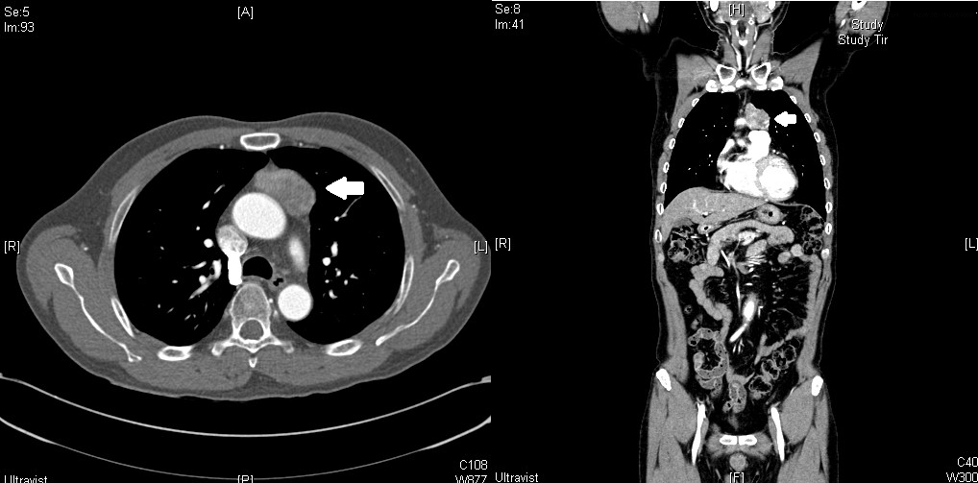
Figure 1 Computed tomography images. A mass (maximum diameter, 45 mm; white arrow) is seen anterior to the ascending thoracic aorta. Histological analysis later identified the mass as a thymoma.
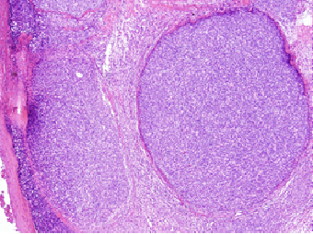
A

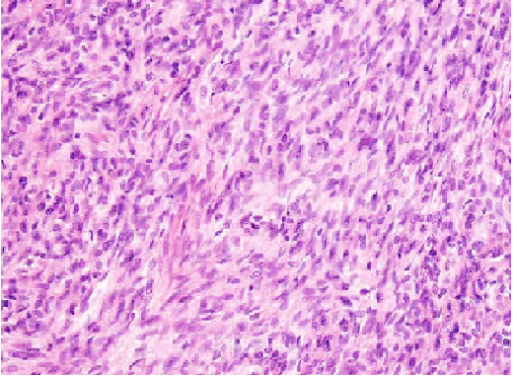
B

Figure 2 Histological analysis of the mediastinal thymoma. A: A stained section of the mediastinal thymoma (H&E staining, × 40); B: The type A component is composed primarily of fibroblast-like spindle cells (H&E staining, ×100).

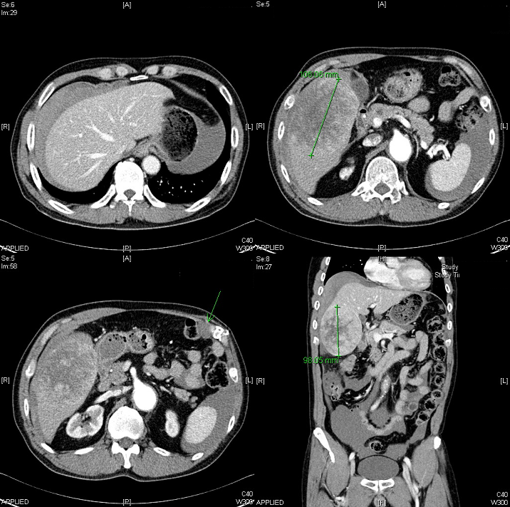
D
C
B
A
Figure 3 Enhanced computed tomography images. A: Large hemoperitoneum is seen around the liver; B: A 10-cm encapsulated mass is seen in S5 and S8 of the liver, and hemoperitoneum is seen around the spleen; C: A 2.3-cm nodular lesion is seen in the right upper quadrant of the abdomen adjacent to the left transverse abdominal muscle (white arrow); D: Coronal view of the large hemoperitoneum with a liver mass.

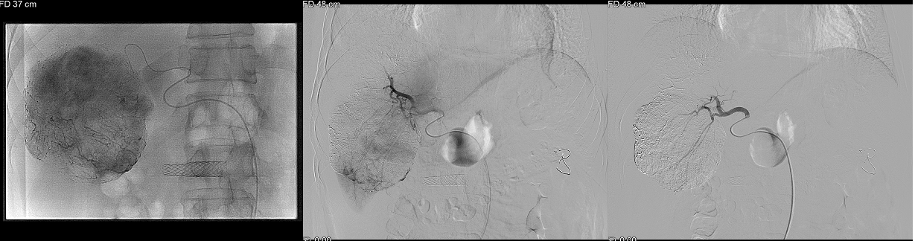
C
B
A
Figure 4 Angiography images. A: Digital subtraction angiography shows a large ruptured hypervascular tumor with staining at the right hepatic lobe during transarterial embolization; B: Active contrast leakage (white arrow) is seen; C: Selection of the right hepatic artery with a mixture of adriamycin (50 mg) and lipiodol (20 mL). The tumor staining disappears after transarterial embolization.

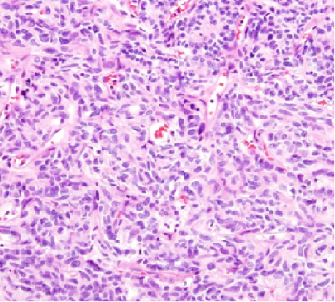
Figure 5 Histopathological analysis of the abdominal wall mass. The tumor is composed of fibroblast-like spindle cells (thymoma type A, metastatic).

