Name of Journal: World Journal of Gastrointestinal Oncology
Manuscript NO: 48784
Manuscript Type: ORIGINAL ARTICLE

Case Control Study
Relationship between cachexia and perineural invasion in pancreatic adenocarcinoma

Petrusel L et al. Cachexia and perineural invasion in pancreatic adenocarcinoma

Livia Petrusel, Ioana Rusu, Daniel Corneliu Leucuta, Radu Seicean, Ramona Suharoschi, Paula Zamfir, Andrada Seicean

Livia Petrusel, Andrada Seicean, Department of Gastroenterology, Regional Institute of Gastroenterology and Hepatology, Iuliu Hatieganu University of Medicine and Pharmacy, Cluj-Napoca 400162, Romania

Ioana Rusu, Paula Zamfir, Department of Pathology, Regional Institute of Gastroenterology and Hepatology, Iuliu Hatieganu University of Medicine and Pharmacy Cluj-Napoca, Cluj-Napoca 400162, Romania

Daniel Corneliu Leucuta, Medical Informatics and Biostatistics Department, Iuliu Hatieganu University of Medicine and Pharmacy Cluj-Napoca, Cluj-Napoca 400012, Romania

Radu Seicean, First Surgery Clinic, Iuliu Hatieganu University of Medicine and Pharmacy, Cluj-Napoca 400006, Romania

Ramona Suharoschi, Faculty of Food Science and Technology, University of Agricultural Sciences and Veterinary Medicine Cluj-Napoca, Cluj-Napoca 400372, Romania
ORCID number: Livia Petrusel (0000-0002-1385-3892); Ioana Rusu (0000-0001-9174-6729); Daniel Corneliu Leucuta (0000-0003-4218-8622); Radu Seicean (0000-0003-4519-2352); Ramona Suharoschi (0000-0002-8306-8670); Paula Zamfir (0000-0003-1461-9405); Andrada Seicean (0000-0002-5809-1334).

Author contributions: Petrusel L and Seicean A conceived and designed the study; Petrusel L, Rusu I, Seicean R, Suharoschi R and Zamfir P performed the research; Leucuta DC analysed data; Petrusel L and Seicean A wrote the paper.

Institutional review board statement: This study was reviewed and approved by the Ethics Committee of the Regional Institute of Gastroenterology and Hepatology in Cluj-Napoca.

Conflict-of-interest statement: The authors report no relevant conflicts of interest.

Data sharing statement: Participants gave written informed consent for data sharing.

STROBE statement: The authors have read the STROBE Statement, and the manuscript was prepared and revised according to the STROBE Statement.

Open-Access: This article is an open-access article which was selected by an in-house editor and fully peer-reviewed by external reviewers. It is distributed in accordance with the Creative Commons Attribution Non Commercial (CC BY-NC 4.0) license, which permits others to distribute, remix, adapt, build upon this work non-commercially, and license their derivative works on different terms, provided the original work is properly cited and the use is non-commercial. See: http://creativecommons.org/licenses/by-nc/4.0/

Manuscript source: Invited manuscript

Corresponding author: Livia Petrusel, MD, PhD, Doctor, Regional Institute of Gastroenterology and Hepatology, Iuliu Hatieganu University of Medicine and Pharmacy, 19-21 Croitorilor Street, Cluj-Napoca 400162, Romania. livia.cutas@umfcluj.ro
Telephone: +40-72-4402389

Received: May 5, 2019
Peer-review started: May 8, 2019
First decision: July 31, 2019
Revised: September 9, 2019
Accepted: October 14, 2019
Article in press: October 14, 2019
Published online: December 15, 2019

Abstract
BACKGROUND
Cachexia is responsible for the low quality of life in pancreatic adenocarcinoma (PDAC). The rapid disease progression and patient deterioration seems related to perineural invasion, but the relationship between cachexia and perineural invasion for the evolution of the disease has been rarely studied. As perineural invasion is difficult to be highlighted, a biomarker such as the neurotrophic factor Midkine (MK) which promotes the neuronal differentiation and the cell migration could be helpful. Also, Activin (ACV) has been described as cachexia related to PDAC. However, their role for assessing and predicting the disease course in daily practice is not known.

AIM
To assess the relationship between perineural invasion and cachexia and their biomarkers, MK and ACV, respectively, and their prognostic value.

METHODS
This study included prospectively enrolled patients with proven adenocarcinoma and a matched group of controls without any malignancies. Patients with other causes of malnutrition were excluded. The plasma levels of ACV and MK were analyzed using western blotting and were correlated with the clinicopathological features and survival data. These results were validated by immunohistochemical analyses of the pancreatic tumor tissue of the patients included in the study and a supplementary group of surgically resected specimens from patients with a benign disease.

RESULTS
The study comprised 114 patients with PDAC, 125 controls and a supplementary group of 14 benign pancreatic tissue samples. ACV and MK were both overexpressed more frequently in the plasma of patients with PDAC than in the controls (63% vs 32% for ACV, p < 0.001; 47% vs 16% for MK, p < 0.001), with similar levels in pancreatic tissue the MK protein expression was closely related to the advanced clinical stage (p = 0.006), the presence of metastasis (p = 0.04), perineural invasion (p = 0.03) and diabetes (p = 0.002), but with no influence on survival. No correlation between clinicopathological factors and ACV expression was noted. Cachexia, present in 19% of patients, was unrelated to ACV or MK level. Higher ACV expression was associated with a shorter survival (p = 0.008).

CONCLUSION
The MK was a biomarker of perineural invasion, associated with tumor stage and diabetes, but without prognostic value as ACV. Cachexia was unrelated to perineural invasion, ACV level or survival.

Key words: Pancreatic adenocarcinoma; Cachexia; Perineural invasion; Activin; Midkine; Biomarker; Survival; Metastases; Endosonography; Surgery

© The Author(s) 2019. Published by Baishideng Publishing Group Inc. All rights reserved.

Core tip: Midkine (MK) is a neurotrophic factor that promotes perineural invasion in pancreatic cancer, neuronal differentiation and cell migration. Our results confirmed that high MK expression is closely correlated with perineural invasion and with advanced tumor stage, diabetes. No relationship with cachexia was found. Activin plays a dominant role in the development and progression of cachexia and in tumor cell growth in pancreatic adenocarcinoma, but this was not confirmed in this study, despite the association with poor survival.

Citation: Petrusel L, Rusu I, Leucuta DC, Seicean R, Suharoschi R, Zamfir P, Seicean A. Relationship between cachexia and perineural invasion in pancreatic adenocarcinoma. World J Gastrointest Oncol 2019; 11(12): 1126-1140
URL: https://www.wjgnet.com/1948-5204/full/v11/i12/1126.htm
DOI: https://dx.doi.org/10.4251/wjgo.v11.i12.1126

INTRODUCTION
Pancreatic cancer is currently ranked on the 3rd place in cancer mortality, but is expected to reach the 2nd leading cause of cancer mortality in 2030^{[1,2]}. The unfavorable prognosis of PDAC can be attributed to late diagnosis and aggressive tumor biology, with a very low survival rate (< 6%)^{[2–4]}. A major factor in the low survival rate is the presence of cachexia, which is seen in over 85% of patients with pancreatic cancer^{[5–7]} constituting the highest rate of cachexia in all malignancies.
Cancer cachexia is a complex syndrome, characterized by body-weight loss; muscle, skeleton and adipose tissue wasting; and inflammation, which is often associated with anorexia^{[8,9]}.
Cachexia has become an obstacle for the successful treatment of cancer and may significantly contribute to cancer-related death.
The mechanism of cachexia involves the interaction host- tumor through TGFβ via the SMAD2/3 pathway which can stimulate tumour growth and inhibits the muscle growth followed by myopenia through myostatin or activin pathway^{[9,10]} or insulin- growth factor binding protein as part of IGF-1/PI3K/Akt signalling pathway with the inhibition of myogenesis and enhancing myotubule protein degradation^{[9]}. Another mechanism is related to hypercatabolism connected to the production of pro-inflammatory cytokines by the tumor, such as interleukin (IL)-1b, IL-6 and the tumor necrosis factor-α, both of which are involved in lipolysis with white adipose tissue wasting and early occurrence of brown fat tissue with high energy expenditure^{[11,12]}, in muscle catabolism too^{[9]}.
Astrocyte activation in the spinal cord induces lipolysis in the adipose tissue^{[13]} and muscle atrophy^{[14,15]} and is also involved in cachexia occurrence; this activation may result from the damage to peripheral nerves during perineural invasion in PDAC, with the hypertrophy and thickening of the nerve branches^{[16,17]}, but their relationship is not completely understood. The cachexia was associated with the degree of neural invasion, known as responsible for the aggressive behaviour of pancreatic cancer^{[18,19]}, with the involvement of the neurotrophic factors^{[20]}, such as midkine. It promotes neuronal differentiation and cell migration in peripheral invasion of pancreatic cancer^{[21]}. Midkine was found to be overexpressed in many pancreatic cancers and may represent a target for chemoresistant patients^{[22]}, but its relationship with cachexia has not been studied.
The main aim of this study was to determine the relationship between cachexia and perineural invasion in patients with PDAC by using clinico-pathological features and the protein expression levels of Activin and Midkine in plasma and tissue of patients compared to healthy patients. The secondary purpose was to assess the prognostic role of Activin and Midkine in survival and metastasis.

MATERIALS AND METHODS
Patients and sample collection
This study was performed at the Regional Institute of Gastroenterology and Hepatology “O. Fodor” in Cluj-Napoca, Romania. This study was prospectively performed and was approved by the Ethics Committee of the hospital and was registered at clinicaltrials.gov (NCT03042442).

Eligibility criteria
Subjects of the study group were at least 18-years-old, with no previous history of any other cancer in the last 5 years. Written consent was given prior to entry into the study. Patients with pancreatic ductal adenocarcinoma, based on the results of endoscopic ultrasonography (EUS), biopsy, or surgery, were enrolled at the time of diagnosis, before any therapeutic intervention had been given, from January 2015 to September 2017.
The exclusion criteria were obvious malabsorption, major depression, artificial nutrition, hyperthyroidism, and other causes of malnutrition. The final diagnosis was based on the histologic results from endoscopic ultrasonography fine needle aspiration (EUS-FNA) or surgery.
The subjects of the control groups were healthy people who were at least 18-years-old, with no previous history of any cancer and other chronic diseases. For the most part, controls were matched to cases for sex and age (plus/minus 5 years). Age, sex, tumor stage, tumor differentiation, body-mass index (BMI), smoking, and the presence of diabetes were noted.

Nutritional and functional assessment
Current body weight and height were measured at the time of inclusion. Diabetes was diagnosed if fasting glucose values met the ADA criteria^{[23]} and the duration since diabetes onset was recorded.
Cachexia was defined as an involuntary weight loss of more than 5% or a weight loss of more than 2% in individuals with a BMI of less than 20 kg/m² over the past 6 mo^{[24]}.

Blood sampling
Blood samples were collected at the time of diagnosis. Peripheral venous blood was drawn into a tube containing ethylenediaminetetraacetic acid and was prepared by centrifugation at 5000 × g for 5 min. The plasma samples were stored at −80 °C until use.
Selected proteins were quantified in the plasma using Western blot analyses.

Antibodies
The following antibodies were obtained from Abcam (Cambridge, United Kingdom): rabbit polyclonal antibody to ACV Receptor Type IIB antibody (cat. no. ab128544), rabbit polyclonal antibody to GAPDH (glyceraldehyde 3-phosphate dehydrogenase) (cat. no. ab37168), and horseradish peroxidase (HRP)- conjugated goat anti-rabbit IgG H.L antibody (cat. no. ab97051). The antibodies against midkine, mouse monoclonal IgG1 MK antibody (sc-46701, Santa Cruz Biotechnology, Santa Cruz, CA, United States) and goat anti-mouse IgG-HRP for MK (sc-2005; Santa Cruz Biotechnology, Santa Cruz, CA, United States) were obtained from Santa Cruz.

Western blot analyses
Protein concentration was determined using a protein assay kit, Quick Start Bradford Protein Assay (Bio-Rad Laboratories, Inc.). A total of 50 μg of total protein from each plasma sample was loaded per lane onto a 12% polyacrylamide gel. Electrophoresis was performed at 120 mV, and the protein fractions were electrotransferred onto a nitrocellulose membrane at 100 mV for 1 h. The membranes were blocked for 3 h with nonfat dry milk powder (Bio-Rad Laboratories, Inc.) in Tris-buffered saline containing 0.1% Tween-20 (TBS-T) under constant agitation. Subsequently, the membranes were incubated overnight at 4 ºC with a rabbit polyclonal antibody to ACV Receptor Type IIB antibody (cat. no. ab128544AbCam) diluted 1: 1000 in TBS-T, with nonfat dry milk powder and a mouse monoclonal antibody to IgG1 MK antibody (sc-46701; Santa Cruz Biotechnology, Santa Cruz, CA, United States) diluted 1: 100 in TBS-T with nonfat dry milk powder. For the loading control, a rabbit polyclonal antibody to GAPDH (glyceraldehyde-3-phosphate dehydrogenase) (cat. no. ab37168 AbCam) was used at a concentration of 0.8 µg/mL in nonfat dry milk powder in TBS-T. Membranes were washed with TBS-T and incubated at room temperature for 1 h with a horseradish peroxidase (HRP)- conjugated goat anti-rabbit IgG H.L antibody (cat. no. ab97051, Abcam) diluted 10000-fold in TBS-T and a goat anti-mouse IgG-HRP antibody for MK (sc-2005; Santa Cruz Biotechnology, Santa Cruz, CA, United States) diluted 5000-fold in TBS-T, with an additional washing step performed prior to detection. For GAPDH determination, an HRP-conjugated goat IgG anti-rabbit IgG antibody (cat. no. ab97051, Abcam) diluted 10000-fold in TBS-T was used. Total protein expression was normalized by dividing each of the protein units by those for GAPDH.
Proteins were detected by using Clarity™ Western ECL (Bio-Rad Laboratories, Inc.) and the membranes were imaged in a Chemidoc Imaging System (Bio-Rad Laboratories, Inc.) and analyzed using ImageLab Software version 5.2.1 for Windows (Bio-Rad Laboratories, Inc.).
Measurement and confirmation of the ACV and MK protein levels is often performed with normalization against “housekeeping proteins”, such as glyceraldehyde-3-phosphate dehydrogenase, to correct for protein loading and other factors, such as transfer efficiency.
For protein expression, after densitometry, the integrated density value (IDV) for each protein band (ACV and MK) was determined, and the normalized levels of ACV and MK were calculated by dividing the IDV of a protein band by the IDV of the GAPDH band (arbitrarily assigned a value of 100) in the same sample, thus quantifying the expression of the proteins as high or low expression.

Tissue samples
Tumor tissue samples from endoscopic ultrasound-fine needle aspiration and surgery were fixed with 10% formalin for pathology studies.
In addition, there was a supplementary group of 14 samples containing normal pancreatic tissues from patients who received partial pancreatectomy for benign tumors that were used as normal controls for the immunohistochemical interpretation.

Analysis of perineural invasion
The perineural invasion was assessed only on surgical tissues. The associations of perineural invasion with characteristics of PDAC were assessed on slides stained with hematoxylin-eosin. The presence of perineural invasion was defined by the infiltration of cancer cells into the perineurium or neural fascicles^{[25]}. The evaluation of perineural invasion was assessed mainly in tissue obtained from surgery after curative treatment. The degree of perineural invasion was defined as follows: 0- less than one occurrence per slide; 1 -two to four occurrences per slide; and 2 - more than four occurrences per slide or intraneural invasion.

Immunohistochemistry
For each case a parafﬁn-embedded block was selected. 3-micron-thick sections were obtained for immunohistochemistry investigation. The primary antibodies used were the following: ACV Receptor Type IIB antibody (cat. no. ab128544) diluted 1: 150 and mouse monoclonal IgG1 MK antibody (sc-46701, Santa Cruz Biotechnology, Santa Cruz, CA, United States) diluted 1: 200. The BOND‐III staining instrument (Leica Biosystems) and Bond Polymer Refine Detection Kit (Leica Biosystems) were used for all antibodies. This analysis was performed with pancreatic tumor and normal tissue samples.
All slides were scored by a pathologist (I.R.) who was blinded to all clinical data. Finally, the tissues were evaluated under a microscope. The intensity of the staining was scored as negative, weak, moderate, or strong (scores of 0, 1, 2, or 3, respectively).

Statistical analysis
Chi square test or Fisher’s exact test were used for categorical data. Comparisons between two groups of continuous data were performed with a t-test for independent samples for data with a normal distribution or a Wilcoxon rank-sum test otherwise. Univariate and, multivariate Cox proportional hazard models with each protein expression variable adjusted for age ≥ 50 years, gender, stage (T4 vs T1-T3), metastasis, tumor size ≥3 cm, and diabetes were built. The Cox proportional hazard assumption and multicollinearity assumptions were checked. Similarly, univariate and multivariate logistic regression models were built to predict metastasis. We checked the models for multicollinearity, misspecification and the goodness of fit.
For all statistical tests, a two-tailed p value was used, along with a 0.05 significance level. All analyses were performed in the R environment for statistical computing and graphics, version 3.4.4.

RESULTS
Patient characteristics
A total of 114 patients with PDAC and 125 controls with no tumor were enrolled in this study (Table 1).
The mean age of the population was 62.41 years (SD 11.56, range: 27-88 years). There were more males than females (61% vs 39%).
A total of 49 (42.98%) patients with PDAC reported a history of diabetes, including new-onset diabetes for 24 (21.05%) patients.
The most common localization of PDAC was in the pancreatic head (66 patients-49%), followed by a localization in the body (33 patients-24%), the isthmus (17 patients-12%), the pancreatic tail (13 patients-10%) and the uncinated process (7 patients-12%).

Nutritional and functional characteristics
Cachexia was more common in women (p = 0.033) and in patients with metastasis (p = 0.011). The presence of cachexia was unrelated to age (p = 0.389), cancer site (p = 0.611), tumor staging (p = 0.148) and perineural invasion (p = 0.12).

Expression of plasma and tissue MK and ACV in pancreatic cancer
MK was expressed in plasma from 54 (47.37%) PDAC patients compared to 20 (16%) controls (p < 0.001). Immunohistochemical staining in PDAC tissue was positive in 56 (49.12%) patients, including weak in 34 (29.82%), moderate in 16 (14.04%), and strong in 6 (5.26%), compared to none of the tissue from the supplementary controls (p = 0.012) (Figure 1).
ACV was expressed in plasma from 72 (63.16%) PDAC patients compared to 39 (31.2%) controls (p < 0.001). Immunohistochemical staining in PDAC tissue was positive in 59 patients (51.8%), including weak in 53 (46.49%) and moderate in 6 (5.26%) compared to none of the tissue from the control group (p = 0.001) (Figure 2).
Both proteins were detected in the tumor tissue by immunohistochemistry, and the tissue expression was significantly correlated with the plasma expression (p = 0.002 for Activin; and p = 0.046 for Midkine).

Relationships of ACV and MK expression with clinicopathological features
Table 2 summarizes the associations of MK and ACV expression with clinicopathological features in pancreatic cancer.
MK was highly expressed in the plasma of patients with an advanced T tumor stage (p = 0.006), metastases (p = 0.046), long-term diabetes (p = 0.002) and nonsmokers (p = 0.032). Nevertheless, there was no relationship between clinicopathological factors and high ACV expression. The association between ACV expression and cachexia was not statistically significant (p = 0.5).

Relationship between perineural invasion and expression of MK and ACV
The presence of perineural invasion was observed in only 61 PDAC specimens. The MK expression levels in PDAC were significantly higher in patients with perineural invasion than in those without perineural invasion (p = 0.033). The ACV expression level was not significantly associated with perineural invasion (p = 0.5).

Prediction of metastasis
To predict the presence of metastasis in patients with adenocarcinoma, we performed uni- and multivariate analysis by creating regression models, where each expression variable (MK and ACV high expression vs low expression) in the model was adjusted by age > 50 years, sex, diabetes, stage T4 vs T1-3, stage N1 vs N0 (Table 3). There were no statistically significant factors.

Survival in PDAC patients
Using data from the 114 patients with PDAC, we further evaluated whether the overexpression of ACV and MK was correlated with patient survival.
The univariate and multivariate Cox proportional survival analysis showed that after adjusting for age, gender, adenopathy, tumor size ≥ 3 cm, and metastases, tumor size > 3 cm, metastasis and ACV expression (Table 4) were independent predictors of poor survival (Figure 3). The survival of patients with high or low levels of MK expression was similar (Figure 4).

DISCUSSION
Our work aimed to study the relationship between perineural invasion and cachexia and their biomarkers, such as MK and ACV, respectively, and their prognostic value in patients with pancreatic cancer.
The survival in PDAC is very low, approximately 6% in 5 years, and one of the reasons is the rich stroma in the tumor tissue and the perineural invasion that extends into the pancreatic nerve plexus^{[26]}. One of the promoters of perineural invasion is a neurite growth factor, MK, which is present on the surface of cells and extracellular matrix that facilitates neural differentiation, cell migration, perineural invasion, neuritis out-growth^{[27,28]}, neuronal survival^{[29,30]}, carcinogenesis and tumor progression^{[31,32]}. During carcinogenesis in PDAC, it appears that the pancreatic cells bind at the level of the nerve gap or perineurium, then MK binds its receptor through an interaction that involves chondroitin sulfate, which promotes cancer infiltration, migration and the rapid development of peripheral invasion. During the repair of damage to the perineurium, more cells expressing MK are attracted, and a vicious circle is formed^{[21]}. MK expression was not inducible in GEM-treated chemosensitive PDAC cell lines, suggesting that MK is necessary to promote survival during chemotherapy by triggering Notch-2 pathway activation^{[22]}.
Increased levels of MK are found in 53% of PDAC, are related to venous invasion, microvessel density, and liver metastasis^{[22,33]} and are involved in biological activities that favor cell growth, survival and angiogenesis^{[34]}. MK had a low expression in the primary tumor in 80% of patients and had moderate expression in 18% of patients^{[35]}, similar to our results in which the tissue expression was weak in almost 30%, moderate in 14% and strong in 6% of patients, and the plasma MK protein was strongly positive in PDAC patients compared to controls (47.37%) (Figure 5).
We found that high MK expression was closely correlated with advanced tumor stage, the presence of metastasis, diabetes and perineural invasion, but no relationship with cachexia was found. Similar to a previous study^{[20]}, we confirmed the association of the MK protein with the presence of perineural invasion but in a larger group of patients (61 patients with pancreatic adenocarcinoma) than was previously reported.
The high level of MK in plasma was more frequently observed in patients with metastasis, similar to other studies^{[33]}, but it did not predict the development of metastasis or survival in multivariate analysis.
Activin A is a member of the TGFβ superfamily and is involved in many pathophysiological processes^{[36]}. ACV exerts most of its biological actions by binding to the membrane ACV type II receptor B^{[10]}, a receptor that is shared with Myostatin (another TGF-β superfamily member), and these proteins eventually activate the SMAD pathway, which is involved in pancreatic carcinogenesis^{[37–39]}. ACV receptor B seems to be involved in cancer cachexia^{[40,41]}, and its blockade by a soluble form prevents muscle atrophy and increases survival without affecting tumor growth^{[42,43]}.
The overexpression of ACV in the tumor tissues^{[44]} and elevated blood ACV levels were found in 38 patients with PDAC, sustaining a non-SMAD (MAPK, PI3K/AKT) pathway^{[45]}, which is contradictory to the suppressive role of ACV (by activating the SMAD pathway) that has been previously reported. Further studies are required to confirm the mechanism of ACV in pancreatic cancer.
In our study, the plasma ACV level in PDAC patients was higher than that in controls (63% vs 32%) (Figure 5), and the immunohistochemistry was positive in 51% of patients, most of whom had a low level of expression.
Despite the previous association of ACV and cachexia in patients with lung and colorectal cancer^{[46]}, in our study, high expression of plasma ACV was not associated with cachexia, but this may be related to the small number of cachectic patients (n = 22). Additionally, in the multivariate analysis, ACV had no role in metastasis. The PDAC patients with high levels of ACV expression had lower survival rates than those of patients with low levels of ACV expression, supporting the prognostic role of ACV, as reported elsewhere^{[45]}, together with tumor size and metastatic status.
Cachexia is associated with decreased visceral body fat and is associated with a lower survival in diabetic patients than in nondiabetic patients^{[47]}. In our study, we found no difference regarding survival in patients with or without diabetes.
Also, in our study we did not find a correlation between the presence of the cachexia and the perineural invasion. This may be due to the small number of patients who have undergone surgery (only in these patients it was possible to evaluate perineural invasion).
Patients with newly diagnosed diabetes have a 5-8 fold higher risk of being diagnosed with PDAC in the first 3 years after the development of diabetes, probably due to the direct action of insulin, which facilitates malignant transformation^{[48]}. Diabetes can also be a secondary phenomenon that is induced by PDAC through the destruction of beta cells^{[49]}, but in our study, no correlation was noted between new-onset diabetes and the level of ACV or MK. In contrast, the MK level was higher in patients with long-term diabetes, but diabetes and MK again had no prognostic role. Hyperglycemia favors perineural invasion in PDAC by two mechanisms. First, hyperglycemia increases the proliferation of cancer cells, which increases the expression of cytokines such as the neurotrophic factor (NGF). The overexpression of NGF may increase the interaction between nerve cells and cancerous cells and neurotropism. The second mechanism is that hyperglycemia causes demyelination and axonal nerve degeneration, allowing cancer cells to invade nerve structures. These two mechanisms promote hyperglycemia or diabetes and may have a role in perineural invasion in pancreatic cancer^{[50]}. The intervention of hyperglycemia and signaling between neurons and cancer cells was associated with a higher expression of NGF in PDAC cells and the p75 neurotrophin receptor in nerve fibers in an experimental study^{[51]}.
The limitations of this study are that perineural invasion was only examined in patients who underwent surgery (and not in all patients) and survival analysis was performed only for cancer patients. Another limitation of the study is that clinicopathological associations were made based on the expression of plasma proteins rather than in tissue. Further studies are, therefore, warranted to explore the mechanism of ACV and MK function, to investigate their potential as therapeutic targets in PDAC progression and the relationship with diabetes and perineural invasion.
In conclusion, the present data suggest that MK is a useful biomarker for perineural invasion, being also correlated with advanced tumor stage, the presence of metastasis and diabetes. Unfortunately, the perineural invasion and the expression of activin was not correlated with casexia, but ACV could be an effective biomarker for predicting poor prognosis in PDAC patients, and it might be a novel therapeutic marker for selectively targeting cancer cells.

Article Highlights
Research background
Pancreatic cancer has a high mortality rate, due to late diagnosis. Cachexia and perineural invasion have an increased incidence in pancreatic cancer, leading to decreased quality of life. Combating pain and cachexia through optimal treatment options can lead to increased quality of life and improved survival.

Research motivation
We wanted a better understanding of the involvement of cachexia and pain in pancreatic cancer and their relationship with different clinico-pathological factors, constituting a basis for discovering new therapeutic targets.

Research objectives
Defining the profile of cachexia in pancreatic cancer; establishing the degree of perineural invasion in pancreatic cancer; Highlighting the interrelationship between cachexia and perineural invasion in pancreatic cancer.

Research methods
We conducted a prospective study in 114 patients with pancreatic cancer and 125 healthy people as controls. Blood samples were used and pancreatic tissue were collected through EUS-FNA or surgery. The method of determining the biomarkers of cachexia (Activin) and perineural invasion (Midkine) in plasma was western blot, respectively immunohistochemistry in pancreatic tissue.

Research results
The analysis of the data showed an Activin (ACV) and Midkine (MK) proteins overexpression in plasma of patients with pancreatic cancer vs control, results that were correlated with the expression of proteins in the pancreatic cancer tissue. MK was also significantly correlated with advanced T stage, metastasis, diabetes and perineural invasion. ACV was significantly correlated with survival.

Research conclusions
MK can be considered a biomarker for perineural invasion, and ACV a prognostic factor for patients with pancreatic cancer.

Research perspectives
This research would open new perspectives in choosing the treatment that involves activin antagonists in order to prolong survival in patients with pancreatic cancer.

ACKNOWLEDGEMENTS
We thank Dr. Cristian Coman, Institute of Biology Research, Cluj-Napoca and Associate Prof. Manuela Banciu, PhD, Faculty of Biology and Geology, University of Babes-Bolyai, Cluj-Napoca for their support. This study was partially funded by the “Iuliu Haţieganu” University of Medicine and Pharmacy, Cluj-Napoca, through the Doctoral Research Project-2015 (No. 7690/36/15.04.2016). The financial support allocated from the grant was used for the acquisition of biomarkers and laboratory supplies. The sponsor had no involvement in the study design, collection, analysis and interpretation of data, writing of the manuscript or decision to submit the manuscript for publication.

REFERENCES
1 Rahib L, Smith BD, Aizenberg R, Rosenzweig AB, Fleshman JM, Matrisian LM. Projecting cancer incidence and deaths to 2030: the unexpected burden of thyroid, liver, and pancreas cancers in the United States. Cancer Res 2014; 74: 2913-2921 [PMID: 24840647 DOI: 10.1158/0008-5472.CAN-14-0155]
2 Global Burden of Disease Cancer Collaboration., Fitzmaurice C, Allen C, Barber RM, Barregard L, Bhutta ZA, Brenner H, Dicker DJ, Chimed-Orchir O, Dandona R, Dandona L, Fleming T, Forouzanfar MH, Hancock J, Hay RJ, Hunter-Merrill R, Huynh C, Hosgood HD, Johnson CO, Jonas JB, Khubchandani J, Kumar GA, Kutz M, Lan Q, Larson HJ, Liang X, Lim SS, Lopez AD, MacIntyre MF, Marczak L, Marquez N, Mokdad AH, Pinho C, Pourmalek F, Salomon JA, Sanabria JR, Sandar L, Sartorius B, Schwartz SM, Shackelford KA, Shibuya K, Stanaway J, Steiner C, Sun J, Takahashi K, Vollset SE, Vos T, Wagner JA, Wang H, Westerman R, Zeeb H, Zoeckler L, Abd-Allah F, Ahmed MB, Alabed S, Alam NK, Aldhahri SF, Alem G, Alemayohu MA, Ali R, Al-Raddadi R, Amare A, Amoako Y, Artaman A, Asayesh H, Atnafu N, Awasthi A, Saleem HB, Barac A, Bedi N, Bensenor I, Berhane A, Bernabé E, Betsu B, Binagwaho A, Boneya D, Campos-Nonato I, Castañeda-Orjuela C, Catalá-López F, Chiang P, Chibueze C, Chitheer A, Choi JY, Cowie B, Damtew S, das Neves J, Dey S, Dharmaratne S, Dhillon P, Ding E, Driscoll T, Ekwueme D, Endries AY, Farvid M, Farzadfar F, Fernandes J, Fischer F, G/Hiwot TT, Gebru A, Gopalani S, Hailu A, Horino M, Horita N, Husseini A, Huybrechts I, Inoue M, Islami F, Jakovljevic M, James S, Javanbakht M, Jee SH, Kasaeian A, Kedir MS, Khader YS, Khang YH, Kim D, Leigh J, Linn S, Lunevicius R, El Razek HMA, Malekzadeh R, Malta DC, Marcenes W, Markos D, Melaku YA, Meles KG, Mendoza W, Mengiste DT, Meretoja TJ, Miller TR, Mohammad KA, Mohammadi A, Mohammed S, Moradi-Lakeh M, Nagel G, Nand D, Le Nguyen Q, Nolte S, Ogbo FA, Oladimeji KE, Oren E, Pa M, Park EK, Pereira DM, Plass D, Qorbani M, Radfar A, Rafay A, Rahman M, Rana SM, Søreide K, Satpathy M, Sawhney M, Sepanlou SG, Shaikh MA, She J, Shiue I, Shore HR, Shrime MG, So S, Soneji S, Stathopoulou V, Stroumpoulis K, Sufiyan MB, Sykes BL, Tabarés-Seisdedos R, Tadese F, Tedla BA, Tessema GA, Thakur JS, Tran BX, Ukwaja KN, Uzochukwu BSC, Vlassov VV, Weiderpass E, Wubshet Terefe M, Yebyo HG, Yimam HH, Yonemoto N, Younis MZ, Yu C, Zaidi Z, Zaki MES, Zenebe ZM, Murray CJL, Naghavi M. Global, Regional, and National Cancer Incidence, Mortality, Years of Life Lost, Years Lived With Disability, and Disability-Adjusted Life-years for 32 Cancer Groups, 1990 to 2015: A Systematic Analysis for the Global Burden of Disease Study. JAMA Oncol 2017; 3: 524-548 [PMID: 27918777 DOI: 10.1001/jamaoncol.2016.5688]
3 Siegel R, Naishadham D, Jemal A. Cancer statistics, 2013. CA Cancer J Clin 2013; 63: 11-30 [PMID: 23335087 DOI: 10.3322/caac.21166]
4 Allemani C, Matsuda T, Di Carlo V, Harewood R, Matz M, Nikšić M, Bonaventure A, Valkov M, Johnson CJ, Estève J, Ogunbiyi OJ, Azevedo E Silva G, Chen WQ, Eser S, Engholm G, Stiller CA, Monnereau A, Woods RR, Visser O, Lim GH, Aitken J, Weir HK, Coleman MP; CONCORD Working Group. Global surveillance of trends in cancer survival 2000-14 (CONCORD-3): analysis of individual records for 37 513 025 patients diagnosed with one of 18 cancers from 322 population-based registries in 71 countries. Lancet 2018; 391: 1023-1075 [PMID: 29395269 DOI: 10.1016/S0140-6736(17)33326-3]
5 Wigmore SJ, Plester CE, Richardson RA, Fearon KC. Changes in nutritional status associated with unresectable pancreatic cancer. Br J Cancer 1997; 75: 106-109 [PMID: 9000606 DOI: 10.1038/bjc.1997.17]
6 Di Sebastiano KM, Yang L, Zbuk K, Wong RK, Chow T, Koff D, Moran GR, Mourtzakis M. Accelerated muscle and adipose tissue loss may predict survival in pancreatic cancer patients: the relationship with diabetes and anaemia. Br J Nutr 2013; 109: 302-312 [PMID: 23021109 DOI: 10.1017/S0007114512001067]
7 Choi MH, Yoon SB, Lee K, Song M, Lee IS, Lee MA, Hong TH, Choi MG. Preoperative sarcopenia and post-operative accelerated muscle loss negatively impact survival after resection of pancreatic cancer. J Cachexia Sarcopenia Muscle 2018; 9: 326-334 [PMID: 29399990 DOI: 10.1002/jcsm.12274]
8 Argilés JM, Stemmler B, López-Soriano FJ, Busquets S. Nonmuscle Tissues Contribution to Cancer Cachexia. Mediators Inflamm 2015; 2015: 182872 [PMID: 26523094 DOI: 10.1155/2015/182872]
9 Yakovenko A, Cameron M, Trevino JG. Molecular therapeutic strategies targeting pancreatic cancer induced cachexia. World J Gastrointest Surg 2018; 10: 95-106 [PMID: 30622678 DOI: 10.4240/wjgs.v10.i9.95]
10 McPherron AC, Lawler AM, Lee SJ. Regulation of skeletal muscle mass in mice by a new TGF-beta superfamily member. Nature 1997; 387: 83-90 [PMID: 9139826 DOI: 10.1038/387083a0]
11 Ji C, Chen X, Gao C, Jiao L, Wang J, Xu G, Fu H, Guo X, Zhao Y. IL-6 induces lipolysis and mitochondrial dysfunction, but does not affect insulin-mediated glucose transport in 3T3-L1 adipocytes. J Bioenerg Biomembr 2011; 43: 367-375 [PMID: 21732177 DOI: 10.1007/s10863-011-9361-8]
12 Negrin KA, Roth Flach RJ, DiStefano MT, Matevossian A, Friedline RH, Jung D, Kim JK, Czech MP. IL-1 signaling in obesity-induced hepatic lipogenesis and steatosis. PLoS One 2014; 9: e107265 [PMID: 25216251 DOI: 10.1371/journal.pone.0107265]
13 Dodt C, Lönnroth P, Wellhöner JP, Fehm HL, Elam M. Sympathetic control of white adipose tissue in lean and obese humans. Acta Physiol Scand 2003; 177: 351-357 [PMID: 12609006 DOI: 10.1046/j.1365-201X.2003.01077.x]
14 Qvisth V, Hagström-Toft E, Enoksson S, Moberg E, Arner P, Bolinder J. Human skeletal muscle lipolysis is more responsive to epinephrine than to norepinephrine stimulation in vivo. J Clin Endocrinol Metab 2006; 91: 665-670 [PMID: 16303838 DOI: 10.1210/jc.2005-0859]
15 Lynch GS, Ryall JG. Role of beta-adrenoceptor signaling in skeletal muscle: implications for muscle wasting and disease. Physiol Rev 2008; 88: 729-767 [PMID: 18391178 DOI: 10.1152/physrev.00028.2007]
16 Ceyhan GO, Bergmann F, Kadihasanoglu M, Altintas B, Demir IE, Hinz U, Müller MW, Giese T, Büchler MW, Giese NA, Friess H. Pancreatic neuropathy and neuropathic pain--a comprehensive pathomorphological study of 546 cases. Gastroenterology 2009; 136: 177-186.e1 [PMID: 18992743 DOI: 10.1053/j.gastro.2008.09.029]
17 Gwak YS, Crown ED, Unabia GC, Hulsebosch CE. Propentofylline attenuates allodynia, glial activation and modulates GABAergic tone after spinal cord injury in the rat. Pain 2008; 138: 410-422 [PMID: 18353556 DOI: 10.1016/j.pain.2008.01.021]
18 Iwasaki T, Hiraoka N, Ino Y, Nakajima K, Kishi Y, Nara S, Esaki M, Shimada K, Katai H. Reduction of intrapancreatic neural density in cancer tissue predicts poorer outcome in pancreatic ductal carcinoma. Cancer Sci 2019; 110: 1491-1502 [PMID: 30776178 DOI: 10.1111/cas.13975]
19 Wang PH, Song N, Shi LB, Zhang QH, Chen ZY. The relationship between multiple clinicopathological features and nerve invasion in pancreatic cancer. Hepatobiliary Pancreat Dis Int 2013; 12: 546-551 [PMID: 24103287 DOI: 10.1016/S1499-3872(13)60086-7]
20 Yao J, Li WY, Li SG, Feng XS, Gao SG. Midkine promotes perineural invasion in human pancreatic cancer. World J Gastroenterol 2014; 20: 3018-3024 [PMID: 24659893 DOI: 10.3748/wjg.v20.i11.3018]
21 Yao J, Li WY, Gao SG. The advances of Midkine with peripheral invasion in pancreatic cancer. Am J Cancer Res 2015; 5: 2912-2917 [PMID: 26609495]
22 Güngör C, Hofmann BT, Wolters-Eisfeld G, Bockhorn M. Pancreatic cancer. Br J Pharmacol 2014; 171: 849-858 [PMID: 24024905 DOI: 10.1111/bph.12401]
23 American Diabetes Association. (2) Classification and diagnosis of diabetes. Diabetes Care 2015; 38 Suppl: S8-S16 [PMID: 25537714 DOI: 10.2337/dc15-S005]
24 Fearon K, Strasser F, Anker SD, Bosaeus I, Bruera E, Fainsinger RL, Jatoi A, Loprinzi C, MacDonald N, Mantovani G, Davis M, Muscaritoli M, Ottery F, Radbruch L, Ravasco P, Walsh D, Wilcock A, Kaasa S, Baracos VE. Definition and classification of cancer cachexia: an international consensus. Lancet Oncol 2011; 12: 489-495 [PMID: 21296615 DOI: 10.1016/S1470-2045(10)70218-7]
25 Zhu Z, Friess H, diMola FF, Zimmermann A, Graber HU, Korc M, Büchler MW. Nerve growth factor expression correlates with perineural invasion and pain in human pancreatic cancer. J Clin Oncol 1999; 17: 2419-2428 [PMID: 10561305 DOI: 10.1200/JCO.1999.17.8.2419]
26 Ceyhan GO, Schäfer KH, Kerscher AG, Rauch U, Demir IE, Kadihasanoglu M, Böhm C, Müller MW, Büchler MW, Giese NA, Erkan M, Friess H. Nerve growth factor and artemin are paracrine mediators of pancreatic neuropathy in pancreatic adenocarcinoma. Ann Surg 2010; 251: 923-931 [PMID: 20395845 DOI: 10.1097/SLA.0b013e3181d974d4]
27 Rauvala H, Peng HB. HB-GAM (heparin-binding growth-associated molecule) and heparin-type glycans in the development and plasticity of neuron-target contacts. Prog Neurobiol 1997; 52: 127-144 [PMID: 9185236 DOI: 10.1016/S0301-0082(97)00007-5]
28 Pirie NW. Some obstacles to eliminating famine. Proc Nutr Soc 1975; 34: 181-186 [PMID: 1208498 DOI: 10.1023/A:1016042303253]
29 Sakaguchi N, Muramatsu H, Ichihara-Tanaka K, Maeda N, Noda M, Yamamoto T, Michikawa M, Ikematsu S, Sakuma S, Muramatsu T. Receptor-type protein tyrosine phosphatase zeta as a component of the signaling receptor complex for midkine-dependent survival of embryonic neurons. Neurosci Res 2003; 45: 219-224 [PMID: 12573468 DOI: 10.1016/S0168-0102(02)00226-2]
30 Owada K, Sanjo N, Kobayashi T, Mizusawa H, Muramatsu H, Muramatsu T, Michikawa M. Midkine inhibits caspase-dependent apoptosis via the activation of mitogen-activated protein kinase and phosphatidylinositol 3-kinase in cultured neurons. J Neurochem 1999; 73: 2084-2092 [PMID: 10537068 DOI: 10.1046/j.1471-4159.1999.02084.x]
31 Muramatsu T. Midkine and pleiotrophin: two related proteins involved in development, survival, inflammation and tumorigenesis. J Biochem 2002; 132: 359-371 [PMID: 12204104 DOI: 10.1093/oxfordjournals.jbchem.a003231]
32 Kadomatsu K, Muramatsu T. Midkine and pleiotrophin in neural development and cancer. Cancer Lett 2004; 204: 127-143 [PMID: 15013213 DOI: 10.1016/S0304-3835(03)00450-6]
33 Maeda S, Shinchi H, Kurahara H, Mataki Y, Noma H, Maemura K, Aridome K, Yokomine T, Natsugoe S, Aikou T, Takao S. Clinical significance of midkine expression in pancreatic head carcinoma. Br J Cancer 2007; 97: 405-411 [PMID: 17622248 DOI: 10.1038/sj.bjc.6603879]
34 Dai LC. Midkine translocated to nucleoli and involved in carcinogenesis. World J Gastroenterol 2009; 15: 412-416 [PMID: 19152444 DOI: 10.3748/wjg.15.412]
35 Grupp K, Melling N, Bogoevska V, Reeh M, Uzunoglu FG, El Gammal AT, Nentwich MF, Izbicki JR, Bogoevski D. Expression of ICAM-1, E-cadherin, periostin and midkine in metastases of pancreatic ductal adenocarcinomas. Exp Mol Pathol 2018; 104: 109-113 [PMID: 29355490 DOI: 10.1016/j.yexmp.2018.01.005]
36 Xia Y, Schneyer AL. The biology of activin: recent advances in structure, regulation and function. J Endocrinol 2009; 202: 1-12 [PMID: 19273500 DOI: 10.1677/JOE-08-0549]
37 Itoh S, Itoh F, Goumans MJ, Ten Dijke P. Signaling of transforming growth factor-beta family members through Smad proteins. Eur J Biochem 2000; 267: 6954-6967 [PMID: 11106403 DOI: 10.1046/j.1432-1327.2000.01828.x]
38 Bernard DJ, Lee KB, Santos MM. Activin B can signal through both ALK4 and ALK7 in gonadotrope cells. Reprod Biol Endocrinol 2006; 4: 52 [PMID: 17040568 DOI: 10.1186/1477-7827-4-52]
39 Tsuchida K, Nakatani M, Yamakawa N, Hashimoto O, Hasegawa Y, Sugino H. Activin isoforms signal through type I receptor serine/threonine kinase ALK7. Mol Cell Endocrinol 2004; 220: 59-65 [PMID: 15196700 DOI: 10.1016/j.mce.2004.03.009]
40 Chen JL, Walton KL, Winbanks CE, Murphy KT, Thomson RE, Makanji Y, Qian H, Lynch GS, Harrison CA, Gregorevic P. Elevated expression of activins promotes muscle wasting and cachexia. FASEB J 2014; 28: 1711-1723 [PMID: 24378873 DOI: 10.1096/fj.13-245894]
41 Seder CW, Hartojo W, Lin L, Silvers AL, Wang Z, Thomas DG, Giordano TJ, Chen G, Chang AC, Orringer MB, Beer DG. Upregulated INHBA expression may promote cell proliferation and is associated with poor survival in lung adenocarcinoma. Neoplasia 2009; 11: 388-396 [PMID: 19308293 DOI: 10.1593/neo.81582]
42 Zhou X, Wang JL, Lu J, Song Y, Kwak KS, Jiao Q, Rosenfeld R, Chen Q, Boone T, Simonet WS, Lacey DL, Goldberg AL, Han HQ. Reversal of cancer cachexia and muscle wasting by ActRIIB antagonism leads to prolonged survival. Cell 2010; 142: 531-543 [PMID: 20723755 DOI: 10.1016/j.cell.2010.07.011]
43 Busquets S, Toledo M, Orpí M, Massa D, Porta M, Capdevila E, Padilla N, Frailis V, López-Soriano FJ, Han HQ, Argilés JM. Myostatin blockage using actRIIB antagonism in mice bearing the Lewis lung carcinoma results in the improvement of muscle wasting and physical performance. J Cachexia Sarcopenia Muscle 2012; 3: 37-43 [PMID: 22450815 DOI: 10.1007/s13539-011-0049-z]
44 Kleeff J, Ishiwata T, Friess H, Büchler MW, Korc M. Concomitant over-expression of activin/inhibin beta subunits and their receptors in human pancreatic cancer. Int J Cancer 1998; 77: 860-868 [PMID: 9714055 DOI: 10.1002/(sici)1097-0215(19980911)77:6<860::aid-ijc11>3.0.co;2-5]
45 Togashi Y, Kogita A, Sakamoto H, Hayashi H, Terashima M, de Velasco MA, Sakai K, Fujita Y, Tomida S, Kitano M, Okuno K, Kudo M, Nishio K. Activin signal promotes cancer progression and is involved in cachexia in a subset of pancreatic cancer. Cancer Lett 2015; 356: 819-827 [PMID: 25449777 DOI: 10.1016/j.canlet.2014.10.037]
46 Loumaye A, de Barsy M, Nachit M, Lause P, Frateur L, van Maanen A, Trefois P, Gruson D, Thissen JP. Role of Activin A and myostatin in human cancer cachexia. J Clin Endocrinol Metab 2015; 100: 2030-2038 [PMID: 25751105 DOI: 10.1210/jc.2014-4318]
47 Sah RP, Nagpal SJ, Mukhopadhyay D, Chari ST. New insights into pancreatic cancer-induced paraneoplastic diabetes. Nat Rev Gastroenterol Hepatol 2013; 10: 423-433 [PMID: 23528347 DOI: 10.1038/nrgastro.2013.49]
48 Li D, Mao Y. Diabetes as a Risk Factor of Pancreatic Cancer. Pancreapedia Exocrine Pancreas Knowledge Base 2015. [doi:10.3998/panc.2015.2]
49 Gupta S, Vittinghoff E, Bertenthal D, Corley D, Shen H, Walter LC, McQuaid K. New-onset diabetes and pancreatic cancer. Clin Gastroenterol Hepatol 2006; 4: 1366-72; quiz 1301 [PMID: 16945591 DOI: 10.1016/j.cgh.2006.06.024]
50 Li J, Ma Q. Hyperglycemia promotes the perineural invasion in pancreatic cancer. Med Hypotheses 2008; 71: 386-389 [PMID: 18571873 DOI: 10.1016/j.mehy.2008.05.001]
51 Li J, Ma Q, Liu H, Guo K, Li F, Li W, Han L, Wang F, Wu E. Relationship between neural alteration and perineural invasion in pancreatic cancer patients with hyperglycemia. PLoS One 2011; 6: e17385 [PMID: 21386984 DOI: 10.1371/journal.pone.0017385]

P-Reviewer: Mastoraki A S-Editor: Zhang L L-Editor: A E-Editor: Qi LL

Specialty type: Oncology
Country of origin: Romania
Peer-review report classification
Grade A (Excellent): 0
Grade B (Very good): 0
Grade C (Good): C
Grade D (Fair): 0
Grade E (Poor): 0

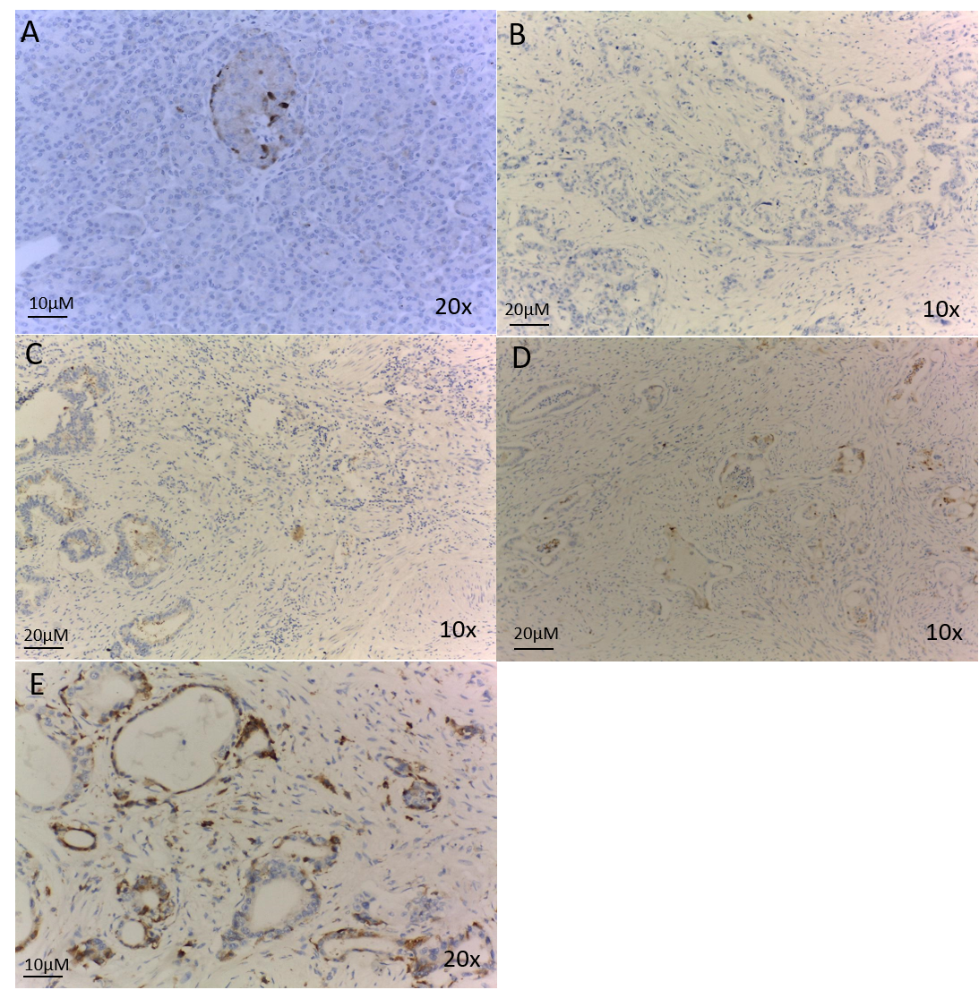
Figure 1 Immunohistochemical staining of Midkine in pancreatic adenocarcinomaand normal pancreatic tissue. A: Negative Midkine staining in normal pancreatic tissue; B: Negative Midkine staining in pancreatic tumor tissue; C: Weak Midkine expression in pancreatic tumor tissue; D: Moderate Midkine expression in pancreatic tumor tissue; E: Strong Midkine expression in pancreatic tumor tissue.

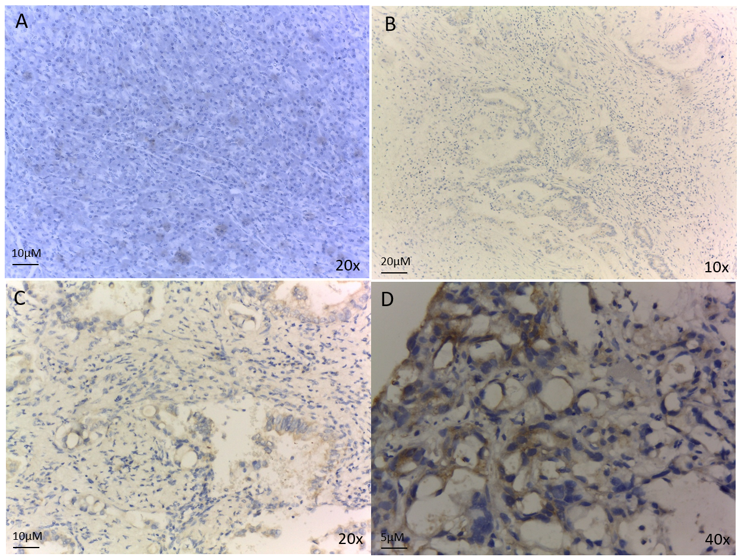
Figure 2 Immunohistochemical staining of Activin in pancreatic adenocarcinoma and normal pancreatic tissue. A: Negative Activin staining in normal pancreatic tissue; B: Weak Activin expression in pancreatic tumor tissue; C: Moderate Activin expression in pancreatic tumor tissue; D: Strong Activin expression in pancreatic tumor tissue.

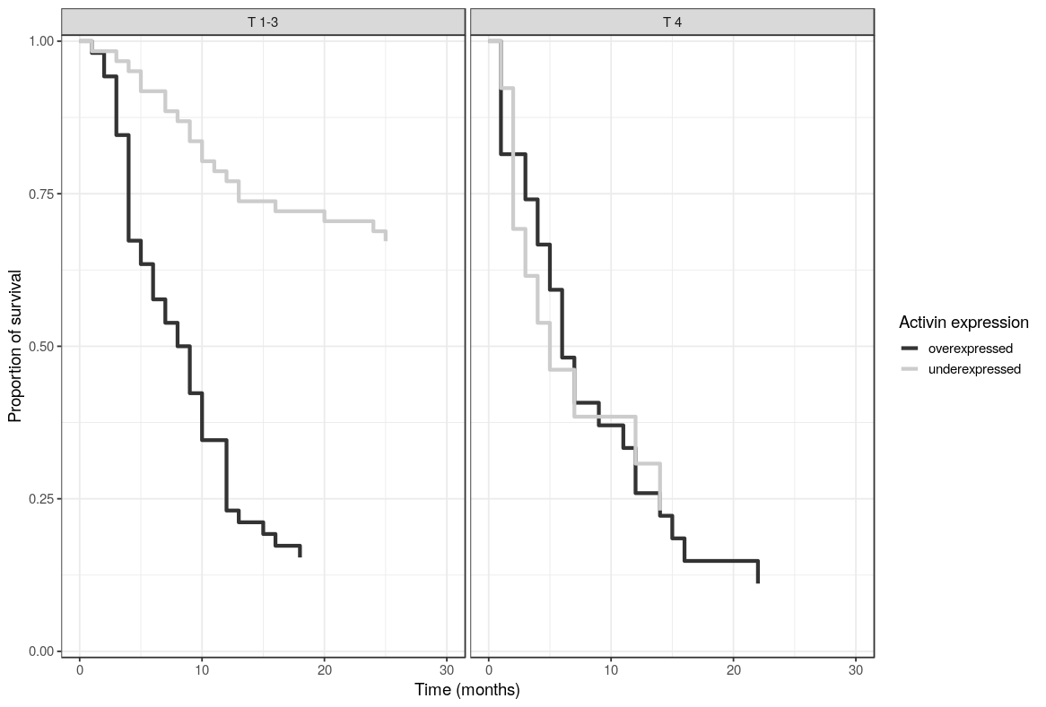
Figure 3 Overall survival comparison between high and low-expressed Activin stratified by tumoral stage T1-3 vs T4.
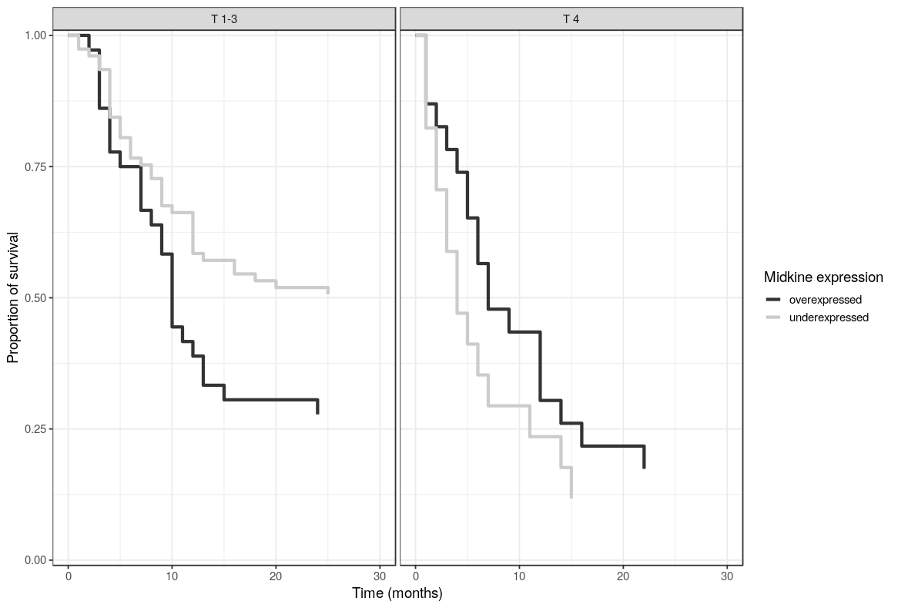
Figure 4 Overall survival comparison between high and low-expressed Midkine stratified by tumoral stage T1-3 vs T4.

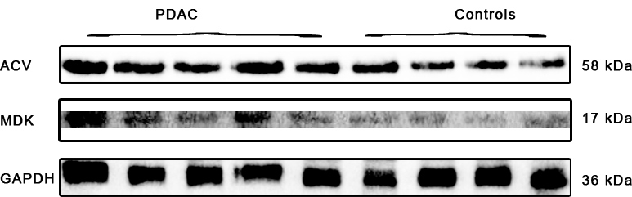
Figure 5 Western blot analyses of Activine and Midkine in patients with pancreatic adenocarcinoma and controls.

Table 1 Patient characteristics in the adenocarcinoma and control groups, n (%)
Characteristics | PDAC (n = 114) | Control (n = 125)
Age (yr), mean (SD) | 64.76 (10.58)^{b} | 60.26 (12.03)
Age > 50 yr | 103 (90.35)^{b} | 89 (71.2)
Sex (female) | 47 (41.23) | 46 (36.8)
BMI (kg/m²), median (IQR) | 25.09 (22.05-27.25) | 25.26 (22.58-28.72)
Weight status
Underweight | 12 (10.53) | 5 (4)
Normal | 48 (42.11) | 53 (42.4)
Overweight | 37 (32.46) | 44 (35.2)
Obesity | 17 (14.91) | 23 (18.4)
Smoking | 50 (43.86) | 69 (55.2)
New-onset diabetes | 24 (21.05)^{b} | 8 (6.4)
Long-term diabetes | 24 (21.05) | 32 (25.6)
Diabetes | 49 (42.98)ª | 38 (30.4)
CA 19-9 (U/mL), median (IQR) | 400 (67.75-400)^{b} | 31.45 (9.58-98.8)
Cachexia | 22 (19) | 8 (6)
T stage | 1-2: 10 (8.85); 3: 65 (57.52); 4: 38 (33.63)
Histological grade | G1: 8/41 (19.51); G2: 24/41 (58.54); G3: 12/41 (29.27)
N stage | 9 (8.18)
Metastasis | 48 (42.11)
ªP < 0.05, ^{b}P < 0.01 vs controls. PDAC: Pancreatic ductal adenocarcinoma; BMI: Body-mass index; CA 19-9: Carbohydrate antigen 19-9; QR: Interquartile range; CI: Confidence interval.

Table 2 Protein plasma expression in adenocarcinoma patients and interaction with clinical and biological parameters, n (%)
Protein expression | Midkine |  | Activin
 | Low (n = 60) | High (n = 54) | Low (n = 42) | High (n = 72)
Age (yr), mean (SD) | 63.02 (10.06) | 66.7 (10.91) | 63.64 (10.4) | 65.42 (10.7)
BMI (kg/m2), median (IQR) | 24.34 (20.71-26.54) | 25.79 (23.11-27.52)ª | 25.66 (22.24-27.52) | 24.52 (22.05-26.94)
CA 19-9 (U/mL), median (IQR) | 400 (53.5-400) | 352 (70-400) | 400 (53.5-400) | 191 (70-400)
Age > 50 yr | 53 (88.33) | 50 (92.59) | 36 (85.71) | 67 (93.06)
Sex (female) | 27 (45) | 20 (37.04) | 18 (42.86) | 29 (40.28)
Stage (III-IV vs I-II) | 28 (46.67) | 39 (72.22)^{b} | 20 (47.62) | 47 (65.28)
Histological grade
G1 | 3 (16.67) | 4 (17.39) | 3 (16.67) | 4 (17.39)
G2 | 10 (55.56) | 12 (52.17) | 13 (72.22) | 9 (39.13)
G3 | 5 (27.78) | 7 (30.43) | 2 (11.11) | 10 (43.48)
Metastasis | 20 (33.33) | 28 (51.85)ª | 14 (33.33) | 34 (47.22)
Tumor size ≥ 3 cm | 44 (78.57) | 43 (87.76) | 30 (75) | 57 (87.69)
Weight loss of 5% over the past 6 mo | 45 (90) | 29 (82.86) | 11 (26) | 23 (32)
Weight
Underweight | 9 (15) | 3 (5.56) | 3 (7.14) | 9 (12.5)
Normal | 28 (46.67) | 20 (37.04) | 16 (38.1) | 32 (44.44)
Overweight | 15 (25) | 22 (40.74) | 14 (33.33) | 23 (31.94)
Obesity | 8 (13.33) | 9 (16.67) |  | 8 (11.11)
Smoking | 32 (53.33) | 18 (33.33)ª | 17 (40.48) | 33 (45.83)
New-onset diabetes | 16 (26.67) | 8 (14.81) | 8 (19.05) | 16 (22.22)
Long-term diabetes | 6 (10) | 18 (33.33)^{b} | 10 (23.81) | 14 (19.44)
Diabetes | 22 (36.67) | 27 (50) | 18 (42.86) | 31 (43.06)
IHC
Negative | 36 (60) | 22 (40.74)ª | 29 (69.05) | 26 (36.11)^{b}
Weak | 18 (30) | 16 (29.63) | 11 (26.19) | 42 (58.33)
Moderate | 5 (8.33) | 11 (20.37) | 2 (4.76) | 4 (5.56)
Strong | 1 (1.67) | 5 (9.26)
Immunohistochemistry perineural invasion (appearances on slide) | 2: 3 (9.09); 0: 17 (51.52); 1: 13 (39.39) | 2: 9 (32.14)ª; 0: 7 (25); 1: 12 (42.86) | 2: 5 (17.86); 0: 13 (46.43); 1: 10 (35.71) | 2: 7 (21.21); 0: 11 (33.33); 1: 15 (45.45)
Cachexia | 16 (73) | 6 (27) | 15 (26) | 7 (32)
ªP < 0.05, ^{b}P < 0.01. BMI: Body-mass index; CA 19-9: Carbohydrate antigen; IHC: Immunohistochemistry; IQR: Interquartile range; CI: Confidence interval.

Table 3 Univariate and multivariate analysis to predict metastasis
 | Univariate analyses |  |  | Multivariate analyses
 | OR unadjusted | 95%CI | p value | OR unadjusted | 95%CI | p value
Age > 50 yr | 0.95 | 0.23-4.16 | 0.942 | 1.24 | 0.33-5.2 | 0.75
Sex (male vs female) | 1.25 | 0.53-2.99 | 0.617 | 1.27 | 0.56-2.91 | 0.571
N1 | 2.04 | 0.53-10.09 | 0.326 | 2.27 | 0.61-10.92 | 0.251
Tumor size ≥ 3 cm | 0.87 | 0.28-2.8 | 0.809 | 1.13 | 0.4-3.39 | 0.821
Midkine expression (high-expressed vs low-expressed) | 2.12 | 0.92-5 | 0.08 | 1.92 | 0.87-4.33 | 0.11
Activin expression (high-expressed vs low-expressed) | 1.94 | 0.78-5.01 | 0.157 | 1.62 | 0.71-3.81 | 0.261
OR: Odds ratio; HR: Hazard ratio; CI: Confidence interval.

Table 4 Univariate and multivariate analysis to predict survival
 | Univariate analyses |  |  | Multivariate analyses
 | HR adjusted | 95%CI | p | HR adjusted | 95%CI | p
Age > 50 yrs | 2.43 | 1.18-5.01 | 0.016 | 1.9 | 0.86-4.2 | 0.113
Sex (male vs female) | 0.51 | 0.34-0.76 | 0.001 | 0.66 | 0.42-1.05 | 0.078
N1 | 1.42 | 0.74-2.73 | 0.299 | 1.13 | 0.54-2.36 | 0.745
Tumor size ≥ 3 cm | 2.13 | 1.13-4.01 | 0.02 | 2.36 | 1.21-4.62 | 0.012
Metastases | 2.09 | 1.4-3.12 | < 0.001 | 1.62 | 1.01-2.62 | 0.047
Midkine expression (high-expressed vs low-expressed) | 1.67 | 1.12-2.48 | 0.011 | 0.76 | 0.48-1.2 | 0.24
Activin expression (high-expressed vs low-expressed) | 3.61 | 2.34-5.56 | < 0.001 | 1.98 | 1.2-3.27 | 0.008
OR: Odds ratio; HR: Hazard ratio; CI: Confidence interval.

