Name of Journal: World Journal of Clinical Cases
Manuscript NO: 56014
Manuscript Type: CASE REPORT

Recovery from a biliary stricture of a common bile duct ligature injury: A case report

Fan Z et al. Recovery from a biliary stricture

Zhe Fan, Ji-Yong Pan, Ye-Wei Zhang

Zhe Fan, Ji-Yong Pan, Department of General Surgery, the Third People’s Hospital of Dalian, Dalian Medical University, Dalian 116033, Liaoning Province, China

Zhe Fan, Ye-Wei Zhang, Department of General Surgery, Zhongda Hospital, School of Medicine, Southeast University, Nanjing 210009, Jiangsu Province, China

Author contributions: Pan J-Y was the patient’s surgeon; Fan Z reviewed the literature and drafted the manuscript; Zhang Y-W analyzed and interpreted the imaging findings; Zhang Y-W revised the manuscript for important intellectual content; All authors issued final approval for the version to be submitted.

Supported by National Natural Science Foundation of China, No. 81701965.

Corresponding author: Ye-Wei Zhang, MD, PhD, Director, Doctor, Department of General Surgery, Zhongda Hospital, Medical School, Southeast University, No. 87, Dingjiaqiao, Nanjing 210009, Jiangsu Province, China. zhangyewei@seu.edu.cn

Received: April 13, 2020
Revised: July 4, 2020
Accepted: July 23, 2020
Published online: August 26, 2020
Abstract
BACKGROUND
Cholecystectomy is a common elective procedure for cholecystic diseases, including cholecystitis and cholelithiasis. Common bile duct injury is a major complication in both open and laparoscopic cholecystectomy (LC). The number of cholecystectomies performed has increased due to popularization and application of the laparoscopic technique, which has led to an increase in the number of bile duct injuries.

CASE SUMMARY
A 65-year-old man presented to the General Surgery Department with a complaint of repeated right upper quadrant pain for 2 years that had worsened over the previous day. The patient had a history of gallstones and hypertension. A LC was performed; it was found that a biliary stricture of 53 h duration was caused by a ligature injury of the common bile duct during the LC. Another laparoscopic exploration was performed, and the stricture was released.

CONCLUSION
LC is a common surgical procedure, but if a complication occurs, it is important for the surgeon to consider another exploratory surgery.

Key words: Biliary stricture; Common bile duct injury; Laparoscopic; Cholecystectomy; Case report; Recovery

Citation: Fan Z, Pan J-Y, Zhang Y-W. Recovery from a biliary stricture of a common bile duct ligature injury: A case report. World J Clin Cases 2020; 8(16): 3567-3572
URL: https://www.wjgnet.com/2307-8960/full/v8/i16/3567.htm
DOI: https://dx.doi.org/10.12998/wjcc.v8.i16.3567

Core tip: Cholecystectomy is a common elective procedure for cholecystic disease, and common bile duct injury is a major complication. We report a case of a biliary stricture caused by a ligation injury of the common bile duct during a laparoscopic cholecystectomy. The patient had a biliary ligation for 53 h with an aggravated procedure 24 d after the ligation injury. The process of patient recovery is presented, which may be helpful to other surgeons who have encountered duct injuries.
INTRODUCTION
Cholecystectomy is a common elective procedure for cholecystic disease, including cholecystitis and cholelithiasis^{[1]}. Common bile duct injury is a major complication in both open and laparoscopic cholecystectomy (LC)^{[2]}. With advances in laparoscopic techniques, the incidence of common bile duct injury has decreased to 0.08%–0.42%^{[3,4]}; however, the number of cholecystectomies performed has increased due to popularization and application of the laparoscopic technique, which has led to an increase in the number of bile duct injuries^{[2]}. The main reasons for common bile duct injuries are complete transection and incorrect ligation^{[5]}. We report a case of a biliary stricture caused by a clamping injury of the common bile duct during a LC and the process of patient recovery, which may be helpful to other surgeons who have encountered duct injuries.

CASE PRESENTATION
Chief complaints
A 65-year-old man presented to the General Surgery Department of the Third People’s Hospital of Dalian with a complaint of repeated right upper quadrant pain for 2 years that had worsened over the previous day.

History of present illness
The patient had a history of gallstones.

History of past illness
The patient had a history of hypertension.

Personal and family history
The patient had no significant personal and family history.

Physical examination upon admission
The physical examination was significant for pain and rebound tenderness in the right upper quadrant upon palpation.

Laboratory examinations
All laboratory testing, including glutamic-pyruvic transaminase (ALT) glutamic-oxalacetic transaminase (AST), gamma-glutamyl transpeptidase (GGT), and alkaline phosphatase was normal, except that the total bilirubin (TBIL) was 28.7 μmol/L and the direct bilirubin (DBIL) was 9.1 μmol/L.

Imaging examinations
Because of the abnormal TBIL and DBIL, magnetic resonance imaging (MRI) was performed, and the MRI did not demonstrate a cholecyst and no strictures of the biliary ducts were noted (Figure 1A); ultrasonography was not performed.

FINAL DIAGNOSIS
A calculous cholecystitis was diagnosed.

TREATMENT
Following treatment with a cephalosporin for 6 d, the TBIL decreased to 21.7 μmol/L, and the DBIL decreased to 7.2 μmol/L. A LC was performed without apparent complication; however, inflammation around Calot's triangle was noted. The pathologic diagnosis was reported as inflammation of the gallbladder and gallstones. On post-operative day 1, the patient complained of mild pain in the right upper quadrant. The pain worsened on post-operative day 2, and the physical examination was significant for jaundice. Laboratory testing revealed the following: TBIL, 133.7 μmol/L; DBIL, 98.1 μmol/L; ALT, 470 U/L; AST, 206 U/L; GGT, 124 U/L; and alkaline phosphatase, 112 U/L. MRI showed an interruption in the mid-common bile duct (Figure 1B). Therefore, a laparoscopic exploration was performed, and the common bile duct was not filled. Intra-operative ligation of the common bile duct was demonstrated due to cholecyst duct traction, similar to a class II Stewart-Way injury (Figure 1E b). The stricture was released, and the common bile duct filled. The patient was administered anti-inflammatories and hepatoprotective therapy for 7 d. The ALT and AST levels decreased slowly, and there was rebound on post-operative day 24. Anti-inflammatories and hepatoprotective therapy were continued for another 7 d. MRI was repeated on the 26th day after releasing the ligature (Figure 1C). The ALT and AST levels had normalized by post-operative day 49. Interruption of the cholecystic bile duct was confirmed based on MRI changes (Figure 1D). The patient was asymptomatic, and the ALT and AST levels remained within the normal range on post-operative day 59.

OUTCOME AND FOLLOW-UP
The patient remained stable and healthy during the 10-mo follow-up evaluation.

DISCUSSION
LC became the gold standard for benign cholecystic diseases in the late 1980s, and > 750000 patients have undergone LCs in the United States^{[6]}. However, with the large number of surgical procedures there have been a significant number of reported iatrogenic injuries. Injury of the common bile duct is a severe complication during LC, and it could lead to significant long-term morbidity, including recurrent strictures, inflammation of the biliary tract , and cirrhosis^{[7]}. There are several causes leading to injury of the common bile duct, including anatomic variations of the extrahepatic bile ducts, inflammatory changes due to cholecystitis, intra-operative bleeding, and lack of surgical experience^{[2,8]}. Biliary injuries that occur during LC are usually more severe than those that occur during open cholecystectomy because injuries are often near to or directly involve the second- and third-order bile ducts^{[8]}. Based on the anatomic structure and mechanism of injury, the patient described herein had a class II Stewart-Way injury (Figure 1E)^{[9]}. Way et al^{[9]} reported 55 (22%) class II Stewart-Way injuries, of which 37 patients (68%) had injuries because of poor exposure. The present patient had a 2-year history of recurrent pain and inflammation around Calot's triangle. Drawing the ductus cysticus resulted in clamping the common bile duct and a stricture injury. Based on the MRI findings and elevated TBIL and DBIL levels on post-operative day 2, obstruction of the biliary tract was suspected, therefore a second laparoscopic surgery was performed to release the ligation. The time that had elapsed from ligation to release was 53 h. During the second procedure, a biliary stent was not placed, and biliary drainage was not performed. Post-operatively, the TBIL, DBIL, ALT, and AST levels slowly decreased (Figure 2A-D). On the 24th day after the second surgery, TBIL and DBIL levels increased, which suggested scarring leading to a second stricture. Thus, 7 additional days of anti-inflammatories and hepatoprotective therapy was carried out, and TBIL and DBIL levels returned to the normal range; the GGT remained elevated and decreased more slowly (Figure 2E).

CONCLUSION
We have presented a case involving a ligation injury to the common bile duct that led to a biliary stricture and provide a detailed description of the recovery process. The patient had a biliary ligation for 53 h with an aggravated procedure 24 d after the clamping injury. LC is a common surgical procedure, but if a complication occurs, it is important for the surgeon to consider another exploratory surgery.

REFERENCES
1 Halbert C, Altieri MS, Yang J, Meng Z, Chen H, Talamini M, Pryor A, Parikh P, Telem DA. Long-term outcomes of patients with common bile duct injury following laparoscopic cholecystectomy. Surg Endosc 2016; 30: 4294-4299 [PMID: 26823055 DOI: 10.1007/s00464-016-4745-9]
2 Zoričić I, Soldo I, Simović I, Sever M, Bakula B, Grbavac M, Marušić M, Soldo A. Common Bile Duct Stricture After Laparoscopic Cholecystectomy: Case Report Acta Clin Croat 2017; 56: 179-182 [PMID: 29120568 DOI: 10.20471/acc.2017.56.01.25]
3 Cai XJ, Ying HN, Yu H, Liang X, Wang YF, Jiang WB, Li JB, Ji L. Blunt Dissection: A Solution to Prevent Bile Duct Injury in Laparoscopic Cholecystectomy. Chin Med J (Engl) 2015; 128: 3153-3157 [PMID: 26612288 DOI: 10.4103/0366-6999.170270]
4 Halbert C, Pagkratis S, Yang J, Meng Z, Altieri MS, Parikh P, Pryor A, Talamini M, Telem DA. Beyond the learning curve: incidence of bile duct injuries following laparoscopic cholecystectomy normalize to open in the modern era. Surg Endosc 2016; 30: 2239-2243 [PMID: 26335071 DOI: 10.1007/s00464-015-4485-2]
5 Parlak E, Odemis B, Disibeyaz S, Oztas E, Kalkan IH, Onder FO, Kucukay F, Sasmaz N, Sahin B. Cholecystectomy-related aberrant bile duct injuries and their endoscopic treatment. Surg Laparosc Endosc Percutan Tech 2013; 23: e119-e123 [PMID: 23752019 DOI: 10.1097/SLE.0b013e3182751e6c]
6 Flum DR, Cheadle A, Prela C, Dellinger EP, Chan L. Bile duct injury during cholecystectomy and survival in medicare beneficiaries. JAMA 2003; 290: 2168-2173 [PMID: 14570952 DOI: 10.1001/jama.290.16.2168]
7 McMahon AJ, Fullarton G, Baxter JN, O'Dwyer PJ. Bile duct injury and bile leakage in laparoscopic cholecystectomy. Br J Surg 1995; 82: 307-313 [PMID: 7795992 DOI: 10.1002/bjs.1800820308]
8 Stewart L. Iatrogenic biliary injuries: identification, classification, and management. Surg Clin North Am 2014; 94: 297-310 [PMID: 24679422 DOI: 10.1016/j.suc.2014.01.008]
9 Way LW, Stewart L, Gantert W, Liu K, Lee CM, Whang K, Hunter JG. Causes and prevention of laparoscopic bile duct injuries: analysis of 252 cases from a human factors and cognitive psychology perspective. Ann Surg 2003; 237: 460-469 [PMID: 12677139 DOI: 10.1097/01.SLA.0000060680.92690.E9]

Footnotes
Informed consent statement: Written informed consent was obtained from the patient for publication of this case report and the accompanying images.

Conflicts of interest: There are no conflicts of interest.

CARE Checklist (2016) statement: The authors have read the CARE Checklist (2016), and the manuscript was prepared and revised according to the CARE Checklist (2016).

Open-Access: This article is an open-access article that was selected by an in-house editor and fully peer-reviewed by external reviewers. It is distributed in accordance with the Creative Commons Attribution NonCommercial (CC BY-NC 4.0) license, which permits others to distribute, remix, adapt, build upon this work non-commercially, and license their derivative works on different terms, provided the original work is properly cited and the use is non-commercial. See: http://creativecommons.org/licenses/by-nc/4.0/

Manuscript source: Invited manuscript

Peer-review started: April 13, 2020
First decision: April 24, 2020
Article in press: July 23, 2020

Specialty type: Medicine, research and experimental
Country/Territory of origin: China
Grade A (Excellent): 0
Grade B (Very good): B
Grade C (Good): 0
Grade D (Fair): 0
Grade E (Poor): 0

P-Reviewer: Sah DN S-Editor: Liu M L-Editor: Filipodia E-Editor: Liu JH

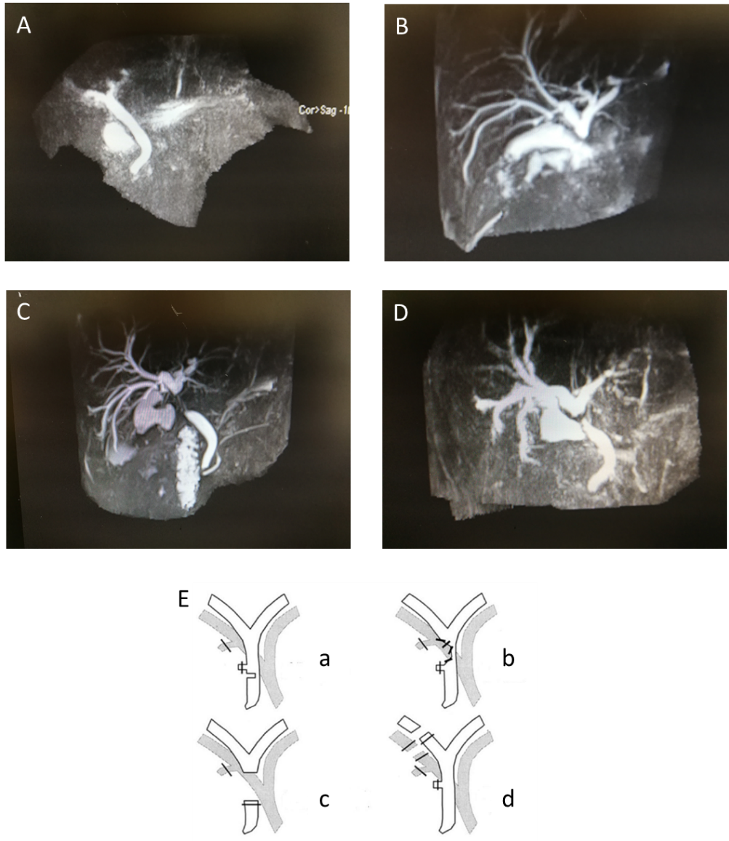
Figure Legends

Figure 1 Changes in magnetic resonance imaging pre- and post-operatively. A: No clear cholecyst and no stricture of the biliary ducts pre-operatively; B: Magnetic resonance imaging presentation before releasing the ligature: there is obvious interruption of the biliary tract; C: The 26th day after releasing the ligature: Interruption of the biliary tract is prolonged compared to B; D: The 47th day after releasing the ligature: interruption of the biliary tract is shorter than C; E: Stewart-Way classification injury, and the present case is classified as class II.

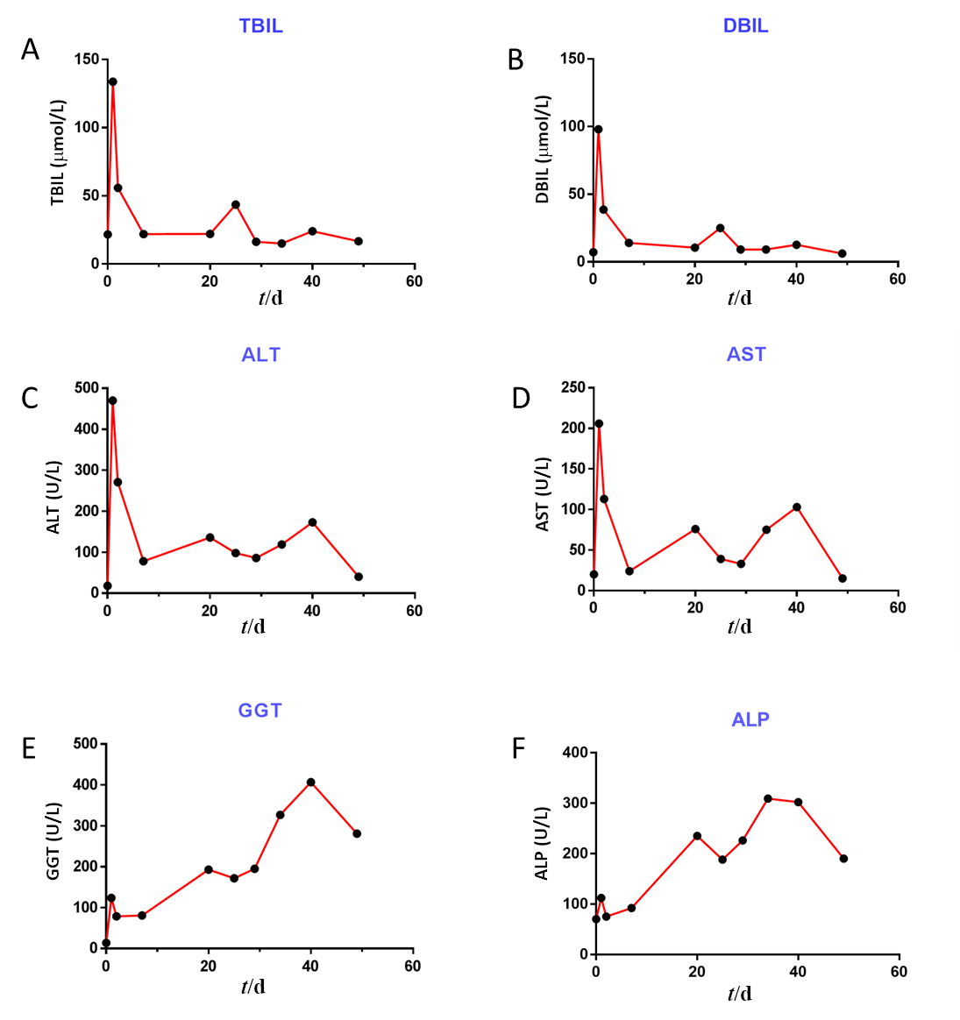
Figure 2 Changes in bilirubin and liver enzymes: Total bilirubin; direct bilirubin; glutamic-pyruvic transaminase; glutamic-oxalacetic transaminase; gamma-glutamyl transpeptidase; and alkaline phosphatase. A: Total bilirubin changes: After releasing the ligature, the value decreases and there is an aggravated procedure on the 24th day post-operatively; B: Direct bilirubin changes: After releasing the ligature, the value decreases and there is an aggravated procedure on the 24th day post-operatively; C: Glutamic-pyruvic transaminase changes; D: Glutamic-oxalacetic transaminase changes; E: Gamma-glutamyl transpeptidase changes; F: Alkaline phosphatase changes: There are similar changes in C and D, E and F. TBIL: Total bilirubin; DBIL: Direct bilirubin; ALT: Glutamic-pyruvic transaminase; AST: Glutamic-oxalacetic transaminase; GGT: Gamma-glutamyl transpeptidase; ALP: Alkaline phosphatase.

