Name of journal: World Journal of Gastroenterology
ESPS Manuscript NO: 12678
Columns: Original Articles

High persistence rate of HBV in hydrodynamic-injection-based transfection model of C3H/HeN mice

Peng XH et al. HBV persist in hydrodynamically injected C3H/HeN

Xiu-Hua Peng, Xiao-Nan Ren, Li-Xiang Chen, Bi-Sheng Shi, Chun-Hua Xu, Zhong Fang, Xue Liu, Jie-Liang Chen, Xiao-Nan Zhang, Yun-Wen Hu, Xiao-Hui Zhou

Xiu-Hua Peng, Xiao-Nan Ren, Li-Xiang Chen, Bi-Sheng Shi, Chun-Hua Xu, Zhong Fang, Xue Liu, Jie-Liang Chen, Xiao-Nan Zhang, Yun-Wen Hu, Xiao-Hui Zhou, Shanghai Public Health Clinical Center, Affiliated to Fudan University, Shanghai 201508, China

Yun-Wen Hu, Xiao-Hui Zhou, Key Laboratory of Medical Molecular Virology, Ministry of Education and Health, Shanghai Medical College, Fudan University, Shanghai 200032, China

Author contributions: Zhou xh conceived and designed the experiments; Peng xh, Ren XN, Chen LX, Shi BS, Xu CH, Fang Z, Liu X, Chen JL and Zhang XN performed the experiments; Peng XH, Ren XN, Chen LX and Zhou XH analyzed the data; Zhou XH, Ren XN, Chen LX, Chen JL, Zhang XN and Hu YW wrote and revised the paper.

Supported by Shanghai Municipal Fund for Science and Technology Development, No. 13140902200 and No. 12140900300; National Key Basic Research Development Program (973project), No. 2012CB519005

Correspondence to: Xiao-hui Zhou, MD, PhD, Associate Professor, Shanghai Public Health Clinical Center, Affiliated to Fudan University, Animal Facility Building, PI's Office, 2901 Caolang Road, Jin Shan District, Shanghai 201508, China. zhouxiaohui@shaphc.org

Telephone: +86-21-37990333 Fax: +86-21-37990333
Received: July 21, 2014 Revised: September 15, 2014
Accepted: October 14, 2014

Published online:

Abstract
AIM: To optimise the viral persistence rate in hydrodynamic-injection (HI) based hepatitis B virus (HBV) transfection mouse model

METHODS: (1) 5-6-wk-old Male C3H/HeN and C57BL/6 mice were hydrodynamically injected with 10 μg endotoxin-free pAAV/HBV1.2 plasmid DNA into the tail veins. hepatitis B surface antigen (HBsAg), hepatitis B e antigen (HBeAg) and HBV DNA, both in the sera and livers, were detected at different time points post HI by ELISA, immunohistochemical staining or quantification polymerase chain reaction (PCR); (2) Male C3H/HeN and C57BL/6 mice, either HI mice at 10 wk post HI or naïve mice, were all immunized s.c. with 5 μg HBsAg formulated in complete Freund’s adjuvant three times within a 2-wk interval. Two weeks after the final immunization, splenocytes were isolated for T cells’ function analysis by ELISPOT assay; and (3) Five weeks post HI, C3H/HeN mice were intragastrically administrated with 0.1 mg/kg entecavir once a day for 14 d, or were i.p. injected of 1 mg/kg Interferon-α twice a week for 2 wk, or were treated with PBS as control. The sera were collected and assayed for HBV DNA at day 0, 7 and 14 after drug treatment.

RESULTS: (1) Eight percent (22 in 25) of the injected C3H/HeN mice were still HBsAg-positive at 46 wk post HI, whereas HBsAg in C57BL/6 mice were completely cleared at 24 wk. The serum levels of HBeAg in C3H/HeN mice were higher than that in C57BL/6 mice from 4 wk to 46 wk. HBV DNA level in the C3H/HeN HI mice were higher than that in the C57BL/6 mice, both in the sera (from 4 wk to 46 wk) and in the liver (detected at 8 wk and 46 wk post HI). Histology showed that hepatitis B core antigen and HBsAg expressed longer in the livers of C3H/HeN mice than in C57BL/6; (2) HBsAg specific T cell responses after HBsAg vaccination in HI mice of C3H/HeN and C57BL/6, or naive control mice of those, were detected by ELISPOT assay. Stimulated by HBsAg, the frequencies of interferon (IFN)-γ producing splenocytes in the HI C3H/HeN mice were significant lower than in HI C57BL/6 mice, control C3H/HeN and control C57BL/6 mice, which was 0, 17 ± 7, 18 ± 10, and 41 ± 10 SFCs/10⁶ splenocytes respectively, and the same pattern in the mean spot sizes. Even just stimulated by PMA and ionomysin, T-cell responses elicited in the vaccinated control C3H/HeN were much higher than that in HI C3H/HeN mice; and (3) For drug treatment experiment on the HI C3H/HeN mice, the serum HBV DNA levels in entecavir treatment group declined (131.2 folds, p < 0.01) at day 7 after treatment and kept going down. In the group of IFN-α treatment, the serum HBV DNA levels declined to a lowest point (6.42 folds, P < 0.05) at 7 d after treatment and then rebounded.

CONCLUSION: We constructed a novel HI HBV transfection model using C3H/HeN mice, which had higher HBV persistence rate than the classic model of C57BL/6 mice.

© 2014 Baishideng Publishing Group Inc. All rights reserved.

Key words: hepatitis B virus; Hydrodynamic injection; Viral persistence; Liver; Mouse

Core tip: In the classic hepatitis B virus (HBV) hydrodynamic-injection (HI) model using C57BL/6 mice, only about 30% of the injected mice carried HBV for more than 12 wk. Here we injected the pAAV-HBV1.2 plasmids into C3H/HeN mice and observed that the hepatitis B surface antigen and hepatitis B e antigen and viral DNA persisted even up to 46 wk in about 90% of the HI mice. Applying IFN-α or entecavir in this HI model decreased HBV DNA in vivo. Hence, C3H/HeN is a suitable strain of mice for the persistent HBV HI model, which might be useful for chronic hepatitis B studies and therapeutic drugs development.

Peng XH, Ren XN, Chen LX, Shi BS, Xu CH, Fang Z, Liu X, Chen JL, Zhang XN, Hu YW, Zhou XH. High persistence rate of HBV in hydrodynamic-injection-based transfection model of C3H/HeN mice. World J Gastroenterol 2014; In press

INTRODUCTION
The chronic infection of hepatitis B virus (HBV) in human liver remains a major health problem globally^{[1]}. More than 400 million people have been infected and about one million patients die annually from HBV infection^{[2]}. Currently, interferon (IFN)-α and nucleoside/nucleotide analogs has been mainly used for clinical therapies of chronic hepatitis B (CHB). Although nucleoside/nucleotide analogs inhibit HBV replication, their drug-resistances remains unsettled tough issues in clinical practice^{[3]}. On the other hand, IFN-α enhances host immune responses and promote HBV clearance. However, only 30% of the CHB patients showed sustained response to IFN-α treatment, which limits the clinical effect and application of IFN-α^{[4]}. New therapeutic strategies are needed to be developed to improve the treatment of CHB.
It is believed that the balance between viral replication and the host immune response during chronic HBV infection determine the pathogenesis and outcomes of CHB. Nevertheless, the etiological mechanisms of the host immune responses that lead to HBV persistence are still to be elucidated integrally yet, though some components of the immunities, particularly cellular immune responses, have shown to be involved in the clearance of HBV^{[5]}.
However, the studies of HBV infection, either researches on immunological mechanisms or therapeutic drugs development, have been hampered by the shortage of suitable animal models^{[6]}. Compared with chimpanzees, woodchuck and duck, mouse is the ideal laboratory animal for its convenient availability, easy husbandry and low cost, and most importantly, their well characterized genetic background, techniques for genetic modification, abundance of immunological reagents. Howbeit the inability of HBV to propagate in mouse, several mouse models of HBV have been developed, including HBV transgenic mouse, adenovirus or adenovirus-associated-virus (AAV) based HBV transduction models, and hydrodynamic based HBV transfection models^{[6]}.
Introducing the HBV genome into mouse liver by hydrodynamic injection through the tail vein represent a model that mimics the natural course of chronic HBV infection in human without side-effects from the viral vectors, such as immune responses against adenovirus^{[7]}. Nonetheless, in the classic model of hydrodynamic injecting HBV plasmid into C57BL/6 mice, only less than 20%-30% injected mice carried HBV for 24 wk^{[8]}. Recently we hydrodynamically injected the HBV plasmid into C3H/HeN mice and succeeded in delaying the mouse immune clearance of HBV. About 90% the injected C3H/HeN mice maintained HBV persistence even up to 46 wk post HI. Applying IFN-α and entecavir in this model showed HBV DNA decrease in vivo. Thus, this novel HI model of HBV might provide a more stable platform for the researches of HBV persistence infection.

MATERIALS AND METHODS
Ethics statement
All procedures on mouse were reviewed by the Institutional Animal Care and Use Committee (IACUC) of Shanghai Public Health Clinical Center and were performed in strict accordance with the approved protocol.

Preparation of HI mice model with recombinant HBV plasmids
The replication-competent recombinant HBV plasmids pAAV/HBV1.2 were kindly provided by Prof. Peijer Chen, National Taiwan University College of Medicine. Specific pathogen free (SPF) C3H/HeN and C57BL/6 mice were purchased from the animal facilities of Shanghai Public Health Clinical Center. Male C3H/HeN and C57BL/6 mice (5-6-wk-old) were injected with 10 μg endotoxin-free pAAV/HBV1.2 plasmid DNA into the tail veins in a volume of PBS equivalent to 10% of the mouse body weight and the total volume was delivered within 5 s, which was so-called hydrodynamic injection as previously described^{[9,10]}. The serum specimens were assayed for HBsAg, HBeAg or HBV DNA at the indicated time points after injection. When the mice sacrificed, the spleens were collected for T cells’ function analysis and the livers were collected preserved in 4% PFA (Paraformaldehyde) for immunohistochemical analysis.

Detection of HBV antigen
The serum specimens were collected and assayed for HBsAg and HBeAg at 0, 1, 2, 3, 4, 5, 8, 10, 16, 24 and 46 wk after HI of pAAV/HBV1.2. Serum levels of HBsAg were determined by the ELISA kit (Kehua, Shanghai, China) . The levels of HBeAg were determined by ELISA (Kehua, Shanghai, China).

Detection of serum HBV DNA
Serum samples were collected at 0, 1, 2, 3, 4, 5, 8, 12, 16, 24 and 46 wk after HI of pAAV/HBV1.2 HBV DNA was extracted as the following method: 10 μl mouse serum was added in to 40 μl PBS, and digested by 10 μg DNaseI for 1 h at 37 ℃, then 100 μl lysis buffer (20 mmol/L Tris-HCl, 20 mmol/L EDTA, 50 mmol/L NaCl, and 0.5% SDS) containing 50 mg proteinase K was added; after incubation at 65 ℃ overnight, viral DNA was isolated by phenol/ chloroform extraction and ethanol precipitation. The DNA pellet was rinsed with 70% ethanol and resuspended in 10 μl ddH2O. The quantification of HBV DNA was performed by using a routine real time PCR procedure described previously, with a SYBR Green Real time PCR Master Mix kit (TOYOBO, Osaka, Japan)^{[11]}.

Detection of liver HBV DNA
Liver tissues were collected from mice receiving hydrodynamically injection killed at the 46 wk. The total DNA of liver was extracted as described above and detected for HBV DNA by real-time PCR or dpnI enzyme before realtime PCR.

Immunohistochemisty
Liver samples were collected at 46 wk post HI. Intrahepatic HBsAg was visualized by immunohistochemical staining of tissues embedded in mouse anti-HBs antibody (Maixin.Biotech, Fuzhou, China), rabbit anti-HBc antibody (Maixin.Bio city, Fuzhou, China), and HRP (Maixin.Bio city, Fuzhou, China).

Mice vaccination
Male C3H/HeN and C57BL/6 mice at 10 wk after hydrodynamically injection with 10μg pAAV/HBV1.2 plasmid or naïve control male C3H/HeN and C57BL/6 mice were all immunized s.c. with 5 μg HBsAg formulated in complete Freund’s adjuvant (CFA) third within a 2-wk interval. Mice were euthanized 2 wk after the final immunization and fresh splenocytes were collected.

IFN-γ ELISPOT assay
Freshly isolated mouse splenocytes were adjusted to the concentration of 4 × 10⁶ cells/ml and plated into 96-well ELISPOT plate (BD Bioscience, Franklin Lakes, New Jersey, United States) coated with antimouse IFN-γ antibody at 50 μl/well (2 × 10⁵ cells per well). The splenocytes were stimulated with 10 μg/ml HBsAg protein. After incubation at 37 ℃ with 5% CO₂ for 20 h, the ELISPOT plates were developed according to the manufacturer’s manual and read with Immunospot Reader (ChampspotⅢ, Beijing Sage Creation Science, China).

IFN-α or entecavir treatment assay
HI mouse model of HBV was set up as described above in fifteen 4-6-wk-old male C3H/HeN mice. Five weeks post HI, they each were randomly divided into 3 groups (five mice each group). The first group was intragastrically administrated with 0.1 mg/kg entecavir（Baraclude, Bristol- Myers Squibb, New York, United States) once a day for 14 d; the second group was i.p. injected of 1 mg/kg interferon-α(IFN-α, R and D, R and D Systems, Minneapolis, United States) twice a week for 2 wk; the third group was treated with PBS as control. The serum specimens were collected and assayed for HBV DNA at day 0, 7 and 14 after treatment.

Statistical analysis
Comparisons between two groups were done by the method of unpaired t test and comparisons among three or more groups were done by using the method of one way ANOVA (GraphPad Software, Inc.). Significant difference was defined as P ≤ 0.05.

RESULTS
HBV persist longer in HI C3H/HeN mice than that in C57BL/6 mice
In the HI C57BL/6 mice, the HBsAg level increased promptly within 1 wk after pAAV/HBV1.2 injection but dropped quickly thereafter. In C3H/HeN mice, the HBsAg level declined much more slowly after injection of the same plasmid. Even at 46 wk post HI, it was still detectable (Figure 1A). 88 percent (22 in 25) of the injected C3H/HeN mice were still HBsAg-positive at 46 wk post HI whereas HBsAg in C57BL/6 mice were completely cleared at 24 wk (Figure 1B). The serum levels of HBeAg was increased to a peak quickly within a week then decreased at 2 wk post HI, and increased again. The serum levels of HBeAg in C3H/HeN mice were higher than that in C57BL/6 mice from 4 wk to 46 wk (Figure 1C). The serum samples from hydrodynamically injected C3H/HeN and C57BL/6 mice were also assayed for the presence of HBV DNA. In the HI mice of C3H/HeN, HBV DNA level were higher than in HI C57BL/6 mice. At 46 wk post HI, HBV DNA in the C3H/HeN mice can still be detected, but it was undetectable in the C57BL/6 (Figure 1D).

Quantification of intrahepatic HBV DNA
We further examined the existing way of the liver HBV DNA. The liver tissues were collected from HI C57BL/6 mice, C3H/HeN mice at 46 wk post injection, and naive mice as control. The liver total DNA were assayed for the presence of encapsidated HBV DNA by realtime PCR. And we use 0.5 μl dpnI to digest the potential free plasmids, then also assayed the HBV DNA level by realtime PCR. Interestingly, we found that the liver HBV DNA level was not significantly changed between before and after dpnI digestion (Figure 2A, B). We suspect that the DNA in 46 wk serum HBsAg-positive C3H/HeN mice was not from free plasmid of pAAV/HBV1.2, but could be from actively replicating cytoplasmic nucleocapsid.

hepatitis B core antigen and HBsAg expression in liver of HI mice
Liver tissues were collected from HI C3H/HeN and C57BL/6 mice. Immunohistochemical staining was performed to determine the expression of hepatitis B core antigen (HBcAg) and HBsAg in the liver sections of the mice at 0, 5, 8, 46 wk post HI. As shown in Figure 3A, the number of HBcAg positive cells in C3H/HeN mice were not significantly different to C57BL/6 at 5 wk post HI. At 8 wk and 46 wk post HI, both cytoplasmic and nucleic HBcAg were detected in the livers of C3H/HeN mice but not in C57BL/6 mice. The pattern of HBsAg expressions in the livers of C3H/HeN and C57BL/6 mice were not significantly different at 5 wk post HI, but obviously higher in C3H/HeN than in C57BL/6 at 8 wk and 46 wk post HI, as shown in Figure3B.

Impaired HBsAg-specific T cell immunities in C3H/HeN mice after hydrodynamic injection
Specific T cell responses against HBV antigens (such as HBsAg etc.) have been suggested to play critical roles in viral clearance^{[12]}. Here we addressed whether HBsAg-specific immunity is associated with the HBV persistence/clearance in C3H/HeN and C57BL/6 mice at 10 wk post HI of pAAV/HBV1.2 or untreated control (Figure 4A). We examined the T cell responses against HBsAg two weeks after the final vaccination of HBsAg by IFN-γ-ELISPOT in HI C3H/HeN mice, HI C57BL/6 mice, control C3H/HeN and control C57BL/6, and the average frequency was 0 , 17 ± 7, 18 ± 10, and 41 ± 10 SFCs/10⁶ splenocytes respectively. The HI C3H/HeN mice were significant lower than control C3H/HeN and C57BL/6 mice on the frequencies (Figure 4B). And the same pattern in the mean spot sizes (Figure 4C). In contrast to HI C57BL/6 capable of responding to HBsAg vaccination, the HI C3H/HeN mice showed totally tolerant phenotype to HBV with no responses to HBsAg vaccination; whereas naive control C3H/HeN mice responded to HBsAg vaccination, though it was lower than control C57BL/6. Even just stimulated by PMA and ionomysin, frequencies of IFN-γ positive T-cells in the in HI C3H/HeN mice were much lower than that in control C57BL/6 (P < 0.05), and a little bit lower than that in HI C57BL/6 and C3H/HeN mice (Figure4D). Those data indicated that the hydrodynamic injection of HBV genome into C3H/HeN mice could impair the T cells’ function in those mice, both specifically (i.e., HBsAg-specific T-cell immunity) and globally.

IFN-α and entecavir treatment decreased HBV DNA in HI C3H/HeN mice
Next, we tested whether this novel C3H/HeN based HI mouse models could be applied to the drugs’ evaluation for HBV. IFN-α and entecavir treatment were performed in those HI C3H/HeN mice. In the group of intragastric administration with entecavir (0.1 mg/kg, daily), real-time PCR analysis showed that the serum HBV DNA levels declined (131.2 folds, P < 0.01) and kept going down after 7 d post HI. In the group of IFN-α treatment (1 mg/kg, twice a week), the serum HBV DNA levels declined to a lowest point (6.42 folds, P < 0.05) at 7 d post HI and rebounded from then on. Those data indicated that this C3H/HeN based HI mouse models can be used for antiviral drugs’ evaluation for HBV.

DISCUSSION
Due to the narrow host restriction of HBV infection, the ideal experimental animal model of HBV should be transgenic mouse of human receptors for HBV. However, it was elusive for a long time about the receptors for HBV entry, though Wenhui Li’s group recently identified NTCP (sodium taurocholate cotransporting polypeptide) was a functional receptor for human hepatitis B virus^{[13]}.Whether there are coreceptors are still under investigation. Therefore, the success of receptor-transgenic mice for HBV could be a long way to reach yet, considering the fact that the HCV receptors (CD81, SCARB1, CLDN1, OCLN) has been identified for a long time, but the receptor-transgenic mouse for HCV has not succeeded until now^{[14]}.
Current available animal models for HBV studies include duck HBV (DHBV)^{[15]} and woodchuck HBV (WHV)^{[16]} infection in their natural hosts, HBV-infected chimpanzees^{[17]}, HBV transgenic mice^{[18]}. DHBV and WHV are genetically different from HBV, and it is difficult to perform immunological studies in those animals due to their uncharacterized background. Chimpanzees are not available easily, and the high cost as well as ethical considerations limit their applications to HBV study. HBV transgenic mice was widely used, but the drawbacks of immunologically tolerant to the virus limit its applications in HBV immunological studies.
HBV genome can be introduced into the mouse liver by viral vectors-based transduction, for example, adenovirus or adeno-associated viral vectors (AAVs) containing HBV DNA^{[19,20]}. Transduction of HBV genome into mice by viral vectors leads to efficient viral genes expression in liver and host immune response against HBV. However, the viral-vectors-induced immune responses (such as induction of type I IFN and other innate immunities) may interfere the host immune responses against HBV.
Hydrodynamic injection can efficiently deliver DNA into liver in vivo. The DNA internalization by this hydraulic-pressure-based physical transfection is receptor-independent and can reach approximately 10%–40% of hepatocytes delivery^{[5,21]}. Yang et al^{[22]} first reported an acute HBV infection models by this methods in B10.D2 mice and persistent expression of HBV antigens are observed in hepatocytes of immunocompromised CB17 NOD/SCID mice. Huang et al^{[8]} further reported that delivery of HBV genome into immunocompetent mice liver by hydrodynamic injection could display HBV hepatitis with very different rates of clearance of the virus. Both plasmid backbone and genetic background of recipient mice contributed to the long-term maintenance of HBV in mice liver. The Plasmid pAAV/HBV1.2 is better than the plasmid pGEM4A/HBV1.2, though both of them harboured replication-competent HBV DNA^{[8]}. And by using the same pAAV/HBV1.2, all BALB/c showed a rapid clearance of viral DNA template, whereas about 30% of the C57BL/6 mice showed the persistence of HBV^{[8]}. However, the bottleneck of relative low rate of the persistence of HBV in the C57BL/6 mice compromised its potential strength in chronic HBV infection studies.
The different persistence rate of HBV in HI BALB/c (H-2^{d}) and HI C57BL/6 (H-2^{b}) encourage efforts to find more suitable mouse strains for optimisation of the HBV persistent rate. Indeed, Chen et al^{[23]} reported that a long term maintaing of HBV antigenmia can be detected in hydrodynamically injection of pGEM4Z/HBV1.3 into FVB/N (H-2^{q}) mice, around 85% (6 in 7) positive at 50 wk, compared with rapid clearance of HBV antigenmia in BALB/c mice within 4 wk and in C57BL/6 within 8 wk.
Our study successfully established HBV persistence in another inbred strain, C3H/HeN mice (H-2^{k}) through hydrodynamic injection of pAAV/HBV1.2 plasmid. Around 90% (22 in 25) of the injected C3H/HeN mice were HBsAg-positive and the HBcAg positive cells in livers were detected at 46 wk，though the detailed mechanisms are not clear yet. Chang et al^{[24]} reported an acute HBV hepatitis model by hydrodynamically injection of pHBV3.6 into 8-12-wk-old C3H/HeN mice. The age of C3H/HeN mice might be critical for the different persistence rate between their model and ours. Actually, we found 5 to 6-wk-old C3H/HeN is best for persistence of HBV after hydrodynamically injection, and the mice older than 8 wk showed a similar acute hepatitis to Chang Wang’s model (data not shown).
It was well established that host immune responses contributed to HBV virus clearance^{[5]}. Chang et al^{[24]} reported C3H/HeJ mice, which were defect in TLR4 signalling, showed higher HBV antigenmia and viral replication than C3H/HeN in the acute model (viraemia within 2 wk), indicating TLR4 mediated innate immune response played a role in the HBV clearance. Adaptive immune responses, especially HBV-specific T cell response, is most critical for HBV clearance^{[12]}. Indeed, we found the hydrodynamic injection of HBV genome into C3H/HeN mice could impair the T cells’ function in those mice, both globally and specifically (i.e., HBsAg-specific T-cell immunity), in contrast to HI C57BL/6 capable of responding to HBsAg vaccination. Those results were consistent with the previous reports on correlations between persistence of HBV in HI mice and few activated specific cytotoxic T cells. Hence, C3H/HeN (H-2K) mice, which were like FVB/N (H-2q)^{[23]}, were weaker in induction of HBV specific T cell responses than C57BL/6 (H-2b);and the latter might be weaker than BALB/c (H-2d)^{[8]}. It prompted that HI of HBV genome could cause tolerance to HBV in the HI C3H/HeN mice and this tolerance might be largely related to the HBV persistence phenotypes in those mice.
Taken together, though the route of viral genome delivered by hydrodynamic-based transfection is different from that of natural infection by receptors, this immunocompetent non-transgenic mouse model can mimic the nature course of chronic HBV infection in human to a great extent. Our novel HI C3H/HeN mice with high persistence rate of HBV described in this manuscript could provide a new approach to dissect the immunomechanism of HBV clearance or persistence, a new platform to evaluate the antiviral drugs against HBV, and a new model to analyse the different pathogenecities of clinical HBV isolates.

Acknowledgements
We appreciate professor Pei-Jer Chen from National Taiwan University College of Medicine, Taiwan, for kindly providing us the pAAV/HBV1.2 plasmid; professor Zheng-Hong Yuan from Fudan University, Shanghai, China for his intensive discussion. We thank the animal facilities in Shanghai Public Clinical Center, Fudan University, China for providing us the platforms and helps for animal experiments.

COMMENTS
Background
To concisely and accurately summarize the related background of the article and to enable the readers to gain some basic knowledge relevant to the article, thus helping them better understand the significance of the article. The studies of hepatitis B virus (HBV) infection, either researches on immunological mechanisms or therapeutic drugs development, have been hampered by the shortage of suitable small animal models, albeit hydrodynamic injection (HI) of plasmids containing replication-competent HBV genome through the tail vein into an immune-competent mice has been a model for HBV studies. However, in the case of classic HI model using C57BL/6 mice, only about 30% of the injected mice carried HBV for more than 12 wk, which limits its applications especially in the studies of chronic hepatitis B.

Research frontiers
To briefly introduce the hotspots or important areas in the research field related to the article. In this manuscript we injected the pAAV-HBV1.2 plasmids into a different inbred mouse strain, C3H/HeN, and observed that the serum hepatitis B surface and hepatitis B e antigens and viral DNA persisted even up to 46 wk in about 90% of the injected mice, while almost all of the injected C57BL/6 mice, as a control, cleared HBV at 24 wk. We also detected HBsAg, HBeAg and HBV DNA expression in the liver tissues of the C3H/HeN mice at 46 wk post HI. Moreover, those mice showed impaired to induce HBsAg specific T cells responses, which is an important phenotype of immune tolerance to HBV. Applying IFN-α or entecavir (an analog of guanosine) in this HI model decreased HBV DNA in vivo.

Innovations and breakthroughs
To summarize and emphasize the differences, particularly the advances, achievements, innovations and breakthroughs, from the other related or similar articles so as to allow the readers to catch up the major points of the article.
The background of mouse can affect the result of the long-term maintenance of HBV in mice liver. HI using the same pAAV/HBV1.2, BALB/c showed a rapid clearance of viral DNA template, whereas about 30% of the C57BL/6 mice showed the persistence of HBV (Huang LR et al). However, the bottleneck of relative low rate of the persistence of HBV in the C57BL/6 mice compromised its potential strength in chronic HBV infection studies. Thus, efforts were encouraged to find more suitable mouse strains for optimisation of the HBV persistent rate. Indeed, Chen et al reported that a long term maintaing of HBV antigenmia can be detected in hydrodynamically injection of pGEM4Z/HBV1.3 into FVB/N (H-2^{q}) mice, around 85% (6 in 7 mice) positive at 50 wk, compared with rapid clearance of HBV antigenmia in BALB/c mice within 4 wk and in C57BL/6 within 8 wk. This study successfully established HBV persistence in another inbred strain, C3H/HeN mice (H-2^{k}) through hydrodynamic injection of pAAV/HBV1.2 plasmid. Around 90% of the injected C3H/HeN mice were HBsAg-positive and the hepatitis B core antigen positive cells in livers were detected at 46 wk. The data came from an observation in 25 mice/group and could be more solid. In addition, more inbred strains (including H-2^{k} background) available for HI HBV models could expand the possibilities to study the genetic factors on HBV persistence. Chang et al reported an acute HBV hepatitis model by hydrodynamically injection of pHBV3.6 into 8-12-wk-old C3H/HeN mice. The age of C3H/HeN mice might be critical for the different persistence rate between their model and ours. Actually, this study showed 5-6-wk-old C3H/HeN is best for persistence of HBV after hydrodynamically injection.

Applications
To summarize the actual application values, the implications for further application and modification, or the perspectives of future application of the article. The results in this manuscript suggested that the HI-based HBV infection model using the C3H/HeN mice might provide a more stable platform for mechanistic studies of chronic hepatitis B and therapeutic development.

Terminology
To concisely and accurately describe, define or explain the specific, unique terms that are not familiar to majority of the readers, but are essential for the readers to understand the article. Hydrodynamic injection transfection means injection with 10μg endotoxin-free plasmid DNA into the tail veins of mouse, in a volume of PBS equivalent to 10% of the mouse body weight, and the total volume was delivered within 5 s. Hydrodynamic injection can efficiently deliver DNA into the liver in vivo. The DNA internalization by this hydraulic-pressure-based physical transfection is receptor-independent and can reach approximately 10%–40% of hepatocytes delivery. This method has been used to establish HBV transfection mouse models, classically in C57BL/6 mice.

Peer review
The paper by Xiuhua Peng et al. showed HBV persisted longer in C3H/HeN (H-2k) mice after the HI compared with C57BL/6 (H-2b) mice, suggesting that host genetic background determines the rate of HBV clearance. The authors suggested that this could be a novel animal model for chronic hepatitis B infection to elucidate the disease pathogenesis and develop new antiviral treatments. Overall, the study showed a clear association between mouse genetic background and the rate of persistence. However, the authors should elucidate the mechanistic basis for the frequent persistence in the C3H/HeN (H-2k) mice.

REFERENCES
1 Kao JH, Chen DS. Global control of hepatitis B virus infection. Lancet Infect Dis 2002; 2: 395-403 [PMID: 12127351 DOI: 10.1016/S1473-3099(02)00315-8]
2 McMahon BJ. Epidemiology and natural history of hepatitis B. Semin Liver Dis 2005; 25 Suppl 1: 3-8 [PMID: 16103976 DOI: 10.1055/s-2005-864785]
3 Li X, Liu Y, Zhao P, Wang Y, Chen L, Xin S, Zhang XX, Xu D. Investigation into drug-resistant mutations of HBV from 845 nucleos(t)ide analogue-naive Chinese patients with chronic HBV infection. Antivir Ther 2014; Epub ahead of print [PMID: 24992206 DOI: 10.3851/IMP2813]
4 Férir G, Kaptein S, Neyts J, De Clercq E. Antiviral treatment of chronic hepatitis B virus infections: the past, the present and the future. Rev Med Virol 2008; 18: 19-34 [PMID: 17966115 DOI: 10.1002/rmv.554]
5 Yang PL, Althage A, Chung J, Maier H, Wieland S, Isogawa M, Chisari FV. Immune effectors required for hepatitis B virus clearance. Proc Natl Acad Sci USA 2010; 107: 798-802 [PMID: 20080755 DOI: 10.1073/pnas.0913498107]
6 Tzeng HT, Hsu PN, Chen PJ. Immunocompetent nontransgenic mouse models for studying hepatitis B virus immune responses. J Gastroenterol Hepatol 2013; 28 Suppl 1: 116-119 [PMID: 23855306 DOI: 10.1111/jgh.12035]
7 Hartman ZC, Kiang A, Everett RS, Serra D, Yang XY, Clay TM, Amalfitano A. Adenovirus infection triggers a rapid, MyD88-regulated transcriptome response critical to acute-phase and adaptive immune responses in vivo. J Virol 2007; 81: 1796-1812 [PMID: 17121790 DOI: 10.1128/jvi.01936-06]
8 Huang LR, Wu HL, Chen PJ, Chen DS. An immunocompetent mouse model for the tolerance of human chronic hepatitis B virus infection. Proc Natl Acad Sci USA 2006; 103: 17862-17867 [PMID: 17095599 DOI: 10.1073/pnas.0608578103]
9 Liu F, Song Y, Liu D. Hydrodynamics-based transfection in animals by systemic administration of plasmid DNA. Gene Ther 1999; 6: 1258-1266 [PMID: 10455434 DOI: 10.1038/sj.gt.3300947]
10 Zhang G, Ludtke JJ, Thioudellet C, Kleinpeter P, Antoniou M, Herweijer H, Braun S, Wolff JA. Intraarterial delivery of naked plasmid DNA expressing full-length mouse dystrophin in the mdx mouse model of duchenne muscular dystrophy. Hum Gene Ther 2004; 15: 770-782 [PMID: 15319034 DOI: 10.1089/1043034041648408]
11 von Freyend MJ, Untergasser A, Arzberger S, Oberwinkler H, Drebber U, Schirmacher P, Protzer U. Sequential control of hepatitis B virus in a mouse model of acute, self-resolving hepatitis B. J Viral Hepat 2011; 18: 216-226 [PMID: 20367794 DOI: 10.1111/j.1365-2893.2010.01302.x]
12 Loggi E, Gamal N, Bihl F, Bernardi M, Andreone P. Adaptive response in hepatitis B virus infection. J Viral Hepat 2014; 21: 305-313 [PMID: 24674098 DOI: 10.1111/jvh.12255]
13 Yan H, Zhong G, Xu G, He W, Jing Z, Gao Z, Huang Y, Qi Y, Peng B, Wang H, Fu L, Song M, Chen P, Gao W, Ren B, Sun Y, Cai T, Feng X, Sui J, Li W. Sodium taurocholate cotransporting polypeptide is a functional receptor for human hepatitis B and D virus. Elife 2012; 1: e00049 [PMID: 23150796 DOI: 10.7554/eLife.00049]
14 Bukh J. Animal models for the study of hepatitis C virus infection and related liver disease. Gastroenterology 2012; 142: 1279-1287.e3 [PMID: 22537434 DOI: 10.1053/j.gastro.2012.02.016]
15 Mason WS, Seal G, Summers J. Virus of Pekin ducks with structural and biological relatedness to human hepatitis B virus. J Virol 1980; 36: 829-836 [PMID: 7463557]
16 Summers J, Smolec JM, Snyder R. A virus similar to human hepatitis B virus associated with hepatitis and hepatoma in woodchucks. Proc Natl Acad Sci USA 1978; 75: 4533-4537 [PMID: 212758 DOI: 10.1073/pnas.75.9.4533]
17 Guidotti LG, Rochford R, Chung J, Shapiro M, Purcell R, Chisari FV. Viral clearance without destruction of infected cells during acute HBV infection. Science 1999; 284: 825-829 [PMID: 10221919 DOI: 10.1126/science.284.5415.825]
18 Chisari FV. Hepatitis B virus transgenic mice: models of viral immunobiology and pathogenesis. Curr Top Microbiol Immunol 1996; 206: 149-173 [PMID: 8608715 DOI: 10.1007/978-3-642-85208-4_9]
19 Huang LR, Gäbel YA, Graf S, Arzberger S, Kurts C, Heikenwalder M, Knolle PA, Protzer U. Transfer of HBV genomes using low doses of adenovirus vectors leads to persistent infection in immune competent mice. Gastroenterology 2012; 142: 1447-50.e3 [PMID: 22426294 DOI: 10.1053/j.gastro.2012.03.006]
20 Huang YH, Fang CC, Tsuneyama K, Chou HY, Pan WY, Shih YM, Wu PY, Chen Y, Leung PS, Gershwin ME, Tao MH. A murine model of hepatitis B-associated hepatocellular carcinoma generated by adeno-associated virus-mediated gene delivery. Int J Oncol 2011; 39: 1511-1519 [PMID: 21805030 DOI: 10.3892/ijo.2011.1145]
21 Herweijer H, Wolff JA. Gene therapy progress and prospects: hydrodynamic gene delivery. Gene Ther 2007; 14: 99-107 [PMID: 17167496 DOI: 10.1038/sj.gt.3302891]
22 Yang PL, Althage A, Chung J, Chisari FV. Hydrodynamic injection of viral DNA: a mouse model of acute hepatitis B virus infection. Proc Natl Acad Sci USA 2002; 99: 13825-13830 [PMID: 12374864 DOI: 10.1073/pnas.202398599]
23 Chen SH, Wu HL, Kao JH, Hwang LH. Persistent hepatitis B viral replication in a FVB/N mouse model: impact of host and viral factors. PLoS One 2012; 7: e36984 [PMID: 22615863 DOI: 10.1371/journal.pone.0036984]
24 Chang WW, Su IJ, Lai MD, Chang WT, Huang W, Lei HY. Toll-like receptor 4 plays an anti-HBV role in a murine model of acute hepatitis B virus expression. World J Gastroenterol 2005; 11: 6631-6637 [PMID: 16425356]

P-Reviewer: Li ZF, Osna NA, Watanabe t S-Editor: Ma YJ L-Editor: E-Editor:

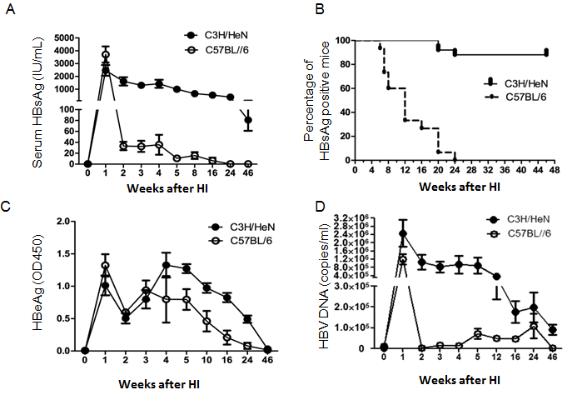
Figure 1 hepatitis B surface antigen, hepatitis B e antigen and hepatitis B virus DNA level in serum of C3H/HeN and C57BL/6 mice after hydrodynamic injection. pAAV/HBV1.2 DNA was injected hydrodynamically into the tail veins of 5-6 wk male C3H/HeN and C57BL/6 mice. After injection, the mice were regularly bled to monitor the serum levels of HBsAg, HBeAg and HBV DNA. A: Titer of serum HBsAg in C3H/HeN or C57BL/6 mice after HI at different time points; B: Positive rate of serum HBsAg in C3H/HeN (n = 25) or C57BL/6 (n = 20) mice at different time points after HI; C: Titer of serum HBeAg in C3H/HeN or C57BL/6 mice after HI at different time points; D: The HBV DNA of serum was determined at different time points. HBsAg: Hepatitis B surface antigen; HBeAg: hepatitis B e antigen; HBV: hepatitis B virus; HI: hydrodynamic-injection.

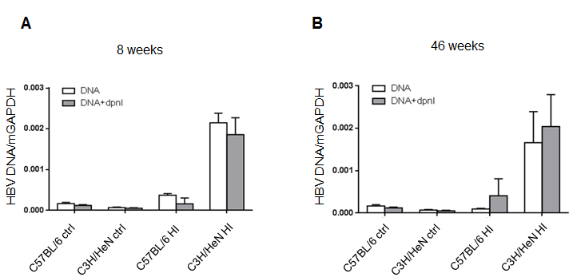
Figure 2 Quantification of intrahepatic hepatitis B virus DNA in the hydrodynamic-injection mice. C3H/HeN or C57BL/6 mice were hydrodynamic injected with 10 μg of pAAV/HBV1.2 plasmid, the livers total DNA of HI C3H/HeN (n = 3) or HI C57BL/6 (n = 3) mice were collected at 8 wk or 46 wk after HI. Naive C3H/HeN (n = 3) or C57BL/6 (n = 3) mice were controls (ctrl). A: HBV DNA/mGAPDH in C3H/HeN or C57BL/6 mice liver total DNA with or without 0.5 μl DpnI digestion at 8 wk post HI; B: HBV DNA/mGAPDH in C3H/HeN or C57BL/6 mice liver total DNA with or without 0.5 μl DpnI digestion at 46 wk post HI. HBV: hepatitis B virus; HI: hydrodynamic-injection.

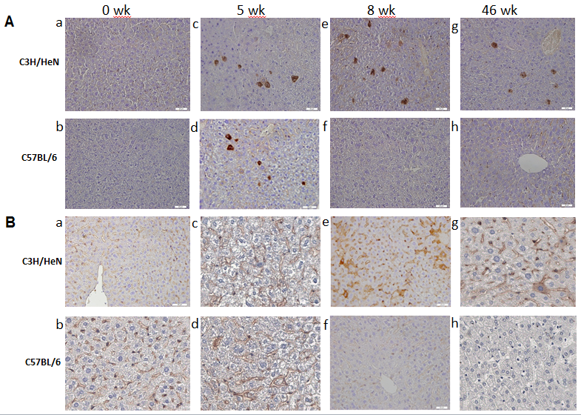
Figure 3 Longer expression of hepatitis B core antigen and hepatitis B surface antigen in the livers of C3H/HeN mice than in C57BL/6 mice. C3H/HeN or C57BL/6 mice were hydrodynamic injected with 10 μg of pAAV/HBV1.2 plasmid, the livers of C3H/HeN or C57BL/6 mice were collected at 5, 8 and 46 wk after HI. A: Detection of HBcAg expression in C3H/HeN or C57BL/6 mice liver at 5, 8 and 46 wk after HI by immunochemistry; B: Detection of HBsAg expression in C3H/HeN or C57BL/6 mice liver at 5, 8 and 46 wk after HI by chemistry. Image of specific antibodies stained slides were observed under microscopy at magnitudes of x 400. Experiments were repeated twice with a similar pattern. HBcAg: hepatitis B core antigen; HBsAg: Hepatitis B surface antigen; HI: Hydrodynamic-injection.

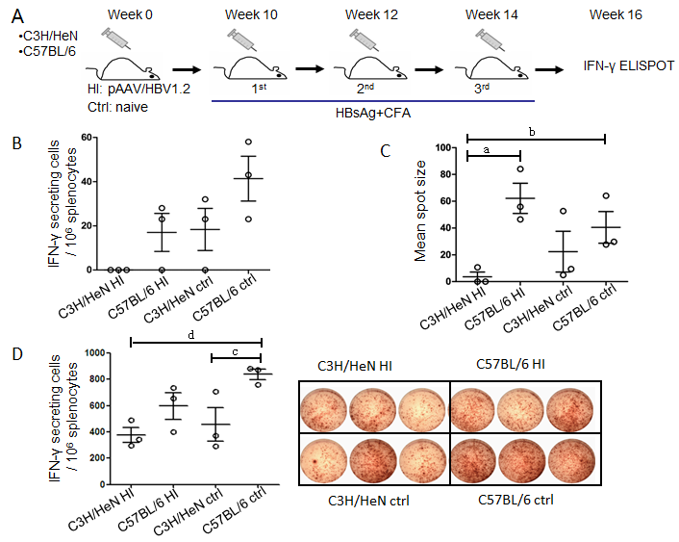
Figure 4 Hepatitis B surface antigen-specific T cell response were impaired in hydrodynamic-injection C3H/HeN mice. A: Regime of immunization: HI C3H/HeN mice (n = 3) and HI C57BL/6 mice (n = 3) were s.c. with 5 μg HBsAg protein formulated in CFA at 10, 12, 14 wk after HI. Age-matched C3H/HeN naïve mice (n = 3) and C57BL/6 naïve mice (n = 3) were s.c. with 5 μg HBsAg protein formulated in CFA three times at 2 wk intervals. Magnitudes of the total T cell responses were analyzed by using the method of IFN-γ ELISPOT two weeks after the final vaccination; B: Frequencies of IFN-γ producing T cells in C3H/HeN and C57BL/6 mice (both HI and control, n = 3 each group) by HBsAg stimulation. While C3H/HeN HI mice showed almost zero on the frequencies of IFN-γ positive cells, the other groups did show IFN-γ positive cells positive; C: Spot sizes of IFN-γ producing T cells in C3H/HeN and C57BL/6 mice (both HI and control, n = 3 each group) by HBsAg stimulation. C57BL/6 HI and control (ctrl) mice were significant larger than C3H/HeN HI mice [ªP < 0.05, C57BL/6 HI vs C3H/HeN HI mice; ^{b}P < 0.01 control (ctrl) mice vs C3H/HeN HI mice, respectively]; D: IFN-γ producing T cells’ spot in C3H/HeN and C57BL/6 mice (both HI and control, n = 3 each group) by PMA+ionomysin stimulated; left: bar chart of frequencies of IFN-γ producing T cells. C57BL/6 HI mice were significant higher than C3H/HeN HI mice (^{d}P < 0.01, C57BL/6 HI vs C3H/HeN HI mice), and than C3H/HeN (^{c}P < 0.05, C57BL/6 HI vs C3H/HeN); right: images of ELISOPT. HI: Hydrodynamic-injection; CFA: complete Freund’s adjuvant; IFN: interferon; HBsAg: Hepatitis B surface antigen.

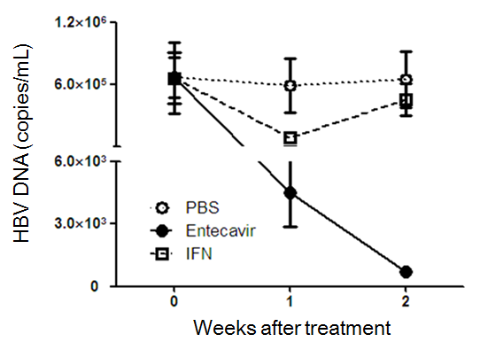
Figure 5 interferon-α or Entecavir treatment decreased hepatitis B virus DNA in hydrodynamic-injection C3H/HeN mice. HI mouse model of HBV was set up in 5-6-wk-old male C3H/HeN mice. IFN-α or entecavir or PBS treatments were performed on those mice at 5 wk post HI. The black dot group (n = 5) was intragastrically administrated with 0.1 mg/kg entecavir once a day for 14 d; the open square group (n = 5) was i.p. injected of 1 mg/kg IFN-α twice a week for 2 wk; the open dot group was treated with PBS as control. The serum specimens were collected and assayed for HBV DNA at day 0, 7 and 14 after treatment. HBV: hepatitis B virus; HI: hydrodynamic-injection; IFN: interferon.

