LANGUAGE CERTIFICATE

As reported by Dr. Jing Yu, science editor, in email sent to me in 06/23/2015, my manuscript does not need a language certification, once it was graded as level A by the two reviewers, considering grammar quality.

Title: Endoscopy versus surgery in the treatment of early gastric cancer: systematic review
Corresponding author: André Kondo (andrekondo@gmail.com; phone number +55(11)99842-9136)
ESPS Manuscript NO: 19996

Sincerely yours,
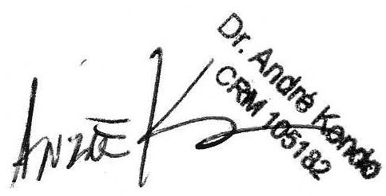
ANDRE KONDO, MD
Gastrointestinal Endoscopy Unit
Hospital das Clínicas da Faculdade de Medicina da Universidade de São Paulo
Sao Paulo, Brazil

