Name of Journal: World Journal of Clinical Cases
Manuscript NO: 88764
Manuscript Type: CASE REPORT

Colonoscopy-induced acute appendicitis: A case report

Song XL et al. Colonoscopy-induced acute appendicitis

Xiao-Ling Song, Jin-You Ma, Zhi-Gao Zhang

Xiao-Ling Song, Jin-You Ma, Zhi-Gao Zhang, Department of Gastroenterology, Sunshine Union Hospital, Weifang 261000, Shandong Province, China

Author contributions: Song XL designed the research plans and wrote the manuscript; Ma JY contributed to the index detection, collation and analysis of original results; Zhang ZG proposed the feasibility analysis of the research scheme and revised the paper.

Corresponding author: Zhi-Gao Zhang, MD, Deputy Director, Department of Gastroenterology, Sunshine Union Hospital, No. 999 Yingqian Street, Weifang 261000, Shandong Province, China. techmed@126.com

Received: October 16, 2023
Revised: November 11, 2023
Accepted: December 12, 2023
Published online: December 26, 2023

Abstract
BACKGROUND
Colonoscopy is widely used for examination, diagnosis, and treatment because of its low incidence of associated complications. Post-colonoscopy appendicitis (PCA) is very rare and is easily misdiagnosed as electrocoagulation syndrome or colon perforation. Therefore, clinicians should pay close attention to this complication.

CASE SUMMARY
A 47-year-old female patient underwent a colonoscopy for a systematic physical examination, and the procedure was uneventful with normal endoscopic and histologic findings. However, the bowel preparation was suboptimal (Boston 2-3-2). After the examination, the patient experienced pain in the lower abdomen, which progressively worsened. Computed tomography of the lower abdomen and pelvis revealed appendiceal calcular obstruction and appendicitis. As the patient refused surgery, she was managed with antibiotics and recovered well.

CONCLUSION
In the current literature, the definition of PCA remains unclear. However, abdominal pain after colonoscopy should be differentiated from acute appendicitis.

Key Words: Colonoscopy; Complications; Appendicitis; Differential diagnosis; Case report

©The Author(s) 2023. Published by Baishideng Publishing Group Inc. All rights reserved.

Citation: Song XL, Ma JY, Zhang ZG. Colonoscopy-induced acute appendicitis: A case report. World J Clin Cases 2023; 11(36): 8563-8567
URL: https://www.wjgnet.com/2307-8960/full/v11/i36/8563.htm
DOI: https://dx.doi.org/10.12998/wjcc.v11.i36.8563

Core Tip: Abdominal pain is a common symptom after colonoscopy and is generally considered to be caused by perforation or electrocoagulation syndrome. Acute appendicitis is often ignored as a differential diagnosis. This case report aims to improve clinicians’ awareness of possible appendicitis after colonoscopy. The causal relationship between colonoscopy and acute appendicitis remains unclear. However, regardless of whether it is defined as a complication, it should be differentiated from colonoscopy-associated abdominal pain, particularly in the right lower abdomen.

INTRODUCTION
Colonoscopy is a common clinical examination, involving an endoscopic analysis of the entire colon, which aids in diagnosis and treatment. Colonoscopy is widely used because of its safety. However, although rare, serious complications, such as pain, bleeding, inflammation, perforation, cardiopulmonary complications, and death, can occur after colonoscopy.
Abdominal pain is a common symptom of colonoscopy. Mild abdominal pain is considered normal, and acute appendicitis, a relatively rare condition, is often ignored as a possible cause. Indeed, a previous study reported that the incidence of acute appendicitis after colonoscopy was approximately 0.038%^{[1]}. However, considering that non-specific abdominal pain symptoms and minor appendicitis are easily overlooked, the recorded incidence of acute appendicitis may have been underestimated.
The number of patients undergoing colonoscopy have recently been increasing, and more cases of appendicitis after colonoscopy have consequently been reported. Since the first reported case in 1988, over 50 cases have been reported in the literature^{[2,3]}. Many cases of perforation or gangrene, for which surgery is the primary treatment, have been reported^{[4-7]}. Herein, we report the case of a woman who developed non-perforated appendicitis 10 h after colonoscopy and was treated with antibiotics immediately after a definitive diagnosis. This treatment yielded satisfactory results. This article aims to attract clinical attention to appendicitis after colonoscopy. Early identification and timely treatment are of paramount importance to avoid serious consequences and improve prognosis.

CASE PRESENTATION
Chief complaints
The patient complained of abdominal pain after undergoing colonoscopy. Appendicitis was diagnosed 10 h later.

History of present illness
The patient underwent a colonoscopy for health management, and the procedure was uneventful without any pathological biopsy. However, the state of intestinal cleanliness was poor (Boston 2-3-2), and clumps were observed in the feces. Ten hours after the examination, the patient experienced progressive pain in the right lower abdomen and was admitted to the gastroenterology department.

History of past illness
The patient’s past medical history was unremarkable.

Personal and family history
The patient denied any possibility of family history-related conditions.

Physical examination
Body temperature was 37.6 °C, blood pressure was 132/75 mmHg, and heart rate was 85 beats/min. Tenderness of the right lower abdomen was evident without total abdominal pain [Murphy (-), Mc (+)].

Laboratory examinations
The white blood cell count, neutrophil count, and C-reactive protein level were 9.54 × 10⁹ cells/L, 11.8 × 10⁹ cells/L (N%: 90.4%), and 25.3 mg/L, respectively.

Imaging examinations
A computed tomography (CT) scan of the lower abdomen and pelvis revealed a dilated and inflamed appendix with fecoliths (Figure 1A).

FINAL DIAGNOSIS
Post-colonoscopy acute appendicitis.

TREATMENT
The patient refused surgery and was administered antibiotics. After 3 d of treatment, the pelvic CT revealed inflammation in the appendix, and the appendicolith had disappeared (Figure 1B). Five days later, the patient was discharged in good physical condition.

OUTCOME AND FOLLOW-UP
The patient was followed up for 1 year and no symptoms of appendicitis recurred.

DISCUSSION
Colonoscopy is widely used to examine, diagnose, and treat intestinal diseases. It is associated with rare serious complications, of which bleeding and perforation are the most common. The incidence rate of complications ranges from 0.2% to 3%^{[8-10]}. In recent years, more rare complications have been reported, including splenic and mesenteric vein embolisms. Post-colonoscopy appendicitis (PCA) is a rare complication.
Further, some scholars believe that PCA is a coincidence rather than a complication. Since the first reported case of PCA in 1988, the number of similar cases has increased over the past 20 years; to date, over 50 similar cases have been reported^{[2,3]}. Interestingly, the number of cases reported in the past decade has increased fourfold compared to the previous decade^{[2]}, suggesting that this complication has gained increasing awareness among physicians.
Currently, no consensus on the definition, pathogenic factors, or pathogenesis of PCA have been established. Shaw et al^{[11]} proposed that PCA should be defined as appendicitis occurring within 72 h of colonoscopy. Currently, there are several hypotheses regarding the pathogenesis of PCA: (1) Air pressure trauma caused by over-inflation^{[9]}; (2) Obstruction and/or inflammation caused by stool pressing on the appendix^{[12]}; (3) Direct trauma caused by unintentional intubation of the appendix tube^{[13]}; (4) Exacerbation of existing subclinical diseases^{[14]}; and (5) Stimulation of residual glutaraldehyde in the endoscope on the mucosa^{[13]}.
In the present case, appendicitis may not have been caused by a single factor. Owing to the impact of intestinal air pressure, fecal calculus in the intestinal cavity rushes into the appendix. Meanwhile, rising airway pressure makes it difficult for the airway to roll out, thereby causing appendicitis. In this case, this assumption was based on the fact that the patient’s intestinal cleanliness was unremarkable.
The diagnosis of PCA presents certain challenges, particularly because its initial clinical manifestations are generally nonspecific. Therefore, misdiagnosis of intestinal perforation or polypectomy syndrome is common. In the early stages of the disease, changes in biochemical examination results are not evident. However, CT can exclude lesions in other organs and intestinal perforations very early. CT scanning has high sensitivity and specificity for detecting acute appendicitis^{[15]}. Plain abdominal film and ultrasound examinations may not be significantly useful in the early diagnosis and treatment of this disease^{[16-21]}. Therefore, CT has become the primary diagnostic modality for PCA in clinical settings. The duration of PCA from symptom onset to diagnosis varied from several hours to 10 d. A recent study demonstrated that patients undergoing colonoscopy are prone to developing appendicitis within a week^{[22]}. Therefore, patients experiencing abdominal pain after an examination should be cautious and skeptical of their diagnosis.
Based on previous treatment of PCA, laparoscopy is the first treatment choice. Over the past 15 years, the success rate of laparoscopy has reached approximately 89.5%^{[3]}. However, when complicated with extensive peritonitis, open surgery remains a more safe, rapid, and effective treatment modality^{[23,24]}. However, in recent years, nonsurgical treatments have received increasing attention. Furthermore, owing to an improved understanding of PCA, this disease can now commonly be diagnosed at an early stage. Non-surgical treatment is feasible for appendicitis without perforation, gangrene, or suppuration^{[3]}.

CONCLUSION
Although PCA is rare, the number of reported cases has increased in recent years. Owing to its nonspecific clinical symptoms and the fact that some mild inflammatory reactions may independently subside, the actual incidence of this disease may be underestimated. However, PCA should be considered in the differential diagnosis of patients with abdominal pain after colonoscopy, especially when intestinal cleanliness is poor.

REFERENCES
1 Chae HS, Jeon SY, Nam WS, Kim HK, Kim JS, Kim JS, An CH. Acute appendicitis caused by colonoscopy. Korean J Intern Med 2007; 22: 308-311 [PMID: 18309695 DOI: 10.3904/kjim.2007.22.4.308]
2 Ng ZQ, Elsabagh A, Wijesuriya R. Post-colonoscopy appendicitis: Systematic review of current evidence. J Gastroenterol Hepatol 2020; 35: 2032-2040 [PMID: 32503089 DOI: 10.1111/jgh.15130]
3 Hamid HKS, Ahmed AY, Simmons JR. Postcolonoscopy Appendicitis: A Review of 57 Cases. Surg Laparosc Endosc Percutan Tech 2019; 29: 328-334 [PMID: 31425452 DOI: 10.1097/SLE.0000000000000718]
4 Gancayco J, Soulos PR, Khiani V, Cramer LD, Ross JS, Genao I, Tinetti M, Gross CP. Age-based and sex-based disparities in screening colonoscopy use among medicare beneficiaries. J Clin Gastroenterol 2013; 47: 630-636 [PMID: 23619827 DOI: 10.1097/MCG.0b013e31828345c8]
5 Musielak M, Patel H, Fegelman E. Postcolonoscopy appendicitis: laparoscopy a viable option. Am Surg 2012; 78: 1300-1303 [PMID: 23089454]
6 Lipton S, Estrin J. Postcolonoscopy appendicitis: a case report. J Clin Gastroenterol 1999; 28: 255-256 [PMID: 10192615 DOI: 10.1097/00004836-199904000-00015]
7 Takagi Y, Abe T. Appendicitis following endoscopic polypectomy. Endoscopy 2000; 32: S49 [PMID: 10935805]
8 Kavic SM, Basson MD. Complications of endoscopy. Am J Surg 2001; 181: 319-332 [PMID: 11438266 DOI: 10.1016/s0002-9610(01)00589-x]
9 Basson MD, Etter L, Panzini LA. Rates of colonoscopic perforation in current practice. Gastroenterology 1998; 114: 1115 [PMID: 9606100 DOI: 10.1016/s0016-5085(98)70348-8]
10 Kim SY, Kim HS, Park HJ. Adverse events related to colonoscopy: Global trends and future challenges. World J Gastroenterol 2019; 25: 190-204 [PMID: 30670909 DOI: 10.3748/wjg.v25.i2.190]
11 Shaw D, Gallardo G, Basson MD. Post-colonoscopy appendicitis: A case report and systematic review. World J Gastrointest Surg 2013; 5: 259-263 [PMID: 24179623 DOI: 10.4240/wjgs.v5.i10.259]
12 Gatto NM, Frucht H, Sundararajan V, Jacobson JS, Grann VR, Neugut AI. Risk of perforation after colonoscopy and sigmoidoscopy: a population-based study. J Natl Cancer Inst 2003; 95: 230-236 [PMID: 12569145 DOI: 10.1093/jnci/95.3.230]
13 Vender R, Larson J, Garcia J, Topazian M, Ephraim P. Appendicitis as a complication of colonoscopy. Gastrointest Endosc 1995; 41: 514-516 [PMID: 7615235 DOI: 10.1016/s0016-5107(05)80015-x]
14 Doohen RR, Aanning HL. Appendiceal colic: A rare complication of colonoscopy. S D J Med 2002; 55: 526-527 [PMID: 12533021]
15 Pickhardt PJ, Lawrence EM, Pooler BD, Bruce RJ. Diagnostic performance of multidetector computed tomography for suspected acute appendicitis. Ann Intern Med 2011; 154: 789-796, W-291 [PMID: 21690593 DOI: 10.7326/0003-4819-154-12-201106210-00006]
16 Wong J, Chang J, Alkidady W. Acute appendicitis post-colonoscopy. ANZ J Surg 2016; 86: 309-310 [PMID: 24846371 DOI: 10.1111/ans.12686]
17 Hirata K, Noguchi J, Yoshikawa I, Tabaru A, Nagata N, Murata I, Itoh H. Acute appendicitis immediately after colonoscopy. Am J Gastroenterol 1996; 91: 2239-2240 [PMID: 8855760]
18 Srivastava V, Pink J, Swarnkar K, Feroz A, Stephenson BM. Colonoscopically induced appendicitis. Colorectal Dis 2004; 6: 124-125 [PMID: 15008912 DOI: 10.1111/j.1463-1318.2004.00579.x]
19 Paramythiotis D, Kofina K, Papadopoulos V, Michalopoulos A. Diagnostic Colonoscopy Leading to Perforated Appendicitis: A Case Report and Systematic Literature Review. Case Rep Gastrointest Med 2016; 2016: 1378046 [PMID: 27980869 DOI: 10.1155/2016/1378046]
20 Kafadar MT, Bilgiç İ, Kartal S, Güliter S. An unusual cause of acute abdomen: Post-colonoscopy appendicitis. Turk J Surg 2018; 34: 340-341 [PMID: 30664438 DOI: 10.5152/turkjsurg.2017.3458]
21 Zhou XC, Huang CW, Dai YY, Huang ZY, Lou Z. Perforated appendicitis after colonoscopy: cause or coincidence?: A rare case report and literature review. Medicine (Baltimore) 2017; 96: e8747 [PMID: 29145325 DOI: 10.1097/MD.0000000000008747]
22 Basson MD, Persinger D, Newman WP. Association of Colonoscopy With Risk of Appendicitis. JAMA Surg 2018; 153: 90-91 [PMID: 28979984 DOI: 10.1001/jamasurg.2017.3790]
23 Ohtani H, Tamamori Y, Arimoto Y, Nishiguchi Y, Maeda K, Hirakawa K. Meta-analysis of the results of randomized controlled trials that compared laparoscopic and open surgery for acute appendicitis. J Gastrointest Surg 2012; 16: 1929-1939 [PMID: 22890606 DOI: 10.1007/s11605-012-1972-9]
24 Sohn M, Agha A, Bremer S, Lehmann KS, Bormann M, Hochrein A. Surgical management of acute appendicitis in adults: A review of current techniques. Int J Surg 2017; 48: 232-239 [PMID: 29155250 DOI: 10.1016/j.ijsu.2017.11.028]

Footnotes
Informed consent statement: Written informed consent was obtained.

Conflict-of-interest statement: All the authors report having no relevant conflicts of interest for this article.

CARE Checklist (2016) statement: The authors have read the CARE Checklist (2016), and the manuscript was prepared and revised according to the CARE Checklist (2016).

Open-Access: This article is an open-access article that was selected by an in-house editor and fully peer-reviewed by external reviewers. It is distributed in accordance with the Creative Commons Attribution NonCommercial (CC BY-NC 4.0) license, which permits others to distribute, remix, adapt, build upon this work non-commercially, and license their derivative works on different terms, provided the original work is properly cited and the use is non-commercial. See: https://creativecommons.org/Licenses/by-nc/4.0/

Provenance and peer review: Unsolicited article; Externally peer reviewed.
Peer-review model: Single blind

Peer-review started: October 16, 2023
First decision: November 1, 2023
Article in press: December 12, 2023

Specialty type: Medicine, research and experimental
Country/Territory of origin: China
Peer-review report’s scientific quality classification
Grade A (Excellent): 0
Grade B (Very good): 0
Grade C (Good): C
Grade D (Fair): 0
Grade E (Poor): 0

P-Reviewer: Day AS, New Zealand S-Editor: Wang JJ L-Editor: Filipodia P-Editor: Zhang XD
Figure Legends
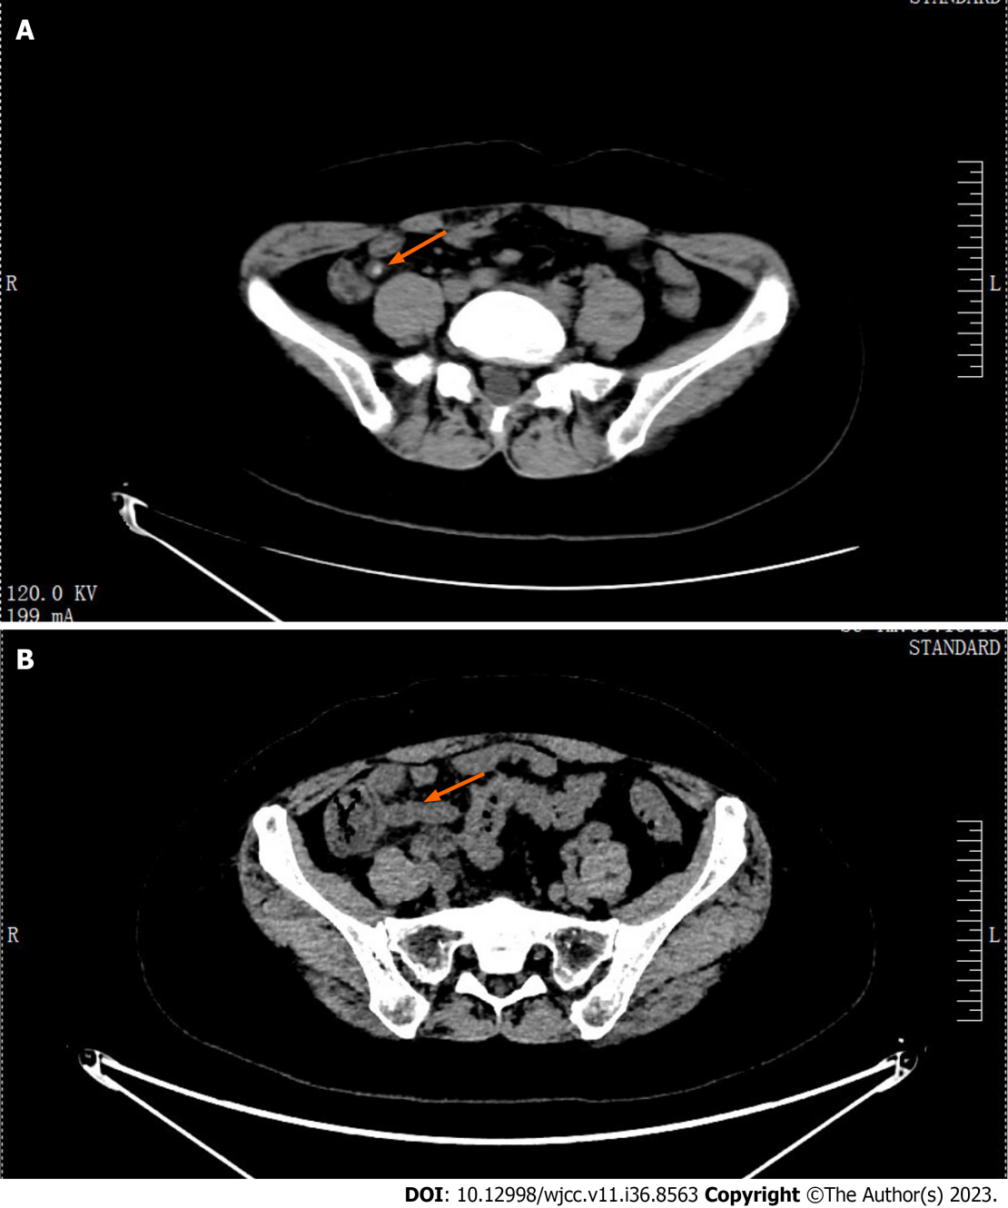
Figure 1 Computed tomography scan of the lower abdomen and pelvis. A: Computed tomography (CT) revealed a dilated and thickened appendix with fecoliths (solid arrow: Appendix with fecoliths); B: After 3 d of treatment, the pelvic CT revealed that the appendicolith had disappeared (solid arrow: Dilated appendix without fecolith).

Published by Baishideng Publishing Group Inc
7041 Koll Center Parkway, Suite 160, Pleasanton, CA 94566, USA
Telephone: +1-925-3991568
E-mail: bpgoffice@wjgnet.com
Help Desk: https://www.f6publishing.com/helpdesk
https://www.wjgnet.com

© 2023 Baishideng Publishing Group Inc. All rights reserved.

