Name of Journal: World Journal of Clinical Cases
Manuscript NO: 71301
Manuscript Type: SYSTEMATIC REVIEWS

Atrial fibrillation burden and the risk of stroke: A systematic review and dose-response meta-analysis

Yang SY et al. AF burden and the stroke risk

Sheng-Yi Yang, Min Huang, Ai-Lian Wang, Ge Ge, Mi Ma, Hong Zhi, Li-Na Wang

Sheng-Yi Yang, Min Huang, Ge Ge, Mi Ma, Department of Epidemiology and Biostatistics, Southeast University, Nanjing 210009, Jiangsu Province, China

Ai-Lian Wang, Yaohua Community Healthcare Center, Nanjing 210046, Jiangsu Province, China

Hong Zhi, Department of Cardiology, Zhongda Hospital, Nanjing 210009, Jiangsu Province, China

Li-Na Wang, School of Public Health, Southeast University, Nanjing 210009, Jiangsu Province, China

Author contributions: Yang SY and Huang M designed the search strategy, performed the literature search and collected the data; Yang SY wrote the manuscript; Ma M checked the data; Ge G performed quality assessment and reviewed the level of evidence; Wang LN designed the project and edited the manuscript; Zhi H helped revised the manuscript for language; Wang AL checked the data; all authors read and approved the manuscript.

Supported by National Natural Science Foundation of China, No. 81673259; and Natural Science Foundation of Jiangsu Province, China, No. BK20161435.

Corresponding author: Li-Na Wang, Doctor, Associate Professor, School of Public Health, Southeast University, No. 87 Ding Jiaqiao Road, Nanjing 210009, Jiangsu Province, China. lnwang@seu.edu.cn

Received: September 2, 2021
Revised: October 26, 2021
Accepted: December 23, 2021
Published online:

Abstract
BACKGROUND
The increased stroke risk associated with atrial fibrillation (AF) burden exceeding 5 min is a matter of debate. In addition, the potential linear or nonlinear relationship between AF burden and stroke risk has been largely unexplored.

AIM
To determine the association between AF burden > 5 min and the increased risk of stroke and explore the potential dose-response relationship between these two factors.

METHODS
Sixteen studies from six databases with 53141 subjects (mean age 65 years) were included. Fifteen studies were observational studies, and one was a randomized controlled trial study. The potential nonlinear dose-response association was characterized using a restricted cubic splines regression model. AF burden for each 1 h and 2 h was associated with an increased risk of stroke. Trial sequential analysis with a random-effect model was used to evaluate the robustness of the evidence from the included 16 studies.

RESULTS
AF burden > 5 min was associated with an increased risk of clinical AF [adjusted risk ratio (RR) = 4.18, 95% confidence interval (CI): 2.26-7.74]. However, no association was found with an increased risk of all-cause mortality (adjusted RR = 1.55, 95%CI: 0.87-2.75). Patients with AF burden > 5 min had an increased risk of stroke (adjusted RR = 2.49, 95%CI: 1.79-3.47). Moreover, a dose-response analysis showed that the increased stroke risk was paralleled by an increase in AF burden at a rate of 2.0% per hour (P_{nonlinear} = 0.656, RR = 1.02, 95%CI: 1.01-1.03). Trial sequential analysis provided robust evidence of the association between AF burden > 5 min and an increased risk of stroke.

CONCLUSION
AF burden was a significant risk factor for clinical AF and future stroke. A significant linear association was documented between increased AF burden and risk of future stroke.

Key Words: Atrial fibrillation; Stroke; Dose-response; Meta-analysis; Risk

Yang SY, Huang M, Wang AL, Ge G, Ma M, Zhi H, Wang LN. Atrial fibrillation burden and the risk of stroke: A systematic review and dose-response meta-analysis. World J Clin Cases 2021; In press

Core Tip: We performed a systematic review and meta-analysis to determine whether atrial fibrillation (AF) burden > 5 min was associated with increased risk of stroke and to explore the dose response effect of AF burden on the future stroke. A significant linear association was documented between increased AF burden and risk of future stroke.

INTRODUCTION
Atrial fibrillation (AF) is one of the most frequent cardiac arrhythmias. Reports suggest that an estimated 12.1 million people will suffer from this condition in the United States by 2030 and 17.9 million people in Europe by 2060^{[1,2]}. It has been established that patients with AF have a 3 to 5-fold increased risk of stroke, and subjects with AF-related embolic stroke have a worse progression than those who experience stroke not related to AF^{[3-5]}. With the widespread use of cardiac implantable electronic devices (CIEDs) and wearable devices, it is now possible to monitor the time and frequency of AF episodes. The American Heart Association recommends that the AF burden should be defined as the duration of the longest AF episode during a defined monitoring period^{[6]}.
Some studies demonstrated an association between AF burden and stroke risk, but few mentioned the existence of a dose-response effect. The Italian AT 500 registry study showed that patients with device-detected AF episodes of > 24 h had a 3.1-fold increased risk of stroke. In contrast, patients with AF episodes of > 5 min and < 24 h experience no significant increase in stroke risk^{[7]}. Moreover, the ASSERT Clinical Trial reported episodes lasting > 6 min were associated with an increased risk of ischemic stroke or systemic embolism^{[8]}. A recent systematic review demonstrated the AF burden exceeding different thresholds was associated with an increased risk of stroke; however, they did not provide a definite threshold for AF burden at stroke risk^{[9]}. It is a matter of controversy whether an AF burden of > 5 min can increase the risk of stroke, and no studies have reported the potential dose-response effect on stroke. Accordingly, we performed a systematic review and meta-analysis to determine the association between AF burden > 5 min and the increased risk of stroke and explored the dose-response effect between these two factors.

MATERIALS AND METHODS
This systematic review and meta-analysis adhered to the Preferred Reporting Items for Systematic Reviews and Meta-analysis (PRISMA) guidelines^{[10]}.

Search strategy
The literature search was performed by two researchers (YSY and HM) with the help of an experienced medical reference librarian. Studies were retrieved by searching electronic databases (PubMed, EMBASE, Medline, Cochrane, Web of Science) from inception until February 28, 2020. The following search terms were used: AF, physiological monitoring, implantable cardiac monitor, artificial pacemaker, electrocardiograph, burden, stroke, cerebrovascular disorders, brain infarction and thromboembolic event. The language of publication was restricted to English. We also retrieved the reference lists of included articles and previous reviews to identify potential studies as comprehensively as possible. All retrieved references were exported to EndNote X9, and duplicate citations were removed.

Inclusion criteria and exclusion criteria
Two investigators (YSY, HM) independently assessed the eligibility of the studies identified. The inclusion criteria included: (1) Studies that described AF burden within 1 d or more; (2) Studies that described the method used to quantify AF burden such as a pacemaker, implantable cardioverter-defibrillator and cardiac-resynchronization device; and (3) Studies where clinical outcomes included stroke, ischemic stroke, systematic embolism, transient ischemic attack or other thromboembolic events. The combined endpoint of these outcomes was also included: (1) Studies that directly and/or indirectly provided the relative risk of the outcome, including hazard ratio (HR), risk ratio (RR) and odds ratio (OR) values; (2) Observational studies or randomized controlled trials (RCTs); and (3) Studies where the study design and methods were described in detail.
However, reviews, conference abstracts, editorials, case reports, duplicate publications and cross-sectional studies were excluded.

Data extraction
Two researchers (YSY and HM) independently extracted the following information from the included studies: Study type, significant AF burden definition, adverse outcomes, sample size, follow-up period, the method for AF monitoring and others. The number of cases and HR, RR, OR for the risk of the adverse outcomes for different AF burdens were also recorded. HRs provided by original studies were considered as adjusted RRs. We also contacted the authors for additional data or any clarification if necessary. Disagreements were resolved by a consensus-based discussion.

Quality assessment and the level of evidence
The quantitative assessment tool ‘QualSyst’^{[11]} and the Oxford Centre for Evidence-Based Medicine 2009 Level of Evidence Tool^{[12]} were used to assess the methodological quality and the evidence levels of the included studies by two researchers (YSY and HMJ). The ‘QualSyst’ scoring system included 14 criteria with three possible answers: Yes, No, and Partial. “Yes” = 2 points, “No” = 0 points and “Partial” = 1 points. Items not applicable to a particular study design were marked ‘NA’ and were excluded from calculating the summary score. A summary score was calculated for each article based on the evaluation criteria. A score greater than 75% of the summary score indicated strong quality, a score ranging from 55% to 75% indicated moderate quality, and a score lower than 55% indicated poor quality. The level of evidence was assessed according to the type of study, and each subgroup level included five levels.

Data synthesis and statistical analysis
Sufficient data were obtained to calculate the incidence of AF burden and stroke. Adjusted RRs and 95% confidence interval (CI) were extracted from each study. A meta-analysis was used to pool the relative risks of each study. Chi-squared-based Q test and the I² value were used to evaluate the heterogeneity within the studies. The random-effects meta-analysis model was used when the heterogeneity was statistically significant (I² > 50%, P < 0.05)^{[13]}. Publication bias was assessed by Egger’s test. A P value < 0.05 was statistically significant.
The potential linear or nonlinear dose-response effect was evaluated using a restricted cubic splines regression model, where the AF burden was associated with an increased risk of stroke every 1 min^{[14]}. We further explored the increased risk of stroke per hour. Four knots at the 5th, 35th, 65th and 95th percentiles of AF burden were used in the regression model. The nonlinear P value was calculated by testing the null hypothesis that the second spline coefficient was equal to zero^{[15]}. If P_{nonlinear} was greater than 0.05, the linear dose-response effect was statistically significant.
Moreover, when the AF burden was not a definite value, the midpoint between the upper and lower boundaries was considered as the average AF burden; when the lowest level was an open interval, the lowest dose was assumed to be 0; when the highest category was open-ended, a value with 1.5 times of the boundary of the highest dose was considered the dose^{[16]}. Trial sequential analysis (TSA) was used to evaluate the statistical power of the current sample size and provide robust evidence of the effect of AF burden on the stroke risk^{[17]}. Heterogeneity-adjusted required information size was calculated with α = 0.05, β = 0.2 and a relative risk reduction of 30%.
The meta-analysis was conducted using Review Manager (v5.3). The potential dose-response association was conducted by STATA software (v15.0, College Station, TX, United States). TSA was conducted with TSA 0.9.5.10 Beta software (http://www.ctu.dk.tsa)^{[18]}.

RESULTS
Identification of studies
The search strategy yielded a total of 10479 abstracts from five English databases, while a manual search of the references cited in other available included articles and previous reviews yielded an additional 372 abstracts. After removing duplicates, 7827 studies remained. After abstract screening, 7004 studies were excluded. The remaining 823 full-texts were assessed for eligibility based on the inclusion and exclusion criteria, and 807 studies were excluded for the following reasons: 412 were not original articles, 218 lacked detailed data on AF burden and 126 did not provide information on the clinical outcomes, 44 had a history of AF or stroke, and seven were cross-sectional studies. Finally, 16 studies were included in the quantitative synthesis (Figure 1).

Characteristics of the involved studies
Table 1 shows the characteristics of the included 16 studies, all except one were RCT studies^{[7,8,19-32]}. The detected devices for AF burden included one or more of the three following devices: Pacemaker, implantable cardioverter-defibrillator and cardiac-resynchronization device. The 16 studies included 53141 subjects with mean or median ages > 65 years. Except for case-crossover study, subjects in all studies were followed up for at least 1 year to ascertain the clinical outcomes^{[25]}. Four studies were multinational consortium studies; six were conducted in European countries, four in North American countries and two in Asian countries.
Table 2 shows the quality evaluation and the evidence level for each study. Twelve studies were associated with scores higher than 21. The levels of evidence ranged from 1b to 3a, and most were considered level 2b evidence.

The incidence of AF burden > 5 min and stroke
Eleven studies provided data on the incidence of AF burden > 5 min. The detectable rate of AF burden > 5 min ranged from 10.12% to 70.77% among CIED patients, and AF burden > 24 h ranged from 6.70% to 39.26%. Overall, AF burdens > 5 min and > 24 h were detected in 26% (95%CI: 1%-52%) and 15% (95%CI: 6%-35%) of patients within the follow-up period, respectively, and the pooled incidence of stroke was 2.80% (95%CI: 1.56%-4.03%).

Association between AF burden > 5 min and future stroke risks
Sufficient data were obtained to calculate the crude RR for stroke associated with AF burden > 5 min in each study. The average follow-up for the 11 studies ranged from 12 to 67 mo (mean = 36.18 mo). The random-effects pooled analysis revealed that patients with AF burden > 5 min had a 67% increased risk of stroke (RR = 1.67, 95%CI: 1.25-2.25) compared with patients with AF burden < 5min (Figure 2A). Significant heterogeneity was found within the included studies (I² = 52%, P = 0.020). The funnel plot was symmetrical, and Egger’s test showed no significant publication bias (t = 1.56, P = 0.150).
Six of the included studies provided adjusted RRs on the strength of association between AF burden > 5 min and the stroke risk. In these six studies, the average follow-up time ranged from 24 to 67 mo (mean = 36.90 mo). Notwithstanding that Li et al^{[31]} found a higher annual incidence of stroke in patients with AF burden > 5 min (1.85% vs 1.14%), the difference was not statistically significant (adjusted RR = 1.31, 95%CI: 0.51-3.38)^{[31]}. The other five studies indicated that the annual incidence of stroke for AF burdens > 5 min and < 5 min ranged from 1.69 to 3.1 and 0.58 to 1.4 per 100 patient-years, respectively. The fixed-effect pooled analysis revealed that patients with AF burden > 5 min had a 2.49-fold increase in the risk of stroke (adjusted RR = 2.49, 95%CI: 1.79-3.47) compared with patients with AF burden < 5min (Figure 2B). There was no significant heterogeneity (I² = 0%, P =0.620) and publication bias (t = 1.08, P = 0.340) among these studies.
TSA of ten studies showed that 71.5% (37144 out of 51978 patients) of the heterogeneity-adjusted information size required was accrued. We also found that the cumulative Z curve crossed the trial sequential monitoring boundary, providing robust evidence of the association between the AF burden > 5 min and increased risk of stroke based on the sample size (Figure 3).

Subgroup analyses of association between AF burden > 5 min and the future stroke risk
The fixed-effect pooled analysis performed with adjusted RRs revealed that patients with AF burden > 5 min had a 1.23-fold increase in risk of stroke (RR = 2.23, 95%CI: 1.48-3.35), compared to AF burden < 5 min among patients with no history of AF. Moreover, patients with AF burden > 5 min had a 2.14-fold increase in the risk of stroke (adjusted RR = 2.14, 95%CI: 1.23-3.72) compared to AF burden < 5 min among patients not on anticoagulation therapy. The detailed results of subgroup analyses with different populations are shown in Supplementary Table 1.

Does-response relationship between AF burden and the future stroke risk
Seven studies were included in the dose-response meta-analysis on the association between AF burden and stroke. The potential linear or nonlinear dose-response association was evaluated using a restricted cubic splines regression model. A linear dose-response relationship (P_{nonlinear} = 0.656) was found (Figure 4), and AF burden was associated with 2.0% and 3.0% increased risks of stroke for every 1 h (RR = 1.02, 95%CI: 1.01-1.03) and 2 h (RR = 1.03, 95%CI: 1.02-1.05), respectively.

AF burden and risk of clinical AF
Three of the included studies, including 3286 patients, provided adjusted RRs values of the AF burden > 5 min on the risk of clinical AF. The random-effect pooled analysis reveal that patients with AF burden > 5 min had a 3.18 fold increased risk of clinical AF (adjusted RR = 4.18, 95%CI: 2.26-7.74) compared with the patient suffering AF burden < 5 min (Figure 5). The heterogeneity was significant among the different study designs (I² = 77%, P = 0.010), RCT^{[19]} and two retrospective observational studies^{[8,26]}. The funnel plot was symmetrical and no significant publication bias was found in the Egger’s test (t = 0.80, P = 0.570).

AF burden and the risk of all-cause mortality
The reported adjusted RRs for the strength of association between AF burden > 5 min and risk of all-cause mortality in three studies differed. An ancillary study of the Mode Selection Trial trial^{[19]} included patients with sinus node disease who were in sinus rhythm at the time of pacemaker implantation and aged > 21 years. Two studies^{[23,26]} included patients with no history of AF. The random-effects pooled analysis found that patients with AF burden > 5 min had a 55% increased risk of all-cause mortality (adjusted RR = 1.55, 95%CI: 0.87-2.75) (Figure 6); however, significant heterogeneity (I² = 68%, P = 0.040) and publication bias (t = -21.13, P = 0.030) were present in this analysis.

DISCUSSION
In this systematic review and dose-response meta-analysis on the association between AF burden and the risk of stroke, 16 original studies were included, including 53141 CIED patients. First of all, we found that patients with an AF burden > 5 min had an increased risk of stroke. Moreover, a linear dose-response relationship was found; the risk of stroke was increased by 2.0% per hour among subjects with AF burden > 5 min. Last but not least, we found AF burden > 5 min was associated with a significantly increased risk of clinical AF but not associated with an increase in all-cause mortality.

AF burden: A significant risk factor for stroke
Data from each study were extracted to calculate the crude RRs without considering the time-to-event endpoints. The pooled results indicated that patients with AF burden > 5 min had a higher stroke risk. That significant heterogeneity was detected for the pooled analysis of the relationship between AF burden and stroke risk (I² = 52%, P = 0.02). The heterogeneity might be associated with the variations in patient populations, hypertension, prior AF and antithrombotic therapy, etc.^{[33]}. The population included in our study had different comorbidities, including patients with symptomatic atrial tachyarrhythmias^{[7,20]}, sinus node disease^{[19]} and heart failure^{[22]}. Moreover, some studies provided no information on patient history of AF^{[8,23,26-28]}. Besides, in the study by Chu et al^{[29]}, patients with oral anticoagulants for any reason were excluded. However, even though anticoagulants were used in different proportions of patients at baseline, we found that the heterogeneity was not significant. With the pooled data of HRs adjusted for one or more known embolism predictors [including age, sex, heart failure, prior stroke diabetes, congestive heart failure, hypertension, age ≥ 75 years, diabetes mellitus, stroke or transient ischemic attack, vascular disease, age 65 to 74 years, sex category (CHA2DS2-VASc) score], we found that an AF burden > 5 min was associated with an increased risk of stroke (I² = 0, P = 0.62).
We found that subjects with AF burden of > 5 min had a 67% increased risk of stroke. Recently, a meta-analysis also found that subclinical AF (pooled with highest AF duration cut-off values from the original studies) was associated with a 2.4-fold increased risk of stroke^{[9]}. These results indicated that the risk of stroke was higher among the subjects with the serious AF burden. This finding provides novel insights that can be used to develop stroke prophylaxis approaches for AF patients.
Consistently, Shanmugam et al^{[22]} found that a higher AF burden (AF burden > 3.8 h) was associated with a 9.4-fold risk of stroke among CIED patients. Two studies^{[28,30]} also reported that patients with AF burden > 24 h had an increased risk of stroke. However, these results were inconsistent with a study by Healey et al^{[8]}, which could be accounted for by the fact that patients who experienced long periods of sinus rhythm and the better treatment of stroke had no history of AF^{[8]}.
The European and American^{[34]} guidelines recommend estimating stroke risk in AF patients based on the CHA2DS2-VASc score. Moreover, an oral anticoagulant is recommended to reduce thromboembolic stroke risk in patients with AF, especially male patients with a CHA2DS2-VASc score of 1 and female patients with a CHA2DS2-VASc score of 2. Interestingly, some studies explored the association between AF burden and CHA2DS2-VASc scores. Botto et al^{[20]} indicated that patients with a CHADS2 score of 1 or 2 had either a high or low stroke risk consistent with a high or low detected AF duration, respectively. Kaplan et al^{[30]} also found an interaction between AF duration and CHA2DS2-VASc score. The risk of systemic embolism in patients with intermediate CHA2DS2-VASc scores was variable and correlated with the maximum AF burden. Accordingly, the stroke risk among AF patients should be evaluated based on the CHA2DS2-VASc score and AF burden to provide better personalized anticoagulation decisions.

Association between AF burden and risk of clinical AF or all-cause mortality
Clinical AF is a chaotic heart rhythm characterized by an irregular and often rapid heart rate documented with a 12-lead electrocardiogram. Electrocardiogram-documented AF was confirmed in 38.9% of patients with AF burden and 2.1% without AF burden^{[19]}. Our study found that AF burden > 5 min was associated with an increased risk of clinical AF. Furthermore, progression from paroxysmal to persistent or permanent AF might be faster in patients with subclinical AF who did not receive treatment. Consequently, more emphasis should be placed on screening patients with AF burden > 5 min and providing timely therapy.
Our study demonstrated that AF burden was not associated with all-cause mortality. However, there was significant heterogeneity in this meta-analysis. Indeed, further research is required to explore the role of AF burden on all-cause mortality.

Limitations
Even though this meta-analysis was performed utilizing crude RRs and adjusted RRs, there are still some limitations. Owing to the lack of adjusted RRs corresponding to three or more groups of AF burden, this meta-analysis was conducted without considering the time-to-event points and adjusting for confounding factors. Furthermore, patients with CIEDs might have diabetes, hypertension and other stroke risk factors, which might lead to an overestimation of the effect of AF on stroke. Underreporting of stroke and prescribing an oral anticoagulant to patients with higher AF burden might also lead to underestimating the impact of AF burden on the stroke risk. However, anticoagulation was used in the different subgroups of patients who had comorbidities at the baseline. Finally, publication bias was present in this study. Our results might have been influenced by non-published studies or language bias as we only included studies published in English.

CONCLUSION
This meta-analysis demonstrated that AF burden is a significant risk factor for clinical AF and stroke. There is a linear dose-response between AF burden and risk of stroke. Further studies are needed to validate this effect and evaluate the cut-off value for AF burden among patients requiring anticoagulation treatment.

ARTICLE HIGHLIGHTS
Research background
With the widespread use of cardiac implantable electronic devices and wearable devices, it is nowadays possible to monitor the atrial fibrillation (AF) burden. However, whether an AF burden of > 5 min can increase the risk of stoke is still highly controversial, and the potential linear or nonlinear relationship between them remains largely unexplored.

Research motivation
A comprehensive systemic review and meta-analysis can summarize the results of available studies and help doctors in the clinical decision-making process.

Research objectives
This meta-analysis aimed to determine the association between AF burden > 5 min and the increased risk of stroke and explore a dose-response effect of AF burden on the risk of stroke.

Research methods
Studies were identified by searching electronic databases (PubMed, EMBASE, Medline, Cochrane and Web of Science) from inception until February 28, 2020. The potential nonlinear dose-response association was evaluated using a restricted cubic splines regression model. AF burden was associated with an increased risk of stroke for every 1 h and 2 h. Trial sequential analysis with a random-effect model was used to evaluate the robustness of the evidence from the included 16 studies. Data from these studies were pooled using RevMan software and Stata.

Research results
The meta-analysis indicated that an AF burden > 5 min was associated with an increased risk of clinical AF [adjusted risk ratio (RR) = 4.18, 95% confidence interval (CI): 2.26-7.74] but was not associated with an increased risk of all-cause mortality (adjusted RR = 1.55, 95%CI: 0.87-2.75). Patients with an AF burden > 5 min had an increased risk of stroke (adjusted RR = 2.49, 95%CI: 1.79-3.47). The linear dose-response analysis showed that the risk of stroke was increased by 2.0% per hour as the AF burden was increased (P_{nonlinear} = 0.656, RR = 1.02, 95%CI: 1.01-1.03). Trial sequential analysis provided robust evidence of the association between AF burden > 5 min and increased risk of stroke.

Research conclusions
AF burden is a significant risk factor for clinical AF and stroke. A significant linear association is present between increased AF burden and the risk of stroke.

Research perspectives
More emphasis should be laid on patients with AF burden to minimize the stroke risks.

ACKNOWLEDGEMENTS
We are grateful to Meng-Jiao He and Fei-Hong Chen for their helpful advice of methodology and statistics and to Mr. Satyajit Kundu for language polishing.

REFERENCES
1 Chung MK, Refaat M, Shen WK, Kutyifa V, Cha YM, Di Biase L, Baranchuk A, Lampert R, Natale A, Fisher J, Lakkireddy DR; ACC Electrophysiology Section Leadership Council. Atrial Fibrillation: JACC Council Perspectives. J Am Coll Cardiol 2020; 75: 1689-1713 [PMID: 32273035 DOI: 10.1016/j.jacc.2020.02.025]
2 Kornej J, Börschel CS, Benjamin EJ, Schnabel RB. Epidemiology of Atrial Fibrillation in the 21st Century: Novel Methods and New Insights. Circ Res 2020; 127: 4-20 [PMID: 32716709 DOI: 10.1161/CIRCRESAHA.120.316340]
3 Jame S, Barnes G. Stroke and thromboembolism prevention in atrial fibrillation. Heart 2020; 106: 10-17 [PMID: 31533990 DOI: 10.1136/heartjnl-2019-314898]
4 Freedman B, Potpara TS, Lip GY. Stroke prevention in atrial fibrillation. Lancet 2016; 388: 806-817 [PMID: 27560276 DOI: 10.1016/S0140-6736(16)31257-0]
5 Wolf PA, Dawber TR, Thomas HE Jr, Kannel WB. Epidemiologic assessment of chronic atrial fibrillation and risk of stroke: the Framingham study. Neurology 1978; 28: 973-977 [PMID: 570666 DOI: 10.1212/wnl.28.10.973]
6 Chen LY, Chung MK, Allen LA, Ezekowitz M, Furie KL, McCabe P, Noseworthy PA, Perez MV, Turakhia MP; American Heart Association Council on Clinical Cardiology; Council on Cardiovascular and Stroke Nursing; Council on Quality of Care and Outcomes Research; and Stroke Council. Atrial Fibrillation Burden: Moving Beyond Atrial Fibrillation as a Binary Entity: A Scientific Statement From the American Heart Association. Circulation 2018; 137: e623-e644 [PMID: 29661944 DOI: 10.1161/CIR.0000000000000568]
7 Capucci A, Santini M, Padeletti L, Gulizia M, Botto G, Boriani G, Ricci R, Favale S, Zolezzi F, Di Belardino N, Molon G, Drago F, Villani GQ, Mazzini E, Vimercati M, Grammatico A; Italian AT500 Registry Investigators. Monitored atrial fibrillation duration predicts arterial embolic events in patients suffering from bradycardia and atrial fibrillation implanted with antitachycardia pacemakers. J Am Coll Cardiol 2005; 46: 1913-1920 [PMID: 16286180 DOI: 10.1016/j.jacc.2005.07.044]
8 Healey JS, Connolly SJ, Gold MR, Israel CW, Van Gelder IC, Capucci A, Lau CP, Fain E, Yang S, Bailleul C, Morillo CA, Carlson M, Themeles E, Kaufman ES, Hohnloser SH; ASSERT Investigators. Subclinical atrial fibrillation and the risk of stroke. N Engl J Med 2012; 366: 120-129 [PMID: 22236222 DOI: 10.1056/NEJMoa1105575]
9 Mahajan R, Perera T, Elliott AD, Twomey DJ, Kumar S, Munwar DA, Khokhar KB, Thiyagarajah A, Middeldorp ME, Nalliah CJ, Hendriks JML, Kalman JM, Lau DH, Sanders P. Subclinical device-detected atrial fibrillation and stroke risk: a systematic review and meta-analysis. Eur Heart J 2018; 39: 1407-1415 [PMID: 29340587 DOI: 10.1093/eurheartj/ehx731]
10 Moher D, Shamseer L, Clarke M, Ghersi D, Liberati A, Petticrew M, Shekelle P, Stewart LA; PRISMA-P Group. Preferred reporting items for systematic review and meta-analysis protocols (PRISMA-P) 2015 statement. Syst Rev 2015; 4: 1 [PMID: 25554246 DOI: 10.1186/2046-4053-4-1]
11 Speyer R, Denman D, Wilkes-Gillan S, Chen YW, Bogaardt H, Kim JH, Heckathorn DE, Cordier R. Effects of telehealth by allied health professionals and nurses in rural and remote areas: A systematic review and meta-analysis. J Rehabil Med 2018; 50: 225-235 [PMID: 29257195 DOI: 10.2340/16501977-2297]
12 Ahmed H, Patel K, Greenwood DC, Halpin S, Lewthwaite P, Salawu A, Eyre L, Breen A, O'Connor R, Jones A, Sivan M. Long-term clinical outcomes in survivors of severe acute respiratory syndrome and Middle East respiratory syndrome coronavirus outbreaks after hospitalisation or ICU admission: A systematic review and meta-analysis. J Rehabil Med 2020; 52: jrm00063 [PMID: 32449782 DOI: 10.2340/16501977-2694]
13 Higgins JP, Thompson SG. Quantifying heterogeneity in a meta-analysis. Stat Med 2002; 21: 1539-1558 [PMID: 12111919 DOI: 10.1002/sim.1186]
14 Orsini N, Li R, Wolk A, Khudyakov P, Spiegelman D. Meta-analysis for linear and nonlinear dose-response relations: examples, an evaluation of approximations, and software. Am J Epidemiol 2012; 175: 66-73 [PMID: 22135359 DOI: 10.1093/aje/kwr265]
15 Du Y, Lv Y, Zha W, Hong X, Luo Q. Chili Consumption and Risk of Gastric Cancer: A Meta-Analysis. Nutr Cancer 2021; 73: 45-54 [PMID: 32241189 DOI: 10.1080/01635581.2020.1733625]
16 Rong Y, Chen L, Zhu T, Song Y, Yu M, Shan Z, Sands A, Hu FB, Liu L. Egg consumption and risk of coronary heart disease and stroke: dose-response meta-analysis of prospective cohort studies. BMJ 2013; 346: e8539 [PMID: 23295181 DOI: 10.1136/bmj.e8539]
17 Wetterslev J, Thorlund K, Brok J, Gluud C. Trial sequential analysis may establish when firm evidence is reached in cumulative meta-analysis. J Clin Epidemiol 2008; 61: 64-75 [PMID: 18083463 DOI: 10.1016/j.jclinepi.2007.03.013]
18 Hemmingsen B, Lund SS, Gluud C, Vaag A, Almdal T, Hemmingsen C, Wetterslev J. Intensive glycaemic control for patients with type 2 diabetes: systematic review with meta-analysis and trial sequential analysis of randomised clinical trials. BMJ 2011; 343: d6898 [PMID: 22115901 DOI: 10.1136/bmj.d6898]
19 Glotzer TV, Hellkamp AS, Zimmerman J, Sweeney MO, Yee R, Marinchak R, Cook J, Paraschos A, Love J, Radoslovich G, Lee KL, Lamas GA; MOST Investigators. Atrial high rate episodes detected by pacemaker diagnostics predict death and stroke: report of the Atrial Diagnostics Ancillary Study of the MOde Selection Trial (MOST). Circulation 2003; 107: 1614-1619 [PMID: 12668495 DOI: 10.1161/01.CIR.0000057981.70380.45]
20 Botto GL, Padeletti L, Santini M, Capucci A, Gulizia M, Zolezzi F, Favale S, Molon G, Ricci R, Biffi M, Russo G, Vimercati M, Corbucci G, Boriani G. Presence and duration of atrial fibrillation detected by continuous monitoring: crucial implications for the risk of thromboembolic events. J Cardiovasc Electrophysiol 2009; 20: 241-248 [PMID: 19175849 DOI: 10.1111/j.1540-8167.2008.01320.x]
21 Glotzer TV, Daoud EG, Wyse DG, Singer DE, Ezekowitz MD, Hilker C, Miller C, Qi D, Ziegler PD. The relationship between daily atrial tachyarrhythmia burden from implantable device diagnostics and stroke risk: the TRENDS study. Circ Arrhythm Electrophysiol 2009; 2: 474-480 [PMID: 19843914 DOI: 10.1161/CIRCEP.109.849638]
22 Shanmugam N, Boerdlein A, Proff J, Ong P, Valencia O, Maier SK, Bauer WR, Paul V, Sack S. Detection of atrial high-rate events by continuous home monitoring: clinical significance in the heart failure-cardiac resynchronization therapy population. Europace 2012; 14: 230-237 [PMID: 21933802 DOI: 10.1093/europace/eur293]
23 Gonzalez M, Keating RJ, Markowitz SM, Liu CF, Thomas G, Ip JE, Lerman BB, Cheung JW. Newly detected atrial high rate episodes predict long-term mortality outcomes in patients with permanent pacemakers. Heart Rhythm 2014; 11: 2214-2221 [PMID: 25131667 DOI: 10.1016/j.hrthm.2014.08.019]
24 Boriani G, Glotzer TV, Santini M, West TM, De Melis M, Sepsi M, Gasparini M, Lewalter T, Camm JA, Singer DE. Device-detected atrial fibrillation and risk for stroke: an analysis of >10,000 patients from the SOS AF project (Stroke preventiOn Strategies based on Atrial Fibrillation information from implanted devices). Eur Heart J 2014; 35: 508-516 [PMID: 24334432 DOI: 10.1093/eurheartj/eht491]
25 Turakhia MP, Ziegler PD, Schmitt SK, Chang Y, Fan J, Than CT, Keung EK, Singer DE. Atrial Fibrillation Burden and Short-Term Risk of Stroke: Case-Crossover Analysis of Continuously Recorded Heart Rhythm From Cardiac Electronic Implanted Devices. Circ Arrhythm Electrophysiol 2015; 8: 1040-1047 [PMID: 26175528 DOI: 10.1161/CIRCEP.114.003057]
26 Witt CT, Kronborg MB, Nohr EA, Mortensen PT, Gerdes C, Nielsen JC. Early detection of atrial high rate episodes predicts atrial fibrillation and thromboembolic events in patients with cardiac resynchronization therapy. Heart Rhythm 2015; 12: 2368-2375 [PMID: 26164377 DOI: 10.1016/j.hrthm.2015.07.007]
27 Benezet-Mazuecos J, Rubio JM, Cortés M, Iglesias JA, Calle S, de la Vieja JJ, Quiñones MA, Sanchez-Borque P, de la Cruz E, Espejo A, Farré J. Silent ischaemic brain lesions related to atrial high rate episodes in patients with cardiac implantable electronic devices. Europace 2015; 17: 364-369 [PMID: 25336664 DOI: 10.1093/europace/euu267]
28 Van Gelder IC, Healey JS, Crijns HJGM, Wang J, Hohnloser SH, Gold MR, Capucci A, Lau CP, Morillo CA, Hobbelt AH, Rienstra M, Connolly SJ. Duration of device-detected subclinical atrial fibrillation and occurrence of stroke in ASSERT. Eur Heart J 2017; 38: 1339-1344 [PMID: 28329139 DOI: 10.1093/eurheartj/ehx042]
29 Chu SY, Jiang J, Wang YL, Sheng QH, Zhou J, Ding YS. Pacemaker-detected atrial fibrillation burden and risk of ischemic stroke or thromboembolic events-A cohort study. Heart Lung 2020; 49: 66-72 [PMID: 31376922 DOI: 10.1016/j.hrtlng.2019.07.007]
30 Kaplan RM, Koehler J, Ziegler PD, Sarkar S, Zweibel S, Passman RS. Stroke Risk as a Function of Atrial Fibrillation Duration and CHA₂DS₂-VASc Score. Circulation 2019; 140: 1639-1646 [DOI: 10.1161/CIRCULATIONAHA.119.041303]
31 Li YG, Miyazawa K, Pastori D, Szekely O, Shahid F, Lip GYH. Atrial high-rate episodes and thromboembolism in patients without atrial fibrillation: The West Birmingham Atrial Fibrillation Project. Int J Cardiol 2019; 292: 126-130 [PMID: 31031080 DOI: 10.1016/j.ijcard.2019.04.055]
32 Nakano M, Kondo Y, Nakano M, Kajiyama T, Hayashi T, Ito R, Takahira H, Kobayashi Y. Impact of atrial high-rate episodes on the risk of future stroke. J Cardiol 2019; 74: 144-149 [PMID: 30728105 DOI: 10.1016/j.jjcc.2019.01.006]
33 Binder N, Herrnböck AS, Schumacher M. Estimating hazard ratios in cohort data with missing disease information due to death. Biom J 2017; 59: 251-269 [PMID: 27870130 DOI: 10.1002/bimj.201500167]
34 January CT, Wann LS, Calkins H, Chen LY, Cigarroa JE, Cleveland JC Jr, Ellinor PT, Ezekowitz MD, Field ME, Furie KL, Heidenreich PA, Murray KT, Shea JB, Tracy CM, Yancy CW. 2019 AHA/ACC/HRS Focused Update of the 2014 AHA/ACC/HRS Guideline for the Management of Patients With Atrial Fibrillation: A Report of the American College of Cardiology/American Heart Association Task Force on Clinical Practice Guidelines and the Heart Rhythm Society in Collaboration With the Society of Thoracic Surgeons. Circulation 2019; 140: e125-e151 [PMID: 30686041 DOI: 10.1161/CIR.0000000000000665]

Footnotes
Conflict-of-interest statement: There is no conflict of interest.

PRISMA 2009 Checklist statement: The authors have read the PRISMA 2009 Checklist, and the manuscript was prepared and revised according to the PRISMA 2009 Checklist.

Open-Access: This article is an open-access article that was selected by an in-house editor and fully peer-reviewed by external reviewers. It is distributed in accordance with the Creative Commons Attribution NonCommercial (CC BY-NC 4.0) license, which permits others to distribute, remix, adapt, build upon this work non-commercially, and license their derivative works on different terms, provided the original work is properly cited and the use is non-commercial. See: http://creativecommons.org/Licenses/by-nc/4.0/

Provenance and peer review: Unsolicited article; Externally peer reviewed.

Peer-review model: Single blind

Peer-review started: September 2, 2021
First decision: October 11, 2021
Article in press:

Specialty type: Medicine, research and experimental
Country/Territory of origin: China
Peer-review report’s scientific quality classification
Grade A (Excellent): 0
Grade B (Very good): B, B
Grade C (Good): C
Grade D (Fair): 0
Grade E (Poor): 0

P-Reviewer: Bagheri-Mohammadi S, Ennab RM, Sergi C S-Editor: Fan JR L-Editor: Filipodia P-Editor: Fan JR

Figure Legends
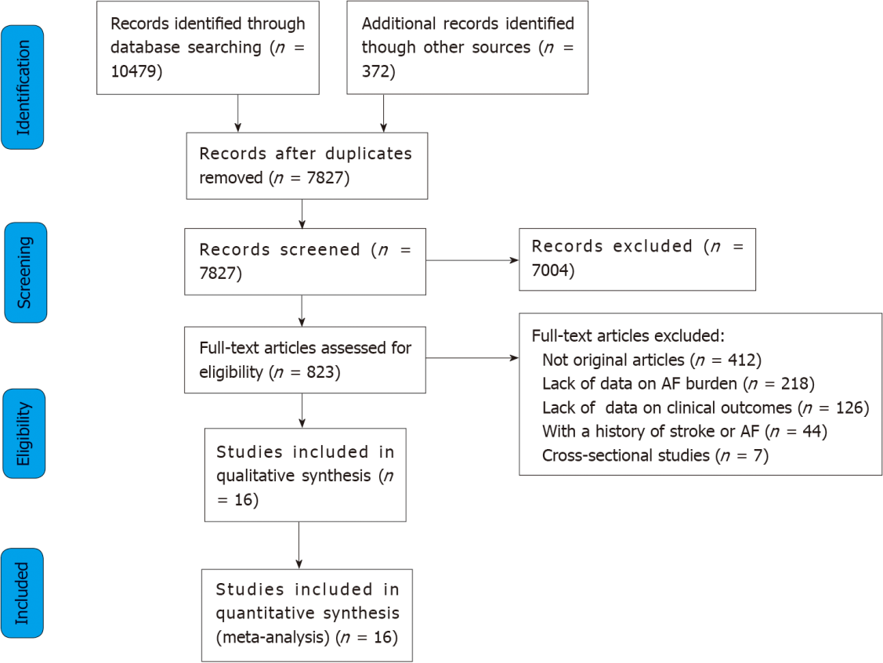
Figure 1 Flow diagram of the study selection process.

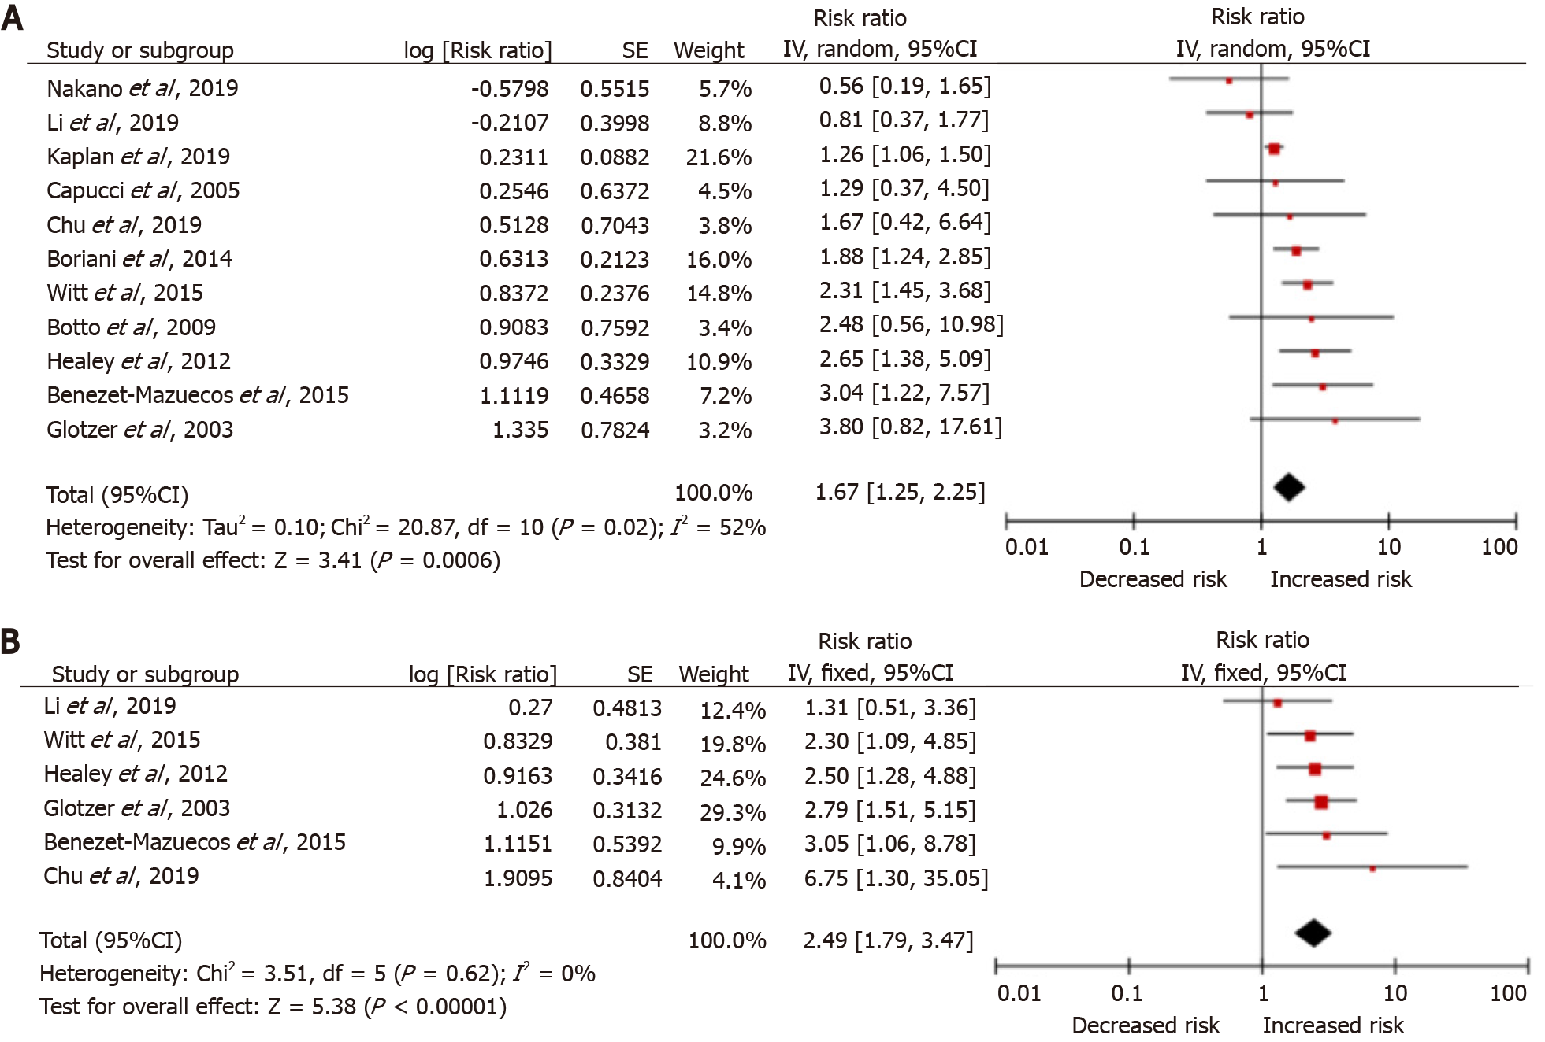
Figure 2 Meta-analysis forest plot: Atrial fibrillation burden and the risk of future stroke. A: Crude risk ratio (RR) model; B: Adjusted RR model; SE: Stand error; CI: Confidence interval.

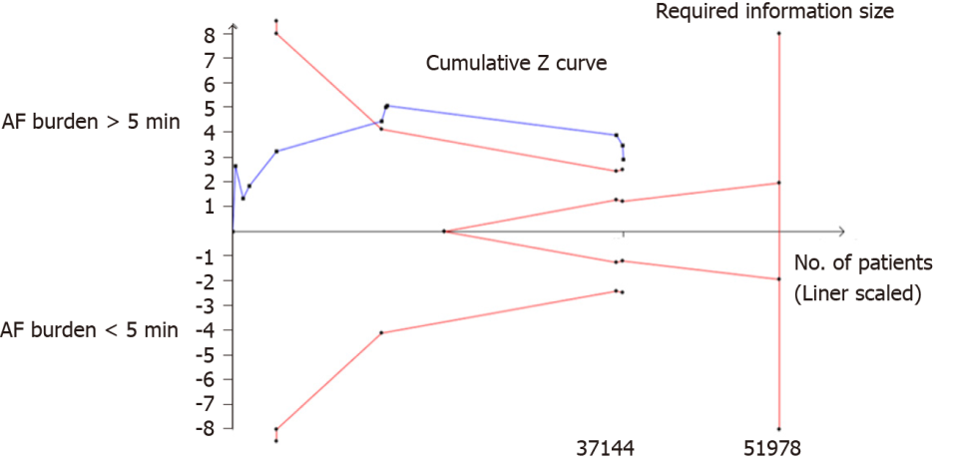
Figure 3 Trial sequential analysis of atrial fibrillation burden > 5 min. Heterogeneity adjusted required information size of 51978 participants calculated on basis of incidence of 2.37% in control group, relative risk reduction of 30%, α = 5%, β = 20%, and I² = 30%. Actually, accrued number of participants was 37144, 71.5% of required information size. AF: Atrial fibrillation.

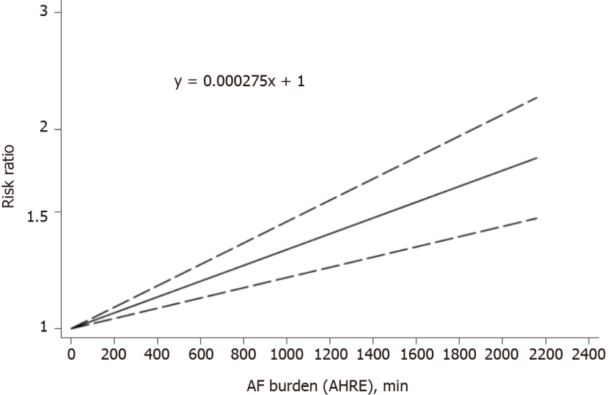
Figure 4 Random-effects liner dose-response association between atrial fibrillation burden and the risk future stroke (P_{nonlinear} = 0.656). AF: Atrial fibrillation.

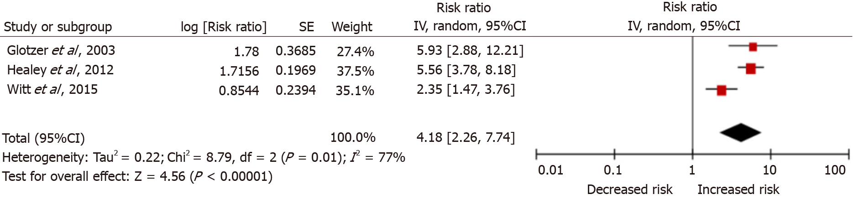
Figure 5 Adjusted risk ratio meta-analysis forest plot: Atrial fibrillation burden and the risk of clinical atrial fibrillation. SE: stand error; CI: confidence interval.

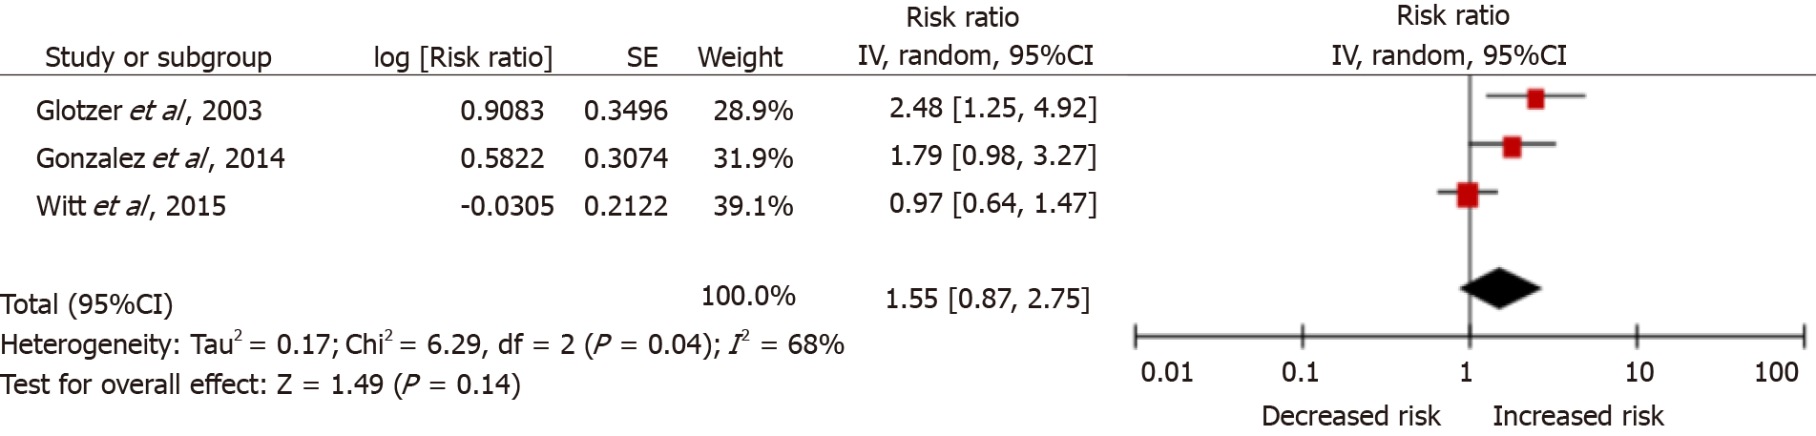
Figure 6 Adjusted risk ratio meta-analysis forest plot: Atrial fibrillation burden and the risk of all-cause mortality. SE: Stand error; CI: Confidence interval.

Table 1 Characteristics of the included 16 studies, all except 1 were randomized controlled trial studies
Ref.¹ | Study type | Significant AF burden definition | Adverse outcomes | Sample size | Follow-up period | AF monitoring | Age (male/female) | Nation | Population
Glotzer et al^{[19]}, 2003, Ancillary MOST | Secondary analysis of multicenter RCT | AF rate > 220 bpm, AF burden ≥ 5 min | Stroke/systematic embolism | 312 | Median: 27 mo | PM | 74 yr (141/171) | United States | Patients with sinus node disease who required PM for bradycardia and a history of AF
Capucci et al^{[7]}, 2005, Italian AT 500 Registry | Prospective, observational study | AF rate > 174 bpm, AF burden ≥ 5 min  or ≥ 1 d | Thromboembolic event | 725 | Median: 22 mo | PM | 72 yr (360/365) | Italy | Patients with symptomatic atrial tachyarrhythmias and a history of AF. Permanent AF were excluded
Botto et al^{[20]}, 2009, NA | Prospective, observational study | AF rate > 174 bpm, AF burden ≥ 5 min  or ≥ 1 d | Stroke/systematic embolism | 568 | Mean: 1 yr | PM | 70 yr (NA) | Italy | Patients with a class I or II American College of Cardiology/American Heart Association indication for dual-chamber PM, symptomatic atrial tachyarrhythmias and a history of AF. Permanent AF were excluded
Glotzer et al^{[21]}, 2009, TRENDS | Prospective, observational study | AF rate > 175 bpm, AF burden ≥ 20 s | Ischemic stroke, TIA, and systemic embolism | 2486 | Mean: 1.4 yr | PM, ICD or CRT | 70 yr (1650/836) | International | Patients with an established class I/II indication for an ICD or stroke risk factor and a history of AF. Permanent AF were excluded
Healey et al^{[8]}, 2012, ASSERT ClinicalTrials | Prospective, observational study | AF rate > 190 bpm, AF burden > 6 min | Ischemic stroke or systemic embolism | 2580 | Mean: 2.5 yr | PM or ICD | 77 yr (1506/1074) | International | Patients who had a history of hypertension, but no AF
Shanmugam et al^{[22]}, 2012, Home Monitor CRT | Prospective, observational study | AF rate > 180 bpm, AF burden > 14 min | Thromboembolic event | 560 | Median: 370 d | PM or ICD | 66 yr (434/136) | Europe | Patients with a heart failure, CRT and a history of AF. Permanent AF were excluded
Gonzalez et al^{[23]}, 2014, NA | Retrospective, observational study | AF rate > 178 bpm,  AF burden ≥ 5 min | Stroke and all-cause mortality | 224 | Median: 6.6 yr | PM | 74 yr (118/106) | United States | Consecutive patients with no history of AF who underwent dual-chamber PM implantation
Boriani et al^{[24]}, 2014, SOS AF project (PANORAMA, TRENDS, ClinicalService) | Prospective studies | AF rate > 175 bpm, AF burden > 5 min | Ischemic stroke or TIA events | 10016 | Median: 2 yr | PM or ICD | 70 yr (6859/3157) | International | Patients who had at least months of follow-up and with a history of AF. Permanent AF were excluded
Turakhia et al^{[25]}, 2015, NA | Case-Crossover | AF burden > 5.5 h in  a day during a defined 30-d period | Ischemic Stroke | 9850 | Case period: 1-30 d Control period: 91-120 d | PM or ICD | NA | United States | Patients with CIEDs remotely monitored in the Veterans Administration Health Care System and a history of AF
Witt et al^{[26]}, 2015, NA | Retrospective, observational study | AF burden > 6 min | Thromboembolic events | 394 | Median: 4.2 yr | CRT | 67 yr (290/104) | Denmark | Patients with a CRT device, and no history of AF
Benezet-Mazuecos et al^{[27]}, 2015, NA | Prospective, observational study | AF rate > 225 bpm, AF burden ≥ 5 min | Silent ischemic brain lesions | 109 | Median: 2 yr | PM, ICD or CRT | 74 yr (61/48) | Europe | Patients with PMs, ICDs, and CRT capable of atrial activity monitoring, and with no history of AF
Van Gelder et al^{[28]}, 2017, ASSERT ClinicalTrials | Prospective, observational study | AF rate > 190 bpm, AF burden > 6 min | Ischemic stroke or systemic embolism | 2455 | Mean: 2.5 yr | PM or ICD | NA | International | Patients with hypertension but no prior AF requiring medical therapy
Chu et al^{[29]}, 2020, NA | Retrospective, observational study | AF rate > 250 bpm,  AF burden > 6 min | Ischemic stroke, transient ischemic attack, or systemic embolism | 152 | Median: 67 mo | PM | 73.2 yr (86/66) | China | Patients who were with a dual-chamber PM and a history of AF
Kaplan et al^{[30]}, 2019, NA | Retrospective, observational study | AF burden > 6 min | Ischemic Stroke and systemic embolism | 21768 | NA | PM, ICD or CRT | 68.6 yr (13611/8157) | United States | Patients who had a cardiovascular diagnosis code or had a cardiovascular related procedure performed during the data collection period and with a history of AF
Li et al^{[31]}, 2019, The West Birmingham Atrial Fibrillation Project | Prospective, observational study | AF rate > 175 bpm, AF burden > 5 min | Thromboembolic event | 594 | Median: 4.2 yr | PM, ICD or CRT | 69 yr (360/234) | United Kingdom | Patients receiving a PM, ICD, or CRT between Januar1999 and January 2017
Nakano et al^{[32]}, 2019, NA | Retrospective, observational study | AF rate > 200 bpm | Embolic stroke | 348 | Median: 65 mo | PM or ICD | 70 yr (224/124) | Japan | Patients receiving PMs and ICDs between May 1980 and May 2016
¹Healey et al^{[8]}, 2012 and Van Gelder et al^{[28]}, 2017 were both from ASSERT clinical Trials and were used for analysis the association between atrial fibrillation burden > 5 min and future stroke, the dose-response association, respectively. PM: Pacemaker; ICD: Implantable cardioverter-defibrillator; CRT: Cardiac-resynchronization device; NA: Not applicable; AF: Atrial fibrillation.
Table 2 Quality evaluation and the evidence level for each study
Ref. | Question described | Appropriate study design | Appropriate subject selection | Characteristics described | Random allocation | Investigators blinded | Subjects blinded | Outcome and measures well defined and robust to bias | Sample size appropriate | Analytic methods appropriate | Estimate of variance reported | Controlled for confounding | Results reported in detail | Conclusion supported by results? | Rating | Levels of evidence
Glotzer et al^{[19]}, 2003 | 2 | 2 | 2 | 2 | 2 | NA | 2 | 2 | 2 | 2 | 2 | 2 | 2 | 2 | S | 1b
Capucci et al^{[7]}, 2005 | 2 | 2 | 1 | 1 | 0 | NA | 0 | 2 | 2 | 2 | 2 | 2 | 2 | 2 | M | 2b
Botto et al^{[20]}, 2009 | 2 | 2 | 2 | 2 | 0 | NA | 0 | 2 | 2 | 2 | 2 | 1 | 2 | 2 | S | 2b
Glotzer et al^{[21]}, 2009 | 2 | 2 | 1 | 2 | 0 | NA | 0 | 2 | 2 | 2 | 2 | 1 | 2 | 2 | M | 2b
Healey et al^{[8]}, 2012 | 2 | 2 | 2 | 2 | 1 | NA | 2 | 2 | 2 | 2 | 2 | 2 | 2 | 2 | S | 2b
Shanmugam et al^{[22]}, 2012 | 2 | 2 | 1 | 2 | 0 | NA | 0 | 2 | 2 | 2 | 2 | 2 | 2 | 2 | S | 2b
Gonzalez et al^{[23]}, 2014 | 2 | 2 | 1 | 1 | 0 | NA | 0 | 2 | 1 | 2 | 2 | 2 | 2 | 2 | M | 2b
Boriani et al^{[24]}, 2014 | 2 | 2 | 1 | 2 | 0 | NA | 0 | 2 | 2 | 2 | 2 | 2 | 2 | 2 | S | 2b
Turakhia et al^{[25]}, 2015 | 2 | 2 | 2 | 2 | 0 | NA | 0 | 2 | 2 | 2 | 2 | 2 | 2 | 2 | S | 3a
Witt et al^{[26]}, 2015 | 2 | 2 | 2 | 2 | 0 | NA | 0 | 2 | 2 | 2 | 2 | 2 | 2 | 2 | S | 2b
Benezet-Mazuecos et al^{[27]}, | 2 | 2 | 2 | 2 | 0 | NA | 0 | 2 | 1 | 2 | 2 | 2 | 2 | 2 | S | 2b
Van Gelder et al^{[28]}, 2017 | 2 | 2 | 2 | 2 | 1 | NA | 2 | 2 | 2 | 2 | 2 | 2 | 2 | 2 | S | 2b
Chu et al^{[29]}, 2020 | 2 | 2 | 1 | 1 | 0 | NA | 0 | 2 | 1 | 2 | 2 | 2 | 2 | 2 | M | 2b
Kaplan et al^{[30]}, | 2 | 2 | 2 | 2 | 0 | NA | 0 | 2 | 2 | 2 | 2 | 2 | 2 | 2 | S | 2b
Li et al^{[31]}, 2019 | 2 | 2 | 2 | 2 | 0 | NA | 0 | 2 | 2 | 2 | 2 | 1 | 2 | 2 | S | 2b
Nakano et al^{[32]}, 2019 | 2 | 2 | 2 | 2 | 0 | NA | 0 | 2 | 2 | 2 | 2 | 1 | 2 | 2 | S | 2b
The quantitative assessment tool ‘QualSyst’ and the Oxford Centre for Evidence-Based Medicine (OCEBM) 2009 Level of Evidence Tool were used to access the methodological quality and the evidence levels. NA: Not applicable; 2 indicates yes, 1 indicates partial, 0 indicates no. Quality scores: ≥ 75% strong (S), 55%-75% moderate (M), ≤ 55% weak (W).

