Name of Journal: World Journal of Gastrointestinal Endoscopy
Manuscript NO: 35238
Manuscript Type: Original Article

Retrospective Cohort Study
New 14-mm diameter Niti-S biliary uncovered metal stent for unresectable distal biliary malignant obstruction

Kikuyama M et al. New large diameter metal stent

Masataka Kikuyama, Naofumi Shirane, Shinya Kawaguchi, Shuzou Terada, Tsuyoshi Mukai, Ken Sugimoto

Masataka Kikuyama, Naofumi Shirane, Shinya Kawaguchi, Shuzou Terada, Tsuyoshi Mukai, Ken Sugimoto, Department of Gastroenterology, Komagome Metropolitan Cancer and Infectious Diseases Center Komagome Hospital, Tokyo 113-8677, Japan

Naofumi Shirane, Department of Gastroenterology, Shizuoka General Hospital, Shizuoka 432-8021, Japan

Tsuyoshi Mukai, Department of Gastroenterology, Gifu Municipal Hospital, Gifu 500-8513, Japan

Ken Sugimoto, Department of Gastroenterology, Hamamatsu University School of Medicine, Shizuoka 113-8677, Japan

ORCID number: Masataka Kikuyama (0000-0003-1869-5536); Naofumi Shirane (0000-0002-3409-6966); Shinya Kawaguchi (0000-0002-7038-7955); Shuzou Terada (0000-0002-1524-1187); Tsuyoshi Mukai (0000-0002-5198-9475); Ken Sugimoto (0000-0001-9586-1097).

Author contributions: All authors have contributed to and agreed on the content of the manuscript: Kikuyama M, the first author; Shirane N, assistance to the first author; Kawaguchi S, data collection; Terada S, statistical analysis; Mukai T, data collection; Sugimoto K, data collection.

Institutional review board statement: This study was approved by the institutional review board of Shizuoka General Hospital, Gifu Municipal Hospital, and Hamamatsu University Hospital.

Informed consent statement: All the treatment procedures were performed after obtaining the informed consent in writing from the patients.

Conflict-of-interest statement: Authors declare no conflicts of interest for this article.

Open-Access: This article is an open-access article which was selected by an in-house editor and fully peer-reviewed by external reviewers. It is distributed in accordance with the Creative Commons Attribution Non Commercial (CC BY-NC 4.0) license, which permits others to distribute, remix, adapt, build upon this work non-commercially, and license their derivative works on different terms, provided the original work is properly cited and the use is non-commercial. See: http://creativecommons.org/licenses/by-nc/4.0/

Manuscript source: Unsolicited manuscript

Correspondence to: Masataka Kikuyama, MD, PhD, Department of Gastroenterology, Komagome Metropolitan Cancer and Infectious Diseases Center Komagome Hospital, 3-15-22, Honkomagome, Bunnkyo-ku, Tokyo 113-8677, Japan. kikuyama110@cick.jp
Telephone: +81-3-38232101
Fax: +81-3-38235433

Received: June 30, 2017
Peer-review started: July 6, 2017
First decision: August 7, 2017
Revised: August 30, 2017
Accepted: November 3, 2017
Article in press:
Published online:

Abstract
AIM
To investigate whether an uncovered self-expandable metal stent (UCSEMS) with a large diameter could prevent recurrent biliary obstruction (RBO).

METHODS
Thirty-eight patients with malignant biliary obstruction (MBO) underwent treatment with an UCSEMS with a 14-mm diameter (Niti-S 14). Retrospectively, we evaluated technical and functional success rate, RBO rate, time to RBO, survival time, and adverse events in these patients.

RESULTS
Stent placement success and functional success were achieved in all patients. Two patients (5.3%) had RBO due to tumor ingrowth or overgrowth. The median time to RBO was 190 (range, 164-215) d. The median survival time was 120 (range, 18-502) d. The 6-mo non-RBO rate was 91%. Other adverse events other than RBO occurred as follows: acute cholecystitis, post-ERCP pancreatitis, hemobilia, and fever without exacerbation of liver injury, and liver abscess in 4 (10.3%), 3 (7.9%), 2 (5.3%), 1 (2.6%), and 1 (2.6%), respectively. Migration of the stents was not observed.

CONCLUSION
Niti-S 14 is considered to be a preferable metal stent because of a low rate of RBO with no migration.

Key words: Metal stent; Malignant biliary obstruction; Recurrent biliary obstruction; Pancreatic cancer; Bile duct cancer; Migration; Overgrowth; Ingrowth; Pancreatitis; Adverse event

© The Author(s) 2017. Published by Baishideng Publishing Group Inc. All rights reserved.

Core tip: Our manuscript reports on 38 patients with unresectable distal malignant biliary obstruction (MBO) treated with a newly developed 14-mm diameter Niti-S biliary uncovered metal stent. The results could show the stent is preferable for the palliate treatment of unresectable distal MBO because of a low rate of recurrent biliary obstruction, no migration, a low rate of other complications, and a high success rate of placement.

Kikuyama M, Shirane N, Kawaguchi S, Terada S, Mukai T, Sugimoto K. New 14-mm diameter Niti-S biliary uncovered metal stent for unresectable distal biliary malignant obstruction. World J Gastrointest Endosc 2017; In press

INTRODUCTION
Endoscopic transpapillary biliary stent placement is an established procedure for relieving jaundice and treating cholangitis in patients with malignant biliary obstruction (MBO). The treatment can contribute to the improvement of quality of life and prognosis of patients with unresectable MBO. A plastic tube stent had been widely used as the first generation of stent treatment for MBO^{[1]}, although it had the issue of being easily occluded due to its small diameter of 7 to 11 Fr.
In the last decade of the 20th century, a self-expandable metal stent (SEMS) with a wider diameter of 8 to 10 mm without being covered, i.e., an uncovered SEMS (UCSEMS), was developed with recognition for its efficacy in relieving jaundice with long term patency^{[2-5]}. However, stent occlusion due to tumor ingrowth and food impaction was frequently experienced and thus requires a solution.
A covered SEMS (CSEMS) was produced to prevent tumor in growth through the stent mesh. The advantage of the CSEMS was long-term patency because the membrane could prevent tumor in growth^{[6]}; however, this stent type could not perfectly avoid occlusion as sludge or food impaction was encountered, or stent migration easily occurred^{[7-9]}. It was hypothesized that the larger stent diameter could contribute to maintaining a longer patency with supportive evidence by some reports^{[10-12]}. Recently, a CSEMS with a 12-mm diameter, SUPREMO 12, was developed and verified this hypothesis^{[13]}. However, easy migration of CSEMS remained an issue despite the larger diameter^{[13]}.
To prevent migration, an UCSEMS is preferable^{[6,14,15]} to a CEMS, because the uncovered mesh of the stent is embedded in the bile duct wall and makes the stent keep still. However, occlusion due to tumor in growth remains unresolved for treatment by an UCSEMS. If an UCSEMS stent had a larger diameter, it could be expected to keep the bile flow despite tumor ingrowth and maintain a longer patency and a UCSEMS with a large diameter of 14 mm, Niti-S 14 (Taewoong Medical CO., Ltd., Seoul, South Korea), was developed. Herein, the efficacy and safety of the Niti-S 14 for MBO was evaluated.

MATERIALS AND METHODS
Study design
We retrospectively evaluated the efficacy and safety of Niti-S 14, placed transpapillarily for consecutive and unresectable MBO from April 2014 to May 2016 in the following 3 institutions; Shizuoka General Hospital, Gifu Municipal Hospital, and Hamamatsu University Hospital. The outcome measures were rate of technical and functional achievement, rate of recurrent biliary obstruction (RBO)^{[16]}, time to RBO (TRBO)^{[16]}, survival time, and stent-related adverse events. Diagnosis of MBO was established by laboratory data, imaging findings, and histopathological examinations. Stage of the disease was determined by the findings of computed tomography or endoscopic ultrasonography.

Patients
Thirty-eight patients with MBO of the middle to lower part of the extrahepatic bile duct and expectance of survival for longer than 2 mo underwent treatment for MBO by Niti-S 14 placement (Table 1). Twenty-one males and 17 females were included with median age of 70 (range, 52-90) years. All patients had fair activity of daily living (ECOG-PS grade 0-2). Those with post-gastrectomy state (Billroth II or Roux-en-Y reconstruction) were excluded from candidates for this treatment. Causes of obstruction of the extrahepatic bile duct were pancreatic cancer, bile duct cancer, and metastatic lymphadenopathy in 36, 1, and 1 patients, respectively. Thirty-seven patients belonged to the clinical stage IV of the UICC TNM classification, and the remaining one patient was stage III. The median tumor size was 33 (range, 13-70) mm and the median length of the biliary stricture was 27 (range, 10-60) mm. The median diameter of the proximal bile duct was 13.5 (range, 7-20) mm.
Niti-S 14
Niti-S 14 is a newly developed UCSEMS with braided structure made from nitinol, and a large diameter of 14 mm with a length of 60 or 80 mm (Figure 1). The outer diameter of the delivery sheath was 9 Fr. A 0.035-inch guide-wire can be used for introducing the stent into the bile duct.

Stent placement
In all patients, Niti-S 14 was placed through the duodenum major papilla during endoscopic retrograde cholangiopancreatography. A 60- or 80-mm stent length was selected according to the length of the stricture. The distal end of the stent was placed in the duodenum (Figure 2). Endoscopic sphincterotomy (EST) was performed at the discretion of the operator, mainly to avoid post-ERCP pancreatitis. The stricture was not dilated by a balloon before stent placement. Niti-S 14 was used as the primary treatment for MBO in principal.

Following-up and adverse events definition
Clinical signs and symptoms and biochemical parameters of liver function and inflammation (aspartate transaminase, alanine transaminase, alkaline phosphatase, gamma glutamyl transpeptidase, total and direct bilirubin, and C-reactive protein levels) were evaluated at least monthly. Complications were defined according to the Tokyo Criteria 2014^{[14]}. According to these criteria, RBO was defined as occlusion or symptomatic migration, and TRBO was the interval between stent placement and RBO, which was calculated instead of patency. The definition of post-ERCP pancreatitis (PEP) was new or worsened abdominal pain with serum amylase ≥ threefold the upper limit of normal, measured > 24 h after the procedure. Acute cholecystitis was diagnosed when a fever > 38 °C or right upper abdominal pain occurred with supportive imaging studies.

Statistical analysis
Stent patency duration and survival time were estimated by the Kaplan-Meier method. Continuous variables were analyzed using one-way analysis of variance, and categorical and binary variables were analyzed using Fisher’s exact test. All statistical tests were two-tailed and assessed at a 0.05 probability level. All analyses were performed using SPSS software, version 18.0 (SPSS Inc., Chicago, Illinois, United States).

RESULTS
Technical and functional achievement
In all patients, stent placement was successful (technical success rate = 100%) (Table 2). Stents with a length of 60 mm and 80 mm were selected for and placed in 14 and 24 patients, respectively. EST was performed before placement in 20 patients (52.6%) because the orifice of the major papilla was small with incomplete obstruction of the main pancreatic duct by pancreatic head cancer in 18 and without pancreatic head cancer in 2. In all patients, total bilirubin level deceased and normalized within 14 d and functional success (defined as 50% decrease in or normalization of the bilirubin level within 14 d of stent placement^{[14]}) was achieved (functional success rate = 100%). Stent placement was performed after relieving jaundice by retrograde biliary drainage and naso-biliary drainage (NBD) in 9 (23.7%) and 2 (5.3%) patients, respectively, and for replacing a previously placed CSEMS with smaller diameter due to cholangitis in 5 (13.2%).

RBO, TRBO, and survival time
Two patients (5.3%) experienced RBO due to tumor ingrowth and overgrowth just above the upper end of the stent (Table 3). Jaundice with liver injury was recognized on 164 d and 215 d in two patients. The median TRBO was 190 (range, 164-215) d. RBO was treated by placing a CSEMS endoscopically across the obstructed biliary portion through the previously placed Niti-S 14. In the patient with tumor overgrowth, the Niti-S 14 was patent on endoscopic retrograde cholangiography, and endoscopic observation revealed coverage of the inside wall of the stent by a hyperplastic mucosal tissue (Figure 3).
The non-obstruction rates of 3, 6, and 12 mo were 100%, 91%, and 78%, respectively (Figure 4). The median survival time was 120 (range, 18-502) d (Figure 5).

Adverse events
Adverse events occurred in 11 patients (28.9%). RBO was recognized in two patients (5.3%) in the manner of tumor ingrowth and tumor overgrowth as described above. Adverse events other than RBO occurred as follows (Table 4): Acute cholecystitis, PEP, hemobilia, fever without exacerbation of liver injury, and liver abscess in 4 (10.3%), 3 (7.9%), 2 (5.3%), 1(2.6%), and 1 (2.6%), respectively. Stent migration was not observed. Bile duct perforation was not experienced despite of the large diameter of 14mm. Acute cholecystitis occurred on day 3, 32, 217, and 487 after stent placement in four respective patients and the inflamed and swollen gallbladder was punctured percutaneously without placing a percutaneous drainage tube with the infected bile aspirated from the gallbladder. PEP was diagnosed within the day after placement but was mild and treated by conservative ways. In 2 patients, hemobilia was recognized by examining the cause of hematemesis on day 92 in one and 119 in the other, and a fully covered EMS (WallFlex stent, 10 mm × 60 mm, Boston Scientific Corp, Natick, Mass, United States,) was placed inside the 14-mm Niti-S with achievement of hemostat. In patients with cholangitis due to migration of a previously placed CSEMS, we swapped the previously placed stent to the Niti-S 14 in 5 patients. Among them, one patient had persistent high fever after replacement without cholecystitis despite the relief of hepatobiliary dysfunction; the patient was treated by antibiotic administration for 10 d. One patient experienced liver abscess, which was diagnosed on day 17 because of high fever, and was treated by percutaneous puncture with drainage tube placement. However, the patient died the next day due to septic shock with abscess rupture toward the peritoneal cavity.

DISCUSSION
The ideal stent is free from occlusion, migration, and other adverse events. Especially, occlusion and migration are major problems for treating MBO by SEMS. To resolve these complications, the 14-mm Niti-STM biliary uncovered-stent (Niti-S 14) was developed, which was characterized by an uncovered feature and a large diameter of 14 mm. On development, the diameter of 14 mm was expected to be large enough to prevent occlusion despite tumor ingrowth. In this study, the results support the superiority of the Niti-S 14 with a low RBO rate, lack of migration, low rates of other complications, and a high technical success rate.

Low RBO rate
Stent occlusion was recognized in just 2 patients (5.3%) with Niti-S 14, and the 6-mo stent patency was 91%. Previous reports described stent occlusion rates of 18%-38% using conventional types of UCSEMS with a diameter of 10 mm^{[5,6,15,16]}. If our result of 5.3% in Niti-S 14 is comparable with that of previous reports, it is because of low incidence of tumor ingrowth. In patients with Niti-S 14, endoscopic observation of the stent showed mucosa or tumor tissue growth into the inside of the stent, which is the same finding observed with the conventional type of UCSEMS, while the stent was not occluded because the large 14-mm diameter could maintain the stent cavity. On the other hand, tumor overgrowth was recognized in one patient. The length of the stent might be insufficient to prevent bile duct obstruction due to overgrowth in patients with a large tumor, and tumor overgrowth resulting from RBO could be resolved by a longer Niti-S 14.
In CSEMS, stent occlusion by tumor ingrowth is rarely experienced, while tumor overgrowth, food impaction, and migration were relatively common causes of stent occlusion, with reported occlusion rates of 14%-23% in a fully-covered SEMS^{[6,15]}, 5.8%-29% in a partially covered SEMS^{[16,17]}, and 26% in SUPREMO 12^{[13]}. In comparing our result with those of previous reports on CSEMS, an RBO rate of 5.3% was preferable.
Six-month stent patency was also evaluated previously, and reported to be 78%-90%, 70%-94%, 63%-91%, and 50% in a conventional type of UCSEMS^{[5,6,15,16]}, fully-covered SEMSs^{[6,18,19]}, partially-covered SEMS^{[16,17]}, and SUPREMO 12^{[13]}, respectively. Our result of 91% using Niti-S 14 was comparable or superior to that of these previous studies.

No migration
Niti-S 14 is an uncovered, which is a characteristic that prevents migration. A lack of migration also contributes to low RBO rate. RBO in patients with CSEMS placement was frequently due to stent migration in previous reports^{[13,16,20]}; this complication was also observed if a partially-covered SEMS was used^{[20]}. To prevent migration, selecting a UCSEMS may be desirable, and the other issue of tumor ingrowth should be resolved. As mentioned above, the large diameter of 14 mm could provide a solution for this problem.

Low other adverse event rates
Acute cholecystitis and PEP are relatively common adverse events after placing an SEMS with rates of 0%-10% and 0%-8%, respectively, in previous reports^{[6,15-23]}, and were experienced in 10.3% and 7.9% of patients with Niti-S 14, respectively. Despite the large diameter of the stent, the incidences were almost equal to those of previous reports. After placing Niti-S 14, EST was performed in 18 patients with pancreatic head cancer or without pancreatic head cancer in 2 for the purpose of preventing PEP, because the main pancreatic duct was not completely obstructed by the tumor and the orifice of the major papilla was small. As a result, PEP occurred in 5% of patients with EST and 11% of those without EST. In patients with EST, the incidence of PEP tended to be low, but it was not statistically significant. Those results suggest that the large diameter of a stent is not responsible for PEP and EST does not contribute to preventing PEP. Our result of performing EST to prevent PEP does not contradict the previous report describing that EST does not effectively act to prevent PEP in patients undergoing stent placement^{[24]}. It is suggested that several factors besides obstructing a pancreatic duct orifice by a stent are responsible for PEP.

High technical success rate
We succeeded placement of SEMS in all patients using Niti-S 14. Despite the large diameter of the stent, the delivery system of Niti-S 14 is thin (9 Fr) and soft. The characteristics of the Niti-S 14 delivery system could provide an optimal effect for endoscopic introduction of the delivery system into the bile duct through the duodenal papilla.
Although these preferable results were obtained in placing Niti-S 14, our study showed that patients undergoing Niti-S 14 placement had a shorter survival time of 113 (range, 18-502) d compared with those of previous reports^{[14,15,20]}. In Niti-S 14, almost all patients had pancreatic cancer and the levels of CA19-9 tended to be higher. This tendency might lead to shorter survival, because, as it is widely known, pancreatic cancer has a poor prognosis and high CA19-9 levels indicate advanced tumor progression^{[25]}. On the other hand, it cannot be denied that the larger diameter were responsible for shorter survival time. The problem of the shorter survival time should be resolved by further randomized control studies comparing Niti-S 14 with other types of stent. Another problem regarding the shorter survival time is this shorter observation time might lead to an apparent low rate of RBO.
In our study, persistent high fever was observed after replacing the CSEMS for Niti-S 14 because of cholangitis due to RBO from migration. Acute cholecystitis was not recognized in the patient. We speculate that this complication might be induced by an enwrapped infected bile duct epithelium, probably with micro-abscess. Moreover, we experienced one patient die on day 18 due to liver abscess in Niti-S 14. The abscess was large at diagnosis, and the possibility that the abscess had already developed by the time of stent placement was presumed.
In conclusion, Niti-S 14 is considered to be a preferable SEMS because of a low rate of RBO, no migration, a low rate of other complications, and a high success rate. However, this study is limited because of the small number of patients and the retrospective evaluation. Further prospective, multicenter, international double-blind controlled studies, comparing different type of stents (e.g., UCSEMS v/s partially covered SEMS) are necessary, in order to standardize the best drainage policy.

COMMENTS
Background
Recurrent biliary obstruction (RBO) due to tumor ingrowth or migration remains to be resolved in endoscopic transpapillary biliary stent placement for malignant biliary obstruction (MBO).

Research frontiers
It was expected that an uncovered self-expandable metal stent with a large diameter could prevent RBO.

Innovation and breakthroughs
Niti-S 14 is a large bore and uncovered metal stent, but is safe for treatment for MBO and considered to be a preferable SEMS because of a low rate of RBO with no migration.

Peer-review
This paper is clearly written, well-illustrated with figures showing the stent, stent placement and the endoscopic view after the placement.

REFERENCES
1 Kozarek RA. Endoscopically placed biliary drains and stents. Am Fam Physician 1982; 26: 189-192 [PMID: 7102497]
2 Davids PH, Groen AK, Rauws EA, Tytgat GN, Huibregtse K. Randomised trial of self-expanding metal stents versus polyethylene stents for distal malignant biliary obstruction. Lancet 1992; 340: 1488-1492 [PMID: 1281903 DOI: 10.1016/0140-6736(92)92752-2]
3 Knyrim K, Wagner HJ, Pausch J, Vakil N. A prospective, randomized, controlled trial of metal stents for malignant obstruction of the common bile duct. Endoscopy 1993; 25: 207-212 [PMID: 8519239 DOI: 10.1055/s-2007-1010294]
4 Prat F, Chapat O, Ducot B, Ponchon T, Pelletier G, Fritsch J, Choury AD, Buffet C. A randomized trial of endoscopic drainage methods for inoperable malignant strictures of the common bile duct. Gastrointest Endosc 1998; 47: 1-7 [PMID: 9468416 DOI: 10.1016/S0016-5107(98)70291-3]
5 Kaassis M, Boyer J, Dumas R, Ponchon T, Coumaros D, Delcenserie R, Canard JM, Fritsch J, Rey JF, Burtin P. Plastic or metal stents for malignant stricture of the common bile duct? Results of a randomized prospective study. Gastrointest Endosc 2003; 57: 178-182 [PMID: 12556780 DOI: 10.1067/mge.2003.66]
6 Isayama H, Komatsu Y, Tsujino T, Sasahira N, Hirano K, Toda N, Nakai Y, Yamamoto N, Tada M, Yoshida H, Shiratori Y, Kawabe T, Omata M. A prospective randomised study of "covered" versus "uncovered" diamond stents for the management of distal malignant biliary obstruction. Gut 2004; 53: 729-734 [PMID: 15082593 DOI: 10.1136/gut.2003.018945]
7 Saleem A, Leggett CL, Murad MH, Baron TH. Meta-analysis of randomized trials comparing the patency of covered and uncovered self-expandable metal stents for palliation of distal malignant bile duct obstruction. Gastrointest Endosc 2011; 74: 321-327.e1-3 [PMID: 21683354 DOI: 10.1016/j.gie.2011.03.1249]
8 Almadi MA, Barkun AN, Martel M. No benefit of covered vs uncovered self-expandable metal stents in patients with malignant distal biliary obstruction: a meta-analysis. Clin Gastroenterol Hepatol 2013; 11: 27-37.e1 [PMID: 23103324 DOI: 10.1016./j.cgh.2012.10.019]
9 Yang Z, Wu Q, Wang F, Ye X, Qi X, Fan D. A systematic review and meta-analysis of randomized trials and prospective studies comparing covered and bare self-expandable metal stents for the treatment of malignant obstruction in the digestive tract. Int J Med Sci 2013; 10: 825-835 [PMID: 23794946 DOI: 10.7150/ijms.5969]
10 Speer AG, Cotton PB, MacRae KD. Endoscopic management of malignant biliary obstruction: stents of 10 French gauge are preferable to stents of 8 French gauge. Gastrointest Endosc 1988; 34: 412-417 [PMID: 2460394 DOI: 10.1016/S0016-5107(88)71407-8]
11 Siegel JH, Pullano W, Kodsi B, Cooperman A, Ramsey W. Optimal palliation of malignant bile duct obstruction: experience with endoscopic 12 French prostheses. Endoscopy 1988; 20: 137-141 [PMID: 2460332 DOI: 10.1055/s-2007-1018158]
12 Loew BJ, Howell DA, Sanders MK, Desilets DJ, Kortan PP, May GR, Shah RJ, Chen YK, Parsons WG, Hawes RH, Cotton PB, Slivka AA, Ahmad J, Lehman GA, Sherman S, Neuhaus H, Schumacher BM. Comparative performance of uncoated, self-expanding metal biliary stents of different designs in 2 diameters: final results of an international multicenter, randomized, controlled trial. Gastrointest Endosc 2009; 70: 445-453 [PMID: 19482279 DOI: 10.1016/j.gie.2008.11.018]
13 Mukai T, Yasuda I, Isayama H, Iwashita T, Itoi T, Kawakami H, Kogure H, Nakai Y. Pilot study of a novel, large-bore, fully covered self-expandable metallic stent for unresectable distal biliary malignancies. Dig Endosc 2016; 28: 671-679 [PMID: 26927207 DOI: 10.1111/den.12643]
14 Kullman E, Frozanpor F, Söderlund C, Linder S, Sandström P, Lindhoff-Larsson A, Toth E, Lindell G, Jonas E, Freedman J, Ljungman M, Rudberg C, Ohlin B, Zacharias R, Leijonmarck CE, Teder K, Ringman A, Persson G, Gözen M, Eriksson O. Covered versus uncovered self-expandable nitinol stents in the palliative treatment of malignant distal biliary obstruction: results from a randomized, multicenter study. Gastrointest Endosc 2010; 72: 915-923 [PMID: 21034892 DOI: 10.1016/j.gie.2010.07.036]
15 Telford JJ, Carr-Locke DL, Baron TH, Poneros JM, Bounds BC, Kelsey PB, Schapiro RH, Huang CS, Lichtenstein DR, Jacobson BC, Saltzman JR, Thompson CC, Forcione DG, Gostout CJ, Brugge WR. A randomized trial comparing uncovered and partially covered self-expandable metal stents in the palliation of distal malignant biliary obstruction. Gastrointest Endosc 2010; 72: 907-914 [PMID: 21034891 DOI: 10.1016/j.gie.2010.08.021]
16 Isayama H, Hamada T, Yasuda I, Itoi T, Ryozawa S, Nakai Y, Kogure H, Koike K. TOKYO criteria 2014 for transpapillary biliary stenting. Dig Endosc 2015; 27: 259-264 [PMID: 25209944 DOI: 10.111/den.12379]
17 Costamagna G, Tringali A, Reddy DN, Devière J, Bruno M, Ponchon T, Neuhaus H, Mutignani M, Rao GV, Lakhtakia S, Le Moine O, Fockens P, Rauws EA, Lepilliez V, Schumacher B, Seelhoff A, Carr-Locke D. A new partially covered nitinol stent for palliative treatment of malignant bile duct obstruction: a multicenter single-arm prospective study. Endoscopy 2011; 43: 317-324 [PMID: 21360423 DOI: 10.1055/s-0030-1256294]
18 Kahaleh M, Talreja JP, Loren DE, Kowalski TE, Poneros JM, Degaetani M, Raijman I, Sejpal DV, Patel S, Rosenkranz L, McNamara KN, Brijbassie A, Wang AY, Gaidhane M, Sethi A, Stevens PD. Evaluation of a fully covered self-expanding metal stent with flared ends in malignant biliary obstruction: a multicenter study. J Clin Gastroenterol 2013; 47: e96-100 [PMID: 23933803 DOI: 10.1097/MCG.0b013e3182951a32]
19 Petersen BT, Kahaleh M, Kozarek RA, Loren D, Gupta K, Kowalski T, Freeman M, Chen YK, Branch MS, Edmundowicz S, Gluck M, Binmoeller K, Baron TH, Shah RJ, Kinney T, Ross W, Jowell P, Carr-Locke D. A multicenter, prospective study of a new fully covered expandable metal biliary stent for the palliative treatment of malignant bile duct obstruction. Gastroenterol Res Pract 2013; 2013: 642428 [PMID: 23606835 DOI: 10.1155/2013/642428]
20 Isayama H, Mukai T, Itoi T, Maetani I, Nakai Y, Kawakami H, Yasuda I, Maguchi H, Ryozawa S, Hanada K, Hasebe O, Ito K, Kawamoto H, Mochizuki H, Igarashi Y, Irisawa A, Sasaki T, Togawa O, Hara T, Kamada H, Toda N, Kogure H. Comparison of partially covered nitinol stents with partially covered stainless stents as a historical control in a multicenter study of distal malignant biliary obstruction: the WATCH study. Gastrointest Endosc 2012; 76: 84-92 [PMID: 22482918 DOI: 10.1016/j.gie.2012.02.039]
21 Kawakubo K, Isayama H, Nakai Y, Togawa O, Sasahira N, Kogure H, Sasaki T, Matsubara S, Yamamoto N, Hirano K, Tsujino T, Toda N, Tada M, Omata M, Koike K. Risk factors for pancreatitis following transpapillary self-expandable metal stent placement. Surg Endosc 2012; 26: 771-776 [PMID: 22011943 DOI: 10.1007/s00464-011-1950-4]
22 Shimizu S, Naitoh I, Nakazawa T, Hayashi K, Miyabe K, Kondo H, Yoshida M, Yamashita H, Umemura S, Hori Y, Ohara H, Joh T. Predictive factors for pancreatitis and cholecystitis in endoscopic covered metal stenting for distal malignant biliary obstruction. J Gastroenterol Hepatol 2013; 28: 68-72 [PMID: 23020651 DOI: 10.111/j.1440-1746.2012.07283.x]
23 Shimizu E, Kikuyama M, Hirai R, Matsumura K, Kin H, NAGASAWA M, OGAWA K. Acute cholecystitis after expandable metal stent placement for malignant biliary obstruction (in Japanese). J Jp Bil Assoc 2006; 20: 142-146
24 Sofi AA, Nawras A, Alaradi OH, Alastal Y, Khan MA, Lee WM. Does endoscopic sphincterotomy reduce the risk of post-endoscopic retrograde cholangiopancreatography pancreatitis after biliary stenting? A systematic review and meta-analysis. Dig Endosc 2016; 28: 394-404 [PMID: 26636754 DOI: 10.1111/den.12584]
25 Dong Q, Yang XH, Zhang Y, Jing W, Zheng LQ, Liu YP, Qu XJ. Elevated serum CA19-9 level is a promising predictor for poor prognosis in patients with resectable pancreatic ductal adenocarcinoma: a pilot study. World J Surg Oncol 2014; 12: 171 [PMID: 24890327 DOI: 10.1186/1477-7819-12-171]

P-Reviewer: Eleftheriadis NP, Fiori E, Slomiany BL S-Editor: Ji FF L-Editor: E-Editor:

Specialty type: Gastroenterology and hepatology
Country of origin: Japan
Peer-review report classification
Grade A (Excellent): 0
Grade B (Very good): B
Grade C (Good): C
Grade D (Fair): D
Grade E (Poor): 0

Table 1 Patient characteristics

 | n = 38
Men/women | 21/17
Age (yr) | 70 (52-90)
PS (0/1/2) | 8/21/9
Diagnosis
Pancreatic cancer | 36
Bile duct cancer | 1
Metastatic nodes | 1
Clinical stage III/IV | 1/37
Tumor size (mm) | 33 (13-70)
Length of the biliary stricture (mm) | 27 (10-60)
Maximum diameter  of the proximal bile duct (mm) | 13.5 (7-20)
PS: Performance status.

Table 2 Results of stent placement

 | n (%)
Technical success | 38 (100)
Functional success | 38 (100)
Selected stent length (60/80 mm) | 14/24 (36.8/63.2)
Endoscopic sphincterotomy | 20 (52.6)
Previous drainage (RBD/NBD) | 9/2 (23.7/5.3)
Replacement for CSEMS | 5 (13.2)
RBD: Retrograde biliary drainage; NBD: Naso-biliary drainage; CSEMS: Covered self-expandable metal stent.

Table 3 Retrograde biliary drainage, time to retrograde biliary drainage, and survival time

 | n (%)
RBO | 2 (5.3)
Tumor ingrowth | 1 (2.6)
Tumor overgrowth | 1 (2.6)
Median TRBO (d) | 190 (164-215)
Non-obstruction rates of 3, 6, 12 mo (%) | 100, 91, 78
Median survival time (d) | 120 (18-502)
RBO: Recurrent biliary obstruction; TRBO: Time to recurrent biliary obstruction.

Table 4 Complications other than recurrent biliary obstruction

Complications | 11/38 (28.9%) | Time to event (d)
Acute cholecystitis | 4 (10.3) | 3, 32, 217, 487
PEP | 3 (7.9) | 1 (each)
Hemorrhage | 2 (5.3) | 92, 119
Fever without exacerbation of liver injury | 1 (2.6) | 1
Liver abscess | 1 (2.6) | 17
PEP: Post-ERCP pancreatitis.

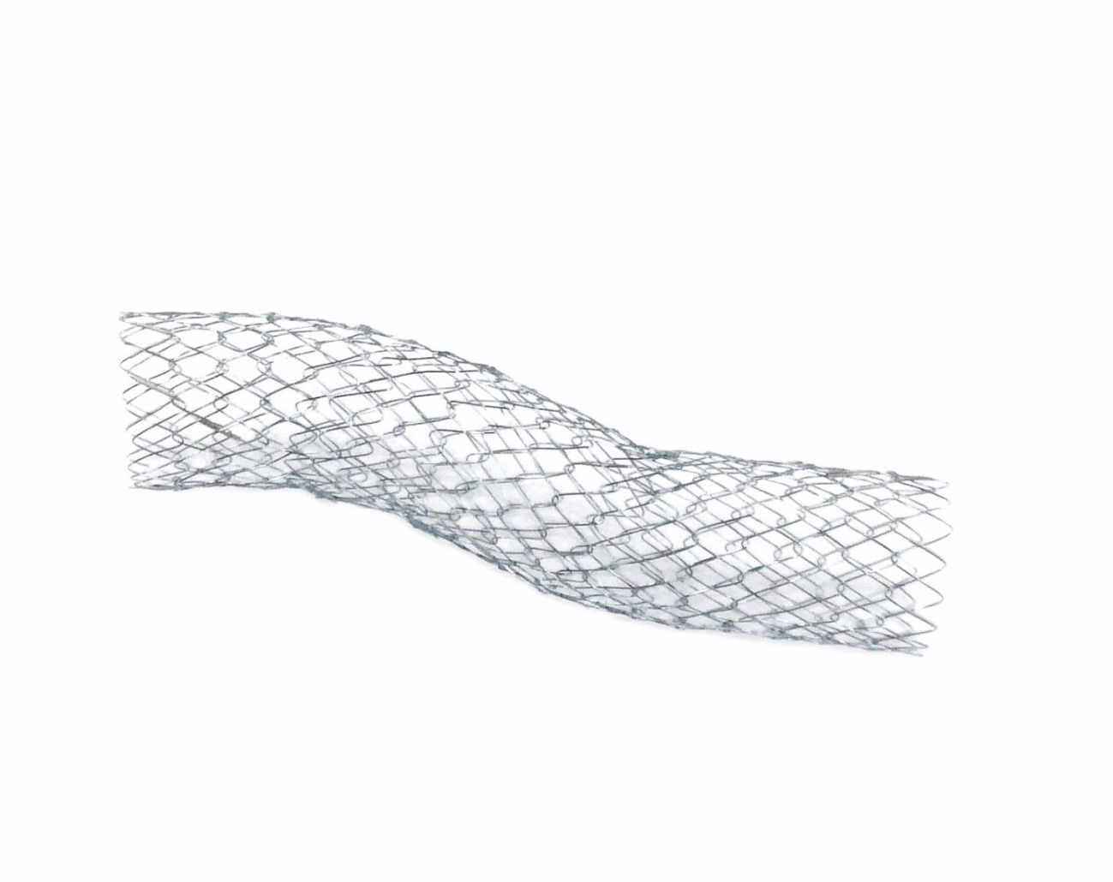

Figure 1 Niti-S 14 appearance with a braided structure made from nitinol, and a large diameter of 14 mm with a length of 60 or 80 mm.

A
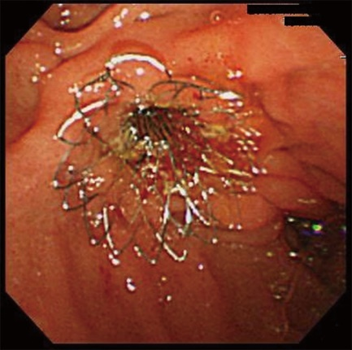
B
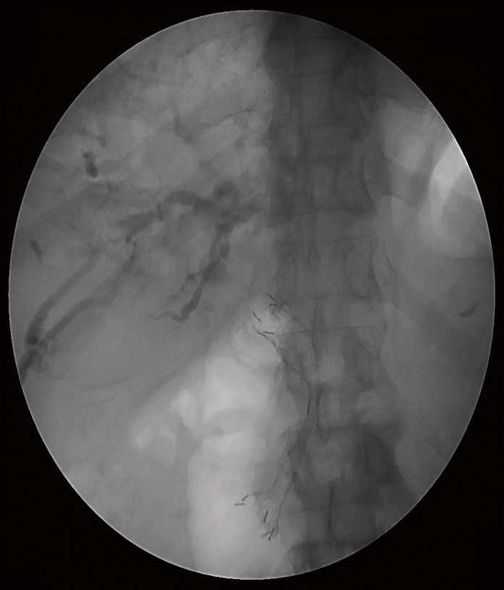
Figure 2 Stent placement of Niti-S 14 after sphincterotomy in pancreatic cancer. A: Endoscopic view; B: Picture of endoscopic retrograde pancreatocholangiography.

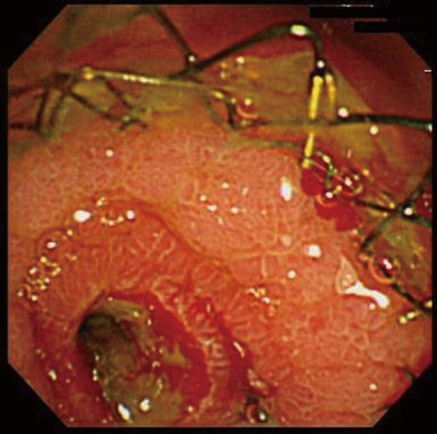

Figure 3 Endoscopic view of the duodenal major papilla after Niti-S 14 placement. The bile duct cavity is maintained despite bile duct mucosa or tumor growth into the stent.

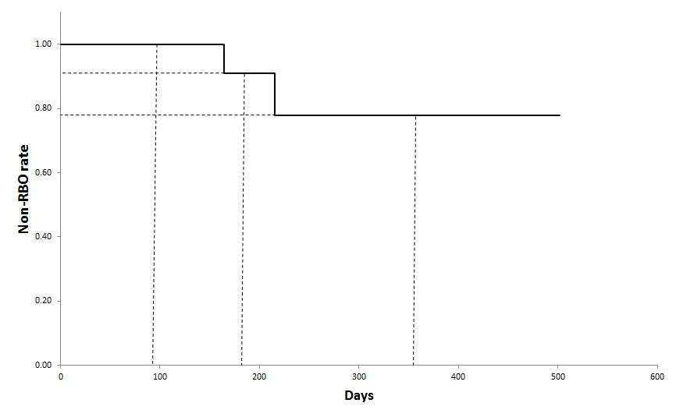

Figure 4 Kaplan-Meier analysis of stent patency. The non-RBO rates of 3, 6, and 12 mo were 100%, 91%, and 78%, respectively. RBO: Recurrent biliary obstruction.

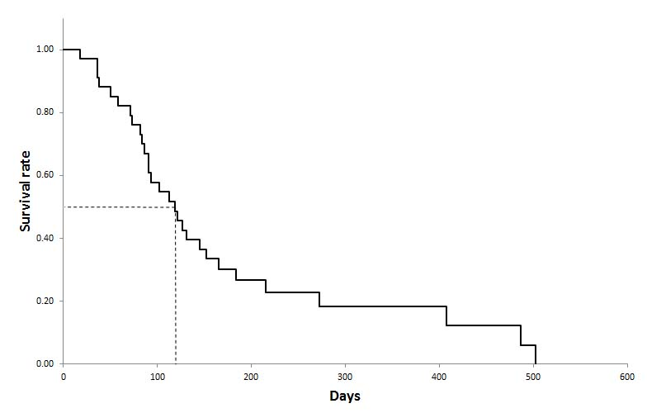
Figure 5 Kaplan-Meier analysis of survival. The median survival time was 120 d.

