Name of Journal: World Journal of Experiment Medicine
Manuscript NO: 48984
Manuscript Type: ORIGINAL ARTICLE

Basic Study
Localization of ATP-sensitive K⁺ channel subunits in rat liver

Zhou M et al. K_{ATP} channel subunits in rat liver

Ming Zhou, Kiwamu Yoshikawa, Hideo Akashi, Mitsutaka Miura, Ryoji Suzuki, Tao-Sheng Li, Hiroshi Abe, Yoshio Bando

Ming Zhou, Hideo Akashi, Ryoji Suzuki, Yoshio Bando, Department of Anatomy, Akita University Graduate School of Medicine, Akita 010-8543, Japan

Kiwamu Yoshikawa, Mitsutaka Miura, Department of Cell Biology and Morphology, Akita University Graduate School of Medicine, Akita 010-8543, Japan

Tao-Sheng Li, Department of Stem Cell Biology, Atomic Bomb Disease Institute, Nagasaki University, Nagasaki 852-8523, Japan

Hiroshi Abe, Department of Anatomy, TRUST, A Long-Term Care Health Facility, Sendai 980-0011, Japan

ORCID number: Ming Zhou (0000-0001-8775-9738); Kiwamu Yoshikawa (0000-0002-0053-6492); Hideo Akashi (0000-0001-8520-0252); Mitsutaka Miura (0000-0001-8454-8978); Ryoji Suzuki (0000-0003-4526-7406); Tao-Sheng Li (0000-0002-7653-8873); Hiroshi Abe (0000-0002-4683-4487); Yoshio Bando (0000-0002-2466-5248).

Author contributions: Zhou M did the main experiments, collected the data, and wrote the paper; Yoshikawa K and Miura M performed the experiment of primary culture for hepatic stellate cells and Kupffer cells; Akashi H and Suzuki R participated in treatment of animals; Li TS, Abe H, and Bando Y supervised the investigation and approved the manuscript for publication.

Supported by the Program of the network-type joint Usage/Research Center for Radiation Disaster Medical Science of Hiroshima University, Nagasaki University and Fukushima Medical University in the Key Project Issue Three: Basic Research on Radiation Development to Li TS and Zhou M, No. 147.

Institutional review board statement: This study was approved by the Animal Research Committee of Akita University.

Institutional animal care and use committee statement: All procedures involving animals were reviewed and approved by the Animal Research Committee of Akita University (a-1-2405).

Conflict-of-interest statement: Authors declare no conflicts of interest for this article.

Data sharing statement: No additional data are available.

ARRIVE guidelines statement: The authors have read the ARRIVE guidelines, and the manuscript was prepared and revised according to the ARRIVE guidelines.

Open-Access: This article is an open-access article which was selected by an in-house editor and fully peer-reviewed by external reviewers. It is distributed in accordance with the Creative Commons Attribution Non Commercial (CC BY-NC 4.0) license, which permits others to distribute, remix, adapt, build upon this work non-commercially, and license their derivative works on different terms, provided the original work is properly cited and the use is non-commercial. See: http://creativecommons.org/licenses/by-nc/4.0/

Manuscript source: Invited manuscript

Corresponding author: Ming Zhou, MD, PhD, Assistant Professor, Department of Anatomy, Akita University Graduate School of Medicine, 1-1-1 Hondo, Akita 010-8543, Japan. mzhou@med.akita-u.ac.jp
Telephone: +81-18-8846260
Fax: +81-18-8846440

Received: May 17, 2019
Peer-review started: May 20, 2019
First decision: August 2, 2019
Revised: September 5, 2019
Accepted: November 20, 2019
Article in press: November 20, 2019
Published online: December 19, 2019
Abstract
BACKGROUND
ATP-sensitive K⁺ (K_{ATP}) channels were originally found in cardiac myocytes by Noma in 1983. K_{ATP} channels were formed by potassium ion-passing pore-forming subunits (Kir6.1, Kir6.2) and regulatory subunits SUR1, SU2A and SUR2B. A number of cells and tissues have been revealed to contain these channels including hepatocytes, but detailed localization of these subunits in different types of liver cells was still uncertain.

AIM
To investigate the expression of K_{ATP} channel subunits in rat liver and their localization in different cells of the liver.

METHODS
Rabbit anti-rat SUR1 peptide antibody was raised and purified by antigen immunoaffinity column chromatography. Fifteen Sprague-Dawley rat were used in this study. Four of them were used for liver protein extraction for immunoblot analysis, seven of them were used for immunohistochemistry both for the ABC method and immunofluorescence staining, and four of them were used for the isolation of hepatic stellate cells (HSCs) and Kupffer cells for both primary culture and immunocytochemistry.

RESULTS
Immunoblot analysis showed that the five kinds of K_{ATP} channel subunits, i.e. Kir6.1, Kir6.2, SUR1, SUR2A, and SUR2B, were detected in liver. Immunohistochemical staining showed that Kir6.1 and Kir6.2 were weakly to moderately expressed in parenchymal cells and sinusoidal lining cells, while SUR1, SUR2A, and SUR2B were mainly localized to sinusoidal lining cells, such as HSCs, Kupffer cells, and sinusoidal endothelial cells. Immunoreactivity for SUR2A and SUR2B was expressed in the hepatocyte membrane. Double immunofluorescence staining further showed that the pore-forming subunits Kir6.1 and/or Kir6.2 colocalized with GFAP in rat liver sections and primary cultured HSCs. These K_{ATP} subunits also colocalized with CD68 in liver sections and primary cultured Kupffer cells. The SUR subunits colocalized with GFAP in liver sections and colocalized with CD68 both in liver sections and primary cultured Kupffer cells. In addition, five K_{ATP} channel subunits colocalized with SE-1 in sinusoid endothelial cells.

CONCLUSION
Observations from the present study indicated that K_{ATP} channel subunits expressed in rat liver and the diversity of K_{ATP} channel subunit composition might form different types of K_{ATP} channels. This is applicable to hepatocytes, various types of Kupffer cells and sinusoidal endothelial cells.

Key words: ATP-sensitive K⁺ channel; Liver; Hepatic stellate cells; Kupffer cells; Sinusoidal endothelial cells; Rat

© The Author(s) 2019. Published by Baishideng Publishing Group Inc. All rights reserved.

Core tip: ATP-sensitive K⁺ (K_{ATP}) channels have been found to be ubiquitously distributed in a variety of cell types and tissues, but the present study revealed that five kinds of K_{ATP} channel subunits are expressed in rat liver by applying western blot analysis, immunohistochemistry, and immunocytochemistry of rat liver tissue and primary cultured cells. These K_{ATP} channel subunits were not only localized in hepatocytes but also in sinusoidal cells, such as hepatic stellate cells, Kupffer cells, and sinusoidal endothelial cells. This was demonstrated using special marker labelling, such as GFAP for hepatic stellate cells, CD68 for Kupffer cells, and SE-1 for sinusoidal endothelial cells. The wide diversity of K_{ATP} channel subunit compositions in rat liver might correspond to their various functions in hepatocytes and sinusoidal cells.

Citation: Zhou M, Yoshikawa K, Akashi H, Miura M, Suzuki R, Li TS, Abe H, Bando Y. Localization of ATP-sensitive K⁺ channel subunits in rat liver. World J Exp Med 2019; 9(2): 14-31
URL: https://www.wjgnet.com/2220-315X/full/v9/i2/14.htm
DOI: https://dx.doi.org/10.5493/wjem.v9.i2.14
INTRODUCTION
ATP-sensitive K⁺ (K_{ATP}) channels were found ubiquitously distributed in a variety of cells and tissues^{[1]}, such as pancreatic β cells^{[2-5]}, skeletal muscle^{[6]}, neurons and glial cells^{[7-9]}, kidney^{[10-13]}, and liver^{[14,15]}. K_{ATP} channels close at high concentrations of intracellular ATP and open at low concentrations during ischemia^{[7,16-18]}, and couple altered energy metabolism with membrane potential^{[19,20]}. K_{ATP} channels are hetero-octamers composed of two kinds of subunits: the four pore-forming subunit Kir6.x (Kir6.1 or Kir6.2), and the four regulatory subunit sulfonylurea receptor SUR (SUR1, SUR2A, or SUR2B)^{[21-24]}. Their physiological and pharmacological functions depend on their subunit compositions^{[25-27]}. In the hypothalamus, glucose homeostasis is controlled by glucagon and catecholamine, which are counter-regulatory hormones, and these functions are involved with K_{ATP} channels^{[26,28]}. The liver is also an organ that directly takes part in glucose metabolism with changes in intracellular (ATPi) concentrations during which K_{ATP} channels are quite sensitive. Although the mRNA of K_{ATP} channels in liver is detected by northern blot analysis^{[14]}, K_{ATP} channels play roles in regulating hepatocyte proliferation in primary rat hepatocytes^{[29]}. There are no detailed references on the localization of K_{ATP} channel molecules and their functions in the liver with respect to hepatocytes, hepatic stellate cells (HSCs), Kupffer cells, and sinusoidal endothelial cells (SECs). In addition to glucose metabolism, the liver has important functions in regeneration after injury and partial hepatectomy, as well as some functions of immune defense because of Kupffer cells. HSCs are localized between SECs and hepatocytes, and are activated during liver injury, producing many growth factors, chemokines, and cytokines, and also excessive extracellular matrix. They are also known as one of the reasons for hepatic fibrosis after liver injury recovery^{[30-33]}. We are interested in clarifying the relationships between K_{ATP} channel subunits and hepatocytes, Kupffer, HSCs, and SECs in the liver during normal and pathological conditions.
Since there is no detailed information on the localization of K_{ATP} channel molecules in the liver with respect to different cells, we focused on the expression and localization of these K_{ATP} channel subunits in liver, and supply morphological data to help understand what functions they could play in parenchymal and non-parenchymal cells.

MATERIALS AND METHODS
Animals and tissue preparation
Sprague-Dawley rats (4-8 wk) were supplied by CLEA Japan Inc. (Tokyo, Japan). This study was conducted according to the protocols of the Animal Research Committee of Akita University. We handled the animals according to the Guidelines of Akita University for Animal Experimentation. Rats used in this study were kept under constant environmental conditions in group cages (2-3 rats per cage) with 12 h light/dark cycles, and normal food and water were given.
Rats under deep anesthesia were perfused through the left ventricle with cold Zamboni fixatives (2 g paraformaldehyde solved in 15 mL of saturated picric acid and Karasson Schwlt’s phosphate buffer solution added to make 100 mL). Liver tissue blocks were taken and further fixed in the same fixative for 6 h at 4 °C, and then changed to 30% sucrose in PBS until they sank to the bottom. No-fixed live tissue was also taken for GFAP immunostaining. Cryosections were cut 10 µm thick with a Leica CM1950 cryostat, thaw-mounted on glass slides (MAS-coated, Matsunami Industries, Kishiwada, Japan) and stored at -20 °C before use. Liver samples for immunoblot analysis was directly taken out without fixation, put into dry ice powder, and stored at ­80 °C until use.

Preparation of hepatic stellate cells and Kupffer cells
Male Wistar rats (400-500 g body mass), maintained on a normal chow diet, were used. Rats were perfused via the portal vein in situ with pre-perfusion solution (Ca²⁺/Mg²⁺-free Hanks’ balanced salt solution (HBSS) containing 10 mM hydroxyethyl piperazine ethanesulfonic acid (HEPES), 0.5 mM EGTA, 4.2 mM NaHCO₃, and 5 mM glucose; pH 7.2) for 5 min at 37 °C, followed by collagenase solution (HBSS) containing 10 mM HEPES, 5 mM CaCl₂, 4.2 mM NaHCO₃, and 0.5 mg/mL bacterial collagenase; pH 7.5) for 15 min at 37 °C at a flow rate of 15 mL/min. Liver digested by collagenase solution was excised, dispersed, and filtered through stainless mesh. Isolation of HSCs and Kupffer cells was performed based on cell size and density^{[34]}. To eliminate most of the parenchymal cells, the cell suspension was centrifuged at 50 × g for 1 min. The supernatant was further centrifuged at 50 × g for 3 min. The supernatant of the second run was centrifuged at 400 × g for 5 min to pellet non-parenchymal cells. The non-parenchymal cells in the pellet were further centrifuged at 700 × g for 30 min in 25% (v/v) Percoll PLUS solution (GE Healthcare Bio-Sciences, Piscataway, NJ, United States). HSCs were enriched in the supernatant, and Kupffer cells were mostly enriched in the pellet with other types of cells. The supernatant liquid enriched in HSCs was diluted with 2 volumes of Dulbecco’s modified Eagle’s medium (DMEM) and centrifuged at 400 × g for 5 min to wash out Percoll PLUS. All centrifugations were performed at 4 °C. The cell fractions enriched in HSCs and Kupffer cells were suspended in culture media (DMEM containing 10% FBS, 100 U/mL penicillin, and 100 µg/mL streptomycin), and then plated on glass-bottom dishes coated with poly-L-lysine (Matsunami Glass, Osaka, Japan). Twelve to sixteen hours later, the cells were washed to remove debris, and then used for immunocytochemistry.

Generation of SUR1 antibody
Rabbit anti-rat SUR1 antibody was generated by immunization with a synthetic 22-mer peptide, NH2-DSALVLSPAARNCSLSQECALD-(OH) (Biologica Co. Nagoya, Japan), which corresponds to amino acid residues of 1038-1059 of rat SUR1 (GenBank Accession No. L40624). Antiserum was purified by peptide antigen immunoaffinity column chromatography.

Western blot analysis
SDS/PAGE was performed as the procedure of Laemmli. Proteins were treated with modified sample buffer (125 mM Tris-HCl, pH 6.8, 2% SDS, 25% glycerol, 0.01% Bromophenol blue, and 10% 2-mercaptoethanol). After electrophoresis, proteins (10 µg/lane) were subsequently transferred to a polyvinylidene difluoride (PVDF) membrane (NENTM Life Science, Boston, MA, United States) using a semi-dry transfer unit (Hoefer TE70 series; Amersham Pharmacia Biotechnology, Little Chalfont, Buckinghamshire, England). After blocking with 5% BLOT-QuickBlocker (Chemicon International, Inc., Temecula, CA, United States) in PBS at room temperature overnight, immunoblotting was carried out by incubating the PVDF membranes with polyclonal goat anti-human Kir6.1 and/or Kir6.2 (Santa Cruz Biotechnology) and rabbit anti-rat SUR1, SUR2A and/or SUR2B antibody^{[35]}, each diluted to 1:1000, respectively, for 1 h at room temperature. Following thorough washing with PBS-T, the PVDF membranes were then incubated with HRP-conjugated donkey anti-rabbit IgG (NA9340; Amersham Pharmacia Biotechnology, England), or HRP-conjugated donkey anti-goat IgG (AP180P), each diluted 1:3000. Signals were visualized with chemiluminescence detection reagents (Amersham Pharmacia Biotechnology, England), and PVDF membranes were exposed to XOMAT film (Eastman Kodak, Rochester, NY, United States) in the dark room. Negative controls and specificity verification of the SUR1 antibody were performed using the antigen peptide preabsorption test.

Immunohistochemistry
After air drying for 30 min, cryosections of liver were treated with 0.3% Tween-20 in PBS for 45 min at room temperature. Sections were blocked either with 5% normal rabbit serum or 5% normal goat serum for 30 min, and then incubated with goat anti-human Kir6.1 (Santa Cruz Biotechnology), goat anti-human Kir6.2 (Santa Cruz Biotechnology), and rabbit anti-rat SUR1, SUR2A, and/or SUR2B, each diluted at 1:500. After washing with PBS three times, the biotinylated rabbit anti-goat IgG, or biotinylated goat anti-rabbit IgG, were applied to sections. As a negative control, the immunoreactive solution was prepared without the primary antibody, and an absorption test was also confirmed by pre-incubation with peptide antigens.
To show whether the pore-forming subunits Kir6.1 and/or Kir6.2 are colocalized with the regulatory subunits SUR1, SUR2A and/or SUR2B in the liver, sections were incubated with a mixture of goat anti-human Kir6.1 and rabbit anti-rat SUR1, and/or anti-rat SUR2A, and/or SUR2B; or a mixture of goat anti-human Kir6.2 with rabbit anti-rat SUR1, SUR2A and/or SUR2B antibody, each diluted 1:500, respectively, for 12 h at room temperature. Sections were then incubated with a mixture of Alexa488-conjugated donkey anti-goat IgG (A21432; Molecular Probes, Inc., Eugene, OR) and Alexa594-conjugated donkey anti-rabbit IgG (A21207; Molecular Probes, Inc., Eugene, OR), each diluted 1:200.
To determine whether the K_{ATP} channel subunit molecules colocalize with HSCs, Kupffer cells and/or SECs, sections were incubated with a mixture of mouse anti-GFAP (marker of HSCs), or incubated with a mixture of mouse anti-CD68 (marker of Kupffer cells), and/or incubated with a mixture of mouse anti-SE-1 antibody (marker of SEs) and one of the K_{ATP} channel subunit antibodies, such as goat anti-human Kir6.1, goat anti-human Kir6.2, rabbit anti-rat SUR1, rabbit anti-rat SUR2A, and/or rabbit anti-rat SUR2B, respectively, each diluted 1:200. After thoroughly washing with PBS, the liver sections were then incubated for 30 min with a mixture of the appropriate fluorescent Alexa 488 or Alexa 594-conjugated secondary antibodies (Molecular Probes, Inc., Eugene, OR) each diluted 1:200. Finally, the sections stained above were mounted with aqueous mounting medium (Thermo, Pittsburgh, PA, United States).
Primary cultured HSCs and Kupffer cells were fixed with Zamboni’s fixatives for 5 min and then double immunofluorescent staining was carried out as (1) mouse anti-GFAP with one of the antibodies of the pore-forming subunits Kir6.1 and/or Kir6.2, and/or one of the antibodies of the regulatory subunits SUR1, SUR2A and/or SUR2B; (2) mouse anti-CD68 with one of the antibodies of goat anti-human Kir6.1, and/or Kir6.2, and rabbit anti-rat SUR1, SUR2A and/or SUR2B; (3) goat anti-human Kir6.1 or Kir6.2 with one of the antibodies of rabbit anti-rat SUR1, SUR2A, and/or SUR2B. After thoroughly washing with PBS, the dishes were incubated for 30 min with the appropriate fluorescent Alexa 488- or Alexa 594-conjugated secondary antibodies (Molecular Probes, Inc., Eugene, OR) each diluted 1:200. Fluorescence image signals were acquired using an Olympus microscope (DP7; Tokyo, Japan) and a laser scanning confocal microscope (LSM 510; Carl Zeiss, Germany).

RESULTS
Expression of K_{ATP} channel subunits in rat liver
Immunoblot analysis demonstrated that Kir6.1, Kir6.2, SUR2A and SUR2B were expressed in rat liver (Figure 1A). For the anti-SUR1 antibody, immunoblot analysis showed that the molecular weight of SUR1 was about 100 kDa with some weak small bands below. After preincubation with immunizing peptide from which the antibody was raised, the SUR1 band disappeared (Figure 1B, +peptide).
Immunohistochemistry revealed that immunoreactivity for Kir6.1 was widely and weakly observed in hepatocytes in the hepatic lobules (Figure 2A), as well as in the endothelia of the central vein, the branches of the hepatic artery, and the portal vein at the portal area (Figure 2C). The intensity of immunoreactivity was gradually decreased along the liver plate from the central vein to the distal area (Figure 2A). Weak immunoreactivity for Kir6.1 was expressed in the cell membrane and cytoplasm of hepatocytes. Under high magnification, the Kir6.1 protein was observed as punctate immunoreactive products in the cytoplasm of liver cells and sinusoidal lining cells (Figure 2B). When the anti-Kir6.1 antibody was omitted or preincubated with antigen peptide, significant immunoreactivity could not be observed (Figure 2D).
Immunoreactivity for Kir6.2 was also weakly distributed in the hepatic lobule (Figure 3A) and in the endothelium of the central vein, the branches of the hepatic artery and the portal vein in the portal area (Figure 3C). The intensity of immunoreactivity was gradually decreased along the liver plate (Figure 3A and B). Weak immunoreactivity for Kir6.2 was expressed in the cell membrane and cytoplasm of hepatocytes. Under high magnification, the immunoreactive products for Kir6.2 could be observed as rough granules in the cytoplasm of hepatocytes and sinusoidal lining cells (Figure 3B). When the anti-Kir6.2 antibody was omitted or pre-incubated with immunizing antigen peptides, no significant immunoreactivity could be observed (Figure 3D).
Immunoreactivity for SUR1 was quite different from that for Kir6.1 and Kir6.2. Moderate immunoreactivity for SUR1 was distributed in small sinusoidal lining cells with round, ovular, or spindle shapes beside the liver plate (Figure 4A and B), and also in the endothelial cells of the branches of hepatic artery and portal veins at the portal area (Figure 4C). The intensity was not decreased along the liver plate. In hepatocytes, the immunoreactivity for SUR1 was hardly observed in the cytoplasm, and only faintly in the cell membrane (Figure 4B). When the anti-SUR1 antibody was omitted or preincubated with immunizing peptide antigen, the positive immunoreactivity disappeared (Figure 4D).
Immunoreactivity for SUR2A was distributed in the hepatic lobule with moderate intensity around the central vein (Figure 5A), and gradually attenuated along the liver plate. It was mainly localized in irregular- or spindle-shaped cells in the sinusoidal lining (Figure 5B). Weak immunoreactivity for SUR2A was expressed in the cell membrane of hepatocytes. In the portal area, it was weakly expressed in the branches of hepatic arteries and portal veins (Figure 5C).
Immunoreactivity for SUR2B was widely and weakly distributed in the hepatic lobule (Figure 6A). It was mainly localized in small round or oval-shaped cells in the sinusoidal lining. Weak immunoreactivity for SUR2B was expressed in the cell membrane of hepatocytes (Figure 6B). The intensity of immunoreactivity was gradually decreased along the liver plate from the central vein to the distal area (Figure 6A). In the portal area, it was moderately expressed in the branches of the hepatic artery and portal vein, and was especially intense in the bile duct (Figure 6C). When the anti-SUR2A or anti-SUR2B antibodies were omitted or preincubated with each immunizing peptide antigen, the immunoreactivity for SUR2A and/or SUR2B disappeared (Figures 5D and 6D).

Colocalization among K_{ATP} channel subunits and sinusoidal cell marker proteins
To show if pore-forming subunits are co-localized with regulatory subunits in rat liver, immunofluorescence double staining was performed. Positive immunoreactivity of Kir6.1 (Kir6.1⁺) and Kir6.2 (Kir6.2⁺) was detected as green fluorescence (Alexa488, Figures 7A, 7D, 8A, 8D, 9A and 9D), and that of SUR1 (SUR1⁺), SUR2A (SUR2A⁺) and SUR2B (SUR2B⁺) was detected as red fluorescence (Alexa594, Figures 7B, 7E, 8B, 8E, 9B, and 9E). In hepatocytes, Kir6.1⁺ and/or Kir6.2⁺ were hardly observed to be colocalized with SUR1⁺, SUR2A⁺, and/or SUR2B⁺. Instead, in a small number of round, oval, or spindle-shaped cells located beside the sinusoid, Kir6.1⁺ and/or Kir6.2⁺ cells were colocalized with that for SUR1, SUR2A, and/or SUR2B (Figures 7C, 7F, 8C, 8F, 9C, and 9F). When labeled by GFAP, a marker of HSCs, some of the Kir6.1⁺ and/or Kir6.2⁺ cells were colocalized with GFAP positive (GFAP⁺) cells beside the sinusoid (Figure 10). GFAP⁺ cells were also colocalized with SUR1⁺, SUR2A⁺, and SUR2B⁺ cells in the sinusoidal lining (Figure 10). When labeled with CD68, a marker of Kupffer cells, a few CD68⁺ cells were colocalized with Kir6.1⁺ and Kir6.2⁺ cells, and more of these small CD68⁺ cells were colocalized with SUR1, SUR2A and SUR2B (Figure 11).
Similarly, when labeled with SE-1, a marker of SECs, a few SE-1⁺ cells colocalized with Kir6.1⁺, SUR1⁺, and SUR2B⁺ cells. On the other hand, a number of SE-1⁺ cells colocalized with Kir6.2⁺ and sur2A⁺ cells, respectively (Figure 12).
Primary HSCs were labeled with GFAP antibody. GFAP⁺ cells also showed positive immunoreactivity for Kir6.1 and/or Kir6.2 (Figure 13). This result indicated that the pore-forming subunits of the K_{ATP} channel were expressed in HSCs. In these HSCs, immunoreactivity for Kir6.1 and Kir6.2 were located in the peripheral cytoplasm, and that for GFAP was located in the perinuclear region. Colocalization of SURs and GFAP in primary HSCs has not been observed.
Primary Kupffer cells showed immunoreactivity for CD68, which confirmed them to be Kupffer cells. When incubating these cells with antibodies of K_{ATP} channel subunits, the CD68⁺ cells showed immunopositive reactivity for Kir6.1, Kir6.2 SUR1, SUR2A, and SUR2B (Figure 14).
Furthermore, when primary Kupffer cells were incubated with multiple paired combined antibodies of pore-forming subunits and regulatory subunits, they showed immunoreactivity for Kir6.1/SUR1, Kir6.1/SUR2A, Kir6.1/SUR2B, Kir6.2/SUR1, Kir6.2/SUR2A, and Kir6.2/SUR2B (Figure 15). The immunoreactive products for K_{ATP} channel subunits exhibited a punctate or granular appearance.

DISCUSSION
In this study, a new polyclonal anti-SUR1 antibody was generated and applied to investigate the exhibition and localization of SUR1 in rat liver. Its specificity was assessed by preabsorption with an immunizing peptide antigen in western blot analysis (Figure 1B). The most significant band at 100 kDa disappeared in the presence of the immunizing antigen, showing the high specificity of the antiserum. The specificity of the antisera for SUR2A and SUR2B was demonstrated elsewhere^{[35]}. The expression of five kinds of K_{ATP} channel subunits in rat liver extract was revealed by western blot analysis with the antibodies, including this new anti-SUR1, and every antibody revealed their corresponding band in the liver extract, respectively (Figure 1). This means that the rat liver contains five kinds of K_{ATP} channel subunits: Kir6.1, Kir6.2, SUR1, SUR2A, and SUR2B.
In liver sections, immunoreactivity for Kir6.1, Kir6.2, SUR2A and SUR2B was weakly to moderately expressed around the central vein and gradually decreased along the liver plate (Figures 2, 3, 5 and 6), but the immunoreactivity for SUR1 showed no such tendency (Figure 4). The Kir6.1 and Kir6.2 pore-forming subunits of the K_{ATP} channel were weakly expressed in hepatocytes and sinusoidal lining cells, such as HSCs, Kupffer cells and SECs. Under high magnification, the Kir6.1 protein was detected as punctate immunoreactive products (Figure 2B) and the Kir6.2 protein was detected as granular immunoreactive products, indicating that Kir6.1 was located in the mitochondria and Kir6.2 in the endoplasmic reticulum, as shown in previous studies on rat brain^{[8,9]}. The regulatory subunits SUR1, SUR2A, and SUR2B were mainly located in small cells, and exhibited staining in sinusoidal cells and weak staining in the cell membrane of hepatocytes.
The K_{ATP} channels play important roles in hyperglycemia, hypoglycemia, ischemia and hypoxia^{[16,36]}. Kir6.1 mRNA and protein are upregulated during myocardial infarction^{[17,37,38]}. When the liver is in ischemia followed by reperfusion, hepatocytes around the central veins were more markedly degenerated than those in the peripheral zone of the liver lobule^{[38]}. During liver ischemia, the different degenerated zonal areas are accordant with the liver blood supply being made up of different gradients of oxygen, hormones, and metabolites, as well as zonal differences form periportal to perivenous^{[39,40]}. The similar zonal differences in immunoreactivity for Kir6.1, Kir6.2, SUR2A, and SUR2B might indicate that these subunits of K_{ATP} channels have some relationship with the protection of hepatocytes, though colocalization of these subunits was hardly observed in the sections of normal rat liver. K_{ATP} channels are important in liver regeneration for keeping a higher ATP content in liver tissue during partial hepatectomy^{[15]} since, clinically, hepatocyte regeneration is a key point for partial liver transplantation.
It is well known that, in addition to parenchymal cells, the liver consists of three other kinds of cells, i.e. HSCs, Kupffer cells, and SECs^{[41]}. HSCs are located between hepatocytes and SECs^{[31]}. They store large amounts of vitamin A and produce extracellular matrix for liver fibrogenesis^{[31,41]}. The pore-forming subunits (Kir6.1 and Kir6.2) were clearly colocalized in HSCs with GFAP both in liver sections and primary cells (Figures 10 and 13). Although the regulatory subunits (SURs) were not yet observed in primary HSCs, they were colocalized in HSCs with GFAP in liver sections (Figure 11). These results might indicate that the K_{ATP} channels have some relation to HSC matrix secretion and fibrogenesis.
In addition to the metabolism of glucose, lipids, hormones, and various substances, the liver also plays important roles in the immune response to eliminate pathogens, such as microorganisms, endotoxins, portal antigens, and tumor cells, and Kupffer cells are responsible for these crucial functions of host defense^{[42]}. There are several subsets of Kupffer cells categorized by the cytokines they produce, such as CD11b⁺, CD68⁺, CD11b⁻ and/or CD68⁻, CD32, and so on^{[40,43]}. Kupffer cells can also be divided into two groups: bone marrow-derived macrophages and sessile hepatic macrophages. These different groups of Kupffer cells play different roles in the liver. For instance, when mice were given food with high-fat or high-cholesterol, CD68⁺ Kupffer cells decreased while CD11b⁺ Kupffer cells increased in number^{[40]}. K_{ATP} channels exhibit different physiological and pharmacological functions depending on their subunit composition^{[26]}. For example, Kir6.2 with SUR1 is strongly sensitive to the K_{ATP} channel activator diazoxide, but not to other activators such as pinacidil^{[25]}, while Kir6.2 with SUR2A is strongly sensitive to pinacidil and cromakalin but only weakly to diazoxide^{[26]}. The diversity of subunit composition of K_{ATP} channels in Kupffer cells might correspond to different types of Kupffer cells or to their various functional stages.
In SECs, SE-1 immunopositive cells were colocalized in different numbers with the five kinds of K_{ATP} channel subunits, respectively (Figure 12). It is well known that SECs are highly specialized endothelial cells (with different classifying types) located between blood, hepatocytes and HSCs^{[31]}. In the physiological state, SECs have a low proliferation rate. They maintain HSC quiescence, thus inhibiting intrahepatic vasoconstriction and fibrosis development under normal conditions. They are also differentially renewable under physiological and pathological conditions^{[44]}. They are also involved in liver regeneration following acute liver injury and partial hepatectomy^{[45]}. They play a key role in promoting liver regeneration by orchestrating the harmonious regeneration of the different cell types and renew themselves with asynchronous liver regeneration^{[44]}. In the present study, SECs showed different combinations of Kir6.x and SURs, which indicates that they have multiple kinds of K_{ATP} channels corresponding with their multiple functions under physiological and pathological conditions.
The present study is, to our knowledge, the first report that HSCs, Kupffer cells and SECs contain K_{ATP} channel subunits. Further investigation is needed to elucidate their functions in detail in liver metabolism, immunity, and fibrogenesis during liver injury.

ARTICLE HIGHLIGHTS
Research background
ATP-sensitive K⁺ (K_{ATP}) channels coupling nutrient metabolism to membrane potential are sensitive to intracellular ATP concentrations and ATP/ADP ratios. K_{ATP} channels are hetero-octameric in composition, formed by four pore-forming subunits including Kir6.1 and Kir6.2, which belong to the inward rectifying potassium channel family, and four regulatory subunits, SUR1, SUR2A and SUR2B, which belong to members of the ATP-binding cassette protein family. K_{ATP} channels were considered to be involved in cellular functions, such as pancreatic B cell secretion, muscle and neuronal excitability, and so on.

Research motivation
How K_{ATP} channels work in liver hepatocytes and sinusoidal cells is important to help understand liver function under normal and injury conditions. The first step is to characterize the localization and distribution of K_{ATP} channel subunits in different cells of the liver. This research focused on the localization and distribution of K_{ATP} channel subunits in hepatocytes and sinusoidal cells of rat liver. This research will provide the basic data to guide further research in medicine exploitation and clinical treatment for related liver diseases.

Research objectives
To investigate the expression of K_{ATP} channel subunits in rat liver and their localization in different cells of the liver.

Research methods
In order obtain basic knowledge of K_{ATP} channel subunits in rat liver distribution and localization, extracted liver protein was used for immunoblot analysis, cryosections of liver were used for immunohistochemistry, and primary cultured hepatic stellate cells (HSCs) and Kupffer cells were used for immunocytochemistry.

Research results
In the present study, five types of K_{ATP} channel subunits, including Kir6.1, Kir6.2, SUR1, SUR2A and SUR2B, were expressed in rat liver as revealed by immunoblot analysis and immunohistochemistry. Double immunofluorescence staining of cryosections, primary cultured HSCs and Kupffer cells showed that not only hepatocytes, but also HSCs, Kupffer cells and sinusoidal endothelial cells (SECs) contain K_{ATP} channel subunits.

Research conclusions
The present study revealed that K_{ATP} channel subunits are expressed in rat liver, which is the first report that HSCs, Kupffer cells and SECs contain K_{ATP} channel subunits formed by Kir6.1/SUR1, Kir6.1/SUR2A, Kir6.1/SUR2B, Kir6.2/SUR1, Kir6.2/SUR2A, and Kir6.2/SUR2B. Different combinations of K_{ATP} channels have different physiological and pharmacological characteristics. Thus, this research will supply basic experimental data to guide further exploration of liver function under normal and injury conditions.

Research perspectives
In the present study, all experiments were performed under normal conditions. Thus, further study is needed to elucidate changes in K_{ATP} channel subunit composition under different metabolic states, including ischemia and hypoxia in vitro and/or in vivo with the use of K_{ATP} channel openers and blockers, such as diazoxide, pinacidil, glibenclamide, and tolbutamide.
REFERENCES
1 Inagaki N, Inazawa J, Seino S. cDNA sequence, gene structure, and chromosomal localization of the human ATP-sensitive potassium channel, uKATP-1, gene (KCNJ8). Genomics 1995; 30: 102-104 [PMID: 8595887 DOI: 10.1006/geno.1995.0018]
2 Aguilar-Bryan L, Clement JP 4th, Gonzalez G, Kunjilwar K, Babenko A, Bryan J. Toward understanding the assembly and structure of KATP channels. Physiol Rev 1998; 78: 227-245 [PMID: 9457174 DOI: 10.1152/physrev.1998.78.1.227]
3 Ashcroft FM, Kakei M, Kelly RP. Rubidium and sodium permeability of the ATP-sensitive K+ channel in single rat pancreatic beta-cells. J Physiol 1989; 408: 413-429 [PMID: 2674421 DOI: 10.1113/jphysiol.1989.sp017467]
4 Ashcroft SJ, Ashcroft FM. Properties and functions of ATP-sensitive K-channels. Cell Signal 1990; 2: 197-214 [PMID: 2119205 DOI: 10.1016/0898-6568(90)90048-F]
5 Aizawa T, Asanuma N, Terauchi Y, Suzuki N, Komatsu M, Itoh N, Nakabayashi T, Hidaka H, Ohnota H, Yamauchi K, Yasuda K, Yazaki Y, Kadowaki T, Hashizume K. Analysis of the pancreatic beta cell in the mouse with targeted disruption of the pancreatic beta cell-specific glucokinase gene. Biochem Biophys Res Commun 1996; 229: 460-465 [PMID: 8954920 DOI: 10.1006/bbrc.1996.1826]
6 Inagaki N, Gonoi T, Clement JP, Wang CZ, Aguilar-Bryan L, Bryan J, Seino S. A family of sulfonylurea receptors determines the pharmacological properties of ATP-sensitive K+ channels. Neuron 1996; 16: 1011-1017 [PMID: 8630239 DOI: 10.1016/S0896-6273(00)80124-5]
7 Akaike N, Jin YH, Koyama S. Functional interaction between Na(+)-K+ pump and KATP channels in the CNS neurons under experimental brain ischemia. Jpn J Physiol 1997; 47 Suppl 1: S50-S51 [PMID: 9266329]
8 Zhou M, Tanaka O, Sekiguchi M, Sakabe K, Anzai M, Izumida I, Inoue T, Kawahara K, Abe H. Localization of the ATP-sensitive potassium channel subunit (Kir6. 1/uK(ATP)-1) in rat brain. Brain Res Mol Brain Res 1999; 74: 15-25 [PMID: 10640672 DOI: 10.1016/S0169-328X(99)00232-6]
9 Zhou M, Tanaka O, Suzuki M, Sekiguchi M, Takata K, Kawahara K, Abe H. Localization of pore-forming subunit of the ATP-sensitive K(+)-channel, Kir6.2, in rat brain neurons and glial cells. Brain Res Mol Brain Res 2002; 101: 23-32 [PMID: 12007828 DOI: 10.1016/S0169-328X(02)00137-7]
10 Anzai N, Kawahara K, Sakai T, Komatsu Y, Inagaki N, Seino S. Localization of the inward rectifier subunit ukatp-1 (kir6.1) in adult rat kidney. J Am Soc Nephrol 1996; 7: 1275
11 Kawahara K, Anzai N. Potassium transport and potassium channels in the kidney tubules. Jpn J Physiol 1997; 47: 1-10 [PMID: 9159639 DOI: 10.2170/jjphysiol.47.1]
12 Zhou M, He HJ, Suzuki R, Tanaka O, Sekiguchi M, Yasuoka Y, Kawahara K, Itoh H, Abe H. Expression of ATP sensitive K+ channel subunit Kir6.1 in rat kidney. Eur J Histochem 2007; 51: 43-51 [PMID: 17548268]
13 Zhou M, He HJ, Tanaka O, Suzuki R, Sekiguchi M, Yasuoka Y, Kawahara K, Itoh H, Abe H. Localization of the sulphonylurea receptor subunits, SUR2A and SUR2B, in rat renal tubular epithelium. Tohoku J Exp Med 2008; 214: 247-256 [PMID: 18323694 DOI: 10.1620/tjem.214.247]
14 Inagaki N, Tsuura Y, Namba N, Masuda K, Gonoi T, Horie M, Seino Y, Mizuta M, Seino S. Cloning and functional characterization of a novel ATP-sensitive potassium channel ubiquitously expressed in rat tissues, including pancreatic islets, pituitary, skeletal muscle, and heart. J Biol Chem 1995; 270: 5691-5694 [PMID: 7890693 DOI: 10.1074/jbc.270.11.5691]
15 Nakagawa Y, Yoshioka M, Abe Y, Uchinami H, Ohba T, Ono K, Yamamoto Y. Enhancement of liver regeneration by adenosine triphosphate-sensitive K⁺ channel opener (diazoxide) after partial hepatectomy. Transplantation 2012; 93: 1094-1100 [PMID: 22466787 DOI: 10.1097/TP.0b013e31824ef1d1]
16 Yokota R, Tanaka M, Yamasaki K, Araki M, Miyamae M, Maeda T, Koga K, Yabuuchi Y, Sasayama S. Blockade of ATP-sensitive K+ channels attenuates preconditioning effect on myocardial metabolism in swine: myocardial metabolism and ATP-sensitive K+ channels. Int J Cardiol 1998; 67: 225-236 [PMID: 9894703 DOI: 10.1016/S0167-5273(98)00257-5]
17 Akao M, Otani H, Horie M, Takano M, Kuniyasu A, Nakayama H, Kouchi I, Murakami T, Sasayama S. Myocardial ischemia induces differential regulation of KATP channel gene expression in rat hearts. J Clin Invest 1997; 100: 3053-3059 [PMID: 9399952 DOI: 10.1172/JCI119860]
18 Yokoshiki H, Sunagawa M, Seki T, Sperelakis N. ATP-sensitive K+ channels in pancreatic, cardiac, and vascular smooth muscle cells. Am J Physiol 1998; 274: C25-C37 [PMID: 9458709 DOI: 10.1152/ajpcell.1998.274.1.C25]
19 Inagaki N, Gonoi T, Clement JP 4th, Namba N, Inazawa J, Gonzalez G, Aguilar-Bryan L, Seino S, Bryan J. Reconstitution of IKATP: an inward rectifier subunit plus the sulfonylurea receptor. Science 1995; 270: 1166-1170 [PMID: 7502040 DOI: 10.1126/science.270.5239.1166]
20 Aguilar-Bryan L, Clement JP 4th, Nelson DA. Sulfonylurea receptors and ATP-sensitive potassium ion channels. Methods Enzymol 1998; 292: 732-744 [PMID: 9711595 DOI: 10.1016/s0076-6879(98)92056-0]
21 Aguilar-Bryan L, Bryan J. Molecular biology of adenosine triphosphate-sensitive potassium channels. Endocr Rev 1999; 20: 101-135 [PMID: 10204114 DOI: 10.1210/edrv.20.2.0361]
22 Babenko AP, Gonzalez GC, Bryan J. Hetero-concatemeric KIR6.X4/SUR14 channels display distinct conductivities but uniform ATP inhibition. J Biol Chem 2000; 275: 31563-31566 [PMID: 10956638 DOI: 10.1074/jbc.C000553200]
23 Inagaki N, Seino S. ATP-sensitive potassium channels: structures, functions, and pathophysiology. Jpn J Physiol 1998; 48: 397-412 [PMID: 10021494 DOI: 10.2170/jjphysiol.48.397]
24 Shyng S, Nichols CG. Octameric stoichiometry of the KATP channel complex. J Gen Physiol 1997; 110: 655-664 [PMID: 9382894 DOI: 10.1085/jgp.110.6.655]
25 Bryan J, Vila-Carriles WH, Zhao G, Babenko AP, Aguilar-Bryan L. Toward linking structure with function in ATP-sensitive K+ channels. Diabetes 2004; 53 Suppl 3: S104-S112 [PMID: 15561897 DOI: 10.2337/diabetes.53.suppl_3.s104]
26 Seino S, Miki T. Physiological and pathophysiological roles of ATP-sensitive K+ channels. Prog Biophys Mol Biol 2003; 81: 133-176 [PMID: 12565699 DOI: 10.1016/S0079-6107(02)00053-6]
27 Tricarico D, Mele A, Lundquist AL, Desai RR, George AL Jr, Conte Camerino D. Hybrid assemblies of ATP-sensitive K+ channels determine their muscle-type-dependent biophysical and pharmacological properties. Proc Natl Acad Sci U S A 2006; 103: 1118-1123 [PMID: 16418275 DOI: 10.1073/pnas.0505974103]
28 Pocai A, Lam TK, Gutierrez-Juarez R, Obici S, Schwartz GJ, Bryan J, Aguilar-Bryan L, Rossetti L. Hypothalamic K(ATP) channels control hepatic glucose production. Nature 2005; 434: 1026-1031 [PMID: 15846348 DOI: 10.1038/nature03439]
29 Malhi H, Irani AN, Rajvanshi P, Suadicani SO, Spray DC, McDonald TV, Gupta S. KATP channels regulate mitogenically induced proliferation in primary rat hepatocytes and human liver cell lines. Implications for liver growth control and potential therapeutic targeting. J Biol Chem 2000; 275: 26050-26057 [PMID: 10862612 DOI: 10.1074/jbc.M001576200]
30 Shiratori Y, Imazeki F, Moriyama M, Yano M, Arakawa Y, Yokosuka O, Kuroki T, Nishiguchi S, Sata M, Yamada G, Fujiyama S, Yoshida H, Omata M. Histologic improvement of fibrosis in patients with hepatitis C who have sustained response to interferon therapy. Ann Intern Med 2000; 132: 517-524 [PMID: 10744587 DOI: 10.7326/0003-4819-132-7-200004040-00002]
31 Mezaki Y, Yamaguchi N, Yoshikawa K, Miura M, Imai K, Itoh H, Senoo H. Insoluble, speckled cytosolic distribution of retinoic acid receptor alpha protein as a marker of hepatic stellate cell activation in vitro. J Histochem Cytochem 2009; 57: 687-699 [PMID: 19332432 DOI: 10.1369/jhc.2009.953208]
32 Troeger JS, Mederacke I, Gwak GY, Dapito DH, Mu X, Hsu CC, Pradere JP, Friedman RA, Schwabe RF. Deactivation of hepatic stellate cells during liver fibrosis resolution in mice. Gastroenterology 2012; 143: 1073-83.e22 [PMID: 22750464 DOI: 10.1053/j.gastro.2012.06.036]
33 Stewart RK, Dangi A, Huang C, Murase N, Kimura S, Stolz DB, Wilson GC, Lentsch AB, Gandhi CR. A novel mouse model of depletion of stellate cells clarifies their role in ischemia/reperfusion- and endotoxin-induced acute liver injury. J Hepatol 2014; 60: 298-305 [PMID: 24060854 DOI: 10.1016/j.jhep.2013.09.013]
34 Alpini G, Phillips JO, Vroman B, LaRusso NF. Recent advances in the isolation of liver cells. Hepatology 1994; 20: 494-514 [PMID: 8045510 DOI: 10.1002/hep.1840200231]
35 Zhou M, He HJ, Tanaka O, Sekiguchi M, Kawahara K, Abe H. Localization of the ATP-sensitive K(+) channel regulatory subunits SUR2A and SUR2B in the rat brain. Neurosci Res 2012; 74: 91-105 [PMID: 22960600 DOI: 10.1016/j.neures.2012.08.005]
36 Seino S. Physiology and pathophysiology of K(ATP) channels in the pancreas and cardiovascular system: a review. J Diabetes Complications 2003; 17: 2-5 [PMID: 12623161 DOI: 10.1016/S1056-8727(02)00274-X]
37 Akao M, Sakurai T, Horie M, Otani H, Takano M, Kouchi I, Murakami T, Sasayama S. Angiotensin II type 1 receptor blockade abolishes specific K(ATP)channel gene expression in rats with myocardial ischemia. J Mol Cell Cardiol 2000; 32: 2239-2247 [PMID: 11112999 DOI: 10.1006/jmcc.2000.1251]
38 Oktar GL, Demir Amac N, Elmas C, Arslan M, Goktas G, Iriz E, Erer D, Zor MH, Tatar T. The histopathological effects of levosimendan on liver injury induced by myocardial ischemia and reperfusion. Bratisl Lek Listy 2015; 116: 241-247 [PMID: 25773952 DOI: 10.4149/BLL_2015_047]
39 Dombrowski F, Evert M. Revelation of simple and complex liver acini after portal transplantation of pancreatic islets or thyroid follicles in rats. Hepatology 2007; 45: 705-715 [PMID: 17326145 DOI: 10.1002/hep.21559]
40 Katz NR. Metabolic heterogeneity of hepatocytes across the liver acinus. J Nutr 1992; 122: 843-849 [PMID: 1542056 DOI: 10.1093/jn/122.suppl_3.843]
41 Schieferdecker HL, Schlaf G, Jungermann K, Götze O. Functions of anaphylatoxin C5a in rat liver: direct and indirect actions on nonparenchymal and parenchymal cells. Int Immunopharmacol 2001; 1: 469-481 [PMID: 11367531 DOI: 10.1016/S1567-5769(00)00038-2]
42 Ikarashi M, Nakashima H, Kinoshita M, Sato A, Nakashima M, Miyazaki H, Nishiyama K, Yamamoto J, Seki S. Distinct development and functions of resident and recruited liver Kupffer cells/macrophages. J Leukoc Biol 2013; 94: 1325-1336 [PMID: 23964119 DOI: 10.1189/jlb.0313144]
43 Kinoshita M, Uchida T, Sato A, Nakashima M, Nakashima H, Shono S, Habu Y, Miyazaki H, Hiroi S, Seki S. Characterization of two F4/80-positive Kupffer cell subsets by their function and phenotype in mice. J Hepatol 2010; 53: 903-910 [PMID: 20739085 DOI: 10.1016/j.jhep.2010.04.037]
44 Poisson J, Lemoinne S, Boulanger C, Durand F, Moreau R, Valla D, Rautou PE. Liver sinusoidal endothelial cells: Physiology and role in liver diseases. J Hepatol 2017; 66: 212-227 [PMID: 27423426 DOI: 10.1016/j.jhep.2016.07.009]
45 Ping C, Xiaoling D, Jin Z, Jiahong D, Jiming D, Lin Z. Hepatic sinusoidal endothelial cells promote hepatocyte proliferation early after partial hepatectomy in rats. Arch Med Res 2006; 37: 576-583 [PMID: 16740426 DOI: 10.1016/j.arcmed.2005.12.004]
P-Reviewer: Gencdal G S-Editor: Yan JP
L-Editor: Filipodia E-Editor: Ma YJ

Specialty type: Medicine, research and experimental
Country of origin: Japan
Peer-review report classification
Grade A (Excellent): 0
Grade B (Very good): 0
Grade C (Good): C
Grade D (Fair): 0
Grade E (Poor): 0

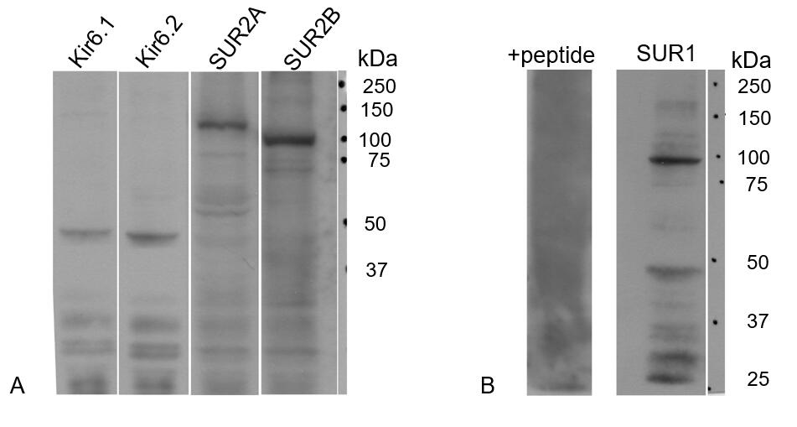
Figure 1 The expression of ATP-sensitive K⁺ channel subunits in rat liver extracts. A: Antibodies to Kir6.1, Kir6.2, SUR2A and/or SUR2B showed prominent specific bands, respectively; B: A prominent band around 100 kDa was recognized with our new anti-SUR1 antibody. The band disappeared when blocked by preincubation with the corresponding SUR1 peptide antigen from which the antibody had been raised (+peptide).

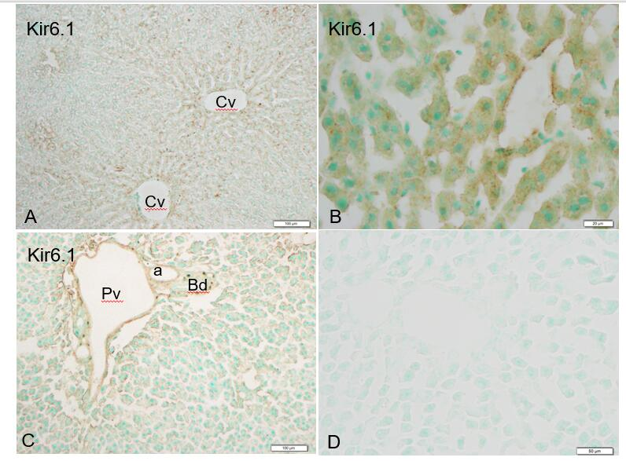
Figure 2 Kir6.1 immunoreactivity in liver sections. Kir6.1 was expressed in hepatocytes and sinusoidal cells of the liver. A: Staining was intense in the area around the central vein; B: Showing granular reactivity around the nucleus in hepatocytes cells and sinusoid cells when viewing with high magnification; C: Weaker immunoreactivity was evident in the triangular areas of the vein and artery, but no reactivity was evident in the bile duct; D: A negative control section devoid of staining. Cv: Central vein; Pv: Portal vein; a: Artery; Bd: Bile duct. Bars: 100 µm (A and C), 20 µm (B), 50 µm (D).

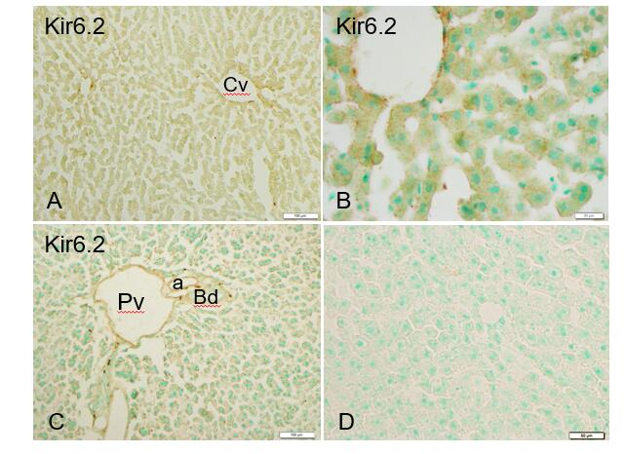
Figure 3 Immunoreactivity with Kir6.2 was expressed in hepatocytes and sinusoid cells of the liver. A and B: Mediated immunoreactivity was seen in the area around the central vein; A and C: Mediated immunoreactivity was weaker in the border areas; D: A negative control section devoid of staining (no more than background staining was observed). Cv: Central vein; Pv: Portal vein; a: Artery; Bd: Bile duct. Bars: 100 µm (A and C), 20 µm (B), 50 µm (D).

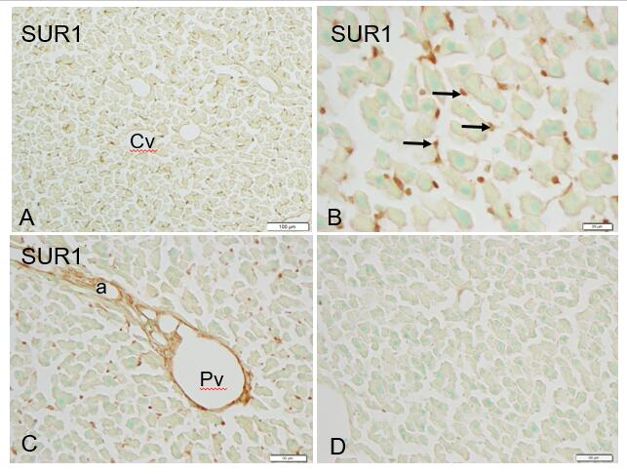
Figure 4 Immunoreactivity with SUR1 was mainly evident in sinusoid cells (arrows) and weaker in the cell membranes of hepatocytes. A and B: There was no such tendency toward immunoreactivity with SUR1 in the area of the central vein vs the border area; C: In the portal area, endothelial cells of the blood vessels showed intense immunoreactivity with SUR1; D: Absorption negative control section devoid of staining (no more than background) after incubation with cognate antigen peptide. Cv: Central vein; Pv: Portal vein; a: Artery. Bars: 100 µm (A and C), 20 µm (B), 50 µm (D).

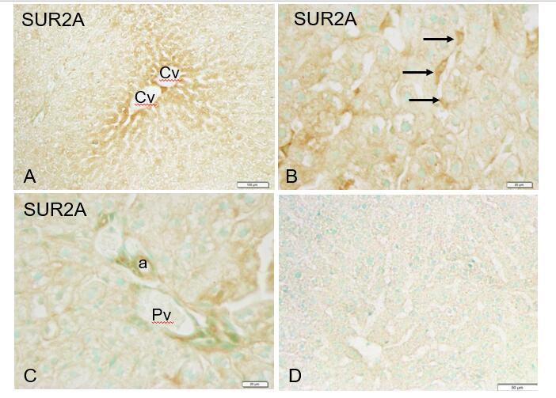
Figure 5 Immunoreactivity with SUR2A was evident in hepatocytes and sinusoid cells (arrows) of the liver. A: Immunoreactivity with SUR2A was stronger in the area of the central vein (Cv) vs the border areas; B: Weaker immunoreactivity in the cell membrane and moderate immunoreactivity in the sinusoid cells were observed (arrows); C: Weaker immunoreactivity with SUR2A was also observed in the endothelial cells of the blood vessels; D: Absorption negative control section devoid of staining (no more than background was observed). Cv: Central vein; Pv: Portal vein; a: Artery. Bars: 100 µm (A and C), 20 µm (B), 50 µm (D).

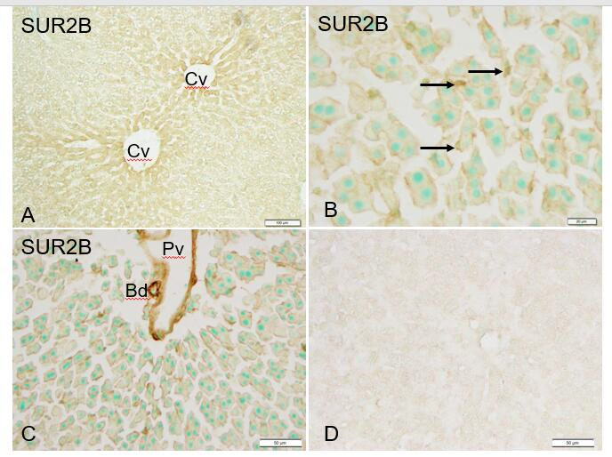
Figure 6 Immunoreactivity with SUR2B. A: Immunoreactivity with SUR2B was stronger in the area of the central vein (Cv) vs the border areas; B: Immunoreactivity with SUR2B was expressed in hepatocytes and sinusoidal cells (arrows) of the liver. Weaker immunoreactivity in the cell membrane and medium immunoreactivity in sinusoidal cells was observed (arrows); C: Immunoreactivity with SUR2B was also observed in the endothelial cells of blood vessels and bile ducts; D: Absorption negative control section devoid of staining (no more than background was observed). Cv: Central vein; Pv: Portal vein. Bars: 100 µm (A), 20 µm (B), 50 µm (C and D).

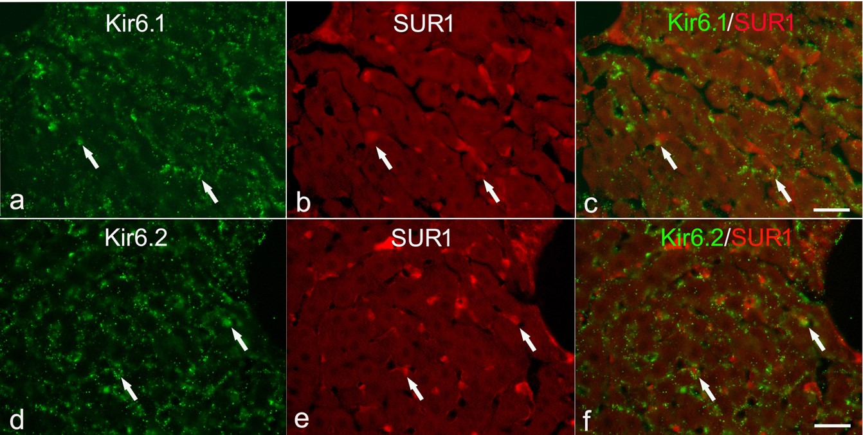
Figure 7 Immunofluorescence double staining for Kir6.1 and/or Kir6.2 with SUR1 in liver sections. A and B: Kir6.1 and Kir6.2 were widely localized in hepatocyte and sinusoid cells; B and E: SUR1 was mainly localized in sinusoid cells; C: There were few sinusoid cells that had colocalized Kir6.1 and SUR1 (arrows); F: There were few sinusoid cells that had colocalized Kir6.1 and SUR1 and/or Kir6.2 and SUR1 (arrows). Bars: 20 µm.

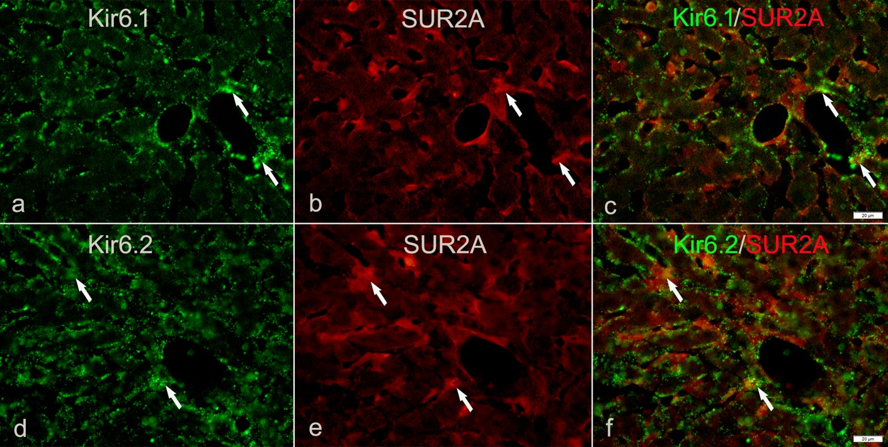
Figure 8 Immunofluorescence double staining for Kir6.1 and/or Kir6.2 with SUR2A in liver sections. A and D: Kir6.1 and Kir6.2 were widely localized in hepatocyte and sinusoid cells; B and E: SUR2A was mainly localized in sinusoid cells; C: There were few sinusoid cells with colocalized Kir6.1 and SUR2A (arrows); F: There were few sinusoid cells with colocalized Kir6.1 and SUR2A and/or Kir6.2 and SUR2A (arrows). Bars: 20 µm.

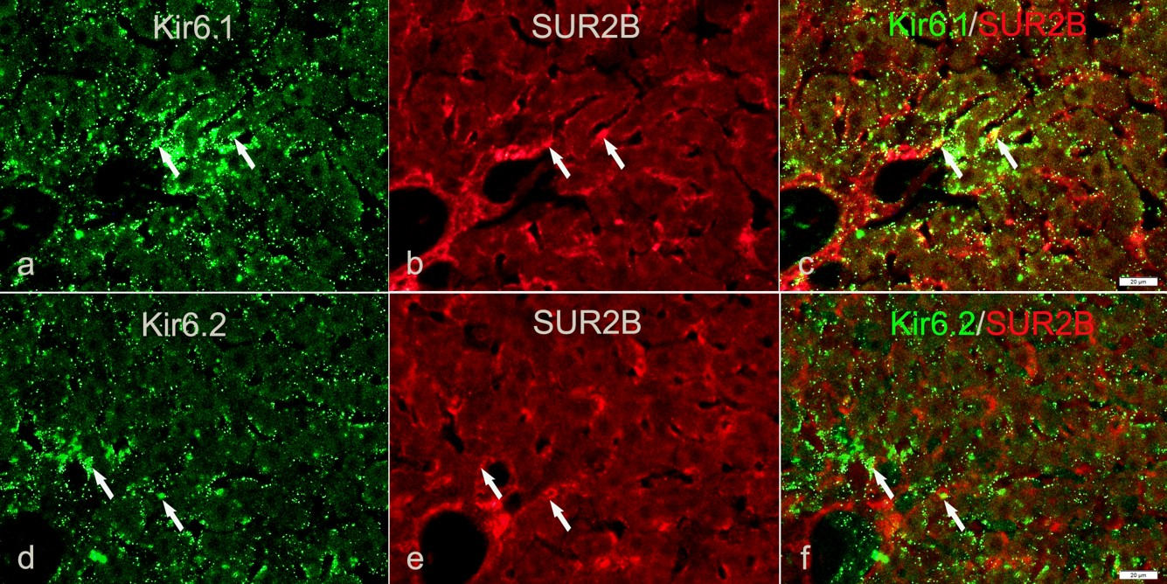
Figure 9 Immunofluorescence double staining for Kir6.1 and/or Kir6.2 with SUR2B in liver sections. A and D: Kir6.1 and Kir6.2 were widely localized in hepatocyte and sinusoid cells; B and E: SUR2B staining was mainly present in sinusoid cells; C: There were few sinusoid cells with colocalized Kir6.1 and SUR2B (arrows); F: There were few sinusoid cells with colocalized Kir6.1 and SUR2B and/or Kir6.2 and SUR2B (arrows). Bars: 20 µm.

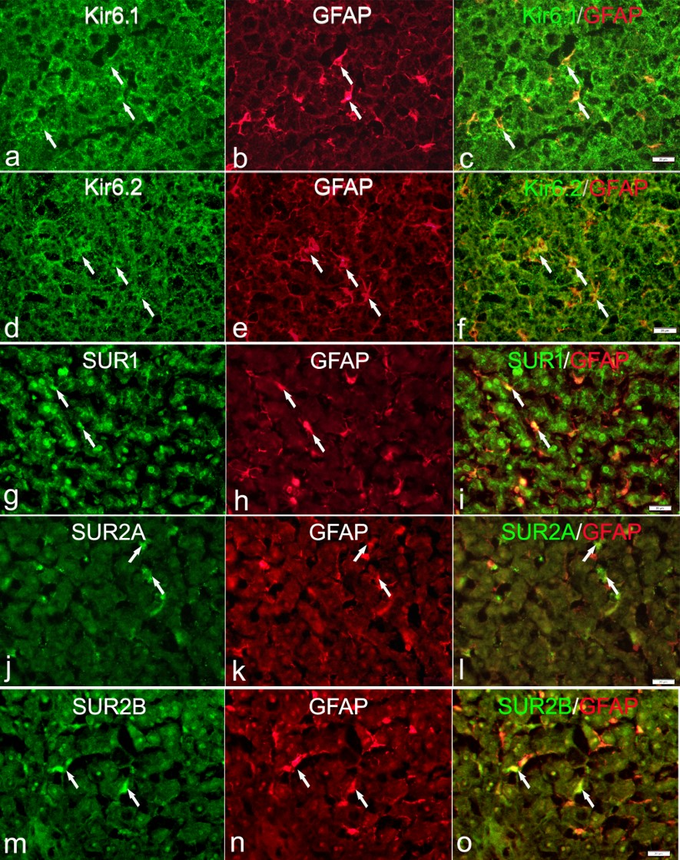
Figure 10 Immunofluorescence double staining. Immunofluorescence double staining for Kir6.1, Kir6.2, SUR1, SUR2A, and/or SUR2B (A, D, G, J, and M) and GFAP [B, E, H, K, and N, marker of hepatic stellate cells (HSCs)] is not present in fixed liver sections; Most of the GFAP⁺ cells (HSCs) colocalized with Kir6.1 (C, arrows) and/or Kir6.2 (F, arrows); There were few GFAP⁺ cells (HSCs) colocalized with SUR1 (I, arrows), SUR2A (L, arrows), and/or SUR2B (O, arrows). Bars: 20 µm.
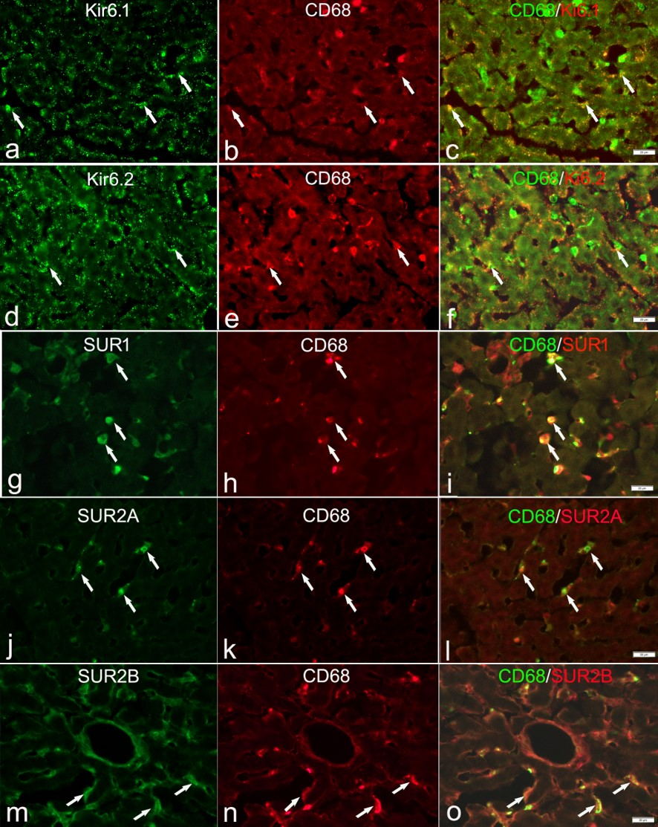
Figure 11 Immunofluorescence double staining for ATP-sensitive K⁺ channel subunits Kir6.1, Kir6.2, SUR1, SUR2A and SUR2B with CD68 in liver sections. Immunofluorescence double staining for ATP-sensitive K⁺ channel subunits Kir6.1 (A), Kir6.2 (D), SUR1 (G), SUR2A (J) and SUR2B (M) with CD68 (B, E, H, K, and N, marker of Kupffer cells) in liver sections; Some CD68⁺ cells (Kupffer cells) colocalized with Kir6.1 (C, arrows) and/or Kir6.2 (F, arrows), but most colocalized with SUR1 (I, arrows), SUR2A (L, arrows) and SUR2B (O, arrows). Bars: 20 µm.

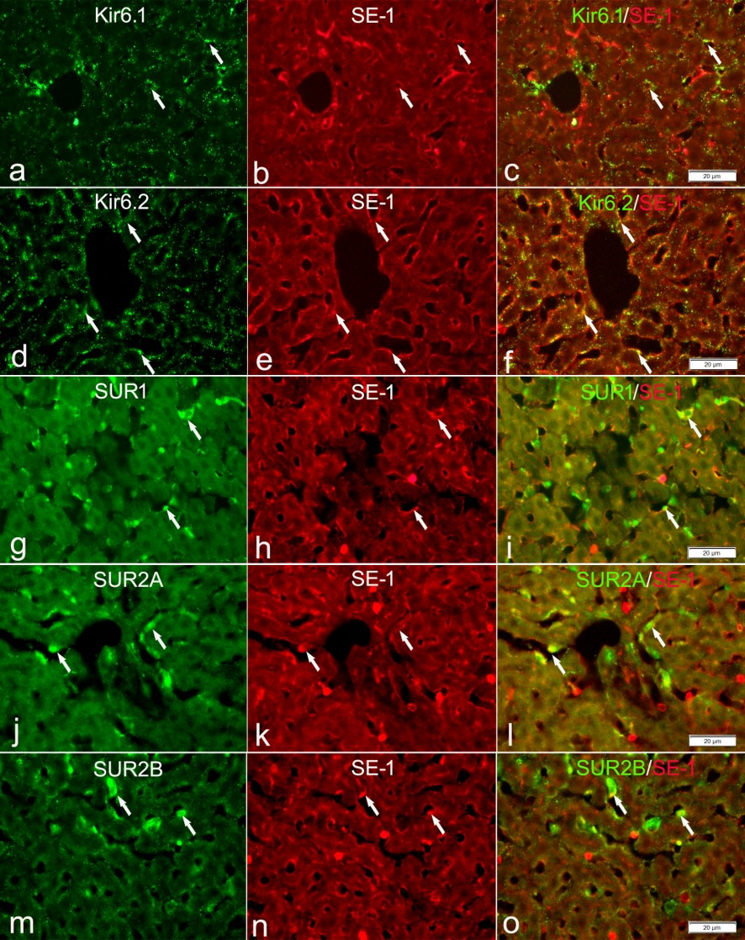
Figure 12 Immunofluorescence double staining for ATP-sensitive K⁺ channel subunits Kir6.1, Kir6.2, SUR1, SUR2A and SUR2B with SE-1. Immunofluorescence double staining for ATP-sensitive K⁺ channel subunits Kir6.1, Kir6.2, SUR1, SUR2A and SUR2B (A, D, G, J, and M) with SE-1 [marker of sinusoidal endothelial cells (SECs)]; In the liver sections, SECs showed immunopositive reactivity to SE-1 (B, E, H, K, and N); A few SE-1⁺ cells colocalized with Kir6.1 (C, arrows), but a number of them colocalized with Kir6.2 (F, arrows); As for SURs, some SE-1⁺ cells colocalized with SUR1 (I, arrows) and/or SUR2B (O, arrows); Most SE-1⁺ cells colocalized with SUR2A (L, arrows). Bars: 20 µm.

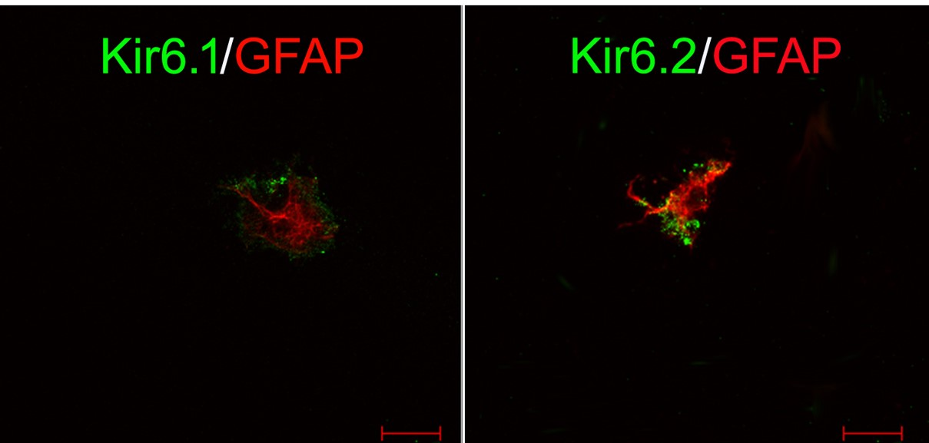
Figure 13 Immunofluorescence double staining for pore-forming subunits in primary cultured hepatic stellate cells. In primary hepatic stellate cells, marked by GFAP (red), Kir6.1 and Kir6.2 showed immunopositive reactivity (green). Bars: 50 µm.

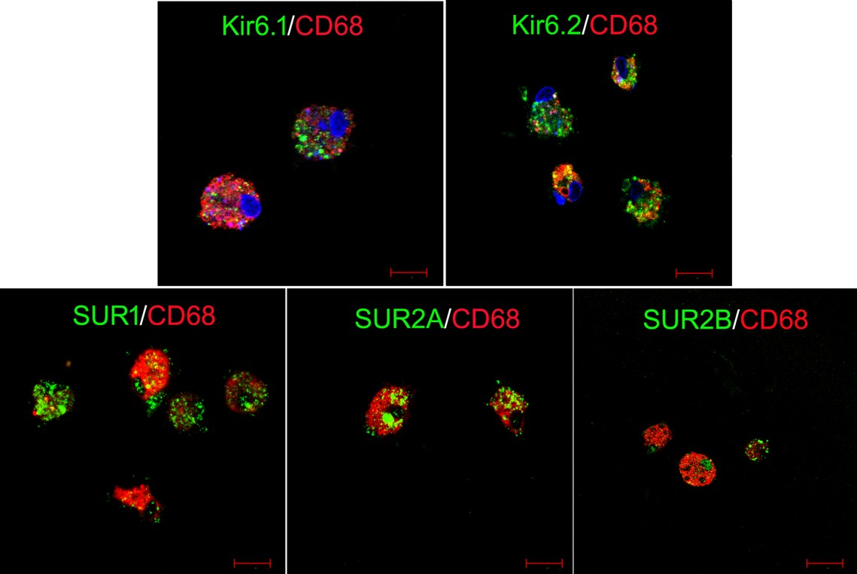
Figure 14 Immunofluorescence double staining for ATP-sensitive K⁺ channel subunits in primary cultured Kupffer cells. Primary cultured Kupffer cells were labeled with CD68 (red). These CD68⁺ Kupffer cells also showed immunopositive reactivity to five kinds of ATP-sensitive K⁺ channel subunits: Kir6.1, Kir6.2, SUR1, SUR2A and SUR2B (green). Bars: 50 µm.

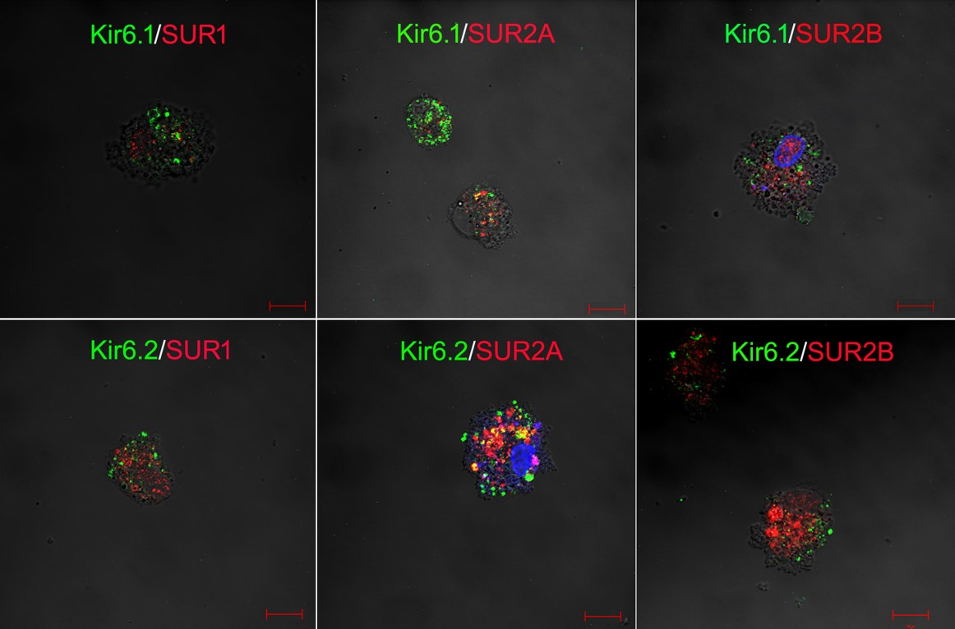
Figure 15 Immunofluorescence double staining for combinations of pore-forming subunits and regulatory subunits in primary cultured Kupffer cells. In primary Kupffer cells, the pore-forming subunits Kir6.1 and Kir6.2 are labeled in green, and the regulatory subunits SUR1, SUR2A and SUR2B are labeled in red. The combinations of Kir6.1/SUR1, Kir6.1/SUR2A, Kir6.1/SUR2B, Kir6.2/SUR1, Kir6.2/SUR2A and Kir6.2/SUR2B are all exhibited in the Kupffer cells. Bars: 50 µm.

