Name of Journal: World Journal of Clinical Cases
Manuscript NO: 77620
Manuscript Type: CASE REPORT

Chondroid syringoma of the lower back simulating lipoma: A case report

Huang QF et al. CS of the lower back

Qiu-Feng Huang, Yong Shao, Bo Yu, Xiao-Ping Hu

Qiu-Feng Huang, Bo Yu, Xiao-Ping Hu, Department of Dermatology, Peking University Shenzhen Hospital, Shenzhen 518035, Guangdong Province, China

Yong Shao, Shenzhen Peking University-The Hong Kong University of Science and Technology Medical Center, Biomedical Research Institute, Shenzhen 518035, Guangdong Province, China

Author contributions: Huang QF contributed to the drafting and revision of the manuscript; Shao Y contributed to the conception and designed the work that led to the submission, acquired the data, and played an important role in interpreting the results; Yu B contributed to approval of the final version; Hu XP contributed to analysis with constructive discussions.

Supported by Shenzhen Sanming Project, No. SZSM201812059; and Shenzhen Key Medical Discipline Construction Fund, No. SZXK040.

Corresponding author: Xiao-Ping Hu, PhD, Associate Professor, Department of Dermatology, Peking University Shenzhen Hospital, No. 1120, Lianhua Road, Futian District, Shenzhen 518035, Guangdong Province, China. 47776040@qq.com

Received: May 9, 2022
Revised: June 10, 2022
Accepted: September 6, 2022
Published online: October 16, 2022

Abstract
BACKGROUND
Chondroid syringoma (CS) is a rare tumor of the apocrine or eccrine glands. CS of the lower back is rare, and its clinical manifestations are similar to those of lipoma, which is a common misdiagnosis for this disease.

CASE SUMMARY
A 39-year-old woman presented with a 2-year history of an asymptomatic subcutaneous mass on the lower back. The lesions increased progressively over time. The patient denied any history. Dermatological examination showed that there was a subcutaneous mass, ranging from 3-4 cm in diameter, with a clear boundary on the lower back. The surface of the skin was smooth without ulceration or scaling. Histopathologic examination was consistent with the diagnosis of CS.

CONCLUSION
CS is a rare tumor of the apocrine or eccrine glands. It usually presents as a well-circumscribed and single subcutaneous masses. Histopathology showed the tumor was located in the dermis, with nests, sheets, and cords of basal-like cells, mucin deposition, and chondroid structures. We herein report a case of CS located in the lower back. CS of the lower back is rare, and its clinical manifestations are similar to those of lipoma, for which it is commonly misdiagnosed.

Key Words: Chondroid syringoma; Mixed tumor; Lower back; Lipoma; Case report

©The Author(s) 2022. Published by Baishideng Publishing Group Inc. All rights reserved.

Citation: Huang QF, Shao Y, Yu B, Hu XP. Chondroid syringoma of the lower back simulating lipoma: A case report. World J Clin Cases 2022; 10(29): 10708-10712
URL: https://www.wjgnet.com/2307-8960/full/v10/i29/10708.htm
DOI: https://dx.doi.org/10.12998/wjcc.v10.i29.10708

Core Tip: Chondroid syringoma (CS) is a rare tumor of the apocrine or eccrine glands. It usually occurs in the nose and surrounding areas, and it is rare in the lower back. It usually presents as a well-circumscribed, slow-growing, and single subcutaneous masses. It is easy to clinically misdiagnose CS as lipoma, but histopathological examination is helpful for the diagnosis and treatment of this disease. In our case, combined with the patient’s present illness, dermatological examination, and histopathology, the patient was diagnosed with CS. After surgical resection, no recurrence was found in follow-up visits.

INTRODUCTION
Chondroid syringoma (CS), also known as mixed tumor of the skin (MTS), is a rare apocrine or eccrine tumor, accounting for 0.01% of primary skin tumors^{[1]}. The etiology of CS is unknown, and it usually occurs in the head and neck, but is uncommon in the lower back. CS has no specific clinical manifestations and it is easily misdiagnosed as epidermoid cyst and lipoma^{[2]}. In addition, CS has the potential for malignant transformation. The risk of clinical atypia and malignancy leads to delayed treatment^{[3]}. Diagnosing CS is a challenge for clinicians. Therefore, we report a case of atypical CS and summarize its clinical manifestations, characteristic pathological findings, and treatment methods to raise clinicians’ awareness of the rare location of this rare disease.

CASE PRESENTATION
Chief complaints
A 39-year-old woman presented with an asymptomatic subcutaneous mass on the lower back which had been present for 2 years.

History of present illness
In 2020, a female patient presented with an asymptomatic subcutaneous mass on the lower back. Dermatological examination showed a subcutaneous mass, ranging from 3-4 cm in diameter, with clear boundaries. The surface of the skin was smooth without ulceration or scaling. We initially considered lipoma; however, histopathologic examination revealed a well-defined dermal tumor with nests, sheets, and cords of basal-like cells, glandular structures, interstitial mucin deposition, and chondroid structures in some areas. Therefore, our final diagnosis was CS.

History of past illness
The patient had no previous history.

Personal and family history
The patient denied any family history of similar diseases or genetic history.

Physical examination
The physical examination indicated that the patient’s general condition was good, with no obvious abnormalities in the heart, lung, or abdomen, and superficial lymph nodes were not touched or enlarged. Upon dermatological examination, there was a subcutaneous mass, ranging from 3-4 cm in diameter, with a clear boundary on the lower back. The surface of the skin was smooth without ulceration or scaling (Figures 1A and 1B).

Laboratory examinations
The patient’s laboratory tests were normal.

Imaging examinations
Imaging examination was not special.

Histopathologic examination
Histopathologic examination revealed a well-defined dermal tumor with nests, sheets, and cords of basal-like cells, including glandular structures, interstitial mucin deposition, and chondroid structures in some areas (Figures 1C and 1D).

FINAL DIAGNOSIS
The final diagnosis was CS.

TREATMENT
The patient underwent surgical excision of the tumor, which revealed a yellow, smooth, tough mass with a clear boundary and a size of about 5 cm × 4 cm (Figure 1B).

OUTCOME AND FOLLOW-UP
There was no reoccurrence during the follow-up. No recurrence was found by palpation, and contrast-enhanced ultrasound was available for evaluation if necessary.

DISCUSSION
CS, also known as MTS, is a rare apocrine or eccrine tumor, accounting for 0.01% of primary skin tumors. CS was first described as a tumor located in the salivary gland by Billroth in 1895, and Virchow called it MTX a few years later because it appeared identical to mesenchymal neoplasm^{[1]}. CS was first named in 1961^{[1]}. Known for its chondroid sweat gland component, CS is mostly benign and has also been reported as malignant. The etiology of CS is unknown, and it usually occurs in the head and neck, especially in the nose and surrounding areas. It is rare in the external ear, lower lip, upper eyelid, scrotum, vulva, and other skin regions^{[1-3]}. Lesions are mostly located in the dermis, with occasional occurrence up to the subcutaneous tissue. CS is more common in males between 20 and 40 years of age, while the malignant variant is more common in females^{[4]}. The clinical features of CS are nonspecific and are characterized by isolated, raised, solid, asymptomatic nodules between 0.5 cm and 3.0 cm in diameter, with an average diameter of about 1 cm. Risk of malignancy increases in CS when lesions are greater than 3.0 cm in size^{[5]}. Clinical diagnosis of CS is relatively difficult, and the diagnosis of CS is mainly based on histopathology. At present, the direction of CS differentiation is still controversial^{[6]}. CS can differentiate either to eccrine or apocrine elements, with apocrine elements showing dominance. The resected tumor was comprised of epithelial and mesenchymal stromal derived elements. Histopathology showed that the tumor was located in the deep dermis or fat layer and differentiated into apocrine elements. It was characterized by irregular tubule-alveolar and ductal structures, which were composed of cuboid or polygonal cells in the shape of cords and nests, and embedded in myxoid and chondroid mesenchyma, with apocrine secretion^{[7]}. The eccrine elements of CS differentiation showed a tubular structure, with epithelial cells scattered in chondroid and myxoid stroma, and without apocrine secretion^{[4,7]}. CS contains acid mucopolysaccharide in cartilage and fibrous connective tissue, so Alcian blue staining can be positive. In addition, immunohistochemistry was helpful to understand the differentiation of CS, and the strong expression of CK15, EMA, carcinoembryonic antigen, and P63 suggested apocrine differentiation of the tumor. Histopathology can present obvious myoepithelial differentiation. Positive myoepithelial markers such as smooth muscle actin or calponin indicate myoepithelial differentiation, which can be diagnosed as myoepithelioma^{[8]}. CS usually has a benign nature, but there is still a risk of malignancy. Histopathology showed cytological atypia, increased mitotic figures, infiltrative tumor margins, satellite nodules, and tumor liquefaction necrosis, which can be indicative of malignant transformation^{[2,9]}. This patient would have typically been identified with lipoma, epidermoid cyst, dermoid cyst, etc. CS can be identified from other disease by histopathology. The clinical manifestations in this patient were similar to those of lipomas, with a subcutaneous active and tough mass. The histopathology of the lipoma revealed a well-defined dermal tumor with normal adipose cells. There are no fatty lobules separating the tumor tissue^{[9]}. The histopathology of the epidermoid cyst showed a sharply defined cyst in the dermis with a wall composed of lamellar squamous epithelium. The contents of the cyst were horny material in the form of a net basket or plate layer^{[10]}. Surgical resection is preferred for CS treatment. Incomplete resection of CS may lead to recurrence and malignant transformation. Therefore, the scope of surgical resection should be clearly defined before surgery and regular follow-up should be conducted after surgery^{[2]}.
The patient was an otherwise healthy middle-aged woman with a subcutaneous mass on the lower back for more than 2 years. The tumor gradually increased with a smooth skin surface and she was asymptomatic. The tumor was non-tender, slightly hard, and mobile, with a mass measuring 4 cm × 5 cm in size palpable on the lower back. Lipoma was considered in the initial diagnosis, but histopathological examination showed CS. Surgical resection was the first choice after diagnosis. The literature has reported that lesions with a diameter of more than 3 cm and occurring in females have a greater risk of malignant transformation. CS on the lower back is rare and easily misdiagnosed as lipoma or epidermoid cysts, resulting in delayed treatment and further increased risk of recurrence and malignant transformation.

CONCLUSION
This case is being reported for its rarity. A CS of the lower back is rare, and it is extremely easy to misdiagnose as lipoma. Even though CS is benign, it may become a malignant tumor. We report CS of the lower back mainly to improve clinicians’ understanding of this disease. Prompt diagnosis and treatment can reduce malignancy and recurrence.

REFERENCES
1 Walvekar PV, Jakati S, Bothra N, Kaliki S. Isolated eyelid chondroid syringoma: a study of two cases. BMJ Case Rep 2021; 14 [PMID: 34969791 DOI: 10.1136/bcr-2021-245354]
2 Gotoh S, Ntege EH, Nakasone T, Matayoshi A, Miyamoto S, Shimizu Y, Nakamura H. Mixed tumour of the skin of the lower lip: A case report and review of the literature. Mol Clin Oncol 2022; 16: 69 [PMID: 35251620 DOI: 10.3892/mco.2022.2502]
3 Bedir R, Yurdakul C, Sehitoglu I, Gucer H, Tunc S. Chondroid syringoma with extensive bone formation: a case report and review of the literature. J Clin Diagn Res 2014; 8: FD15-FD17 [PMID: 25478357 DOI: 10.7860/JCDR/2014/10026.5003]
4 Barnett MD, Wallack MK, Zuretti A, Mesia L, Emery RS, Berson AM. Recurrent malignant chondroid syringoma of the foot: a case report and review of the literature. Am J Clin Oncol 2000; 23: 227-232 [PMID: 10857882 DOI: 10.1097/00000421-200006000-00003]
5 Reddy PB, Nandini DB, Sreedevi R, Deepak BS. Benign chondroid syringoma affecting the upper lip: Report of a rare case and review of literature. J Oral Maxillofac Pathol 2018; 22: 401-405 [PMID: 30651687 DOI: 10.4103/jomfp.JOMFP_35_18]
6 Agarwal R, Kulhria A, Singh K, Agarwal D. Cytodiagnosis of chondroid syringoma-Series of three cases. Diagn Cytopathol 2021; 49: E374-E377 [PMID: 34174020 DOI: 10.1002/dc.24818]
7 Jain A, Arava S. Chondroid syringoma with extensive cystic change and focal syringometaplasia: A rare histomorphological finding. Indian J Pathol Microbiol 2018; 61: 143-144 [PMID: 29567907 DOI: 10.4103/IJPM.IJPM_539_16]
8 Bahrami A, Dalton JD, Krane JF, Fletcher CD. A subset of cutaneous and soft tissue mixed tumors are genetically linked to their salivary gland counterpart. Genes Chromosomes Cancer 2012; 51: 140-148 [PMID: 22038920 DOI: 10.1002/gcc.20938]
9 De Sanctis CM, Zara F, Sfasciotti GL. An Unusual Intraoral Lipoma: A Case Report and Literature Review. Am J Case Rep 2020; 21: e923503 [PMID: 32564054 DOI: 10.12659/AJCR.923503]
10 Cui X, Wu X, Yao X. Surgical treatment for a giant epidermoid cyst on the buttock. Dermatol Ther 2020; 33: e13275 [PMID: 32061013 DOI: 10.1111/dth.13275]

Footnotes
Informed consent statement: The patient gave written informed consent to the publication of her case details.

Conflict-of-interest statement: All the authors report no relevant conflicts of interest for this article.

CARE Checklist (2016) statement: The authors have read the CARE Checklist (2016), and the manuscript was prepared and revised according to the CARE Checklist (2016).

Open-Access: This article is an open-access article that was selected by an in-house editor and fully peer-reviewed by external reviewers. It is distributed in accordance with the Creative Commons Attribution NonCommercial (CC BY-NC 4.0) license, which permits others to distribute, remix, adapt, build upon this work non-commercially, and license their derivative works on different terms, provided the original work is properly cited and the use is non-commercial. See: https://creativecommons.org/Licenses/by-nc/4.0/

Provenance and peer review: Unsolicited article; Externally peer reviewed.
Peer-review model: Single blind

Peer-review started: May 9, 2022
First decision: May 30, 2022
Article in press: September 6, 2022

Specialty type: Medicine, research and experimental
Country/Territory of origin: China
Peer-review report’s scientific quality classification
Grade A (Excellent): 0
Grade B (Very good): 0
Grade C (Good): C, C
Grade D (Fair): 0
Grade E (Poor): 0

P-Reviewer: Jeyaraman M, India; Taieb MAH, Tunisia S-Editor: Wang JJ L-Editor: Wang TQ P-Editor: Wang JJ

Figure Legends
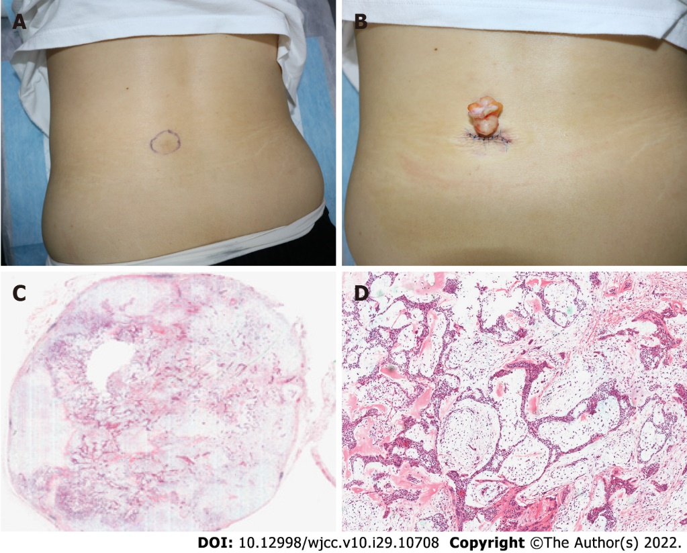
Figure 1 Images of the mass. A: A Clinical image of a subcutaneous mass, ranging from 3-4 cm in diameter; B: A yellow, smooth, tough mass with a clear boundary and a size of about 5 cm × 4 cm; C: A well-defined dermal tumor (hematoxylin-eosin staining, × 10); D: Tumor with nests, sheets, and cords of basal-like cells, glandular structures, interstitial mucin deposition, and chondroid structures in some areas (hematoxylin-eosin staining, × 200).

Published by Baishideng Publishing Group Inc
7041 Koll Center Parkway, Suite 160, Pleasanton, CA 94566, USA
Telephone: +1-925-3991568
E-mail: bpgoffice@wjgnet.com
Help Desk: https://www.f6publishing.com/helpdesk
https://www.wjgnet.com

© 2022 Baishideng Publishing Group Inc. All rights reserved.

