Name of Journal: World Journal of Gastroenterology
Manuscript NO: 50590
Manuscript Type: ORIGINAL ARTICLE

Basic Study
LncRNA-SNHG15 accelerates the development of hepatocellular carcinoma by targeting miR-490-3p/ histone deacetylase 2 axis

Dai W et al. LncRNA-SNHG15 accelerates progression of HCC

Wei Dai, Jia-Liang Dai, Mao-Hua Tang, Mu-Shi Ye, Shuo Fang

Wei Dai, Jia-Liang Dai, Department of Hepatobiliary Surgery, the Affiliated Hospital of Guangdong Medical University, Zhanjiang 524001, Guangdong Province, China

Mao-Hua Tang, Department of Infectious Disease, the Second Affiliated Hospital of Guangdong Medical University, Zhanjiang 524003, Guangdong Province, China

Mu-Shi Ye, Department of Surgery, the Affiliated Hospital of Guangdong Medical University, Zhanjiang 524001, Guangdong Province, China

Shuo Fang, The Seventh Affiliated Hospital, Sun Yat-sen University, Shenzhen 518107, Guangdong Province, China

Shuo Fang, Li KaShing Faculty of Medicine, the University of Hong Kong, Hong Kong, China

ORCID number: Wei Dai (0000-0003-3490-0819); Jia-Liang Dai (0000-0002-0257-8143); Mao-Hua Tang (0000-0002-2386-224X); Mu-Shi Ye (0000-0002-2802-8254); Shuo Fang (0000-0003-4535-0955).

Author contributions: Dai W and Dai JL performed the majority of experiments and analyzed the data; Ye MS performed the molecular investigations; Tang MH designed and coordinated the research; Fang S wrote the paper.

Institutional review board statement: This study was reviewed and approved by the Affiliated Hospital of Guangdong Medical University Ethics Committee.

Informed consent statement: All patients in our study provided informed consent.

Conflict-of-interest statement: The authors declare no conflict of interest.

Data sharing statement: No additional data are available.

ARRIVE guidelines statement: The authors have read the ARRIVE guidelines, and the manuscript was prepared and revised according to the ARRIVE guidelines.

Open-Access: This article is an open-access article which was selected byan in-house editor and fully peer-reviewed by external reviewers. It is distributed in accordance with the Creative Commons Attribution Non Commercial (CC BY-NC 4.0) license, which permits others to distribute, remix, adapt, build upon this work non-commercially, and license their derivative works on different terms, provided the original work is properly cited and the use is non-commercial. See: http://creativecommons.org/licenses/by-nc/4.0/

Manuscript source: Unsolicited manuscript

Corresponding author: Shuo Fang, PhD, Attending Doctor, The Seventh Affiliated Hospital, Sun Yat-sen University, No. 628, Zhenyuan Road, Xinhu Street, Guangming New District, Shenzhen 518107, Guangdong Province, China. shuofangzhongshan@163.com
Telephone: +86-852-65923702
Fax: +86-852-65923702

Received: July 29, 2019
Peer-review started: July 29, 2019
First decision: August 17, 2019
Revised: August 30, 2019
Accepted: September 13, 2019
Article in press:
Published online:

Abstract
BACKGROUND
Now, hepatocellular carcinoma (HCC) has become a great threat for people’s health. Many long noncoding RNAs (lncRNAs) are involved in pathogenesis of HCC. SNHG15, as a tissue specific lncRNA, has been studied in many human cancers, except HCC.

AIM
to explore the regulatory mechanism of SNHG15 in HCC.

METHODS
In the present research, one hundred and one HCC patient samples, two HCC cell lines and one normal liver cell line were used. RT-qPCR and Western blot analysis were applied to detect SNHG15, miR-490-3p and histone deacetylase 2 (HDAC2) expressions. The regulatory mechanism of SNHG15 was investigated using CCK-8, Transwell and luciferase reporter assays.

RESULTS
Our research showed that upregulation of SNHG15 was found in HCC and was related to aggressive behaviors in HCC patients. Moreover, knockdown of SNHG15 restrained HCC cell proliferation, migration and invasion. In addition, SNHG15 served as a molecular sponge for miR-490-3p. Further, miR-490-3p directly targets HDAC2. Furthermore, HDAC2 was involved in HCC progression by interacting with SNHG15/miR-490-3p axis.

CONCLUSION
In conclusion, lncRNA SNHG15 promotes HCC progression by mediating miR-490-3p/HDAC2 axis in HCC.

Key words: SNHG15; miR-490-3p; Hepatocellular carcinoma; Histone deacetylase 2; Pathogenesis; Regulatory mechanism

© The Author(s) 2019. Published by Baishideng Publishing Group Inc. All rights reserved.

Core tip: Long noncoding RNA (LncRNA)-SNHG15 is up-regulated in tissue and cell lines of hepatocellular carcinoma. Hepatocellular carcinoma patients with up-regulated lncRNA-SNHG15 level were more probably had larger tumor size, and advanced clinical stage. LncRNA-SNHG15 promotes cell proliferation, migration and invasion in hepatocellular carcinoma (HCC) cell lines. MiR-490-3p/ histone deacetylase 2 axis was determined to be the target regulated by lncRNA-SNHG15 in hepatocellular carcinoma, and the regulatory mechanism of lncRNA-SNHG15 has been preliminarily illuminated in HCC.

Dai W, Dai JL, Tang MH, Ye MS, Fang S. LncRNA-SNHG15 accelerates the development of hepatocellular carcinoma by targeting miR-490-3p/histone deacetylase 2 axis. World J Gastroenterol 2019; In press
INTRODUCTION
Hepatocellular carcinoma (HCC) is a high-risk, highly harmful malignant tumor. Recently, HCC has jumped to the top three cancers in the Asia-Pacific region including China, posing a threat to human health^{[1]}. Moreover, the pathogenesis of HCC is not fully understood. It has been reported that environmental and dietary factors affect the occurrence of HCC^{[2]}. At present, surgery is still the first choice for the treatment of HCC. However, the recurrence rate of HCC is still high, and the five-year survival rate is generally below 50%^{[3]}. Thus, exploring the pathogenesis of HCC to screen for effective diagnostic markers and therapeutic targets is very urgent for HCC patients.
Long non-coding RNAs (lncRNAs) have found to involve in the occurrence of human diseases and cancers^{[4]}. Recently, increasing lncRNAs have been demonstrated to be involved in HCC progression. For instance, lncRNA HOXD-AS1 was overexpressed in HCC and accelerated cell proliferation and cell cycle progression through MEK/ERK pathway^{[5]}. On the contrary, lncRNA TPTEP1 was downregulated in HCC and restrained HCC progression by suppressing STAT3 phosphorylation^{[6]}. Now, the specific functions of lncRNA SNHG15 in human cancers have caught our attention. It had been reported that SNHG15 was downregulated and served as a tumor suppressor in thyroid cancer^{[7]}. However, SNHG15 was upregulated in prostate cancer and acted as a tumor promoter by mediating miR-338-3p^{[8]}. These results indicate that expression of SNHG15 is tissue specific. In particularly, SNHG15 expression reported to be was increased in HCC and predicted poor survival in HCC patients^{[9]}. However, the specific role of SNHG15 is still unclear and need to be elucidated.
In addition, it is well-known that lncRNAs exert effect in human diseases by inhibiting the expression and biological functions of miRNAs^{[10]}. SNHG15 was found to enhance colorectal cancer cell viability through downregulation of miR-338-3p^{[11]}. In this study, miR-490-3p was predicted to have binding sites with SNHG15. Moreover, miR-490-3p sponging by CircSLC3A2 was reported to regulate HCC progression^{[12]}. Especially, it had been shown that miR-490-3p expression was reduced in HCC and restrained autophagy^{[13]}. However, whether SNHG15 regulates HCC progression via regulating miR-490-3p remains unknown.
Besides that, Histone deacetylase 2 (HDAC2) was predicted as a target of miR-490-3p in this study. Moreover, HDAC2 expression had been reported to be increased in HCC tissues, which was related to adverse prognosis^{[14]}. Additionally, miR-145 was proposed to act as a tumor inhibitor via binding to HDAC2 in liver cancer^{[15]}. But the interaction between miR-490-3p and HDAC2 has not been reported in previous studies. Therefore, their relationship in HCC was investigated in our research. Further, the regulatory mechanism of lncRNA SNHG15 with miR-490-3p/HDAC2 axis was elucidated in HCC progression. Our results will contribute to better understand the role of mechanisms of lncRNA SNHG15 in HCC progression.

MATERIALS AND METHODS
Clinical tissues
One hundred and one HCC patients in the Affiliated Hospital of Guangdong Medical University, the second Affiliated Hospital of Guangdong Medical University and the Seventh Affiliated Hospital of Sun Yat-sen University participated in this research. The clinical features of the patients were shown in Table 1. Among them, randomly selected thirty-three HCC tissues and paired adjacent nonneoplastic liver tissues were applied for further experiment. Before the experiment, written informed consents were collected from all HCC patients. Moreover, patients with HCC did not receive any treatment except for surgery. The permission of this study was obtained from the Institutional Ethics Committee of the Affiliated Hospital of Guangdong Medical University, the second Affiliated Hospital of Guangdong Medical University and the Seventh Affiliated Hospital of Sun Yat-sen University.

Cell culture
HCC cell lines HuH-1, HuH-7 and normal human liver cells L-O2 were obtained from the Japanese Collection of Research Bioresources Cell Bank (JCRB, Shanghai, China). The growth conditions of these cells are 5% CO₂, 37 °C and culture solution [90% DMEM+10% foetal bovine serum (FBS)].

Cell transfection
SNHG15 siRNA (si-SNHG15), pcDNA3.1-SNHG15 vectors, HDAC2 siRNA (si-HDAC2) and miR-490-3p mimics or inhibitor were purchased from Genepharma (Shanghai, China). Next, the siRNAs, vectors, mimics or inhibitors (20 nM) were transfected into HuH-1 or L-O2 cells using Lipofectamine 2000 (Invitrogen). Untreated cells were used as the controls (NC).

RT-qPCR
Total RNA isolation was performed with TRIzol reagent (Sigma, United States). The cDNA was reverse transcribed using microRNA reverse transcription kit (TAKARA, Dalian, China). RT-qPCR assay was performing using SYBR Green Master Mix II (TAKARA). U6 or Glyceraldehyde-3-phosphate dehydrogenase (GAPDH) is used as internal reference for RNA or protein. Relative expressions of SNHG15, miR-490-3p and HDAC2 were detected with the 2−^{△△ct} method.

Western blot analysis
Protein sample was lysed using RIPA buffer (Beyotime, Shanghai, China). Next, 10% SDS-PAGE was used to separate protein. Protein samples were transferred to PVDF membranes and blocked with 5% non-fat milk. Next, protein samples were incubated with HDAC2 and GAPDH primary antibodies (Abcam, Shanghai, China) overnight at 4 °C. After washing, secondary antibodies (Abcam, United States) were continued to incubate protein samples for 1 hour. Finally, ECL kit (Beyotime) was used to assess protein bands.

CCK-8 assay
Transfected HuH-1 cells were incubated for 24 h (at 37 °C, 5% CO₂) in 96-well plates. Next, HuH-1 cells (3 × 10³/well) were incubated in DMEM medium for 24, 48, 72 and 96 h. CCK-8 (Dojindo, Kumamoto, Japan) was added to incubate the cells for 4 h. Finally, the optical density at 450 nm was observed by microplate reader (Molecular Devices) to assess cell viability.

Transwell assay
First, cell invasion was detected in the upper chamber with Matrigel (BD Biosciences, CA, United States). After 30 min, Transwell upper chamber was added with HuH-1 or L-O2 cell suspension (5 × 10³ cells/well). Next, lower chamber was added with DMEM medium (10% FBS). After 24 h, 0.1% crystal violet was applied to stain the moved cells. For cell migration, 5 × 10³ transfected cells were placed in the upper chambers without Matrigel. Other process is the same as the cell invasion. Observation and photographing were performed by a light microscope.

Dual luciferase reporter assay
Reporter plasmids of SNHG15 (wt-SNHG15 and mut-SNHG15) and HDAC2 (wt-HDAC2 and mut-HDAC2) were cloned into empty pGL3 vectors (GenePharma, Shanghai, China), respectively. Then, the above reporter vectors were transfected into HuH-1 cells with miR-490-3p mimics. After 48 h, luciferase activities were examined by dual-luciferase reporter assay system (Promega, United States). HuH-1 cells with empty pGL3 vectors were used as the control (NC).

Statistical analysis
Data were analyzed by SPSS 17.0 or Graphpad Prism 6, which are shown as mean ± standard deviation. One-way ANOVA and Student’s t-test were employed to compare differences among multiple groups. Chi-squared test was used to analyze the association between SNHG15 and clinical features in HCC patients. P < 0.05 indicated significant difference.

RESULTS
The dysregulation of SNHG15 in HCC
First, the alternation of SNHG15 expression was detected in HCC tissues. We found the higher SNHG15 expression in HCC tissues than normal tissues (Figure 1A). Similarly, upregulation of SNHG15 was found in HuH-1 and HuH-7 cells compared to L-O2 cells (Figure 1B). The difference of SNHG15 expression in HuH-1 cells is more significant than HuH-7 cells. Therefore, HuH-1 cells were used for the further experiment. In addition, the association between HCC clinical features and abnormal expression of SNHG15 was analyzed. Tumor size, TNM stage and degrees of differentiation in HCC under Edmondson-Steiner grading system were associated with abnormal SNHG15 expression in HCC patients (Table 1). These results suggest that SNHG15 may affect tumorigenesis of HCC.
Next, SNHG15 siRNA or SNHG15 overexpression vector was transfected into HuH-1 cells to explore its role in HCC. The transfection efficiency was confirmed by RT-qPCR (Figure 1C). CCK-8 assay suggested that knockdown of SNHG15 suppressed proliferation of HuH-1 cells, while upregulation of SNHG15 accelerated cell proliferation in HuH-1 cells (Figure 1D). In addition, transwell assay showed that cell migration was also promoted by upregulation of SNHG15 and restrained by knockdown of SNHG15 (Figure 1E). In addition, we also found that SNHG15 siRNA decreased its expression in L-O2 cells, whereas SNHG15 overexpression vector enhanced its expression in L-O2 cells (Figure 1C). However, upregulation or downregulation of SNHG15 had little effect on cell migration and invasion in normal human liver cells L-O2 (Figure 1E and F). These findings indicate the potential carcinogenesis of SNHG15 in HCC.

Direct interaction of SNHG15 and miR-490-3p in HCC
To explore the regulatory mechanism of SNHG15, its target miRNA was searched in starBASEv2.0 database (http://starbase.sysu.edu). It predicts that SNHG15 has potential binding sites with miR-490-3p (Figure 2A). Luciferase reporter assay showed that miR-490-3p mimics declined SNHG15-wt luciferase activity, but not SNHG15-mut (Figure 2B). Next, lower miR-490-3p expression was identified in HCC tissues than normal tissues (Figure 2C). Furthermore, SNHG15 was negatively associated with miR-490-3p expression in HCC tissues (Figure 2D). In HuH-1 cells, knockdown of SNHG15 enhanced miR-490-3p expression, while upregulation of SNHG15 reduced miR-490-3p expression (Figure 2E). The funny thing is, downregulation or overexpression of miR-490-3p could also inversely regulate SNHG15 expression in HuH-1 cells (Figure 2F). To further explain their interaction, SNHG15 vector was transfected into HuH-1 cells containing miR-490-3p mimics. Moreover, the increased miR-490-3p expression mediated by its mimics was weakened by upregulation of SNHG15 (Figure 2G). Functionally, miR-490-3p induced inhibition of cell proliferation was also restored by SNHG15 upregulation (Figure 2H). Similarly, upregulation of SNHG15 also weakened the suppressive effect of miR-490-3p on migration and invasion of HCC cells (Figure 2I and J). Based on the results, we consider that SNHG15 may accelerate HCC progression via a molecular sponging miR-490-3p.

miR-490-3p directly targets HDAC2
Then, TargetScan (http://www.targetscan.org) predicts that miR-490-3p has a binding site with HDAC2 (Figure 3A). Dual-luciferase reporter assay indicated that miR-490-3p mimics reduced HDAC2-wt luciferase activity, but not HDAC2-mut (Figure 3B). Moreover, miR-490-3p mimics were found to decrease HDAC2 expression, while miR-490-3p inhibitor upregulated HDAC2 in HuH-1 cells (Figure 3C and D). These studies indicate that miR-490-3p directly targets HDAC2. In addition, the dysregulation of HDAC2 was identified in HCC tissues. Furthermore, HDAC2 was upregulated in HCC tissues compared with normal tissues (Figure 3E). Furthermore, miR-490-3p had an inverse correlation with HDAC2 expression in HCC tissues (Figure 3F). On the contrary, a positive correlation between SNHG15 and HDAC2 expressions was identified in HCC tissues (Figure 3G). According to these results, we suspect that HDAC2 may be involved in HCC progression through affecting SNHG15/miR-490-3p axis.

HDAC2 regulated HCC progression through mediating SNHG15/miR-490-3p
Finally, HuH-1 cells containing HDAC2 siRNA were transfected with SNHG15 vector or miR-490-3p inhibitor to further explain their interaction. First, we found that mRNA and protein expression of HDAC2 was downregulated by HDAC2 siRNA. However, the decreased expression of HDAC2 was reversed by miR-490-3p inhibitor or SNHG15 vector (Figure 4A and B). Functionally, the inhibition of cell proliferation induced by HDAC2 siRNA was restored by miR-490-3p downregulation or SNHG15 upregulation (Figure 4C). Similarly, the reverse effects of miR-490-3p inhibitor or SNHG15 vector on migration and invasion were also identified in HuH-1 cells with HDAC2 siRNA (Figure 4D and E). These results show that SNHG15/miR-490-3p axis exerts effect in the development of HCC progression by interacting with HDAC2.

DISCUSSION
As potential therapeutic targets, many lncRNAs have been found to regulate HCC progression. For example, lncRNA-MNX1-AS1 was found to accelerate HCC development via regulating miR-218-5p/COMMD8 axis^{[16]}. In our research, lncRNA SNHG15 also served as an oncogene in HCC. In particularly, upregulation of SNHG15 was identified in HCC, which was related to adverse clinical outcomes in HCC patients. Functionally, knockdown of SNHG15 restrained migration, invasion and proliferation of HCC cells. At the same time, SNHG15 was found to accelerate HCC progression by targeting miR-490-3p/HDAC2 axis, indicating that SNHG15 may be a therapeutic target for HCC patients.
Consistent with our results, upregulation of SNHG15 was also detected in colorectal carcinoma and lung cancer^{[17,18]}. Functionally, upregulated expression of SNHG15 accelerated proliferation and invasion of gastric cancer cells^{[19]}. In addition, Kong et al. reported that SNHG15 facilitated human breast cancer cell migration by sponging miR-211-3p^{[20]}. The same effect of SNHG15 was also identified in HCC, which was consistent with previous studies. Besides that, Zhang et al. demonstrated that abnormal expression of SNHG15 was related to TNM stage and vein invasion in HCC patients^{[9]}. Similarly, tumor size, Edmondson-Steiner grading and TNM stage were also related to SNHG15 expression in our research. Further, SNHG15 was confirmed as a molecular sponge for miR-490-3p in this study, which has not been found in previous studies.
The dysregulation of miR-490-3p has been identified in tumorigenesis of human cancers. Downregulation of miR-490-3p had been found in ovarian epithelial carcinoma and colorectal cancer^{[21,22]}. In this research, miR-490-3p was also downregulated in HCC. Furthermore, miR-490-3p overexpression was found to restrain migration, invasion and proliferation of HCC cells. Consistently, the inhibitory role of miR-490-3p had been also identified in lung cancer and colorectal cancer^{[23,24]}. Especially, miR-490-3p promoted viability and Epithelial to Mesenchymal Transition of HCC cells^{[25]}, which also proves the accuracy of our results. In addition, reciprocal suppression between SNHG15 and miR-490-3p was identified in HCC. Furthermore, SNHG15 upregulation abolished the suppressive effect of miR-490-3p in HCC progression. These findings imply that SNHG15 accelerated HCC development by sponging miR-490-3p.
Next, we explored the downstream mechanism of miR-490-3p in HCC. We found that miR-490-3p directly targets HDAC2. Moreover, upregulation of HDAC2 was found in HCC. And a negative association between their expressions was detected in HCC. Meanwhile, a positive correlation between SNHG15 and HDAC2 expressions was observed in HCC. Previous studies suggested that HDAC2 was upregulated in breast cancer and colorectal cancer, acting as an oncogene^{[26,27]}. In our research, knockdown of HDAC2 was also found to inhibit HCC progression, serving as a tumor promoter. More importantly, downregulation of miR-490-3p or upregulation of SNHG15 was identified to recover the inhibitory effect of HDAC2 silencing in HCC. Taken together, we for the first time demonstrated that HDAC2 regulated by SNHG15/miR-490-3p axis promoted the tumorigenesis of HCC.

Article Highlights
Research background
Among all cancers, hepatocellular carcinoma (HCC) related mortality is one of the highest and has seen a dramatic increase in annual global incidence rate. Many recent studies have demonstrated the molecular mechanisms involved in transcriptional regulation have been extensively investigated in HCC, lncRNAs play an irreplaceable role in the initiation and progression of HCC, such as maintaining cell growth, evasion of apoptosis, promotion of invasion and metastasis, stemness maintenance and Epithelial to Mesenchymal Transition.

Research motivation
To find out more biomarkers for diagnosis and treatment of HCC.

Research objectives
To investigate the underlying mechanisms of lncRNA-SNHG15 in HCC.

Research methods
LncRNA-SNHG15 expression was observed by qRT-PCR assay in HCC tissue and cell lines. Clinicopathological characteristics were collected, arranged and combined with expression analysis of HCC to evaluate the functions of lncRNA-SNHG15. Moreover, cell function assays and western blot were performed to explore the functions of lncRNA-SNHG15 and target regulated by lncRNA-SNHG15 in CRC cell lines.

Research results
We found that lncRNA-SNHG15 were increased in HCC tissues and cell lines, and exhibited a significantly positive relation with tumor sizes, TNM stage, and Edmondson-Steiner grading. Cell experiments showed SNHG15 increased the proliferation and invasion capacity of HCC cell lines, and miR-490-3p/ histone deacetylase 2 (HDAC2) may be the target regulated by lncRNA-SNHG15 in HCC cells.

Research conclusions
Our study demonstrated that lncRNA-SNHG15 can significantly promote cell growth, migration and invasion of HCC. Furthermore, it can work through miR-490-3p/HDAC2. Therefore, our study provides some molecular mechanism and three new biomarkers for HCC.

Research perspectives
In the future, research may reveal the important role of lncRNA-SNHG15 that enhances the sensitivity of HCC detection and further develop for its application in anti-cancer treatments.
REFERENCES
1 Bray F, Ferlay J, Soerjomataram I, Siegel RL, Torre LA, Jemal A. Global cancer statistics 2018: GLOBOCAN estimates of incidence and mortality worldwide for 36 cancers in 185 countries. CA Cancer J Clin 2018; 68: 394-424 [PMID: 30207593 DOI: 10.3322/caac.21492]
2 Zhu RX, Seto WK, Lai CL, Yuen MF. Epidemiology of Hepatocellular Carcinoma in the Asia-Pacific Region. Gut Liver 2016; 10: 332-339 [PMID: 27114433 DOI: 10.5009/gnl15257]
3 Liu PH, Hsu CY, Hsia CY, Lee YH, Su CW, Huang YH, Lee FY, Lin HC, Huo TI. Prognosis of hepatocellular carcinoma: Assessment of eleven staging systems. J Hepatol 2016; 64: 601-608 [PMID: 26551516 DOI: 10.1016/j.jhep.2015.10.029]
4 Harries LW. Long non-coding RNAs and human disease. Biochem Soc Trans 2012; 40: 902-906 [PMID: 22817756 DOI: 10.1042/BST20120020]
5 Sun J, Guo Y, Bie B, Zhu M, Tian H, Tian J, Li J, Yang Y, Ji F, Kong G, Li Z. Silencing of long noncoding RNA HOXD-AS1 inhibits proliferation, cell cycle progression, migration and invasion of hepatocellular carcinoma cells through MEK/ERK pathway. J Cell Biochem 2019; Epub ahead of print [PMID: 31231887 DOI: 10.1002/jcb.29206]
6 Ding H, Liu J, Zou R, Cheng P, Su Y. Long non-coding RNA TPTEP1 inhibits hepatocellular carcinoma progression by suppressing STAT3 phosphorylation. J Exp Clin Cancer Res 2019; 38: 189 [PMID: 31072375 DOI: 10.1186/s13046-019-1193-0]
7 Liu Y, Li J, Li F, Li M, Shao Y, Wu L. SNHG15 functions as a tumor suppressor in thyroid cancer. J Cell Biochem 2019; 120: 6120-6126 [PMID: 30623483 DOI: 10.1002/jcb.27899]
8 Zhang Y, Zhang D, Lv J, Wang S, Zhang Q. LncRNA SNHG15 acts as an oncogene in prostate cancer by regulating miR-338-3p/FKBP1A axis. Gene 2019; 705: 44-50 [PMID: 30981837 DOI: 10.1016/j.gene.2019.04.033]
9 Zhang JH, Wei HW, Yang HG. Long noncoding RNA SNHG15, a potential prognostic biomarker for hepatocellular carcinoma. Eur Rev Med Pharmacol Sci 2016; 20: 1720-1724 [PMID: 27212162]
10 Keller C, Kulasegaran-Shylini R, Shimada Y, Hotz HR, Bühler M. Noncoding RNAs prevent spreading of a repressive histone mark. Nat Struct Mol Biol 2013; 20: 994-1000 [PMID: 23872991 DOI: 10.1038/nsmb.2619]
11 Li M, Bian Z, Jin G, Zhang J, Yao S, Feng Y, Wang X, Yin Y, Fei B, You Q, Huang Z. LncRNA-SNHG15 enhances cell proliferation in colorectal cancer by inhibiting miR-338-3p. Cancer Med 2019; 8: 2404-2413 [PMID: 30945457 DOI: 10.1002/cam4.2105]
12 Wang H, Chen W, Jin M, Hou L, Chen X, Zhang R, Zhang J, Zhu J. CircSLC3A2 functions as an oncogenic factor in hepatocellular carcinoma by sponging miR-490-3p and regulating PPM1F expression. Mol Cancer 2018; 17: 165 [PMID: 30470261 DOI: 10.1186/s12943-018-0909-7]
13 Ou Y, He J, Liu Y. MiR-490-3p inhibits autophagy via targeting ATG7 in hepatocellular carcinoma. IUBMB Life 2018; 70: 468-478 [PMID: 29676845 DOI: 10.1002/iub.1715]
14 Noh JH, Bae HJ, Eun JW, Shen Q, Park SJ, Kim HS, Nam B, Shin WC, Lee EK, Lee K, Jang JJ, Park WS, Lee JY, Nam SW. HDAC2 provides a critical support to malignant progression of hepatocellular carcinoma through feedback control of mTORC1 and AKT. Cancer Res 2014; 74: 1728-1738 [PMID: 24448241 DOI: 10.1158/0008-5472.CAN-13-2109]
15 Noh JH, Chang YG, Kim MG, Jung KH, Kim JK, Bae HJ, Eun JW, Shen Q, Kim SJ, Kwon SH, Park WS, Lee JY, Nam SW. MiR-145 functions as a tumor suppressor by directly targeting histone deacetylase 2 in liver cancer. Cancer Lett 2013; 335: 455-462 [PMID: 23499894 DOI: 10.1016/j.canlet.2013.03.003]
16 Ji D, Wang Y, Sun B, Yang J, Luo X. Long non-coding RNA MNX1-AS1 promotes hepatocellular carcinoma proliferation and invasion through targeting miR-218-5p/COMMD8 axis. Biochem Biophys Res Commun 2019; 513: 669-674 [PMID: 30982576 DOI: 10.1016/j.bbrc.2019.04.012]
17 Saeinasab M, Bahrami AR, González J, Marchese FP, Martinez D, Mowla SJ, Matin MM, Huarte M. SNHG15 is a bifunctional MYC-regulated noncoding locus encoding a lncRNA that promotes cell proliferation, invasion and drug resistance in colorectal cancer by interacting with AIF. J Exp Clin Cancer Res 2019; 38: 172 [PMID: 31014355 DOI: 10.1186/s13046-019-1169-0]
18 Cui HX, Zhang MY, Liu K, Liu J, Zhang ZL, Fu L. LncRNA SNHG15 promotes proliferation and migration of lung cancer via targeting microRNA-211-3p. Eur Rev Med Pharmacol Sci 2018; 22: 6838-6844 [PMID: 30402848 DOI: 10.26355/eurrev_201810_16152]
19 Chen SX, Yin JF, Lin BC, Su HF, Zheng Z, Xie CY, Fei ZH. Upregulated expression of long noncoding RNA SNHG15 promotes cell proliferation and invasion through regulates MMP2/MMP9 in patients with GC. Tumour Biol 2016; 37: 6801-6812 [PMID: 26662309 DOI: 10.1007/s13277-015-4404-0]
20 Kong Q, Qiu M. Long noncoding RNA SNHG15 promotes human breast cancer proliferation, migration and invasion by sponging miR-211-3p. Biochem Biophys Res Commun 2018; 495: 1594-1600 [PMID: 29217194 DOI: 10.1016/j.bbrc.2017.12.013]
21 Xu X, Chen R, Li Z, Huang N, Wu X, Li S, Li Y, Wu S. MicroRNA-490-3p inhibits colorectal cancer metastasis by targeting TGFβR1. BMC Cancer 2015; 15: 1023 [PMID: 26714817 DOI: 10.1186/s12885-015-2032-0]
22 Chen S, Chen X, Xiu YL, Sun KX, Zhao Y. MicroRNA-490-3P targets CDK1 and inhibits ovarian epithelial carcinoma tumorigenesis and progression. Cancer Lett 2015; 362: 122-130 [PMID: 25819031 DOI: 10.1016/j.canlet.2015.03.029]
23 Gu H, Yang T, Fu S, Chen X, Guo L, Ni Y. MicroRNA-490-3p inhibits proliferation of A549 lung cancer cells by targeting CCND1. Biochem Biophys Res Commun 2014; 444: 104-108 [PMID: 24440705 DOI: 10.1016/j.bbrc.2014.01.020]
24 Zheng K, Zhou X, Yu J, Li Q, Wang H, Li M, Shao Z, Zhang F, Luo Y, Shen Z, Chen F, Shi F, Cui C, Zhao D, Lin Z, Zheng W, Zou Z, Huang Z, Zhao L. Epigenetic silencing of miR-490-3p promotes development of an aggressive colorectal cancer phenotype through activation of the Wnt/β-catenin signaling pathway. Cancer Lett 2016; 376: 178-187 [PMID: 27037061 DOI: 10.1016/j.canlet.2016.03.024]
25 Zhang LY, Liu M, Li X, Tang H. miR-490-3p modulates cell growth and epithelial to mesenchymal transition of hepatocellular carcinoma cells by targeting endoplasmic reticulum-Golgi intermediate compartment protein 3 (ERGIC3). J Biol Chem 2013; 288: 4035-4047 [PMID: 23212913 DOI: 10.1074/jbc.M112.410506]
26 Shan W, Jiang Y, Yu H, Huang Q, Liu L, Guo X, Li L, Mi Q, Zhang K, Yang Z. HDAC2 overexpression correlates with aggressive clinicopathological features and DNA-damage response pathway of breast cancer. Am J Cancer Res 2017; 7: 1213-1226 [PMID: 28560068]
27 Tang W, Zhou W, Xiang L, Wu X, Zhang P, Wang J, Liu G, Zhang W, Peng Y, Huang X, Cai J, Bai Y, Bai L, Zhu W, Gu H, Xiong J, Ye C, Li A, Liu S, Wang J. The p300/YY1/miR-500a-5p/HDAC2 signalling axis regulates cell proliferation in human colorectal cancer. Nat Commun 2019; 10: 663 [PMID: 30737378 DOI: 10.1038/s41467-018-08225-3]
P-Reviewer: El-Hawary AK, Tanabe S S-Editor: Wang J
L-Editor: E-Editor:
Specialty type: Gastroenterology and hepatology
Country of origin: China
Peer-review report classification
Grade A (Excellent): A
Grade B (Very good): B
Grade C (Good): 0
Grade D (Fair): 0
Grade E (Poor): 0
Grade E (Poor): 0
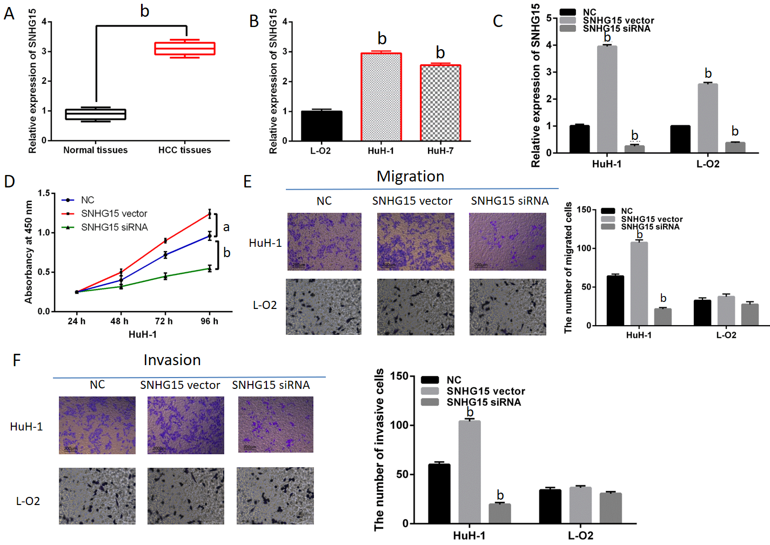
Figure 1 The dysregulation of lncRNA-SNHG15 in hepatocellular carcinoma. A: SNHG15 expression in 33 randomly selected hepatocellular carcinoma tissues and normal tissues; B: SNHG15 expression in HuH-1, HuH-7 and L-O2 cell lines; C: lncRNA-SNHG15 expression in HuH-1 and L-O2 cells containing SNHG15 siRNA or vector; D: Cell proliferation in HuH-1 and L-O2 cells with SNHG15 siRNA or vector; E: Cell migration in HuH-1 cells with SNHG15 siRNA or vector; F: Cell invasion in HuH-1 cells with SNHG15 siRNA or vector. Untreated cells were used as control (NC). ªP < 0.05, ^{b}P < 0.01. SNHG15: Small nucleolar RNA host gene 15; HuH-1: Hepatocellular carcinoma cell lines; HuH-7: Hepatocellular carcinoma cell lines; L-O2: Normal human liver cells; siRNA: Small interfering RNA.

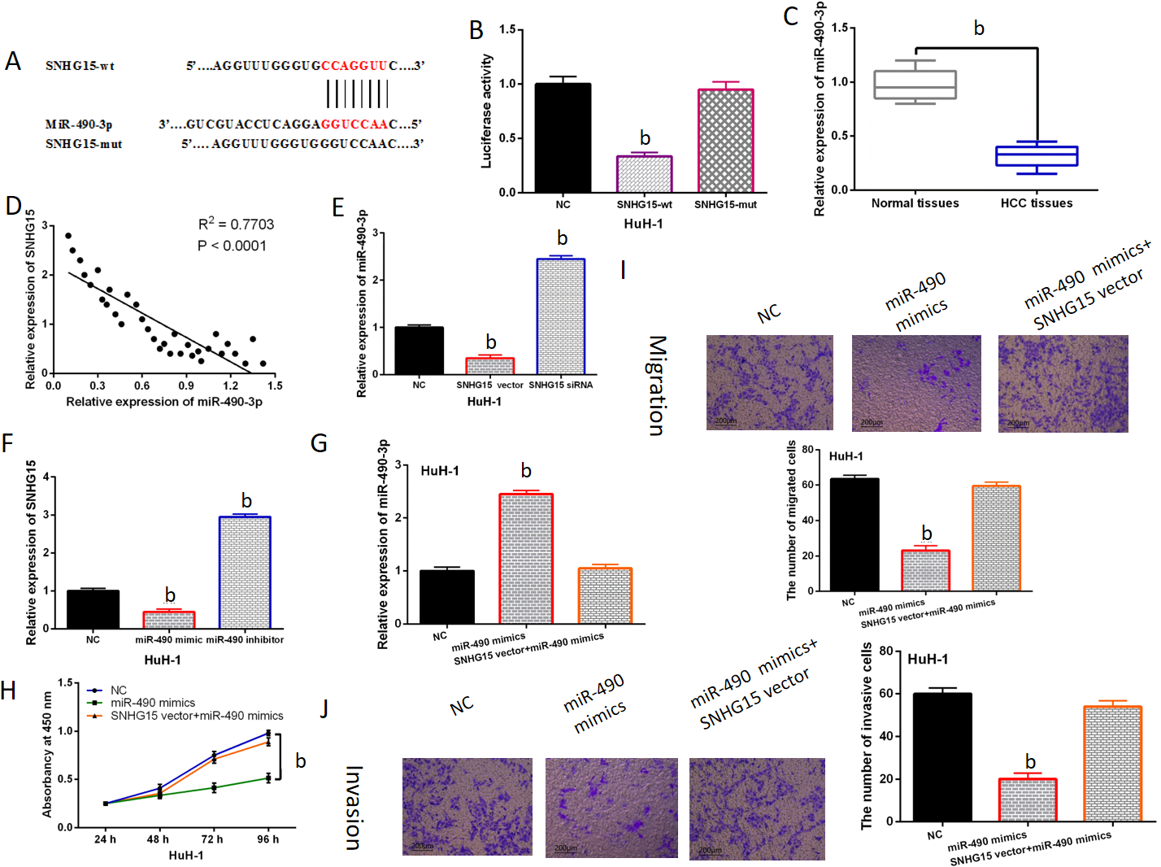Figure 2 Direct interaction of lncRNA-SNHG15 and miR-490-3p. A: The binding sites between lncRNA-SNHG15 with miR-490-3p; B: Luciferase reporter assay; C: miR-490-3p expression in 33 randomly selected HCC tissues and normal tissues; D: SNHG15 had negative correlation with miR-490-3p expression in 33 randomly selected HCC tissues; E: miR-490-3p expression regulated by SNHG15 siRNA or vector in HuH-1 cells; F: SNHG15 expression in HuH-1 cells containing miR-490-3p mimics or inhibitor; G: miR-490-3p expression in cells with miR-490-3p mimics or miR-490-3p mimics + SNHG15 vector. H: Cell proliferation in HuH-1 cells containing miR-490-3p mimics or miR-490-3p mimics + SNHG15 vector; I: Cell migration in HuH-1 cells containing miR-490-3p mimics or miR-490-3p mimics + SNHG15 vector; J: Cell invasion in HuH-1 cells containing miR-490-3p mimics or miR-490-3p mimics + SNHG15 vector. Untreated cells were used as control (NC). ^{b}P < 0.01. SNHG15: Small nucleolar RNA host gene 15; miR-490-3p: Hsa-miR-490-3p; HCC: Hepatocellular carcinoma; siRNA: Small interfering RNA; HuH-1: Hepatocellular carcinoma cell lines.
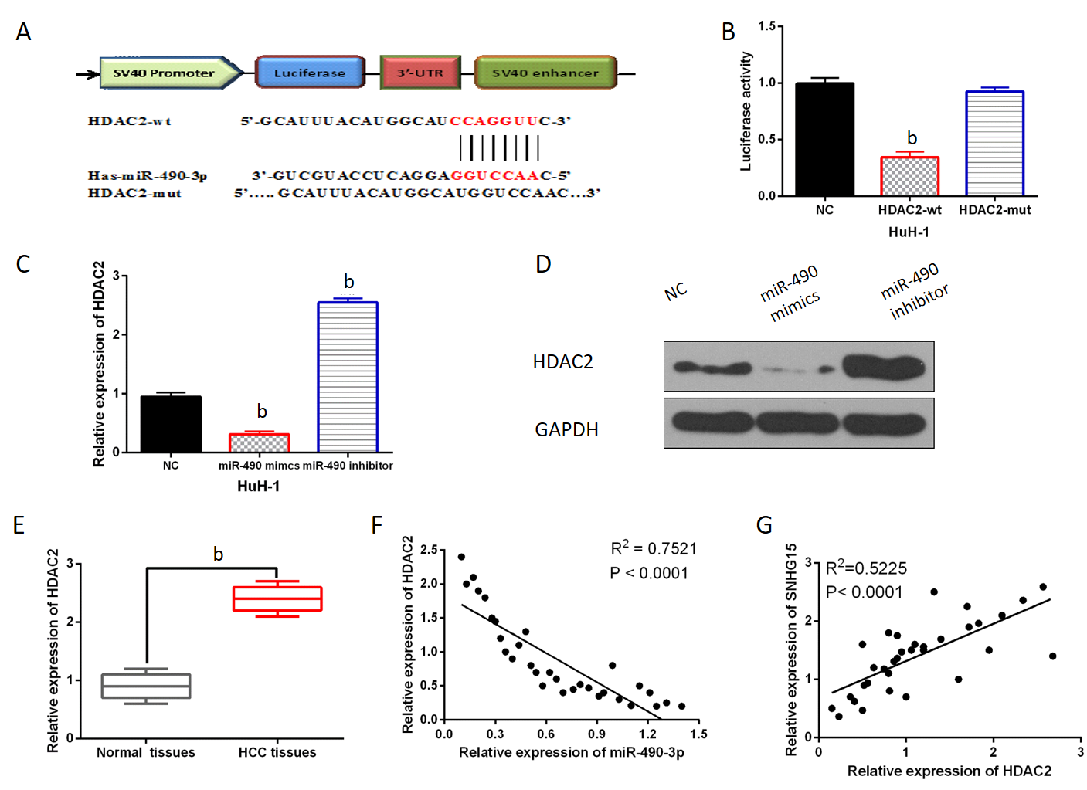 Figure 3 miR-490-3p directly targets Histone deacetylase 2. A: The binding sites between miR-490-3p and HDAC2; B: Luciferase reporter assay; C: miR-490-3p regulated HDAC2 expression in HuH-1 cells; D: miR-490-3p regulated HDAC2 expression in HuH-1 cells; E: HDAC2 expression in 33 randomly selected hepatocellular carcinoma tissues and normal tissues; F: HDAC2 was negatively correlated with miR-490-3p in 33 randomly selected HCC tissues; G: LncRNA-SNHG15 was positively correlated with HDAC2 in 33 randomly selected HCC tissues. Untreated cells were used as control (NC). ^{b}P < 0.01. miR-490-3p: Hsa-miR-490-3p; HDAC2: Histone deacetylase 2; HuH-1: Hepatocellular carcinoma cell lines; HCC: Hepatocellular carcinoma; SNHG15: Small nucleolar RNA host gene 15.
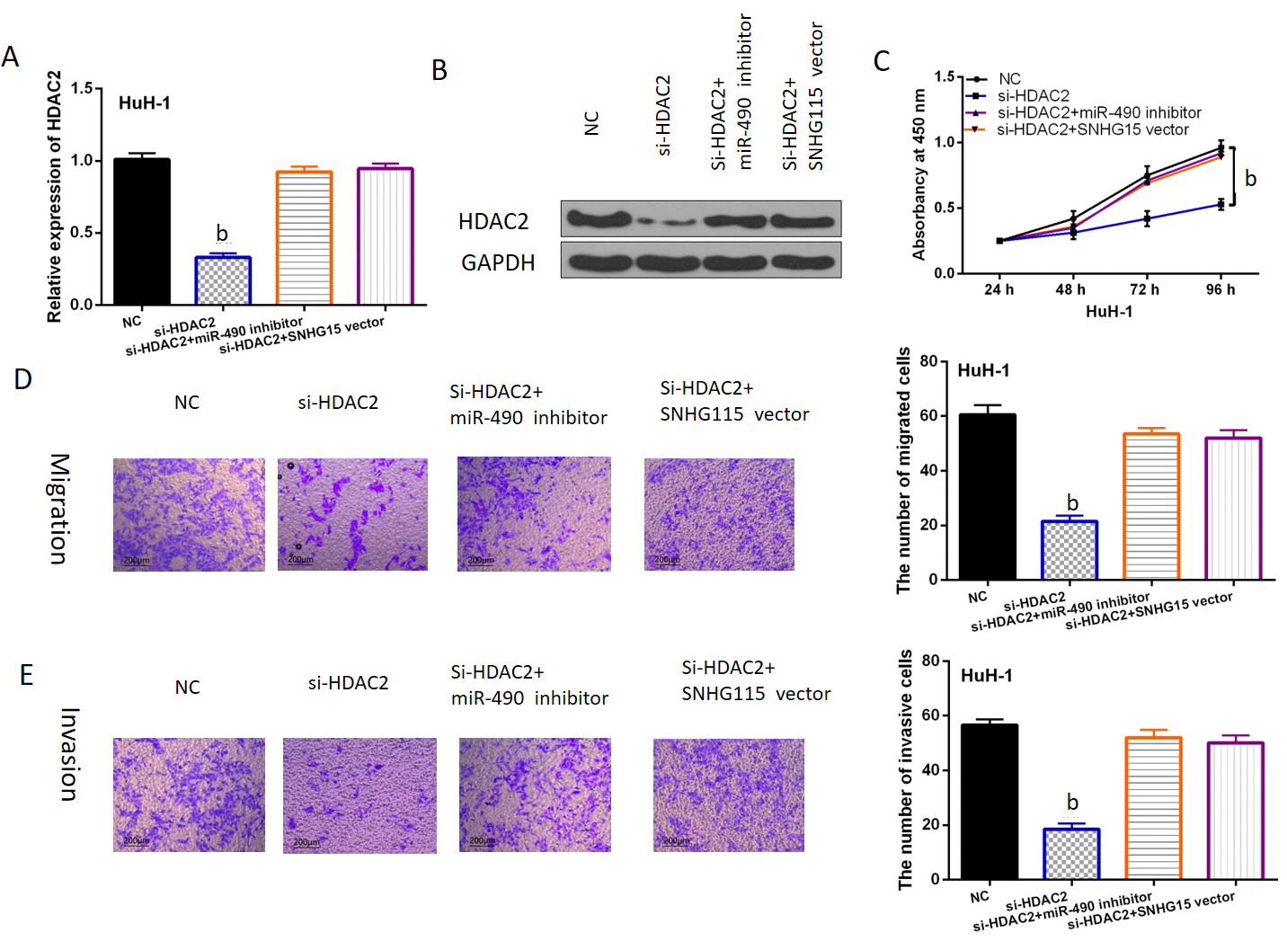 Figure 4 Histone deacetylase 2 regulated hepatocellular carcinoma progression through mediating SNHG15/miR-490-3p. A: HDAC2 expression in HuH-1 cells containing HDAC2 siRNA, si-HDAC2+miR-490-3p inhibitor or si-HDAC2+ SNHG15 vector; B: HDAC2 expression in HuH-1 cells containing HDAC2 siRNA, si-HDAC2+miR-490-3p inhibitor or si-HDAC2+ SNHG15 vector; C: Cell proliferation in HuH-1 cells containing HDAC2 siRNA, si-HDAC2+miR-490-3p inhibitor or si-HDAC2+ SNHG15 vector; D: Cell migration in HuH-1 cells containing HDAC2 siRNA, si-HDAC2+miR-490-3p inhibitor or si-HDAC2+ SNHG15 vector; E: Cell invasion in HuH-1 cells containing HDAC2 siRNA, si-HDAC2+miR-490-3p inhibitor or si-HDAC2+ SNHG15 vector. Untreated cells were set as control (NC). ^{b}P < 0.01. SNHG15: Small nucleolar RNA host gene 15; miR-490-3p: Hsa-miR-490-3p; HDAC2: Histone deacetylase 2; HuH-1: Human hepatoma cell lines; siRNA: Small interfering RNA; si-HDAC2: HDAC2 siRNA.

Table 1 Relationship between lncRNA-SNHG15 expression and the clinic-pathological characteristics in hepatocellular carcinoma patients
Characteristics | Cases | lncRNA-SNHG15 |  | P value
 |  | High | Low
Age (yr) |  |  |  | 0.56
≥ 65 | 40 | 26 | 14
< 65 | 61 | 44 | 17
Gender |  |  |  | 0.86
Male | 68 | 48 | 20
Female | 33 | 22 | 11
Tumor size (cm) |  |  |  | 0.01ª
< 5 cm | 72 | 51 | 21
≥ 5 cm | 29 | 19 | 10
Edmondson-Steiner grading |  |  |  | 0.01ª
I + II | 75 | 53 | 22
III + IV | 26 | 17 | 9
TNM stage |  |  |  | 0.02ª
I-II | 80 | 55 | 25
III-IV | 21 | 15 | 6
Statistical analyses were performed by the χ² test. ªP < 0.05 was considered significant. SNHG15: Small nucleolar RNA host gene 15.

