Name of journal: World Journal of Gastroenterology
Manuscript NO: 40167
Manuscript type: ORIGINAL ARTICLE

Basic Study
Mechanism of combined use of vitamin D and puerarin in anti-hepatic fibrosis by regulating the Wnt/β-Catenin signalling pathway

Huang GR et al. Anti-hepatic fibrosis mechanism

Gan-Rong Huang, Si-Jun Wei, Yan-Qiang Huang, Wei Xing, Lu-Yao Wang, Ling-Ling Liang

Gan-Rong Huang, Yan-Qiang Huang, Wei Xing, Lu-Yao Wang, Ling-Ling Liang, Youjiang Medical University for Nationalities, School of Basic Medical Sciences, Baise 533000, Guangxi Zhuang Autonomous Region, China

Si-Jun Wei, Affiliated Hospital of Youjiang Medical University for Nationalities, Baise 533000, Guangxi Zhuang Autonomous Region, China

ORCID number: Gan-Rong Huang (0000-0001-5580-8689); Si-Jun Wei (0000-0001-6948-2747); Yan-Qiang Huang (0000-0002-2121-8258); Wei Xing (0000-0001-5640-1151); Lu-Yao Wang (0000-0001-5545-0170); Lin-Ling Liang (0000-0002-1498-2370).

Author contributions: Huang GR and Wei SJ contributed equally to this work; Huang YQ, Wang LY and Liang LL performed the majority of the experimenting; Xing W performed the experimental design, write and analysis.

Supported by Key Laboratory Cultivation Base of Universities in Guangxi (Guangxi Education Research), No. [2014] 6.

Institutional animal care and use committee statement: This study was reviewed and approved by the Youjiang Medical University for Nationalities.

Conflict-of-interest statement: All authors have no conflict of interest.

Data sharing statement: No additional data are available.

ARRIVE guidelines statement: The manuscript has been revised according to the ARRIVE guidelines.

Open-Access: This article is an open-access article which was selected by an in-house editor and fully peer-reviewed by external reviewers. It is distributed in accordance with the Creative Commons Attribution Non Commercial (CC BY-NC 4.0) license, which permits others to distribute, remix, adapt, build upon this work non-commercially, and license their derivative works on different terms, provided the original work is properly cited and the use is non-commercial. See: http://creativecommons.org/licenses/by-nc/4.0/

Manuscript source: Unsolicited manuscript

Correspondence To: Wei Xing, MD, Professor, Youjiang Medical University for Nationalities, School of Basic Medical Sciences, 98 Urban-Rural Road, Baise 533000, Guangxi Zhuang Autonomous Region, China. 116895009@qq.com

Received: June 5, 2018
Peer-review started: June 5, 2018
First decision: June 21, 2018
Revised: July 30, 2018
Accepted: August 1, 2018
Article in press:
Published online:

Abstract
AIM
to reveal the protective mechanism of the combined use of vitamin D and puerarin in the progression of hepatic fibrosis induced by carbon tetrachloride (CCl₄).

Methods
Eight-week-old male Wistar ratswere randomly divided into a normal control group (C group), a CCl₄ group (CCl₄ group), a vitamin D group (V group), a puerarin group (P group), and a combined group of vitamin D and puerarin (V+P group), each of which contained 10 mice. In this way, we built a rat model of CCl₄-induced hepatic fibrosis and that intervened by vitamin D, puerarin, and a combination of the two. After eight weeks, the mice were sacrificed to collect serum and liver specimens. Blood was collected to detect the hyaluronic acid (HA). We also measured the hydroxyproline (Hyp) and prepared paraffin sections of liver. After Sirius red staining, the liver specimens were observed under a microscope. RT-PCR and western blot analysis were adopted to detect the mRNA and the protein levels of Collagen I, Collagen III, Wnt1, and β-Catenin in the liver tissues, respectively.

Results
Hepatic fibrosis was observed in the CCl₄ group. In comparison, the hepatic fibrosis was attenuated in the V, P, and V+P groups: the HA level in blood and the Hyp level in liver were reduced, and the mRNA levels of Collagen I, Collagen III, Wnt, and β-Catenin in liver were also decreased, as well as the protein levels of Wnt1 and β-Catenin. Among these groups, the V+P group witnessed the greatestamelioration of hepatic fibrosis.

Conclusion
The combined application of vitamin D and puerarin is capable of alleviating the CCl₄-induced hepatic fibrosis of mice. As to the mechanism, it is probably because the combined use is able to silence the Wnt1/β-Catenin pathway, suppress the activation of hepatic stellate cells, and reduce the secretion of collagen fibres, therefore improving the anti-hepatic fibrosis effect.

Key words: Carbon tetrachloride; Hepatic fibrosis; Vitamin D; Puerarin; Wnt/β-Catenin

© The Author(s) 2018. Published by Baishideng Publishing Group Inc. All rights reserved.

Core tip: The proliferation of hepatic stellate cells (HSCs), are associated with hepatic fibrosis. the activated HSCs, as well as Wnt1 and β-Catenin,have become important targets in anti-hepatic fibrosis therapy. The research investigated the protective effect of the combined use of vitamin D and puerarin against CCl₄-induced hepatic fibrosis in mice. The protective effect of the combined use of vitamin D and puerarin in the progression of hepatic fibrosis is closely associated with the functions of silencing the Wnt1/β-Catenin pathway, suppressing the activation of HSCs, and decreasing the secretion of collagen fibres, which provided a useful reference for those in clinical practice.

Huang GR, Wei SJ, Huang YQ, Wei X, Wang LY, Liang LL. Mechanism of combined use of vitamin D and puerarin in anti-hepatic fibrosis by regulating the Wnt/β-Catenin signalling pathway. World J Gastroenterol 2018; In press

INTRODUCTION
Hepatic fibrosis is the change of pathological structures due to all kinds of chronic liver diseases. Essentially, it occurs because extracellular matrix (ECM) synthesised by hepatic stellate cells (HSCs) under the actions of various pathogenic factors increases substantially, exceeding the degradation ability of liver itself. The long-term accumulation of ECM will lead to hepatic fibrosis and thus cause liver cirrhosis^{[1,2]}. In recent years, it has been proved that the β-Catenin protein plays a critical role in the occurrence and development of hepatic fibrosis^{[3,4]}. Previous studies reveal that the more serious the hepatic fibrosis, the higher the expression of β-Catenin in liver tissues compared with normal liver tissues, and silencingβ-Catenin is able to suppress the secretion of collagen and the proliferation of HSCs and mediate cell apoptosis. β-Catenin participates in many signalling pathways, among which the Wnt/β-Catenin pathway is the most common along which β-Catenin plays its role. Apart from this, β-Catenin also participates in alternative pathways including E-cadherin, NF-κB, and TGF-β^{[5-7]}. Therefore, β-Catenin is key to the intersection of multiple signalling pathways. Existing experiments reveal that HSC-T6 cell membranes and cytoplasm with activated phenotypes show β-Catenin expression, and β-Catenin expression is also observed in nuclei. This indicates that Wnt/β-Catenin signalling pathway is activated in activated HSCs. The expression of α-SMA in HSC-T6 cells is down-regulated by blocking the transduction of Wnt/β-Catenin signalling pathway, and the expression of types I and IIIcollagen (Collagen I and Collagen III) was also significantly down-regulated. The analysis based on the String database finds that DVL1, DVL2, and DVL3 play their functions in the signal transduction pathways mediated by multiple Wnt genes. They are regulatory factors for the Wnt signalling pathway and ER-to-Golgi transport and participate in the ER-to-Golgi transport, thus KLHL12 plays a critical role in the export of collagen, as shown in Figure 1. This implies that the Wnt/β-Catenin signalling pathway is closely associated with the activation of HSCs.
Carbon tetrachloride (CCl₄) is one of the classical poisons used in establishing hepatic fibrosis models and therefore is widely used in fundamental research^{[8]}. Previous research has proved, in vivo, that vitamin D is able to alleviate hepatic fibrosis and in vitro experiments confirm that vitamin D can reduce the secretion of collagen fibres of HSCs^{[9,10]}. There are also evidences from existing research that puerarin is capable of attenuating hepatic fibrosis, which is probably associated with the inhibition of the activation of HSCs by blocking the TNF-α signalling pathway^{[11,12]}. A preliminary study by the present research team has confirmed that the combined use of vitamin D and puerarin is able to enhance the anti-hepatic fibrosis effect; however, the related mechanism has not been revealed. Therefore, the current research investigated the effects of vitamin D combined with puerarin on the expressions of key factors including Wnt1, β-Catenin, Collagen I, and Collagen III in the Wnt/β-Catenin signalling pathway based on the aforementioned preliminary study. By doing so, we attempted to further clarify the mechanism of the combined use of vitamin D and puerarin in anti-hepatic fibrosis.

MATERIALS AND METHODS
Experimental materials
Fifty clean-grade healthy male Wistar mice (with a body mass of about 200 g) of similar age were provided by the Animal Center of Youjiang Medical College for Nationalities. Analytically pure CCl₄ was purchased from Sinopharm Chemical Reagent Co., Ltd, and vitamin D and puerarin were purchased from Sigma. In addition, corn oil, Sirius red staining solution, and real-time fluorescence quantitative PCR kits were purchased from Wako Pure Chemical Industries, Ltd, Beijing LeageneBiotech Co., Ltd, and Roche (Switzerland), respectively. Wnt1 and β-Catenin antibodies were purchased from Santa Cruze (United States). Table 1 shows the designations and sequences of primers.

Experimental methods
Fifty Wistar mice were randomly divided into five groups. Mice in the CCl₄ group were administered with 3 ml/kg of corn oil solution containing 45% CCl₄ through intraperitoneal injection twice a week. The normal control group (C group) was administered with same dose of normal saline through intraperitoneal injection twice a week. The V, P, and V+P groups are drug intervention groups. On the basis of the models established using corn oil solution containing CCl₄, mice in the three groups received 2 μg/kg of vitamin D, 0.4 g/kg of puerarin, and a combination of D vitamin (2 μg/kg) and puerarin (0.4 g/kg) through intragastric administration, twice a week. The mice were subjected to fasting for one hour before each administration of treatment. The C group received with same quantity of normal saline through intragastric administration. After eight weeks, the mice were fasted overnight in the day before the end of the experiments and sacrificed the next day. Whole blood was collected and stood for 20 min at room temperature. Then, the blood was centrifuged at 5000 rpm for 15 min. Thereafter, the supernatant and then the serum were obtained, followed by the detection of hyaluronic acid (HA) in blood using the aforementioned kit. After collecting the liver of the mice, the kit was used to detect the hydroxyproline (Hyp) in liver. Part of the liver was fixed in a polyformaldehyde solution and paraffin sections prepared. After Sirius red staining, the liver tissue slices were placed under the microscope to observe their pathological changes and degree of fibrosis. Moreover, real-time fluorescence quantitative PCR was applied to detect the mRNA levels of Collagen I, Collagen III, Wnt1, and β-Catenin, and a western blot assay was used to measure the protein levels of Wnt1 and β-Catenin.

Statistical analysis
The experiments were repeated three times for each group. SPSS17.0 statistical software was used for subsequent analysis. The analytical results were expressed using mean ± SD and the t-test was used when comparing paired groups. The difference was deemed statistically significant when P < 0.05.

RESULTS
Determination biochemical indices of blood and liver
HA is a kind of proteoglycan distributed surrounding hepatic cells and its content increases significantly in blood when hepatic fibrosis occurs^{[13]}. Hyp in liver is an important part of the collagen fibres in liver and the amount thereof also increased when hepatic fibrosis occurs^{[14]}. Therefore, the two factors are important diagnostic indices of hepatic fibrosis. As shown in Table 2, the HA and Hyp of the CCl₄ group were significantly higher than those of the C group, which indicated, to some extent, that the hepatic fibrosis model had been successfully established. The HA and Hyp levels of the V, P, and V+P groups were much lower than those of the CCl₄ group. Among these groups, the V+P group showed the most significant reduction in HA and Hyp levels.

Observation of the pathological sections of liver tissues
The Sirius-red-stained sections of each group were observed under the microscope. As illustrated in Figure 2A-F, mice in the CCl₄ group and the medication groups showed larger areas of fibrosis in their liver tissues than in the C group. In addition, the areas of fibrosis of liver tissues in mice in each of the medicated groups were smaller than that of the CCl₄ group (P < 0.05). Among the three groups, the V+P group presented the smallest area of fibrosis.

mRNA levels of collagen I, collagen III, Wnt1, and β-catenin
RT-PCR detection was conducted to test the mRNA levels of Collagen I, Collagen III, Wnt1, and β-Catenin of the mice in each group. It can be seen from Table 3 that the mRNA levels of Collagen I, Collagen III, Wnt1, and β-Catenin of liver tissues of mice in the CCl₄ group and the medicated groups are all higher than those of the C group. The mRNA levels of these indices of mice in the three medicated groups were all lower than those of the CCl₄ group (P < 0.05). Among the medicated groups, the V+P group showed the lowest mRNA levels.

Protein levels of Wnt1 and β-catenin of liver
As the Wnt/β-Catenin signalling pathway plays a significant role in the progression of hepatic fibrosis, a western blot assay was applied to detect the protein levels of Wnt1 and β-Catenin of liver. Figure 3 shows that the protein levels of Wnt1 and β-Catenin of liver tissues in mice in the CCl₄ group and the medicated groups were higher than the C group. The medicated groups showed lower protein levels than the CCl₄ group (P < 0.05), among which the V+P group exhibited the lowest protein levels (P < 0.01).

DISCUSSION
Hepatic fibrosis is the inevitable pathological change during the development of chronic liver diseases. If it is not blocked, its further development would cause liver cirrhosis and even liver cancer. Hepatic fibrosis can be induced by many pathogenic factors, including viruses, parasites, alcohol, and some poisons such as CCl₄. It is essentially a disturbance of the balance between the production and degradation of ECM outside hepatocytes. The ECM accumulates in the liver and its main component is collagen fibre^{[15,16]}. HSCs, as the principal participant in the production and degradation of ECM, when activated, are the key link necessary for the occurrence of hepatic fibrosis. Existing in the Dissespace, HSCs mainly play their roles in metabolising and storing vitamin A in normal conditions. They can synthesise and secrete small amounts of ECM and produce collagenase. When hepatic fibrosis occurs, HSCs in their resting state are activated. Active oxygen, lipid peroxide, and molecules secreted by nearby cells, such as activated Kupffer cells, and liver sinusoidal endothelial cells, as well as damaged hepatic cells, all can facilitate the activation of resting HSCs. After activation, HSCs have different morphologies, and the changes include the secretion of alpha smooth muscle actin (α-SMA), loss of vitamin A stored in cells, and increase in the rough endoplasmic reticulum. The activation of HSCs is also accompanied by a series of changes in genetic expression, including the appearance of receptors that can respond to paracrine stimulation on the cytomembrane of activated HSCs and a series of signalling cascade reactions in cells. The presence of the signalling cascade reactions in cells is beneficial to maintaining the phenotype of activated cells and controlling the occurrence of fibrosis, the proliferation of HSCs, and the increases in the transcription and translation of Collagen I and Collagen III^{[17-19]}.
The canonical Wnt signal transduction pathway is also known as Wnt/β-catenin signal transduction pathway. It is the pathway that has been the subject of most of the research to date. As a highly conservative signalling pathway activated during the evolution of some species, it is a basic pathway which is able to regulate cell proliferation and cell polarity, control cell fate, and maintain homeostasis in the embryo, and influence tissue development. Therefore, the pathway plays significant roles in various physiological processes including early development of animal embryos, organofaction, and tissue regeneration, as shown in Figure 4^{[20]}. When Wnt is deficient, β-catenin in cytoplasm is generally degraded via Axin complexes; in addition, glycogen and casein kinase 1 (CK1) synthesise glycogen synthase kinase 3 (GSK3), which sequentially phosphorylates the amino terminal ofβ-catenin. As a result, β-catenin is recognised by β-Trcp and the sub-unit of E3 ubiquitin ligases and is then degraded by the ubiquitination pathway. The continuous removal of β-catenin inhibits the nuclear import of β-catenin and the combination of the protein family of T cell factor/lymphoid enhancer factor (TCF/LEF) with DNA, thus suppressing the transcription of the Wnt target gene^{[21,22]}. When Wnt ligands are bound with transmembrane Frizzled (Fz) receptors and their co-receptor–low-density lipoprotein receptor related protein 6 (LRP6) or similar LRP5, Wnt/β-Catenin signalling pathway and dishevelled Dsh/Dvl proteins in cells are activated. Consequently, the GSK-3β activity is suppressed, Axin falls off, and the formation of biodegradable composite film (mainly composed of Axin, APC, and GSK-3β) of β-Catenin is inhibited. Therefore, β-Catenin will aggregate, not be recognised, and then is degraded via the ubiquitination pathway^{[23,24]}. As β-Catenin accumulates to a certain level, it dissociates. Under these conditions, β-Catenin is likely to undergo nuclear translocation, thus combining with the transcription factor TCF/LEF, forming transcriptional activation complex, and finally upregulating, or downregulating, the expressions of some downstream genes. At present, the known target downstream genes include D1 (cyclin D1), c-myc, MMP7, survivin, CD44, and growth factor, and new target genes are constantly being discovered^{[25,26]}. In the Wnt/β-catenin pathway, Wnt 1 is the key gene participating in the aggregation and disappearance of β-catenin and is closely related to the occurrence and development of hepatic fibrosis and tumours.
The Wnt/β-Catenin pathway, and the activation and proliferation of HSCs, are therefore associated with hepatic fibrosis. The Wnt/β-Catenin pathway, dominated as it is by Wnt and β-Catenin, plays a significant role in regulating the activation of HSCs and the secretion of Collagen I and III. Although the mechanism via which the Wnt/β-Catenin signalling pathway takes part in hepatic fibrosis by activating HSCs is not completely understood, activated HSCs, as well as Wnt1 and β-Catenin, have become important targets in anti-hepatic fibrosis therapy.
Most of the vitamin D in the body can be produced by the liver which is also one of the target organs of vitamin D. Previous studies have revealed that vitamin D is capable of ameliorating CCl₄-induced hepatic fibrosis in mice. In vitro experiments have shown that this is probably because it reduces the activation of HSCs and the secretion of collagen fibres. Puerarin, as a type of flavonoid drug that is widely applied in clinical practice, is also able to alleviate CCl₄-induced hepatic fibrosis (according to the evidence of existing research): however, there is no report on the issue as to whether, or not, the Wnt/β-Catenin signalling pathway can be significantly suppressed after the combined use of vitamin D and puerarin. Whether using vitamin D or puerarin alone, its protective effect on the liver during the progression of hepatic fibrosis is found to be closely associated with its functions of suppressing HSCs: our preliminary research revealed that the combined use of the two drugs is able to impart greater protective function, so we speculated that the mechanism of the combined use is probably related to HSCs, Wnt, and β-Catenin.
The research demonstrated that CCl₄ greatly increased the HA level in blood and Hyp level in mouse liver. By observing the Sirius-red-stained specimens under a microscope, it was found that CCl₄ caused the deposition of collagen fibres in the liver of the mice. All these results indicated that the mouse model of hepatic fibrosis was successfully established. Vitamin D and puerarin can both reduce the HA level in blood and Hyp level in liver of the mice, thus greatly decreasing the amount of collagen fibres in the liver. The combined use of vitamin D and puerarin most significantly reduced various damage indices and alleviated the deposition of collagen fibres, which proved that the two drugs had synergistic effects. Meanwhile, we detected the mRNA and protein levels of Collagen I, Collagen Ⅲ, Wnt1, and β-Catenin molecules in the liver of the mice. The results indicated that both vitamin D and puerarin are capable of decreasing the mRNA and protein levels of these molecules. Likewise, the most significant reduction effect was also observed in the V+P group. This suggested that the protective effect of the combined use of vitamin D and puerarin in the progression of hepatic fibrosis is closely associated with the functions of silencing the Wnt1/β-Catenin pathway, suppressing the activation of HSCs, and decreasing the secretion of collagen fibres.
The research investigated the protective effect of the combined use of vitamin D and puerarin against CCl₄-induced hepatic fibrosis in mice. The results revealed that the combined use of the two drugs exhibited a superior anti-hepatic fibrosis effect compared to that of each of the agents used as a single medication. It was preliminarily found that the protective mechanism of the combined use was related to the Wnt/β-Catenin pathway, which provided a useful reference for those in clinical practice: however, the regulatory mechanism is complex and involves multiple factors and pathways. Other mechanisms of action warrant further investigation.

Article Highlights
Research background
Hepatic fibrosis is seriously endangering the safety of life. At present, there is no ideal way to treat hepatic fibrosis. The combination of vitamin D and puerarin can improve the effect of anti hepatic fibrosis, but the mechanism is not clear. Therefore, the aim of this study is to explore the mechanism of combined use of vitamin D and puerarin in the treatment of hepatic fibrosis, so as to improve the theoretical basis for the treatment of hepatic fibrosis.

Research motivation
The combination of vitamin D and puerarin can improve the effect of anti hepatic fibrosis, but its mechanism is not clear. The Wnt/β-Catenin pathway is closely related to liver fibrosis. In this study, we found that vitamin D and puerarin are closely related to the regulation of Wnt/β-Catenin pathway in hepatic fibrosis, which provided a useful reference for those in clinical practice.

Research objectives
The research aimed to reveal the protective mechanism of the combined use of vitamin D and puerarin in the progression of hepatic fibrosis induced by carbon tetrachloride (CCl₄).

Research methods
In this study, a Wistar rat model of hepatic fibrosis was constructed by CCl_{4,} used vitamin D combined with Puerarin in the treatment of hepatic fibrosis rats, the hepatic pathological and the genes related to the Wnt/β-Catenin pathway were detected. The protective mechanism of the combined use of vitamin D and puerarin in the progression of hepatic fibrosis was explored at the molecular level.

Research results
The research demonstrated that CCl₄ greatly increased the HA level in blood and Hyp level in mouse liver. CCl₄ caused the deposition of collagen fibres in the liver of the mice. Vitamin D and puerarin can both reduce the HA level in blood and Hyp level in liver of the mice, thus greatly decreasing the amount of collagen fibres in the liver. The combined use of vitamin D and puerarin most significantly reduced the various damage indices, and alleviated the deposition of collagen fibres, which proved that the two drugs had synergistic effects.

Research conclusions
The combined application of vitamin D and puerarin is capable to alleviating the CCl₄-induced hepatic fibrosis of mice.

Research perspectives
We have learned to induce animal model and study the drug effects by the animal model, but also because we were not skilled enough experimental technique, spent more time to do repetitive work. The future research direction is to explore the prevention and treatment measures of hepatic fibrosis. The drug targets are study by Transcriptome, Proteomics and other methods.

References
1 Ding BS, Cao Z, Lis R, Nolan DJ, Guo P, Simons M, Penfold ME, Shido K, Rabbany SY, Rafii S. Divergent angiocrine signals from vascular niche balance liver regeneration and fibrosis. Nature 2014; 505: 97-102 [PMID: 24256728 DOI: 10.1038/nature12681]
2 Friedman SL. Molecular regulation of hepatic fibrosis, an integrated cellular response to tissue injury. J Biol Chem 2000; 275: 2247-2250 [PMID: 10644669 DOI: 10.1074/jbc.275.4.2247]
3 Ge WS, Wang YJ, Wu JX, Fan JG, Chen YW, Zhu L. β-catenin is overexpressed in hepatic fibrosis and blockage of Wnt/β-catenin signaling inhibits hepatic stellate cell activation. Mol Med Rep 2014; 9: 2145-2151 [PMID: 24691643 DOI: 10.3892/mmr.2014.2099]
4 Li W, Zhu C, Li Y, Wu Q, Gao R. Mest attenuates CCl4-induced liver fibrosis in rats by inhibiting the Wnt/β-catenin signaling pathway. Gut Liver 2014; 8: 282-291 [PMID: 24827625 DOI: 10.5009/gnl.2014.8.3.282]
5 Barrott JJ, Cash GM, Smith AP, Barrow JR, Murtaugh LC. Deletion of mouse Porcn blocks Wnt ligand secretion and reveals an ectodermal etiology of human focal dermal hypoplasia/Goltz syndrome. Proc Natl Acad Sci USA 2011; 108: 12752-12757 [PMID: 21768372 DOI: 10.1073/pnas.1006437108]
6 Qian J, Niu M, Zhai X, Zhou Q, Zhou Y. β-Catenin pathway is required for TGF-β1 inhibition of PPARγ expression in cultured hepatic stellate cells. Pharmacol Res 2012; 66: 219-225 [PMID: 22706027 DOI: 10.1016/j.phrs.2012.06.003]
7 Nejak-Bowen K, Kikuchi A, Monga SP. Beta-catenin-NF-κB interactions in murine hepatocytes: a complex to die for. Hepatology 2013; 57: 763-774 [PMID: 22941935 DOI: 10.1002/hep.26042]
8 Ma ZG, Lv XD, Zhan LL, Chen L, Zou QY, Xiang JQ, Qin JL, Zhang WW, Zeng ZJ, Jin H, Jiang HX, Lv XP. Human urokinase-type plasminogen activator gene-modified bone marrow-derived mesenchymal stem cells attenuate liver fibrosis in rats by down-regulating the Wnt signaling pathway. World J Gastroenterol 2016; 22: 2092-2103 [PMID: 26877613 DOI: 10.3748/wjg.v22.i6.2092]
9 Abramovitch S, Dahan-Bachar L, Sharvit E, Weisman Y, Ben Tov A, Brazowski E, Reif S. Vitamin D inhibits proliferation and profibrotic marker expression in hepatic stellate cells and decreases thioacetamide-induced liver fibrosis in rats. Gut 2011; 60: 1728-1737 [PMID: 21816960 DOI: 10.1136/gut.2010.234666]
10 Ding N, Yu RT, Subramaniam N, Sherman MH, Wilson C, Rao R, Leblanc M, Coulter S, He M, Scott C, Lau SL, Atkins AR, Barish GD, Gunton JE, Liddle C, Downes M, Evans RM. A vitamin D receptor/SMAD genomic circuit gates hepatic fibrotic response. Cell 2013; 153: 601-613 [PMID: 23622244 DOI: 10.1016/j.cell.2013.03.028]
11 Li R, Xu L, Liang T, Li Y, Zhang S, Duan X. Puerarin mediates hepatoprotection against CCl4-induced hepatic fibrosis rats through attenuation of inflammation response and amelioration of metabolic function. Food Chem Toxicol 2013; 52: 69-75 [PMID: 23146695 DOI: 10.1016/j.fct.2012.10.059]
12 Kaji K, Yoshiji H, Ikenaka Y, Noguchi R, Aihara Y, Douhara A, Moriya K, Kawaratani H, Shirai Y, Yoshii J, Yanase K, Kitade M, Namisaki T, Fukui H. Dipeptidyl peptidase-4 inhibitor attenuates hepatic fibrosis via suppression of activated hepatic stellate cell in rats. J Gastroenterol 2014; 49: 481-491 [PMID: 23475323 DOI: 10.1007/s00535-013-0783-4]
13 Lei X, Wang Yl, tu-er-xun AL, Zhang H, Zhang RL, Yang Y, Wu G, Cheng W. Correlation between radiation-induced hepatic fibrosis and serum levels of hyaluronic acid, type IV collagen and laminin in rats. Zhonghua Quanke Yixue 2015, 13: 18-20
14 Wang Zl, Liu Zj, Song T, Sun XH, Luo WM, Liu S. Effects of FuzhengHuoxue recipes on liver fibrosis associated serum indicators and hepatic hydroxyproline in liver fibrosis rats. Zhongyao Xinyao Yu Linchuang Yaoli 2010, 21: 611-613
15 Lu J, Chen B, Li S, Sun Q. Tryptase inhibitor APC 366 prevents hepatic fibrosis by inhibiting collagen synthesis induced by tryptase/protease-activated receptor 2 interactions in hepatic stellate cells. Int Immunopharmacol 2014; 20: 352-357 [PMID: 24735816 DOI: 10.1016/j.intimp.2014.04.001]
16 Wang Y, Zhao Z, Yan Y, Qiang X, Zhou C, Li R, Chen H, Zhang Y. Demethyleneberberine Protects against Hepatic Fibrosis in Mice by Modulating NF-κB Signaling. Int J Mol Sci 2016; 17: [PMID: 27376272 DOI: 10.3390/ijms17071036]
17 Schuppan D, Kim YO. Evolving therapies for liver fibrosis. J Clin Invest 2013; 123: 1887-1901 [PMID: 23635787 DOI: 10.1172/jci66028]
18 Friedman SL. Hepatic fibrosis -- overview. Toxicology 2008; 254: 120-129 [PMID: 18662740]
19 Atzori L, Poli G, Perra A. Hepatic stellate cell: a star cell in the liver. Int J Biochem Cell Biol 2009; 41: 1639-1642 [PMID: 19433304 DOI: 10.1016/j.biocel.2009.03.001]
20 Ota C, Baarsma HA, Wagner DE, Hilgendorff A, Königshoff M. Linking bronchopulmonary dysplasia to adult chronic lung diseases: role of WNT signaling. Mol Cell Pediatr 2016; 3: 34 [PMID: 27718180 DOI: 10.1186/s40348-016-0062-6]
21 Qi B, Wang Y, Chen ZJ, Li XN, Qi Y, Yang Y, Cui GH, Guo HZ, Li WH, Zhao S. Down-regulation of miR-30a-3p/5p promotes esophageal squamous cell carcinoma cell proliferation by activating the Wnt signaling pathway. World J Gastroenterol 2017; 23: 7965-7977 [PMID: 29259372 DOI: 10.3748/wjg.v23.i45.7965]
22 Wang D, Lu G, Shao Y, Xu D. MiR-182 promotes prostate cancer progression through activating Wnt/β-catenin signal pathway. Biomed Pharmacother 2018; 99: 334-339 [PMID: 29353209 DOI: 10.1016/j.biopha.2018.01.082]
23 Wang C, Zhu H, Sun Z, Xiang Z, Ge Y, Ni C, Luo Z, Qian W, Han X. Inhibition of Wnt/β-catenin signaling promotes epithelial differentiation of mesenchymal stem cells and repairs bleomycin-induced lung injury. Am J Physiol Cell Physiol 2014; 307: C234-C244 [PMID: 24898581 DOI: 10.1152/ajpcell.00366.2013]
24 Dijksterhuis JP, Petersen J, Schulte G. WNT/Frizzled signalling: receptor-ligand selectivity with focus on FZD-G protein signalling and its physiological relevance: IUPHAR Review 3. Br J Pharmacol 2014; 171: 1195-1209 [PMID: 24032637 DOI: 10.1111/bph.12364]
25 Kim JT, Liu C, Zaytseva YY, Weiss HL, Townsend CM Jr, Evers BM. Neurotensin, a novel target of Wnt/β-catenin pathway, promotes growth of neuroendocrine tumor cells. Int J Cancer 2015; 136: 1475-1481 [PMID: 25098665 DOI: 10.1002/ijc.29123]
26 Gibbons GS, Owens SR, Fearon ER, Nikolovska-Coleska Z. Regulation of Wnt signaling target gene expression by the histone methyltransferase DOT1L. ACS Chem Biol 2015; 10: 109-114 [PMID: 25361163 DOI: 10.1021/cb500668u]
P-Reviewer: Facciorusso A, Musquer N, Shin T S-Editor: Gong ZM
L-Editor: E-Editor:
Specialty type: Gastroenterology and hepatology
Country of origin: China
Peer-review report classification
Grade A (Excellent): A
Grade B (Very good): B, B
Grade C (Good): 0
Grade D (Fair): 0
Grade E (Poor): 0

Figure 1 Interaction between WNT related genes and collagen-related genes.

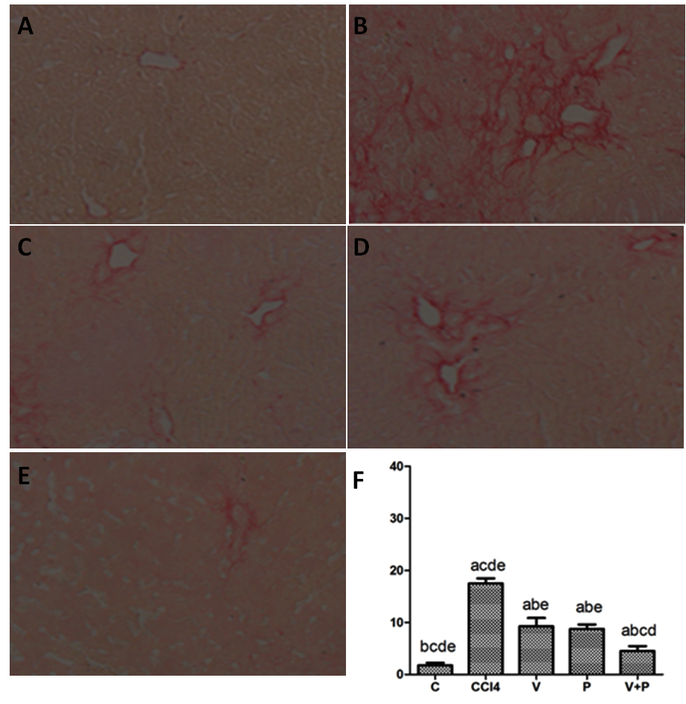
Figure 2 Sirius red staining. A: C group, B: CCl₄ group, C: V group, D: P group, E: V+P group (200 × magnification), F: Statistical graph of positive Sirius-red-stained areas (in the comparison of the mean ± SD of various groups, differences are statistically significant when p < 0.05, n = 10. Besides, a, b, c, d, and e represent statistical differences vs C, CCl₄, V, P, and V+P groups, respectively).

Figure 3 The protein levels of Wnt1 and β-catenin of liver tissues in mice in the CCl₄ group and the medicated groups were higher than the C group. A: Detection of protein levels of Wnt1, and β-Catenin using western blot assay; B: Grey analysis of Wnt1; C: Grey analysis of β-Catenin (in the comparison of mean ± SD of various groups, differences are statistically significant when p < 0.05, n=10. In addition, a, b, c, d, and e represent statistical differences vs C, CCl₄, V, P, and V+P groups, respectively).

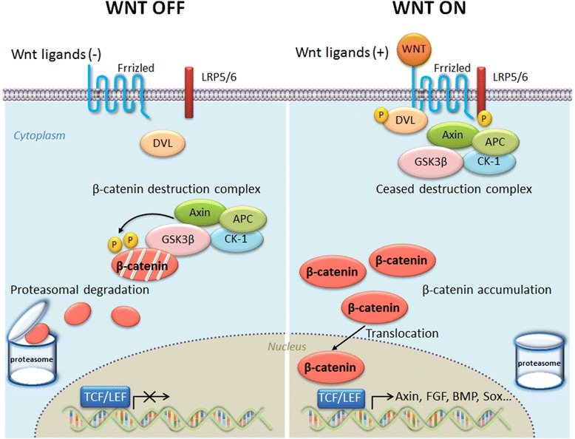
Figure 4 Overview of WNT/β-catenin signalling. Without WNT signalling (“WNT OFF”), “destruction complex phosphorylates cytosolic β-catenin and phosphorylated β-catenin is recognized and degraded by the proteasomes. With WNT signalling (“WNT ON”), the function of “destruction complex” is inhibited to phosphorylate cytosolic β-catenin. Then unphosphorylated β-catenin accumulates in the cytosol, translocates into the nucleus, and activates WNT target gene expression, such as is manifest by the presence of the T-cell factor and lymphoid enhancer factor-1 (TCF/LEF1) family of transcription factors.

Table 1 Designations and sequences of primers
Designation (mice) | Sequence (5’-3’)
GAPDH | F: GGCATCCTGACCCTCAAGTA
 | R: GGGGTGTGAACCTCTCAAA
Collagen I | F: GGACACTACTGGATCGACCTAAC
 | R: CTCACCTGTCTCCATGTTGCA
Collagen III | F: CTACCTTGCTCAGTCCTATGAGTCTAGA
 | R: TCCCGAGTCGCAGACACATAT
Wnt1 | F: GAAACCGCCGCTGGAACT
 | R: CCCTGCCTCGTTATTGTGAAG
β-Catenin | F: ACC TCC CAAGTC CTG TAT
 | R: CCT GGT CCT CGT CAT TTA

Table 2 Biochemical indices of blood and liver
groups | HA (μg/l) | Hyp (μg/g)
C | 61 ± 20.6 ^{bcde} | 195.6 ± 10.5^{bcde}
CCl4 | 157.3 ± 44.3^{acde} | 503 ± 31.7^{acde}
V | 70.2 ± 12.9^{b} | 375.2 ± 26.9^{ab}
P | 79.5 ± 11.6^{b} | 361.3 ± 24.1^{ab}
V+P | 65 ± 12.1^{b} | 353.7 ± 21.6^{ab}
In the comparison of the mean ± SD of various groups, differences are statistically significant when P < 0.05, at n = 10. In addition, a, b, c, d, and e represent statistical differences vs C, CCl₄, V, P, and V+P groups, respectively.

Table 3 The mRNA levels of collagen I, collagen III, Wnt1, and β-catenin of liver
groups | Collagen I | Collagen Ⅲ | Wnt1 | β-catenin
C | 1.17 ± 0.16^{bcde} | 0.62 ± 0.15 ^{bcde} | 0.56 ± 0.13 ^{bcde} | 0.48 ± 0.21^{bcde}
CCl4 | 4.73 ± 0.76^{acde} | 2.47 ± 1.12^{acde} | 1.77 ± 0.32^{acde} | 2.16 ± 0.42^{acde}
V | 1.97 ± 0.31^{b} | 1.29 ± 0.19^{ab} | 1.06 ± 0.35^{ab} | 1.25 ± 0.33^{ab}
P | 1.75 ± 0.46^{b} | 1.35 ± 0.17^{ab} | 0.83 ± 0.19^{ab} | 0.71 ± 0.46^{ab}
V+P | 1.53 ± 0.12^{abcd} | 1.03 ± 0.08^{abcd} | 0.61 ± 0.24^{abcd} | 0.59 ± 0.14^{abcd}
Differences are considered to exhibitstatistical significance when P < 0.05 (n = 10) in the comparison of the mean ± SD between various groups. Besides, a, b, c, d, and e indicate that there are statistical differences vs C, CCl₄, V, P, and V+P groups, respectively.

