Name of Journal: World Journal of Gastroenterology
Manuscript NO: 63825
Manuscript Type: ORIGINAL ARTICLE

Observational Study
Effect of gastric microbiota on quadruple Helicobacter pylori eradication therapy containing bismuth

Niu ZY et al. Effect of microbiota on H. pylori eradication

Zhan-Yue Niu, Si-Zhu Li, Yan-Yan Shi, Yan Xue

Zhan-Yue Niu, Si-Zhu Li, Yan Xue, Department of Gastroenterology, Peking University Third Hospital, Beijing 100191, China

Yan-Yan Shi, Research Center of Clinical Epidemiology, Peking University Third Hospital, Beijing 100191, China

Author contributions: Xue Y was the guarantor and designed the study; Niu ZY, Li SZ and Shi YY participated in the acquisition, analysis, and interpretation of the data and drafted the initial manuscript; Xue Y revised the article critically for important intellectual content; all authors have read and approved the final manuscript.

Supported by The Key Projects of Peking University Third Hospital, No. BYSY2017026.

Corresponding author: Yan Xue, MD, Doctor, Department of Gastroenterology, Peking University Third Hospital, No. 49 North Garden Road, Haidian District, Beijing 100191, China. xueyanby@163.com

Received: February 9, 2021
Revised: April 10, 2021
Accepted: May 27, 2021
Published online: July 7, 2021

Abstract
BACKGROUND
Helicobacter pylori (H. pylori) is an important pathogen that can cause a variety of diseases. Yet, full eradication of H. pylori remains a significant challenge in clinical practice. H. pylori and other microbial communities have complex interactions in the unique gastric microecological environment. However, it is not clear whether the interactions have any effect on the therapeutic effect of H. pylori.

AIM
The aim was to investigate the characteristics of the gastric microbiota with H. pylori infection and the influence on the H. pylori eradication treatment.

METHODS
Patients with H. pylori infection underwent gastroscopy and received treatment for eradication. The prescription included esomeprazole 20 mg bid, Livzon Dele 220 mg bid, amoxicillin 1000 mg bid, and clarithromycin 500 mg bid for 14 d. Patients who did not respond to treatment and failed eradication were compared with those who achieved eradication by 1:2 propensity matching. High-throughput sequencing of the gastric mucosal microbiota was performed, and the results were evaluated by alpha diversity analysis, beta diversity analysis, species correlation analysis, and metabolic pathway correlation analysis.

RESULTS
The eradication rate of all the patients was 95.5% (171/179). Twenty-four patients were enrolled in the study after propensity-matched scoring. There were eight cases in the failure group (patients who did not respond well to therapy) and 16 cases in the success group. The majority phyla in the two groups were the same, and included Proteobacteria, Bacteroides, Firmicutes, Actinomycetes, and Fusobacteria. The microbial diversity in the failure group had a decreasing trend (P = 0.092) and the species abundance was significantly lower (P = 0.031) compared with the success group. The high rate of H. pylori eradication was associated with Rhodococcus, Lactobacillus, and Sphingomonas, as they were significantly enriched in the successful group (P < 0.05). Veronococcus and Cilium were enriched in the mucosa of chronic atrophic gastritis patients compared with chronic superficial gastritis patients (P = 0.0466 and 0.0122, respectively). In both study groups, H. pylori was negatively correlated with other bacterial genera. More bacterial genera were directly related to H. pylori in the successful group compared with the failure group.

CONCLUSION
The effectiveness of quadruple H. pylori eradication therapy containing bismuth depended on gastric microbiota, and the high rate of H. pylori eradication was associated with the presence of Rhodococcus, Lactobacillus, and Sphingomonas.

Key Words: Helicobacter pylori; Eradication; Quadruple therapy; Influence factors; propensity matching; Gastric microbiota

©The Author(s) 2021. Published by Baishideng Publishing Group Inc. All rights reserved.

Citation: Niu ZY, Li SZ, Shi YY, Xue Y. Effect of gastric microbiota on quadruple Helicobacter pylori eradication therapy containing bismuth. World J Gastroenterol 2021; 27(25): 3913-3924
URL: https://www.wjgnet.com/1007-9327/full/v27/i25/3913.htm
DOI: https://dx.doi.org/10.3748/wjg.v27.i25.3913

Core Tip: Helicobacter pylori (H. pylori) is an important pathogen that can cause a variety of diseases. Its eradication can be affected by many factors. In this study, we explored the effect of the gastric microbiota on quadruple H. pylori eradication therapy containing bismuth. The results indicated that quadruple H. pylori eradication therapy containing bismuth was affected by the gastric microbiota. A high rate of H. pylori eradication was associated with the presence of Rhodococcus, Lactobacillus, and Sphingomonas. Our findings may provide the basis for clinical treatment.

INTRODUCTION
The gastric mucosal environment was long thought to be sterile. Yet, the discovery of Helicobacter pylori (H. pylori) put an end to the traditional view of the sterile stomach^{[1]}. Furthermore, the development of modern technology led to a deeper understanding of gastric microbiota. Numerous gastric microbiota have been discovered over the years by 16S rRNA sequencing^{[2]}. H. pylori and other microbial communities have complex interactions in the unique gastric microecological environment. H. pylori can inhibit other microbial communities by inducing the production of cytokines and antimicrobial peptides^{[3]}. On the contrary, other microbial communities can affect H. pylori. For example, Streptococcus can change the spiral form of H. pylori into a spherical shape and inhibit its growth^{[4]}.
H. pylori is an important pathogen associated with a variety of diseases^{[5-7}including gastric cancer^{[8]}. About 50% of the global population is infected with H. pylori^{[9]}. H. pylori infection is an infectious disease and a "screening-treatment" strategy has been recommended for the treatment of H. pylori. However, the eradication of H. pylori can be affected by many factors, including antibiotic resistance^{[10]}, medication compliance^{[11,12]}, virulence factors^{[13]}, and others. In this study, we investigated the characteristics of the gastric microbiota in patients with H. pylori infection and the effect of the gastric microbiota on the success of quadruple H. pylori eradication therapy containing bismuth.

MATERIALS AND METHODS
Participants
Patients diagnosed with H. pylori infection in the Gastroenterology Department of Peking University Third Hospital between were enrolled between July 2018 and July 2019. Patients who were (1) 18-70 years of age; (2) with H. pylori infection confirmed by gastroscopy and histopathology were eligible. Patients (1) with previous H. pylori eradication therapy; (2) using proton pump inhibitors, H₂ receptor blockers, bismuth, antibiotics, or other drugs that might affect the study results within 4 wk of inclusion; (3) with gastrointestinal tumors; (4) with a history of gastric or esophageal surgery; (5) with Zollinger-Ellison syndrome; (6) with abnormal liver or kidney function; (7) with severe cardiovascular, respiratory, blood, endocrine, neurological, or mental disease; (8) with allergy to a study drug; (9) were pregnant or lactating; and (10) or with histories of alcohol abuse or clinical conditions that might increase the risk of side effects were excluded.

Methods
Before inclusion, all patients provided informed consent for clinical sample collection. A biopsy was taken from the antrum before H. pylori eradication treatment. A rapid urease test (RUT) was performed during the gastroscopy, and if the result was positive, gastric mucosa biopsies from the lesser curvature of antrum and corpus were collected, placed in a cryovial, and stored −80 ℃. At the same time, mucosa specimens were collected from the gastric antrum and corpus were collected for histopathological examination and Warthin-Starry (WS) staining.
Patients diagnosed with H. pylori infection by positive RUT results and WS staining were treated with esomeprazole 20 mg bid, amoxicillin 1000 mg bid, clarithromycin 500 mg bid, Livzon Dele bismuth potassium citrate 220 mg bid for14 d. A ¹³C urease breath test (¹³C-UBT) was performed 8 wk after treatment, which was considered successful if the ¹³C-UBT was negative.
Patients were divided into failure and the success groups after their treatment was completed. Patients who did not respond well to therapy were included in the failure group. The success group was evaluated by nearest-neighbor matching, which is a type of propensity score matching and paired with patients in the failure group who had a similar propensity index. The propensity index was estimated by the model so as to equalize the covariates between the two groups. Gender, age, body-mass index (BMI kg/m²), gastroscopy diagnosis, and background gastric mucosa were the covariables used to calculate the propensity values. Taking the sample size and matching quality, the allowable error was set to 0.1. The failure and success groups were matched at a ratio of 1:2. The gastric mucosa microbiota were assayed and compared according to the results of propensity score matching.

Microbial diversity sequencing
The total DNA of the microbiota was extracted following the instructions with E.Z.N.A.® soil DNA kits (Omega Bio-Tek, Norcross, GA, United States) following the manufacturer’s instructions, and the quality of DNA extraction was assayed by 1% agarose gel electrophoresis. DNA concentration and purity were determined by a NanoDrop 2000 spectrophotometer, and 338 F (5'-ACTCCTACGGGAGGCAGCAG-3') and 806R (5'-GGACTACHVGGGTWTCTAAT-3') primers were used for PCR amplification of the V3-V4 region of the 16S rRNA gene. The PCR products were recovered on 2% agarose gels after combining the PCR products of the same sample. Recovered products were purified with AxyPrep DNA gel extraction kits (Axygen Biosciences, Union City, CA, United States) and assayed with a Quantus™ Fluorometer (Promega, United States). The library was built with NEXTFLEX Rapid DNA-Seq Kits and sequenced with a Miseq PE300 platform (Illumina).

Sequence data analysis
Fastp software was used for quality control of the original sequence, and Flash software was used for stitching. Usearch software (version7.0, http://drive5.com/uparse/) was used to for operational taxonomic unit (OTU) clustering of sequences based on 97% similarity and elimination of chimeras. RDP classifier (http://rdp.cme.msu.edu/) was used to compare each sequence with the sequences included in Silva database (SSU132). The threshold was set to 70%, and the results of species classification annotations were obtained. The sample species composition was analyzed based on the annotation results.
The alpha diversity analysis (i.e. within-sample diversity) reflected species diversity, including Shannon, ace, and coverage indices. Beta diversity analysis (i.e. diversity between samples) or between-group differences in species composition was by principal coordinates analysis (PCoA). The Wilcoxon rank-sum test was used to compare the two groups. A P value of < 0.05 was considered significant. Correlation analysis of species was carried out by correlation heatmaps, network analysis, and metabolic pathway analysis. The relationship between the microbiota and the result of H. pylori eradication was preliminarily explained.

Statistical analysis
SPSS 23.0 was used for data analysis. measurement data were reported as means ± SD and compared by t-tests. Categorical data were compared by χ² tests P values of < 0.05 were considered statistically significant.

RESULTS
Basic information
Of the 179 enrolled patients, 171 responded well to therapy with successful H. pylori eradication. Eight patients failed treatment. The eradication therapy success rate was 95.5%. Propensity scoring resulted in matching eight failed cases with 16 successful cases. The results of gastroscopy revealed chronic gastritis in all patients; and after matching, there were no significant differences in the baseline characteristics between the two groups (Table 1).
A total of 1 204 878 reads and 1028 OTUs were obtained from 24 samples. The samples contained a mean of 50 203 reads and 191 OTUs. The reads in the failed eradication group (58 487) were significantly higher (P = 0.013) than those in the successful eradication group (46 061); the difference between the OTUs in the two groups was not significant (166 and 203, respectively, P = 0.719). The samples were randomly flattened according to the minimum number of sample sequences to avoid analysis deviation. A total of 980 OTUs were obtained, and each sample contained 30 043 reads. All samples were dominated by H. pylori at the genus level; H. pylori infection was pathologically confirmed.

Analysis of microbiota composition and differences
The proportions of bacterial species in the failure and the success groups were evaluated by Good's species coverage index, which found that the difference between the two groups was not significant (P = 0.125). The coverage index in both groups was higher than 0.99 and confirmed that the test results covered most bacterial species in the gastric mucosa. Analysis of community composition showed that the gastric mucosa microbiota mainly contained Proteobacteria, Bacteroidetes, Firmicutes, Actinomycetes, and Fusobacteria, regardless of the study group. The abundance of Proteobacteria was higher in the failure group than in the success group, and that of Actinobacteria was lower (Table 2).
Alpha and beta diversity reflect differences in the microbial composition. The results of the Shannon index, which is one an indexes of alpha diversity, showed that the diversity in the failure group was reduced compared with the success group, but the difference was not significant (P = 0.092; Figure 1A). The Ace index showed that the species abundance was significantly lower in the failure group than in the success group (P = 0.031; Figure 1B). The dominant species in both study samples was H. pylori, but the microbiota composition differed at the genus level (Figure 2A). PCoA analysis of beta diversity resulted in a weighted UniFrac showing that the total diversity of the first two principal coordinates was 89.96% and the difference between the two groups was significant (ANOSIM, P = 0.048; Figure 2B). According to the unweighted UniFrac, the difference between the two groups was significant (ANOSIM, P = 0.001; Figure 2C). Binary Euclidean analysis, which was used to assess the difference in species composition, showed a significant difference between the two groups (ANOSIM, P = 0.001; Figure 2D). As shown in Figure 3, H. pylori was more abundance in the failure than in the success group, but the difference was not significant (Wilcoxon rank-sum test, P = 0.0809). Rhodococcus, Lactobacillus, and Sphingomonas were significantly enriched in the success group, (Wilcoxon rank-sum test, P < 0.05).
The flora composition of gastric mucosa that were histologically different was also analyzed. The abundance of H. pylori was higher in the mucosa of chronic superficial gastritis but the difference was not significant (Wilcoxon rank-sum test, P = 0.1179). Veronococcus and Cilium were more enriched in the mucosa of chronic atrophic gastritis (Wilcoxon rank-sum test, P = 0.0466 and 0.0122).

Correlation analysis of microbiota
Heatmap results of the species correlation analysis found that H. pylori was negatively correlated with other bacterial genera (Figure 4), H. pylori was negatively correlated with Ralstonia in the failure group (genus level) and negatively correlated with Haemophilus, Prevotella, Streptococcus, Actinomycetes, Veillonella, Neisseria, Fusobacterium, and Leptotrichia in the success group (genus level). The PICRUSt metabolic pathway function prediction showed that the level two metabolic pathways in the two study groups were basically the same, mainly including carbohydrates, amino acids, energy, coenzyme factors, and vitamins.

DISCUSSION
The composition of the gastric mucosa microbiota infected by H. pylori mainly included Proteobacteria, Bacteroidetes, Firmicutes, Actinobacteria, and Fusobacteria, which is consistent with the results reported by previous studies^{[14,15]}. H. pylori infection can significantly reduce the diversity of gastric mucosal microbiota^{[16]}. In this study, the Shannon index did not reveal a significant difference in the diversity of the microbiota between the success and the failure group. However, the microbiota diversity in the failure group was lower, which suggests that eradication of H. pylori may be associated with the diversity of gastric mucosal microbiota.
The abundance of Proteobacteria was higher in the failure group. The genus level data suggests that the higher abundance of H. pylori in the eradication failure group might have caused an increased abundance of Proteobacteria. Although the difference in H. pylori abundance between the two groups was not significant, previous studies have shown that a higher abundance of H. pylori may reduce the effectiveness of empirical eradication therapy^{[17]}. It has been reported that the abundance of H. pylori impacted only the result of traditional triple therapy^{[18]}. Nevertheless, our results implied that the abundance of H. pylori had an impact on the eradication effect of quadruple therapy containing bismuth. In addition, 16s RNA may be more accurate than the ¹³C/¹⁴C-UBT or histological evaluation for the determination of H. pylori abundance.
At the genus level, the gastric mucosa microbiota species diversity was similar in the two groups. However, PCoA analysis showed that there were differences in the species composition and abundance between the two groups. The Ace index confirmed the differences in abundance of the two groups, and statistical analysis confirmed that the success group was significantly enriched in Rhodococcus, Lactobacillus, and Sphingomonas. The reason for the increased abundance of Actinomycetes in the success group may be related to the enrichment of Rhodococcus, an opportunistic pathogen^{[19,20]} that can be detected in the stool of healthy people. Thiamine is required for the growth of Rhodococcus^{[21]} and is essential nutrient for the growth of H. pylori^{[22]}. H. pylori is a thiamine auxotroph that lacks the gene that synthesizes thiamine^{[23]}. Vitamin metabolism is one of the microbiota's main metabolic pathways predicted by PICRUSt. Therefore, Rhodococcus may inhibit the growth of H. pylori through the acquisition of thiamine. Lactobacilli, which are beneficial bacteria, effectively improve H. pylori eradication if added to the prescription, especially in 7-d and 14-d triple therapy^{[24]}. Previous studies have shown that Lactobacillus is a strong antagonist of H. pylori by preventing colonization and growth^{[25,26]} and inhibiting adhesion to and invasion of gastric epithelial cells. Lactobacillus even has an antagonistic effect on multidrug resistant H. pylori^{[27]}. In this study, the abundance of Lactobacillus was significantly higher in the success group than in the failure group, confirming the beneficial effect of Lactobacillus in the eradication of H. pylori. Moreover, previous studies found changes in Sphingomonas in a variety of diseases^{[28,29]}. In this study, it had a significant negative correlation with H. pylori and was more abundant in the success group than in the failure group.
Analysis of the microbiota against different gastric mucosa backgrounds showed that the genera Veronococcus and Cilium were enriched in chronic atrophic gastritis. Previous studies have shown bacterial overgrowth in the gastric mucosa of pre-gastric cancer. Veronococcus and Cilium are enriched in gastric mucosa of gastric cancer^{[30]}. Veronococcus can convert nitrate to nitrite, and the increased concentration of nitrite may promote gastric cancer^{[31]}. In addition, Veronococcus is enriched in patients with oral cancer, colorectal cancer, and lung cancer^{[32-35}. A study conducted in Colombia showed that the gastric mucosal flora of a population at high risk of gastric cancer was significantly enriched in Veronococcus and Cilium but the rate of H. pylori infection was not increased. Therefore, the genus Veronococcus and Cilium may be factors promoting the occurrence of gastric cancer. Our results confirmed a trend in pre-gastric cancer.
A negative correlation was found between H. pylori and other microbiota, which was more significant in the success group than in the failure group. The negative correlation of H. pylori and other microbiota was associated with a positive correlation among the other bacterial communities. Co-inhibition of H. pylori by a variety of mutually-promoting microbiota may improve the effectiveness of H. pylori eradication. There was no difference in the abundance of mutually-promoting microbiota present in the two groups. The lack of correlation between mutually-promoting microbiota and H. pylori in the failure group may have been related to a difference in H. pylori strains and needs to be confirmed by further studies.
Differences in the gastric microbiota may have contributed to H. pylori eradication failure, because all samples were collected before H. pylori eradication. This study has some limitations. It had a relatively small sample size because of the high eradication rate. The result preliminarily showed an effect of the gastric microbiota on H. pylori eradication, but studies that have larger sample sizes are needed to confirm these findings. This study did not determine H. pylori resistance, but the results provide clinically significant guidance for empirical treatment.

CONCLUSION
The effect of quadruple H. pylori eradication therapy containing bismuth depends on the gastric microbiota. A high rate of H. pylori eradication was associated with the presence of Rhodococcus, Lactobacillus, and Sphingomonas. The study identified gastric microbiota beneficial to H. pylori eradication and laid a foundation for further research on how the gastric microbiota influences H. pylori eradication. In addition, the study results may help to improve the eradication rate of H. pylori in the future.

ARTICLE HIGHLIGHTS
Research background
There are complex interactions between Helicobacter pylori (H. pylori) and other microbial communities in the gastric microecological environment. Yet, it remains unclear whether the interactions affect the eradication of H. pylori.

Research motivation
The motivation was to explore the interaction between gastric microbiota and H. pylori and to determine the influence of gastric microbiota on the eradication of H. pylori.

Research objectives
To investigate the characteristics of the gastric mucosa microbiota with H. pylori infection and the influence on H. pylori eradication treatment. This may help improve the eradication rate of H. pylori in the future.

Research methods
Patients with H. pylori infection underwent gastroscopy and received treatment. Propensity matching analysis was conducted, including the number of patients who did not respond to treatment. The gastric microbiota was assayed by high-throughput sequencing and subsequent analysis of alpha diversity, beta diversity, species correlations, and predicted metabolic pathways.

Research results
The main phyla in the two groups were the same in the eight failure group patients who did not respond well to therapy and the 16 success group patients and included Proteobacteria, Bacteroides, Firmicutes, Actinomycetes, and Fusobacteria. The high rate of H. pylori eradication was associated with Rhodococcus, Lactobacillus, and Sphingomonas. H. pylori was negatively correlated with other bacterial genera, and more bacterial genera were directly related to H. pylori in the success group.

Research conclusions
The effectiveness of quadruple H. pylori eradication therapy containing bismuth depended on the gastric microbiota. The high rate of H. pylori eradication was associated with Rhodococcus, Lactobacillus, and Sphingomonas.

Research perspectives
This study laid a foundation for further research on the mechanism of the influence of the gastric microbiota on H. pylori eradication, which will help to improve the eradication rate of H. pylori in the future.

ACKNOWLEDGEMENTS
We thank all medical staff and technicians from the Department of Gastroenterology and Clinical Epidemiology Research Center who agreed to participate in this study.

REFERENCES
1 Marshall BJ, Warren JR. Unidentified curved bacilli in the stomach of patients with gastritis and peptic ulceration. Lancet 1984; 1: 1311-1315 [PMID: 6145023 DOI: 10.1016/s0140-6736(84)91816-6]
2 Petrosino JF, Highlander S, Luna RA, Gibbs RA, Versalovic J. Metagenomic pyrosequencing and microbial identification. Clin Chem 2009; 55: 856-866 [PMID: 19264858 DOI: 10.1373/clinchem.2008.107565]
3 Mustapha P, Paris I, Garcia M, Tran CT, Cremniter J, Garnier M, Faure JP, Barthes T, Boneca IG, Morel F, Lecron JC, Burucoa C, Bodet C. Chemokines and antimicrobial peptides have a cag-dependent early response to Helicobacter pylori infection in primary human gastric epithelial cells. Infect Immun 2014; 82: 2881-2889 [PMID: 24778119 DOI: 10.1128/IAI.01517-13]
4 Yin YN, Wang CL, Liu XW, Cui Y, Xie N, Yu QF, Li FJ, Lu FG. Gastric and duodenum microflora analysis after long-term Helicobacter pylori infection in Mongolian Gerbils. Helicobacter 2011; 16: 389-397 [PMID: 21923685 DOI: 10.1111/j.1523-5378.2011.00862.x]
5 Correa P, Houghton J. Carcinogenesis of Helicobacter pylori. Gastroenterology 2007; 133: 659-672 [PMID: 17681184 DOI: 10.1053/j.gastro.2007.06.026]
6 Wang AY, Peura DA. The prevalence and incidence of Helicobacter pylori-associated peptic ulcer disease and upper gastrointestinal bleeding throughout the world. Gastrointest Endosc Clin N Am 2011; 21: 613-635 [PMID: 21944414 DOI: 10.1016/j.giec.2011.07.011]
7 Franceschi F, Zuccalà G, Roccarina D, Gasbarrini A. Clinical effects of Helicobacter pylori outside the stomach. Nat Rev Gastroenterol Hepatol 2014; 11: 234-242 [PMID: 24345888 DOI: 10.1038/nrgastro.2013.243]
8 Malfertheiner P, Megraud F, O'Morain CA, Gisbert JP, Kuipers EJ, Axon AT, Bazzoli F, Gasbarrini A, Atherton J, Graham DY, Hunt R, Moayyedi P, Rokkas T, Rugge M, Selgrad M, Suerbaum S, Sugano K, El-Omar EM; European Helicobacter and Microbiota Study Group and Consensus panel. Management of Helicobacter pylori infection-the Maastricht V/Florence Consensus Report. Gut 2017; 66: 6-30 [PMID: 27707777 DOI: 10.1136/gutjnl-2016-312288]
9 Khalifa MM, Sharaf RR, Aziz RK. Helicobacter pylori: a poor man's gut pathogen? Gut Pathog 2010; 2: 2 [PMID: 20356368 DOI: 10.1186/1757-4749-2-2]
10 Graham DY, Dore MP. Helicobacter pylori therapy: a paradigm shift. Expert Rev Anti Infect Ther 2016; 14: 577-585 [PMID: 27077447 DOI: 10.1080/14787210.2016.1178065]
11 Kotilea K, Mekhael J, Salame A, Mahler T, Miendje-Deyi VY, Cadranel S, Bontems P. Eradication rate of Helicobacter Pylori infection is directly influenced by adherence to therapy in children. Helicobacter 2017; 22 [PMID: 28303625 DOI: 10.1111/hel.12383]
12 Liou JM, Fang YJ, Chen CC, Bair MJ, Chang CY, Lee YC, Chen MJ, Chen CC, Tseng CH, Hsu YC, Lee JY, Yang TH, Luo JC, Chang CC, Chen CY, Chen PY, Shun CT, Hsu WF, Hu WH, Chen YN, Sheu BS, Lin JT, Wu JY, El-Omar EM, Wu MS; Taiwan Gastrointestinal Disease and Helicobacter Consortium. Concomitant, bismuth quadruple, and 14-day triple therapy in the first-line treatment of Helicobacter pylori: a multicentre, open-label, randomised trial. Lancet 2016; 388: 2355-2365 [PMID: 27769562 DOI: 10.1016/S0140-6736(16)31409-X]
13 Wang D, Li Q, Gong Y, Yuan Y. The association between vacA or cagA status and eradication outcome of Helicobacter pylori infection: A meta-analysis. PLoS One 2017; 12: e0177455 [PMID: 28493953 DOI: 10.1371/journal.pone.0177455]
14 Ferreira RM, Pereira-Marques J, Pinto-Ribeiro I, Costa JL, Carneiro F, Machado JC, Figueiredo C. Gastric microbial community profiling reveals a dysbiotic cancer-associated microbiota. Gut 2018; 67: 226-236 [PMID: 29102920 DOI: 10.1136/gutjnl-2017-314205]
15 Sohn SH, Kim N, Jo HJ, Kim J, Park JH, Nam RH, Seok YJ, Kim YR, Lee DH. Analysis of Gastric Body Microbiota by Pyrosequencing: Possible Role of Bacteria Other Than Helicobacter pylori in the Gastric Carcinogenesis. J Cancer Prev 2017; 22: 115-125 [PMID: 28698866 DOI: 10.15430/JCP.2017.22.2.115]
16 Sung J, Kim N, Kim J, Jo HJ, Park JH, Nam RH, Seok YJ, Kim YR, Lee DH, Jung HC. Comparison of Gastric Microbiota Between Gastric Juice and Mucosa by Next Generation Sequencing Method. J Cancer Prev 2016; 21: 60-65 [PMID: 27051651 DOI: 10.15430/JCP.2016.21.1.60]
17 Lai YC, Wang TH, Huang SH, Yang SS, Wu CH, Chen TK, Lee CL. Density of Helicobacter pylori may affect the efficacy of eradication therapy and ulcer healing in patients with active duodenal ulcers. World J Gastroenterol 2003; 9: 1537-1540 [PMID: 12854158 DOI: 10.3748/wjg.v9.i7.1537]
18 Onal IK, Gokcan H, Benzer E, Bilir G, Oztas E. What is the impact of Helicobacter pylori density on the success of eradication therapy: a clinico-histopathological study. Clin Res Hepatol Gastroenterol 2013; 37: 642-646 [PMID: 23796974 DOI: 10.1016/j.clinre.2013.05.005]
19 Prescott JF. Rhodococcus equi: an animal and human pathogen. Clin Microbiol Rev 1991; 4: 20-34 [PMID: 2004346 DOI: 10.1128/cmr.4.1.20]
20 Meijer WG, Prescott JF. Rhodococcus equi. Vet Res 2004; 35: 383-396 [PMID: 15236672 DOI: 10.1051/vetres:2004024]
21 Goodfellow M, Alderson G. The actinomycete-genus Rhodococcus: a home for the "rhodochrous" complex. J Gen Microbiol 1977; 100: 99-122 [PMID: 874450 DOI: 10.1099/00221287-100-1-99]
22 Testerman TL, Conn PB, Mobley HL, McGee DJ. Nutritional requirements and antibiotic resistance patterns of Helicobacter species in chemically defined media. J Clin Microbiol 2006; 44: 1650-1658 [PMID: 16672389 DOI: 10.1128/JCM.44.5.1650-1658.2006]
23 Nosaka K, Uchiyama R, Tadano K, Endo Y, Hayashi M, Konno H, Mimuro H. Thiamin transport in Helicobacter pylori lacking the de novo synthesis of thiamin. Microbiology (Reading) 2019; 165: 224-232 [PMID: 30620266 DOI: 10.1099/mic.0.000765]
24 Wang F, Feng J, Chen P, Liu X, Ma M, Zhou R, Chang Y, Liu J, Li J, Zhao Q. Probiotics in Helicobacter pylori eradication therapy: Systematic review and network meta-analysis. Clin Res Hepatol Gastroenterol 2017; 41: 466-475 [PMID: 28552432 DOI: 10.1016/j.clinre.2017.04.004]
25 Khosravi Y, Dieye Y, Loke MF, Goh KL, Vadivelu J. Streptococcus mitis induces conversion of Helicobacter pylori to coccoid cells during co-culture in vitro. PLoS One 2014; 9: e112214 [PMID: 25386948 DOI: 10.1371/journal.pone.0112214]
26 Zaman C, Osaki T, Hanawa T, Yonezawa H, Kurata S, Kamiya S. Analysis of the microflora in the stomach of Mongolian gerbils infected with Helicobacter pylori. J Gastroenterol Hepatol 2010; 25 Suppl 1: S11-S14 [PMID: 20586850 DOI: 10.1111/j.1440-1746.2009.06215.x]
27 Chen YH, Tsai WH, Wu HY, Chen CY, Yeh WL, Chen YH, Hsu HY, Chen WW, Chen YW, Chang WW, Lin TL, Lai HC, Lin YH, Lai CH. Probiotic Lactobacillus spp. act Against Helicobacter pylori-induced Inflammation. J Clin Med 2019; 8 [PMID: 30646625 DOI: 10.3390/jcm8010090]
28 Richard ML, Liguori G, Lamas B, Brandi G, da Costa G, Hoffmann TW, Pierluigi Di Simone M, Calabrese C, Poggioli G, Langella P, Campieri M, Sokol H. Mucosa-associated microbiota dysbiosis in colitis associated cancer. Gut Microbes 2018; 9: 131-142 [PMID: 28914591 DOI: 10.1080/19490976.2017.1379637]
29 Qian Y, Yang X, Xu S, Wu C, Song Y, Qin N, Chen SD, Xiao Q. Alteration of the fecal microbiota in Chinese patients with Parkinson's disease. Brain Behav Immun 2018; 70: 194-202 [PMID: 29501802 DOI: 10.1016/j.bbi.2018.02.016]
30 Schulz C, Koch N, Schütte K, Pieper DH, Malfertheiner P. H. pylori and its modulation of gastrointestinal microbiota. J Dig Dis 2015; 16: 109-117 [PMID: 25624012 DOI: 10.1111/1751-2980.12233]
31 Castaño-Rodríguez N, Goh KL, Fock KM, Mitchell HM, Kaakoush NO. Dysbiosis of the microbiome in gastric carcinogenesis. Sci Rep 2017; 7: 15957 [PMID: 29162924 DOI: 10.1038/s41598-017-16289-2]
32 Plottel CS, Blaser MJ. Microbiome and malignancy. Cell Host Microbe 2011; 10: 324-335 [PMID: 22018233 DOI: 10.1016/j.chom.2011.10.003]
33 Geng J, Song Q, Tang X, Liang X, Fan H, Peng H, Guo Q, Zhang Z. Co-occurrence of driver and passenger bacteria in human colorectal cancer. Gut Pathog 2014; 6: 26 [PMID: 24995042 DOI: 10.1186/1757-4749-6-26]
34 Yan X, Yang M, Liu J, Gao R, Hu J, Li J, Zhang L, Shi Y, Guo H, Cheng J, Razi M, Pang S, Yu X, Hu S. Discovery and validation of potential bacterial biomarkers for lung cancer. Am J Cancer Res 2015; 5: 3111-3122 [PMID: 26693063]
35 Guerrero-Preston R, Godoy-Vitorino F, Jedlicka A, Rodríguez-Hilario A, González H, Bondy J, Lawson F, Folawiyo O, Michailidi C, Dziedzic A, Thangavel R, Hadar T, Noordhuis MG, Westra W, Koch W, Sidransky D. 16S rRNA amplicon sequencing identifies microbiota associated with oral cancer, human papilloma virus infection and surgical treatment. Oncotarget 2016; 7: 51320-51334 [PMID: 27259999 DOI: 10.18632/oncotarget.9710]

Footnotes
Institutional review board statement: The study was reviewed and approved by the Peking University Third Hospital Medical Science Research Ethics Committee Institutional Review Board (Approval No. M2017389).

Informed consent statement: Informed written consent was obtained from the patient.

Conflict-of-interest statement: The authors declare that they have no competing interests.

Data sharing statement: No additional data are available.

STROBE statement: The authors have read the STROBE Statement—checklist of items, and the manuscript was prepared and revised according to the STROBE Statement—checklist of items.

Open-Access: This article is an open-access article that was selected by an in-house editor and fully peer-reviewed by external reviewers. It is distributed in accordance with the Creative Commons Attribution NonCommercial (CC BY-NC 4.0) license, which permits others to distribute, remix, adapt, build upon this work non-commercially, and license their derivative works on different terms, provided the original work is properly cited and the use is non-commercial. See: http://creativecommons.org/Licenses/by-nc/4.0/

Manuscript source: Unsolicited manuscript

Peer-review started: February 9, 2021
First decision: March 28, 2021
Article in press: May 27, 2021

Specialty type: Gastroenterology and hepatology
Country/Territory of origin: China
Peer-review report’s scientific quality classification
Grade A (Excellent): 0
Grade B (Very good): B, B
Grade C (Good): C
Grade D (Fair): 0
Grade E (Poor): 0

P-Reviewer: Baryshnikova NV, Slomiany BL S-Editor: Ma YJ L-Editor: Filipodia P-Editor: Wang LL

Figure Legends
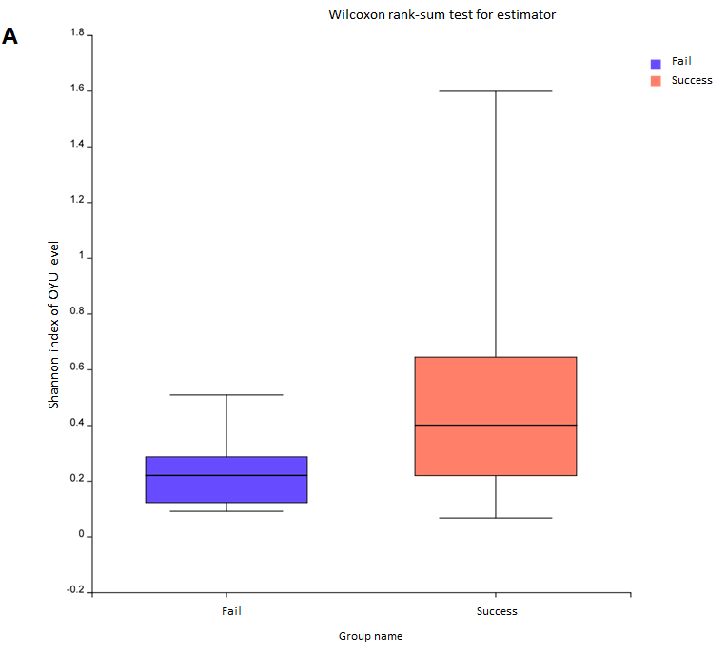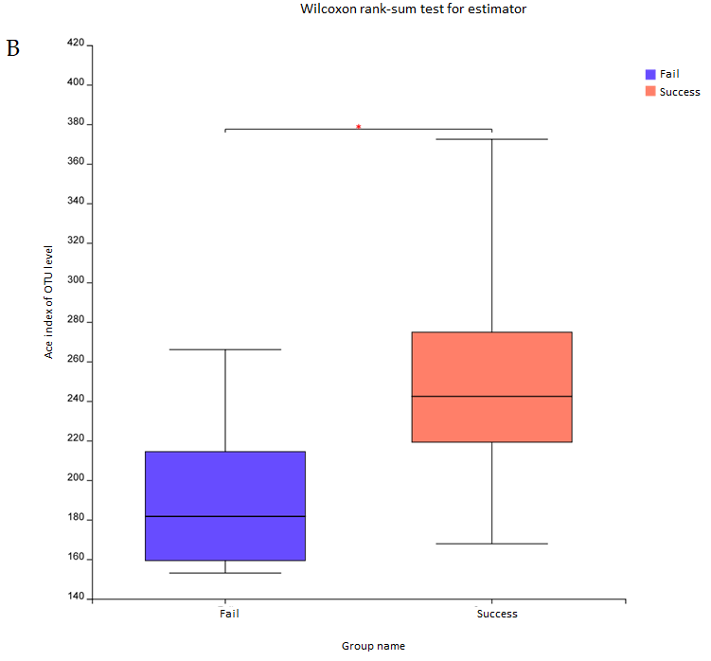
Figure 1 Alpha diversity analysis. A: Shannon index; B: Ace index.
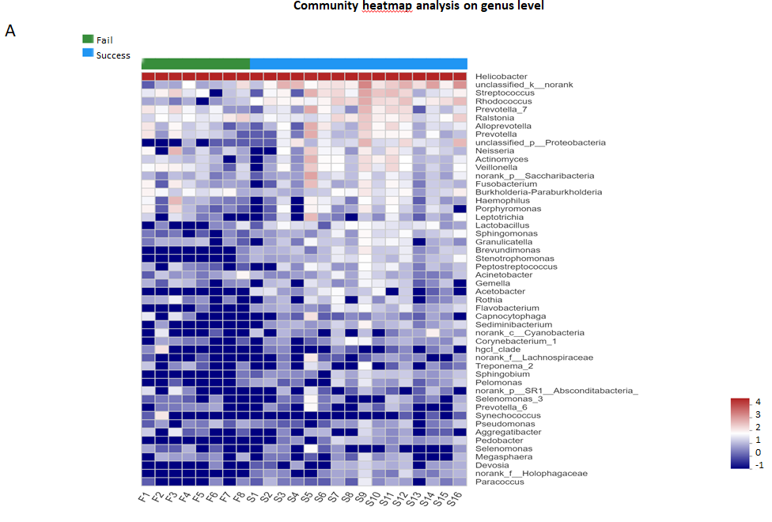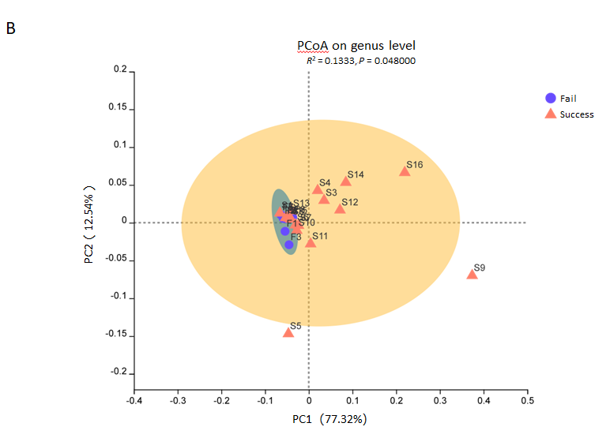
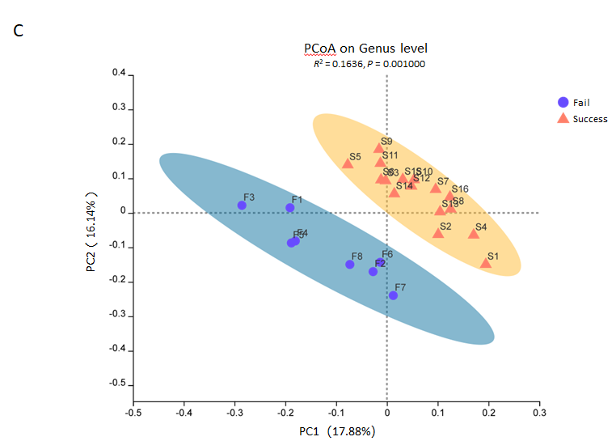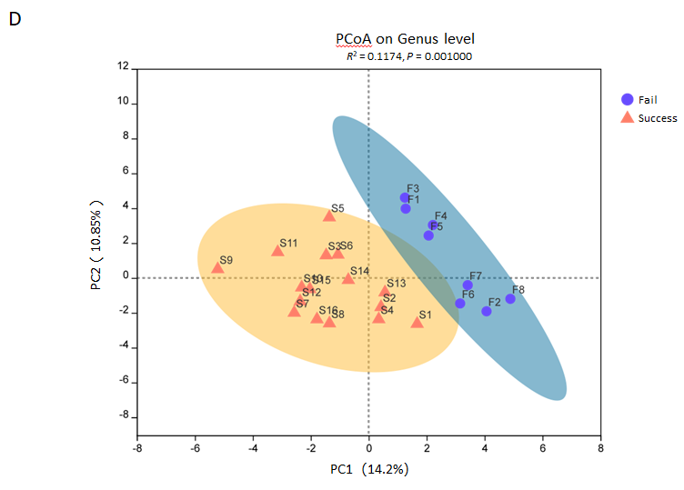
Figure 2 Beta diversity analysis. A: Heatmap; B: Weighted UniFrac; C: Unweighted UniFrac; D: Binary Euclidean. Points with different colors or shapes represent samples from different groups. The closer the two points are, the more similar the species composition is.
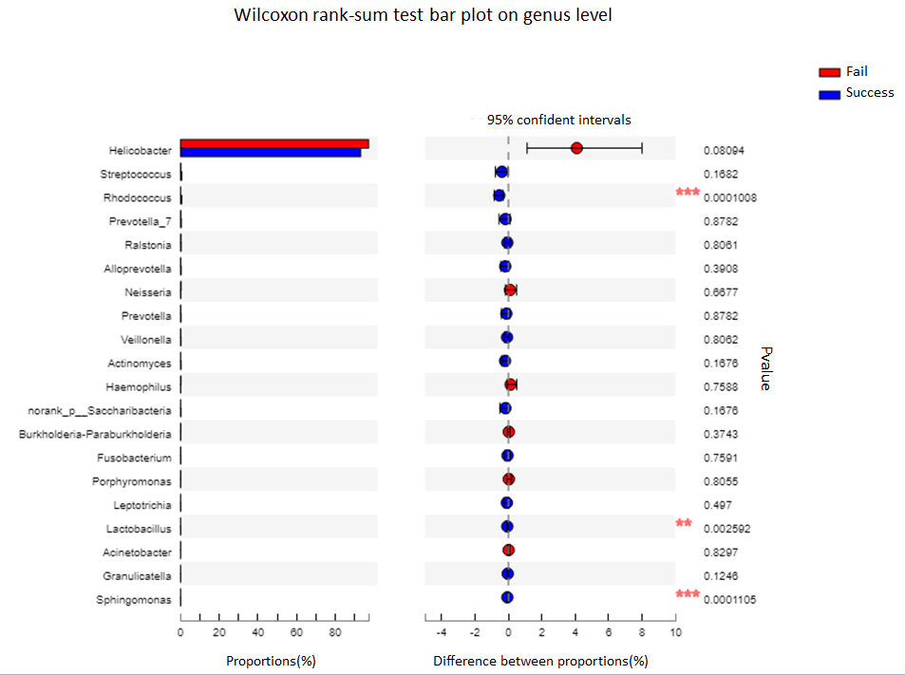
Figure 3 Genus-level differences between the success group and the failure group. The analysis includes the 20 most abundant genera.
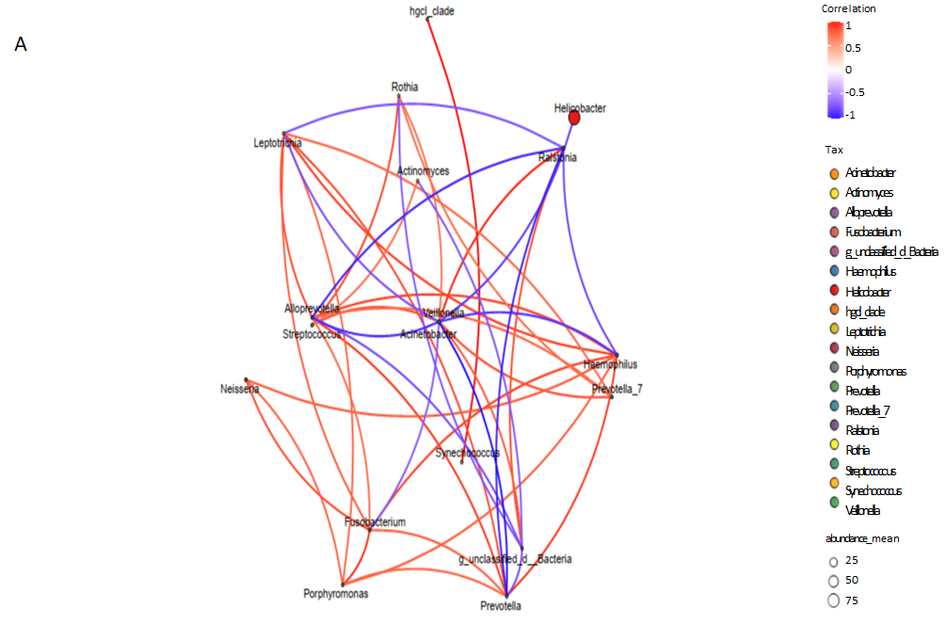
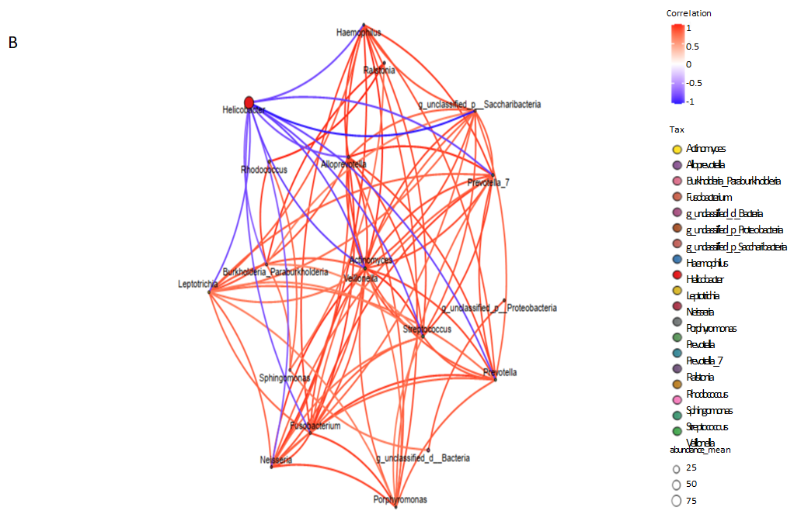
Figure 4 Single factor correlation network analysis including the 20 most abundant genera. A: Failure group; B: Success group. Each circle represents a species. Red and blue line represent positive and negative correlations. The thickness of the lines represents the correlation coefficient.
Table 1 Baseline characteristics used in case matching of Helicobacter pylori eradication failure and success
 |  | Failure group | Success group | P value
Sex | Male | 7 | 14 | 1.000
 | Female | 1 | 2
Age in yr, mean ± SD |  | 40.13 ± 14.55 | 37.44 ± 6.42 | 0.532
BMI in kg/m², mean ± SD |  | 25.01 ± 5.32 | 25.20 ± 2.84 | 0.913
Background mucosa | Chronic superficial gastritis | 6 | 13 | 1.000
 | Chronic atrophic gastritis | 2 | 3
SD: Standard deviation.
Table 2 Phylum-level differences of gastric mucosa microbiota
Phyla | Failure group, % | Success group, % | P value
Proteobacteria | 98.26 | 94.60 | 0.0346
Bacteroidetes | 0.60 | 1.23 | 0.4623
Firmicutes | 0.52 | 1.23 | 0.2839
Actinomycetes | 0.21 | 0.96 | 0.0016
Fusobacteria | 0.11 | 0.27 | 0.6025

Published by Baishideng Publishing Group Inc
7041 Koll Center Parkway, Suite 160, Pleasanton, CA 94566, USA
Telephone: +1-925-3991568
E-mail: bpgoffice@wjgnet.com
Help Desk: https://www.f6publishing.com/helpdesk
https://www.wjgnet.com

© 2021 Baishideng Publishing Group Inc. All rights reserved.

